Sample template to invite athletes and their families or caregivers to the HP Virtual Health Assessment

Date
Dear Special Olympics Athlete:
We hope you are all doing well and since it’s been awhile since we have seen one another in person. We want to continue staying connected with you! We have planned an activity to help bring us together! Will you join us in our Health Promotion Virtual Health Assessment?
This activity will will help us:
- Understand more about foods you eat, beverages you drink, handwashing and other health habits so we can address your needs and interests.
- Collect your current health measurements for height, weight and waist size. waist and height and upload your photo. See graphic and video measuring instructions at https://www.dropbox.com/s/hlggt0qvqmmhfw1/Waist%20Height%20Measurement%20Instructions.docx?dl=0
- Offer important and fun health education later, where you and your friends can ask questions and share ideas about staying healthy.
All the information you share with us is confidential.

Here’s how to participate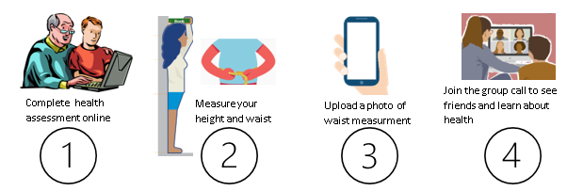
After you finish steps one, two and three please click to return it to (Name of Program).
We will put together your group’s results and share it during a follow-up session (enter date of session). Our Health Promotion Clinical Director (name or staff member presenting) will be with us to discuss the results, discuss health topics and answerquestions. (insert registration instructions for the scheduled session- if needed).
We look forward to seeing your completed assessment by ( enter date) and talking to you (enter meeting name and date). Thanks for joining us in our Virtual Health Assessment!
To get started, just click on Fill Out Form at the bottom of this letter.
Sincerely,

(name of local person responsible for Healthy Athletes)

