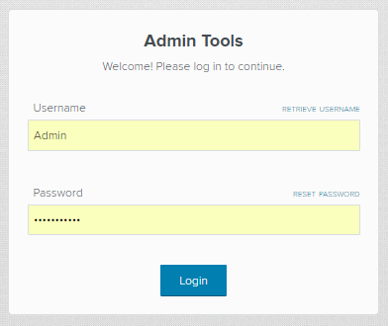

* Enter the username and password written on the back of your tablet.
* Select “Login.”

**STEP 1**

* Select your event.
* To find your event, you can use the text box at the top to search for the name.
* Select “Start.”

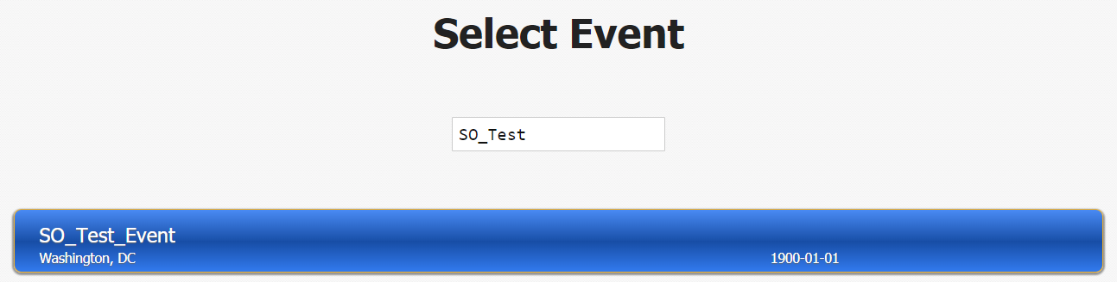

**STEP 2**

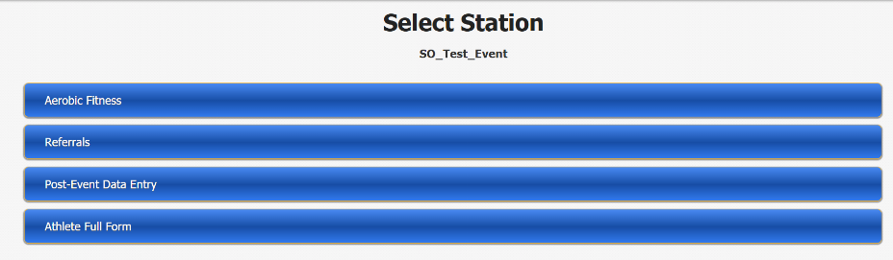

* Select “FUNFitness.”
* Select “Referrals.”

**STEP 3**

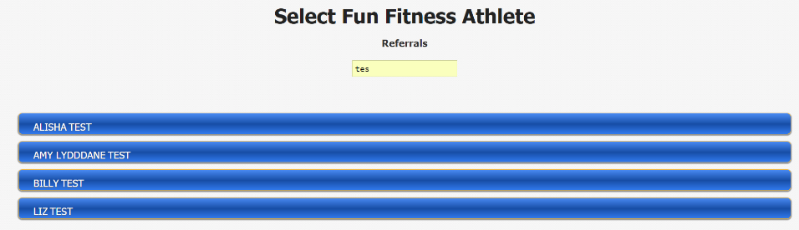

**STEP 4**

* Select the participant’s name.
* You can use the text box at the top to search for the participant’s name.

**Data Entry Notes**

* If you would like to review the participant’s data from other FUNFitness Stations, press save, then “summary”, and select the stations you would like to review. To return back to the screening, select back.
* If you would like to deselect all radio buttons, press the deselect all radio button on the bottom left corner of the screen.

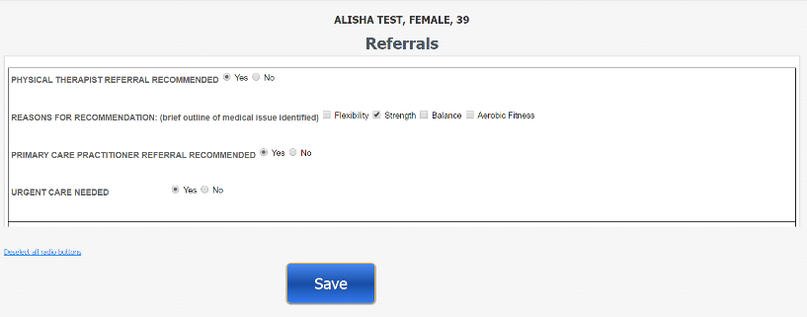

* Review the information entered at previous stations by clicking the station titles.
* Once reviewed, select “Proceed.”
* Answer the referral questions.
* Select “Save.”
* Select “Submit Data.”

**STEP 5**

* Select “Finish.”

**STEP 6**

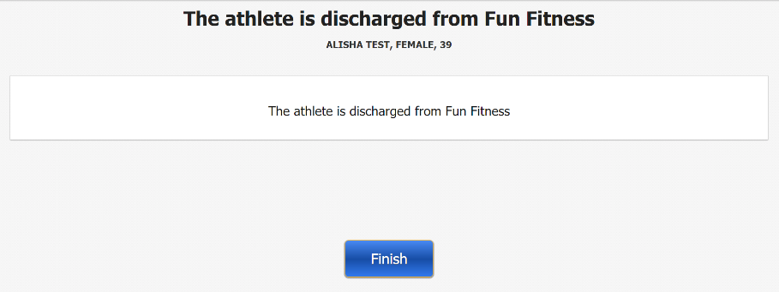



* Begin screening the next participant by selecting “Start.”

**STEP 7**