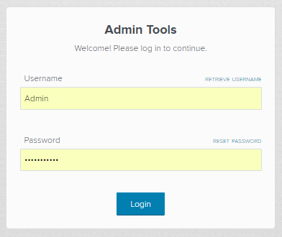

* Enter the username and password written on the back of your tablet.
* Select “Login.”

**STEP 1**

* Select your event.
* To find your event, you can use the text box at the top to search for the name.
* Select “Start.”

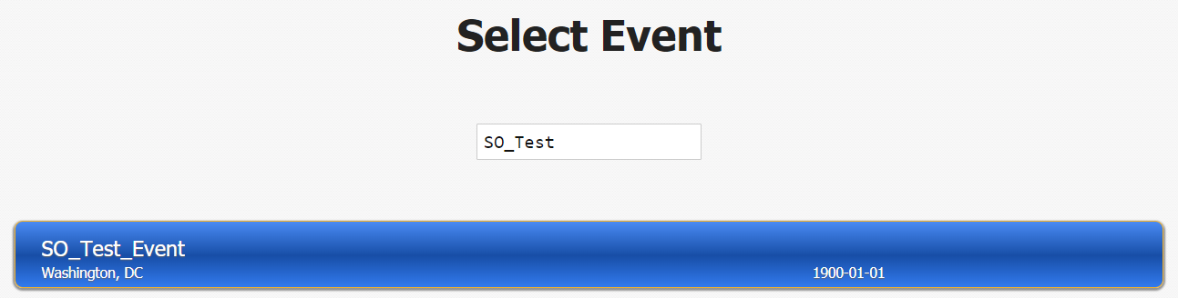

**STEP 2**

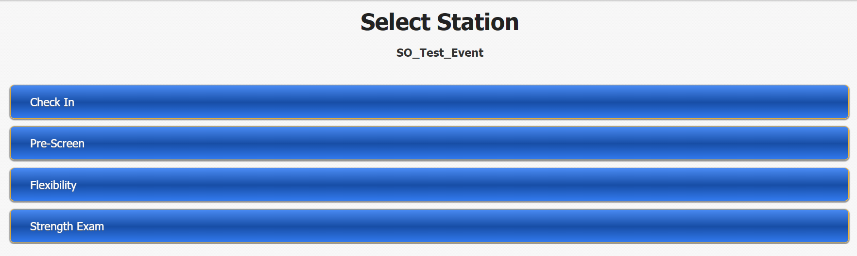

* Select “FUNFitness.”
* Select “Flexibility.”

**STEP 3**

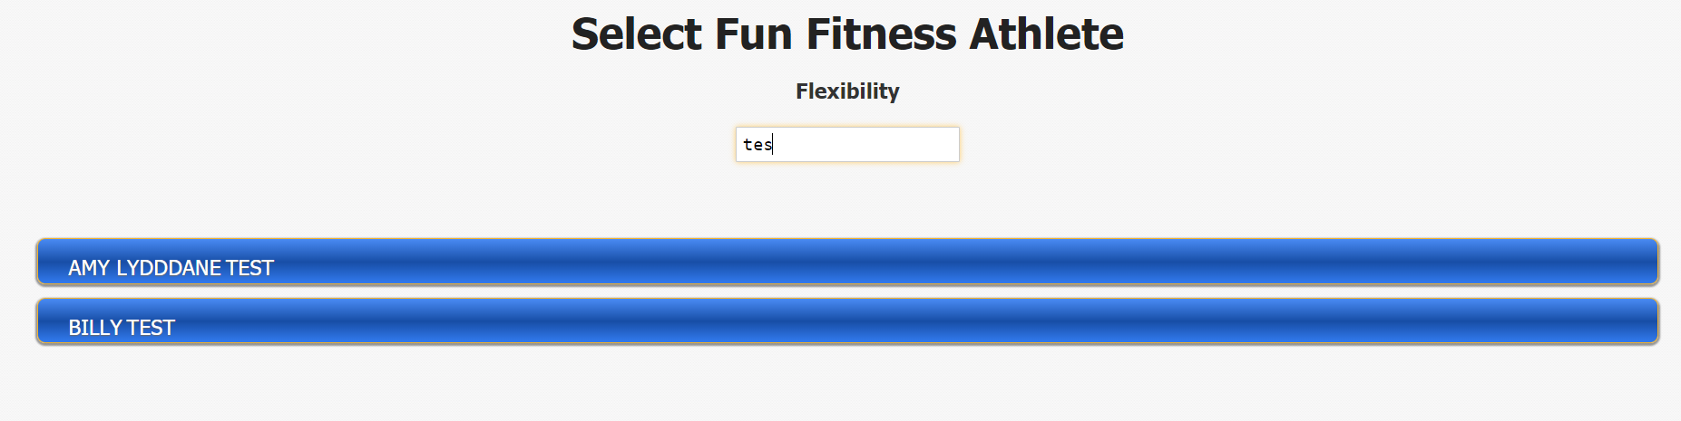

**STEP 4**

* Select the participant’s name.
* You can use the text box at the top to search for the participant’s name

**Data Entry Notes**

* For negative values, you must enter a negative sign (-) before the value, but for positive values do NOT include a positive sign (+). Once the user clicks on the fields listed below, a numeric keyboard will appear.
* Hamstring – supine (passive) knee extension: Values must be less than or equal to 20 and greater than or equal to -90 (x=<20 or x>=-90).
* Calf – supine (passive) ankle dorsiflexion: Values must be less than or equal to 15 or greater than or equal to -70 (x=15 or x>-70).
* Anterior hip – Modified Thomas Test: Values must be between 0 and – 90. (x=0 or x> or = -90).
* Shoulder – Ampley’s Test (Functional Shoulder Rotation): Currently, there is NO data validation, but please refer to the reference sheets provided at each station for further guidance.
* If you would like to review the participant’s data from other FUNFitness Stations, press save, then “summary”, and select the stations you would like to review. To return back to the screening, select back.
* If you would like to deselect all radio buttons, press the deselect all radio button on the bottom left corner of the screen

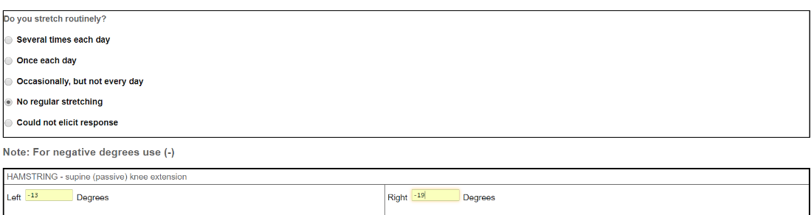

* Enter the participant’s responses.
* Select “Save”
* Select “Proceed”

**STEP 5**

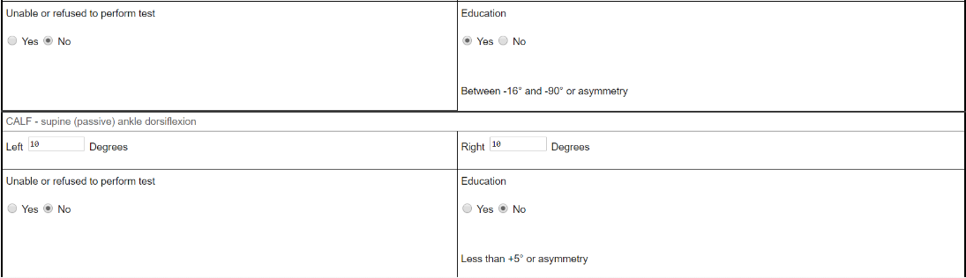

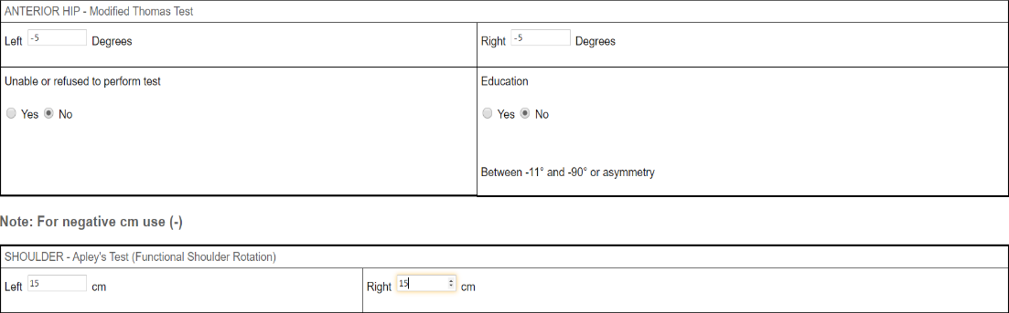

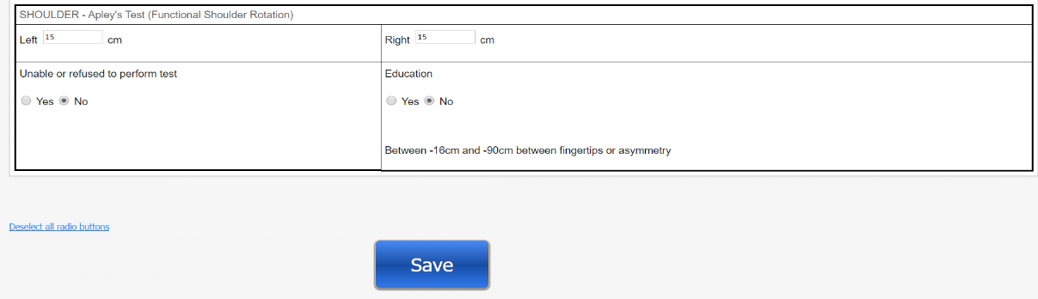

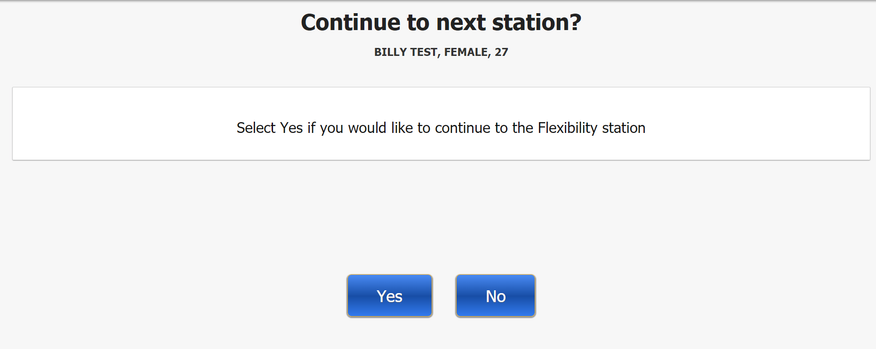

* When asked “Continue to next station?” select “No” as you are not continuing on to the next station with the participant.

**STEP 6**



* Begin screening the next participant by selecting “Start.”

**STEP 7**