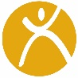

FUNFITNESS ATHLETE EXERCISE GUIDE

Flexibility Exercises

HIP FLEXOR STRETCH KNEE TO CHEST HAMSTRINGSTRETCH/MOBILIZATION
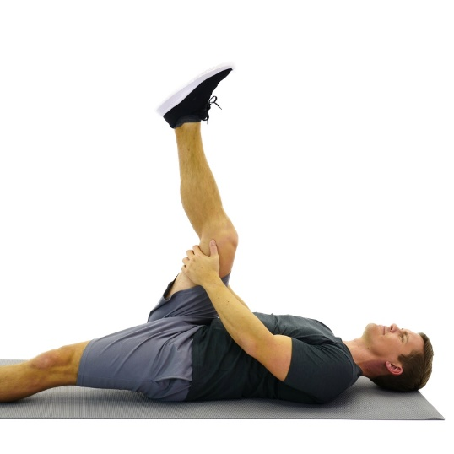
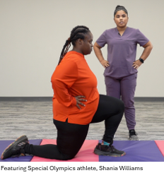
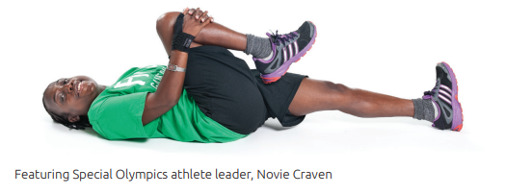

____________________________________________________________________________________________________________________________________________________________________________________________________________________________________________________________________________________________________________________________________________________________________________________________________________________________________

THORACIC MOBIILY SHOULDER/CHEST STRETCH ANKLE MOBILITY
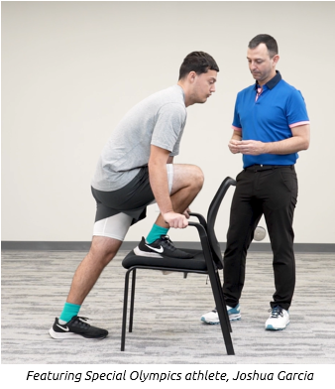
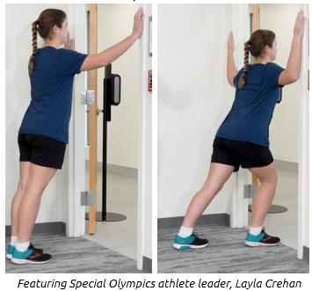
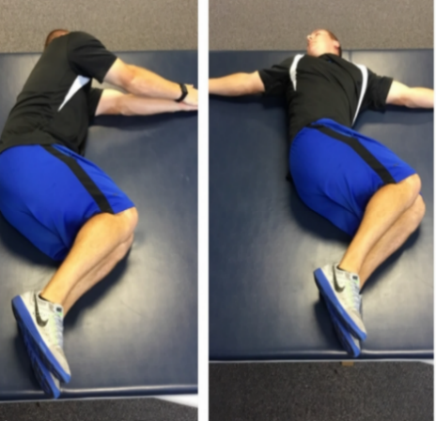
Open books Knee to chair stretch

________________________________________________________________________________________________________________________________________________________________________________________________________________________________________________________________________________________
____________________________________________________________________________________________________________________________________________
Photo Credit: All non-Special Olympics images obtained from HEP2go.com

Strengthening Exercises

THERABAND T’S PUSH-UP VARIATIONS TOWEL WRINGS
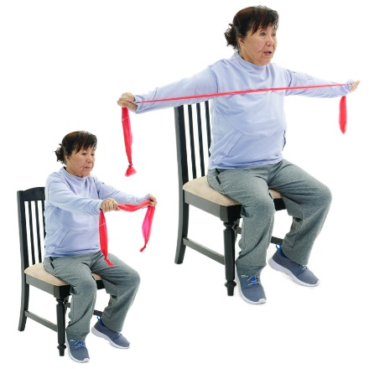
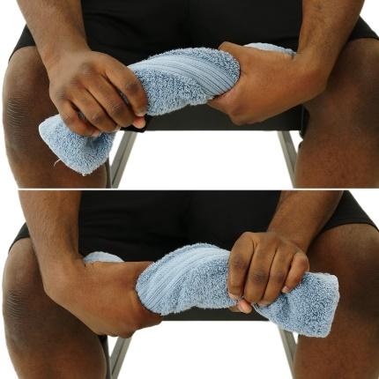
modified knee push up wall- pushup
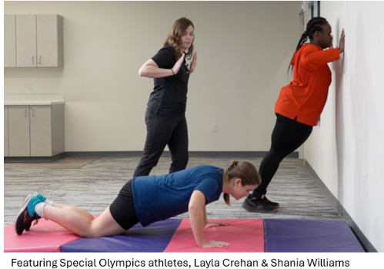

____________________________________________________________________________________________________________________________________________________________________________________________________________________________________________________________________________________________________________________________________________________________________________________________________________________________________

CHAIR SQUAT PLANK
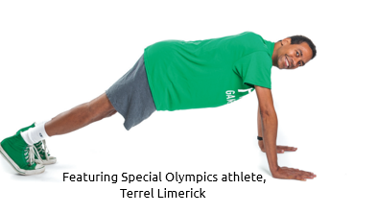
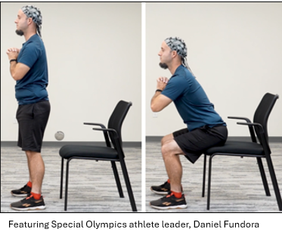

__________________________________________________________________________________________________________________________________________________________________________________________________________________________________________________________________________________________________________________________________________________________________________________________________________________________________________________________________

Photo Credit: All non-Special Olympics images obtained from HEP2go.com

SIDE-STEPPING BRIDGE
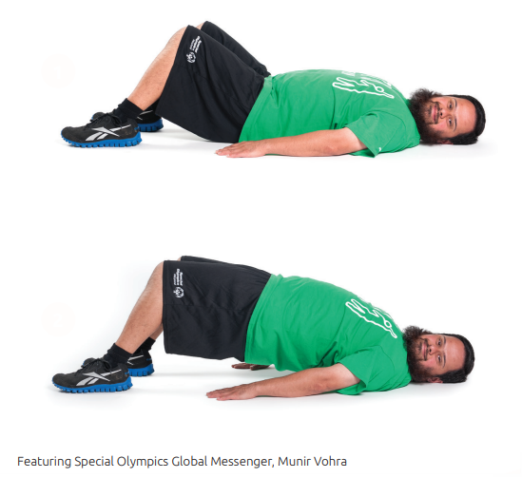
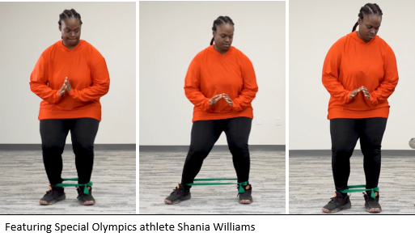

__________________________________________________________________________________________________________________________________________________________________________________________________________________________________________________________________________________________________________________________________________________________________________________________________________________________________________________________________

SINGLE LEG DEADLIFT BIRD DOGS
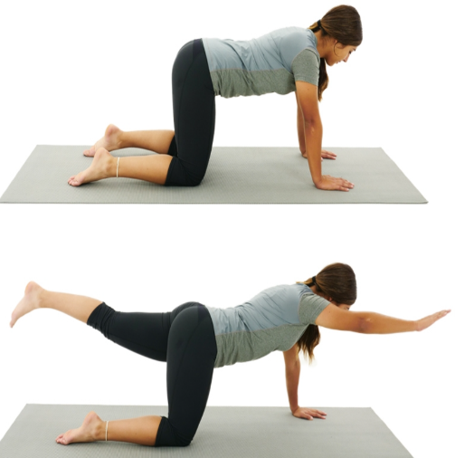
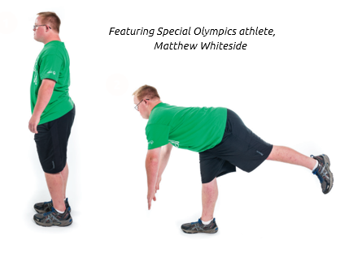

__________________________________________________________________________________________________________________________________________________________________________________________________________________________________________________________________________________________________________________________________________________________________________________________________________________________________________________________________

Photo credit: All non-Special Olympics images obtained from HEP2go.com

Balance Exercises

SINGLE LEG STANCE TANDEM WALKING SINGLE LEG TOE TAPS
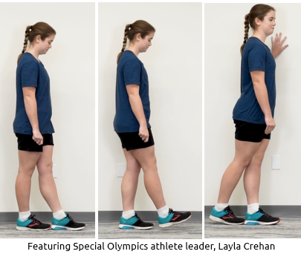
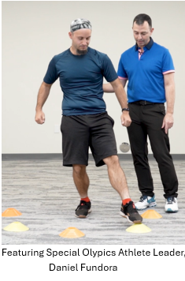
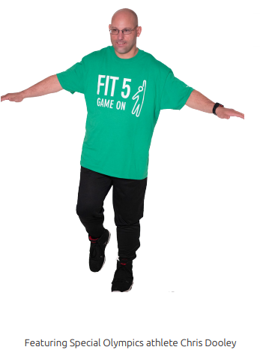

___________________________________________________________________________________________________________________________________________________________________________________________________________________________________________________________________________________________________________________________________________________________________________________________________________________________________________________

SEATED REACHING: FORWARD & LATERAL ALTERNATING MARCH HOLD
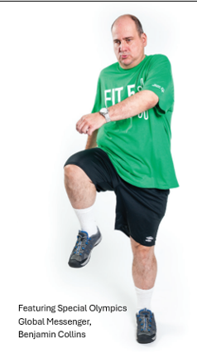
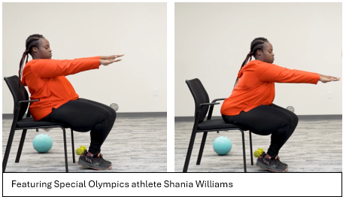

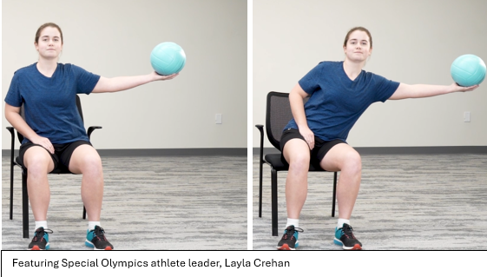

__________________________________________________________________________________________________________________________________________________________________________________________________________________________________________________________________________________________________________________________________________________________________________________________________________________________________________________________________

Photo credit: All non-Special Olympics images obtained from HEP2go.com

Aerobic Exercises

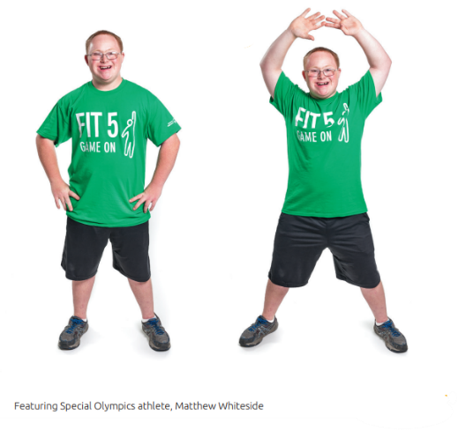
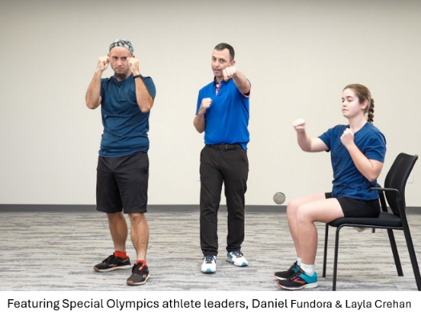
AIR PUNCHES JUMPING JACKS

________________________________________________________________________________________________________________________________________________________________________________________________________________________________________________________________________________________________________________________________________________________________________________________________________________________________________________________

QUICK STEP-UPs LINE JUMPS
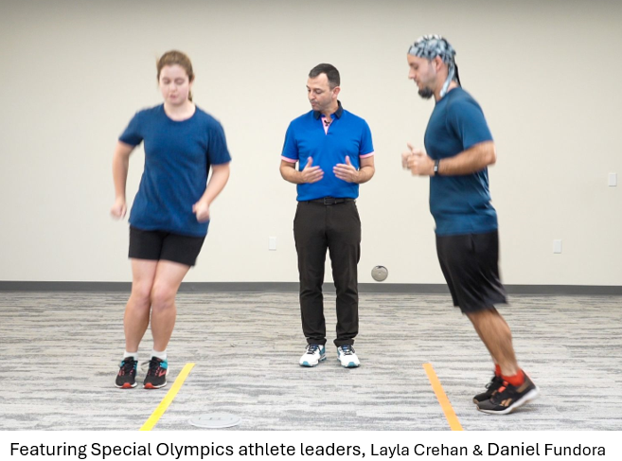
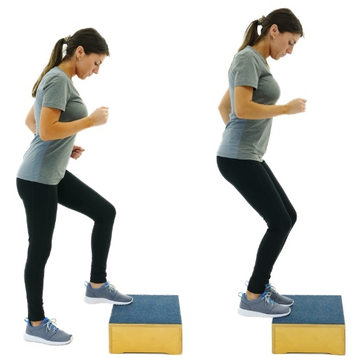

______________________________________________________________________________________________________________________________________________________________________________________________________________________________________________________________________________________________________________________________________________________________________________________________________________________________________________________

For more information about FUNfitness, exercises, and fitness resources
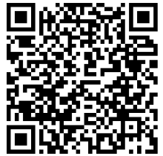
Visit the FUNfitness MyHealth page

Photo Credit: All non-Special Olympics images obtained from HEP2go.com

