Fit Feet Clinical Protocol
Fit Feet examines the shoes/socks, foot-ankle-complex, and overall lower extremity biomechanics of Special Olympics athletes to identify potential areas of concern in overall foot health, biomechanics, and foot care practices. This identification informs the provision of education on appropriate foot care/proper shoe fitting, and when appropriate, referrals to community-based providers for additional follow-up care.
While this screening provides examination of the foot, skin, nails, and biomechanics of athletes, please remember that this is a screening program, not a comprehensive evaluation. There should be no treatment given to athletes outside of basic first aid. Any significant concerns requiring immediate attention should be directed to the event’s medical services/tent.
The Fit Feet screening includes the following stations:
Station | Areas Tested | Overview of Station
- Check In | Athlete Demographic & History Information
- Shoe/Sock Exam & Measurement | Foot & Shoe Measurement | - Measurement of foot size  - Compare foot size & shoe size to determine proper fit
- Shoe/Sock Exam & Measurement | Shoe/Sock Exam | - Examine wear patterns, condition, and type of shoes/socks being used to determine appropriateness
- Foot Assessment | Structural Exam | - Examine foot/ankle for any apparent structural abnormalities (e.g., bony changes, digital deformities)
- Foot Assessment | Dermatological Exam | - Examine skin, nails, and feet for dermatological changes
- Foot Assessment | Diabetic Foot Screen | - Specific testing including  - History gathering  - Distal pulses  - Palpation (ulceration risk/review)  - Protective sensation
- Biomechanics | Static Biomechanics | - Non-weight Bearing Exam  - Ankle & great toe range of motion (ROM)  - Weight Bearing Exam  - Identify the presence of an arch deformity and/or abnormal calcaneal position
- Biomechanics | Dynamic Biomechanics | - Gait Analysis
- Check Out | - Data Review & Education
- Check Out | - Check Out
Each station has a specific examination protocol, including guidelines for indicating the need for additional follow-up and what types of recommendations to make. While these guidelines can be a helpful tool to ensure athletes receive appropriate follow-up care, please utilize your overall clinical decision-making skills and professional judgment when selecting follow-up recommendations and providing education.

Overall, this guide will help to:
- Explain each station and sub-station of the Fit Feet screening & HAS Form
- Highlight and provide examples of common findings/areas of concern for this population
- Provide specific protocols for result recording on the HAS form
- Provide additional guidance, if needed, on what actions to take based on the results of the screening

Station 1: Check In
Background & Demographics: Athlete information will likely be pre-populated in the digital system; therefore, only confirmation of information is required. Changes may be made as appropriate. For paper forms, obtain information to the best of your ability if not pre-provided on stickers/name badges.
History Questions: Gather additional information about the athlete that could impact screening results.
Volunteer Needs: General Volunteers (one per test site)
HAS recording:
- Select any/all current and/or previous medical history, diseases, or injuries that apply to you and may affect screening results.
  - If none of the options apply to the athlete, then select: No conditions nor medical history that may affect this screening
    - Note: If selected, no other boxes should be selected for this question
  - If any of the conditions and/or history do apply, multi-select any/all that apply
    - Note: Some selections will require additional information (e.g., pain/injury location)
  - If unable to obtain additional information, select either I don’t know, or Did not answer
- On most days, do you have pain, aching, or stiffness in either of your feet?
  - Select response from the following options: Yes, No, I don’t know, or Did not answer
    - If unable to obtain information, select either I don’t know, or Did not answer
- Have you been told by a doctor or other health worker that you have raised blood sugar or diabetes?
  - Select response from the following options: Yes, No, I don’t know, or Did not answer
    - If unable to obtain information, select either I don’t know, or Did not answer
- Have you had an amputation of any part of your foot, ankle, or leg?
  - Select response from the following options: Yes, No, I don’t know, or Did not answer
    - If Yes:
      - Indicate laterality as one of the following: Right, Left, or Both
      - Indicate level as free text
    - If unable to obtain information, select either I don’t know, or Did not answer
- Do you typically wear a brace, orthotic, or prosthetic on either or both of your legs?
  - Select response from the following options: Yes, No, I don’t know, or Did not answer
    - If Yes:
      - Indicate laterality as one of the following: Right, Left, or Both
      - Indicate type as free text
    - If unable to obtain information, select either I don’t know, or Did not answer
- Do you have regular foot checks with a doctor?
  - Select response from one of the following: Yes, No, I don’t know, or Did not answer
    - If Yes:
      - Indicate specialty as one of the following: Podiatrist, PCP, Physiotherapist, Dermatologist, Orthopedist, or Other
        - If Other, indicate specialty as free text
      - Indicate when their last visit was as free text
    - If unable to obtain information, select either I don’t know, or Did not answer
- In the past 12 months, how many times have you fallen?
  - Select response from the following options: 0, 1, 2, >3, I don’t know, Did not answer
    - If the athlete has not fallen, select 0 times
    - If unable to obtain information, select either I don’t know, or Did not answer

Station 2: Shoe/Sock Exam & Measurement
Station 2 examines an athlete’s shoe/sock fit and condition. During this station, an athlete’s proper shoe size is measured/calculated, and the condition and type of shoes/socks are reviewed to make recommendations on the most appropriate type for the athlete based on their specific sports/activities.
Volunteer Needs: Clinical volunteers, or general volunteers with specialized training in shoe fitting (i.e., shoe retail professionals). One per test site.
Athlete Position: The athlete will be standing, with shoes on, and then again with their shoes off.
Measurement/Exam Technique:
- With the athlete standing and shoes on, check how the foot appears to fit within the shoe
- Remove the athlete’s shoe and record the printed shoe size as ‘Current Shoe Size’
  - At this time, you may also start your inspection of the condition and the type of shoe/sock (see below in the fifth bullet)
    - If no shoe size is printed/legible, ask the athlete what shoe size they typically wear
- Measure the athlete’s ‘Current Foot Size’
  - With shoes removed and the athlete standing on a flat surface with their heel against a hard surface, measure the length and width of the athlete’s foot
      - Length: Measure the distance, in cm, between the base of the heel to the tip of the longest toe (this may not be the great toe)
        - A defined starting point for measurement should be established, such as using a hard surface (e.g., a wall, table leg, or a clipboard behind the foot), to ensure consistent measurement of the base of the heel.
          - If unavailable, extra diligence should be noted to ensure the edge of the heel is exactly at the starting point of the tape measure
        - Note: Affixing the tape measure to the floor may support efficient measurement throughout the event, if allowable by the venue
      - Width: Measure, in cm, the distance between the lateral borders of the foot, at its widest part
- Determine the athlete’s ‘Proper Shoe Size’
  - The digital system will automatically calculate the proper shoe size based on the selection of the athlete’s preferred size type that corresponds to their country/region
      - For paper forms, utilize the shoe size conversion charts available on the Fit Feet resources page to convert the measured foot size from CM to the athlete’s preferred shoe size type
  - Compare the current shoe size to the proper shoe size and answer the proper fit question
- Examine the shoes/socks for condition and type for appropriateness for sport
  - Shoe/Sock Condition: Consider if the shoe is worn excessively, if the midsole cushioning is unevenly compressed, if the shoe is aligned on the foot bed properly, overall age of the shoe, and type of activity
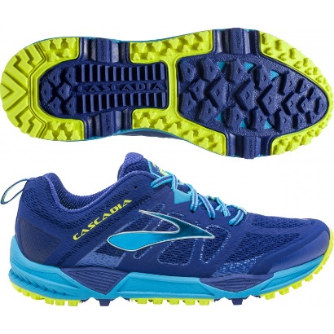
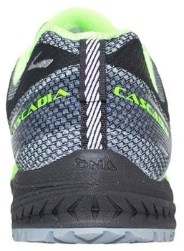
      - Examples of good condition:

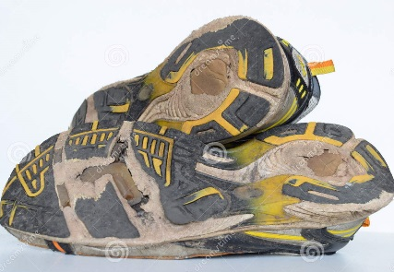
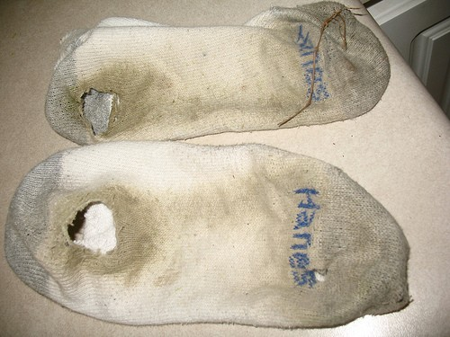
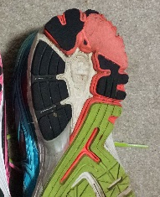
      - Examples of Poor Condition

  - Shoe/Sock Types: Consider the type of shoes/socks the athlete is wearing in comparison to the sport/activities they regularly participate in
      - Note: Some athletes do not wear their competition shoes/socks to the screening; therefore, this examination will not be applicable.
      - Consider the following when examining the athlete’s socks:
        - Wool Socks should be utilized for winter sports
        - Acrylic socks tend to be better for athletic competition than cotton socks
HAS form Action Items:
- Screener Name: Record the name of the volunteer completing the measurement.
Note: For all stations with ‘Screener Name’ required, this is used as if clarification of results is needed from the volunteer completing measurement/testing
- Current shoe size
  - Size type: Indicate the size types for the athlete’s shoes from the options below:
    - Select one: USA, EUR, UK, or CM
    - Select one: Men, Women, or Child
  - Length and Width: Record the printed or reported shoe size for the right and left
    - If size for length/width is unavailable, and/or unable to test for either side, select N/a
- Current foot size
  - Length and width: Record, in cm, measurements taken of the athlete's right and left foot
      - If unable to measure right or left, select N/a
- Proper Shoe Size
  - Size type: Indicate the preferred size type (based on the athlete’s country/region) from the options below
    - Select one: USA, EUR, UK, or CM
        - If unable to determine the size type used in the athlete’s community, select CM
    - Select one: Men, Women, or Child
  - Length: The digital system will automatically populate the proper size for length once the size type is selected
    - If using paper forms, record the corresponding proper shoe size for left and right length based on the shoe size conversion chart, or if the size type selected is CM, record the measured ‘Current Foot Size’ from above
      - Note: For children’s sizes: As the length(cm) becomes larger, UK and US sizing restarts at 1. In practice, these are considered “big kids” or “junior” sizes; however, there is no option for this designation on the HAS form. Therefore, when calculating proper shoe size and proper fit, this scenario needs to be taken into account. If there is an overlap between a “big kids” sizes and adult sizes, the recommendation is to provide the proper size as the adult size (i.e., 23.6 cm = children’s “big kid” 5 but can also be a women’s size 7)
    - If unable to measure either right or left, select N/a
  - Width: There is no conversion system available for width; therefore, please use your clinical judgement to select an appropriate width from the following options: Narrow, Medium, Wide, Extra Wide, or N/a
    - If unable to measure either right or left, select N/a
- Do the current shoes have a proper fit?
  - Select Yes if the athlete’s current shoe size is equal to, or up to 1 size larger than, the calculated proper shoe size (based on the measured current foot size)
    - Note: Proper-fitting shoes should NEVER be any size smaller than the foot size
  - Select No if you determine the athlete is wearing the incorrect shoe size
    - If No, select the appropriate option from: too big or too small
        - Too Big = shoe sizes > 1 size larger than the proper shoe size
        - Too small = ANY shoe size smaller than the proper shoe size

- Is the current shoe in good condition?
  - Based on the current shoe condition, select from the following options: Yes, No, or N/a
    - Consider wear patterns, shoe age, etc., as noted above
- Are the current socks in good condition?
  - Based on the current sock condition, select from the following options: Yes, No, or N/a
    - Consider if the socks are worn excessively (i.e., holes present or thread is sparse)
- Is the shoe appropriate for the sport type?
  - Based on the athlete’s sport, select from the following options: Yes, No, or N/a
    - Select N/a if appropriateness is not applicable or is unable to be determined (e.g., athlete is not wearing competition shoes, athlete does not wear shoes for their sports)
- Are the socks appropriate for the sport type?
  - Based on the athlete’s sport, select from the following options: Yes, No, or N/a
    - Select N/a if appropriateness is not applicable or is unable to be determined (e.g., athlete is not wearing competition socks, athlete does not wear socks for their sports)
- Follow-up Recommended?
This recommendation should only prompt the provision of education regarding proper shoe/sock fit, condition, and/or types based on sport. This may include providing the athlete with additional resources as appropriate/available.
  - Select No if the athlete’s shoes properly fit AND shoes/socks were in good condition/appropriate for sport where applicable.
  - Select Yes if the athlete’s shoes do not properly fit, OR if No was the response for any question regarding condition and/or appropriateness for sport.

Station 3: Foot Exam
Station 3 includes 3 sub-stations: Structural Exam, Dermatological Exam, and Diabetic Foot Screen.
Volunteer needs: At least 1 clinical volunteer per test site (additional volunteers may be used for recording)
Athlete Position: The athlete’s shoes are removed, and they are seated with their leg and foot extended or propped up in a way that allows the whole foot, including the bottom of the foot, to be examined. For athlete comfort and ease of examination, the athlete’s foot may be propped up on something (e.g., a chair, stool, etc.)
Structural Exam
In this sub-station, an athlete’s foot structure is examined for overt deformities/ abnormalities.
Measurement/Exam Protocol:
Inspect the athlete’s foot for any abnormal presentation, including, but not limited to, the examples below
Digital deformities Hammer toe Brachymetatarsia Hallux Varus Metatarsus Adductus
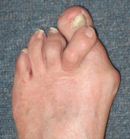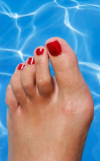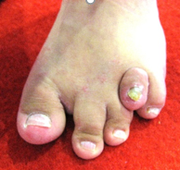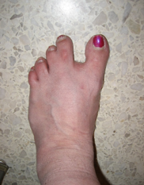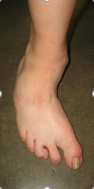
Hallux Abducto Valgus (Bunions)
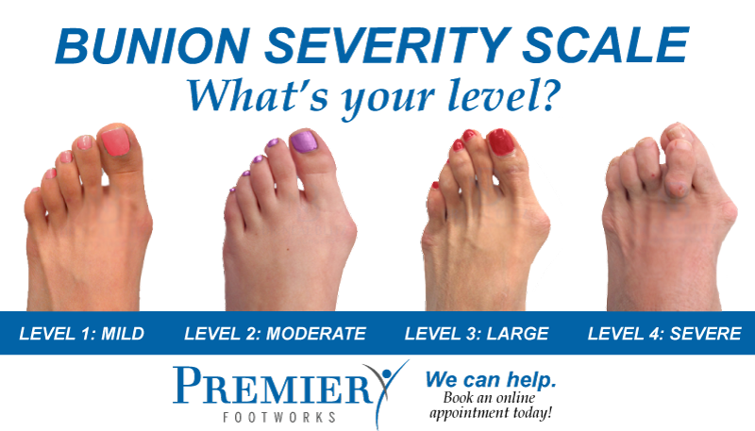

HAS Recording:
- Screener Name: Record the name of the volunteer completing the measurement.
- Exam Result:
  - Select Normal, Abnormal, or Unable to test, based on examination findings
    - Select Unable to test, if unable to examine the athlete
      - If Unable to test, select the reason from the following options:
Refused to perform, Unable to perform, Unable to understand, or Other
          - If Other, indicate reason as free text.
    - Select Normal if no abnormal findings were revealed during examination
    - Select Abnormal if the examination revealed abnormal findings, including but not limited to examples from above
      - If abnormal, multi-select the specific exam findings, including but not limited to the examples above
          - If the finding is not pre-listed on the form, select ‘Other’
- Follow-up Recommended?
Guidelines for making specific follow-up recommendations based on examination findings are included below; however, volunteers are encouraged to use clinical judgment to make recommendations for follow-up type.
  - Select No if Normal was selected as the exam result
  - Select Yes if Abnormal was selected as the exam result
    - If Yes, select from: Education Only, Non-urgent referral, or Urgent referral
      - Select Education Only if non-painful bunions, hammer toes, etc., are present
          - At check out, provide education on independent management of finding(s) and when to seek additional care
      - Select Non-Urgent Referral if ≥ 3 findings are recorded and/or if pain is present with examination, as this may suggest the presence of larger pathology needing formal evaluation and diagnosis
*Note: Guidelines for follow-up recommendations automatically pull into Check Out on the digital form

Dermatological Exam
In this sub-station, the athlete’s skin and nails are examined for any abnormal dermatological changes
Measurement/Exam Protocol:
Inspect the athlete’s foot for any abnormal findings/presentations of the skin and nails
- When examining the condition of the athlete’s skin, consider the following:
  - Inspect the web spaces, looking for fissures and maceration
  - Look for suspicious pigmentation
  - Pay special attention to areas of high friction for possible ‘pre-blistering’
  - Is the skin especially dry or moist?
*Abnormal findings include signs of lesions, unusual colors, thickening, and/or any other signs of possible pathology. Below are some examples of common findings:
Callus Corn Wart Suspicious pigmentation Ulcer Blister
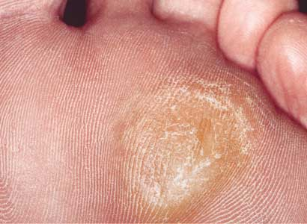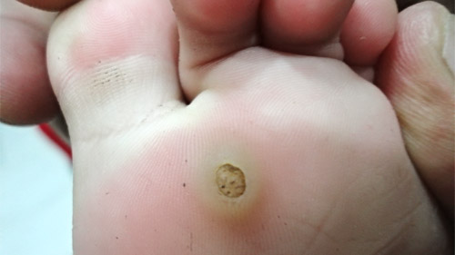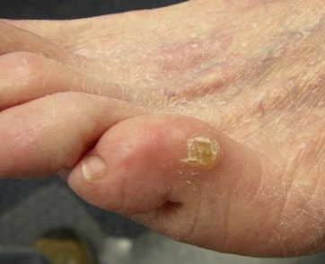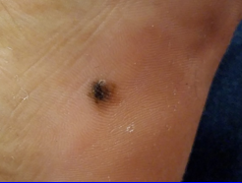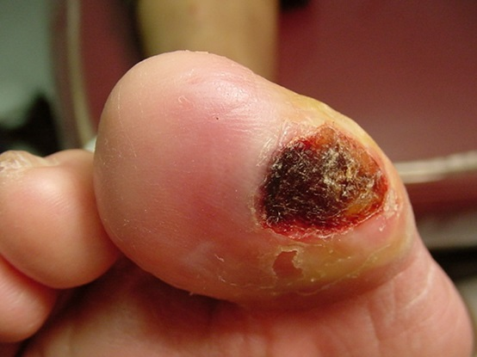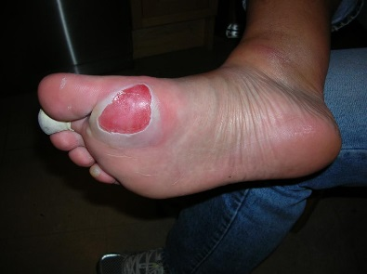
- When examining the condition of the athlete’s nails, consider the following:
  - Is the nail firmly attached, or is there any cracking or lysis?
  - Are there any potential signs of infections?
  - Does the nail appear as if it has been trimmed/cut properly?
*Abnormal findings include signs of unusual colors, thickening, and/or any other signs of possible pathology. Below are some examples of common findings:
Poorly Cut Nail Subungual hematoma Dystrophic Nails Onychocryptosis (ingrown nail) with/without infection
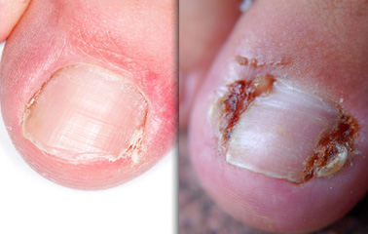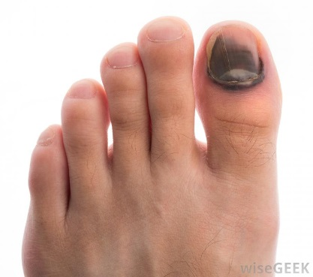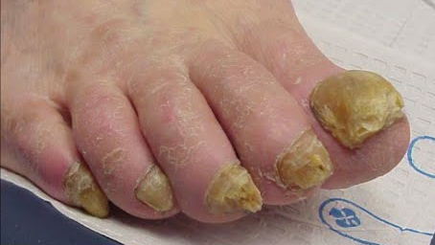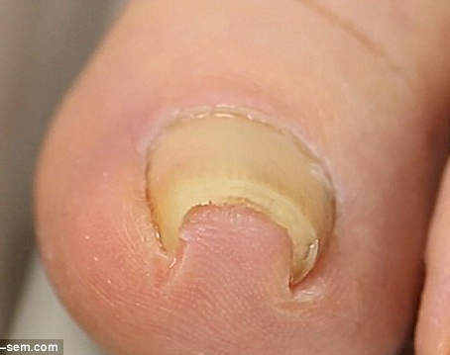

HAS Form Action Items:
- Screener Name: Record the name of the volunteer completing the measurement.
- Exam Result
  - Select Normal, Abnormal, or Unable to test, based on examination findings
    - Select Unable to test, if unable to examine the athlete
        - If Unable to test, select the reason from the following options:
Refused to perform, Unable to perform, Unable to understand, or Other
        - If Other, indicate reason as free text.
    - Select Normal if no abnormal findings were revealed during examination
    - Select Abnormal if the examination revealed abnormal findings, including but not limited to examples from above
        - If abnormal, multi-select the specific exam findings, including but not limited to examples from above
        - If Onychocyptosis (ingrown nail) is selected, select infected or not infected
        - If the finding is not pre-listed on the form, select Other

- Follow-up Recommended?
Guidelines for making specific follow-up recommendations based on examination findings are included below; however, volunteers are encouraged to use clinical judgment to make recommendations for follow-up type
  - Select No if Normal was selected as the exam result
  - Select Yes if Abnormal was selected as the exam result
    - If Yes, select from: Education Only, Non-urgent referral, or Urgent referral
      - Select Education Only if any of the following are present
        - Poorly cut nails, Non-painful calluses, blister(s), corns(s) and/or any other notable concern that would benefit from education regarding independent management and monitoring.
          - At Check Out, provide appropriate based on findings
      - Select Non-Urgent Referral if any of the following findings are present:
        - >3 findings are recorded and/or pain was indicated during examination, as this may suggest the presence of larger pathology needing formal evaluation and diagnosis
      - Select Urgent Referral if any of the following findings are present
        - Ulcer(s), acute subungual hematoma, suspicious pigmented lesion, and/or signs of infection
*Note: Guidelines for follow-up recommendations automatically pull into Check Out on the digital form

Diabetic Foot Screen (DFS)
In this sub-station, the athlete is screened for using subjective questions and a 3-part examination to gather clinically relevant information/findings that may suggest risk factors for and/or presence of diabetes or adverse foot health presentations, such as foot ulcers.
History Question:
Subjective question to obtain relevant information regarding sensation changes, wound healing, etc., that could indicate the presence of and/or risk for developing diabetes
- Ask the athlete if they have ever experienced burning or tingling, skin color changes, skin lesions, loss of sensation, and/or slow healing of wounds in their lower leg/feet
- Record any/all that apply based on the athlete’s responses
Pulses
Test for the presence of dorsal pedis and posterior tibial pulses using manual palpation
Measurement/Exam Protocol:
On both the right and left foot, palpate for the following:
- Dorsal Pedis pulse
  - Palpate the dorsum of the foot for the presence of a pulse, and record results accordingly
- Posterior tibial pulse
  - Palpate the medial aspect of the ankle, posterior to the medial malleolus, for the presence of a pulse, and record results accordingly

Palpation
Review structural and dermatological exam findings to indicate possible increased risk for developing an ulcer, and/or in the presence of an ulcer, inspect for additional clinical findings that may contribute to the identification of potential healing outcomes
Measurement/Exam Protocol:
On both the right and left foot:
- Prominences:
  - Inspect the foot for any findings that may increase the athlete’s risk of developing an ulcer, such as bunions, hallux deformities, digital deformities, etc.
    - Note: These findings may have already been identified in the exams above
- Ulcer(s):
  - Indicate presence of any ulcer(s) on right/left and if present, inspect for additional clinically relevant findings, including: size ( >1cm or not), infection status (signs of infection or not), location (midfoot or hindfoot), and depth (visibility of bone or ligament or not)

Protective sensation:
Test for a loss of protective sensation (LOPS) in the athlete’s foot.
Exam Selection
Protective sensation may be tested in 2 different ways. See below for Measurement/Exam Protocol:
- Ipswich Test:
  - The Ipswich test is a method to test for the presence of protective sensation that requires no equipment. For this sub-station, the Ipswich test is considered the required measurement
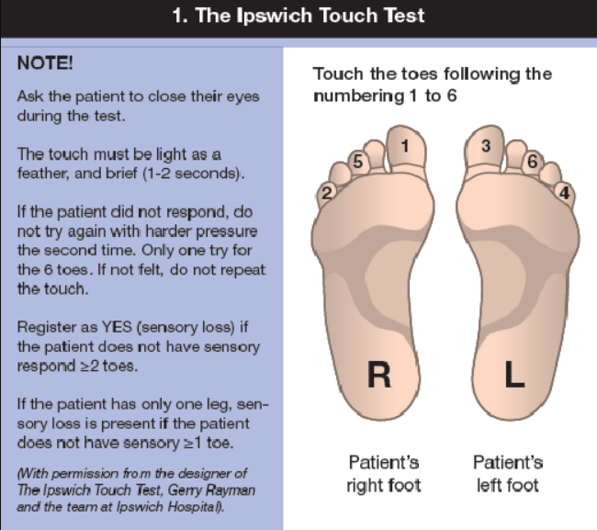
    - Explain the test to the athlete and request permission to touch their feet
Hellstrand Tang U, Tranberg R, Zügner R, et.al. The D-Foot, for prosthetists and orthotists, a new eHealth tool useful in useful in risk classification and foot assessment in diabetes. FAOJ. 2017;10(2):4. doi: 10.3827/faoj.2017.1002.0004
    - Instruct the athlete to close their eyes, keeping them closed for the entire test
    - Ask the athlete to say ‘Yes’ each time they feel their toe is touched
    - Lightly touch the tip of your index finger for 1–2 seconds on the plantar surface of the athlete’s toes in the order below: Note: Be careful to avoid pushing taping, or poking the toes as this may elicit a sensation other than light touch
        - Right Hallux
        - Right little toe
        - Left Hallux
        - Left little toe
        - Right middle toe
        - Left middle toe
  - LOPS = no response for ≥ 2 toes
    - If only 1 foot can be tested, LOPS = no response for ≥ 1 toe
- Monofilament testing
  - Alternative testing methods using monofilaments, such as the Semmes-Weinstein monofilament test, may be used instead of the Ipswich test if the required equipment is available
    - Note: Alternative testing methods may also allow for testing of residual limbs
  - Protocol for testing and/or LOPS indications using alternative methods should be determined based on the presence of validated, evidence-based recommendations/research
    - Monofilament testing methods, outside of the Semmes-Weinstein monofilament test, may be utilized on a case-by-case basis
SINBAD Score
SINAD is a scoring system related to diabetic foot ulcer outcomes management that requires additional clinical examination of an ulcer(s); however, it does not require additional equipment. SINBAD is an acronym for 6 categories that describe characteristics of a wound that may impact healing outcomes.
- SINBAD scores range from 0-6 based on questions related to each of the 6 SINBAD categories.
- When an ulcer is present, for either or both the right and left, a score is calculated based on the related SINBAD category clinical findings included within the DFS, as detailed below:
  - Site (Location): Score is based on the response to the Palpation question “Is the ulcer(s) or sore(s) located at midfoot or hindfoot?”
  - Ischemia (Pedal Pulses): Score is based on the results of Pulse testing
  - Neuropathy (LOPS): Score is based on the results of Protective Sensation testing
  - Bacterial infection: Score is based on the response to the Palpation question, “Is the ulcer(s) or sore(s) infected?”
  - Area (Size): Score is based on the response to the Palpation question, “Is the ulcer(s) or sore(s) > 1cm?”
  - Depth: Score is based on the response to the Palpation question, “Can you see ligament or bone through the ulcer (s) or sore(s)?”
- Note: Research has shown that a score >3 suggests delayed healing outcomes for the wound that would potentially require additional care
HAS Recording:
- History Question:
  - Have you ever experienced any of the following in your lower legs/feet?
    - Multi-select any/all that apply to the athlete’s response from the following:
Burning or tingling, Changes in skin color or skin lesions, Loss of sensation, Slow healing
      - If none of the above apply, select None
- Pulses:
  - Based on examination findings, select “Exam Result” as one of the following
Present, Absent, or Unable to test,
    - Select Unable to test if unable to test any pulses for the athlete
      - If selected, indicate reason as one of the following:
Refused to perform, Unable to perform, Unable to understand, or Other
        - If Other, enter reason as free text
    - Select Present if all available pulses are present
    - Select Absent, if of available pulses, at both distal pulses are not palpable
      - If Absent, record findings for each pulse on both right and left as follows:
        - Select N/a if unable to test ONLY that respective side or pulse
        - Select Yes if the pulse is palpable
        - Select No if that particular pulse is not detected
- Palpation:
  - Based on examination findings, select “Exam Result” as one of the following
Normal, Abnormal, or Unable to test
    - Select Unable to test if unable to examine the athlete.
      - If selected, indicate the reason as one of the following:
Refused to perform, Unable to perform, Unable to understand, or Other
        - If Other, enter reason as free text.
    - Select Normal if there are no at-risk prominences or ulcers on the right or left foot
    - Select Abnormal if dermatological/structural exams revealed any relevant findings, including the presence of at-risk prominences and/or the presence of an ulcer or sore
      - If Abnormal, record responses for appropriate questions below for both right and left sides based on examination findings
        - Prominences/deformities present in the above exams that could result in ulceration?
          - Select N/a if unable to examine that respective side ONLY
          - Select No if there are no prominences or skin changes that increase the athlete’s risk for ulceration on that respective side
          - Select Yes if a prominence/skin change that may increase the athlete’s risk of ulceration is present on that respective side
        - Ulcer(s) or sore(s) present in above exams?
          - Select N/a if unable to examine that respective side ONLY
          - Select No if there is no ulcer present for that respective side
            - If No, omit additional clinical findings questions regarding size, infection status, location, and depth
          - Select ‘Yes’ if there is an ulcer present for that respective side
            - If Yes, choose either answer each additional question below with either ‘Yes’ or ‘No’ based on further examination
              - Is the ulcer(s) or sore(s) > 1cm
              - Is the ulcer(s) or sore(s) infected
              - Is the ulcer(s) or sore(s) located at midfoot or hindfoot
              - Can you see ligament or bone through the ulcer(s) or sore(s)

- Protective Sensation
  - Based on examination findings, select “Exam Result” as one of the following
Present, Absent, or Unable to test based
    - Select Unable to test if unable to examine the athlete.
      - If selected, indicate the reason as one of the following:
Refused to perform, Unable to perform, Unable to understand, or Other
        - If Other, enter reason as free text.
    - Select Present if sensation is intact for both sides
    - Select Absent if testing results indicate any LOPS
      - If Absent, record the results for both right and left foot as follows:
        - Loss of protective sensation?
          - Select N/a if unable to test on ONLY that respective side
          - Select No if the athlete has sufficient protective sensation
          - Select Yes if the test result indicates the athlete has a LOPS
- SINBAD Score
  - For right and/or Left, select N/a if no Ulcer(s) or sore(s) were found during examination
    - i.e. ‘No’ was selected for the question “Ulcer(s) or sore(s) present in above exams?”
  - For both the right and left, if an ulcer/sore is present, calculate a SINBAD score (from 0-6) using results/response from all examinations in the DFS.
    - Assign a score of either 0 or 1 based on the guidelines below.
      - Site: Is the Ulcer/Sore located at midfoot or hindfoot?
        - Score = 0 if selected No (present in another location);
        - Score = 1 if selected Yes
      - Ischemia: Reduced pedal blood flow
        - Score = 0 if selected Yes for at least one pulse on that side
        - Score = 1 if selected No for both pulses for that side (possible ischemia)
      - Neuropathy: Loss of Protective Sensation
        - Score = 0 if selected No on that side
        - Score = 1 if selected Yes on that side (LOPS present based on testing results)
      - Bacterial Infection: Is the Ulcer/Sore infected?
        - Score = 0 if selected No (no signs of an active infection)
        - Score = 1 if selected Yes (possible signs of an active infection)
      - Area: Is the Ulcer/Sore > 1cm?
        - Score = 0 if selected No (size is <1cm in diameter)
        - Score = 1 if selected Yes
      - Depth: Can you see ligament or bone?
        - Score = 0 if selected No
        - Score = 1 if selected Yes (full tissue loss visible)
    - Each category's score will be added together as the total SINBAD score from 0-6/6
- Follow-Up Recommended?
Guidelines for making specific follow-up recommendations based on examination findings are included below; however, volunteers should use clinical judgment to make recommendations for follow-up type
  - Select No if None, Present, and Normal were the selections made for each section of the DFS
  - Select Yes if Absent/Abnormal was selected as any of the exam results
    - If Yes, select from: Non-urgent referral or Urgent referral
      - Select Non-Urgent Referral if any of the following Abnormal or Absent was selected for only 1 test
      - Select Urgent Referral if any of the following are true:
        - Abnormal or Absent selected for > 1 test
        - Presence of an ulcer(s) or open sore(s) and/or symptoms of Charcot-Marie-Tooth disease
*Note: Guidelines for follow-up recommendations automatically pull into Check Out on the digital form

Station 4: Biomechanics
Station 4 includes 2 sub-stations: Static Biomechanics and Dynamic Biomechanics. Static biomechanics should be examined first, then the athlete’s dynamic biomechanics should be examined.
Volunteer needs: At least 1 clinical volunteer per test site. This station is often performed in the same area as station 3, therefore, the same volunteers are often used to perform the biomechanics examinations.

Static Biomechanics
In this sub-station, the athlete’s joint range of motion and weight bearing foot/ankle positioning are examined
Non-weight bearing exam:
Examines the mobility/ROM of the toe, foot, and overall ankle complex
Athlete Position: Athlete is seated with their leg and foot extended or propped up to allow for examination
Measurement:
- Ankle dorsiflexion (DF):
  - Ask the athlete to actively dorsiflex their ankle (i.e., bring toes towards shin)
  - Once the athlete achieves their full ROM, record the athlete’s dorsiflexion mobility
    - Clinical observation options = Hypermobility, Hypomobility, WFL
      - Note: WFL = 10-25°
- 1st MTP extension ROM:
  - Ask the athlete to actively extend their great toe (i.e., lift just the big toe)
  - Once the athlete achieves their full ROM, record the athlete’s 1st MTP mobility
    - Clinical observation options = Hypermobility, Hypomobility, WFL
      - Note: WFL = 65-90°
- Pain with testing:
  - Ask the athlete if they experienced any pain during testing
Weight bearing exam:
Examines the foot-ankle complex for structural abnormalities, different from any structural findings revealed in station 3, that may impact biomechanical performance
Athlete Position: Athlete is standing, with their shoes removed. They should be facing forward for the entire examination (not turning or looking down
Measurement:
- Arch Positioning:
  - While the athlete is standing and facing forward, inspect the athlete’s feet for the presence of an arch deformity
    - Clinical observation options: Pes Planus (flat foot), Pes Cavus (high arch)
- Calcaneal Position:
  - Ask the athlete to face forward and march in place for 5-10 seconds.
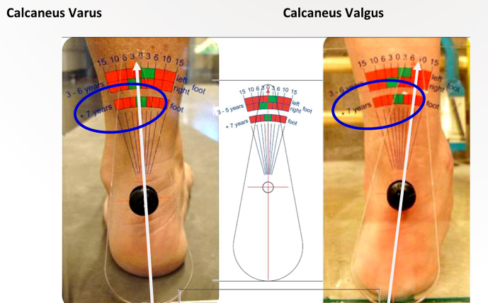
  - Once the athlete has returned to standing, and continues to face forward (no turning or twisting, and the athlete is presumed to be in their natural base of support, observe the athlete’s calcaneal position
  - Clinical Observation options:
    - WFL= calcaneal position ≤ 5° from neutral
    - Varus = > 5° from neutral medially
    - Valgus = > 5° from neutral laterally

- Pain with testing: Ask the athlete if they experienced any pain while standing in neutral positioning

HAS Recording
- Non-weight bearing exam:
  - Based on examination findings, select “Exam Result” as one of the following
Normal, Absent, or Unable to test
    - Select Unable to test if unable to examine the athlete for both joints and sides
      - If selected, record reason as one of the following:
Refused to perform, Unable to perform, Unable to understand, or Other
        - If Other, indicate reason as free text
    - Select Normal if ROM in all joints for right/left = WFL and no pain with testing.
    - Select Abnormal if any ROM is measured outside of WFL or pain with testing is reported
      - If Abnormal, record testing results for the right and left side for the following:
        - Ankle ROM (dorsiflexion)
          - Select N/a if unable to examine that respective side/joint ONLY
          - Select WFL if ankle DF is within 10-25° past neutral
          - Select Hypermobile if ankle DF is > 25°
          - Select Hypomobile if ankle DF is <10°
            - Including inability to achieve neutral ankle positioning
        - 1st MTP ROM (extension)
          - Select N/a if unable to examine that respective side/joint ONLY
          - Select WFL if 1st MTP extension is within 65-90°
          - Select Hypermobile if 1st MTP extension is > 90°
          - Select Hypomobile if 1st MTP extension is < 65°
        - Pain with testing?
Note: Pain may be present in WFL, hypo-, and/or hyper-mobility
          - Select No if the athlete reports no pain during measurement
          - Select Yes if the athlete reported pain during measurement
            - If Yes, enter pain location as free text
          - Select Did not answer if unable to obtain information
- Weight bearing exam:
  - Based on examination findings, select “Exam Result” as one of the following:
Normal, Absent, or Unable to test
    - Select Unable to test if unable to examine the athlete.
      - If selected, record reason as one of the following:
Refused to perform, Unable to perform, Unable to understand, Other
        - If ‘Other’, enter reason as free text.
    - Select Normal if the athlete’s arch and calcaneal position were WFL and no pain was reported during examination
    - Select Abnormal if any abnormal results were found with testing/examination:
      - If Abnormal, record results for both right and left sides for the following:
        - Arch Deformity
          - Select N/a if unable to examine that side/position
          - Select No if there is no deformity observed
          - Select Yes if there is an observed deformity.
            - If Yes, then indicate type from either:
Pes Cavus, or Pes Planus
        - Calcaneal position
          - Select N/a if unable to examine that side/position
          - Select No if calcaneal position is WFL
          - Select Yes if the calcaneal position is abnormal
            - If Yes, indicate direction as either:
Varus or Valgus

        - Pain with testing
Note: Pain may be present even if there are no abnormalities
          - Select No if the athlete reports no pain during testing
          - Select Yes if the athlete reported pain during testing
            - If Yes, indicate the location of pain as free text
          - Select Did not answer if unable to obtain information about pain

- Follow-up Recommended?
Guidelines for making specific follow-up recommendations based on examination findings are included below; however, volunteers should use clinical judgment to make recommendations for follow-up type
  - Select No if Normal was selected for non-weight bearing and weightbearing exam results
  - Select Yes & ‘Non-urgent referral’ if any of the following is true: *
    - Hyper-or hypomobile is selected for BOTH ankle and 1st MTP on either Right and/or Left, with or without ‘yes’ being selected for ‘pain with testing’
    - hyper- or hypomobile was selected for either joint on right or left AND ‘yes’ pain is selected with testing
*Recommendations for additional follow-up regarding the results of the weight-bearing exam should be made based on clinical judgement and availability of products at an event/in the community. This includes recommendations for custom orthotics/shoe inserts. If appropriate, athletes should be directed to the orthotics & products station if available, provided education on pre-fabricated orthotics, or be provided a referral to the most appropriate provider, with the reason for recommendation being custom orthotics (this can be added onto an existing referral based on other screening results)

*Note: Guidelines for follow-up recommendations automatically pull into Check Out on the digital form

Dynamic Biomechanics
In this sub-station, a basic gait analysis is performed
Athlete Position: The athlete is standing, prepared to walk a designated path with their shoes on and off
Measurement/Exam Protocol:
- Set up unobstructed walking lane(s) to analyze athlete gait
  - Walking lanes/paths should be: Clearly marked, flat, and at least 30 meters (~100 ft) in length
- If the athlete already has their shoes off from the previous station, complete shoes off analysis first, and then repeat the analysis with shoes off; otherwise, complete with shoes on first, and then off.
- Ask the athlete to walk down and back the pre-determined walking lane at a natural pace (not too fast/too slow), watching for any abnormalities throughout the gait pattern.
  - This may be repeated 2-3 times (or more) to ensure capture of any notable findings
- While the athlete is walking, ask if they are experiencing any pain
- Repeat walking with the athlete’s shoes on
  - Note: If started with shoes on, then ask the athlete to remove their shoes, and instead repeat the gait analysis with shoes off
- Record findings
  - Consider the following during the examination
    - How does the athlete’s gait differ between shoes on/off?
    - Does the athlete’s gait change with repetition
    - When in the gait cycle are you seeing abnormalities
    - Common abnormalities to consider include, but are not limited to, the following:
      - Stride length differences, toe walking, abnormal hip/pelvic movement, early heel off, presence of pronation/supination, ab/adducted forefoot positioning

HAS Recording:
- Basic Gait Analysis:
  - Based on results during analysis, select from one of the following:
Normal, Abnormal, or Unable to Test
    - Select Normal if the gait pattern was within functional limits and without pain
    - Select Abnormal if any gait abnormalities were observed and/or pain was reported (even with normal gait pattern)
      - If Abnormal:
        - Select specific findings for both right and left from the following:
Decreased step or stride length, Toe walking, Abnormal hip/pelvic motion, Early heel off, Excessive pronation, Excessive supination, Forefoot abduction, Forefoot adduction, and/or Other
          - Select Other to indicate any additional findings
            - If Other, list findings as free text
          - Special notes:
            - Select Abnormal hip/pelvic motion for any abnormal movements are noted during the gait cycle
              - e.g., hip drop, hip hiking, etc.
            - Selection of excessive pronation or supination
              - For each side, only one of these may be selected (i.e., if excessive pronation is selected on the R, excessive supination cannot also be selected on the R)
                - Excessive Pronation = heel remains everted >10°
                - Excessive Supination = heel remains inverted >5°
            - Selection of forefoot position
              - For each side, only one of these may be selected (i.e., if forefoot abduction is selected on the L, forefoot adduction cannot also be selected on the L)
                - Forefoot Abduction (toe out) = >15° from midline
                - Forefoot Adduction (toe in) = < 0° from midline
        - Indicate if the athlete reported any pain with walking.
          - Select No if the athlete reports no pain with walking.
          - Select Yes if the athlete indicates any pain during walking.
          - Select Did not answer if unable to obtain information
    - Select Unable to test if unable to examine the athlete.
      - If selected, select the reason as one of the following:
Refused to perform, Unable to perform, Unable to understand, or Other
        - If Other, write in reason as free text.
- Follow-up Recommended?
Guidelines for making specific follow-up recommendations based on examination findings are included below; however, volunteers should use clinical judgment to make recommendations for follow-up type
  - Select No if Normal was selected as the exam result
  - Select Yes and ‘Non-urgent referral if: Abnormal was selected as the exam result and/or ‘Pain with walking” was selected

*Note: Guidelines for follow-up recommendations automatically pull into Check Out on the digital form

STATION 5
Station 5 includes 2 sub-stations: Data Review & Education and Check Out. Depending on the event, these sub-stations can be completed together in one area of the screening layout by the same clinical volunteer or can be split into separate areas of the screening layout to be completed by different volunteers. See below for additional details regarding volunteers, sub-station procedures, and HAS recording.

Data Review & Education
Volunteers needed: 2-4 well-experienced & licensed clinical volunteers (1 per test site), to make clinical decisions regarding follow-up recommendations, including referrals (podiatrists are preferred)

Data Review
Data review includes the review of an athlete’s HAS form for completion and accuracy, and making final follow-up care recommendations based on the results of the screening. Once the review is complete & recommendations are made, all results and recommendations should be reviewed and explained to the athlete and their family, caregiver, and/or coach as appropriate.
Procedures:
- Review the form in its entirety to ensure that the athlete completed all stations
  - If a station, exam, and/or test was missed, send the athlete back to that station to complete all remaining aspects of the screening
    - Note: In the digital system, the station box in the navigation line will turn green when all required fields have been completed
- Consolidate results to make referral recommendations for community-based healthcare services.
  - Guidelines to support clinical volunteers with clinical decision-making are available, however, clinical volunteers are encouraged to use their clinical judgement to make the most appropriate recommendations for each specific athlete. To enable this, clinical volunteers have the option to go back through the screening and review each exam/test to support their consolidated recommendations as needed
    - Note:
      - On paper forms, the result of each exam will be indicated in the gray box labeled “Follow-up recommended?” for quick reference
        - If ‘Yes’ is selected in these boxes, then the exam is considered abnormal
      - In the digital form, any abnormal results from testing will populate in a summary table at Check Out
  - For any referral recommendation made, clinical volunteers will need to select a provider type and Follow up type
    - Provider Types: Selection of the healthcare provider that the athlete is recommended to seek additional follow-up from, including but not limited to:
      - Podiatrists, Physiotherapists, Primary Care Providers
    - Follow up Types: The urgency level of the recommendation, including how quickly the recommendation should be followed up on
      - Only one follow up type per provider should be selected
      - Follow up types include:
        - Routine follow-up: Suggested when an athlete is already under the care of a specified provider for their foot health
        - Non-urgent referral: Suggested if significant abnormal results are found within the screening, which should receive follow-up within 4 weeks of the screening.
        - Urgent Referral: Suggested if significant abnormal results are found within the screening that require more immediate attention/care and should receive follow-up within 2 weeks of the screening.
- Once all referral recommendations have been made, the clinical volunteer should provide relevant education as indicated below
Education
Education includes providing information on overall foot health, foot-care/hygiene, and, when appropriate, any other specific educational needs related to the athlete’s specific foot health and/or shoe fit.

Procedures
- Clinical volunteers should provide all athletes with education on overall foot health, and foot care/hygiene best practices. This may include indirect education using handouts, videos, etc.
  - When providing education to athlete’s keep the following in mind:
    - Some athletes may have difficulty with only verbal instructions/education. Implementing demonstrations and/or pictures can help with the carryover of information
    - Sample handouts for athletes with pictures and room for comments are available on the Fit Feet resources page to be given to athletes to help with carry-over of information provided at the screening.
    - Additional athlete-facing resources regarding Fit Feet, foot health, and shoes/socks can be found and provided to athletes via the Fit Feet MyHealth page (see QR code below)


- After reviewing the athlete’s screening results, additional education topics should be included on a case-by-case basis that is specific to each athlete’s needs (e.g., shoe fit, monitoring non-painful structural and dermatological findings, etc).
- After all education is provided, the athlete should be directed to the check-out area to complete the screening

Orthotics & Products (OPTIONAL)
At some events, orthotics and products may be available based on athlete-specific needs and results of the screening. This is typically completed in a separate area by separate volunteers (either clinical and/or retail professionals related to the available orthotics/products being provided). If this is available, provision of such products should occur after Data Review has been completed, but before the athlete checks out.

Check Out
Once the athlete has received any appropriate referrals, education, and/or orthotics/products (when available, and indicated), they will be escorted to the Check Out area. This is often in a separate area of the screening layout, closest to the exit. Check Out is the last stop of the Fit Feet screening to ensure that all forms are collected and all athletes’ needs are met.
Volunteers needed: 1-2 general volunteers
- Note: the same volunteers from Data Review & Education may be used to complete the tasks of Check Out; however, often, to help with flow, Check Out is completed in a separate area with general volunteers.
Procedures:
- Tablets/HAS forms should be collected from the athlete, saved, and secured.
  - In the digital form, to save the athlete’s screening, ‘Finish Screening’ needs to be selected
    - Once results are saved, tablets should be returned to Station 1 and/or to a charging area based on pre-determined charging guidelines
  - Paper forms should be collected, stored, and then given to the Special Olympics Program staff after the screening event is over, based on pre-established protocols
- Before the athlete leaves, volunteers should provide any available giveaways that have not already been given to the athlete to support the athlete’s continued foot health needs
- Provide and/or mark the athlete’s passport with their completion of Fit Feet, if available
- Direct the athlete to the exit and/or next Healthy Athletes screening
HAS Recording:
- Screening Completion (Paper Form ONLY)
  - Was the screening unable to be completed and/or concluded prior to completion for any reason?
    - Select Screening complete if the athlete’s HAS form has all stations/tests/questions completed
    - Select Screening incomplete if the athlete left before completing their full screening and is not returning to complete the screening
  - Note: In the digital form, if a screening cannot be completed, please select “Save and Finish later” before exiting the screening. This will allow the screening to be reopened if the athlete returns.
- Extra Resources Provided Onsite
  - Select any/all resources that were provided to the athlete as part of the Fit Feet event and relate to overall foot health from the following: Orthotics (shoe inserts), Shoes, Socks, Shoelaces, Adaptive Laces, Foot Hygiene Products, and/or Other
    - Select ‘Orthotics (shoe inserts)’ if orthotics are recommended based on screening results, and are available through the optional station “Orthotics and Products” station
      - If selected, indicate the type of orthotic provided/recommended from the following: low arch, neutral, or high arch
    - If Other, indicate specific resource as free text
- Follow-up recommended?
Please use clinical judgment based on the athlete’s screening results to make recommendations for additional follow-up. The guidelines provided below are intended to help clinical decision-making; however, the final recommendation should be based on each specific athlete’s needs.
  - Select No if, based on the athlete’s screening results, there are no recommendations, including continuing with routine care, and/or new referrals to healthcare services
    - If No, the screening is complete, and the form can be saved and finished (or collected if using paper forms)
  - Select Yes if screening results suggest additional follow-up would benefit the athlete
    - If Yes, select any appropriate provider types from the following: Podiatrist, Physiotherapist, Primary Care Provider, Other (specify as free text)
      - For each provider selected, consolidate the most appropriate findings per provider, and select the most elevated referral type from one of the following: Routine Follow Up, Non-Urgent Referral, or Urgent Referral
        - Routine Follow up: Continue with regular foot checks
          - Include frequency as free text
        - Non-urgent Referral: Follow-up within 1 month of the screening
          - Multi-select reason(s) for recommendation from: Pain, Abnormal gait, Structural abnormalities, Abnormal joint ROM, Skin or nail abnormalities, Positive diabetic foot screen, or Other (free text)
            - Note: PCP reason for recommendation is free text
        - Urgent Referral: Follow-up within 2 weeks of the screening
          - Multi-select reason(s) for recommendation from: Pain, Abnormal gait, Structural abnormalities, Abnormal joint ROM, Skin or nail abnormalities, Positive diabetic foot screen, or Other (free text)
            - Note: PCP reason for recommendation is free text
*Note: Guidelines for referral recommendation automatically populate into check out, however, clinical volunteers may change, add, and/or remove referrals based on the most appropriate needs of the athlete and their review of the screening as a whole
- Finish Screening (digital form only)
  - Select “Finish screening” once all findings and referral information have been input to save all information and close the athlete’s screening.
Special Olympics Health activities are supported by many sources, including in the United States, by Grant Number NU27DD000021 from the Centers for Disease Control and Prevention of the U.S. Department of Health and Human Services, with $18.1M (64%) financed with U.S. federal funds and $10.2M (36%) supported by non-federal sources. These contents are solely the responsibility of the authors and do not necessarily represent the official views of the Centers for Disease Control and Prevention or the Department of Health and Human Services.

