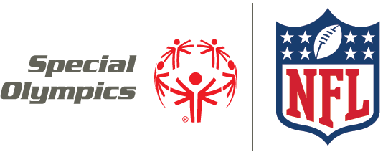

Special Olympics and NFL Foundation Announcement
Social Media Guidance

FACEBOOK
- We’re excited to announce that [TAG] Special Olympics has partnered with the [TAG] NFL Foundation! We can’t wait to work with our friends from the [TAG] NFL TEAM this year!
- We’ve been selected as a grant recipient from the [TAG] NFL Foundation! We can’t wait to [INSERT WHAT ACTIVITY IS] with the [TAG] NFL TEAM!
- Check out these photos from our recent [INSERT WHAT ACTIVITY IS] with the [TAG] NFL TEAM! {Include photo album or link to more photos}

TWITTER
- We're excited to announce that @SpecialOlympics has partnered with @NFLFoundation! We can't wait to work w/ @NFLTEAM!
- Good luck to the @SpecialOlympics athletes taking part in the Unified #ProBowl on 1/25! #PlayUnified
- We're excited to be receiving a grant from @NFLFoundation! Let's get to work, @NFLTEAM!
- So excited to partner with @NFLTEAM this year! Stay tuned for more information about how we will be working together!
- Check out these photos from our recent [INSERT WHAT ACTIVITY IS] with the [TAG] NFL TEAM! {Include photo album or link to more photos}

INSTAGRAM
- We’re excited to be with the @NFLTEAM today to [INSERT WHAT ACTIVITY IS]! Thank you @NFL Foundation for making this possible for our athletes!

