**Addendum to Return to Activities Protocol for Young Children**

**Participating in Young Athletes**

The following resource provides additional guidance for Special Olympics Programs, teachers and coaches implementing Young Athletes activities. This does not replace Special Olympics’ Return to Activities protocol; rather, it should complement the protocol to provide additional support and considerations to mitigate risk and ensure the health and safety of our youngest participants.

**Young Athletes Recommendations for Return to Activities**

Special Olympics has adopted a three (3) level approach to return to activities, outlined in the [Special Olympics Return to Activities Protocol](https://resources.specialolympics.org/resources-to-help-during-the-crisis/return-to-activities-during-covid-19) (updated 29 June, 2021). This is the primary resource to guide return to activities, including Young Athletes activities. All guidance and considerations must be met before beginning in-person activities. **The recommendations outlined below can serve as supplemental guidance for implementing in-person activities for young children.** Special Olympics Programs should continue to use and offer [Young Athletes at Home](https://resources.specialolympics.org/sports-essentials/young-athletes/young-athletes-at-home) activities to engage high risk individuals, communities with in significant high risk areas and complement school activities, if schools are offering a mix of distance and in-person learning.

**Physical Distancing**

* Increase the size of the field, court or space being used for Young Athletes activities to ensure children can always remain 6 feet or 2 meters apart.

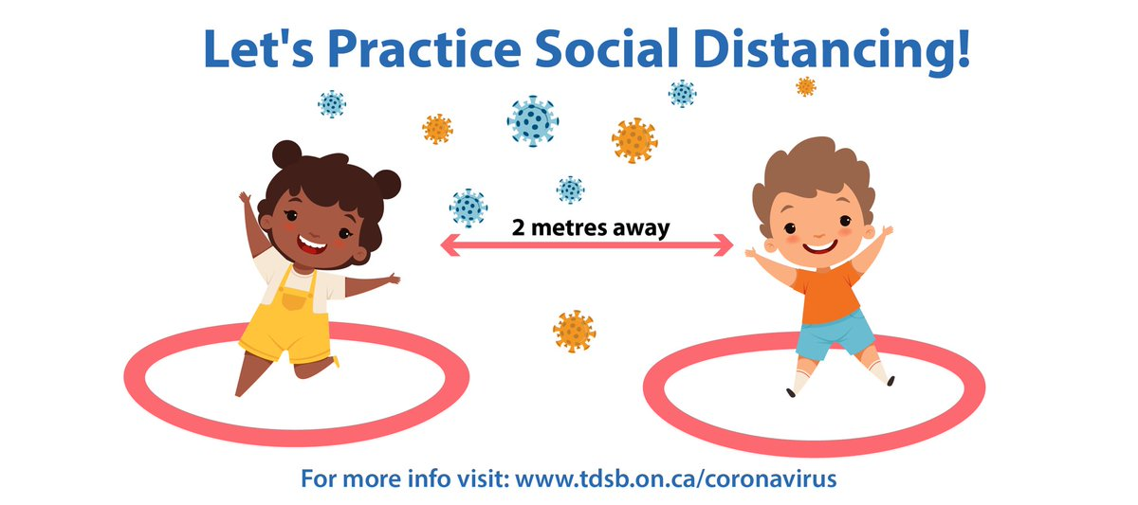

* When possible, use outdoor facilities to increase space and limit opportunity for transmission.
* Use tape, chalk, floor markers, hula hoops, cones or other Young Athletes equipment to help create a physical space for each individual child.
  + Floor markers are regularly used in Young Athletes to help show children where they should stand. Using them to promote physical distancing will be familiar to many children.
  + Make sure the space is big enough to allow children to move around during activities while still maintaining physical distance from others.
* Encourage children to wave, smile or use sign language to say hello instead of using hugs or high-fives to greet each other during Young Athletes activities.

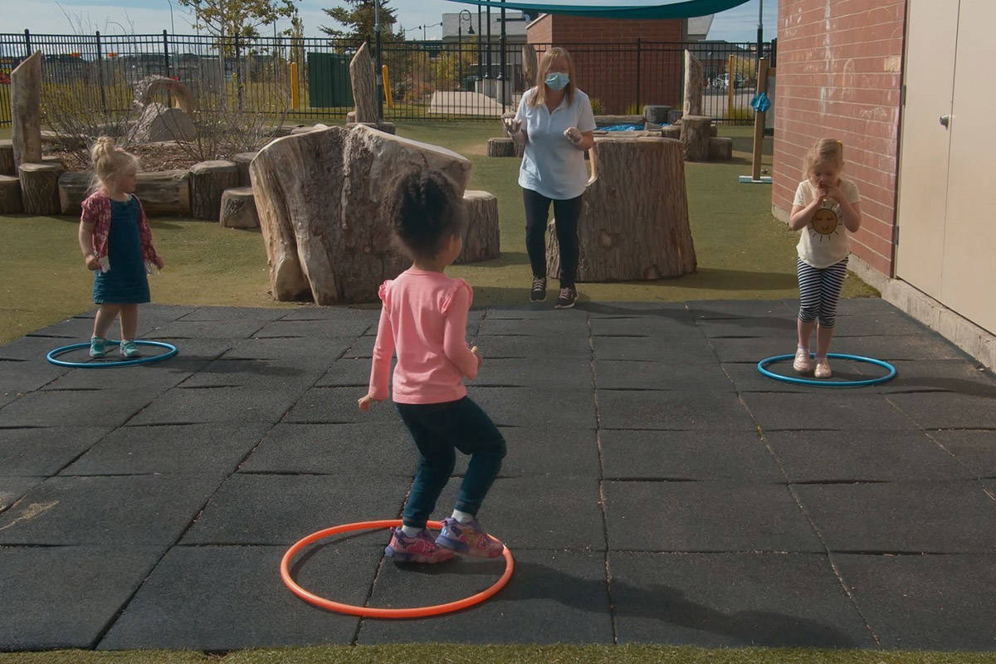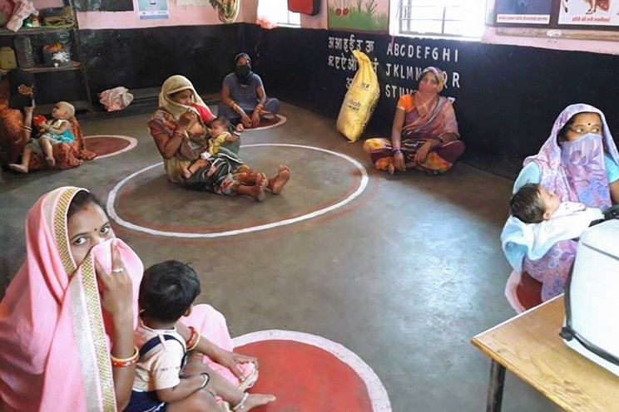

* Use different Young Athletes games and activities to help children understand physical distancing and redirect children when they get too close to one another.
  + Within each child’s designated space, place a hoop or bucket approximately 6 feet or 2 meters away from the child and have them practice their underhand and overhand throwing with a ball or beanbag.
  + Use the game “Red Light, Green Light” to stop children when they are getting too close to someone else.
    - 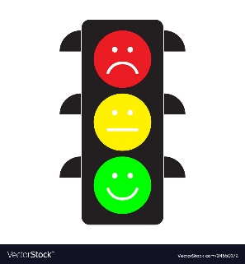Red Light, Green Light is typically played with children lined up at one end of a field or court. When the coach says, “green light,” children can start walking or running towards the other end of the field. When the coach says, “red light,” the children must stop quickly. The coach alternates between “green light” and “red light” until all children are at the other end, changing up speed, duration and type of movement.
    - Yelling “stop” can be scary or upsetting to children, which can cause unnecessary fear or stimulate an emergency. Using “red light” instead can keep things fun, while redirecting children away from others.
    - It is important to practice this activity often, so children know how to respond when they hear “red light.”
* For community-based Young Athletes activities, have parents or caregivers serve as Young Athletes volunteers, instead of external individuals. Many children require direct or hand-over-hand support to ensure safety while participating in Young Athletes activities. Having parent or caregiver volunteers can support children with safely following the coach’s instruction from a distance, while reducing exposure to additional individuals. They can also help to keep their child physically distant from others.
* Only one parent or caregiver per child should attend activities. Follow the size restrictions per your local authority regulations. In Orange level (significant risk), limit indoor gatherings to no more than 50 people.
* Given what we know about transmission of COVID-19, effort should be made to ensure all unvaccinated adults present maintain 6 feet or 2 meters from others not in their household.
* Stagger arrival and departure times so families are not entering the facility at the same time. Ensure that distance is maintained during the COVID screening upon arrival using [signage](https://media.specialolympics.org/resources/covid-19/Sample-Venue-Signage.zip), markers and visual aids.

**Face Masks**

* Children over 2 years old should wear a cloth face mask when participating in in-person Young Athletes activities or events. *There are some situations, outlined below, where children may be unable to wear a mask. In these situations, families should delay participation in in-person Young Athletes activities until Phase 3, when face masks are no longer required.* 
  + Wearing a face mask will cause the child to touch their face more than without a mask.
  + The child has trouble breathing.
  + The child is unable to remove their mask without assistance.
* If necessary, face masks may be removed once physical activities (that meet physical distance requirements) begin and replaced when they end. This will be most relevant if children are participating in high intensity activities, like running, where a face mask may cause difficulty breathing.
* 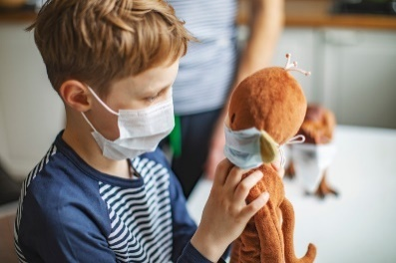Talk to parents and caregivers in advance of Young Athletes activities about helping children develop a sensitivity and tolerance to wearing a cloth face mask. In most cases, resistance to wearing a mask is based on fear or discomfort. Consider sharing the suggestions below:
  + Put a cloth face mask on your child’s favorite stuffed animal or show your child pictures of other children wearing face masks.
  + Find or make a mask that features your child’s favorite color, sports team or character. Or decorate your child’s face mask so it is more personalized and fun.
  + Encourage your child to pretend they are a doctor, nurse or superhero when wearing their mask. Make believe makes wearing a mask fun!
  + For children with touch sensitivities, add buttons to a hat or headband and secure the face mask around the buttons, instead of on the ears.
  + Practice wearing the face mask at home to help your child get used to wearing it.
  + Give your child a clear way to ask for breaks from wearing their face masks. Consider using a hand signal, a new button on their communication device or creating a “break” card to indicate when they need to take the mask off.
* **All non-vaccinated adults** present at Young Athletes activities (coaches, parents, caregivers, etc.) **must wear a face mask from arrival through departure. In Yellow and Orange levels, all individuals should wear a mask.**
* When feasible, consider having coaches and/or parents wear face masks with a transparent central area. Seeing, and reacting to, facial emotions is a critical part of early development for children and can help support children in developing their own emotional competencies.

**Young Athletes Activities**

*Young Athletes Equipment*

* When feasible, coaches and Programs should have sufficient Young Athletes equipment to provide each child with their own station or set of equipment, to avoid sharing equipment.
* All equipment should be sanitized before and after each session. Select equipment that can be easily wiped down. For example, a rubber or flyweight ball will be easier to clean than cloth beanbags or balls.
* 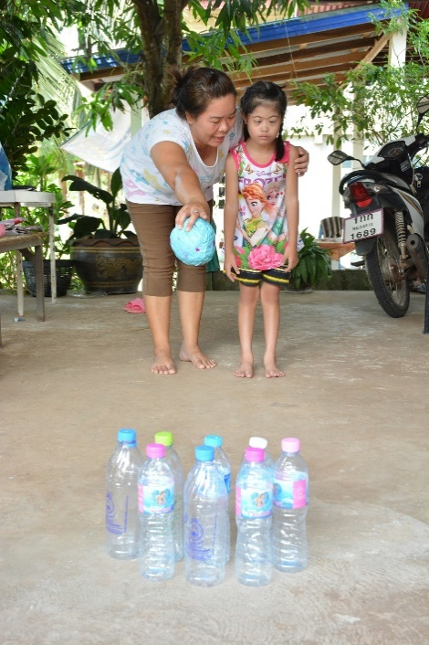If there is not enough equipment to provide each child with their own set, consider asking families to make their own equipment out of household materials and bringing the equipment with them to the Young Athletes activities. Or spend the first part of your session making equipment with children and families.
  + Empty soda bottles filled with water or beans can become cones, while newspaper rolled and wrapped with tape can become a bat or a ball.
  + More suggestions for building your own equipment kit can be found in the “[Build Your Own YA Kit at Home](https://youtu.be/s0hQzUC4iSY)” video tutorial.
* Alternatively, coaches can focus on Young Athletes activities that can be done with no equipment (see table of activities below).
* If equipment is shared between children, sanitize equipment after each individual use.

*Young Athletes Activities*

* Try to limit direct contact between children during the activities, especially under Orange level. The activities below focus on individual skill development and can be completed individually or with support from a parent or guardian. Detailed descriptions of each activity can be found in the [Young Athletes Activity Guide](https://media.specialolympics.org/resources/community-building/young-athletes/young-athletes-activity-guide/Young-Athletes-Activity-Guide-English.pdf) (page numbers listed below) or the [Young Athletes Family Flash Cards](https://media.specialolympics.org/resources/community-building/young-athletes/Young-Athletes-Family-Flashcards.pdf).

|  |  |  |  |  |  |
| --- | --- | --- | --- | --- | --- |
| **No Equipment Activities** | | **Limited Equipment Activities** | | **Limited Equipment Activities**  ***(Need support from 2nd person)*** | |
| *Activity* | *Page #* | *Activity* | *Page #* | *Activity* | *Page #* |
| Children’s Songs | 14 | Musical Markers | 16 | Scarf Games | 14 |
| I Spy | 15 | Walk Tall | 22 | Rolling and Trapping | 34 |
| Animal Games | 17 | Run and Carry | 23 | Goalie Drill | 34 |
| Follow the Leader | 22 | Balance Beam | 28 | Big Ball Catch | 35 |
| Side Stepping | 22 | Step, Jump and Grab | 29 | Low Ball Catch | 36 |
| Sticky Arms | 24 | Jumping High | 31 | High Ball Catch | 36 |
| Heavy Feet, Light Feet | 24 | Bowling | 40 | Bounce Catch | 37 |
| Leaping Lizards | 31 | Target Practice | 43 | Two-Handed Underhand Toss | 41 |
| Galloping | 58 | Handball | 46 | One-Handed Underhand Toss | 41 |
| Skipping | 58 | Beginning Floorball | 47 | Two-Handed Overhand Throw | 42 |
|  |  | Stationary Ball Kick | 52 | One-Handed Overhand Throw | 42 |
|  |  | Penalty Kick | 52 | Ball Tap | 46 |
|  |  | Three-Pin Bowling | 54 | Stand, Roll and Trap | 59 |
|  |  | Cone Dribble | 55 | One-on-One | 59 |
|  |  | Punting | 58 |  |  |
|  |  | Dribble | 60 |  |  |
|  |  | Dribble and Shoot | 60 |  |  |

*Planning Young Athletes Sessions*

* Ensure you have a COVID screening protocol in place for all participants (coaches, children and parents/family members), in alignment with [Special Olympics’ protocol](https://media.specialolympics.org/resources/covid-19/Return-To-Activities-Protocol.pdf) (see Appendix B).
* It is important to assess each child’s skill level upon returning to Young Athletes activities and adjust accordingly. Given the extended time at home and away from school, therapies and peers, some children may have gone backwards in their skill development or behaviors. Regression is a very common reaction to stress and should not cause alarm to coaches or parents.
* Use a similar structure to your Young Athletes activities before COVID-19 to support children with familiarity and repetition: Warm up (10 minutes), Individual skill development (20 minutes), Cool down and closing song (10 minutes)
* Stretching, songs and warm-up activities can all be done as a group while maintaining physical distance. Focus on activities that allow for social interaction without direct contact.
  + For example, have children take turns being the leader in Follow the Leader. Focus on stationary activities and stretches that keep children in their own space but allow them to interact with others.
* Instead of group games, focus on individual skills. To decrease the amount of equipment needed for each session, consider focusing on one skill area during each Young Athletes session.
  + For example, focus your Young Athletes session on kicking skills and spend 5 minutes each on four activities: stationary ball kick, penalty kick, cone dribble and one-one-one. Activities can progress in difficulty to continue development.
* Coaches should station themselves in a location where all children call see as they demonstrate activities, for example, in the center of the circle.

**Teaching Preventive Actions**

* Before the session begins, remind parents about preventing the spread of COVID-19 in children:
  + Wash hands often using soap and water for 20 seconds. If soap and water are not available, use an alcohol-based hand sanitizer.
  + Avoid people who are sick and keep a 6-foot or 2-meter distance between your child and people outside your household.
  + Wear cloth face coverings when outside the home (*for all children above age 2 except in the specific situations outlined above when children may not be able to wear a mask*).
  + Clean and disinfecting “high touch" surfaces daily.
  + Wash laundry and plush toys regularly on the warmest setting advised and dry them fully.
* Have handwashing facilities or hand sanitizer available at the venue.
  + Supervise children when using hand sanitizer to monitor effective use and avoid potential ingestion or contact with eyes, nose or mouth. Alcohol-based hand sanitizer is toxic if ingested. Keep hand sanitizers out of children’s reach and have an adult pump the hand sanitizer directly into a child’s hands.
  + Teach children to rub their hands together immediately until the hand sanitizer is dry. For some children, a parent or caregiver may need to help rub their hands together.
* Have families bring their own snacks and water to Young Athletes activities.
* Post signage around your venue that reinforces handwashing with soap and water for at least 20 seconds. Use materials that cater to children and feature limited words, visuals or cartoons.
  + The US Center for Disease Control (CDC) offers a variety of fun posters, in multiple languages, to highlight the importance of handwashing.
* Use different Young Athletes games and activities to help children understand preventative actions they can take to stay healthy, like washing their hands or coughing into their elbow.
  + Using games and activities to reinforce health messaging is an important tool to ensure the messages come across in a positive and fun light. Sometimes talking about COVID-19 can cause children to be afraid of the virus, going outside their home and more. Play can reinforce positive messages without instilling fear or worry.
  + 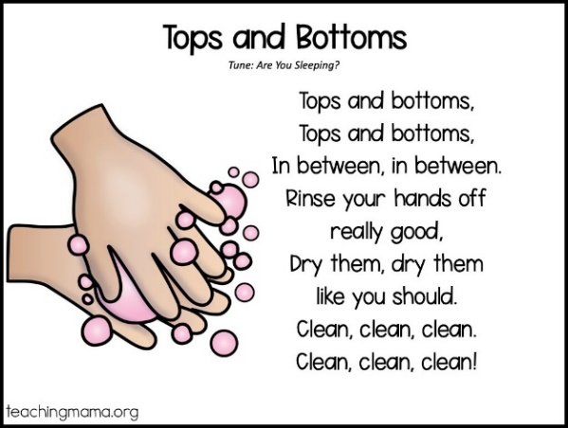Use songs during warm up and cool down. For example, the song below, “Wash, Wash, Wash Your Hands,” is sung to the tune of “Row, Row, Row Your Boat.” Children can mimic the movements of washing their hands, eating, sleeping and playing.

Wash, wash, wash your hands

Wash the dirt away

Before you eat, before you sleep

And after outdoor play.

* + End the cool down with a story or book that helps children understand COVID-19. The examples below are online stories and can be printed to share with children or viewed through a tablet.
    - [#COVIBOOK](https://www.mindheart.co/descargables?fbclid=IwAR1mdqJcpb2K1UUEBujlJC-jjoAmt8VcuH1fm7HwBjTw0BDll6pM0qgksJQ) – an illustrated storybook (available in 25 languages)
    - [King COVID and the Kids Who Cared](https://www.autismresourcecentral.org/wp-content/uploads/2020/04/unabridged_king_covid_and_the_kids_who_cared-1.pdf)
* Share videos and books with families that can be used at home to help children understand the virus and things they can do to keep themselves and their families safe and healthy.
  + From Sesame Street: [Learn to Belly Breathe with Rosita](https://youtu.be/Xq3DwzX6MUw), [R is for Routine](https://www.sesamestreet.org/videos?vid=25351), [Elmo’s Morning Routine](https://youtu.be/Udd1AlNB3Zc), and [Wash Hands with Elmo](https://cms-tc.pbskids.org/global/StayingHealthy_PRINT_Hands.pdf?mtime=20200306102330)
  + From Daniel Tiger: [Germs, Germs Go Away](https://pbskids.org/video/daniel-tigers-neighborhood/2365375359) and [Handwashing](https://pbskids.org/video/daniel-tigers-neighborhood/2365375359) songs
  + Additional videos: [Time to Come In, Bear](https://youtu.be/DA_SsZFYw0w), a children’s story about social distancing and [We Wear Masks](https://youtu.be/lnP-uMn6q_U), a social story about the coronavirus.

**Additional Considerations for Schools**

* Students should participate in Young Athletes with the same group of children that they are with throughout the day, to avoid increased interactions. If a school previously combined two classrooms to make Young Athletes activities inclusive, the classrooms should participate in Young Athletes separately and use technology to stay connected.
* Limit Young Athletes volunteers to teachers, assistants or aids that are already interacting with children throughout the day. Avoid introducing new adults during the Young Athletes activities.
* As students and staff return to school, many will return with high levels of stress, trauma or anxiety due to the COVID-19 pandemic and its effects. To ensure the best opportunity for success, it is important to prioritize the development of the whole child when schools return, with social and emotional development, as well as academic learning. The inclusion of social-emotional learning can help to create a supportive, safe and responsive learning environment that ensure students and adults can thrive when they return to school.
  + Trauma and stress for children may be coming from a lot of different places. They have been stuck at home and isolated from their friends. They may be afraid about getting sick. Their family may be experiencing financial hardship. Or they may know someone who has had or died from COVID-19. All of these fears and anxieties should be acknowledged and supported at home and as children return to school.
  + The [Young Athletes Educator Flash Cards](https://media.specialolympics.org/resources/community-building/young-athletes/Yount-Athletes-Educator-Flashcards.pdf) can support teachers in using Young Athletes skills as a base to develop social-emotional learning skills through play.

**Questions**

**For local volunteers and participants**, please contact your Accredited Program office for questions.

**For Accredited Programs**, please contact your Regional Office or Special Olympics, Inc. for questions.

**For general questions to SOI**, Regions may email [COVID@specialolympics.org](mailto:COVID@specialolympics.org) or for liability questions, email [Legal@specialolympics.org](mailto:Legal@specialolympics.org).



All Return to Activities guidance and supplemental documentation is available on the [Special Olympics Resources for COVID-19 website](https://resources.specialolympics.org/resources-to-help-during-the-crisis/return-to-activities-during-covid-19).