COVID-19 Vaccine Advocacy Toolkit

Since the emergence of the COVID-19 pandemic, scientists have been hard at work developing a vaccine against the virus. As of this writing, there are currently several COVID-19 vaccines starting to be used in different parts of the world, including the Pfizer-BioNTech, Moderna, Oxford-AstraZeneca, Johnson and Johnson, Sinovac/CoronaVac, and Sputnik V vaccines.
As scientists have been working to create COVID-19 vaccines, health stakeholders at different levels have been reviewing the results of vaccine trials, issuing approvals and usage guidance for the vaccines, developing policies to guide the allocation of the vaccines, which will be in high demand with low supply to start, and planning how to distribute the vaccine.
SOI has developed this guide to provide important information and orientation to Special Olympics Programs about four topics related to the COVID-19 vaccines:
- Advocacy
- Education
- Access
- Internal Guidance
Special Olympics encourages everyone who is able to get the COVID-19 vaccine, to be vaccinated. People with ID are a high-risk group for COVID-19 illness, complications, and death. Being vaccinated will help protect you from getting COVID-19, prevent serious illness, and may also help protect people around you.
You may contact COVID@specialolympics.org to request technical assistance on using the information and materials provided, adapting the materials to your local context as well as requesting additional materials be created.

ADVOCACY

The first vaccines became available in late 2020. With the development of these vaccines, countries worldwide began to approve at least one vaccine for emergency use, purchase and receive vaccine supplies, and began to vaccinate people. Many other countries have ordered doses of COVID-19 vaccines and are awaiting their arrival. Inequities in global vaccine procurement systems mean that the timeline for widespread vaccination varies by country and appears to extend into 2022 in some locations. As a result, many Special Olympics athletes and others in the movement do not yet have a clear path to access to the vaccine.
Worldwide, demand for the COVID-19 vaccines is greater than supply. Because of this, countries must make difficult decisions about who will have access to the vaccine first.
In the United States, the Advisory Committee on Immunization Practices (ACIP), a committee within the Centers for Disease Control and Prevention (CDC) made up of medical and public health experts, advises the CDC on vaccine-related issues and publishes guidance that is updated on a continual basis. This guidance prioritizes long-term care facility residents at the same level as healthcare personnel (phase 1a), followed by older adults (75+) and frontline essential workers (phase 1b), then older adults (65-74) and people with medical conditions that increase risk for severe COVID-19 illness (phase 1c). Considering the devastating impact of COVID-19 on people with ID living in congregate care settings, the priority that ACIP gives to this population is meaningful for people with ID.
In late December 2020, the CDC added Down syndrome to the list of medical conditions that increase risk for severe COVID-19 illness—a list which also includes conditions such as obesity and diabetes that are common among people with ID. The effect of this change is that it gave priority to people with Down syndrome in the states that prioritize people with high-risk conditions and have adopted the CDC’s list of conditions.
Several US states, including Delaware, Louisiana, Maryland, Missouri, and New York, have prioritized people with IDD or disabilities more generally in their state vaccination plans.
The evolving situation worldwide presents opportunities for Special Olympics to elevate the needs of people with ID in the context of the COVID-19 pandemic by encouraging stakeholders to recognize people with ID as a priority group, similar to what has been done in several US states (or has been done on a more widespread basis with regards to people with Down syndrome).
The approach that SOI recommends that US Programs consider depends on what action the state has already taken for people with ID and if the state utilizes CDC’s list of medical conditions that increase risk for severe COVID-19 illness.
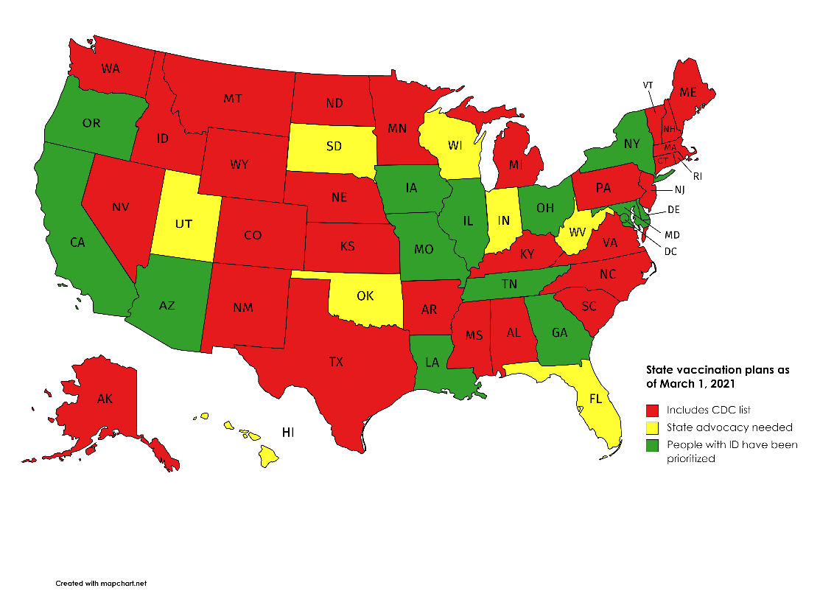

Category | States that incorporate the CDC’s list of medical conditions that increase risk for severe COVID-19 illness | States that do not incorporate the CDC’s list | States that have already acted to prioritize people with ID (or people with disabilities generally)
States | Alabama  Alaska  Arkansas  Colorado  Connecticut  Idaho  Kansas  Kentucky  Maine  Massachusetts  Michigan  Minnesota  Mississippi  Montana  Nebraska  Nevada  New Hampshire  New Jersey  New Mexico  North Carolina  North Dakota  Pennsylvania  Rhode Island  South Carolina  Texas  Vermont  Virginia  Washington  Wyoming | Florida  Hawaii  Indiana  Oklahoma  South Dakota  Utah  West Virginia  Wisconsin | Arizona  California  Delaware  Georgia  Illinois  Iowa  Louisiana  Maryland  Missouri  New York  Ohio  Oregon  Tennessee  Washington, DC
Recommendation | Federal and state advocacy | State advocacy | State advocacy related to the priority phase, as needed
Analysis as of March 1, 2021.

SOI has developed the following resources to help in these discussions:
- VoterVoice Grassroots Advocacy Campaign for Federal Action. SOI has created a VoterVoice digital grassroots advocacy campaign for federal action on the COVID-19 vaccines. Special Olympics supporters can use this campaign to ask their federal legislators to put pressure on the CDC to add people with ID to its list of people with medical conditions that increase risk for severe COVID-19 illness. A change to this list would give people with ID in around 30 states priority access to the COVID-19 vaccines.

- Programs, particularly in states that do not incorporate the CDC’s list, may want to create a VoterVoice campaign tailored for their state’s situation targeting state policymakers. The SOI HQ Government Relations team can help interested Programs set up a VoterVoice campaign for state advocacy. Interested Programs should contact Meredith Pierce, mpierce@specialolympics.org. Programs should be ready to share what type of VoterVoice campaign they would like to run (email, phone, Twitter or any combination of those). They should also be prepared to share what action they would like their state legislator to take (e.g. please contact the [STATE] Department of Health to ask them to add people with ID to [STATE]'s vaccine priority list.")
- Template Letter for Policymakers and Public Health Decision-Makers. This letter provides a summary of the health equity issues that the COVID-19 pandemic and vaccines have posed with regards to people with ID. The letter briefly summarizes the most compelling scientific literature alongside key Special Olympics messaging and several pre-crafted asks that Special Olympics may choose among and tailor based on their state’s vaccine priority situation. This letter would be a good complement to a VoterVoice campaign, as it provides much more detailed information about the situation of people with ID in the pandemic than is communicated in the character-limited VoterVoice message. This letter should be sent on Special Olympics Program letterhead from the Program CEO/Leadership. Special Olympics recommends targeting this letter to state agency officials (like Dept. of Health officials), other public health decision makers (state surgeon general, perhaps), and very specific state legislators in a position of influence/authority on the COVID-19 policy in the state legislature. **Please note that Governors and Lt. Governors could also be included in this audience for the letter if they are NOT included in a VoterVoice campaign.

- People with IDD and COVID-19 Health Disparities Literature Review. This document summarizes the existing scientific literature on the elevated risks of severe disease and death that the population with ID faces vis-à-vis the general population. This document’s highly technical content and approach align with its intended use: with public health stakeholders, including epidemiologists and policymakers.

- How to Make COVID-19 Vaccine Campaigns Inclusive of People with ID Infographic. This infographic provides a quick and visual summary of high-impact data points about the effects of the COVID-19 pandemic on people with ID and concrete actions that policymakers can follow to improve inclusion and equity. The document’s asks are aimed at policymakers but are also relevant to and actionable by other stakeholders engaged in vaccine planning and implementation.
Please note that Special Olympics encourages Programs to continue using person-first language and discourages Programs from referring to ID as a solely medical diagnosis. Instead, focus on the lack of access to health care and lack of provider training that may be contributing to high COVID-19 death rates in this population.
Finally, but most importantly, Special Olympics reminds Programs to ensure that athletes not only visibly lead advocacy initiatives but also participate meaningfully in determining the direction of any such initiatives.

EDUCATION

Special Olympics recognizes that unfortunate inequities in global vaccine procurement and other systems mean that access to COVID-19 vaccines remains a distant prospect for many Special Olympics athletes and families. Providing information about the vaccines is nevertheless a crucial task for the movement. There is mixed evidence about the access that people with ID have to vaccines in general and their openness to vaccination. Some families of people with IDD, particularly those with Autism Spectrum Disorder (ASD), have demonstrated hesitance around vaccination, generally.

Many studies have shown that vaccine hesitancy has a great deal to do with “a general distrust of doctors, government sources and/or pharmaceutical companies,” and less to do with specific information about a particular vaccine. It is very important for vaccine-related information to come from a trusted source, which is exactly what Special Olympics represents to so many athletes and their families.
In order to ensure that Special Olympics athletes and their families have information that responds to their needs and concerns, SOI has developed the Athlete Guide to the COVID-19 Vaccines which includes easy-to-read information about the COVID-19 Vaccines. Resources Include:
- A frequently asked questions document
- A printable poster including information on how the vaccines work, what are any side effects, and why athletes should consider getting a COVD-19 vaccine if they have the opportunity
- A fact sheet on debunking the myths around the vaccines
- Social media graphics
- Videos of athlete leaders sharing their experiences getting the vaccine
**Future resources include educating caregivers of people with ID about the COVID-19 vaccines
In addition to sharing the resources contained in the Athlete Guide, SOI encourages Special Olympics Programs to consider hosting education events, such as Family Health Forums to share information about the COVID-19 vaccines, answer any questions, and address concerns and myths that may be more localized.

ACCESS

Special Olympics Programs have the potential to position themselves to play a role in the rollout of COVID-19 vaccine campaigns for people with ID. Because the stakeholders involved in the vaccine rollout may vary in each country, some of these approaches will be localized. For example, where the private sector is involved in vaccine distribution, Special Olympics Programs should consider pursuing partnerships with retail pharmacies or hospitals that may help ensure the accessibility of vaccines to people with ID. Partnerships with public health authorities will also be highly valuable in many locations. Such partnerships could entail Special Olympics sharing guidance on inclusive and accessible vaccine campaigns, providing training on inclusion of people with ID to vaccine workers, or providing accessibility audits of proposed vaccine locations. They may also involve inviting providers or health systems partners to administer vaccinations in conjunction with a Healthy Athletes event or hosting a vaccine-specific Healthy Athletes or Family Health Forum or other event. This would help them reach a population that may be both high-risk and hard-to-reach, while people with ID would benefit from accessing the vaccine with reduced barriers and in a more familiar environment: a win-win!
Even if your state is slow in rolling out its COVID-19 vaccine doses, you should consider reaching out to stakeholders to start these conversations. The lack of coordination of the early vaccine rollouts in many states may serve as cautionary tales for others. It may be easier to find an audience for these ideas when distribution planning is still in development—it can be more difficult when countries are already implementing their vaccine campaigns and reacting to new developments, demands, and obstacles. Furthermore, Special Olympics Programs’ proven ability to mobilize the health workforce and organize high quality and efficient health events may make them an attractive partner in COVID-19 vaccine distribution efforts.
Finally, you may want to consider partnering with other disability groups to advocate for inclusive vaccine distribution. While there are some varied accessibility concerns across different disability groups, there are a number of shared principles and tenets. Amid the many complexities in the rollout of the COVID-19 vaccines, vaccine stakeholders may be more likely to invest in inclusive vaccine campaigns if they feel the pressure from a larger portion of the population than the 1-3% that people with ID represent. The CDC estimates that around one-quarter of adults in the United States have some sort of disability.

INTERNAL GUIDANCE

On 25 January 2021, Mary Davis issued a memo to all Programs in regards to the current guidance around the vaccine and return to activities.
“Special Olympics strongly recommends that all Programs continue to follow the SOI Return to Activities Protocol, distributed in July 2020. The Protocol advises on risk mitigation efforts, including limiting the size of events and encouraging those at high risk to remain safely at home, to limit the spread of the disease and risk to our athletes, volunteers, and communities.
At this time, SOI is also not recommending Programs require vaccination for participants to return to local activities. Any requirements and/or additional guidance from local and national authorities should be followed.
SOI is participating in active discussions with the World Health Organization (WHO), the US Centers for Disease Control and Prevention (CDC), sport federations as well as Programs’ recommendations on vaccination and will continue to monitor, evaluate, and evolve the guidance as appropriate.”
Ongoing guidance and FAQs will be available at Special Olympics Resources website.

So, A.D., Woo, J. Reserving coronavirus disease 2019 vaccines for global access: cross sectional analysis BMJ 2020; 371 https://doi.org/10.1136/bmj.m4750.
U.S. Centers for Disease Control and Prevention (CDC). Interim Considerations for Phased Implementation of COVID-19 Vaccination and Sub-Prioritization Among Recommended Populations. https://www.cdc.gov/vaccines/covid-19/phased-implementation.html.
U.S. Centers for Disease Control and Prevention (CDC). People with Certain Medical Conditions. https://www.cdc.gov/coronavirus/2019-ncov/need-extra-precautions/people-with-medical-conditions.html.
Johns Hopkin University Disability Health Research Center. COVID-19 Vaccine Prioritization Dashboard. https://disabilityhealth.jhu.edu/vaccine/.
Johns Hopkin University Disability Health Research Center. COVID-19 Vaccine Prioritization Dashboard. https://disabilityhealth.jhu.edu/vaccine/.
Bazzano, A., Zeldin, A., Schuster, E., Barrett, C., & Lehrer, D. (2012). Vaccine-related beliefs and practices of parents of children with autism spectrum disorders. American journal on intellectual and developmental disabilities, 117(3), 233–242. https://doi.org/10.1352/1944-7558-117.3.233. O'Neill, J., Newall, F., Antolovich, G., Lima, S., & Danchin, M. (2020). Vaccination in people with disability: a review. Human vaccines & immunotherapeutics, 16(1), 7–15. https://doi.org/10.1080/21645515.2019.1640556.
Dubé, E., Gagnon, D., & Vivion, M. (2020). Optimizing communication material to address vaccine hesitancy. Canada communicable disease report = Releve des maladies transmissibles au Canada, 46(2-3), 4852.https://doi.org/10.14745/ccdr.v46i23a05.
U.S. Centers for Disease Control and Prevention (CDC). Disability Impacts All of Us. https://www.cdc.gov/ncbddd/disabilityandhealth/infographic-disability-impacts-all.html#:~:text=61%20million%20adults%20in%20the,is%20highest%20in%20the%20South..

