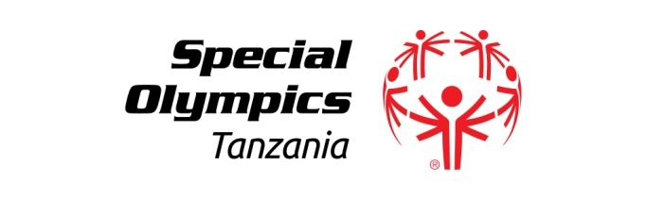 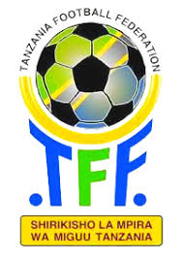

**Special Olympics Tanzania (SOT), Tanzania Football Federation (TFF) Memorandum of Understanding**

This Memorandum of Understanding (MoU) is entered into on 13th September, 2019 between:

**Party A:** Special Olympics Tanzania (Representative)

**Party B:** Tanzania Football Federation (Representative)

Through Unified Sports under the ***Play Unified, Learn Unified Project***a sports and education combined program, Special Olympics Tanzania will contribute to promote school communities where all young people are agents of change - fostering respect, dignity and advocacy for people with intellectual disabilities. *Special Olympics Tanzania will recruit and retain at least 250 new coaches, 1000 new Unified athletes and 1000 new Unified partners in all selected locations by 2020*.

***Party A,*** shall gather athletes with intellectual disabilities and their partners without intellectual disabilities and host Special Olympics Unified Sports activities *in all 25 selected Unified Schools in Tanzania*  in partnership with **Party B** who shall provide technical advice and officials for the various sporting activities.

For the purpose of promotion and collaboration on Special Olympics Tanzania Unified Sports Program and on the basis of voluntariness, equality, mutual benefit and good faith, the two parties agree as follows:

**Whereas,** the mission of Special Olympics is to provide year-round sports training and athletic competition in a variety of Olympic-type sports for children and adults with intellectual disabilities; and

**Whereas,** in the spirit of Special Olympics-skill, courage, acceptance and joy-transcends boundaries of geography, nationalities, political philosophy, gender, race and religion; and

**Whereas,** throughout the five locations/Subprograms Special Olympics Tanzania athletes and partners train and compete in football, striving for unprecedented merit; and

**Whereas,** Special Olympics Tanzania athletes and partners offer inspiration to all citizens through their accomplishments and dedication; and

**Now;** therefore, Special Olympics Tanzania obtains the unanimous support of Tanzania Football Federation (TFF), and conveys this to all our athletes and supporters with the purpose of enhancing the sport of football.

## Party B`s Duties and Obligations:

**Whereas,** Tanzania Football Federation whose main mission supports the development of football in Tanzania; and

**Whereas,** Tanzania Football Federation is committed to expanding opportunities in football to all interested people in Tanzania; and

**Whereas,** under the structure of the Tanzania Football Federation, football players offer inspiration to all citizens in Tanzania as symbols of excellence and achievement; and

**Whereas,** when players from different parts of Tanzania compete together, any differences of opinion, belief, and territory are set aside, in favor of a common pursuit in application of sport.

**Now,** therefore, Tanzania Football Federation hereby proclaims unanimous support and affinity for Special Olympics Tanzania and all its players whose extraordinary courage on and off the field represents the true sportsmanship.

***The MoU will be renewed every three years and in the event of any matters and disputes arising out of or in connection with this MoU, the parties shall attempt to resolve the disputes through friendly consultation.***

13th  September, 2019

Dr. Juma M. Mwankemwa

**Chairman; Special Olympics Tanzania**

Wallace Karia

**President; Tanzania Football Federation**

***Play Unified, Learn Unified***