**INTRODUCTION TO UNIFIED CHAMPION SCHOOLS**

**AN EXAMPLE OF HOW TO PRESENT PROGRAMMING TO EDUCATORS**

# Introduction

## 1.1 Overview

There are many ways to introduce Unified Champion Schools (UCS) programming to educators. Each country has its own characteristics and educational systems, so the Special Olympics Programs must be creative and adapt to the singularity of their culture and context. However, hands-on experience worldwide shows us key themes when introducing UCS in school settings.

This document presents an example of how to do it—always considering that this is a starting point and that each Program can adapt the proposal according to its needs.

The document consists of fifth main parts. First, this introduction. Second, a summary; third, a run of show to exemplify how a UCS workshop could be conducted in a school; fourth, some recommendations post-workshop; and fifth, some additional resources. You will note that the document will mention other available resources, including checklists, templates, a presentation, videos, examples of group activities, and a post-workshop evaluation.

## 1.2 To whom is this document intended?

To all staff members of Special Olympics Programs collaborating with schools— especially those that belong to Programs starting to implement UCS. Please note that if you are an experienced Program, you can continue presenting UCS programming to educators as you have been doing it. We invite you to explore this document and check if there is something that can complement your work.

## 1.3 Why the focus on educators?

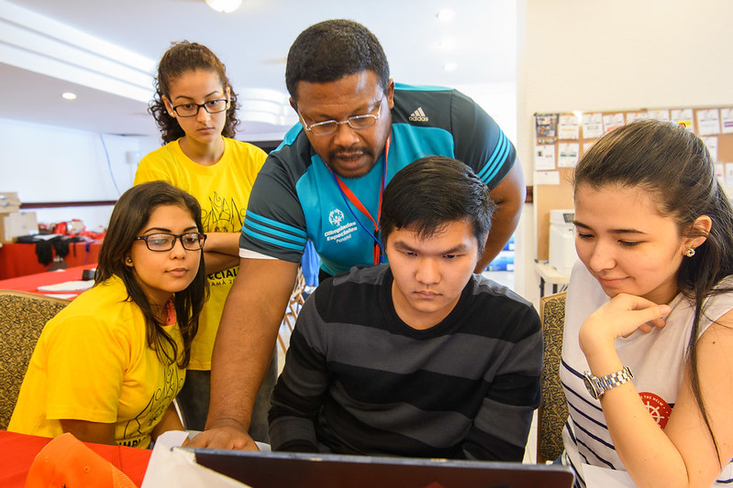Because they are the foundation of the Special Olympics Unified Champion Schools, their support is essential to work with students with and without intellectual disabilities. At the same time, they often stay with the school for many years. Their commitment is vital to ensuring the continued success and sustainability of the UCS model over time. We are grateful for their dedication and hard work, and we couldn't do it without them.

In summary, we know that educators must be empowered agents of change with values, knowledge, attitudes, and behaviors that embrace and ensure the inclusion of every student.

## 1.4 How to use this document?

Please use this document at your convenience. Read it, take the time to analyze it, and adjust it. For example, consider the following:

* Time: How many hours will you have to work with a group of educators at a school? One hour? Two days? Three days?
* Audience: Will you work with Physical Education Teachers or have diverse types of personnel? Social Workers, Psychologists, school leaders, teachers from other subjects? Please note that this is a general example intended for diverse educators. However, specific groups, such as school leaders, will require or not delve into details.
* Relevance of the topics: Please organize the topics according to your needs. For example, is it helpful to talk about inclusive education laws in your country at the end or beginning of the workshop? You can also add or remove topics if you need to.
* School modality and level: Will you work with a kindergarten? A high school? A university? Is it a special or a mainstream school? Consider these characteristics to organize your UCS presentation.
* Education modality: most examples in this document have been considered for an in-person workshop. However, you can adapt many of these resources to a virtual modality.

We also invite you to explore the other resources presented in the document. We wish you much success working with schools and educators!

# Example Overview

# Example of a UCS Workshop Run of Show

**What is a Run of Show?** [1]

A run of show is your go-to document that includes all the information essential to run an event. A vital part of the pre-production phase, a run of show, lists everything in detail – from the event's timing to the durations, topics, and speakers.

**Who uses a Run of Show**?

Anybody involved in the production of an event.

**Why the Run of Show is a must-have for successful events?**

From press conferences to seminars, concerts, workshops, and presentations, every event needs a run of show to help with the right planning and execution. A run of show binds every element of the show by listing the sequence of activities that occur during an event.

And when you share it with the key players, you ensure that everyone is on the same page (well, exactly) – which is the cornerstone of a successful event.

## 3.1 UCS Workshop

Imagine it's your first time presenting the UCS model to a group of educators in a school. You have eight hours over two days. What materials, activities, and resources will you use? Let's explore an example:

## 3.2 Objectives

### 3.2.1 General

* Present the UCS model to promote the inclusion of persons with intellectual disabilities in schools.

### 3.2.2 Specific

* Raise awareness about the importance of promoting the social inclusion of persons with intellectual disabilities in schools.
* Demonstrate the power of Unified Sports to promote inclusion.
* Explain how Special Olympics is an international movement that advocates for the rights of persons with intellectual disabilities through sports, education, and inclusive youth leadership, health, and community programming.

## 3.3 Expected results

### At the end of the UCS workshop:

### 3.3.1 General

* Educators will understand the UCS model, including its goals, main results, three main components, and how it can be a tool to support inclusive education efforts in their schools.

### 3.3.2 Specific

* Educators will have more information about intellectual disabilities and be aware that access to education is a human right for all people, regardless of their disability.
* Educators will understand the power of Unified Sports for inclusion.
* Educators will recognize Special Olympics as an international movement working for the rights of persons with intellectual disabilities. They will also know that Special Olympics has sports, education, community building, health, and inclusive youth leadership programming.

## 3.4 What is the UCS workshop not about?

Setting our limits:

* The workshop won’t provide educators with techniques for teaching students with intellectual disabilities in curricular subjects.
* The workshop will not make educators experts on intellectual disabilities, but it will give them a foundation for understanding disability from a human rights perspective.
* The workshop won’t seek to give educators extra work but rather complement their efforts in their schools, providing them with more tools and ideas to promote social inclusion.

What else will you include? It is essential to be straightforward with educators about what we can and cannot do.

## 3.5 Monitoring mechanisms

* Before the workshop: Verify the UCS Workshop checklist form (Annex 1)
* During the workshop: Make a list of the participants (Annex 2), take photos and videos, and at the end, get feedback from the educators (Annex 3)
* After the workshop: write a systematization of the experience (Annex 4). Outline the most important parts of the session so that you can reference them in the future.

Systematization is a process that intends to produce knowledge about action or practice through analytical reflection and interpretation of what happened. The understanding of the process allows us to not only improve practice but also to communicate and disseminate the lessons and knowledge produced.[2]

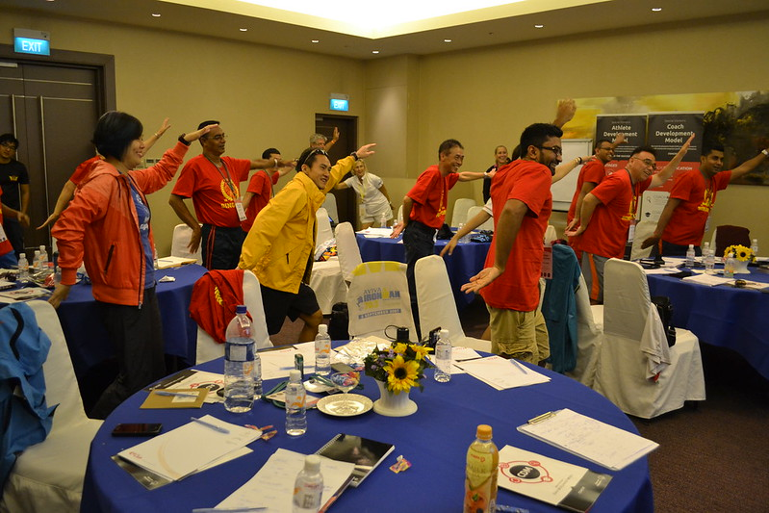

## 3.6 Run of show example (Annex 5. Template)

|  |  |  |  |  |  |
| --- | --- | --- | --- | --- | --- |
| [Insert the name of the event. For example, Unified Champion Schools presentation at Oyster Adam School] | | | | | |
| [Insert day and date of the event]  [Insert time of the event]  [Insert location or venue for the event] | | | | | |
| [Insert the facilitator name]  [Insert the co-facilitators names]  We recommend having at least two Special Olympics staff members while presenting at a school. | | | | | |
| Contact [insert the name and number of whom to contact in case of emergency, for example, technological problems] | | | | | |
| **Part I. Introduce Special Olympics**  *Why is it important? Because educators must know who we are. This helps us gain credibility, as we are the largest global Movement working for the inclusion of persons with intellectual disabilities.* | | | | | |
| **Start time** | **Finish time** | **Duration** | **Insert description of what needs to be done** | **Facilitator** | **Materials** |
| 8: 00 am | 8: 05 am | 5 min | Welcoming  The facilitator greets the participants and shows enthusiasm for their presence in the UCS workshop.  The facilitator hands out the printed agenda and other materials required.  The facilitator explains the objectives of the UCS Workshop.  Jointly with the participants, the facilitator establishes the workshop-grounded rules. | Haylie | PPT (Annex 6) |
| 8:05 am | 8:25 am | 20 min | Ice-breaking activity:  *Red stars mean activity (visual support for athletes co-facilitating).  The facilitator warms up the conversation among participants and enables each of them to introduce themselves briefly. | Maricris | Ice-breaking examples (Annex 7) |
| 8:25 am | 9:00 am | 35 min | Introduction to Special Olympics:  The facilitator presents the organization’s purpose, Eunice Kennedy Shriver’s story, discusses the organization’s focus areas, and gives information about the Program. | Maricris | PPT. Part I  SO overview  (Annex 6) |
| **Part II. Raise Awareness about Intellectual Disabilities**  *Why is it important? Because through disability awareness, the stereotypes and misconceptions surrounding those with disabilities can become known. When these disappear, attitudes and behaviors become more positive and impactful. Digging deeper to create a better understanding is a powerful way to raise awareness.[3]*  We encourage you to invite trained athlete leaders to co-facilitate this part of the UCS workshop. #UnifiedLeadership | | | | | |
| 9:00 am | 9:20 am | 20 min | Activity: Common myths about intellectual disabilities  The facilitator shows a statement to the audience and asks if it is true or false. Once the group answers, the facilitator presents the correct answer and discusses it with the group. The facilitator continues with the following statement.  For example:  Intellectual disabilities are a type of mental illness.  Is it true or false? Answer: False. This is a myth. IDs are not mental illnesses.  Using the PPT, the facilitator explains that “Words Matter” and what are the correct ways to refer to persons with disabilities. | Pedro  (a trained athlete leader)  #UnifiedLeadership | PPT Part II.  Intellectual Disabilities (Annex 6) |
| 9:20 am | 9:40 am | 20 min | What is an intellectual disability?  Using the PPT, the facilitator explains what a disability is according to the Convention on the Rights of Persons with Disabilities (CRPD), what an ID is, the most common causes, and how common intellectual disabilities are.  The facilitator concludes this section by presenting an inspirational video like the Challenge Expectations video. | Maricris | PPT Part II.  Intellectual Disabilities (Annex 6)  [Challenge Expectations video.](https://www.youtube.com/watch?v=letqznT2Xwo) |
| 9:40 am | 10:05 am | 25 min | Coffee break |  | Refreshments |
| **Part III. Unified Champion Schools**  *Why is it important? Because the UCS model has shown that it contributes positively to school settings worldwide. It is a tool to promote the social inclusion of persons with intellectual disabilities.* | | | | | |
| 10: 05 am | 11:00 am | 55 min | Unified Champion Schools  The facilitator explains what a UCS is, mentions its three main components, highlights our international work, discusses the current global and national scope, explains our impacts on schools, and shows some of the investigation results done in the USA, China, India, and Kenya.  The facilitator concludes this section by presenting inspirational videos like Unified Champion Schools. | Haylie | PPT Part III  Unified Champion Schools (Annex 6)  [Unified Champion Schools video](https://www.youtube.com/watch?v=9hCrHO8kbX4) |
| 11:00 am | 11:40 am | 40 min | Unified Sports experience  The facilitator invites the participants to live a Unified Sports Experience—for example, a Unified soccer game.  Remember that Unified Sports joins people with and without intellectual disabilities on the same team. Training together and playing together is a quick path to friendship and understanding. | Pedro | Coordinate with a group of athletes to come to the school.  Ask the educators to bring a proper outfit and shoes.  A soccer ball. |
| 11: 40 am | 12:00 noon | 20 min | First-day wrap-up  The facilitator asks the group how they feel after the Unified Sports experience.  The facilitator asks them about the most important things they have learned.  The facilitator thanks everyone for their contributions and reminds them that they will continue the next day. | Pedro | None. |
| **Day 2** | | | | | |
| **Part III. Unified Champion Schools’ three main components.**  *Why is it important? Because we need to explain to the educators how the UCS model works and how important each component is to promote the social inclusion of persons with intellectual disabilities.* | | | | | |
| **Start time** | **Finish time** | **Duration** | **Insert description of what needs to be done** | **Facilitator** | **Materials** |
| 8: 00 am | 8: 05 am | 5 min | Welcoming of Day 2  The facilitator:  Make a brief recap of Day 1.  Welcome the participants and show enthusiasm for their presence!  Remind them of the workshop grounding rules. | Haylie | None |
| 8: 05 | 8:25 am | 20 min | Ice-breaking activity  The facilitator warms up the conversation among participants. | Pedro | Ice-breaking examples (Annex 7) |
| 8:25 am | 9: 00 am | 35 min | UCS’s three main components  The facilitator explains with details and examples the three main UCS components:   1. Unified Sports 2. Inclusive Youth Leadership 3. Whole School Engagement   While talking about Unified Sports, depending on the type of school, the facilitator could also include general information about Young Athletes Program, MATP, Unified Fitness, Unified Physical Education, etc. | Haylie | PPT Part III  Unified Champion Schools (Annex 6)  [Unified Sports video](https://youtu.be/4UqlSjGSnXw) |
| 9:00 am | 9:20 am | 20 min | Activity: How to implement UCS in our school?    The facilitator divides the group into subgroups.  Using the PPT, the facilitator explains to the participants that one example is to “establish a leadership team” in the school. They will be responsible for implementing UCS.  The facilitator asks each subgroup to brainstorm and write into a flipchart how to implement UCS’s three main components in their school. | Maricris | Flipcharts  Masking tape  Pilots of different colors |
| 9: 20 am | 9:40 am | 20 min | Discussion  The facilitator asks each subgroup to present their ideas on implementing the UCS model. | Maricris | PPT Part III  Unified Champion Schools (Annex 6) |
| 9:40 am | 10:05 am | 25 min | Coffee break |  | Refreshments |
| **Part IV. Take a step forward!**  *Why is it important? It is necessary to show educators how the UCS model contributes to the UN 2030 Agenda and the Convention on the Rights of Persons with Disabilities. In the same way, we can highlight that UCS is a tool that can help them strengthen inclusive laws and public policies in their countries.* | | | | | |
| 10:05 am | 11:00 am | 55 min | Inclusive Education in [insert name of your country]  The facilitator explains how the UCS model supports the United Nations Developmental Goals, The Convention on the Rights of Persons with Disabilities.  The facilitator explains some of their country's most important laws and policies regarding persons with disabilities and inclusive education.  The facilitator highlights how UCS is a tool to reach these National goals. | Haylie | PPT Part IV  Inclusive Education (Annex 6)  [Information about inclusion per country. Laws, policies, and programs (UNESCO, 2023)](https://education-profiles.org/latin-america-and-the-caribbean/jamaica/~inclusion) |
| **Part V. Conclusion**  *Why is it important? Closing the workshop to address final questions and recap the most important parts of the session. Closing is also important to encourage the group to develop UCS programming in their schools.* | | | | | |
| 11: 00 am | 11: 40 am | 40 min | Conclusion  The facilitator summarizes the workshop by restating the main points. The facilitator reviews the objectives and highlights how they have been met.  The facilitator invites the participants to create action plans and set goals for UCS.  The facilitator concludes with an inspirational video and says thank you to everybody. | Maricris | PPT Part IV  Conclusion  (Annex 6)  [Upgrade your world video](https://resources.specialolympics.org/marketing-and-communications/photos-and-videos/special-olympics-video-resources/upgrade-your-world?locale=en). |
| 11:40 am | 12:00 noon | 20 min | UCS Workshop Evaluation  The facilitator asks for the group’s feedback on the workshop. | Haylie | [UCS Workshop evaluation](https://www.dropbox.com/s/gfll25zl8pc73ls/3.%20UCS%20Workshop%20Evaluation.docx?dl=0) |

# After the UCS Workshop

## 4.1 Systematization of the Experience

Systematization is a process that intends to produce knowledge about action or practice through analytical reflection and interpretation of what happened. Understanding the process allows us to improve practice and communicate and disseminate the lessons and knowledge produced.

We encourage you to systematize the UCS workshop so that you can reference back if needed.

## 4.2 Certificates

Giving a certificate of participation is a meaningful way to recognize the contributions of all participants. Be sure to spell names correctly, and if it is under your possibilities, arrange for the school educators to receive professional development hours for the workshop.

## Follow-up with the schools

Follow-up with schools is necessary to ensure the sustainability of the UCS program.

Look for the strategies and the right moments to do it. For example, through WhatsApp groups, school visits, emails, and meetings with those in charge of the UCS programming. Be creative and have fun!

# Additional resources

Please find some additional resources to dig deeper into the UCS world.

## 5.1 Unified Champion Schools

* [Special Olympics Youth and Education webpage](https://www.specialolympics.org/what-we-do/youth-and-schools/unified-schools)
* [Faces of Inclusion](https://www.specialolympics.org/tag/unified-schools): Unified (Champion) Schools’ stories of impact worldwide.
* [Unified Schools resources](https://www.specialolympics.org/what-we-do/youth-and-schools/resources/schools?locale=en)
* [Recommended e-learning courses:](https://learn.specialolympics.org/)
* **Global Unified Schools Teacher Training**
* Global Youth Engagement 101
* Building Inclusive Communities through Unified Champion Schools

## 5.2 Unified Sports

Do you want to learn more about Unified Sports programming? We invite you to explore these resources:

* [Unified Sports Resource page](https://resources.specialolympics.org/sports-essentials/unified-sports?_ga=2.265290575.1166849543.1688391139-324371550.1675350307): a one-stop shop for all things Unified Sports.
* [The principle of meaningful involvement](https://media.specialolympics.org/resources/sports-essentials/unified-sports/Unified-Sports-Principles-of-Meaningful-Involvement.pdf?_ga=2.13052215.1686125404.1688390148-1315435595.1675953472)
* [Some guidance for building Unified Sports teams](https://media.specialolympics.org/resources/sports-essentials/unified-sports/Assessing-Players-and-Forming-Unified-Teams.pdf?_ga=2.215419159.1686125404.1688390148-1315435595.1675953472)
* [Competition](https://media.specialolympics.org/resources/sports-essentials/unified-sports/Guidelines-for-Successful-Unified-Sports-Competition.pdf?_ga=2.206007827.1686125404.1688390148-1315435595.1675953472)
* [High-level research findings](https://resources.specialolympics.org/research/unified-sports-research?locale=en)
* Some videos
* [Unified Sports Educational video](https://www.youtube.com/watch?time_continue=1&v=4UqlSjGSnXw&embeds_referring_euri=https%3A%2F%2Fresources.specialolympics.org%2F&source_ve_path=Mjg2NjY&feature=emb_logo) (developed by SOEE)
* [Three Models of Unified Sports](https://media.specialolympics.org/resources/sports-essentials/unified-sports/Unified-Sports-Models-HD-720p_normal.mp4?_ga=2.256172299.1686125404.1688390148-1315435595.1675953472)
* [Online Coach Education](https://resources.specialolympics.org/sports-essentials/sports-and-coaching/online-coach-education?locale=en)

Recommended e-learning courses:

* **Unified Sports Coaching Course (an introduction to Unified Sports).**
* Level 1 Sports Assistant
* Level 2 Coaching Assistant
* Level 3 Coach
* [More general useful resources for coaches](https://resources.specialolympics.org/sports-essentials/sports-and-coaching/coaching-special-olympics-athletes?locale=en)
* [Young Athletes resources for schools and community programs](https://resources.specialolympics.org/sports-essentials/young-athletes?_ga=2.23012475.1166849543.1688391139-324371550.1675350307)
* Young Athletes and Unified Champion Schools

Recommended e-learning courses:

* Special Olympics Young Athletes Coach course

1. https://streamyard.com/blog/live-streaming-strategy/run-of-show-for-livestream
2. https://sistematizandoexperiencias.files.wordpress.com/2012/04/issystematization-resource-pack-actionaid.pdf
3. https://www.weaverindustries.org/blog-details/why-its-important-to-raise-awareness-around-disabilities