
Government Partnership Proposal

SPECIAL OLYMPIC 50th ANNIVERSARY –
A GLOBAL MILESTONE FOR AN URGENT GLOBAL DEVELOPMENT ISSUE
“PLAY UNIFIED. LEARN UNIFIED.”

Executive Summary
It began as a small summer sports camp in the backyard of a concerned citizen, and it has spawned one of the strongest global movements for positive social change- the movement of Special Olympics. With inclusive programming in over 170 nations, and engaging over 5,000,000 athletes with intellectual disabilities (ID), Special Olympics has become the largest grass-roots disability sports organizations in the world. In many nations, it is perhaps the strongest beacon of hope for one of the most marginalized populations in the world, as well as for their families and communities. Despite progress over recent years, there are nearly 200 million people with intellectual disabilities (ID) who still continue to face unimaginable stigma and isolation. For most, it’s a lack of access to healthcare and social protection, for others education, and still others the threat of ongoing discrimination, neglect and abuse. It is an urgent global development issue for developed and developing nations alike.

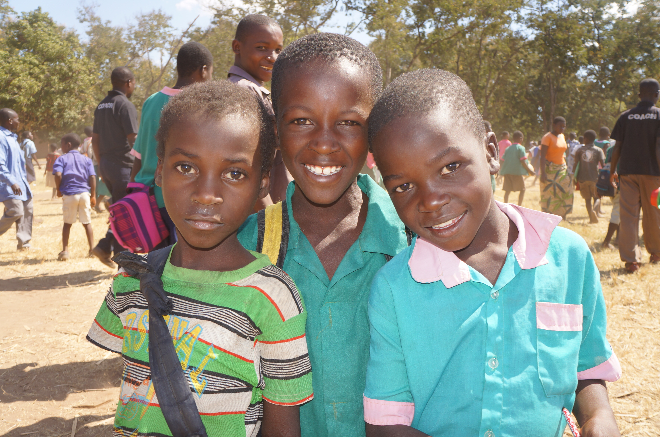
In recognition of the vision and legacy of its Founder, Eunice Kennedy Shriver, and harnessing the powerful voice of its athletes, the Special Olympics upcoming 50th Anniversary offers the world a unique opportunity to support increased social inclusion using proven methodologies that have brought about sustained benefits to youth of all abilities. Special Olympics’ signature program, Unified Sports, is an inclusive sports model that brings youth with and without ID on the same team to train and compete as partners. The program is a proven integration model that has created strong social inclusion practices worldwide and helped to break down the walls of exclusion, both on and off the field of play. To ensure sustainability and create effective, positive longitudinal change, Special Olympics has placed increased emphasis and global focus on embedding Unified Sports within educational and school settings- creating the Unified Schools initiative, as part of the larger mandate of expanding and scaling the impact of inclusive sports.

Through the expansion of Special Olympics Unified Sports and Unified Schools, the Special Olympics movement has demonstrated it has the passion, capacity, and focus to make inclusive sports and related educational programming a reality for students and youth of all ability levels, transforming school climates into academic settings of welcome and integration. Play Unified. Learn Unified - this is the vision and commitment of Special Olympics as the movement looks to the next 50 years of programming.

SPECIAL OLYMPICS – A TRANSFORMATIVE ORGANIZATION

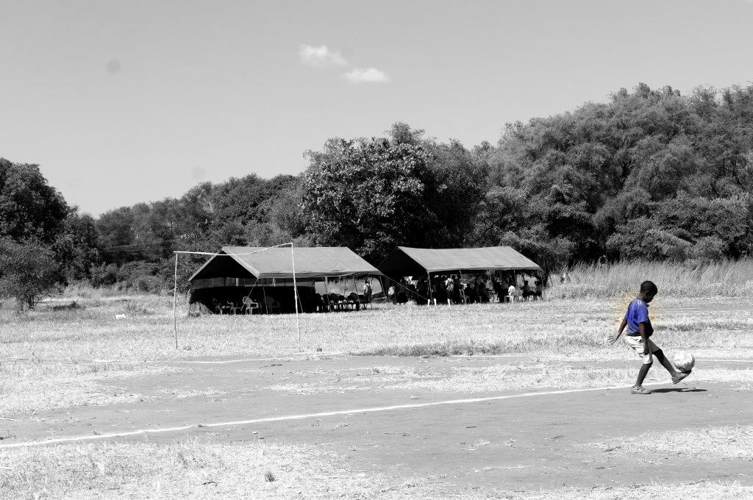
In 2018, Special Olympics will celebrate its 50th Anniversary, marking a half century of concerted global action to bring individuals with ID out of the shadows and into the light of their communities and nations. Unified Sports and Unified Schools are key drivers to this strategy, offering community-based and cost-effective programming which positions individuals with ID as leaders in and outside the movement. This shift represents a core transformation for Special Olympics over the next half century: what was once a movement for people with intellectual disabilities has now become a movement from them. Special Olympics wishes to create a scalable global partnership design with [GOVERNMENT PARTNER] to bring the excitement and benefits of inclusive sports to communities worldwide, to create new and lasting inclusive policies around sports and education, and to bring [GOVERNMENT PARTNER’s] commitment to human connection to a world in dire need of social inclusion.

UNIFIED SPORTS AS A GLOBAL EDUCATION TOOL

Since 1968, Special Olympics has dedicated itself to bringing grass-roots sports programming to individuals with ID, of all ability levels. Now present in over 170 nations, the Special Olympics movement has become the largest sports organization for individuals with special needs in the world, and has helped pioneer new ways of thinking, understanding, and engaging a population often on the margins of their societies and nations.

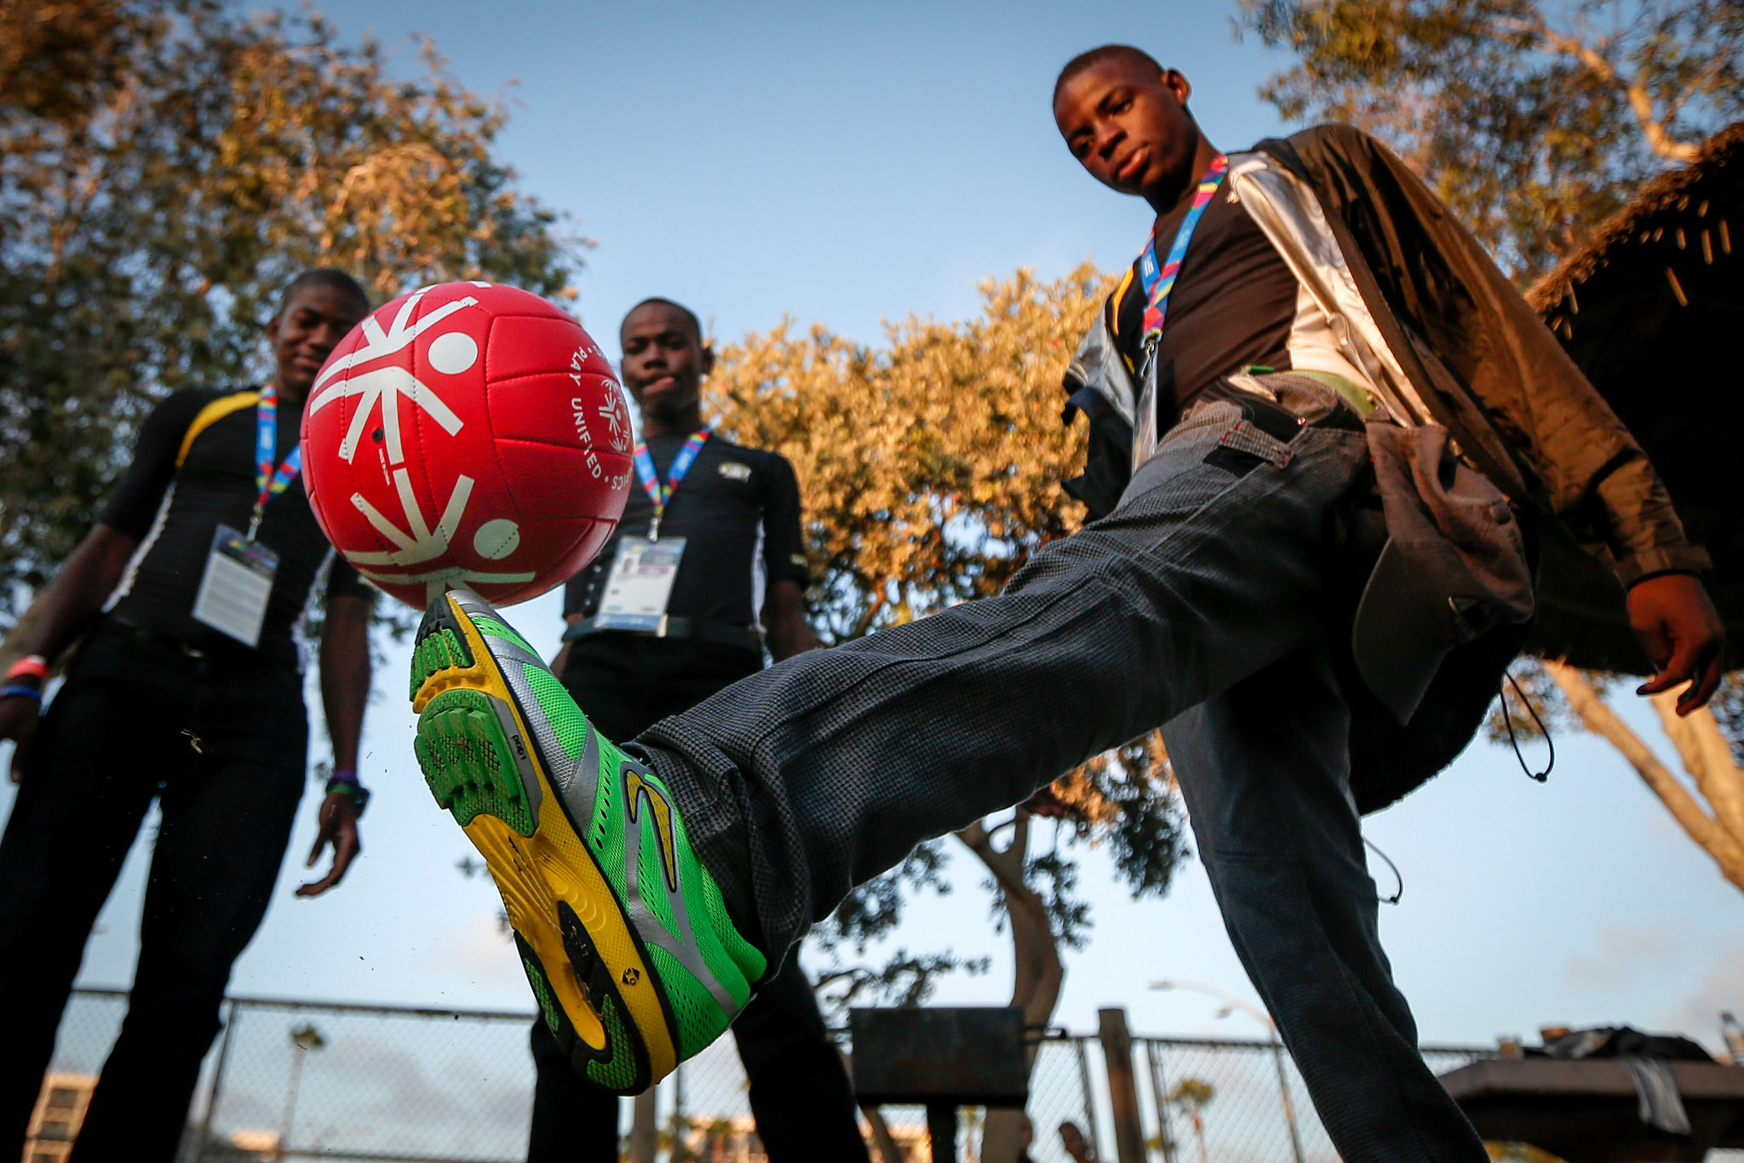
In an effort to ensure that global attitudes toward individuals with ID are positively changed to reflect the rights, talents and abilities of these athletes, Special Olympics developed the Unified Sports program to increase opportunities for the wider community to directly engage in the Special Olympics movement, learn from the example set by Special Olympics athletes, and integrate its programming into community-based sports, recreation and social structures to ensure sustainability and effectiveness. Unified Sports is an inclusive sports program that combines an approximately equal number of Special Olympics athletes and Unified Partners (individuals without ID) on team for training, competition, and recreational play.

The four dominant elements of Unified Sports that challenge barriers to inclusion at the community level are:
- Promoting the personal development of Special Olympics athletes and Unified partners (individuals without ID), and developing social and sports skills while focusing on ability rather than disability;

- Creating inclusive and equal bonds among athletes and partners, and promoting true partnerships that are positive and fully inclusive of diversity;

- Generating positive perceptions of athletes with intellectual disabilities, which serve as a powerful platform to inform the world about the talents and abilities of individuals with special needs.

- Building alliances within the community, while also creating parent support/advocacy networks and connecting local sports clubs and associations, schools and governments for increased cooperation.

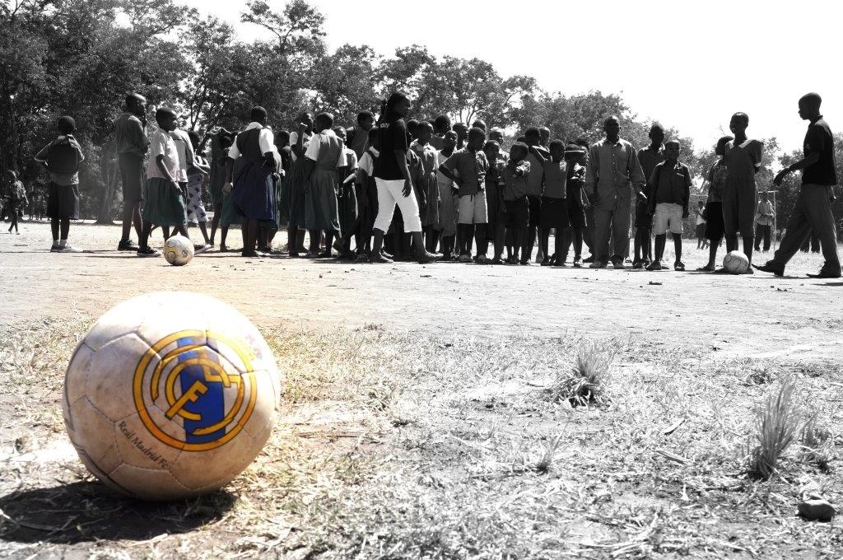
Leveraging the power of inclusive sports and positioning individuals with ID as the lead agents of change, the Special Olympics Unified Sports program creates equality through sport that transcends the playing field, and provides individuals with ID the opportunity to demonstrate their skills and talents, as well as the opportunity for full acceptance and dignity in their communities. For example, a study led by the University of Massachusetts Boston of a multi-national Unified Football initiative found that Unified Sports led to improved self-image in 87% of Athlete participants and that Unified Sports led to spending time together with Unified Partner teammates for many Athlete participants (40%). This increased social connectedness off the field of play was corroborated by a 6-country survey conducted by Special Olympics, which found that 65% of Athlete and Partner respondents spent time together as a team outside of training and competition.
Special Olympics Unified Partners, individuals without ID, have been proven to broaden their outlook, become core advocates of their athlete peers, and help to better inform the wider community as to the benefits of full social inclusion, and the power that comes with a celebration of difference. For example, the multi-national study by UMass Boston found that Unified Sports not only provided for most Unified Partners (57%) the first interaction point with people with ID, it also drove improved understanding of people with ID in a large majority of Unified Partners (79%).
In addition, participation in community-based Unified Sports contributes to people with and without ID of all ages and of all abilities to improve sports skills and become healthier and more fit, thereby reducing the incidence of non-communicable diseases, other complicating health issues, as well as improving the quality of life of all participants. According to a study published in Research in Developmental Disabilities, Unified Sports leads to improved fitness in participants over control group non-participants. Indeed, 85% of Athletes report an increase in their weekly exercise amount while 94% of all participants report that Unified Sports made them healthier. In addition, 91% of all participants report that participation in Unified Sports improved their sports skills.
UNIFIED SCHOOLS – TRANSFORMING EDUCATION SYSTEMS THROUGH INCLUSIVE SPORTS
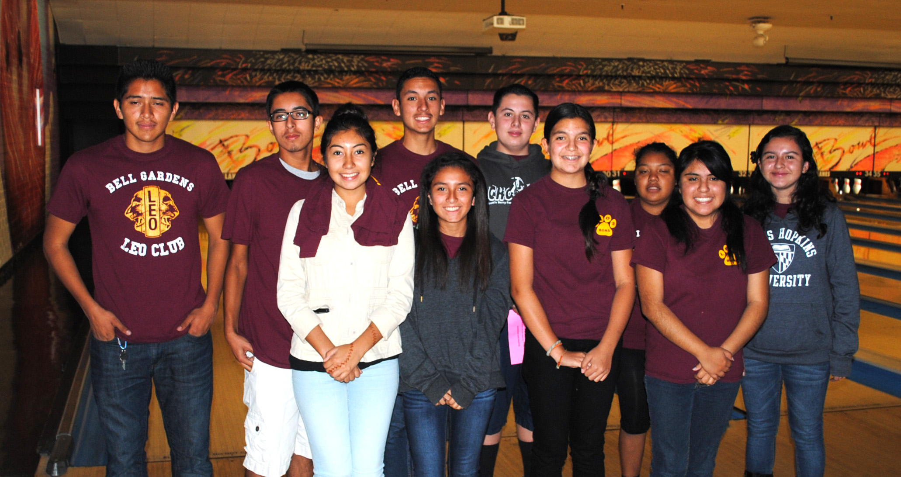
Special Olympics believes that in order to create lasting attitudinal change across the world, the focus must begin on today’s youth. As part of a concerted strategy to ensure the movement reaches as many young people as possible, in all demographic settings, Special Olympics has created Unified Schools: a program designed to promote social inclusion and social-emotional learning through inclusive sport, inclusive youth leadership development, and youth-led advocacy for inclusion in primary schools, secondary schools, and universities throughout the world.
Special Olympics has created Unified Schools as a sustainable and scalable mechanism to deliver Unified Sports opportunity to more youth worldwide and to address the global need to teach social and emotional learning to youth of all abilities.
Young people with intellectual disabilities are grossly underserved by the global education system, perpetuating the discrimination and injustice they face in developed and developing nations alike. Some United Nations estimates show that 90% of children with any disability do not attend school, thereby enabling a cycle of exclusion, poverty of access, and marginalization that burdens not only youth with ID, but also their families, and communities. Given the particular historic barriers to education specific to children with intellectual disability, this percentage may be even higher for those children.
Unified Schools is a global initiative that recognizes that most youth, across all demographic or geographic locations, are not positioned through standard education curricula to develop strong social and emotional skills, which are in urgent demand in an ever-changing and dynamic marketplace. In a world more and more defined by globalization, the ability for today’s youth to develop core skills around acceptance of difference, celebration of diversity, and learning from different forms of talents serve as one of the strongest differentiation points in becoming tomorrow’s leaders. As example, a survey of American employers found that 40% reported a lack of “soft skills” (i.e., social-emotional skills) amongst young people entering the workforce. Special Olympics Unified Schools programming addresses this, providing all participants opportunities to develop empathy, grit, teamwork, and other social-emotional skills.
The Unified Schools program commits to the following transformative goals:
- Create positive, high-quality sports experiences while facilitating a significant increase in inclusive opportunities for all people with and without intellectual disabilities;
- Create opportunities for social inclusion in school environments such that attitudes are changed and all students feel welcomed, connected and valued;
- Grow Unified Sports as a key driver in creating grass-roots inclusive sports activation, inclusive youth leadership opportunity, and thought leadership among student leaders;
- Execute ongoing research demonstrating the impact of inclusive sports interventions and leverage this research to drive national, regional, and global policy and cultural shift for inclusion

An increasingly broad set of research and evaluation work has shown Unified Schools programming to have impact in increased social inclusion of special education students, positive school climate shift, and development in social-emotional learning dimensions (especially for non-disabled participants) – all in addition to the health, fitness, and sport skill development benefits of Unified Sports cited above.

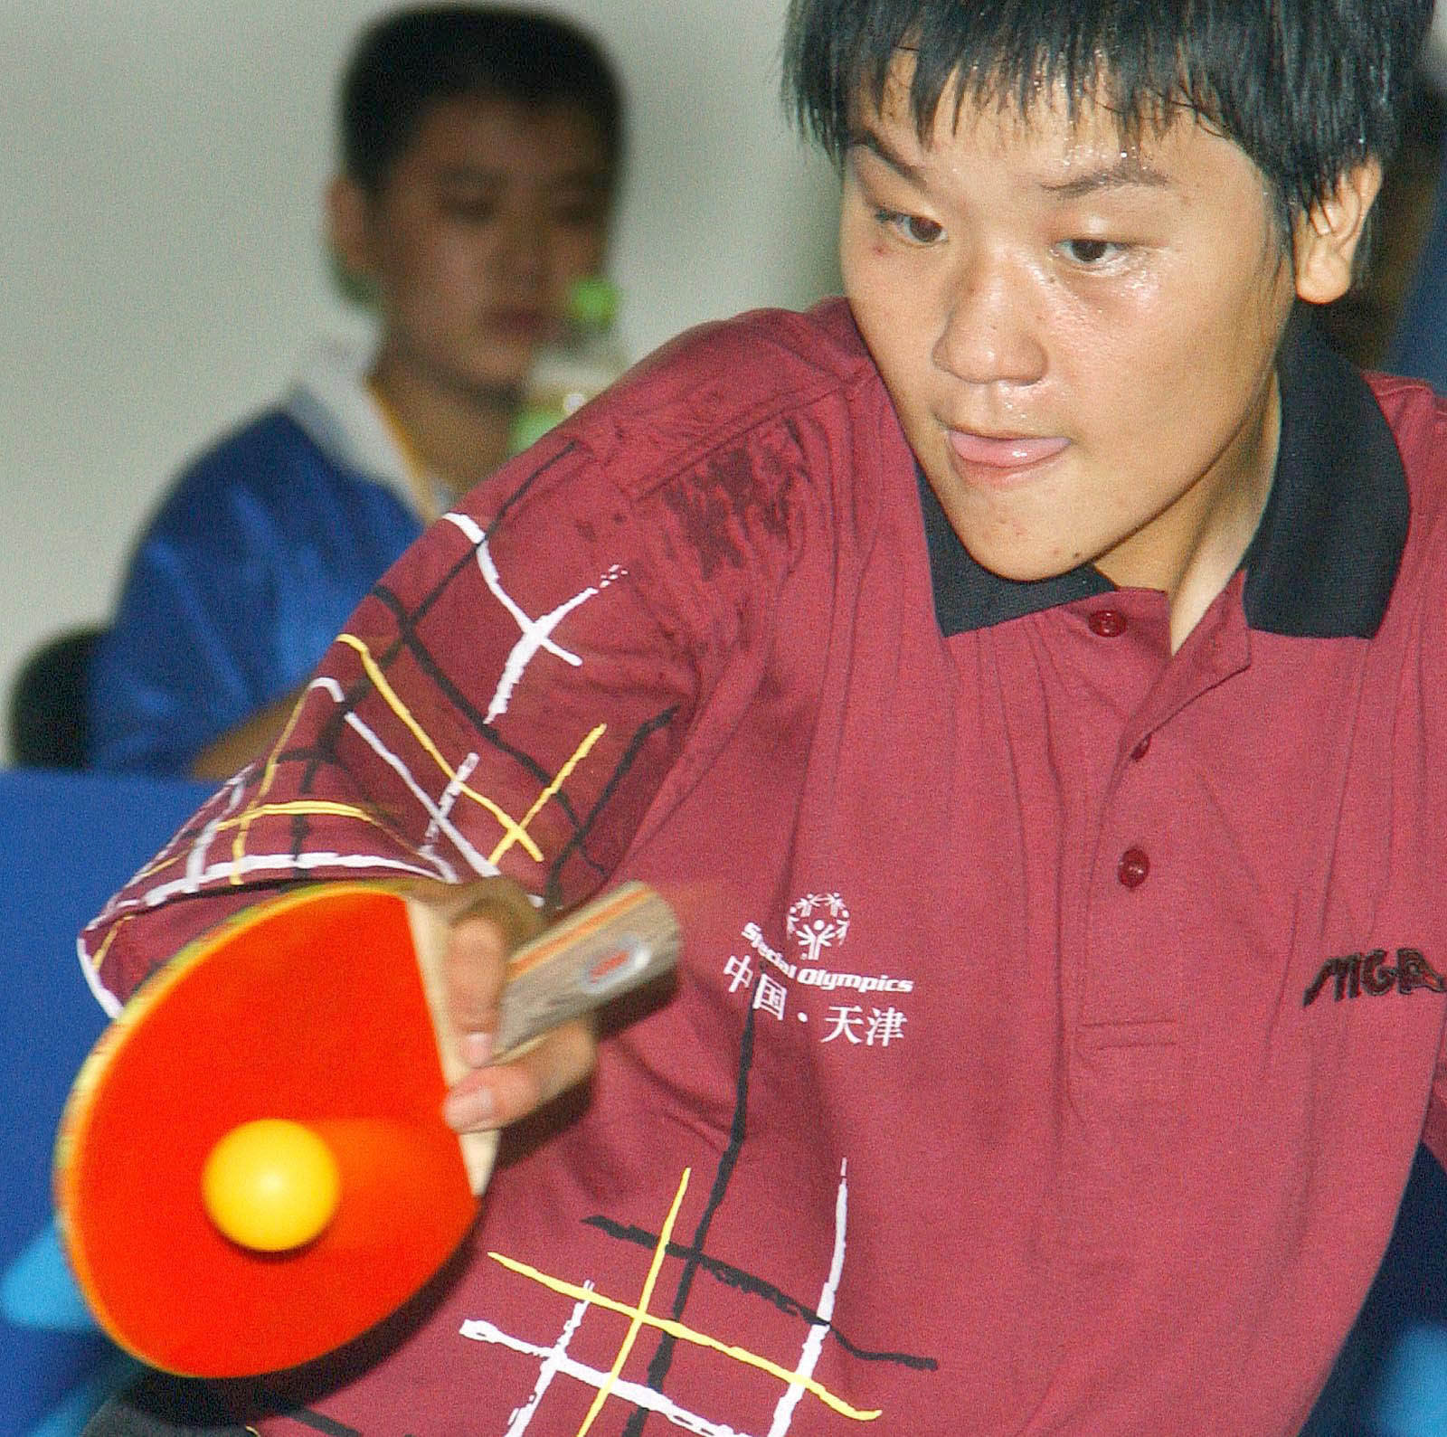
Evaluative surveys in the United States have found that the Special Olympics Unified Schools programming increases opportunities for social inclusion for students with intellectual disabilities. Indeed, 89% of surveyed participating school staff report an increase in opportunities for students with ID to be involved in school activity and 93% report that the program has created a more socially inclusive environment in the school that helps students with ID become part of the school community. Students with ID internalize this beneficial shift: 72% of surveyed school staff believe that the program made a big difference in increasing confidence of students with ID. Similar outcomes have been seen in Unified School programming in Great Britain, where 89% of surveyed youth participants report a more favorable view of people with ID after participation in the program.

Youth participants in Unified Schools report learning across several foundational social-emotional dimensions. Of those surveyed in the United States, 84% of youth participants report learning patience and compromise and 84% report improvement in sharing responsibility. Meanwhile, 85% of youth participants report learning that standing up for what they believe in is the right thing to do and 87% report learning how emotions and attitudes affect others. In Great Britain, 83% of youth participants report increased confidence in their leadership skills, while 87% report feeling more positive about their own abilities.

Unified Schools programming has also been shown to drive positive shift in school culture and climate. From evaluation of United States Unified Schools, 86% of surveyed staff from participating schools credit the program with reducing bullying and teasing in the school. Additionally, 63% report that the program has increased the sense of community within the school and that students are open to and accepting of differences.

GEOGRAPHIC EXPANSION AND SCALING
The Special Olympics Unified Sports- Unified Schools platform has produced promising results, and traction, in a number of countries worldwide, helping to engage national ministries of education, sports federations and school districts. Through the proposed Special Olympics – [GOVERNMENT PARTNER] partnership, the Unified Sports and Unified Schools programming models are poised to take the program to the next level of execution and impact, achieve true global expansion, and widen the footprint to bring sustained benefits to youth worldwide.

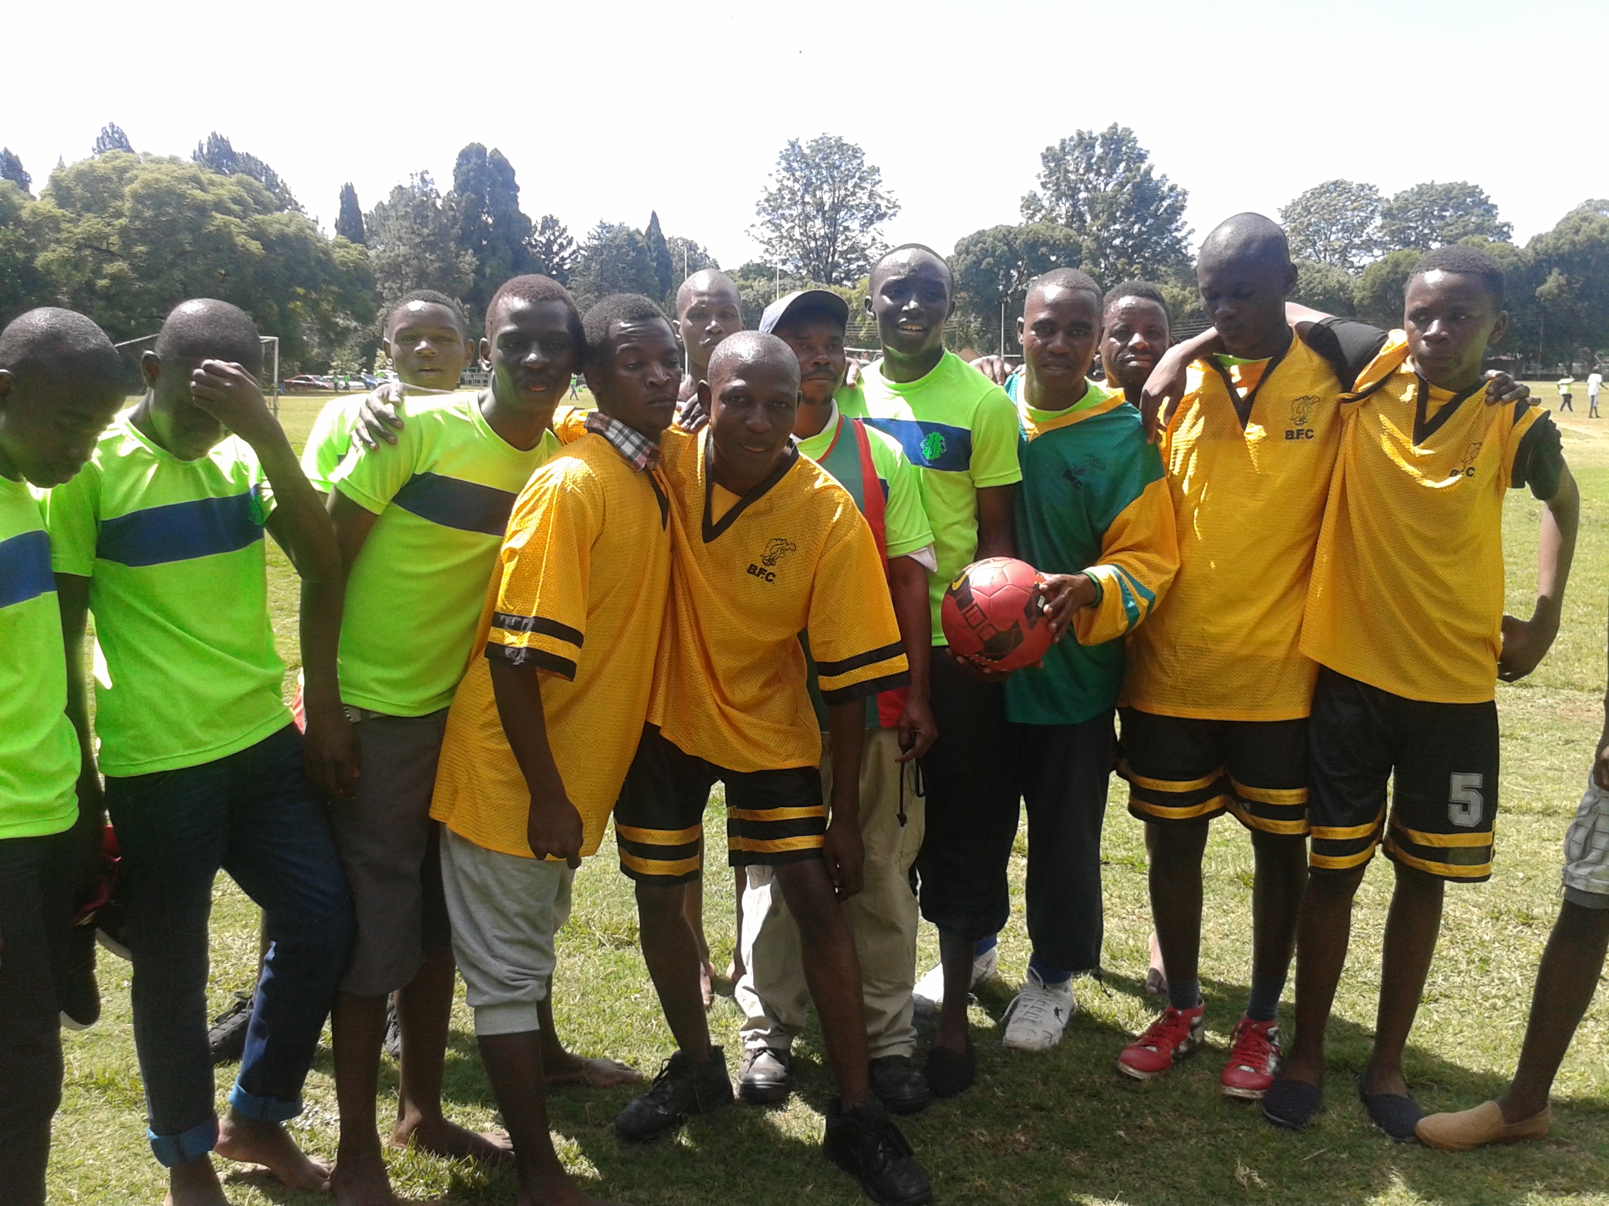
In an effort to drive the partnership where it is needed most, Special Olympics has created an initial list of target nations for consideration, representing strong opportunities for national programmatic growth, visibility, and innovation. The criteria used to select these nations on the part of Special Olympics are as follows:

- Across many low-to-middle income nations, national governments have been receptive to working with Special Olympics to bring forth viable, sustainable and cost –effective programs in an effort to connect inclusive policies at the national level to inclusive programs at the grass-roots level, namely in support of one of the hardest-to-reach population subsets, youth with intellectual disabilities; these national governments have expressed high interest to work with Special Olympics to further develop socially inclusive programs;
- Special Olympics has strong positioning in these nations through the standard programmatic approach, and these National Special Olympics Programs have expressed high interest to scale Unified Sports and Unified Schools in their jurisdictions;
- The countries selected offer Special Olympics a chance to complement the significant impact and philanthropic footprint that the [GOVERNMENT PARTNER] has established in these locations.

SUSTAINABILITY THROUGH INCREASED PARTNERSHIP
Special Olympics is committed to measuring the longevity and sustainability of Unified Sports and Unified Schools as a long-term success indicator. The vision of the movement is to ensure that every school has formal Unified Sports programming, which represents not only school-based inclusive programming, but also envisions a global community where youth with ID attend school- a reality far from realization in the 21st century, especially across the Global South.
The key to sustaining Unified Sports and Unified Schools into the long-term can be seen in the ability of Special Olympics to create and steward vibrant partnerships that bring increased value, capacity and scalability. The sustainability of this growing initiative rests also in the ability of Special Olympics to generate increased funding, value-in-kind, school and community engagement, and local-to-national government support. To this end, Special Olympics is fully committed to using best efforts to generate a $1: $1 match over the course of the [PARTNERSHIP TERM] to leverage such a significant investment at national, regional and global levels.
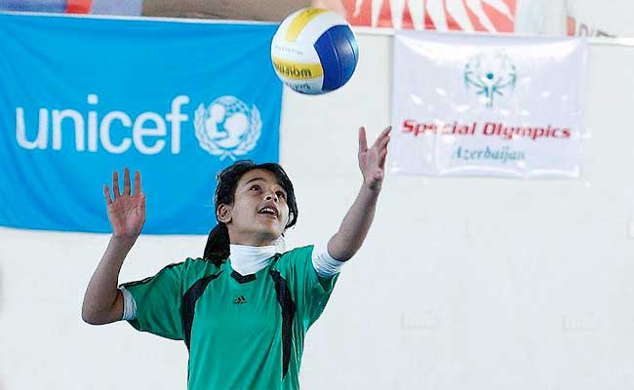
This commitment aims to ensure solidification of Unified Sports and Unified Schools as core programmatic elements across the Special Olympics movement, but also as part of the wider mandate brought forth by the international community. The Special Olympics Unified Sports and Unified Schools platform is rooted heavily in the tenants of the United Nations Convention on the Rights of Persons with Disabilities (UN-CRPD), namely Articles 24 and 30. The UN-CRPD provides the global community with a viable, and internationally-recognized, policy framework from which to expand programming that puts the Convention into practice. As part of the Convention Article 24, “States Parties recognize the right of persons with disabilities to education. With a view to realizing this right without discrimination and on the basis of equal opportunity, States Parties shall ensure an inclusive education system at all levels and lifelong learning (…)”. In addition, the Convention also states the universal rights that individuals with intellectual disabilities have in participating in safe, community-based sport and physical activity: “To ensure that children with disabilities have equal access with other children to participation in play, recreation and leisure and sporting activities, including those activities in the school system (..)”.
By putting the core tenants of the UN-CRPD into practice, Special Olympics works directly with local and national governments, and regional governments in select regions (e.g. European Union, etc.), to ensure that Unified Sports and Unified Schools is integrated into national policies and strategies around national and inclusive development. The engagement with the United Nations, the [GOVERNMENT PARTNER] and the global community will create the potential to offer sustained inclusive programming, in-country collaborative opportunities, and increased value and investment to the Special Olympics movement. As part of its focus on partnerships to scale programming in-country and globally, Special Olympics looks forward to continuing and creating partnerships with key stakeholders that provide leadership and scope to the global sports and education fields:
- National Governments / Local and National Ministries of Youth and Sports to provide increased capacity for implementation;
  - Through active government relations, Special Olympics has been able to create lasting partnership agreements with national Ministries of Youth and Sport, and national Ministries of Education to both generate needed awareness in-country, while also ensuring the provision of important infrastructural components like sporting facilities, equipment, etc.;
  - Many nations have created national partnership agreements with their affiliated Special Olympics National Program as a way to scale inclusive sports and health programming, namely across the developing world; the benefits to this model bring formal ministerial support, while also offering grants at the national level that can complement and leverage investments made in-country through international grants, etc.; some of these nations include but are not limited to Rwanda, Jamaica, Malawi, India, Bangladesh, and more;

- National Sports Federations to embed inclusive sports programming in all sports structures;
  - Special Olympics offers over 30 Olympic-type sports spanning winter and summer modules; one of the primary ways the movement strengthens the quality of sports programming is through partnerships with national sports federations such as the national football federation, the national swimming federation, or the national athletics federation in a given country; these partnerships have strong value in awareness building, while also accessing key infrastructural and service elements like sports officials, referees, technical experts and guides, and more;

- United Nations agencies in-country to positon Unified Sports as a key program under the United Nations Convention on the Rights of Persons with Disabilities (UN-CRPD) and the United Nations Sustainable Development Goals (UN-SDGs);
  - Special Olympics currently works with the United Nations Children Emergency Fund (UNICEF), the United Nations High Commission for Refugees (UNHCR), and other leading agencies to position the movement as a key driver in creating both viable programming models, while also offering key research in the development of inclusive policies around sport, education and social development; in addition, Special Olympics wishes to position the proposed partnership with the [GOVERNMENT PARTNER] as a primary contribution to inclusive development under the newly adopted United Nations Sustainable Development Goals (UN-SDGs);

- Global service club organizations to help strengthen and sustain local programming;
  - The viability of inclusive sports programming, both at a community and school level, rests heavily on the ability to attract, and retain, volunteers; with this in mind, Special Olympics looks forward to continuing to build strong links with service clubs organizations worldwide, such as Lions Clubs International, Knights of Columbus, etc. to secure the availability of human resources, and in some instances, the ability to engage directly with youth networks such as those of the YMCA, YWCA, Leo youth network, and more.
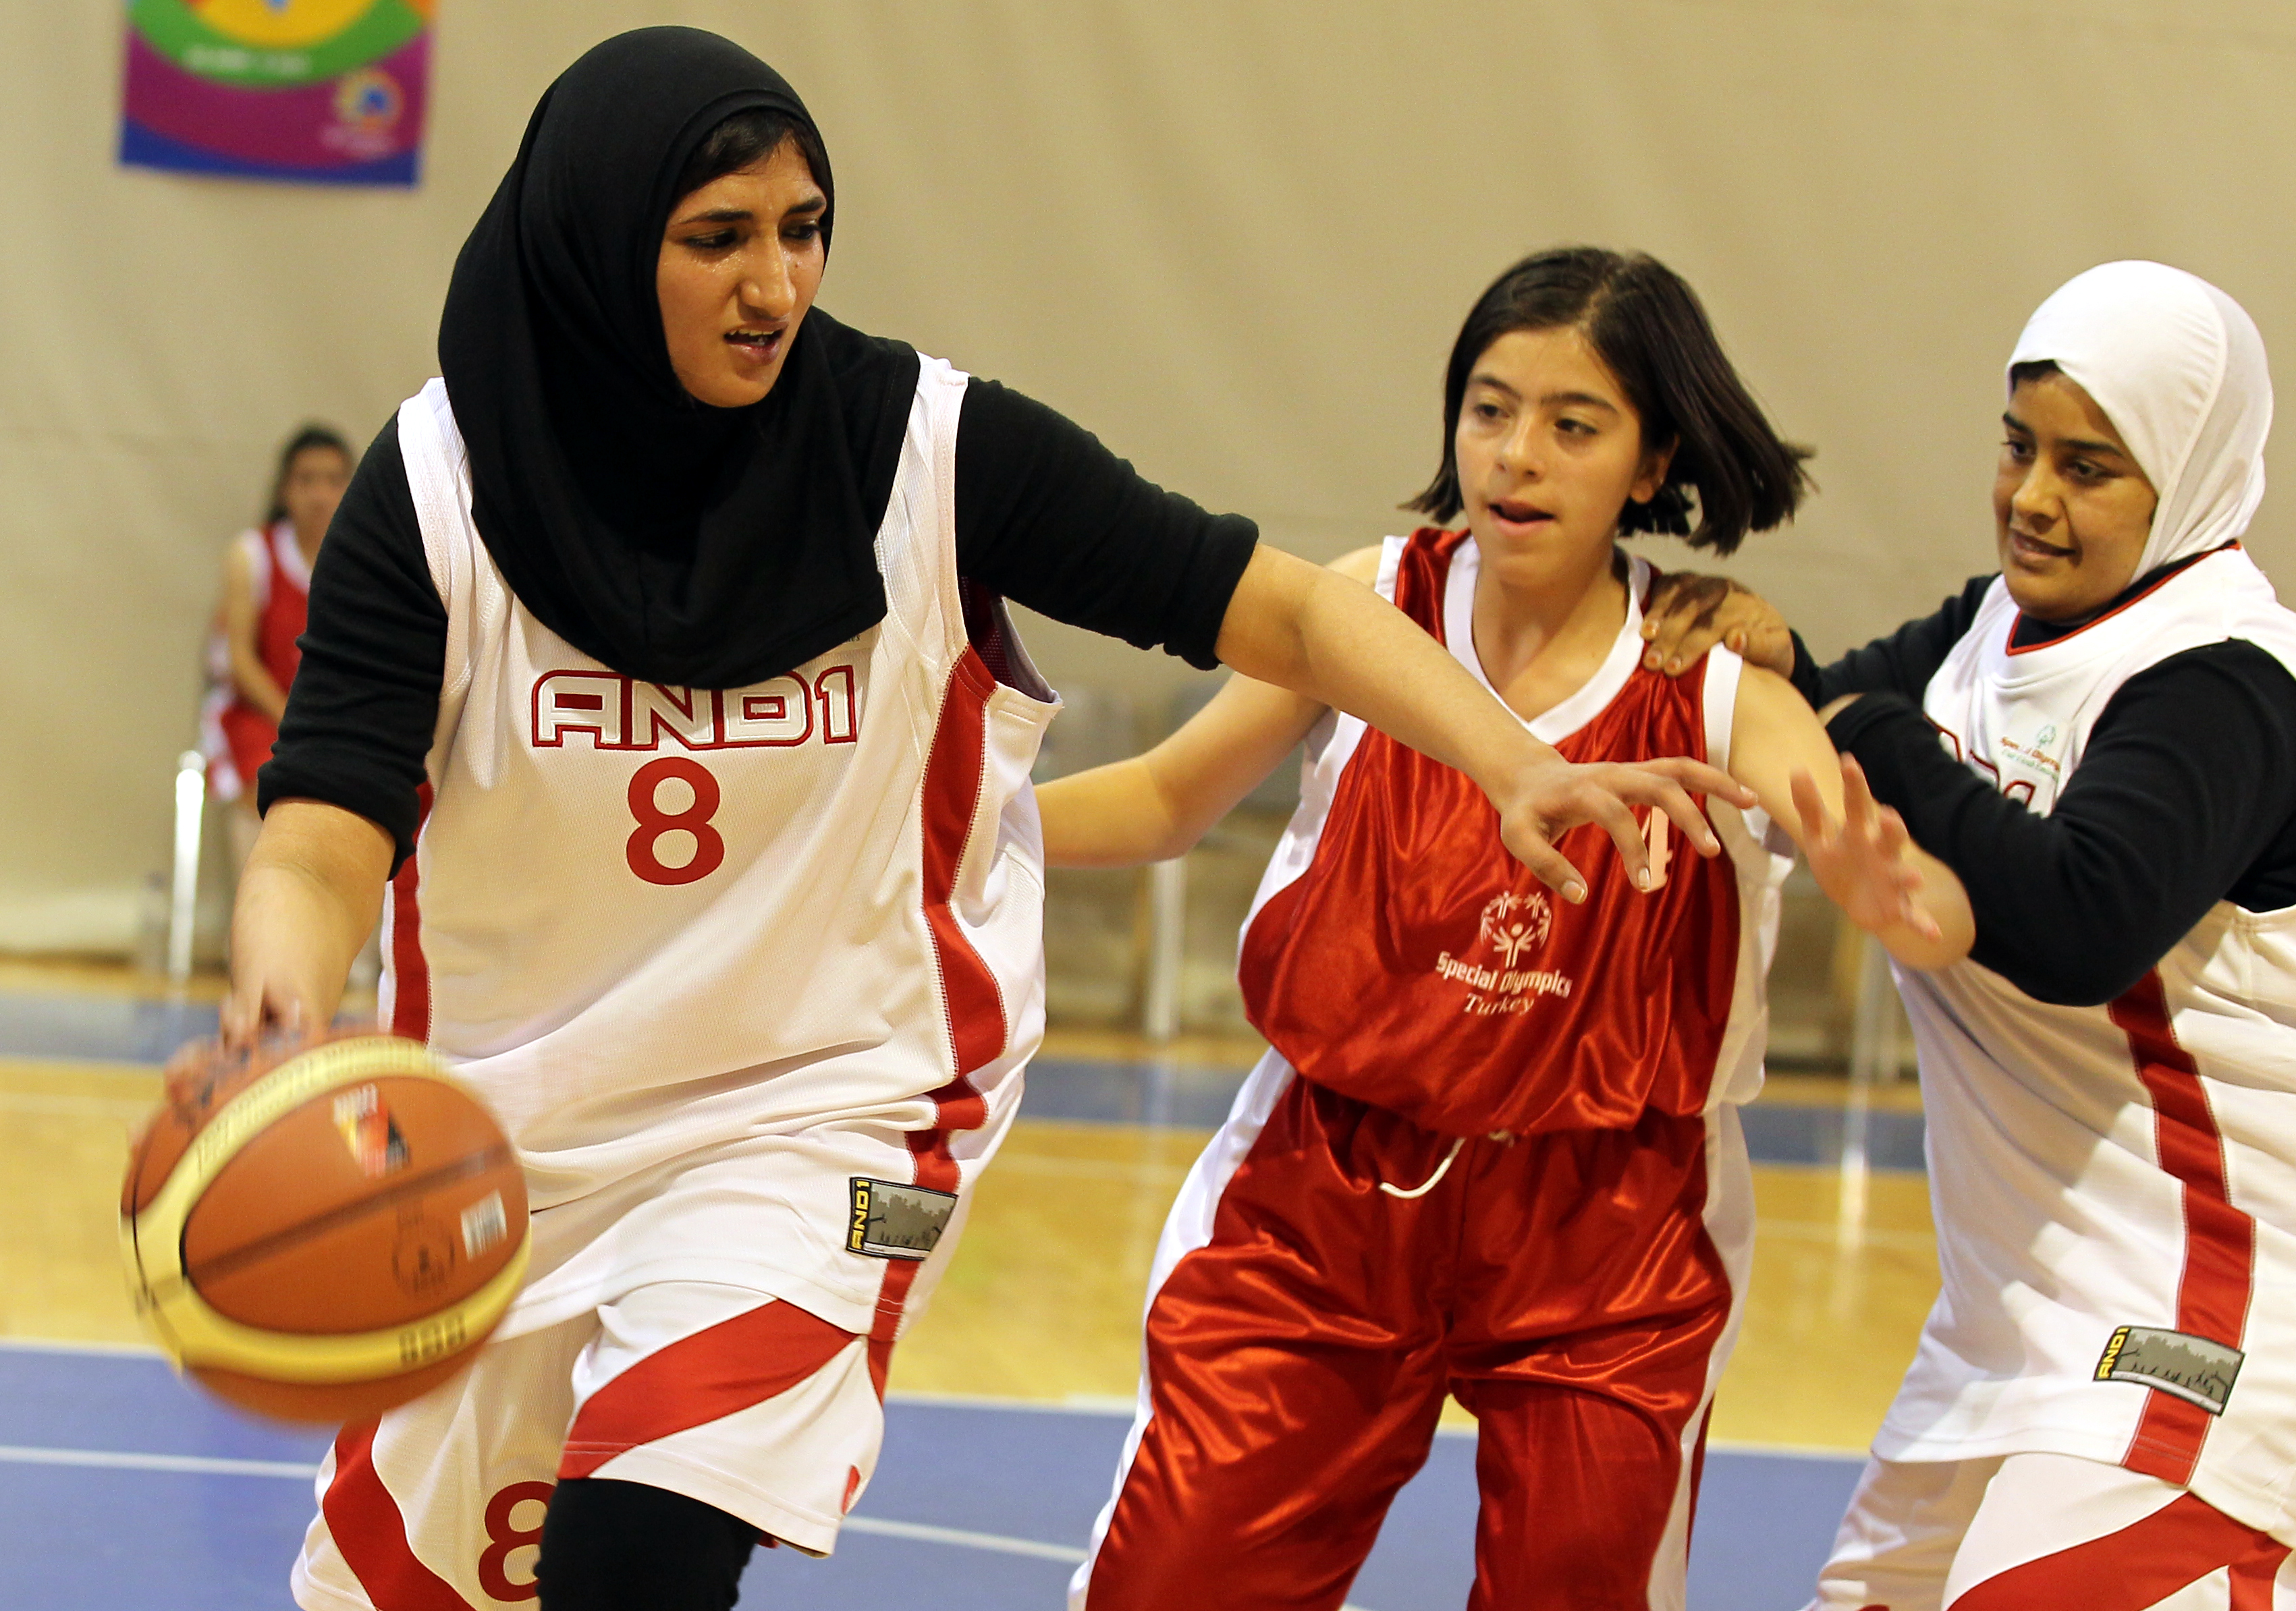
One of the overarching goals of Special Olympics is to solidify a living legacy of the Special Olympics- [PARTNER] partnership by demonstrating a robust, substantive and ambitious international expansion effort that significantly increases the number of youth, with and without ID, that benefit from this important inclusive development initiative.

RESEARCH AND EVALUATION- BRINGING DATA TO POLICY CHANGE
In order for standard practice to change, attitudes and policies must change first. It is for this reason that Special Olympics wishes to ingrate a strategic Research and Evaluation element to the project, to ensure that reputable and empirical data can be generated, analyzed, and positioned as assets to inform policymakers, and create more inclusive and equitable policies for youth with ID.
As part of this approach, Special Olympics will be strengthening its data collection, and data dissemination both internally and externally as part of a shared commitment to create increased public awareness to issues facing youth today. A variety of tools and methodologies will be executed to provide a 360-degree assessment of the project including: Key informant interviews, focus group discussions, coach questionnaires and surveys.
In addition, Special Olympics understands the need to engage local and national governments in this program, and utilize data to drive informed policy development. This said, Special Olympics is committed to creating annual reports of the partnership to demonstrate progress in relation to proposed metrics, as well as a comprehensive 3 year report that would compile all data sets across the years of programming. Special Olympics would welcome the opportunity to work closely with the [GOVERNMENT PARTNER] in creating a joint report that could be presented to local, national and regional governments, as well as the international development community, to underscore the urgency of making education fully inclusive through cost-effective means such as Unified Sports and Unified Schools.
Research and Data Analysis Partners for the “Play Unified. Learn Unified” platform include but are not limited to:

- University of Massachusetts – Boston (USA)
- University of Ulster (Northern Ireland)
- United States Department of Education

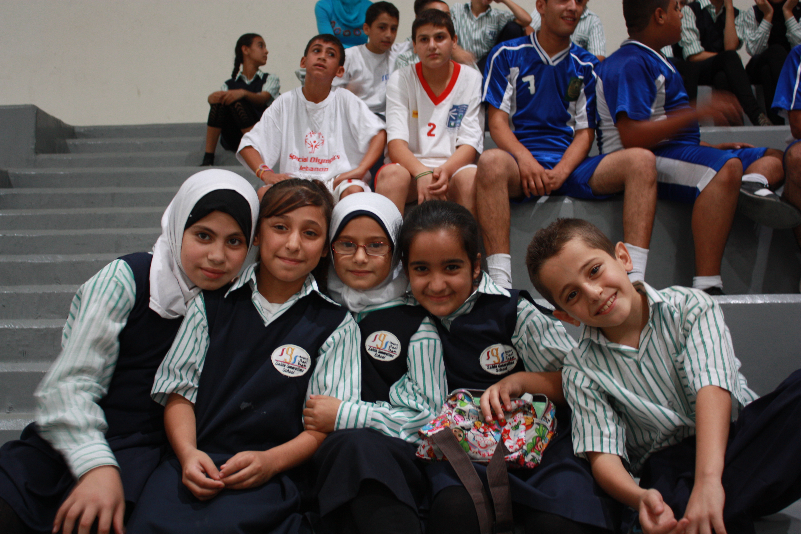
As part of the continued development and stewardship of the proposed Special Olympics- [GOVERNMENT PARTNER] partnership, Special Olympics is also keen to establish annual site-visits to select Unified Sports and Unified Schools projects, together with the [GOVERNMENT PARTNER], to share impressions, consider modified modules and approaches, capture and disseminate ‘best practices’, and create greater efficiencies through close collaboration.

KEY PERFORMANCE INDICATORS: Play Unified. Learn Unified. (3-year figures)

KEY PERFORMANCE INDICATOR 1: Create [##] new Unified Schools that promote social inclusion and social-emotional learning through efforts including inclusive sport, inclusive youth leadership development, and youth-led advocacy for inclusion in primary schools, secondary schools, and universities, thereby transforming school climates into academic settings of welcome and integration.

KEY PERFORMANCE INDICATOR 2: Award over [##] Innovation Grants to unified pairs (one youth with ID and one without) to bring their unique visions for inclusion come to life within their own communities.


KEY PERFORMANCE INDICATOR 3: Train over [##] NEW Unified Sports Coaches to ensure that athletes receive a positive, high quality sports experience. Coaches are the lynchpin to better physical and mental health and inclusion on and off the sports field.


KEY PERFORMANCE INDICATOR 4: Actively engage [##] athletes and Unified Partners from around the world in the development of core skills around acceptance of difference, celebration of diversity and learning from people of different abilities.

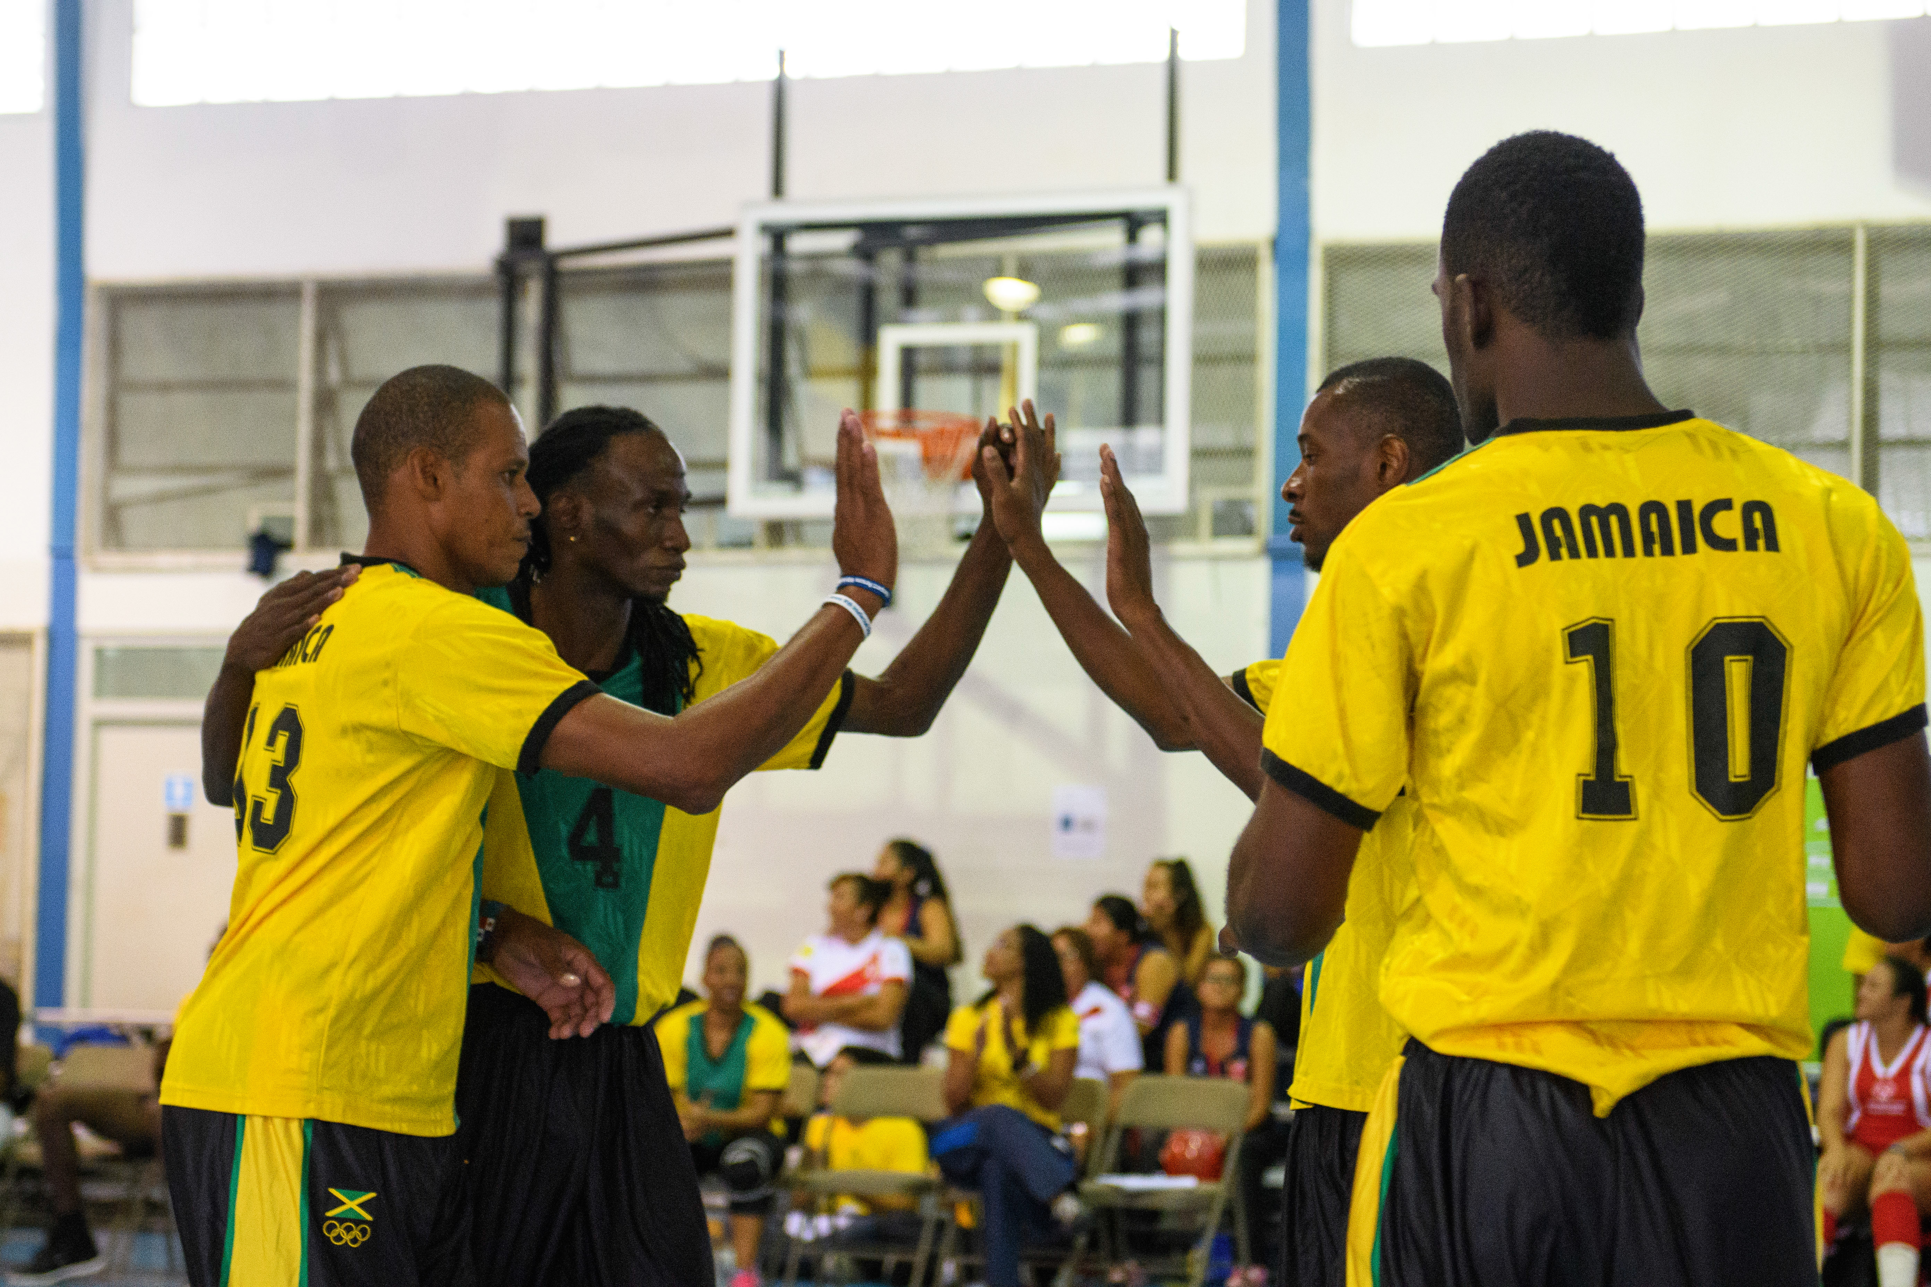

PROJECT BUDGET DETAIL

CONCLUDING STATEMENT

The Special Olympics 50th Anniversary positions the global movement with an opportunity to bring its global vision to reality in creating a truly Unified Generation. Through the focused and strategic utilization of sport to affect school climate, Special Olympics Unified Sports and Unified Schools offer viable, scalable models of programming that align with all sectors in forging more inclusive education systems and policies. Most importantly, this platform places one key performance indicator above all: empowering youth with and without intellectual disabilities to hit the field, and life, as partners- as one.

There is perhaps no issue more urgent for the world today than the need to accept, even celebrate, difference. In a time when division, separation, and isolation ring the airwaves within the political, economic and social domains, Special Olympics, with the support of the [GOVERNMENT PARTNER], stands to serve as a counter model – a beacon of hope to civil society, development and government, in its promotion of inclusive sports as a way to celebrate diversity, and ensure that diversity and special abilities benefit the entire population of today’s youth, of all abilities.

Special Olympics is grateful for the consideration of the [GOVERNMENT PARTNER] for this proposed partnership model, and is excited to envision a day when both organizations can take a stand on inclusion, disrupt the status quo, and harness the powerful message and example of Special Olympics to change the world as part of this peaceful, hopeful Inclusion Revolution.

Special Olympics Contact:
[CONTACT INFO]

Norins, J., Haradan, C., Parker, R. (2006). Evaluation of the Special Olympics Europe/Eurasia Unified Football Pilot Project: Findings from Austria, Poland, Romania, Serbia, and Slovakia. Washington, DC: Special Olympics, Inc. & University of Massachusetts Boston.
Nanavati, J. & Haas, K. (2015). Unified Sports Evaluation. Washington, DC: Special Olympics International.
Norins, J., Haradan, C., Parker, R. (2006).
Baran, F., Aktop, A., Özer, D., Nalbant, S., Ağlamış, E., Barak, S., & Hutzler, Y. (2013). The effects of a Special Olympics Unified Sports Soccer training program on anthropometry, physical fitness and skilled performance in Special Olympics soccer athletes and non-disabled partners. Research in developmental disabilities, 34(1), 695- 709.
Nanavati, J. & Haas, K. (2015). Unified Sports Evaluation. Washington, DC: Special Olympics International.
UNICEF (2013). Children and Young People with Disabilities Fact Sheet. Accessible at https://www.unicef.org/disabilities/files/Factsheet_A5__Web_NEW.pdf.
McKinsey and Company Global Institute (2017). Technology, Jobs, and the Future of Work. Accessible at https://www.mckinsey.com/global-themes/employment-and-growth/technology-jobs-and-the-future-of-work.
Center for Social Development and Education: University of Massachusetts Boston, Special Olympics Unified Champion Schools Program: Year 8 Evaluation Report 2015-2016. (Boston, MA: 2016). Retrieved from https://www.umb.edu/editor_ uploads/images/Year_8_Evaluation_Report(Final).pdf.
Center for Social Development and Education: University of Massachusetts Boston (Boston, MA: 2016).
Youth Sports Trust Research and Insight, Play Unified and Unified Sports Interim Report October 2015 – July 2016. Page 10.
Center for Social Development and Education: University of Massachusetts Boston (Boston, MA: 2016).
Youth Sports Trust Research and Insight, Play Unified and Unified Sports Interim Report October 2015 – July 2016. Page 10.
Center for Social Development and Education: University of Massachusetts Boston (Boston, MA: 2016).
UN General Assembly, Convention on the Rights of Persons with Disabilities : resolution / adopted by the General Assembly, 24 January 2007, A/RES/61/106, http://www.un.org/disabilities/documents/convention/convoptprot-e.pdf, page 17 of 37.
UN General Assembly, Convention on the Rights of Persons with Disabilities : resolution / adopted by the General Assembly, 24 January 2007, A/RES/61/106, http://www.un.org/disabilities/documents/convention/convoptprot-e.pdf, page 24 of 37.

