**Strong Siblings**

**A Support Resource for Siblings of**

**Youth with Intellectual Disabilities**

**Workbook**

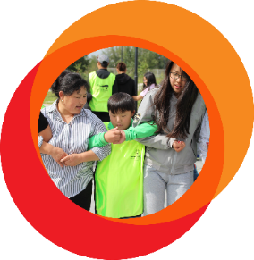

**Strong Siblings**

**A Support Resource for Siblings of**

**Youth with Intellectual Disabilities**

**Table of Contents**

|  |  |
| --- | --- |
| **01** |  |
| Introduction | |
| **02** |  |
| Taking Care of Yourself | |
| **03** |  |
| Positive Communication with Peers, Friends and Family | |
| **04** |  |
| Engaging with your Community | |
| **05** |  |
| Resources | |

**Introduction to Sibling Engagement**

|  |  |
| --- | --- |
|  | Special Olympics sibling engagement occurs when a sibling of a person with an intellectual disability (ID) joins Special Olympics as an active member of the movement and/or their sibling’s journey. Together, the sibling without ID may play, learn, develop, and work with their sibling with ID or another Special Olympics athlete. Engaging in siblings work, Special Olympics has found that the sibling relationship often grows stronger as there is more mutual understanding between the pair.  Special Olympics offers many ways for siblings to be involved with the movement, such as joining a Special Olympics Unified Sports program, volunteering at a local Special Olympics event, or simply just being a supporter and cheerleader on the sidelines! Siblings can choose the activities that best fit their interests and time commitments. Through these activities, siblings will motivate and support each other while working toward achieving shared and personal goals. |

|  |  |  |
| --- | --- | --- |
|  | Scan the code to find out more ways you can get involved with the Special Olympics movement! |  |

**Benefits for Siblings**

Sibling engagement through Special Olympics has benefits for both siblings with and without ID. Pursuing individual skill development will support personal growth and enhance the relationship between siblings. Participating in Special Olympics can benefit siblings in the following ways:

|  |  |
| --- | --- |
|  | **Connect with Supportive Community** |
|  | Develop a network of peers and family members who may have similarities to your own family. Meeting role models in older siblings and Special Olympics leaders who understand what you are experiencing. |
|  |  |
|  | **Elevate Your Voice** |
|  | Special Olympics offers you a platform to share and introduce your peers, friends, and other family members to intellectual disabilities. Use your voice to educate others and spread inclusion in your community, Program, Region, and around the world! |
|  |  |
|  | **Develop Your Leadership Skills** |
|  | Special Olympics will give you the opportunity to develop your professional, project management, and problem-solving skills. |

**How to Use the Strong Siblings Workbook**

This workbook is designed to support and help you navigate your journey as a sibling of a person with ID. The workbook is broken into three sections to address your personal, family, and community needs. Each topic covers one or two common challenges faced by siblings and includes activities to help your work through each challenge. These activities can be done by siblings ages 8+, though some may be better suited for adolescents and young adults.

|  |  |  |  |  |
| --- | --- | --- | --- | --- |
| **Workshop Activity Topics** | | | | |
|  | | | | |
|  |  |  |  |  |
| **You and Self-Care** |  | **You and your Family** |  | **You and your community** |
| Prioritizing yourself so you can gain a greater understanding of your own needs and the importance of taking care of yourself, while also balancing other family needs. |  | Assessing your relationships with your family members and how to have open conversations, while examining components of active listening for tough decisions. |  | Empowering you to explore your voice in society as an advocate for inclusion. |

|  |  |
| --- | --- |
|  | YOU AND **SELF-CARE** |

|  |  |
| --- | --- |
|  | **Having a sibling with ID can come with a lot of responsibility. Your family may rely on you for certain tasks, like caring for your sibling. When you love someone who needs extra care, you may feel conflicted.**  While you want to support your sibling and your other family members, you also want to do things for yourself, like hang out with a friend or play a sport. It is normal to feel conflicted between your needs and your family’s needs. You have to learn how to deal with these types of feelings before they become overwhelming.  In the following pages, you will go through a series of activities to better identify your feelings and emotions, while also learning how to express them in a healthy manner. You will be introduced to techniques that can help when you are feeling stressed or overwhelmed. It is important to remember that you can only help others as much as you help yourself. |

|  |  |
| --- | --- |
|  | Be kind, be patient, be generous, be accepting.  **Be all of these things to yourself first.** |

**Understanding the Emotions Spectrum**

|  |  |  |  |  |  |
| --- | --- | --- | --- | --- | --- |
|  | | | |  | As you go about your day-to-day life, you will experience a variety of feelings. This is because we all have a range of emotions, which can be expressed as a spectrum (see graphic).  Some days you may be feeling great and other days not so much. Everyone feels emotions that are not great sometimes, and that is ok. An important first step is to understand and accept what you are feeling. |
| **NOT GOOD** | **OK** | **GOOD** | **GREAT** |  |
| This emotion spectrum can help identify your feelings as your progress through these activities. | | | |  |



**Activity: Feelings Check-in**

In this activity, you will try to identify what you feel when you experience a certain emotion.

Circle the feelings you experience.

|  |  |  |  |  |  |  |
| --- | --- | --- | --- | --- | --- | --- |
| **When you are stressed, what do you experience?** | | |  | **When you are happy, what do you experience?** | | |
|  |  |  |  |  |  |  |
| Trouble  concentrating |  | Headaches |  | Relaxation |  | Smiling |
|  |  |  |  |  |
| Lack of interest | Anger |  | Rest | Friendly |
|  |  |  |  |  |
| Teeth grinding | Stomach Problems |  | Focused | High energy |
|  |  |  |  |  |
| Muscle tension | Fatigue |  | Excited | Hungry |
|  |  |  |  |  |  |  |

When do you experience these types of feelings?

Write examples below.

|  |  |  |
| --- | --- | --- |
| **I feel stressed when…** |  | **I feel happy when…** |
|  |  |  |
|  |  |
|  |  |
|  |  |

**Activity: Self-Talk / Part 1**

|  |  |
| --- | --- |
| **Background** |  |
| Most people experience an inner voice that guides them through the day, this voice can be called “self-talk”. Self-talk can be what you say to yourself in your head, or it can be spoken out loud.  Our emotions and how we feel about certain things can influence our inner dialogue. When you are happy, positive self-talk can encourage you, however, if you are worried or stress, negative self-talk can diminish your confidence. |  |

In the first part of this activity, you will write down some examples of positive inner thoughts as well as negative inner thoughts. There are examples to help you get started!

|  |  |  |  |  |
| --- | --- | --- | --- | --- |
| **Positive Thoughts** | |  | **Negative Thoughts** | |
|  |  |  |  |  |
| I **CAN** make a difference |  |  |  | Nobody likes me |
|  |  |  |  |  |
|  |  |  |  |  |
|  |  |  |  |  |
|  |  |  |  |  |
|  |  |  |  |  |
|  |  |  |  |  |

**Activity: Self-Talk / Part 2**

You now know how to differentiate between positive and negative thoughts. This is a great first step in converting those negative feelings into positive ones.

In this next part of the activity, you are going to learn how to contain your negative thoughts. This is not an activity of avoidance or denial but an activity of self-control and empowerment.

|  |  |  |  |  |
| --- | --- | --- | --- | --- |
| **Step 1** | | | | |
| Imagine a big container.  What shape is it? What color is it? What is its size?  Draw your container below. | | | | |
|  | | | | |
|  |  | | |  |
|  | | | | |
| **Step 2** | |  | **Step 3** | |
| Now imagine you are putting your worries, stress, pain, or negative thoughts into this container.  Make sure it all fits. | |  | When you are ready, shut the container lid.  This container visualization can help you from becoming overwhelmed with negative thoughts. You are not hiding your feelings away but rather choosing to focus on other thoughts until you are ready to work through these issues.  You can choose when you open and close your safe container. | |



|  |  |
| --- | --- |
| **How to use this in the future** |  |
| The purpose of this technique is not to avoid problems that we can solved right now. It is intended to help you have a safe place to put feelings and choose when you engage with them. |  |

**Activity: Strong Breathing**

|  |  |
| --- | --- |
| While it may seem simple, breathing is the best way to deal with stress and help you with self-care. Breathing can be used to balance ourselves when we are feeling overwhelming emotions.  In the activities below, you will learn different techniques for how to mindfully breathe. |  |

**Deep Breathing**

|  |  |  |  |  |  |
| --- | --- | --- | --- | --- | --- |
| **1** |  |  | **2** |  |  |
|  | |  |  | |  |
|  | |  |  | |  |
| Pretend you are smelling a flower by **breathing in through your nose slowly**. | |  | Pretend you are **blowing out a candle slowly**. | |  |

**Triangle Breathing**

|  |  |  |
| --- | --- | --- |
|  |  |  |
| **Start here ->** | **Breathe in for 3**  **Breathe out for 3**  **Hold for 3** |  |

**Square Breathing**

|  |  |  |  |
| --- | --- | --- | --- |
|  |  | |  |
|  | **Breathe out for 4**  **Breathe in for 4**  **Hold for 4**  **Hold for 4** | **<- Start here** | |

**Activity: Identifying your support**

Prioritizing yourself and your self-care does not always have to be an individual activity.

It is okay to ask for help or talk to someone about how you are feeling. Also, if you are feeling strong and happy you can reach out to others who may need help.

Who helps you feel strong and happy? Circle anyone listed below who provides you support!

|  |  |  |
| --- | --- | --- |
| **Sibling** |  | **Parent** |
|  |  |
| **Friend** | **Teammate** |
|  |  |
| **Coach** | **Teacher** |

|  |  |  |
| --- | --- | --- |
| **Write about what these people do that makes you feel supported?** |  | **Write about what you can do to help and support them?** |
|  |  |  |

|  |  |
| --- | --- |
|  | YOU AND **YOUR FAMILY** |

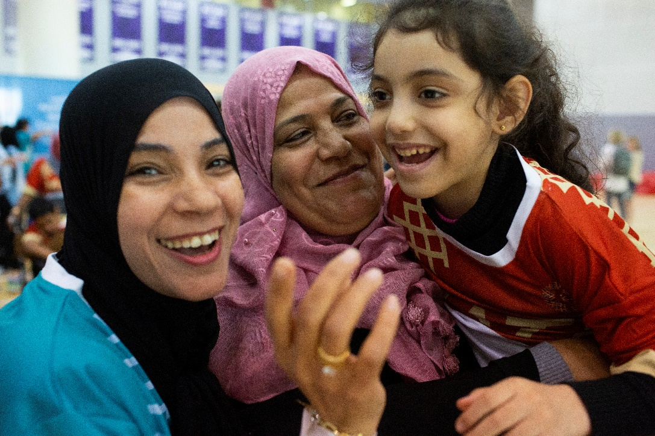

|  |  |
| --- | --- |
|  | **Thinking about your own needs, desires, and the future, and be scary and confusing. You may wonder what will happen when your parents get older and what that will mean for you. Who will support your sibling with ID if they need it? It is important to ask this question and to start this conversation.**  Think about your own boundaries and preferences. Not every sibling will become a caretaker and that is okay. Others may decide to take on that role. It is normal to feel both grateful and uncertain. That uncertainty can be eased with proper preparation. When you feel prepared, you will feel more confident.  Talking with your parents or caregivers early can help answer your questions. The following activities are to help you through these conversations. |

|  |  |
| --- | --- |
|  | “Since I am a unified partner with my team, [my brother] calls me and supports me. And when he is in his competition, I am the one who goes and supports him. **So, it is a mutual support and I think it is very positive**.” |

**Activity: Prepare the Conversation**

|  |  |  |
| --- | --- | --- |
| Make a list of questions you hope to get answered. You can also write down specific topics or situations you want to address. Use the document on the next page to help you plan this conversation.  **Guiding phrases:**  By the end of this conversation, I hope to feel…  By the end of this conversation, I hope to know… |  | Identifying your goals can help you guide the conversation. |

|  |  |  |
| --- | --- | --- |
| Write down ways you can bring up this topic. What feels most natural and comfortable to you?  Communicating with your family is a very personal thing, so what feels comfortable to you, may not be the same for someone else. |  | Starting the conversation  can feel like the hardest part. |

|  |  |  |
| --- | --- | --- |
| **Option 1** |  | **Option 2** |
|  |  |  |

|  |  |  |  |  |  |  |
| --- | --- | --- | --- | --- | --- | --- |
| **Playbook with solid fill** |  | | | | |  |
|  | **CONVERSATION**  **PLANNING** | | | | |  |
|  |  | | | | |  |
|  | **Date of conversation:** |  | | |  |  |
|  |  | | | | |  |
|  | **People you want to speak with:** | | | | |  |
|  |  | | | | |  |
|  |  | | | | |  |
|  | **Topics** | |  | **Questions** | |  |
|  |  | |  |  | |  |
|  |  | |  |  | |  |
|  | **Notes** | | | | |  |
|  |  | | | | |  |
|  |  | | | | |  |

**Activity: Planning for the future**

**Ways to end the conversation with an action plan**

This may be the first conversation in a long line of conversations you will have with your family. It is important to remember that your family may not have all the answers to your questions. However, you can work with your parents or other family members to create a plan on how to proceed.

|  |  |  |  |  |
| --- | --- | --- | --- | --- |
| **01** | Make a list of outstanding questions. |  | **03** | Do some research about topics that you had questions. |
|  |  |  |  |  |
| **02** | Suggest additional times to talk. |  | **04** | Discuss if you all want to include your sibling with ID on these conversations. |

**Helpful Tips on Talking with Family Members**

|  |  |  |
| --- | --- | --- |
|  | **Be clear and direct** |  |
|  | Express what you are feeling and thinking. Being specific can help parents understand your point of view better. |  |
|  |  |  |
|  | **Try to understand their point of view** |  |
|  | Remember you are all on the same team and want the best for your sibling. Your parents may have a different perspective but that doesn’t mean you are wrong. Try to be open to their thoughts and help them be open to yours. |  |
|  |  |  |
|  | **Use a tone that is kind and respectful** |  |
|  | It will make your parents take you and what you have to say more seriously. Try to remain calm and collected. Do not let your emotions overwhelm you. This could lead to an argument instead of a productive conversation. If you feel you are getting angry or frustrated, remember the container visualization. |  |

|  |  |
| --- | --- |
|  | YOU AND **YOUR COMMUNITY** |

|  |  |
| --- | --- |
|  | **How can I share information to help my community understand disabilities?**  You have a unique experience in having a sibling with an intellectual disability (ID). You understand how to communicate and interact with individuals with ID in a way that many of your peers and community members do not. Others may believe things about ID that you know are untrue. They may say hurtful things. You may feel sad or angry by the things they believe and say.  It's okay to have these feelings and to express them. You see your sibling for everything you love about them. You see their strengths and abilities. You want other people to see those things, too.  It is important to understand the difference between blatantly offensive comments and other common assumptions people make about people with ID which perpetuate negative stereotypes. Understanding the difference between the two will help you engage in more productive conversations.  Through these activities, you will learn how to address mistaken beliefs and create an inclusive community. |

|  |  |
| --- | --- |
|  | “I feel more responsible because I know that I can help different people to raise awareness and include people with disabilities.” |

**Expressing your thoughts to start a constructive conversation**

|  |  |
| --- | --- |
| **Background** |  |
| While sometimes it is easy to blame those who do not understand, it can lead to them becoming defensive. Sharing your emotions can lead to a more positive conversation about disability and your sibling. |  |
| **I Feel Statements** |  |
| I Feel Statements are a simple way to help the speaker avoid placing blame on someone else while also expressing their feelings. |  |

|  |  |  |
| --- | --- | --- |
| **I FEEL statement: structure** |  | **Example** |
| **I feel** ______  *(emotion)*  **when you** _____  *(action/word)*  **I would like for you to** _________  *(what you would like them to learn/know)* |  | Instead of saying “You said my sister can’t learn to ride her bike and you are wrong!” you can use an “I feel statement” and say “I felt sad when you said my sister couldn’t ride a bike. I would like for you to know that she is learning how to ride a bike and is getting good! People with ID can do many things!" |

**Activity: Fill in the next scenarios with how you would feel.**

|  |
| --- |
| **SITUATION 1** |
| Carol: People with intellectual disabilities can’t play sports, I don’t want them playing on our team. |

**Your response:**

|  |
| --- |
| *I feel* |
| *when you* |
| *I would like for you to* |

|  |
| --- |
| **SITUATION 2** |
| Your uncle is waiting for your sibling to tie their shoes, but it is taking a bit longer than expected.  “I’ll just do it; it is taking forever!". |

**Your response:**

|  |
| --- |
| *I feel* |
| *when you* |
| *I would like for you to* |

**Helpful tips to educate others in a meaningful and positive way**

|  |  |  |  |  |
| --- | --- | --- | --- | --- |
| **01** | **Think Before You Speak** |  | **03** | **Have Mutual Respect** |
| Take a pause before responding to a feeling and think through your choices. |  | Be respectful when correcting the other  person. Then, they will be more likely to listen to what you have to say. |
|  |  |  |  |  |
| **02** | **Have an Open Conversation** |  | **04** | **Educate. Do Not Judge** |
| Try asking the other person questions about what they mean or why they would say something that you know is incorrect or offensive. Listen to understand. This will help the other person feel comfortable asking questions and understand your point of view. |  | Use other sentence starters that avoid  judgment and guide the other person toward a new belief.  "In my experience”  “What I found to be true” |

**Activity: Common beliefs about people with ID**

In this activity, you will write down common misconceptions that you have heard about people with intellectual disabilities and then write how you would respond.

|  |  |  |
| --- | --- | --- |
| **Mistaken Beliefs** |  | **Your Response** |
| **Example:**  People with ID can't play sports |  | **Example:**  Everyone can play sports with the proper equipment and support |
|  |  |  |
|  |  |  |
|  |  |  |

**Finding your community and network**

You are not alone. There are others in your community who are advocating for people with ID. Together, you can all change the perspectives of society.

Finding your community can be a bit imitating if you don’t know where to look. Here are some ways you can find a community:

|  |  |
| --- | --- |
|  | **Join a Special Olympics Unified Sport Team** |
|  |  |
|  | **Apply for a Special Olympics Youth Activation Committee Position** |
|  |  |
|  | **Find clubs at school with students who have the same interest as you** |
|  |  |
|  | **Reach out to members of your community like counselors or religious leaders** |

**Ways to create inclusive communities with your network of friends**

|  |  |
| --- | --- |
|  | Together you and your network can spread inclusion through schools and other areas of your community!   * Hold a week of inclusion to your school * Partner with a local art organization to host an inclusive art show * Post a message or photo on Facebook sharing why inclusion is important to you or what you do with Special Olympics * Create a club that connects siblings of people with ID together * A qr code on a white background    Description automatically generatedScan the code to learn more about how to create an inclusive community! |

**Resources**

|  |  |
| --- | --- |
| **Resources for you** | |
| * [Special Olympics Sibling Guide](https://media.specialolympics.org/resources/community-building/youth-engagement/Program-Guidebook-Sibling-Youth-Engagement-English.pdf?_ga=2.243808455.373835062.1637698796-1987224568.1637340321) |  |
| * [COVID-19 Adaptation Strategies for Siblings](https://b08dcac7-9670-40db-8b53-6b2b8809566f.filesusr.com/ugd/4d8a8a_09590d81e0204d0d8425a73785655f14.pdf) |  |
| * [Self-Care Strategies for Siblings](https://media.specialolympics.org/resources/community-building/youth-engagement/Self-Care-Strategies-for-Siblings.pdf?_ga=2.21886201.373835062.1637698796-1987224568.1637340321) |  |
| * [Strong Minds Activity Cards](https://media.specialolympics.org/resources/health/disciplines/strongminds/Strong-Minds-YA-Activity-Cards-08-2020.pdf) |  |
|  |  |
| **Resources for your family** |  |
| * [A Parent’s Guide for supporting Siblings](https://media.specialolympics.org/resources/community-building/youth-engagement/Parent-Sibling-Youth-Engagement-Guidebook-2019-English.pdf) |  |
|  |  |
| **Additional General Sibling Engagement Resources** | |
| * [Special Olympics Sibling Resources Website](https://resources.specialolympics.org/community-building/families/sibling-engagement) |  |

**Conclusion**

|  |
| --- |
| Through this workbook, you have been given the introductory skills to prioritize your mental and emotional health, effectively communicate with family members, respectfully educate the public on ID and identify ways to find a support network within your community.  Congratulations on the completion and thank you for the love and support you provide your sibling with ID. You are now more equipped with the tools and knowledge to live a positive healthy life. |