A Warm Welcome to
the Special Olympics Movement

On behalf of the Special Olympics community, it is with great joy and enthusiasm that I extend a heartfelt welcome to you and your family as you embark on a remarkable journey with us in the world of sports.
We understand that joining Special Olympics is a significant step, and we are thrilled to have you become a part of our close-knit family. This movement is built upon the foundation of inclusivity, empowerment, and love for every individual, and we are confident that you will find it to be a place of warmth, acceptance, and growth.
We encourage you to actively participate in events, training sessions, and community activities that are an integral part of the Special Olympics experience. These opportunities will not only bring immense joy but will also help your family members grow physically, socially, and emotionally.
As you navigate this journey, please know that we are here to support you every step of the way. Our dedicated team and fellow families are always available to offer guidance, answer questions, and share experiences to ensure a smooth and enriching experience for all.
Together, let us champion the cause of unity, acceptance, and empowerment through the power of sport!

Sincerely,

Special Olympics (insert Program/Region name)

Get to know us!

 |  |  |  | FAMILY ENGAGEMENT
 |  |  |  | 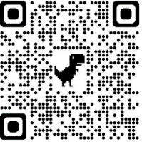 | Families are the number one fans of our Special Olympics athletes. They offer a unique type of support, love, and encouragement that no one else can. Special Olympics is a support network that brings families together in a caring, positive way—and that makes the cheers for our athletes even louder!
 | 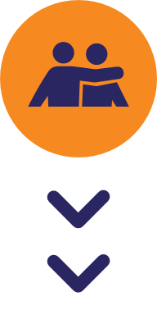
 |  |  |  | SIBLING RESOURCES
 |  |  |  | 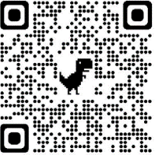 | Siblings are connectors of three groups central to our movement: athletes, families, and youth. Through Special Olympics, siblings can find a supportive community, a platform to share their experiences, and an opportunity to develop as leaders. This section will provide resources for youth-age siblings of individuals with intellectual disabilities.
BECOMING A SPECIAL
OLYMPICS ATHLETE
 |  |  |  | 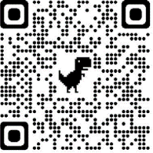 | Athletes are the heart of Special Olympics. Our athletes are children and adults with intellectual disabilities from all around the world. They are finding success, joy, and friendship as part of our global community.  They're also having lots of fun!
 |  |  |  | BECOMING A COACH
 |  |  |  |  | Was there a mentor, teacher or coach who made a difference in your life? The one who gave you the courage and determination to strive to be your best? The one who helped shape both your performance and your character? You can be that important person in someone else's life.

 |  |  | HEALTHY ATHLETES
 |  |  | 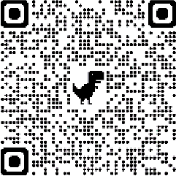 | Special Olympics Healthy Athletes® offers health screenings and education to Special Olympics athletes in a welcoming, fun environment. We offer health screenings in eight disciplines:
 |  |  |  | - MedFest (history and physical exam)  - Healthy Hearing (audiology)  - Opening Eyes (vision/eye health)  - Fit Feet (podiatry) |  | - Health Promotion (prevention and nutrition)  - Special Smiles (dentistry)  - Strong Minds (emotional health)  - FUNfitness (physical therapy)
 |  |  | BECOME AN OFFICIAL
 |  |  |  | Special Olympics sports officials ensure adherence to the rules and safe competition and are necessary to ensure the integrity of the sport.
 |  | 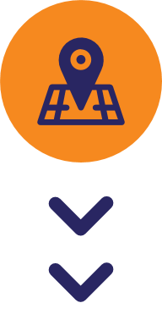 | JOIN A LOCAL PROGRAM
 |  |  | 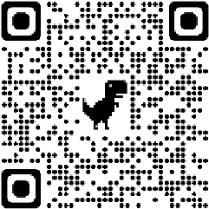 | A Local Program is simply local branch of the Special Olympics National/State Program. A Local Program is open for anyone to become a member—people with and without intellectual disabilities, their families, and volunteers from all backgrounds. It is at the Local Program grassroots level of the movement where communities of inclusion are built, and everyone’s abilities are appreciated. Click the QR code to learn how to join or start a Local Program in your city!
 | UNIFIED LEADERSHIP  Building from sport, Unified Leadership teaches leaders without disabilities to value and learn from people with intellectual disabilities to create environments where people with intellectual disabilities have meaningful jobs and roles. |  |  |  | UNIFIED SCHOOLS  Unified Schools begin with Special Olympics Unified Sports® to build inclusive school communities for people of all abilities. Unified Schools creates an environment where everyone feels welcome, valued, and included both in school and in their local community. |  | UNIFIED SPORTS  Special Olympics Unified Sports® is an inclusive sports Program that combines an equal number of Special Olympics athletes (individuals with intellectual disabilities) and partners (individuals without intellectual disabilities) on teams for training and competition.
 | 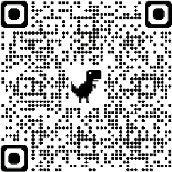 |  |  |  | 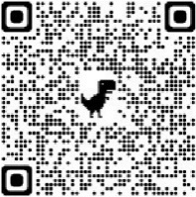 |  | 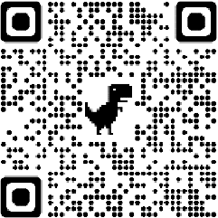

 |  |  | ATHLETE LEADERSHIP
 |  |  | 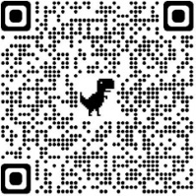 | If we want a more inclusive organization and accepting world, Special Olympics athletes must be allowed to contribute in ways beyond the sports field. One of the most powerful ways we do this is through Athlete Leadership, which creates opportunities for people with intellectual disabilities to develop and demonstrate their abilities in leadership roles.
 |  | 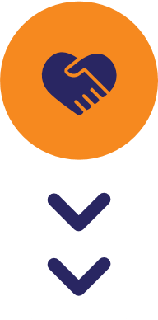 | BECOME A VOLUNTEER
 |  |  | 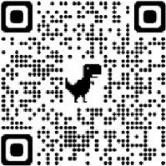 | Volunteers are the backbone of the Special Olympics Government. They are coaches, trainers, officials, event organizers, fundraisers and managers. They can also be unified partners—playing alongside athletes with intellectual disabilities—or fans cheering in the stands.
 |  |  | YOUNG ATHLETES
 |  |  | 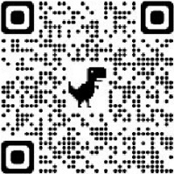 | Young Athletes welcomes children and their families into the world of Special Olympics by showing how all children can be valued for their talents and abilities.
 |  | 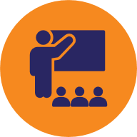 | YOUTH AND SCHOOLS
 |  |  |  | Our work aims to empower young people, educators, coaches, and families as leaders of inclusion, starting in their local schools and communities around the world.
Special Olympics Oaths
- ATHLETE OATH
“Let me win, but if I can not win, let me be brave in the attempt.”
- VOLUNTEER OATH
“I promise to support Special Olympics not just as an expression of charity, but as a form of respect for my fellow human beings. I promise to spread the word of volunteerism because in giving, I receive so much more in return.”
- COACHES OATH
“In the name of all coaches and in the spirit of sportsmanship, I promise that we will act professionally, respect others, and ensure a positive experience for all. I promise to provide quality sports and training opportunities in a safe environment for all athletes.”

Special Olympics Structure
SPECIAL OLYMPICS INTERNATIONAL
- Provides global resources.
- Guides overall strategic direction.
- Accredits National and State level Special Olympics Programs.
- Organizes global events and Games.
SPECIAL OLYMPICS REGION
- Supports implementation of SOI rules & policies regionally.
- Supports development and roll-out of Special Olympics resources.
- Provides support to National and State Programs in the Region.
- Organizes Regional events and Games.
SPECIAL OLYMPICS NATIONAL / STATE PROGRAM
- Organizes national, state, and local events and Games.
- Often is divided into sub-Programs (by province, county, or similar geographic area within Country/State).
- Provides Local Programs with guidance, support, information, resources, policies, and procedures.
LOCAL PROGRAM
- Organizes Special Olympics in a local community.
- Engages athletes, families and siblings, coaches, and volunteers.
- Organized according to Accredited Program rules and this guide.

