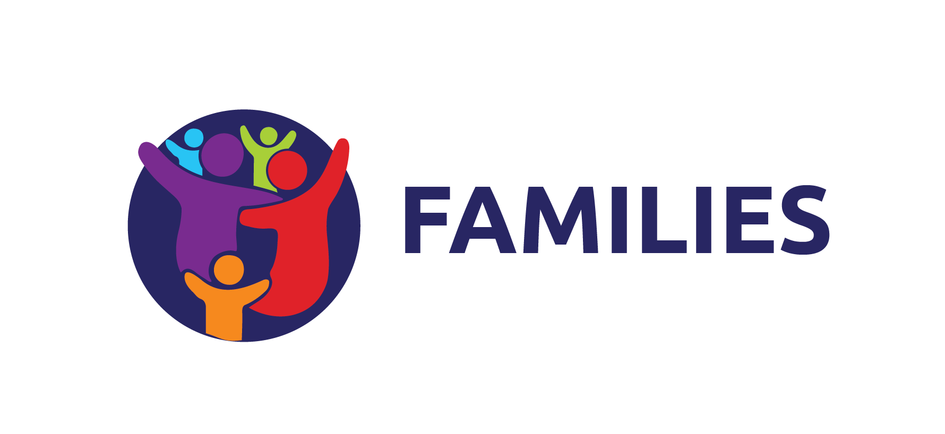
Phase 2 Family Engagement Strategy
Local program implementation guide
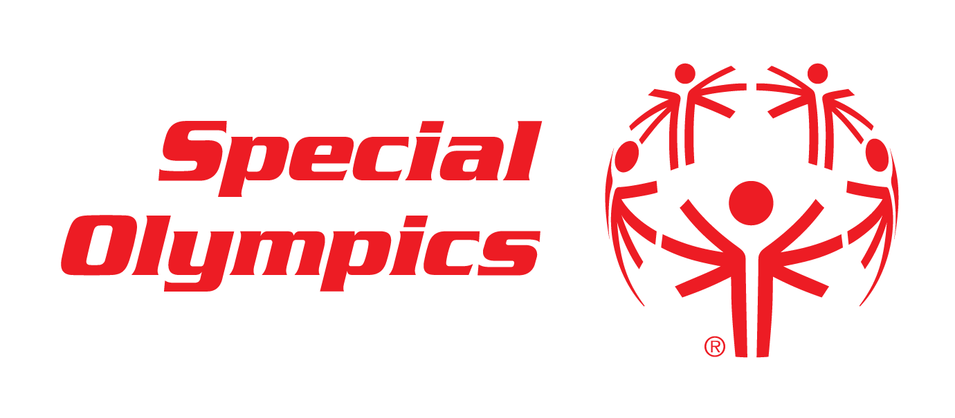

Purpose
The Family Engagement Strategy provides a framework for strengthening family engagement across Special Olympics Programs. It moves family engagement from individual activities to a coordinated approach that helps families experience belonging, build connections, develop skills, and contribute to the movement.

The Three Strategic Pillars
ENGAGE | Create opportunities for families to connect, support one another, and build a sense of belonging through Special Olympics.  Examples: Family Support Networks, Family gatherings and forums, Family activities at competitions, Peer-to-peer support opportunities

EDUCATE | Provide families with information, resources, and learning opportunities that help them support their athletes and grow their confidence.  Examples: Family workshops, Family health education, Parent and caregiver resources, Coach certification opportunities

EMPOWER | Support families to become leaders, advocates, storytellers, and mobilizers for inclusion.  Examples: Family Leadership Councils, Advocacy initiatives, Storytelling campaigns, Family volunteer leadership roles

Implementing this Strategy
Step 1: Review Your Existing Family Activities
Ask:
- What family activities already exist in our Local Program?
- Which pillar does each activity support: Engage, Educate, or Empower?
- Are there opportunities to strengthen or expand impact?

Step 2: Identify Gaps
Consider:
- Are families connected to one another?
- Do families have access to learning opportunities?
- Are families helping lead, advocate, or mobilize others?
Not every Program needs activities in all areas immediately, but Programs should work toward a balanced approach across the three pillars.

Step 3: Build on Current Strengths
Start with what already exists.
- A family gathering can become the foundation of a Family Support Network.
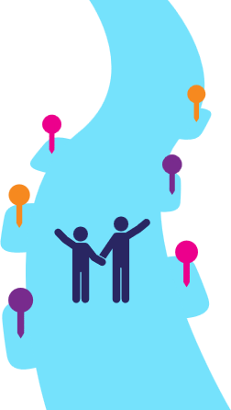
- A parent training can be expanded into an ongoing learning series.
Awareness
Participation
Connection
Contribution
Leadership
Mobilization
- Active family volunteers can be developed into Family Leaders.

The Family Belonging Journey
Families engage with Special Olympics in different ways and at different times. Our goal is not to move every family along the same path, but to create opportunities for belonging, education, and leadership throughout their journey.
When planning activities, consider how they support families who are:
- New to Special Olympics (Awareness)
- Participating in programs and events (Participation)
- Building relationships (Connection)
- Contributing skills and experiences (Contribution)
- Taking on leadership roles (Leadership)
- Inspiring and activating others (Mobilization)

Start with Existing Resources
The Family Resources page should be your first stop when planning family engagement activities. It contains tools, guidance, training materials, stories, and best practices that can support implementation of the Phase 2 Family Engagement Strategy.
FAMILY RESOURCES: Visit the Special Olympics Family Resources page

What Success Looks Like
Programs are encouraged to:
- Increase meaningful opportunities for family engagement
- Create pathways for family leadership
- Elevate family voices and stories
- Strengthen support networks for families
- Collect data and feedback to understand impact

Key Question
How does this activity help families feel connected, supported, informed, or empowered?
If the answer aligns with one or more pillars of the strategy, the activity is contributing to the Phase 2 Family Engagement Strategy.
Programs should not need to implement every component of the strategy at once. Start with current strengths, identify opportunities for growth, and use the Family Resources page as the primary source for tools and guidance. Quality growth is key.

Need Support?
For additional support, contact your Special Olympics Region’s Family Engagement team.

