Family Leader Training
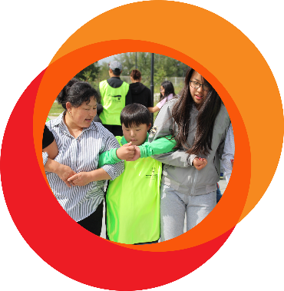
Welcome to the Family Leader Training!
Participation Guide
Family Leader Training
Parents, Caregivers & Siblings

Family Leaders,
Welcome to the Family Leader Training Participation Guide! Thank you for dedicating your time to growing as a leader in Special Olympics.
This guide accompanies the Family Leader Training that you will undertake.
As Family Leaders, you will have the opportunity to increase family engagement locally, which will support the growth of your Special Olympics Program and athlete participation. Family Leaders are unique because they actively carry our family engagement activities and strategies through action. This differs from the Family Leadership Council, which focuses on strategy and idea creation.
In preparation for the training, please gather information on the goals of your local Special Olympics Program for the year. During the training, you will have an opportunity to create an Acton Plan that will prepare you to contribute to these Program goals.
In this training, you will explore the following topics:
- Introduction to Special Olympics
- What is a “Leader”
- What is a “Family Leader”
- Telling Stories of Impact or Sibling Engagement (siblings only)
- Creating an Action Plan
You can follow along with the training through this Participation Guide, take notes, and carry your knowledge with you once the training concludes.

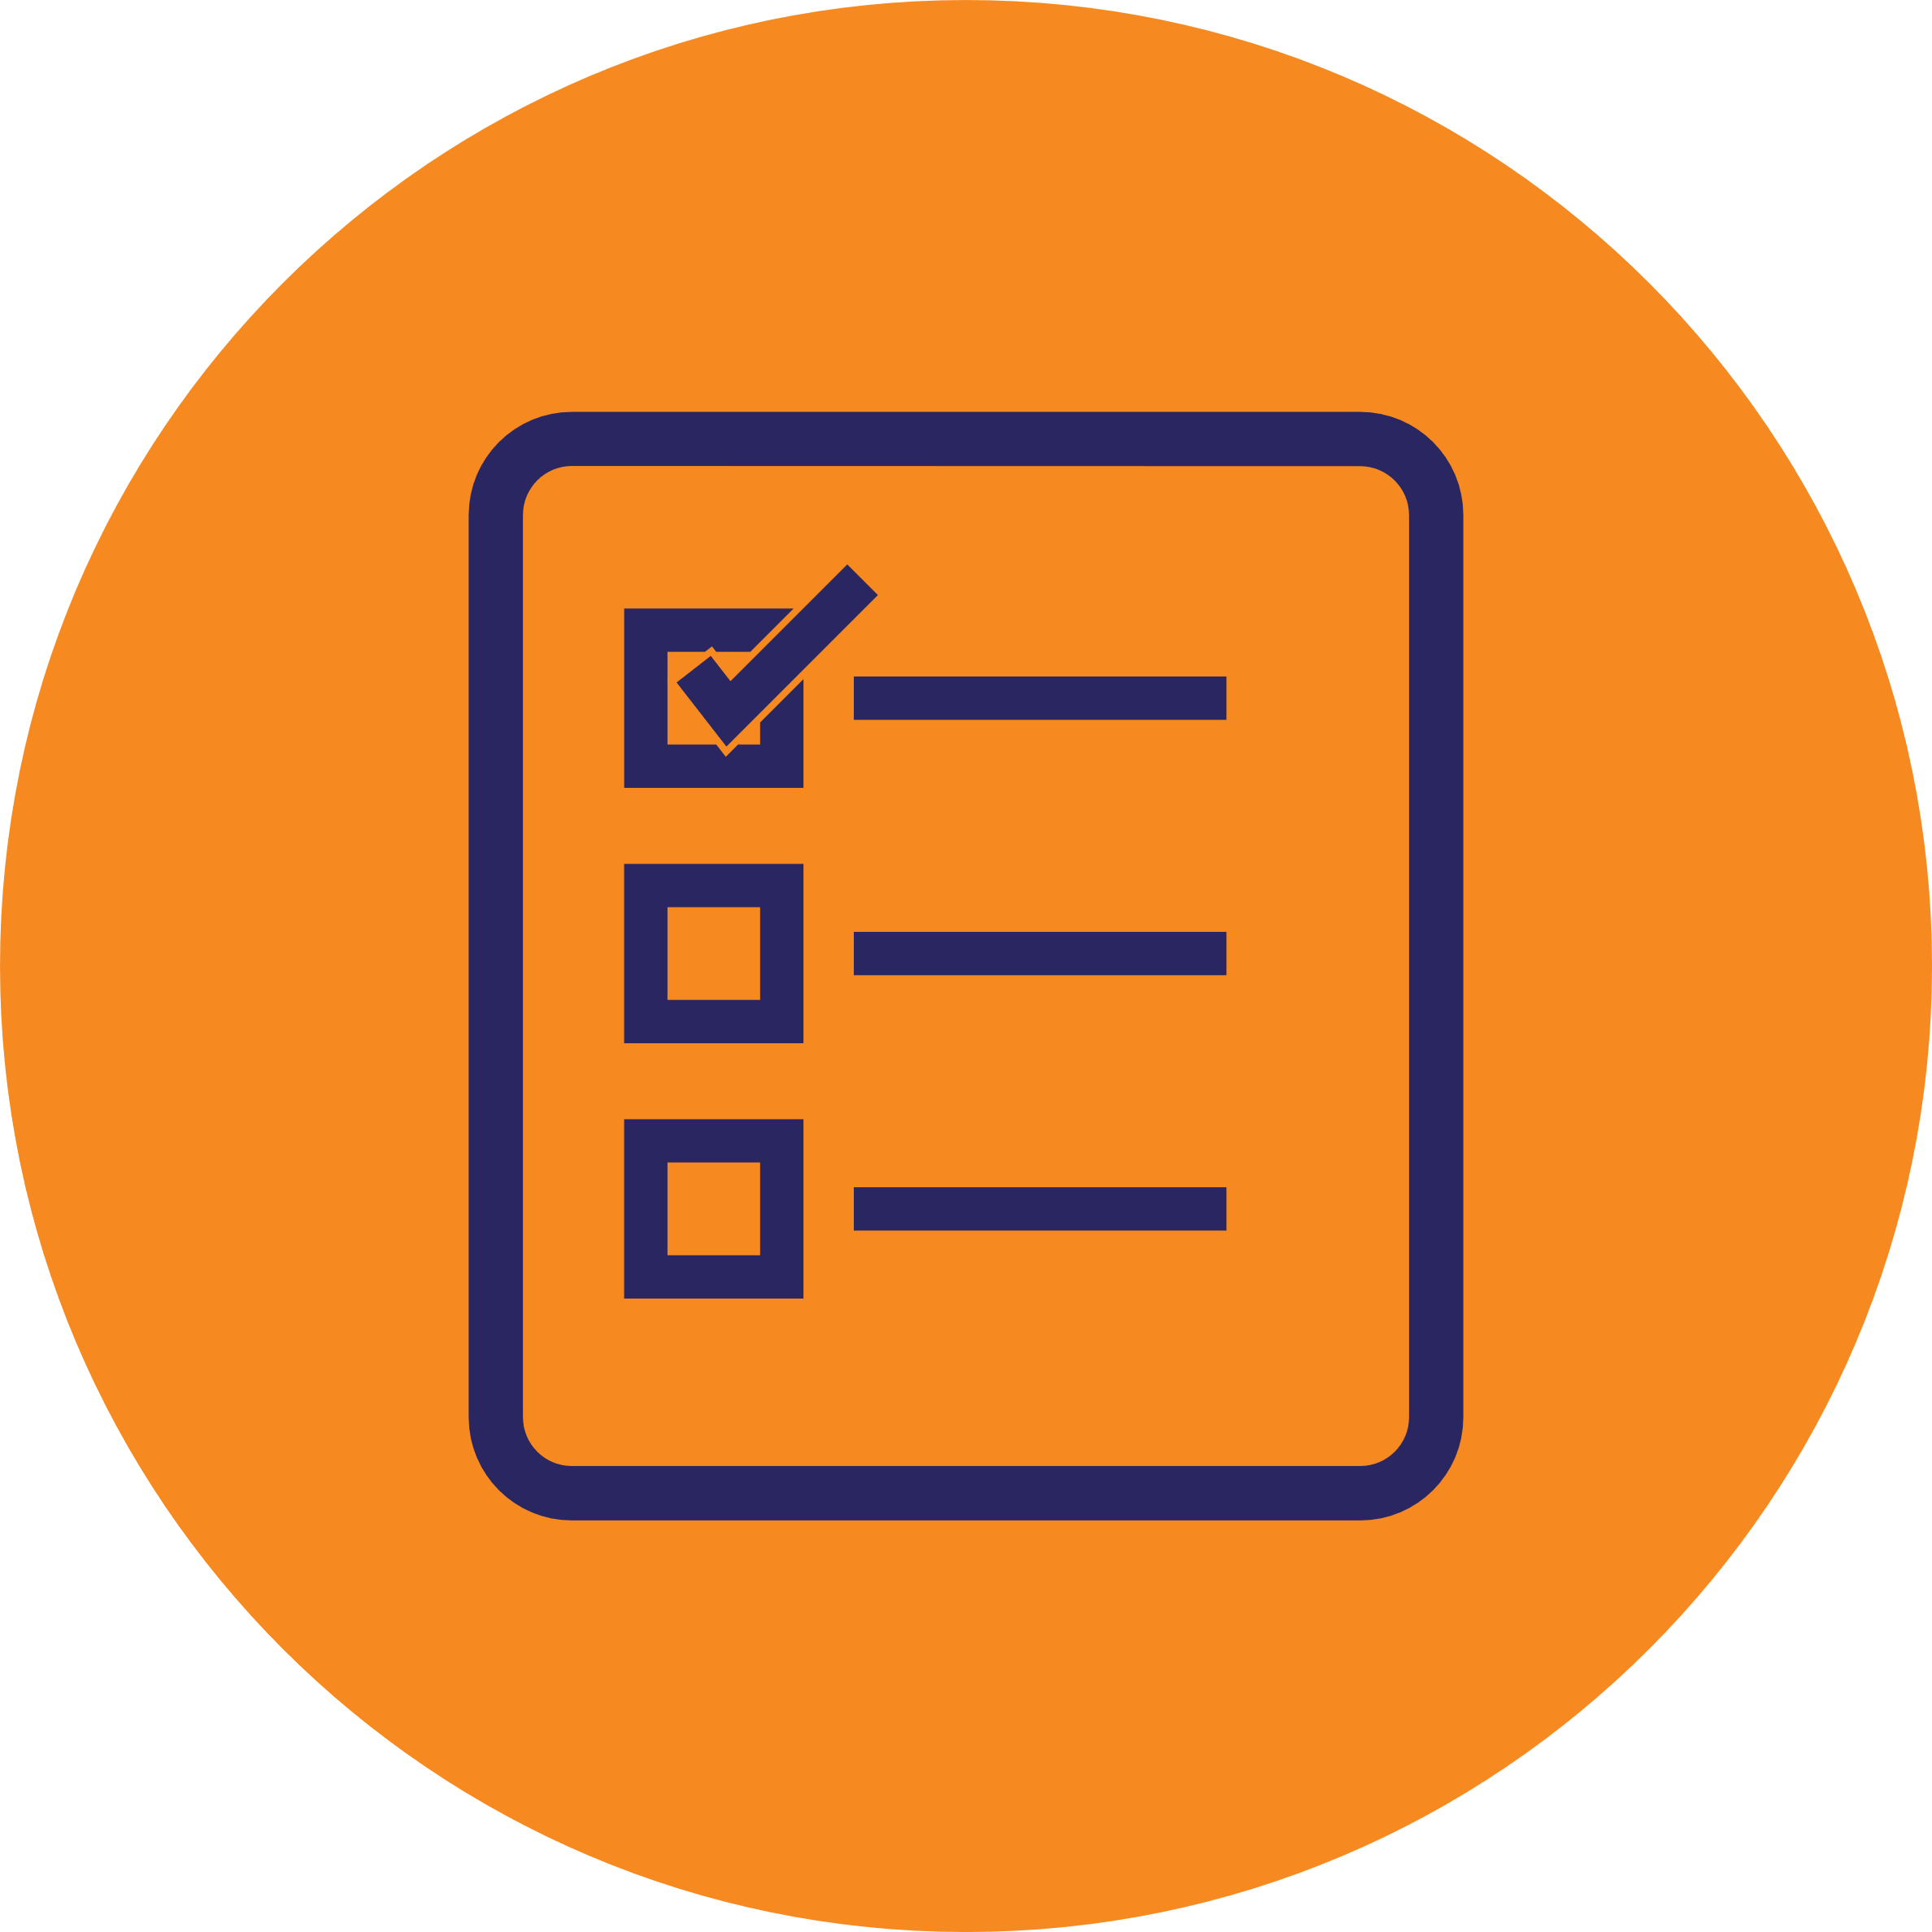
Family Leader Training:
Optional Initial Family Well-Being Survey
Thank you for joining the Family Leader Training! Your strengths will contribute greatly to the success of our global inclusion movement.
Below, you will find an optional survey on family well-being, as part of the Special Olympics social-emotional well-being initiative. You will complete the same survey twice: before and after the Family Leader Training. If you opt to complete the initial survey, we kindly request that you also fill out the final survey.
Participation is voluntary, and your information will remain anonymous. If you opt to participate, you will be asked to provide optional demographic information in the initial survey. You may choose not to provide demographic information, but you will be asked to complete the Family Well-Being Scale before submission.
Your responses will be invaluable in identifying how Special Olympics can best support family well-being in the future.
This survey is expected to take approximately five minutes of your time. Thank you for your participation.

Family Well-Being Scale
Listed below are family members’ feelings when caring for their child with developmental disabilities.
Please indicate if you share these feelings by circling one of the 10 boxes between the two extremes shown.
For example, a score of 1 to the health item would mean you feel your health is very poor. A score of 10 would mean your health is very good. If you feel your health falls somewhere in between, then select a number from 2-9.
Do not think too long over your answer—it is your first reaction we want.
Overall, my health is poor | 1 | 2 | 3 | 4 | 5 | 6 | 7 | 8 | 9 | 10 | Overall, my health is good
Feeling Down | 1 | 2 | 3 | 4 | 5 | 6 | 7 | 8 | 9 | 10 | Feeling great
Feeling Stressed | 1 | 2 | 3 | 4 | 5 | 6 | 7 | 8 | 9 | 10 | Relaxed
I have no friends or others who provide support to me | 1 | 2 | 3 | 4 | 5 | 6 | 7 | 8 | 9 | 10 | I have friends or others who provide support
I find it difficult to look after my child | 1 | 2 | 3 | 4 | 5 | 6 | 7 | 8 | 9 | 10 | I enjoy looking after my child
I find it hard to manage the day-to-day tasks of running a home | 1 | 2 | 3 | 4 | 5 | 6 | 7 | 8 | 9 | 10 | I can manage the day-to-day tasks of running a home
I spend most of my time in the house | 1 | 2 | 3 | 4 | 5 | 6 | 7 | 8 | 9 | 10 | I get out and about when I want to
Overall, my quality of life is poor | 1 | 2 | 3 | 4 | 5 | 6 | 7 | 8 | 9 | 10 | Overall, my quality of life is good

Demographic Questions
Listed below are demographic questions. If you choose not to answer, you may submit your response without providing this information. Please circle your response.
- What gender do you identify as?
- Male
- Female
- Non-binary / third gender
- Prefer not to say

- What is your age?
- 0 - 15 years old
- 15 - 30 years old
- 30 - 45 years old
- 45+
- Prefer not to say

- What is your marital status?
- Single, never married
- Married or domestic partnership
- Widowed
- Divorced
- Separated
- Prefer not to say

- What is your ethnicity?
- White
- Black
- Hispanic
- East Asian (Chinese, Japense, Korean, etc.)
- South East Asian
- West Asian (Arab, Iranian, etc.)
- First Nations
- Other: ____________________________
- Prefer not to say

- What is the highest degree or level of education you have completed?
- Some High School
- High School
- Bachelor's Degree
- Master's Degree
- Ph.D. or higher
- Vocational School
- Prefer not to say

- What is your annual household income?
- Less than $25,000
- $25,000 - $50,000
- $50,000 - $100,000
- $100,000 - $200,000
- More than $200,000
- Prefer not to say

- What is your current employment status?
- Employed Full-Time
- Employed Part-Time
- Seeking opportunities
- Retired
- Prefer not to say

 | Activity (1.1.)
 | 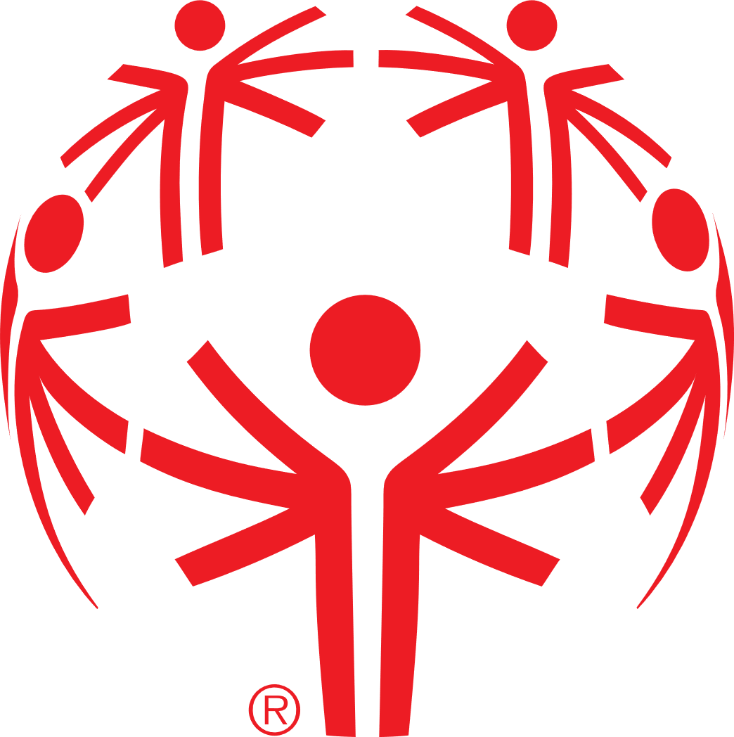 | - What does our logo represent to you?

Activity (1.1.)
What resonated with you?
- What aspects of the history of Special Olympics resonated with you most and why?
- In what ways do you think the history of Special Olympics has led the shift in perceptions and attitudes towards people with ID?
- Can you share any personal experiences that relate to this?

Activity (1.2.)
Who is a Leader?
Think about a leader you know.
It can be someone in Special Olympics, your community, or in the media.
- Who are they?
- What inspires people to follow this person?
- What behaviors or skills do they have that you see reflected in your own leadership?

Reflection (1.4.)
Strengths Evaluation
- How can these diverse strengths be combined and utilized to enhance family leadership in Special Olympics?

Sibling Activity (1.4.)
Iceberg Identity
- How do the above the surface characteristics impact us as Family Leaders?
- How do the below the surface characteristics impact us as Family Leaders?
- How can we use these icebergs to help us understand each other as leaders?

Activity (1.5.)
Action Plan

Personal Mission
Who are the people who can help me? | What resources do I need?
What challenges might I face? | What are solutions to those challenges?

Activity (2.2.)
Reflections
- What is your Rose?
A highlight, a success, or something positive that you are taking with you from your action plan.
- What is your Thorn?
A challenge you experienced, or something you can use more support with.
- What is your Bud?
New ideas or something you’re looking forward to knowing or understanding more.

Family Leader Training:
Optional Final Survey
Thank you for joining the Family Leader Training! Your strengths will contribute greatly to the success of our global inclusion movement.
Below, you will find an optional survey on family well-being, as part of the Special Olympics social-emotional well-being initiative. You will complete the same survey twice: before and after the Family Leader Training. If you opt to complete the initial survey, we kindly request that you also fill out the final survey.
Participation is voluntary, and your information will remain anonymous.
Your responses will be invaluable in identifying how Special Olympics can best support family well-being in the future.
This survey is expected to take approximately five minutes of your time. Thank you for your participation.

Family Well-Being Scale
Listed below are family members’ feelings when caring for their child with developmental disabilities.
Please indicate if you share these feelings by circling one of the 10 boxes between the two extremes shown.
For example, a score of 1 to the health item would mean you feel your health is very poor. A score of 10 would mean your health is very good. If you feel your health falls somewhere in between, then select a number from 2 to 9.
Do not think too long over your answer—it is your first reaction we want.
Overall, my health is poor | 1 | 2 | 3 | 4 | 5 | 6 | 7 | 8 | 9 | 10 | Overall, my health is good
Feeling Down | 1 | 2 | 3 | 4 | 5 | 6 | 7 | 8 | 9 | 10 | Feeling great
Feeling Stressed | 1 | 2 | 3 | 4 | 5 | 6 | 7 | 8 | 9 | 10 | Relaxed
I have no friends or others who provide support to me | 1 | 2 | 3 | 4 | 5 | 6 | 7 | 8 | 9 | 10 | I have friends or others who provide support
I find it difficult to look after my child | 1 | 2 | 3 | 4 | 5 | 6 | 7 | 8 | 9 | 10 | I enjoy looking after my child
I find it hard to manage the day-to-day tasks of running a home | 1 | 2 | 3 | 4 | 5 | 6 | 7 | 8 | 9 | 10 | I can manage the day-to-day tasks of running a home
I spend most of my time in the house | 1 | 2 | 3 | 4 | 5 | 6 | 7 | 8 | 9 | 10 | I get out and about when I want to
Overall, my quality of life is poor | 1 | 2 | 3 | 4 | 5 | 6 | 7 | 8 | 9 | 10 | Overall, my quality of life is good

