Family Leader Training
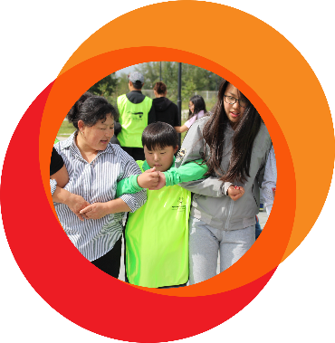
Welcome to the Family Leader Training!
Facilitator Guide
Family Leader Training: Facilitator Guide

Welcome to the Family Leader Training Facilitator Guide! Thank you for dedicating your time to empowering family leadership in Special Olympics.
The “Facilitator script” on each slide will provide you with a general script to follow. The (Facilitator Note:) will also guide you in action. We highly recommend incorporating an Athlete Leader as a co-facilitator throughout the training. We have noted possible slides where collaboration with an Athlete Leader may be helpful with three asterisks. (***)
Please note that the slides, the training, and your facilitation, are flexible and open to adaptations based on your Program and Region. We encourage you to add Program-specific content to make it more relatable to your group of Family Leaders.

Session Outcomes
By the end of this session, participants will:
- Understand Special Olympics.
- Know unique themes of Special Olympics leaders.
- Assess personal strengths and areas of improvement.
- Create an action plan for furthering family engagement.

Tips for Planning a Family Leader Training:
- The course can be divided into multiple sessions. You will need to adapt them to fit your constraints as a Program (time, space, technology, etc.).
- Please read through the facilitator script prior to the sessions to ensure you have the materials needed for each session or activity.
- Program leaders should be advised prior to this training on how to use family leaders.
- The Family Orientation Guide should be sent to family leaders prior to training to account for any gaps in Special Olympics knowledge. It can be found on the family resources page of the SOI website.
- Here are some standards to consider when selecting a potential Family Leader:
  - Should be an existing Special Olympics Family Member
  - Should be willing to support family engagement efforts in their Program.
Agenda Day 1
9:00 – 9:30 | Meet and greet
9:30 – 10:30 | Introduction to Special Olympics
10:30 – 11:00 | Fitness Energizer + Independent Break
11:00 – 11:30 | What is a “Leader”?
11:30 – 12:00 | What is a “Family Leader”?
12:00 – 13:00 | Lunch Break + Fitness Energizer
13:00 – 14:00 | Telling Stories of Impact + Sibling Engagement Breakout
14:00 – 14:30 | Next-step Planning
14:30 – 15:00 | Fitness Energizer + Independent Break
15:00 – 16:00 | Guest Speaker
Agenda Day 2
9:00 – 12:00 | Field Day
12:00 – 13:00 | Lunch Break
13:00 – 14:00 | Debrief

Length:
Recommended: less than 1 hour per module
Session Materials
PowerPoint Slides, link to participant workbook so participants can download, note cards, pens/markers.

Topic | Script | Slide
DAY ONE
Welcome | Good morning family members. Welcome to our Family Leader Training! This training will equip you to become Leaders within your Program or Region and connect you with other Family Leaders. Thank you for volunteering your time, we are grateful for you! | 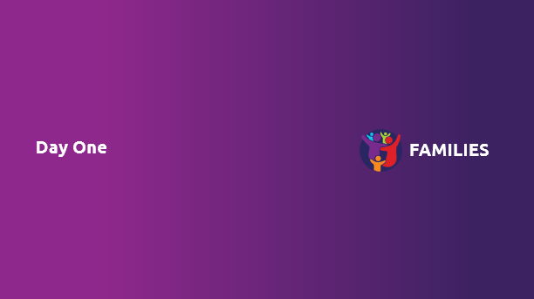
Module  Meet and Greet  Time  30 min | We will first begin by introducing ourselves, and then overviewing the agenda for the next two days together. | 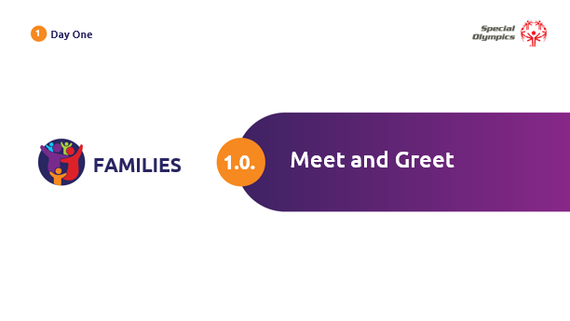
Optional Initial Family Well-being Survey | Before we officially begin, you have the opportunity to take part in an optional Family Well-Being Survey as part of the Special Olympics social-emotional well-being initiative. If you choose to participate, you will complete the same survey twice: before and after the Family Leader Training. If you opt to complete the initial survey, we kindly request that you also fill out the final survey.  Participation is voluntary, and your information will remain anonymous. If you opt to participate, you will be asked to provide optional demographic information in the initial survey. You may choose not to provide demographic information, but you will be asked to complete the Family Well-Being Scale before submission.  Your responses will be invaluable in identifying how Special Olympics can best support family well-being in the future.  This survey is expected to take approximately five minutes of your time.  You will find the initial survey in your Family Leader Training: Participation Guide, but you can also choose to scan the QR code on the next slide to take the survey electronically.  I will now give you around five minutes to fill in the survey, should you wish to participate! | 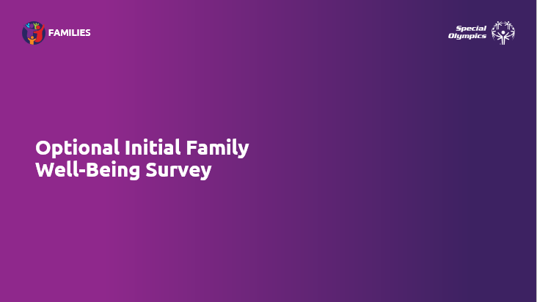
Optional Initial Family Well-being Survey – QR CODE | If you have chosen to participate and wish to do so electronically, here is the QR code | 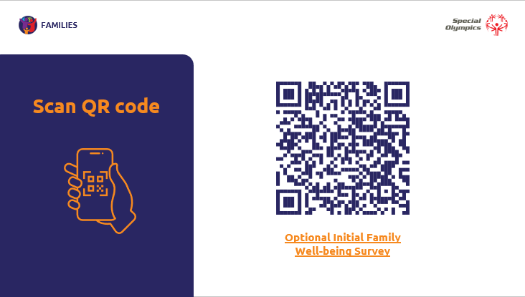
Personal introductions | ***Athlete participation recommended  Let’s begin by introducing ourselves. Please include your name, details about your involvement in Special Olympics, and the best thing that’s happened to you recently. I will begin! | 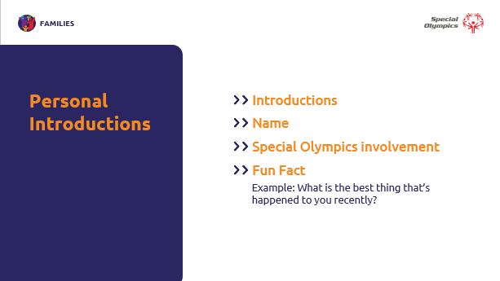
Meeting Agenda | Thank you for sharing!  Over the next two days, we will have further opportunities to get to know Special Olympics, ourselves, and each other better.  Here is our agenda for Day One.  - Our morning will include an introduction to Special Olympics, followed by a fitness energizer and independent break.  - We will then discuss what a “Leader” and “Family Leader” is, followed by a lunch break.  - In the afternoon, our siblings will attend a “Sibling Engagement” workshop, while other family members attend the “Telling Stories of Impact” workshop. We will then come back together for next-step action planning.  - After another short fitness energizer and independent break, we will have a guest speaker to end the day. | 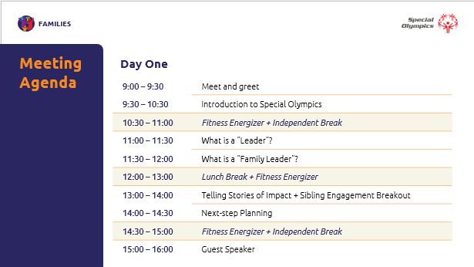
Meeting Agenda | Our second day will consist of our field day activity, time for lunch, and a debrief of our two days together. Let’s get started! | 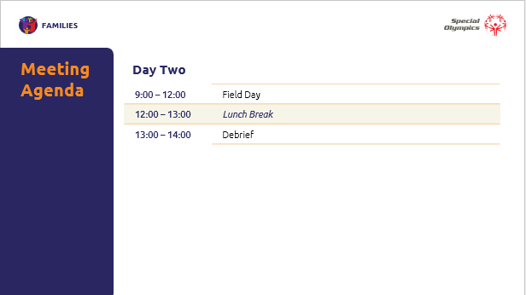
Module  Introduction to Special Olympics  Time  1 hour | Our introduction to Special Olympics module will discuss:  - The origin of Special Olympics  - Our mission statement and logo  - The organizational structure  - Important terms and definitions  - Overview of the United Nations Convention on the Rights of Persons with Disabilities  - and finally, the importance of family involvement.  This background information will be helpful for your general knowledge as a Family Leader. | 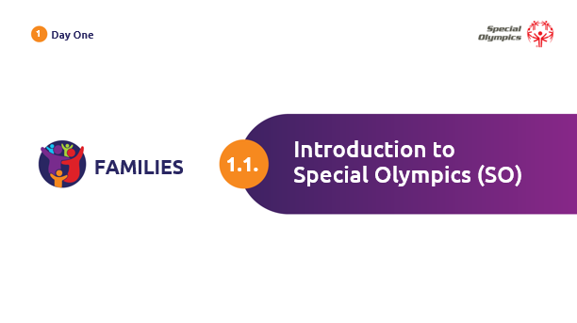
Introduction to Special Olympics  Origin of Special Olympics: Eunice Kennedy Shriver | ***Athlete participation recommended  Let’s begin with a general history of Special Olympics. In 1968, Eunice Kennedy Shriver, founder of Special Olympics, organized a backyard summer camp for people with intellectual disabilities. Eventually, this summer camp transformed into the global Special Olympics movement that we know today.  Eunice Kennedy Shriver was a pioneer in advocating for rights and acceptance for people with intellectual disabilities. She taught the world that sports can change lives.  Here is a short video biography on our founder.  (Facilitator Note: Click on the orange button (Watch a short biography) and make sure to TURN ON closed captioning). | 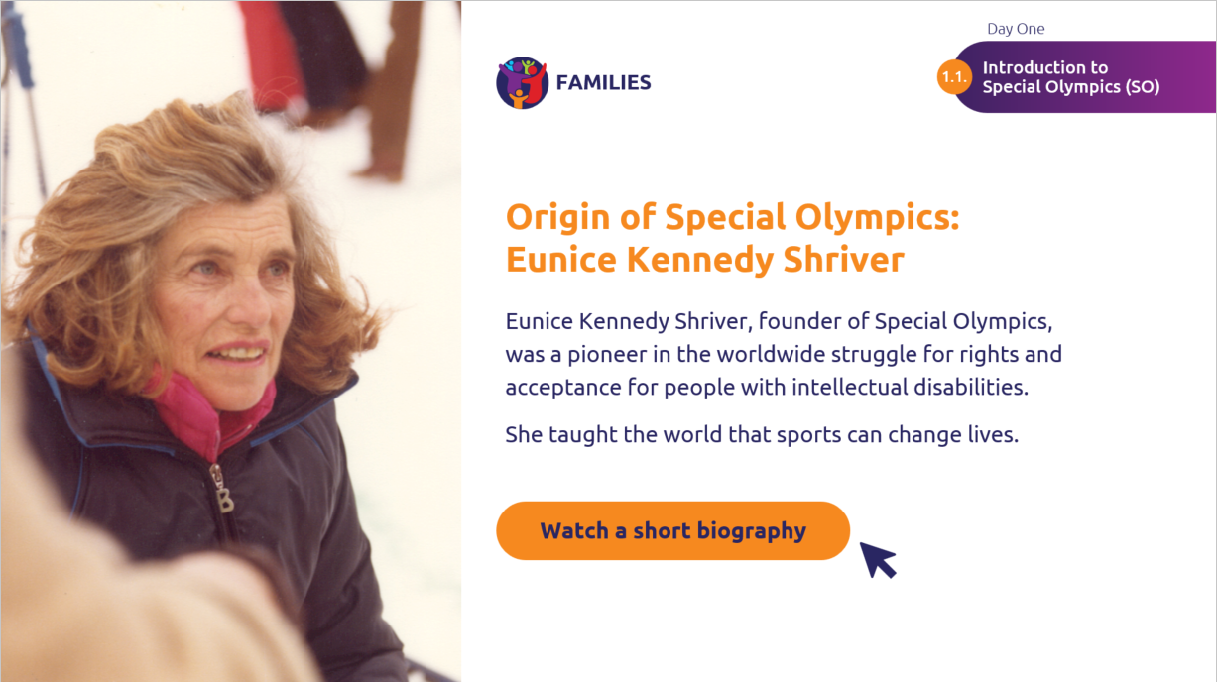
Introduction to Special Olympics  Mission Statement | What is the goal of Special Olympics? Our mission is to provide year-round sports training and athletic competitions for children and adults with intellectual disabilities (ID), giving them continuing opportunities.  These opportunities include developing physical fitness, demonstrating courage, experiencing joy, and participating in a sharing of gifts, skills, and friendships with family members, other Special Olympics athletes, and our communities. | 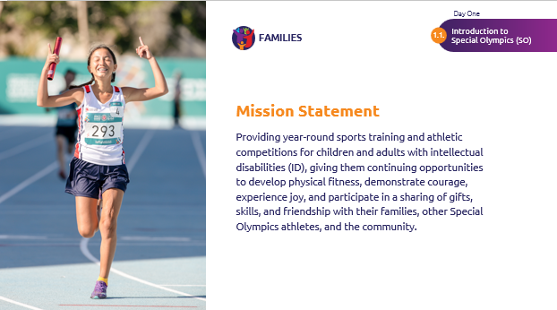
Introduction to Special Olympics  Special Olympics Logo | ***Athlete participation recommended  Have you ever thought about our logo? What does our logo represent to you?  (Facilitator Note: allow time for participation) | 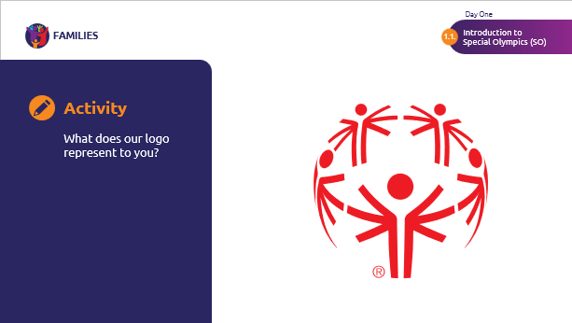
 | ***Athlete participation recommended  Great ideas!  Our logo shows five figures in a unifying circle, which represents our global unity.  Have you noticed that the arms of the figures are in three positions?  The raised arms represent joy and continued realization of ultimate goals. The straight arms represent greater equity and outreach. The lowered arms represent a time before Special Olympics when many people were unaware of the talents and abilities of people with ID. | 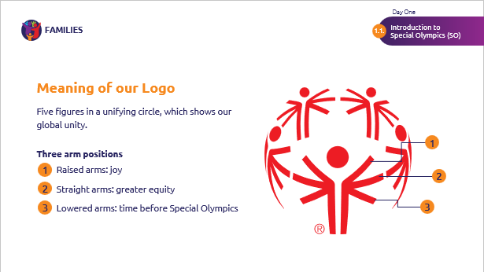
 | ***Athlete participation recommended  And here are some fun facts about our logo.  Did you know that our logo is based on the “Joy and Happiness to All the Children of the World” sculpture in New York? The sculpture was created by President of the Russian Academy of Arts Zurab Tsereteli.  The five pillars represent the five continents who participated in the 1979 Special Olympics World Games. | 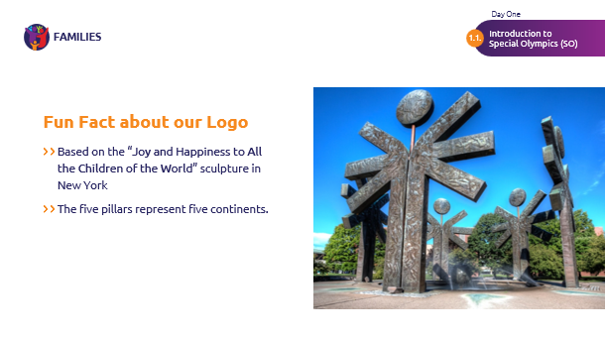
Introduction to Special Olympics  Activity: Introduction to Special Olympics | (Facilitator Note: these questions will encourage participants to share personal reactions and emotional responses to Special Olympics, fostering a deeper connection to the topic, material, and one another.)  Now, we will take a moment to split up into groups of 2-3. We will take 10 minutes to share our personal thoughts on the following question:  - What aspects of the history of Special Olympics resonated with you most, and why?  - In what ways do you think the history of Special Olympics has led the shift in perceptions and attitudes towards people with ID? Can you share any personal experiences that relate to this? | 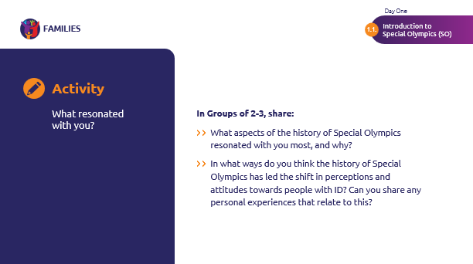
Introduction to Special Olympics  Organizational Structure | Great! Thank you for sharing.  Now we will move onto the structure of the organization. There are many groups of people who work together to make Special Olympics, as we know it, a reality. Here are the main components of our organization: The Board of Directors, Special Olympics International, the Global Leadership Team, the Regional Presidents and Managing Directors, Regions, and Programs.  As we click through the chart, we will learn a bit more about each component. | 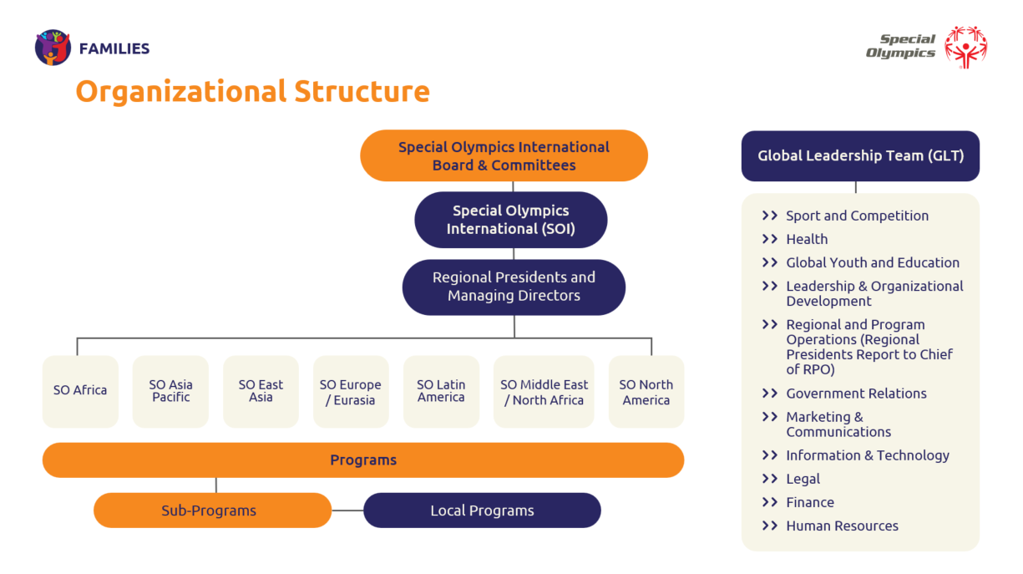
 | The Board of Directors are volunteers, and they work on international policies. They include business and sports leaders, athletes, and educators. Some names you may recognize are Chairman of the Board Timothy Shriver and Chief Inspiration Officer Loretta Claiborne | 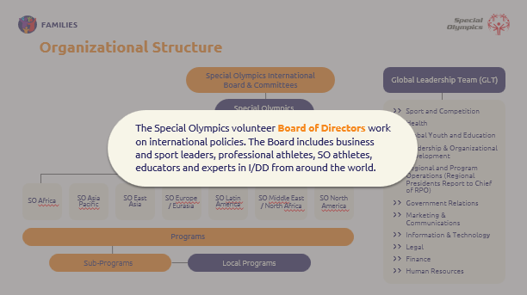
 | Special Olympics International, or SOI, refers to the staff who work at our international headquarters in Washington D.C. Although regions may have differing goals, SOI is responsible for maintaining an overall vision for the organization. | 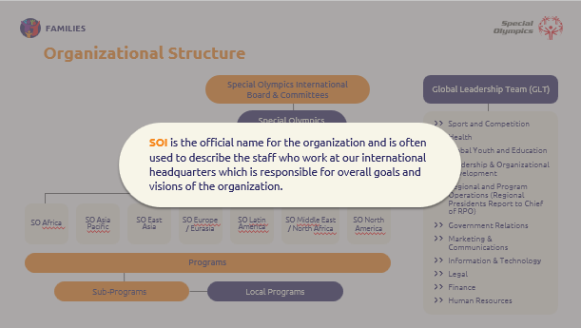
 | The Global Leadership Team is a team of senior management at SOI. They use their background in corporate and nonprofit experiences to help make important decisions for the organization. | 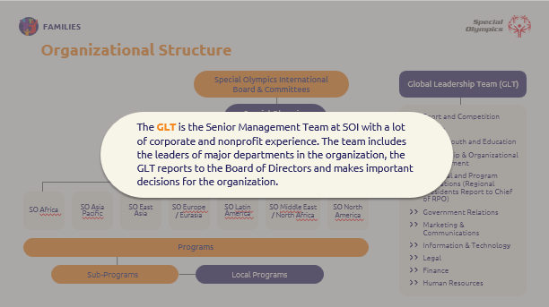
 | The Regional Presidents and Managing Directors are members of the Global Leadership Team. They lead our seven regional offices around the world. | 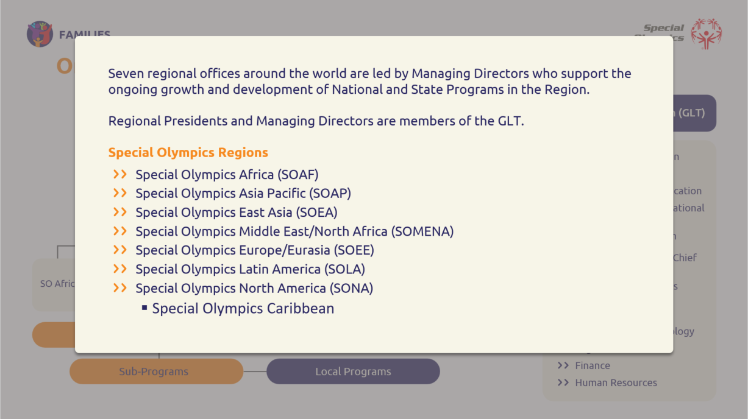
 | The 250 Programs we have worldwide are accredited by SOI, and they bring the mission and strategic plan to life. | 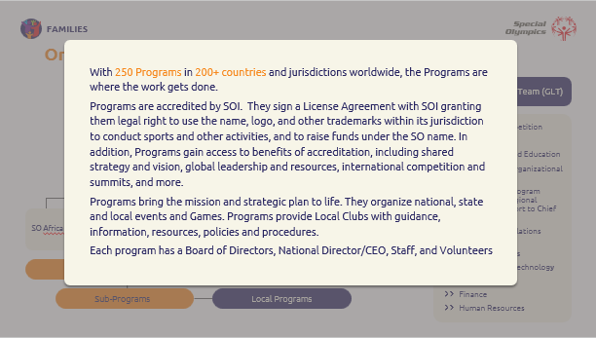
 | There may be more local Programs in each region. These are the people who conduct SO sport and non-sport activities in the community. They rely on athletes, coaches, and volunteers, such as Family Leaders, like you! | 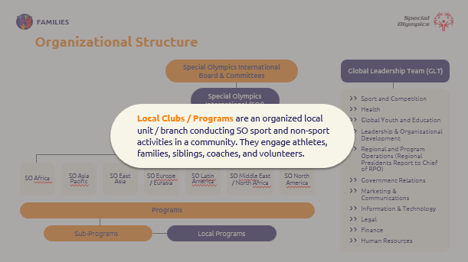
Introduction to Special Olympics  Definitions | ***Athlete participation recommended  (Facilitator Note: Athletes present can speak about what the following definitions mean for them personally)  At Special Olympics, we are intentional about the terms we use and their corresponding definitions. As Family Leaders, the words you use matter.  Let’s review some important terms and definitions.  (Facilitator Note: Click to open each definition one by one. Read the term and definition. Provide time for any questions.) | 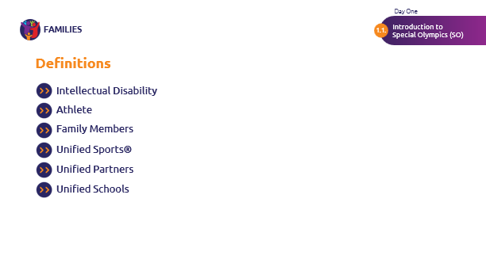  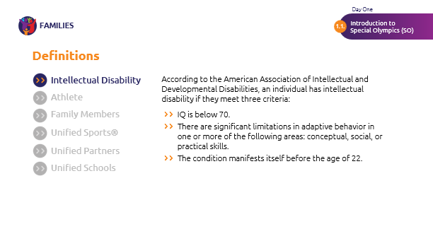
Introduction to Special Olympics  UNCRPD | By show of hands, who is familiar with the United Nations on the Rights of Persons with Disabilities?  Great!  The UNCRPD sets out the fundamental human rights of persons with disabilities. Special Olympics helps countries fulfill their commitments to the CRPD.  Does anyone have any specific experiences with the UNCRPD and Special Olympics that they would like to share?  Thank you for sharing. | 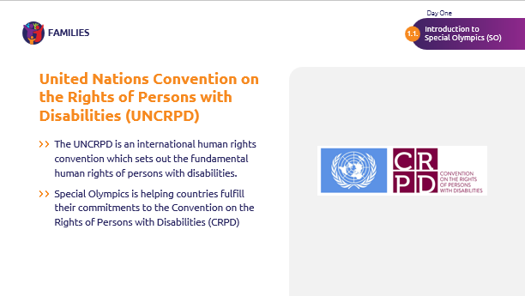
Introduction to Special Olympics  Importance of Family Involvement | ***Athlete participation recommended  So, why is it important for you as a family member to be involved with Special Olympics?  Special Olympics Programs rely on family involvement.  At Special Olympics competitions and events, family members are among friends—and feel at home. They watch with pride as their athlete finds success and joy. Special Olympics is a support network that brings families together in a caring, positive way.  Families are also an essential link to the community and wider support for our movement.  Finally, Families are the number one fans of our Special Olympics athletes. They offer a unique type of support, love and encouragement that no one else can. | 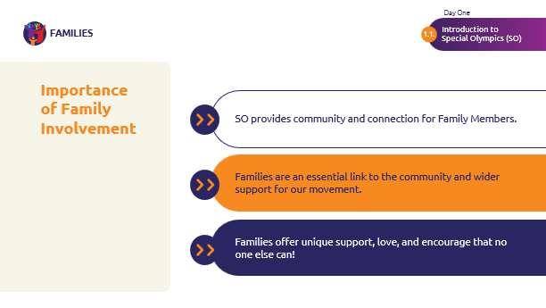
Fitness Energizer  Time: 3 min  Independent Break  Time: 30 min | ***Athlete participation recommended  You have now completed the “Introduction to Special Olympics” module.  Thank you for your participation! We hope you found the information useful.  Let’s take a short, three-minute fitness break together. Afterwards, you will have around 30 minutes for an independent break to refresh.  (Facilitator Note: Click on camera button to play fitness energizer) | 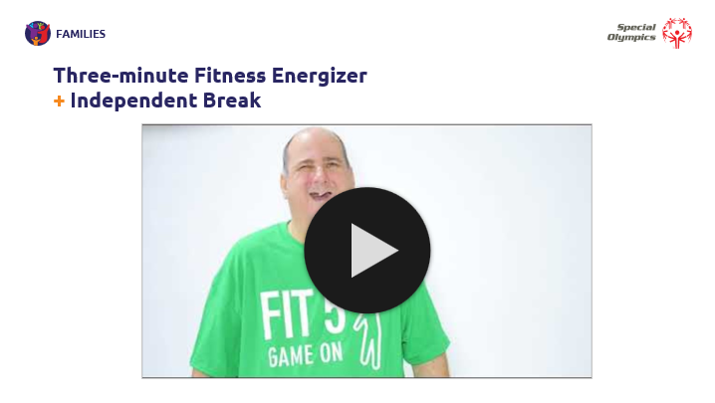
Module  What is a Leader?  Time  30 minutes | Welcome back! I hope you had a good break.  Our next module focuses on understanding leadership – what leadership means and the traits and skills that leaders have. | 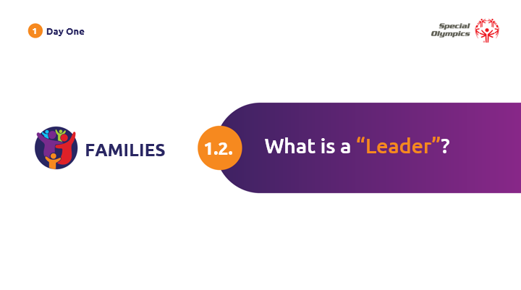
What is a Leader?  Define Leadership | ***Athlete participation recommended  (Facilitator Note: Athletes present can speak about what the following definitions mean for them personally, and how they are a leader in their community.)  When we think of leadership, different phrases may come to mind. In general, Leadership is a relationship where one person influences the behaviors or actions of other people to achieve goals. Leaders have the ability to guide, direct, or influence people.  Now, let’s move on to a short activity. | 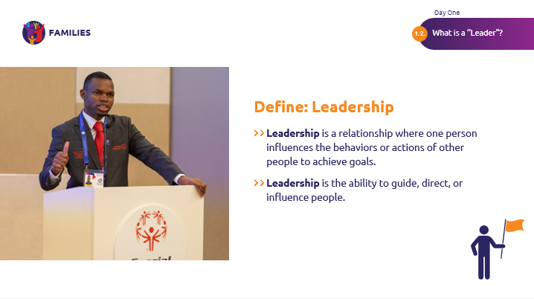
What is a Leader?  Activity: Define Leadership | For this activity, we will split up into groups of 2-3 again.  Before we split up, take a moment to think about a leader you know. This can be someone in Special Olympics, or outside.  We will share the following three answers with our groups:  - Who is this leader?  - What do you think inspires people to follow this person?  - What behaviors or skills do they have that you see reflected in your own leadership?  (Facilitator Note: Give around five minutes for sharing)  Great! Let’s come back together, and take a poll | 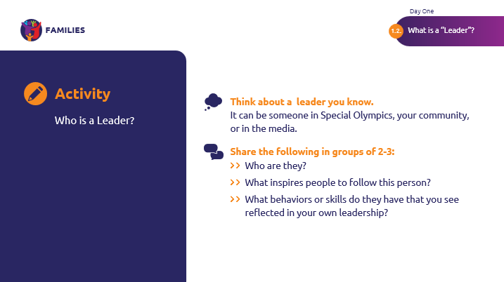
 | Please pick the category that best represents the leader you picked.  - Coach  - Teacher  - Teammate  - Special Olympics Volunteer  - Community group leader  - Co-Worker  - Athlete Leader  (Facilitator Note: Point out any trends that you see in the kind of person they picked. What traits do they share? Ask the group to point out any similarities among the groups.)  Let’s keep these similarities in mind as we move forward! | 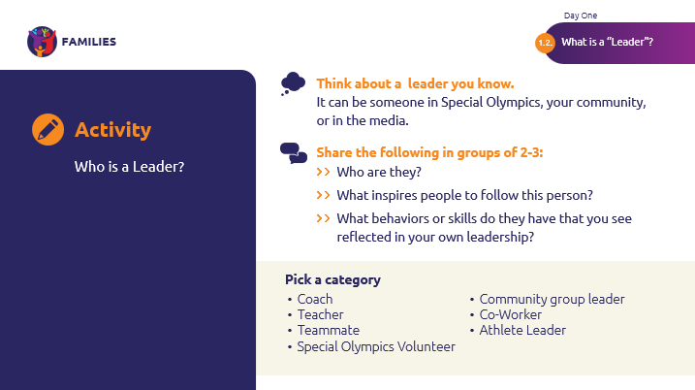
What is a Leader?  Behaviors of a Successful Leader | There are many behaviors that leaders you have chosen have in common and things they do that make them good leaders.  Here are few examples of behaviors that the best leaders have.  Good leaders  - Model the way: They set good examples for other people to look up to. They show people how they should treat others and how to work hard.  - Inspire the shared vision: Leaders believe they can make a difference. They share enthusiasm for the future. Great leaders find a way to inspire others to act.  - Challenge the process: Great leaders are always learning new things and improve the way things are done. They are not afraid to ask questions and do not let people use the excuse, “Well that’s the way it has always been done!”  - Encourage the heart: Great leaders see when others are doing good things and give them credit for their work. They cheer people on, especially when things are difficult.  - Enable others to act: Great leaders encourage and empower others. They want everyone on the team to contribute. They create an atmosphere of trust and respect for everyone involved. | 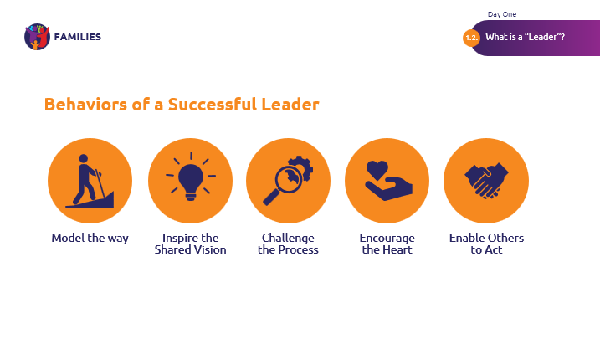
What is a Leader?  Skills of a Unified Leader | ***Athlete participation recommended for this section  Now we are going to discuss 6 basic unified leadership skills.  We want to develop these six competencies in all people who participate in leadership development at Special Olympics. We believe that these 6 competencies are the key to unlocking our true potential not just as leaders, but as inclusive leaders who stand up and fight for radical inclusion, especially for people with IDD.  As a Family Leader, you will have a chance to practice these skills as you lead within the organization.  It is important for us to have self-awareness about which skills we are best at, and which skills we want to improve.  We all have things we are good at (strengths) and things we can improve (weaknesses).  Knowing your strengths and weaknesses is very important to becoming a great leader. It helps you know what to improve or how to build a successful team. Good leaders surround themselves with people whose strengths work well with their own and cover their weaknesses or gaps in knowledge. | 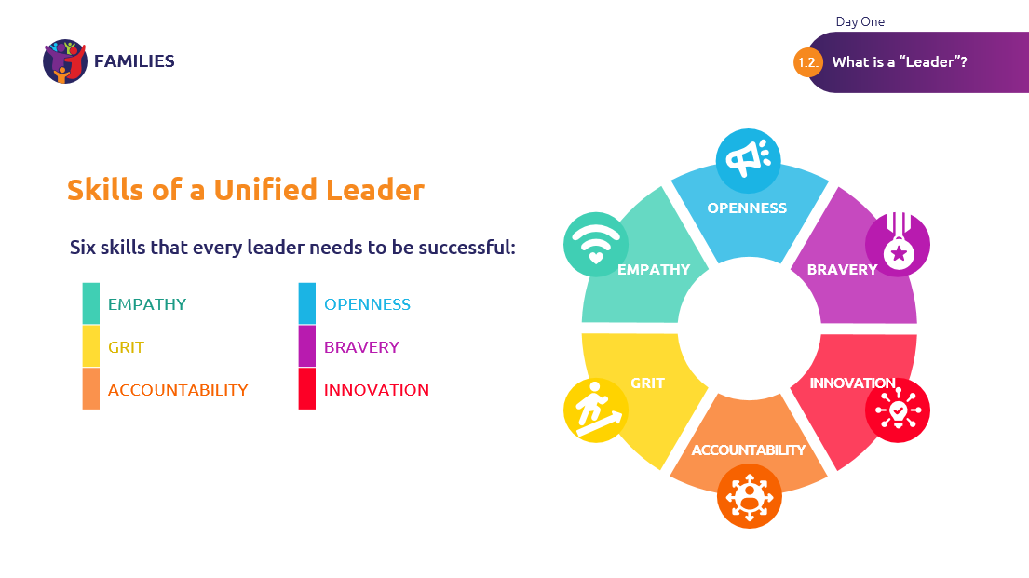
 | Empathy  The first skill is empathy.  Empathetic leaders are people who: Seek diversity, show belief in others, step into others’ shoes, and are authentic and aware of their own behaviors and biases. | 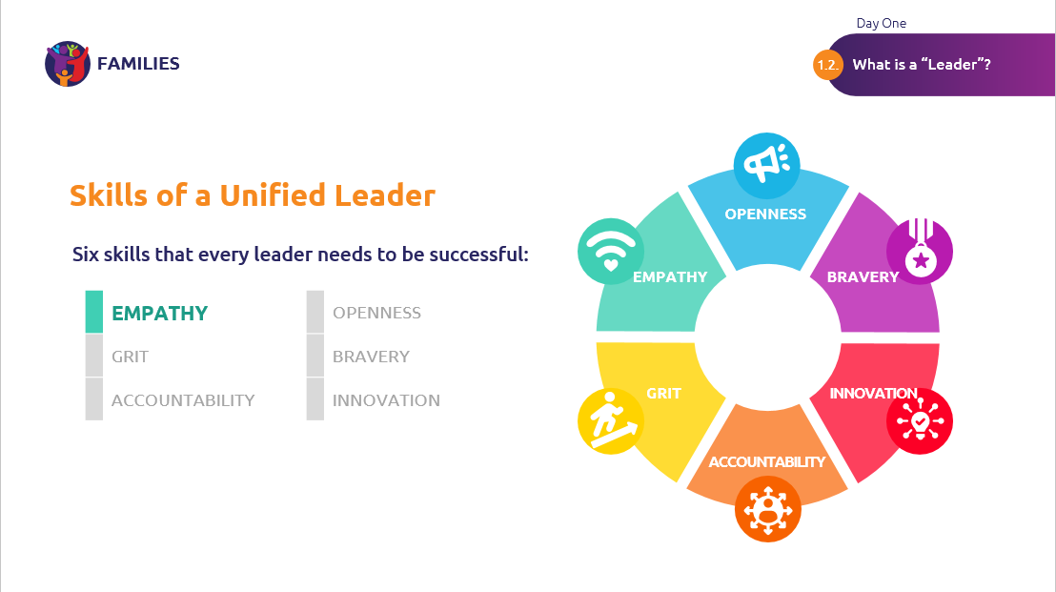
 | Grit  Next is Grit.  People who show this skill are resilient, relentless, show drive and are active, they overcome barriers and maintain focus on inclusion. | 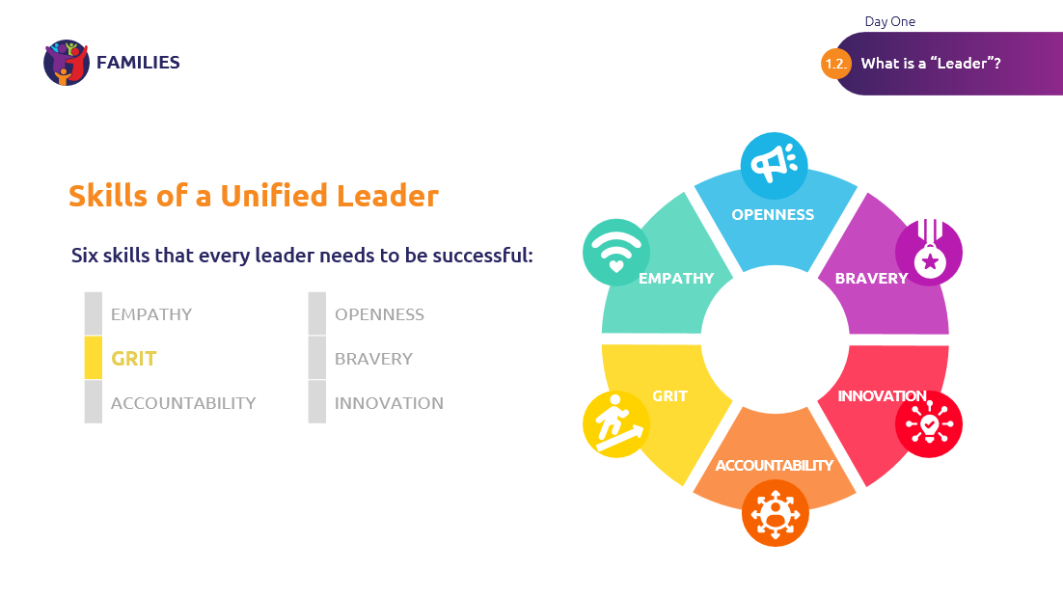
 | Accountability  Accountability is next.  Having this skill means you focus on results, follow through on promises, and inspire others through action. | 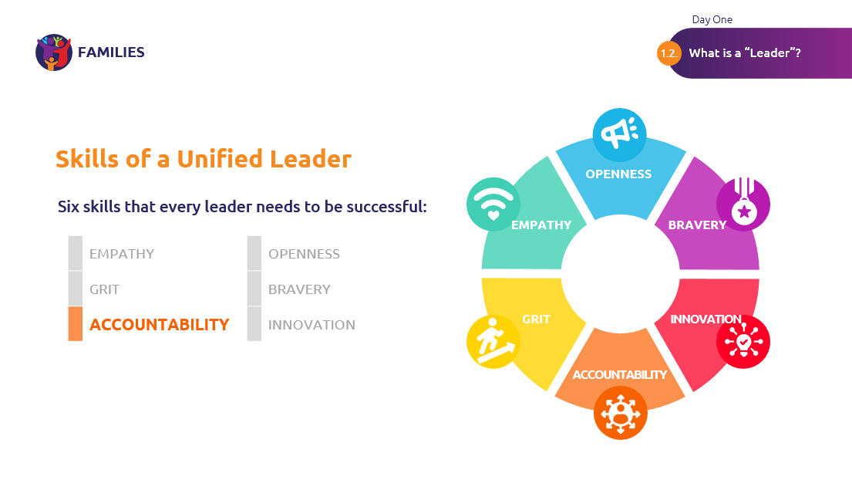
 | Openness  Openness is also very important.  Openness means you actively look for different perspectives, communicate well, listen more than talk, and build partnerships and work well in teams. | 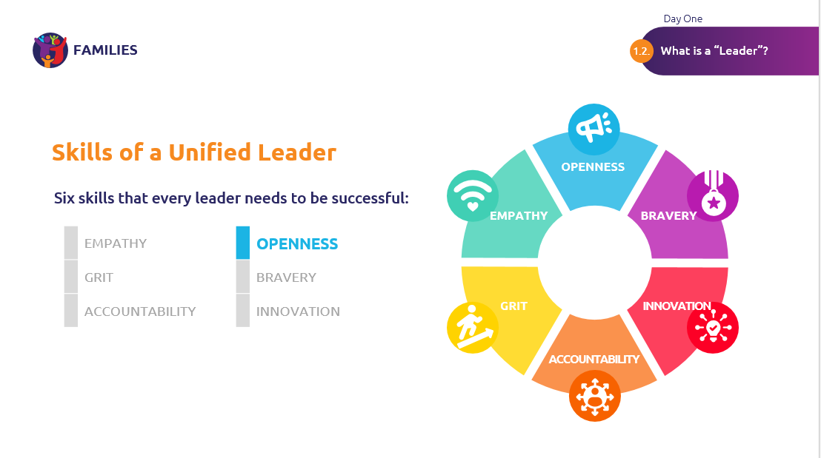
 | Bravery  Just as important as openness is bravery.  Brave people challenge others, are courageous and passionate, dare to fail, and learn from mistakes. | 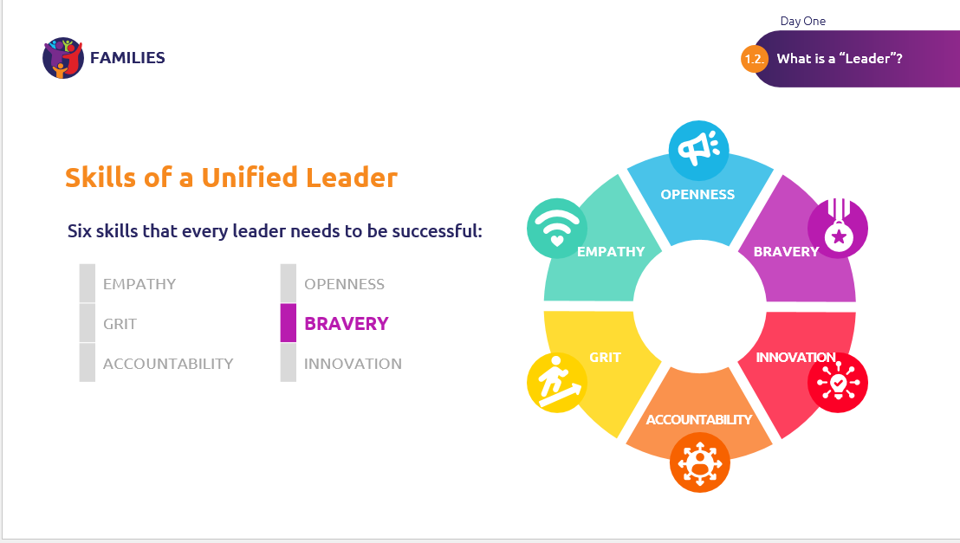
 | Innovation  Last, but not least, is Innovation.  Leaders skilled in innovation realize that change can be a good thing and make things better.  They encourage a growth mindset, enable creative sharing of ideas by others, inspire with joy, and facilitate learning and look for continuous improvement. | 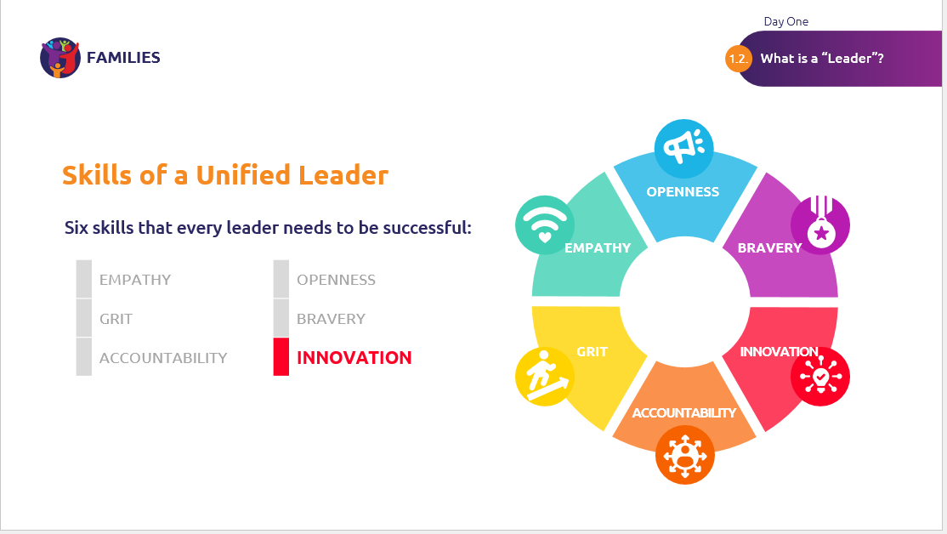
Okay, now we are going to take a poll by hands. Keep these reflections in mind, as we will have a Strengths Evaluation Activity at the end of our next module.

Which skill do you think you are best at?
- Empathy
- Grit
- Accountability
- Openness
- Bravery
- Innovation

Which skill do you want to get better at?
- Empathy
- Grit
- Accountability
- Openness
- Bravery
- Innovation

How do you think you can use your best skill and get better at your skill? Write down your answer and work on that over the next few weeks and months. Remember, good leaders are always working to get better at their skills.

Module  What is a Family Leader?  Time  30 minutes | Now that we know what a leader is, let’s discuss becoming a Family Leader! We will provide an overview of the primary goal of a Family Leader, the core roles and responsibilities, expectations after this training, potential roles, and a strengths evaluation activity. | 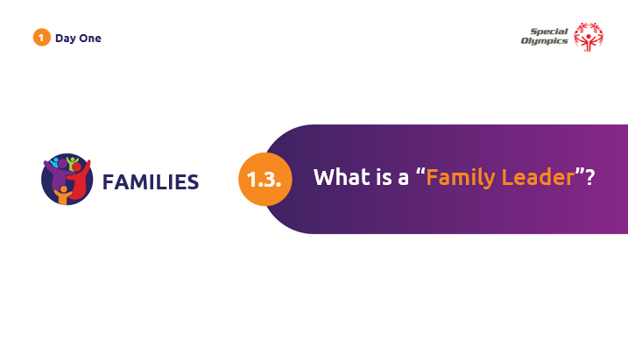
What is a Family Leader?  Primary Goal of a Family Leader | As a Family Leader, your primary goal is to work with local programs to foster a supportive and inclusive community for Special Olympics families by creating a network where families can share experiences, access resources, and actively contribute to the success of Special Olympics programs. Family Leaders play a crucial role in enhancing communication, collaboration, and engagement among Special Olympics families. | 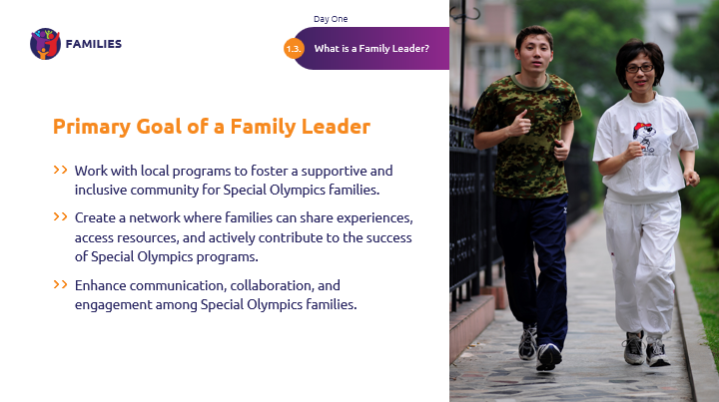
What is a Family Leader?  Core roles and responsibilities | The following are the core roles and responsibilities of a Family Leader.  Family leaders should:  Understand Local Program Structure and Goals: Family Leaders should work closely with their local program to understand the goals and structure of the program. This ensures everyone is in alignment and supporting the same strategy and mission.  Family Support: Offer support to families by providing information, resources, and guidance on Special Olympics involvement and other community services. | 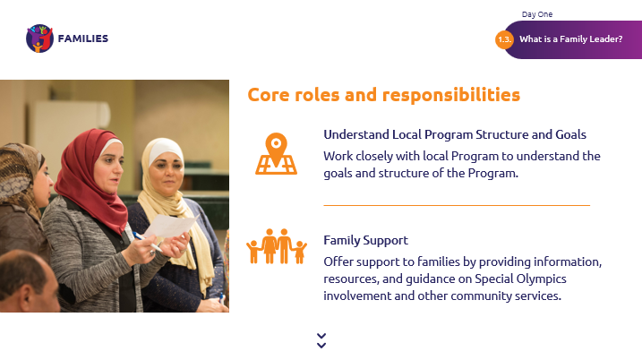
 | Program Support: As a trained Family Leader, work with your program to determine if there is a need that you have the time and expertise to fill.  Feedback Collection: Collect feedback from families and ensure their voices are represented in discussions and decision-making processes. Depending on your program’s family engagement structure, this information can be given to your program’s Family Coordinator or Family Leadership Council. | 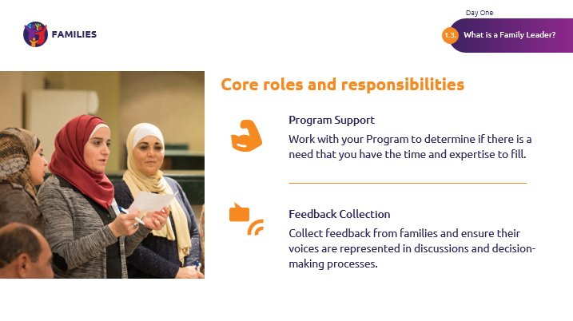
What is a Family Leader?  Activity: Strengths Evaluation | ***Athlete participation recommended  (Facilitator Note: Make sure you have enough leadership characteristics prepared: one characteristic per individual. Refer to the “Leadership Characteristics” chart above and write one characteristic on each piece of paper. Hand one characteristic to every participant.)  As you begin to think about how you can work with your Program/Regional Leaders to meet mutual goals, it will be useful to think about your strengths in relation to Special Olympics.  We will now conduct a strength evaluation activity to reflect on some leadership characteristics and how they relate to your own leadership as a Family Leader in Special Olympics.  - First, read the leadership characteristic on your card and take a moment to reflect on how it relates to your leadership in Special Olympics.  - Next, let’s stand up and gather in a circle.  - Now, we will take turns sharing the strength on our own card and explain how we see it manifesting in our leadership style or approach.  - Once you are done sharing your strength, pass this strength to the person on your left.  - The new holder of the card reflects on how this strength applies to them or how they have seen it in their own leadership, as well as sharing their own strength card.  I will begin.  Great teamwork! Let’s take our seats again. | 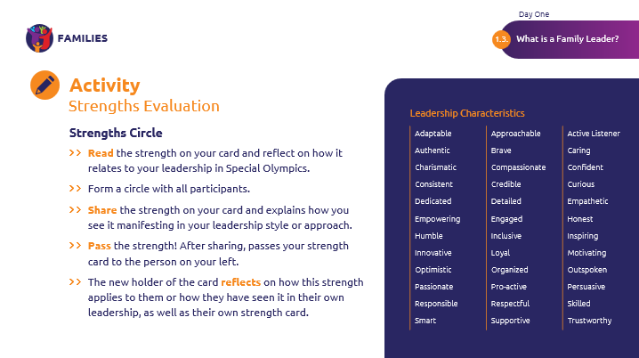
What is a Family Leader?  Reflection: Strengths Evaluation | ***Athlete participation recommended  (Facilitator Note: conclude the activity with a group reflection on the strengths identified)  As you see, our individual strengths are multiplied when we work together in a circle of strength. Remember this as we part from each other at the end of the training and know that you have a community of strength in our Family Leaders!  What do you think? How can these diverse strengths be combined and utilized to enhance family leadership in Special Olympics? | 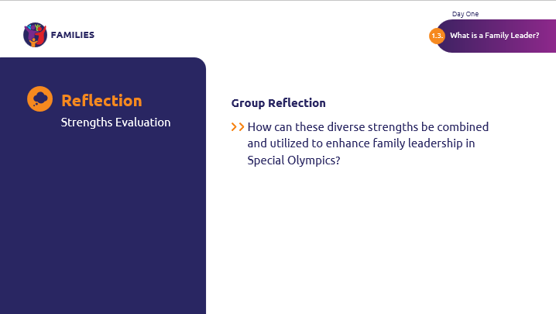
What is a Family Leader?  Expectations after training | So, what happens after our two days of training together, and how can you begin your role as a Family Leader?  After the training, it is important to meet with your program’s Family Coordinator or another Special Olympics staff member in your local community. At this meeting, you can present to them your goals and plans for increasing family engagement in your local Program, which we will develop at the end of today. During and following this meeting with the SO staff, you can modify your goals as needed to ensure alignment with your local Program’s goals. You can then implement this new action plan as a Family Leader.  Throughout your time as a Family Leader, make sure to follow up with your local Program contact regularly to report feedback, successes, or obstacles. Remember that you are not alone, and we all work together to meet Program goals! | 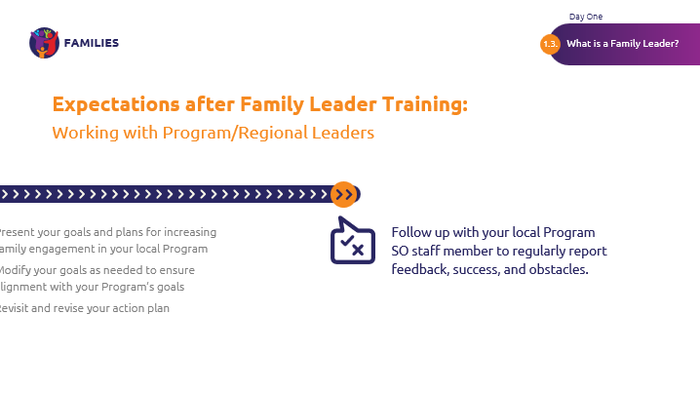  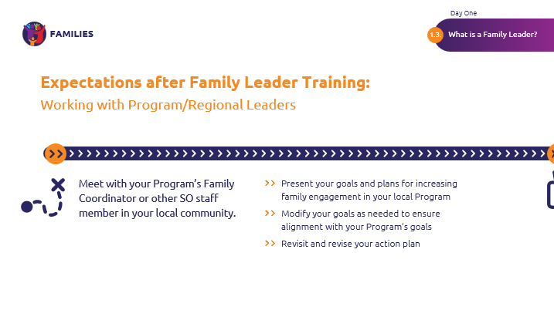
What is a Family Leader?  Functions and Roles of a Family Leader | Before meeting with your SO staff, it will be useful to have an idea of some roles you can have as a Family Leader. This list is not exhaustive, and your SO contact may have different ideas. Remember to keep your strengths in mind and to consult with your local Program to align your skills to their needs.  Your leadership may be useful in:  Recruitment of family members: Reaching out to new families using email, phone, or the preferred communication method in your region. New family members may find it useful to hear your experiences with Special Olympics. It would also be useful to keep family contact information organized, such as through an Excel file, in order to maintain communication with family members throughout the years. You may also support or plan family events.  Formation of Family Support Networks (FSN): Family Support Networks provide a programmatic structure in which Special Olympics families reach out to new families to welcome them into the Special Olympics community. The objective of FSNs is to support families, develop partnerships with community organizations, and train new Family Leaders. If your region does not have FSNs, you can take a look at what other regions are doing! One example is the FSN in Italy.  Family Health Forums: Family Health Forums (FHF) provide a space for parents, caregivers, and siblings to engage in health education and gain direct access to resources from health professionals, community leaders and social service providers. You may volunteer in planning an FHF, invite other families to attend, and present at a FHF as a Subject Matter Expert of selected topics.  Young Athletes: Young Athletes (YA) delivers direct support to children ages 2 to 7 through inclusive developmental skill activities, impacting the social, cognitive, psychological, and physical development of young children. YA takes place in homes, schools, and communities, led by parents, families, teachers, and volunteers supported with Special Olympics training and resources. You may volunteer for YA activities or serve as a coach. Siblings ages 2-7 can also join inclusive YA activities as participants with their sibling with ID.  Healthy Athletes: Healthy Athletes® (HA) provides free health screenings and health education in a fun, welcoming environment with a focus on removing the anxiety people with ID often experience when faced with a visit to a medical professional. HA offers screening in nine different areas of health including pediatrics, emotional wellbeing, vision, dental, audiology, physical therapy, podiatry, health promotion, and sports physicals. As a student or health care professional, you may serve as a health expertise volunteer.  Advocacy and empowerment: Athletes as self-advocates are vital to the goal of Special Olympics, and Family Leaders can join this effort as well. You may educate lawmakers and other organizations about the significant consequences that arise from the stigma and stereotypes faced by people with ID.  Other functions and roles make include raising donations for your Program, Storytelling for Impact (which we will learn about in the next module), or any other needs that the Program has where your strength aligns.  The opportunities are endless, and we are grateful to have you along! | 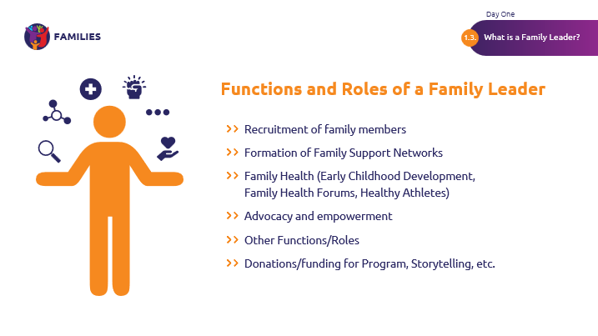
Lunch Break  Time: 1 hour  Fitness Energizer  Time: 3 min | ***Athlete participation recommended  You have now completed the “What is Leader” and “What is a Family Leader” Modules. Great work!  We will now have a one-hour lunch break. We will return with a three-minute energizer, before we split for our “Telling Stories of Impact” and “Sibling Engagement” workshops. | 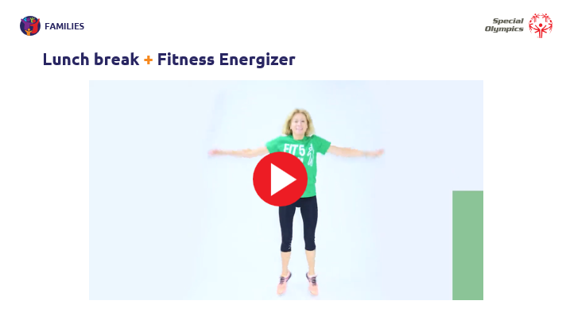
Module  Telling Stories of Impact / Sibling Engagement  Time  1 hour | ***Athlete participation recommended  Welcome back!  This afternoon, we will begin by splitting up into groups. Our siblings will attend the “Sibling Engagement” workshop, while other family members will remain here for a “Telling Stories of Impact” workshop.  The “Telling Stories of Impact” workshop will prepare you to tell stories about the impact of the work that Special Olympics does.  The “Siblings Engagement” workshop will present an opportunity for siblings to get to know one another and discuss becoming a Family Leader, specifically as a sibling.  Let’s split up now. | 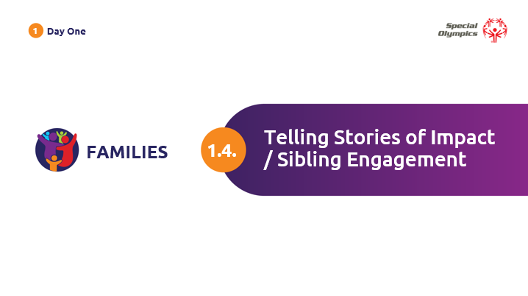
Telling Stories of Impact | There are many types of stories people tell about Special Olympics. The best ones are about the impact of the work. Impact is a word that different people think of differently. We will clarify it, so we are all thinking about it the same way. | 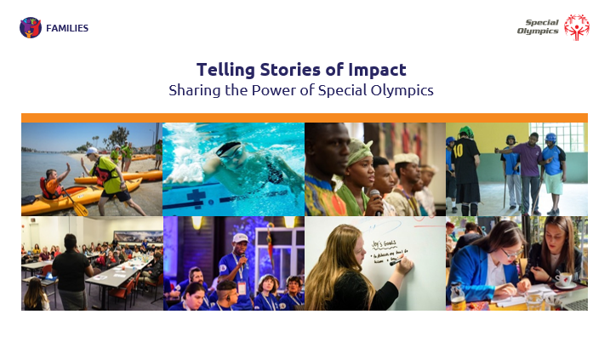
 | Before we begin, let's take a moment to reflect. Life has brought both joys and challenges to you, and it can be easy to forget how much you and your family have grown. Storytelling is important, because it gives you a chance to share and celebrate your experiences and the power of Special Olympics. | 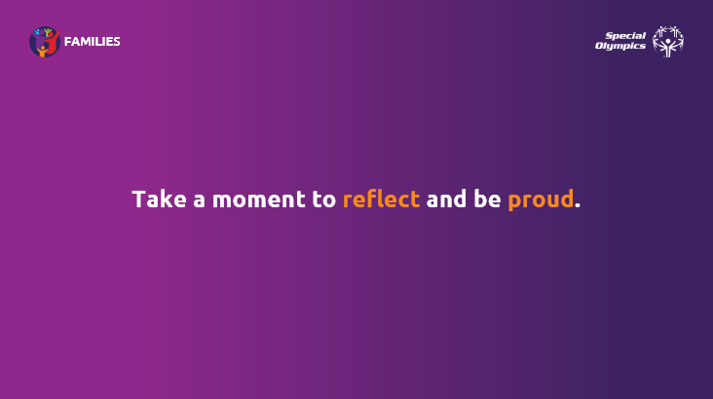
 | When you think about what Special Olympics does, many things might come to mind. The common purpose behind what Special Olympics does is to solve problems.  In fact, Special Olympics was created because there was a space to solve problems, where governments, businesses, and individuals were not equipped just yet.  When Special Olympics solves problems, it can change lives. When you solve big problems, those are changes that matter.  Those kinds of changes are what impact stories are all about. | 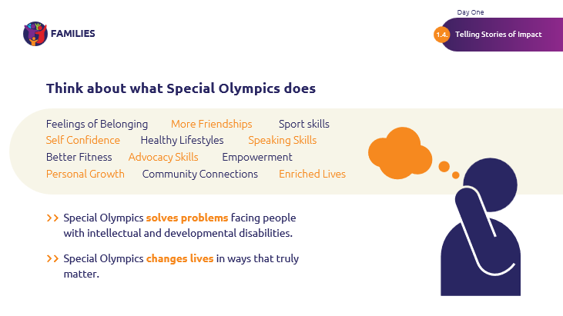
 | We talk about how big Special Olympics is, but compared with all the people in the world, Special Olympics is a small group of people. You are part of that group, and you understand why the work is valuable.  However, people may not be familiar with our work. Special Olympics exists so that the capabilities and potential of people with intellectual and developmental disabilities are celebrated.  So, it is our job to help other people recognize these gifts. We do that by telling stories that explain how important Special Olympics is. | 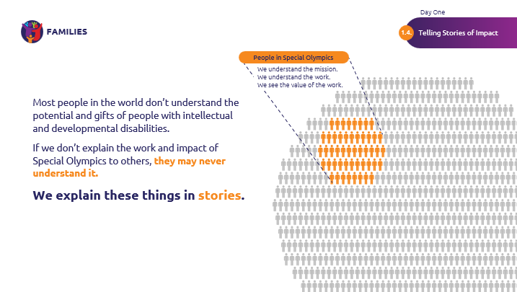
 | So, here we are at our main point.  Impact is change. It is changes in a person’s life.  Stories of impact show what Special Olympics did to make change happen in someone’s life.  Stories of impact talk about what actually happens …to an individual person…with a name, a hometown, with a challenge that they overcame every day.  Instead of what we hope to do, plan to do, or what may happen, we get to focus on the impact that has already happened! | 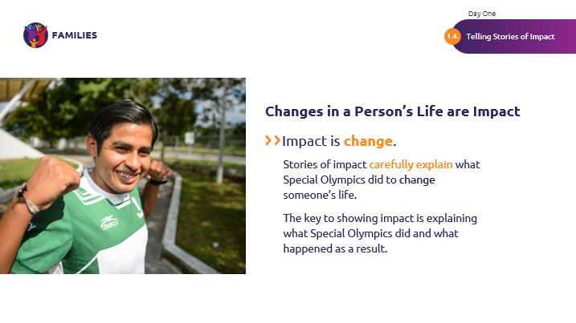
 | Every story has a beginning, a middle and an end.  - At the beginning of a story, we find out about the situation and the people involved.  - And then, in the middle, something happens that changes the situation for the people in the story.  - The end of the story describes how that change works out.  It’s like a fairy tale.  “Once upon a time” gives us the situation.  Then something happens, and that something might be caused by the action of a magical fairy.  And we see how things work out. Sometimes, it’s a “happily ever after” ending. Sometimes not. | 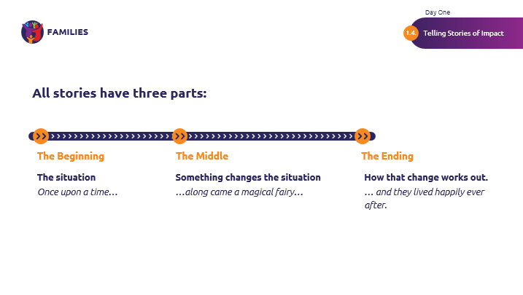
 | Special Olympics stories follow the same pattern.  Uniquely, Special Olympics stories also show the value of Special Olympics.  That’s especially true in that middle part where something changes.  In a Special Olympics story, the focus is on changes caused by Special Olympics work. If it was not caused by Special Olympics, then we can celebrate this impact story in another instance.  The ending here will show a change in someone’s life, however small or large! This is a chance to talk about the change as impact.  If you think that there might be no change in your story, take a closer look. If you’re still having trouble, we can always choose another Special Olympics impact story! | 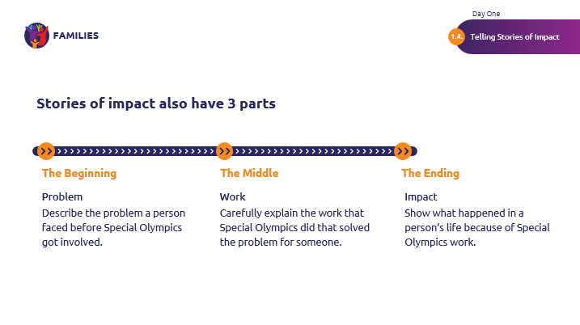
 | Remember that these stories of impact are our opportunity to uplift and spread awareness about Special Olympics by giving credit to the organization for the changes that happen. | 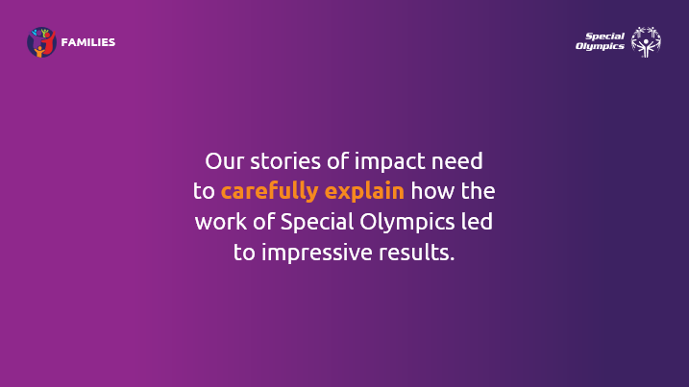
 | Remember, we are a knowledgeable group, and we know what the work involves.  Many people may not, but we have a chance to tell them through writing these stories!  By writing clearly and showcasing Special Olympics as a change maker, we can raise awareness. | 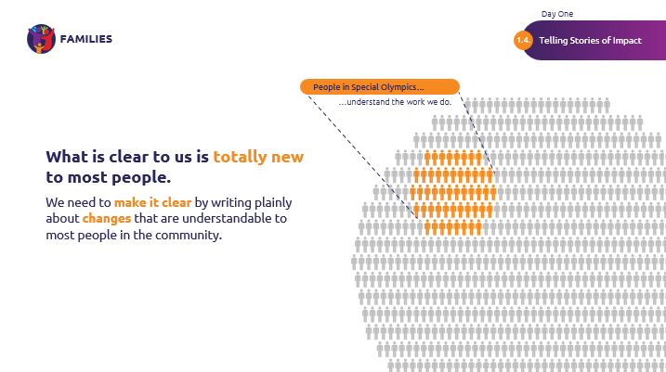
Telling Stories of Impact  Stories | Let’s practice together! Some stories may be very clear to you, but they may not make clear what Special Olympics does to others.  (Read Harriet’s story out loud)  As Family Leaders, I know that we have seen this story come to life and we know that there’s more to the work than simply offering sports to play. But, someone who is not familiar with Special Olympics may think that’s all this story says. What we can do is add more details about the work that goes into Harriet’s life changes! | 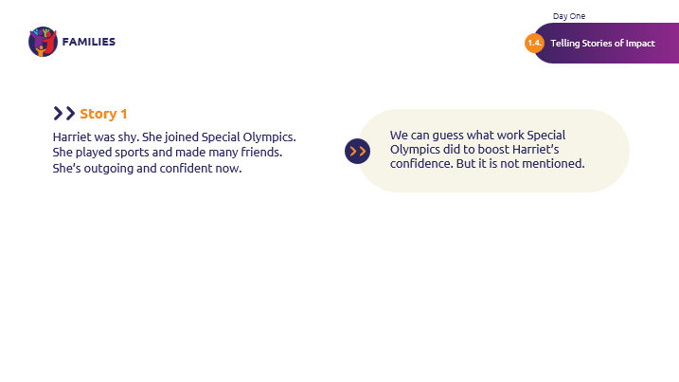
 | (Read the Nigel story out loud)  What do you think some details are that we can add?  Great!  We can add answers to questions such as who coached him? Who guided him? Who believed in him and encouraged him? These details will make the impact of Special Olympics more clear for others outside of the organization. | 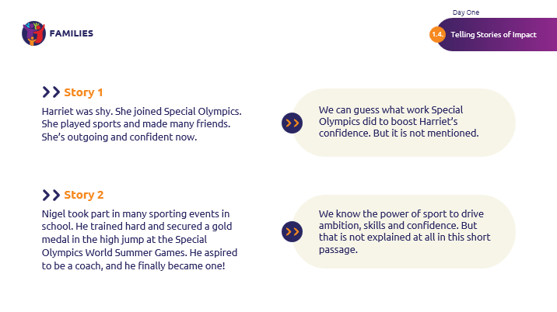
 | Now, what do you think of this story here?  Yes! This story is a great example of what our goal is in creating stories of impact.  The highlighted part talks about the work of Special Olympics. It’s clear what the coaches did. It’s clear that they made a difference. This shows the impact of Special Olympics work.  Can you point out the beginning, middle, and end?  Absolutely!  Let’s talk about the three different parts. | 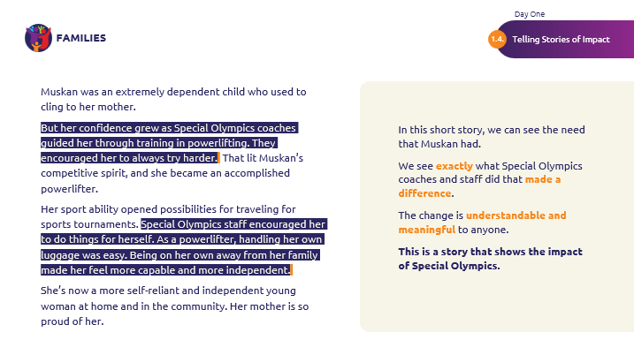
 | The story about Muskan is a common and joyful one that a lot of are familiar with! Someone was shy, they joined Special Olympics, and now they are no longer shy. How we tell this story will make it into a story of impact, specifically, we need to clearly show how life changes when you are no longer shy.  Let’s look at the three parts of this story.  - First, we clearly see that Muskan had a need.  - Next, it shows what Special Olympics did that met that need—in detail!  - Last—and this is critical and often missing from stories—it describes the change in Muskan and how it is visible at home and in the community.  If we could write a longer version, we could even add more details and quotes from the athlete and her mother.  Keep the slide up as you ask this question.  I have a question for you: How long do you think it took for the impact of Special Olympics work to be visible in Muskan? One year? Maybe two years?  Allow ideas to be spoken.  It is important to know that impact takes time. Great impact stories show the effect of Special Olympics work over months or even years. | 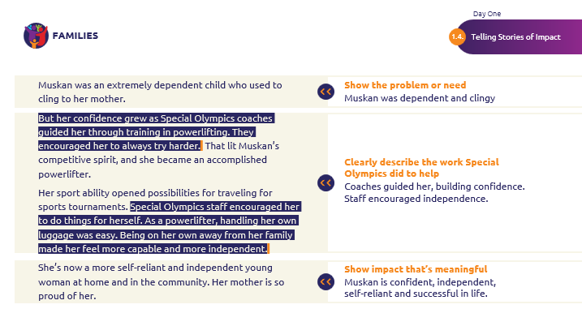
 | Read the story out loud, then go to the next slide. | 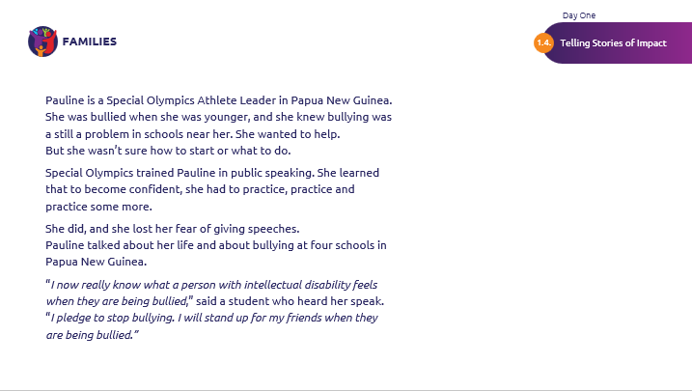
 | Let’s take a close look at this story. You can see it talks about different kinds of work and different kinds of impact. And yet it is very short.  Read the questions on the right and let the attendees answer.  (Note to Moderator: Pauline saw bullying happen, as it had when she was younger. Pauline needed confidence and skills to help meet that need.  Special Olympics work was training Pauline. Pauline’s work was learning and practicing, and then applying her skills by speaking.  The change caused by Special Olympics was really caused by Pauline: at least one student had a new perspective on bullying and resolved to take action on her own when she sees it happening.) | 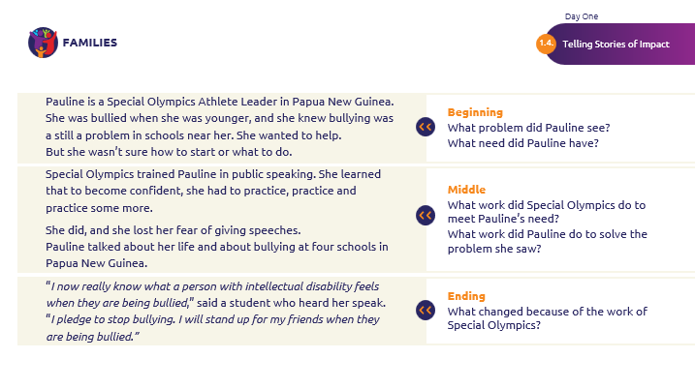
Telling Stories of Impact | One of the reasons why stories of impact can be difficult to write is because we need to shift our focus from describing the work to describing change.  Work is not change. Remember that work only allows change to happen. Work isn’t change. We can write stories of impact to describe change!  As Family Leaders, we see the true impact of Special Olympics, and we can share stories about it! | 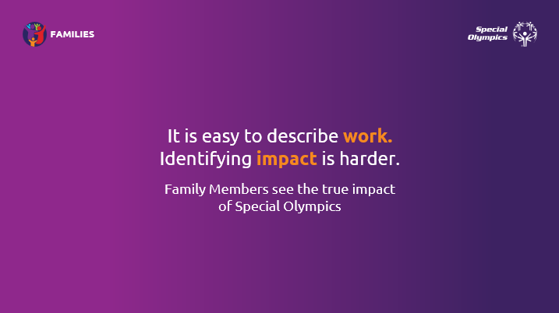
 | There are millions of families in the world who see the impact of the work of Special Olympics.  That is why we are sharing this workshop with you.  You are one of the best sources of impact stories because you are in this for the months and years it might take for impact of work to be clearly visible. | 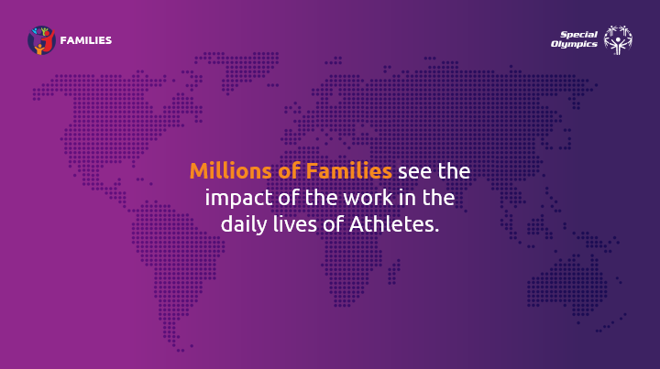
 | Think about the people doing the Special Olympics work (staff, volunteers, etc.).  Even if you’re a doctor handing someone a pair of glasses, all you know is that they can see better. You don’t necessary get to witness how their life will change. | 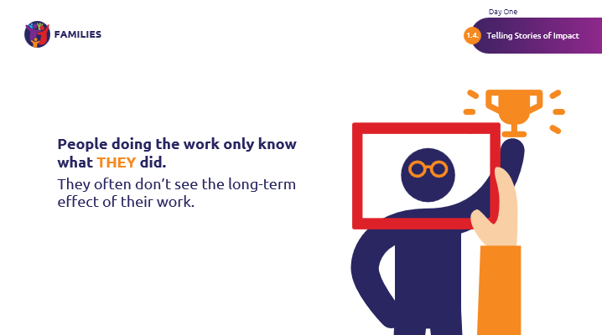
 | Talk through the examples listed on the slide.  Take a look at these examples. The difference between doing work and seeing impact is time.  Someone might give lessons on time management, and they might have really great ideas that an athlete begins implementing every day.  But that teacher will not know about the impact of their work. The great part is that you, as Family Leaders, and your athletes will know about it. It is important to remember that what you see is the most important part of Special Olympics work. | 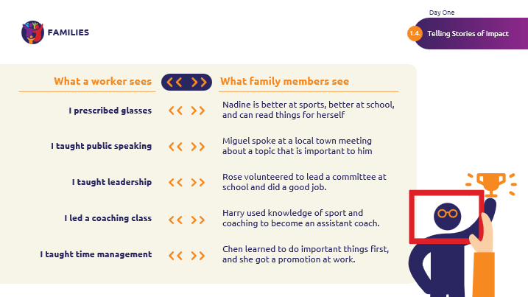
 | All of the people, money, planning, tools, equipment and work only makes impact possible.  When you see it, when you write stories about it, you make that impact visible! | 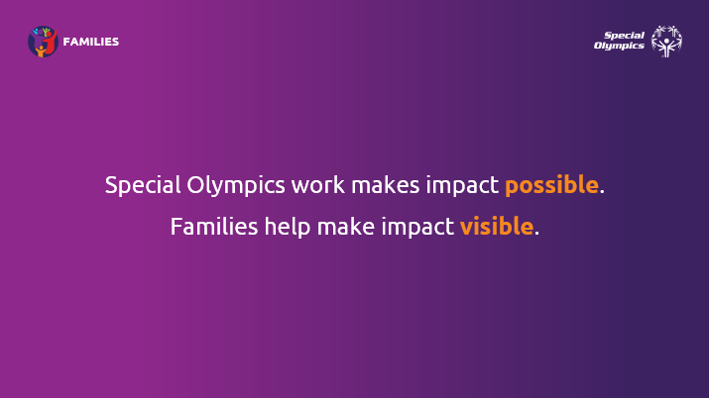
Telling Stories of Impact  Impact Story Discussion | Spend about five to seven minutes on this.  Let’s join together.  I think we all believe in Special Olympics. I think we all agree with the mission, we see the value of the work. But what have you seen yourself that shows that Special Olympics changes lives? It does, doesn’t it?  Yes? No?  Raise your hand if you believe Special Olympics changes lives.  When someone raises their hand, ask them the questions on the slide:  What was the problem that needed to be met?  What work did Special Olympics do that made a difference?  What changed? What was the difference?  Great work! Thank you for sharing a story of impact. | 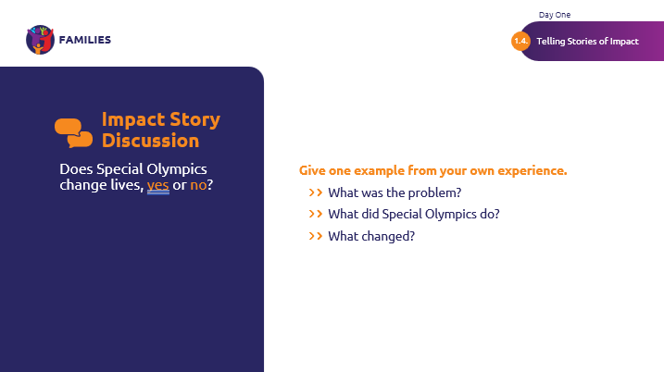
Telling Stories of Impact  Photos | Next, let’s talk about photos.  This is a photo of Pauline, from the previous story. This is a great example of Special Olympics work in action.  Pauline is talking. She is captivating the audience!  What do you like about this picture?  Absolutely! It’s close enough to see her expression and the expressions on people near her. This is a great example of a picture that we’re looking for. | 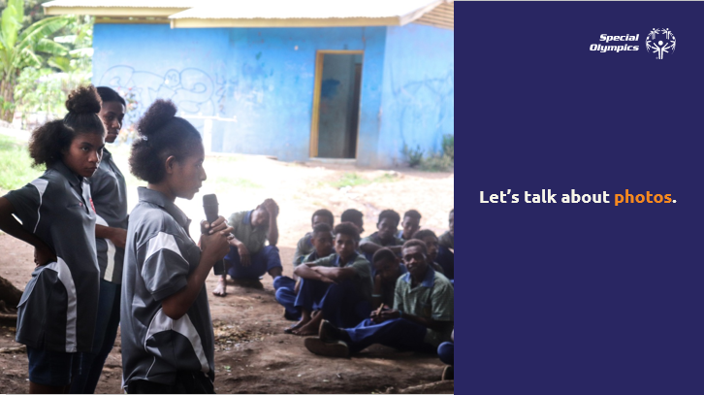
 | A good Special Olympics photo shows work happening. We can’t show impact usually, but we can definitely show work happening.  You can tell that there’s a girl cutting vegetables, there’s someone getting a shot, and there are people washing their hands with that special jug.  Those are interesting photos, and they can make someone stop to look at them on a web page or a social media feed. | 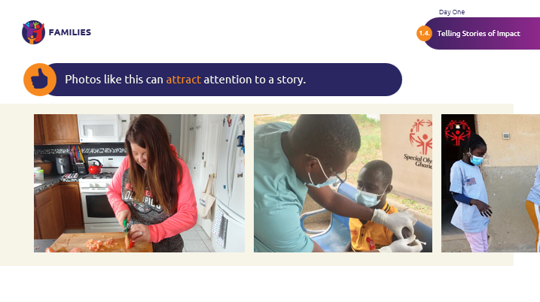
 | What do you think about these photos?  Thanks for sharing!  These pictures may not be as interesting as the ones previously, as they don’t tell a story since we don’t see the work happening.  They’re of course valuable and interesting to the people in the photo, but they may not be to an outside audience. We’ll want to focus on producing the first set of photos instead. | 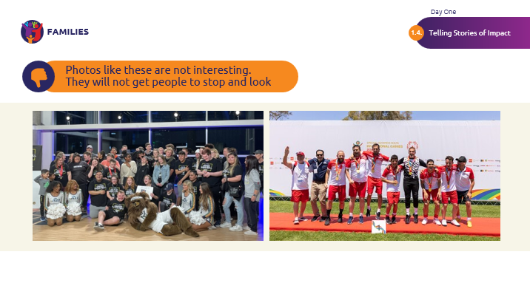
 | If we have a group, what we can do is focus on a group of people working together! | 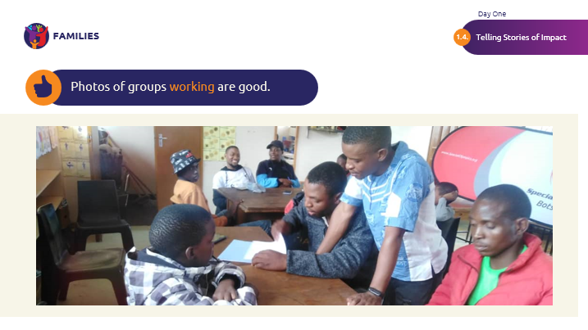
 | What do you notice about this focus?  Athletes in action, yes!  We want to show that athletes can cook, shop and can be an official in a competition. | 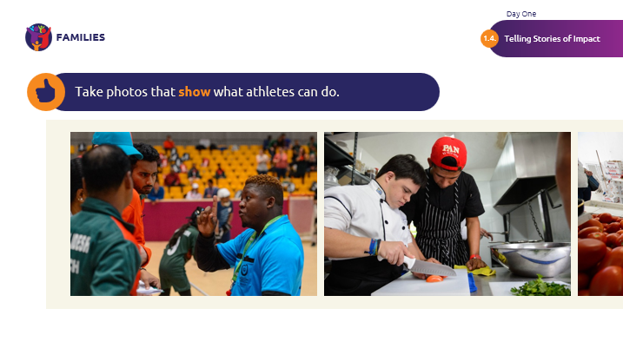
 | A lot of times, getting a good photo means waiting for the right moment.  I am going to show you two pictures.  This one was taken at the right moment, when the athlete was leading, and his mentor and others were listening.  It takes a little patience to wait for those moments, but it is worth it! | 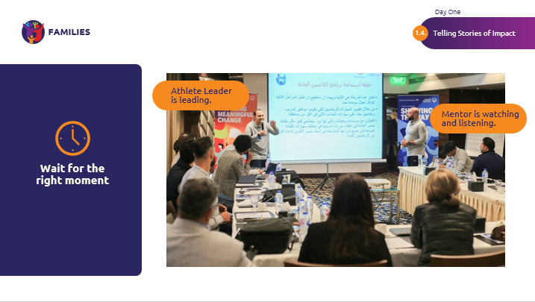
 | Here is the next photo.  In this photo, the mentor is leading, and the athlete is just watching.  This doesn’t show what the athlete can do. It only shows her listening. We can find a better moment! | 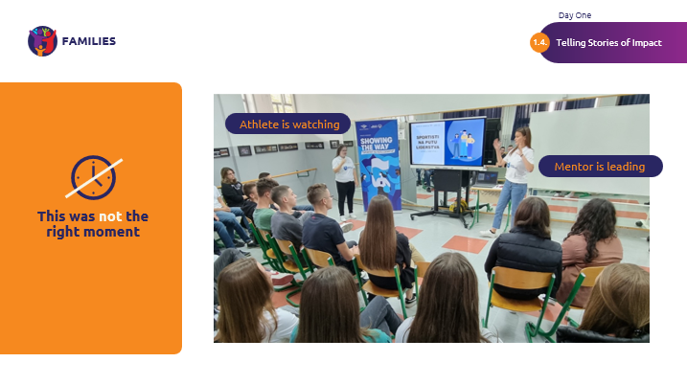
 | Photos that go with stories show our athletes at their best.  The time you spend getting close, and getting a good photo will be worth it!  People are more likely to stop and look at the photo. And if your story starts with an interesting situation, they will stay to read. | 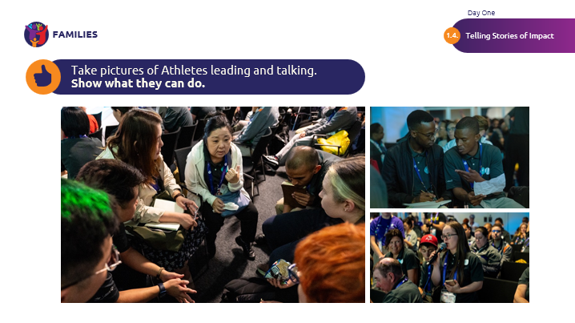
Telling Stories of Impact  Getting people to read your stories | And getting people to read the stories we write is important.  A great story will mean that people will read on!  Here are a few tips to make it MORE likely that people will read your story. | 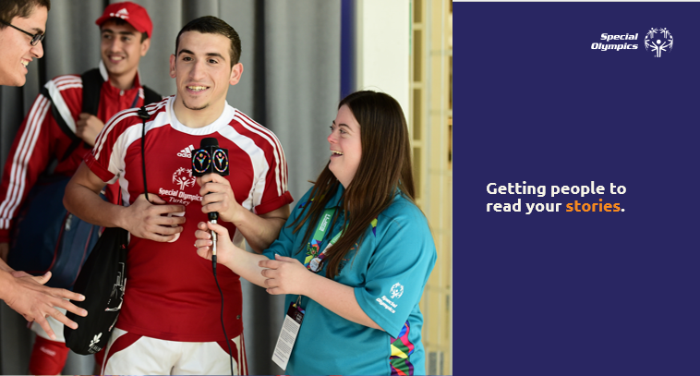
 | Can you guess when people decide to read or not read a story?  Yes, the beginning of a story is where people usually decide to either read or not read.  If you start with a lively, interesting quote or situation, you are more likely to have people read your story. Facts, on the other hand, may not be interesting to readers. | 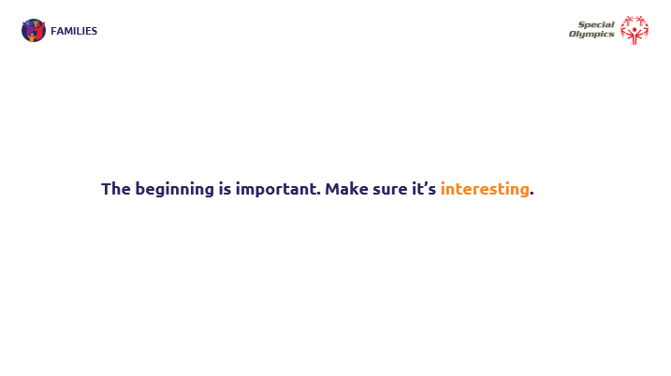
 | Do you notice the difference in these two examples? Take your time reading!  Notice in this example that both story samples contain the same information.  One starts in an interesting way, then leads into the facts. The other one starts with the facts before getting to the very interesting quote. | 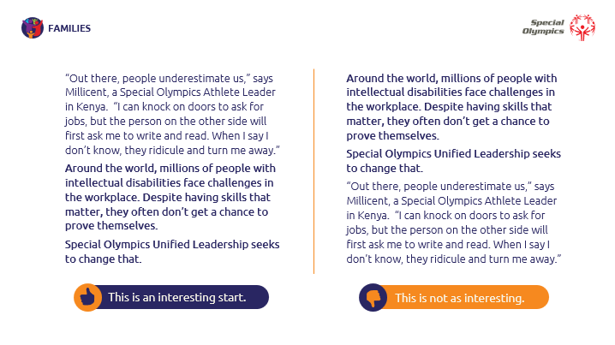
 | As you are writing your story, we can add in vivid action words! By choosing powerful words to describe the work and impact of Special Olympics, we show the power of Special Olympics. | 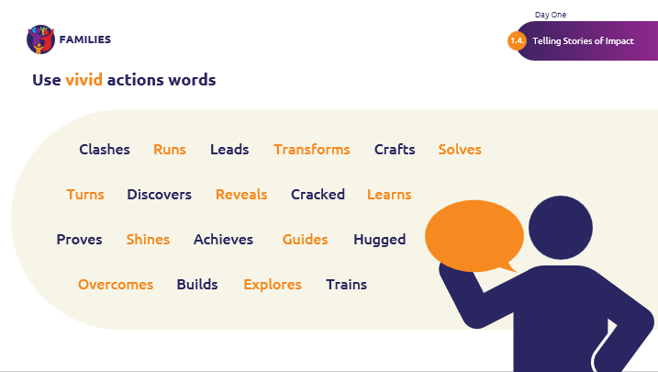
Telling Stories of Impact  Conclusion | To conclude,  Our goal is to choose stories that clearly show strong impact.  It will take us time to develop and write an excellent story of impact. But it will be worth it, because this is how we grow the movement as Family Leaders.  Showing how Special Olympics takes on a need and solves it shows that Special Olympics is effective to people who may not be familiar with our organization. | 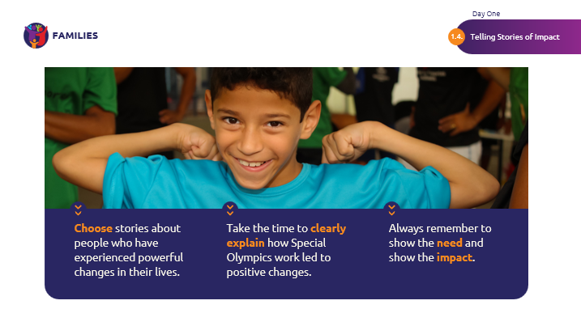
Telling Stories of Impact  Impact Story Discussion | Let’s close with one last discussion.  We have discussed the need to describe the work that Special Olympics does. It’s that middle part of the story where something changes.  Think about what you know about your Program.  What’s an example of important work that people outside of Special Olympics might not understand? What are parts of the work that you didn’t know about or understand at first? What kind of impact will that work have?  Let people discuss with one another to connect knowledge with impact.  Point out that this kind of thinking will help them know where to look for examples of impact. | 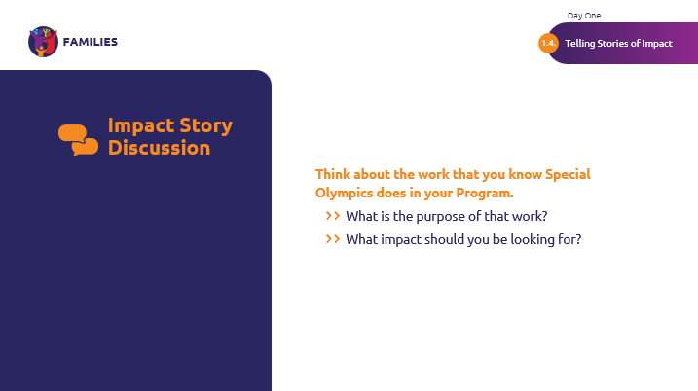
Module  Telling Stories of Impact / Sibling Engagement  Time  1 hour | Hi siblings. Thank you for joining us for the “Sibling Engagement” workshop! As siblings, you have a unique and important role as a Family Leader, and we are so glad to have you as part of our community.  First, let’s begin with an activity called the “Iceberg.” This is designed to get to know ourselves, and each other, a bit better. | 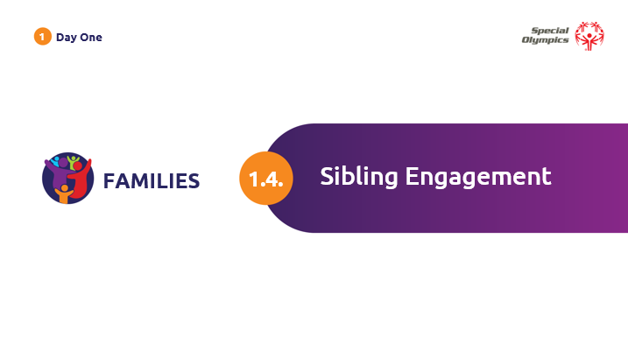
Sibling Engagement  Iceberg Activity | In this activity, we will draw an iceberg in an ocean.  What do you already know about icebergs?  (Facilitator Note: allow participation)  Great! It is important to know that most of the iceberg is hidden from view. How much of an iceberg is visible? The answer is 10 percent. This means that 90 percent of the iceberg is invisible unless we plunge below the surface of the water. A surface-level look alone doesn’t allow us to see the depth and breadth of the full iceberg.  People are similar to icebergs. Why do you think that is?  (Facilitator Note: allow participation)  You got it! In some ways, people are similar to icebergs – some things about us are on the surface (e.g. physical characteristics, dress, language). Other aspects of who we are hidden below the surface, and not immediately obvious (past experiences, where we grew up, our values, things we like or dislike, our beliefs).  (Facilitator Note: You may want to consider your own identity iceberg and add examples to your own iceberg as you go)  What do you think is the risk of making assumptions about people based on the tip of the iceberg?  Great! Thank you for sharing.  Now, let’s take some time to complete our own iceberg. Please only include what you are comfortable sharing.  After you are done, we will take time to share as a group. | 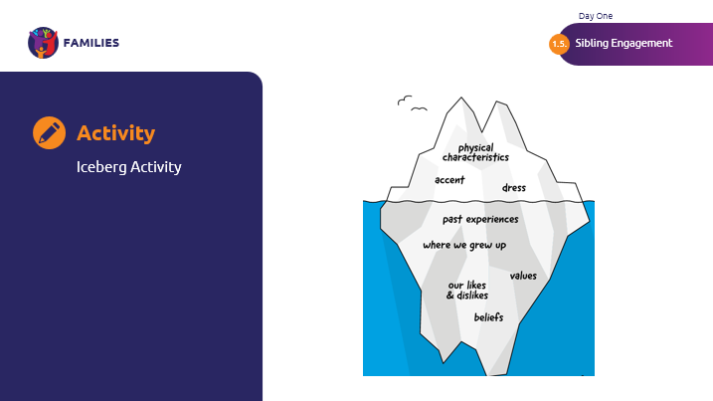
 | Great work! Let’s come back together to share our icebergs.  (Facilitator Note: Give time for all to share)  Thank you all for sharing. As you can see, while there are a lot of characteristics we have in common, we are all also completely unique!  Now that you’ve heard everyone share their iceberg, how do you think the above the surface characteristics impact us as Family Leaders? How about the below the surface characteristics? How can we use these icebergs to help us understand each other as leaders?  (Facilitator Note: Give time for all to share)  Thanks, everyone! Let’s now discuss sibling engagement. | 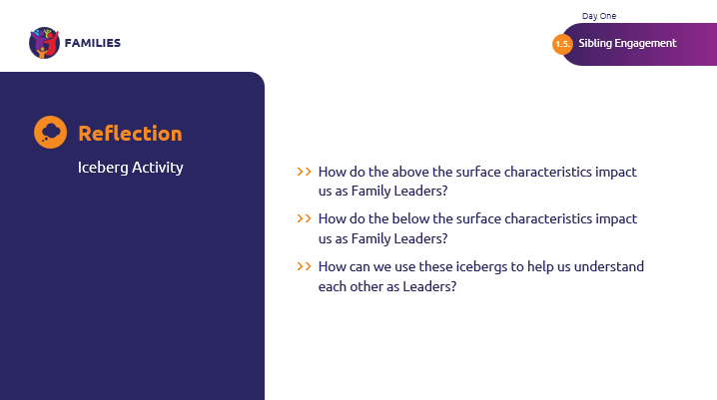
Sibling Engagement | What is sibling engagement?  Sibling engagement occurs when the sibling of a person with intellectual disabilities is actively involved in their brother or sister’s life. Engaged siblings are active participants in their brother’s and sister’s Special Olympics journeys. They play, learn, develop and work together, strengthening their relationship in the process.  The siblings are a team who motivate and support each other. They work toward and achieve shared and personal goals. There are many ways you can become an engaged sibling in Special Olympics, including through:  - Supporting: cheering on your sibling  - Volunteering: at local SO Events, Healthy Athletes, becoming an SO Official, or helping your local Program as a Family Leader, of course!  - Participating: in Young Athletes, Unified Sports, University Engagement, or becoming an SO Coach  - Connecting: connecting with other siblings and your local Programs, such as through this training, and working towards Program goals together.  - Advocating: this could mean advocacy in your school or within your local Program. | 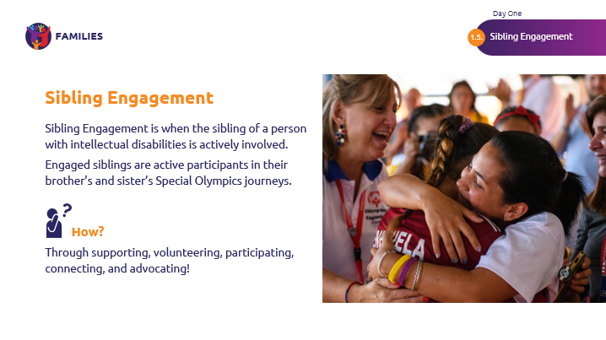
Sibling Engagement  Mutually Beneficial Outcomes | Engaging with Special Olympics as siblings not only benefits your local Program and sibling, but it is also beneficial to you. Your sibling will appreciate the time you invest in their goals. Meanwhile, sibling engagement can offer you:  - Pride in yourself and your sibling  - Increased self-esteem  - Professional development skills  - Leadership skills and opportunities  - Advocacy skills  - Friendships with other siblings and athletes  - A stronger bond with your sibling  - Greater tolerance and acceptance for all people  - Stronger family unity  - Opportunities for personal and athletic growth  As a sibling, your role in Special Olympics will change over time depending on your interests, goals and time commitments. There is always a place for you in Special Olympics! | 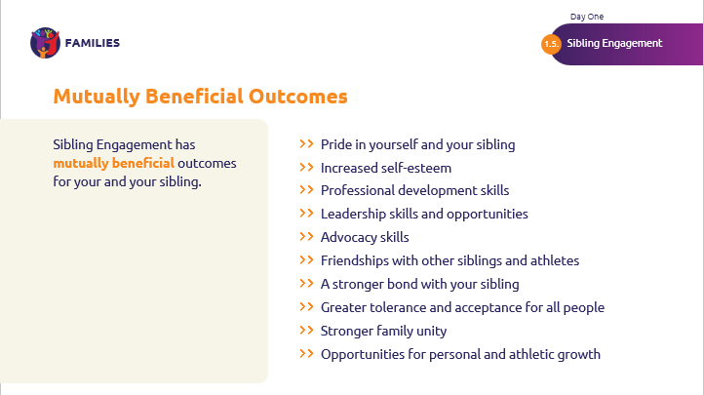
Sibling Engagement  Examples of Sibling Engagement | Worldwide, sibling engagement occurs in a variety of ways. Here is a successful example of sibling engagement in the United Arab Emirates, which is located in our SO Middle East/North Africa Region!  Siblings in the United Arab Emirates have the chance to apply to and join the UAE Sibling Council for two years. On the council, there are five local siblings from the UAE and five expat siblings who live in the UAE.  Their general responsibilities include representing SO UAE in local and international events, attending monthly meetings, reviewing and advising SO UAE on projects and university clubs, speaking in public events, taking part in youth circles and groups, and actively engaging and working with inclusion organizations within the UAE.  Can you think of ways that you can incorporate some strengths of this example into your own local Program?  Great! Let’s now join back together with the rest of the family members. | 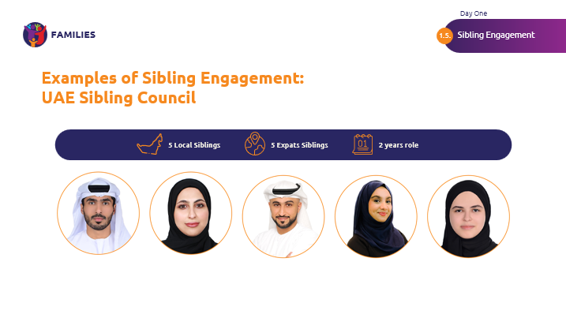
Module  Next Step Planning  Time  30 minutes | Welcome back together, Family Leaders!  As promised, this will be our chance to reflect on our learnings and to create our own Action Plan draft. You will create this Action Plan based on the details you gathered about your Program in your pre-work, as well as your own strengths. After the training, you will present this Action Plan to the contact in your Program. This will give you a chance to edit your Action Plan to align further with your local Program. | 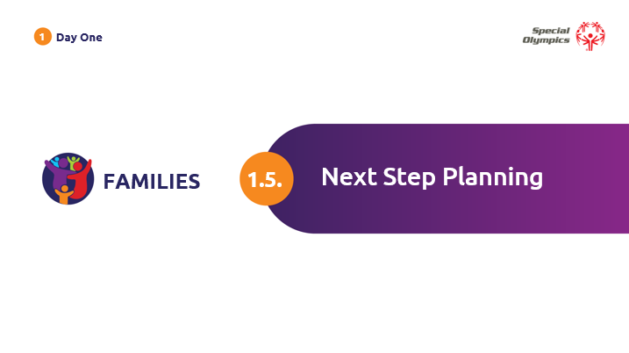
Next Step Planning  Activity: Action Plan | ***Athlete participation recommended  Here is a chance to create your Action Plan. You will have 15 minutes to answer the questions listed on the Action Plan:  - Who are the people who can help me?  - What resources do I need?  - What challenges might I face?  - What are solutions to those challenges?  After 15 minutes, you will have an opportunity to share any concerns or challenges you think you might face with a small group of around 5-8 people. You can support one another and think about solutions.  If, after talking with your group, you want to change our action plan, that is okay! You may find out that a fellow Family Leader gave you a great suggestion for resources or solutions to potential challenges.  (Facilitation Note: Give about 15 minutes to share and discuss in groups)  Great job, everyone! I hope you found this exercise useful and now have an action plan to help achieve your leadership goal. | 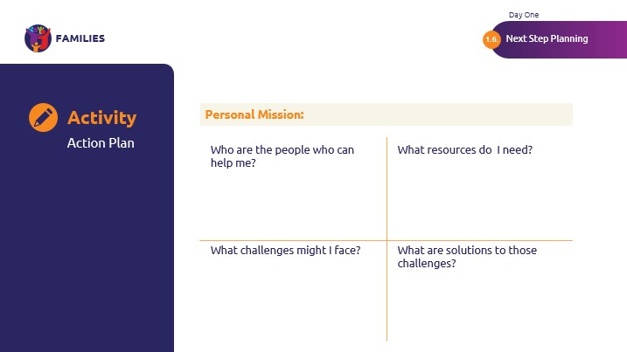
Fitness Energizer  Time: 3-5 min  Independent Break  Time: 30 min | ***Athlete participation recommended  You have now completed the “Next Step Planning” module. Thank you for your participation!  Let’s take a short fitness break together.  Afterwards, you will have around 30 minutes for an independent break to refresh. | 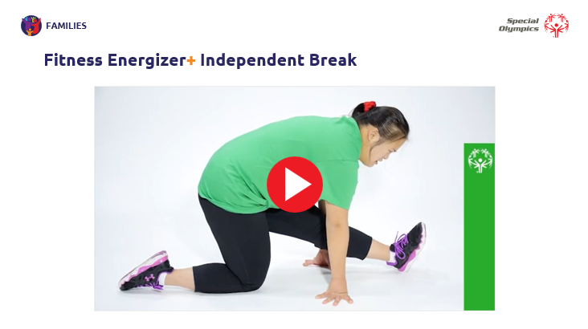
Module  Guest Speaker  Time  1 hour | Facilitator Note:  Invite a speaker to cover one of the below topics. Speaker and topic should be focused on family engagement in some way:  - Families engaging in government advocacy, inclusion, local family support systems, or in any area/program of interest related to family engagement  - Have a current Family Leader share their experiences/how they became a leader  - Have a current athlete leader share their experiences/how they became a leader | 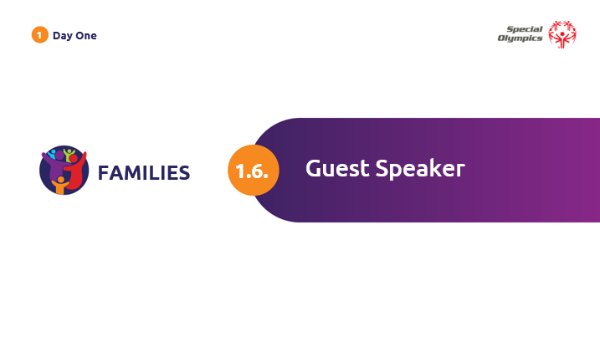
DAY TWO
Module  Field Day  Time  3 hours | Facilitator Note:  Here are a few ideas of event that can be carried out during Field Day. If you are leaving the site of the training, make sure transportation has been configured in advance.  - Attend an event and learn ways of volunteering.  - Attend an event and discuss how it was planned and executed.  - Attend a practice and discuss a family member’s role in sport practices.  - Incorporate Family Health Forum.  - Visit a Program office to meet staff and volunteers and discuss ideas for family engagement.  - Let us move while having fun: bring a coach to run a 30-minute cardio training or stretching to relax at the end of the training day. | 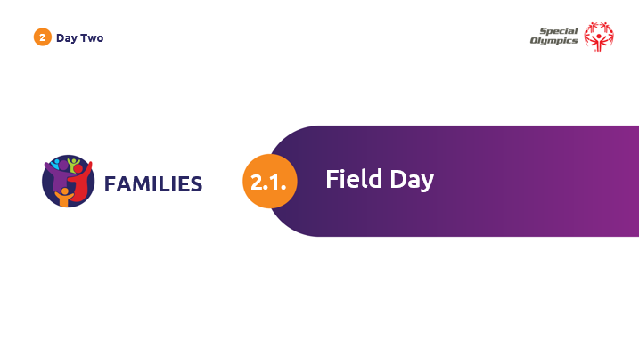
Lunch Break  Time: 1 hour  Fitness Energizer  Time: 3 minutes | ***Athlete participation recommended  Welcome back from Field Day!  We will now have a one-hour lunch break. We will return with a three-minute energizer, before we conclude with a final reflection together. | 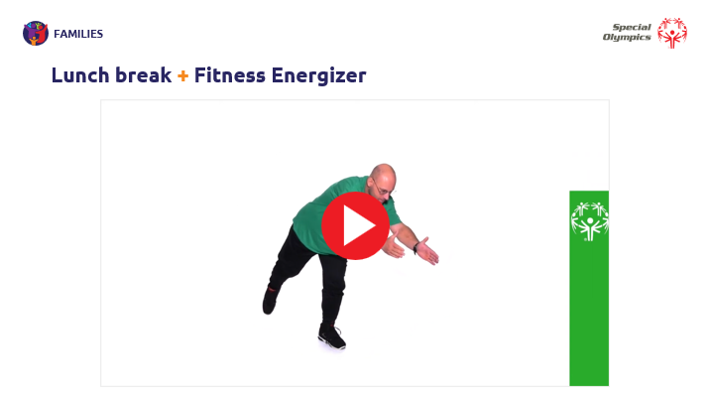
Module  Debrief  Time  1 hour | We have come to the end of our training! Wonderful job, everyone!  Thank you for your commitment to growing as a Family Leader and continuing your personal development.  Remember, your leadership journey, goals, and action plan are unique to you. You may go through several different missions as a Family Leader, and that is okay.  To conclude our training, we will come back together for a reflection activity. | 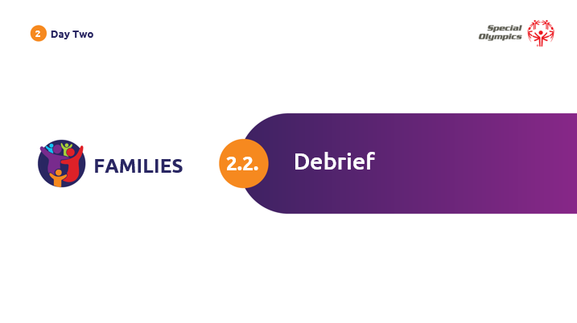
Debrief  Activity: Reflections | ***Athlete participation recommended  In this final activity together, we will have an opportunity to reflect using the “Rose, Thorn, Bud” method. This can be based on your Action Plan, or the training in general.  - Rose = A highlight, success, small win, or something positive that happened.  - Thorn = A challenge you experienced or something you can use more support with.  - Bud = New ideas that have blossomed or something you are looking forward to knowing more about or experiencing.  You have around two minutes to sit silently and reflect on your rose, bud, and thorn. Then, we will join back together to share our own rose, bud, and thorn, and then go around the room while others share.  (Facilitator Note: Begin with your own rose, bud, thorn. Allow everyone who is comfortable sharing to do so)  Great reflections! | 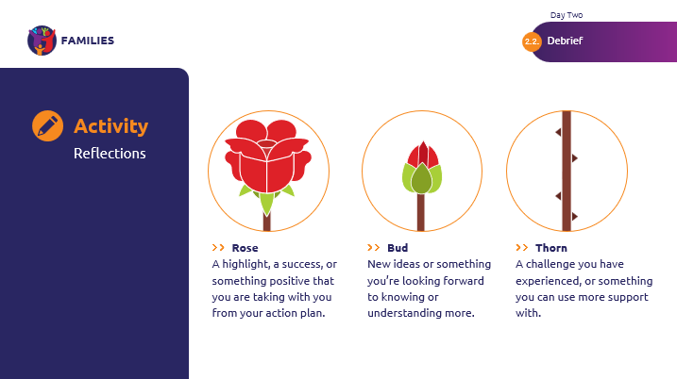
Optional Final Family Well-being Survey | Before we officially end, Family Leaders who chose to participate in the optional initial Family Well-Being Survey will be asked to participate again in the Final Family Well-Being Survey. If you opted to complete the initial survey, we kindly request that you also fill out the final survey.  Your responses will be invaluable in identifying how Special Olympics can best support family well-being in the future.  This survey is expected to take approximately five minutes of your time.  You will find the final survey in your Family Leader Training: Participation Guide, but you can also choose to scan the QR code on the next slide to take the survey electronically.  I will now give you around five minutes to fill in the final survey! | 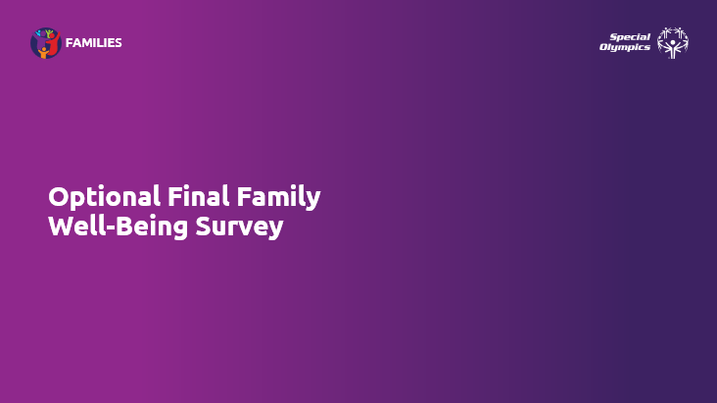
Optional Final Family Well-being Survey – QR CODE | If you have chosen to participate and wish to do so electronically, here is the QR code | 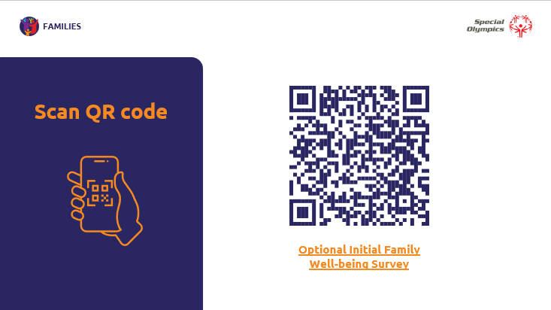
 | Thank you for your time, effort, and participation! I will personally follow up with you one month after training to check in on your Action Plan.  We are grateful to have you as our new Family Leaders, and we are excited to hear about your leadership in action!  (Facilitator Note: Make sure to follow up with Family Leaders after one month to ensure support and guidance!) | 