Benefits of Special
Olympics Involvement
Involvement in Special Olympics sports and activities is a favorite pastime for millions of people across the world. Here are a few benefits of being involved with the Special Olympics movement:

Physical Health and Fitness:
Participation in Special Olympics helps people with intellectual and developmental disabilities (IDD) improve their physical health, develop motor skills, enhance coordination, and maintain a healthy lifestyle through regular physical activity.
 |  | Social Inclusion and Community Engagement:  Special Olympics fosters a sense of belonging and inclusion among athletes, promoting social interaction, friendship, and a sense of community. Athletes often build lasting friendships with fellow athletes, coaches, volunteers, and supporters. |  | 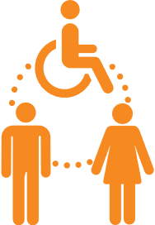
 |  | 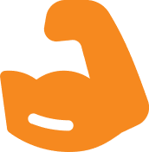 | Skill Development:  Athletes in Special Olympics develop and enhance their skills, including teamwork, sportsmanship, communication, and goal-setting. These skills are beneficial in their daily lives.
Boosted Self-Esteem and Confidence:
Participation in sports and achieving personal goals at Special Olympics significantly boosts self-esteem and confidence. It provides a platform for people with IDD to showcase their abilities and achievements.
Personal Growth and Empowerment:
Special Olympics encourages athletes to challenge themselves, set and achieve personal goals, and overcome barriers. This empowerment leads to greater independence and a more fulfilling life.
Improved Mental Health:
Regular physical activity and participation in sports have a positive impact on mental health, promoting a sense of well-being, reducing stress and anxiety, and improving overall mental resilience.

 |  | 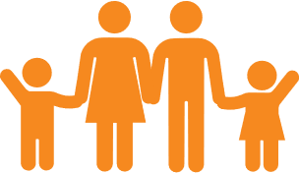 | Family involvement and support:  Special Olympics provides families of athletes with opportunities to be involved, support their loved ones, and connect with other families facing similar challenges. This creates a strong support network.
Community and competitions:
Special Olympics organizes local, national, and international competitions, allowing athletes to compete on a larger stage and experience a sense of achievement, pride, and camaraderie with athletes from around the world.
Awareness and Understanding:
Special Olympics raises awareness about the abilities and contributions of people with IDD, challenging stereotypes and promoting a more inclusive society.
Educational Opportunities:
Special Olympics offers educational programs related to health, fitness, nutrition, and overall well-being, providing athletes and families with valuable knowledge and skills to lead healthier lives.
 |  | Special Olympics enriches the lives of individuals with intellectual and developmental disabilities and their families by promoting physical health, social inclusion, skill development, empowerment, and a sense of belonging, ultimately contributing to a more inclusive and accepting society.

