Athlete Leadership PowerPoint

Participant Guide
2016

Table of Contents/Agenda

Time | Slide | Topic | Page
9:00 am |  | Table of Contents/ Agenda | 2
 | 2 | Part 1 COURSE OVERVIEW, WELCOME & INTRODUCTIONS
 | 3 | Welcome, Course Overview and Agenda | 3
 | 4 | Introductions | 3
9:35 am | 5 | Part 2 MENTORS’ ROLES AND WHY USE POWERPOINT
 | 6 | Mentors’ Roles | 4
 | 7 | Mentors’ Roles (cont.) | 4
 | 8 | Why use PowerPoint? | 4
 | 9 | Multi Media PowerPoint Training | 4
10:00 am | 10 | Part 3 TERMINOLOGY
 | 11 | Terminology | 4
 | 12 | Explanation of Terminology | 4
 | 13 | Getting Started | 5
 | 14 | Opened Template | 5
 | 15 | Slide Show Template | 6
 | 16 | More Terminology | 7
 | 17 | Save As (Your Name) | 8
 | 18 | Top Tool Bar | 9
10 |  | Break
 | 19 | Home – Copy, Cut, Paste | 10
 | 19 | Home - Slides | 11
 | 20 | Home – Font | 12
 | 21 | Home - Paragraph | 13
 | 22 | Home – Drawing | 14
 | 22 | Home – Editing | 15
45 | 23 | Lunch
 | 24 | Insert – Tables and Illustrations | 16
 | 25 | Insert (cont.) – Links and Text | 17
 | 26 | Design – Slide Size/Format, Themes | 18
 | 27 | Transitions – Style, Sound, Speed and Preview | 19
 | 28 | Animations – Add Animation, Animation Pane, Timing, Preview | 20
 | 29 | Slide Show – Start Slide Show, Set up Slide Show | 21
 | 30 | Review – Proofing/Comments -- Spelling, Research, Thesaurus, Comments, Compare | 22
 | 31 | View – Presentation Views, Master Views, Zoom, Color/Grayscale, Window | 23
2:20 pm | 32 | BREAK
2:30 pm | 33 | Part 4 DEVELOP A SLIDE SHOW
 | 34 | Developing Your Slide Show | 24
3:30 pm | 35 | Part 5 PRESENTATIONS, PRACTICUM AND COURSE FEEDBACK
 | 36 | Presentations | 25
 | 37 | Practicum and Practicum Form | 25-26
 | 38 | Back Home/Feedback | 27-28
 | 39 | Show me the ATHLETE

Welcome and Review of Agenda
- Welcome trainers and participants.

- See one-pager of Athlete Leadership Training Series model your Program is offering and where PowerPoint fits.

- The training is designed primarily to teach athletes how to utilize computers. With this knowledge, they will learn to develop their own PowerPoint presentations. There are many uses for athletes to utilize PowerPoint such as a non-verbal Global Messenger, different means for current Global Messengers to get their message across, presentations during workshops, Athlete Input Council Meetings, Presentations to Local Management Teams and many more.

- Turn to page 2 of this Participant Guide. Review the time frames and the content of the agenda. Stress the need for participants to be on time.

- Handle any logistical details and announcements, and indicate availability to help with any problems that arise during the session.

Trainer and Athlete Introductions

Participant Guide
- This Participant Guide will follow along with the hands-on demonstration of the terminology explained in the PowerPoint. You will learn a lot of information in a short amount of time today. Please do not be worried if you do not remember it all. The only way you will begin to remember is after you begin to actually do the work on the computer. Relax and do not get frustrated. Hopefully, by the end of the day, it will all make sense. Turn on your computer.

Role of Mentor
- This is a Best of Ability workshop.

Why Use PowerPoint?

- Because there are many different ways to give speeches, presentations, etc., PowerPoint is just another method of getting out information on the Special Olympics movement.
- PowerPoint opens the door to athletes that cannot use their own voice to tell their story. Non-verbal athletes have a very powerful story that now can be told.
- Athletes have a new outlet to explore within Athlete Leadership. Technology is a fascinating for many of our athletes, and many of them have a talent for it.
- Many times a visual aid in presentations can be very powerful. Pictures can speak a thousand words.
- Even if you cannot take a laptop and do a PowerPoint presentation, it can be made into a video very easily. Sometimes getting a TV and VCR from the people you are presenting to is easier than an LCD projector.

Multi-Media PowerPoint Training
  - The three PowerPoint presentations that you are going to see have many of things that we will be working on today. Those items are: pictures, video, captions, templates, transitions and animations.

Terminology
The following is an explanation of the items below:
- Hardware is the actual machine you are working on.
- Software is the USB Flash Drive and CDs that you may use.
- Keyboard is the place where you will input your information. How many of you have ever practiced typing?
- Monitor is the screen that you look at on your computer.
- Mouse is the object that moves the arrow around on your monitor.

Getting Started
- Put USB Flash Drive or CD into the appropriate Port.
- Find Start or Windows Globe on Task Bar.
- Click on Globe: find and click on Computer.
- Find and double click on the drive that is located under Devices with Removable Storage. It may be listed by the brand of the USB Flash Drive.
- Double click on the folder called “Template”.

Opened Template
- What you are looking at is called a pre-made template. Many of your Special Olympics presentations can be done using these templates.
- Click on the SOI Presentation Template Arial.

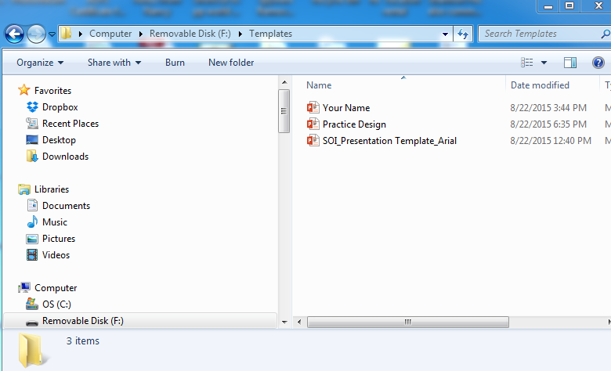

My Notes: ______________________________________________________________________________________________________________________________________________________________________________________________________________________________________________________________________________________________________________________________________________________________________________________________________________________________________________________________________________________

Slide Show Template
- This is what the Template on your computer monitor should look like when it opens.
- Next we’re going to learn to save this template under another name, this is called Save As.
- Click on “File” located in the upper left corner of your monitor.

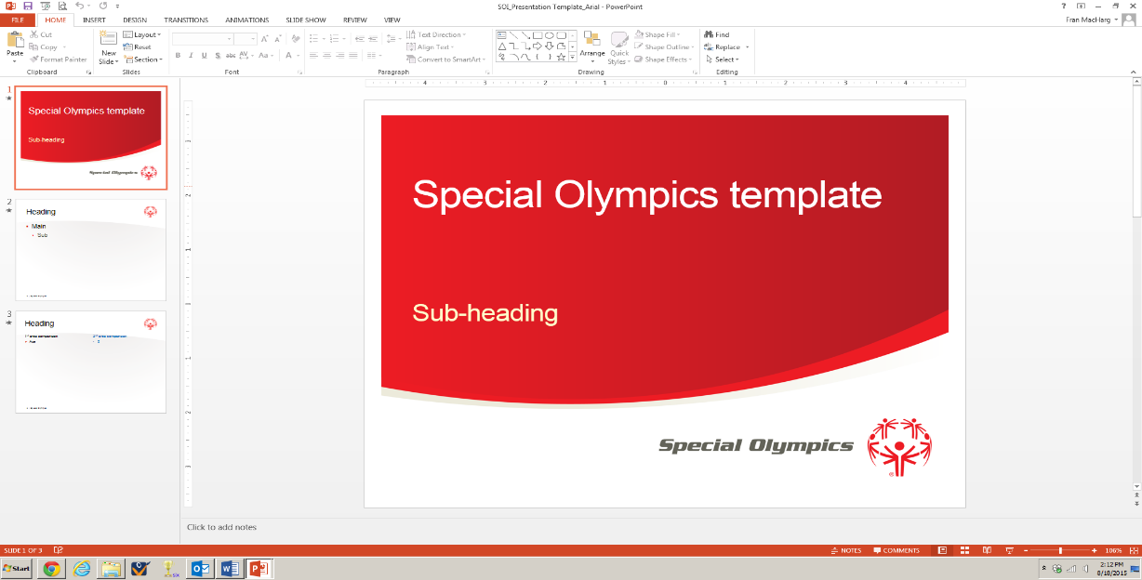

My Notes: ______________________________________________________________________________________________________________________________________________________________________________________________________________________________________________________________________________________________________________________________________________________________________________________________________________________________________________________________________________________________________________________________________________________________________________________________________________________________________________________________________________________________________________________________________________________________________________________________________________________________________________________________________________

More Terminology
- You will see this menu (might be another color) on the left side of your monitor.
- We are now going to move through the Toolbars on your screen.

  - Info: Protection, Inspect, Versions
  - New : Starts a new presentation
  - Open: Opens an existing presentation
  - Save: Saves the presentation you are working on.
  - Save As: Saves the presentation you are working on as a new name.
  - Print: Prints the open presentation
  - Share: Invite People, Email, Present Online, Publish Slides
  - Export: Create PDF/XPS Doc, Create Video, Package Presentation, Create Handouts, Change File Type
  - Close: Closes Presentation
  - Account: User Information
  - Options: General options for working with PowerPoint.

- Click on Save As …
My Notes: ________________________________________________________________________________________________________________________________________________________________________________________________________________________________________________________________________________________________________________________________________________________________________________________________________________________________________________________________________________________________________________________________________________________________________________________________________________________________________________________________________________________________________________________________________________________________________________________________________________________________________________________________________________________________________________________________________________________________________________________________________________________________________________

Save as
- Save template as Your Name
1
Save to the Letter that represents the USB Flash Drive. You may have to browse.
My Notes: ________________________________________________________________________________________________________________________________________________________________________________________________________________________________________________________________________________________________________________________________________________________________________________________________________________________________________________________________________________________________________________________________________________________________________________________________________________________________________________________________________________________________________________________________________________________________________________________________________________________________________________________________________________________________________________________________________________________________________________________________________________________________________________

TOP TOOL BAR
N
S

2
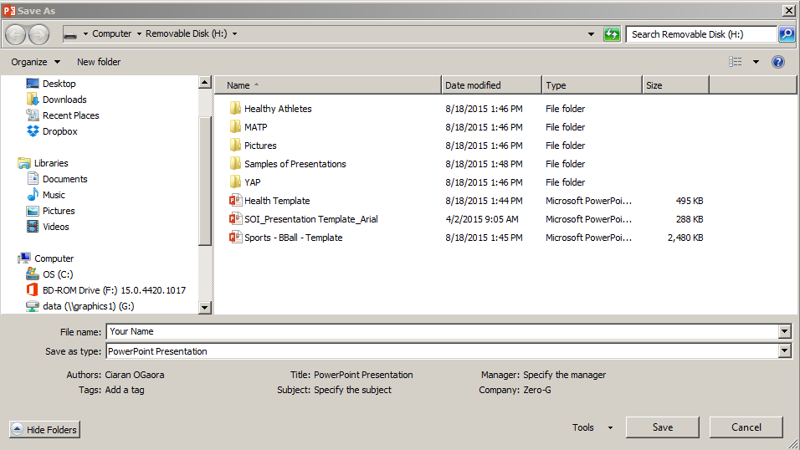

My Notes: ________________________________________________________________________________________________________________________________________________________________________________________________________________________________________________________________________________________________________________________________________________________________________________________________________________________________________________________________________________________________________________________________________________________________________________________________________________________________________________________________________________________________________________________________________________________________________________________________________________________________________________________________________________________________________________________________________________________________________________________________________________________________________________

- Top Tool Bar – Overview of Top Taps of PowerPoint
  - Home – Basic design of Design, Font and shapes
  - Insert – Add Pictures, Clip art, and sounds
  - Design- Slide color and design
  - Transitions – Moving from Slide to Slide
  - Animations – Adds movement to word
  - Slide Show – Define and view presentation
  - Review – Spell Check / Add comments
  - View – Presentation view type
My Notes:
______________________________________________________________________________________________________________________________________________________________________________________________________________________________________________________________________________________________________________________________________________________________________________________________________________________________________________________________________________________________________________________________________________________________________________________________________________________________________________________________________________________________________________________________________________________________________________________________________________________________________________________________________________________________________

HOME TAB
N
S

- Home Tab (Demonstrate and have athlete practice each task during review)

  - Clipboard:
  - Copy: Copy a highlighted object

  - Cut: Cuts a highlighted object

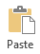
  - Paste: Pasted the object that has been cut or copied
My Notes: ________________________________________________________________________________________________________________________________________________________________________________________________________________________________________________________________________________________________________________________________________________________________________________________________________________________________________________________________________________________________________________________________________________________________________________________________________________________________________________________________________________________________________________________________________________________________________________________________________________________________________________________________________________________________________________________________________________________________________________________________________________________________________________

HOME TAB
N
S

  - Slides:
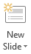
  - New Slide: Insert new slide
  - Layout: Design of slide
  - Reset: Undo to default slide design

  - Sections – Organize your slides into sections.

My Notes: ________________________________________________________________________________________________________________________________________________________________________________________________________________________________________________________________________________________________________________________________________________________________________________________________________________________________________________________________________________________________________________________________________________________________________________________________________________________________________________________________________________________________________________________________________________________________________________________________________________________________________________________________________________________________________________________________________________________________________________________________________________________________________________

HOME TAB
N
S

  - Font:
  - Font Style: Change style of letters
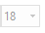
  - Font Size: Change size of letters

  - Bold: Make letters bold
  - Italicize; Italicize the letters

  - Font color: Changes letter color
My Notes: ________________________________________________________________________________________________________________________________________________________________________________________________________________________________________________________________________________________________________________________________________________________________________________________________________________________________________________________________________________________________________________________________________________________________________________________________________________________________________________________________________________________________________________________________________________________________________________________________________________________________________________________________________________________________________________________________________________________________________________________________________________________________________________
HOME TAB
N
S

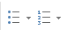
  - Paragraph:
  - Bullets: Add numbers or Bullet style to a list
  - Align text Left: Move words to left of box

  - Align Text Center: Move words center of box
  - Align Text Right: Move words right of box

  - Justify Text: Moves words even across box
  - Text to Columns: Places a list to columns

  - Text Direction: Changes direction of words
My Notes: ________________________________________________________________________________________________________________________________________________________________________________________________________________________________________________________________________________________________________________________________________________________________________________________________________________________________________________________________________________________________________________________________________________________________________________________________________________________________________________________________________________________________________________________________________________________________________________________________________________________________________________________________________________________________________________________________________________________________________________________________________________________________________________

HOME TAB
N
S

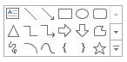
  - Drawing:
  - Shapes: Add shapes and lines to presentation
  - Shape fill: Fill shape with color
  - Shape Outline: Outline shape with color

  - Shape Effects: Change design of shape

My Notes: ________________________________________________________________________________________________________________________________________________________________________________________________________________________________________________________________________________________________________________________________________________________________________________________________________________________________________________________________________________________________________________________________________________________________________________________________________________________________________________________________________________________________________________________________________________________________________________________________________________________________________________________________________________________________________________________________________________________________________________________________________________________________________________

HOME TAB
N
S

  - Editing:
  - Find: Locate words in presentation
  - Replace: Change words to different Font

  - Select: Selects areas for copy, changing or delete area

My Notes: ________________________________________________________________________________________________________________________________________________________________________________________________________________________________________________________________________________________________________________________________________________________________________________________________________________________________________________________________________________________________________________________________________________________________________________________________________________________________________________________________________________________________________________________________________________________________________________________________________________________________________________________________________________________________________________________________________________________________________________________________________________________________________________

INSERT TAB
N
S

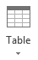
  - Tables
    - Insert Excel tables/ Drawings

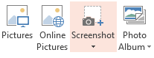
  - Illustrations
    - Picture: Insert pictures from Computer, Disk or USB Flash Drive
    - Clipart: Insert clip Art from Internet

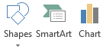
    - Shapes: Add shapes to presentation
    - Smart Art: Places lists into complex graphics
    - Chart: Places a Chart into presentation

My Notes: ________________________________________________________________________________________________________________________________________________________________________________________________________________________________________________________________________________________________________________________________________________________________________________________________________________________________________________________________________________________________________________________________________________________________________________________________________________________________________________________________________________________________________________________________________________________________________________________________________________________________________________________________________________________________________________________________________________________________________________________________________________________________________________

INSERT TAB
N
S

  - Links:
    - Hyperlink: Link to web page or picture
    - Action: Set action when you mouse click or hover over

My Notes: ________________________________________________________________________________________________________________________________________________________________________________________________________________________________________________________________________________________________________________________________________________________________________________________________________________________________________________________________________________________________________________________________________________________________________________________________________________________________________________________________________________________________________________________________________________________________________________________________________________________________________________________________________________________________________________________________________________________________________________________________________________________________________________

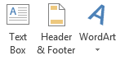
  - Text:
    - Text Box: Make Box for words
    - Header & Footer: Slide number or date added to each page
    - WordArt: Make decorative words
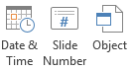
    - Date & Time: Add Date and Time to Slide
    - Slide Number: Add Slide Number to slide
    - Object: Add Object to Slide
My Notes: ________________________________________________________________________________________________________________________________________________________________________________________________________________________________________________________________________________________________________________________________________________________________________________________________________________________________________________________________________________________________________________________________________________________________________________________________________________________________________________________________________________________________________________________________________________________________________________________________________________________________________________________________________________________________________________________________________________________________________________________________________________________________________________

DESIGN TAB
N
S

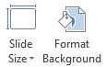
Design
  - Slide Size/Format Background: Page size, Format Background.

  - Themes: Set Background Design, Color, & Effects
Practice changing design and color on your Practice Design Template.
My Notes: ________________________________________________________________________________________________________________________________________________________________________________________________________________________________________________________________________________________________________________________________________________________________________________________________________________________________________________________________________________________________________________________________________________________________________________________________________________________________________________________________________________________________________________________________________________________________________________________________________

TRANSITIONS TAB
N
S

- Transitions – How moving from slide to slide looks and sounds.

- Style: Design type of transitions to next slide.
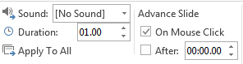
- Sound: Design sound for slide transition

- Speed: Set Speed of transition
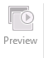
- Preview: View created slide transition

Practice 1 or 2 Transitions on Slide 4 in Practice Design.
My Notes: ________________________________________________________________________________________________________________________________________________________________________________________________________________________________________________________________________________________________________________________________________________________________________________________________________________________________________________________________________________________________________________________________________________________________________________________________________________________________________________________________________________________________________________________________________________________________________________________________________________________________________________________________________________________________________________________________________________________________________________________________________________________________________________

ANIMATIONS TAB
N
S

- Animations: How a letter, word or an object moves
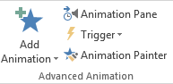
- Add Animation: Choose an animation effect to add to the selected objects.

- Animation Pane: Display animations and how they are activated.

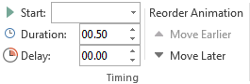
- Timing: Determine/adjust time for an animation.

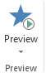
- Preview: View created slide animation

Practice 1 or 2 Animations on Slide 4 in Practice Design.
My Notes: ________________________________________________________________________________________________________________________________________________________________________________________________________________________________________________________________________________________________________________________________________________________________________________________________________________________________________________________________________________________________________________________________________________________________________________________________________________________________________________________________________________________________________________________________________________________________________________________________________________________________________________________________________________________________________________________________________________________________________________________________________________________________________________
SLIDE SHOW TAB
N
S

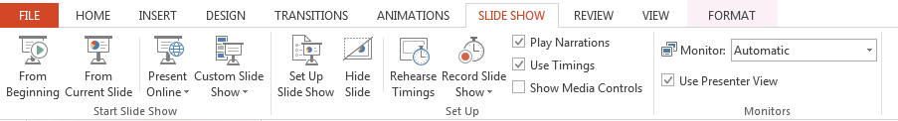

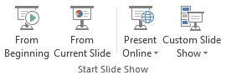
- Slide Show
  - Start Slide Show
    - Beginning: Start show at 1st slide.
    - Current: Start show from slide you are viewing.
    - Custom Slide Show: Show to only slides selected.
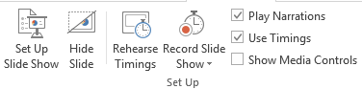
    - Set Up Slide Show: Set up advances options.
    - Hide Slide: Hide Current Slide.
    - Rehearse Timing: Practice slide show to see what works best.

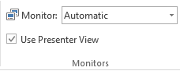
- Monitors: Set Monitor Resolution

Practice 1 or 2 Slide Shows Viewing on Practice Design.
My Notes: ________________________________________________________________________________________________________________________________________________________________________________________________________________________________________________________________________________________________________________________________________________________________________________________________________________________________________________________________________________________________________________________________________________________________________________________________________________________________________________________________________________________________________________________________________________________________________________________________________________________________________________________________________________________________________________________________________________________________________________________________________________________________________________

REVIEW TAB
N
S

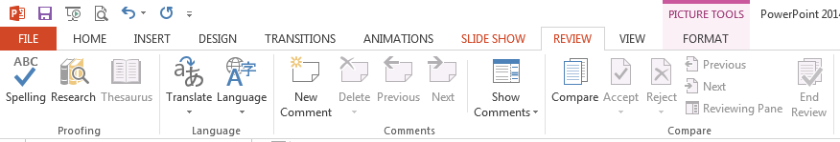

- Review - Proofing / Comments
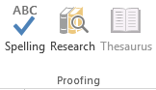
  - Proofing
    - Spelling: Spell check presentation.
    - Research: Look up information.
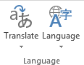
    - Thesaurus: Look up new words.
    - Language: Translate text into a different language and proofing tools.
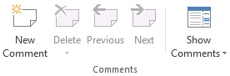
    - Comments: Add/Edit Comment to slide.

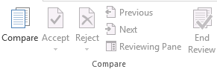
- Compare: Compares and combines other presentations into current presentation.

My Notes: ________________________________________________________________________________________________________________________________________________________________________________________________________________________________________________________________________________________________________________________________________________________________________________________________________________________________________________________________________________________________________________________________________________________________________________________________________________________________________________________________________________________________________________________________________________________________________________________________________________________________________________________________________________________________________________________________________________________________________________________________________________________________________________
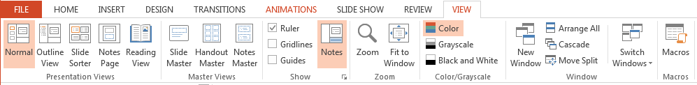
VIEW TAB
N
S

- View
  - Presentation Views
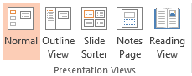
- Normal: Is Presentation Design View
- Outline View: See the Outline of presentation.
- Slide Sorter: Arrange slide.
- Notes Page: Add Presentation Notes.
  - Use Notes Pages when giving a presentation having to remember facts or figures.
- Reading View: View Slide Show.
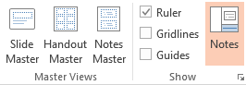
    - Master Views: View Slide Show in various ways.
    - Ruler/Gridlines: Use for Show Design.

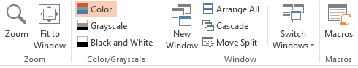
    - Zoom: Enlarge view.
    - Color/Grayscale: Change show color.
    - Window: View and switch between multiple windows
My Notes: _______________________________________________________________________________________________________________________________________________________________________________________________________________________________________________________________________________________________________________________________________________________________________________________________________________________________________________________________________________________________________________________________________________________________________________________________________________________________________________________________________________________________________
Developing a Slide Show
  - Decide on a topic to present.
  - Write the outline of the presentation (dictate ideas to mentor).
  - Make slides with information (try to make at least 10 slides).
  - Insert Pictures & Shapes.
  - Design Themes and Background.
  - Set Slide Transitions.
  - Set Animations.
  - Review / Check Spelling.
  - View Show.

My Notes: _____________________________________________________________________________________________________________________________________________________________________________________________________________________________________________________________________________________________________________________________________________________________________________________________________________________________________________________________________________________________________________________________________________________________________________________________________________________________________________________________________________________________________________________________________________________________________________________________________________________________________________________________________________________________________________________________________________________________________________________________________________________________________________________________________________________________________________________________________________________________________________________________________________________________________________________________________________________________________________

Presentations
- Each athlete will make their own PowerPoint Presentation and present today to our class.
    - 1 hour to develop your presentation.
    - 1 hour for the whole class to present their PowerPoints.

Practicum Requirements
- Each athlete must make two new PowerPoint Presentations on any topic about Special Olympics. Presentation must be at least 20 slides in length. One presentation must use the Special Olympics template provided.
My Notes: _____________________________________________________________________________________________________________________________________________________________________________________________________________________________________________________________________________________________________________________________________________________________________________________________________________________________________________________________________________________________________________________________________________________________________________________________________________________________________________________________________________________________________________________________________________________________________________________________________________________________________________________________________________________________________________________________________________________________________________________________________________________________________________________________________________________________________________________________________________________________________________________________________________________________________________________________________________________________________________

Athlete Leadership Practicum Form PowerPoint
Practicum must be completed within 6-12 months; otherwise, your coursework will not count.

Must be returned to Program office by email ______________ or Fax _____________by________

Athlete name Phone
Address Gmail

Mentor Phone
Address E-mail

Name of Program you represent

Certification requirements for the PowerPoint Course:

Date of Course: Instructors:

Lead Instructor’s Email address

- Made and delivered 2 PowerPoint Presentations (minimum of 20 slides each). One presentation must use the Special Olympics template.

- Date__________________ Topic____________________________________________________
- Date__________________ Topic____________________________________________________
- Attach copies of each PowerPoint Presentation (print with Notes Pages) or PDF and send to instructor.

- Date mailed
Must be signed below:

I did this PowerPoint on my own. My athlete did his/her own PowerPoint.

Signature of Athlete (Date) Signature of Mentor (Date)

Athlete Leader Coordinator Signature (Date) Athlete Leader Coordinator (Print) (Date)

Next Steps Back Home

What am I going to do when I go back home?

1.
2.
3.
4.

Return to: ________________________________
By: ________________________________

PowerPoint Evaluation

Please complete this Evaluation Form and return to the instructors by the end of the class. We value your opinions and want to make continuous improvements.

Name: ________________________________ Program: ______________________

Please check (X) Athlete _____ Mentor ____

Name 2 things YOU learned that are going to make your PowerPoint presentation standout.

1.

2.

Describe the section of this course you liked best ____________________________________________
And explain why you liked it.

Identify which part of the course didn’t work for you. __________________________________________
Suggest why it may not have worked.

Explain how you would improve this course when we offer it in the future?

What was your favorite exercise in the PowerPoint course?

Return to: ________________________________
By: ________________________________

