Introduction to Athlete Leadership
Participant Guide
2016

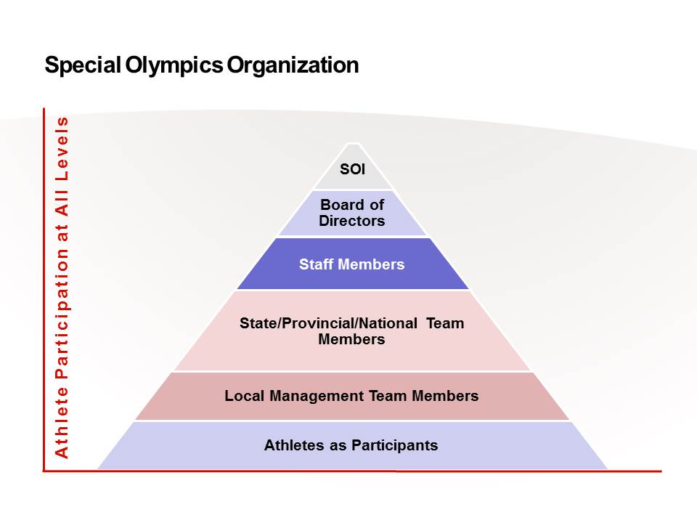

With proper training,
our athletes can be involved
and contribute in meaningful ways
at all levels.

Global Messengers or Reporters | Athletes as  Coaches or Officials | Athlete Input Council or Athlete Congress Member
Athletes as  Volunteers | Games/Program Management/ Team Members | Athletes as Mentors or Advocates
Athletes as Fundraisers/donors | Athletes as Course Instructors | Athletes on Committees  or Boards of Directors
Existing Athlete Leadership Roles

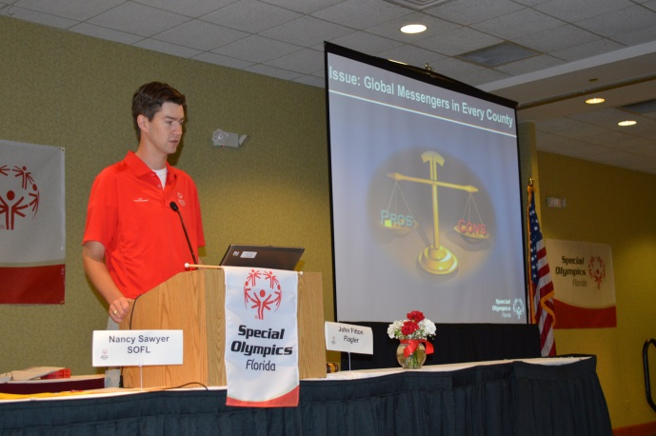

For assistance with Athlete Leadership Programs and information, please click go to the Special Olympics International website and click on resources and athlete leadership.
Roles for Athletes

Athlete Input Council Member — You can improve your local Program by making suggestions and discussing problems. Find out if your Program has an Athlete Input Council and become a participating member!
YOUR INPUT IS VALUABLE AND IS NEEDED!

Athletes as Global Messengers — Do you like to talk? You can be trained by Special Olympics in presentation skills to become an expert speaker. We’ll even teach you to use PowerPoint to give presentations to schools, community groups, parents, churches.
GIVE A TALK & GET NEW PEOPLE INVOLVED IN SPECIAL OLYMPICS!

Athletes as Coaches — You can become a coach or assistant coach if that is your dream! You will need to make a commitment to attend certification training by the state office then apply your training. There are many Special Olympics athletes in all Programs who have become coaches.
BECOME A COACH IF THAT IS YOUR DREAM!

Athletes as Officials — You can become an official if that is your dream! Special Olympics will provide athletes information so they can participate in sport National Governing Body certification programs as an official or other skilled sport personnel.
BECOME AN OFFICIAL IF THAT IS YOUR DREAM!

Athletes on Program Committees or Board of Directors — You can become a representative of athletes on these very important groups. Training is provided to prepare athletes to participate in Special Olympics programming and policy meetings. Training focuses on awareness and listening skills and reading financial reports. Many Programs have had several athletes on its Board of Directors.
BECOME A BOARD MEMBER; MAKE IMPORTANT DECISIONS!

Athletes in the Media — You can get the Special Olympics WORD out. You can write articles, do television or radio shows, or work with the newspapers. There are even Special Olympics athletes who produce and host their own monthly TV show on cable.
JOIN US AND HELP GET THE WORD OUT TO EVERYONE!

Athletes on Games/Program Management Teams — You can be a valuable asset on a Special Olympics Summer Games management team. Some athletes are filling important roles by helping the state office conduct the games that you compete in. More than half the of the local program management teams have an athlete representative.
ASK YOUR LOCAL PROGRAM WHAT YOU CAN DO TO IMPROVE SPECIAL OLYMPICS!

Athletes as Special Olympics Employees — Someday you might be employed by Special Olympics. Several states, provinces, Accredited Programs and the international office have athletes on their payroll as regular employees.
WORK AT GETTING THE SKILLS YOU NEED TO BECOME AN EMPLOYEE!

Athlete Congress Member — The Athlete Congress exists in several programs and there’s a World Congress. It provides a formal, deliberative process and place for athlete input on programming, policy and other processes of Special Olympics. There have been a total of three World Congresses.
BE AN ACTIVE INPUT COUNCIL MEMBER TO BECOME ELIGIBLE TO SERVE IN AN ATHLETE CONGRESS!

Athletes as Volunteers or Donors — Some of you have already done this, maybe without realizing it. You’ve may have helped with bake sales, raffles, 5K Runs in the past. Perhaps you helped chaperone other athletes for a little while. Many of you have done these leadership roles for Special Olympics when you are not competing.
YOU WILL FIND NEW WAYS TO HELP YOUR PROGRAM EVERYDAY!

Athletes as Mentors or Advocates — You can help fellow athlete leaders by being their helper at Athlete Leadership Program University or advocating for their rights when they are having sports or leadership problems.
NOTHING FEELS BETTER THAN HELPING YOUR FELLOW ATHLETES!

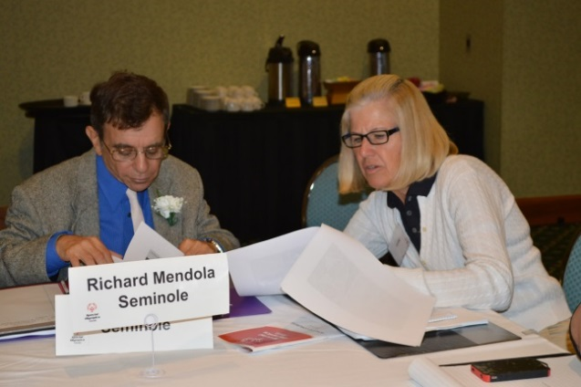
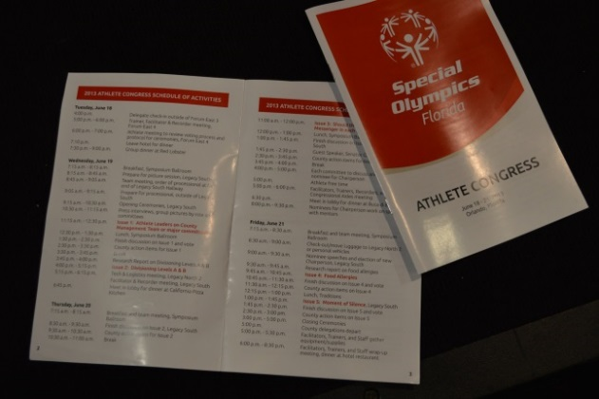
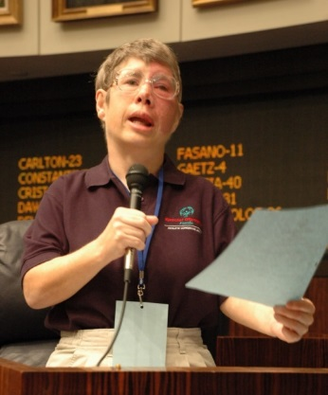

Athlete Leadership in Action!

Communications
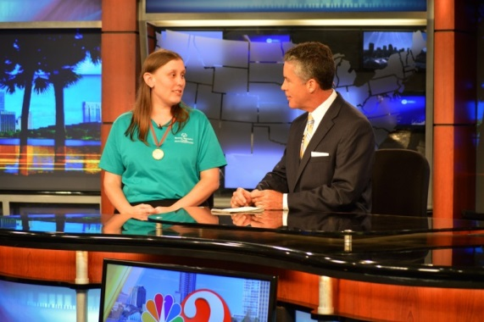
- Speaking to clubs, government, schools, sports organizations, sponsors, potential sponsors, Torch Run, businesses
- Being Master of Ceremonies (Opening Ceremonies; Sponsor recognitions program: Gala
- Interviews (Newspaper; TV)
- Newsletter articles
- Website
- Radio
- Your idea_______________________________________

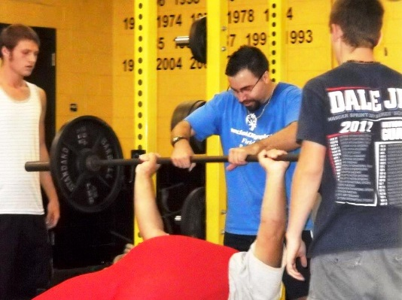
Sports
- Team manager
- Equipment managers
- Games helper
- Assistant coach
- Coach
- Official
- Scorer
- Timer
- Your idea_______________________________________

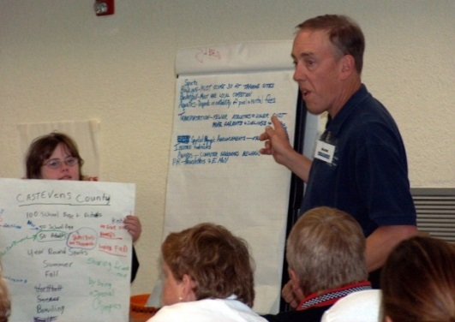
Volunteering
- Helping to organize Opening Ceremonies
- Sponsor recognition program
- Assisting with awards
- Athlete Instructor for Athlete Leadership & General Orientations
- Young Athletes (YAP) Play Pals
- Your idea_______________________________________
Help Lead the Program (Governance)
- Member of committee
- Member of management team
- Member Athlete Input Council
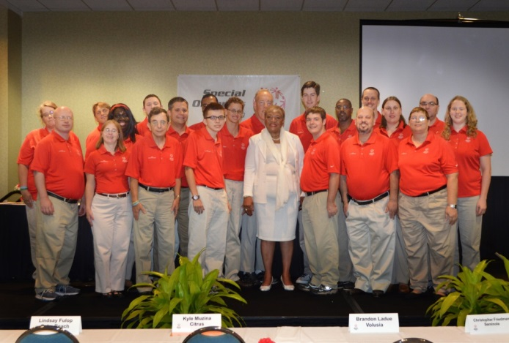
- Member of an group of athletes who give informal suggestions
- Board of Director Member
- Change of Policy or the way Program does business; samples of what has already been implemented in various Programs’ Athlete Congresses include the following:
  - Athletes helped choose code of conduct.
  - Athletes chose own uniform style.
  - Athletes voted on new sports.
  - Athlete helped choose Healthy menu options for Games.
- Your choice_________________________________________________________

Fundraising
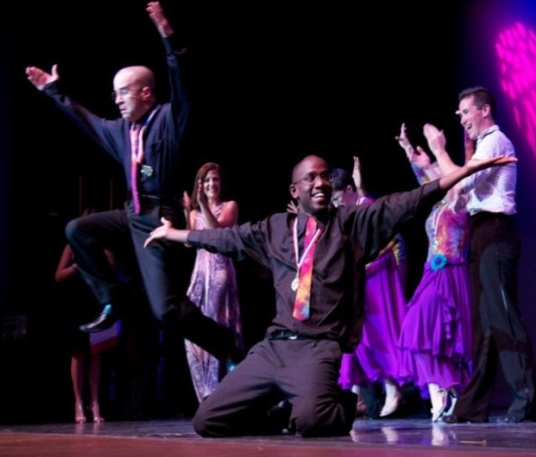
- Polar Plunge
- Walk-A-Thons
- Car washes
- Dancing with Stars
- Dinners; Breakfasts
- Can drives
- Bake sales
- Donations
- Sponsor an Athlete
- Grocery store promotions/Torch Icons
- Your decision(s)__________________________________

Sample Athlete Congress Issues from a Special Olympics US State Program

- Issue #1: Codes of Conduct and Dating Policy for athletes and coaches must be reviewed by coaches with athletes at the beginning of each season, by persons conducting the general orientations (for all attendees), by Local Program Coordinators with games management teams prior to each competition, and by Local Program with local management team members once a year.
Voting Results: 27 Yes 1 No 0 Abstain

- Issue #2: Wristbands must be replaced with photo identification at Program-level competitions.
Voting Results: 14 Yes 15 No 0 Abstain

- Issue #3: Special Olympics Inc. General Rules’ Smoking and Tobacco Policy must be extended in state to include all Program non-competitive events.
Voting Results: 17 Yes 9 No 2 Abstain

- Issue #4: Special Olympics state must have permanent sports symbols or identification on all medals and ribbons.
Voting Results: 16 Yes 12 No 0 Abstain

- Issue #5: All Local Programs must provide each athlete attending a Program-level competition shirt or jacket printed with the name of the Local Program or Special Olympics logo. It must be worn during non-competitive activities at Games or tournaments and be collected by the Local Program after each competition.
Voting Results: 8 Yes 18 No 2 Abstain

Issues 1, 3, & 4 must be recognized by the Board of Directors as motions for review and vote.

- Issue #1: Each Local Program must have an Athlete Leader on their Management Team or a Committee of Importance.
Vote Results: 20 Yes 0 No 0 Abstain
- Issue #2: All Divisions at Program-level Games (1-4 or 1-5 depending on the team sport) must have an A and B Division.
Vote Results: 2 Yes 17 No 1 Abstain
- Issue #3: Each Local Program must have a Global Messenger who has attended an Program-level Workshop using a trainer, trained by Special Olympics.
Vote Results: 19 Yes 0 No 1 Abstain
- Issue #4: Program Games Management Teams must provide food alternatives for people with food allergies (specifically gluten, lactose and nuts).
Vote Results: 10 Yes 7 No 3 Abstain
- Issue #5: Special Olympics should offer a moment of silence at every Program-level competition to honor those athletes, coaches and volunteers who have passed away since the last competition
Vote Results: 17 Yes 3 No 0 Abstain

Issues 1, 3, & 5 must be recognized by the Board of Directors as motions presented for review/vote

Sample Athlete Leader Contract

By signing below, each Athlete Leader agrees to the following:
- Be able to explain the Special Olympics mission, uniqueness from other sport organizations, divisioning, purpose and basic concepts of Athlete Leadership.
- Follow the Special Olympics Code of Conduct, and practice respect, courtesy, and good sportsmanship of Special Olympics at the local, area, and state levels.
- Represent Special Olympics in a professional manner at local, area and state levels.
- Be an athlete at least 16 years of age in good standing and currently train and compete in at least one sport.
- Be a role model for other athletes.
- Take as many Athlete Leadership courses as possible and, when possible or available, strive to obtain a degree in one of the three major subject areas ~ Communications, Sports, or Governance.
- When you take an Athlete Leadership course, study material with mentor.
- Attend scheduled Athlete Leadership meetings (local, area, state) and arrange transportation.
- Be prepared; read all materials prior to meetings, enabling informed comments and suggestions.
- Offer suggestions for improvement about activities or meetings in which participate.
- Work with your mentor to be the best you can be.
- Always follow through with anything you start.
- Commit to Athlete Leadership for a minimum of two years.
- Help recruit mentors, facilitators and athletes for Program.

Athlete name (printed) Program Name

Athlete signature Witness – Mentor name

Dates of commitment

Sample Athlete Mentor Contract

By signing below, each Athlete Mentor agrees to the following:
- I am a Class A Volunteer in good standing and at least 18 years of age.
- Will help my Athlete Leader develop and express his or her opinions. When serving as a Mentor, it is never appropriate to make your point. Doing so will often cause the athlete to adapt his or her views, or not express them at all.
- Be encouraging and supportive. Will make sure I respect athletes as equal partners in your Special Olympics experience.
- Value my athlete’s opinions and preferences.
- Listen, both during the meetings and afterward. Answer questions athlete has. Take the time to be sure you understand when your athletes speak to you.
- Work with parents, guardians, or programs serving persons with intellectual disabilities to explain what an Athlete Leader is and the significance of the program to the athlete.
- Be an advocate for my athlete, making sure the athlete leader experiences meaningful positions of influence and leadership.
- Remember that I am not the group leader.
- Be willing to help the athlete stay on task while attending Athlete Leader meetings, but understand that it is the athlete’s responsibility to speak for themselves.
- Ensure that the athlete understands the minutes from each meeting and is prepared for any questions or discussion that may arise from the minutes.
- Attend Athlete Leadership trainings with my athlete and participate in the appropriate workshops and training opportunities throughout the year. Work in a one-on-one relationship with your athlete during each course and locally during the required practical experience.
- Ensure that my athlete has transportation to and from Athlete Leadership trainings and any scheduled Athlete Leadership meetings (must attend 75% of the meetings).
- Acknowledge that parents can serve as Mentors for their sons or daughters on a trial basis.
- Agree to a two-year commitment to partner with my athlete to make their Athlete Leader experience as meaningful and educational as possible.

Mentor name (printed) Program Name

Mentor signature Athlete name

Dates of commitment

Uniqueness from Other Sports Organizations

Special Olympics is more similar than different from other sports organizations. However, it is important to identify the five areas that make Special Olympics unique. Per Official Special Olympics General Rules:

- A variety of sports opportunities are provided for all ability levels. For example in track and field, we have athletes that are in wheelchair events or may only be walking 10 meters all the way to athletes who are running half or full marathons. Those are very different ability levels within the same sport. For Basketball you may provide Individual Skills Basketball for the athletes that are just learning how to dribble, shoot and rebound to those athletes that are playing on teams and Unified Sports teams.

- Ability groupings are created through a process called divisioning. The goal is to provide fair and equitable competition (evenness) for all athletes within each ability grouping (division). One of the founding principles is that we provide an opportunity for every athlete, not to win but to excel, in competition. The games organizing committee goes through a process of evaluating their skills as well as their game play to determine the most appropriate division.

- Awards are provided to all participants who compete. The award itself is based on participation and place of finish within each division. Even if an athlete starts but cannot finish the competition, that athlete receives a participation award.

- The established criteria for athlete advancement to higher levels of competition is based on order of finish for each division and random draw. In most Programs you MUST compete in a local competition in order to be eligible to advance to the next level which could be an Area/Regional competition or a State/Provincial or National, Regional or World Competition. As a result of winning your state or provincial competition, you are eligible to attend a National o, Regional or World Games. SOI still enforces the Random Draw selection. Names are thrown in a hat from all Gold Medalists that attended the Program’s Games in that sport. Whoever’s name is selected may have the opportunity to attend the next level of competition IF they meet all the requirements set by the Program.

- Special Olympics does not charge a fee to athletes (or their families) to train or compete. Unlike the sport organizations, basketball leagues, clubs, etc., Eunice Kennedy Shriver wanted to ensure that ALL individuals would be able to join Special Olympics, not just the ones whose families could afford it. Everyone needs to help support the fundraising efforts in their Program so that in order for Special Olympics to continue. However, it does mean that athletes and their families should not be told they have to “pay to play”.

Divisioning

Special Olympics organizes its competition so that, whenever possible, athletes compete against others of similar ability. This process is called divisioning.

Ensuring fair divisioning of athletes for competition is one of the primary duties of the competition management team. The following criteria shall determine how Special Olympics athletes are assigned to competition divisions at Special Olympics competitions. Where exceptions to these criteria are necessary, competition management will review proposed modifications to these criteria and make a final decision based on the goal of providing the most dignified and challenging competition experience for each athlete. The competition management has final authority concerning divisions and any variation from these criteria. Protests based on divisioning are not allowed.

Athletes or teams are divisioned (grouped) using the following basic procedure:

- Divide by Gender: Male, Female or Combined (under some circumstances)

- Divide by Age: Individual Sports Team Sports
8-11 15 and under
  - 16-21
  - 22 and over
  - 30 and over
30 and over

- Divide by Ability:
- Pre-competition information and scores are used to place individuals or teams into preliminary divisions.
- On-site preliminary events (timed heats or team observations) are conducted to verify or modify divisions for the final competition.
- In individual sports, the suggested guideline to determine a division is that the difference between the best time/score and the worst time/score within a final division should not vary by more than 15%.

- Combining Groups:
- Age groups and/or males and females may be combined if this achieves a closer matching of ability.
- The minimum number of athletes or teams in a division is 3. The maximum is 8.

In many Accredited Programs, the numbers of participants are so low that divisioning becomes a tremendous challenge. In all instances, competition management personnel are charged with providing competition among those of equal abilities. Thus, ability is the overriding factor as long as there is no health or safety risk to athletes.

Getting to Know You (For athlete to keep)

Please list your greatest strengths:

1.

2.

3.

Describe some of the happiest moments in YOUR life.

Identify the things that are the most important to YOU.

List 2 things you would like to learn.

1.

2.

List how you think you can contribute to Special Olympics (hint, look at pages 4-7 in in this document).

Getting to Know You (For Special Olympics Program to keep-Athlete Only)
Please list your greatest strengths:

1.

2.

3.

Describe some of the happiest moments in YOUR life.

Identify the things that are the most important to YOU.

List 2 things you would like to learn.

1.

2.

List how you think you can contribute to Special Olympics (hint, look at pages 4-7 in this document).

My Special Olympics Personal Purpose Statement (Athlete)

On this date: Day __________ Month __________Year _________

By ______________________________________ and ___________________________
(Your name) (Mentor name)

Please check (X) one of the following.

I want to concentrate my coursework in: Communication____ Governance ____ Sports____

Other: ______________________________________________________________
(Please List)
Athlete Copy

(Record your Special Olympics Purpose Statement. Your purpose statement is what you want to be and do with your life with regard to Special Olympics. Make sure it is specific. Your purpose statement will empower you to become the leader you want to be in Special Olympics! GO FOR IT!

Name 2 things YOU can do when you get home that will start you on the path to becoming an athlete leader.
1.

2.

My Special Olympics Personal Purpose Statement (Mentor)

On this date: Day __________ Month __________Year _________

By ______________________________________ and ___________________________
(Your name) (Mentor name)

Mentor Copy

(Record your Special Olympics Purpose Statement. Your purpose statement is what you want to be and do with your life with regard to Special Olympics. Make sure it is specific. Your purpose statement will empower you to become the leader you want to be in Special Olympics! GO FOR IT!

Practicum Form

To receive credit for courses attended; this form must be completed and returned by the deadline.

Must be returned to Program office by email ______________ or fax _____________by________

Athlete name Phone
Address E-mail

Mentor name Phone
Address E-mail
Name of Program you represent

Certification requirements for the Introduction to Athlete Leadership Course:
Date of Course:________ Instructors:_________________________________________________

- Completed 10 Volunteer Service hours with Mentor
Date______ Hours____ Job_____________ Date______ Hours____ Job_____________
Date______ Hours____ Job_____________ Date______ Hours____ Job_____________
Date______ Hours____ Job_____________ Date______ Hours____ Job_____________
Date______ Hours____ Job_____________ Date______ Hours____ Job_____________
Date______ Hours____ Job_____________ Date______ Hours____ Job_____________

- Completed a General/Volunteer Orientation
Date: ____________ Instructor: ___________________ Location: ________________

- Attached a copy of the Class A Volunteer Form for Athlete and Mentor or whatever your Program requires

- Attached any other documentation required by your Program office (i.e. Protective Behaviors course confirmation)

- Feedback:
What are some of the things you learned from your practicum experiences?

Circle the area of course work you want to study (Communications; Sports; Governance or Other): _________________________________________________________________

Must be signed below:

(Signature of Athlete) (Date) (Signature of Mentor/Helper) (Date)

Athlete Leader Coordinator Signature (Date) Athlete Leader Coordinator (Print) (Date)
Course Evaluation

Athletes and mentors please complete this Course Evaluation Form and return to the instructors by the end of the class. We value your opinions and want to make continuous improvements.

Name: ________________________________ Program: ______________________

Please identify who is completing form and check (X) one: Athlete _____ Mentor ____

You learned about several roles that athlete leaders can play. Identify the athlete leader role you liked best._________________________. Explain why you chose this role.

Describe the section of this course you liked best____________________________________
And explain why you liked it.

Explain how you would improve this course when we offer it in the future?

What was your favorite experience in the Introduction to Athlete Leadership course?

What questions do you still have about this course or Athlete Leadership in General?

ADDENDUM 1:

POWERPOINT SLIDES
FOR INTRODUCTION TO
ATHLETE LEADERSHIP COURSE

(Printout Handout Format; 3-slides per page with column for notes)

ADDENDUM 2:

YOUR PROGRAM’S FACT SHEETS

