A Handbook for Athlete Leaders
Athlete Leadership Training Series
2016

Foundation

The Mission of Special Olympics
To provide year-round sports training and athletic competition in a variety of Olympic-type sports for children and adults with intellectual disabilities giving them continuing opportunities to develop physical fitness, demonstrate courage, experience joy, and participate in the sharing of gifts, skills, and friendship with their families, other Special Olympics athletes and the community.

Goal of Special Olympics
The ultimate goal of Special Olympics is to help persons with intellectual disabilities participate as productive and respected members of society at large, by offering them a fair opportunity to develop and demonstrate their skills and talents through sports training and competition, and by increasing the public's awareness of their capabilities and needs.

Value Statement of Athlete Leadership
Special Olympics empowers athletes to be contributing and respected members of Special Olympics and society. We support athlete-leaders on and off the playing field.

Purpose of Athlete Leadership
The purpose of Athlete Leadership is empowering athletes to develop leadership skills and utilize their voices and abilities to undertake meaningful leadership roles, influence change in the Special Olympics movement and create inclusive communities around the world.

Definition of Athlete Leadership
Through organized training and practical experiences, Athlete Leadership prepares athletes to undertake meaningful positions of influence and leadership throughout the Special Olympics organization, both on and off the playing field.

Basic Concepts of Athlete Leadership:

- Athlete leadership is fundamental to Special Olympics being an athlete-centered organization.
- Every Special Olympics athlete has leadership abilities that can contribute to the movement.
- Athlete leadership starts with an athlete making an informed choice of leadership role(s).
- Athlete leadership has a powerful effect on athletes’ self-esteem and self-confidence.
- Athletes require education in leadership skills before being placed in positions of responsibility.
- Athlete Leadership includes courses that guide athletes toward a variety of roles, including: board/committee membership, games management, public speaking, coaching, officiating, and youth leadership.
- After attending courses, athletes need both immediate and real opportunities to practice newly-learned leadership skills.
- Most athletes benefit from the support of a committed athlete-centered mentor whose role evolves as the athlete leader becomes more capable in their leadership role.
- Special Olympics staff, volunteers and families must be educated to ensure they value and support the involvement of athletes in meaningful roles.
- Skills learned in Athlete Leadership Programs enrich athletes' abilities to become more involved and respected in the community.

Milestones

The First Purpose Statement for Athlete Leadership
To empower athletes in developing leadership skills and utilizing their voices to assume meaningful leadership roles, influence change in the Special Olympics movement, and educate communities around the world that results in positive life changes.
– Athlete Leadership Summit, Vancouver, British Columbia, Canada, March 2011

Redefining the Purpose of Athlete Leadership
The purpose of Athlete Leadership is empowering athletes to develop leadership skills and utilize their voices and abilities to undertake meaningful leadership roles, influence change in the Special Olympics movement and create inclusive communities around the world.
– Athlete Leadership Summit, Philadelphia, Pennsylvania, November 2013

Roles for Athletes

Input Council Member
You can improve your local program by making suggestions and discussing problems. Find out if your local program or area has an Input Council and become a participating member!
YOUR INPUT IS VALUABLE AND IS NEEDED!

Athletes as Global Messengers
Do you like to talk? You can be trained by Special Olympics in presentation skills to become an expert speaker. We’ll even teach you to use PowerPoint to give presentations to schools, community groups, parents, churches.
GIVE A TALK & GET NEW PEOPLE INVOLVED IN SPECIAL OLYMPICS!

Athletes as Coaches
You can become a coach or assistant coach if that is your dream! You will need to make a commitment to attend certification training by the Program office then apply your training. There are many Special Olympics athletes who have become coaches.
BECOME A COACH IF THAT IS YOUR DREAM!

Athletes as Officials
You can become an official if that is your dream! Special Olympics will provide athletes information so they can participate in sport National Governing Body certification programs as an official or other skilled sport personnel. Athletes who have become certified officials have served in that capacity at Local, State, Provincial, National, Regional and World Games.
BECOME AN OFFICIAL IF THAT IS YOUR DREAM!

Athletes on Subprogram and Program Committees or Boards of Directors
You can become a representative of athletes on these very important groups. Training is provided to prepare athletes to participate in Special Olympics programming and policy meetings. Training focuses on awareness and listening skills and reading financial reports. Many Programs have had several athletes on its Board of Directors and others have held key leadership positions in the state.
BECOME A COMMITTEE MEMBER; MAKE IMPORTANT DECISIONS!

Athletes Working with the Media
You can get the Special Olympics WORD out. You can write articles, do television or radio shows, or work with the newspapers. Some Special Olympics athletes have even produced and hosted their own TV show on cable.
JOIN US AND HELP GET THE WORD OUT TO EVERYONE!

Athletes on Management and Sports Development Teams
You can be a valuable asset on a Special Olympics Games or Sport Development Management Team. Some athletes are filling important roles by helping the Program/Subprogram conduct the Games that you compete in.
ASK YOUR PROGRAM WHAT YOU CAN DO TO IMPROVE SPECIAL OLYMPICS COMPETITION!

Athletes as Special Olympics Employees
Someday you might be employed by Special Olympics. Several states and the national office have athletes on their payroll as regular employees.
WORK AT GETTING THE SKILLS YOU NEED TO BECOME AN EMPLOYEE!

Athlete Congress Member
The Congress exists in several states and national programs and there’s a World Congress. It provides a formal, deliberative process and place for athlete input on programming, policy and other processes of Special Olympics. There have been a total of three World Congresses. Programs offer a Congress Prep Course for those selected to attend the Congress. This ensures the right athletes are able to do all the tasks necessary to have a successful Congress.
BE AN ACTIVE INPUT COUNCIL MEMBER TO BECOME ELIGIBLE TO SERVE IN AN ATHLETE CONGRESS!

Athletes as Volunteers or Donors
Some of you have already done this maybe without realizing it. You’ve may have helped with bake/candy sales in the past. Perhaps you helped chaperone other athletes for a little while. Many of you have done these leadership roles for Special Olympics when you are not competing.
YOU WILL FIND NEW WAYS TO HELP YOUR PROGRAM EVERYDAY!

Athletes as Mentors or Advocates
You can help fellow athlete leaders by being their Mentor for Governance, at Athlete Leadership University or advocating for their rights when they are having sports or leadership problems.
NOTHING FEELS BETTER THAN HELPING YOUR FELLOW ATHLETES!

Athlete Leadership Training Series

Your Program’s Athlete Leadership Stage of Development
If your Program is just starting or re-energizing its Athlete Leadership efforts and unsure of what course(s) to offer, start with the basic courses of the Athlete Leadership Training Series. Currently, there are three areas of focus – communication, sports and governance with health and wellness in the process of being developed. Every course requires a completed practicum before the athlete receives a certificate for that course. The most important action is to begin to offer Athlete Leadership Training based on athlete interest.

History and Athlete Leadership Development
Special Olympics has provided training in athlete leadership since 1986 with the Athlete for Outreach Course, which is now called Sargent Shriver Global Messenger Program. The program was expanded in 2002 to include additional courses beyond that of the Sargent Shriver Global Messenger Program. Many Special Olympics athletes now have a variety of educational opportunities that include communication, sports and governance leadership topics and Athlete Congress (when applicable).

Eligibility
Athletes who sign up for Athlete Leadership Training Series must be at least 16 years old and previously or currently actively involved in Special Olympics. Each athlete must be accompanied by a mentor (volunteer), who works with the athlete during each course and during the required practical experience, locally.

Continuing Education
Athlete leaders are encouraged to repeat courses on a periodic basis to update their leadership knowledge and skills. Course content changes over the years as new concepts are introduced.

Additional Procedures
To receive credit for a course, an athlete and his/her mentor must attend the course followed by practical experiences related to the course conducted in their local or regional program. Parents can serve as mentors or speech coaches to their son or daughter on a trial basis. A mentor should commit to working with his/her athlete for a minimum of two years. An athlete should commit to a minimum of two years participation after the initial Introduction to Athlete Leadership Course.

Practicum
A completed practicum form must be received within 6-12 months of taking a course with the exception of Athletes as Officials or Athletes as Coaches since the sport training may not be offered in a timely manner.

Athletes Enrolled Follow Special Olympics Eligibility Guidelines

Identifying Persons with Intellectual Disabilities
A person is considered to have an intellectual disability for purposes of determining his or her eligibility to participate in Special Olympics if that person satisfies any one of the following requirements:
- The person has been identified by an agency or professional as having an intellectual disability as determined by their localities; or
- The person has a cognitive delay, as determined by standardized measures such as intelligent quotient or “IQ” testing or other measures that are generally accepted within the professional community in that Accredited Program’s nation as being a reliable measurement of the existence of a cognitive delay; or
- The person has a closely related developmental disability. A “closely related developmental disability” means having functional limitations in both general learning (such as IQ) and in adaptive skills (such as in recreation, work, independent living, self-direction, or self-care). However, persons whose functional limitations are based solely on a physical, behavioral, or emotional disability, or a specific learning or sensory disability, are not eligible to participate as Special Olympics athletes, but may be eligible to volunteer for Special Olympics
For example, such volunteers could be partners in Unified Sports if they otherwise meet the separate eligibility requirements for participation in Unified Sports that are set forth in the SOI Sports Rules.

Preserving Flexibility in Identifying Eligible Athletes
An Accredited Program may request limited permission from SOI to depart from the eligibility requirements identified above if the Accredited Program believes that there are exceptional circumstances that warrant such a departure, and so notifies SOI in writing. SOI will consider such requests promptly, but shall have the final authority in determining whether any departure or exception is appropriate.

Athlete Leadership Training Series Overview

The Athlete Leadership Training Series can be seen and experienced as a series of courses that can be taken based on interest and ability and include courses from different areas. Each course has a PowerPoint and Notes pages, Trainer Guide and Participant Guide as well as complementary materials and handouts to assist the trainers. It is recommended that at least one of the trainers be an athlete with a defined role and subject matter and who has been trained in that role.

Athlete Leadership begins with awareness and promotion of the program. Beyond the Vision and This is Athlete Leadership are two such courses getting the word out and allowing the participants information on what Athlete Leadership is and what Athlete Leadership Training is offered.

Promotion, Awareness, Orientation and Training of Athlete Leadership
- Beyond the Vision (20-minute persuasive presentation with video)
- This Is Athlete Leadership (60-minute orientation to the Athlete Leadership program)
- Introduction to Athlete Leadership Course

Communications
- Global Messenger Course – Public Speaking
- Working with the Media Course*
- Advanced Global Messenger Course*

Sports
- Athletes as Coaches Course
- Coaching Special Olympics Athletes Course (offered to all coaches face-to-face or online)
- Athletes as Officials Course

Governance
- Athletes on Committees and Input Councils Course
- Athletes Experiencing Input Councils Course*
- Developing Athletes as Board Members Course* (Elective)

Technology
- Email, Internet and Search Engines Course
- PowerPoint Course
- Social Media Course* (Elective)

Health
- Athletes as Healthy Athletes Assistants Course*
- Athletes as Fitness Coaches Course*

Introduction to Athlete Leadership is the required first course in the Athlete Leadership Training Series. Courses in the athlete’s area of interest require both participation in the course and completion of a practicum within 6-12 months. A new Health area plus the starred (*) courses are in development. The doubled starred (**) courses are to be taught by sport qualified and Special Olympics experienced instructors.
Awareness, Promotion, Orientation and Training

Beyond the Vision is a short 20-minute persuasive presentation that is designed for an athlete presenter to help staff, athletes, volunteers and families understand what Athlete Leadership can do for athletes and what an asset it is for the program. If you’ve never offered Athlete Leadership opportunities, it may be hard to understand why you need it. The PowerPoint is accompanied by a video, Beyond the Vision, which was produced by athletes and is a call to action by athletes to get started.

This Is Athlete Leadership – An Orientation including Beyond the Vision Video
Local Programs that want to involve athletes in leadership roles should offer the “This is Athlete Leadership,” which is a 60-minute educational awareness orientation to its Program leaders, management team, coaches, potential athlete leaders and families.
This orientation can be offered on a one-to-one, a group, to a specific audience or at a local level for the whole program .It should be taught by an Athlete Leadership mentor/coordinator and an athlete. Recruit nearby ATHLETE LEADERSHIP volunteers and athletes to help you offer the first orientation class and to share good examples of athlete leadership success stories if you have none, speak with them to get good examples of program successes to share. It will make a difference. Once the overview course has been done, the local Program or Program Leader should be able to offer the orientation with a prospective Athlete Leader.

Key Course to the Series
Introduction to Athlete Leadership Course is the first course that every athlete who wants to become an Athlete Leader should take. The goal is to assist athletes in taking courses that match their passion, personality and skill sets. This introductory course sets the stage for and Athlete Leader’s direction and future coursework.

Beginning Level Courses for Athlete Leadership Training
Courses are selected based on interest and ability.
- Introduction to Athlete Leadership Course (finding your voice, developing your purpose statement and experiencing an Input Council)
- Global Messenger Course (learning how to effectively speak, telling one’s story and changing the culture)
- Committees and Input Councils Course [Governance] (learning how to serve on committees and Athlete Input Councils)
- Athletes as Coaches Course (learning how to coach athletes or assist during training and competition)
- Athletes as Officials Course – Officiating Track and Field (learning how to serve on a competition management team and conduct an area of competition)
- Email, Internet and Search Engines Course [Technology] (learning how to navigate the internet plus create and send emails)
- PowerPoint Course (creating powerful presentations)

See the handout on the Athlete Leadership Training Series for the most updated list of courses.

Communications
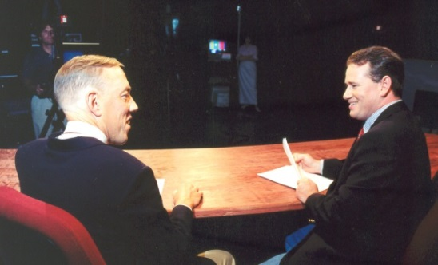
Global Messenger Course
Curriculum: Basic facts about Special Olympics and Special Olympics Program; Special Olympics Mission Statement; how to write a speech and what parts to include in a speech, learning to speak from the heart and from your notes. Making your statement of what does Special Olympics Mean to Me. Give a 2-3 minute speech about yourself and give speeches to target audiences that are 3-5 minutes long.
Practicum: Deliver 8 speeches to internal audiences within 8-12 months. Send copy to state/national Athlete Leadership Coordinator.

Working with the Media Course (being developed)
Curriculum: Understand types of media and how to interact with each one. Understand the difference between a sound bite and an interview. Know how to prepare for different types of media experience and role play radio and TV interviews and PSA’s. Athlete will be able to complete a I-minute radio interview and a 3 minute TV interview.
Practicum: Seek out and complete: 2 radio interview, 1 print interview and 2 TV interviews on cable, Public Service or network television. Within 8 months of taking class.

Overall Goals: Provide athletes with the skills necessary to give a short speech and answer questions from the audience about Special Olympics; offer ideas on different audiences that would be interested in hearing an athlete speak about Special Olympics. Speak with print and electronic media in a fashion that will enable reporters, editors, directors to share the Special Olympics story with its customer.

Advanced Global Messenger Course (being developed)
Curriculum: Ideas on opportunities for giving speeches and making contacts; learning target marketing and their selling points, learning how to introduce someone work with a mentor who offers support in arranging speaking opportunities. Give a 5 minute speech to a specific target market using selling points, inflection and expression.
Practicum: Deliver 8 speeches to a minimum of 3 target markets to external organizations agencies etc. within 8-12 months and send copy to state/provincial/national Athlete Leadership Coordinator.

Governance
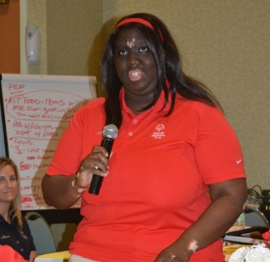

Committees and Athlete Input Council Course
Curriculum: Governance definition; basic understanding of committee work and Athlete Input Councils and the difference between them; participate in committee and Input Councils meetings. Learn the roles of mentor and facilitator. Learn how to set-up an Athlete Input Council in your local area.
Goals: Provide athletes with the additional skills necessary to establish and conduct Athlete Input Councils at local, area, and state/provincial levels.

Experiencing Athlete Input Council Course
Curriculum: Provide athletes with numerous topics to choose from. Each athlete rotates as a chair one time and serves as a member providing feedback to committee members. There will be at least 8 opportunities /Input meetings with 8 different topics. There is no mentor/helper participation in this course. Athletes are expected to interact among themselves.
Goals: To get practical experience leading an Input Council meeting and being a member giving and taking feedback during the meeting. Practice is the main objective.

Developing Athletes as Board Members Course (Elective – not yet designed)
Curriculum: Understanding difference between policy and rules, policy setting; Special Olympics local/county; regional/area, state/provincial, national organizational structure; practice board and committee meetings.
Goals: Provide athletes with the skills necessary to become an effective board and committee member; understanding of the athlete’s role as a member of a decision-making group.
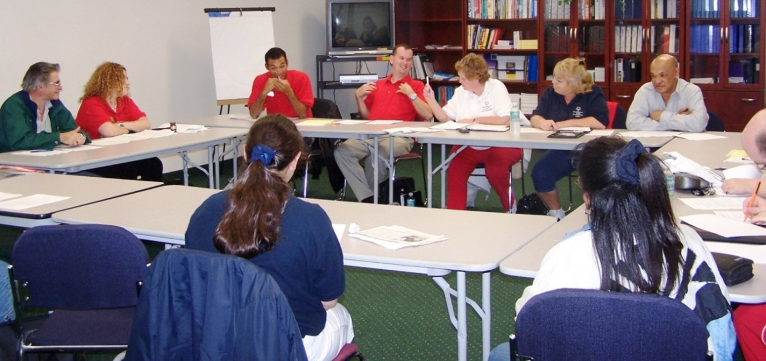

Sports

Coaching
To become a Special Olympics certified coach, you must complete the following: Athletes as Coaches Course, Coaching Special Olympics Athletes Course and Sport-Specific Skills Course as well as the General Orientation, Protective Behaviors and Concussion Training.

Athletes as Coaches Course
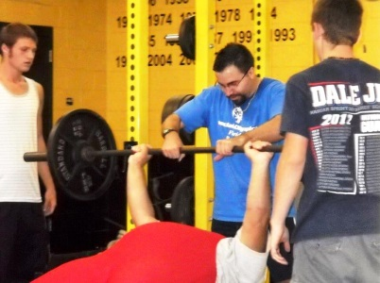
Curriculum: Preparation for athletes to be certified as coaches at the level they desire; experience working with athletes as a coach; introduce athletes and mentors to the process of working together as a team; discuss the various roles of a coach; learn coaching by practicing many skills during course time.
Goals: Provide athletes with the skills necessary to become an assistant or head coach; understanding of the coach’s role during both practice and competition and in the planning process.
Practicum: Help Coach 8-10 sessions.

Coaching Special Olympics Athletes Course (online or face-to-face course)
Curriculum: This course prepares Special Olympics coaches to use their sport-specific knowledge in coaching and/or working with athletes who have intellectual disabilities. The 24/7 convenience and low cost make it attractive to new coaches in preparation for their first Special Olympics coaching role. It can be accessed via Human Kinetics at http://www.asep.com/asep_content/org/SONA.cfm.
Goals: Athletes and their mentors jointly take the course, which models head coach and assistant coach working together. It also meets the Special Olympics standards and competencies for coach certification. For veteran Special Olympics coaches, this course serves as a reminder of the essentials sometimes forgotten after years of coaching. The course also satisfies the Special Olympics recertification or continuing education requirement.
Practicum: Season or 10-hour practicum working with athletes.

Sport-Specific Skills Course
Note: This is a sport-specific instructional program offered by an NGB and sanctioned by Special Olympics, Inc. The course contains information on fundamental skills, practice planning, events and rules. In addition to course room instruction, there is a hands-on session working with Special Olympics athletes in fundamental skill instruction. These courses are NOT offered within the Athlete Leadership University Curriculum, but are offered throughout the year at various locations. Some of the sports are offered online via the American Sport Education Program (ASEP) http://www.asep.com/asep_content/org/SONA.cfm and the National Federation of State High Schools (NFHS eLearnCenter) (http://nfhslearn.com/courses/36000).
Practicum: Season or 10-hour practicum working with athletes.

Tactics Course (Elective)
Curriculum: This is a sport-specific instructional program offered by an NGB and sanctioned by Special Olympics, Inc. The course contains strategies to improve training programs, creating and adapting drills, new rules updates, effective coaching strategies and techniques preparing for, during and following competition. Some of the sports are offered online via the American Sport Education Program (ASEP) http://www.asep.com/asep_content/org/SONA.cfm and the National Federation of State High Schools (NFHS) eLearn Center (http://nfhslearn.com/courses/36000).
Practicum: Season or 10-hour practicum working with athletes.

Officiating
Competition management, as opposed to venue management, contains many roles and responsibilities that could be considered under the term “official”.

Athletes as Officials Course – Officiating Track and Field
Curriculum: Provide athletes with all the basic skills and knowledge necessary to serve on competition management teams at a local or regional competition. This course shall be taught based on the ability level of the athlete some of whom may be on a competition management level and others maybe working on officiating and judging skills. Learn how to stage athletes, time, judge finishes, and understand the importance of safety. Such roles would include raker and scorer all the way to timer and judge. They learn about the ethics of officiating (doing your best without being partial to anyone). Be able to identify potential problems and how to avoid them. After taking this course, an athlete could be certified at one or more of 3 levels:
Level 1 = escort; raker; measurer for tennis and softball throws, shot put and high jump; ball retrievers; placing and replacing the bar at high jump
Level 2 = scorer; stager; foot fouls; measurer for standing and running long jumps and triple jump
Level 3 = finish line judge; timer; exchange zone judge
Goals: Implement the golden rule for officials at all times. Decide to grow as an official and experience different roles, working up to officiating at Program-level events and then becoming an NGB certified official passing all written and practical tests.
Practicum: Help officiate at 5 Local and Subprogram Games.

National Governing Body Officiating Course (Elective)
Curriculum: After an athlete has complete the Athlete as Officials Course and the Leadership/ Independent Study Course for Officials, an athlete may upon the recommendation of an NGB official and or local official mentor enroll in the class of that sport. Athlete Officials are expected to complete course and pass a written and practical exam. An athlete should have a local official to serve as a mentor official thru the process.
Goals: Provide athletes with the skills and knowledge necessary to officiate their sport in a community, school, recreational or Special Olympics setting.
Practicum: Athlete-official continues officiating in at least 5 competitions adhering to NGB requirements.
Technology

Email, Internet and Search Engines Course
Curriculum: How to use e-mail, search engines and the internet.
Goals: Provide athletes with the skills necessary to use e-mail and the internet to become better communicators and athlete leaders.

Practicum: Set up personal email on Gmail and have 10 athletes in address book. Show proof of regular emailing for 6-months after course ends in addition to a project assigned by instructor.

PowerPoint Course
Curriculum: Microsoft PowerPoint use and practice in completing a presentation.
Goals: Provide athletes with the skills necessary to make PowerPoint presentations on their own and in their roles of Global Messengers or Governance members.
Practicum: Make a 25-slide Athlete Leadership presentation for Local Management team member, school, and group home. Presentation and feedback form is submitted within six-twelve months of taking course.

Social Media (Elective – being developed)
Curriculum: Computer-mediated tools that allow people to create, share, or exchange information, ideas, and pictures/videos in virtual communities and networks.
Goals: Provide athletes with the skills necessary to understand, create and maintain a Facebook page as well as posts via blog, Instant Message, Twitter, etc.
Practicum: Create a Facebook page for your Local Program and/or as an individual. Send 6 posts that are shared and 6 posts that are individual via social media. 6 of the 12 must include pictures. 1 of the posts must include a video.

Athlete Leadership Training Series and Practicum Requirements

All practicum work must be completed AFTER completing an Athlete Leadership University course. Presentations and time spent in the course do not count toward completed practicum.

Introduction to Athlete Leadership Course
  - Become a Class A Volunteer.
  - Attend a General/Volunteer Orientation.
  - Complete 10 hours of volunteer activities for Special Olympics.
  - View ATHLETE LEADERSHIP video online if not shown during course

Communications
- Global Messenger Course
  - Make 8 presentations to 5 internal and 3 external audiences about Special Olympics within 8-12 months.

- Working with the Media Course*
- Conduct 1 print interview, 2 radio interviews, 2 TV interview within 12-months

- Advanced Global Messenger Course*
- Make 8 presentations within 6-12 months to external audiences using at least 3 different target markets

Sports – Coaching
- Athletes as Coaches
  - Complete 8-10 sessions in working with Special Olympics athletes.

- Coaching Special Olympics Athletes (online or in-class course)
  - Complete a season or 10-hour practicum in working with Special Olympics athletes.

- Sport-Specific Skills Course
  - They are the regular courses that any volunteer coach would take.
  - Complete a season or 10-hour practicum in working with Special Olympics athletes.

- Sport-Specific Tactics Course (Elective)
  - These courses are regular courses that any volunteer coach would take.
  - Complete a season or 10-hour practicum in working with Special Olympics athletes

Sports – Officiating
- Athletes as Officials Course
  - Complete a full season as an official
  - Serve on a competition management team at Games.

- Coaching Special Olympics Athletes (online or in-class course)
  - Complete a season or 10-hour practicum of working with Special Olympics athletes.

- National Governing Body (NGB) Officiating Course (Elective)
  - These courses are the regular courses that any official would take.
  - Athlete-official continues officiating in at least 5 competitions adhering to NGB requirements.

Governance
- Committees and Athlete Input Councils Course
  - Attend 1 Subprogram Management Team meeting, I Games Management Meeting, 2 Athlete Input Council meetings and start an Input Council if there is not one.
  - Substitute 2 community meetings and 2 Special Olympics meeting of some kind.

- Experiencing Athlete Input Council Course*
- Serve as a chair of an Athlete Input Council at least once.
- Serves as a member providing feedback to committee members. Participate in at least 6 opportunities/input meetings with 6 different topics.

- Developing Athletes as Board Members Course* (Elective)
  - Attend two committee meetings at the Subprogram level.
  - Attend three Board of Directors meetings at Program level.
  - Attend one Board of Directors meeting of a community organization.
  - Cannot include Input Council meetings.

Technology
- Email, Internet and Search Engines Course
  - Set up personal email on Gmail and have 10 athletes in address book. Show proof of regular emailing for 6-months after course ends as project follow-up to instructor.

- PowerPoint Course
- Create a new 25 slide PowerPoint presentation to a group about Athlete Leadership.

- Social Media Course* (Elective)
- Create a Facebook page for your local Program and/or as an individual.
- Send 6 posts that are shared and 6 posts that are individual via social media.
- 6 of the 12 must include pictures.
- 1 of the posts must include a video.

Sample Athlete Leadership Management Team Directory

THIS SPACE IS FOR YOUR DIRECTORY - ANY FORMAT

The following people coordinate and manage Athlete Leadership in your Program:

Program/National Leaders and Course Trainers

Special Olympics Program/National Staff Liaison
Name Email Phone

Program Athlete Leadership Coordinator(s): Facilitate and Train the various courses offered.
Name Email Phone

Introduction to Athlete Leadership Trainers
Name Email Phone

Committees and Input Council Trainers:
Name Email Phone

Global Messenger Trainers:
Name Email Phone

Email Technology 1 Trainers
Name Email Phone

PowerPoint Trainers
Name Email Phone

Athletes as Coaches Trainers
Name Email Phone

Athletes as Officials Trainers
Name Email Phone

Add other Course Trainers as needed
Name Email Phone

Name Email Phone

Local Program Athlete Leadership Coordinators

Area 1 – Name Email Phone

Area 2 – Name Email Phone

Area 3 – Name Email Phone

Area 4 – Name Email Phone

Area 5 – Name Email Phone

Area 6 – Name Email Phone

Area 7 – Name Email Phone

Area 8 – Name Email Phone

Area 9 – Name Email Phone

Area 10 – Name Email Phone

Area 11 – Name Email Phone

Athlete Leaders Serving in Key Leadership Roles

Athlete Congress Chair:
Name Email Phone

Athlete Board Member:
Name Email Phone

Past Congress Chair:
Name Email Phone

Past Board Member:
Name Email Phone

Program Athlete Input Council Chair:
Name Email Phone

Add your own ______________________________:
Name Email Phone
Sample State/Provincial/National Program AIC
1 – Name Email Phone

2 – Name Email Phone

3 – Name Email Phone

4 – Name Email Phone

5 – Name Email Phone

6 – Name Email Phone

7 – Name Email Phone

8 – Name Email Phone

9 – Name Email Phone

10 – Name Email Phone

11 – Name Email Phone

Getting Additional Information about Athlete Leadership

Go to the Special Olympics, Inc. website and click on Resources to access additional information on Athlete Leadership.
Special Olympics Inc. resources website: resources.specialolympics.org

Sample Athlete Leader Contract

By signing below, each Athlete Leader agrees to the following:
- Follow the Special Olympics Code of Conduct, and practice respect, courtesy, and good sportsmanship.
- I am an athlete in good standing, am at least 16 years of age and currently train and compete in at least one sport.
- Recognize that as an Athlete Leader, I am a representative of Special Olympics at all levels at all times.
- Will take as many courses as possible to help me grow as an athlete leader depending on my interest and ability.
- Attend scheduled Athlete Leadership meetings (any type) as needed. I will let my Mentor know if I have transportation challenges
- Read over meeting materials with my Mentor ahead of time so that I will be able to offer my comments and suggestions.
- Work with my Mentor ~ ask him or her questions if I do not understand something and offer my suggestions that might improve the Special Olympics athlete experience.
- In order to become a knowledgable Athlete Leader, I commit to participate in the Athlete Leadership activities for two years.

Athlete name (printed) Subprogram/Program Name

Athlete signature Witness – Mentor name

Dates of Commitment

Roles of the Mentor

- Serve many purposes such as mentor; speech coach; coach; official; volunteer.
- Know your athlete.
- Work with parents, guardians or day training programs, schools and group homes to explain what Athlete Leadership is.
- Be knowledgeable about Special Olympics.
- Always give encouragement – especially before a speech, meeting or event.
- Listen – people want to know what the athlete thinks, not the ideas of the helper.
- Act as a leadership “coach” and role model
- Allow the athlete to express him or herself – give help only if asked
- Value your athlete’s opinions and preferences and help refine and articulate ideas.
- Provide constructive feedback.
- Ensure athlete has meaningful positions of leadership.
- Help athletes stay on task and ensure follow through.
- Help athlete understand minutes of meetings, after action notes and to do lists
- Assist athlete with technology and paperwork.
- Help work through transportation challenges.
- Help athletes with medical or diet needs.
- Work one-on-one with your athlete during each course and to help with follow-up tasks.
- Commit to a partnership with your athlete to make his or her Athlete Leadership experience as meaningful and educational as possible.
- Be an advocate for your athlete and all athletes.
- Provide support as needed.
- Represent Special Olympics professionally and follow the Special Olympics Code of Conduct
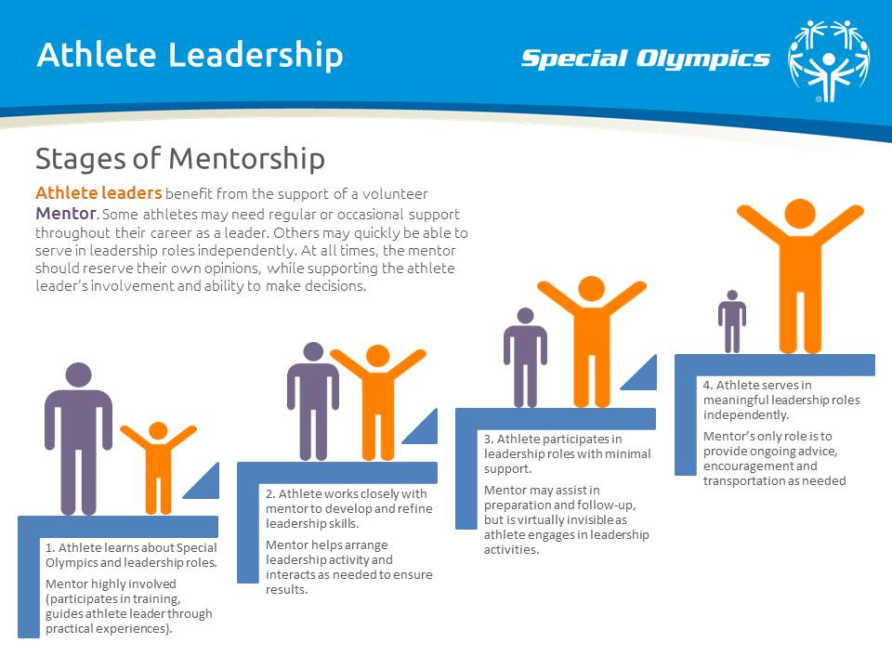

Sample Mentor Contract

By signing below, each mentor agrees to the following:
- I am a Class A Volunteer in good standing and at least 18 years of age.
- I will always help my athlete leader develop and express his or her opinions. When serving as a Mentor, I will never push my opinion on an athlete leader. Doing so will often cause the athlete to adapt your view and not express theirs. Value your Athlete Leader’s opinions and preferences.
- Be encouraging and supportive. Make sure you respect athletes as equal partners in your Special Olympics experience.
- Listen to your athlete, both during experiential activities and at meetings. Should your athlete have questions or need direction take the time to understand what your athletes is asking.
- Mentors should work with parents, guardians, or programs serving persons with intellectual disabilities to explain what Athlete Leadership is, and help the others understand the significance of the program to the athlete.
- The Mentor should be an advocate for the athlete, making sure the athlete leader experiences meaningful positions of influence and leadership.
- Remember that you are not the group leader in meeting.
- Be willing to help the athlete stay on task while attending events or meetings, but understand that it is the athlete’s responsibility to speak for themselves.
- Ensure that the athlete understands the minutes or after action to do lists is prepared for any questions or discussion that may arise from the minutes.
- Attend classes with your athlete and participate in the appropriate training opportunities throughout the year. Work on a one-on-one relationship with your athlete during each course and during the required practical experience.
- Ensure that your athlete arranges transportation to and from classes, meetings or activities. Assist as needed.
- If I am a parent, I am serving as a mentor on a trial basis as my athlete might prefer to have a mentor but we have not found one for him or her.
- Agree to a two-year commitment to partner with your Athlete Leader to make their Athlete Leadership experience as meaningful and educational as possible.

Mentor name (printed) Subprogram/Program Name

Mentor signature Athlete name
Dates of Commitment

Sample Athlete Leadership Practicum Form
Introduction to Athlete Leadership Course

To receive credit for courses attended; this form must be completed and returned by the deadline.

Must be returned to Program office by email by

Athlete name Phone
Address E-mail

Mentor name Phone
Address E-mail

Name of Program you represent

Certification requirements for the Introduction to Athlete Leadership Course:
Date of Course: _______ Instructors:_________________________________________________

- Completed 10 Service Hours with your Mentor
Date______ Hours____ Job_____________ Date______ Hours____ Job_____________
Date______ Hours____ Job_____________ Date______ Hours____ Job_____________
Date______ Hours____ Job_____________ Date______ Hours____ Job_____________
Date______ Hours____ Job_____________ Date______ Hours____ Job_____________
Date______ Hours____ Job_____________ Date______ Hours____ Job_____________

- Completed a General/Volunteer Orientation
Date: Instructor: Location:

- Attached a copy of the Class A Volunteer Form for Athlete and Mentor or whatever your Program requires

- Attached any other documentation required by your Program office

- Feedback:
What are some of the things you learned from your practicum experiences?

What area of interest did you choose (Communications; Sports; Governance)?

Must be signed below:

(Signature of Athlete) (Date) (Signature of Mentor/Helper) (Date)

Athlete Leader Coordinator (Date) Athlete Leader Coordinator (Print) (Date)

