Athlete Leadership Global Messenger –

*Public Speaking*

Participant Guide

2016

Table of Contents

|  |  |
| --- | --- |
| Topic | Page |
| Table of Contents | 2 |
| **Part A** | |
| Introduction Information | 3 |
| Objectives of the Training | 4 |
| **Part B (Should be covered in Introduction Course)** | |
| What Is Athlete Leadership? | 5-7 |
| The Mission of Special Olympics | 8-14 |
| What Makes Special Olympics Unique | 15 |
| Facts About Special Olympics | 16 |
| **Part C** | |
| Roles of a Global Messenger and Ambassadors | 17 |
| My 30 Second Speech Elevator Speech | 18 |
| Roles of the Speech Coach | 19 |
| What is a Speech | 20 |
| Speech Enhancements | 21-25 |
| Special Olympics Target Audiences | 26 |
| Special Olympics Selling Points | 27-42 |
| Target Audience Practice Worksheet | 43 |
| Target Audience Practice Worksheet Sample | 44 |
| What Goes Into a Speech | 45 |
| Researching a Speech | 46 |
| Parts of a Speech: Opening, Body, Closing | 47-49 |
| Tool For Talks | 50 |
| Getting Ready for a Presentation Checklist | 51 |
| Feedback – Speech Feedback Sheet | 52 |
| Next Steps Back Home | 53 |
| Athlete Leadership Practicum Form – Global Messenger | 54 |
| Global Messenger Training Feedback | 55 |

**Part A**

**Introduction Information**

Complete the information about your partner and your partner will complete information about you. Your partner must be someone you do not know.

* My name is __________________________________________________________
* I have the pleasure of introducing_________________________________________
* He/she is from Special Olympics __________________________________________ *(Name of Local Program)*
* _________________________ has been involved in Special Olympics for ___ years.
* Say, “If she/he had a room full of money, she/he would ________________________________________________________________________________________________________

***Option:***

* If ______________________________________ could be any animal, she/he would be a________________________________________________________________ because_____________________________________________________________

**Objectives of the Training**

Why Are We Here Today?

* Learn about Athlete Leadership & Special Olympics
* Learn how to create a speech
* Provide the tools to seek speaking engagements
* Write a speech
* Focus your speech on a specific audience
* Present a 1 – 5 minute speech
* Be courteous throughout the training and follow the ground rules

**Part B**

**Foundation**

**The Mission of Special Olympics**

To provide year-round sports training and athletic competition in a variety of Olympic-type sports for children and adults with intellectual disabilities, giving them continuing opportunities to develop physical fitness, demonstrate courage, experience joy, and participate in the sharing of gifts, skills, and friendship with their families, other Special Olympics athletes and the community.

# Goal of Special Olympics

The ultimate goal of Special Olympics is to help persons with intellectual disabilities participate as productive and respected members of society at large, by offering them a fair opportunity to develop and demonstrate their skills and talents through sports training and competition, and by increasing the public's awareness of their capabilities and needs.

**Value Statement of Athlete Leadership**

Special Olympics empowers athletes to be contributing and respected members of Special Olympics and society. We support athlete-leaders on and off the playing field.

**Purpose of Athlete Leadership**

The purpose of Athlete Leadership is empowering athletes to develop leadership skills and utilize their voices and abilities to undertake meaningful leadership roles, influence change in the Special Olympics movement and create inclusive communities around the world.

**Definition of Athlete Leadership**

Through organized training and practical experiences, Athlete Leadership prepares athletes to undertake meaningful positions of influence and leadership throughout the Special Olympics organization, both on and off the playing field.

**Basic Concepts of Athlete Leadership:**

1. Athlete leadership is fundamental to Special Olympics being an athlete-centered organization.
2. Every Special Olympics athlete has leadership abilities that can contribute to the movement.
3. Athlete leadership starts with an athlete making an informed choice of leadership role(s).
4. Athlete leadership has a powerful effect on athletes’ self-esteem and self-confidence.
5. Athletes require education in leadership skills before being placed in positions of responsibility.
6. Athlete leadership includes courses that guide athletes toward a variety of roles, including: board/committee membership, games management, public speaking, coaching, officiating, and youth leadership.
7. After attending courses, athletes need both immediate and real opportunities to practice newly-learned leadership skills.
8. Most athletes benefit from the support of a committed athlete-centered mentor whose role evolves as the athlete leader becomes more capable in their leadership role.
9. Special Olympics staff, volunteers and families must be educated to ensure they value and support the involvement of athletes in meaningful roles.
10. Skills learned in Athlete Leadership enrich athletes' abilities to become more involved and respected in the community.

# Milestones

# The First Mission Statement for Athlete Leadership

To empower athletes to develop leadership skills and utilize their voices to assume meaningful leadership roles, influence change in the Special Olympics movement, and educate communities around the world that results in positive life changes.

– Athlete Leadership Summit, Vancouver, British Columbia, Canada, March 2011

# Current Mission Statement for Athlete Leadership

The purpose of Athlete Leadership is empowering athletes to develop leadership skills and utilize their voices and abilities to undertake meaningful leadership roles, influence change in the Special Olympics movement and create inclusive communities around the world.

-- Athlete Leadership Summit October 2013, North America

**What Is Special Olympics Athlete Leadership?**

|  |  |
| --- | --- |
| **Athlete Leader Role Options** | **Training/Resources to Support** |
| Public Speaking | Sargent Shriver Global Messenger Training |
| Committees, Input Councils, and Boards of Directors members | Governance training:  Handbook to Inclusive Boards |
| Team Captain, Assistant Coach, Coach, Officials | Athletes as Coaches/Officials  Special Olympics Coach Certification Trainings  Sport Federation Coach/Official Certification |
| Helping Local Programs with Technology | Technology Training (Emailing; Internet; Search Engines) |
| Healthy Lifestyle | Athletes as Peer Health Coaches, Healthy Athlete Overview, Healthy Lifestyle training. |
| Volunteering | Volunteering Training |
| Fundraising | Athletes Assisting with Fundraising Training |

It is Special Olympics’ strong belief that every athlete and mentor/speech coach should be offered the best training possible to fulfill their new roles. Look at the different role options for athlete leaders as well as the courses that can be offered to fulfill those roles.

Part of the process in the Introduction to Athlete Leadership Course is to determine what each athlete really likes to do and what course is right for them!

In the Athlete Leadership Training handout, let’s briefly review the courses listed in each area.

**The Mission of Special Olympics**

*To provide* ***year-round sports training***

*and* ***athletic competition*** *in a variety of*

***Olympics-type*** *sports for* ***children and***

***adults*** *with intellectual* ***disabilities****, giving them*

*continuing opportunities* ***to develop physical***

***fitness, demonstrate courage, experience***

***joy*** *and participate in the sharing of* ***gifts,***

***skills*** *and* ***friendship*** *with their families, other*

*Special Olympics athletes and the community.*

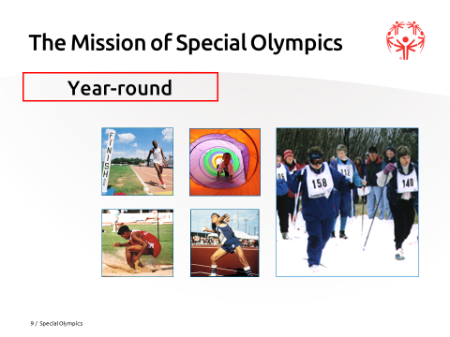

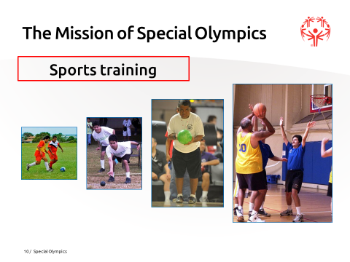

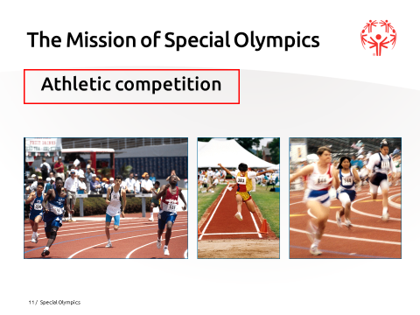

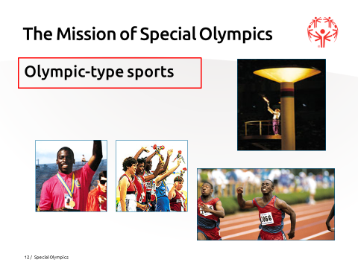

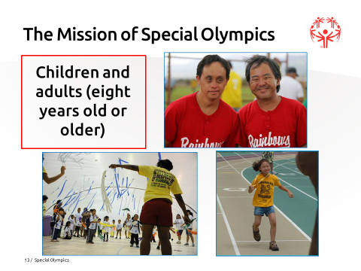

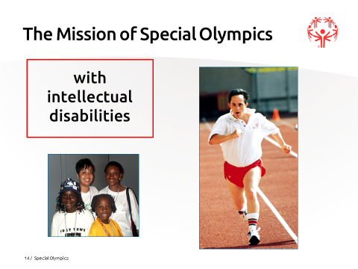

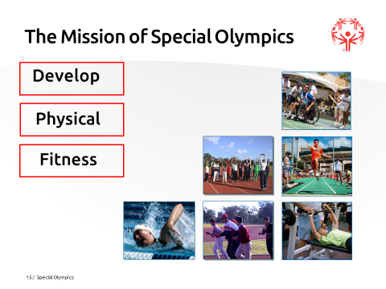

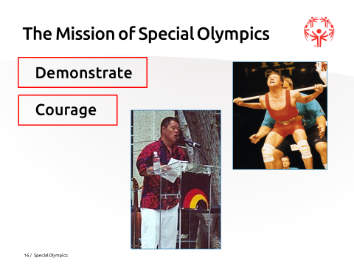

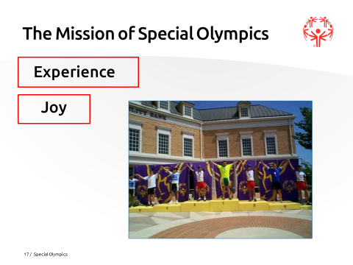

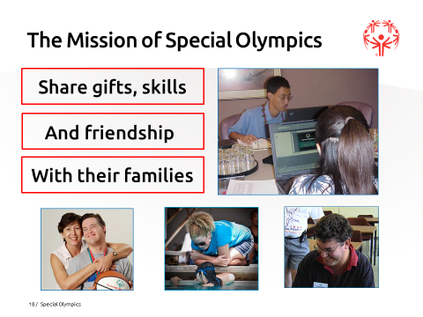

**Favorite Part of the Mission**

**Courage**

**Joy**

**Sharing gifts, Skills & Friendship…**

**Competition**

**Physical fitness**

**Children/Adults**

**Olympic-type**

**Year-round**

**Intellectual Disabilities**

**Sports Training**

**What Makes Special Olympics Unique?**

* No charge to athletes
* Awards for all who compete
* Advancement to higher levels of competition
* All ability levels can participate
* Divisioning gives everyone an opportunity to win

**Facts About Special Olympics**

* Special Olympics is for people with intellectual disabilities
* Special Olympics is free
* You must be 8 years old to train and compete; no upper age limit
* 2-7 year olds train only and participate in the Young Athletes Program
* Special Olympics is an international, worldwide organization in over 170 countries
* Special Olympics has 32 sports
* Special Olympics is year-round
* Special Olympics is a sports training and competition program
* Special Olympics offers both team and individual sports
* Unified Sports® is for people with and without intellectual disability

**Part C**

**Roles of Global Messengers and Ambassadors**

**Role of a Global Messenger**

* Be attentive during the course
* Understand Special Olympics Mission and facts
* Learn different ways to provide information to audiences
* Prepare and practice your speech
* Demonstrate the ability to give a public speech to different audiences with enthusiasm
* Maintain contact with your Speech Coach and with the Special Olympics staff
* Represent Special Olympics professionally in manner and appearance
* Be an Ambassador of Special Olympics

**Role of an Ambassador**

* Be comfortable with speaking to people in any setting
* Know the mission and facts about Special Olympics
* Know misconceptions about Special Olympics
* Know the key elements and philosophy of Special Olympics
* Ambassadors do not have to be Global Messengers
* Know *Spread The Word to End the Word* information
* Represent Special Olympics professionally in manner and appearance

**My 30-Second Elevator Speech**

1. Hello, my name is ___________________________________. I am an athlete from Special Olympics ______________________.
2. The mission of Special Olympics is to provide year-round sports training and athletic competition in a variety of Olympic-type sports for children and adults with intellectual disabilities.
3. I have been involved in Special Olympics for _____ years.
4. The sport I enjoy most is _____________________. I also compete in _____________, _____________, _____________, and _____________. I have earned ________ medals and ribbons.
5. Special Olympics has helped me ________________________. What I like most about Special Olympics _______________________________.
6. If you would like to know more about getting involved with Special Olympics

you may visit our website _____________________________________. (may use Phone # or Facebook if no website presence)

**Role of the Speech Coach**

* Know your Global Messenger
* Support your Global Messenger
* Understand Special Olympics Mission and Facts
* Provide support as needed: not to little/too much
* DO NOT WRITE SPEECHES FOR GLOBAL MESSENGER
* Allow the Global Messengers to express themselves in their own way
* Provide constructive feedback to help skill development while staying positive
* Represent Special Olympics professionally
* Maintain contact with Program Office

**What Is A Speech?**

A speech is simply telling a group of people about something that interests you and your audience.

There are three kinds of speeches:

1. Informative: You give information to your audience.

2. Demonstrative: You give information as well as “teach” the audience something.

3. Persuasive: You are trying to influence the audience to do something, such as give us money or come out and coach.

**Speech Enhancements**

**A Gold Medal Presentation**

* Smile! Be friendly & courteous
* Body language: posture, facial expressions, eye contact, gestures, movement, etc.
* Not too loud - Not too long
* Know your audience: what organization are you talking to
* Personal space: don’t stand too close
* Arrive on time
* Appropriate dress and hygiene
* Tools for talks: don’t forget your script, flyers, etc.

**Speech Enhancements**

**Body Language**

* + Posture: how you stand
  + Facial Expression
  + Eye Contact
  + Gestures
  + Movement

**Facial Expressions – Exercise**



**Speech Enhancements**

**Vocal Variety**

* + Pitch – how high or low your tone is
  + Rate – how fast you talk
  + Quality(tone) – emotions in your voice
  + Pauses – appropriate breaks of silence
  + Volume – how loud or soft you talk

**Volume Activity**

**What Special Olympics means to me?**

Tell a story **30-60 seconds** long about Special Olympics without writing it down. There are 3 options for your story.

Always start with -- My name is______, and I want to tell you:

* “About my favorite experience with Special Olympics.

**OR**

* “Why _______ is my favorite sport.

**OR**

* “About my favorite experience with my coach.

You will have 2 minutes to prepare your story.

**Speech Enhancements**

**Word Punch**

Your voice is a powerful tool. By emphasizing words or the way you say something adds to your message.

Practice each sentence below while you emphasize highlighted words.

1. **I** was born in (your place of birth)
2. I **was** born in (your place of birth)
3. I was **born** in (your place of birth)
4. I was born **in** (your place of birth)
5. I was born in (your place of birth)

**Catch Line**

A “Catch” Line is something you love to say about you and/or Special Olympics.

Some Examples:

* Special Olympics changes lives
* Special Olympics inspires all
* Special Olympics creates heroes
* Special Olympics celebrates differences
* Special Olympics provides training for life
* Special Olympics promotes inclusion and respect

Develop your own “Catch” Line…

**Speech Enhancements**

**My “Catch” Line**

What do I want to say in all of my speeches that will excite the audience and get their attention?

_________________________________________________

_________________________________________________

_________________________________________________

_________________________________________________

Examples are:

Special Olympics changes lives.

Special Olympics inspires all.

Special Olympics creates heroes.

Special Olympics celebrates differences.

Special Olympics provides training for life.

Special Olympics promotes inclusion and respect.

**Special Olympics Target Audiences**

Who we “sell” Special Olympics to

* Schools (administrators, teachers, superintendent)
* Civic Club Members
* Athlete in the Workplace
* Families of potential athletes
* Potential athletes (in Schools, Group Homes, Day Programs)
* Potential Unified Partners (in Schools, colleges, leagues)
* Potential and/or Current Sponsors and Donors
* Potential Fundraising Participants
* Law Enforcement Torch Run Members
* Potential Sport Fans
* Potential Volunteers
* Government/Parks and Recreation Department
* Potential and/or Current Coaches
* Group Home; Day Training Administrators
* Potential Athlete Leaders

**Special Olympics Target Audiences**

**Selling Special Olympics to School Administrators**

*Why School Administrators would want to be involved with Special Olympics?*

**Benefits to the School District:**

* Special Olympics shares their mission of preparing students for full participation in the community as adults
* Helps schools meet physical education and extra-curricular mandates
* Fits into existing physical education and after-school sports programs of the school district by providing inclusion sports opportunities
* Helps students transition into community sports program after graduation.
* Enhances self-esteem and self-confidence of students through positive sports experiences and peer recognition (athletic letters, pep rallies and sports banquets) for their accomplishments
* Compliments vocational training through the development of fine and gross motor skills, physical fitness and social skills (cooperation, team spirit, and competitiveness) needed for competitive employment
* Enhances the community image
* Brings Special Olympics public relations and volunteer resources to schools.
* Increases school spirit of student body
* Special Olympics fosters respect for people who are different

**Benefits to Potential Special Olympics Athletes:**

* Improves physical fitness and sports skills
* Improves Special Olympics athletes self-esteem and confidence
* Improves competitiveness
* Increases social interaction and inclusion between students

**Special Olympics Target Audiences**

**Benefits to Regular Education Students:**

* Regular education students can participate in sports with peers with intellectual disabilities (Special Olympics Unified Sports®) and increase social interaction and inclusion between students
* Provides students without intellectual disabilities the opportunity to become event volunteers, teammates, assistants, peer coaches and/or boosters
* Students can receive recognition by peers at school awards ceremonies, pep rallies, yearbooks and newspapers
* Special Olympics can give students hours toward service learning requirements

**Benefits to Teachers:**

* Special Olympics can offer coaches training courses that lead to teachers receiving CEUs (credit hours)
* Special Olympics can provide Character Education Curriculum for regular education classes K through 12. (SO GET INTO IT)
* Special Olympics can provide a Pre-School Curriculum for movement education in pre-school classrooms through Young Athletes (YAP).

**Special Olympics Target Audiences**

**Selling Points to Administrators of Day Training Programs/Group Homes**

*Why should Day Training Programs encourage participants to join Special Olympics?*

* Learn and improve social skills
* Learn and improve language skills
* Learn and improve coordination skills
* Learn and improve listening skills
* Improve self-discipline skills
* Supports learning perseverance (Stick to it)
* Improves self-confidence
* Learns better time management skills
* Enhances the transfer of competitive/productivity skill
* Learning to function as a team member
* Becomes more physically fit, develops more stamina, has less sick days

**Special Olympics Target Audiences**

**Selling Special Olympics to Civic/Club Organization Members**

*Why would Civic Organizations and Members want to participate?*

* Enhances professional skills
* Builds a good image for them in the community: caring organization
* Group has a chance to volunteer and have fun together
* Can become a coach or a Unified Partner®
* Gives members opportunity to build leadership skills
* Receive recognition: T-shirts, meals, or thank-you notes
* Meet new people
* Adds to your networking potential
* Document Service Hours and projects for Club Recognition at their Program Level School requirements
* Builds club morale: promotes teamwork and cooperation between officers and members
* Gives Special Olympics athletes respect and acceptance because Special Olympics has enabled them to show what they can do
* Your dollars could provide athletes the chance to train for competition for free of charge
* Your dollars could provide coaches training sessions, so they can be certified to train Special Olympics athletes
* Get matching dollars from employer for hours donated

**Special Olympics Target Audiences**

**Selling Special Olympics to Potential Donors or Sponsors**

Why Organizations, Businesses, and Corporations might want to be donors or sponsors?

* Builds morale: promotes teamwork and cooperation at all levels
* Proud of their company for donating.
* Identified in the community as a giving and caring company.
* Your money provides athletes the chance to train for competition for free of charge
* Gives Special Olympics athletes respect and acceptance because Special Olympics has enabled them to show what they can do
* Your dollars provide coaches training sessions so they can be certified to train Special Olympics athlete
* Your dollars provide equipment for Young Athletes Program
* Your dollars provide competition opportunities at all levels
* Your dollars provide training for athletes to attend Athlete Leadership training

**Special Olympics Target Audiences**

**Selling Special Olympics to Torch Run Participants**

*Why would Law Enforcement want to participate in the Torch Run? Or Thank you for participating in the Torch Run.*

* The Law Enforcement Torch Run is the largest grassroots fundraising and public awareness vehicle for Special Olympics with more than 85,000 law enforcement personnel involved worldwide.
* The law enforcement Torch Run provides law enforcement with the opportunity to positively impact their community with a positive image.
* A great opportunity for law enforcement to get involved as coaches, event volunteers and be a part of a winning team.
* Thanks to Special Olympics and the efforts of the Torch Run, athletes like me have had the opportunity to:
  + train and compete
  + develop new skills
  + build my self-esteem
  + meet new friends
* This is how you can get involved in the Torch Run:
  + Contact your local Program and find out who your Torch Run Director is.
* Volunteer to be a runner, a support team member, or plan a local fundraiser for your Program.
* You have helped Special Olympics ________________
  + Provide medals and ribbons for all our games
  + Housing & meals for State Games
  + Transportation to State Games

**Special Olympics Target Audiences**

**Selling Special Olympics to Potential Athletes Living at Home**

*Why someone would want to join Special Olympics?*

* Participate in many different sports
* Have Fun
* Learn how to play a sport and improve sports skills
* Helps to improve self-confidence and self esteem
* Become more physically fit
* Travel out of town to new places
* Learn to use community facilities
* Meet sports celebrities and VIPs
* Get to wear uniforms
* Win medals and ribbons
* Be a part of a team
* Experience new social opportunities
* Meet new friends

**Special Olympics Target Audiences**

**Selling Special Olympics to Families of Potential Athletes**

*Why Families or Caregivers would want their son or daughter to join Special Olympics?*

* Opens new social opportunities with the whole family
* New recreational opportunities with the whole family
* Family takes pride in athlete accomplishments
* Brothers and sisters can participate as Unified Partners®
* Builds family self-esteem
* Gives family members an opportunity to be involved with the organizational structure or become a coach
* Chance for families to meet other families with similar interests
* Chance for families to have fun
* Chance for the family to be “Fans in the Stands”

**Special Olympics Target Audiences**

**Selling Special Olympics to Potential Volunteers**

Why would anyone want to volunteer with Special Olympics?

* Get to spend time in a sports setting
* Experience joy with Special Olympics athletes
* Helps build a community service resume
* Builds leadership skills
* Receive Recognition: T-shirts, meals, or thank-you notes
* Meet and make new friends
* Adds to networking potentials
* Feels good giving back to community
* Employer matching programs
* Receive Service Learning Hours for school requirements
* Can participate along with an athlete by registering as a Unified Partner®

**Special Olympics Target Audiences**

**Selling Points for Participating in Unified Sports®**

Why should someone join a Unified Team with Special Olympics?

* Increases social interaction between people with and without intellectual disabilities
* Increases school spirit
* Improves physical fitness and sports skills
* Improves self-esteem and competitiveness
* Can participate in sports with peers and receive recognition
* Openness and understanding that we are more alike than different and we learn from one other. We all want the same thing…to be accepted for who we are.
* Becoming friends on an off the playing field brings a better understanding of how people are treated differently. You can be a part of making a difference in someone else’s life.

**Special Olympics Target Audiences**

**Selling Special Olympics to Potential Athlete Leaders**

*Why an Athlete would want to become an Athlete Leader:*

* Athlete learns how to become a volunteer outside of sports
* Athletes have a chance to learn how to be a leader and about different leadership roles available to them
* Athletes can learn to express their own opinion freely and feel valued
* Athletes promote Special Olympics to other athletes, family and community better than anyone
* Athletes meaningfully participate on committees and can influence change

**Special Olympics Target Audiences**

**Selling Special Olympics to the General Public**

What would we like everyone to know about Special Olympics?

* Persons with intellectual disabilities can participate in sports
* Shows that people with intellectual disabilities are more like, rather than unlike other people
* Fosters an increased sense of self-esteem and confidence for Special Olympics athletes
* Special Olympics promotes respect and inclusion
* Improves physical fitness and motor skills of athletes
* Gives the community a chance to give back by volunteering or donating
* Promotes friendships and family support
* Promotes ability, not disability
* Special Olympics makes the world and our community a better place to live

**Special Olympics Target Audiences**

**Selling Special Olympics to Government Leaders**

Why Government Leaders would want to help Special Olympics?

* Special Olympics and Government share the mission to provide quality services and experiences for all people in their community
* Fulfills the government mandates for offering appropriate experiences to special populations
* Special Olympics involvement can enhance the government’s image
* Special Olympics can bring new volunteers
* Special Olympics brings good public relations opportunities
* Special Olympics can bring new businesses and corporate support
* Special Olympics will not cost the agency a cash outlay, just access to existing facilities and communication links

**Special Olympics Target Audiences**

**Selling Special Olympics to Administrators of Parks and Recreation Departments**

Why Parks and Recreation Departments want to help Special Olympics?

* Special Olympics and Parks and Recreation share the mission to provide quality leisure experiences for all people in the community
* Offering appropriate recreation experiences to special populations is important to both organizations
* Special Olympics fits into existing sports league structure run by Parks and Recreation Departments
* Special Olympics can enhance the community image and support of Parks and Recreation Departments
* Special Olympics can bring new volunteer resources to Parks and Recreation
* Special Olympics brings good public relations opportunities to Parks and Recreation Departments
* Special Olympics can bring new businesses and corporate support to the Department
* Special Olympics can bring free training opportunities to the Parks and Recreation staff and others who use the facilities
* Special Olympics will not cost the department cash outlay, just access to existing facilities, equipment and newsletters

**Special Olympics Target Audiences**

**Selling Special Olympics to Potential Sports Fans**

Why people would want to become sports fans of Special Olympics:

* Get to spend time in a sports setting
* Experience the joy of being around Special Olympics athletes
* Can watch many different levels of competitions in many sports without leaving my home county
* We need to have fans in the stands at all Special Olympics competition.
  + You could invite your school, your business or your club to volunteer and have fun as a group
* There are roles available as day of officials at track, field events, linesmen, recorders and many more if you are a fan of sports.
* The biggest fan is playing alongside of athletes as a Unified Partner®. Ask us how you can be a partner?

**Special Olympics Target Audiences**

**Selling Special Olympics to Potential Fundraising Participants**

*Why would people want to attend or help publicize a Special Olympics Fundraising Event; speaking to an audience about a specific fundraising event that you want them to attend.*

Factors to Stress:

**What**

* Event will be fun! Explain how
  + Costume contest at the 5k, Cook Off or Polar Plunge
* There will be additional prizes that your entry fee entitles you to, raffle such as drawing for concert tickets
* Lots of Food and Music

**Who**

* Age limits
* Targeting a specific population i.e. people interested in Running, Cycling, Motorsports.

**When**

* Deadline for ticket sales or entry fee
* Day and month and time of event (flyer or email)

**Where**

* Address, Facility Name,
* Restrictions to parking or entrance, parking fee?
* You will be Identified in the community as a giving and caring person
* Your money provides athletes the chance to train for competition free of charge
* Special Olympics helps gives Special Olympics athletes respect and acceptance

**Target Audiences Practice Worksheet**

My Target audience is ______________________________

*Answer Section:*

My target group is the ______________________________.

I want to get them to ______________________________ for _________________________.

I am going to bring to the presentation __________________________________________________________________________________________________________________________________________________________________________________________________________________________________________

I am going to wear _______________________________________

I am going to tell them

1. ___________________________________________________
2. ___________________________________________________
3. ___________________________________________________
4. ___________________________________________________
5. ___________________________________________________

**Target Audiences Practice Worksheet Sample**

My Target audience is Volunteers .

Answer Section:

My target group is the Lions Club . I want to get them to

Volunteer for Holiday Classic in December .

I am going to bring to the presentation A picture board of the games, fact sheets about Special Olympics, a volunteer video to show them, and volunteer registration forms.

I am going to wear Nice pants, dress shirt, and dress shoes.

I am going to tell them

1. Volunteering helps to build their OWN self esteem .
2. There are many things they can do at the events .
3. Chance for them to improve their professional skills .
4. They will make new friends .
5. They will make a difference in other people’s lives .

**What Goes into a Speech?**

***Sharing Personal Special Olympics Experience***

***5 W’s and an H***

**Who:** (Name, Age, City)

*Name* _________________________________________________

*Age* _________________________________________________

*City*

**What:** (What do you do in Special Olympics i.e. Sports, Athlete Leader)

_________________________________________________

_________________________________________________

**When:** (When do you train, compete?)

_________________________________________________

_________________________________________________

**Where:** (Where do you practice, complete?)

_____­­­­_______________________________________________

____________________________________________________

**Why:** (Why I like Special Olympics)

_________________________________________________

_________________________________________________

**How:** (How the Target Market can get involved and make a difference)

_________________________________________________

_________________________________________________

**Researching a Speech**

**RESEARCH**

* 1. Who is my target audience? _____________________________________________

1. What are the selling points: (why should they be involved)? ______________________

______________________________________________________________________

______________________________________________________________________

______________________________________________________________________

1. How will you present these ideas (talking; video; PowerPoint; Storyboard)?

______________________________________________________________________

______________________________________________________________________

______________________________________________________________________

1. What facts about Special Olympics do you want to tell them?

______________________________________________________________________

______________________________________________________________________

______________________________________________________________________

1. What personal information do you want to share? ______________________________

______________________________________________________________________

______________________________________________________________________

______________________________________________________________________

1. What do I want the audience to do (call to action)?

______________________________________________________________________

______________________________________________________________________

_____________________________________________________________________

**Parts of a Speech**

**Opening**

**Body**

**Closing**

**Parts of a Speech**

**“Who Am I”**

*I have __________ people in my family ☺*

*I love to ________________________ ☺*

*I do not like _____________________ ☹*

*A recent event that I just finished was ________________ ☺*

*In my free time, I like to ____________ ☺*

**Parts of a Speech**

Presentation Outline

* **Opening:** Thank the person that introduced you.

Thank the audience for having you come and speak to them.

Tell them your name.

Tell them what you are going to talk about.

* **Body:** Use your “catch” line if it fits here.

Share personal Information about you and your

involvement in Special Olympics.

Give facts about Special Olympics and the Mission.

Say what you want the people to do.

Use selling points and**WHY** they should be involved.

Show your video, medals, etc.

* **Closing:** Tell them what you told them.

Tell them what you want them to do.

Tell them **HOW** they can get involved.

Say your “catch” line here if it fits.

Ask if they have any questions.

Show brochures (or Fact Sheets; sign-up

sheets; business cards).

Direct them to your website at____________

for more information.

Thank them for inviting you and learning how

they can _______________.

**Tools for Talks**

**Things You Can Take With You**

**Business Cards:**

Be sure to sign or stamp your name on the card and have your local Special Olympics program address and phone.

**Photographs/Banners of Special Olympics:**

Bring posters, podium banners, banners, story-boards, scrapbooks or pictures.

**Brochures/Handouts:**

Bring materials to pass out. (Can be Program, Area or International brochures, material, fact sheets, Games programs or yearbooks).

**Registration Materials:**

Bring Volunteer or Athlete Registration Forms. Use Athlete Enrollment Kits, if available.

**Videos/CD:**

Use Program CDs from past Games or borrow a Program CD produced by Special Olympics.

**Medals, Ribbons, or Letter Sweaters/Jackets:**

Show off medals, ribbons or letters you have won in the past.

**Checklist:**

A reminder of things to bring and do.

***Getting Ready for a Presentation Checklist***

Complete this checklist (✓) before going to your presentation.

Date: _______________ Time: _______________

Location: _____________________________________

How many people will be in the audience: _____

***What has this group done with Special Olympics? What do I want them to do as a result of my speech?***

I have been given _____ minutes for my presentation.

Person going with me: ________________________________________________________

_____ My presentation notes

_____ Program brochures and local Program fact sheets

_____ Video/CD (how many minutes does it last)

_____ Business cards

_____ Registration forms and/or Enrollment Kits

_____ Special Olympics banner or posters

_____ Special Olympics medal, ribbon or letter awards

_____ Turn off Cell phone

_____ Appropriate dress (sports clothes, uniforms, dress clothes, casual clothes)

_____ Grooming

_____ clean hair _____ shoes shined

_____ clean nails _____ clothes clean and ironed

_____ no body odor _____ breath smells fresh

_____ clean teeth _____ no gum

**Speech Feedback Sheet**

Global Messenger ___________________ Date of Speech_____________

Speech Coach ______________________ Audience ________________________

|  |  |
| --- | --- |
| CONTENT | PERFORMANCE |
| Introduction   * Thanks audience * States name * States purpose of talk * Creates interest * Comments __________________________________________________________________________   Body:   * Organized, keeps on topic * Correct facts about Special Olympics mission * Facts about self; uses personal story to make interesting. * Includes appropriate selling points for target market * Tell them WHY they should do what you are asking * Uses video or show and tell items * Comments _______________________________________________________________________________________________________________   Closing:   * Invites them to get involved * Tells them HOW to get involved * Shares resources/information * Asks for questions & fields questions appropriately * Thanks audience * Comments __________________________________________________________________________ * General Comments * _____________________________________   __________________________________________________________________________ | Body Language:   * Dressed and groomed appropriately * Has good posture (stands up straight) * Appears at ease in front of audience * Good eye contact and interaction with the audience * Positive facial expressions and gestures * Utilized notes effectively * Handles podium, microphone, and props * Avoids distracting noises * Comments ________________________________________________________________________________________________________________________________________________________________   Speech and Language:   * Volume level appropriate for room * Can speak into microphone clearly * Pace of speech comfortable * Clear pronunciation of words * Uses good intonation and expression * Doesn’t use “fillers” (um, OK, well then…) * Clearly expresses thoughts and ideas * Listens and captures ideas of participants to answer questions * Can express humor * Can “think on their feet” * Responds to prompts of speech coach * Comments ________________________________________________________________________________________________________________________________________________________________________________________________________________________________________________________________________________________________________________________________ |

**Next Steps Back Home**

What am I going to do when I go back home?

1.

2.

3.

4.

5.

Return to: ________________________________

By: ________________________________

**Athlete Leadership Practicum Form ⯎ Beginning Global Messenger**

*Practicum must be completed within 6-12 months; otherwise, your coursework will not count.*

Must be returned to Program office by email or Fax by

Athlete name Phone

Address E-mail

Speech Coach Phone

Address E-mail

Name of Program you represent

**Certification requirements for the *Beginning Global Messenger Course*:**

Date of Course: Instructors:

1. Wrote and delivered 8 presentations
2. Date____________ To Whom _______________ How many in audience _____ Topic_____________________
3. Date____________ To Whom _______________ How many in audience _____ Topic_____________________
4. Date____________ To Whom _______________ How many in audience _____ Topic_____________________
5. Date____________ To Whom _______________ How many in audience _____ Topic_____________________
6. Date____________ To Whom _______________ How many in audience _____ Topic_____________________
7. Date____________ To Whom _______________ How many in audience _____ Topic_____________________
8. Date____________ To Whom _______________ How many in audience _____ Topic_____________________
9. Date____________ To Whom _______________ How many in audience _____ Topic_____________________
10. Attach copies of each speech; pictures.
11. Feedback:

What are some of the things you learned from your practicum experiences?

**Must be signed below**:

Signature of Athlete (Date) Signature of Mentor/Helper (Date)

Athlete Leader Coordinator Signature (Date) Athlete Leader Coordinator (Print) (Date)

**Global Messenger Training Feedback**

Please complete this Evaluation Form and return to the instructors by the end of the class. We value your opinions and want to make continuous improvements.

**Name**: **Program**:

Please check (X) Athlete Mentor

Name 2 things YOU learned that is going to help you when you speak to a group.

1.

2.

Describe the section of this course you liked best.

And explain why you liked it.

Identify which part of the course didn’t work for you. Suggest why it may not have worked.

Explain how you would improve this course when we offer it in the future?

What was your favorite experience/exercise in the Global Messenger course?