☐

Athlete Leadership Athletes as Coaches

Participant Guide
2016

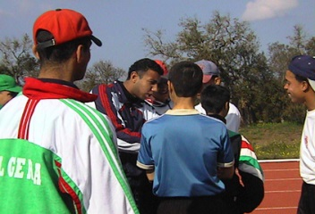
Athlete Leadership Training Series

The First in the Athlete Leadership Training Series within the Sports Track
See the one-page handout regarding the list of Athlete Leadership Courses.

Athletes as Coaches Course

From Competing to Coaching, Special Olympics Athletes Taking on Leadership Roles

Welcome to the Athletes As Coaches Course. Are you ready for a new challenge in Special Olympics? Do you know how to talk with other athletes so that they understand what you mean? Do you like helping the coach?
As we know, the key to improving athlete performance and well-being is based on the quality of sport training and experiences provided by the local Special Olympics coach. The term “coach” refers to the individual who assumes responsibility for athletes, actively trains them, and coaches them in competitions (the Class A Volunteer). This person in some cultures is referred to as the “trainer”.

How do I know I’m ready to be a coach?

Nobody knows for sure until they try it! Many people volunteer to be Special Olympics coaches and then find that it just wasn’t for them. You may do the same thing once you go through the Coaches Training School. One way to know if you are ready to be a coach is by watching a coach and asking yourself if that is what you want to do. If you REALLY want to do it, you are probably ready!!

Another way to see if you are ready is to ask your coach if you can be an assistant. Ask them to show you how they plan the workouts, set up the practices and get ready for competition. Ask if you can help with one or more of those jobs. If it turns out that you like doing that and you want to learn more, you can ask about going to a Skills Course in that sport.

What do I do if I think I am ready to be a coach?

This course is an excellent first step in exploring the possibilities.

First, talk to your coach to get his or her ideas. They need to know that you are ready to move on to coaching. They may be able to give you some practice being a Coach Assistant while you are waiting to go to a Coaches Training School. Your coach can also help you decide whether you will need to have a Support Person as you go through the certification process.

Second, talk to your Local Special Olympics Coordinator. Ask them when and where the next Coaches Training School will be held for your sport. You can also talk to them about your possible coaching assignment once you get certified. Most people start off as a Coach’s Assistant for at least one (1) year before assuming more responsibility. By letting your coordinator know that you are going through this training, you are letting them know that you are their newest VOLUNTEER!

Third, study the Sport Skill Coaching Guide for the sport you want to coach. You can go online to www.resources.specialolympics.org, or your coach or coordinator might be able to give you a copy. It will tell you how Special Olympics recommends that you teach the athletes the skills they will need. If you need help understanding the Sport Skills Coaching Guide, you can call on your support person or mentor to help.

The Athletes as Coaches Course is the first in the series of Athlete Leadership Training Series within the sports track. This introductory course on coaching will provide basic knowledge, skills, value statements and a practical application for the athlete to work toward becoming a coach. The mentor provides a variety of opportunities for the prospective coach to meaningfully contribute their ideas. Two key learning areas include managing the group of athletes and solving problems. The goals are to help athletes develop sport skills and/or help athletes get better. Within this course, the athlete who is going through the training will be referred to as “Prospective Coach.”

Desired Outcomes
- Describe Athlete Leadership.
- Describe what it means to be a coach.
- Identify what a coach needs to know.
- Outline expectations that the Prospective Coach has for the Mentor and that the Mentor has for the Prospective Coach.
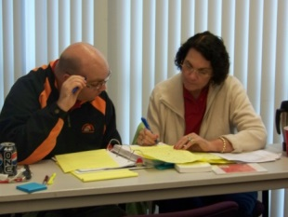
- Explore the various coaching jobs which reflect different levels of responsibility.
- Apply key communication skills, task analysis and skills instruction to effectively teach and train athletes.
- Experience working with athletes.
- Plan next steps in training and certification.

The course will be divided into four parts:
Part 1: Explore what it means to be a “coach” and what the prospective coach needs to know
Part 2: Explore the jobs and levels of responsibility
Part 3: Test the role – through practical experience of coaching experience
Part 4: Wrap-up – next steps and course evaluation

What has it been like for other athletes who have become coaches?

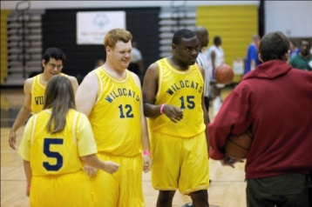
Here are some comments from Special Olympics athletes that have gone from competing to coaching:

- “I really feel needed.”
- “I love sharing what I know.”
- “I understand the athletes’ problems.”
- “It’s so great to help the younger kids.”
- “I am important to someone.”
- “I am doing what I love.”

Part 1: Explore What It Means to Be a Coach or Assistant Coach
1. Is coaching for me?
Things to Consider: With the help of your Mentor if needed, complete the following self-assessment of your actions, interests, abilities and capabilities that are related to coaching.
Place a mark (“X”) in each box that identifies your actions, interests, abilities and capabilities. Then briefly describe why you feel it is important in the space provided.
  - Do you enjoy helping others?

  - Are you comfortable with athletes of any age – young, school-age and adult?

  - With what age group would you prefer working?

  - Are you willing to listen and follow instructions from the Head Coach?

  - Are you patient and calm when dealing with athletes who are misbehaving?

  - Can you keep a positive attitude in negative situations?

  - Can you manage a group of athletes?

  - Can you problem solve and help athlete’s learn and/or change their behavior?

  - Do you have good sportsmanship and uphold the code of conduct?

  - Are you willing to learn more about your sport through ongoing training and certification?

  - Can you deal with criticism even when you feel it is undeserved?

  - Are you responsible and reliable?

  - Can you keep smiling?

Any other comments

Prospective Coach Date
Mentor
- What do I need to know to coach?

Now that you see where you are with coaching, the next consideration is what you need to know to be a coach. Having the desire is a great beginning; learning what a coach needs to know is the next step.
Briefly describe what each of the following phrases means.
  - Special Olympics’ mission, athlete oath and uniqueness from other sport organizations

  - Divisioning and advancement to higher levels of competition

  - Necessary skills of the sport in which I would like to train and coach athletes

  - Communication skills (verbal and nonverbal)

  - Organizational skills (planning practice)

  - Rules, including those for events with lower skilled athletes _________________________________

  - Ability to perform and demonstrate sport-specific skills

  - Ways to help athletes having problems learning

  - Knowledge of athletes’ physical abilities, medical concerns, emotions, behaviors, etc.

  - Ways to motivate and encourage, not discourage, athletes _________________________________

  - Safety – in environment, in training, in program

  - Who and how to contact in an emergency

Additional comments

Prospective Coach Date
Mentor
Coaching – Three (3) Different Responsibilities

PLANNING The first job is to PLAN the practices. This means that you have to think about your players and what they need to learn to improve at their sport. The coach works to plan each practice session before the players arrive so that the athletes learn a new skill or improve on one they already know. The coach has to make sure the athletes don’t get frustrated. This takes practice, knowing what skills are needed, knowing how to teach those skills and knowing how to work with each athlete.

CONDUCTING PRACTICE The second job is to CONDUCT THE PRACTICE. This job requires that you be able to get and keep the players’ attention and to set up the workout so that everyone is doing something most of the time. Knowing how to talk with athletes is very important. A Coach Assistant is someone who helps conduct practice, but is not in charge of planning the practice.

COMPETITION The third job is to make sure the athletes get to the event and to coach during COMPETITION. Filling out registration forms, getting transportation to the competition, making sure the team gets to the gym or field on time and getting them through the competition is all part of this job. Some coaches have an assistant that does the paper work so the coach can work on making sure athletes are ready to compete.

Some people find that they are ready to do some of these jobs, but maybe not all of them. They become Coach or Training Assistants. They still go through Coaches Training Schools, but they ask to be assigned to a Head Coach that will be in charge.

Who will help the Prospective Coach learn how to be a coach?

Mentor
A Mentor is an individual who commits to working with the Prospective Coach for two years. The following actions represent some of what a Mentor can do to assist the Prospective Coach.
- Assists Prospective Coach in learning all he/she can about one sport (rules; equipment; uniforms; court/field).
- Attends competitions with Prospective Coach to observe the sport being contested.
- Volunteers with Prospective Coach in that sport, either in a training or competition setting.
- Observes Prospective Coach in a volunteer role and give feedback.
- Assists Prospective Coach in completing the practicum for this course.
- Assists Prospective Coach with filling in the log for this course’s practicum.
- Assists Prospective Coach in finding an Assistant Coach or Training Assistant position in chosen sport.
- Attends a coach’s training school with the Prospective Coach in the chosen sport.
- Assists Prospective Coach in fulfilling practicum hours for certifications.
- Gives continuous feedback to Prospective Coach on coaching techniques.
- Talks with a Prospective Coach about continuing education opportunities (sports clinics run by other sport organizations, Coaching Special Olympics Athletes Course, Principles of Coaching Course, other recertification courses.

Expectations

- What do I expect of the Head Coach or Mentor?

Here is one perspective from an athlete with the Special Olympics Massachusetts Program.
“As Prospective Coaches, we hope coaches will be dedicated to the team and committed to learning about each athlete’s strengths, weaknesses and different personalities. We want coaches to put athletes in a position to be successful, while at the same time challenging us to improve by showing us what we need to develop. Teach us teamwork and unselfish play, but remember “safety first”. Challenge us, help us aim high, help push us according to our capabilities, and support us in our efforts. Make playing fun and make being on the team an enjoyable experience. Be open to change – because a drill may work for some of the team but not for all of the team. Know the rules of the sport with regard to both the sport-specific governing body and Special Olympics standards. And lastly, we want coaches to remember our Special Olympics athlete oath: ‘Let me win. But if I cannot win, let me be brave in the attempt.’”
– Matt Millett, Special Olympics Massachusetts athlete and coach

I expect the following of the Head Coach or Mentor:
  - Assistance in what is needed
  - Involvement during practices and competitions
  - Effective communication with each other – before, during and after practice
  - Opportunities to manage the group and problem solve
  - Sources of ongoing education

- What will a Head Coach/Mentor expect out of me?

Expectations go both ways. If the Head Coach is the mentor, the Prospective Coach works directly with him/her. If the Head Coach is not the mentor, the mentor will work with the Prospective Coach and provide assistance but under the guidance/supervision of the Head Coach. The mentor is the individual who helps the athlete learn particular behavior and enhances/facilitates the learning process. The Head Coach, not the mentor, is in charge of the team, Assistant Coaches and manager.

The Head Coach should expect me to:
- Get to and be on time to training sessions, meetings and competitions
- Follow directions and being involved
- Provide information on what I need to know about my job in order to learn and carry it out
- Uphold my job responsibilities during practice and at competitions; be reliable/dependable
- Meaningfully contribute during training
- Communicate with the coach and mentor before, during and after practice
- Be a role model for sportsmanship and good conduct

Considerations for the Head Coach/Designee

Communication is extremely important and involves the Head Coach or designee and his or her staff (including the Prospective Coach). Communication is weekly, seasonal and whenever the plan is changed or modified.

- It is the Head Coach/designee who gives instructions to his or her staff. The Head Coach may designate an Assistant Coach who has excellent teaching skills and rapport with athletes.
  - How will we (Prospective Coach and Head Coach/designee) communicate?
  - How will Head Coach or designee communicate with Prospective Coach and Mentor? (Mentor will follow lead of Head Coach but will not distract the Prospective Coach from doing his or her job. The Mentor may intervene at the request of the Head Coach and the need of the Prospective Coach.)
  - How frequently will Head Coach/designee communicate with Prospective Coach and Mentor?
  - How frequently will the Prospective Coach and Mentor need to communicate?

- What kind of weekly feedback will be helpful to the coach and Prospective Coach regarding his/her job?
- Identify what is going well.
- Describe what needs improvement.
- Complete and review the feedback form.
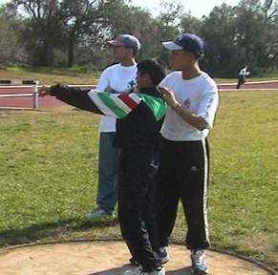
- Prospective Coach also completes a training diary (what went well, what was learned and what we need to work on next – this is entirely personal).

- Who should be included in formal feedback at end of season?

  - Prospective Coach
  - Mentor
  - Head Coach or designee
  - Teammates
  - Other coaches

Part 2: Explore the Jobs and Levels of Responsibility

There is a range of opportunities for the Prospective Coach. One can start out in a role as an observer then that of Team Manager, Training Assistant or Assistant Coach. There is a continuum of experiences that are meaningful, challenging yet fun and interactive.

Sample job descriptions of this continuum of coaching experiences follow – beginning with the ultimate experience as Head Coach and continuing down to Assistant Team Manager.

Note: All athletes who become coaches (any form) must be registered and approved Class A volunteers and are subject to all the same screenings, training and standards as any other Class A volunteer.

Head Coach:
- Person in charge of group of athletes in particular sport for a particular season.
- Knowledgeable in the Special Olympics Sports Rules and the National Governing Body (NGB) Sport Rules.
- Be Certified in the Sport.
- Distributes Crisis Communication Plan for all practices.
- Develops a phone tree / email network to communicate with parents, guardians, coaches, athletes.
- Decides on disciplinary measure to be taken regarding athletes when necessary.
- Decides on training site based on safety, accessibility and cost.
- Is responsible for completing a Registered Training Program form for the season.
- Supervises all coaches and athletes.
- Is responsible for equipment, transportation, and lodging issues when at events.
- Assigns duties to coaches, Assistant Coaches, Training Assistants and Team Managers.
- Ensures that each coach receives the Sports Information Guide, practice schedule, rules, etc. as needed.
- Volunteers, before the first practice (this is for the safety of the athletes and other volunteers):
  - Recruits volunteers for various duties and tasks.
  - Ensures Class A Volunteer forms are filled out and turned in to the Local Program Coordinator.
  - Completes Protective Behaviors and Concussion Training online courses.
  - Attends a General Orientation, which provides an overview of Special Olympics.
- Before the first practice: ensures that al athletes (or their providers) complete an Athlete Medical Screening Form and Permission Form; keep copy on hand!

Coach:

- Is knowledgeable in the Special Olympics Sports Rules and the National Governing Body (NGB) Rules of the sport
- Should be working on certification in the sport
- Has reading skills
- Assigns practices for a specific sport
- Supervises athletes
- Arranges car pools and transportation
- Assigns duties by Head Coach
- Assigns any or all of duties of Head Coach

Assistant Coach:

- Is knowledgeable in the Special Olympics Sports Rules and the National Governing Body (NGB) Rules of the sport
- Is knowledgeable about Team Manager responsibilities
- Has preferred sports experience

- Must be 16
- Is working toward certification in the sport
- Assists coach with the preparation in practices, set up, clean up
- Works with athletes assigned by coach

Training Assistant:
- Does not have to be working toward certification.
- Helps with practice and duties as assigned by coach or Assistant Coach
- Assists Team Manager with duties: laying out field or court, putting out equipment, filing, assessments, scoring, safety checks, etc.

Team Manager:

- Is knowledgeable in Special Olympics Sports Rules and the National Governing Body (NGB) Rules of the sport
- Is knowledgeable in the uniforms, their numbers, and specific details related to uniform requirements
- Cares for the uniforms (washed, mended)
- Is knowledgeable in field/court requirements
- Conducts safety checks before each practice of the equipment and facility
- Knowledgeable in the equipment as it relates to the sport.
- Cares for equipment (repair, stores, orders)
- Keeps files on site for each athletes medical, assessment, progress chart, update information, etc. (MUST BE TRANSPORTABLE)
- Makes sure files are accessible to each coach and Assistant Coach

Assistant Team Manager:
- Managers assigns duties which are a good fit with the volunteers skills

Responsibilities at Competition for All Sports Assistants, Coaches and Managers:

- 24 hour supervision of athletes
- Understands medical issues of assigned athletes
- Reviews code of conduct with each athlete
- Reviews the schedule; if it is hard to understand, sense ask someone
- Knows location of training and how the schedule works out with coaches and athletes
- Reviews the rules with athletes
- Ensures athletes are hydrated (check intake frequently)
- Ensures athletes drink enough water
- Reminds athletes of their medication schedule
- Is prepared to perform first aid
- Has parents’/guardian’s phone numbers available for assigned athletes
- Carries medicals for assigned athletes
- Holds valuables for athletes while they compete as necessary
- Wears appropriate clothing
Teaching and Training Athletes

Now that you have seen what a coach needs to know as well as what a coach does, let us review how a coach effectively teaches and trains the athlete. There are three keys to effectively teaching and training athletes.

- The first is communication.
- Words need to be clear and have only one meaning. In that way, what the coach is trying to convey has a better chance of being understood. “Go to the ball,” is clear, has few words and is action oriented.
- Few words are better than many words; the athlete needs to process words/meaning easily.
- Words also need to be spoken with consistency. Multiple words conveying the same action or meaning only confuse the athlete.
- Use concrete or real examples to reinforce concepts. For example, say “move to the right towards your bench, instead of just move to the right.”
- Words need to be action oriented, producing the desired behavior. “Good follow through” expresses what is good rather than saying “good.”
- Communication can also take the form of visuals or nonverbals. Board Maker, pictures, videos and images enable athletes to see what the skill or desired action looks like. If they can see it, many times it is easier for them to repeat it.
- Give 1 to 2 part instructions. For example, say, “After you get a drink of water, move to the clock end of the pool.”
- Reward the athlete’s attitude and efforts. Another team or individual may have a better day in terms of a win or a loss, but an athlete can always keep a positive attitude and work hard.

- The second is utilizing appropriate levels of instruction within a training sequence –
There are four levels of instruction.
    - The first is verbal. Some athletes may be able to perform a skill after a verbal cue or a simple direction.
    - However, if they cannot perform the skill, a teammate or coach can demonstrate the skill so that the athlete can see it done properly and then attempt to perform it.
    - A little or partial assistance may be needed if the athlete is not in the right position. Ensuring that the athlete is in the right position or holding the ball a particular way may be all that the athlete needs.
    - Full assistance plus breaking skills down into their tasks (parts) is the last resort. An athlete may never have felt what going through a particular skill feels like. In this level, the coach takes the athletes arm and physically moves the arm through the entire skill. Then apply skills in performing the sport; now apply skills during competition. Promote demonstrations and visual images then do. Utilize technology to be a good trainer.
- Start by demonstrating; briefly verbalize what the skill is; see if the athlete can do it.
- If unable to perform the skill, give them verbal cues and assist the athlete by ensuring that he/she is in the right position.
- Continue working on the skill and apply it in a low-organized way.
- If that does not work, then physically assist the athlete by taking her/him through the full range of the skill
- If athlete still cannot do the skill, break the skill down into the various tasks which are the various parts of the skill.
Part 3: Practical Experience – Testing the Role in a Sport

Regardless of the sport, the following elements and a practice plan will form the necessary structure.

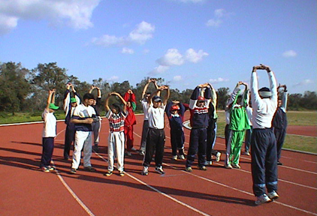
- Warming-up (body and skill)
- Skills Instruction (which also includes assessing athletes’ level of skills and previously learned)
- Competition Experience
- Cool-down and Team Talk

Participating in a Training Session

There are many ways to conduct a training session for Special Olympics athletes. Because of comprehension and memory challenges for the athlete, there is considerable value in a developing a consistent training “routine” that provides familiarity, stability, and comfort.

There are four essential components of a typical training session: warm-up and dynamic stretching, skills instruction, competition experience, and cool-down and stretching. (Fitness training or conditioning can also be included following competition experience and prior to cool-down.) The following techniques and tips will provide the most successful learning opportunities.

- Warming up
• Time is precious, and skills repetition is vital. Warm up in a way specific to the sport. For example in soccer, dribble a ball while jogging as opposed to just running.
• If athletes have difficulties with balance, use activities that can be done while sitting, lying down, or leaning against a wall or partner.
• Involve athletes in leading the activities; coaches are then free to circulate and directly assist others who need help.
• Teach a simple routine involving the major muscle groups, which athletes can repeat at home and at competition.
- Warm-up by walking or jogging 5 minutes. If a swimmer, substitute swimming laps.

- Move into using a ball or whatever the sport dictates

- Skills Instruction

Training Sequence (tasks → skills → application in game/event → performing in competition)
• The key is to break down skills into small tasks or steps; tasks are then put together to form skills.
                - • Drills/activities are developed so that skills are applied in a game or an event situation. The result is that skills will be applied and performed in competition. Simplify.
                - • Reward efforts; best not to use food as reward due to health challenges, including Prader Willi.
• Communicate effectively – be clear, concise, consistent, concrete and action oriented.
• Look for athlete interests. Ask athletes questions rather than always provide directions. Lead them to think for themselves.
• Assess what an athlete is already ready and able to do; then build upon strengths.
• Practice skills in situations that are related to the game or event.
• Use drills and activities that involve many athletes at all times. No one should be standing around. Utilize all coaches during each practice.
3. Competition Experience
• Go through a realistic competition experience during each practice in order to improve confidence and performance under the pressure of real competition.
• In team sports, athletes need to understand game concepts by providing immediate and concrete feedback. During scrimmages or practice games, the play is briefly stopped to help athletes recognize critical situations and learn how to react successfully.
• In individual sports, the focus is on competition elements like the turns in swimming and staying between the lines and starts in track and field.
• Rules need to be addressed during training. Rules enforcement helps prepare athletes for participation in community sports and in life.

4. Cool-down and Stretching Plus Team Talk
• Performing several light stretching activities with the major muscle groups will prevent muscle cramps and soreness and increase flexibility.
• For stretching, what to do and not to do:

Do | Do Not
Perform warm-up activity for 5 minutes (walk, run or swim with ease, not fast); use sport-specific elements. | Do not begin practice by stretching and pushing full range of motion; can tear muscle fibers.
Perform each of the stretching exercises by moving into it for 10-30 seconds each. | Do not perform static stretches; beginning to move and work in range of motion begins to get the body ready for the sport.
Start with the large muscle groups such as the legs then move to the shoulders, etc. | Do not start with the smaller muscles. Go from large muscles to small muscles.
Perform each stretch to the point of tension. | Do not put strain on the joints, back or neck.
Breathe while stretching. | Do not hold breath.
Perform stretches in a “safe” position and as far as possible within the range of motion. | Avoid the hurdler’s stretch, deep knee bends, straight-leg sit-ups, sit-ups pulling on the neck, and lying on the back and moving legs overhead as if riding a bicycle.
• Review the main themes of the training session; reward athlete performance, and talk about the next competition or training session.

Part 4: Next Steps
You have now begun the first step to become a certified Special Olympics coach. Here is an overview of the steps.
Step 1: Athletes as Coaches Course (which you have just completed) followed by a 10-hour Observation Practicum completing your Sports Assistant Diary at the end of this document and noting lessons learned
Step 2: Coaching Special Olympics Athletes Course and a 10-hour Practicum assisting the coach in Training and Competition and completing your Sports Assistant Diary with the activities experienced as well as what was learned
Step 3: Skills Course and 10-hour Practicum of Working with Athletes and completing your Sports Assistant Diary with the activities experienced as well as what was learned
Within the 3 steps complete General Orientation; Protective Behaviors; Concussion Training.
Result: Certification gained
In essence to become a certified Special Olympics coach, you will need to attend or take the Special Olympics General Orientation, Protective Behaviors and Concussion Training in person or online. You will also take the Coaching Special Olympics Athletes Course in person or online with the help of your Mentor, as needed. You or your Mentor can ask your local coordinator when and where the next one will be held. Whether you want to be a Head Coach or a Coach/Training Assistant, it is a good idea to attend the Training School. This training will be followed by a 10-hour practicum where you will complete your Sports Assistant Diary at the end of this document to prepare you for the next course which is a Skills Course. You’ll learn a lot about your sport and what the coach is supposed to do. And the coaches there will learn a lot from you about how to talk with athletes!

You may want to get someone in addition to your Mentor to help you go through the process of registering for each Training School, getting there and then getting a coaching assignment. We call this your Support Person; in many cases, this may be your Mentor. A Support Person or Mentor might be a parent or brother or sister; it might be a coach or teacher you have now; or it might just be a friend. You will need to talk to your Support Person about what you need.

Now work with your Mentor in putting together your plan for what you will do next.

Congratulations on taking the first step in becoming a coach!

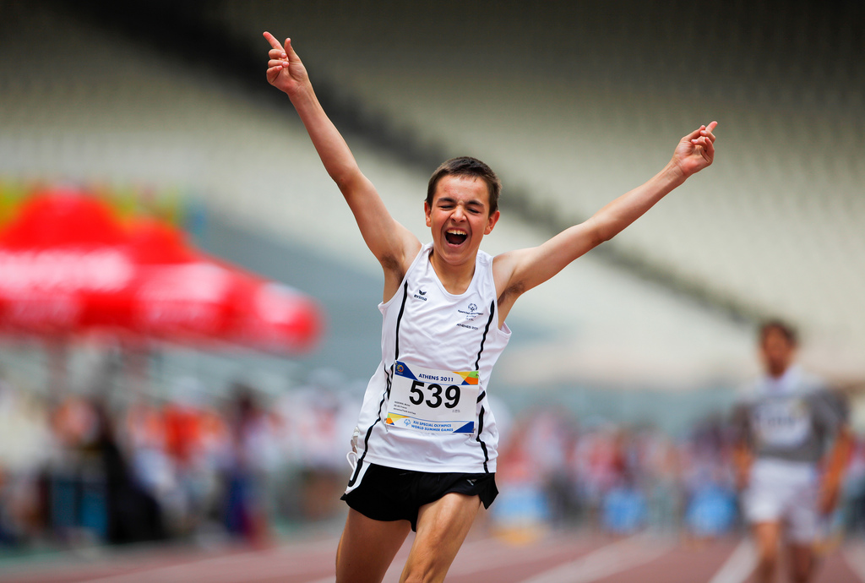
My Sports Assistant Diary

Name: ____________________________________ Phone: ____________________________
Local Program: ________________________ Sport I chose: ________________________________
Name of my Mentor: _________________________________________________
Email: _____________________________________ Phone: ___________________________
Date(s) | Sport and activity you conducted or assisted followed by a description of what you learned from the experience | How many minutes | How many athletes
Please copy this page for additional activities and experiences as needed.

My Sports Assistant Diary

Name: ____________________________________ Phone: ____________________________
Local Program: ________________________ Sport I chose: ________________________________
Name of my Mentor: _________________________________________________
Email: _____________________________________ Phone: ___________________________
Date(s) | Sport and activity you conducted or assisted followed by a description of what you learned from the experience | How many minutes | How many athletes
Please copy this page for additional activities and experiences as needed.

Practicum Exercises to Receive Credit
All exercises are due within 6-12 months of the class date.

Name: ____________________________________ Phone: ____________________________

Local Program: ________________________ Sport I chose: ________________________________

Name of my Mentor: _________________________________________________

Email: _____________________________________ Phone: ___________________________

 | ACTIVITY AND HOURS SUMMARY
1 | I certify that I have attended a General Orientation. | Yes | No
2 | I certify that I have reviewed the Sport-Specific Coaching Guide with my Mentor. | Yes | No
3 | I certify my Mentor and I have taken Protective Behaviors and Concussion Training. These courses must be completed before coach certification is achieved. | Yes | No
4 | I certify that my Mentor and I have submitted Class A Volunteer forms. | Yes | No
5a | Total number of hours I have logged watching Practices or Competitions techniques (pages 1 & 2).
5b | Total number of hours spent in Preparation for my first role as an Assistant Coach, Manager or Training Assistant (pages 1 & 2).
6 | Total number of hours working as a Sports Assistant – Coach, Assistant Coach, Manager, Assistant Manager, or Training Volunteer (pages 1 & 2).
7 | Totals of 5 and 6 above from pages 1 and 2.
8 | I have attached My Sports Assistant Diaries that include both the activities experienced as well as the lessons learned from the experiences. | Yes | No
9 | I want to become certified as a coach. | Yes | No
10 | I CERTIFY THAT I COMPLETED MY COACHES’ TRAINING PRACTICUM. | Yes | No

My Local Program Coordinator is: ______________________________________________________

My Local Program Coordinator’s Phone: ___________________Fax______________________________

Prospective Coach may log as many hours watching practice/competition with coach as needed.
Prospective Coach must log 5 hours of coaching prep-time with Mentor & 10 hours as Assistant Coach, or Assistant Team Manager before submitting to Local Program Coordinator and Athlete Leadership Program Director.
Upon receipt of this Diary with boxes 1 through 7 complete, Prospective Coach and Mentor will receive a certificate of completion. For further information, please contact __________________
Course Evaluation

Name: _______________________________ Your Program: _________________________

Please mark an “X” next to your Role: Athlete ____ Mentor ____

You learned about several roles that athlete leaders pursuing coaching can play. Which athlete leader coaching role did you like the best? Why?

Name two things YOU can do when you get home that will make your athletes better because of your coaching.

- ____________________________________________________________________
- _____________________________________________________________________

What section of this course did you like best and why?

Was there a part of the course that just didn’t work for you? Which one and why?

How would you improve this course when we offer it in the future?

What was your favorite activity or experience during the Athletes as Coaches training?

