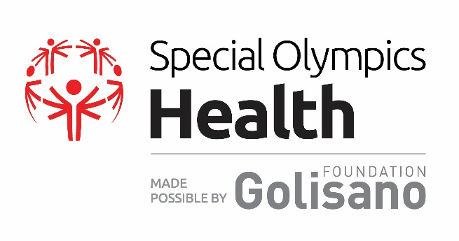
Golisano Global Health Leadership Award

About the Award:
The Golisano Global Health Leadership Award is the highest honor for health partners and individuals that Special Olympics awards. The award was created to recognize local health champions and their extraordinary efforts toward fulfilling the goals, values, and mission of Special Olympics’ global health program, made possible by the Golisano Foundation.

The award recognizes individual leaders and/or organizations that are making significant contributions to Special Olympics Health programs and the promotion of equal access to healthcare, wellness, and fitness for people with intellectual disabilities.

Every two years, one recipient per region will be selected and invited to the World Games to be presented with the Golisano Global Health Leadership Award for their region.

Nominees for the global award were evaluated based on their leadership for and contributions to the following areas:
- Expanding the Special Olympics Healthy Athletes® program in the nominee’s home state/country
- Increasing local athletes’ ability to access quality follow-up health care and/or Increasing athletes’ access to and participation in year-round wellness/ fitness programs
- Increasing the financial sustainability of Special Olympics health work
- Advancement of the health rights of Special Olympic athletes and people with ID

