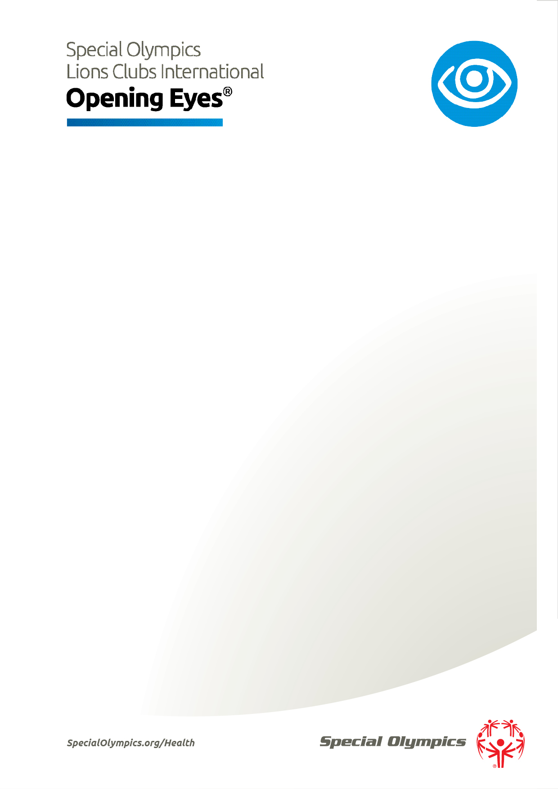

Instructions
To create a master template for your own program please follow these instructions:

1
Ensure you have the Ubuntu typeface installed on your computer.

2
Insert the correct Sub-Program Name and Mark are in the header (above)

3
Delete this instructional text from your document and save your version of the Word file as a template file. This will form the basis of all future fact sheets.
….
Please note that when sending fact sheets to your audience, or uploading them to your website, be sure to save them as PDF format. Word files should not be circulated to the public as they can be altered and may contain meta-date you don’t wish to share with the public.

