TRAIN
Testing Recreational Activities and Improving Nutrition

2010

Special Olympics International
Simon Chan
Brian Hrebec
Sara Staubach
Michelle Williams
Erin Wilson

Contents
Executive Summary 3
TRAIN Assessment 4
Holding a TRAIN Event 4
Suggested Layout 5
Station Descriptions 6
Volunteers 8
Summary of Volunteers 8
Volunteer Job Descriptions 9
Materials and Budget 10
TRAIN@Home 13
TRAIN@School 13
Background and Rationale 14
Appendix A- Material Sources 15

Executive Summary
Background
TRAIN (Testing Recreational Activities and Improving Nutrition) is an assessment program formally known as FIT (Fitness Improvement Training). This health assessment and educational program is designed to assess Special Olympics athletes’ sport skills and provide them with nutritional information.
Methodology
TRAIN is a program developed by Special Olympics to track and improve athlete health and quality of life. TRAIN is designed to be set up at a Special Olympics event, but is also suitable for use in a school or group setting.
Athletes go through a series of nutrition and sport skills stations. The nutrition stations are educational, focusing on the concept of a balanced plate. Athletes interactively learn about the different food groups, the functions of the food groups, and practice making balanced plates. The sport skill stations test seven basic sport skills: aerobic endurance, balance, coordination, flexibility, power, strength, and speed/agility. The station results will be used to help each athlete discover their strongest skills, skills for them to improve, and additional Special Olympics sports to try.
TRAIN offers two sets of supplementary material: TRAIN @ Home and TRAIN @ School. These offer athletes resources to learn about nutrition and exercise away from a Special Olympics setting.
TRAIN @ Home provides athletes and their families with easy-to-understand information on proper exercise and nutrition habits. A nutrition booklet contains an overview of healthy nutrition, sample menus, grocery store lists, healthy snacking, and other nutritional resources. An exercise booklet includes an overview of healthy exercise, stretching information, fitness outlines, and activities for the seven sport skills. At the conclusion of a TRAIN assessment, athletes will receive these books to take home with them.
TRAIN @ School consists of a series of lesson plans designed to complement and expand on the TRAIN assessment. The lesson plans are aimed towards elementary school students with intellectual disabilities, but can be used and modified for any classroom environment. The nutrition lessons cover topics such as: food groups, the importance of a balanced meal, healthy snacking, and the role of water in the body. An adaptive PE lesson is given for each of the seven sport skills; each lesson gives students information about the skill along with activities to both reinforce the information and practice the skill itself.

TRAIN Assessment

The assessment event is the central part to the TRAIN program. It tests athletes’ skills, introduces the basics of healthy nutrition, and sets the stage for further development.

Holding a TRAIN Event

Layout
TRAIN requires approximately 20 meters by 20 meters of open space. A wall or other vertical surface is recommended for several of the stations.
Time
Each athlete will take approximately 45 minutes to complete all stations. It will take approximately 2 hours for 20-25 athletes to go through. If additional volunteers are available, two athletes can use each station at once, allowing twice the athletes in the same time.
Volunteers
- 15-25 volunteers are required.
- 40-50 volunteers are ideal, which allows two athletes per station simultaneously.
Budget
- The minimum material for TRAIN can be purchased or made for $165.00
- The ideal materials for TRAIN can be purchased or made for $540.00.
Procedure
At the registration table, each athlete will receive a sports assessment form and name tag. Athletes should then proceed through each station in order. At the last station (SNAP), they will receive recommendations based on their assessment results, along with supplemental material (TRAIN@Home) to take with them.

Suggested Layout

Registration**

14: SNAP**
1: Shuttle Run

13: 3 Minute Step test min
2: Medicine Ball Throw*
Legend

* Requires wall space
** Requires a table

20m
12: Sit and Reach
3: Vertical Jump*

11: Nutrition Dining Detective**
4: Nutrition Jump Start

10: Walk a line
5: Push- ups
9: Dribbling a Soccer Ball
7: Nutrition Food Toss
8: Catching and Throwing*
6: Wall Sits*

20m

*Stations 2-12 can be rearranged in order to accommodate space. However, keep in mind nutrition stations should be kept in the same order and were dispersed intermittently to provide athletes with breaks.

Station Descriptions
Detailed station descriptions are available on the program CD and website.
Registration
The athlete will be given a nametag and an assessment sheet with their name and a list of currently played sports.
Station 1- Shuttle Run
The 10 meter shuttle run measures an athlete’s speed and agility. The athlete will run twice between two lines that are 10 meters apart. The athlete will be assessed by how fast they run and by how quickly they can change directions.
Station 2- Medicine Ball Throw
This station measures an athlete’s upper body power. The athlete will get three chances to throw a weighted ball for distance with correct form. The athlete will be assessed by the distance the ball travels from the point of release to the point it lands.
Station 3- Vertical Jump
The vertical jump measures the athletes’ lower body power. The athlete will get three chances to jump as high as they can. The athlete will be assessed by the peak height of their jump.
Station 4- Jump Start
The athlete will learn the food groups on the plate. A volunteer will explain the plate, emphasizing to the athlete the four areas of the plate and the colors that correspond with each. The athlete will then practice using the plate by choosing one food item from each food group and placing it on the correct section of the balanced plate.
Station 5- Push-ups
Push-ups measure an athlete’s upper body strength endurance. The athlete will complete as many push-ups as possible in thirty seconds. The athlete will be assessed on how many push-ups they can complete in thirty seconds with correct form.
Station 6- Wall Sits
This station measures an athlete’s lower body and core strength endurance. The athlete attempts to hold the wall sit position for sixty seconds. The athlete will be assessed on the length of time the position is held.
Station 7- Food Toss
The colors of the balance plate will be reinforced. Volunteers will review the functions of the food groups using the plate. Athletes will then toss Frisbees with picture of specific food items to the corresponding food group. A volunteer will assist the athlete in determining whether the foods were placed in the proper group.

Station 8- Catching and Throwing
Catching and throwing assesses an athlete’s hand eye coordination and fine motor skills. The athlete will throw the ball at a target three meters away and catch the ball as it returns to them after one bounce. The athlete will be assessed on how many times they accurately hit the target and use only their hands to catch the ball.
Station 9- Dribbling a Soccer Ball
This station measures an athlete’s foot coordination. The athlete will be timed as they dribble a soccer ball around three cones and change direction. The athlete will be assessed on how they control the ball and the time it takes the athlete to complete the skill.
Station 10- Walk the Line
Walk the line measures an athlete’s sense of balance. The athlete will walk a straight line heel to toe forward and backwards without looking at their feet. The athlete will be assessed on their ability to keep both feet on the line.
Station 11- Dining Detective
Volunteers will review the functions and sections of each food group. Athletes will make their own balanced plate by answering a series of clues about different foods from each food group. The volunteer will then make sure that the athlete places the correct food item in each section and review the colors and functions a final time.
Station 12- Sit and Reach
This station measures the athlete’s lumbar back and hamstring flexibility. The athlete will perform a hip flexion three times reaching as far forward as possible with their arms. The athlete will be assessed on how far they can stretch.
Station 13- 3 Minute Step Test
The 3 minute step test measures an athlete’s aerobic endurance level. The athlete will step up on an aerobic step at a constant pace. The athlete will be assessed by their ending heart rate to determine their fitness level.
Station 14- SNAP (Sports Nutrition Aptitude Profile)
Summarize (using the SNAPPER computer software or SNAP by Hand) each athlete’s assessment scores and provide recommendations to the athlete. A volunteer will explain the results to the athlete and provide them with the TRAIN@Home booklet, placemat, and water bottle.

Volunteers

Summary of Volunteers

 | REQUIRED NUMBER | IDEAL NUMBER*
TOTAL NUMBER OF VOLUNTEERS | 16-25 | 40-50
Registration | 1-2 | 2
- 10 M Shuttle Run | 1 | 2
- Medicine Ball Throw | 1 | 2
- Vertical Jump | 1 | 2
- Jump Start | 1-2 | 4
- Wall Sits | 1 | 2
- Knee Push-ups | 1 | 2
- Food Toss | 1-2 | 2-4
- Catching and Throwing | 1 | 2
- Passing a Soccer Ball | 1 | 2
- Walk a Line | 1 | 2
- Dining Detective | 1-2 | 4
- Sit and Reach | 1 | 2
- 3 Minute Step Test | 1-2 | 2
- SNAP and Goals | 2 | 3
Additional Volunteers | 4 | 5-13

*This ideal volunteer list will allow two athletes to use every station simultaneously.

Volunteer Job Descriptions
Detailed volunteer instructions are available on the program CD and website.
Registration:
Volunteers will record the athlete’s name and sports they regularly compete in on the sports assessment sheet. They will then give the athlete a name tag and the assessment sheet.
Sports Stations (1-3, 5, 6, 8-10, 12, 13):
Volunteers will explain the station clearly to the athlete and demonstrate the station when needed. They will then assess the athlete’s performance and record the result on the sports assessment form.
Nutrition Stations (4, 7, 11):
Volunteer 1 will be positioned at the beginning of the activity and explain the balanced plate to the athlete.
Volunteer 2 will take the athlete through the activity after the plate has been explained to them, and assist the athlete in the activity.
SNAP and Goals (14):
Volunteer 1 will calculate the athlete’s results by using the SNAPPER computer program or the SNAPPER chart.
Volunteer 2 will explain the SNAP results to the athlete. They will also introduce the TRAIN@Home booklet and provide the athlete with a placemat and water bottle.
Additional Volunteers:
A few additional volunteers are needed for the following jobs:
- If the athlete does not have a coach, parent, or friend accompanying them through the station, a volunteer will be assigned to them at registration to walk around from station to station and assist the athlete.
- If several athletes are waiting at a station, more volunteers can be assigned to the station from this group.

Materials and Budget

REQUIRED MATERIALS | COST | QUANTITY | TOTAL COST
Station Signs | TRAIN CD | 16 | 0.00
Sports Assessment Sheets | TRAIN CD | * | 0.00
Clue Cards | TRAIN CD | 15 | 0.00
Food Group Signs | TRAIN CD | 12 | 0.00
Food Labels | TRAIN CD | 30 | 0.00
Food Pictures | TRAIN CD | 30-60 | 0.00
Frisbee Tips | TRAIN CD | 5 | 0.00
Frisbees | 3.95 | 5 | 19.75
Coloring Utensils | 6.97 | 1 | 6.97
Paper Plates (package) | 2.49 | 1 | 2.49
Metric Measuring Tape | 10.95 | 1 | 10.95
Small Metric Measuring Tape | 1.99 | 2 | 3.98
Floor Tape | 8.95 | 1 | 8.95
Stopwatches | 8.95 | 6 | 53.7
Cones | 2.75 | 5 | 13.75
Medicine Ball 1 kg | 11.50 | 1 | 11.5
Medicine Ball 2 kg | 14.95 | 1 | 14.95
Tennis Balls | 3.95 | 1 | 3.95
Soccer Balls | 6.95 | 2 | 13.9
TRAIN@Home Booklets | Special Olympics | * | 0.00
TRAIN Bags | Special Olympics | * | 0.00
Placemats | Special Olympics | * | 0.00
Water Bottles | Special Olympics | * | 0.00
Computer w/web browser | On Site | 1 | 0.00
Aerobic Step | On Site | 1 | 0.00
TOTAL |  |  | 164.84

* One item needed per athlete.
See Appendix A for a list of sources, manufacturers, and item numbers for all materials.

Make your own Kit
Material | Alternative | Examples | Quantity
Aerobic Step | A item with similar height | Stairs, crate, cinder block | 1
Clue Cards | Find Clues on TRAIN CD and make your own | Make them by hand | 15
Coloring Utensils | Use any coloring utensil | Crayons, markers, colored pencils, paints | 4
Computer SNAP Program | TRAIN CD | SNAP by Hand | 1
Cones | Make item resembling a cone | Cardboard boxes, cups, milk jugs | 3
Floor Tape | Any item to mark boundaries | Masking tape, string, ribbon | 1
Food Group Signs | Find Signs on TRAIN CD and make your own | Make them by hand | 12
Food Labels | Find Labels on TRAIN CD and make your own | Make them by the hand | 30
Frisbee | Any object that food label can be taped to and thrown | Bean bags, piece of cardboard, tennis ball | 5
Measuring Tape | Any type of measuring tool | Sewing tape measure, household measuring tape, ruler | 3
Medicine Ball | Any item weighing 1-2 kg | Ankle weights, Milk jug filled with sand | 1
Paper Plates | Item resembling a paper plate | Draw a balanced plate on cardboard or paper | 5
Soccer Balls | Any ball of similar size and weight | Kickball, volleyball, basketball | 2
Sports Assessment Sheets | Find sheet on TRAIN CD and make your own | Make them by hand | *
Station Signs | Find Signs on TRAIN CD and make your own | Make them by hand | 16
Stop Watches | Use an device capable of tracking time | Watches, clocks, cell phones | 6
Tennis Balls | Any ball the same size and weight | Small beach ball, wiffle ball, racket ball | 2
Placemats | Give them homemade Balanced Plate | Make a Balanced Plate on a paper plate using coloring utensils | *
Water Bottles | Do not have to handout | Talk about proper hydration during SNAP results | *
TRAIN@Home Booklets | Do not have to handout | Talk about proper exercise and nutrition habits during SNAP results | *
TRAIN Bags | Do not have to handout | Give them any kind of bag to hold their stuff | *
* One item needed per athlete.
IDEAL MATERIALS | COST | QUANTITY | TOTAL COST
Station Signs | TRAIN CD | 16 | 0.00
Sports Assessment Sheets | TRAIN CD | * | 0.00
Clue Cards | TRAIN CD | 15 | 0.00
Food Group Signs | TRAIN CD | 16 | 0.00
Food Labels | TRAIN CD | 30 | 0.00
Frisbee Tips | TRAIN CD | 10 | 0..00
Food Models | 22.99 | 6 | 137.94
Frisbees | 3.95 | 10 | 39.50
Stickers | Special Olympics | 10 | 0.00
Paper Plates | 2.49 | 1 | 2.49
Metric Measuring Tape | 10.95 | 1 | 10.95
Scaled Measurement | 14.89 | 1 | 14.89
Floor Tape | 8.95 | 1 | 8.95
Stopwatches | 8.95 | 10 | 89.50
Cones | 2.75 | 3 | 8.25
Medicine Ball 1 kg | 11.50 | 1 | 11.50
Medicine Ball 2 kg | 14.95 | 1 | 14.95
Tennis Balls | 3.95 | 1 | 3.95
Soccer Balls | 6.95 | 2 | 13.90
Sit and Reach Box | 145.00 | 1 | 145.00
Aerobic Step | 42.95 | 1 | 42.95
Heart Rate Monitor | 24.95 | 1 | 24.95
TRAIN@Home Booklets | Special Olympics | * | 0.00
Placemats | Special Olympics | * | 0.00
Water Bottles | Special Olympics | * | 0.00
TRAIN Bags | Special Olympics | * | 0.00
Computer w/web browser | On Site | 1 | 0.00
Printer | On Site | 1 | 0.00
TOTAL |  |  | 569.67

* One item needed per athlete.
See Appendix A for a list of sources, manufacturers, and item numbers for all materials.

TRAIN@Home

TRAIN @ Home is a series of supplementary materials that provides athletes, their families, and friends with resources promoting exercise and healthy eating. These materials should be given to each athlete at the end of a TRAIN event.
The nutrition section of the booklet contains information on healthy eating, the importance of nutrition, proper nutrition while exercising, sample menus, grocery store lists, and other beneficial resources.
The exercise section of the booklet includes an overview of healthy physical activity, stretching information, fitness outlines, a fitness plan section, and muscles of the body. Activities for each of the seven sport skills are also given, both for the athlete to do individually and with friends or family.
At a TRAIN event, athletes will be given a water bottle with exercise tips, their SNAP results, and a placemat with nutrition tips.

TRAIN@School

TRAIN @ School meets the need for nutrition and fitness education to be accessible to school age persons with intellectual disabilities. TRAIN@School consists of nutrition and adaptive physical education lesson plans based on the TRAIN assessment program. These lessons are aimed towards elementary students with intellectual disabilities, but can be used for any student through twelfth grade in a special education, inclusive, or general education classroom. This is possible due to the different levels of complexity built into each activity through planned differentiation, guidance, limited guidance, and independent work.
These lesson plans can be given to teachers as a way to easily incorporate nutrition and fitness education into the classroom; they include curriculum connections in order to correlate these lessons with other classroom material. The nutrition lessons focus on topics such as various food groups, healthy snacking, the importance of water, and what a healthy plate looks like. The adaptive P.E. lessons cover the seven sport skills, giving students information and fun activities for each one.

Background and Rationale
TRAIN is part of the Healthy Athletes initiative that combines sports aptitude testing with nutrition education in order to promote a healthy lifestyle for athletes and their families.
Special Olympics found a direct correlation between an athlete’s sports performance and their health (Special Olympics, 2001)^{i}. According to a study done by Ayzazogulu et. al (2004)^{ii}, individuals with intellectual disabilities are more likely to develop a sedentary lifestyle, yet individuals with intellectual disabilities have the same fitness needs and capacities as those without a disability. Physical activity not only increases the health of an athlete, but it also increases the probability that they will be successful in other aspects of their life (2004).
During the exercise portion of TRAIN, the athletes will go through a series of sports stations that assess their current abilities. At the final station of TRAIN, volunteers will assess the athletes’ abilities based on the results from the sports stations. SNAP provides the athlete’s with a list of their strongest skills and skills that could be improved on. SNAP also provides athletes with suggestions for sports in which they could succeed. It should be noted that the most popular sports in Special Olympics are athletics, football, basketball, bowling, aquatics and table-tennis (Reach Report, 2009)^{iii} – TRAIN is intended to encourage athletes to participate in a wider variety of sports.
Individuals with intellectual disabilities have a high risk of obesity. According to data collected by Special Olympics, 28.2% of adult U.S. athletes are overweight and 46.4% of adult U.S. athletes are obese. Special Olympics also have found that 16.1% of U.S. children athletes are overweight, and 32.9% of U.S. children athletes are obese (Harris, 2010)^{iv}. These records show the percentage obesity directly correlates with the general U.S. population. It is clear that teaching athletes about proper nutrition is vital to further develop the athletes’ athletic performance and quality of life.
The nutrition portion of TRAIN is therefore an educational platform. The objective is to introduce basic nutrition concepts to athletes in a way that can be used in their daily lives. The nutrition lessons focus on arranging a healthy, balanced meal on a plate. The goal is for the athletes to replicate these healthy meals at home.
The Special Olympics community values a strong support network for the athletes. Families, caregivers, friends, coaches, and teachers are all essential assets to athletes and their athletic performance. TRAIN increases the participation of the athletes’ support network. TRAIN@Home and TRAIN@School offers athletes and their friends, families, coaches, and teachers resources to promote a healthy lifestyle both inside and outside the Special Olympics setting.
^{I} – Special Olympics., (2001). Promoting health for individuals with mental retardation. The Exceptional Parent (31), 94-104.
^{ii} – Ayvazoglu, N.R., Ratliffe, T., & Kozub, F.M. (2004). Encouraging lifetime physical fitness. Teaching Exceptional Children 37(2), 16-2
^{iii} – Reach report 2009 – a comprehensive review of annual growth of Special Olympics, (2010). http://media.specialolympics.org/soi/SO_Reports/Reach%20Report%202009.pdf
^{iv} – Harris, Amy (personal communication, 2 August 2010).

Appendix A- Material Sources

REQUIRED MATERIALS | QUANTITY | SOURCE | ITEM #
Clue Cards | 1 | Train CD | -
Coloring Utensils | 1 | Wal-Mart | 687409
Computer | 1 | On Site | -
Cones | 5 | Flag House | #W2023 ORG
Floor Tape | 1 | Flag House | #W592
Food Group Signs | 3 | Train CD | -
Food Labels | 1 | TRAIN CD | -
Food Pictures | 2 | TRAIN CD | -
Frisbees | 5 | Flag House | #W1678
Medicine Ball 1 kg | 1 | Flag House | #W14894
Medicine Ball 2 kg | 1 | Flag House | #W14902
Metric Measuring Tape | 1 | Flag House | #W4030
Paper Plates | 1 | Wal-Mart | #LP-158B
Placemats | * | Special Olympics | -
Small Metric Measuring Tape | 1 | Wal-Mart | 372654
Soccer Balls | 2 | Flag House | #W10123
Sports Assessment Sheets | * | TRAIN CD | -
Station Signs | 1 | TRAIN CD | -
Stopwatches | 6 | Flag House | #W557
Tennis Balls | 1 | Flag House | #W12585
TRAIN@Home Booklets | * | Special Olympics | -
TRAIN Bags | * | Special Olympics | -
Water Bottles | * | Special Olympics | -

* One item needed per athlete.
Flag House- www.flaghouse.com
Toys R Us- www.toysrus.com
TRAIN CD- Provided with this program guide. These materials are also available on the TRAIN website.
Quick Medical- www.quickmedical.com
Wal-Mart- www.walmart.com

IDEAL MATERIALS | QUANTITY | SOURCE | ITEM # | PICTURE
Aerobic Step | 1 | Flag House | #W30636 | 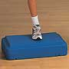
Clue Cards | 2 | TRAIN CD | -
Computer | 1 | On Site | -
Cones | 3 | Flag House | #W2023 ORG | 
Floor Tape | 1 | Flag House | #W592 | 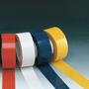
Food Group Signs | 4 | TRAIN CD | - | 
Food Labels | 1 | TRAIN CD | -
Food Models | 2 | Toys R Us | 2673982
Food Models | 2 | Toys R Us | 2673983
Food Models | 2 | Toys R Us | 2673984
Frisbees | 10 | Flag House | #W1678 | 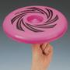
Heart Rate Monitor | 1 | Flag House | #W30852 | 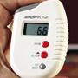
Medicine Ball 1 kg | 1 | Flag House | #W14894 | 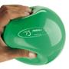
Medicine Ball 2 kg | 1 | Flag House | #W14902 | 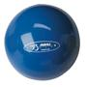
Metric Measuring Tape | 1 | Flag House | #W4030 | 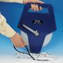
Paper Plates | 1 | Wal-Mart | #LP-158B | 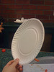
Placemats | * | Special Olympics | - | 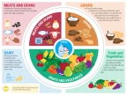
Printer | 1 | On Site | -
Scaled Measurement | 1 | Quick Medical | QM338
Sit and Reach Box | 1 | Flag House | #W1438 | 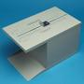
Soccer Balls | 2 | Flag House | #W10123 | 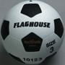
Sports Assessment Sheets | * | TRAIN CD | -
Station Signs | 1 | TRAIN CD | - | 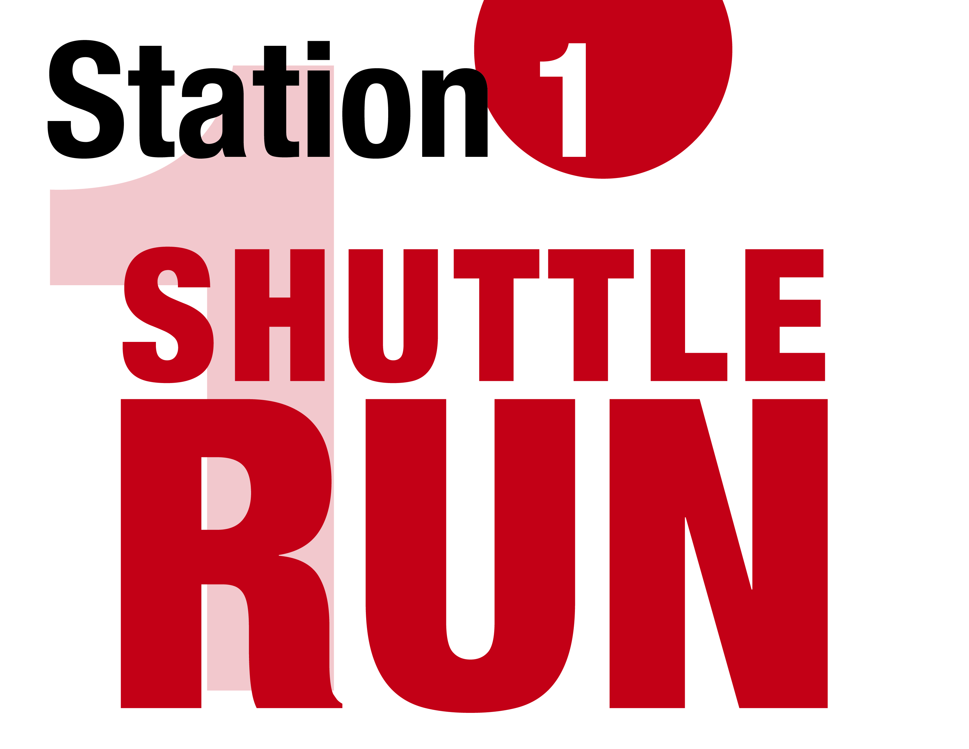
Stickers | 10 | Special Olympics | -
Stopwatches | 10 | Flag House | #W557 | 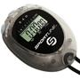
Tennis Balls (six count) | 1 | Flag House | #W12585 | 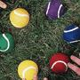
TRAIN@Home Booklets | * | Special Olympics | - | 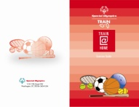
Water Bottles | * | Special Olympics | -
* One item needed per athlete.
Flag House- www.flaghouse.com
Toys R Us- www.toysrus.com
TRAIN CD- Provided with this program guide. These materials are also available on the TRAIN website.
Quick Medical- www.quickmedical.com
Wal-Mart- www.walmart.com
The following image is licensed under CC attribution: http://creativecommons.org/licenses/by/3.0/ : Paper plate by flickr user InfoMofo

Gym Floor Tape (2010). Flag House. http://www.flaghouse.com/Gym-Floor-Tape-Colored-2-x-60-yds-item-592+BLK
Medium – Weight 12” Orange Game Cone (2010). Flag House. http://www.flaghouse.com/Medium-Weight-12-Orange-Game-Cone-item-2023+ORG
SpinJammer ® 100 Flying Disc (2010). Flag House. http://www.flaghouse.com/SPINJAMMER-100-Flying-Disc-item-1678
FITBALL Softmeds ® – Green (2010). Flag House. http://www.flaghouse.com/FITBALL-Softmeds-Green-item-14894
FITBALL Softmeds ® – Blue (2010). Flag House. http://www.flaghouse.com/FITBALL-Softmeds-Blue-item-14902
Open-Reel Fiberglass Measuring Tape – 100’/30 m (2010). Flag House. http://www.flaghouse.com/Open-Reel-Fiberglass-Measuring-Tape-100-30m-item-4030
Active Series #3 Soccer Ball (2010). Flag House. http://www.flaghouse.com/Active-Series-Rubber-Soccer-Ball--3-item-10123
All Purpose Stopwatch (2010). Flag House. http://www.flaghouse.com/All-Purpose-Stopwatch-item-557
FlAGHOUSE Color Select Tennis Ball Set (2010). Flag House. http://www.flaghouse.com/FLAGHOUSE-Color-Select-Tennis-Ball-Set-item-12585

