Alpine Skiing

Special Olympics, Inc.

2013

Technical Delegates

Profiles At A Glance

Jeff BYRNE
New York, USA
byrne@orda.org

- Senior Vice President, New York Olympic Regional Development Authority
- Served as Technical Delegate f or the past 6 Special Olympics World Winter Games
- Active member, United States Ski and Snowboard Association (USSA)
- Active member, International Ski Federation (FIS)
- Member, Special Olympics Sport Resource Team – Alpine Skiing
- Former Winter Sports Director, Special Olympics, Inc.

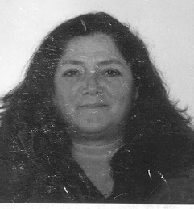

Patty FEDERER
Ontario, CANADA
Patty.Federer@simcoe.ca

- Member of alpine team 2010 Vancouver Olympics /Whistler
- FIS Alpine Level 3 official
- International Technical Official, 2009 Special Olympics World Winter Games, Boise, Idaho
- International Technical Official, 2005 Special Olympics World Winter Games, Nagano, Japan
- Member, Special Olympics Sport Resource Team – Alpine Skiing
- 2001 Ontario Female Coach of the Year

Cross Country Skiing

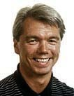
Steinar Pettersen
Oslo, NORWAY
steinar.b.pettersen@gmail.com

- Technical Delegate, 2009 Special Olympics World Winter Games in Boise, Idaho
- Technical Delegate, 2005 Special Olympics World Winter Games in Nagano, Japan
- Active member, Norweigan Ski Federation
- Ski instructor and coach
- Recognized as an International Ski Federation (FIS) technical delegate

Figure Skating

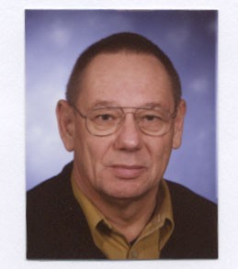

Helmut SIEBER
Wien, AUSTRIA
sieber.helmut@aon.at

- Certified figure skating judge – International Skating Union (ISU)
- Judge, 2010 Olympic Games, Vancouver
- Technical Delegate, 2009 Special Olympics World Winter Games, Boise, Idaho
- Technical Delegate, 2005 Special Olympics World Winter Games, Nagano, Japan
- Member, Special Olympics Inc. Sport Resource Team – Figure Skating

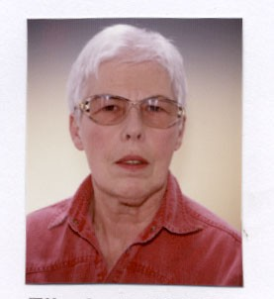

Elisabeth Sieber

Elisabeth SIEBER
Wien, AUSTRIA
sieber.elisabeth@aon.at

- Head Coach, Figure Skating, 2009 Special Olympics World Winter Games, Boise, Idaho
- Technical Delegate, 2005 Special Olympics World Winter Games, Nagano, Japan
- Member, Special Olympics Inc. Sport Resource Team – Figure Skating
- Former figure skating competitor
Floor Hockey

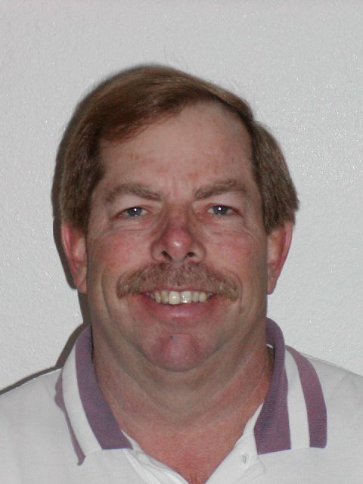
Jim DAY
California, USA
jmday@cox.net

- Member, SOI Sport Resource Team – Floor Hockey
- Technical Delegate, 2009 Special Olympics World Winter Games, Boise, Idaho
- Technical Delegate, 2005 Special Olympics World Winter Games, Nagano, Japan
- Technical Delegate, 2001 Special Olympics World Winter Games, Anchorage, Alaska
- Has been involved with Special Olympics for 29 ½ years

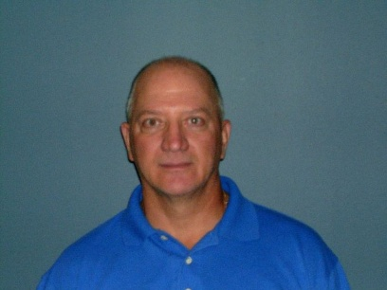
Dennis BORDIN
Ontario, CANADA
Dennis.bordin@gmail.com

- Assistant Technical Delegate, 2005 Special Olympics World Winter Games, Nagano, Japan
- Technical Official, 2009 Special Olympics World Winter Games, Boise, Idaho
- Technical Official, 2005 Special Olympics World Winter Games, Nagano, Japan
.
Short Track Speedskating

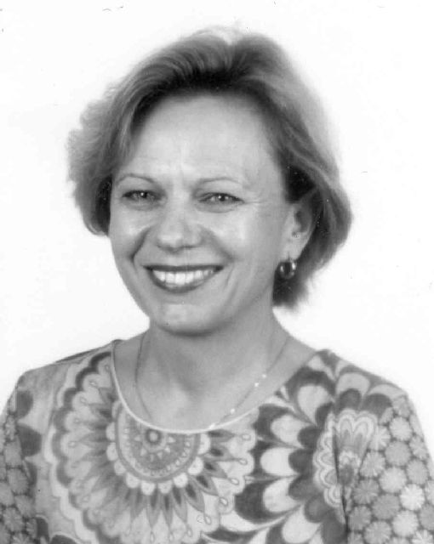
Urszula JANKOWSKA
Warsaw, POLAND
jula@wa.onet.pl

- Technical Delegate, 2009 Special Olympics World Winter Games, Boise, Idaho
- Technical Delegate, 2005 Special Olympics World Winter Games, Nagano
- Internationally certified referee, International Skating Union (ISU)
- Deputy Chef de Mission, Polish Olympic Committee
- Served as roller skating official for the 2003 Special Olympics World Summer Games, Dublin, Ireland
- Games Evaluation Team Member, 2001 Special Olympics World Winter Games, Anchorage, Alaska
- Long time volunteer with Special Olympics Poland
.

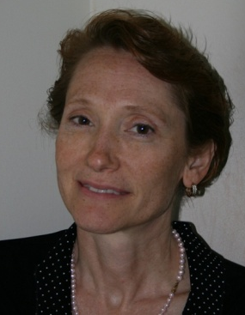

Cindi HART
Indiana, USA
CHart@Regenstrief.org

- Speedskating Coach, SO Team USA, 2009 Special Olympics World Winter Games, Boise, Idaho
- Cycling Head Coach, SO Team USA , 2007 Special Olympics World Summer Games, Shanghai, China
- 2006 National Council on Youth Sports (NCYS) Coach of the Year
- 2006 Honorary Survivor and spokes person for the Komen Race for the Cure, Indianapolis
- 2005 United States Olympic Committee (USOC) Volunteer Coach of the year
- 2005 United States Speedskating (USS) Volunteer Coach of the year
- 2005 Head Coach, Special Olympics Speedskating, SO Team USA (Nagano, Japan)
- 2003 United States Speedskating (USS) Finalist, Coach of the year
- 1996 Cycling Staff, Olympic Games, Atlanta
- Speedskating National medalist - 2002, 2004, 2005. 2 National Speedskating Records 2005
Snowboarding

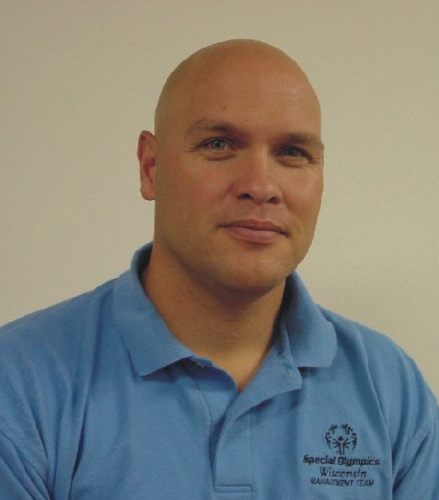
Bob WHITEHEAD
Wisconsin, USA
Bwhitehead@specialolympicswisconsin.org

- Member, Jury of Appeals, 2011 Special Olympics World Summer Games - Athens
- Member, Special Olympics Sports Rules Advisory Committee
- Member, Special Olympics Global Sport Resource Team – Snowboarding
- Vice President of Sports, Special Olympics Wisconsin
- Served as snowboarding technical delegate for Special Olympics World Games since the sport introduction in 2001

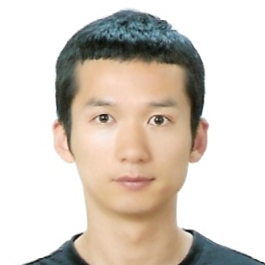

Won LEE
KOREA
- 2011 : Special Olympics Korea's Open Water Swimming coach for the 2011 World Summer Games in Athens
- 2009 : Special Olympics Korea's snowboarding head coach for the 2009 World Winter Games in Idaho
- 2008 : Entitled as technical director of Snowboarding by Special Olympics Korea
- 2006 : Participated in Special Olympics in Roller Skating & Snowboarding. Special Olympics Korea Coach
- 2000 : Snowboarding Instructor licensed by Korea Ski Association
- Snowboarding Gate Judge & Half-pipe Judge licensed by Korea Ski Association
- 1999 - 2005 :Chungbuk provincial snowboarding team member / athlete

Snowshoeing

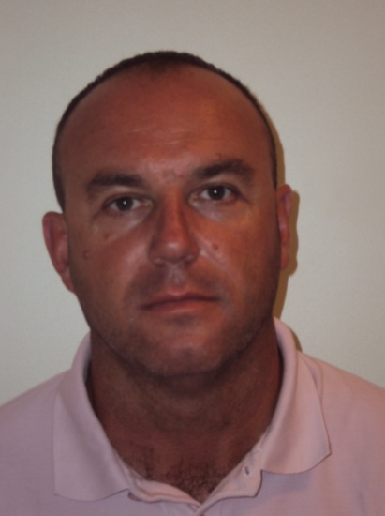

Silvester POLC
Mezica, SLOVENIA
Silvo.polc@gmail.com

- Sport Director Special Olympics Slovenia
- Head coach, Special Olympics Slovenia, 2009 Special Olympics World Winter Games
- Technical Delegate for snowshoeing competitions on National Winter Games since 2005
- Instructor/Group therapist in special institution for people with special needs
- Responsible Organizer of the first national snowshoeing seminar

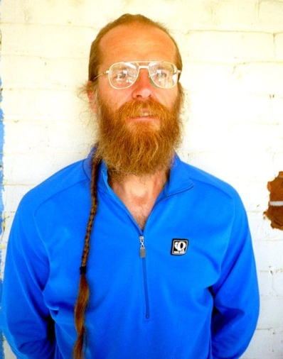
Tom Sobal
Colorado, USA
tsobal@hotmail.com

- Served as technical delegate since the sport introduction as a demonstration in 2001
- Known as one of America’s top snowshoe racers
- Member, Special Olympics Sport Resource Team, Snowshoeing

FloorBall (Demonstration Sport)

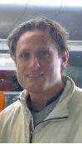
Steen HOUMAN
Haslev, DENMARK
psteen.houman@gmail.com

- Special Olympics Europe Eurasia Sport Advisor – Floorball
- 2011- Selected to the Danish House of Sports Development committees
- 2009- EliteSports consultant, TEAM Denmark project Roskilde municipality
- 2002-2009 Development consultant, Danish Floorball Federation
- Coached Floorball at the highest level women, and division 1 men

MOTOR ACTIVITIES TRAINING PROGRAM (MATP)

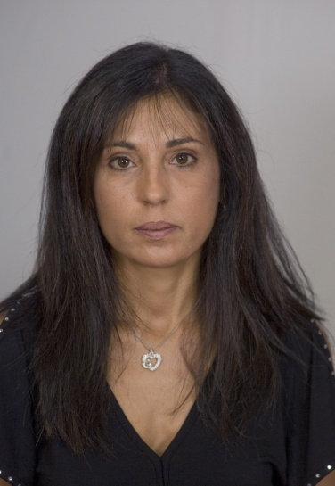
Eleni ROSSIDES, PH.D.
Nicosia, CYPRUS
eleni@rossides.com

- Technical Delegate, 2011 Special Olympics World Summer Games - Athens
- MATP Advisor, Special Olympics Europe Eurasia
- Member, Special Olympics Global Resource Team - MATP
- Have conducted MATP training seminars to coaches, therapists and teachers in Europe, Egypt, Syria, Saudi Arabia and Lebanon.
- Member, Special Olympics Cyprus Board of Directors

