Tennis Coaching Guide

Benefits of Tennis
Tennis is a popular sport played at all levels of skill and by players of all ages. It emphasizes values, such as fair play, sportsmanship and respect for fellow competitors. Tennis is not only fun to play, but it is a lifetime sport activity that is fun to practice and fun to learn.
You do not need to be an expert to begin coaching, only enthusiasm and a commitment to learn the basics. With guidance, anyone with time and interest can become a successful Special Olympics tennis coach and help athletes with intellectual disabilities join the worldwide tennis family.

Tennis Events Offered
Tennis competition is based on athlete ability level.
- For athletes with lower ability and limited court mobility, competition is offered in individual skills competition.
- For athletes transitioning from individual skills to traditional match play, competition is offered in Short Court Tennis.
- For athletes with higher physical ability, competition is offered in traditional match play (singles and doubles) and Unified Sports® doubles.
- For the actual tennis events offered, see the Official Special Olympics Sports Rules for Tennis.

Acknowledgements
Special Olympics wishes to thank the professionals, volunteers, coaches and athletes who helped in the production of the Tennis Coaching Guide. They have helped fulfill the mission of Special Olympics: to provide year-round sports training and athletic competition in a variety of Olympic-type sports for people 8 years of age and older with intellectual disabilities, giving them continuing opportunities to develop physical fitness, demonstrate courage, experience joy and participate in a sharing of gifts, skills and friendship with their families, other Special Olympics athletes and the community.
Special Olympics welcomes your ideas and comments for future revisions of this guide. We apologize if, for any reason, an acknowledgement has been inadvertently omitted.

Contributing Authors
Anne Krupp, Professional Tennis Registry
Kirstie Marx, Special Olympics North Carolina, Coach
Ryan Murphy, Special Olympics, Inc.
Geoff Norton, Professional Tennis Registry
Steven Parker
Glenn Roswal, Special Olympics, Inc. – Tennis Technical Delegate

Special Thanks To the Following for All of Your Help and Support
Jack Barker, Special Olympics South Carolina, Volunteer
Sandra Boyette, Special Olympics North Carolina, Coach
Floyd Croxton, Special Olympics, Inc., Athlete
Dave Lenox, Special Olympics, Inc.
Sue Maner, Special Olympics South Carolina
Kellie Walls, Special Olympics, Inc.
Paul Whichard, Special Olympics, Inc.
Professional Tennis Registry
Dan Santorum, CEO and Executive Director
Julie Jilly, Vice President of Operations
Special Olympics North America
Dennis Van der Meer, Founder and President of Professional Tennis Registry
Pat Van der Meer
Van der Meer Tennis Center, Use of facilities for filming of video clips
Video Clips Starring Athletes from Special Olympics North Carolina
Rob Williams
John Gray
Video Clips Starring Athletes from Special Olympics South Carolina
Sue Taylor
Steven Cole
Suzanne Darveau
Peggy Cole
Betty Strathern, Coach

Tennis Coaching Guide

Planning a Tennis Training & Competition Season

Table of Contents
Setting Goals 6
Essential Components of Planning a Tennis Training Session 7
Principles of Effective Training Sessions 8
Coaches’ Top 10 Principles of Effective Planning 9
Tips for Conducting Safe Training Sessions 10
Tennis Practice Competitions 11
Selecting Team Members 11
Creating Meaningful Involvement in Unified Sports 12
Special Olympics Tennis Rating System Sheet 14
Tennis Equipment 19

Setting Goals
Realistic, yet challenging goals for each athlete are important to the motivation of the athlete both at training and during competition. Goals establish and drive the action of both training and competition plans. Sport confidence in athletes helps make participation fun and is critical to the athlete's motivation. Please see the Principles of Coaching Section for additional information and exercises on goal setting.

Elements of Setting Goals
Setting goals is a joint effort with the athlete and coach. The main features of goal setting include the following.

Structured into short-term, intermediate and long-term
Stepping stones to success
Must be accepted by the athlete
Vary in difficulty - easily attainable to challenging
Must be measurable

Short-Term Objective
Learning tennis in a fun environment.

Long-Term Goal
The athlete will acquire basic tennis skills, appropriate social behavior and functional knowledge of the rules necessary to participate successfully in tennis competitions.

Benefits
Increases athlete's level of physical fitness.
Teaches self-discipline
Teaches the athlete sports skills that are essential to a variety of other activities
Provides the athlete with a means for self-expression and social interaction

Essential Components of Planning a Tennis Training Session
Each training session needs to contain the same essential elements. The amount of time spent on each element will depend on the goal of the training session, the time of season the session is in and the amount of time available for a particular session. The following elements need to be included in an athlete’s daily training program. Please refer to the noted sections in each area for more in-depth information and guidance on these topics.
- Warm-ups
- Previously taught skills
- New skills
- Competition experience
- Feedback on performance

The final step in planning a training session is designing what the athlete is actually going to do. Remember when creating a training session using the key components of a training session, the progression through the session allows for a gradual build-up of physical activity.
- Easy to difficult
- Slow to fast
- Known to unknown
- General to specific
- Start to finish

Principles of Effective Training Sessions

Keep all athletes active | Athletes need to be active listeners.
Create clear, concise goals | Learning improves when athletes know what is expected of them.
Give clear, concise instructions | Demonstrate – increase accuracy of instruction.
Record progress | Chart progress together with your athlete.
Give positive feedback | Emphasize and reward things the athlete is doing well.
Provide variety | Vary exercises – prevent boredom.
Encourage enjoyment | Training and competition is fun. Help keep it this way for you and your athletes.
Create progressions | Learning is increased when information progresses from:  - Known to unknown – discovering new things successfully  - Simple to complex – seeing that “I can do it”  - General to specific – “this is why I am working so hard”
Plan maximum use of resources | Use what you have and improvise for equipment that you do not have – think creatively.
Allow for individual differences | Different athletes, different learning rates, different capacities.

Coaches’ Top 10 Principles of Effective Planning
- Assign assistant coaches their roles and responsibilities in accordance to your training plan.
- When possible, have all equipment and courts prepared before the athletes arrive. Walk the court area and remove unsafe objects.
- Provide positive reinforcement and “make it fun.”
- Safety: Each athlete should (1) find their own personal space, (2) hug rackets against chest when listening to instructions from the coach, and (3) hit only on a cue from the coach.
- Alter the plan according to weather and the facility in order to accommodate the needs of the athletes.
- Change activities before the athlete becomes bored or loses interest, keeping all players involved.
- Devote the end of the practice to a fun, group activity that can incorporate challenge and fun and provide athletes with something to look forward to at the end of each practice. This will also assist with assessing the players’ progress.
- Coaches should maintain a command of the court through voice, direction or delegation.
- Summarize the session, and announce arrangements for the next session.
- Recognize your volunteers.

Tips for Conducting Safe Training Sessions
Though the risks can be few, coaches have a responsibility to ensure that athletes know, understand and appreciate the risks of tennis. The safety and well-being of athletes are the coaches’ primary concerns. Tennis is not a dangerous sport, but accidents do occur when coaches forget to take safety precautions. It is the head coach’s responsibility to minimize the occurrence of injuries by providing safe conditions.

- Establish clear rules for behavior at your first practice and enforce them. Some examples are:
❑ Keep your hands to yourself.
❑ Listen to the coach.
❑ When you hear the whistle, “Stop, Look, and Listen.”
❑ Ask the coach before you leave the field of play.
- When the weather is poor, have a plan to immediately remove athletes from inclement weather.
- Make sure athletes bring water to every practice, especially in hotter climates.
- Check your first-aid kit; restock supplies as necessary.
- Train all athletes and coaches on emergency procedures.
- Choose a safe field area. Do not practice in areas with rocks or holes that could cause injury. Simply telling players to avoid obstacles is not enough.
- Walk the court area and remove unsafe objects. Be particularly vigilant when you are playing in cluttered indoor gyms. Remove anything that a player might run in to.
- Review your first-aid and emergency procedures. Have someone who is trained in first aid and CPR on or very near to the field during practice and games.
- Warm up and stretch properly at the beginning of each practice to prevent muscle injuries.

Tennis Practice Competitions
The more athletes compete, the better they get. Part of the strategic plan for Special Olympics tennis is to drive more sport development at the local levels. Competition motivates athletes, coaches and the entire sport management team. Expand or add to your schedule as many competition opportunities as possible. Here are a few suggestions:
- Schedule matches with nearby local Special Olympics Programs.
- Ask the local high school if your athletes can practice with the team and play practice matches.
- Join the local community tennis club and/or associations.
- Host weekly matches.
- Create a tennis league or club in your community.
- Incorporate competition components at the end of every training session.

Selecting Team Members
The key to the successful development of a traditional Special Olympics or Unified Sports team is the proper selection of team members.

Ability Grouping for Unified Sports Doubles or Doubles
Unified Sports teams work best when all team members have similar sports skills. Partners with abilities that are far superior to other teammates will either control competition or accommodate others by not competing to their potential. In both situations, the goals of interaction and teamwork are diminished and a true competitive experience is not achieved. For example, in tennis, an 8-year-old should not be competing against or with a 30-year-old athlete.

Age Grouping
All team members should be closely matched in age.
- Within 3-5 years of age for athletes 21 years of age and under
- Within 10-15 years for athletes 22 years of age and over

Creating Meaningful Involvement in Unified Sports
Unified Sports embraces the philosophy and principles of Special Olympics. When selecting your Unified Sports team you want to achieve meaningful involvement throughout your sport season. Unified Spots teams are organized to provide meaningful involvement for all athletes and partners. Every teammate should play a role and have the opportunity to contribute to the team. Meaningful involvement also refers to the quality of interaction and competition within a Unified Sports team. Achieving meaningful involvement by all teammates on the team ensures a positive and rewarding experience for everyone.

Indicators of Meaningful Involvement
- Teammates compete without causing undue risk of injury to themselves or others.
- Teammates compete according to the rules of competition.
- Teammates have the ability and opportunity to contribute to the performance of the team.
- Teammates understand how to blend their skills with those of other athletes, resulting in improved performance by athletes with lesser abilities.

Meaningful Involvement Is Not Achieved When Team Members
- Have superior sports skills in comparison to their fellow team members.
- Act as on-field coaches, rather than teammates.
- Control most aspects of the competition during critical periods of the game.
- Do not train or practice regularly, and only show up on the day of competition.
- Lower their level of ability dramatically, so they do not hurt others or control the entire game.

Special Olympics Tennis Rating System
The Special Olympics Tennis Rating System is a systematic method to determine the skill ability of an athlete. The system is designed to assist coaches in determining an athlete’s ability level in tennis before they begin participation. The rating is also used in preliminary divisioning of athletes for competition. Coaches will find the rating system a useful tool for several reasons:
- Helps the coach and athlete determine in which events he/she will compete.
- Establishes the baseline training areas of the athlete.
- Assists coaches in grouping athletes of similar ability into training teams.
- Measures the athlete’s progression.
- Helps determine the athlete’s daily training schedule.

Before administering the rating system, coaches need to perform the following analysis while observing the athlete:
- Become familiar with each of the tennis skills.
- Have an accurate visual picture of each skill.
- Have previously observed a skilled performer executing the skill.
In preparing for Special Olympics tennis competitions, it is recommended that the coach complete the Special Olympics Tennis Rating System Sheet and submit it to the Tournament Committee with registration materials. The Tournament Committee should then conduct a separate on-court rating during a preliminary divisioning round. The Special Olympics Tennis Rating System is modeled after the USTA National Tennis Rating Program. It is a subjective evaluation and it is recommended that raters be familiar with the USTA National Tennis Rating Program or other systems of evaluating tennis playing ability. To use the Special Olympics Tennis Rating System, the rater should observe the athlete during simulated play situations. This could involve:
- Athletes hitting with raters, or
- Athletes playing mini-matches with other athletes, or
- Athletes practicing with other athletes.
When administering the Special Olympics Tennis Rating System, coaches should strive to observe the best performance by the athlete. Always begin by explaining the skill you would like to observe and demonstrate the skill when possible.
The Special Olympics Tennis Rating System categorizes playing ability into eight levels. Athlete skill is rated on seven basic tennis skills: forehand, backhand, movement, first serve, second serve, return of serve and volleys. The rater should observe the athlete and indicate playing ability by rating the athlete from one to eight on each of the basic skills. The rating form task analyzes each basic skill into levels of ability. A total score is determined for all seven skills and an average rating calculated (for example, 2.5 or 3.8). The overall rating is then used to division the athlete with other athletes of equal playing ability.

Special Olympics Tennis Rating System Sheet
Athlete's Name:_______________________ |  |  |  |  |  | Coach’s Rating:________________
Delegation:__________________________ |  |  |  |  |  | Date of Coach’s Rating:___/___/___
Rater's Name:________________________ |  |  |  |  |  | Final Rating:____________________
 |  |  |  |  |  | Date of Final Rating:____/____/_____
Level 1 |  | (athlete at this level should complete the ISC Skills Testing)
Player just starting to play tennis (1)
Appropriate competition would be ISC (1)
 |  |  |  |  |  |  |  |  | Score:
A. Forehand |  | (one choice --- should be the most representative of the athlete's skill level)
Has difficulty hitting FH shots (2)
Hits inconsistent weak FH shots (3)
Hits FH shots with little directional control (4)
Sustains a short rally using FH and BH shots (5)
Sustains a rally with directional control (6)
Sustains a rally with consistency and depth (7)
Sustains an extended rally (8)
 |  |  |  |  |  |  |  |  | Score:
B. Backhand |  | (one choice --- should be the most representative of the athlete's skill level)
Has difficulty hitting BH shots (2)
Hits inconsistent weak BH shots (3)
Hits BH shots with little directional control (4)
Has directional control of BH shots, but shots lack depth (5)
Returns difficult shots defensively (6)
Has difficulty with high and hard shots (7)
Controls FH and BH shots with direction, pace and depth (8)
 |  |  |  |  |  |  |  |  | Score:
C. Movement |  | (one choice --- should be the most representative of the athlete's skill level)
Stationary position; does not move to ball to hit shots (2)
Moves only 1-2 steps toward ball to hit shots (3)
Moves toward ball; but court coverage is poor (4)
Movement allows sufficient court coverage of most shots (5)
Exceptional court coverage (6)
Exceptional court coverage and hits defensive lobs and inconsistent overheads (7)
Exceptional court coverage and hits offensive lobs and consistent overheads (8)
 |  |  |  |  |  |  |  |  | Score:

D. First Serve |  | (one choice --- should be the most representative of the athlete's skill level)
1st serve is weak (2)
1st serve faults are common (3)
Hits 1st serves in at a slower pace (4)
Hits 1st serves with pace (6)
Hits 1st serves with pace and control (8)
 |  |  |  |  |  |  |  |  |  |  |  |  |  | Score:
E. Second Serve |  |  |  | (one choice --- should be the most representative of the athlete's skill level)
Double faults are common (2)
Pushes 2nd serves (4)
Hits 2nd serves with control (6)
Hits 2nd serves with control and depth (7)
Hits 2nd serves with spin, control and depth (8)
 |  |  |  |  |  |  |  |  |  |  |  |  |  | Score:
F. Return of Serve |  | (one choice --- should be the most representative of the athlete's skill level)
Has difficulty returning serve (2)
Returns serve occasionally (3)
Returns 2nd serve consistently (4)
Returns some 1st serves; returns 2nd serves consistently (5)
Returns 1st and 2nd serves consistently (6)
Aggressive return of 2nd serve; weak return of 1st serve (7)
Aggressive return of 1st and 2nd serves (8)
 |  |  |  |  |  |  |  |  |  |  |  |  |  | Score:
G. Volleys |  | (one choice --- should be the most representative of the athlete's skill level)
Avoids net (2)
Does not hit volleys; avoids net (3)
Hits inconsistent volleys; avoids net (4)
Hits consistent FH volleys; BH volley is inconsistent (5)
Hits aggressive FH volleys; hits defensive BH volleys (6)
Hits aggressive FH and BH volleys (8)
 |  |  |  |  |  |  |  |  |  |  |  |  |  |  |  | Score:
 |  |  |  |  |  |  |  |  |  |  |  |  |  |  |  | Total Score:
Divide Total Score by 7 to determine Overall Rating
(round off to the nearest tenth I.e. 4.97 = 5.0 or 3.53 = 3.5)
 |  |  |  |  |  |  |  |  |  |  |  |  |  |  | Overall Rating:
Individual Skills Competition Assessment
For athletes of lower skill ability, coaches should use the tennis individual skills competition to rate playing ability. The individual skills competition consists of seven basic tennis skills: forehand volley, backhand volley, forehand groundstroke, backhand groundstroke, serve (deuce court), serve (advantage court) and alternating groundstrokes with movement. The individual skills competition can be used as both an assessment tool for evaluating lower skilled players and a competition format for athletes not ready for traditional match play competition.

Tennis Attire
Appropriate tennis attire is required for all competitors. As coach, discuss the types of tennis clothing that is acceptable and not acceptable for training and competition. Discuss the importance of wearing properly fitted clothing, along with the advantages and disadvantages of certain types of clothing worn during training and competitions. For example, long pants or jeans and blue jean shorts are not proper tennis attire for any event. Inappropriate clothing can hinder a player’s performance and be a safety hazard. Shirts and shorts should be loose fitting to allow for free movement. Take athletes to high school or college training or competitions and point out the attire being worn. You should set the example by wearing appropriate attire to training and competitions. Do not reward athletes who do not come properly dressed to train and/or compete.
Shirts |  | Shorts
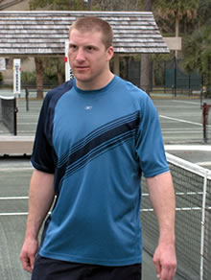 |  | 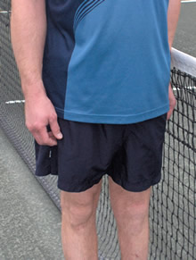
T-shirts are the most comfortable and practical tops for practice and training. Traditionally, tennis competitions are played in collared shirts that are tucked into shorts. |  | During practice, athletes should wear loose fitting gym shorts or conventional tennis shorts. During competition, a traditional tennis short or skirt is preferable. Wearing proper tennis attire for competition can build an athlete’s excitement for the competition.

Shoes and Socks |  | Warm-ups
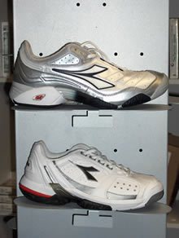 |  | 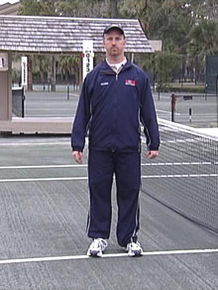
Shoes should be traditional tennis shoes with proper ankle, arch and heel support. Running shoes are inappropriate for tennis because they do not support the ankle. Be cautious of black-soled shoes as they mark the courts. Socks should be of an absorbent cloth to prevent blisters. If an athlete is prone to blisters, two pairs of socks can be worn. |  | Cotton materials are good for tennis players. They should be worn before and after practice and competitions. Athletes should not wear sweat suits during play unless it is an extremely cold day.

Other items that might help a player's performance:

Tennis Female Attire
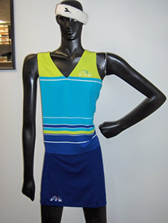
- Hats or sunglasses keep sun and wind out of the eyes.
- Sweatbands and headbands keep moisture off the racket hand and out of the eyes.
- Sunscreen can keep athletes from being overexposed to the sun.

Tennis Equipment
The sport of tennis requires the type of equipment noted below. It is important for athletes to be able to recognize and understand how equipment impacts their performance. Have athletes name each piece of equipment as you demonstrate its use. Coaches and athletes should work together to select the proper equipment for each athlete.

Tennis Rackets
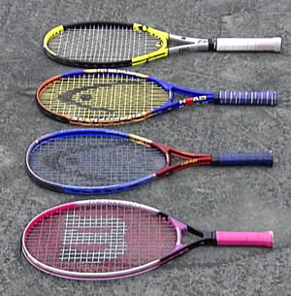
Tennis rackets have changed dramatically in the past few years. Space-age materials have made rackets lightweight and very durable. Athletes should select a racket that "feels good" and is not too heavy or too light. Grip size is important for good technique. Have the athlete grip the racket comfortably. There should not be more than a finger width between the base of the thumb and the fingertips. If the fingers are touching the base of the hand, the grip is too small. Younger athletes may benefit from junior-sized rackets which are lighter and shorter. Broken strings and unraveling grips should be replaced as soon as possible. Coaches should teach athletes proper care of their rackets and all equipment.
Coaches will find the following rackets sizes: A 23-inch racket is recommended for athletes 8-10 years of age, a 25- or 26-inch racket is recommended for athletes 10-12 years of age and a 27-inch racket is recommended for adults. These are general guidelines as strength, size of athlete and grip size are factors in determining the ideal racket to use.

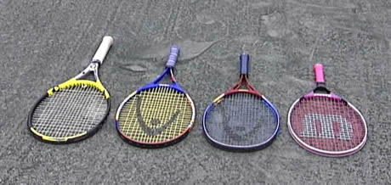

Tennis Balls
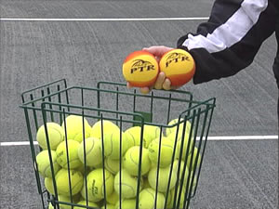
An abundance of tennis balls is important for a successful practice. Ideally, each court would have a separate hopper (teaching cart) of balls. Practice balls can be obtained from tennis clubs (ask a teaching professional for his/her old tennis balls), high schools and colleges.

Other Teaching Aids
- Notebook for recording attendance, telephone numbers, student comments and progress reports, and medical needs for special athletes.
- Targets of any shape, size and color can help athletes aim for a specific spot (examples are a pyramid of tennis balls, cones, hula hoops, chalk circles and rope).
- SpeedBalls (foam balls).
- Balloons to practice hand-eye coordination drills.
- Ball machine for athletes to practice a variety of skills.
- Ball containers as targets in games.
- Radio or music box to increase attention and enjoyment.

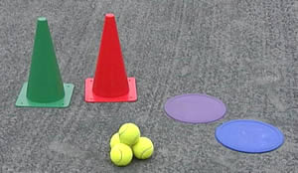 | 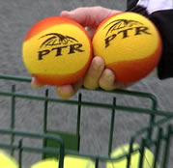

Tennis Coaching Guide

Teaching Tennis Skills

Table of Contents
Warm-Up 23
Cool-Down 24
Stretching 24
Lower Body Stretches 27
Upper Body Stretches 30
Hand-Eye Coordination 34
Assessing the Player's Readiness 34
Teaching the Skill 34
Drills for Eye-Hand Coordination 34
Racket Control 35
Assessing Player Readiness 35
Groundstrokes 40
Forehand 40
Teaching the Skill 40
Coaching Tips 41
Faults & Fixes –Forehand 42
Backhand 43
Teaching the Skill 43
Coaching Tips 45
Faults & Fixes –Backhand 46
Drills for Forehand and Backhand Groundstokes 47
Volley 50
Assessing Player Readiness 50
Teaching the Skill 50
Drills for Volleys 51
Serve 53
Assessing Player Readiness 53
Teaching the Skill 53
Drills for Serves 54
Return of Serve 58
Assessing Player Readiness 58
Teaching the Skill 58
Hitting with Movement 59
Assessing Player Readiness 59
Drills for Teaching Movement 59
Teaching Strategies 61
Drills for Practicing Strategy 61
Singles Strategy 61
Doubles and Unified Sports® Doubles 61
Doubles Drills 62
Sample Eight-Week Lesson Plan 63
Short Court Tennis 65
Understanding the Game 66
Modifications and Adaptations 66
Mental Preparation and Training 66
Cross-Training in Tennis 66
Home Training Program 66

Warm-Up
A warm-up period should be the first part of every training session or preparation for competition. When possible, with a group of four or more, form a circle on the court and have players face each other with plenty of space for free movement. Warm-ups are much more likely to be effective in a group setting. Players make each other accountable, and communication in the circle builds team spirit. The warm-up starts slowly and gradually involves all muscles and body parts. In addition to preparing the athlete mentally, the warm-up also has several physiological benefits.
The importance of a warm-up prior to exercise cannot be overstated. This is true even for a sport like tennis. Warming up raises the body temperature and prepares the muscles, nervous system, tendons, ligaments and the cardiovascular system for upcoming stretches and exercises. The chances of injury are greatly reduced by increasing muscle elasticity.

Warming Up:
- Raises body temperature;
- Increases metabolic rate;
- Increases heart and respiratory rate; and
- Prepares the muscles and nervous system for exercise.
The warm-up should include tennis-specific activities, such as short sprints, footwork skills and short court drills. Footwork warm-up may include side-to-side skipping in a similar way to the way one moves horizontally across the court during a game. Follow the leader in a group – be creative with stepping and skipping. Warm-ups consist of active motion leading up to more vigorous motion to elevate heart, respiratory and metabolic rates. The warm-up period should last 5-10 minutes and precedes training or competition. The warm-up is a part of a balanced training program to include the following basic sequence and components.

Activity | Purpose | Time (minimum)
Warm-Up | Heat muscles | 5 minutes
Stretching | Increase range of movement | 10 minutes
Event-Specific Drills | Coordination preparation for training/competition | 40 minutes
Cool-Down | Reduces heat in muscles | 5 minutes

Stretching
Stretching is one of the most critical parts of the warm-up and an athlete’s performance. A more flexible muscle is a stronger and healthier muscle. A stronger and healthier muscle responds better to exercise and activities and helps prevent injury. Please refer to the Stretching section for more in-depth information.
Flexibility is a major element in an athlete’s optimal performance in both training and competition. Stretching follows tennis-specific activities, such as short sprints, footwork skills and short court drills.

Event-Specific Drills
Drills are activities designed to teach tennis skills. Progressions of learning start at a low ability level, advance to an intermediate level and, finally, reach a high ability level. Each athlete should be encouraged to advance to his or her highest possible ability level. Drills can be combined with the warm-up and lead into specific skill development.
Skills are taught and reinforced through repetition of a small segment of the skill to be performed. Many times, the actions are exaggerated in order to strengthen the muscles that perform the skill. Each coaching session should take the athlete through the entire progression so that he/she is exposed to all of the skills that make up an event.

Cool-Down
The cool-down is as important as the warm-up, however it is sometimes ignored. It may prevent cramps, soreness and other problems for Special Olympics athletes. The cool-down gradually reduces the body temperature and heart rate and speeds the recovery process before the next training session or competitive experience. After playing, practicality or time constraints may prevent systematized cool-down exercises. ‘Walking it off’ is much better than sitting and stiffening up. The cool-down is also a good time for the coach and athlete to talk about the training session or competition. Note that cool-down is also a good time to do additional stretching. Muscles are warm and receptive to stretching movements which promote increased flexibility.

Stretching
Stretching prevents injury by increasing the range of motion for joints and muscles. Athletes should be monitored closely during stretching exercises to make sure they are doing them properly. Instruction should involve demonstration by the coach.
Stretches should be done without bouncing and free from pain. Athletes should begin with an easy stretch to the point of tension and hold this position for a vocal count of 10 led by the coach. Each stretch should be repeated on both sides of the body. Athletes should be reminded to breathe while stretching by inhaling when leaning into the stretch, then exhaling. Once the stretching point is reached, the athlete should keep inhaling and exhaling while holding the stretch.
The stretches listed below are guidelines; coaches should tailor the stretching routine to suit the group of athletes that they are working with. All the major muscle groups should be stretched, with emphasis on the shoulders, trunk and legs. In a ten minute period, do about three stretching exercises from the lower body group and three stretching exercises from the upper body group, alternating activities on successive workout days. On training days when drills dominate the activity, all these stretches may be used in a single workout session.

Lower Body
- prone quad stretch
- hamstring stretch
- seated straddle stretch
- groin stretch
- hip roll
- calf stretch
- ankle stretch

Upper Body
- shoulder stretch
- tricep stretch
- chest stretch
- side stretch
- side arm stretch
- arm circles
- forearm and wrist stretch
- neck stretch
Some athletes, like those with Down syndrome, may have low muscle tone that makes them appear more flexible. Be careful these athletes do not stretch beyond a normal, safe range. Several stretches are dangerous to perform for all athletes, and should never be part of a safe stretching program. These unsafe stretches include the following:
- Neck Backward Bending
- Trunk Backward Bending
- Spinal Roll
Stretching is effective only if the stretch is performed accurately. Athletes need to focus on correct body positioning and alignment. Take the calf stretch, for example. Many athletes do not keep the feet pointing forward, in the direction that they are running.
Incorrect | Correct

Another common fault in stretching is bending the back in an attempt to get a better stretch from the hips. An example is a simple sitting forward leg stretch.

Incorrect | Correct

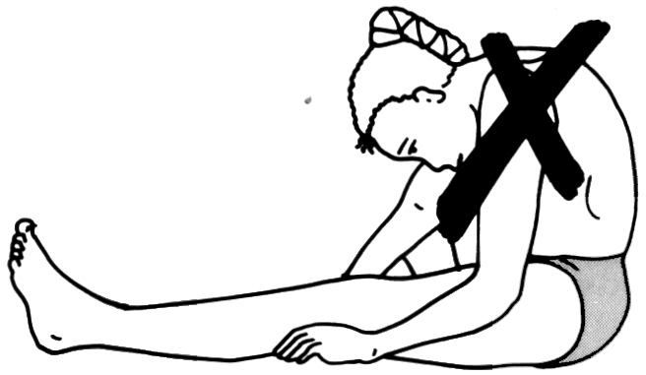
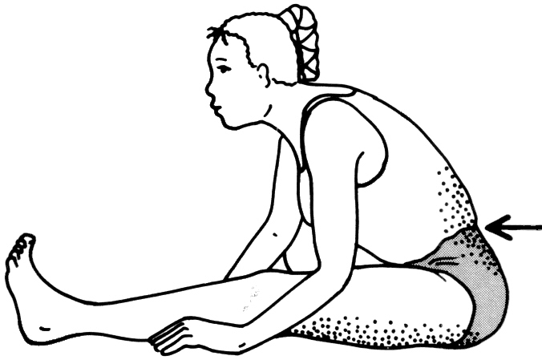

In this guide, we will focus on basic stretches for major muscle groups. Along the way we will also point out some common faults, illustrate corrections and identify stretches that are more event-specific. We will start with the lower body and work toward the upper body.

Coaching Tips
- Practices should have a low player/coach ratio.
- It is important that coaches and assistants make sure that stretches are being done effectively and are not harmful to the athlete. To do this may require direct, individual physical assistance, particularly with lower-ability players.
- Some stretches require a good sense of balance. If balance is a problem, use stretches that can be done while in a sitting or prone position.
- Current elite tennis training models promote using dynamic (moving) stretching activities. These activities are appropriate for Special Olympics tennis players, but coaches should be careful when using with athletes who have poor balance.
- Coaches should attend to athletes doing the exercises improperly, as well as provide personal attention and reinforcement to those doing them effectively.
- Use stretching as a “teachable moment” with your athletes. Explain the importance of each stretching exercise and which muscle group is being stretched. Later, ask the athletes why each stretching exercise is important.

Lower Body Stretches

Prone Quad Stretch | Standing Quad Stretch
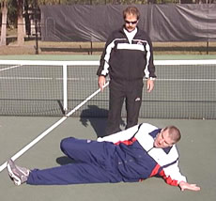 | 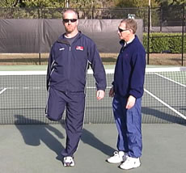
- Lie on side  - Bend knee toward buttock while grasping foot or ankle with hand  - Pull foot directly toward buttock  - Do not twist knee  - Keep hip on ground | - Stand with foot flat on ground  - Bend knee towards buttock while grasping ankle with hand  - Pull foot directly toward buttock  - Do not twist knee  - Stretch can be done standing alone or balancing with partner or fence/ wall

Hamstring Stretch | Seated Straddle Stretch
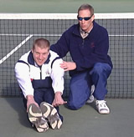 | 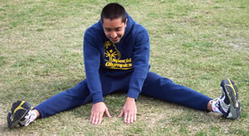
- Legs straight out and together  - Legs are not locked  - Bend at hips, reach toward ankles  - As flexibility increases, reach for feet  - Push out through the heels, forcing toes to the sky | - Legs straddled, bend at hips  - Reach out toward the middle  - Keep back straight

Butterfly Groin Stretch | Standing Groin Stretch
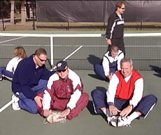 | 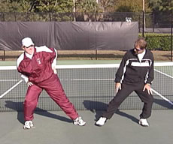
- Sit with bottoms of feet touching  - Hold feet/ankles  - Bend forward from hips  - Ensure that the athlete is pulling up in his/her lower back | - Stand with feet flat on the ground  - Lean body to one side, bending knee slightly  - Keep opposite leg straight  - Repeat with other leg
Calf Stretch |  | Calf Stretch w/Bent Knee
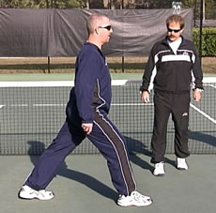 |  | 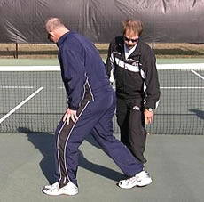
- Bend forward leg slightly  - Bend ankle of back leg  - Athlete may also stand facing a wall/fence |  | - Bend both knees to ease strain

Hip Rolls | Ankle Rolls
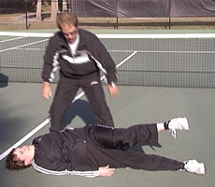 | 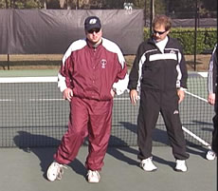
- Lie on back, arms at sides with shoulders down  - Roll to right side, keeping right leg straight while flexing the knee of the left leg  - Bring left leg across the body, exhale and hold the stretch  - Lie flat on back, inhale and repeat on opposite side  - Work on keeping the hips on the ground to get the full stretch through the buttocks | - Stand or lay on back  - Raise foot off ground  - Point toes and move in a figure-eight motion  - Repeat with other foot

Upper Body Stretches
Chest Stretch | Arm Circles
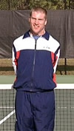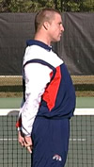 | 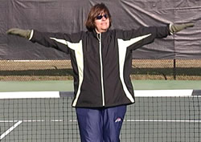
- Clasp hands behind back  - Palms facing in  - Push hands towards sky | - Swing arms forward in large circles  - Repeat going forward and backward
Triceps Stretch |  | Shoulder Stretch
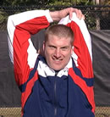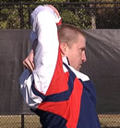 |  | 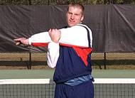
- Raise both arms over head  - Bend right arm, bring hand to back  - Grasp elbow of bent arm and pull gently toward the middle of the back  - Repeat with other arm |  | - Take elbow into hand  - Pull to opposite shoulder  - Arm may be straight or bent  - Repeat with other arm

Side Stretch
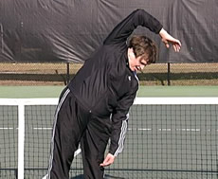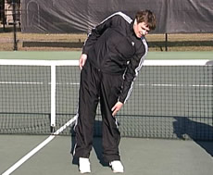
- Bend to one side with or without hand over head
- Feel stretch in side
- Repeat on other side

Forearm and Wrist Stretch
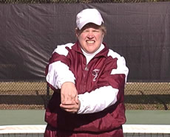 | 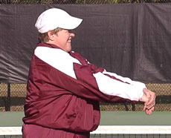
- Extend arm with wrist flexed down with assistance of opposite hand until a stretch is felt on top of the forearm
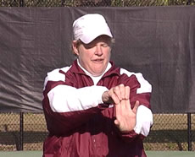 | 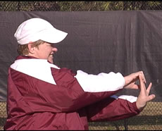
- Reverse wrist so hand points up and a stretch is felt on bottom of forearm | - Make sure you stretch both directions with both hands

Neck Stretch
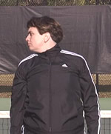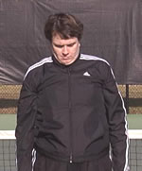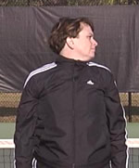
- Roll the neck from shoulder to shoulder with chin touching body at all times
- Do not perform full circles as they may hyperextend the neck
- Tell athlete to roll neck to right, center and left. Never have the athlete roll neck backwards.

Stretching - Quick Reference Guidelines

Start Relaxed
Do not begin until athletes are relaxed and muscles are warm.
Be Systematic
Start at the top of the body and work toward the legs or alternate between upper and lower body.
Progress from General to Specific
Start general, then move into event-specific exercises.
Easy Stretching before Developmental Stretches
Athletes should perform slow, progressive stretches, without bouncing or bobbing.
Use Variety
Make it fun. Use different exercises to work the same muscles.
Breathe Naturally
Athletes should stay calm and relaxed and not hold their breath.
Allow for Individual Differences
Athletes start and progress at different levels.
Stretch Regularly
Always include time for warm-up and cool-down. Encourage athletes to stretch at home as well.

Hand-Eye Coordination
Hand-eye coordination is the foundation for striking the tennis ball. Without developing this skill, the athlete will become frustrated by not making contact with the ball.

Assessing the Player's Readiness
The beginning player typically has difficulty recognizing the spatial relationship between the racket and the ball. Beginning athletes may occasionally swing and miss the ball or hit it off center. The intermediate player has learned the relationship between the distance between racket and oncoming ball. Intermediate players have become proficient at making contact with the ball near the center of the racket.

Safety Concerns
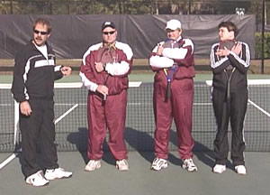
Each athlete should establish his/her own personal space and should remain in that space at all times. A good safe position for each athlete is to hug the racket to his/her chest. In a group setting, ask athletes to place rackets against the fence when not in use. During group activity, athletes should identify their own space by holding their outstretched rackets so they do not touch other athletes. There should be enough space so rackets do not touch one another.

Teaching the Skill
- Utilize different size “balls” such as balloons, foam balls, transition balls (low compression) and SpeedBalls, as well as traditional tennis balls. SpeedBalls are specially designed soft balls available through the Professional Tennis Registry (PTR), the Official Training Partner of Special Olympics Tennis.
- To develop hand-eye coordination, the beginning player should begin by practicing with a tennis ball and his/her hand (no racket).
- Encourage athletes to watch the ball.
- Encourage athletes to keep their heads still when making contact.

Drills for Eye-Hand Coordination
Hand Bounce Drill
The athlete performs the following progression:
- Gently toss a foam ball from left hand to right hand.
- Place the ball in the left hand, bounce on the ground and catch with the right hand.
- Find a partner and gently toss the ball toward the partner with the ball bouncing before it is caught.
- Gently bounce a large foam ball tennis ball with the palm of the racket hand, eventually progressing to the transition ball and then the traditional tennis ball (“hit gently”).
- Attempt to keep the ball bouncing in a controlled fashion for 15 seconds (“stay in your place”).
The coach can utilize targets and lines on the court (hoops, poly spots, etc.) to make the hand bounce drill more advanced.

Cup/Cone Catches
- Athlete holds a large cup or cone in his/her dominant hand and catches a tossed ball in the cup or cone and tosses back to his/her partner (“watch the ball”).

Key Words
- "Watch the ball."
- "Hit gently.”
- “Stay in your place.”

Racket Control
Controlling the racket is an important building block to learning tennis skills. Coaches should consider the size of the racket and racket grip for their players.

Assessing Player Readiness
Beginners have difficulty in controlling their rackets in relation to the approaching ball. A beginner often swats at the ball instead of controlling the racket. Intermediate players have developed control of the racket to a level where they rarely miss contacting the ball. Strokes are relatively smooth and in control.

Teaching the Skill
Although tennis players hold the racket (grip) in many ways to execute different strokes, Special Olympics recommends using the eastern grip for athletes beginning to play tennis. View the video for further information on teaching correct grips.
- Use of foam balls is recommended when athletes are beginning the skill progressions.
- Athletes should be taught the traditional forehand "shake hands with the racket" grip, where the athlete:
- Stands with feet slightly apart with the racket in the non-racket hand.
- Places the palm of the racket hand against the strings of the racket and slide the racket hand down the racket until the hand reaches the grip.
- Wraps fingers around the handle comfortably and "shakes hands.”
- Using this grip, have athletes practice drills that increase their ability to control the racket head.

Eastern Backhand Grip
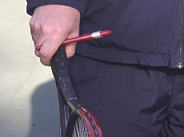 | 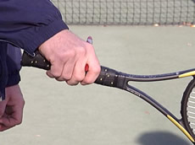

Forehand Grip
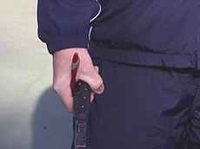 | 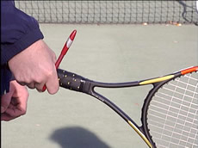
Semi-Western Grip | Serve Grip
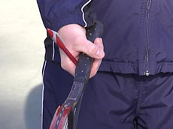 | 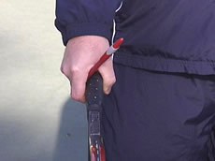

Western Grip
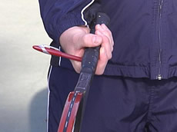 | 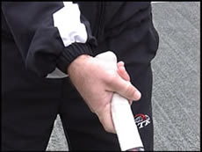
NOTE: Within the video clips and the still photos; the pen is used as a reference to emphasize the position of the hand, insuring that the pointer finger knuckle is resting on the correct bevel for the specified grip.

Drills for Racket Handling

Racket Balance
- Athletes hold the racket head on the ground with one hand on the grip, then let go of the racket, but catch it before it falls.
- Drills can be made more difficult by having athletes touch a body part (head, shoulder, knee, etc.) before catching the racket.

Walk the Dog (Follow the Lines)
- With the racket touching the ground, the athlete rolls the ball on the ground with the racket by following the lines around the court, trying to maintain control of the ball.
- Like walking a dog on a leash, the athlete attempts to keep the ball beside the racket.

Pass the Ball
- With a partner, athletes pass the ball from the middle of their strings to the middle of their partner’s strings without using their hands.
- The ball is passed gently “gentle” back and forth in a down-the-line exercise (can be used as a team game).
- With their rackets, athletes line up on the baseline and place a ball on the racket strings. Athletes walk or run to the net trying to keep the ball on the strings. If the ball drops, athletes pick up the ball and continue.

Ups
- Using the forehand grip “fingernails up,” the athlete holds the racket at waist level.
- Athlete drops a ball onto the strings with the non-racket hand. "Hit the ball in the middle of the strings.”
- Athlete performs as many "ups" as possible in 30 seconds.

Downs
- Using the forehand grip “fingernails down,” the athlete holds the racket at waist level.
- Athlete gently bounces "gentle” the ball downward with the strings of the racket.
- Athlete performs as many "downs" as possible in 30 seconds.
- As players advance, have them hit “edgies,” dribbling the ball using the side of their racket.

Forehand Bumps
- Remind athletes to bump up, rather than down at the target.
- Partners stand about 5-10 feet away from each other with a target in between them and bump “bump” the ball with a gentle forehand motion, trying to hit the target.
- Emphasis is on control in this drill “control the ball.”

Backhand Bumps
- Partners stand about 5-10 feet away from each other with a target in between them and bump the ball with a gentle backhand motion, trying to hit the target.
- Remind athletes to bump up, rather than down at target.
- Emphasis is on control in this drill “control the ball.”

Toss-Bump-Catch Game
- Partners stand 10-15 feet apart. One partner gently tosses a ball so the partner can bump it back.
- Athletes complete 10 successful bumps and catches, then switch roles

Racket Rolls
- Athlete rolls the ball around the racket in a clockwise direction.
- Direction is reversed.
Emphasis on control and improvement should be implemented whether or not this is a game or progression. Intermediate players can play the drills in the form of relay races. The drills can be played for time with the number of successful attempts being recorded.

Key Words
- "Shake hands with the racket"
- "Shake hands"
- "Watch the ball"
- "Gentle”
- “Fingernails up” and “Fingernails down”
- "Hit the ball in the middle of the strings"
- “Control the ball"
- “Bump”

Coaching Tips
- Emphasize control and gentle bumps of the ball. This is a difficult concept for some Special Olympics athletes.
- Instruct athletes to watch the strings and try to contact the ball in the center of the racket (sweet spot).
- It is important that the athlete is using the appropriate racket size, length and weight.
- With lower ability levels it may be useful to use partners as coaches.
- Have athletes practice swinging the racket while balancing a penny on the edge of the racket. This teaches athletes to swing under control and to keep the racket at a right angle to the ground.

Groundstrokes
The groundstrokes are the basic rallying strokes in tennis. A groundstroke is any ball that is played off the bounce and is usually hit while standing close to the baseline. Coaches should incorporate mobility drills in the practice plan as footwork is an essential part of good stroke production. It is recommended to begin with static teaching and progression drills involving footwork.

Note: It is recommended that a coach focus on one stroke within each lesson plan.

Forehand

Teaching the Skill
Coaches are encouraged to use demonstration throughout each progression. When teaching a skill there are four basic components: grip, ready position, stroke and follow-through. It is best to begin new athletes in a short court format (playing at the service line area or inside the service box). This will allow for greater success and less intimidation than on a full court.

Forehand Grip
- Have athletes learn the traditional forehand "shake hands with the racket" grip (eastern forehand grip), where the athlete:
- Stands with the feet slightly apart and holds the racket with the non-racket hand.
- Places the palm of the racket hand against the strings of the racket and slides the racket hand down the racket until the hand reaches the grip.
- Wraps the fingers around the handle comfortably and "shake hands."
- The grip should not be held too tight ("not too tight, not too loose").

Ready Position
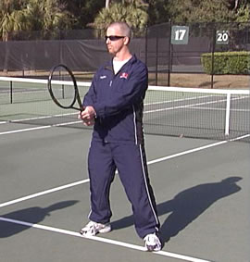
- Athletes face forward with knees slightly flexed, feet shoulder width apart and heels up off the ground.
- The racket should be held comfortably at waist level.
- Use the key words "eyes on the ball" and "relax and be ready."

Forehand Stroke
- Athletes turn shoulders and hips to face sideways to the net (racket is in a volley position with the strings facing the net). Use the key words, "stand sideways with your racket back and look like a surfer" or "turn your shoulders."
- Athletes take the racket back and down (pointing at the back fence and down toward the court surface). The shape of the swing, when put together as one motion, will be a “C” loop.
- Before initiating the swing, the athlete takes a few adjusting steps towards the ball.
- Demonstrate the contact point position (freeze this position and emphasize that this is where the ball is contacted).
- The stroke continues with a balanced follow-through with the racket high and out in front (be careful not to exaggerate the follow-through as athletes will put it all together when actually striking a ball), racket pointing up and toward the net (like “shaking hands with a giant”).

Follow-through
- The swing is completed with a follow-through that finishes with the racket pointing to the opposite side of the net "finish the stroke," “point the racket at your opponent, "turn, step, hit."
- The follow-through should be high above the head, swinging from low to high “swing low to high.”

Key Words
- "Shake hands"
- "Not too tight, not too loose"
- "Eyes on the ball"
- "Relax and be ready"
- "Stand sideways with your racket back and look like a surfer"
- "Turn your shoulders"
- "Finish the stroke"
- “Shaking hands with a giant”
- “Point the racket at your opponent"
- “Swing low to high”
- "Turn, step, hit"

Coaching Tips
- The contact point is the most important part of the forehand. Emphasize contact at the front foot with a perpendicular racket head.
- Begin with the contact point and follow-through for the first 50 balls the athlete hits. Working from the contact point will provide the best control once the stroke begins to take shape. Add the backswing once the athlete has demonstrated a balanced contact and follow-through position.
- Encourage the athlete to hit the forehand gently and stress that tennis is a game of control. Hitting the ball over the fence is not a home run in tennis!

Faults & Fixes –Forehand

Error | Correction
Incorrect grip | Mark the racquet handle for a visual reminder.
Improper point of contact or misjudges the ball | Ask the athlete (without racket in hand) to catch the ball at the proper contact position. Do this with a ball tossed directly to the athlete, progressing to a ball tossed a slight distance from the player, requiring more footwork.
Wrist break on backswing (too large a backswing) | With the player turned and the racket head up, have the athlete place the palm of the non-hitting hand on the strings (side of the racket facing the player) and complete the stroke from this position. Placing the hand on the strings will prevent the racket from taking a big backswing.
Racquet rolls on follow-through | Ask the athlete to roll the racket over the shoulder. The resulting higher follow-through will improve the stroke.
Slicing the ball (chopping) | The slice is a quality stroke to develop. Ask the player to reach for a long follow-through. The shape is a banana on its back.  Adding topspin for this player is done easier with an old racket and asking the athlete to touch the ground before contacting the ball.
Wristy at point of contact | Have the athlete choke up on the grip. The athlete will feel the grip on their arm.
Hits off back foot | Have the player stomp the front foot in the proper position. This will allow them to hear and feel the step.
Not enough shoulder turn on backswing | Have the player turn completely to the side before feeding a ball.
Steps in with wrong foot | Use chalk to trace the feet in the proper footwork sequence.

Backhand
The backhand is hit on the opposite side of the body as the forehand. It is perfectly acceptable to hit the backhand with two hands. A two-handed backhand helps the athlete control the backswing. Remember that some athletes may have difficulty with this and may want to hit two forehands. It is important to explore the backhand but be prepared to work with two forehands, if needed.

Teaching the Skill

Grip
Athletes perform the backhand grip using the following tips (these tips are used for the dominant hand for the two-handed player).
- Hold the racket with the forehand grip.
- Turn the hand until the first knuckle of the index finger is on top of the grip (1/4 turn).
- Another way to find this grip is to put the racket under the left armpit and grab the racket as if unsheathing a sword.
For a two-handed grip, the dominant hand should be in the continental grip (same as the serve) and the non-dominant hand is placed in an eastern forehand grip. For a right-handed player, the non-dominant hand is a forehand grip for a left-handed player and this is reversed in teaching a left-handed dominant player.

2-Handed Backhand Grip
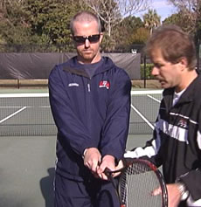 | 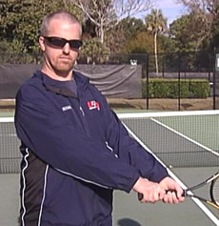

Eastern Backhand Grip
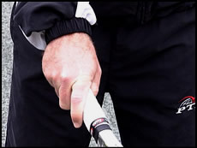 | 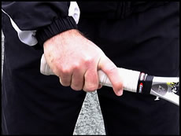

Continental Backhand Grip
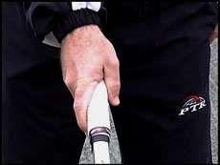 | 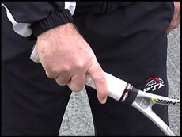

Lefty Continental Backhand Grip
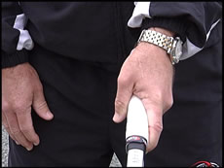 | 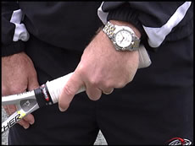

Ready Position
The athlete faces forward with knees slightly flexed and feet shoulder width apart. The racket should be held comfortably at waist level, weight leaning forward on the toes. Athletes should be reminded to keep their eyes on the ball ("eyes on the ball") and be relaxed and ready ("relax and be ready").

Backhand Stroke
In the backhand stroke the shoulders and hips are turned so the athlete is standing sideways (racket is in a volley position with the strings facing the net). Use the key words, "stand sideways with your racket back and look like a surfer” or "turn your shoulders." The athlete should use the forehand grip in the ready position. It will be necessary to practice the grip change to the backhand. The coach should be observant, making sure this is happening. Use the key words “change your grip.”
NOTE: See the forehand and backhand grip video.
- The racket is taken back and down (pointing at the back fence and down toward the court surface), with a continuous swing. This allows the student to have a loop “C” shaped swing.
- A few adjusting steps are taken towards the ball.
- The coach should demonstrate the contact point position. Freeze at the progression and emphasize that this is where the ball is contacted. Use the key words "hit off your front foot"; "turn, step, hit."
Keep in mind that a one-handed backhand contact point will be out in front of the forward foot, whereas a two-handed backhand contact point will be near the front foot position. Use the key words "hit off your front foot” or “turn, step, hit.”

Follow-through
The stroke continues with a balanced follow-through with the racket high and out in front (one-handed). Be careful not to exaggerate the follow-through, as the athlete will put it all together when actually striking a ball. The racket will finish pointing up and toward the net like “shaking hands with a giant.” The two-handed follow-through will wrap around the opposite shoulder in a full swing pattern.

Key Words
- "Eyes on the ball"
- "Relax and be ready"
- "Stand sideways with your racket back and look like a surfer"
- "Turn your shoulders"
- “Change your grip”
- "Hit off your front foot”
- “Shaking hands with a giant”

Coaching Tips
- Many Special Olympics tennis players like to hit two forehands, a left-handed and a right-handed one. It is important that coaches have athletes learn the backhand stroke.
- The backhand requires more strength and control and it is quite acceptable to use two hands.

Faults & Fixes –Backhand
Error | Correction
Incorrect grip | Mark the racquet handle for a visual reminder.
Improper point of contact or misjudges the ball | Toss the athlete a few balls and ask him/her to freeze the racket at the point of contact.
Wrist break on backswing (one-handed backhand) | Have the athlete use the non-hitting palm and place it on the strings or on the racket. This will prevent a large backswing or a break in the wrist.
Racquet rolls on follow-through | Have the athlete stop at the point of contact and then add the follow-through.
Slicing the ball | Have the athlete touch the racquet to the ground before swinging forward. Drop a ball and have the player brush up the back of it to simulate the feeling of topspin.
Hits off back foot | Feed balls from behind the player. Allow the ball to bounce so the athlete can step and hit. The player should start in a side to the net position.
Excessive hip and shoulder rotation (one-handed backhand) | Ask athletes to imagine they are a baseball umpire making a safe sign motion.

Drills for Forehand and Backhand Groundstrokes
The following drills are presented in a progression from basic to advanced skill level. Some Special Olympics athletes will be able to move quickly through the progression and others may stay at certain levels for a prolonged time. Be flexible and monitor athlete success in these drills. Be cautious of using athletes as training partners, as delivering the ball to each other may be difficult, hampering their success.

Shadow Drills
These drills are done without a ball and are an excellent way to monitor proper stroke production. Examples of common game formats include the following.
- Follow the leader: athlete or coach leads the group and coach checks technique.
- Simon Says: athletes follow the leader’s instructions only when he says "Simon Says, hit a forehand."
- Freeze: the coach calls out a command for forehand or backhand and then calls out "freeze." Check for proper grips and technique at this point.

Self-Drop Forehand and Backhand Drills
These drills can be also be modified to become a relay race. Each team has 20 balls to hit over the net. Start with a drop hit groundstroke. If the ball lands within the court the athlete repeats the skill; with a maximum of 3 balls per athlete and then switch. If a mistake is made, the next person in line takes a turn. The first team to hit all the balls is the winner. An adaptation is to have the coach stand to the side of the athlete and drop the ball.
The athlete should:
- Hold the racket with the proper grip and stand sideways to the net, with the racket pointing toward the back fence.
- Drop a ball from the non-racket hand, in front and to the side of the body.
- Step toward the ball with the front foot and stroke the ball over the net and into the court.
- Record the number of successful drop hits and monitor improvement as the season progresses.

Alley Rally
- The athlete stands on the singles sideline facing a coach or partner on the doubles sideline 3 feet away.
- Place one tennis ball on the singles sideline and another one on the doubles sideline.
- Have athletes stand just behind the targets and, using the proper grip, gently bump the ball the partner’s target.
- Partners rally back and forth.
- Monitor how many times the target is hit.
- To increase or decrease difficulty, use smaller or larger targets.

Tossed Ball Drills
- A partner or coach tosses tennis balls to the forehand and backhand sides.
- Athletes contact the ball after the first bounce and bump it over the net and into the court.
- Use targets, count consecutive hits and keep score between players. Be creative and keep athletes interested.
- Have a line of athletes “shadow” the hitter. The hitter stands at the service line and athletes follow the movements of the hitter.

Basket Feeding Drills
- Coach feeds balls from a hopper to students.
- Students form one or two lines on one side of court (depending on the number of athletes).
- The coach gently hits balls to the forehand or backhand side.
- Athletes hit a designated number of shots and return to the back of the line.
- Coaches can make the feeds easy or more difficult.
- Keep score, aim for targets or have "fielders" who try to catch hit balls. If a ball is caught by a fielder, they become a hitter.
- Have an athlete on the same side of the net as the coach and play out the point.
- Be creative and create different combinations of forehands and backhands.
- Let athletes help create games.

Ground Stroke Rallying with a Partner or Coach
- As players progress, they can rally the ball consecutively over the net.
- Start at the service line and complete 10 consecutive hits. After successfully completing 10 hits, athletes move to the mid-court area and then to the baseline area.
- Rally using a variety of balls and targets. For example: forehand to forehand cross courts; backhand to backhand cross courts; down the line shots; or all shots must land beyond the service line.
- Rally a number of consecutive hits. Set realistic goals!

Ground Stroke Points
- Athletes play points (no serve) using ground strokes.
- Play a game to a designated number of points (first to win 6 points, 11 points or 21 points) depending upon skill level.
- Have athletes play as a team. If they win a point the athlete stays in the game; if they lose the point a teammate takes their place.

Around the World (requires rallying skills)
- This is a large group drill with a minimum of 4 athletes per side.
- Two lines of athletes stand at opposite ends of the court.
- A drop hit starts the point and the rally begins.
- Each player hits one ball and runs to the end of the line at the opposite side of the court. The next player in line keeps the rally going.
- When a ball is missed, the player is out.
- The last two players play out the point, but do not have to run to the other side of the net.
- For lower skills players, the coach feeds most of the balls.
- Variation: Play as a team. After the team returns a ball, each player returns to the end of their respective line. The team with the last remaining player wins.

Around the World: Forgot My Racket Variation
- Athletes play Around the World (above), but all team members share one tennis racket. This drill requires athletes to pay attention to the game.

King (or Queen) of the Court; (three to six players) if more players use two courts
The king or queen returns the serve or a drop-hit serve from a member of the group. The players in the group alternate points until someone wins two points in a row and becomes the king or queen. The new king or queen replaces the old king or queen on his/her side of the court. This game is immensely popular and can be played for a long time.
Volley
A volley is a stroke that is played before the ball bounces. It is normally hit when the player is inside the service line.

Assessing Player Readiness
Beginners are sometimes more successful with hitting the volley because it does not require the eye-hand coordination of playing the ball off the bounce. Common mistakes made by beginning and intermediate players are taking too big a swing or swinging down on the ball. Players should be reminded to focus on control rather than speed and power.

Teaching the Skill

Grip
The same grips used for the forehand and backhand are used for the volley. The eastern forehand and the eastern backhand should be used for both beginning and intermediate players. The volley grip for an advanced player is positioned between the forehand and the backhand groundstroke grips. The same grip is used for both the forehand and backhand volley.

Ready Position
The ready position is the same as for the forehand and backhand.

Volley Stroke
The volley progression includes the following steps:
- Begin with the athlete blocking the ball with his/her hand (hand up in the air as if giving a “high five”).
- Add the racket, with the athlete holding the racket near the throat, so that the fingers are behind the strings, making a “big hand.”
- Move the hand down the grip, eventually achieving an eastern grip position.
- The same progression is followed for the backhand, with a “big thumb” instead of a “big hand.”
- Athletes turn sideways to the approaching ball.
- There is no backswing in the volley stroke.
- The ball should be met in front of the body with a short motion.
- The wrist is kept firm.
Once the athlete masters basic racket work, the athlete can learn to step into the stroke. Athletes should work on properly executing the volley while maintaining balance.

Follow-through
- The racket head should remain above the wrist throughout the volley.
- There is a short follow-through, finishing in the ready position for the next volley.
- Key words are "racket head up" and "keep the racket above the wrist.”

Drills for Volleys

Volley Tap
- Athlete stands in the ready position and the coach tosses or hits a ball to him/her.
- Athlete steps in with a crossover step and bumps the ball with outstretched hand, simulating a forehand or backhand volley.
- Next, athletes catch the ball using proper footwork and toss it back to the partner. This drill could be repeated several times.

Cup/Cone Catches
- Using a large cup/ cone, have athletes catch a tossed ball.
- This emphasizes that athletes do not need to swing to hit a volley.

Volley Toss
- Coach or partner tosses a ball and players hit a forehand or backhand volley.
- Using proper volleying technique, players hit volleys to a partner.
- Count how many tosses and catches can be completed before a miss.

Volley Feeding Drills
Coach feeds balls from a hopper to a single-file line of players. Players hit a specified number of balls and return to the end of the line.
Criss-Cross Volley Drill
- Two lines of players start at the corner of the service box.
- Feed a forehand volley to the first person in the left line and then feed a backhand volley to the right line. Continue to feed volleys, alternating between the two lines.
- After volleying a designated number of balls, the player returns to the end of other line.

Alternating forehand and backhand volleys
- Coach feeds four balls, alternating forehand and backhand volleys.
Corner Volley Drill
- Two lines are formed at the corners of the service boxes.
- Feed a ball so the athlete must move to hit the volley.
- After hitting the volley, the athlete touches the corner of the service box with the racket and runs back to the net to play another volley.
- As the player is running to touch the corner, a ball is fed to player on the backhand corner side.
Approach and Volley (Forehand, Backhand and Same Side)
- Player hits an approach shot off a ball fed to the mid-court area.
- The second shot is a deep volley from a ball hit at the service line.
- The coach feeds several volleys, stressing forward movement between hits.

Rallying Drills
As players become more advanced, they can practice the volley in a rallying situation with a coach or partner.

Quick Volleys
- Two players stand at opposite service lines and volley with control back and forth to each other.
- Keep track of consecutive hits.

One Up - One Back
- Athlete volleys to a coach or partner who is rallying from the baseline.
- Aim for specific targets (example: forehand cross court rallies).
- Keep score or devise a game to make this situation competitive.

Key Words
- "Racket head up"
- "Keep the racket above the wrist”

Coaching Tips
- Emphasize that athletes should not swing at the volley, but instead "punch" or "catch" the ball. Have athletes hit and stop their racket to avoid swinging. Ask them often if they can see their racket. If they lose sight of the racket they have taken it too far back.
- The racket head should be above the wrist throughout the volley.
- Volleys are simple to teach and many Special Olympics tennis players are relatively successful with the stroke. But it is often difficult to make the transition from the baseline to the net in a game situation. Many athletes may only use the volley when in the net position in doubles. Even though they may not use it in their matches, encourage your athletes to practice their volleys.
- To be balanced properly after hitting the volley, it is necessary to use the correct footwork. On the forehand volley, step across with the left front foot and conversely on the backhand step across with the right front foot.
- When feeding balls, make sure balls are fed at different heights and speeds so athletes learn that not all balls approach at shoulder height. Initially, athletes should be given verbal cues such as forehand and/or backhand to help them react more quickly.

Serve
The serve is the stroke that starts each point. Players have two attempts to hit the serve into the service box. The serve must be hit diagonally across the court to be a "good" serve.

Assessing Player Readiness
The serve can be the hardest part of tennis for beginners. Because the serve is a complex motion, the following modifications can be used to allow athletes to put the ball in play.
- Use a self-drop forehand stroke to put the ball into the appropriate serve box. Note that International Tennis Federation (ITF) rules require the serve to be hit from a tossed ball that does not touch the ground.
- Allow the server to start play by hitting to either the left or right service box.
- Allow the athlete to have three attempts on the serve.
- Play balls that are returnable but not within the boundaries (just missed serves).
- Throw the ball into the appropriate box.
- Stand at the service line or between the service line and the baseline.
NOTE: These modifications are not appropriate for competition but they will allow athletes to put the ball into play and play a game of tennis.
- Intermediate players are more likely to complete a successful serve, but are still prone to double faults. They may struggle with placing the toss consistently and therefore have trouble serving consistently. The following modifications are appropriate for intermediate players.
- Hit an underhand serve (a forehand drop-hit with the ball hit in mid-air).
- Use an abbreviated service motion:
- 1/2 serve is started with the racket in the "back scratch position."
- 3/4 serve is started with the racket behind the body and pointing toward the ground.

Teaching the Skill

Grip
Beginners will normally resort to a "pancake" or "frying pan" grip. This grip is usually between the forehand grip and up to a half turn to the right of the forehand grip. The proper grip is a “continental grip” (between the forehand and the backhand), which is the same grip as the volley. Many athletes will struggle with this grip because it requires sufficient racket head speed to be successful. The grip is a matter of comfort and coaches will have to make adaptations as necessary. It is recommended that coaches begin teaching the serve using a short court format.

Ready Position
- Stand sideways to the net, behind the baseline, with feet comfortably (shoulder width) apart.
- Hold the racket in front of the body, with arms relaxed and a tennis ball in the non-racket hand.
- Shoulders and hips should be aligned diagonally to aim toward the appropriate service box.
- Key words are "relax," "where are you aiming?" and "where are your feet pointed?"

Serve Stroke
Ball Toss (for the right handed player)
- The left hand tosses (key word “lift and let go” or “place the ball on the second shelf”) the ball slightly in front and to the right of the server, high enough so the ball can be contacted with an extended racket.
- Stress that the ball is placed, not thrown.
- Coaches can help the player by standing to the side of the athlete and tossing the ball until they get the idea of both arms working together. Assist athletes with a “down together, up together” arm motion.

Serving Motion
- It is best to have athletes start with the racket in the backscratch position resting on the shoulder (this will represent half of the full backswing). The athlete tosses and hits the ball from this position (emphasize the contact point).
- The full backswing can be added when athletes are able to get the contact point and toss to meet.
- To assist with teaching the full stroke, have the racket and arm in the “down together, up together” motion. The racket will swing across the top of the player’s feet, then toward the back fence and eventually reach the shoulder position.
- The racket reaches up to contact the ball with an extended arm.

Follow Through
- After contact, the weight comes forward into the court and the racket finishes across the body.
Backscratch Position | Lefty Backscratch Position
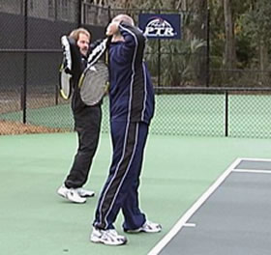 | 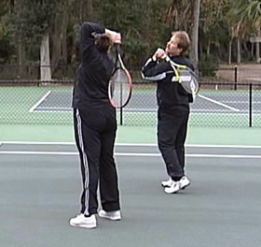

Drills for Serves

Throwing Drill
- Throw a ball over the net and into the appropriate service box.
- Using an overhead throwing motion, throw a designated number of balls into the appropriate service box.
- Athletes struggling to get the ball over the net can start at the service line and gradually work to the point of throwing from behind the baseline.
- Use various balls, such as footballs, foam balls, etc.

Toss Drill
- Stand in the ready position with a ball in the non-racket hand.
- Hold the ball with the fingertips and point the palm upward.
- With a straight arm, raise the ball upward and let go of the ball when the hand reaches its highest point.
- Allow the ball to drop back into the left hand while the right arm is outstretched.
- Count the number of successful tosses and catches.
- Variations:
- Put the racket on the ground to the right side of the server to act as a target.
- Toss the ball as if to serve, but allow the ball to drop to ground.
- Count the number of times the ball hits the racket strings.
- Toss the ball while standing alongside the fence. The ball should not touch the fence. This drill helps show the athlete if the toss is going straight up.

Arm Reach Drill
- Place the palm of the racket hand against the back of the neck (back scratch position). Make sure the elbow is bent and pointing upwards.
- Extend the arm from behind the neck until it is straight and slightly in front of the shoulder.
- Now try the drill with a racket in the hand “extend the arm."

Catch a Ball from the Service Toss
- Start with a ball in the tossing hand and the serving arm in the back scratch position with palm against the back of the neck “scratch your back."
- Toss the ball and extend the arm as in the Arm Reach Drill and catch the ball with the arm fully extended.

Serving practice
- With a bucket of balls at the baseline, practice serves from the deuce court and the ad court. Two athletes can practice serves at the same time.
- Aim for targets or count the consecutive number of successful serves.
- Play in teams and race to see which team can get 10 serves in the correct box first. When an athlete misses a serve, they go to end of line.

Key Words
- "Relax"
- "Where are you aiming?"
- "Where are your feet pointed?"
- “lift and let go”
- “Place the ball on the second shelf”
- “Down together, up together”
- "Scratch your back"
- "Hit only a good toss”
- "Extend the arm"

Coaching Tips
- Explain the boundaries and rules for the serve: (a) athletes must stand behind the baseline; (b) two attempts are allowed; (c) ball must be served diagonally; and (d) serve is replayed if it hits the net and lands in the correct service box (let).
- Stress the proper tactical priorities: (a) get the ball in play and (b) use a progression of placement, depth control, spin and pace.
- Start athletes near the service line when they are learning to serve. As they progress, move back and eventually serve from behind the baseline.
- Modify the serve by using a forehand stroke or a 1/2 or 3/4 serve. It is more fun to begin playing points rather than have a game of double faults.
- Provide athletes with corrections to missed serves.
- For corrections, consider that a ball in the net indicates the toss is probably too far in front or too low and the athlete is hitting down, rather than reaching up.
- A serve that goes long indicates the ball toss is too far behind the body. More extension of the hitting arm is needed.
- Stress the importance of an accurate toss. If the ball is not in the right place, it is difficult to control the serve. When there is a bad toss, encourage athletes to catch the toss and try again. There is no penalty for a bad toss ("hit only a good toss”).
- Athletes should practice the serve in every practice. A point cannot be played without putting the serve in the correct service box.

Faults & Fixes –Serve
Error | Correction
Back foot slides up to the front foot before contact | Place an object on the foot or drag the back foot through the movement, as opposed to taking a step.
Front foot slides forward before contact (foot fault) | Place an object (ball/ racket) in front of the front foot.
Improper stance | Imagine aiming a bow and arrow or use chalk to trace the feet of players.
Changes grip in backswing | Place colored dots on the grip for reference, where different colors represent grips for different strokes. Each dot should indicate where the index knuckle is placed.
Uses improper grip | Place colored dots on the grip for reference, where different colors represent grips for different strokes. Each dot should indicate where the index knuckle is placed.
Backswing is too short | Have athlete swing across the top of their shoe laces.
Backswing is too quick | Have the athlete serve in slow motion, increasing speed as they near completion.
Knees dip before toss | Bend the knees first, then complete the serve.
Straight arm serve | Serve by swinging across the shoe laces, then touch the back before contacting the ball and completing the motion.
Lack of continuity (hitch in swing) | Ask the player to toss the ball only two inches in height, making the player hurry through the stroke to achieve a contact point. The coach can also make the toss for the player.
Athlete drops elbow | Exaggerate a high toss, emphasizing reaching up to contact the ball.
Scissor toss | Place the tossing arm over the racket arm.
Quick toss | Perform a slow motion serve or place the tossing hand under the racket, allowing the racket to begin the stroke before the toss has been made.
Weight shifts too soon | Have the athlete stand with a tennis ball under each foot (under toes, not heels), which starts the service motion from a leaning back position.
Improper point of contact | Coaches often do not teach the ball toss and rarely teach how to toss. Emphasize the point of contact by tapping the ball at the point of contact against the fence or backdrop.
Loss of balance | Have the student serve from a standing position with the legs crossed.

Return of Serve
After the serve, the return of serve is the most important shot in tennis. Successful tennis players have consistent returns.

Assessing Player Readiness
Special Olympics athletes must constantly be reminded to be ready and pay attention to the server. Teach players to watch the ball during the toss. This allows for immediate tracking skills to take place. It is often necessary for the athlete to move toward the ball for the return. These can be very difficult concepts to master, but are necessary for the athlete to progress.

Teaching the Skill
- The basic ready position (using a forehand grip), presented in the groundstroke lesson, is used in the return of serve. Use the key words “relax,” “look for the ball” and “be ready.”
- Athletes should begin near the baseline, close enough to touch the singles sideline. The position is the same for both singles and doubles play.

Return of Serve Stroke
- The return of serve is similar to the forehand and backhand, with a shorter backswing due to decreased time to react to the ball. Use the key words “turn,” “shorten your backswing” and “move your feet.”
- The student turns as if preparing for a volley and takes the racket back as the body is turning. This helps teach a shorter backswing.
- Footwork is similar to groundstroke preparation. With limited reaction time, the athlete may take just one step toward the ball before contact. Be sure that the initial step or steps will achieve a suitable position, ‘split step’. A step in the wrong direction will tell the coach that more time is needed working on tracking skills.
- To practice return of serve, have the athlete track the oncoming serve and catch the ball in a short court format. Increase distance as skill progresses.
- NOTE: a tennis player should never have both heels on the ground at the same time. In getting ready to return serve, a player must be on the balls of their feet and split step and prepare just before returning the ball.

Key Words
- “Relax”
- “Look for the ball”
- “Be ready”
- “Turn”
- “Shorten your backswing”
- “Move your feet”

Hitting with Movement
For many Special Olympics tennis players, moving to the ball and then executing a stroke can be very difficult. It is important for coaches to instruct athletes that in a match the ball is not going to come to them; they must move to the ball. Hitting with movement drills should be introduced in the early stages of skill development and should lead to practices that prepare athletes for match play.

Assessing Player Readiness
- Beginners typically do not like to run to the ball. They would rather reach from the waist, extend their arms and then flick their wrist at the ball rather than move their feet.
- Intermediate players will move more readily to the ball but will often get "jammed" with a ball that is too close or they will reach for a ball that is too far away.
- The best tennis players move to the ball quickly and get in position to execute their stroke effectively. They are rarely out of position and are balanced at the end of each stroke. They always seem to be in the right place.

Teaching the Skill
There are five steps to developing efficient movement around the court.
- The athlete needs to determine the direction of the approaching ball. To practice, toss balls to the athlete positioned on the other side of the court. The athlete points in the direction of the approaching ball with the non-racket hand before the ball reaches the net.
- Make contact with the ball. The athlete runs toward the tossed ball and catches it after only one bounce. This can be progressed into a drill where the athlete next catches the ball on the strings.
- Turn the shoulders and take the racket back into the hitting position while running toward the ball.
- Step forward with the front foot as contact is made with the ball. Asking the athlete to freeze at that point allows the coach to get a good view of the athlete’s footwork.
- After following-through, the athlete turns and takes a few running steps back to the center of the court. Getting back to a balance position toward the center of the court with a split step in preparation for the next shot. This split step is done at the opponents’ forward swing at the ball.
Throughout the sequence, practice the split step to maintain balance. To execute the split step, as the opponent starts his/her swing, the athlete jumps on both feet. Use the key words “split step” or “take little steps.” Be sure the athlete understands that the split step occurs all over the court and in between each contact or swing of the racket.

Drills for Teaching Movement
- Demonstrate the correct way to move to the ball
- Exaggerate what happens if the athlete forgets to take the racket back while running to the ball.
- Show the hesitation step to prevent running through the ball.

Shadow Drills
- Coach calls out "running forehand." Athlete runs to hit an imaginary forehand and completes a forehand stroke, executing a “split step” after recovering from each stroke.
- Coach calls out "running backhand.” Athlete runs to hit an imaginary backhand and completes a backhand stroke, executing a “split step” after recovering from each stroke.

Tossing Drills
- Toss balls to alternating sides and have athletes hit and move.
- Toss balls progressively farther away from athletes.
- Toss balls without a pattern and have athletes hit and move.

Feeding Drills with a Basket
- Athletes stand in a line at the baseline.
- Players respond one at a time by hitting and moving to a ball fed by the coach.
- Athletes run side to side to hit a designated number of alternating forehands and backhands.

Five Ball Drill
- Coach feeds five balls in the following sequence: forehand, backhand, mid-court forehand, backhand volley, forehand volley.
- Athlete hits five balls and returns to the hitting line.

Agility Drills
- Shuttle Runs: The doubles sideline is the starting line. Run to the center service line and back to the doubles sideline. Then run to the singles sideline and back. Continue running to far service sideline and back. This can be done several times in a row or on several courts. With four or more players, make a relay race of this drill pitting two against two or three against three etc.
- Run the lines: Starting in the corner of the doubles sideline, run to the net and backpedal back to the corner. Shuffle over to the singles sideline and run to the net. Backpedal to the service line and shuffle to the center service line.
- Line jumps: Athletes stand on one side of any line on the court. As fast as possible they jump back and forth over the line for 30 seconds.
- Jump roping: A great way to increase agility. Do various skipping and hopping routines. Go for speed and endurance.

Key words
- “Relax”
- “Look for the ball”
- “Be ready”
- “Split step”
- “Take little steps”

Coaching Tips
- When waiting in line, athletes should be active by jogging or moving in place, rather than standing still.
- Balance is the key to moving well. Teach athletes how to be balanced when they hit the ball.
- Incorporate movement or agility drills at the end of each practice. These drills can be done following the lines of the court and run as relay races. Keep it fun!

Teaching Strategies
A goal of practice time is to prepare athletes for match play competition. As a coach, it is easy to get caught up in stroke production and the technical aspects of the game. It is important to always remember the game itself. The serve starts play! Practicing the serve should be a part of each practice. Returning serve is the second most important stroke in a match. Practice during each training session. Tennis matches are won by the person who makes the fewest errors. Stress consistency in your drills. Practice keeping score and alternating side of courts during each practice session. Practice the positioning of athletes for doubles play.

Drills for Practicing Strategy
The best drill for competition is competition. Try to simulate the conditions in which your athletes will be playing matches. Devise fun games where players can practice keeping score. For example, play a few games of “shadow tennis” without a ball. Play a few games without rackets where athletes throw and catch the ball, using the rules of tennis.
Athletes of low ability level preparing for the individual skills competition should practice the skills competition. This will also help them master the basic strokes of the game. Have assistant coaches conduct the individual skills competition with athletes. Follow the rules and keep score.
Intermediate-level athletes should play practice matches with their teammates, coaches and parents. The more they practice following the rules, switching sides of the court and keeping score, the more proficient they will become. Have a partner at courtside to help direct the athlete to appropriate positions and to help with scoring.
Advanced players should be able to play a regulation set with little outside supervision. Line calling and score keeping may still present some problems. Have a coach monitor a few courts where advanced athletes are playing practice matches.

Singles Strategy
- Be consistent! Most singles matches are won by the player who makes the fewest mistakes. Use high net clearance to eliminate net errors.
- Move your opponent around the court. This causes your opponent to miss balls because they are out of position and become tired.
- Serves and returns must be consistent. Many points are lost on missed serves and missed returns.
- Play aggressively. Put pressure on your opponent by taking advantage of weakly hit returns. Serve and volley, and rush the net after short balls.
- Special Olympics athletes do very well with routines. Teach them what to do in between points as well as what to do during the point. Between each point, the athlete should:
- Transfer the racket to the non-dominant hand.
- Take a deep breath.
- Walk to pick up stray balls. Make sure the head and shoulders are held up.
- Walk to the correct position for the next point.
- Call the score.

Doubles and Unified Sports® Doubles
Athletes who play doubles should practice the same skills as singles players. It is important to master the serve and rallying from the baseline. Doubles positioning requires the athlete to play the net; therefore volleying skills are used more in doubles. Athlete personality is important in selecting doubles partners. Partners should be compatible and able to work together as a team. Remember, the partner needs to be a positive example of the expected behavior of athletes. For a game of doubles to run smoothly, all the participants must know how to keep score and how to position themselves for each point. Repetition is the key to having athletes understand their role and positioning on the court.

Basic Strategies for Doubles
- Get first serves in. This puts pressure on the opponent to make a more difficult return. The second serve can be hit slower with a higher trajectory, insuring a well placed ball in play.
- Aim down the middle of the court on put-away shots. This cuts down on errors and takes the angle away from the opponent if they return the serve.
- Move as a team. If your partner is at the net, try to join him there. Try to have both players at the net or both players back at the baseline. Try to avoid a split, with one up and one back, because this gives the opponents openings in the court.
- If the team finds themselves in a one up and one back formation, aim the ball at the person at the baseline rather than the person at the net. Always look for an opportunity to move forward to the net.
- Net player should not hug the sidelines to closely; learn to stand midway between the singles sideline and the mid-service line. You give up a little on the alley but help your partner far more by being a force in the middle. If opponent passes you down the alley, compliment him. The pros only make one of four attempts.

Doubles Drills
Players of all ability levels should practice for competition by playing practice matches. This also reinforces keeping score and positioning strategy. Try to match ability levels or have teams play against coaches who can control the point.
Practice doubles play with a doubles team playing against one singles player. This is a great idea when there are odd numbers of players during practice.
Practice doubles with a basket of balls. The coach feeds balls to the doubles team to simulate point play. Players serve and the coach feeds a designated number of balls, making the doubles team hit volleys, overheads and groundstrokes. The coach should emphasize appropriate strategy and positioning.
Beginners must master the serve to play effective doubles. After hitting the serve, the athlete may want to stay at the baseline instead of advancing to the net. At this level, most points will be won on double faults and service winners. Focus on the serve and service return when preparing for this level of competition.
Intermediate players are able to return more serves; therefore strategy becomes a bigger part of the game. Points are longer, so coaches should stress volleying as the way to finish off the rally. Athletes may rush the net after serves and service returns.
Advanced players rarely double fault and the rallies often involve three or four shots. High-ability players should practice the serve and volley as a way to put pressure on their opponents. Coaches should emphasis strategy at this level as they have developed proficiency on the basic strokes.

Sample Eight-Week Lesson Plan

Week 1
- Objectives of the eight-week lesson plan
- Go over safety procedures
- Demonstrate warm-up exercises
- Ball control drills: Hand Bounce Drill
- Racket balance
- Equipment explanation
- Introduce the forehand, grip, ready position and stroke
- Shadow Drill
- Self-drop forehand
- Basket feeding drills
- Skill assessments
- Cool down and closing remarks

Week 2
- Warm-up exercises
- Ball control drills: Hand Bounce Drill
- Cup Catches
- Review of forehand
- Forehand drill reinforcement
- Ally Rally
- Introduce the backhand
- Skill assessment
- Cool down and closing remarks

Week 3
- Warm-up exercises
- Ball control drills: Walk the Dog, Ups and Down
- Review forehand and backhand
- Forehand and backhand with movement, Shadow Drill, Tossed Ball Drill
- Introduce the forehand volley
- Volley drills: Volley Tap, Cup Catches, Volley Toss
- Skill assessment
- Cool down and closing remarks

Week 4
- Warm-up exercises
- Ball control drills, Forehand and Backhand Bumps, Toss-Bump-Catch Game
- Review the forehand volley and introduce the backhand volley
- Volley drills: Criss-Cross Volley, Alternating Forehand/Backhand Volley Drill
- Approach and Volley Drill
- Skill assessment
- Cool down and closing remarks

Week 5
- Warm-up exercises
- Ball control drills: Walk the Dog, Ups and Downs, Racket Rolls
- Review the forehand and backhand volley
- Introduce the serve
- Throwing Drill, Toss Drill, Arm Reach Drill, Catch a Ball from the Service Toss Drill
- Skill assessment
- Cool down and closing remarks

Week 6
- Warm-up exercises
- Ball control drills: Forehand and Backhand Bumps, Toss Bump Catch Game
- Review the serve, serve from the service line and move gradually back to the baseline
- Return of serve
- Introduce short court
- Skill assessment
- Cool down and closing remarks

Week 7
- Warm-up exercises
- Ball control drills: Around the World
- Five Ball Drill
- Short Court
- Special Olympics Tennis Rating Sheet
- Introduce competition (games format)
- Go through stations of competition
- Cool down and closing remarks

Week 8
- Warm-up exercises
- Competition
- Cool down
- Review sportsmanship
- Rewards and closing

Short Court Tennis

Purpose
Short Court tennis is designed to prepare athletes for matchplay competition and provide a transition to full court play while slowly introducing the logistics of the game.
Short Court tennis is a transition game for athletes who have been successful with Individual Skills Competition and are ready to begin competitive matchplay, but are not quite ready for a full court game. Short Court tennis is an excellent game to work on footwork, racquet preparation, court movement and the rules of tennis. By downsizing the tennis court boundaries, athletes can be more successful as they work on developing their game in a more compact, non-threatening environment. Adding only one variable at a time allows the athlete to make adjustments more easily.
Unified Sports Doubles Short Court tennis is the first transition step from Individual Skills Competition. Small court coverage reduces the movement component, while the Unified tennis partner provides a stroke model for the athlete. The partner also provides encouragement and praise for the athletes on an individual basis.
Unified Doubles Short Court tennis may be followed by traditional Short Court doubles (all players are Special Olympics athletes) and by Short Court singles play. This progression provides the athlete a sequential learning opportunity in the components of tennis matchplay necessary to proceed to full court play.

Short Court Rules
Short Court tennis follows the Rules of the International Tennis Federation (ITF) with the following exceptions:
- Server must stand behind the service line to serve. It will be considered a foot fault if the server steps over the service line prior to contacting the tennis ball.
- Only the service box area is in-bounds.
- PTR Speedballs are used, which are larger than regulation-size tennis balls and provide a slower paced game, permitting players to work on strokes and court coverage. As the athlete progresses in skill and court movement, low-compression tennis balls may used to provide faster ball speed.

Understanding the Game
Do not assume that lower ability players will know even the basic aim of the game. Such players may have difficulty with simple concepts such as distinguishing between teammates and opponents.

Modifications and Adaptations
In competition, it is important that the rules not be changed to suit athletes’ special needs. However, coaches can modify the training exercises, communication and sport equipment to assist athletes in achieving success. Different athletes require different communications systems. For example, some athletes learn and respond better to demonstrated exercises, whereas others require greater verbal communication. Some athletes may need a combination – to see, hear and even read a description of the exercise or skill.

Mental Preparation and Training
Mental training is important for the athlete, whether striving to do his or her personal best or competing against others. When appropriate, athletes should practice mental imagery. The mind cannot tell the difference between what is real and what is imagined. Practice is practice, regardless of whether it is mental or physical. Ask the athlete to sit in a relaxed position, in a quiet place with few distractions. Tell the athlete to close his/her eyes and picture performing a particular skill. Each is seeing himself or herself on a large movie screen on the tennis court. Walk them through skills step by step. Use as much detail as possible, using words to elicit the senses of sight, hearing, touch and smell. Ask the athlete to repeat the image, picture rehearsing the skill successfully, even to the point of seeing the ball going over the net.
Some athletes need help to start the process. Others will learn to practice this way on their own. The link between performing skills in the mind and performing skills on the court may be hard to explain. However, the athlete who repeatedly imagines himself or herself correctly completing a skill and believing it to be true is more likely to make it happen. Whatever goes into one’s mind and one’s heart comes out in their actions.

Cross-Training in Tennis
Cross-training is a modern-day term which refers to the substitution of skills other than the skills directly involved in the performance of an event. Cross-training came about as a result of injury rehabilitation and is now also used in injury prevention. When tennis players sustain injuries that keep them from playing, other activities can be substituted so that the athlete can keep up his/her aerobic and muscular strength.
There is a limited value and cross-over to the specific exercise. A reason to "cross-train" is to avoid injury and maintain muscular balance during a period of intense sport specific training. One of the keys to success in sport is staying healthy and training over the long haul. Cross-training allows athletes to do event-specific training workouts with greater enthusiasm and intensity and less risk of injury.

Home Training Program
- If athletes only train once a week with their coaches and do no training on their own, progress will be very limited.
- An Athlete Handbook/ Home Training Guide can be downloaded from the Special Olympics Web site to assist coaches in integrating home training into their season, as well as help athletes and families with ideas on how to practice between practices.
- Nothing improves the athlete’s sport ability like playing! Parents/guardians can include the athlete in family competitions for additional practice and social outings.
- To be effective, coaches should run a home training orientation for family members and/or training partners. This should be an active session where partners receive hands-on experience with the different activities.
- As a motivational tool, a coach may want to award a certificate of achievement to athletes and training partners who complete a set number of home training sessions during the season.

Tennis Coaching Guide

Tennis Rules & Protocol

Table of Contents

Teaching Tennis Rules 69
Unified Sports® Rules 69
Protest Procedures 70
Tennis Court with Dimensions 70
Tennis Protocol 71
Sportsmanship 72
Tennis Glossary 74

Teaching Tennis Rules
The best time to teach the rules of tennis is during practice. The Official Special Olympics Sports Rules shall govern all Special Olympics tennis competitions. As an international sports program, Special Olympics has created these rules based upon International Tennis Federation (ITF) Rules for tennis. ITF Rules shall be employed except when they are in conflict with the Official Special Olympics Sports Rules. In such cases, the Official Special Olympics Sports Rules shall apply. Please refer to the Official Special Olympics Sports Rules Book for the complete listing of tennis rules.

Match Play Rules
Competition will be governed by the Rules of Tennis from the official code of the ITF. Please note items of particular interest below.
Service: The service motion may be underhand or overhand. The ball shall not bounce before being struck.
Scoring: One six-game, no-ad pro set will be used, with a 12-point tiebreak played at six games all (6-6). Traditional scoring of love, 15, 30, 40, etc. or simplified scoring of 1, 2, 3, 4 may be used. At deuce (or 3–3), the server serves into the side of the court chosen by the receiver.
Continuous play: Umpires allow 25 seconds between points and 90 seconds on changeovers. There is no break after the first game.
Coaching: Players may receive coaching from a designated coach when the player changes ends at the end of a game. Coaching is not allowed during a tiebreaker.
Balls: Three new balls should be used for all matches.
Officials: Officials will call lines, service lets, foot faults, time violations and code violations under the ITF point penalty system. Lateness for match will be penalized in accordance with the point penalty system.
Medical Timeouts and Toilet Breaks: A medical timeout for each new medical condition, or aggravation of a pre-existing condition, may be taken during the warm-up or match for a treatable medical condition. Treatable medical conditions include, but are not limited to, injury, illness, and heat-related conditions and cramps. Once the umpire is notified and the trainer or medical personnel has reached the court and made a diagnosis that the condition is treatable, the three-minute treatment time begins. A player may request one or more toilet breaks during the match. Coaching is not allowed during medical breaks or toilet breaks. Players will be escorted during toilet breaks.

Unified Sports® Rules
There are few differences in the rules for Unified Sports doubles competition as stipulated in the Official Special Olympics Sports Rules and modifications outlined in the rules book. The additions are highlighted below.
- Each Unified Sports doubles team shall consist of one athlete and one partner.
- Each team shall determine its own order of service and selection of courts (ad or deuce).
The selection of athletes and partners of similar age and ability is essential for Unified Sports doubles competition. Though rule modifications have been implemented to minimize differences between athletes and partners, inappropriate competition experiences and a higher risk of injury result from teams where athletes and partners are poorly matched.

Protest Procedures
Protest procedures are governed by the rules of competition. The role of the Competition Management Team is to enforce the rules. As coach, your duty to your athletes is to protest an action or event that violates the Official Tennis Rules. Protests should be filed to correct a specific rules violation. Making a protest is a serious matter that impacts the competition schedule. Check with the Competition Management Team prior to competition to learn the protest procedures for that competition.

Tennis Court with Dimensions

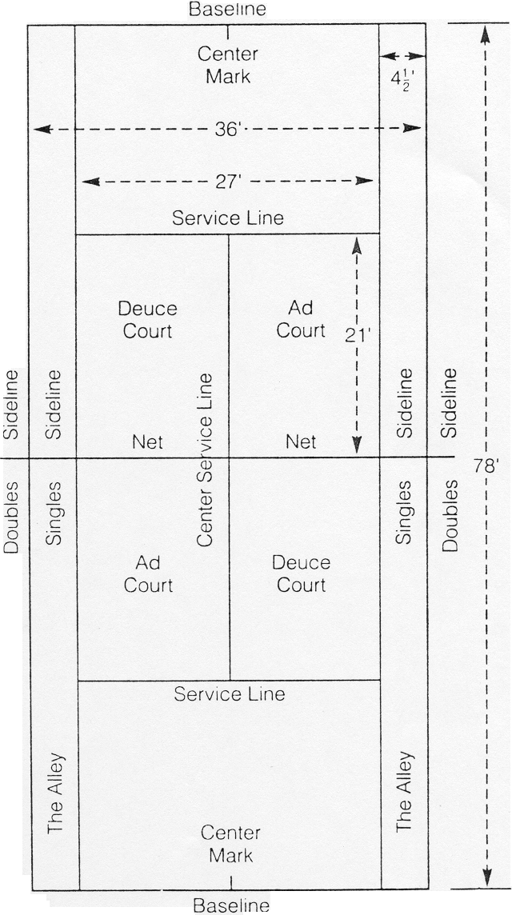

Tennis Protocol
Coaches and athletes should refer to the National Governing Body Code of Conduct in tennis for their respective country. An excellent resource in the United States is the United States Tennis Association (USTA) Code of Conduct, which may be found in the USTA publication Friend at Court. General conduct may include the following:
- Players make calls on their own side of the net. A player calls all shots landing on or aimed at the player’s side of the net.
- A ball touching any part of the line is good.
- A player should not enlist the aid of a spectator in making a call.
- When a ball from an adjacent court enters the playing area, any player may call a let, as soon as the player becomes aware of the ball.
- The server shall announce the game score before the first point of the game and the point score before each subsequent point of the game.
- Athletes and coaches need to be aware of disruptive noises on and off the court.
- Be respectful to matches in play. Outside spectators should not be on the court.

Sportsmanship
Good sportsmanship is both the coach’s and athlete’s commitment to fair play, ethical behavior and integrity. In perception and practice, sportsmanship is defined as those qualities which are characterized by generosity and genuine concern for others. Below are highlighted a few focus points and ideas on how to teach and coach sportsmanship to athletes. Coaches should lead by example.
Tennis is a game that requires cooperation and courtesy from all participants. Make tennis a fun game by praising your opponent’s good shots and by not exhibiting the following behaviours as noted in the USTA Friend at Court.
- Making loud noises after points.
- Complaining about shots, like lobs and drops shots.
- Embarrassing a weak opponent by being overly gracious or condescending.
- Losing your temper, using foul language, throwing your racket or slamming a ball in anger.
- Sulking when you are losing.

Competitive Effort
- Put forth maximum effort during each event.
- Practice with the same intensity as you would perform in competition.
- Always finish the event. Never quit.

Fair Play at All Times
- Always comply with the rules.
- Demonstrate sportsmanship and fair play at all times.
- Respect the decision of officials at all times.

Expectations of Coaches
- Always set a good example for participants and fans to follow.
- Instruct participants in proper sportsmanship responsibilities and demand that they make sportsmanship and ethics a top priority.
- Respect the judgment of officials, abide by rules of the event and display no behavior that could incite fans.
- Treat opposing coaches, directors, participants and fans with respect.
- Shake hands with officials and the opposing coach in public.
- Develop and enforce penalties for participants who do not abide by the highest sportsmanship standards.

Expectations of Athletes and Partners in Unified Sports
- Treat teammates with respect.
- Encourage teammates when they make a mistake.
- Treat opponents with respect. Shake hands prior to and after contests.
- Respect the judgment of officials, abide by rules of the contest and display no behavior that could incite fans.
- Cooperate with officials, coaches or directors and fellow participants to conduct a fair contest.
- Do not retaliate (verbally or physically) if other athletes demonstrate poor behavior.
- Accept seriously the responsibility and privilege of representing Special Olympics.
- Define winning as doing your personal best.
- Live up to the high standard of sportsmanship established by your coach.

Remember
- Sportsmanship is an attitude that is shown by how you and your athletes act on and off the field of play.
- Be positive about competing.
- Respect your opponents and yourself.
- Always stay under control, even when you are feeling mad or angry.

Tennis Glossary

Term | Definition
Ace | Ball served so well that the opponent fails to touch it with his/her racket.
Ad | Short for advantage in traditional scoring. It is the first point scored after deuce. Not used in the no-ad scoring system used for Special Olympics tennis competition.
Ad Court | Left service court.
Alley | The area between the singles sideline and the doubles sideline.
Approach | The shot hit from mid-court range that allows the player to come to the net to volley.
ATP | Association of Tennis Professionals; the organization for men’s professional tennis.
Backcourt | Area between the service line and the baseline.
Backhand | The stroke that is used to return balls hit on the left side of a right-handed player and right side of a left-handed player. It can be hit with one or two hands. Note: Athletes should learn to hit a proper backhand not a right-handed forehand and a left-handed one.
Center Strap | Strap in the center of the net, anchored to the ground to hold the net secure.
Cross Court Shot | A shot in which the ball travels diagonally across the net from one corner to the other.
Deuce | A score of 40-40 in traditional scoring. Not used in the no-ad scoring system used for Special Olympics tennis competition.
Deuce Court | The right court, so called because the deuce point is played on that side.
Double Fault | The server loses the point if both of the two services attempts fail to cross the net and land in the appropriate service box.
Doubles | A match played by teams of two players. The court is extended to the doubles sidelines (after the serve).
Down the Line | A ball hit in a straight line near the sideline.
Draw | Procedure established to determine the position of each player in a tournament.
Drop shot | A touch shot that is hit softly over the net to force the opponent to run forward.
Etiquette | Rules of behavior on the tennis court.
Fault | A served ball that does not fall into the service box or goes into the net.
Fifteen | First point won by a player.
Foot Fault | An illegal serve caused by the server stepping on or over the baseline before hitting the ball.
Forehand | The stroke used to return balls hit to the right side of a right-handed player or the left side of a left-handed player.
Forty | Player’s score after winning three points.
Game | The part of a set that is completed when one player or team wins four points. In no-ad tennis the scoring is 1, 2, 3, “game.”
Good | A ball that lands inside the court or on the line forming the boundary of the court.
Grip | Bottom part of the racket that is used to grasp the racket.
Groundstrokes | Strokes played after the ball has bounced. Forehands and backhands are called groundstrokes.
Half Volley | Ball hit immediately following the bounce of the ball on the court.
In | A ball which lands within the boundaries of the court. Balls that hit any portion of the line are good in tennis.
ITF | International Tennis Federation.
Let | A point replayed because of interference; such as a ball rolling onto the court during play. This point would be replayed with two serves.
Let Serve | A serve that hits the top of the net and lands in the appropriate service box is replayed.
Lob | A stroke hit high in the air with the intent of being hit over a net playing opponent.
Love | A score of zero.
Match | A Special Olympics tennis match consists of one no-ad set. Traditional tennis matches are best 2 out of 3, or best 3 out of 5 sets.
Mixed Doubles | Doubles play in which a male and female team up to oppose another male and female team.
Net | The 3-foot barrier which divides the two sides of the court. To “play the net” means to attack your opponent by positioning yourself close to the net and hitting the ball before it bounces.
No-ad Scoring | The scoring system used in Special Olympics tennis in which the first player to win 4 points wins the game. If the point score reaches 3-3, the next point decides the game. The receiver has the choice of sides at 3-3.
Out | A ball is “out” if it lands outside of the boundaries of the court.
Overhead | An aggressive stroke played normally at the net when the ball is above the head.
Point | The smallest unit of score, awarded to a player when the opponent does not return a ball in play.
Racket | An implement used to strike the tennis ball.
Rally | A series of good shots exchanged between players. Also a term used for the type of practice where players intentionally hit balls back and forth to each other.
Receiver | The player who receives the service.
Referee | The official in charge of a tournament.
Serve | Short for service. It is the stroke used to put the ball into play. A server gets two chances to put the ball in play diagonally into the service box. The serve must be struck from a tossed ball (not off of a bounced ball).
Server | Player who serves the ball.
Service Box | Court area where a serve should be played. Deuce court or Advantage court.
Set | The scoring unit that is awarded to the player or team that has won 6 games by a margin of at least 2 games. Examples: 6-2, 6-4 or 7-5. If the game score reaches 6-6 a tie-breaker is played.
Short Court | Short court is a transitional game utilizing the service box area only.
Singles | A match played by two players.
Tie-breaker or Tie-break | A system used to decide a set when the score is 6-all (6-6).
Thirty | Score which indicates a player has won 2 points.
Umpire | The person who officiates at a match.
Unified Sports Doubles | A Special Olympics event played with a doubles team, consisting of a Special Olympics tennis player and a peer tennis partner. Ideally, teammates would be of similar ages and ability levels.
Volley | A stroke made by hitting a ball before it has touched the ground. Normally done inside the service line.
WTA | Women’s Tennis Association; the organization for women’s professional tennis.

