Snowboarding Coaching Guide

Teaching Snowboarding Skills

Table of Contents
Warm-Up 5
Stretching 7
Snowboarding Basic Skills 15
Balance 15
Rotation 15
Edge Control 15
Pressure 15
Dry land Training 16
On-snow Training 20
Training Aids 20
Putting on Boots 22
Putting Boots in Binding (Clipping in) 23
Teaching Points – Putting Boots on and in Bindings (Clipping in) 23
Faults & Fixes – Putting Boots on and in Bindings (Clipping in) 24
Removing Boots from Binding (Clipping out) 25
Teaching Points – Removing Boots from Bindings (Clipping out) 25
Faults & Fixes – Removing Boots from Bindings (Clipping out) 26
Lift Riding 27
Types of Lifts 27
Lift Loading 30
Lift Unloading 30
Falling – (To be done on a flat surface with soft snow) 29
Teaching Points –Falling 31
Faults & Fixes – Falling 32
Getting Up – (To be done on a flat surface with soft snow) 33
Teaching Points – Getting Up 33
Faults & Fixes – Getting Up 33
Falling and Getting Up Drills 34
Skating – (To be done on a flat surface) 35
Teaching Points – Skating 35
Faults & Fixes – Skating 36
Skating Drills 37
Skate to Glide – (To be done on a flat surface) 38
Teaching Points – Skate to Glide 38
Faults & Fixes – Skate to Glide 38
Skate to Glide Drills 39
Climbing – (To be done on a gentle slope) 40
Teaching Points – Climbing 40
Faults & Fixes – Climbing 40
Climbing Drills 41
One Foot Straight Glide – (To be done on a gentle slope) 42
Teaching Points – One Foot Straight Glide 42
Faults & Fixes – One Foot Straight Glide 43
One Foot Straight Glide Drills 44
Direction Changes 46
Teaching Points –Direction Changes 46
Faults & Fixes –Direction Changes 46
Toeside Turn 47
Heelside Turn 47
One Foot In – Directional Changes – (To be done on a gentle slope) 48
Teaching Points – Directional Changes 48
Faults & Fixes – Directional Changes 49
Directional Changes Drills 50
Side Slip 52
Heelside Side Slip – (To be done on a gentle slope) 53
Teaching Points – Heelside Side Slip 53
Faults & Fixes – Heelside Side Slip 54
Toeside Side Slip – (To be done on a gentle slope) 55
Teaching Points – Toeside Side Slip 55
Faults & Fixes – Toeside Side Slip 56
Side Slip Drills 57
Falling Leaf – (To be done on a gentle slope) 58
Heelside Falling Leaf 59
Teaching Points – Heelside Falling Leaf 59
Faults & Fixes – Heelside Falling Leaf 60
Toeside Falling Leaf 61
Teaching Points – Toeside Falling Leaf 61
Faults & Fixes – Toeside Falling Leaf 62
Falling leaf Drills 63
Garlands – (To be done on a gentle slope) 64
Assisted Garlands 65
Heelside Garlands 65
Teaching Points – Heelside Garlands 65
Faults & Fixes – Heelside Garlands 66
Toeside Garlands 67
Teaching Points – Toeside Garlands 67
Faults & Fixes – Toeside Garlands 68
Garland Drills 69
Straight Glide Review (Both Feet Clipped In) – (To be done on a gentle slope) 70
Straight Glide to Turn (J-Turn) – (To be done on a gentle slope) 71
Teaching Points – Straight Glide to Turn (J-Turn) 71
Faults & Fixes – Straight Glide to Turn (J-Turn) 72
Straight Glide to Turn (J-Turn) Drills 73
Linking Turns – (To be done on a gentle to moderate slope) 74
Teaching Points – Linking Turns 74
Faults & Fixes – Linking Turns 75
Linking Turns Drills 76
Turning on Purpose – (To be done on a gentle to moderate slope) 77
Turning on purpose Drills 77
Snowboarding Skills Progression 78
Racing Skills 79
Course Definitions 79
Slalom 79
Giant Slalom (GS) 79
Super Giant Slalom 79
How to Read a Course 79
Dry Land 79
On-Snow 79
Race Tactics 80
Racing Skills Drills 81
Carving 84
Teaching Points – Carving 84
Faults & Fixes – Carving 84
Carving Drills 85
Snowboarding Racing Skills Progression 87
Cool-Down 88
Understanding Snowboarding 89
Cross Training in Snowboarding 90

Warm-Up
A warm-up period is the first part of every training session or preparation for competition. The warm-up starts slowly and gradually involves all muscles and body parts. In addition to preparing the athlete mentally, warming up also has several physiological benefits.
The importance of a warm-up prior to exercise cannot be overstressed. This is true even for a sport like athletics. Warming up raises the body temperature and prepares the muscles, nervous system, tendons, ligaments and cardiovascular system for upcoming stretches and exercises. The chances of injury are greatly reduced by increasing muscle elasticity.

Warming Up:
- Raises body temperature
- Increases metabolic rate
- Increases heart and respiratory rate
- Prepares the muscles and nervous system for exercise

The warm-up is tailored for the activity to follow. Warm-ups consist of active motion leading up to more vigorous motion to elevate heart, respiratory and metabolic rates. The total warm-up period takes at least 25 minutes and immediately precedes the training or competition. A warm-up period will include the following basic sequence and components:

Activity | Purpose | Time (minimum)
Slow aerobic walk/ fast walk/ run/ jumping jacks (star jumps) | Heat muscles | 5 minutes
Stretching | Increase range of movement | 10 minutes
Event specific drills | Coordination preparation for training/competition | 10 minutes

Aerobic Warm-Up
Activities such as walking, light jogging, walking while doing arm circles, jumping jacks.

Walking
Walking is the first exercise of an athlete’s routine. Athletes begin warming the muscles by walking slowly for 3-5 minutes. This circulates the blood through all the muscles, thus providing them greater flexibility for stretching. The sole objective of the warm-up is to circulate the blood and warm the muscles in preparation for more strenuous activity.

Running
Running is the next exercise in an athlete’s routine. Athletes begin warming the muscles by running slowly for 3-5 minutes. This circulates the blood through all the muscles, thus providing them greater flexibility for stretching. The run starts out slowly, and then gradually increases in speed; however, the athlete never reaches even 50 percent of maximum effort by the end of the run. Remember, the sole objective of this phase of the warm-up is circulating the blood and warming the muscles in preparation for more strenuous activity.

Stretching
Stretching is one of the most critical parts of the warm-up and an athlete’s performance. A more flexible muscle is a stronger and healthier muscle. A stronger and healthier muscle responds better to exercise and activities and helps prevent injury. Please refer to the Stretching section for more in-depth information.

Event Specific Drills
Drills are activities designed to teach sport skills. Progressions of learning start at a low ability level, advance to an intermediate level and, finally, reach a high ability level. Encourage each athlete to advance to his/her highest possible level. Drills can be combined with warm-up and lead into specific skill development.
Skills are taught and reinforced through repetition of a small segment of the skill to be performed. Many times, the actions are exaggerated in order to strengthen the muscles that perform the skill. Each coaching session should take the athlete through the entire progression so that he/she is exposed to all of the skills that make up an event.

Specific Warm-Up Activities
- Swing arms back and forth simulating the pendulum swing.
- Freeride: Allow the athletes to freeride their boards down the mountain for a few runs.

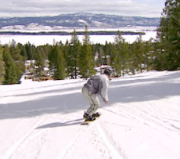 |  | 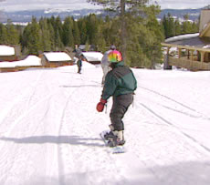
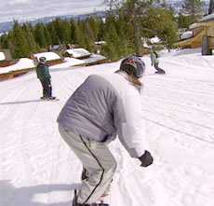 |  | 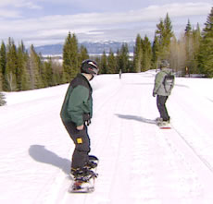

Stretching
Flexibility is critical to an athlete’s optimal performance in both training and competition. Flexibility is achieved through stretching. Stretching follows an easy aerobic jog at the start of a training session or competition.
Begin with an easy stretch to the point of tension, and hold this position for 15-30 seconds until the pull lessens. When the tension eases, slowly move further into the stretch until tension is again felt. Hold this new position for an additional 15 seconds. Each stretch should be repeated four to five times on each side of the body.
It is important to continue to breathe while stretching. As you lean into the stretch, exhale. Once the stretching point is reached, keep inhaling and exhaling while holding the stretch. Stretching should be a part of everyone’s daily life. Regular, daily stretching has been demonstrated to have the following effects:

- Increase the length of the muscle-tendon unit
- Increase joint range of motion
- Reduce muscle tension
- Develop body awareness
- Promote increased circulation
- Make you feel good

Some athletes, such as those with Down Syndrome, may have low muscle tone that makes them appear more flexible. Be careful to not allow these athletes to stretch beyond a normal, safe range. Several stretches are dangerous to perform for all athletes, and should never be part of a safe stretching program. Unsafe stretches include the following:

- Neck Backward Bending
- Trunk Backward Bending
- Spinal Roll

Stretching is effective only if the stretch is performed accurately. Athletes need to focus on correct body positioning and alignment. Take the calf stretch, for example. Many athletes do not keep the feet forward, in the direction that they are running.
Incorrect | Correct
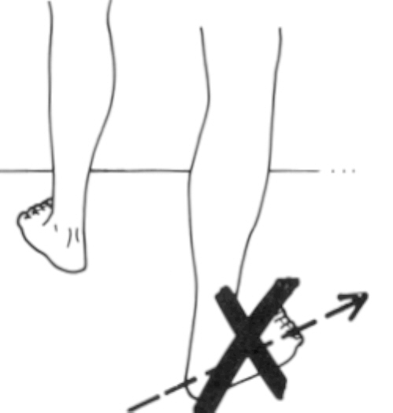
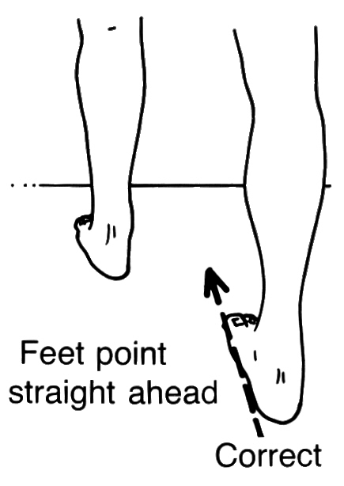

Another common fault in stretching is bending the back in an attempt to get a better stretch from the hips. An example is a simple sitting forward leg stretch.
Incorrect | Correct

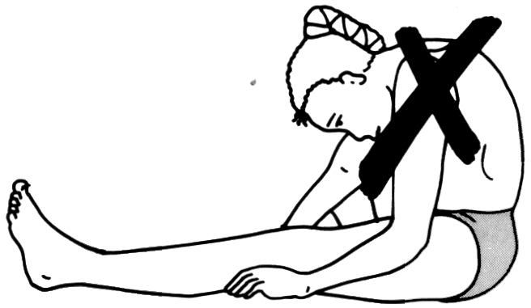
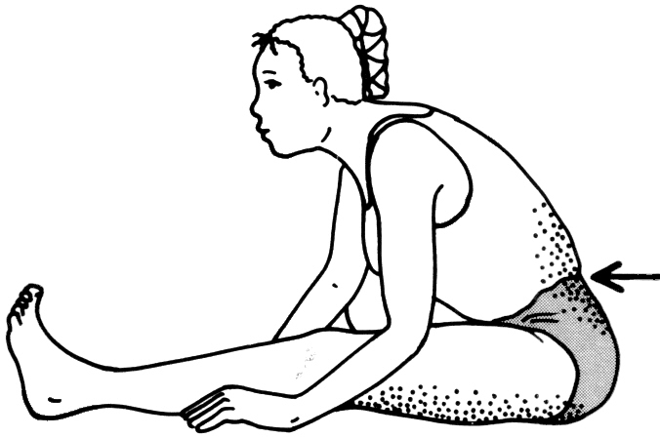

In this guide, we will focus on some basic stretches for major muscle groups. Along the way we will also point out some common faults, illustrate corrections and identify stretches that are more event specific. We will start at the top of the body and work our way to the legs and feet.

Upper Body

Chest Opener | Side Stretch
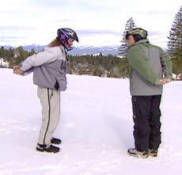 | 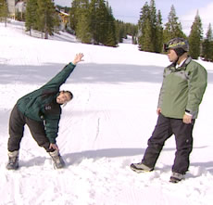
Clasp hands behind back  Palms facing in  Push hands toward sky | Raise arms over head  Bend to one side  Bring arms back to center  Switch to other side

Side Arm Stretch |  | Trunk Twist
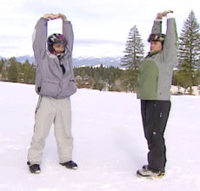 |  | 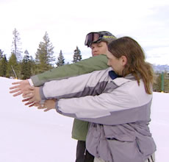
Raise arms over head  Clasp hands, palms up  Push hands toward sky | If the athlete is unable to clasp the hands, he/she can still get a good stretch by pushing the hands to the sky | Stand with back to partner (as above)  Turn, reaching palms toward partner's palms  Repeat on other side

Triceps Stretch | Shoulder Triceps Stretch
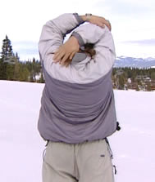 | 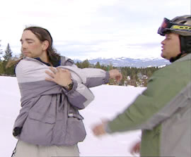
Raise both arms over head  Bend arm, bring hand to back  Grasp elbow of bent arm and pull gently toward the middle of the back  Repeat with other arm | Take elbow into hand  Pull to opposite shoulder  Turn head in the opposite direction of the pull  Arm may be straight or bent  Repeat with other arm

Chest Stretch
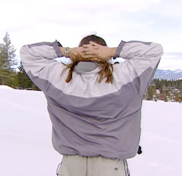 | 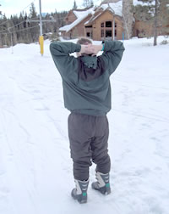
Clasp hands behind neck  Push elbows back  Keep the back straight and tall | This is a simple stretch that the athletes may not feel a lot when stretching. However, it opens up the chest and inner shoulder areas, preparing the chest and arms for the workout.

Arm Circles
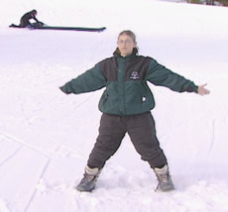
Swing arms forward in large circles
Repeat going forward and backward

Lower Body

Calf Stretch | Calf Stretch w/Bent Knee
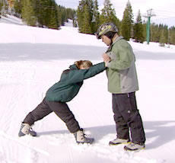 | 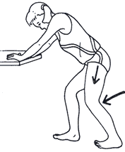
Stand facing partner  Bend forward leg slightly  Bend ankle of back leg  Push on hands of partner to get full stretch | Bend both knees to ease strain

Hamstring Stretch | Standing Straddle Stretch
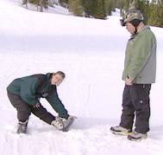 | 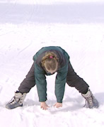 | 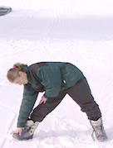
Stand with Legs straight out and together  Legs are not locked  Bend at hips, reach toward ankles  As flexibility increases, reach for feet  Push out through the heels, forcing toes to the sky | Stand with feet more than shoulder length apart, bend at hips  Reach out toward the middle of legs, then alternate between right and left legs  Keep the back straight

Quad Stretch | Forward Bend
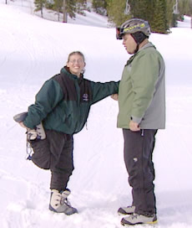 | 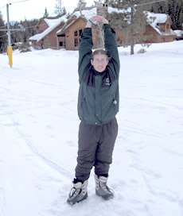
Stand with one foot flat on ground  Bend knee of other leg, reaching foot toward buttock while grasping ankle with hand  Pull foot directly toward buttock  Do not twist knee  Stretch can be done standing alone or balancing with partner or fence/ wall  If pain occurs in knees during stretch and foot is pointing out to the side, point foot back to relieve stress | Stand, arms outstretched overhead  Slowly bend at waist  Bring hands to ankle level without strain

Stretching - Quick Reference Guidelines

Start Relaxed
Do not begin until athletes are relaxed and muscles are warm
Be Systematic
Start at the top of body and work your way down
Progress from General to Specific
Start general, and then move into event specific exercises
Easy Stretching before Developmental
Make slow, progressive stretches
Do not bounce or jerk to stretch farther
Use Variety
Make it fun, use different exercises to work the same muscles
Breathe Naturally
Do not hold your breath, stay calm and relaxed
Allow for Individual Differences
Athletes start and progress at different levels
Stretch Regularly
Always include time for warm-up and cool-down
Stretch at home

Snowboarding Basic Skills

Balance
Balance movements are used to help maintain a body’s state of equilibrium. When internal (body movements) or external (gravity, changing snow conditions) forces act on the body, balancing movements are relied upon to keep the body from falling out of equilibrium. These may be large motor movements such as an arm swing, or small motor movements such as a slight shift in weight.

Rotation
Rotary movements involve some sort of rotation, either by the entire body or one of its parts. Rotary movements may be large and very noticeable or fine and virtually unseen.

Edge Control
This affects the way the edge of the board makes contact with the riding surface. It is the relationship between the edges of the board and the riding surface that causes a board to turn.

Pressure
Pressure movements determine how strongly a board will press down on the riding surface.

Dry Land Training

Stance
The stance used in board sports such as snowboarding is slightly different than that used in sports such as skiing, because it is a countered position. This means that the athlete’s feet will point off to the side, while the body is countered so that the torso is pointing downhill.
The athlete should start in a relaxed athletic stance, with the knees slightly bent and the feet approximately shoulder width apart. With the feet stationary, the athlete will then turn his or her shoulders slightly toward the front of the board (and toward the front foot).
Your athlete can practice this position first on a flat surface, and then on the snowboard with no bindings. Finally, have your athlete put on his or her snowboard and assume the correct stance. It is important to remind athletes that statues are too rigid to snowboard properly, and that they will constantly be moving while in their stance.
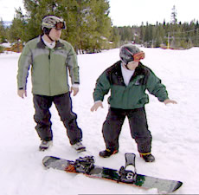

Dry Land Skills
While on a flat surface, and practicing stance, your athletes can begin to become familiar with the skills required to snowboard, and with their equipment. This is a good time to quiz athletes on terms like nose, tail, heel-edge, toe-edge, etc. The more familiar your athletes are with equipment, the less confusion will arise as you try to explain movements while on-hill.

Balance
To work on balance, a few simple drills can be used. For example, have your athletes stand on a flat surface (without a board), and practice jumping up and landing in their stance. While in their stance (both with and without the snowboard), have your athletes feel what happens when they lean forward, and to the sides. Have them practice leaning and then returning to a centered stance position. Remember to ask a lot of questions about how they are feeling. As a coach, you may need to be close to prevent falls, especially when practicing balance while strapped into a snowboard. Much of successful snowboard riding depends on how well an athlete can maintain balance, or recover balance when it has been lost.

Rotation
An athlete can feel rotation by standing in a snowboard stance, and tuning the upper body to the left and right. The athlete should try to maintain a good athletic snowboarding position. Have your athletes experiment with rotation of the upper body first on a flat surface, followed by standing on the snowboard without bindings, and finally while clipped into the snowboard.

Edging Movements
Start by showing your athlete the way a board moves when it is on edge. Start with a board lying on a flat surface. This is the position of the board when it is running straight. Tip the board toward the toeside and then the heelside to demonstrate how a board moves when turns are made. Show how a board starts by running flat, then edges on one side, goes back to flat, and then edges to the other side. Next, have your athlete stand on a flat surface in a snowboard stance. Explain that this is the correct stance for running straight ahead. Have the athlete concentrate his or her weight on the toes, while maintaining balance (like pressing on a gas pedal). Follow by having the athlete concentrate his or her weight on the heels (like lifting off of the gas pedal or like digging in with the heels). It should be stressed that an upright position and balance are to be maintained at all times, even when weight is shifted. If the athlete is falling forward or back, he or she is applying too much weight, or leaning. The athlete should follow each of these movements by returning to a centered stance with weight evenly distributed. Finally, have the athlete clip in with one foot while standing on the board. Have the athlete place the free foot in front of the board on the toeside. Have the athlete tip the board onto its toe edge by standing on the ground and lifting and tilting the board with the clipped foot. Reverse this process for the heelside. Have the athlete place the free foot on the floor on the heelside of the board, followed by tipping the board with the clipped foot.
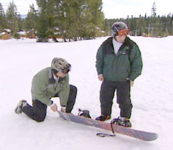

Pressure Movements
The idea of pressure can best be demonstrated rather than explained. Have your athlete sit in a chair. Place one or both of the athlete’s feet in your hands with the knees bent. To show downward pressure, have the athlete push his or her feet toward you. To demonstrate the effect that reducing pressure may have, ask the athlete pull his or her feet away. Next have the athlete stand on a flat surface in a snowboard stance. Have the athlete practice lowering (increasing pressure) by bending the knees while in an upright position – not by bending over. Next have the athlete practice rising (reducing pressure) by rising up – without standing up straight). Have the athlete practice these movements on a flat surface, then on a board with no bindings, and finally while clipped into the board.
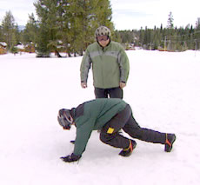

Snowboard Set-up and Stance Adjustment
It is best to have the snowboard set up by a qualified technician at a reputable shop; however, it can be done by a coach. Start by inspecting all of the equipment for loose screws, missing parts, etc. Next, determine the athlete’s stance.

Determining Stance
While many boards are made to be ridden forward and backward (fakie), each athlete will have a dominant foot that will remain forward in most situations. Most people have their left foot forward when riding a board. This is known as a Regular stance. Some athletes will prefer to ride with their right foot forward. This is known as a Goofy-foot Stance. It is not safe to assume that all of your athletes will ride with the same foot forward. Each rider has an individual preference that is not related to hand dominance. A good way to check your athlete for foot preference is to ask if they have engaged in similar board-sport activities (i.e., wake boarding, skateboarding and slalom skiing). If they have, they will most likely ride a snowboard in the same way. Another quick way to check stance is to use one of the following simple tests:

Method 1: Push Test
Have your athlete stand up straight with both feet placed together. Gently push your athlete forward from behind until he or she is forced to put a foot out to maintain balance. For uncomfortable athletes or those with balance problems, have another coach stand in front to prevent falls. In most cases, the foot that is used by the athlete to catch himself or herself will be the forward foot when riding.

Method 2: Ball Kick Test
Have your athlete kick a ball for you. In most cases the foot used for kicking will be the preferred front foot for your athlete. The final check will be to communicate constantly with your athlete as he or she learns to snowboard. It may take some time for your athlete to get comfortable with the equipment, and some measure of trial and error to be sure which foot should be forward.

Method 3: Push-up Test
Have your athlete get down in the push-up position. Ask the athlete to stand up out of the push-up position; the foot that steps forward first will be the dominant leg. In most cases, the foot that is the dominant leg will be the forward foot when riding.

Method 4: Slide Test
Have your athlete, while wearing socks, take a few steps and slide on a gymnasium floor. In most cases, the foot that is the dominant leg will be the forward foot when sliding.

Method 5: Skateboarding Test
If available, have your athlete ride a skateboard. Assistance with support may be necessary from the coach. The stance that the athlete finds most comfortable will be his or her stance.

Determining Stance Angles
Modern bindings have marks on the mounting pieces to help you determine the binding angle. In simple terms, you want both feet angles toward the front of the board with the front foot angle slightly more. People riding racing boards may use stance angles of up to 60 degrees, while freestyle riders may use a more neutral stance. Start your beginning athletes with a stance angle of 3-12 degrees for the back foot and 12-24 degrees for the front foot, as determined by what feels comfortable for the athlete. If, while riding, the athletes’ toes drag in the snow, the stance angle should be increased. Once the basics have been learned, stance angles can be changed according to comfort and preference. As with stance, a certain amount of trial and error may be necessary.

On-snow Training
One word of caution before you begin practicing skills on the snow: Snowboarding is more difficult than it looks at the beginning stages. The natural assumption of most students is that the on-hill movements will be as easy to perform on the snow as they are on dry land. This is simply not true. Almost every student will be tempted to start out by going straight to the top of the hill, and our athletes are no different. RESIST THIS TEMPTATION! If there is one piece of advice that should be followed when learning to snowboard, it is that snowboarding skills are best learned at slow speeds on shallow terrain. If you progress up the hill too soon, you will only increase the likelihood and severity of falls. Please remember that one bad fall can end your lesson, and in some cases can cause an athlete to quit snowboarding! The teaching progression that has been outlined here has been designed with the safety (and success) of the athlete in mind. Leaning to snowboard safely can seem slow at first, but extra time taken to practice and master skills on shallow terrain will pay off by helping the athlete adjust more quickly later.

Training Aids
- Magic stic: a kind of stick or pole about 50 to 70 cm (approximately 24 – 42 inches) in length (approximately one arm length). It should be made of an unbreakable material like wood or plastic (from a slalom pole). The ends of the stic should be taped and padded to avoid injury and give a good grip. The stic can be used in many different ways: To pull the athlete (for example, from the ground to stand up and while gliding from one point to another); to support the athlete (for example, in learning new movements) and giving the athletes different kinds of movement experiences (for example, using the stic as a steering wheel or handle bar).
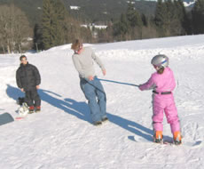
- Colored tape/ Stickers: to be fixed on the front and backside of the board. If the athlete has problems with keeping in mind toeside and heelside, it is easier to have a blue and red edge. This helps the athlete react faster when you give advice such as, “Give pressure on the red edge!” while he or she is riding. The frontside and nose of the board may also be marked with tape or stickers. In the beginning, many athletes may have difficulty keeping in mind which end is the front.
- Safety equipment: It is a good idea for athletes to wear protective padding on the first few days, especially for their knees! (Use in-line skating/skateboarding/volleyball guards such as wrist, elbow and knee pads.)
- Hand assistance: Keeping in mind that one hard fall can end a lesson and/or cause an athlete to quit, be available while teaching to offer assistance and support while the athlete learns new skills. In this way, you can help prevent falls. Also, be ready to re-position the athletes as necessary so that they can feel the skill performed in the correct way.

Basic Guidelines
In addition to training aids, there are some teaching tips that can help.
- While there are many learning styles (thinking, doing, feeling, watching), most athletes learn best by seeing and imitating movements, and do not learn well from lengthy explanations. When you demonstrate movements, for example, show the important parts in an exaggerated way.
- While explaining new movements, try to show examples.
- Training aids should only be used as necessary to introduce new skills. If you use training aids such as a magic stic or just holding a hand while making a new movement, it is very important to urge the athlete to perform the task without training aids as soon as possible (for example, offering hand assistance during the first two attempts and then having the athlete perform the movement without). The first priority should be to help the athlete feel safe, so that he or she will have the courage to try a new movement! Nevertheless, the athlete must develop his or her own movement experiences as early as possible. It is unproductive for the athlete to become dependent on the training aids. The coach should evaluate each athlete as he or she develops new skills, and use the training aids where appropriate depending on the movement and the skill level, anxiety level and safety of the athlete.
- The main target is to give the athlete many different movement experiences. The more he or she gets, the faster he or she will learn new movements in the future and the more safe he or she will feel on the board. So be creative and find as many different drills as possible for every new movement!

Putting on Boots
Most snowboard boots will have use a lace system and/or buckles that should be figured out and mastered in a warm, dry, indoor place before putting them on in the cold. Athletes should practice ensuring that they get a secure fit and that the pants and/or socks are not bunched up inside of the boot.

Skill Progression – Putting on Boots

Your Athlete Can | Never | Sometimes | Often
Identify left and right boot
Loosen straps or laces
Place foot in boot with heel secure in the back of the boot
Ensure that the socks and/or pants are not bunched up inside the boot
Tighten boots properly

Totals

Putting Boots in Binding (Clipping in)
Most snowboard bindings use a ratchet strap system to hold the boots firmly in place. All ratchets and/or buckles should be figured out and mastered in a warm, dry, indoor place before putting them on in the cold. Athletes should practice bucking and unbuckling their binding before they go out on the snow. For athletes with step-in bindings, there are several types available; each one is unique and should be practiced according to the instructions that come with the bindings.
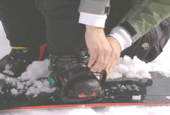

Skill Progression – Putting Boots in Bindings (Clipping in)

Your Athlete Can | Never | Sometimes | Often
Identify left and right bindings
Loosen straps
Place boot in binding with heel secure in the back of the binding
Tighten bindings properly

Totals

Teaching Points – Putting Boots on and in Bindings (Clipping in)
- Begin by determining the left boot and binding from the right boot and binding. Generally, most toe and heel straps buckle to the outside.
- Loosen binding straps so that there is sufficient play to insert your boot easily.
- Place your boot into the binding so that the heel is secure in the back of the binding.
- Tighten the larger heel strap first: thread the strap into the buckle and tighten until firm. Repeat the process for the smaller toe strap. (Athlete may feel more comfortable sitting while doing this for the first few times).
- Pull the straps snug but not so tight that they pinch the foot and/or restrict movement and circulation.
- Check the tightness of straps again after 3-5 minutes of snowboarding warm-up.
- While on snow, it is important to ensure that the binding and the surface of the boot are free of snow before clipping in.

Faults & Fixes – Putting Boots on and in Bindings (Clipping in)

Error | Correction | Drill Reference
Putting incorrect boot on foot | Switch boot to opposite foot | Repeat putting on correct boot
Incorrect boot placement in binding | Correctly place boot in correct binding | Practice on dry land if necessary
Foot loose in boot | Tighten boot | Repeat tightening boots
Boot loose in binding | Tighten bindings | Repeat tightening bindings

Removing Boots from Binding (Clipping out)
For athletes with step-in bindings, there are several types available; each one is unique and should be practiced according to the instructions that come with the bindings.
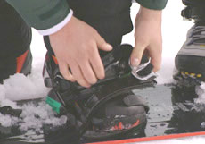

Skill Progression – Removing Boots from Bindings (Clipping out)

Your Athlete Can | Never | Sometimes | Often
Unbuckle rear binding first
Remove rear boot from binding without losing balance
Remove front boot from binding without losing balance
Remove leash while securing snowboard

Totals

Teaching Points – Removing Boots from Bindings (Clipping out)
- Begin by loosening the rear binding straps.
- Loosen binding straps so that the boot can be removed easily.
- Remove rear boot from the binding without losing balance. (Athlete may feel more comfortable sitting while doing this for the first few times).

If the athlete has stopped snowboarding (i.e., for the day or for a break), remove the snowboard completely:
- Loosen the binding straps on the opposite foot so that the boot can be removed easily.
- Remove the front boot from the binding without losing balance. (Athlete may feel more comfortable sitting while doing this for the first few times).
- Remove the leash while securing the snowboard.
- When setting the snowboard down, the snowboard should always be set down on the bindings to prevent runaways.

Faults & Fixes – Removing Boots from Bindings (Clipping out)

Error | Correction
Athlete falls over while clipping out | Slow down movement  Sit down on the ground while clipping out
Snowboard runs away from athlete | Secure snowboard with leash  Set snowboard on bindings

Lift Riding
There are several types of ski lift to help transport skiers and snowboarders up the hill. Before using any type of lift, it is important to be comfortable with how the lift works and how to use it safely. A brief description of the different types of lifts, and tips for how to use them, is included here. However, it is best to talk to a ski lift operator or ski instructor at the area you are using for more complete information on proper use of their lifts.

Types of Lifts
There are two major types of lifts that are used at most major ski areas: surface lifts and chairlifts. Surface lifts are generally used for smaller hills and more gentle slopes, and chair lifts are used for bigger hills and higher slopes. Depending on the area, most beginning snowboarders will primarily use surface lifts.

Surface Lifts
A surface lift is any lift that takes a skier or snowboarder up the hill while the person is standing on the snow under their own power. There are several types of surface lifts. The most common lifts are the rope tow, magic carpet, T-bar, poma lift and paddle or cable tow.
One advantage to surface lifts is that they often (although not always) give the rider the opportunity to unload before arriving at the top. This gives an athlete the opportunity to start his or her run on more gentle terrain. As the athlete prepares to unload, remind him or her to maintain a relaxed position and begin to steer the board away from the lift. Once the athlete is moving away, he or she can let go of the rope or paddle and ride the board and begin to skate to the desired starting point.

Magic Carpet
The magic carpet is similar to a conveyor belt. People stand on the belt and are moved uphill. Magic carpets generally move slowly; however, there are a few tips to make riding easier. As the athlete moves into position at the bottom of the belt, have him or her step onto the belt with the free foot and place the board alongside the free foot using small steps. As the belt approaches the top, have the athlete begin by placing the free foot on the snow and follow with the board. Once the athlete has regained his or her balance, have him or her skate with the board to an area that is out of the flow of traffic to strap in. The magic carpet is very useful for the first beginners’ lessons. Most of the time, these are conducted near gentle slopes, where the first drills can be done with less chance of falling. The magic carpet can be used by the athlete with very little experience. The design of the magic carpet also allows the athlete to save a lot of energy, because he or she does not have to walk up the hill.
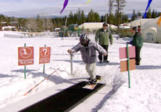 |  | 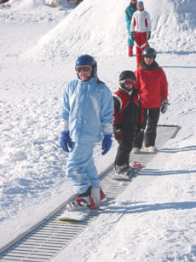

Towing lifts
Other types of surface lifts move people up the hill by towing them. Lifts that tow can be difficult for snowboarders because they must ride with one foot strapped in while the other rests on the stomp pad. Rope tows and paddle tows are basically looped systems that run continually uphill. Athletes are towed to the top by grabbing onto the rope or paddle.

Rope tows and paddle tows
Rope tows and paddle tows have a loop of rope or cable that the athlete must hold onto to move uphill. When your turn arrives, move forward and place the board in the track pointing uphill with the free foot placed on the stomp pad. The body should be in a relaxed position with the knees bent. As you prepare to load, look downhill over the shoulder next to the lift. Rope tows do not require a specific hand placement. While the rope is running, gently lift it to waist height, allowing it to run through your hand. Then squeeze the rope using both hands until it is held firmly in your grip (the rope is not slipping though your hands). As your grip tightens, you will begin to move forward. Remember to look straight ahead and maintain a relaxed position. Paddle tows are more difficult to ride because they require the rider to hold onto a handle. The preparation for riding a paddle tow is similar to that used for the rope tow. Once in position, have the athlete reach backward down hill as the paddle approaches. The athlete should then guide the paddle into position as it passes and grasp the handle with both hands. Remind the athlete to keep his or her weight shifted slightly toward the back and the knees bent, because once the athlete had grasped the handle, the lift will pull him or her forward abruptly. If relaxed and ready, the athlete will be more prepared for the sudden pull.
Tip: If the athlete is unloading at any point other than the top of the hill, have him or her immediately move the board so that it is not pointing down the hill (the board should be across the fall line). This will help prevent sliding backward downhill or into the lift.
Practice Tip: To give the athletes practice with the balance and body position required for riding a rope tow, you can tow them using a magic stic or a ski pole (see below) before having them attempt to ride the lift.
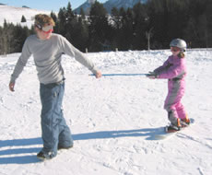

T-bars and Poma Lifts
T-bars and poma lifts are similar in that they pull one or two persons while they stand on the board; however, these lifts are slightly different because rather than the person holding on, he or she is towed by a piece of the lift that is positioned behind the legs. It is important to note that with these types of lifts, the person being towed does not sit on the seat, but rather is pulled by it. As you approach the loading area, you will be signaled by the attendant when it is time to move forward. When signaled, skate forward and position the board so that it is pointed uphill. The attendant will guide the T-bar or poma seat so that it is behind the legs of the people being towed. As the lift begins to tow, remind the athlete to maintain a relaxed stance with the knees bent, maintain the same pressure on both feet, and allow the lift to do the work. Because of the unevenness of the terrain, it may be necessary to constantly adjust your balance to keep from moving off track. As the lift approaches the top, a sign will indicate when it is time to unload. Unloading usually takes place in a flat area. Firmly hold seat pole and, as you are moving forward, slowly release it. The spring on the seat will move it ahead and away from you. When it is clear, move off to an area out of the flow of traffic to strap in.
For the first times using a t-bar lift, it is easier for the athletes if they are accompanied by a good skier or snowboarder who can ride in a straight line and offer support if necessary. For practice in using the t-bar lift, most lift stations have a t-bar without a towline to give beginners practice before attempting to ride.
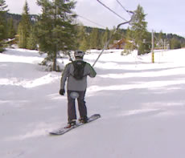

Chairlifts
All chairlifts function in a similar way, although they may vary in size, speed and the number of people carried by each chair. Chairlifts vary in size from lifts carrying two people to lifts carrying up to six. High-speed detachable chairlifts perform similarly to regular chairlifts, but the chairs detach at the loading and unloading points, making it easier to get on and off. Each chairlift has an attendant at the top and bottom to assist with loading and unloading. The attendant is also available to either slow or stop the lift if there is a problem. If you are unsure about how to proceed, ask the attendant for help!
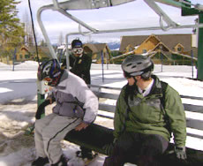

Lift Loading
Most lifts will have a system of ropes to keep the waiting line moving in an orderly fashion. At the end of the waiting line and prior to the loading area, each lift has a line to mark the position of the riders who will load next. As the people ahead of you are loading, it is important to pay attention and be at the line and ready to move to the loading area as soon as the previous chair is loaded. Once the previous chair has been loaded, the attendant will give a signal for the next group of riders to move forward and prepare to load.
Tip: Lifts normally run at a faster speed, but you can ask the attendant to slow the lift down to make loading easier and safer for beginning snowboarders.
Have the athlete skate forward to the line indicating where the chair will load. Make sure that his or her snowboard is pointing straight forward uphill. Have the athlete assume a relaxed stance with the knees slightly bent. Have the athlete look over his or her shoulder as the chair approaches, and sit as it reaches the loading line. Once aboard the chair, remind the athlete to keep his or her snowboard pointed forward until the chair is completely off the ground. Make sure that the athlete is seated completely on the chair with his or her back firmly against the backrest. Once the chair has left the loading area, lower the safety bar and enjoy the ride.

Lift Unloading
As the chair approaches the unloading area, raise the safety bar and prepare to unload. Remind the athlete to keep the tip of the board up and to point it straight forward. The unloading point will be marked so that you will know when to stand.
Tip: You can signal the attendant to slow the lift to make unloading safer and easier. As you approach the unloading point, have the athlete place the board onto the snow, with his or her free foot on the stomp pad, and slowly begin to stand. The momentum of the chair will push you forward and down a ramp into the unloading area. You can remind the athlete that the movement used to ride down the unloading ramp is the same movement used in skating with one foot in. Have the athlete remain in a relaxed stance and ride the board until it stops. Point out that the board can be steered, if necessary, just as it was during the skating drills. Once at the bottom of the ramp, skate to an area that is near the run that you will be using and out of the flow of traffic, and strap in.
Falling (To be done on a flat surface with soft snow)
Before you begin the on-snow portion, it is important to teach your athletes the proper way to fall. Falls are a natural part of snowboarding, and falling in the correct way can prevent injury. Take some time to talk to your athletes, letting them know that it is OK for a fall to occur. By practicing falling, an athlete will become less apprehensive if a fall does occur. Be sure that the athlete also has all of the proper protective equipment prior to practicing falls.
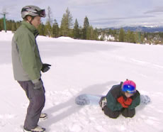

Forward Fall
Ninety percent of the injuries in snowboarding are to the wrist and shoulder. Most of these injuries happen when a snowboarder falls forward in the incorrect way. Practice these movements side by side with your athlete. Start on your knees and let yourself fall forward onto your forearms. Catch your weight with the forearms slightly away from the body, with the elbows bent. Allow your forearms to touch the ground first. Try to resist reaching out toward the ground or placing the hands out in front. As contact is made, absorb the fall with your arms. You may want to practice this movement with your athlete until he or she is completely comfortable with it.

Rear Fall
The rear fall is generally the most painful because athletes tend to tense up, causing them to land flat. Most injuries during rear falls occur to the head. Start in a crouched position with your athlete. Gently rock backward until your balance is lost. As you fall, curl your body into a ball, making sure to keep the head tucked forward. A good visualization is to have the athlete pretend that he or she is a turtle going into its shell. As you fall, remember to bend the knees and bring the board up off the ground. This will prevent the board from catching while sliding downhill and causing a potential flip.
It is important to have the athlete work without a board until falling is comfortable. Once comfortable, have the athlete practice falling while clipped into the board. When this practice is approached the right way, the athlete will become less fearful of falling (and may even find it fun). Reducing fear will help the athlete perform better. Everyone learning a skill will be much more tentative if they are afraid of being hurt.

Teaching Points – Falling
- Emphasize that falling can be safe.
- Emphasize keeping elbows bent and close to body when falling.
- Teach athlete how to tuck and roll (roll on shoulder).
- Make sure the athlete is not physically injured.

Faults & Fixes – Falling

Error | Correction | Drill Reference
Athlete does not fall correctly | Teach athlete how to fall | Line Drill
Athlete falls with arms extended | Teach athlete to keep elbows bent and close to body | Circle Drill

Getting Up (To be done on a flat surface with soft snow)
Because falling is common, it is important to teach the athlete how to get up from the snow. Many times this can be more frustrating than the fall itself, especially on an incline. The easiest way for a snowboarder to get up is to rise from a kneeling position. The kneeling athlete can dig the toe-edge of the board into the snow, support his or her weight on the hands, and rock the board back until the base is flat on the snow. The athlete can then slowly rise to a standing position.
If the fall has been to the back, the athlete will need to do a turtle roll in order to get to the kneeling position. A turtle roll begins with the athlete sitting on the snow, then rocking backward while lifting the board off the snow. Once the board is off the ground, the athlete can roll to one side, bringing the board around and under the legs. From this position, the athlete can stand from the kneeling position as described above.
Even an athlete in good condition may have problems getting up from a fall. It is important to work until the athlete is comfortable before going uphill. During lessons, it is a good idea to have the athlete practice getting up without assistance if he or she falls. It is also important to make sure that the athlete isn’t becoming overtired from having to get up too often. In this case you may want to offer more assistance.
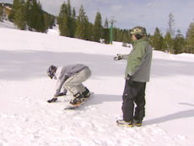

Teaching Points – Getting Up
- If athlete falls completely to ground, roll onto side.
- Position snowboard so that it is across the fall line (not facing downhill).
- Get up to the hands and knees.
- Dig toe edge into the snow close to hand placement.
- Slowly rise to a standing position while maintaining pressure on toe edge.
- Make sure the athlete is not physically injured.

Faults & Fixes – Getting Up

Error | Correction | Drill Reference
Athlete does not get up | Make sure athlete works through steps | Steps to getting up/ Line Drill
Athlete does not get up correctly | Reinforce steps to getting up | Steps to getting up/ Circle Drill
Athlete cannot maintain stationary position while trying to get up | Make sure the snowboard is facing across the fall line  Put more pressure on the toe edge | Line Drill
Athlete takes too long getting up | Reinforce time restraint  Check for injury or tiredness | Timed getting up

Falling and Getting Up Drills

Circle Drill
Have the athletes stand in a circle. Randomly call out athletes by name, jacket color, etc., and have athletes practice falling when called out.

Line Drill
Have the athletes stand in a line. Begin by tossing a hat or other object to an athlete, who must then demonstrate a proper fall. The athlete then tosses the object back to the coach, who then throws the object to another athlete in the line. While practicing falling, athletes can help encourage proper form of teammates.

Skating (To be done on a flat surface)
Skating is a skill that will be used to maneuver around at the bottom of the hill, in the lift lines and in other situations when the snowboarders’ momentum has stopped in a flat area. At this point, the skill of skating will be used to introduce the athlete to gliding on the snow surface. Begin by having the athlete stand in a snowboard stance on the board on flat ground, with the front foot clipped in. The athlete will then push forward with the free foot. Following the push, the free foot should be placed on the stomp pad between the bindings. The athlete will then ride the board as it glides to a stop. The coach should remain close to the athlete in case of loss of balance or a fall.
In the case of an apprehensive athlete, or an athlete with balance problems, the coach can assist by holding both of the athlete’s hands during the glide. It is important to remember that this assistance is only to prevent falling and to provide security. The athlete should be supporting his or her own weight as much as possible.
Skating is an important concept for the athlete to master, as it is used to get around during the frequent instances when the athlete’s board has lost momentum. It will be necessary for the athlete to skate in order to use the lift and to maneuver around prior to going downhill.
Continue to work on skating until the athlete is able to glide with good balance. Stay on a relatively flat surface to begin. As the athlete becomes more comfortable, the terrain can be varied by introducing a SLIGHT grade, allowing the athlete to experience the sensation of skating uphill. Also, the athlete can begin gliding for longer distances.
NOTE: Be very conservative when choosing terrain, especially during the beginning phases of learning. Many athletes experience unnecessary injury by trying to negotiate terrain that is too steep too early. Stay on flatter terrain until you are sure that the athlete has become comfortable with the skills you have been teaching. Overall, the athlete will learn proper snowboarding technique more quickly if the difficulty of the terrain is increased slowly.
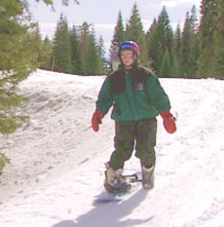

Teaching Points – Skating
- Begin with free foot next to the board on the toeside.
- Only take small steps, to avoid slipping.
- Keep head up with eyes facing forward.
- Maintain most of the weight on the strapped -n foot.
- Practice pushing with free foot on the heelside.
- Practice alternating between toeside and heelside.

Faults & Fixes – Skating

Error | Correction
Athlete fails to maintain balance | Head up with eyes forward  Take small steps  Keep weight on front leg
Athlete cannot skate on heelside | Try skating on toeside
Athlete cannot skate on toeside | Try skating on heelside

Skating Drills
All the following drills may be introduced first by using the magic stic or giving support with hands if necessary. Please keep in mind that the goal is to reduce the use of aids and have the athlete perform the drills without assistance as soon as possible!

Board Slide Drill
Have the athletes sit on their boards (between the bindings) on even terrain. Have the athletes push with their hands and glide a bit. This can be performed on a gentle slope. Let the athletes glide to a certain point and get used to the feeling of gliding and movement. Keep safety in mind, and do not let the boards get too far away. Be sure to have the athletes hold the leashes in their hands.

Skate to Object Drill
Choose an object on the hill such as a sign post, cone, coach, etc. Have the athlete practice skating skills toward the object. Remember to stress maintaining balance and keeping eye contact with the object.

Skate Over Uneven Terrain Drill
Choose an area on the hill with uneven terrain, such as small mounds of snow, indentations, etc. Have the athlete practice skating skills over the uneven terrain while maintaining proper balance and body position.

Obstacle Course Drill
A good method for practicing skating is to set up a short obstacle course requiring the athlete to negotiate from one location to another. Small cones or flags can be used to form a course. Have the athlete practice pushing on the toeside and on the heelside.
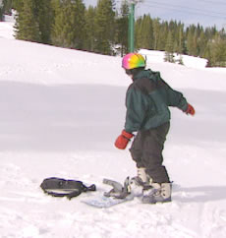

Skating Competition Drill
Be careful with practicing skating in competition mode, because having just one foot attached to the board can cause injuries. If the athletes are secure in skating, you can have them compete in small races or relays.

Skate to Glide (To be done on a flat surface)
As the athletes demonstrate better balance and become less fearful, have them experiment with movement during the glide portion. Begin by having the athletes rise and lower slightly while the board is gliding. This can be followed by shifting weight forward and back, and then finding a centered balance. These experiments will help the athlete to realize the correct position for boarding, and will show how constant movement is required in order to maintain balance.
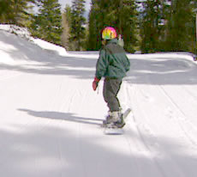

Teaching Points – Skate to Glide
- Begin with free foot next to the board on the toeside.
- Only take small steps, to avoid slipping.
- Keep head up with eyes facing forward.
- Maintain most of the weight on the strapped-in foot.
- Practice placing the free foot on the board, between the bindings.
- Maintain proper stance.
- Have the athlete start with short glides, then progress to slightly longer glides.

Faults & Fixes – Skate to Glide

Error | Correction
Athlete fails to maintain balance while skating | Head up with eyes forward  Take small steps  Keep weight on front leg
Athlete fails to maintain balance while gliding | Head up with eyes forward  Knees flexed  Keep weight evenly distributed
Athlete does not go straight while gliding | Keep feet flat on the snowboard

Skate to Glide Drills
All the following drills may be introduced first by using the magic stic or giving support with hands if necessary. Please keep in mind that the goal is to reduce the use of aids and have the athlete perform the drills without assistance as soon as possible!

Glide Along a Line Drill
Have the athletes glide along a line made out of cones or a line in the snow. It helps them to maintain their direction.

Glide to Object Drill
Choose an object on the hill such as a sign post, cone, coach, etc. Have the athlete practice skating to a glide while aiming toward the object. Remember to stress maintaining balance and eye contact with the object. Begin with gliding short distances and gradually work toward gliding greater distances.

Glide While Rising and Sinking Drill
As the athletes demonstrate better balance and become less fearful, have them experiment with movement during the glide portion. Begin by having the athletes rise and lower slightly by bending at the knees (not at the waist) while the board is gliding. You can name this drill “small and tall” to make it more creative and fun for the athletes.

Glide with Weight Shift Drill
Once the athlete has mastered rising and sinking, begin having the athlete glide while shifting his or her weight forward and back (toward the nose or tail), and then finding a centered balance. These experiments will help the athlete to realize the correct position for boarding, and will show how constant movement is required in order to maintain balance.

Gliding Contest Drill
“Who can glide farthest?” Have the athletes push three times from a certain point, then have them stand with the back foot between the bindings to see who can glide farthest.

Skate and Glide “Backside” Drill
Although it may be a difficult movement, have the athletes attempt to skate their board while pushing with their back foot on the backside (heelside) of the board.

Climbing (To be done on a gentle slope)
During the course of snowboarding, it may become necessary for the athlete to skate uphill, or even to climb. Begin by having the athlete skate uphill on a slight grade. On steeper terrain, it may become necessary for the athlete to use the step and drag method. To prevent the board from sliding downhill, the athlete should place the free foot on the toeside of the board while facing uphill.
The board is then turned, placed across the hill and rested on the toe-edge. The athlete begins by putting weight on the board foot, stepping out with the free foot and then dragging the board forward. The process is then repeated in order to climb.
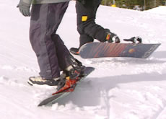

Teaching Points – Climbing
- Practice stepping over the board toward the toeside.
- Tip the board onto the toe edge, across the fall line.
- Practice pushing against the toe edge without the board slipping.
- Begin taking small steps.

Faults & Fixes – Climbing

Error | Correction
Board slips | Tip the board onto the toe edge and put pressure on the edge  Increase the angle of the board on the snow
Athlete takes too long of a step | Begin by taking smaller steps
Athlete trips over the board | Begin by taking smaller steps

Climbing Drills

Walking Up and Down the Hill (without board) Drill
Have the athletes practice walking, running or jumping on their toes while moving uphill. Most of the athletes may have problems staying in good riding position while standing on the toes. Practicing the movements without a board can give them a feeling for the movement in a safe way.

Climb to a Point Drill
Have the athlete stand at the bottom of a relatively shallow slope. Place the athlete in the correct position. Climb the hill ahead of the athlete and turn around. Have the athlete practice climbing toward you.

One Foot Straight Glide (To be done on a gentle slope)
Once the athlete has become comfortable with the previous skills, it is time to move uphill. Have the athlete skate or climb up a slight incline. Resist the temptation to go too high too fast. The incline should be low enough that the athlete will be able to glide to a stop (remember that he or she does not yet know how to turn or stop). Be sure that the finish area is clear of obstacles or other people. It may be a good idea to have an assistant stand at the bottom to act as an emergency “catcher” should the athlete get out of control.
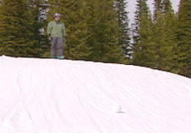
Once the athlete has reached the start position, have him or her clip into the front binding while facing uphill. The coach should offer assistance by standing below athlete and taking the athlete’s hands. As the coach, you will need to make sure that the athlete does not start before he or she is ready. Once the athlete is standing, have him or her place the free foot on the stomp pad between the bindings, and allow the board to glide downhill.
Before beginning the glide, review with the athlete the proper stance (eyes facing downhill, knees and hips bent slightly, athlete in a relaxed position). Remind the athlete to stay relaxed until the end of the glide.
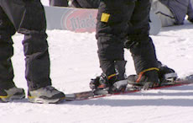

Teaching Points – One Foot Straight Glide
- Start by securing the board so that it does not move before the athlete is ready.
- Have the athlete begin in the correct snowboard stance.
- Keep knees flexed and stay in a relaxed position.
- Keep feet flat and weight centered (over both feet, front to back and side to side).
- Keep eyes forward, looking ahead.

Faults & Fixes – One Foot Straight Glide

Error | Correction
The snowboard does not go in a straight line | Keep feet flat and weight centered
Athlete leans too far back | Review correct snowboard stance  Keep feet flat and weight centered  Start on a more gentle slope so that the athlete does not go too fast
Athlete looks down (leans too far forward) | Review correct snowboard stance, keep eyes forward

One Foot Straight Glide Drills
All the following drills may be introduced first by using the magic stic or giving support with hands if necessary. Please keep in mind that the goal is to reduce the use of aids and have the athlete perform the drills without assistance as soon as possible!

Glide to a Stop Drill
Begin by having the athlete climb a short, gentle slope. Once the athlete has reached the start position, have him or her clip into the front binding while facing uphill. The coach should offer assistance by standing below athlete and taking the athlete’s hands. As the coach, you will need to make sure that the athlete does not start before he or she is ready. Once the athlete is standing, have him or her place the free foot on the stomp pad between the bindings, and allow the board to glide downhill.
When ready, release the athlete to complete the glide. The athlete should ride the board in a relaxed position until it stops completely. It will be necessary to spend some time repeating this drill until the athlete has shown good balance throughout.

Glide with Movement Drill
Once the athlete has become comfortable with the glide, movement can be introduced. Start by using the following drills:
- Rising and lowering stance while gliding (“small and tall”).
- Adjusting weight forward, back and to center during glide.

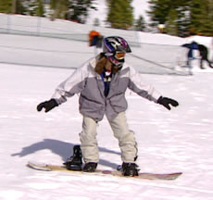

Glide to Object Drill
Choose an object on the hill such as a sign post, cone, coach, etc. Have the athlete practice skating to a glide while aiming toward the object. Remember to stress maintaining balance and eye contact with the object.

Glide with Brake Drill
Have the athletes glide to a certain point (to a flat area) and have them brake with the back foot in front of the frontside edge.
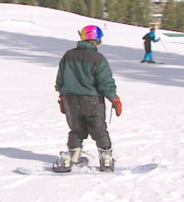

Glide with Rotation Drill
Have the athletes rotate the shoulder with arms spread wide while gliding.

Direction Changes
Turning is actually accomplished using rotation, edging and pressure (with balance maintained throughout) at the same time. A proper stance should be maintained with the hands up in front.

Introducing Direction Changes (To be done on a flat surface)
At this point, it is a good idea to return to the flat surface to work on the movements that will be used when making a turn. Have the athlete assume a snowboard stance, and practice going from the neutral, centered position into the position for a toeside turn and then back. Follow this by going from a neutral stance into the position for a heelside turn, and then back. Once the athlete has mastered the movements, introduce the idea of turning rhythm. The athlete will start in a neutral stance, go to a toeside position (count to 2), then back to center (count to 2), to a heelside position (count to 2) and back to center (count to 2, then repeat cycle).
NOTE: Extra time should be spent at this level to be sure that the athlete is comfortable before progressing.

Teaching Points – Direction Changes
- Start the athlete in a centered neutral stance.
- Flex the knees and put pressure on the toes.
- Return to the centered neutral stance.
- Flex the knees and put pressure on the heels.
- Return to the centered neutral stance.

Faults & Fixes – Direction Changes

Error | Correction | Drill Reference
Athlete loses balance | Keep knees flexed, bending at the knees and not at the waist  Eyes forward | Gas Pedal Drill

Toeside Turn
A toeside turn will be in a different direction depending on the athlete’s front foot preference. Those who are regular-footed (left foot forward) will be making a turn to the right, while the goofy-footed (right foot forward) will make a toeside turn to the left.
The athlete begins in a centered balance stance. To initiate a toeside turn, the athlete will begin to apply pressure to the balls of the feet, and will begin to lower his or her body as the hips are turned slightly in the direction of the turn.
NOTE: Turning rotation happens at the hips, NOT the shoulders. The shoulders should remain relatively still when a turn is initiated. Rotation is provided by equal movement of the ankles, knees and hips.

Heelside Turn
A heelside turn will be to the left for regular-footed riders, while the goofy-footed rider will turn to the right. A heelside turn can be slightly more difficult because movement is hampered by the feet being locked into the bindings (there is less range of movement), and because an athlete will have more of a tendency to lose balance to the rear.
The heelside turn begins in a balanced, centered position. The turn occurs as pressure is placed on the heels, the body is lowered, and the hips turn slightly in the direction of the turn.

One Foot In – Direction Changes (To be done on a gentle slope)
At this point, have the athlete skate or climb uphill to the starting point used earlier. The process for beginning a glide with a direction change is the same as the straight glide. As the athlete is gliding, he or she will sink into the position for a heelside turn and hold it until the board has changed direction, finishing by gliding to a stop. This process should be repeated until the direction change can be made with good control and balance. As the athlete becomes more comfortable, he or she can move to the heelside turn position until the board changes direction, and then return to the neutral position (the board should straighten out in the downhill direction).
The process is then repeated for the toeside direction change. Begin by introducing the single direction change and then advance to having the athlete return to a neutral position.
The final step is to have the athlete make a toeside direction change, followed by a return to the neutral position, and then into a heelside direction change.
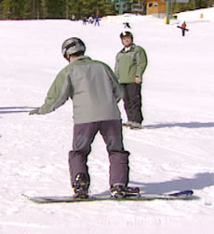 |  | 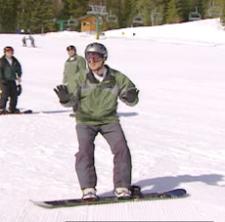

Teaching Points – Directional Changes
- Start by securing the board so that it does not move before the athlete is ready.
- Have the athlete begin in the correct snowboard stance.
- Keep knees flexed and stay in a relaxed position.
- Athlete begins with a straight glide.
- While the snowboard is moving, athlete begins to put pressure on toes.
- As the athlete puts pressure on the toes, the snowboard should make a gradual direction change.
- Once the athlete is comfortable making a toeside direction change, repeat for the heelside direction change: Have the athlete put pressure on the heels while lifting the toes.

Faults & Fixes – Directional Changes

Error | Correction | Drill Reference
Athlete loses balance | Keep knees flexed, bending at the knees and not at the waist  Eyes forward | Gas Pedal Drill
Athlete catches the downhill edge of the snowboard in the snow | Keep knees flexed, weight centered  Athlete should keep pressure on one edge  Eyes forward
Athlete falls into the turn | Keep knees flexed, bending at the knees and not at the waist  Athlete should use gentle pressure, keeping the pressure on one edge

Direction Changes Drills
All the following drills may be introduced first by using the magic stic or giving support with hands if necessary. Please keep in mind that the goal is to reduce the use of aids and have the athlete perform the drills without assistance as soon as possible!

Complete Toeside/ Heelside Direction Change to a Stop Using Pressure Drill
Begin by having the athlete climb a short, gentle slope. Once the athlete has reached the start position, have him or her clip into the front binding while facing uphill. The coach should offer assistance by standing below athlete and taking the athlete’s hands. As the coach, you will need to make sure that the athlete does not start before he or she is ready. Once the athlete is standing, have him or her place the free foot on the stomp pad between the bindings, and allow the board to glide downhill. When ready, release the athlete to complete the glide.

Toeside direction change
Have the athlete begin in a straight glide. When moving, have the athlete apply pressure with the toes (pressing the gas pedal). The board will gradually begin to change direction toward the toeside. Complete the glide to a stop. It will be necessary to spend some time repeating this drill until the athlete has shown good balance throughout.
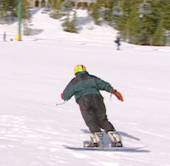

Heelside direction change
Have the athlete begin in a straight glide. When moving, have the athlete apply pressure with the heels (digging heels in). The board should begin to change direction gradually toward the heelside. Complete the glide to a stop. It will be necessary to spend some time repeating this drill until the athlete has shown good balance throughout.
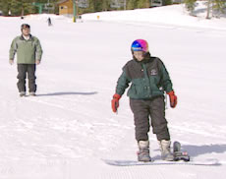

Complete Toeside/ Heelside Direction Change Adding Rotation Drill
Once the athlete can complete a direction change while maintaining good balance and body position, rotation can be introduced to help make the direction change more dramatic. Begin by having the athlete execute a direction change using either toeside or heelside pressure as described above. When the board begins to change direction, have the athlete experiment by slightly rotating the upper body while gliding (watch what happens). When the upper body is rotated in the direction of the turn, the board should begin to make a slightly more dramatic direction change. Stress that the rotation should be a slight movement to avoid catching an edge and falling. Continue to experiment until the athlete can complete the movement comfortably and with good balance.

Complete Toeside/ Heelside Direction Change Toward an Object Drill
Choose an object on the hill such as a sign post, cone, coach, etc. Have the athlete practice turning toward the object using the skills described above. Remember to stress maintaining balance and eye contact with the object. Begin with gliding short distances and gradually work toward gliding greater distances and utilizing turn shapes. Be sure to have the athlete practice turning on both the toeside and heelside, making turns in both directions.
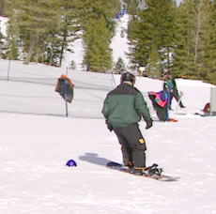

Side Slip
Up until this time, the athlete has been working with only the front foot clipped into the binding. The free foot has allowed the athlete to learn with a measure of safety. Before attempting turns and direction changes with both feet clipped in, the athlete must be introduced to the side slip. There is no gliding wedge position, as in alpine skiing, to slow the athlete down. Speed adjustments and stopping are accomplished with either a turn or a side slip. It is important to introduce the side slip before going any further in the learning sequence.
The side slip position may seem to be the opposite of what you have been teaching so far; however, it will become a useful tool for reducing speed and even stopping. The side slip position is similar to the neutral riding position except that the body is not countered. The feet, hips and shoulders all face in the same forward direction, with the board perpendicular to the direction moved. This position can be introduced and reviewed on a flat area, and then moved uphill.
The side slip, garlands and the J Turn are decisive parts in learning more advanced snowboarding techniques. They also are an important part of snowboarding safely. These techniques allow the athletes to slow their speed and even stop, making it possible to safely handle nearly every slope. The more secure the athletes are in these techniques (especially braking and feeling comfortable with sliding on one edge), the faster they will learn further techniques such as linking or carving turns. More time spent with these basic exercises and drills can save much time later due to falls (catching the wrong edge, for example).

Heelside Side Slip (To be done on a gentle slope)
Begin by having the athlete return to the glide starting point on the hill. Learning to side slip on the heelside is easiest for most people. Have the athlete sit on the snow facing downhill and clip into both bindings. Place yourself on the downhill side facing the athlete. When ready, take both hands and help the athlete into a standing position. Remind the athlete of the proper stance (knees bent, relaxed position, etc). When the athlete is stable, begin to move backward down the hill, bringing the athlete with you. Tell the athlete to lift his or her toes off of the snow. The athlete’s snowboard should be riding on the heel-edge as the athlete moves forward.
It is important to stress that the toeside edge should be kept up to avoid having it catch on the snow causing a forward fall. The movement of the side slip should be a smooth, flowing motion. The athlete may require some practice until jerky movements can be eliminated. A good visualization is to have the athlete pretend that the board is spreading butter in a smooth motion. Repeat this exercise several times until the athlete can move forward (with minor assistance) smoothly without falling.
Once the athlete can side slip smoothly with assistance, it is time to try without. The first few times the athlete attempts to side slip unassisted, the coach should stand downhill facing the athlete, moving backward as the athlete moves forward. This will place the coach in the best place to offer assistance should the athlete need it. This also will offer the athlete a measure of comfort seeing the coach nearby. Monitor the athlete’s progress until he or she can side slip without assistance and without falling.
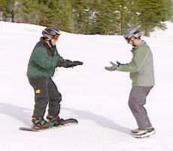

Teaching Points – Heelside Side Slip
- Keep the knees flexed, eyes up.
- Keep pressure on the heelside edge, equally with both feet.
- Release heel pressure SLOWLY; snowboard will begin to move downhill.
- The movement of the side slip should be a smooth, flowing motion.

Faults & Fixes – Heelside Side Slip

Error | Correction | Drill Reference
Athlete falls backward | Keep knees flexed | Offer hand assistance  More support with magic stik
Athlete catches front edge (downhill edge) of snowboard in snow | Keep constant pressure on heelside edge  Move to slightly steeper slope  Have the athlete grasp the snow with his or her toes
Athlete slips too fast | Apply more pressure on heelside edge  Have the athlete grasp the snow with his or her toes
Nose or tail of the snowboard turns into the fall line | Keep equal pressure on both heels

Toeside Side Slip (To be done on a gentle slope)
The toeside side slip is more difficult than the heelside for two reasons: The toeside side slip is done in reverse with the athlete’s back facing downhill, and typically balance is easier to maintain when standing on the heels. Begin at the same starting point used previously. Have the athlete clip into the board, then turtle roll into a kneeling position facing uphill. Stand above the athlete and take both hands. Assist the athlete into a standing position. Take a moment to remind the athlete of the correct body position. Tell the athlete to raise his or her heels off of the snow. When ready, assist the athlete downhill, with athlete moving backward as you move forward. The snowboard should be riding on the toeside edge while the heelside edge is up off the snow. Repeat this exercise until the athlete can perform the side slip smoothly and with good balance.
Once the athlete has shown good balance, it is time to try the side slip unassisted. As the athlete performs the toeside side slip, walk behind (uphill) to offer assistance if necessary.
Note: Both side slips should be practiced until the athlete can perform them smoothly and without assistance.
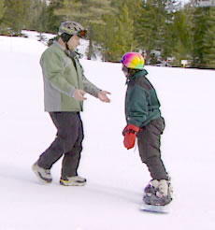

Teaching Points – Toeside Side Slip
- Keep the knees flexed, eyes up.
- Keep pressure on the toeside edge, equally with both feet.
- Release toe pressure SLOWLY; snowboard will begin to move downhill.
- The movement of the side slip should be a smooth, flowing motion.

Faults & Fixes – Toeside Side Slip

Error | Correction | Drill Reference
Athlete falls forward (uphill) | Keep knees flexed  Don’t bend at the waist | Offer hand assistance  More support with magic stik
Athlete catches back edge (downhill edge) of snowboard in snow | Keep constant pressure on toeside edge  Move to slightly steeper slope
Athlete slips too fast | Apply more pressure on toeside edge
Nose or tail of the snowboard turns into the fall line | Keep equal pressure on both toes

Side Slip Drills

Elevator Drill
Place a line of cones or other markers in two vertical lines approximately six to eight feet apart, creating a corridor down the slope. Have the athlete practice maintaining a side slip within the corridor (like an elevator moving up and down). Have the athlete practice with both the heelside and toeside until each can be completed with good balance and body position.

Side Slip with Foot Movement Drill
When the athlete can complete the side slip with good balance and body position, introduce foot movement. While hand-assisting the athlete, have him or her initiate the side slip as described above. When the board is moving downhill, have the athlete experiment by pressuring first one foot, then the other. Always remind the athlete to return to a balanced and centered position before pressuring the other foot. Unequal amounts of pressure will cause the board to begin to change direction and will affect how the athlete maintains his or her balance. Have the athlete experiment with varying amounts of foot pressure while maintaining proper body position. Be sure to practice on both the heelside and toeside.
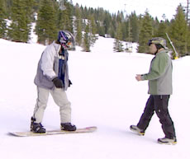

Side Slip with Changing Speeds Drill
Have the athlete slip down the slope while consciously changing velocities by varying the amount of edge used. This should be done in a rhythmical order in response to commands given by the coach.

Side Slip in a Small and Tall Position Drill
Have the athlete do some side slips in “small and tall” position.
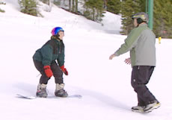

Side Slip to Falling Leaf Drill
Place a line of cones in two vertical lines to make a course that moves down the hill in both directions (not in a straight downhill as in the Elevator Drill). The cone line should look like a snake, forcing the athletes to side slip to the side as well as vertically. The cones should be placed in such a way that it is still possible for the athlete to move vertically if necessary.

Falling Leaf (To be done on a gentle slope)
The Falling Leaf is named because the movement of the boarder will resemble the movement of a leaf as it falls from a tree. The objective of this drill is to introduce movements that will allow the athlete to begin changing direction while controlling his or her speed.
SAFETY NOTE: This skill involves movement across the hill. Be sure to check for other snowboarders and/or skiers that may be on the slope.

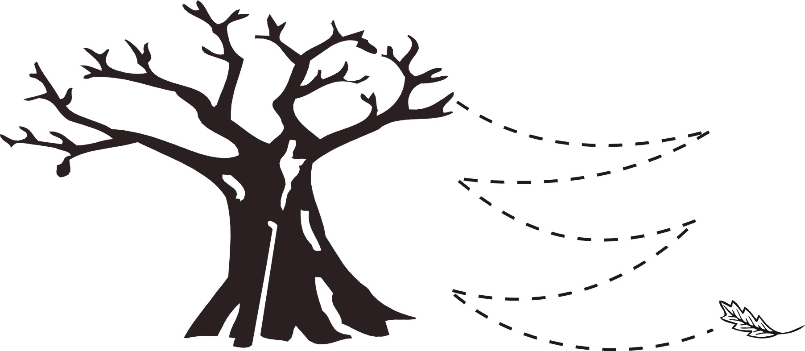
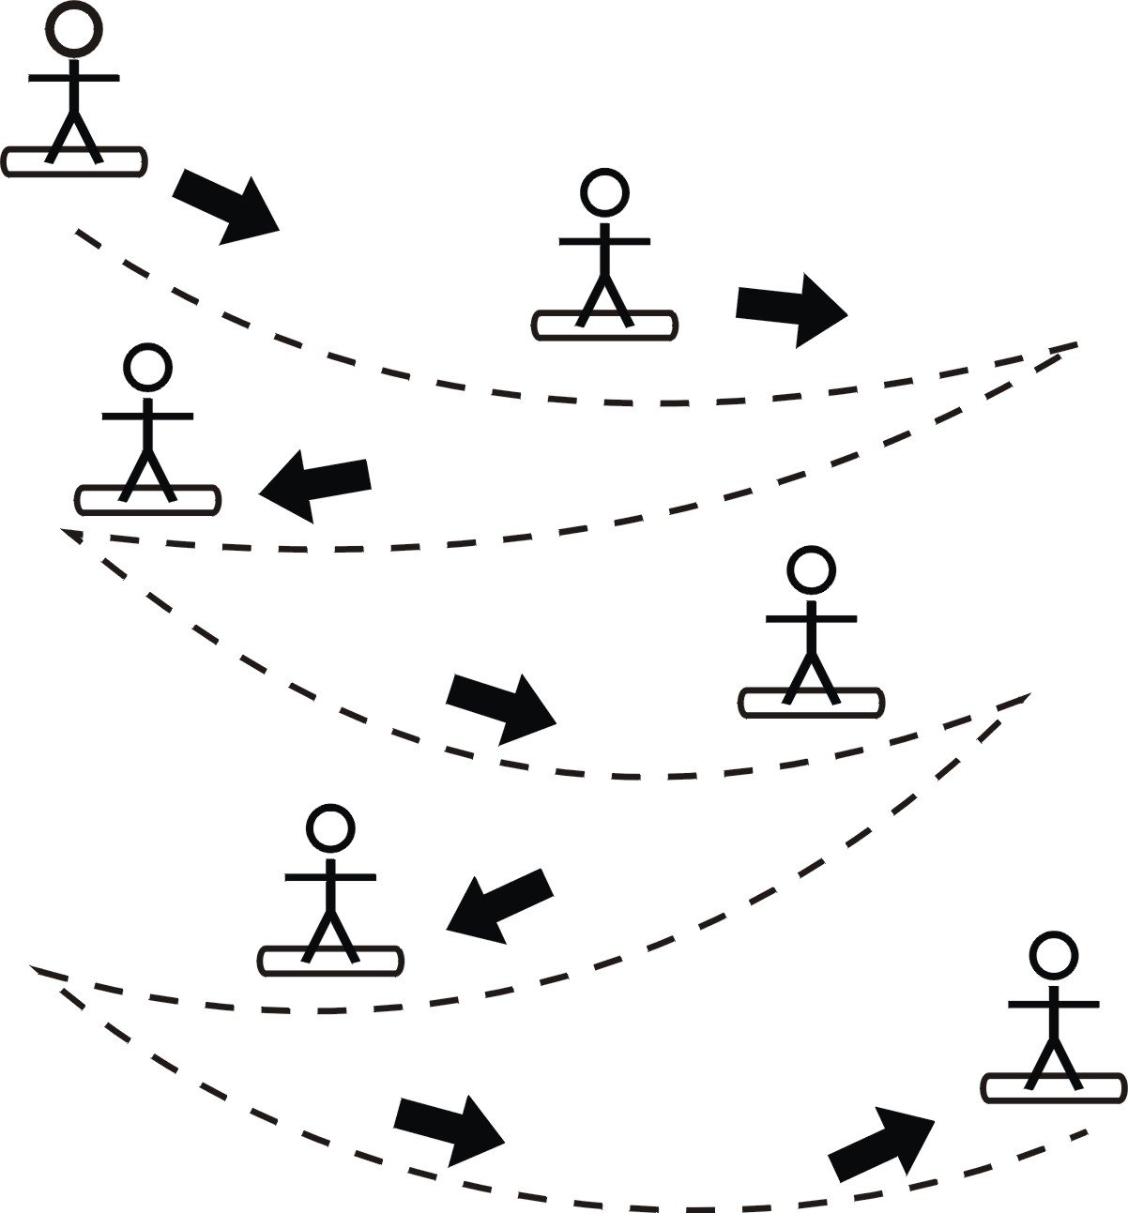

Heelside Falling Leaf
Do not introduce this skill until the athlete has developed the ability to perform both the heelside and toeside side slips with good balance. Before initiating the drill, review a properly balanced and centered stance as well as how speed can be controlled by utilizing the edge of the board. Begin by hand-assisting the athlete as he or she performs a heelside side slip. As the athlete moves forward, begin to have him or her apply more pressure to one foot. Remind the athlete to use the edge of the board to keep from picking up too much speed. Ask him or her to notice what happens. As more pressure is applied, the board will begin to move in that direction. When the athlete’s stance is returned to the center with weight equally distributed, the board will begin to travel in a straighter line forward down the hill.
While hand-assisting the athlete performing a side slip, have him or her apply slight pressure to one foot. As the board begins to change direction (the board will begin to move across the hill rather than down), ask the athlete to return to a centered stance with balance equally distributed on both feet. Once the board is centered and moving straight downhill, have the athlete apply pressure to the opposite foot, followed by returning to center. By alternating pressure to each side and back to center, the athlete’s board will begin to follow the “falling leaf” pattern down the hill. As the athlete becomes comfortable with the movement, ask him or her to begin experimenting with the amount of pressure used, each time returning to center. Offer progressively less hand assistance as the athlete becomes more proficient with the movement, but walk in front of the athlete so that assistance can be offered if necessary and to help slow the athlete if he or she begins to lose control. Be sure to practice pressuring in both directions across the hill.
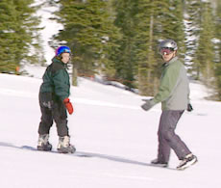

Teaching Points – Heelside Falling Leaf
- Start with knees flexed, eyes up.
- Begin with pressure on the heelside edge, equally with both feet.
- Have the athlete slowly shift the weight toward the nose or the tail of the snowboard, looking in the direction of travel.
- Release heel pressure SLOWLY; snowboard will begin to move downhill in a diagonal direction.
- The movement of the snowboard should be a smooth, flowing motion.
- Once the athlete is comfortable moving in one direction, have him or her move in the opposite direction.
- Continue alternating directions down the hill.

Faults & Fixes – Heelside Falling Leaf

Error | Correction | Drill Reference
Athlete’s snowboard spins down the fall line | Keep the shoulders more square going down the hill  Maintain heelside edge pressure  Don’t shift too much weight on one foot  Remind the athlete not to over-rotate while turning
Athlete falls backward | Keep knees flexed | Offer hand assistance  More support with magic stik
Athlete catches front edge (downhill edge) of snowboard in snow | Keep constant pressure on heelside edge  Move to slightly steeper slope
Athlete slips too fast | Apply more pressure on heelside edge

Toeside Falling Leaf
Once the athlete has become familiar with the falling leaf movement utilizing the heelside edge, begin to practice the movement utilizing the toeside edge.
Important! Please remember to take extra care when teaching the toeside falling leaf. While performing the toeside falling leaf, the athlete will be traveling with his or her back facing downhill, increasing the risk of potential injury. Achieving success with the heelside falling leaf may make the athlete anxious to rush into trying the same movement on the toeside. Be careful to start slowly and progress as the athlete becomes more comfortable with the movement.
Begin with a review of the balance progression, and practice with a straight toeside side slip. When the athlete has re-familiarized himself or herself with the side slip motion, begin to have him or her experiment with applying pressure in the same manner that was used while performing the falling leaf on the heelside.
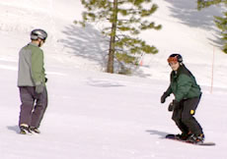

Teaching Points – Toeside Falling Leaf
- Start with knees flexed, eyes up.
- Begin with pressure on the toeside edge, equally with both feet.
- Have the athlete slowly shift the weight toward the nose or the tail of the snowboard, looking in the direction of travel.
- Release heel pressure SLOWLY; snowboard will begin to move downhill in a diagonal direction.
- The movement of the snowboard should be a smooth, flowing motion.
- Once the athlete is comfortable, have them move in the opposite direction.
- Continue alternating directions down the hill.

Faults & Fixes – Toeside Falling Leaf

Error | Correction | Drill Reference
Athlete’s snowboard spins down the fall line | Keep the shoulders more square going down the hill  Maintain toeside edge pressure  Don’t shift too much weight on one foot  Remind the athlete not to over-rotate while turning
Athlete falls forward (uphill) | Keep knees flexed  Don’t bend at the waist | Offer hand assistance  More support with magic stik
Athlete catches back edge (downhill edge) of snowboard in snow | Keep constant pressure on toeside edge  Move to slightly steeper slope
Athlete slips too fast | Apply more pressure on toeside edge

Falling Leaf Drills
All the following drills may be introduced first by using the magic stic or giving support with hands if necessary. Please keep in mind that the goal is to reduce the use of aids and have the athlete perform the drills without assistance as soon as possible!

Snake Drill
Place cones in two vertical lines to make a course that traverses down the hill in both directions. The cone line should look like a snake, forcing the athlete start to side slip to the side as well as vertically. The cones should be placed in such a way that it is not possible for the athlete to move vertically.
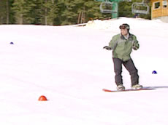 |  | 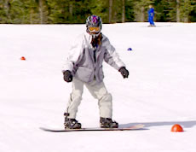

Slide to a Point Drill
Set different points (cones) on the slope the athletes should slide to.

Up and Down Drill
Have the athletes rise and sink (small and tall) while sliding to one side.
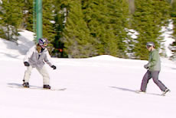

Slide after the Leader Drill
Have the athletes slide after the coach or after each other.

Slide Along a Line of Cones Drill
Have the athletes slide along a line of cones to a certain point and then back along the other side.

Garlands (To be done on a gentle slope)
Garlands are named after the pattern that they make in the snow resembling a garland on a Christmas tree. The purpose of the garland is to teach the athlete board control: edge control, balance, speed control by releasing and engaging the edge while traveling across the hill in the same direction.
SAFETY NOTE: This skill involves movement across the hill. Be sure to check for other snowboarders and/or skiers who may be on the slope.

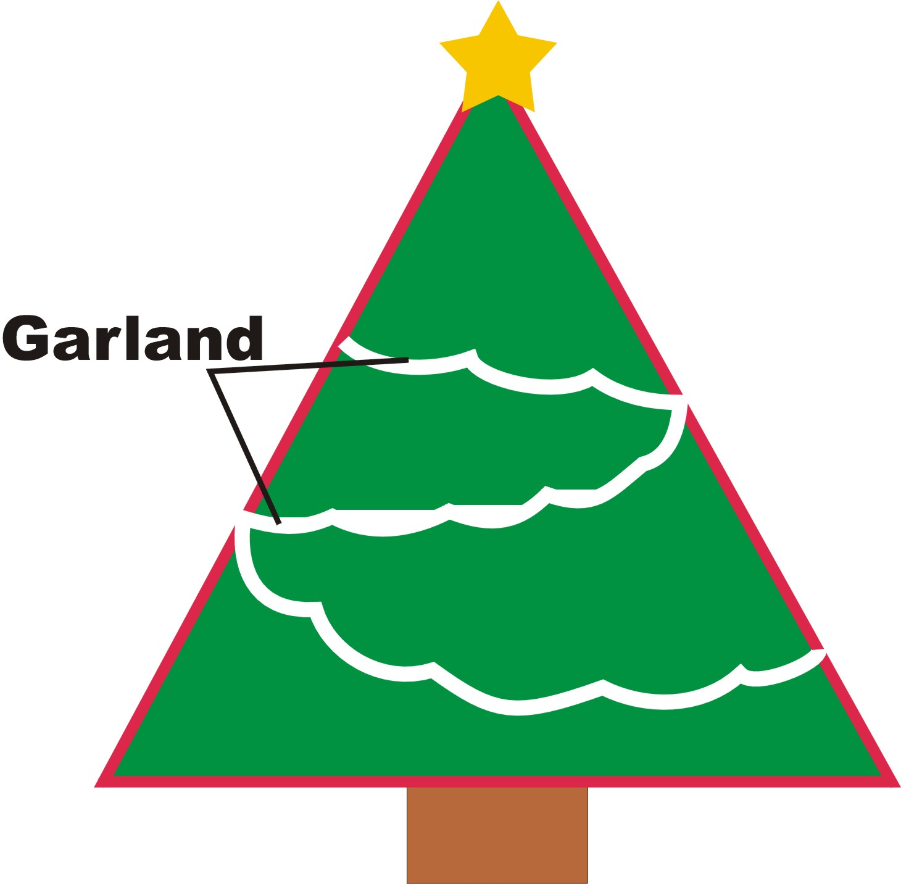
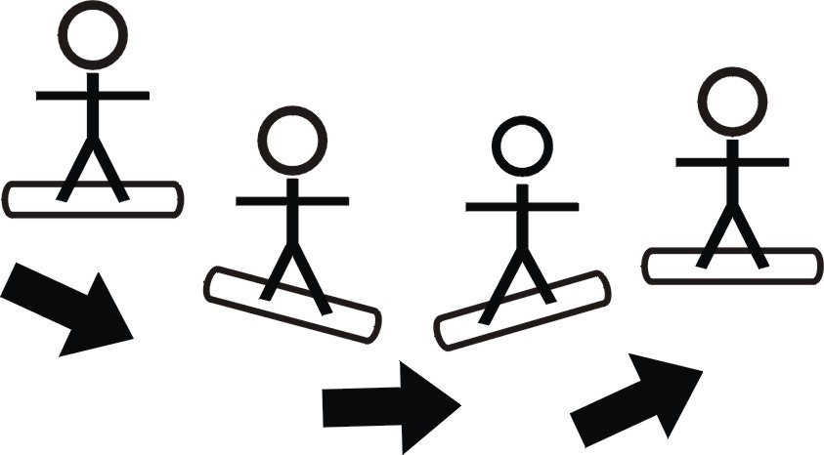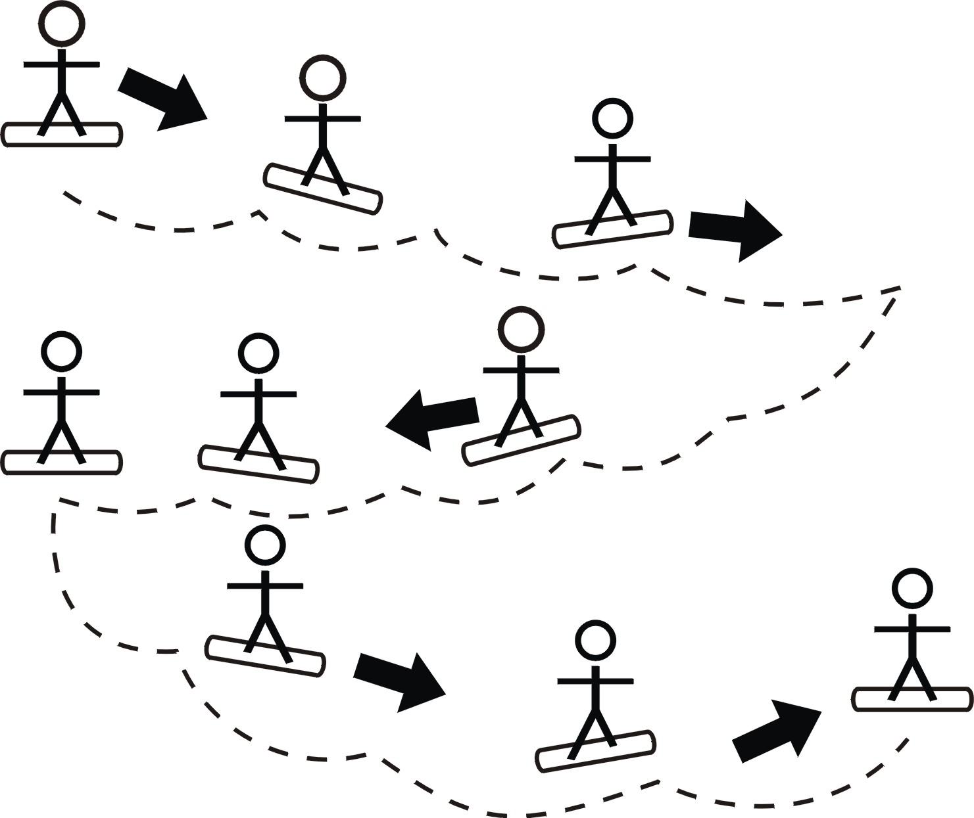

Assisted Garlands
Important! The garland should first be taught with some assistance from the instructor. This can be done similar to the falling leaf, with the instructor standing slightly in front of and down the hill from the athlete, with hands outstretched toward the athlete for the heelside turn and slightly in front of and uphill from the athlete for the toeside turn. The athlete should have the hands outstretched in front, reaching for and/or touching your hands.

Heelside Garlands
Explain to the athlete that a garland is started with the same shifting of weight to the front foot as in the falling leaf. Remind the athlete how speed can be controlled by using different amounts of edge pressure. As the board begins to slide to the side and down the hill, have the athlete move the weight back to the center of the board and look up the hill to a spot. This will cause the athlete to rotate slightly, and the board will turn up the hill and slow to a stop. When the momentum of the snowboard has stopped, the athlete should move the weight over the front foot and let the nose of the board slide back down the hill, starting the process over again. This cycle should be repeated until the athlete is all the way across the hill. At this point the same skill should be practiced moving across the hill in the opposite direction. As the athlete becomes more familiar with the skill, provide less support until the athlete can complete the skill with no assistance.
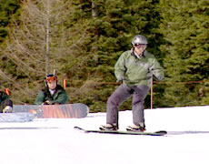

Teaching Points – Heelside Garlands
- Start with knees flexed, eyes up.
- Begin with pressure on the heelside edge, equally with both feet.
- Have the athlete slowly shift the weight toward the nose of the snowboard, looking in the direction of travel.
- Release heel pressure SLOWLY; snowboard will begin to move downhill in a diagonal direction.
- The movement of the snowboard should be a smooth, flowing motion.
- Repeat the garland process across the fall line, until you run out of room.
- Repeat the garland process in the opposite direction using the same edge.
- Continue alternating directions down the hill.

Faults & Fixes – Heelside Garlands

Error | Correction | Drill Reference
Athlete’s snowboard spins down the fall line | Keep the shoulders more square going down the hill  Maintain heelside edge pressure  Don’t shift too much weight on one foot  Remind the athlete not to over-rotate while turning
Athlete falls backward | Keep knees flexed | Offer hand assistance  More support with magic stick
Athlete catches front edge (downhill edge) of snowboard in snow | Keep constant pressure on heelside edge  Move to slightly steeper slope
Athlete slips too fast | Apply more pressure on heelside edge  Have athlete flex knees more

Toeside Garlands
This drill is done in the same way as the heelside garland but on the toeside of the board.
Important! Please remember to take extra care when teaching the toeside garland. While performing the toeside garland, the athlete will be traveling with his or her back facing downhill, increasing the risk of potential injury. Achieving success with the heelside garland may make the athlete anxious to rush into trying the same movement on the toeside. Be careful to start slowly and progress as the athlete becomes more comfortable with the movement.
Begin with a review of the balance progression, and practice with a straight toeside side slip. When the athlete has re-familiarized himself or herself with the side slip motion, begin to have him or her experiment with applying pressure in the same manner that was used while performing the garland on the heelside. As the athlete becomes more familiar with the skill, provide less support until the athlete can complete the skill with no assistance.
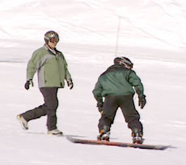

Teaching Points – Toeside Garlands
- Start with knees flexed, eyes up.
- Begin with pressure on the toeside edge, equally with both feet.
- Have the athlete slowly shift the weight toward the tail of the snowboard, looking in the direction of travel.
- Release heel pressure SLOWLY; snowboard will begin to move downhill in a diagonal direction.
- The movement of the snowboard should be a smooth, flowing motion.
- Repeat the garland process across the fall line, until you run out of room.
- Repeat the garland process in the opposite direction using the same edge.
- Continue alternating directions down the hill.

Faults & Fixes – Toeside Garlands

Error | Correction | Drill Reference
Athlete’s snowboard spins down the fall line | Keep the shoulders more square going down the hill  Maintain toeside edge pressure  Don’t shift too much weight on one foot  Remind the athlete not to over-rotate while turning
Athlete falls forward (uphill) | Keep knees flexed  Don’t bend at the waist | Offer hand assistance  More support with magic stick
Athlete catches back edge (downhill edge) of snowboard in snow | Keep constant pressure on toeside edge  Move to slightly steeper slope
Athlete slips too fast | Apply more pressure on toeside edge  Have athlete flex knees more

Garland Drills

Garland after the Coach Drill
Have the athlete perform garlands while following the coach. The coach can give advice and encouragement during this.

Garland with Rotation Drill
Adding shoulder rotation to the new direction will help the athlete to change to a new direction. For safety, have the athlete practice shoulder rotation first and then add it to the garland. This will help the athlete to finish the first garland movements.

Garland on Command Drill
Have the athletes practice some garland turns on command.

Fakie Garland Drill
Have the athletes try making garlands while riding fakie (backward). They already should have some practice riding fakie from the falling leaf drills. Practicing while riding fakie will help with practicing balance, and will help them when learning to ride fakie later.
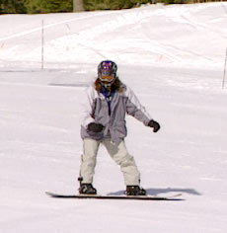

Straight Glide Review, with Both Feet Clipped In (To be done on a gentle slope)
Up to this point the athlete has been learning to control the speed and move across the hill. He or she will now have to get comfortable once again with moving straight down the hill with both feet buckled. The following drills should be performed at the bottom of a hill where there is a large flat area that the athlete can use to coast to a stop before picking up too much speed. Have the athlete buckle in both of the feet, and assist with pointing the board straight down the fall line. Use your foot as a stop in front of the nose to keep the athlete from sliding down the hill. Once he or she is in the proper stance you can move your foot and allow the athlete to coast down the hill to a stop while maintaining balance and athletic position. Once the athlete is comfortable going straight, the coach can start the drill with the athlete standing across the fall line instead of pointing down the fall line. Have the athlete start the downhill straight glide by moving the weight over the front foot and letting the nose of the board slide down the hill until moving in a straight line down the hill. Have the athlete do this numerous times until comfortable going from a standing position on the hill to a gliding run down the hill on their own.

Straight Glide to Turn, or J-Turn (To be done on a gentle slope)
Once the athlete is comfortable with the straight glide with both feet attached to the board, turns can be introduced again. The following skills should be performed on the lower slope of a hill where there is a large flat area that the athlete can use to coast to a stop before picking up too much speed. Use your foot as a stop in front of the nose to keep the athlete from sliding down the hill. Once he or she is in the proper stance, you can move your foot and allow the athlete to coast down the hill while maintaining balance and athletic position. Once the board is going straight down the fall line, the athlete should press gently on the toes and look up the hill in the direction he or she wants to go. This will cause the board to edge and turn slightly. As the board begins to turn, the athlete should sink down by flexing the knees while progressing through the turn. The athlete should hold this position until he or she has turned back up the hill and come to a complete stop. During this skill the coach should stay in front of the athlete and to the side toward which the athlete is expected to turn. This allows the coach to continue talking to the athlete and helps to have the athlete focus on the direction that he or she is trying to turn. Once the athlete has come to a complete stop, the process can be repeated with a turn in the opposite direction (heelside) to go back across the hill to the other side. As the athlete gets more comfortable and proficient at controlling speed and stopping, the skill can be started higher up the hill on a steeper slope. It is also a good idea to do several J-turns in a row without stopping between each one, allowing the snowboard to point straighter down the fall line each time (which will result in faster speeds). When the athlete has become comfortable making a J-turn from a straight slide, have the athlete do a J-turn following a slow traverse across the hill.
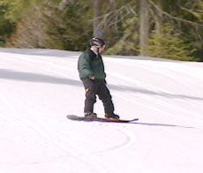

Teaching Points – Straight Glide to Turn (J-Turn)
- Start by securing the board so that it does not move before the athlete is ready.
- Have the athlete begin in the correct snowboard stance.
- Keep knees flexed and stay in a relaxed position.
- Keep feet flat and weight centered (over both feet, front to back and side to side).
- Keep eyes forward, while looking ahead.
- While the snowboard is traveling down the hill, pressure the toeside (or heelside) edge, equally with both feet, while flexing the knees.
- The athlete should continue the turn until the board stops.

Faults & Fixes – Straight Glide to Turn (J-Turn)

Error | Correction | Drill Reference
The snowboard does not turn | Check to see if the athlete is leaning too far back  Apply more pressure to edge of snowboard  Have athlete flex more at the knees
Athlete leans too far back | Review correct snowboard stance  Keep feet flat and weight centered  Start on a more gentle slope so that the athlete does not go too fast  Distribute more weight to the forward foot | Flagpole Drill  Hip to Wall
Athlete catches the downhill edge of snowboard in snow | Keep constant pressure on uphill edge

Straight Glide to Turn (J-Turn) Drills
All the following drills may be introduced first by using the magic stic or giving support with hands if necessary. Please keep in mind that the goal is to reduce the use of aids and have the athlete perform the drills without assistance as soon as possible!

Make J-turn to an Object Drill
After moving in a straight line, have the athlete practice a J-turn toward a person. (This is important, because a person can change position!) It is often necessary to give advice in these moments. Remind the athlete to look and also point at the person toward whom he or she is moving. Later the athlete can make the J-turn toward a cone or other object.

J-turns on Command Drill
Have the athlete ride straight and start initializing the J-turn on command when you call out “Now!”

J-turns by Signal Drill
Have the athlete ride straight and start initializing the J-turn by when you give a non-verbal signal with the hands or a magic stic. This drill will help athletes who still look at their boards while riding.
When the athlete feels comfortable with both sides of J-turns, you can give non-verbal signals to the different sides. The athlete should make the J-turn in the direction the coach points.

Complete Toeside/ Heelside J-turn around an Object Drill
Choose an object on the hill such as a sign post, cone, coach, etc. Have the athlete practice moving downhill, then turning around the object using the skills described above. Remember to stress maintaining balance and looking in the direction of the movement (not at the board or the object). Begin by placing the object a short distance down the hill and gradually begin experimenting with the placement of the object – placing it farther downhill, farther left or right, etc. Placing the object in different locations will force the athlete to complete the drill by varying the size and shape of the turn. Be sure to have the athlete practice turning on both the toeside and heelside edges, making turns in both directions until good balance and proper body position can be maintained throughout.
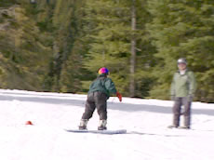

Linking Turns (To be done on a gentle to moderate slope)
Once the athlete is comfortable and proficient making J-turns on toesides and heelsides, he or she is ready to learn how to link these turns together. The athlete has already learned all of the skills needed to make turns. In this process, the athlete is learning to combine the skills he or she already has in order to make continuous toeside and heelside turns down the hill. The athlete should begin by making a J-turn from a traverse. As the athlete finishes the turn and begins to slow to a stop, he or she should rise by straightening the legs and shift some weight to the front foot while reducing the pressure on the edge. At this point the snowboard will point down the fall line and increase speed. The coach should be aware that as the board picks up speed, the athlete may have a tendency to lean back or to get frightened, so be sure to do this in an area where the athlete will not pick up excessive speed. The coach should be downhill and close enough to the athlete during this skill to provide support as necessary. When the snowboard is traveling down the fall line, the athlete should then gently pressure the edge on the opposite side of the board from the turn just completed, i.e., if the first turn was toeside, the athlete should gently pressure the heelside edge for the second turn. It is best to link one set of turns (one in each direction) together and then come to a stop. This will allow the athlete to practice the skill without building up excessive speed. As the athlete becomes more proficient, he or she can be allowed to link several sets of turns together. To practice speed control, have the athlete make large turns that cross the entire run, placing the snowboard across the fall line for a long period of time. Making larger turns will help the athlete to slow down and be more able to control the speed.
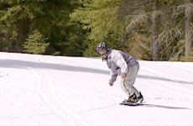

Teaching Points – Linking Turns
- Have the athlete begin in the correct snowboard stance.
- Keep knees flexed into a turn and stay in a relaxed position.
- Keep your eyes forward, while looking in the direction that you want to travel.
- Rise, extend the knees and reduce edge pressure at the completion of the turn to begin the initiation of a new turn.
- While the snowboard is traveling down the hill, pressure the toeside (or heelside) edge, equally with both feet, while flexing the knees.
- The athlete should continue down the hill, linking turns together.

Faults & Fixes – Linking Turns

Error | Correction | Drill Reference
The snowboard does not turn correctly | Check to see if the athlete is leaning too far back  Remind athlete to extend the knees and reduce edge pressure on the snowboard to initiate the new turn  Have athlete flex more at the knees while turning
Athlete leans too far back | Review correct snowboard stance  Keep feet flat and weight centered  Start on a more gentle slope to keep the speed low and to ease any fears  Distribute more weight to the forward foot | Flagpole Drill  Hip to Wall
Athlete catches the downhill edge of snowboard in snow | Keep constant pressure on uphill edge
Athlete counter-rotates | Remind athletes to keep shoulders and hips in line with stance and with the direction that the snowboard is moving
Athlete picks up too much speed | Make bigger (wider) turns  Traverse across the hill  Move to a more gentle slope

Linking Turns Drills

Approach to the Fall Line Drill
Have the athlete ride in garlands and gradually approach the fall line. He or she may become afraid when performing the first movements through the fall line because the board will have a tendency to speed up. Fear can cause the athlete to get out of position because of the tendency to lean back, etc. By introducing the skill gradually, fears can be reduced because the athlete will feel that he or she can always stop the movement. Practice this on both the heelside and toeside.

Linking Turn with Rotation Drill 1
The athlete is already comfortable making garlands. Shoulder rotation to the new direction will help him or her change to the new direction. Have the athlete practice turns using a big shoulder rotation. This will also help him or her to finish the first linked turns.

Linking Turn with Rotation Drill 2
Begin by having the athlete rotate as described in Drill 1. You can offer support by letting the athlete point to the new direction with the front hand. You can also use the magic stic or other training aid as a steering wheel, steering to the new direction. You can also have the athlete practice lifting an object (magic stic, etc,) from one side to the new side, pretend to play baseball or golf to the new direction, etc.

Up and Down while Linking Turns Drill
While preparing for the next turn by riding on heelside or toeside, have the athlete move up and down (small and tall). Rising causes the board to un-weight, releasing the edge. The rising and sinking movements will also help the turns become more automatic.

Cone Drill
Place a series of cones in a line moving downhill approximately 15 to 20 feet apart and in a path approximately 20to 30 feet wide (see picture). Have the athlete practice linking turns by moving around the cones as he or she moves downhill. Begin with one turn in each direction and then increase.

Follow the Leader Drill
Have the athlete practice following in your track as you make a variety of turns while moving downhill. Show the athlete how your snowboard leaves a track in the snow, and ask the athlete to follow in your tracks. Begin with wide slow turns moving across the fall line, and then begin making turns in a variety of shapes and sizes. At the end of each run, ask the athlete how each turn felt and to describe which turns were the fastest or slowest and which felt the most stable. After a few runs, ask the athlete to act as the leader making large turns and controlling his or her speed.
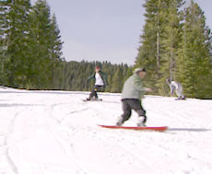
Training aids can also be used during this drill. The use of training aids can have many positive effects:
- Most athletes learn new movements by imitating; they can watch the coach while riding and imitate directly.
- The coach can advise directly during riding.
- The coach can demonstrate good and bad riding examples to show the correct/incorrect movements.
- The athletes learn to turn on purpose (when they have to vs. when it is convenient).
- The athletes learn to ride on a given course (good for race practice).
- The athletes can concentrate on their techniques rather than finding their own way down the slope.
- While riding as a snake, the athletes make each other aware of the rest of the group.

Turning on Purpose (To be done on a gentle to moderate slope)
As the athlete develops the skills that allow him or her to be able to link turns together, the coach should begin to think about introducing racing skills. Turning on purpose is the first step in this sequence. On the race course, an athlete will need to change direction based on the shape of the course and the terrain. Turning on Purpose is just one of the skills that racing skills involves; these can be found in the Racing Skills Section of this guide.

Turning on Purpose Drills

Modified Cone Drill
Set up a series of cones as described in the previous Cone Drill. When the athlete has mastered turning in both directions, vary the size and shape of the course by increasing or decreasing the number of cones, and by varying the distance and/ or width between them. Changes in cone placement will help the athlete learn to make turns of various shapes and sizes, and will teach the athlete to make a turn when needed. Varying the course through which the athlete must turn will help the athlete learn to turn based on the demands of the course rather than simply making turns at random while moving downhill.
Training aids can be used for all of the following drills and offer many positive effects:
- Most athletes learn new movements by imitating; they can watch the coach while riding and imitate directly.
- The coach can advise directly during riding.
- The coach can give good and also bad riding examples to show the correct/incorrect movements.
- The athletes learn to turn on purpose.
- The athletes learn to ride on a given course (good for race practice).
- The athletes can concentrate on their techniques rather than finding their own way down the slope;
- While riding as a snake, the athletes make each other aware of the rest of the group.

Turns into a Funnel Drill
Before setting a slalom course, create funnels out of cones. Have the athlete practice riding into the cone while making a turn.

Turn on Command Drill
Begin by standing downhill from where the athlete will be starting, facing uphill. Have the athlete begin by moving in a straight line downhill. When the athlete is moving, signal or point to the left or right, asking the athlete to turn toward the direction indicated. Repeat this process until the athlete has completed a series of turns of varying shapes and sizes down the hill. As the athlete increases in confidence and skill, change the speed and interval of the commands.

Turns by Signal Drill
Have the athlete begin by riding down the slope while the coach is standing at the bottom. Have the athlete make turns when the coach gives a non-verbal command or signal (hands, magic stic, etc.). This drill is more difficult than the Turn into a Funnel Drill, because the athlete must look up and has to react fast while adjusting to the slope.
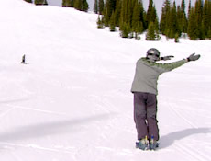

Snowboarding Skills Progression

Your Athlete Can | Never | Sometimes | Often
Perform a correct Skating Technique
Perform a correct Skate to Glide
Perform a correct Climbing Technique
Perform a correct One Foot Straight Glide
Perform a correct Direction Change
Perform a correct Toeside Turn
Perform a correct Heelside Turn
Perform a correct One Foot In Direction Change
Perform a correct Heelside Side Slip
Perform a correct Toeside Side Slip
Perform a correct Falling Leaf
Perform a correct Heelside Falling Leaf
Perform a correct Toeside Falling Leaf
Perform a correct Assisted Garland
Perform a correct Heelside Garland
Perform a correct Toeside Garland
Perform a correct Straight Glide (Both Feet Clipped In)
Perform a correct Straight Glide to Turn (J-Turn)
Perform correct Linking Turns
Perform a correct Turn on Purpose

Totals

Racing Skills

Course Definitions

Slalom
A slalom course will be set up such that the athlete needs to make a series of quick, short- to medium-radius turns while avoiding side slipping. The gates will be fairly close to each other, making edge control very important. Due to the technical difficulty of slalom, it will often take longer to complete than the other races, even when it is a shorter course.

Giant Slalom (GS)
A giant slalom course will be set up such that the athlete needs to make a series of flowing, medium- to long-radius turns. The gates will be spaced farther apart than the slalom course with slower, more fluid edge changes required.

Super Giant Slalom
A super giant slalom course will be set up such that the athlete will need to make a minimal number of turns, taking them slowly across the entire width of the course. The gates will be spaced very far apart with slow, smooth long-radius turns needed.

How to Read a Course

Dry Land
There are a few things that a rider needs to be aware of when looking at a course. They include slope of the hill, terrain features and placement of the gates. Before “slipping the course,” detailed below, the coach should discuss with the athlete how these factors can affect the course.

On-Snow
Before the beginning of each event, the athletes and coaches are allowed to “slip” the course. This means that both athletes and coaches may travel the course but must remain in a sideslip throughout the entire course. Edge changes are permitted, but any race-style practicing will result in a disqualification. The purpose of slipping the course is to let the riders get a feel for the course and decide how they want to approach each turn. As the athlete and coach progress down the course, they should be looking for a couple of things. The first is the rhythm of the gates. This is the downhill distance between the gates and the horizontal offset between the gates. Some may be closer together in one or both of the above aspects, and the rider needs to be aware of these changes to plan turns. The second thing to be aware of is the terrain on the hill as the course progresses. For example, there may be a small roller or hump in the course. If this is present between the gates, it may not affect the shape or timing of the turn. However, if there is a gate on the top of it, the rider may pick up more speed on the down side of the gate and roller, making it harder to complete the turn and get to the next gate. Therefore, the rider may have to adjust the timing of the turn and start it earlier than when going around a gate with no roller. The athlete should become familiar with each part of the course and should have a strategy for finishing the course. This means that the athlete will need to control the speed while navigating the gates. It may even be necessary to use a falling leaf or garland type of turn to make it through an especially steep section of the course.

Race Tactics
The coach and athlete should discuss how the rider approaches running the course. The rider should be in a flexed athletic stance with the arms in front of and close to the body. This allows the rider the widest range of motion and makes it easier to keep in a balanced stance while negotiating the course. The eyes should always be up and focused on the course as opposed to looking down at the snowboard. This will help the rider anticipate and prepare for what is ahead as opposed to reacting to things as they happen. It is very important that the rider knows that the turn should be started before reaching the gate and that the turn should be ending while passing the gate. It is actually advantageous to be in control at all times; speed is not always beneficial if it makes it too hard for the athlete to finish the course. Due to this, there may be sections of the course where it is appropriate to use a falling leaf or a skidded turn.
One last thing to keep in mind as the coach and athlete slip the course is that a snowboarder will take a different route through a course than a skier will. As a snowboarder changes direction, he or she moves out and down the fall line, taking less time and a more curved path to the next gate than a skier.

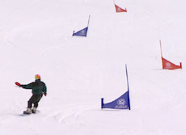 |  | 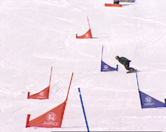
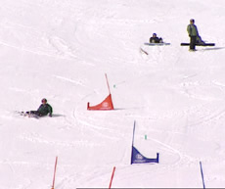

Racing Skills Drills
All drills in the “Turning on Purpose Drills” may also be used as basic drills for practicing race tactics.

Cone Shuffling Drill
This drill can be done on the snow or during the summer on a grassy hill. The coach should set up a series of four to ten cones on a hill, similar to a race course. The coach should then help the athlete read the course while looking at it from the top. Discuss where the turns should be made and what size and shape they should be. The coach can then shuffle sideways down the hill through the course using the line that was discussed with the athlete. The athlete should then do the same thing, and the coach and athlete can discuss what they felt and saw during the drill. This can then be repeated several times, and the course can be changed as needed. The coach should be reminding the athlete to have bent knees, hands up and eyes forward while shuffling through the course.

Practicing in a Race Course Drill
The best way to practice racing is to race. Practicing and refining general snowboard skills is important, but whenever possible it is important to practice those skills under the same conditions an athlete will face in competition. Allowing the athlete to practice making turns under race conditions is the best way to improve times. The best practice is to race in various courses using the same gates, timing system, etc., used in competition; however, access to such equipment is often limited. For those with limited access to equipment, there are some options to help offer a similar experience to athletes.
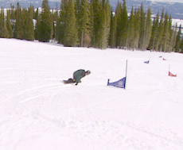

Practice Course Drill
If you do not have access to regular racing gates and other equipment, you can set up a practice course using orange cones, ski poles, etc. The advantage is that you can re-create an environment where the athlete can practice his or her turning skills in a race-type setting without spending a lot of money. Practice courses are also much more portable and do not take as much time and effort to set up. When setting up practice courses, it is important to try to re-create the type of course that the athlete will be facing in competition. Try to give the athlete experience practicing small (slalom) turns, medium (giant slalom) turns and large (downhill) turns. The best way to measure improvement is to time the athlete in each of a series of six to ten runs on the same course. When the athlete has completed the course, take a few minutes to share his or her time and talk about how it felt. You can also share helpful hints for improvement that the athlete can then practice on the next run. Comparison of times between runs can help an athlete see whether or not he or she is improving.
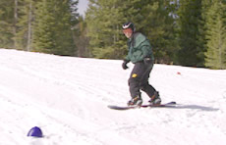

Public NASTAR Racing Drill
Many ski hills offer public NASTAR racing. NASTAR is a system where the general public can sign up and race timed runs in a giant slalom format. While NASTAR only offers giant slalom, it is a good way to give athletes an opportunity to race using the same racing gates, timing system, etc., used in regular competition.

Follow the Leader Drill
The coach should ride a few meters in front of the athletes through the course (best in a giant slalom course). In this way the athlete can see and imitate the best point to change the edges and begin a new turn early, which is most important in racing through poles. Please note that this should be used only to introduce movement through gates, and the athletes should learn to navigate a course on their own as soon as possible.
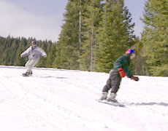

Turning in the Poles on Command Drill
The coach may practice riding parallel to the course and giving the athlete advice on when to turn (“NOW!”). In this way the athlete can more easily determine the proper time to initiate his or her turns. Please note as mentioned above that this should be used only to introduce movement through gates, and the athletes should learn to navigate a course on their own as soon as possible.
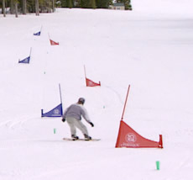

Human Slalom Drill
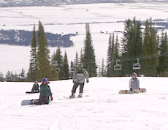 |  | 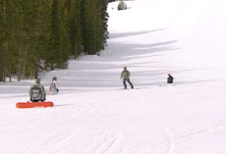

Simulation Competition Drill
Many athletes have a tendency to become nervous in competition and make unforced mistakes. Simulate competition mode as often as possible in training racing skills to allow the athletes to get used to competition moments and pressure.

Special Drill: Playing with Smurfs
Some athletes with perception disabilities may have problems riding through the course on the correct side of the gates (the small side). Practice this on paper: Draw or paint a snowboard course with gates and have the athlete indicate the correct line through it. Athletes can also practice moving a “smurf “or other snowboard model through the course, letting it ride through slalom poles.
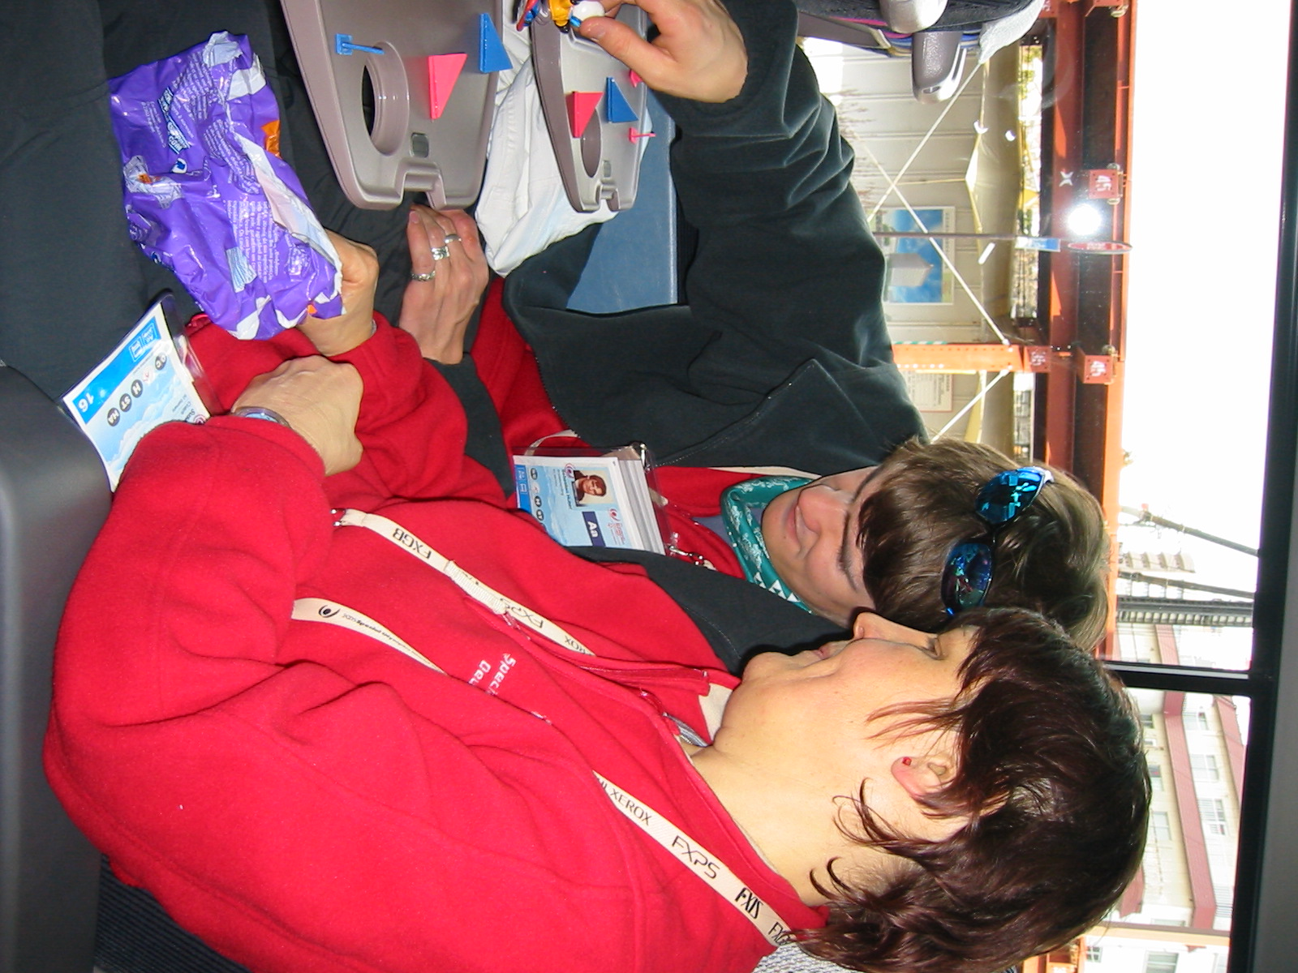
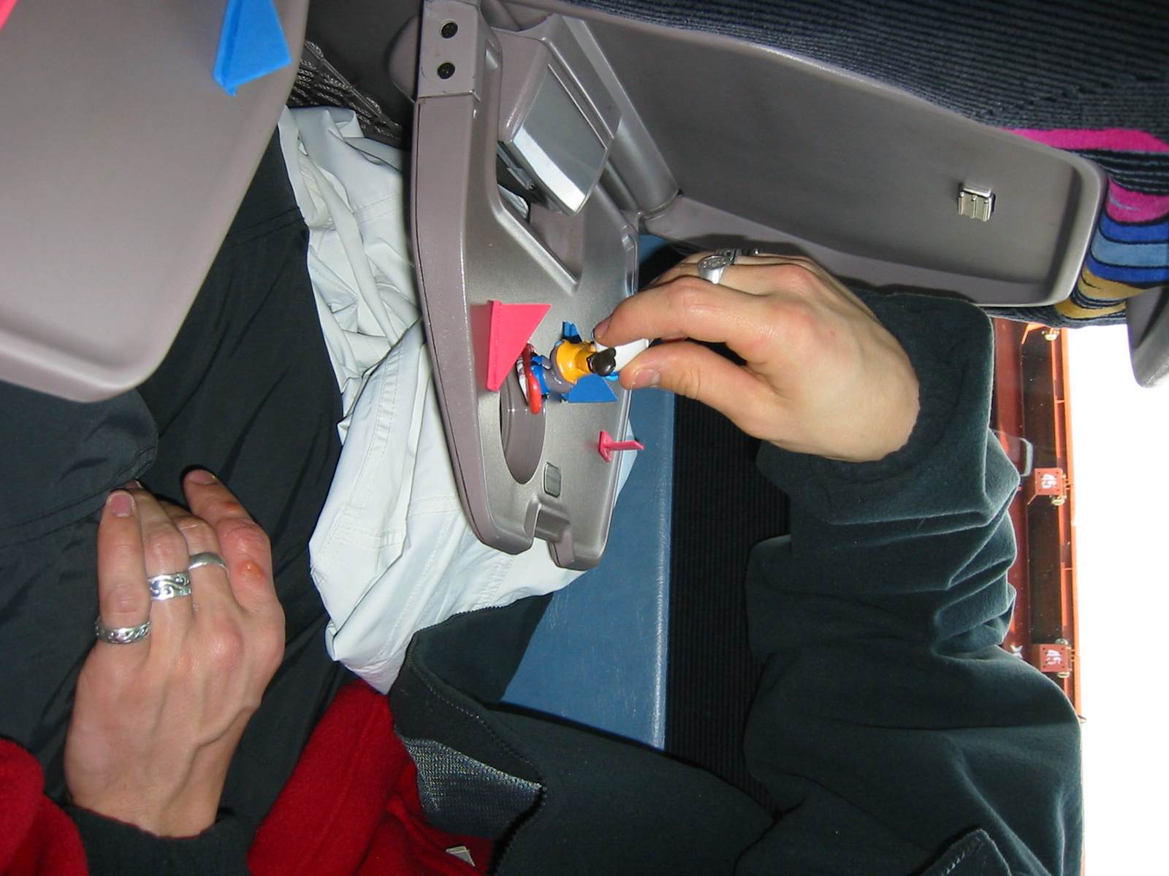

Carving
The turns that an athlete will have learned to this point will most likely be “skidded turns” where the snowboard slides perpendicular to the fall line as the turn progresses. This type of turn is good for controlling speed and is often very comfortable for the athlete to complete. However, a “carved turn” is the most efficient and fast way to come down the hill. In a carved turn, the snowboard remains on its edge throughout the whole turn, and the tail of the board follows the same path through the turn as the nose of the board – as opposed to sliding down the fall line on a lower path than the nose of the board. To make a carved turn, the athlete will need to put more pressure on the edge for a longer amount of time through the turn. A good drill is to have the athlete start on one side of a run and make a single turn to the opposite side of the run, while putting a lot of pressure on the edge and not letting it slip down the hill. To be able to do this, the athlete will have to be in an athletic stance with knees bent and lots of flexion in the ankles. A carved turn will be easy to recognize because the snowboard will leave one track in the snow that is a single thin line. Once the athlete is able to make a single turn like this in both directions, he or she can try to link several carved turns together. To do this, the athlete will have to switch from one edge to the other in a single faster movement. To practice, the athlete can do a small straight glide while quickly hopping from one edge to the other and back again.
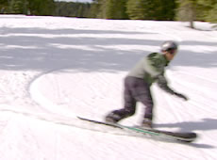

Teaching Points – Carving
- Have the athlete begin by assuming the correct snowboard stance with eyes looking straight forward.
- Make sure the athlete remains loose, keeping the knees flexed.
- Begin by moving down the hill and initiating a turn.
- As the board begins to turn, have the athlete tilt the board on edge by applying pressure with both feet.
- Have the athlete experiment with different amounts of pressure. Explain how different amounts of pressure add different amounts of emphasis to the turn.
- Maintain constant pressure on the edge throughout the entire turn to completion.
- While moving through the turn, concentrate on keeping the board on edge with no sliding.
- Once this can be done consistently for a single turn on the toeside and the heelside, begin linking several turns together.

Faults & Fixes – Carving

Error | Correction | Drill Reference
The board skids while turning | Apply more pressure to edge. Be sure not to rotate excessively at the hips and knees. | Hold The Line Drill  Show Me the Board! Drill
Athlete falls down | Do not try to tip the board at too high of an angle on the edge. Maintain a balanced body position by flexing at the ankles, knees, and hips | Kinetic Chain Drill

Carving Drills

Hold the Line Drill
This drill should be performed on a moderately pitched run with plenty of open space. Begin with a toeside turn. Have the athlete start on the side of the run, with the tip of the board pointing across the slope. Have the athlete begin by allowing the board to start moving downhill and performing one large turn across the hill. While turning, have the athlete tip the board up onto its edge and hold it throughout the turn. Repeat the drill until he or she can complete the turn, making one line across the hill without sliding sideways and making a track in one thin line. When the athlete can complete the drill at slower speeds with no skidding, have him or her practice the drill with more emphasis, allowing the board to move faster before making the large turn. When the athlete has mastered the drill on the toeside, repeat on the heelside.
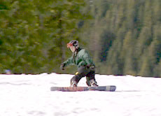

Show Me the Board Drill
Begin by positioning the athlete as if he or she is making a toeside turn. While offering assistance with balance, have the athlete tip the board up onto its edge, “showing” it to the people at the bottom of the hill. Repeat the same process for the heelside. When the athlete is comfortable tipping the board on both the toeside and heelside, stand at the bottom of the hill and watch the athlete make lined turns. During the deep part of the turn, have the athlete show you the bottom of the board while turning, by tipping the board uphill. Tipping the board will help ensure that it is firmly on edge and will add extra emphasis and authority to the turns.

Making Garlands while Carving Drill
To help the athlete become familiar with his or her first experiences while riding on the edge, have the athlete make garlands again while practicing carving. Emphasize the importance of using the edge. Remind the athletes to ride in a position with knees bent and body compact. Start with toeside garlands. Later, while practicing linked carved turns, have the athlete do big turns and long traverses to emphasize standing on the edge.

Kinetic Chain Drill
When an athlete is snowboarding and making turns, the entire body works together in what is referred to as a Kinetic Chain. Each body part is connected to another, forming a chain. All of the body parts are connected to each other, and movement in one body part affects other parts linked by the kinetic chain. This drill is designed to isolate the body parts to show the athlete how each part affects the others, and then puts all of the movements back together to perform turns.
This drill should be performed on a moderately pitched slope with plenty of open space. The idea is to add emphasis to turns while isolating different body parts individually and examining their effect on the turn. Begin by having the athlete move down the hill making turns, while keeping the body stiff and maintaining a strong edge with as little skidding as possible. After completing several linked turns, have the athlete complete several turns while flexing at the ankles. After several turns, stop and discuss the difference and how the turns felt. Repeat if necessary until the athlete can feel the difference made by flexing the ankles. Then, have the athlete complete several linked turns while flexing only at the knees. When the athlete has completed several turns, discuss how the turns felt and how they were different than those made when just the ankles were flexed. Finally, have the athlete make a series of turns using the knees and ankles together, and discuss how they felt. Making turns with body parts isolated will demonstrate how much more effective turning is when all of the body parts work together. Spend some time afterward making several runs and experimenting with putting emphasis on different body parts. Experimenting on their own will allow the athletes to find out what works for them and to complete turns using all of their body parts together. This will facilitate making stronger, more defined turns in a smooth and relaxed way.

Additional Advice
Athletes who reach this level in snowboarding may require special advice. Here are some tips to emphasize when teaching carving:
- Bend your knees and ride in a compact body position.
- While doing a toeside turn, press your knees to the snow.
- While doing toeside turn, grasp or claw your toes in the snow.
- While doing a heelside turn, pull up your toes to the top of your boot.
- While doing a heelside turn, feel the pressure on the high back of the binding.
- While riding on the edge when making traverses, jump up and practice landing on the edge.
- Emphasize leaning and tipping the board onto the edge during the turn.

Snowboarding Racing Skills Progression

Your Athlete Can | Never | Sometimes | Often
Negotiate a slalom course without falling
Negotiate a giant slalom course without falling
Negotiate a downhill course without falling
Carve a portion of a turn
Complete one carved turn
Complete linked carved turns in succession

Totals

Cool-Down
The cool-down is as important as the warm-up; however, it is often ignored. Stopping an activity abruptly may cause pooling of the blood and slow the removal of waste products in the athlete's body. It may also cause cramps, soreness and other problems for Special Olympics athletes. The cool-down gradually reduces the body temperature and heart rate and speeds the recovery process before the next training session or competitive experience. The cool-down is a good time for the coach and athlete to talk about the session or competition. Note that cool-down is also a good time to do stretching. Muscles are warm and receptive to stretching movements.

Activity | Purpose | Time (minimum)
Slow aerobic jog | Lowers body temperature  Gradually lowers heart rate | 5 minutes
Light stretching | Removes waste from muscles | 5 minutes

Understanding Snowboarding
Do not assume that lower ability players will know even the basic aim of the sport. Such players may have difficulty with simple concepts.

A Typical Training Day

Structure:
- Warm up without the board, stretching.
- Practice one or two runs, getting warmed up on the board. Be sure to remind the athletes to look at the slope and snow conditions.
- Work on technique, correction or race training; introduce only one or two new techniques to keep the athletes from becoming overwhelmed with information.
- Riding together, remind the athletes to keep in mind what they have practiced and to build in the new techniques or corrections.
- Cool down.

Practice Basics for Intermediate Groups
Basics for beginners are listed earlier in the various sections of the coaching guide. For new groups of intermediate/advanced athletes or for reviewing sessions such as the beginning of a new season, try a new area – but be aware of the following aspects:
- Repeat the basics, such as: “What are the slope rules, in which way do I lay my board in the snow, what are the different terms, and what are our rules in our group?”
- Determine the riding level of the group: Ask former coaches or parents, practice games like gliding competitions on a gentle slope that runs out flat, have the athletes pull each other around, etc. Many practice sections involving a group will have to be conducted at the level of the athlete with the lowest ability in order to be offered safely.
- Start from the ability level of the group: You should be able to determine the appropriate slope that they will be able to ride now! Be aware of the fitness level of the athletes, especially at the beginning of the season.
- Keep it short: Be careful not to overdo things during the first training days.
- Always ride with a coach in the front and the back, especially for groups of more than three athletes and/ or groups with new or unfamiliar members.
- Determine a meeting point in case someone becomes separated from the group. Does everyone have a cellular phone? Do you have their numbers? Write down your own cellular phone number on the athletes’ lift tickets!
- If the athletes ride at a higher level, there is no better way of learning and getting secure and feeling comfortable on the board than by riding and anticipating new slopes.
- IMPORTANT! When you start riding new parts of the slope, always tell the members of the group where to stop, such as at the next lift pole or tree.

Cross Training in Snowboarding
Cross training is a modern-day term that refers to the substitution of skills other than the skills directly involved in the performance of the sport. Cross training is mostly used in injury rehabilitation and is now used in injury prevention as well. When athletes sustain injuries in the legs or feet that keep them from training or competing, other activities can be substituted to keep up their aerobic and muscular strength. Cross training for athletes comes in the form of swimming pool workouts, bicycling and athletics.
There is a limited value and crossover to this specific exercise. A reason to "cross train" is to avoid injury and maintain muscular balance during a period of intense sport specific training. One of the keys to success in sports is staying healthy and training over the long haul. Cycling is not the same as snowboarding. But if cycling takes the pressure off shins, knees and hips on a recovery steady-state day, then it will probably make the next snowboarding workout better. Why? Because it keeps athletes injury-free and snowboarding. Cross training allows athletes to do event specific training workouts with greater enthusiasm and intensity and minimal risk of injury.

Swimming Pool Workouts
Have athlete swim or perform running actions in the pool. Have athlete swim at a steady state for a minimum of 2 minutes (aerobic). Using a flotation vest or inner tube, have athlete perform running actions while in an upright position. Use intervals of 30 to 120 seconds with 2:1 rest.

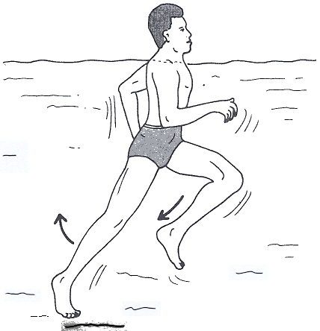

Bicycle Workouts
Have athlete ride a bicycle as interval and steady-state workouts. The athlete uses a stationary bike or spinning bike, doing aerobic and anaerobic workouts. The athlete rides an outdoor bike for 20 minutes to 1 hour at various paces.

Summer Sport Cross Training

Athletics
Athletics is a great sport to keep snowboarders training and competing during the spring/summer season. Several of the basic principles, such as mechanics of running and energy systems, are common between snowboarding and athletics. Athletics and S\snowboarding also share some principles in how their events and competitions are set up.

