

Golf Coaching Guide

Introduction to Special Olympics Golf
Those who play the game of golf are driven to become better players by experience like hitting a tee shot flush one moment and missing a three foot putt the next. Each stroke motivates a golfer to continue the pursuit of better shots and lower scores. For players of any ability, the opportunity to compete provides the single most compelling reason to practice and improve. It stands to reason then, the more you play, the more you practice.
The strategic plan for Special Olympics Golf states that frequent high quality competition opportunities must be provided to stimulate and sustain athlete participation in the game. Special Olympics Golf strives to provide individuals with intellectual disability the opportunity to play and compete like any golfer. From 1995 to 1999 the number of Special Olympics Golfers in the United States doubled from 3,500 to 7,000. Currently there are approximately 8,000 golfers globally participating in 14 nations.
Special Olympics Golf depends on widespread community based support to identify thousands of volunteers, to serve as coaches, playing partners, tournament organizers, and general program administrators. Additionally, financial resources must be secured to sustain existing opportunities and fund program expansion.
The PGA of America (PGA) and the United States Golf Association (USGA) have played a vital role in the development of the Special Olympics Golf program worldwide. Both have sustained the program since the sport was introduced in 1992 with grants from their foundations. Both organizations support worldwide development with links to other professional and amateur associations such as the British PGA and the Royal and Ancient Golf Club of St. Andrews, Scotland.
The Special Olympics Golf program strives to fulfill the mission and philosophy of the Special Olympics movement. It is a sport that can be enjoyed and played by all, regardless of age and ability.
The Game of Golf consists of playing a ball from a teeing ground into a hole by a stroke or successive strokes in accordance with the Rules. It is one of the oldest sports in the world, and was originally played by the kings and noblemen on the sandy links in Scotland. Golf is now played by people of all ages in almost every country. Unlike most sports, you do not have to be big, strong, and fast or part of a team to be successful. Anyone — man, woman, young, old, amateur or professional can enjoy the game of golf.

Attributes of Golf

Individualization
No special physique is required to hit a golf ball, so everyone is free to do it however he/she is able. The philosophy of "I intend to make it work" applies here.

Sociability
Each personality has needs of interacting and fellowship with others, and our game is particularly adaptable to this desire.

Mental Gymnastics
Performance of a physical skill brings great satisfaction to the individual. To some degree decision-making enters into the process, as a result, character building takes place. We must assure that our instructional periods create a sense of accomplishment that is necessity for everyone.

Sportsmanship and a Sense of Belonging
Everyone faces success or failure with each shot. The bad must be accepted along with the good. The need to exhibit self-discipline occurs many times. But remember! Golf is still a game, and should be enjoyed as such.

Acknowledgements
The Special Olympics Golf Coaches and Skills Guide is a resource tool designed to assist Sport Directors, Golf Coaches, Volunteers and Families. Special Olympics wishes to thank the professionals, volunteers and coaches who helped in the revision of this resource. Truly, they have helped fulfill the mission of Special Olympics to provide year-round sports training and athletic competition in a variety of Olympic-type sports for people eight years of age and older with intellectual disability, giving them continuing opportunities to develop physical fitness, demonstrate courage, experience joy, and participate in a sharing of gifts, skills, and friendship with their families, other Special Olympics athletes, and the community.

Authorized by:
Special Olympics Sports, 1325 G Street, NW, Suite 500, Washington, DC, 20005 USA

Contributing authors:
Rick Burton, Special Olympics Golf Skills Guide author, PGA of America
Conrad Rehling, Special Olympics Golf Skills Guide author, Master Professional, PGA of America
Jim Schmutz, Managing Director-Special Olympics-North America
Eric Wilson, Special Olympics Golf Committee Chair, PGA of America
Donna H. White, Golf Manager, Special Olympics Inc., LPGA/PGA member
Dr. Dede Owens, LPGA Past President, author
Venisha Bowler, Competition Manager, Special Olympics Inc.
Annette Lynch, Special Olympics-Maryland
Wanda Durden, Director of Sports, Special Olympics Inc.
Dave Lenox, Vice-President of Sports and Competition, Special Olympics Inc.
Doug McCallister, Director of Publications
Sharon McDonagh, Web Content Manager
Paul Whichard, Sports Resources Web Manager, Special Olympics Inc.
Reuben Silva, GMS Manager, Special Olympics Inc.

Resource Consultants and Technical Assistants:
Thank you to all Special Olympics Managing Directors, Regional Sport Directors, volunteers and families for your input.
Laura Bauwinkle, Physical Education teacher and High School Golf Coach
Ron Backus, Special Olympics-Palm Beach County Golf Coach, FL
Kitty Tierney, Special Olympics-Ireland
Tom Nesbit, Special Olympics-Scotland
Cheryll Wood, United States Golf Association, P.J. Boatwright intern
Mary-Lee Cobick, LPGA/Canadian PGA
Kellie Walls, Special Olympics Inc.

Special Olympics Golf Committee:
Tom Addis, Past President PGA of America
Jeff Beaudry, PGA of America
Rick Burton, PGA of America
Monty Castevens, Executive Director-Special Olympics-Florida
Dr. Trey Holland, United States Golf Association
Dorothy Mastromonaco, United States Golf Association
Karen Moraghan, United States Golf Association
David Normand, PGA of America
Frank Selva, PGA of America
Marty Sheets, Special Olympics Athlete
Dave Sheets, Special Olympics Family
Henry Thrower, PGA of America
Eric Wilson, PGA of America

Video Production:
Denise Jakows, Jakows Productions, Inc.
Bob Gural, Videographer, Editor
Jamie Choban, Special Olympics Florida Athlete
Matt Reiman, Special Olympics Florida Athlete
Wayne Reiman, Special Olympics Florida Athlete
Brooks Koepka, Special Olympics Volunteer
Nichole Johnson, LPGA Apprentice
Brian Vaisnoras, PGA Professional

Golf Coaching Guide

Planning a Golf Training and Competition Season

Table of Contents

Introduction
Golf Goals and Objectives
Benefits of Goal Setting
Setting and Attaining Goals
Building a Practice Schedule
Securing the use of a Facility
Golf Course
Design your own facility (Indoor, Outdoor)
Confirmation of Practice Schedules
Practice Competitions
Samples of Program Schedules
Essential Components of the Training Session
Training Session Plan Template
Golf Training Session Plan Sample
Tips for Conducting a Successful Training Session
Safety Hints for your Session
8 – Week Lesson Plans
Golf Training Log
Weekly Home Training
Practice/Play Note Chart

To go directly to a section, hold down your control key and click on the heading

Planning a Training Season
Special Olympics require that an athlete participate in an eight-week training program before entering a competition. This includes instruction on the basic skills of golf and a Summary of the Rules of Golf. It is up to the individual instructor or coach to plan his or her own eight-week training program using this information as a guideline. Other material related to golf training or golf experience by the instructor is welcomed.

Prior to season you have:
- Recruited athletes and coaches
- Developed your seasonal budget
- Trained Coaches, volunteers
- Hosted a Family Orientation
- Secured a training site
It is suggested that the eight-week training program consist of two practice sessions per week. Each practice should be at least one hour in duration and it is recommended that each practice include the following elements:
- Warm-up session
- Review previous instruction
- Introduce new skills
- Incorporate rules into instruction
- Play a fun game
Ideally, a professional should give supervision of each Special Olympics Golf program, even though volunteers from various sources will probably handle much of the training process.

Considerations:
- Trained personnel must give the volunteers as much instruction as possible.
- This instruction should be perfectly clear and acceptable to each potential instructor.
- Each instructor:
  - Must be comfortable in his/her physical teaching skills
  - Have a high level of enthusiasm
  - Maintain realistic hopes and expectations as to what is to be gained through this process
Because golf is a game where skill may improve with time and practice, it is necessary that we do not raise our expectation to too high a level. But conversely, to enter this training period with very low expectations would be wrong because much improvement can result from inspiration and instruction on the correct level for the individual concerned. If pupil and instructor a like enters this training period with high expectations, the rewards, which may be garnered, are beyond belief.
Review the goals and objectives below. Be prepared to set small goals for your athletes to attain during each session. Assign each assistant coach his or her responsibilities as well so that everyone feels needed and important.

Special Olympics Golf Goals and Objectives

1. Long-Term Goal
Our aim is to impart to the athlete: basic golf skills, acceptable social behavior and fundamental knowledge of the rules of golf to enable him/her to participate in a regulation or modified game of golf.

2. Short-Term Objective
- The instructor will demonstrate and assist the athlete to perform proper golf warm up procedures.
- The instructor will demonstrate and help the athlete to perform the basic skills in putting.
- After a demonstration, the instructor will assist the pupil in practicing the basic skills of the chip shot.
- Follow the same procedure-first demonstrate, and then assist in the skills of the pitch shot.
- Next in the progression follow the skills of the short iron.
- Skills of the long iron shot.
- Skills of the wood shot.
- Time for practice on all of the above shots will vary in length but must be adequate for each athlete. Follow this with inspirational instruction on etiquette and sportsmanship appropriate to the game of golf.

3. Benefits
Golf is recognized as a lifetime sport, one that promotes socialization and enhances self-esteem. Overall motor skills are improved and better physical fitness is a result. Hand-eye coordination is refined, and general body control often is achieved. The joy and gratification of experiencing the achievement of new skills learned or a new performance level reached, will add much to the athlete’s personal satisfaction.

Benefits of Goal Setting
- Prepares the athletes and coaches mentally and emotionally to act out their commitment.
- Expresses confidence.
- Creates a positive self-image that the athlete and coach are in control of improvement and performance.
- Provides a positive focus of energy.
It is the process of attaining the goals rather than winning or losing that is important in golf.

Goals should be:
- Clear
- Reachable
- Realistic

Setting Goals and Attaining Them

Six Step process
Step 1: Know the athlete and your coaches
Step 2: Know the skills required for golf
Step 3: Evaluate commitment
Step 4: Define goals that are realistic yet challenging
Step 5: Plan
Step 6: Evaluate progress

Building a Practice Schedule
Below are factors to consider when planning your training season, schedule and budget.

Safety First

Venue Assessment

The Golf Course, practice areas or playing field
- Turf/Floor Conditions
- Level grade
- Foreign objects
- Obstructions to practice or play area
- Inclement weather options
- Adaptations required to facility (indoor/outdoor)

Equipment

Determine your equipment needs
- Number of clubs and golf balls available per athlete
- Proper size and fit
- Selection Available
- Maintenance
- Storage

Athletes

Focus on Ability
- Know any physical, social, or medical concerns and golf experience of each athlete
- Early in the season it is important to administer the Golf Skills Assessment. This test enables you to determine the ability range of each athlete so you can set personal goals for improvement.
- The physical preparation of the athlete is important. Major fitness components to develop into the training process. Athletes will perform differently to the same training process because of physical and intellectual limitations.
  - Flexibility: Stretching Routine
  - Muscular Fitness: Strength, Endurance, Power, Speed
  - Cardiovascular Endurance

Volunteers
- Golf knowledgeable
- Coaching experience
- Commitment
- Completed training and orientation
- Athlete to Coach ratio

Transportation
Assure athletes and volunteers have transportation to and from sessions

Proper Golf Attire (including footwear)
Confirm appropriate dress code of facility

Securing the Use of a Facility
Assuming you secure the use of a golf facility, it is important to meet with the golf professional or club director to review facility policy and procedures.
- Communicate all policy and procedures for trainings and competitions to athletes, coaches, volunteers and family members.
- Inform and copy all information to your local Special Olympics Coordinator.

Confirm with professional or club director
- Dates and times of trainings and competitions
- Driving Range and practice area rules and regulations
- Provision of equipment
- Storage of equipment
- A designated greeting area for athlete, coaches and volunteer arrival and departure
- Registration procedures for coaches and athlete upon arrival to the course
- Clubhouse Access
- Food and Beverage/Cooler Policy (Many facilities do not allow food and beverage to be brought onto property.)
- Golf Car policy for Coaches and Volunteers
- Access to the Golf Course: Tee time and registration procedures
- A scoring area for athletes that have completed on course play
- Exchange contact information: telephone, e-mail addresses

The Golf Course: Your play or practice field.
In golf every hole has different boundaries and each course is made up of either 9 or 18 holes. All are designed differently; however, every hole does have things in common:
- Starts from a tee (a raised area of grass to begin play)
- Finishes on a green (a closely mowed area that contains a cup and a flagstick)
- The closely mowed grass lying between the tee and the green is called the fairway.
Holes can range anywhere from under 100 to over 500 yards in length and each hole has certain obstacles, such as trees and two kinds of hazards: water and bunkers (some have sand). The recommended hole yardage for each level of the competition is covered in Article IX, Special Olympics Golf in the Special Olympics Summer Sports Rules.
Your athletes will need to develop several skills in order to make the different kinds of shots necessary to score well and have fun on the course. As athletes develop these basic skills, they will become better golfers and take fewer strokes to play each hole.
When assessing or selecting a golf course for your Special Olympics Golf program the total yardage, tee to green accessibility, course rating, slope, location of inclement weather shelters and restroom facilities should also be recognized factors.

Design Your Own Golf Course
Suppose you do not have access to a championship golf course. This does not mean you cannot start your program. You can introduce the game with a little imagination and creativity. A challenging and fun golf course can be created on the school athletic field, playground, at a driving range, or in a gymnasium. The key is effectively utilizing existing space and equipment to create golf shot or course situations.
The course should contain all elements of a regular course, with the exception of a putting green,

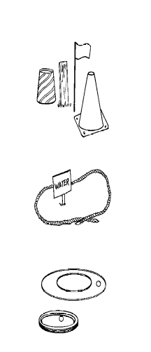
The following suggestions are listed for consideration in planning a limited space golf play area:
- Teeing areas can be easily established by using any kind of markers, such as paper cups, small stakes, flags or pylons,
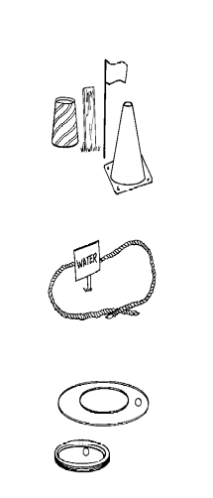
- Hazards of a golf course, including bunkers, lateral water and a sign and an outline of tape, paint or rope can design regular water hazards. If the ball comes to lie within the area, the appropriate golf rule is in effect and the student must play accordingly.
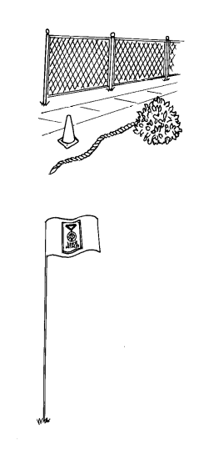
- Greens can be marked with a sign, cone or flagstick and varied in size and shape. Use tape or paint to mark two concentric circles for the "green." Balls landing in the larger circle call for 2 additional strokes in lieu of putting, If only a flagstick is used with no markings, ball is considered holed when within 1 club length from the flagstick. Bicycle tires or hula-hoops can also be used for a target green. Balls must come to rest within the circle to be considered holed out.
- To construct a putting course on grass, use cones or paper cups with flags. Balls hitting the cups or cones are scored as holed putts.
- Boundary lines should be established and marked with small stakes, paint, rope or cones; The use of natural or manmade objects in outside courses, such as trees, bushes, fences and walks can add variety and challenge to your short course.
- The distance of the holes can vary in length depending on the type of ball used and the space available. Students should begin with a plastic or soft ball, such as a tennis ball. As they become more skilled, a golf ball can be introduced in outdoor settings, (Short distance golf balls may be used in Outdoor settings).
- Scorecards for the course should be designed so that students can actually experience the thrill of on-course play and competition.

Indoor Course Options
The modifications for construction of a golf course in a gymnasium or large indoor area as follows:
- The use of a plastic ball or soft ball such as a tennis ball is mandatory in an indoor setting.
- The use of protective material for the floor is essential, Brush mats can be used to protect the teeing areas and small carpet remnants can be used to protect the floor during the fairway shots.
- The green can be a commercial-style putting strip or can be improvised from suitable indoor-outdoor carpeting.
- The ball can be putted into a putting disc or metal cup.
- Use a tape or rope on the floor, mark indoor golf course similar to an outdoor course.
- As a creative indoor golf designer, add variety to your gym layout: use mats for bunkers, chairs for trees, mark water hazards on the floor, and so on.

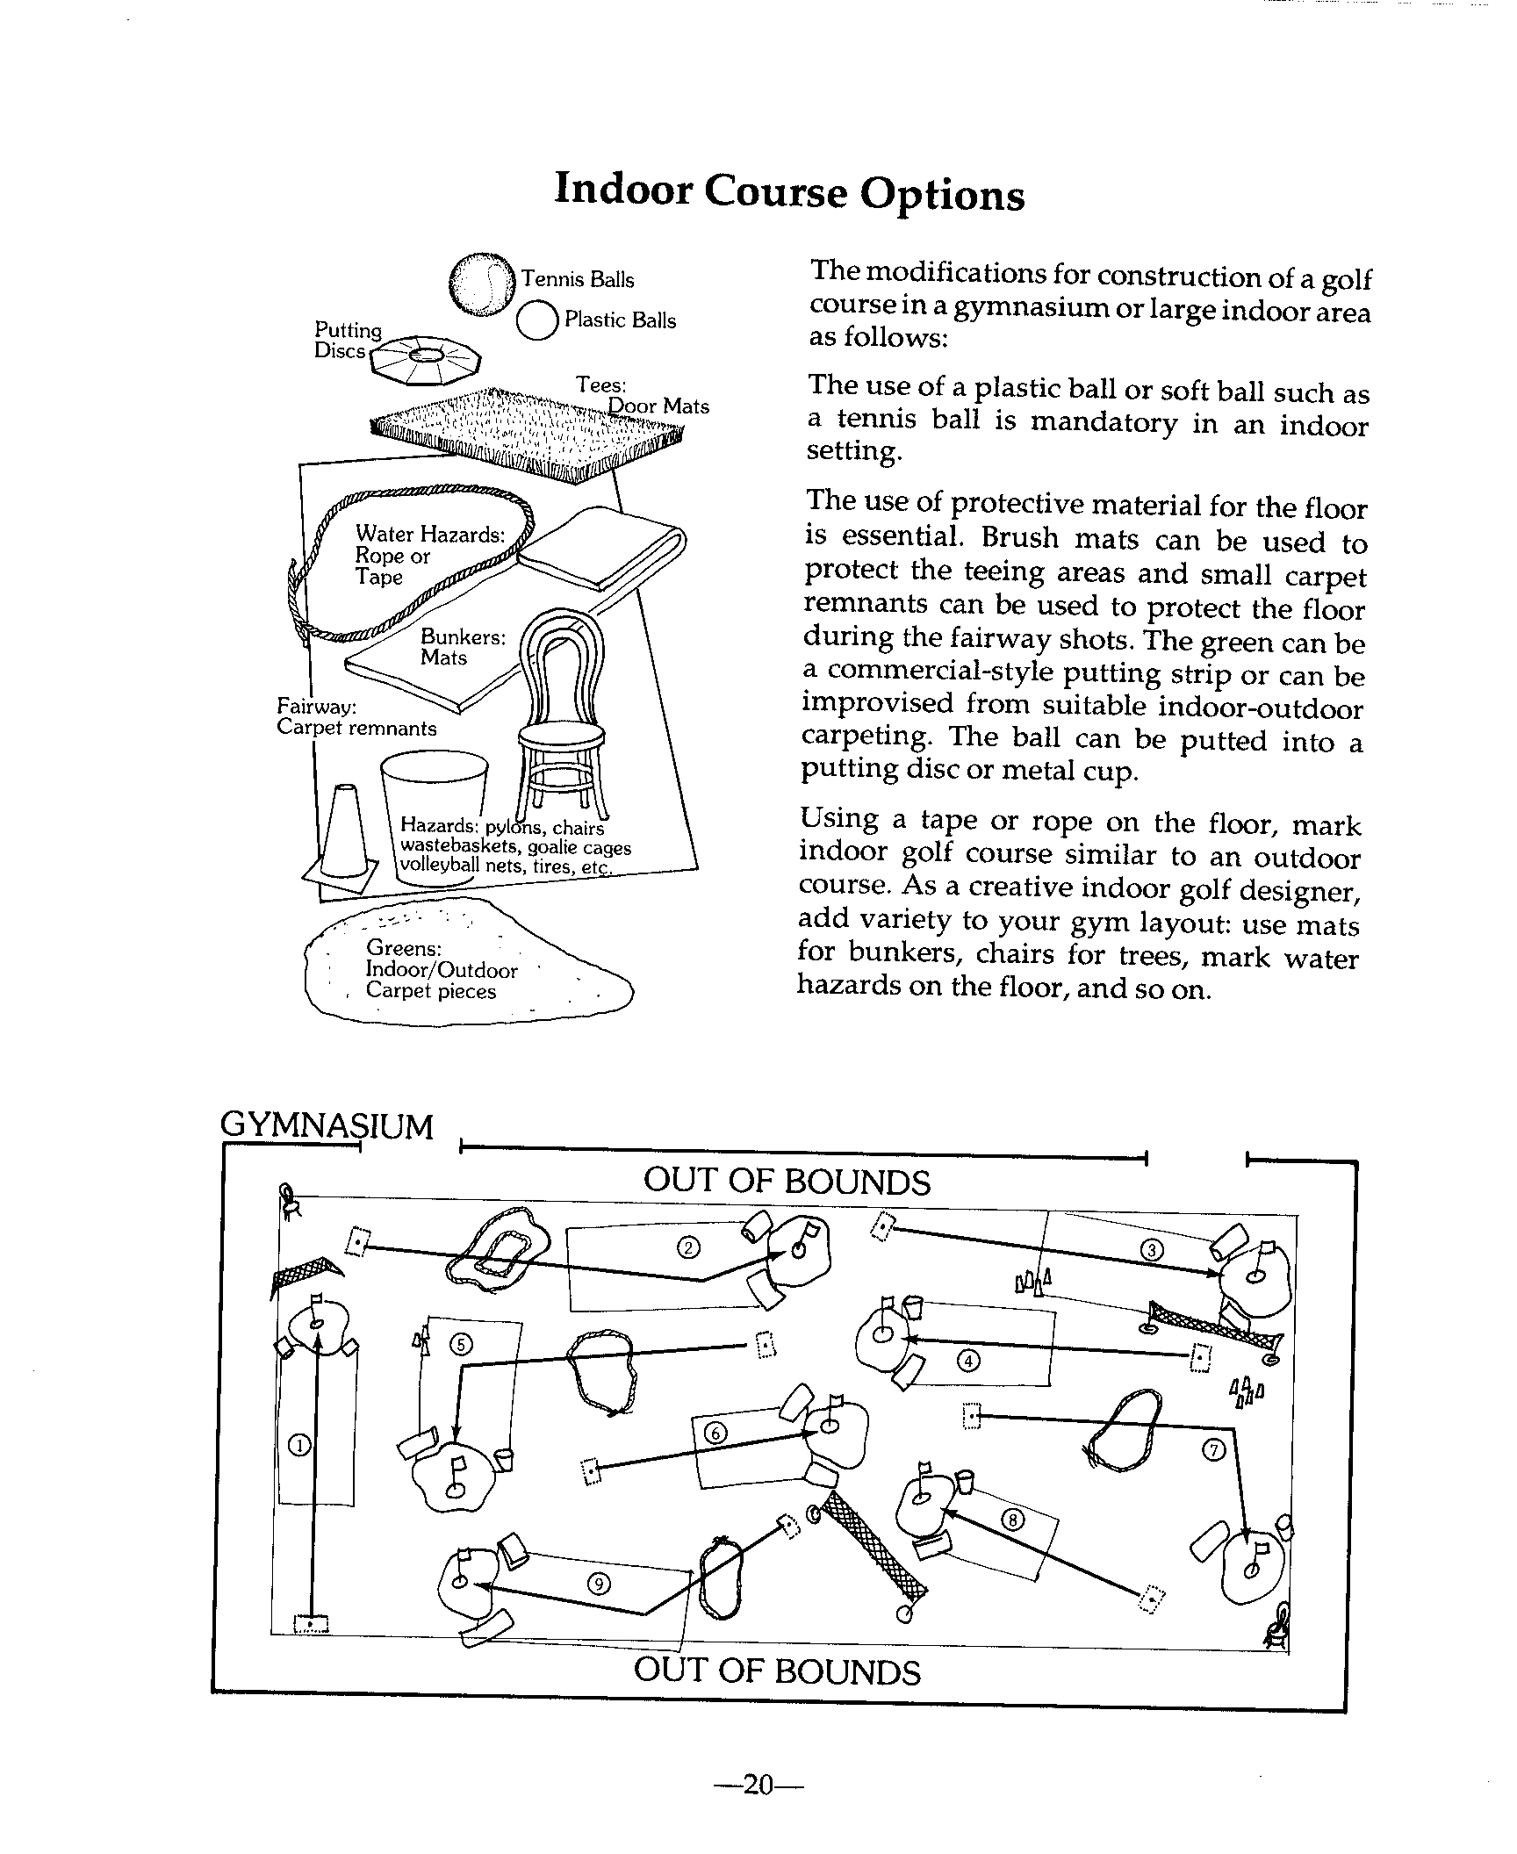

Outdoor Course Options
If an unimproved area is used, you may consider designing some actual golf holes.
- We recommend a using a cup hole twice the size of a normal cup. These larger holes would have an 8 '1 /2 inch diameter and be 4 inches deep (or about the size of a #'10 can). Insert a dowel rod with a flag attached, and you have a golf hole!
- The enlarged cup will accommodate the use of a lofted club in getting the ball into the cup. This is more effective than attempting to use a putter on ungroomed surfaces. Be sure that the holes are marked so that they do not become a hazard when your course is not in use.
- If mowing equipment is available, cut the grass to a height of '1 /2 inch. Sand will help smooth the surface. Although this putting area will not be maintained in the same condition as a green, it will allow for students to get the feel and experience of putting.
- Short-distance golf balls, which have been recently introduced, can create a more realistic round of golf by requiring the use of a greater variety of clubs. These balls are not designed to substitute for plastic balls or whiffle balls in an indoor situation.
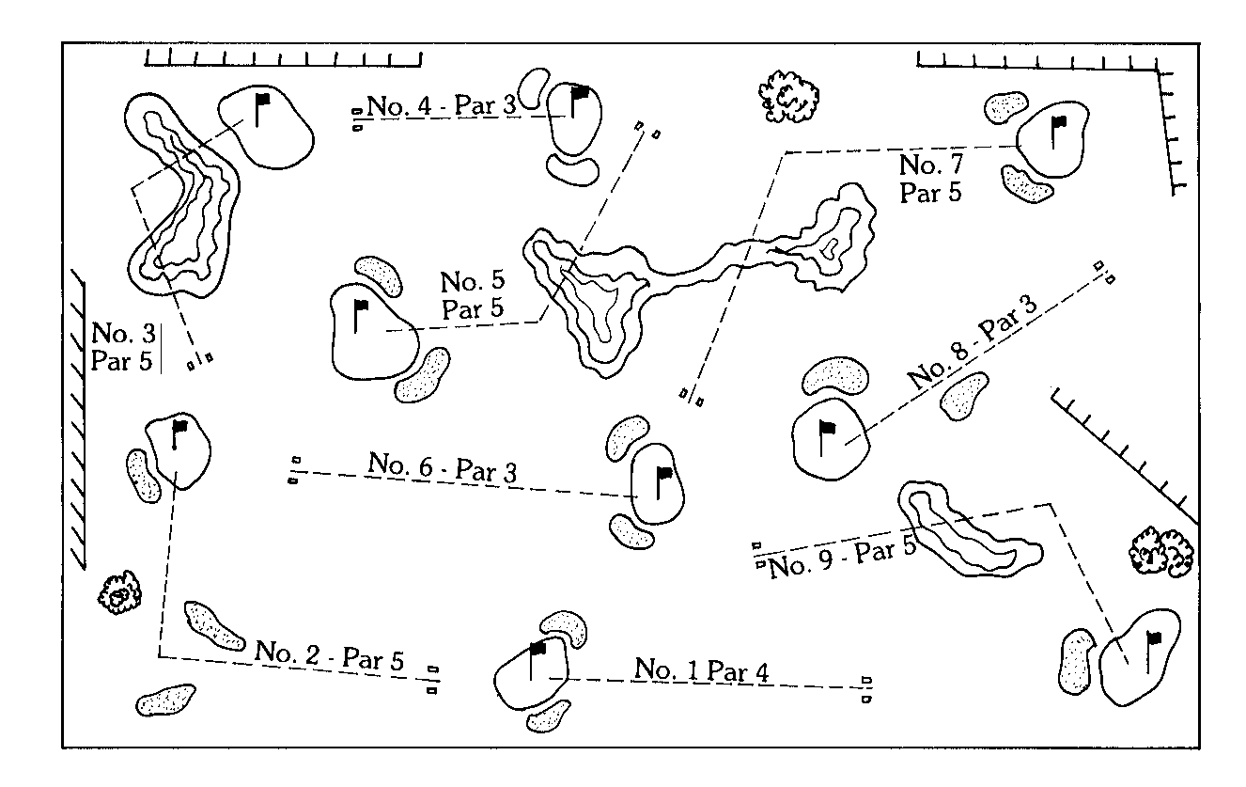
- When laying out an open area golf course, arrange the holes in a counterclockwise pattern in regards to safety. Most players will be right-handed and their tendency will be to hit to the right.

Confirmation of Practice Schedule
Once your venue has been determined and assessed you are now ready to confirm your training and competition schedules.

It is important to publish training and competition schedules to submit to:
- Facility Representatives
- Local Special Olympics Program
- Volunteer Coaches
- Athletes
- Families
- Media
- Management Team members
- Officials

The Training and Competition schedules might include:
- Dates
- Start Times
- Registration or Meeting area
- End Times
- Designated Pick-up area
- Contact phone number at the facility
- Coaches phone number

Other Suggestions:
Lesson topic:
Example Week 1: Putting
Equipment needs: Putter
Course or Practice Facility Rules

Practice Competitions
The strategic plan of golf states that high quality competition shall be the driving component of program development. Competition motivates athletes, coaches and volunteers to participate and train.

Expand your program and schedule to expose your athletes to as many competitive opportunities as possible. A few suggestions:
- Competition should be part of every lesson plan.
- Contact Special Olympics Golf programs in your area to participate in a tournament or league.
- Organize a Special Olympics Unified Golf League.
- Encourage Level 3 –5 athletes that are eligible, to compete in local junior golf programs and tournaments.
- Host a Family/Volunteer Skills Team Competition: Father/Son; Daughter/Mom; Adult/Athlete
- Host a competition at an alternative golf facility: Putt-Putt/ Par three course; Pitch and Putt

Example: National Schedule

Special Olympics Scotland

Golf Development Program 2002-3

(Tom Nesbit: SO Golf Coordinator)

September | SO Great Britain Championships | Longlands G C, East Kilbride
November | SO Great Britain Team Training | SNGC, St. Andrews
November | Driving Range Day | Gary Mitchell Golf, Uddingston
February | Driving Range Day | Coatbridge Driving Range
March | On-Course Coaching | Kirkhill G C, Cambuslang
March | Target Golf | Kirkhill G C,Cambuslang
April | On-Course Coaching | Kirkhill G C, Cambuslang
April | SO Great Britain Team Training | Wolverhampton
May | On – Course Coaching | Kirkhill G C, Cambuslang
May | Team Golf Camp | Alexandra parade, Glasgow
September | SO Great Britain Championships | Cawder G C, Bishopbriggs

Example of a Local Program Schedule:

Palm Beach County

Special Olympics Golf

Orientation and Registration
April 15, 9am | Coaches Training/Orientation | Okeeheelee
April 25, 9am | Family/Athlete Orientation | Okeeheelee
May 1 | Registration Deadline | PBC Special Olympics
May 10 | Training Begins | All Courses

Training Days: May, June, July, August, September
Tuesdays : 4pm – 5pm | Southwinds
Thursdays: 4pm – 5pm | Dyer Park
Saturdays: 9am – 10am | Okeeheelee

Competition
May – September | Monday Twilight League | Okeeheelee
July 14 | County Games | Okeeheelee
July 24-27 | Area | Martin County Municipal
August 10 | Mixed Scramble | Lakeview G.C.
September 17-19 | State Tournament | Players Club, Clermont FL

Local Rules Example
In accordance to the Rules of Golf, Golf Course Management or Tournament Committee establish several Local Rules relative to the course or conditions of play. Here is an example of a set of Local Rules submitted to participants in a Unified League Competition in Rhode Island. Local Rules may also be printed on the Golf Course scorecard.

East Greenwhich Country Club

East Greenwhich, Rhode Island

Course Rules
- Each Player must have own set of clubs
- Non-golfers are not allowed on course. (Insurance rule)
- Proper dress required at all times.
- No fivesomes at any time.
- Players under 12 must play with an adult.
- No player under 8 unless by special permission.

Not Permitted on Course
- Metal spikes (no exceptions)
- Beverage coolers
- Alcoholic beverages
- Loud and/or abusive language

Please...
- Repair ball marks
- Rake traps after use
- Replace divots
- Observe out of bounds between holes ONE & EIGHT (dangerous), all will be played as hazards. If you hit a ball beyond the boundary markers, bring the ball back to the approximate point where it went out of bounds, under penalty of 1 stroke. Do not hit another ball from the teeing area.
- Embedded Ball Rule is in effect.

Essential Components of the Training Sessions
There are many ways to organize a training session for Special Olympics athletes. Because of comprehension and memory challenges for the athlete, there is considerable value in a developing a consistent training “routine” that provides familiarity, stability, and comfort.
There are four essential components of a typical training session: warm-up and stretching, skills instruction, competition experience, and cool-down and stretching. (Fitness training or conditioning can also be included following competition experience and prior to cool-down.) The following techniques and tips will provide the most successful learning opportunities.
- Warm-up and Stretching
- Time is precious and skills repetition vital. Warm up in a way specific to golf.
- When athletes have difficulties with balance, use stretching activities that can be done while sitting, lying down, or leaning against a wall or partner.
- Involve athletes in leading the exercises; coaches are then free to circulate and directly assist others who need help.
- Teach a simple routine involving the major muscle groups, which athletes can repeat at home and at competition. Warm-up by walking or jogging 5 minutes. Then perform the following stretches: 1) calf stretch against wall, 2) hamstring stretch or toe touch, 3) quad stretch holding onto wall for balance (both directions), 4) groin stretch while sitting or lunging to each side, 5) shoulder stretch (grasping hands behind body and leaning forward, and 6) triceps stretch (reaching to sky with one arm, bending elbow which points forward, and pulling elbow straight back with opposite hand; performing stretch with other arm).
- Concerning stretching, what to do and not to do follows:
Do | Prevention
Perform warm-up activity for 5 minutes (walk or run slowly). | Muscle fiber tear or strain
Perform held stretches for 10-30 seconds each. | Muscle fiber tear or strain.
Start with the large muscle groups such as the legs then move to the shoulders, etc. | Greater energy required warming large muscle groups. Circulation and heart rate is increased immediately.
Perform each stretch to your personal point of tension. | Strain on the joints, back or neck.
Breathe while stretching. | Releases tension and oxygen flow to muscles
Perform stretches in a “safe” position and through range of motion. | Example performs a sit-up crunch with back flat to ground to avoid stress on low back.
- Skills Instruction
Training Sequence (tasks → skills → application in game/event → implementation in competition)
- The key is to break skills into small basic tasks or steps; tasks are then put together to form skills. (Addresses difficulty in performing multi-step tasks)
- Drills are developed so that skills can be applied in a game situation. The result is skills performed in competition.

Communication when Teaching and Coaching
- Communicate effectively.
- Concise: Use a few descriptive “key words”. Do not use long sentences. For example: “Reach for the sky.” (Addresses difficulty in understanding verbal instructions and desired actions)
- Consistent: Use the same word or words for the same action. (Addresses need for repetition and reinforcement)
- Command-oriented: Verbally reinforce the athlete immediately after a desired action. Make the reinforcement action-oriented and specific to the skill. (Addresses need for frequent motivation and words associated with a physical action)
- Make sure an athlete is looking at you when making a coaching point. When needed, physically prompt an athlete to look at you. (Addresses difficulty in maintaining attention)
- Ask athletes questions rather than always providing directions. Lead them to think for themselves. Verify athlete responses. (Addresses independence )

Levels of Instruction: Skills Progression
- Assess what an athlete is ready to do; build upon strengths.
- Use appropriate levels of assistance for each athlete – verbal, visual (demonstration), physical prompt, physical assistance. Gradually reduce physical assistance in favor of simple cues and eventually no prompting at all. (Addresses difficulty in learning and improving)
- The lower the ability athlete, the more assistance may be required.
- Verbal cues should always be accompanied by demonstration.
- Physical prompts may be needed to help the athlete get positioned properly.
- When all else fails, move the athlete through the complete skill.
- Practice skills in situations that are related to the game or event. (Addresses difficulty in generalizing to new situations)
- Use drills and activities that involve many athletes at all times. (Addresses slower rate of learning and the need for motivation and repetition)
- Competition Experience
- Provide a realistic competition experience during each practice in order to improve confidence and performance under the pressure of real competition.
- Help athletes understand game concepts by providing immediate and concrete feedback. During scrimmages or practice games, stop the play to help athletes recognize critical situations and learn how to react successfully.
- Emphasize the value of enforcing the rules during training. Rules enforcement helps prepare athletes for participation in community sports and in life.
- Cool-down and Stretching
- Having athletes do light jogging and then stretching major muscle groups will prevent muscle cramps and soreness and increase flexibility.
- Review the main themes of the training session; reward athlete performance, and talk about the next competition or training session.

 Training Session Plan

Sport: Date: # of Athletes: # of Coaches:
Goals for training session:
Facility safety check: Equipment Practice Area Course Layout Supervision

Time | Session | Specific Objectives | Drills/Activities | Layout
Warm-up
Exercises

Stretching
Exercises

Skills
Instruction

Competition
Experience

Rules/Strategy

Training Session Plan [SAMPLE]
Sport: Golf Date: 6/29/03 # of Athletes: 6 # of Coaches: 2
Goals for training session: Using Mini-Swing and lofted club ,develop target and distance control for the chip
Facility safety check: Equipment Practice Area Course Layout Supervision

Time | Session | Specific Objectives | Drills/Activities | Layout
1:00  1:10 | Welcome, Review Session, Assign stations  Warm-up: Jog in place  Stretching: Straddle Stretch  Body Bend  Hamstring  W/Club: Torso Rotation  Shoulder stretch  Wrist curls w/club |  | Equipment: Short, mid iron, putter  Balls  Targets: Cones, flags, or tees  After Warm Up:  Exercise: w/o club: Elephant Trunk  Head-Wall  w/club: ¼,1/2, Full Swing
1: 20 | Skills  Instruction: Explain, Demonstrate  - Underhand toss: roll ball to designated target  - Underhand toss: Landing area: distinguish length of swing and effort required for distance and direction  - Review grip, posture, aim  - Mini Swing relative to loft of club and clock concept to control distance back and through |  | Skills training progression:  - Underhand Toss – Various targets  - Underhand Toss – Various distances  - Brush grass, 5 – 7  - Clip tee, 5-7  - Chip balls to designated targets  - Change target to different distances  - Rehearse required back and through stroke required for the distance  - Execute
2: 00 | Competition Experience:  Athlete will hit to designated targets, from various distances  Rules/Strategy :  Rule: Requesting opponent to mark ball  Strategy: Club selection for chipping |  | Must land 4 of 10 balls in target zone  Change target and distance and repeat  Game: “Up and In”: Each athlete will chip onto green and putt out for score.
2: 20  2:30 | Group discussion/ Review  Remind about change time for next week  Dismiss

Tips for Conducting a Successful Training Session
- Assign assistant coaches their roles and responsibilities in accordance to your lesson plan
- When possible, have all equipment and stations prepared before the athletes arrive
- Introduce and acknowledge coaches and athletes
- Review intended program. Keep athletes informed of changes in schedule or activities.
- Alter the plan according to weather, the facility in order to accommodate the needs of the athletes.
- Change activities before the athlete loose interest
- Devote part of each training session to a group activity.
- Keep drills and activities brief so athletes do not get bored. Keep everyone busy.
- Devote the end of the practice to a fun, group activity that can incorporate challenge and fun giving them something to look forward to.
- If an activity is going well, it is often useful to stop the activity while interest is high.
- Summarize the session and announce arrangements for next session
- Keep the fun in fundamentals. Use games to teach new skills and review old ones.
- Devote part of each training session to a group activity.

Safety Hints for Your Training Session
- A golf club can be like a dangerous weapon. It should never be swung in a group.
- Athletes should be taught to swing in designated “swing” areas only.
- Always approach an athlete who has a club in the address position from the front facing the athlete.
- Never position yourself or a student in the target line of a person swinging the club.
- Pair students so they share one club. One student can become the “watchdog” for the other.
- Establish a hitting line. No student should ever be allowed to hit in front of the established line.
- Students should hold their golf club at the club head end whenever an instructor is demonstrating or organizing. This discourages swinging the club.
- Teach students when to use the term, “fore” and that using the term is not a substitute for following safety procedures.
- Athletes should be taught to use a stop-look-and-swing method prior to each swing when playing golf.
- In situations where close supervision is difficult, allow only half-swings or to hip height. Note: Half-swings incorporate all the fundamental movements in a full swing.

A Word of Caution
Instructors have a legal responsibility to be sure students know, understand and appreciate the risks of golf. You must repeatedly warn students of the serious or fatal injuries that could occur if they are struck by a club or ball, and teach them to recite back to you the safety precautions in golf and the injuries that can occur if these procedures are not followed. Effective group teaching and safety in golf depends on the physical spacing of students. Please refer to the group formation outlined on the following page.

Sample Eight Week Lesson Plan

Week 1
- Welcome
- Introduce the game of golf
- Go over safety procedures
- Program content
- Demonstrate warm-up exercises
- Opening remarks
- Swing demonstration
- Equipment explanation
- Warm-up exercises
- Skill assessments

Week 2
- Opening remarks
- Review
- Warm-up exercises
- Demonstrate proper stance
- Have athletes assume stances of other sports to show similarity
- Game: Range Ball Relay
- Review
- Warm-up
- Demonstrate arm swing
- Have athletes perform elephant trunk exercise
- Review safety rules
- Game: Range Ball Relay

Week 3
- Review
- Warm-up exercises
- Introduce pivot
- Use hands to place athletes in proper positions
- Throw tennis balls underhanded to show proper movement
- Game: Range Ball Relay
- Review
- Warm-up
- Introduce the grip
- Stress safety rules
- Demonstrate hand action
- Use hands-on technique to place athletes hands in proper position
- Game: Range Ball Relay

Week 4
- Review
- Warm-up exercises
- Demonstrate basic golf swing
- Teach movement progression
- Go over safety with a club
- Introduce grass cutting swing drill
- Conduct acceleration test {tennis ball)
- Game: Open Fairway
- Review
- Warm-up
- Balance drill
- Introduce club, ball, and target
- Demonstrate
- Acceleration test with tennis balls
- Game: Open Fairway

Week 5
- Review
- Warm-up
- Introduce the golf swing progression
- Set up partner formation for chip, pitch and catch
- Set up partner formation Use clock hand system
- Stress that the swing is a continuous motion
- Game: Tee Track
- Review
- Warm-up
- Use partner formation for chip, pitch and catch warm-up; Review target concept and aiming
- Game: Tee to Target or Range Ball Relay

Week 6
- Review
- Warm-up
- Introduce mini-swing and demonstrate
- Review club safety
- Use clock hand system
- Game: Tee to Target
- Review
- Warm-up exercises
- Have athletes roll with underhand toss
- Have athletes roll ball with a putter different distances
- Have athletes roll ball by hand to a target
- Set up a putting course
- Game: Hole Out Relay or Crack Putters Open

Week 7
- Review
- Warm-up exercises
- Introduce chipping and pitching
- Review mini-swing and half-swing
- Demonstrate
- Stress proper hand action
- Have athletes use different clubs
- Game: Field Goal Golf or Leap Frog
- Review
- Warm-up exercises
- Review pitching and chipping
- Play tee me - pitch me
- Game: Golf Bocce

Week 8
- Review
- Warm-up exercises
- Demonstrate full swing
- Review club safety
- Demonstrate swing sequence
- Use tennis balls on a tee
- Game: Bullseye Golf or Death or Glory
- Review
- Warm-up exercises
- Review golf swing principles
- Cover basic rules of golf and etiquette
- Set up a short course and have athletes play Game: Scramble

SAMPLE 8-Week Level II-V TRAINING LESSON PLAN:
Coaches may follow the skills training progression in the above 8-week lesson plan; however, your goal would be to get Level 2-5 athletes playing golf as much as possible. If you do not have access to a course, please refer to the lead up golf games and activities in the Teaching Sport Skills section. Rules, Etiquette, Safety and on course strategy should be part of every plan.

Week 1
- Welcome
- Introduce the game of golf
- Go over safety procedures
- Program content and handbook
- Demonstrate warm-up exercises
- Opening Remarks
- Swing demonstration
- Equipment explanation
- Warm-up exercises
- Skill assessments

Week 2
- Welcome
- Review
- Warm Up Exercises
- Demonstrate Basic Golf Swing
- Teach movement progression ( tee line)
- Balance Drills
- Review Safety
- Basic Rules/Etiquette
- Putting Contest
- Chipping Contest

Week 3
- Welcome
- Review
- Warm up Exercise
- Introduce target awareness and club selection
- Hit balls to designated targets starting with short yardages, working out
- Demonstrate
- Play 3 holes: 4 Person Scramble
- Post scores,
- Rules of the week

Week 4
- Welcome
- Review
- Warm Up Exercises
- Chip and Putt
- Full shots on range
- Level 2 and 4: Play 4 hole: 2 Person Scramble
Level 3 and 5: Individual Stoke Play
- Score and discuss Rule of the Week
- Prepare for Rules Test

Week 5
- Welcome
- Rules, Safety, Etiquette Test
- Warm Up
- Golf Ball Race (first hole)
- Holes 2 –4, play assigned Level format
- Post Score
- Review Course Strategy

Week 6
- Welcome
- Review Rule of the Week
- Warm Up Exercises
- Hit balls
- Distribute Round Chart Card
- Explain record keeping
- Play 4 holes, designated format level
- Post scores
- Review Chart Card
- Rule of the Week

Week 7
- Welcome
- Warm Up
- Review Round Chart Card
- Work on area of weakness
- Alternate Shot Competition
- Review Pre-Shot routine
- Rule of the Week

Week 8
- Level 2 –5:
- 9 Hole Competition

Sports Skills Assessment Record Sheets
The levels of instruction include: Physical Assistance (P.A.), Physical Prompt (P.P.), Demonstration (D), Verbal Cue (VeC.) and Visual Cue (ViQ). Physical Assistance means the instructor gives total manual assistance to the athlete for the entire task. Physical Prompt means the instructor gives partial manual assistance to the athlete for the entire task. Demonstration involves the instructor demonstrating the entire task for the athlete.
A Verbal Cue is a partial verbal prompt where the instructor uses key words or phrases to elicit motor responses from the athlete. A Visual Cue is a partial visual prompt where the instructor points at the key elements of the task to elicit motor responses from the athlete.

Date Mastered
When the athlete performs the task according to the pre-set conditions and criteria, the instructor enters the date the task was mastered and proceeds to a new task. Once all of the tasks are mastered and the athlete performs the entire skill upon command and without assistance, the instructor enters that date in the right-hand column, across from the skill entry.

Sports Skills Assessment Record Sheet

Purpose
The Sports Skills Assessment Record Sheet is designed for the instructor to record the athlete's pre-assessment and post-assessment scores. The instructor can use the record sheet as a master list which indicates several things: one, each athlete's overall development in the program; two, the current ability levels of all the athletes in the program; and three, comparable progress between athletes in the same ability level, Also, the record sheet is useful for quickly determining the athlete's placement on sports teams or in future sports skills classes. Together, the Sports Skills Assessment Record Sheet and the Daily Performance Record are effective training devices.

Using the Sports Skills Assessment Record Sheet
The instructor tests the athlete with the sports skills assessment before the athlete begins training, and enters the pre-training assessment score in the proper column on the sheet. After the athlete has trained in the sports skills of that particular level, the instructor retests the athlete and enters the post-training assessment score in the corresponding achievement column. Of course, the instructor may allow the athlete to fill in the record sheet so the athlete may see what progress he/she is making and take pride in his/her achievement.

 Golf Skills Assessment Record Sheet

Instructor ________________
Name | Grip | Posture | Balance | Aim | Putting | Chip | Pitch | Iron | Wood | Total  (180 possible)
Joe (Ex.)  (Pre-Test Scores) | 15  VeC  6/3/03 | 15  ViC  6/3/03 | 15  VeC  6/3/03 | 14  D  6/3/03 | 18  WA  6/3/03 | 16  VeC  6/7/03 | 14  PA  6/7/03 | 16  WA  6/7/03 | 15  WA  6/7/03 | 138
Conditions & Criteria

Level of Instruction

Code: Levels of Instruction: PA = Physical Prompt D= Demonstration VeC=Verbal Prompt Cue WA=Without Assistance ViC=Visual Prompt Cue

Daily Performance Record

Purpose
The Daily Performance Record is designed for the instructor to keep an accurate record of the athlete's daily performances as he/she learns the sports skills described in this guide, There are several reasons why the instructor should use the Daily Performance Record.
- the record becomes a permanent documentation of the athlete's progress, which is important in itself, and helps the instructor establish measurable consistency in the athlete's curriculum, This is extremely important when more than one instructor works with the athlete.
- the record allows the instructor to be flexible during the actual instructional session because he/she can break down the skills into tasks that are more specific than those indicated in this guide and, thus, meet the individual needs of each athlete.
- the record helps the instructor choose proper skills and tasks, viable conditions and criteria for mastering the skills and tasks, and correct levels of instruction to suit the athlete's learning abilities in future sessions.

These reasons make the Daily Performance Record an important aspect of an individualized educational program. The Pre-Skills assessment administered the first practice session and Daily Performance records are management tools to enable the athlete and coach to achieve season goals and objectives.

Using the Daily Performance Records
At the top of the record, the instructor enters his/her name, the athlete's name, the sport and the sports skills program level from which the skills are taken, If more than one instructor works with the athlete, they should enter the dates that they work next to their names.

 Golf Task Record

Scale 1-10
Instructor ________________
Name | Etiquette | Rules | Sportsmanship | Cooperation | Behavior Patterns | Total | Level of Instruction
1.Joe ( Ex.)
2.
3.
4.
5.
Code: Levels of Instruction: PA = Physical Prompt D= Demonstration VeC=Verbal Prompt Cue WA=Without Assistance ViC=Visual Prompt Cue

Special Olympics Golf Training Log

Date:

Name: Coach:

Skill:

Goals:

Corrective Instruction Tips:

- Pre-Swing:
Routine:

Grip:

Ball Position:

Stance and Aim:

Posture:

- In-Swing:
Back Swing:

Impact:

Through Swing:

Finish:

Recommended Drills/ Suggestions:

Notes/ Comments:

Using the Golf Training Log Template

Weekly Home Training
After each session, each athlete should have a golf specific drill or exercise to rehearse at home. Supplement the rehearsals with some stretching and strengthening suggestions, depending on the athletes assessment.
Share the home training suggestions to the family or friend that is responsible for the athlete to assure the training gets done or to serve as a training partner.
Coaches and athletes may use this template to track practice progress and prepare for your next practice session or competition.
It is important that the athletes have at least 1 or 2 positive thoughts to reflect between practice sessions. The template does not have to be completed at each sub-title. Simply circle the one or two key areas of concern and write the tip or thought in the space provided.
Also, encourage the athlete to write down their personal swing keys in their own words if possible. Ask the athlete their intention and use their words.
Below is an example of tips one might include when completing the template:

Skill:
Chipping

Goal:
To chip 4 of 10 balls into the designated target area.

Pre-Swing:
Grip: Palms facing each, choke down on the handle when placing hands.

In-Swing:
Tempo: TICK-TOCK, 5 – 7 on the clock

Drills/Suggestions:
Brush grass drill using mini-swing
Railroad track alignment: Place one club on target line and one on body line
Practice your chipping to close targets with whiffle balls or tennis ball in back yard.
Notes: Squeeze your tennis ball. Remember your personal tempo swing que: “Donald Duck”!

Remember, my thoughts are not your thoughts.
It is important to not only jot down corrective swing thoughts, but to note thoughts or comments the athlete might have when they hit a good shot, or made an awesome swing.
Ask the athlete, try to use their words or body description when making a point. Felt like……Looks like…….Sounds like…..!

Practice and Play Note Chart
Keep this journal to note improvements or areas of your game that need attention. Describe the best shots from your last several rounds so that you can recall your performance later. Knowing you have executed a good shot once, will build confidence and make easier the challenge to do it again!
Name: ________________
Date | Location | Description, Drills, Comments

Golf Coaching Guide

Teaching Golf Skills

Table of Contents

Sport Skills Assessment
Golf Skills Assessment
Golf Competition Levels and Criteria
Pre-Sport Skills Assessment Record
Daily Performance Record
Level II-V Assessment
Equipment
Golf Swing, Swing Progression and Skills Tests
Warming Up
Straddle Exercise
Body Bend
Trunk Rotation
Hamstring Stretch
Shoulder Stretch
Hands and Wrists
Golf Specific Exercises
Head-Wall
Rear-Wall
Double-Hitchhiker
Hands and Arms Set Up
Towel Exercises
Basic Golf Swing Overview
Swinging the Golf Club
Pre-Swing Preparation
Grip
Hand Action
Address and Ball Position
Positioning the Club and Ball
Aim and Target
The Swing Sequence
Back to the Target, Chest to the Target
Grass Cutting Exercise
Swing Test Progression
The Golf Swing and Swing Progression
Putting
Putting Tests
Putting Faults and Fixes
Chipping
Chipping Test
Chipping Faults and Fixes
Pitching
Pitching Tests
Pitching Faults and Fixes
Additional Putt, Chip, Pitch Tests
Full Swing
Fairway Approach
Driver
Fairway Tests
Full Swing Faults and Fixes
Ball Flight Feedback
Basic Drills for Golf
Balance and Posture
Release
Speed
Swing Path
Golf Games Directory
Lead-Up Games
Mini Swing Games
Full Swing Games
Fun and General Games
Putting Games
Short Course Games and Activities
Level II-V
How the Game is Played
Special Golf Terms
Playing a Course

To go directly to a section, hold down your control key and click on the heading

Teaching Golf Skills
You have now planned your season, trained your instructors, recruited your athletes and have tools to write your lesson plans. You are now ready to begin the training program for your athletes!
- First you will administer the Golf Skills Assessment to determine the ability levels of your athletes.
- After the assessments, the time for individualization is at hand. In the event that 2 or more Athletes come through the skills assessment on approximately the same level, they may be grouped together in the same teaching session which has been individualized to their needs. Keep in the forefront of your mind that this may be teaching on an individual level and not in a group process. Thus the assessment of the athlete’s achievement will have to be made for him/her alone. Monitor the athletes’ progress using Daily Performance Records to track various skills and tasks.
- Be sure that each teaching session opens with proper warm-up period of 5 – 10 minutes. The instructional period should be at least 25 – 30 minutes in length. Finis each training session with praise for the achievements made during the session and anticipation for the next session. A fun time is of importance to your pupils so that they can approach the next class with eagerness. Establish a personal relationship with each athlete and focus on their ability, not their disability!

Sport Skills Assessment

Sports Skills Assessment Record Sheets
The levels of instruction include: Physical Assistance (P.A.), Physical Prompt (P.P.), Demonstration (D) Verbal Cue (VeC) and Visual Cue (ViQ). Physical Assistance means the instructor gives total manual assistance to the athlete for the entire task. Physical Prompt means the instructor gives partial manual assistance to the athlete for the entire task. Demonstration involves the instructor demonstrating the entire task for the athlete. A Verbal Cue is a partial verbal prompt where the instructor uses key words or phrases to elicit motor responses from the athlete. A Visual Cue is a partial visual prompt where the instructor points at the key elements of the task to elicit motor responses from the athlete.

Date Mastered
When the athlete performs the task according to the pre-set conditions and criteria, the instructor enters the date the task was mastered and proceeds to a new task. Once all of the tasks are mastered and the athlete performs the entire skill upon command and without assistance, the instructor enters that date in the right-hand column, across from the skill entry.

Sports Skills Assessment Record Sheet

Purpose
The Sports Skills Assessment Record Sheet is designed for the instructor to record the athlete's pre-assessment and post-assessment scores. The instructor can use the record sheet as a master list which indicates several things: one, each athlete's overall development in the program; two, the current ability levels of all the athletes in the program; and three, comparable progress between athletes in the same ability level, Also, the record sheet is useful for quickly determining the athlete's placement on sports teams or in future sports skills classes. Together, the Sports Skills Assessment Record Sheet and the Daily Performance Record are effective training devices,

Using the Sports Skills Assessment Record Sheet
The instructor tests the athlete with the sports skills assessment before the athlete begins training, and enters the pre-training assessment score in the proper column on the sheet. After the athlete has trained in the sports skills of that particular level, the instructor retests the athlete and enters the post-training assessment score in the corresponding achievement column. Of course, the instructor may allow the athlete to fill in the record sheet so the athlete may see what progress he/she is making and take pride in his/her achievement.

Golf Skills Assessment
The sports skills assessment chart is a systematic method useful to determine the skill ability of an athlete. It can be used to establish the initial starting points of a training program and to measure the athlete’s progress throughout the season.
Before administering the assessment coaches should:
- Become familiar with each of the tasks listed under the major skills
- Have an accurate visual picture of each task
- Have observed a skilled performer executing the skill.
- This will make it easier to analyze the skill when observing the athlete.

When Administering the assessment coaches should:
- Work with the athlete in a quiet space devoid of distraction.
- Explain the skill you would like to observe.
- Demonstrate the skill once.
- Have the athlete perform the skill several times. If the athlete performs the skill correctly 3 out of 5 times, check the box next to the skill to indicate that the skill has been accomplished.

Golf Skills Assessment
If the athlete performs the skill correctly 3 out of 5 times, check the box next to the skill to indicate that the skill has been accomplished.
Your Athlete Can: | Never | Sometimes | Often
Equipment
Identify an iron
Identify a wood
Identify a putter
The Golf Course
Identify the teeing ground
Identify the green
Identify the hazards (water and bunker)
Scoring
Understand scoring terminology
Keep score (match and stroke play)
Add score
Score own scorecard
Grip
Place left (right) hand on the club
Place right (left) hand on the club
Place both hands on the club with palms facing
Grip club with clubface in proper position
Posture and Stance
Place feet in proper position
Bend properly from the waist
maintain balance in this position
Swing
Demonstrate proper arm swing without a club
Demonstrate swing sequence with a club
Address and Aim
Take grip and stance
Place the club behind the ball
Aim both the club and the body
Etiquette and Safety
Cite three rules of safety
Show where to stand
Demonstrate basic care of the course
Sportsmanship
Dress correctly
Observe rules of etiquette and rules of the game
Cooperate with other players
Acknowledge achievements of other players

Totals

Special Olympics Golf Competition Levels and Criteria
Please refer to Special Olympics Golf Rules Article IX in the Special Olympics Summer Rules for detail
Level | Description/Requirements | Eligibility
Level 1:  Individual Skills | - Perform 6 Basic Golf Skills  • wood • chip  • iron • long putt  • pitch • short putt  - Scorekeepers at each station | - All Special Olympics Athletes
Level 2:  Alternate Shot Play | - Alternate Shot team play  - 1 golfer with intellectual disability  - 1 golfer without intellectual disability  - Rules knowledge for golfer without intellectual disability  - Ability to walk 9 holes  - Provide own equipment  - Shall keep, verify and sign score  - (Markers may be assigned) | - Must have scored a minimum of 60 points on the Individual Skills Test  - Must score 10 points or more in at least 4 of the 6 skills with one of the four scores of 10 being in either the wood or the iron.  - Must achieve a minimum of 5 points in the two skills that total less than 10.  - Each team most submit most recent 6 scores under this format
Level 3:  Unified Sports™ Team Play | - Alternate Type Team Play  - 1 golfer with intellectual disability  - 1 golfer without intellectual disability  - Athletes of similar ability  - Ability to walk 18 holes  - Provide own equipment  - Shall keep, verify and sign score  - (markers may be assigned) | - Must achieve Level 2 Individual Skills requirements  - Capable of all Level 4 requirements  - Verified handicap of 35 or less or six most recent 18 hole scores  - Difference between the team members handicaps should not exceed 10
Level 4:  Individual Stroke Play  9 hole competition | - Individual Stroke Play  - Ability to walk and play 9 holes independently  - Provide own equipment  - Basic Rules Knowledge  - Shall keep, verify and sign score  - (markers may be assigned) | - Achieved Level 2 Individual Skills Requirements  - Verified Handicap or submit most recent 6 scores over 9 holes
Level 5:  Individual Stroke Play  18 hole competition | - Individual Stroke Play  - Ability to walk and play 18 holes independently  - Provide own equipment  - Basic Rules Knowledge  - Shall keep, verify and sign score  - (markers may be assigned) | - Achieved Level 2 Individual Skills requirements  - Verified Handicap or submit most recent six scores over 18 holes

Pre-Sports Golf Skills Assessment Record

Scale 1-10
Instructor: Athlete: Date:
Has Never Played
Has Played Some
Advanced (Individual) Level IV, V
Intermediate (Partner Play) Level 11, III
Beginner Level I

Comments

Daily Performance Record

Purpose
The Daily Performance Record is designed for the instructor to keep an accurate record of the athlete's daily performances as he/she learns the sports skills described in this guide. There are several reasons why the instructor should use the Daily Performance Record. One, the record becomes a permanent documentation of the athlete's progress, which is important in itself, and helps the instructor establish measurable consistency in the athlete's curriculum, This is extremely important when more than one instructor works with the athlete, Two, the record allows the instructor to be flexible during the actual instructional session because he/she can break down the skills into tasks that are more specific than those indicated in this guide and, thus, meet the individual needs of each athlete. Lastly, the record helps the instructor choose proper skills and tasks, viable conditions and criteria for mastering the skills and tasks, and correct levels of instruction to suit the athlete's learning abilities in future sessions. These reasons make the Daily Performance Record an important aspect of an individualized educational program.

Using the Daily Performance Record
At the top of the record, the instructor enters his/her name, the athlete's name, the sport and the sports skills program level from which the skills are taken. If more than one instructor works with the athlete, they should enter the dates that they work next to their names.

Skills and Task Analysis
Before the instructional session begins, the instructor decides what skill(s) will be taught. The instructor makes this decision based on the athlete's age, the athlete's interest and his/her mental and physical abilities. The skill should be a statement or a description of the specific terminal behavior that the athlete must perform, for example: "Chip a golf ball from 45 feet toward the cup." The instructor enters the skill on the top line of the left-hand column.
On the second line, the instructor enters the first task from the task analysis that described the skill, Each subsequent task is entered after the athlete masters the previous task. Of course, more than one sheet may be used to record all of the tasks involved in one skill. Also, if the athlete cannot perform a prescribed task, the instructor may break down the skill into even more specific tasks that will allow for the athlete's success.

Conditions and Criteria for Mastering
After the instructor enters the skill and the first task on the record, he/ she then decides on the conditions and criteria by which the athlete must master the skill and the task. Conditions are special circumstances which define the manner in which the athlete must perform a skill, for example: "given a demonstration, and with assistance," The instructor should always assume that the ultimate conditions in which the athlete masters a skill are, "upon command and without assistance," and therefore, should not feel obliged to enter these conditions in the record next to the skill entry, However, the instructor should enter conditions next to the task entry, and must select conditions that suit the task being performed and the individual abilities of the athlete. The instructor should arrange the tasks and conditions in such a way that as the athlete learns to perform the skill, task by task. He/she also gradually learns to perform it upon command and without assistance.
Criteria are the standards that determine how well the skill or task must be performed. A non-handicapped athlete should be able to perform a skill "upon command and without assistance, 90% of the time" for the instructor to consider that the athlete has mastered it. But, in the case of a Special Olympics athlete, the instructor should determine a standard that more realistically suits the athlete's mental and physical abilities, for example: "into a wider than normal target, six out of ten items." Given the varied nature of tasks and skills, the criteria might involve many different types of standards, such as: amount of time, number of repetitions, accuracy, distance or speed.

Dates of Sessions and Levels of Instruction Used
The instructor may work on one task for a couple of days, and may use several levels of instruction during that time to progress to the point where the athlete performs the task upon command and with assistance. To establish a consistent curriculum for the athlete, the instructor must record the dates he/she works on particular tasks, and must enter the levels of instruction that were used on those dates.


Daily Sports Skills Assessment Record

Instructor ________________
Name | Grip | Posture | Balance | Aim | Putt | Chip | Pitch | Iron | Wood | Total  (180 possible)
Joe (Example) | 15  WA  6/3/03 | 15  VeC  6/3/03 | 15  PA  6/3/03 | 14  VeC  6/3/03 | 18  ViC  6/3/03 | 16  ViC  6/7/03 | 14  D  6/7/03 | 16  WA  6/7/03 | 15  WA  6/7/03 | 138
CODE:Levels of Instruction: PA = Physical Prompt D= Demonstration VeC=Verbal Prompt Cue WA=Without Assistance ViC=Visual Prompt Cue

Daily Individual Task Record For Golf

Scale 1 – 10
Instructor ________________
Name | Etiquette | Rules | Sportsmanship | Cooperation | Behavior Patterns | Level of Instruction | Total
Levels of Instruction: PA = Physical Prompt D= Demonstration VeC=Verbal Prompt Cue WA=Without Assistance ViC=Visual Prompt Cue

Daily Performance Record Summary

Athlete:_______________________ Competition Level:___________ Instructor:_______________________
Skill & Task Analysis | Skills Assessment Score | Conditions & Criteria | Date/Session/ Levels of Instruction | Date Mastered
Grip
Posture/Stance
Address/Aim
Putt
Chip
Pitch
Iron
Wood
Equipment I.D.
Golf Course
Scoring
Rules
Etiquette/Safety
Sportsmanship
Code: Levels of Instruction: PA = Physical Prompt D= Demonstration VeC=Verbal Prompt Cue WA=Without Assistance ViC=Visual Prompt Cue

Level II – V Skill Test

At the completion of the five basic shots each student will be given a subjective performance test.
The purpose of this test is to determine the player's ability to compete within the class situation. This means he/she has:
- Acquired sufficient knowledge of the game to enable him to continue to improve
- Developed sufficient interest and desire to continue participation
- Developed enough skill to permit him to participate successfully with others of his/her age and general skill ability

Subjective Test
- Ability to use the proper stance.
- Ability to address the ball correctly.
- Ability to use proper grip (a) putting and (b) overlap.
- Ability to execute the proper swings (a) mini swing and (b) full swing.
- Ability to understand the difference between a short shot versus the long shot.

When assessing athletes for Levels 2-5 training and competition note:
- Athletes that complete an individual Skills Test with at total of at least 60 points may compete in Levels 2-5. In addition, the athlete must score ten points or more in at least four out of the six skills with one of the four scores of ten being either in the wood or iron shot. The athlete must also achieve a minimum of five points in the two skills that total less than ten.
- Each level has a defined purpose and criteria designed for various abilities.
- Athletes, coaches and partners should review all levels and forms of play in preparation for competition to assure an athlete selects the level of play suited to their ability and personal goals.
- Golfers competing in levels 2-5 are required to provide their own equipment.
- Golfers must walk the stipulated round.
- Levels 3-5 require athletes be capable of playing independently.

Individual Equipment

You will need the following equipment to conduct your skills training sessions
- 1 golf club per student (or pair of students). A lofted iron is preferred (#9,8,7,6,5)
- 1 putter per pair of students. #1,2,3 irons may also be used as putters
- 10 golf balls per student
- 1 tennis ball per student for introductory games
- 2 regular size whiffle or plastic balls per student
- 1 square of carpet remnant per student. Because the carpet is used for floor protection for indoor classes, the pile should be thick enough to protect the floor from the floor

* Level II-V athletes are responsible for providing their own equipment at competition for on course play:
- A set of clubs shall include at least one wood, one iron and one putter.
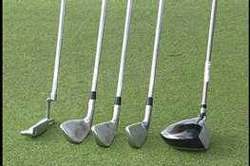
- A golf bag
- Golf Balls
- Pitch Mark Repairer

Equipment Sources
- Golf Professionals
- Golf Club Members
- Golf Associations
- Equipment manufacturers
- Thrift shops
- Parks and Recreation Departments
- School Physical Education Departments
- Sporting Goods Retail Shops

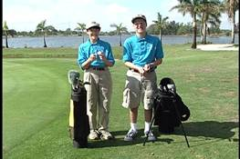
Proper (Preferred) Golf Attire
- Golf Shirt: Shirt with collar
- Slacks or Shorts
- Footwear:
  - Golf Shoe (Soft Spikes)
  - Sneaker or smooth soled shoes

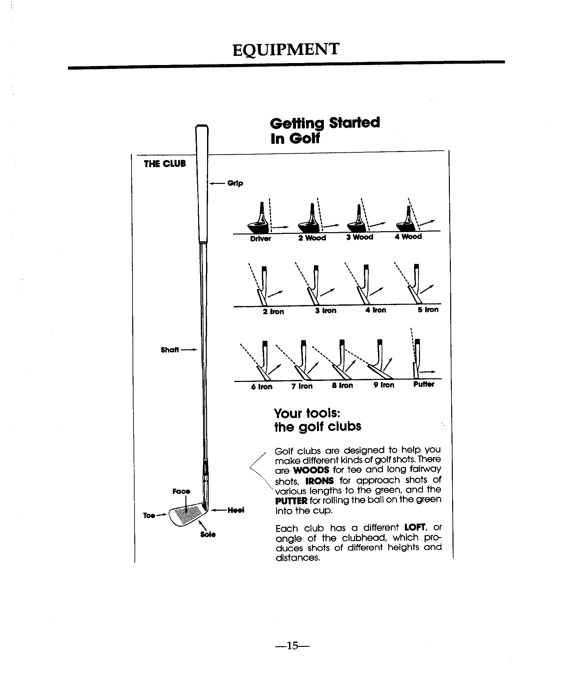

Let’s Get Started!
You have secured a facility, equipment, assessed the athletes and are now ready to begin your skills training program. Let’s review the recommended training session outline from Section 5.
- Warm up session
- Review previous instruction
- Introduce new skills
- Incorporate rules into the instruction
- Play a fun game.

The Golf Swing, Swing Progression and Skills Tests
A series of skill tests follow each segment of the basic skills and swing instruction in this Golf Sports Skills program to measure athlete's progress in the golf program, These prescribed tests will identify certain parameters for various golf skill, i.e., putting, chipping, pitching, etc. However, the individual instructors, as needed, due to the athlete’s abilities, may modify these tests.

The Golf Swing and Swing Progression
Through demonstration and practice the athlete will learn the basic golf swing skills and swing progression.

Coach’s Note:
Arranging for some kind of success in hitting the golf ball is important to motivate the athlete to have interest in and to continue in the game.
An analysis of the golf swing reveals separate actions, which if done in sequence account for total movement. It is also known that all distinct skills of golf-putting, chipping and pitching-are scaled down versions of the full swing. With this in mind, the concept of golf skills-swing progression was designed so that the athlete can start with a simple movement and progress to a more complex one through:
- Demonstration
- Explanation
- Application (Repetitive Rehearsal)

Warm-Up Drills
Given proper demonstration and practice the athlete will properly warm up before each practice session. Jog in place lightly to warm muscles properly before stretching.

Stretching

Straddle Stretch

- Stand with feet shoulder width apart, hands on hips.

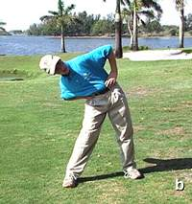

- Bend trunk as far right as possible and hold for 10 seconds.

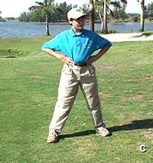

- Bend trunk to the front and hold for 10 seconds.

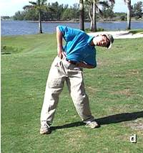

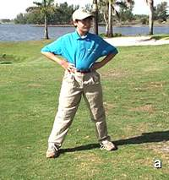
- Slowly bend trunk as far left as possible and hold for 10 seconds.
- Bend trunk to the back and hold for 10 seconds.
- Bend trunk to the front and hold for 10 seconds.
- Bend trunk to the back and hold for 10 seconds.

Repeat the exercise 3 times.
Body Bend Exercise
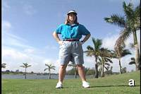

- Stand with feet slightly apart, extend arms and reach overhead

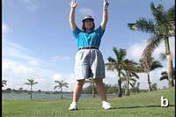

- Bend from the waist and arch backward as far as possible

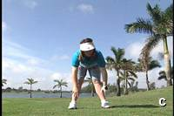

- Bend forward as far as possible swinging the arms forward, trying to touch the ground with hands.

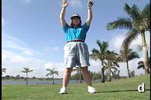

- Return to starting position.

Repeat the exercise 3 times.

Stretching (with a golf club)

Trunk Rotation

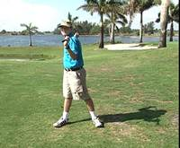
- Put one hand on grip end (handle) of club and the other hand on the head of the club.
- Raise club overhead and place on shoulders.
- Rotate the shoulders from left to right while hands are still on the club.

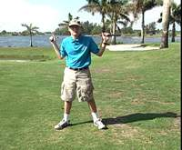
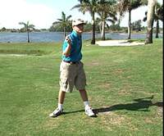
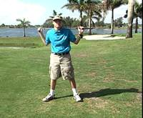

Hamstring
From a standing position go slowly to a squatting position and return to a standing position.

Shoulders

- Hold club as in the trunk rotation drill.
- From a standing position, raise club as far overhead as possible, then forward as far as possible.

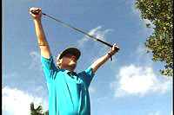
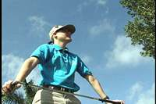
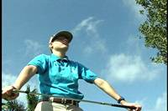

Hands and Wrists
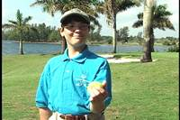

- Squeeze and release tennis ball or similar soft ball.
- Squeeze and hold for a two count and release.

Do 5 to 10 repetitions.

Golf Exercises
Caution: Full swing exercises should be used only after proper stretching exercises have been done.

Head–Wall Exercise
This exercise is a great warm up to test your posture control. You do not need a golf club.
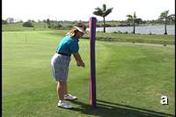
- Assume your golf stance away from a wall or post, tilting forward from your hips. Relax your knees allowing your forehead to touch a post or wall. (If against a wall, you may also insert a pillow or cushion between wall and your forehead applying enough pressure to avoid dropping the pillow). Allow your arms to drop in front of your chest. Extend your target thumb to an imaginary ball gripping it with your rear palm as if on a golf club.

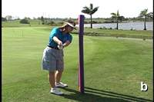

- Swing your arms back to the 9 o'clock position (hip high) while maintaining your spine angle and knee flex. Your head should remain the same distance from the wall. Your target arm will be parallel to the ground, thumbs pointing to the sky.

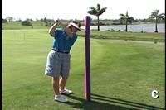

- Allow your head to pivot slightly away from the target, not pulling away from the wall as you swing to the top! Note how Jamie's chin has pivoted slightly out of the way to allow a full shoulder turn.

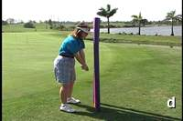

- Returning to impact, the head is still touching the wall and spine angle maintain in a position similar to the address as weight shifts into target side, arms drop and the target hip has "cleared" away from target line.

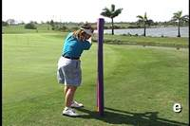

- This transition and pivot towards the target creates room for the rear side of the body to rotate and release on the through swing. Note how the rear arm has extended and rotated to the 3 o'clock position allowing the thumbs to once again point to the sky.

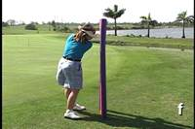

- The centrifugal force created by the pivot and arm swing around the spine will enable the golfer into swing to a well-balanced finish.

Rear–Wall Exercise
This exercise is similar to the Head and Wall testing your posture control especially in the impact zone. This exercise can be rehearsed without a club, with a club and even while hitting a ball. As a safety precaution, a chair, golf bag or broken shaft may be substituted when hitting a ball.
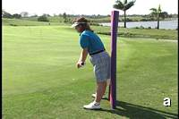

- Assume your golf posture and place your rear end against a wall.

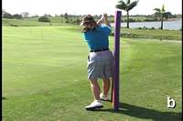

- Turn your torso, arms and hands to the top without letting your rear leave the wall. Feel your weight move into your rear leg as your back turns away from the target. Your head should counterbalance your rear-end, allowing you maintain contact with the wall as you swing the arms and hands swing over your rear shoulder.

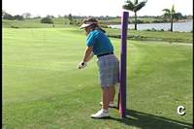

- Returning into impact, your rear should stay against the post when you begin the downswing transition into your target leg. This will allow your arms to drop and wrists to unhinge into a desirable swing path.

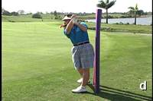

- Keep your rear against the wall as you complete your pivot into the target leg and your arms release to the 3 o'clock position.

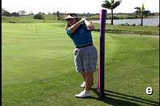

- Allow your arms to fold over the target shoulder into a balanced finish as your eyes "follow your ball!"

Double-Hitchhiker Lower Arm Rotation Drill
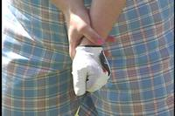

The purpose of this exercise is to develop proper forearm rotation.

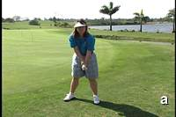

- Assume golf posture extending target arm and gripping the wrist of the target arm with rear hand

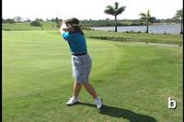

- Swing arms back to thumbs up, "hitch-hike" position. The forearms will rotate and rear elbow will point down to the ground as target arm extends across the chest.

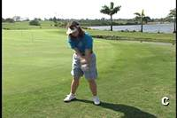

- At impact, rotate arms and hands back to imaginary ball assuring target hand is facing the target.

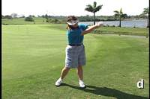

- Continue through impact allowing opposite rotation of forearms and hands to thumbs up "hitchhike position." Target elbow will be pointing towards ground as rear arm extends toward target.

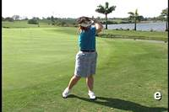

- Finish high with weight on target side.

Hands and Arms Set Up Drill

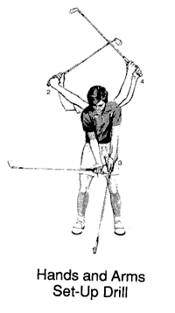
The Hands and Arms drill will allow you to feel a maximum wrist cock, uncock and recock through the back and forward swing. Do this drill keeping your lower body quiet slowly several times swinging only the arms and hands. Once you feel the arms swinging freely and the hinging, unhinging and rehinging of the wrists, add your pivot of torso and hips.
- Establish your address position, without swinging the arms, turn your thumbs away from the target allowing the forearms to roll establishing a 90 degree angle with clubshaft and target forearm. This cocking position or "set postion" is shown in position 1 of the photo on the left.
- From the "set postion" swing arms to a completed backswing with thumbs under the shaft.
- Return to impact, position 3 by dropping arms and uncocking wrists at hip level.
- Swing arms to finish position 4 recocking the wrists and keeping arms in front of your chest.

Towel Exercises
An easy warm up to keep your golf muscles and swing path in check is the Towel exercise.
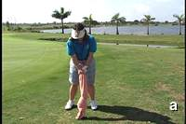

- Assume your golf posture, stance and grip with a towel.

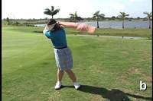

- Swing your torso, arms and hands away as a unit. Allow the towel to drop over your rear shoulder. Shift your weight and begin the pivot of your torso.

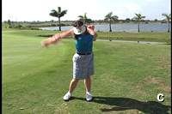

- Swing the towel freely through impact into a balanced finish with weight on target leg. Rear knee, chest and hips should face target as towel drops over target shoulder.

Coach’s Note: Warm-Up/Stretching exercises should make up part of each practice session.

Basic Golf Swing
When teaching the golf swing it is common to refer to the target. When we stand to hit a golf ball, we stand side-ways to the target. If you are a right-handed golfer, your left side would be called your target side and your right arm and leg would be called the rear side. This would be the exact opposite for a left-handed golfer.
Using the terms target and rear allows us to address both left and right- handed golfers equally.

Fundamental Swing Elements:
- Grip, Stance, Aim
- Arm Swing
- Body Movement_ The Pivot
Arm Swing+ Pivot = Basic Golf Swing
Caution: No player should swing until he or she is in designated area and all others are in position.

Stance
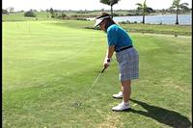

- Feet should be shoulder width apart

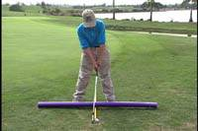

- Flex Knees

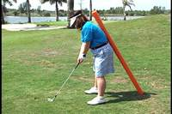

- Establish posture by bending forward from the waist (at your hips) so that arms drop down from your body as demonstrated in the photo to the left.

Coaching suggestions
- Should be done without a golf club
- Weight should be evenly balanced
- Similar to other athletic stances
- Insure stance is not too wide

Arm Swing
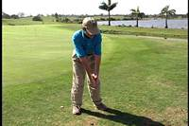
- Assume stance
- With palms together, swing arms back and forth, keepings arms in front of chest (elephant trunk exercises). First pocket to pocket, hip to hip, shoulder to shoulder
- Make a bigger swing—arms will follow body in a circular motion.

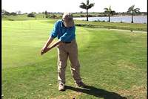

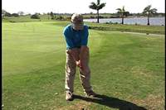

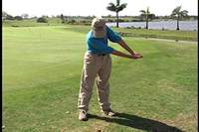

Coaching Suggestions
- Demonstrate elephant trunk exercise. (Pendulum motion)
- Using hands on technique place athletes in position
- Arm swing is similar to arm swing while walking.

Body Movement – The Pivot
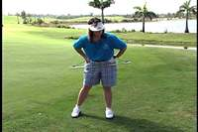

- Assume Stance

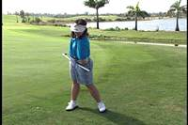

- Put hands on hips and turn body to the right side (left side for left handers)
- Target knee and hip should move slightly towards center, not beyond
- Weight should transfer back into rear heel.

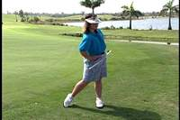

- Turn forward now and the opposite weight transfer should occur.
- Continue turning until you face the target.

Coaching suggestions
- Have athletes toss a tennis ball with arm below the waist
- Demonstrate the similarities between the golf swing and other sports: baseball, tennis, bowling

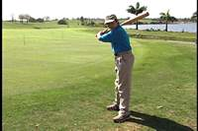 | 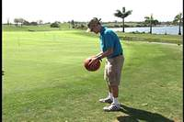 | 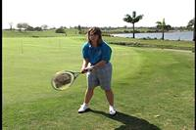
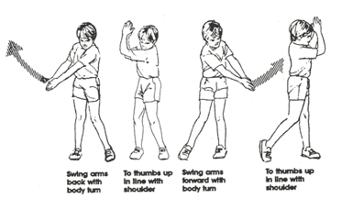

Swinging The Golf Club

Pre-Swing Preparation

The Grip
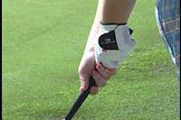
- With the club off the ground, hold the handle of the club 1/2 inch from the butt end with your target hand in a handshake-like position diagonal with the club.
- Then, place rear hand on the club below your target hand, but on top of your target thumb. The target thumb fits in the lifeline of the rear hand.
Checkpoint: (Palm of rear hand should be to target.)
- The back of the target hand and the palm of the rear hand should point in the same direction.
Checkpoint: The toe of the club should point straight up.
Club/Hands in-line V’s to chin or slightly to rear side of chin. No gaps between thumbs and index fingers. Club in fingers, not palm.

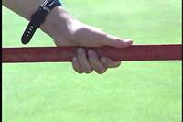

Coaching Suggestions
- Remind athletes to keep clubs down, no swing yet.
- Have athletes handshake the club with the left hand only to determine proper club position.
- Encourage the athletes to use ten-finger grip first.
- Have athletes assume the proper stance and also grip the club.
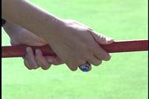

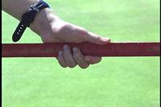

The hands hinge or bend vertically to properly position the golf club and for added speed.

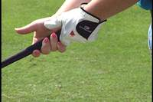
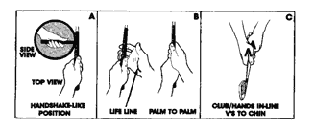

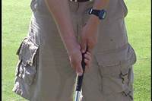

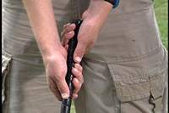

Hand Action
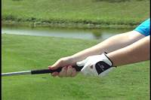
- Assume athletic stance, shoulder width apart
- Grip the club
- Hold the club out stretched at chest height
- Move the club toward your head by only bending your wrists

Coaching Suggestions
- Make sure that athletes keep clubs in front of them.
- Check grip and make sure that the toe of the club is pointing straight up
- Use hands-on technique to set athletes hands in the proper position.

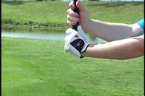

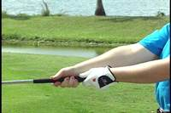

Caution: Players should be careful when they approach a player who has a club down in an address position; the best position is in front or to the side of the player.

Addressing the Ball and Swinging with a Club, Ball and Target
- Take proper stance and grip the club.
- Place the club sole flat on the ground behind the ball.
- Distance from the ball is determined by the length of the club.
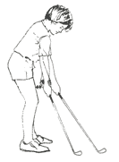

Positioning the Club and Ball
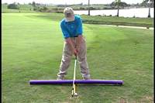
- Set the club behind the ball and place feet together.
- Step sideways with your target foot to position the ball
- Step sideways with your rear foot to achieve the proper stance width.
- Always set the club in position first, before you take your stance.

Coaching Suggestions
- Encourage athletes to position ball in the middle of their stance at first.
- Make sure that athletes have achieved proper set up and address before going further with instruction.
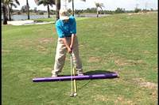

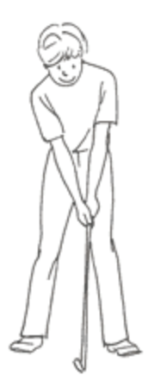

Aim and Target

Target
- The primary target is not the ball; it is the destination for the shot.
- Targets can be many things, the fairway, green or flagstick.
- Look at the ball but try and think about its destination.
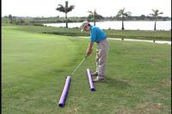

Aiming
- You must aim both the club and the body.
- Aim the face of the club head in the same direction as the target.
- Aim your entire body, feet, knees, hips and shoulders, parallel to the target line.
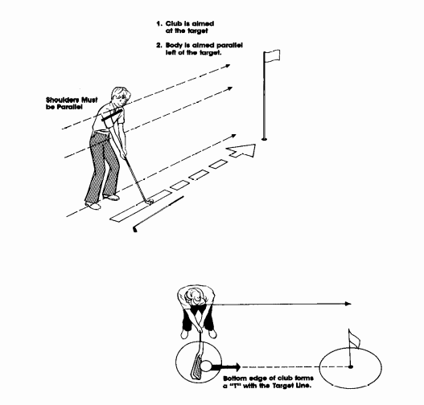
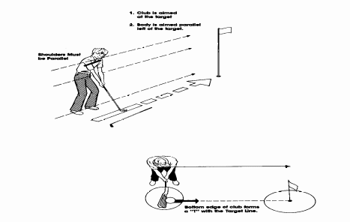

Coaching Suggestions
- Use targets close to the athletes at first.
- A line drawn on the ground using paint, string or golf club will greatly aid in proper aim.

Back to the Target, Chest to the Target
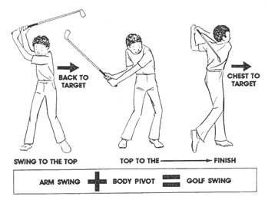
Caution: A golf club can be a dangerous weapon. It should never be swung in a group.

The Swing Sequence

Swinging a Club – Grass Cutting Exercise
A good way to learn to swing a golf club is the grass-cutting exercise with non-stop swinging.
- Using proper grip and stance athlete should swing the club back and forth a short distance and brush the grass.
- Then swing the club back until the hands hinge and brush the grass continuously.
- Swing club over shoulder.
- Athlete should also try this drill with feet together-will help the athlete feel the body turn

Coaching Suggestions
- Insure there is ample room between athletes.
- Demonstrate swing and grass cutting drill,
- To swing the club, athlete must learn to use body, arms and hands in a unified manner.
- Back swing is one motion. A wind-up. Swing the club back so that your club is over your shoulder and back is facing toward target.
- Forward swing is one motion. Unwind; the club is swung from the top to the finish in the direction of the target. As the swing goes forward the body turns in the direction of the target,
- At the finish the club should be over the left shoulder and the athlete's weight should be on the left foot. Note: Back to the Target Chest to the Target

Swing Test Progression: Tee Only, Teed Ball, Without Tee
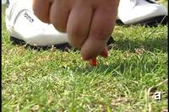

- Start with a tee in the ground.

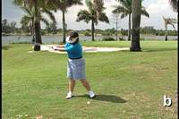

- Goal is to swing the club to the finish—not just to hit the ball. Attempt to strike the tee on the forward motion.

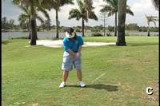

- Add a ball on the tee and continue the same motion.

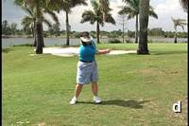

- Try without teeing ball.

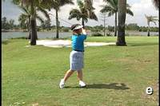

- Athlete can make the complete swing to the finish position with speed and balance.

Coaching Suggestions
- Use tennis ball for this drill, first, so athletes may have more success. If tennis balls are not available use a plastic whiffle or some other soft ball.
- Demonstrate swing

The Golf Swing and Swing Progression
Following the golf swing skills-progression, the athlete will begin with a mini-swing or skill of putting-chipping. The athlete will gradually progress to a half-swing or pitching and finally to a full swing in a graduated manner until some competency is reached at each level.

Skill Tests
A series of skills tests are prescribed in this program to measure the athletes’ progress in the golf program. There prescribed tests identify certain parameters required to perform various golf swing skills for putting, chipping, pitching, etc. These tests may be modified by the instructor as needed, due to the athletes’ abilities.
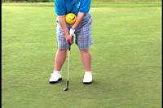

Mini-Swing (Chipping and Putting Skills)
- Athlete takes stance with feet close together.
- Athlete should use putter, 5-6-7 iron.
- Back swing and forward swing should be the same length.
- Club must be swung to the finish in one motion.

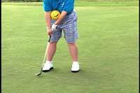

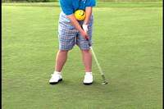

Stop, look and then swing. A good rule to remember before each swing of the club.

Putting

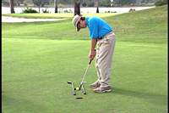
- Athlete uses a putter.
- Putter is placed in the palms with the palms facing each other; thumbs are placed on top of the shaft.
- Stance is taken with feet close together.
- Eyes are over target line.
- The putter is swung on a path toward the target.

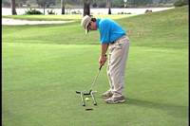

Coaching Suggestions
- Have the athletes roll a ball with an underhand toss. It will help them relate the amount of arm swing and speed to distance.
- Have athletes roll ball with a putter different distances. Make sure that the club accelerates in the stroke.
- Have athletes roll the ball at a target. Start at a distance of 3 feet and work back at 1-foot intervals. This will point out the importance of swinging in the direction of the target with the clubface square at impact.

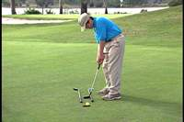

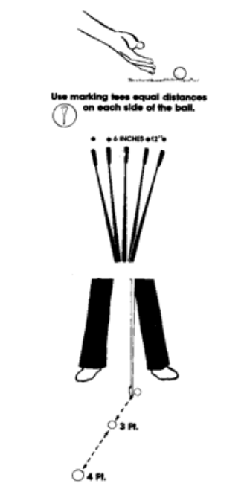
Try the following 3 steps to learn how to putt. If a golf green is unavailable, you can perform these skills on any short-pile carpet.

Roll the Ball Series
- Learn to roll the ball with an underhand toss. You will soon relate the amount of arm swing and speed to distance. Try it with a putter and see if ball rolls.
- Roll the ball with a putter different distances. Always make sure the club accelerates in the stroke. To practice - place a marking tee equal distance on each side of the ball - swing back to one tee and forward to the corresponding tee.
- Roll the ball to a target. Start at a distance of 3 feet and work back at 1-foot intervals to 10 feet when you are able to hit the target consistently. This will point out the importance of swinging in the direction of the target with the clubface square at impact.

Putting Test #1
Purpose: To test the player's ability to perform (1) good stance, (2) stroke the putt firmly, and (3) two putt a green from 25 feet.

Equipment and facility:
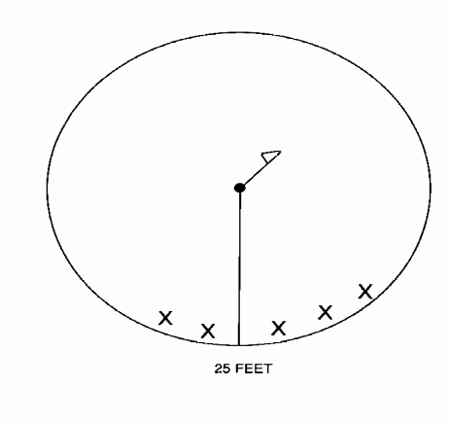
- One putter
- 6 golf balls
- One green or lined off area

Procedure: The student may putt anywhere on the green, as long as he or she remains 25 feet from the cup. The student can score a possible 20 points on each ball, and is scored on his/her best 4 balls out of 6. The student may acquire these points in the following manner. Five points for stroking the ball firmly, and 15 points for two putting the green, He/she many gain 10 points for 3 putts and 5 points for 4 putts.

Putting Test #2

Putting is considered a Two-Phase Skill
- Short putting for accuracy
- Long putting for distance

Short Putt
Place a tee at each of the driver length distances to indicate the starting place. Remove the flagstick and then putt for the cup. Score the number of balls that go into the cup. (Refer to diagram below)

Long Putt
Place a tee for the target area at each of the ends of a 25-foot distance. Putt 10 balls from one tee area toward the other tee or target area, and measure the shots with your putter. Any part of the ball inside the grip counts one point (see diagram).

Putting Set-Up:
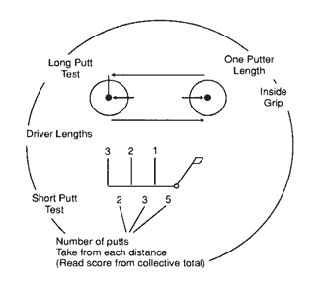
Your putting score is the highest level you reach for both the Long and Short putt test.
Example: 5 – Short Putt
8 – Long Putt
13 – Putting Score

Putting Faults and Fixes

Error | Correction | Drill/Test Reference
Ball consistently rolls to the right or to the left as it slows down | Check alignment, club path | Railroad Track Drill
Ball consistently rolls through the break and beyond the hole | Check swing pace, may be putting the ball too hard and allowing wrists to overtake “one-piece” motion of shoulders, arms, hands and putter. | - Take 3 balls. Putt the first ball just outside your peripheral vision, without looking at the first ball, putt the next 2 balls trying to land the balls in a cluster or hitting the first ball. Focus on repeating the same motion of the stroke back and through. Change distances and repeat.  - Roll the Ball Series  - Crack Open Putter Game
Balls consistently comes up short | Assure back swing and forward swings are equal. | Elephant Trunk Drill and practice same references above
On breaking putts, ball always miss below or beyond the hole | Watch your aim and putting line. Assure your eyes are over ball and keep them there until ball to clubface contact is made | Practice reading the green. Find a green with various slopes. Take note of the various degrees of slope and how the slope will affect the curvature of a ball. Roll a few balls underhand towards the hole and note the direction of how the ball might be “breaking” or curving. Next, putt a few balls towards the hole and allow the slope to carry the ball to the hole.

Chipping
In the chipping stoke, the swing is relatively small in length. Use the clock above as a guide. The swing length should move from 7 to 5 or 8 to 4.
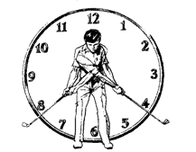

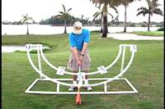
- A stance is taken with the feet close together.
- A short swing motion is used with a 5, 6, 7 iron.
- Little wrist movement is used and body moves naturally in the direction of the swing.
- The distance of the shot will vary the amount of back swing.
- The chip shot will fly low and roll further.

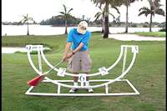

Coaching Suggestions
- Insure that the back swing and the forward swing are about the same length.
- Stress proper hand action, watch for target hand cupping at the back of the ball. Usually happens when the athlete tries to lift the ball up instead of swinging.
- Ball position: back of center.
- Hands and shaft: front of ball.

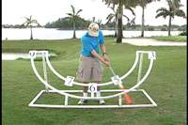

Test on chipping

Purpose:
To determine the student's ability to hit within 10 feet and 20 feet radius of the cup from a distance of 45 feet.

Equipment and facility:
            - 5 iron
            - 6 golf balls
            - A green or marked off area with a cup in the center

Procedure:
- The athlete stands anywhere around the green as long as he/she remains 45 feet from the edge.
- The athlete may score 20 points per ball.
- The athlete can receive 5 points for stroking the ball firmly and 15 points for the ball remaining in the 10-foot radius.
- He/she can get 10 points for the 20 feet radius
- He/ she can receive 5 points for the ball going 5 feet short of the 20 feet radius and 5 points past the 20 feet radius.
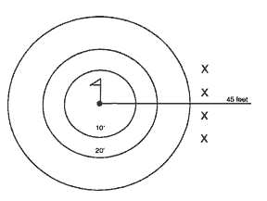

Chipping Faults and Fixes

Error | Correction | Drill/Test Reference
Hitting the top of the ball | Take notice that your shaft stays in front of the ball and that your target wrist remains flat to the target, verses in a cupped. | Extended Club Drill. Hold follow through to check position. Rear wrist bent, Target wrist straight.
You hit the ball either too long or too short. | Compare your forward swing length with the distance the balls travels | Chip to various targets at different distances to develop feel for distance.
You hit the ground behind the ball. | Maintain your posture and assure weight remains on your target side throughout the swing and arms shoulders and hands swing as a unit.. | One –Leg Back Toe Drill. Pull your trail foot back behind your target foot placing only the toe of the trail foot on the ground. Chip and maintain your balance keeping the club low through the impact area.
When chipping with a 7 iron you get a high trajectory. | Watch your ball position to make sure it is behind center and your hands, shaft and club are in a straight line in front of ball. ( This position will deloft the clubface angle.) | Chip and hold your finish assure that hands remain in front of clubface throughout swing. On the finish, clubface should still be low and facing target line, not the sky.
Ball consistently is off target | Check set up, aim of body and clubface | Railroad Track Drill .Place 2 clubs parallel to the target line approximately 8 inches apart to confirm aiming lines of body and club.

Pitching

Half-Swing
- The club is swung to one-half the length of the full swing. Hip high to hip high.
- The stance is taken with feet approximately shoulder width.
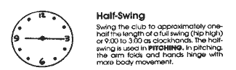

Pitching
- Athlete uses a lofted club such as a #9, pitching wedge or sand wedge.
- Shots are produced that have more time in the air and less time on the ground.
- The club is swung about one-half the length of a full swing. On a clock face from (9 to 3).
- The hands will hinge and unhinge in the swing.

Coaching Suggestions
- Insure that the back swing and the forward swing are approximately the same in length.
- Have athletes swing to the finish in one motion.
- Demonstrate pitch shot.
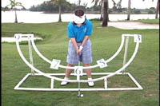

- This is a good visual of the clock concept. Athlete will assume golf stance.

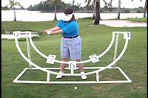

- Athlete's arms swing to the 9 o'clock position.

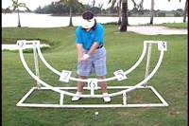

- Arms return to the impact zone.

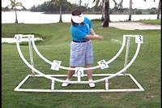

- Arms continue on the through swing, allowing body to rotate with arms.

Pitching Test #1

Purpose:
To determine the student's ability to strike a ball in the air over a goal post 5 feet high.

Equipment or facility:
            - 9 iron or wedge
            - 6 golf balls
            - Two standards with a rope between; the width 15 feet, the cross bar 5 feet off the ground.

Procedure:
The student stands 25 feet from the standard. Each shot has a possible 20 points. To score 20 points, he/she must strike ball firmly and in the air over the cross bar. Five points are given for hitting the ball solid, and 15 points for the ball going in the air over and in between the 15 feet width. He/she can score 10 points for the ball to go under the cross bar. He/she can score 5 points for just striking the ball. Only count 4 best balls out of 6. The student may use a tee for each shot.
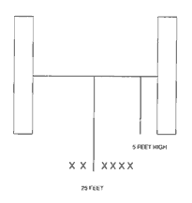

Pitching Test #2

Green Version (9 - pitching wedge or Sand wedge)
- While using the chipping/Pitching diagram, simply place a bag, club or obstacle 1/3 the distance from the starting point to establish a restraining line.
- All shots must fly over the restraining line and come to rest within the target area to be considered a successful shot.

Range Version (9 - PW or SW)
- Follow above instructions while using the Range Version diagram below.
- The pitching test for the range version is optional in the event that pitching is not allowed on the putting green.

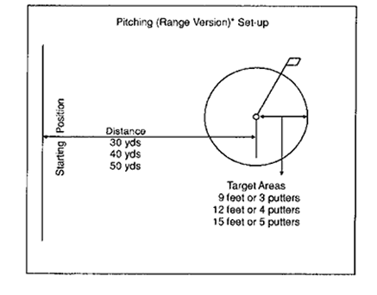

Pitch/Chip Test
Use the Chipping/Pitching diagram and select any one of the three distances. (Short, Medium, Long)
There is no restraining line, however the starting distance should allow the ball to land on the green with any of the less lofted clubs.
Use the short shot chart to help you select the proper iron for the shot distance.
Note: Any ball, which hits a tee, can be replayed if there is some doubt of its status.
Note: Use same distances for both pitch and chip skills except for the pitch place a club or bag l/3 the distance from the starting line for a restraining line in pitching.
Note: Use the roll and flight calculations from the pitching a chipping short shot chart to select your proper iron for each distance.
Student Set-Up Instructions: Pace the distance and use golf tees to outline the targets to establish the test stations.

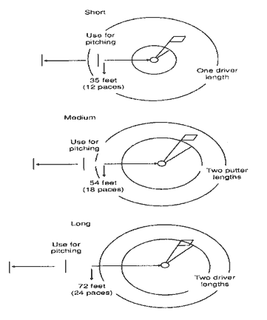

Pitching Faults and Fixes

Error | Correction | Drill/Test Reference
Hitting the top of the ball | Maintain body posture from setup through to finish | Brush the grass using the mini-swing with and without a ball
You hit the ball either too long or too short. | Distance will be determined by the club used, swing length and swing speed. 9 iron, PW and SW will each perform differently. | Clock Concept. Practice swing lengths with all pitching clubs from 5 –7, 9-3. Note ball carry and roll distances.
You hit the ball in the hosel of the club. | - Check your ball position to make sure it is in the center of your stance. It may be too far toward your target foot or too close to your rear foot.  - Watch your balance and swing path, you may be moving forward or towards the ball on the back or forward swing. | - One –Leg Toe Drill. Pull your trail foot back behind your target foot and placing only the toe of the trail foot on the ground. Practice making mini-swings and maintaining your balance.  - Hit balls next to a 2 x 4 or head cover
Ball comes off low, no trajectory | Check ball position. Make sure it is in the center of your stance and not too far back. | Practice Cocking Drill, 3 - 9
You hit the ground behind the ball | Maintain knee flex and body posture though to the finish. | Mini-Swings, Rear Against the Wall

Additional Putt, Chip, Pitch Tests
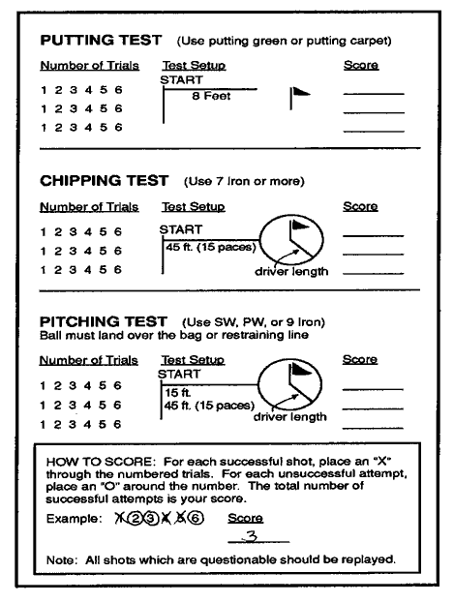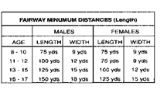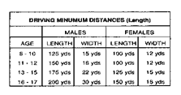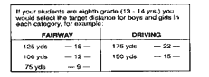

Full Swing
- Stance is taken with feet at shoulder width.
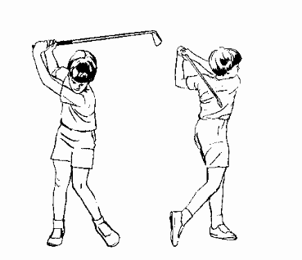
- The club is swung "around the clock."
- The proper motion sequence is used.

Fairway Approach
- Athlete takes proper address position.
- Athlete grips club.
- Athlete sees target.
- Athlete aligns himself with body (knees, hips and shoulders) on a parallel with the target.
- The ball is positioned in middle of stance.
- Athlete swings the club using the proper motion sequence.

Coaching Suggestions
- Demonstrate swing slowly using proper motion sequence.
- Draw lines on the ground to aid in alignment and ball position.
- Have athletes make 5 swings without the ball, then make 5 swings with the ball!
- Put the ball on a tee first.
- Consider using a tennis ball or soft ball in the beginning. This will build confidence.

Driver
- Athlete takes proper stance with feet shoulder width.
- Athlete grips the dub properly.
- Athlete aligns himself properly.
- The ball is positioned in the forward part of the stance.
- Athlete swings the club using the proper motion sequence.

Coaching Suggestions
- Demonstrate swing with proper swing motion sequence.
- Have athletes use a fairway wood when starting.
- Draw lines on the ground for alignment and position,
- Use a tee when beginning.
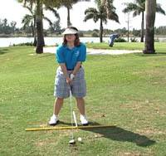

- Athlete will assume golfing stance. The ball is positioned in the forward part of the stance.

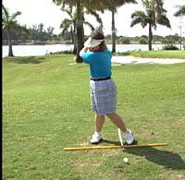

- Turning the back to the target.

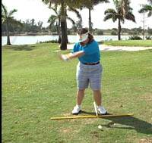

- Shifting the weight from the top of the swing into the target side.

- Allowing arms to drop into the impact zone.

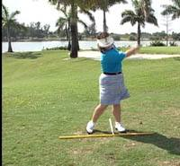

- Swinging through to the finish.

Test for Iron Shots

Purpose:
To determine the student's ability to hit the ball in the air 60 yards.

Equipment and facility:
            - 5 or 7 iron
            - 6 golf balls
            - Space needed – playground – golf range.

Procedure:
- The student stands 60 yards from a flagstaff or pole.
- Each ball has a possible 20 points. This is a best of 4 out of 6 shots event.
- The student gets 5 points for hitting the ball solid and 15 points if the ball carries in the air 60 yards.
- The student gets 5 points for hitting the ball solid; and 10 points for hitting the ball 40 yards in the air.
- The player gets 5 points for just hitting the ball.
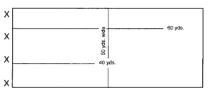
Length and width can be adapted by the group’s activity.

Additional Fairway Tests

Fairway Test
Markers should be placed on the range at the listed distances and target widths. The test is taken with a 5 iron and the ball on the ground. You establish your own target based on your present distance ability. Once this distance is known, the next closest distance becomes the restraining line for your golf shots. Shots, to be successful, must pass over the restraining line in the air and then go to and between your target markers (See Driving example.)
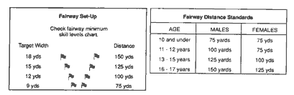
Student Set-Up Instructions: The Driving and Fairway test stations are established by pacing off the distances and using range markers for targets.

Skills Testing Procedures
- Record date
- Indicate type of session (practice or test)
- Record number of successes out of 10
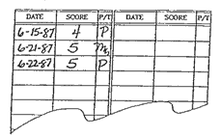
Note: Use a standard golf scorecard to record the successful trials for each test.
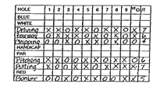
Use a golf scorecard, place an ''X'' for each successful shot, and an ''O” for those which do not count. Add the total for each test.

Driving Test
Range markers should be placed on the range at the listed distances and target widths. The test is taken using a driver (2 or 3 wood or metal wood if unavailable). Tee is required. You establish your own target based on your present distance ability. Once the distance is known, the next closest distance becomes the restraining line for your golf shot.
Example: If you can drive the ball 200 yards, 175 yards becomes your restraining line. Shots to be successful must pass over the restraining line in the air and then go to and between your target markers.
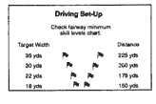
The only age-adjusted skills are Fairway Irons and Driving. For these skills we have set some recommended minimum standards for distance. The distances should be used only as goals for the students - not to restrict participation,
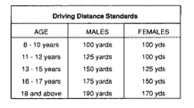
Note: If driving test distance is under 150 yards use the fairway test markers.
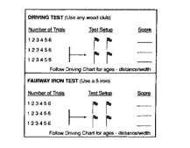

Wood Shot Test:

Purpose:
To determine the student's ability to hit the ball in the air 60 yards.

Equipment and facility:
            - Fairway metal or wood
            - 6-golf balls
            - Space needed – playground area – golf range.

Procedure:
- The student can score a possible 20 points per shot.
- Five points for hitting the ball solid, and 15 points if the ball carries in the air 60 yards; the student gets the best four out of six hits to count.
- The student can get five points for hitting the ball solid, and ten points for the ball in the air 40 yards.
- The student can get five points for wherever the ball goes. The width of the boundaries can be determined by space available.
- Keep a record of each individual's results.
At the completion of this skill level, the pupil now has all of the basic shots that are necessary for a game of golf. Although this pupil has not yet played, he/ she has completed a survey of the basic skills and ideally is now ready for his /her first trip to the golf course.

Wood Shot Test

X_________________________________40yds._____________________________
X
X_________________________________100yds.____________________________
X
X______________________________(50 yds.wide)__________________________

When the time for ball-striking arrives, along with demonstration and personal instruction in this shot, have the athlete stand within the teeing area and hit the ball, trying to make it carry 60 yards or more in the air. He/she must be shown how to stay within the 50 yard width limit.

Full Swing Faults and Fixes

Error | Correction | Drill/Test Reference
You hit the ground behind the ball as your weight shifts. | - Swing “through” the ball  - Maintain posture at impact | Swoosh Drill. Turn club upside down, grip and swing allowing freedom in the arms and hands. You should hear a Swoosh sound in the impact zone.
Club hits the top of the ball | - On the forward swing keep club extended towards the ground. and arms long through the impact zone  - Be sure of arm extension when wrists uncock towards the ball. | Make a full swing back and an abbreviated follow through, stopping at 9:00 as if you were “Shaking hands with the target.”
You hit the ball with the toe of your club | Maintain your posture over the ball. Do not shift your weight backwards, or stand up during your forward swing. | Rear end against the Wall Drill
You hit the ball with the heel or hosel of your club | At setup make sure your arms are relaxed and that they are not too far away from your body. Do not lean forward beyond the ball. | - Rear End Against the Wall Drill  - Place a 2 x 4 in front of ball and hit the ball without hitting the board. Railroad Track
Losing distance with full swings because you don’t turn your hips | Make sure you feel your full body turning back and through. | Rehearse Pivot Drills. “Belt buckle back and belt buckle through. Towel Drill.
Hitting the ball straight but not on target | Make sure you check your alignment before you swing. | Place clubs down on the ground to confirm aiming lines.
You “whiff” the ball (swing and miss). | Keep your posture the same throughout your swing and long arms through impact. | Clip the tee drill. Assure you maintain your arm extension through the impact zone.

Ball Flight Feedback

Learn from Your Ball Flight
Direction is influenced by | Distance the ball will travel is affected by
- the alignment and aim of clubhead and body at setup.  - the path you swing the club.  - position of the clubface when it contacts the ball. | - how squarely the clubface hits the ball.  - how fast the club is traveling when it contacts the club.  - the club’s angle of approach when it hits the ball.

The chart below from Dr. Dede Owens and Linda K. Bunkers’ “Steps To Success” is an excellent reference to detect and correct common ball flight feedback.

Error | Correction
Direction: Path
- Ball travels straight but lands left or right of target. A path error due to an alignment problem | - Adjust the alignment of body to square position. Stance should be parallel to target. Check: feet, hips and shoulders. Explanation: Directional errors are primarily caused by one of two problems: lack of square alignment or club swung on a path not aligned to the target.
- Ball lands right or left of target due to path on which you swing club. | - Swing club on path to target. Check alignment to visualize desired path of ball flight. Explanation: Direction of ball flight is primarily the same as the direction in which you swing the clubhead
Direction: Clubface
- Ball slices | - Allow clubhead to return to square at contact. Check to make sure hands are relaxed. Check “release” at contact and your grip. Explanation: The angle of clubface in relation to the path of your swing determines sidespin imparted to the ball. An open club face produces a slice.
- Ball hooks | - Arms are stopping too soon and hands unclock too early. Increase the tension in the hands slightly to change the timing of the release; be sure hands and arms start down as a unit from the top. Explanation: Angle of clubface in relation to path and swing determines sidespin imparted to ball. A closed clubface produces a hook.
Distance
- Balls lands short of target, but flight looks about the right height. | - Increase length of swing or swing speed. Explanation: Distance a golf ball travels depends on 4 things: the length of the swing, speed of the clubhead at the moment of impact, squareness of the contact made by the club on the ball and the angle of approach or path of the club to the ball.
- Ball travels too high with an iron and lands short or target. | - Angle of approach is too steep. Adjust angle of approach to be shallower or less steep by extending swing (making it wider on backswing and forwardswing).
- Ball seems to pop up in the air on the tee shot due to a steep approach. | - Adjust angle of approach of club by extending swing (by making it wider on the backswing and forwardswing). This flattens the angle into the ball.
- Ball lands short of the target, but swing seems about the right speed and length. | - Check for square contact of clubface on ball. Club selection may need to be changed. Explanation: Each club has a sweet spot (centroid) which is its center of mass extended to the clubface surface. This is the point on the clubface that can impart the moist force into the ball, allowing the ball to travel its maximum distance. The farther away from the sweet spot the ball is hit, the more its distance and direction will vary.
- Ball shoots off sharply in front due to being hit in the hosel—a “shank”. Upper body falls back on forwardswing. | - Contact ball at sweet spot of club by keeping proper posture over ball on forwardswing.

Basic Drills for Golf

I. Balance and Posture Drills

Feet together
This drill promotes the idea of the arms swinging the body. It gets rid of arm tension and helps the balance.
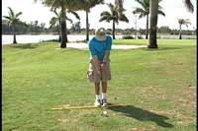

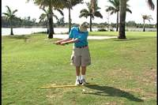

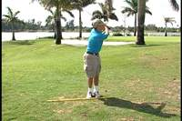

Legs Crossed
Cross legs and swing, while keeping the balance.

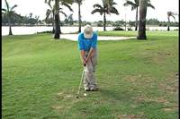

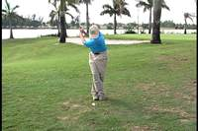

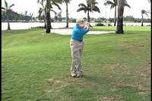

One Leg
Swing a club on one leg.

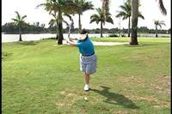

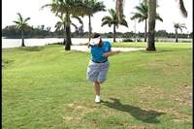

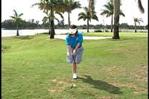

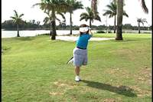

Eyes Closed
Swing a club with eyes closed.

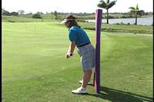

Rear against the Wall
This drill forces you to maintain your spine angle and counterbalanced positions of the head and rear throughout the swing. Simply make rehearsal swings without a club with your rear against the wall or a chair. You should feel contact with the wall as you pivot back and through.

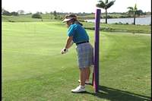

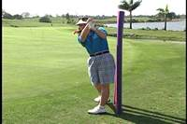

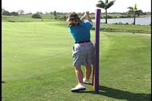

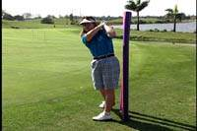

II. Release Drills

3 o'Clock Drill
Just swing back and forth from waist to waist for 3.5 minutes without stopping.

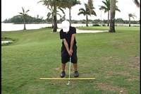

Quarter Turn Drill
From address position, make a quarter turn so that your back is to the target. Then make your turn and hit the ball. You should feel the right hand over the left after impact (caution-make sure that the pupil has no back problems before doing this drill).

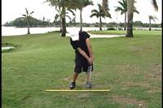

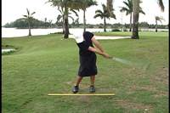

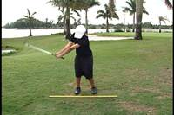

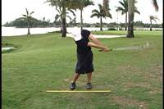

Trail leg back
Pull trail leg back behind target line to create and closed stance and swing. Swing back and through keeping the heel of the trail leg. Pulling the trail leg back will allow you to feel the freedom of the arm swing as you pivot your torso away from the target and pivot on the through swing.
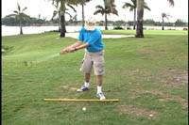

III. Speed Drill

Right Hand Only
Hit balls with right hand only. This gives the feeling of what the right arm does in the regular swing.
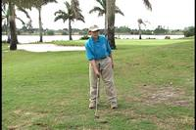

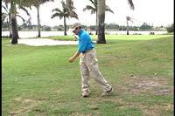

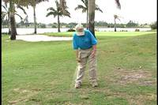

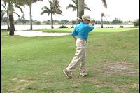

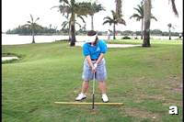

"Swoosh" Drill
- Turn your golf club upside down and grip the shaft below the clubhead. Assume your golf stance and posture. Your arms should be should be hanging naturally in front of your chest and your shoulders nice and wide. Avoid tension as it will inhibit the motion of your swing. Your grip pressure should be firm, not tight. Enough pressure in your fingers to hold the club, but still allow your wrists to hinge and unhinge.

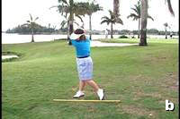
- Swing your arms freely to the top. Allow your wrists to hinge and your trailing elbow to fold as you support the shaft in a horizontal at the top of your swing. You should feel your weight inside your rear foot.

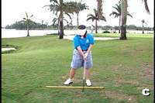
- Once reaching this horizontal position, transition into your forward swing by shifting the weight onto the target leg. As your arms drop back down towards the ball, try to create a "swishing sound" as you approach the 6 o'clock position or impact area. The unhinging of your wrists and rotation of your forearms and body through impact will enable you to generate this sound.

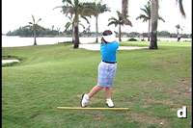
- This "release of energy" should carry you into a well-balanced finish. Repeat this drill several times, as you will find that the less tension you have in your arms and hands, the louder the "swish."

IV. Swing Path Drill
Hit balls next to a 2 x 4.
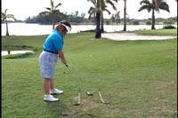
Place two clubs parallel to each other and swing between them.

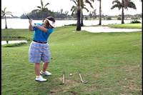

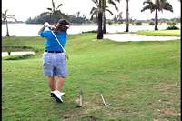

Just swing the club and take a divot. Then take a step and swing again. Continue doing this. Then check to see if the divots are in a straight line.

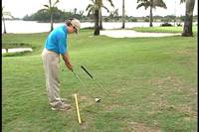
Intermediate—swing path drill. Stick a club shaft into the ground in front of you to relate your arm swing to the proper path.

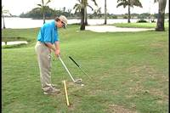

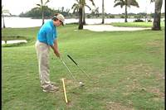
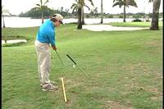

Trail Leg Back. (See Release Drill). This drill is also effective for preventing a student from casting the hands and arms away from the body in the transition from backswing to forward swing, or as many call, “coming over the top.” Have the student pull the trail leg back behind the line and focus on keeping the heel of the trail leg in the starting position as he/she swings back and through. This will allow the athlete to keep their back to the target a few second longer and allow for the arms and trailing elbow to drop into the proper path when changing directions. If the student throws the hands and arms away from the trail shoulder (casting) when making this transition, the chest will open to the target and trail heel will raise too early.

Golf Games
Listed in this section are a number of golf related and lead-up type of games which are designed to both reinforce the instructional segment and to present golf as a fun sport.
Some of the activities are self-testing in that they are used to provide some practical application of newly learned skills. Other games were designed to promote a spirit of competition, cooperation, and team effort among the participants – forming the foundation for an effective class program.
When teaching the games, point out how students can use the games on their own for practice, The games can help teach the game of golf apart from the instruction program, as they encourage the youngster to use a combination of skill, knowledge of rules and inventiveness.
To use the games section effectively, each class should be divided into 3 or 4 teams 16 to 10 players per team) depending on the size of the class.
Assignments to teams should be made on the basis of physical size or athletic ability as it is unlikely that golf skills will be a known criteria. Teams can then be named after famous tour players (e.g, Woods, Sorenstan, Duval, Palmer )for easy identification and organization purposes.
Each activity is scored and tallied on a large score-board which could be displayed in the classroom. An example of how the points could be distributed is as follows:

Game: Tee Me-Pitch Me (30 points)
3 Teams | 1st | 14
3 Teams | 2nd | 10
3 Teams | 3rd | 6

4 Teams | 1st | 12
4 Teams | 2nd | 8
4 Teams | 3rd | 6
4 Teams | 4th | 4

5 Teams | 1st | 10
5 Teams | 2nd | 8
5 Teams | 3rd | 6
5 Teams | 4th | 4
5 Teams | 5th | 2

Points for the different events can be standard throughout or may be scaled for the popularity of events. Points for individual event winners should be tallied toward the team total; however, individual scoring records can also be kept.
Note: Individual events should be scored for 1st, 2nd and 3rd by age and sex.

Golf Games Directory
- Lead Up Games
  - Open Fairway
  - Chip, Pitch and Catch
  - Tee Track
  - Tee to Targets
- Short Swing Games
  - Tee Me-Pitch Me
  - Field Goal Golf
  - Leap Frog
  - Golf Bocce*
- Full Swing Games
  - Bullseye Golf
  - Death and Glory
  - Golf Bocce*
- Fun and General Games
  - Range Ball Relay
  - Golf Ball Race
- Putting Games
  - Hole Out Relay
  - Crack Putters Open
  - Mat on Green Games
- Short Course Golf Games
  - Regular Games
  - Scramble
  - Alternate Shot
  - Best Ball
  - Match and Medal Play
  - Putting contests

* This game will be used for both short and full swing.

A. Lead Up Games

1) Open Fairway
An introduction to the concept of playing golf where the student hits the ball, locates it, hits it again until reaching a designated finish line. (Use oversize balls, tennis, whiffle to start)
- Divide athletes into four groups
- Form single file lines approximately 20 yards apart
- Each student plays a ball to the finish line counting all swings, including misses.
- Students should attempt to travel in a straight line; but shots which go astray or into another players area can be played; however, the errant player must yield the right of way. The distances and types of balls can be changed for progression, challenge and variety.
 | Start | Finish
20  Yards  Apart | X→→→→→→→→→→→→→→→→→X
20  Yards  Apart | X→→→→→→→→→→→→→→→→→X
20  Yards  Apart | X→→→→→→→→→→→→→→→→→X
20  Yards  Apart | X→→→→→→→→→→→→→→→→→X

2) Chip, Pitch and Catch
This is a game for the Chip and Pitch Shots to develop distance control and target awareness
1_________________________2 This can be set up in a school yard or practice field.
3_________________________4

- Have the pupils pair off and face each other at a starting distance of 20 feet.
- Pupils tosses a ball using a short back swing.
- Player 1 tosses toward player 2, and player 2 tosses toward player 1.
*A tennis ball or some other type of soft ball should be used. The distance of tossing will vary to the simulate shots desired:
- Chip shot-shorter distance
- Pitch shot-longer

The game is to score points for tosses to your partner, which do not make him move to catch or touch the ball. Each time the player catches the ball; it is recorded as 2 points for the thrower. Once practiced, teams will be given 10 chances (5 per person) and the team making the most points is the winner.

3) Tee Track
This is an introductory golf activity which utilizes a boundary area (track) from the start to finish.
- Each student begins play from a designated area and attempts to follow a course or track ( 10 to 15 yards wide) to a finish point.
- Balls which are struck out of the boundary area must be retrieved, with a penalty stroke added, and play continued from that point.
- Athletes should count each swing and penalty until they advance the ball across the finish line.
- The object is to do this in the fewest number of swings.
- Suggest using an oversize ball ( tennis or whiffle) and send the –players off in groups of two or three to learn the proper order of play. Use the 2 miss of whiff rule.
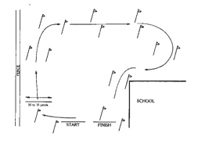

4) Tee to Targets
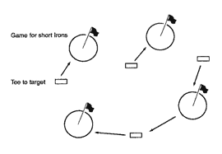

This can be set up in a very small area and introduces the playing game.
- Have the students in foursomes
- Using the etiquette of golf, have the players strike tennis balls from the designated tee toward the target.
- When the ball is within 1 club-length of the flag, the players would proceed to the next tee.
- Any number of holes could be set up for this game.
- Each player should keep his/her score for each hole, how many shots it takes to come within 1 club length of the target. Distances for the holes should be from 30 to 60 yards,
- It is suggested that a tennis ball or some other soft ball be used for this activity.
- It is important that the instructor understands that these 4 basic shots (putt, chip, pitch and iron) can be taught on a playground or field if a regular golf facility simply is not available. Throughout this entire program, much improvising has perhaps been required, but sometimes that brings a closer feeling of togetherness."
- The key to teaching the athletes is to repeat, repeat again, each skill required in striking the ball.

B. Short Swing Games

1) Tee Me-Pitch Me:

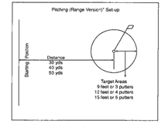

This games challenges the student to pitch over an obstacle and land within a designated target area either on a green or on the practice field. Place a bag or obstacle 1/3 the distance from an established restraining line. The student may tee use a tee for each shot.
- Students will hit 6 balls from the restraining line
- All shots must carry over the obstacle and come to rest within the designated target area.
- Each shot has a possible 20 points.
- Five points for striking the ball, 15 for getting the ball over the obstacle and coming to rest within the target area..
- Count 4 of the 6 ball total for score.

2) Field Goal Golf
This is a target contest which tests the ability of the student to hit shots of different trajectories.
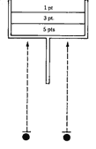
- The students attempt to hit the ball through space or target zones at
different heights established by placing rope or string across goal
post standards, trees, etc.
- Each space has an assigned point value depending on the width of the
zone.
- A variation is to award bonus points for scoring in all target zones in
order (1-3-5).
- Recommended club is #7 iron using a half-swing technique. Use line
formations with each student taking a shot at each target.

3) Leap Frog
This is a game to enhance carry yardage and distance control. This game can be played using the mini or full swing. Divide athletes into teams of 2 – 8 players. To start the game, define an initial target or boundary line for the first player to land on or over. Teams will alternate shots, attempting to land their ball over the subsequent ball hit.
Points are scored when a player lands his/her ball on or over the previous hit ball. If a ball comes to rest short of the target, no points will be awarded. The team scoring the most successful “leaps” will be determined the winner.
This practice game can also be played independently, you against yourself.

4) Golf Bocce
Bocce is a game of skill and strategy. The object is for one team to get as many of their balls closer to the hole or target than the opposing team's closest ball. There may be anywhere from two to four to eight players on a team. Each player is given two balls. Each player must then take turns hitting the ball toward the hole or target. The players are given points for the balls rolled closest to the target. Players may also strike other balls to move closer to the target. Balls may also be displaced by the balls of other players.
The team scoring the most points is the winner.

C. Full Swing Games
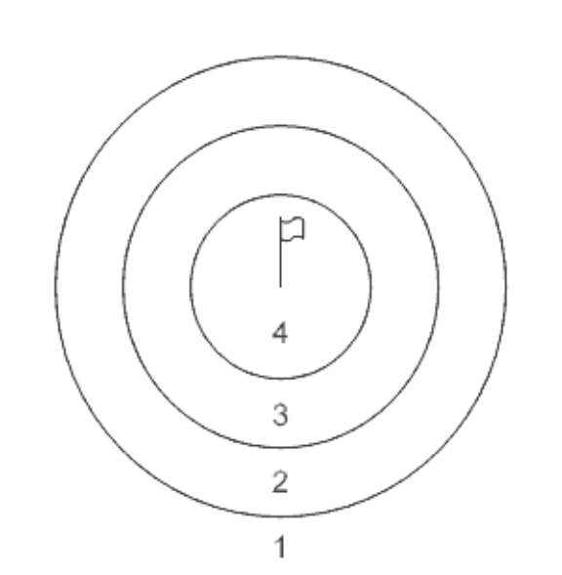

1) Bullseye Golf
A target focused game awarding points to where the ball comes to rest within a given zone. Targets may be set up in a circle or grid relative to Level 1: Skills Competition. Point increments from low ( farthest ) to high(closest) should be awarded . See diagram to the right.

2) Death or Glory
This is a short swing game to test the student's ability to hit a controlled pitch shot over an obstacle. Students attempt to hit the ball into scoring zones which are located just beyond a designated danger area, such as a lake, tennis court, road, etc. scoring is based on a ball landing safely in the zone with higher point values near the obstacle results in a penalty or minus points.
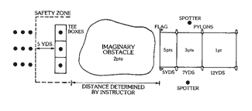

3) Golf Bocce
Bocce is a game of skill and strategy. The object is for one team to get as many of their balls closer to the hole or target than the opposing team's closest ball. There may be anywhere from two to four to eight players on a team. Each player is given two balls. Each player must then take turns hitting the ball toward the hole or target. The players are given points for the balls rolled closest to the target. Players may also strike other balls to move closer to the target. Balls may also be displaced by the balls of other players.
The team scoring the most points is the winner.

D. Fun and General Games

1) Range Ball Relay
This is a modified ball retrieving relay game used to pick up the range when practice is completed.
- Teams should be spread out evenly around the range and at the sound of a whistle, attempt to pick up as many balls as they can carry until the range is clean.
- Ball containers for each team should be placed at spaced locations for deposit of the balls.
- A variation of this activity is to designate Ball Toters and Loaders.
- The toters (one or two) would fold their arms in front of the body and allow the loaders to fill them with balls.
- The toters would then deposit the balls in the basket and return for another load.
- Any ball stealing, pushing, etc., would be penalized by deducting balls from the team total.
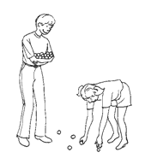

2) Golf Ball Race
This is a team relay race of two golf holes for speed.
- Players are assigned to a position on each hole, such as designated driver, f fairway and putter for the team.
- At the whistle, Player A ( first driver) hits the ball down #1 fairway to Player B (fairway player) who I turn hits the ball toward the green to Player C (putter).
- The ball is putted in to the cup with the putter, removed by hand and thrown or carried to the #2 teeing area for continued play to the #2 green.
- A ball which is dubbed or hit off line may be played by any player who is able to get to the ball fastest.
- Use of the hands or body to influence the ball is considered a violation and subject to a 10 second penalty.
Number of players per team can vary. One person can double as putter and driver.

E. Putting Games

1) Hole Out Relay
This is a putting or chipping relay race of two players at a time. Players start and finish at the same point.
- At the whistle, each player plays to their designated target area ( hole or circle).
- After holing out or ( ball inside the circle), the players must then play across to the opponents target and then retrace this route back to the starting line in the same manner.
- Players may not use their hands, feet or body to influence the ball (except to take the ball out of the cup) or block another’s player’s path. Penalty for any violation is 5 seconds.
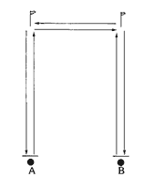

2) Crack Putters Open
A putting contest on a variety of surfaces (walks, blacktop, flooring, etc.) or green to see who can make the ball stop closest to the target (crack or line like in pitching pennies).
- Play begins from both ends of the surface with the players putting toward the crack or line. scoring zones are marked with higher values nearer the crack.
- If another player strikes a competitor’s ball, the balls will be scored where they come to rest. Each player should be given a set number of putts.

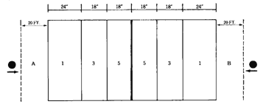

3) Mat or Green Games: See “Short Course Golf Games, Putting Contests.”

F. Short Course Games and Activities

Regular Golf Games
A short course of 3 to 6 holes of 10 to 50 yards each, can offer a variety of golf play situations and a transition from the practice area. You can vary the length of the holes to emphasize different techniques, and to allow the use of larger or softer balls. Boundaries and hazards should be established and marked so that rules can be taught.
Sramble | An members of a team play from the tee. The best positioned ball of the group is selected and all play their next shot from this point. Continue this same play format until the ball is holed out or in the target area.
Alternate Shot | Two members of a team drive from the tee. They select the best positioned ball, then alternate play on this ball until it is holed out or in the target area.
Best Ball | An members of the team play their respective balls from the tee to the hole or target area, each player scoring individually. The best ball score for the hole would then count for the team.

Putting Contests
For Greens or Carpet-Like Surfaces
Putting Course | Set up a miniature golf course using string, tees and other convenient materials to present the challenge of a golf course with all of the hazards and obstacles. Play the following games with an opponent:
Horseshoes | Putt two balls. Score 3 points for a ball holed; Closest ball to hole scores 1 point, two balls closer scores 2 points. A ball must be within the putter grip to score.
Twenty-One | Putt one ball. Only after you make the first putt are you entitled to play a short putt Ifrom one club-length) for a bonus point. Continue play until you miss a long putt} you still get to short putt) and the opponent plays. First one to twenty-one wins.
Drawback | Putt one ball. If the ball does not go in, draw the ball back one club-length and putt again. Continue this format until ball is holed and score total number of putts.
Ladder | Putt at one foot intervals from one to ten feet to the cup attempting to make each putt in succession. You must start over at one foot after a miss. Score is the distance you achieve.

Note: Begin all putting games from a prescribed distance from 10 to 15 feet depending on space available.

Level II – V

How the Game of Golf is Played
The idea of the game of golf is to send the ball from a starting place (the tee) swinging as many times as it may take you until you get it to the green and into the finish place (the hole, or cup). The object of the game is to do this in as few strokes as possible. You count every swing, including penalty strokes and whiffs (misses) at the ball (but not practice swings away from the ball). Your score for the hole is the total number of strokes you took from the tee to the hole or cup in the green.

Scoring
Each hole will have a number, or score listed for it, which is called par. This is the standard of excellence that golfers shoot for when they begin to play golf. Your scores will be much higher than par when you first start playing, but your scores will go down as you practice and improve your skills.
Depending on the length of the hole, a hole may be rated for a 3-stroke, 4-stroke, or 5-stroke par. Although you may not be shooting for par, you can use the par standard to help measure your own skill on different holes.
Golfers who shoot close to par use special terms for their scores on a hole. Finishing the hole with the same score as par is called making par. scoring one stroke under par is a birdie, and two strokes under par is a eagle. Scoring one stroke over par is a bogey, and two strokes over par is a double bogie.

A Final Swing Checklist:
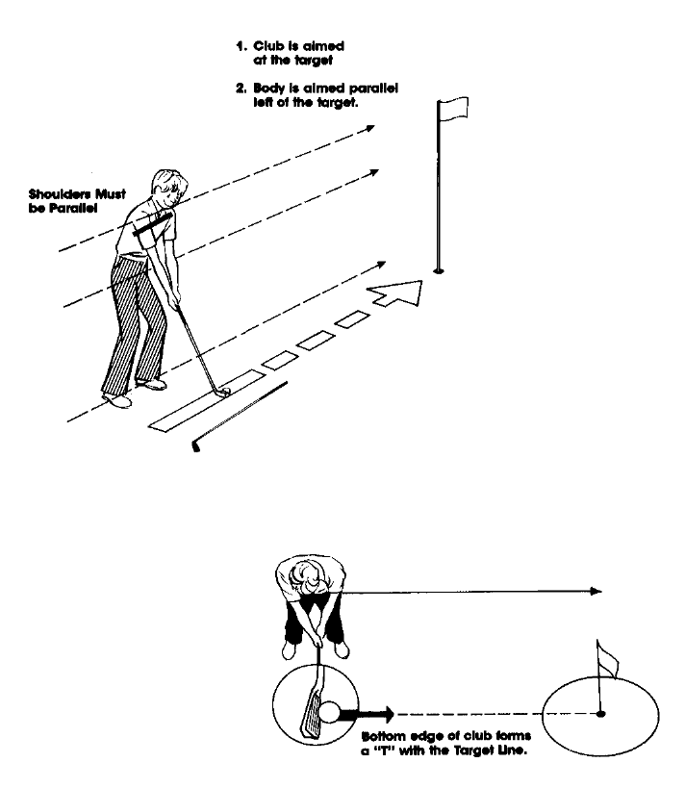
Here is a routine to line up and play a shot:
- Stand behind the ball and look at the line to the target.
- Take your stance, aiming the club and your body parallel to the target.
- Look at the target, imagine a good shot.
- Make a swing.

Special Golf Terms

Term | Definition
Address | Position of a player when he/she has taken his/her stance and grounded the club, or if in a hazard, when he/she has taken his /her stance.
Approach | Stroke intended to place the ball on the putting green.
Bunker | An area of bare ground, often a depression, which is usually covered with sand,
Chip | A short low shot played to the putting surface partly through the air and partly rolling along the ground.
Course | The whole area within which play is permitted – 9 or 18 holes.
Divot | A piece of turf or sod cut loose by a player's club when making a shot.
Dogleg Hole | One that does not follow a straight line from tee to green.
Drive | A long shot played from the teeing ground, usually with a wood club.
Etiquette | Courtesies expected of and to golfers.
Fellow Competitor | Any player with whom the competitor plays. Neither is the partner of the other,
Flagstick | A pole or straight indicator with a flag centered in the hole on the green to show its position.
Fore | A warning shouted to let a person within range know that a player is about to hit his/her ball or that a ball in flight may hit or come very close to that person,
Hole | An area of the course consisting of a teeing ground, putting green and the area in between; the small hole or cup cut into the ground into which the player fries to play his/her ball. A round of golf is played over 18 holes.
Iron Shot | A golf club with an iron or steel head used to hit the ball from the tee to the fairway.
Lie | Spot where the ball rests,
Match Play | Play in which each hole is a separate contest, the winner being the player or side winning the most holes.
Penalty Stroke | One added to the score of a side under certain Rules of Golf. It does not affect the order of play.
Pitch Shot | A high trajectory shot played to the putting green.
Putt | A shot played on the putting surface with a fairly straight-faced club with the intention of rolling the ball toward the cup.
Stroke | The name given to each time you swing at the ball. The total number of strokes you take give you your score.
Stroke Play | Play in which the total strokes for the round surface, having little or no roll. or the stipulated number of rounds determine the winner.
Rough | The area of long grass that adjoins tees, fairway and green.
Wood Shot | A long shot usually played from the fairway with a wood or metal wood club.

Playing a Golf Course
It is suggested that athletes be divided into two groups.
- Those who have experience playing and those who are not able to play a regulation golf course.
- Those who have experience, play a 9 hole round. Stroke play will determine the winner. There should be several categories, competing by age. The only change of rules would be the distance of each hole. It is recommended that Par 3 should not be over 125 yards. The Par 4 should not be over 250 yards, and the Par 5 should not be over 300 yards. This could be easy to arrange on most courses, It is suggested a Cayman ball be used, if not a regular golf ball. Special scorecards could be made and used for the competitors.
The scoring and skill criteria for each level is detailed in the Official Special Olympics Summer Rules: Golf (Article IX.) Athletes are encouraged to keep their own score and establish a handicap.

Golf Coaching Guide

Golf Competition Rules, Protocol and Etiquette

Table of Contents

Rules of Competition
Definition of Terms
Teaching the Rules of Sport
Levels of Competition or Events
Golf Competitions
Venue Requirements
Flow of Athletes
Equipment
Uniforms
Event Personnel
Results and Scoring
Disqualification Procedures
Protest Procedures
Criteria for Advancement to Higher Level of Competition

To go directly to a section, hold down your control key and click on the heading

A Summary of the Rules of Golf
Golf is a game. But remember, EVERY GAME HAS ITS RULES. The official Special Olympics Sports Rules shall govern all Special Olympics Golf competitions. Special Olympics has created these rules based upon The Rules of Golf as governed by the Royal and Ancient Golf Club of St. Andrews (R& A) and the United States Golf Association. To enjoy a fair match and protect the integrity of competition, it is important know and understand the basic rules of the game.

Table of Contents

Etiquette
Courtesy on the Course
Safety First
Taking Care of the Course

A Summary of the Rules of Golf
Rule l-The Game
Rule 2-MatchP1ay
Rule 3-Stroke Play
Rules 4&5- C1ubs and the Ball.
Rule 6-Things a Player Should Know
Rule 7-Practice
Rule 8-Advice on How to Play
Rule 9-Advising Opponent on Strokes Taken
Rule 10-When to Play a Shot
Rule 11-Teeing Ground
Rule 12-Finding Ball in Hazard/Identifying Ball
Rule 13-Playing the Ball as It Lies and the Course as You find it
Rule 14-Striking the Ball
Rule 15-Playing a Wrong Ball
Rule 16-The Putting Green
Rule 17-The Flagstick
Rule 18-Moving the Ball
Rule 19-Ball in Motion, Deflected or Stopped
Rule 20-Lifting and Dropping the Ball
Rule 21-Cleaning the Ball
Rule 22-Ball Interfering with or Assisting Play
Rule 23-Loose Impediments
Rule 24-Obstructions
Rule 25-Casual Water; Ground under Repair; Animal Holes
Rule 26-Water Hazards
Rule 27-Ball Lost or Out of Bounds
Rule 28-Ball Unplayable

Etiquette

Courtesy on the Course
- If someone else is playing from the tee, do not tee your ball until he/she has played
- Always stand still and to the side of rather than behind another player when he or she is playing. Do not talk.
- Be ready to play when it is your turn.
- When you are playing slowly or looking for a lost ball, ask the group behind you to play through, so you do not slow everyone down.
- Write down scores on the way to the next hole, not on the green you are leaving.
- Never take more than one practice swing, if any.

Safety First.

Both in Practice and Play, always make sure that:
- No one is near you when you swing the club
- No one is ahead of you where your shot might hit them,
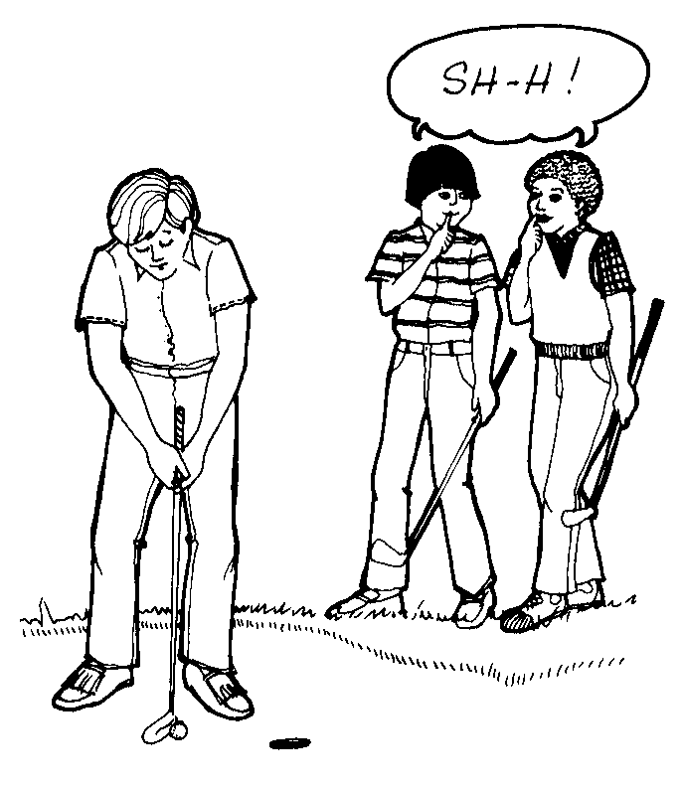

Taking Care of the Course
- Always wear golf or tennis shoes. Do not slide or drag your feet or the on the green.
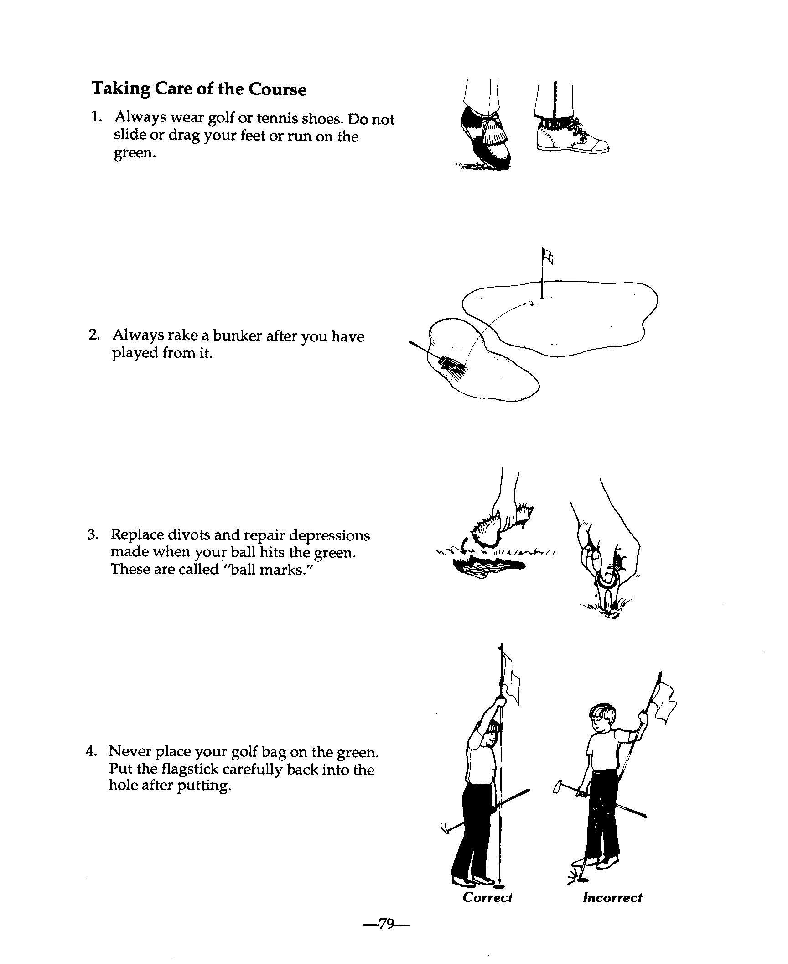
- Always rake a bunker after you have played from it.

- Replace divots and repair depressions made when your ball hits the green. These are called ''ball marks."
- Never place your golf bag on the green. Put the flagstick carefully back into the hole after putting,

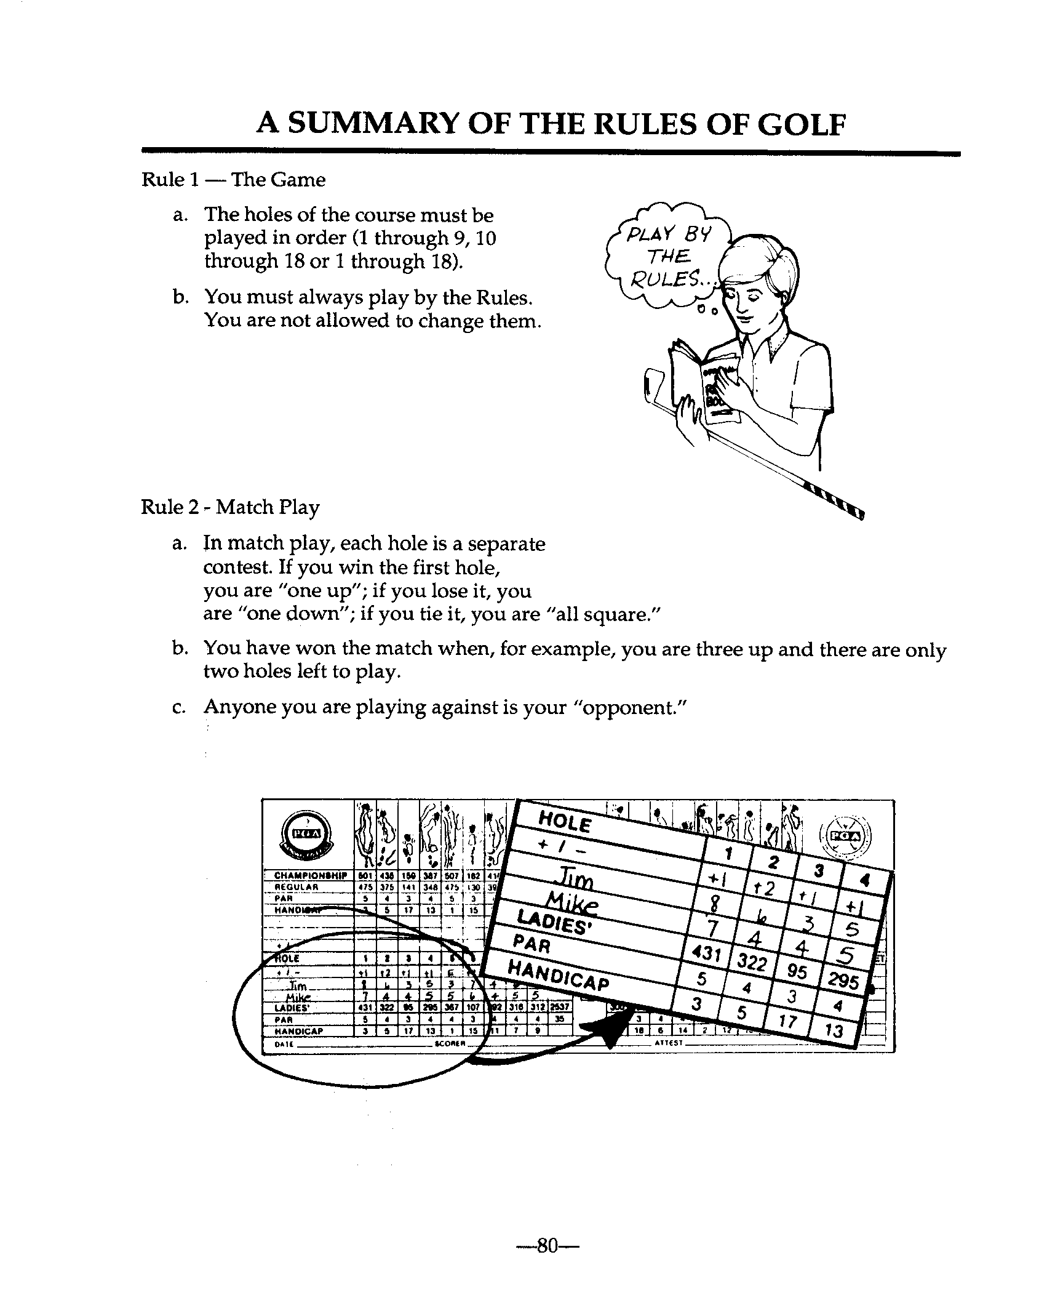
A Summary of the Rules of Golf

Rule 1 - The Game
- The holes of the course must be played in order (1 through 9, 10 through 18).
- You must always play by the Rules. You are not allowed to change them.

Rule 2 - Match Play
- In match play, each hole is a separate contest. If you win the first hole, you are “one UP”; if you lose it, you are “one down"; if you tie it, you are ''all square."
- You have won the match when, for example, you are three up and there are only two holes left to play.
- Anyone you are playing against is your "opponent."

Rule 3 - Stroke Play
- In stroke play, the stipulated competitor with the lowest total score for the round is the winner.
- You must play the ball into the hole before starting the next hole. No "gimmies!"
- Anyone you are playing with is a fel1ow competitor.
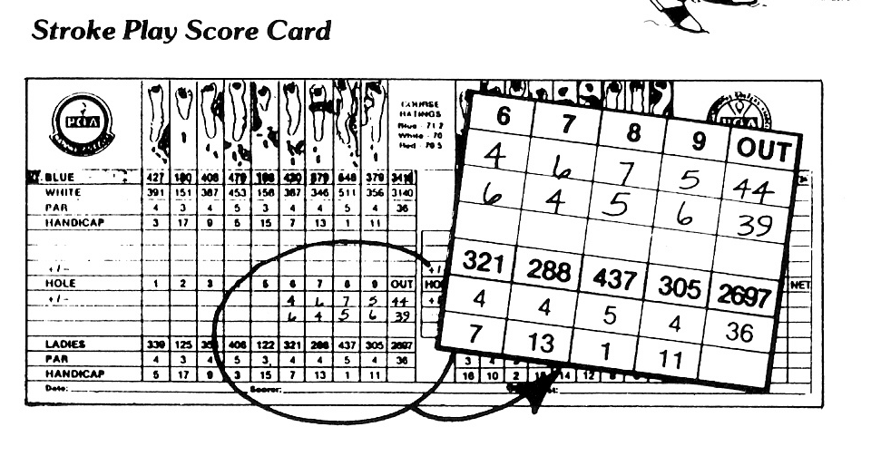

Rules 4 and 5 - Clubs and the Ball
- You may carry no more than fourteen clubs.
- You may not change balls during the play of a hole.
However, if you damage or cut your ball, you may do so after first asking your opponent or a fellow competitor.

Rule 6 - Things a Player Should Do

You should:
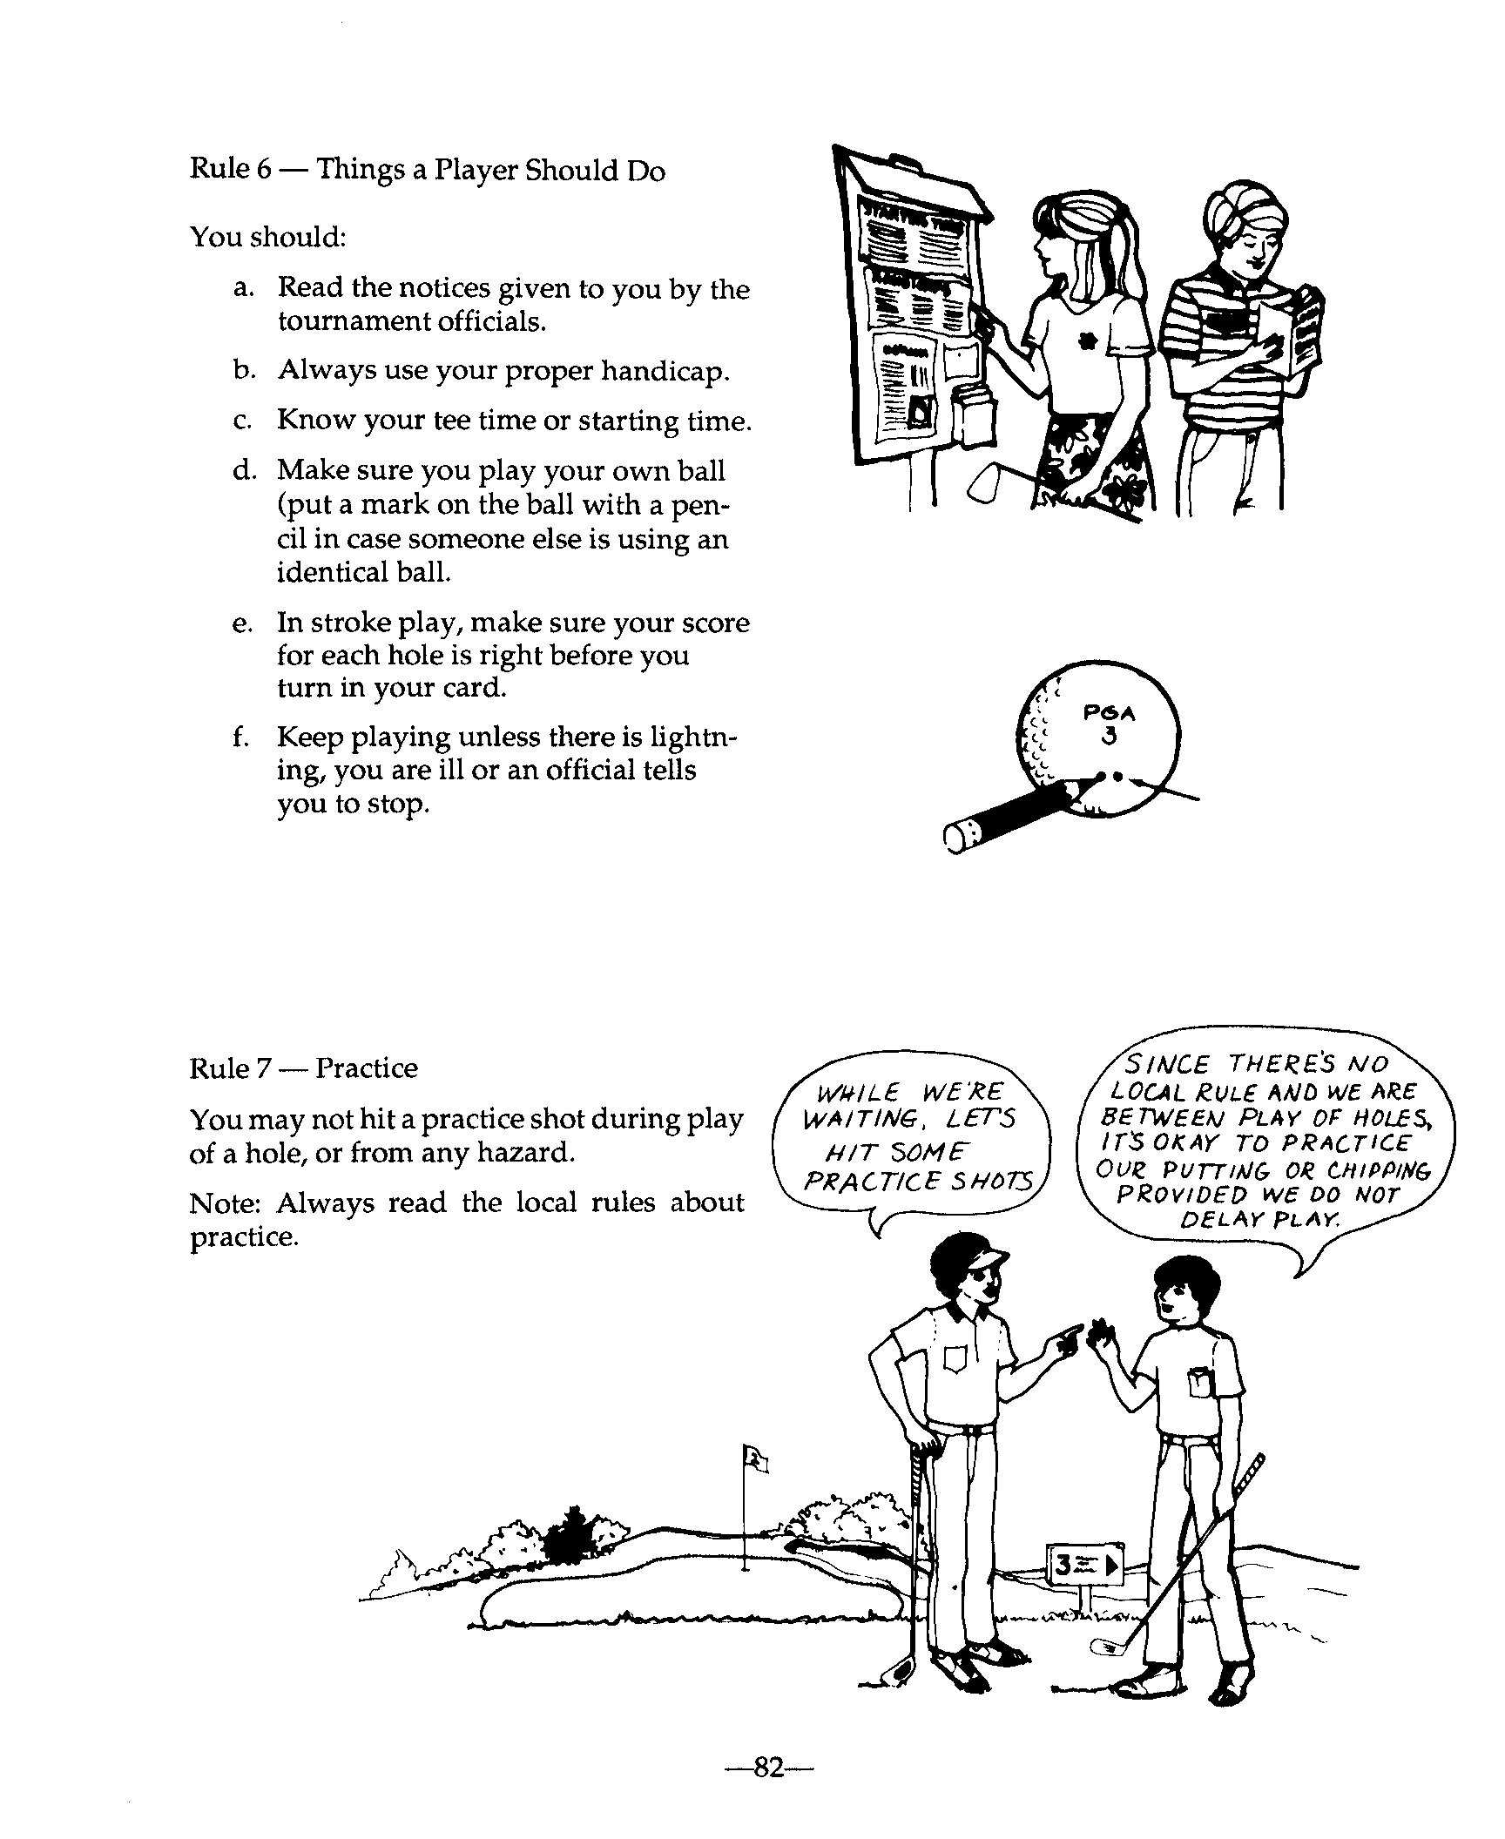
- Read the notices given to you by the tournament officials.
- Always use your proper handicap.
- Know your tee time or starting time.
- Make sure you play your own ball (put a mark on the ball with a pencil in case someone else is using an identical ball.
- In stroke play, make sure your score for each hole is right before you turn in your card.
- Keep playing unless there is lightning, you are ill or an official tells you to stop.

Rule 7 - Practice
You may not hit a practice shot during play of a hole, or from any hazard. Note: Always read the local rules about practice.

Rule 8 - Advice on How to Play
- You may not ask anyone except your caddie or partner for advice on how to play, However, you may ask about Rules or the position of hazards or the flagstick.
- You may not give advice to your opponent or a fellow-competitor.

Rule 9- Advising Opponent on Strokes Taken
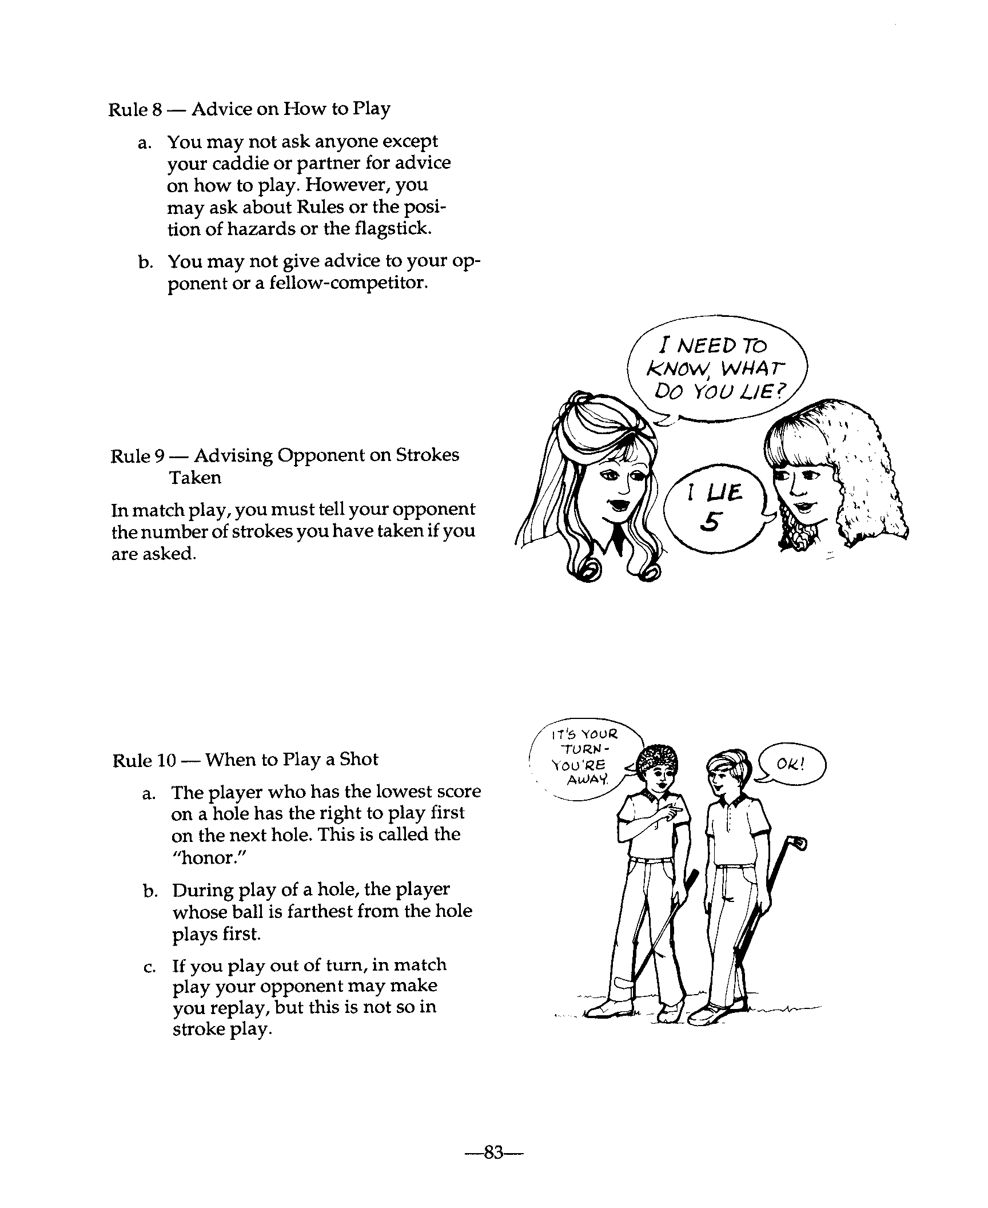
In match play, you must tell your opponent the number of strokes you have taken if you are asked.

Rule 10 - When to Play a Shot
- The player who has the lowest score on a hole has the right to play first on the next hole. This is called the “honor."
- During play of a hole, the player whose ball is farthest from the hole plays first,
- If you play out of turn ,in match play your opponent may make you replay, but this is not so in stroke play.

Rule 11 - Teeing Ground
- Tee your ball between the tee-markers or a little behind them. You may go behind them as much as two club-lengths.
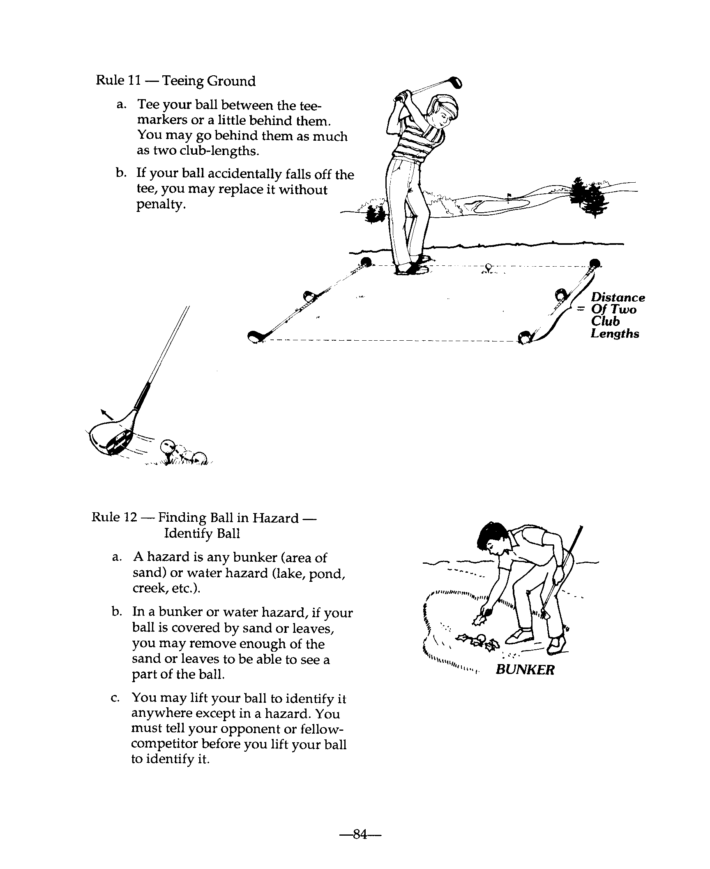
- If your ball accidentally falls off the tee, you may replace it without penalty.

Rule 12 - Finding Ball in Hazard Identify Ball
- A hazard is any bunker (area of sand) or water hazard (lake, pond, creek, etc.).
- In a bunker or water hazard, if your ball is covered by sand or leaves, you may remove enough of the sand or leaves to be able to see a part of the ball.
- You may lift your ball to identify it anywhere except in a hazard. You must tell your opponent or fellow competitor before you lift your ball to identify it.

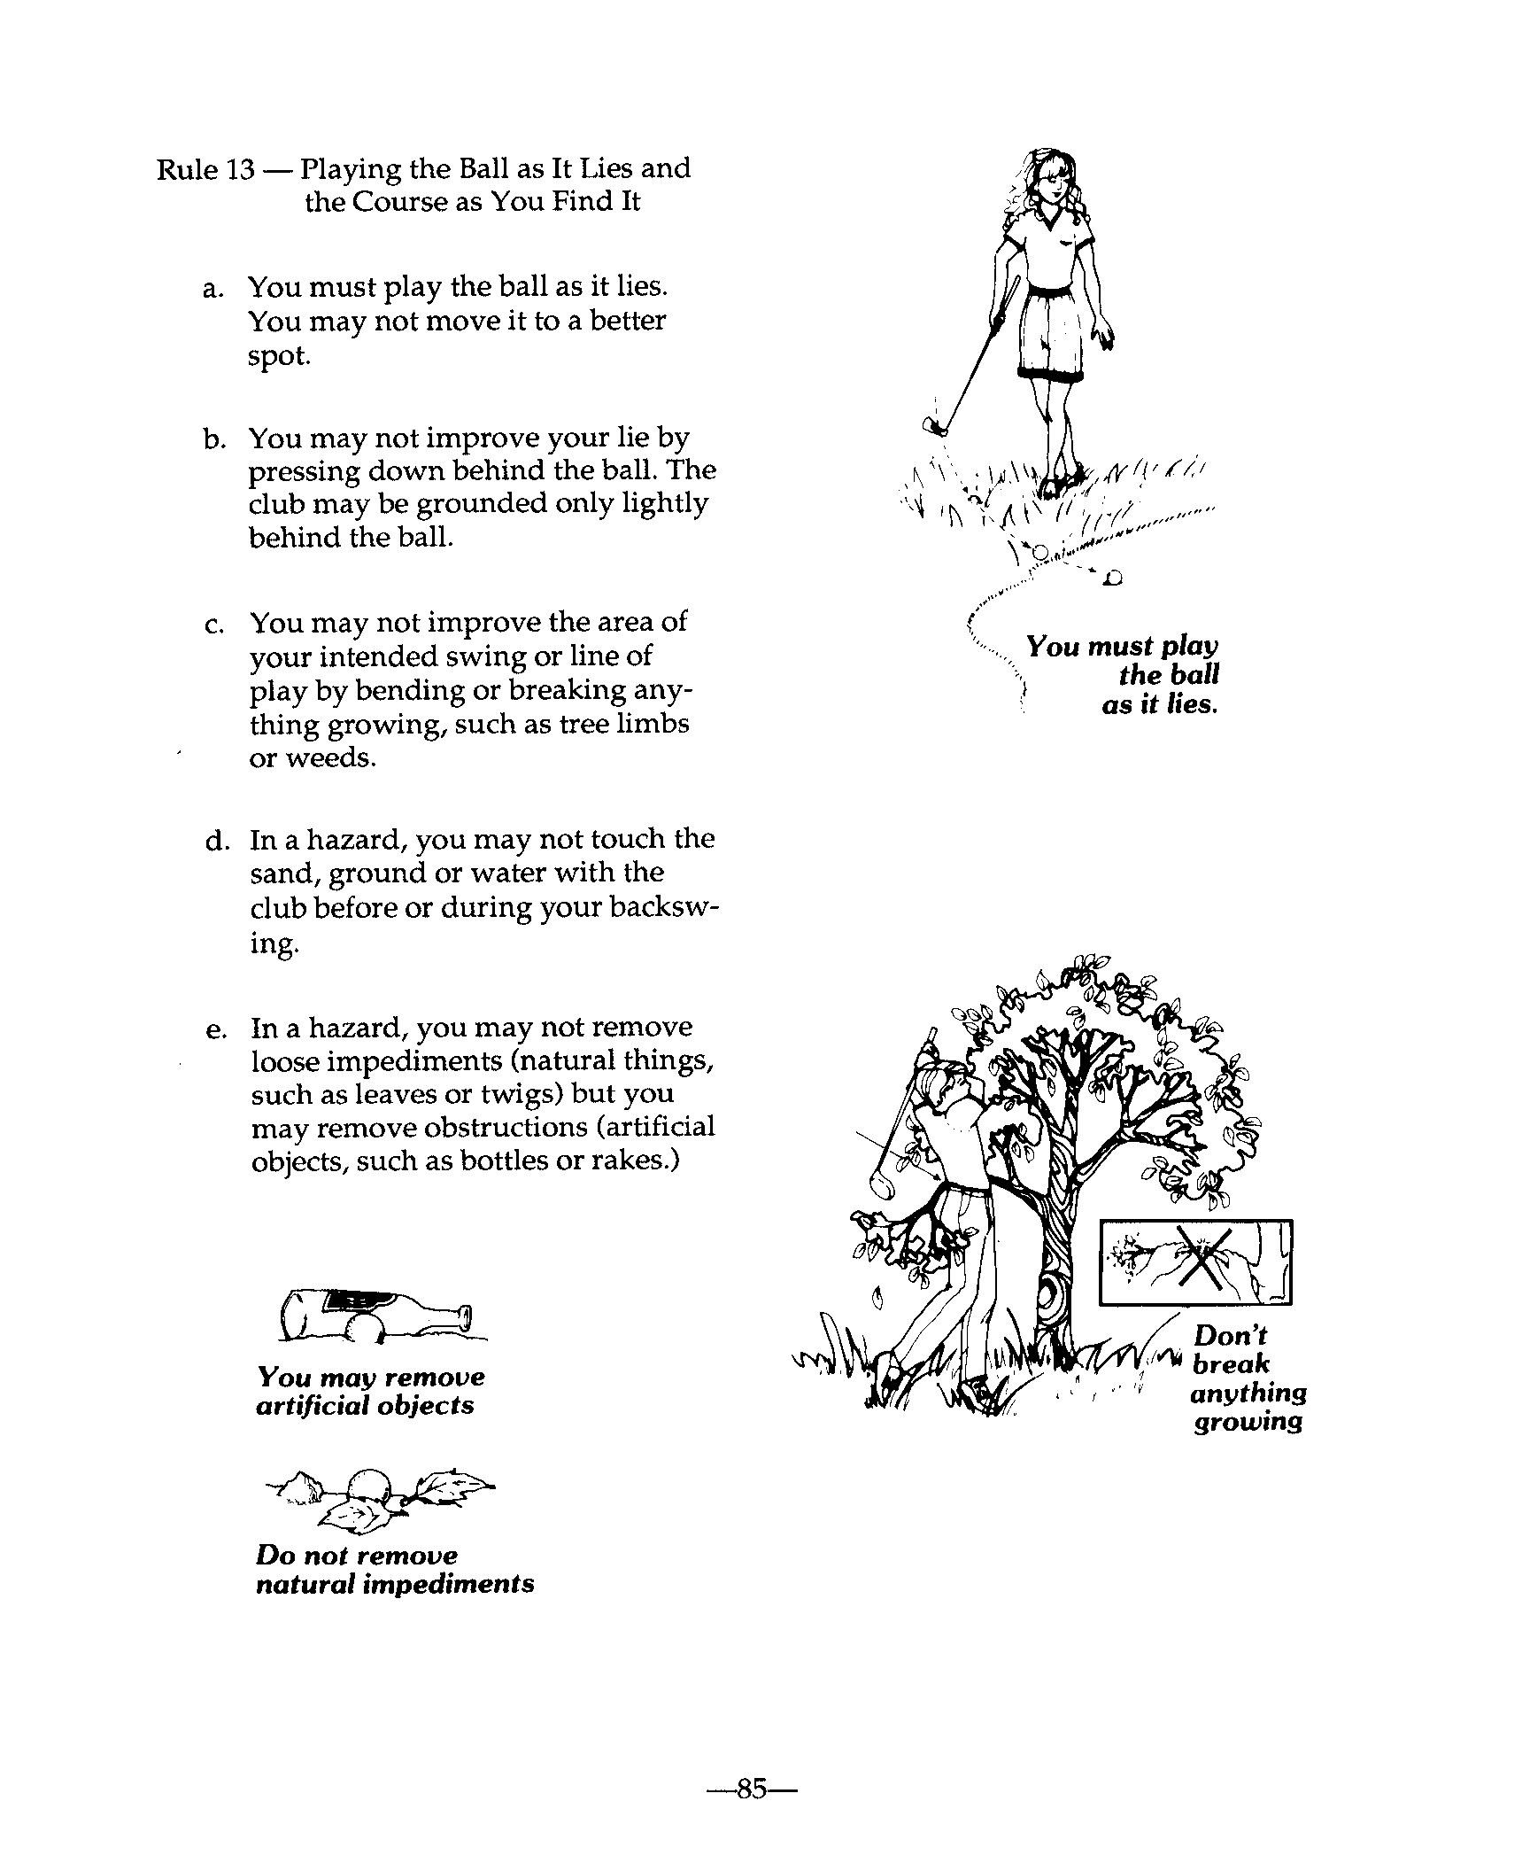
Rule 13 - Playing the Ball as It Lies and the Course as You Find It
- You must play the ball as it lies, You may not move it to a better spot,
- You may not improve your lie by pressing down behind the ball. The club may be grounded only lightly behind the ball.
- You may not improve the area of your intended swing or line of play by bending or breaking anything growing, such as tree limbs or weeds.
- In a hazard, you may not touch the sand, ground or water with the club before or during your backswing.
- In a hazard, you may not remove loose impediments (natural things, such as leaves or twigs) but you may remove obstructions (artificial objects, such as bottles or rakes,)

Rule 14 - Striking the Ball
- You must fairly strike the ball with the head of the club. You may not push, scrape or rake the ball,
- You must not hit your ball while it is moving.

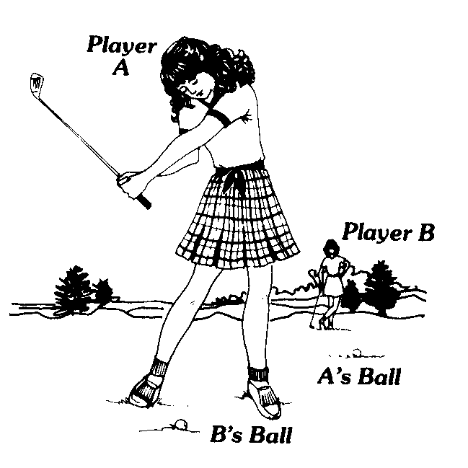
Rule 15 - Playing a wrong Ball
- a. In match play, if you play a ball that is not yours you lose the hole unless the wrong ball is played in a hazard; if you play a wrong ball in a hazard, you must then play the right ball.
- b. In stroke play, if you play a ball that is not yours, you must take a two-stroke penalty unless the wrong ball was played in a hazard. You must then play out the hole with your own ball; If you do not do so, you are disqualified.

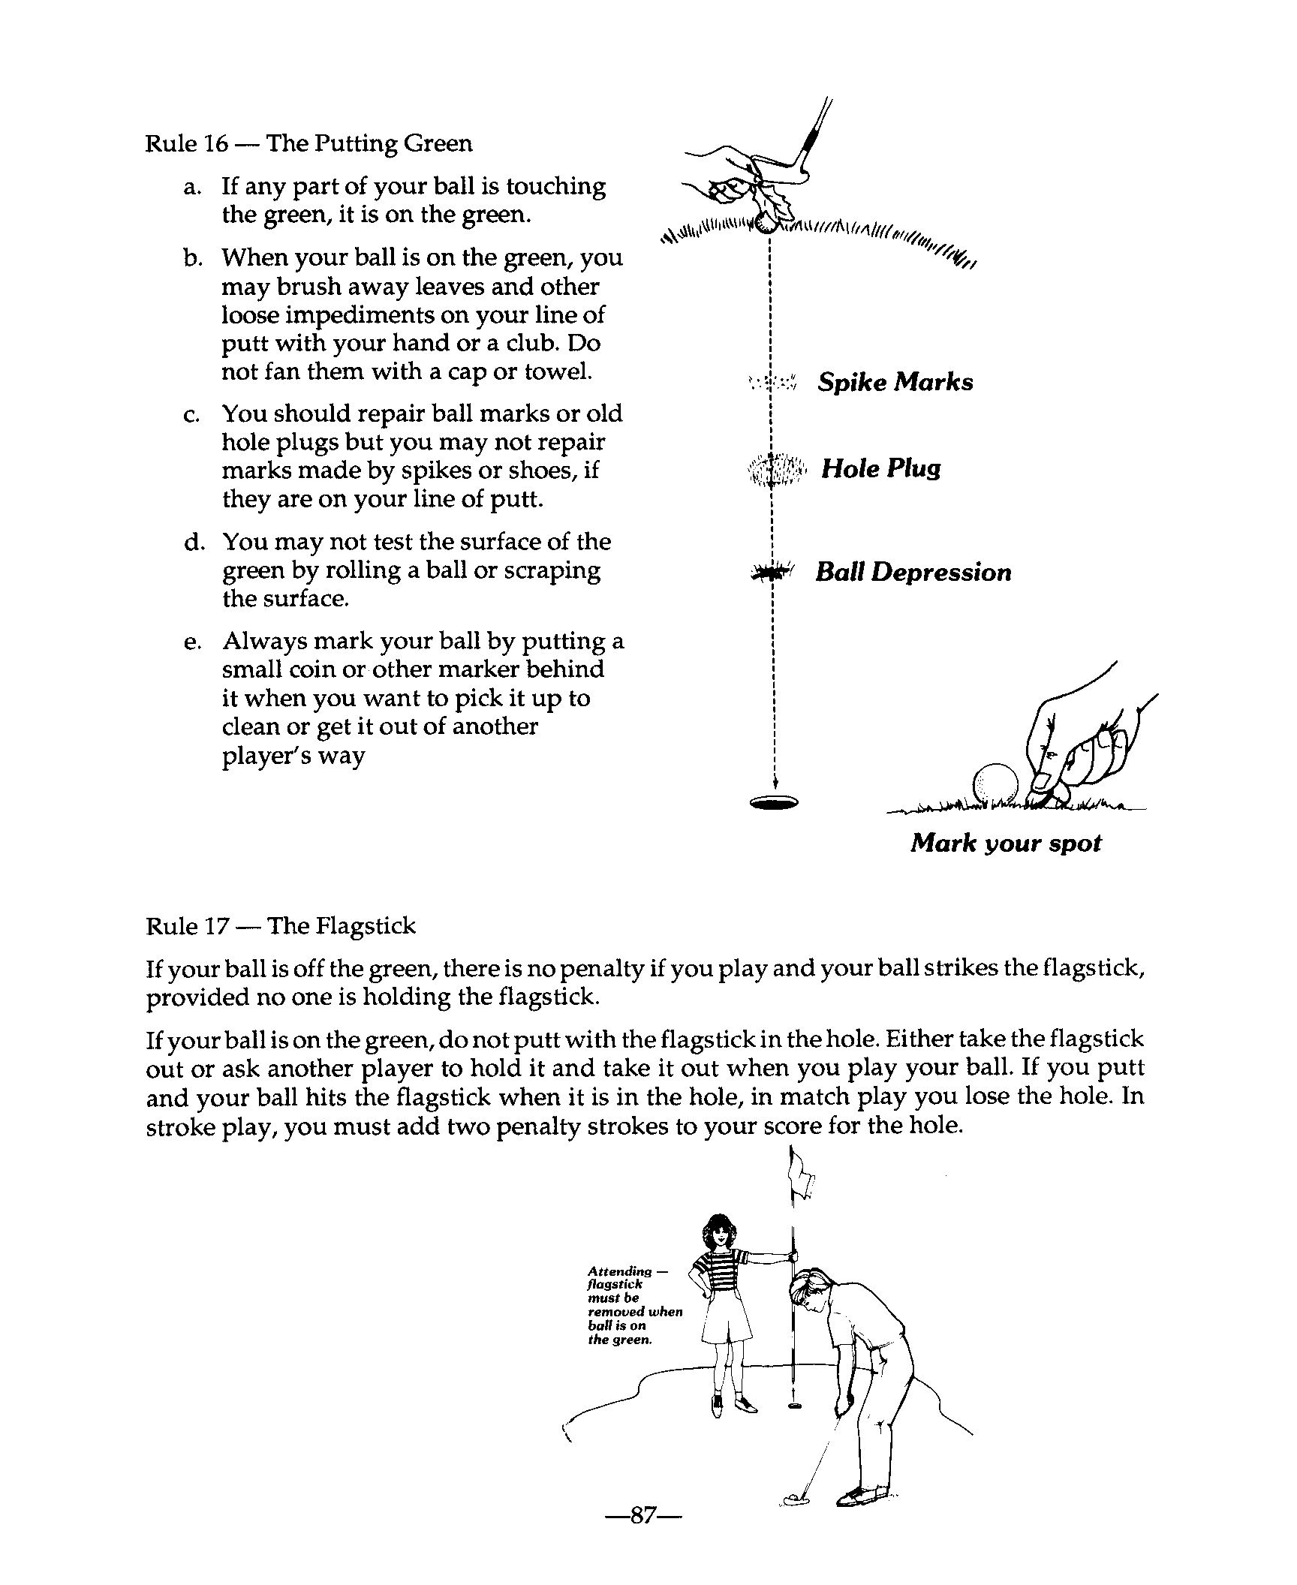
Rule 16 - The Putting Green
- If any part of your ball is touching the green, it is on the green.
- When your ball is on the green, you may brush away leaves and other loose impediments on your line of putt with your hand or a club, Do not fan them with a cap or towel.
- You should repair ball marks or old hole plugs but you may not repair marks made by spikes or shoes, if they are on your line of putt.
- You may not test the surface of the green by rolling a ball or scraping the surface.
- Always mark your ball by putting a small coin or other marker behind it when you want to pick it up to clean or get it out of another player's way.

Rule 17 - The F1agstick
If your ball is off the green, there is no penalty if you play and your ball strikes the flags tick, provided no one is holding the flagstick.
If your ball is on the green, do not putt with the flagstick in the hole. Either take the flagstick out or ask another player to hold it and take it out when you play your ball. If you putt and your ball hits the flagstick when it is in the hole, in match play you lose the hole. In stroke play, you must add two penalty strokes to your score for the hole.

Rule 18 - Moving the Ball
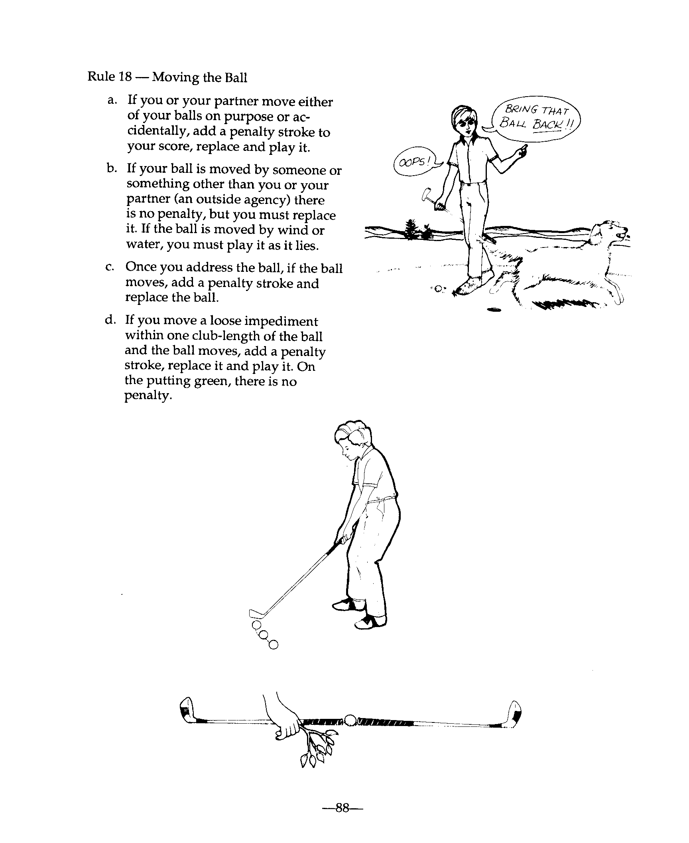
- If you or your partner move either of your balls on purpose or accidentally, add a penalty stroke to your score, replace and play it.
- If your ball is moved by someone or something other than you or your partner (an outside agency) there is no penalty, but you must replace it. If the ball is moved by wind or water, you must play it as it lies.
- Once you address the ball, if the ball moves, add a penalty stroke and replace the ball.
- If you move a loose impediment within one club-length of the ball and the ball moves, add a penalty stroke, replace it and play it. On the putting green, there is no penalty.

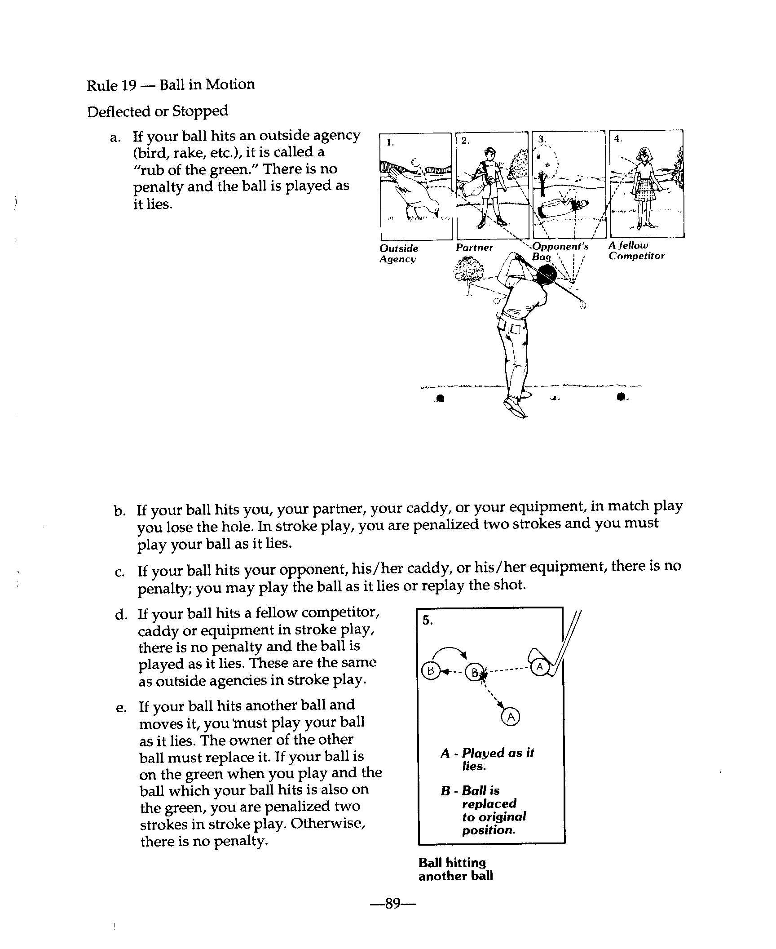
Rule 19 - Ball in Motion Deflected or Stopped
- If your ball hits an outside agency (bird, rake, etc.) it is called a “rub of the green.” There is no penalty and the ball is played as it lies.
- If your ball hits you, your partner, your caddy, or your equipment, in match play you lose the hole. In stroke play, you are penalized two strokes and you must play your ball as it lies.
- If your ball hits your opponent, his/her caddy, or his/her equipment, there is no penalty; you may play the ball as it lies or replay the shot.
- If your ball hits a fellow competitor, caddy or equipment in stroke, there is no penalty and the ball is played as it lies. These are the same as outside agencies in stroke play.
- If your ball hits another ball and moves it, you must play your ball as it lies, The owner of the other ball must replace it. If your ball is on the green when you play and the ball which your ball hits is also on the green, you are penalized two strokes in stroke play. Otherwise, there is no penalty.

Rule 20 - Lifting and Dropping the Ball
- If you are going to lift your ball under a Rule and the Rule requires that the ball be replaced, you must put a ball-marker behind the ball before you lift it.
- When you drop a ball, stand erect, hold the ball at shoulder height extend your arm out straight and drop it.
- If a dropped ball hits the ground and rolls into a hazard, out of a hazard, more than two club-1engths, nearer the hole or, if you are dropping away from an immovable obstruction or ground under repair, etc., back into the obstruction or ground under repair, you must re-drop. If the same thing happens when you re-drop, you must place the ball where it struck the ground when it was re-dropped.

Rule 21 - Cleaning the Ball
You may usually clean your ball when you are allowed to lift it, Except on the green, you may not clean the ball when you lift it for identification, because it interferes with another player, or to determine if it is unfit.

Rule 22 - Ball Interfering with or Assisting Play
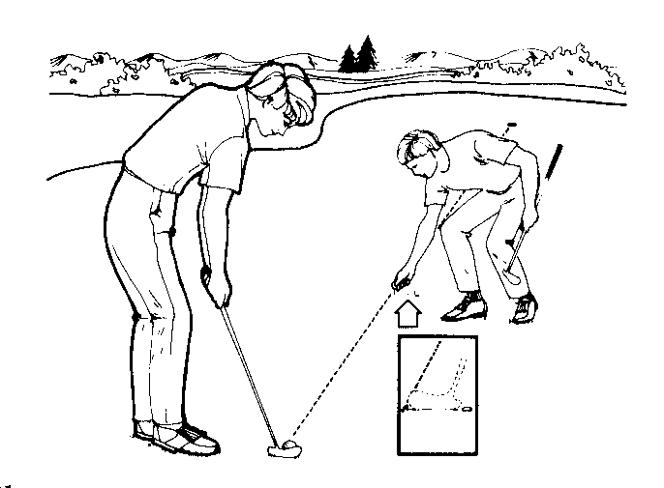
- If another ball interferes with your swing or is in your line of putt, you may ask the owner of the ball to lift it.
- If your ball is near the hole and might serve as a backstop for another player, you might lift your ball.

Rule 23 - Loose Impediments
Loose impediments are natural objects that are not growing or fixed -- such as leaves twigs, branches, worms and insects. You may remove a loose impediment except when your ball and the loose impediment lie in a bunker or water hazard.

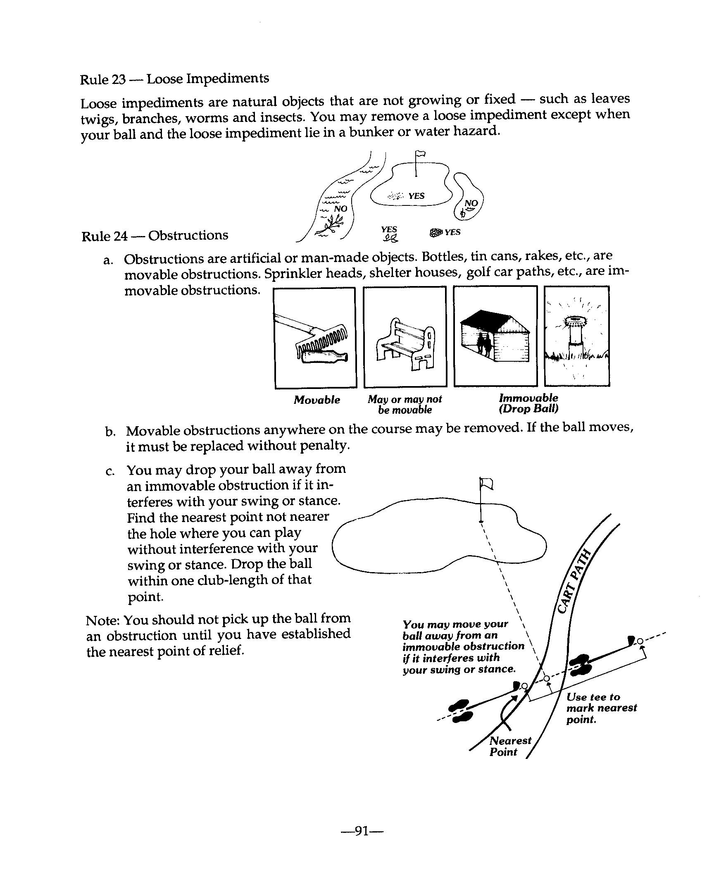
Rule 24 - Obstructions
- Obstructions are artificial or man-made objects. Bottles, tin cans, rakes, etc., are movable obstructions. Sprinkler heads, shelter houses, golf car paths, etc., are immovable obstructions.
- Movable obstructions anywhere on the course may be moved. If the ball moves, it must be replaced without penalty.
- You may drop your ball away from an immovable obstruction if it interferes with your swing or stance. Drop the ball within one club-length of that point.

Note: You should not pick up the ball from an obstruction until you have established the nearest point of relief.

Rule 25 - Casual Water; Ground Under Repair; Animal Holes
- Casual water is any temporary puddle of water caused by rain or over watering. Ground under repair is any damaged area which the Committee has marked as such.
- If your ball or your stance is in casual water, ground under repair or a burrowing animal hole, you may either play the ball as it lies or find the nearest place not nearer the hole which gives you relief and drop the ball within one club-length of that place.
- If your ball is in casual water, etc., and you cannot find it, determine where the ball entered the area and drop a ball within one club-length of that place without penalty.
- If your ball is on the wrong green, find the nearest place off the green which is not nearer the hole and drop the ball within one club-length of that place.

Rule 26 - Water Hazards
- Water hazard margins are identified by yellow stakes or lines. Lateral water hazard margins are identified by red stakes or lines. Lateral water hazards are identified by red stakes or lines.
- If your ball is in a water hazard or a lateral water hazard, you may play it as it lies. If you cannot find it or do not wish to play it where it lies, add a penalty stroke and:
- play another ball from where you last played or
- drop a ball behind the water hazard as far back as you wish keeping a straight line between the hole and the point where your ball last crossed the hazard margin and where you want to drop.
If your ball is in a lateral water hazard, you may
- also drop a ball within two club-lengths of where the ball last crossed the hazard margin.
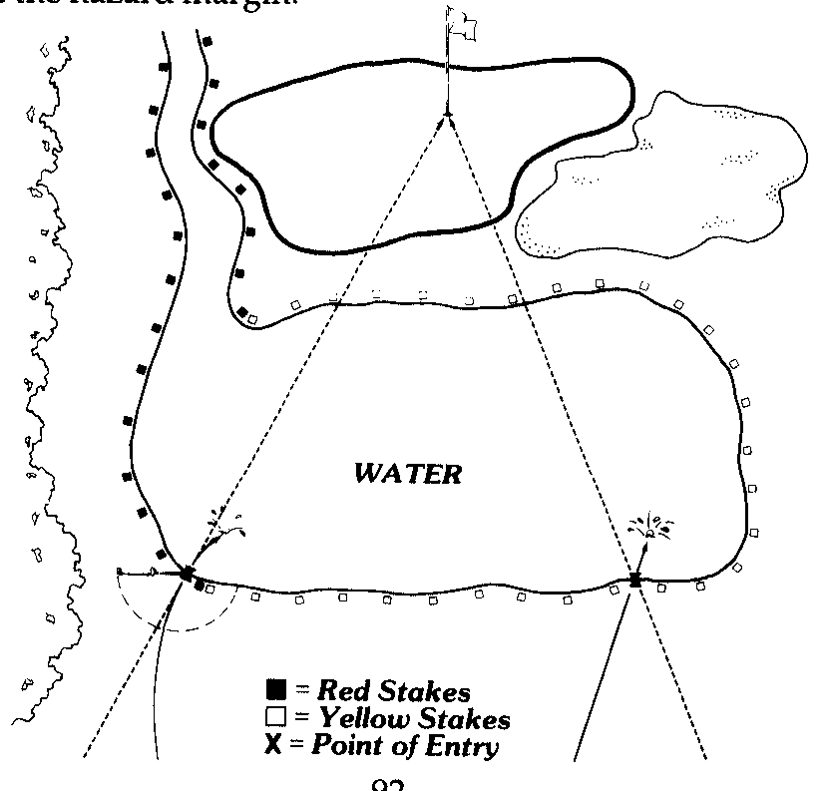

Rule 27 - Ball Lost or Out of Bounds
- A ball is lost if it is not found within five minutes after you first begin to search.
- A ball is out of bounds when all of it lies beyond the inside line of objects, such as white stakes, or a fence or wall that marks the playing area.
- If your ball is lost or out of bounds, you must add a penalty stroke to your score and play another ball from where you played your last shot.
- If you think your ball may be lost or out of bounds, you may play another ball (provisional ball) from the place where your first ball was played. You must tell your opponent of fellow competitor that you are playing a provisional ball and play it before you look for your first ball. If you cannot find your first ball or if it is out of bounds, you must count the strokes with the first and provisional balls, add a penalty and play out the hole with the provisional ball. If you find your first ball in bounds, continue play with it and pick up the provisional ball.
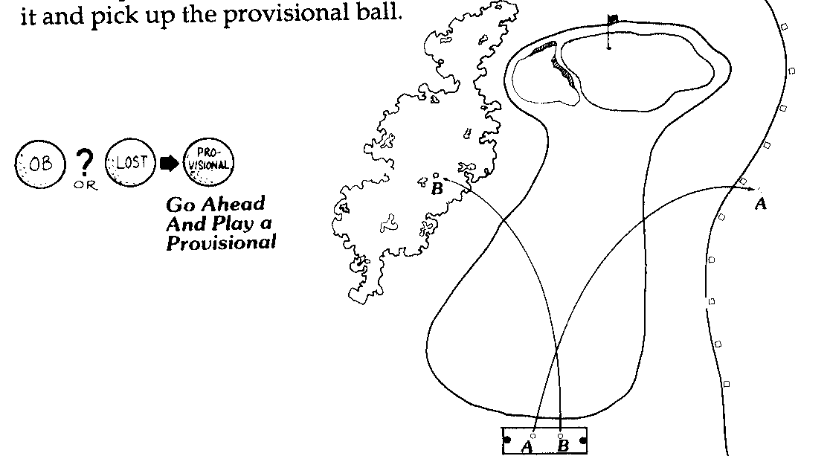

Ball is out of bounds when it is beyond white stakes, fences, or walls marking playing area. SEE BALL A photo above. If your ball is lost or out of bounds, add one penalty stroke. Play another ball from where you played your last shot. SEE BALL B photo above.

Rule 28 - Ball Unplayable
If your ball is under a tree or in some other bad situation and you decide you cannot play it, add a penalty stroke and do one of the following:
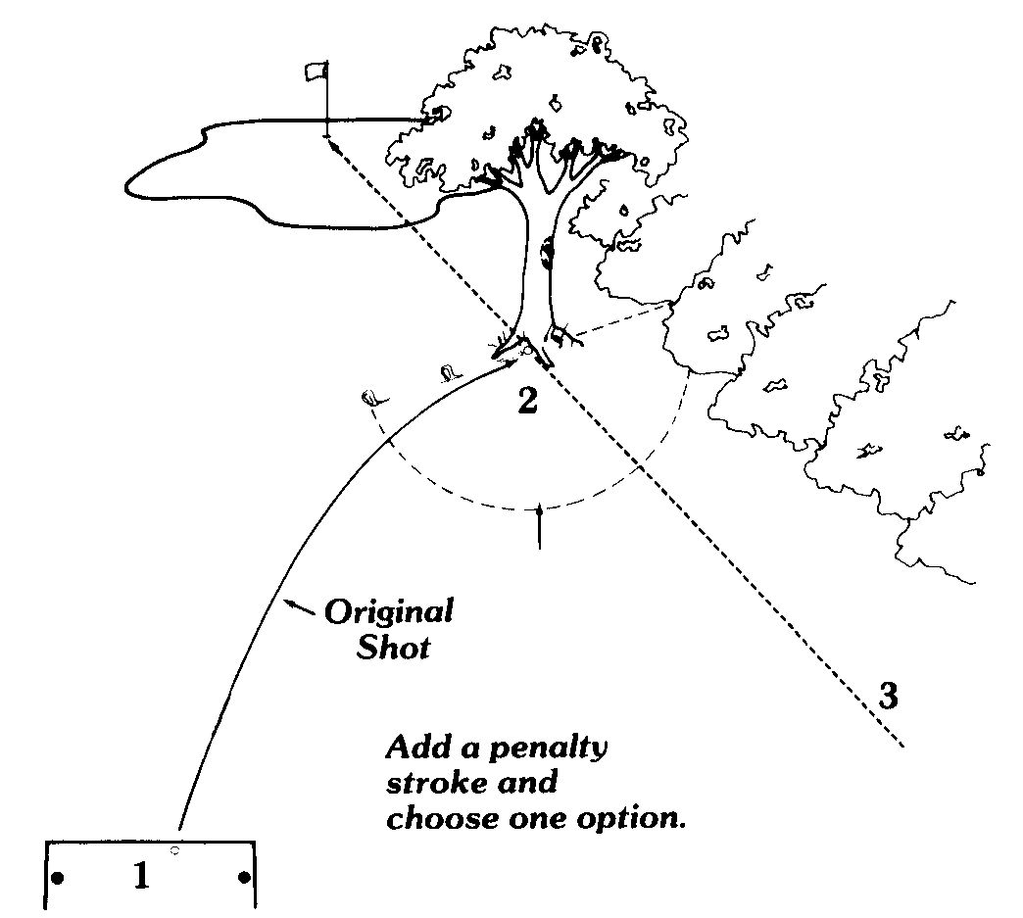
- Go back to where you played the last shot and play a ball from there; or
- Measure two club-lengths from the unplayable lie, drop a ball and play from there, or
- Keep the unplayable lie between where you drop the ball and the hole, go back as far as you wish on a straight line and drop and play the ball.

Definitions

Abnormal Ground Conditions
An “abnormal ground condition” is any casual water, ground under repair, or hole, cast or runway on the course made by a burrowing animal, a reptile, or a bird.

Addressing the Ball
A player has ''addressed the ball'' he/she has taken his/her stance and has also grounded his/her club, except that in a hazard, a player has addressed the ball when he/she has taken his/her stance.

Advice
"Advice” is any counsel or suggestion which could influence a player in determining his/her play, choice of a club or in the method of making a stroke.
Information on the Rules or on matters of public information, such as the position of hazards or the flagstick on the putting green, is not advice.

Ball Deemed to Move
See ''Move or Moved."

Ball Holed
See “Holed.”

Ball Lost
See “Lost Ball”

Ball in Play
A ball is ''in play'' as soon as the player has made a stroke on the teeing ground. It remains in play until holed out, except when it is lost, out of bounds or lifted, or another ball has been substituted under an applicable Rule, whether or not such Rule permits substitution a ball so substituted becomes the ball in play.

Bunker
A ''bunker'' is a hazard consisting of a prepared area of ground, often a hollow, from which turf or soil has been removed and replaced with sand or the like. Grass-covered ground bordering or within a bunker is not part of the bunker. The margin extends vertically downwards. A ball is in the bunker when it lies in or any part of it touches the bunker.

Caddie
A “caddie” is one who carries or handles a player’s clubs during play and otherwise assists him in accordance with the Rules.
When one caddie is employed by more than one player, he/she is always deemed to be the caddie of the player whose ball is involved, and equipment carried by him is deemed to be that player’s equipment, except when the caddie acts upon specific directions of another player, in which case he/she is considered to be that other player’s caddie.

Casual Water
"Casual water'' is any temporary accumulation of water on the course which is visible before or after the player takes his/her stance and is not a water hazard. Snow and natural ice, other than frost, are either casual water or loose impediments, at the option of the player. Manufactured ice is an obstruction. Dew and frost are not casual water.

Committee
The ''Committee" is the committee in charge of the competition or, if the matter does not arise in competition, the committee in charge of the course.

Competitor
A ''competitor'' is a player in a stroke competition. A ''fellow-competitor'' is any person with whom the competitor plays. Neither is partner of the other.

Course
The “course” is the whole area within which is permitted. See Rule 33-2.

Equipment
''Equipment'' is anything used, worn or carried by or for the player except any ball he/she has played at the hole being played and any small object, such as a coin or a tee, when used to mark the position of a ball or the extent of an area in which a ball is to be dropped. Equipment includes a golf cart, whether or not motorized. If such a cart is shared by more than one player, its status under the Rules is the same as that of a caddie employed by more than one player.

Fellow Competitor
See “Competitor.”

Flagstick
The "flagstick" is a moveable straight indicator, with or without bunting or other material attached, centered in the hole to show its position. It shall be circular in cross-section.

Forecaddie
A “forecaddie” is one who is employed by the Committee to indicate to players the position of balls during play. He/she is an outside agency.

Ground Under Repair
"Ground under repair” is any portion of the course so marked by the Committee or so declared by its authorized representative. It includes material piled for removal and a hole made by golf course maintenance even if not so marked. Stakes and lines defining ground under repair are in such ground such stakes are obstructions. The margin of ground under repair extends vertically downwards but not upwards. A ball is in ground under repair when it lies in or any part of it touches the ground under repair.
Note 1: Grass cuttings and other material left on the course which have been abandoned and are not intended to be removed are not ground under repair unless so marked.
Note 2: The Committee may make a Local Rule prohibiting play from ground under repair or an environmentally –sensitive area which has been defined as ground under repair.

Hazards
A “hazard” is any bunker or water hazard.

Hole
The “hole” shall be 4 ¼ inches ( 108mm) in diameter and at least 4 inches (100mm) deep. If a lining is used, it shall be sunk at least 1 inch (25mm) below the putting green surface unless the nature of the soil makes it impractical to do so; its outer diameter shall not exceed 4 ¼ inches (108mm).

Holed
The ball is ‘holed” when it is at rest with the circumference of the hole and all of it is below the level of the lip of the hole.

Honor
The side entitled to play first from the teeing ground is said to have the “honor.”

Lateral Water Hazard
A “lateral water hazard” is a water hazard or that part of a water hazard so situated that it is not possible or is deemed by the Committee to be impractical to drop a ball behind the water hazard in accordance with Rule 26-1b.
That part of the water hazard to be played as lateral water hazard should be distinctly marked.
Note 1: Lateral water hazards should be defined by red stakes or lines.
Note 2: The Committee may make a Local Rule prohibiting play from an environmentally-sensitive area which has been defined as a lateral water hazard.
Note 3: The Committee may define a lateral water hazard as a water hazard.

Line of Play
The “line of play” is the direction which the player wishes his ball to take after a stroke, plus a reasonable distance on either side of the intended direction. The line of play extends vertically upwards from the ground, but does not extend beyond the hole.

Loose Impediments Marker
"Loose impediments" are natural objects, such as stones, leaves, twigs, branches and the like, dung, worms and insects and casts or heaps made by them, provided they are not fixed or growing, are not solidly embedded and do not adhere to the ball.
Sand and loose soil are loose impediments on the putting green, but not elsewhere.
Snow and natural ice, other than frost, are either casual water or loose impediments, at the option of the player. Manufactured ice is an obstruction.
Dew is not a loose impediments.

Lost Ball
A ball is "lost" if:
- It is not found or identified as his/her by the player within five minutes after the players side or his or their caddies have begun to search for it; or
- The player has put another ball into play under the Rules, even though he/she may not have searched for the original ball; or
- The player has played any stroke with a provisional ball from the place where the original ball is likely to be or from a point nearer the hole than that place, where-upon the provisional ball becomes the ball in play.

Time spent in playing a wrong ball is not counted in the five-minute period allowed for search

Marker
A “ marker” is one who is appointed by the Committee to record a competitor’s score in stroke play. He/she may be a fellow competitor. He/she is not a referee.

Matches
See “Sides and Matches.”

Move or Moved
A ball is deemed to have “moved” if it leaves its position and comes to rest in any other place.

Nearest Point of Relief
The “nearest point of relief” is the reference point for taking relief without penalty from interference by an immovable obstruction (Rule 24-2), an abnormal ground condition (Rule 25-1) or a wrong putting green (Rule 25-3).
It is the point on the course nearest to where the ball lies, which is not nearer the hole and at which, if the ball were so positioned, no interference (as defined) would exist.

Observer
An “observer" is one who is appointed by the Committee to assist a referee to decide questions of fact and to report to him any breach of a Rule. An observer should not attend the flagstick, stand at or mark the position of the hole, or lift the ball or mark its position.

Obstructions
An “obstruction" is anything artificial, including the artificial surfaces and sides of roads and paths and manufactured ice, except:
- Objects defining out of bounds, such as walls, fences, stakes and railings;
- Any part of an immovable artificial object which is out of bounds; and
- Any construction declared by the Committee to be an intregal part of the course.

Out of Bounds
“Out of bounds” is ground on which play is prohibited. When out of bounds is defined by reference to stakes or a fence or as being beyond stakes or a fence, the out of bounds line is determined by the nearest point of the stakes or fence posts at ground level excluding angled supports.
When out of bounds is determined by a line on the ground, the line itself is out of bounds.
The out of bounds line extends vertically upwards and downwards.
A ball is out of bounds when all of it lies out off bounds.
A player may stand out of bounds to play a ball lying within bounds.

Outside Agency
An ''outside agency'' is an agency not part of the match or, in stroke play, not part of a competitor's side, and includes a referee, a marker, an observer or a forecaddie. Neither wind nor water is an outside agency.

Partner
A "partner" is a player associated with another player on the same side.
In a threesome, foursome, best-ball or four-ball match, where the context so admits, the word "player" includes his/her partner or partners.

Penalty Stroke
A ''penalty stroke" is one added to the score of a player or side under certain Rules. In a threesome or foursome, penalty strokes do affect the order of play.

Provisional Ball
A "provisional ball" is played under Rule 27-2 for a ball which may be lost outside a water hazard or may be out of bounds.

Putting Green
The “putting green” is all the ground of the holed being played which is specially prepared for putting or other wise defined as such by the Committee. A ball is on the putting green when any part of it touches the putting green.

Referee
A “referee” is one who is appointed by the Committee to accompany players to decide questions of fact and apply the Rules of Golf. He/she shall act on any breach of a Rule which he/she observes or is reported to him.
A referee should not attend the flagstick, stand or mark the position of the hole, or lift the ball or mark its position.

Rub of the Green
A “rub of the green” occurs when a ball is motion is accidentally deflected or stopped by any outside agency (see Rule 19-1).

Rule
The term “Rule” includes Local Rules made by the Committee under Rule 33-8a.

Sides and Matches
Side: A player, or two or more players who are partners
Single: A match in which one plays against another.
Threesome: A match in which one plays against two and each side plays one ball.
Three-Ball: A match play competition in which three play against one another, each playing his/her own ball. Each player is playing two distinct matches.
Best-Ball: A match in which one plays against the better ball of two or the best ball of three players.
Four-Ball: A match in which two play their better ball against the better ball of two other players.

Stance
Taking the ''stance'' consists in a player placing his /her feet in position preparatory to making a stroke.

Stipulated Round
The ''stipulated round” consists of playing the holes of the course in their correct sequence unless otherwise authorized by the Committee. The number of holes in a stipu- lated round is 18 unless a smaller number is authorized by the Committee. As to extension of stipulated round in match play, see Rule 2-3.

Stroke
A''stroke" is the forward movement of the club made with the intention of fairly striking the ball, but if a player checks his/her downswing voluntarily before it reaches the ball he/she is deemed not to have made a stroke.

Teeing Ground
The “teeing ground” is the starting place for the hole to be played. It is a rectangular area two club-lengths in depth, the front and sides of which are defined by the outside limits of two tee-markers. A ball is outside the teeing ground when all of it lies outside the teeing ground.

Through the Green
“Through the green” is the whole area of the course except:
- the teeing ground and putting green of the hole being played; and
- all hazards on the course.

Water Hazard
A “water hazard” is any sea, lake, pond, river, ditch, surface drainage ditch or other open water course (whether of not containing water) and anything of similar nature. All ground or water within the margin of a water hazard is part of the water hazard. The margin of a water hazard extends vertically upwards and downwards. Stakes and lines defining the margins of water hazards are in the hazards. Such stakes are obstructions. A ball is in a water hazard when it lies or touches the water hazard.
Note 1: Water hazards (other than lateral water hazards) should be defined by yellow stakes or lines.
Note 2: The Committee may make a Local Rule prohibiting play from an environmentally-sensitive area which has been defined as a water hazard.

Wrong Ball
A “wrong ball” is any ball other than the players:
- Ball in play, or
- Provisional ball, or
- In stroke play, a second ball played under Rule 3-3 or Rule 20-7b.
Note: Ball in play includes a ball substituted for the ball in play, whether or not such substitution is permitted.

Wrong Putting Green
A “wrong putting green” is any putting green other than that of the hole being played. Unless otherwise prescribed by the Committee, this term includes a practice putting green ot pitching green on the course.

Local Rules Example
In accordance to the Rules of Golf, Golf Course Management or Tournament Committee establish several Local Rules relative to the course or conditions of play. Here is an example of a set of Local Rules submitted to participants in a Unified League Competition in Rhode Island. Local Rules may also be printed on the Golf Course scorecard.

East Greenwhich Country Club

East Greenwhich, Rhode Island

Course Rules
- Each Player mat have own set of clubs
- Non-golfer are not allowed on course. (Insurance rule)
- Proper dress required at all times.
- No fivesomes at anytime.
- Players under 12 must play with an adult.
- No player under 8 unless by special permission.

Not Permitted on Course
- Metal spikes (no exceptions)
- Beverage coolers
- A1coholic beverages
- Loud and/or abusive language

Please...
- Repair ball marks
- Rake traps after use
- Replace divots
- Observe out of bounds between holes ONE & EIGHT (dangerous), all will be played as hazards. If you hit a ball beyond the boundary markers, bring the ball back to the point where it approximately where it went out, under penalty of 1 stroke. Do not hit another ball from the teeing area.
- Embedded Ball Rule is in effect.

Teaching the Rules and Etiquette
Define the Game of Golf
Rule 1-1: The Game of golf consists in playing a ball from the teeing ground into the hole by a stroke or successive strokes in accordance with the Rules.

Explain the governing bodies and protocol of the Special Olympics Golf Rules:
- The Official Special Olympics Sport Rules shall govern all Special Olympics Golf competitions.
- As an international Sports Program, these rules have been based upon The Rules of Golf as approved by The Royal and Ancient Golf Club of St. Andrew, Scotland ( R & A ) and the United States Golf Association.
- These rules shall govern all competition except when in conflict with the Official Special Olympics Rules. In such cases, the Official Special Olympics Rules shall apply.
- There are five levels of play in Special Olympics golf designed for all abilities.

Demonstrate and review the Summary of the Rules of Golf
- Pictures
- Video
- What if Scenarios

Rules Assessment
- Written
- Oral
- Athlete demonstration of proper procedure

Training Session Review
- 28 Basic Rules (8 week training session)
- Feature at least 3– 4 basic rules as part of each training session and incorporate into skills training: Example: When teaching putting, introduce rules and etiquette that would apply to the putting green. (Marking the ball, touching the line, order of play, etc.)
Coaching suggestion: Invite a golf Association representative or golf professional to host a Golf Rules Training for the athletes, coach and volunteers.

Special Olympics –Scotland

Introductory Model for Rules Training and Testing
Equipment
Golf Course
Rules
Terminology
Etiquette
Scoring

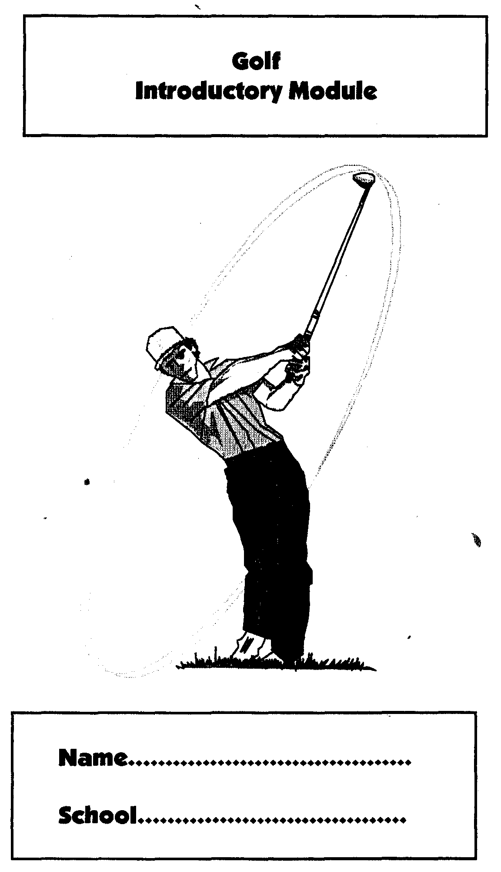
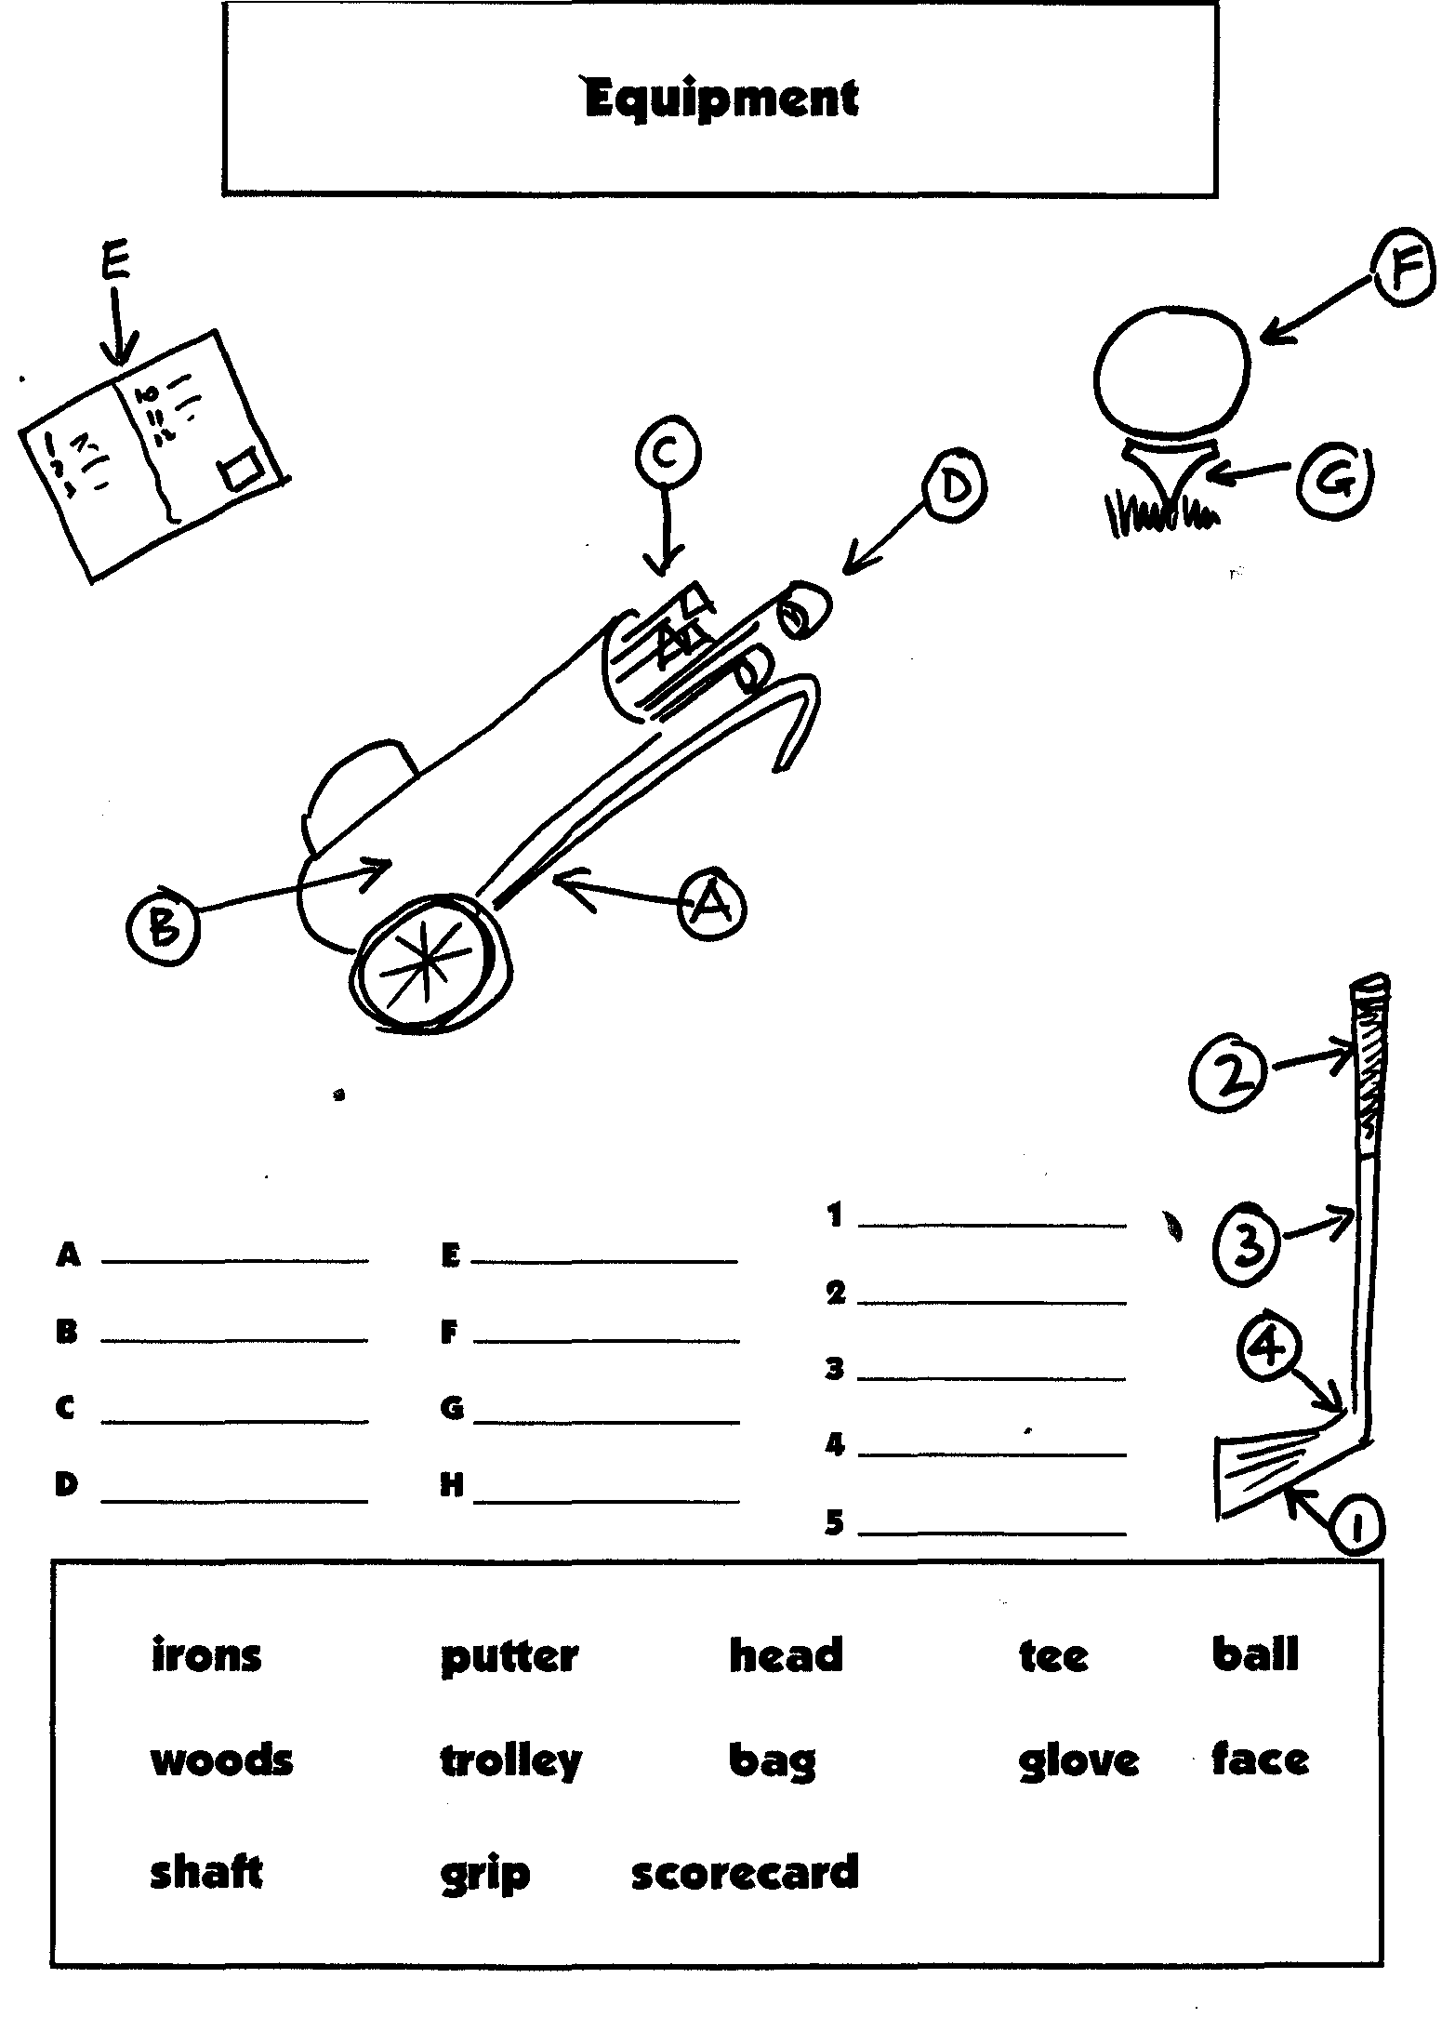
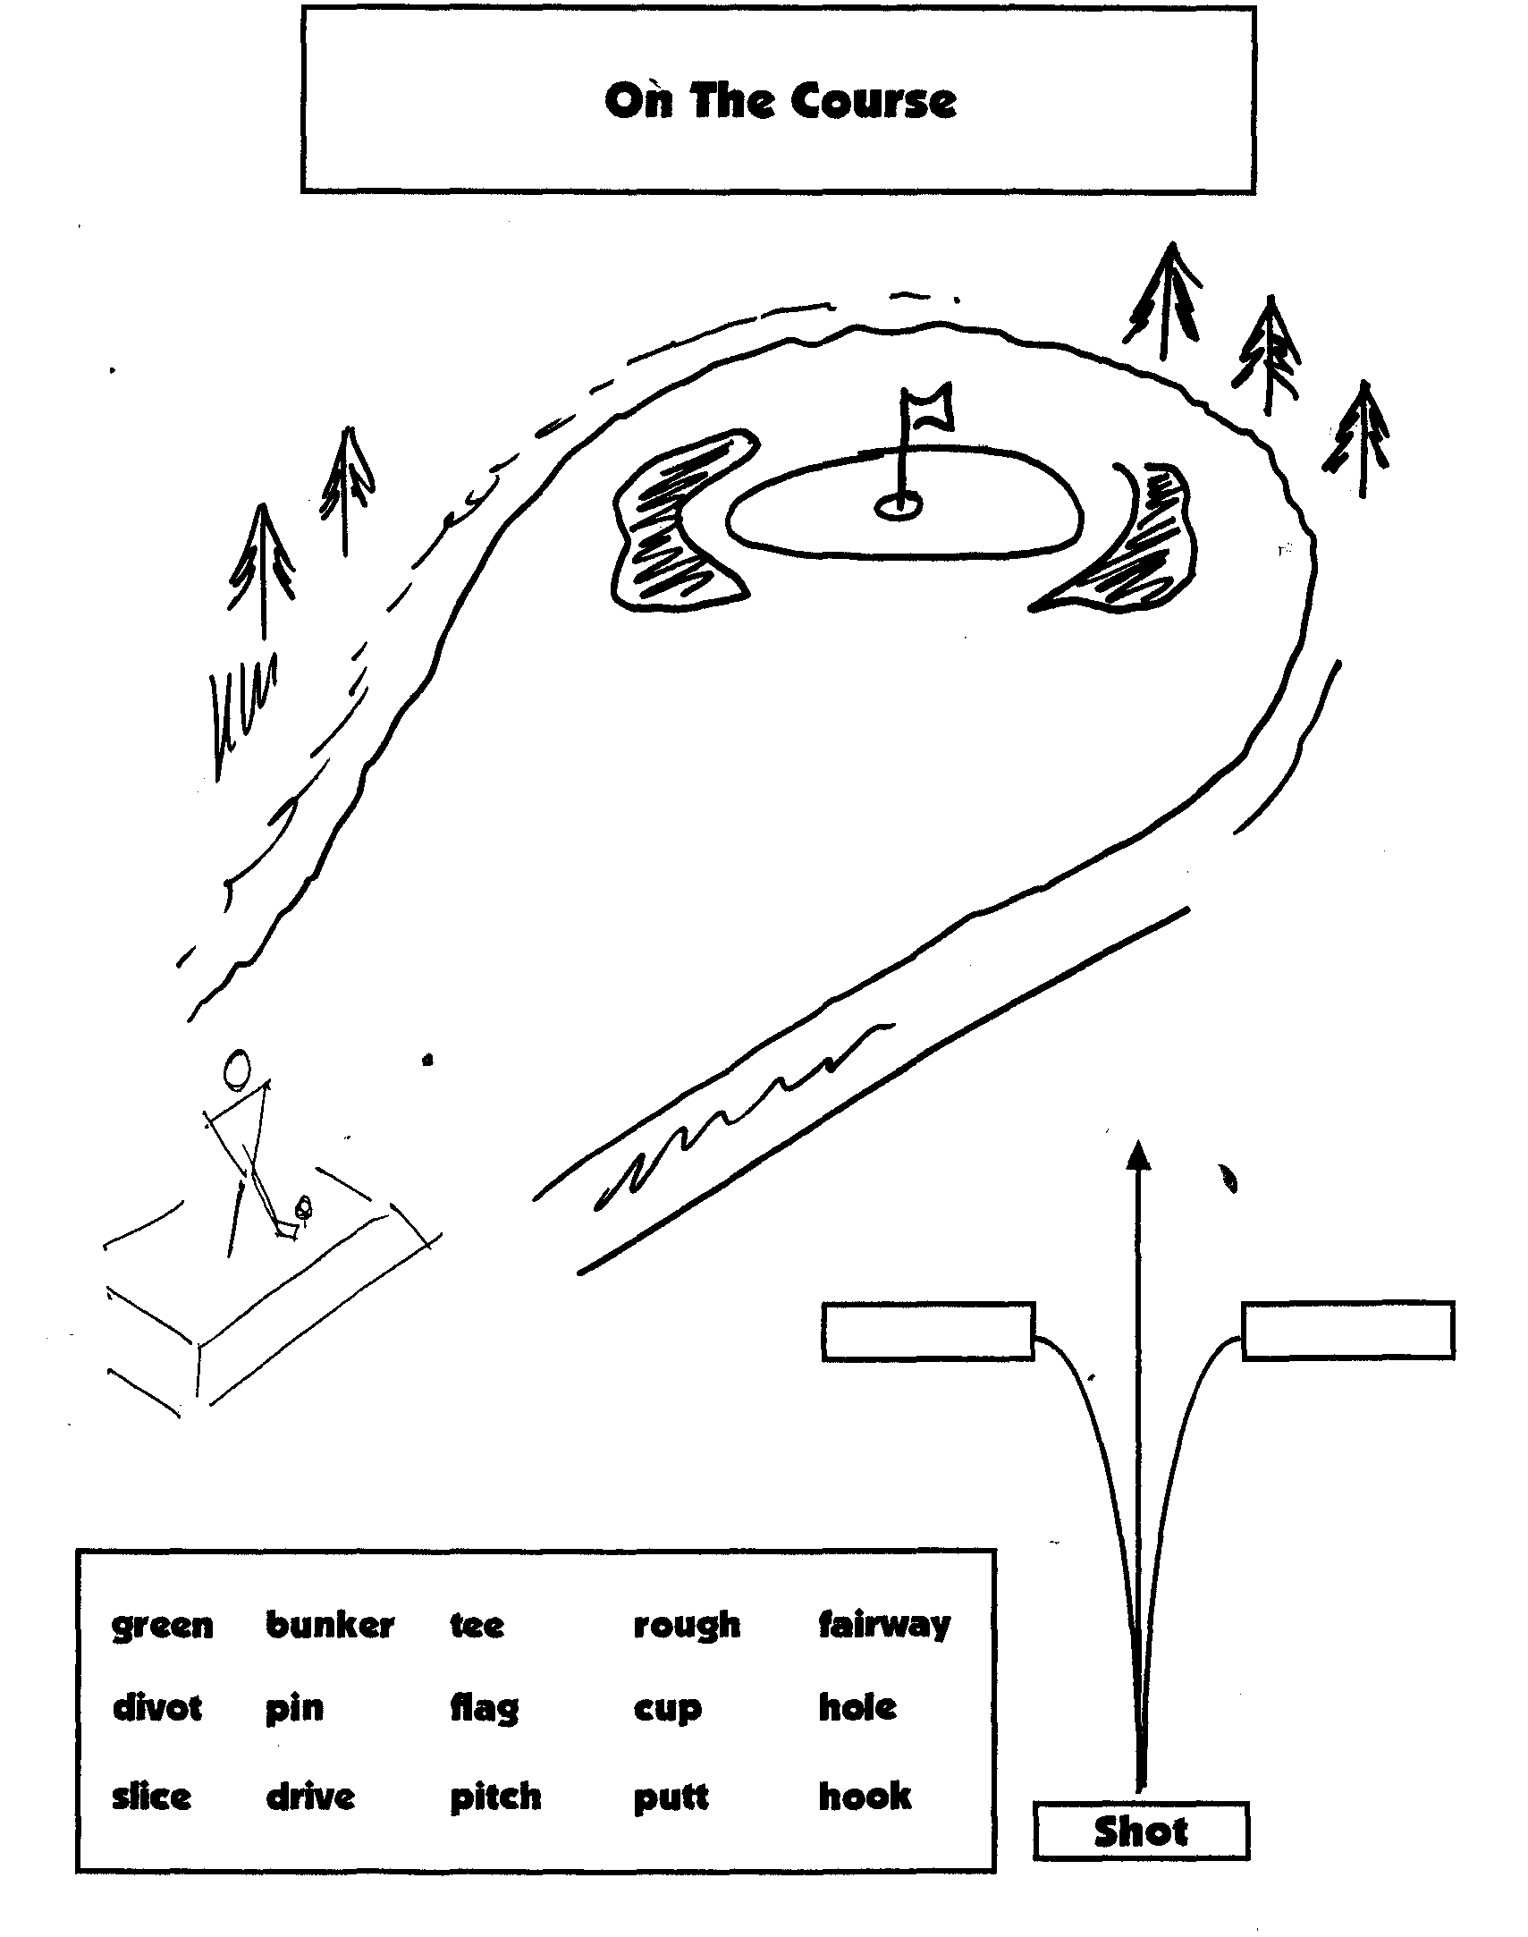

On The Course – Scoring

Par means scoring what we should
Shoot 3 on a par 3 =_______________
Shoot 4 on a par 4 =_______________
Shoot 5 on a par 5 =_______________
Birdie means scoring 1 under par
Bogey means scoring 1 over par
Eagle means scoring 2 under par
Double Bogey means scoring 2 over par
Shoot 3 on a par 4 is______________________
Shoot 5 on a par 4 is______________________
Shoot 2 on a par 3 is______________________
Shoot 4 on a par 3 is______________________
Shoot 4 on a par 5 is______________________
Shoot 6 on a par 5 is______________________
Shoot 3 on a par 5 is______________________

eagle | bogie | par | birdie
over par | under par | double bogie | hole in one

Etiquette

(How to behave)

Answer yes or no to these questions

We all play at the same time
The person furthest away from the flag plays first
You should keep quiet when someone is playing a shot
The person nearest the flag plays first
If you take a divot with a shot you should just walk on past it
You can hit a practice ball first before playing your real ball
You can take your trolley on to the green with you
You can practice chipping on the green
If you have lost your ball and are looking for it. If someone is waiting behind you then just let them wait
If you play the ball THROUGH THE GREEN then it has gone over and behind the green
If you think your shot is going to hit someone then run and hide.

Fill in the Blanks

We use a ____________________ on the green
We use a ____________________ from the tee
We use a ____________________ to carry our bag
We use a ____________________ to hold our clubs
We count the number of _________________ to see who has won
We putt on the _________________
We try not to hit the ball into the __________________
When we score what we should we get a ______________
We try to hit our ball on to the ______________________
We use our __________________ for long distances
A____________________ is when the ball spins to the right
A_____________________ is when the ball spins to the left
A____________________ is when the ball goes straight then to the right
A____________________ is when the ball goes straight then to the left

putter | wood | trolley | bag
strokes | rough | green | slice
par | fairway | wood | hook
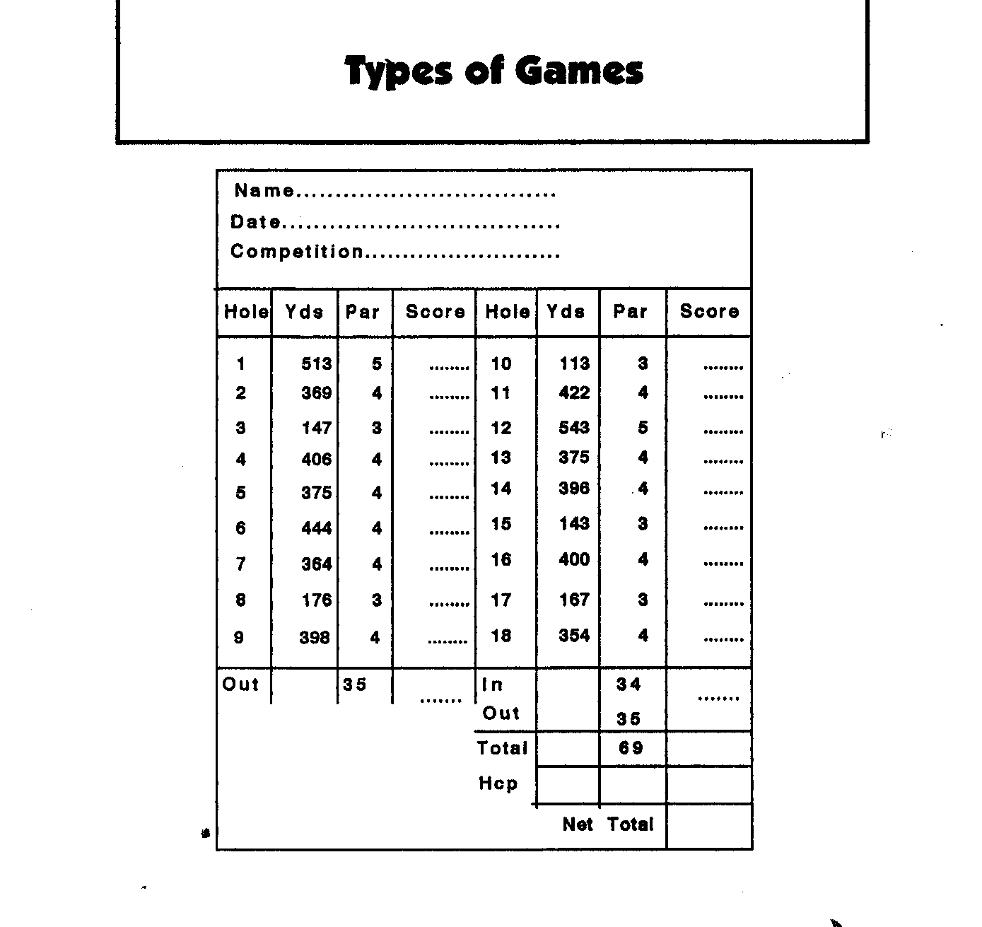
Marking the card until the end is called____________________________
Playing against someone for holes is called_______________________
Scoring points on your strokes is called _________________________

stroke play | match play
medal | stableford

Pick a Word and Explain

green | rough | iron | par
bogey | handicap | bunker | fairway
hole-in-one | wood | sand iron | chip
putt | match play | putter | swing
stance | semi-rough | bag | caddy
trolley | tee | gloves | spikes
cart | card | eagle | birdie
loft | face | shaft | grip
backswing | flag | pin | cup
clubhouse | divot | club | marker
ball | hazard | tee-off | top
fore | strokes | member | range
slice | hook | out-of-bounds

The Eighteenth Hole
Robert, Gerard and David walked to the eighteenth t___ from the seventeenth g________. Robert walked on to the t___ first because he had w____ the last hole.
The 18th was 250 yards long so Robert used his d______. He took a practice s______ and then hit along d____ up the middle of the f_______ Gerard played next and chose a 3 i______. His shot was s_______ to the right. David was next and he h________ his ball to the left. It only went a few yards.
David played his second shot as his b____ was furthest from the hole. He was in the r______ so he used a 7 i____ Gerard played next and he used a 9 iron. Robert was only 25 yards from the green so he used a w_______ and played the ball to only 6 feet from the f ____. He was there in 2 shots!!
Both Gerard and David had played their second s_____ on to the green. David was nearer the hole so Gerard played f____. Gerard p_______ the ball into the h____ for a t______. David two putted so he shot a f______. Robert three-putted from 6 feet so he took a f____.
So who won the eighteenth hole ???

Golf Attendance

Session | Date | Venue
1
2
3
4
5
6
7
8
9
10
11
12
13
14
15
16
17
18
19
20
21
22
23
24
25

Levels of Competition

Special Olympics Golf Program  Levels of Play

Designed for All Ability Levels
A summary of Special Olympics golf events is outlined below and designed to offer competition opportunities for all ages and ability levels.
Level 1 - Individual Skills Contest - This level is designed for entry level athletes or those of lower ability to test the athletes in six skills; short putt, long putt, chip shot, pitch shot, iron shot, and wood shot.
Level II - Nine Hole Alternate Shot Play - This level is designed to give the Special Olympics golfer an opportunity to transition from skill to individual play. It allows for progress under the guidance of a partner whose ability and knowledge of golf is more advanced than that of the Special Olympics athletes. As a result, this level does not function in the traditional Unified Sports® model where the partner and Special Olympics athlete are of similar ability. The format will be Foursome (Alternate Shot) - The players play alternately from the teeing grounds and then alternate strokes until the ball is holed.
Level III - Unified Sports® Play - A team shall consist of one Special Olympics golfer and one non-Special Olympics golfer. This level is designed to give the Special Olympics golfer a chance to play in a team format in the traditional Unified Sports ® model where the partner and Special Olympics athlete are of similar ability.
This is designed for an alternative competition for the player capable of playing at level IV.
Level IV - Nine Hole Individual Play - This level is designed to meet the needs of those Special Olympics golfers wishing to play individually in a tournament where the stipulated round is nine holes. The player should be capable of playing independently in a stroke play competition.
Level V - Individual Play - This level is designed to meet the needs of those Special Olympics golfers wishing to play individually in a tournament where the stipulated round is 18 holes. The player will be capable of playing independently in stroke play competition.

Golf Competition Requirements
Your local coordinator should supply you with the following competition registration materials. A detailed Golf Competition Guide is available.

Prior to a competition, the following forms must be submitted:
- Delegation Information
- Non-Athlete ( Coach/ Chaperone) Listing
- Athlete Sport Entry Form
- Med Cards
- Golf Score Cards if no established handicap
- Partner and Unified Team Forms

Expect to complete the following on-site forms for competition registration:
- Housing Forms
- Scratch List
- Registration Summary Form

Competition Venue Requirements
The goal of the Competition Management team is to offer the athletes a high quality challenging competition. Safety and access must be of utmost concern for athletes, coaches, volunteers, officials, families and spectators when previewing a golf or practice area for competition.
Below are general venue planning services for consideration when assessing a facility for competition. Ask the questions: Where? Who? How many? How long? What will follow? Would advise to establish a committee or Chairperson for each or a combination of these areas.
If you are a coach participating but not hosting a competition, this list will also be helpful to you in managing and familiarizing your athletes to a particular competition venue.
- Opening/Closing Ceremony
- Registration for athletes, coaches, officials, volunteers, families, caddies, golf cars
- Athlete staging prior to and during competition
- Scoring Area/Computer
- Schedule and Tee Time Assignments
- Awards
- Hospitality
- Housing
- Public Relations/ Media
- Food/ Beverage
- Emergency/Medical/Inclement Weather
- Restrooms
- Security
- Special Events/ Entertainment/Clinics
- Transportation: Arrival, Departure
- Warm-Up or Practice Areas
- Equipment Storage
- Conditions of Play : Please refer to Article IX of the Special Olympics Summer Rules edition for the appropriate dimensions of each skills station and specific golf course yardages.

- Level 1: Skills Competition
Wood, Iron, Pitch, Chip, Long Putt, Short Putt Stations
*Safety is critical in reviewing where, how and flow of each station.
- Level 2-5: On Course Competition
- Start holes and scoring areas should be clearly defined
- Assure course can be set up and marked in accordance to the USGA Rules of Golf and SO Golf Rules

Flow of Athletes
Determine the safest most efficient traffic and staging flow for the athletes. It is ideal to have the registration as close to the transportation drop as possible. Keep athletes moving in the same direction and avoid any back tracking. Direct athletes immediately to the practice area for warm up.
To avoid confusion, set up an overall schedule of the competition. Diagrams and maps are also helpful Assure coaches receive copies of each prior to the competition or at registration.
Participating coaches should immediately familiarize themselves with the competition venue upon arrival. Select a designated meeting area for your athletes and volunteers to meet if separated. Divide your athletes into two groups: Level 1 participants and Levels 2 – 5. Assign volunteer coaches or chaperones accordingly. When possible, all practice and warm ups should be done as a group when possible and then disperse Level 2 – 5 athletes to appropriate competition staging. Confirm all on course registration procedures with coaches and athletes.
It is important that a coach or volunteer greet the athletes when they come off the course and direct them to a central scoring area or practice area.
A good rule of thumb: Put yourself in the position of the athlete, coach, volunteer, official, spectator or family member when establishing your competition venues, schedules and event flow patterns.

Equipment

If hosting or participating in a Special Olympics Golf competition, equipment requirements would include:
- Golf Competition Equipment for athletes:
Level 1:
- An assorted number of left and right handed irons, woods and putters
- Golf Balls (appropriate number based on number of competitors)
- Target Flags
- Boundary markers (cones or other visible marker)
- Hitting mat, carpet or tees
- Paint, chalk, rope or cord to mark boundary lines or hitting areas
- Tape measure or yardage marking device
Level 2 – 5: All competitors must provide their own equipment to include
- A set of clubs ( A set shall include at least one wood, one iron and one putter)
- A golf bag
- Golf Balls
- Pitch Mark Repairer
Tournament Management and Coaching Equipment/Supplies list for designated areas and related committees:
- Scorecards
- Tee Time Assignment and Pairings
- Conditions of Competition
- Local Rules Sheets
- Pencils/Pens/ Highlighters
- Tables/ Chairs
- Tents
- 2 way Radios
- Banners
- PA System
- Clocks for tee time start and officials
- Rules Books
- Sunscreen
- Starters boxes
- Awards/ Ribbons/Appreciation
- Gift bags,raffle

Uniforms
It is important to confirm appropriate golf attire for both training and competition. Many course have very strict dress codes that must be adhered.

Athletes

Recommended golf attire:
- Shirt with collar, tucked into pants/shorts/skirt would be recommended.
- Golf shoes with spikes (soft or metal). Smooth soled athletic shoes would suffice if golf shoes are not available.

Officials
Proper attire should be stated in the Coaches, Players, Volunteers and Official handbooks.
Volunteer officials may be requested to wear certain bottoms, shirts or headwear. Golf car indicators or official location blocks are suggested as well. To expedite requests for rulings or questions, all participants should be informed of golf hole assignments of official locations. The uniform, golf car indicator signage and official locations can easily be included on the Rules of Play Sheets and distributed at the coaches meetings.

Event Personnel
The planning of a Special Olympics competition requires a core of committed and energetic volunteers. To assist in the coordination of a Special Olympics Golf Competition, the latter pages may be useful in creating a Competition Management Team. A Committee and Sub-Committee structure is recommended to coordinate and produce a high quality competition.

Tournament Committee
Under the Rules of Golf the Tournament Committee serves as the main organizing body of the tournament. The committee makes all the final decisions on the parameters of the competition. The committee is given the authority to create policy as long as it is consistent to the Rules of Golf ( Rule 33.)

Committee members and their jobs:

Tournament Director:
Serves as the Chair of the tournament and is responsible for organizing and supervising the Tournament Committee.

Competition Director
Responsible for organizing and supervising all aspects pertaining to the golf competition in a tournament, both during the planning process of the tournament and the day of.

Sub-Committee Roles for the Competition Team:
- Rules
- Scorers/Markers
- Registration
- Caddie
- Fore Caddies
- Secretariat
- Skills Coordinator

Volunteer Manager
Responsible for recruiting, organizing, and coordinating volunteers for the tournament.

Support Services Manager
Responsible for procuring all the equipment necessary for the tournament, as well as responsible for the setup and breakdown of the whole venue. Coordinate and supervise the support services volunteer staff.

Sub-Committees under Support Services:
Equipment: Assess and procure needs of each function of the tournament
Volunteers: Assess needs and supervise
- Set up and Break down
- On Course
- Registration areas
- Scoring areas
- Starters area
- Ceremonies
- Scoreboard

Media Relations Coordinator
Responsible for coordinating all aspects regarding media and public relations for the tournament. He/she is responsible for all publicity leading to the tournament and after the tournament, as well as for opening and closing ceremonies

Insert Organizational chart: ElmGreen

Scoring and Results of Competition
The Committee shall issue score cards or score sheets for each competitor. Each score card should have the date, competitors name or names. The Committee is responsible for adding and applying handicap. Scoring results, tee times and pairings should be posted and copies delivered to a designated area or areas for all coaches, athletes, volunteers and media. All scoring shall be in accordance to Special Olympics Golf Rules.
Scoring for each level of competition is detailed in Article IX of the Special Olympics Summer Rules beginning on page _____of this document.
Upon completion of play, the athletes will report to the designated scoring area to review his/her scores. Athletes should be taught to keep score and sign their scorecard. Whenever possible in competition, athletes should be encouraged to serve as a marker for a fellow competitor.

Scan Level I Individual Score Sheet from Florida SO or Ireland

Nine hole Score Sheet relative to levels

18 hole

Golf Individual Skills Scorecard, Pre-Lims
Athlete Name:
County/ID:
Sex: Age: Date:
Heat: Tee Time:
Scorer:

 | Scores
Event | 1 | 2 | 3 | 4 | 5 | Total
Wood Shot

Iron Shot

Pitch Shot

Chip Shot

Short Putt

Long Putt

 |  |  |  |  | Grand Total

Golf Individual Skills Scorecard, Finals
Athlete Name:
County/ID:
Sex: Age: Date:
Heat: Tee Time:
Scorer:

 | Scores
Event | 1 | 2 | 3 | 4 | 5 | Total
Wood Shot

Iron Shot

Pitch Shot

Chip Shot

Short Putt

Long Putt

 |  |  |  |  | Grand Total
 |  |  |  |  | Place

Disqualification Procedures
All Special Olympics Golf competitions shall be governed by the Special Olympics Summer Rules. Article IX of those rules cover Golf specifically. Infractions of specific Special Olympics Rules and Guidelines as well as The Rules of Golf might result in disqualification of a competitor or competitors. Rules infractions that result in disqualification are clearly stated in both of these resources.
In accordance to the Rules of Golf, 33-7: “A penalty of disqualification may in exceptional individual cases be waived, modified or imposed if the Committee considers such action warranted. Any penalty less than disqualification shall not be waived or modified.

Protest Procedures
Special Olympics Inc. protest procedures are designed to alleviate conflicts that arise during the conduct of the competition. Special Olympics rules provide a structure to handle all protests that occur at any level of competition.

Types of Protests
- Valid Protests: A protest that involves the application of procedural rules concerning the conduct of competition (including Divisioning ).
- Invalid Protests: A protest that involves judgments by officials. Any protests concerning a judgment by a competition official will automatically be denied and will not progress through the appeals process.

Submitting Protests
Any head delegate or official coach can submit a protest in writing to the Sports Rules Referee assigned for that sport ( generally the Competition or Venue Director ) within 30 minutes following the competition that is subject of the protest. All protests must include:
- Athlete/Team Name, county and ID number
- Event
- Division number
- Nature of the protest and the rule in question (the rule must be stated)
- Name of the Head Delegate or coach submitting the protest
The Sports Rules Referee for that sport will make all decisions on protests.

Appeals Procedure
Appeals of the decision of the Sports Rules Committee are made to the Games Rules Committee. The Head Delegate should submit all such appeals in writing to Games Headquarters within 30 minutes of the Sports Rules referee’s decision. The Head Delegate should notify Games Headquarters that the written form is on its way to Games Headquarters. All appeals must include:
- Athlete/Team Name, County and ID number
- Event
- Division Number
- Name of Head of Delegate making the appeal
- Nature of the appeal and the rule in question (the rule must be stated)
- Time and date of the appeal
All County and Area Games Rules Committee will be comprised of the overall Games Director, a primary coach and another coach to serve as substitute in case the primary coach would be asked to rule on a protest involving an athlete from his/her training program.
The Games Rules Committee will make a final decision on all appeals. All protests and appeals must be resolved prior to the close of competition.

Protest Form
Date:
Must be submitted to the protest table no later than 30 minutes after the conclusion of the event being protested.
Time Submitted:
Sport: Golf Event/Venue:
Division:
Delegation:
Reason for Protest: (MUST BE FOR RULES INFRACTION, NOT JUDGEMENT CALL)

Signature of sport head coach:

Decision by Rules Committee:
Protest Approved:
Protest Denied:
Signed:
Time:

Criteria for Advancement to Higher Level Competition
- Introduction.
Competitions are held at a number of levels within the Special Olympics Movement. The criteria used to determine how athletes from all sports advance from one Games or Tournament to the next is an important responsibility each Accredited Program must administer. The criteria for athlete advancement, along with the divisioning procedures, are considered two of the most critical elements of Special Olympics and serve to distinguish it from virtually every other sports organization in the world. Adherence to the fundamental principles of athlete advancement is essential for the consistent implementation and development of Special Olympics Programs world-wide. In addition, Accredited Programs are encouraged to develop selection criteria for coaches based on technical background and practical experience that will enhance the competitive experience of Special Olympics athletes.
- Fundamental Principles.
  - Athletes of all ability levels have an equal opportunity to advance to the next.
  - Each competition reflects all aspects of the previous competition, including but not limited to the age, gender and ability level of athletes and the variety of sports events competed in at the previous competition.
- Quota Allocation.
  - All Accredited Programs need to have a system for quota allocation to manage the number of athletes attending a competition. The quota allocation process utilize shall not violate the Fundamental Principles of athlete advancement (listed above).
  - The procedures used for selecting athletes to fill assigned quotas for an event must follow the procedures set forth in this section, unless a waiver is granted from the appropriate body.
- Eligibility For Advancement.
  - An athlete is eligible to advance to the next competition provided she or he has:
    - Participated in an organized training program directed by a qualified coach consistent with Special Olympics rules of training and competition (e.g., Sports Rules, Sports Skills Guide, etc.), and occurring at a level of frequency that provides necessary skill acquisition and preparation for competition in the specific sports and events in which the athlete competes. The recommended minimum training time is 10 hours within two months prior to the competition.
    - Participated in the previous competition (e.g., an athlete must compete in the National/U.S. Games before advancing to the World Games), with the following two exceptions:
      - When the Games or Tournament is the first competition opportunity for an athlete (e.g., at the Local or Area level), previous competition experience is not required . Some flexibility is also left to Accredited Programs for determining, in exceptional circumstances, eligibility for participation prior to completing the recommended minimum training time (e.g., a basketball team may begin league play after five one-hour practices).
      - A team for which there has been no competition opportunity at a Tournament or Games shall be eligible to advance to the next competition.
  - Training and previous competition experience must be in the same sport as the athlete will be competing in at the next competition. If additional events within that sport are available at the next competition, athletes should receive proper training prior to advancing.
- Procedure for Athlete and Team Selection.
  - Determine number of athletes or teams that will be allowed to participate at the next competition by sport and/or event. This is the quota to be filled.
  - Identify the number of athletes or teams eligible for advancement within the sport/event based on eligibility requirements.
  - If the number of eligible athletes or teams does not exceed the quota, all athletes and teams shall advance.
  - If the number of eligible athletes or teams exceeds the quota, athletes or teams that advance shall be selected as follows:
    - Priority is given to first place finishers from all divisions of the sport/event. If the number of first place finishers exceeds the quota, select athletes or teams to advance by random draw.
    - If there are not enough first place finishers to fill the quota, all first place finishers shall advance. The remaining quota shall be filled by a random draw of second place finishers from all divisions of the sport/event.
    - If the quota is large enough for all second place finishers to advance, the remaining quota shall be filled by a random draw of third place finishers form all divisions of the sport/event.
    - Repeat this process, adding each place of finish as necessary, until the quota is filled.
  - These procedures apply to both individual and team sports.
  - An athlete shall not be barred from advancement based on prior competition experience (e.g., an athlete shall not be prohibited from advancing to World Games solely on the basis that she or he attended World Games in the past).
- Adherence.
  - As an essential component of the Special Olympics Movement, the criteria for athlete advancement must be adhered to. Under extraordinary circumstances when the criteria cannot be met, authority to deviate from established procedures may be requested, provided the alternate selection procedures do not conflict with the Fundamental Principles of athlete advancement.
  - Accredited Programs may request authorization to add additional criteria for advancement based on behavior, medical or judicial considerations and/or to deviate from these advancement procedures due to the size or nature of their Program.
  - Requests to deviate from the established procedures must be submitted in writing as follows:
    - For advancement to Multi-National and World Games: SOI will consider and approve/disapprove all requests.
    - For advancement to Competitions at or below the National/U.S. Level: the Accredited Program will consider and approve/disapprove all requests. SOI shall have the right and responsibility to review approved deviations during the accreditation process.

Special Olympics Golf Competition Levels and Criteria
Please refer to Special Olympics Golf Rules Article IX in the Special Olympics Summer Rules for detail
Level | Description/Requirements | Eligibility
Level 1:  Individual Skills | - Perform 6 Basic Golf Skills  - Scorekeepers at each station | - All Special Olympics Athlete
  - wood | - chip
  - iron | - long putt
  - pitch | - short putt
Level 2:  Alternate Shot Play | - Alternate Shot team play  - 1 golfer with intellectual disability  - 1 golfer without intellectual disability  - Rules knowledge for golfer without intellectual disability  - Ability to walk 9 holes  - Provide own equipment  - Shall keep, verify and sign score  - (Markers may be assigned) | - Must have scored a minimum of 60 points on the Individual Skills Test  - Must score 10 points or more in at least 4 of the 6 skills with one of the four scores of 10 being in either the wood or the iron.  - Must achieve a minimum of 5 points in the two skills that total less than 10.  - Each team most submit most recent 6 scores under this format
Level 3:  Unified Sports™ Team Play | - Alternate Type Team Play  - 1 golfer with intellectual disability  - 1 golfer without intellectual disability  - Athletes of similar ability  - Ability to walk 18 holes  - Provide own equipment  - Shall keep, verify and sign score  - (markers may be assigned) | - Must achieve Level 2 Individual Skills requirements  - Capable of all Level 4 requirements  - Verified handicap of 35 or less or six most recent 18 hole scores  - Difference between the team members handicaps should not exceed 10
Level 4:  Individual Stroke Play  9 hole competition | - Individual Stroke Play  - Ability to walk and play 9 holes independently  - Provide own equipment  - Basic Rules Knowledge  - Shall keep, verify and sign score  - (markers may be assigned) | - Achieved Level 2 Individual Skills Requirements  - Verified Handicap or submit most recent 6 scores over 9 holes
Level 5:  Individual Stroke Play  18 hole competition | - Individual Stroke Play  - Ability to walk and play 18 holes independently  - Provide own equipment  - Basic Rules Knowledge  - Shall keep, verify and sign score  - (markers may be assigned) | - Achieved Level 2 Individual Skills requirements  - Verified Handicap or submit most recent six scores over 18 holes

Golf Coaching Guide

References, Additional Resources and Web Sites

References and Recommended Reading
Adams, M., T.J. Tomasi, and J. Suttie (1998) The Laws of the Golf Swing. New York, NY:
HarperCollins Publishers.
Armstrong, W. (1994) Wally Armstrong’s GolfLog. South Laguna, CA: Sports Log Publishers.
De la Torre, M. (2001) Understanding the Golf Swing. Portola Valley, CA: Warde Publishers.
Dillon, M.J. and C. N. Proctor (1994) Golf For Women: The Beginner’s Guide. St. Augustine, FL:
Severn Group.
Haney, H. and J. Huggan (1999) The Only Golf Lesson You Will Ever Need. New York, NY: HarperCollins Publishers.
Harmon, C. and J. Andrisani (1996) Four Corner Stones of Winning Golf. New York, NY: Simon and Schuster.
McCord, G. and J. Huggan (1996) Golf for Dummies. Chicago, IL: IDG Books Worldwide Inc.
McLean, J. (1994) The Eight-Step Swing. New York, NY: HarperCollins Publishers
Owens, D. (1984) Teaching Golf to Special Populations. West Point, NY: Leisure Press.
Owens, D. and L. Bunker (1995) Golf, Steps to Success. Champaign, IL: Human Kinetic Publishers, Inc.
PGA of America (1993) Junior Golf Operations Guide. Palm Beach Gardens, FL: PGA Publications.
Reinmuth, D. (1995) Tension Free Golf. Chicago, IL: Triumph Books.
Sherad, J. and W. Armstrong (1998) Playing the Game. Nashville, TN: J. Countryman.
Toski, B. and J. Flick (1983) How to Become a Complete Golfer. Norwalk, CT: Golf Digest Inc.

Golf Associations and Federations Web Sites
www.randa.org
www.usga.com
www.pga.com
www.lpga.com
www.ngf.com
www.ajga.org
www.futurelinks.org
www.thefirsttee.org
www.juniorlinks.org
www.lpgagirlsgolfclub.org
www.hookakidongolf.org

Grant and Volunteer Information
www.fdncenter.org
www.tgci.com
www.volunteertoday.com
USGA Foundation
1631 Mesa Avenue
Colorado Springs, Colorado 80906
719-471-4810
www.usga.org
PGA of America
100 Avenue of Champions
Palm Beach Gardens, FL 33410
www.pga.com
LPGA
100 International Drive.
Daytona Beach. FL 32124
The Women’s Sport Foundation
www.womenssportsfoundation.org

International Golf Association and Federations
Name | Address | City | Country | Zip
Royal and Ancient Golf Club | St Andrews | Fife | SCOTLAND | KY 16 9JD
Council of National Golf Unions | 19 Birch Green, Formby | LIverpool | ENGLAND | L37 1NG
The Professional Golfers' Association | Centenary House, The De Vere Belfry, Sutton Coldfield | West Midlands | ENGLAND | B76 9PT
The Professional Golfers' Association, East Region | John O'Gaunt Golf Club | Biggleswade | ENGLAND | SG19 2LY
The Professional Golfers' Association, Midland Region | Golf Club, Brockhill Lane, Weatheroak | Alvechurch | ENGLAND | B48 7ED
The Professional Golfers' Association, North Region | Bolton Golf Club, Lostock Park | Bolton | ENGLAND | BL6 4AJ
The Professional Golfers' Association, South Region | Golf Club, Epsom Road, West Clandon | Guildford | ENGLAND | GU4 7TT
The Professional Golfers' Association, West Region | Topsham Road, Countess Wear | Exeter | ENGLAND | EX2 7AE
The Professional Golfers' Association, Irish Region | Blackrock | Dundalk | IRELAND
The Professional Golfers' Association, Scottish Region | Glenbervie Golf Club, Stirling Road | Larbert | SCOTLAND | FK5 4SJ
PGA European Tour | PGA European Tour, Wentworth Drive | Surrey | ENGLAND | GU25 4LX
Women Professional Golfers' European Tour | Chief Exec, T Coates, The Tytherington Club | Macclesfield | ENGLAND | SK10 2JP
Association of Golf Writers | 106 Byng Drive, Potters Bar | Herts | ENGLAND | EN6 1UJ
Golf Foundation | Hanbury Manor | Herts | ENGLAND | SG12 0UH
Welsh Golfing Union | Catash | Newport | WALES | NP61JQ
European Golf Association | Place de la Croix, Blanche 19 | Lausanne | SWITZERLAND | EPALINGES CH-1066
Golfing Union of Ireland | 81 Eglington Road | Donneybrook, Dublin 4 | IRELAND
Austrian Golf Association | Haus des Sports, Prinz-Eugen-Strasse 12 | Vienna | AUSTRIA | 01040
Austrian PGA | Golf Club Marhof, 8130 Frohnleiten | Adriach | AUSTRIA | 00053
Royal Belgian Golf Federation | Chausee de la Hulpe 110 | 1000 Brussels | BELGUIM
Czech Golf Federation | Strakonicka | Prague 16 | CZECH REPUBLIC | 00005
Danish Golf Union | Brøndby Stadion 20 | 2605 Brondby | DENMARK
Finnish Golf Union | Radiokatu 20 | Helsinki | FINLAND | SF-00240
French Golf Federation | 69 Avenue Victor Hugo | Paris Cedex 16 | FRANCE | 75783
French PGA | 176 Rue Jean Jaures | Puteaux | FRANCE | 92800
Hellenic Golf Federation | P.O. Box 70003 | Glyfada, Athens | GREECE | GR 16610
Iceland Golf Union | Sport Center | Reykjavik | ICELAND | 00104
Italian Golf Federation | Viale Tiziano 74 | Rome | ITALY | 00196
Luxembourg Golf Union C/o GC Grand Ducal | c/o GC Grand Ducal, 1 Route de Treves | Senningerberg | LUXEMBOURG | 02633
Netherlands Golf Federation | P.O. Box 221 | De Meern | NETHERLANDS | 3454 ZL
Netherlands PGA | Burg. van der Borchlaan1 | Bilthoven | NETHERLANDS | 3722 GZ
Norwegian Golf Union | Hauger Skolevei 1 | Rud | NORWAY | 01351
Portuguese Golf Federation | Rua General Ferreira Martins 10, | Miraflores | PORTUGAL | 1495 Alges
Slovenian Golf Association | Bled G & CC, C. Svobede 13 | Bled | SLOVENIA | 64260
Spanish Golf Association | Captain Haya 9-5 | Madrid | SPAIN | 28020
Swedish Golf Federation | P. O. Box 84 | Dandeyd | SWEDEN | 181 21
Swedish PGA | P.O. Box 1035 | Lidingo | SWEDEN | 01860
Swiss Golf Association | Place de la Croix Blance 19, 1066 Epalinges | Lausanne | SWITZERLAND | CP 21000
Swiss PGA | Hauserstrasse 14, P.O.Box CH-8030 | Zürich | SWITZERLAND
South American Golf Federation | Cra 7, 72-64 Int 26 | Santa Fe de Bogota | COLOMBIA
Bahamas Golf Federation | P.O. Box F-41790 | Freeport, GBI | BAHAMAS
Barbados Golf Association | C/o Sandy Lane Golf Club, P.O. Box 743 | Kingston 8 | BARBADOS
Bermuda Golf Association | P.O. Box HM 433 | Hamilton | BERMUDA | HM BX
El Salvador Golf Federation | Apartado Postal 631 | San Salvador | EL SALVADOR
Jamaica Golf Association | Constant Spring GC, P.O. Box 743 | Kingston 8 | JAMAICA
Mexican Golf Association | Cincinnati, No. 40-104 | Mexico City | MEXICO | 18DF
Argentine Golf Association | Corrientes 538, Piso 11 | Buenos Aires | ARGENTINA | 01043
Bolivian Golf Federation | Casilla de Correo 6130 | La Paz | BOLIVIA | 06130
Brazilian Golf Federation | Rua 7 de Abril | Sao Paulo | BRAZIL | 01044
Chilean Golf Federation | Casilla 13307, Correo 21 | Santiago | CHILE
Paraguay Golf Association | Casilla de Correo 302 | Asuncion | PARAGUAY
Uruguay Golf Association | Casilla 1484 | Montevideo | URUAGUAY
Venezuela Golf Federation | Local 5, Avda. Avila | La Florida, Caracas | VENEZUELA | 01050
Botswana Golf Union | P.O. Box 1033 | Gaborone | BOTSWANA
Ghana Golf Association | P.O. Box 8 | Achimola | GHANA
Kenya Golf Union | P.O. Box 49609 | Nairobi | KENYA
Kenya Ladies' Golf Union | P.O. Box 45615 | Nairobi | KENYA
Malawi Golf Union | P.O. Box 1198 | Blantyre | MALAWI
Malawi Ladies' Golf Union | P.O. Box 5319 | Limbe | MALAWI
Namibian Golf Union | P.O. Box 2989 | Windhoek | NAMIBIA | 09000
Nigeria Golf Union | National Sports Commission,Surulere PO Box 145 | Lagos | NIGERIA
Sierra Leone Golf Federation | Freetown Golf Club, P.O. Box 237 | Lulmey Beach, Freetown | SIERRA LEONE
South African Golf Federation | P.O. Box 391994 | Bramley | SOUTH AFRICA | 02018
South African Ladies' Golf Union | P.O. Box 135, 1930 Vereenigning | Transvaal | SOUTH AFRICA
South African PGA | P.O. Box 66201 | Woodhill | SOUTH AFRICA | 00076
South African Women's PGA | P.O. Box 72275 | Parkview | SOUTH AFRICA | 02212
Swaziland Golf Union | P.O. Box 1739 | Mbabane | SWAZILAND
Tanzania Golf Union | P.O. Box 6018 | Dar es Salaam | TANZANIA
Tanzania Ladies' Golf Union | P.O. Box 286 | Dar es Salaam | TANZANIA
Uganda Golf Union | Kitante Road, P.O. Box 2574 | Kampala | UGANDA
Zaire Golf Federation | BP 1648 | Lubumbashi | ZAMBIA
Zambian Golf Union | P.O. Box 71784 | Ndola | ZAMBIA
Zambia Ladies' Golf Union | P.O.Box 90554 | Luanshya | ZAMBIA
Zimbabwe Golf Association | P.O. Box 3327 | Harare | ZIMBABWE
Zimbabwe Ladies' Golf Union | P.O. Box 3814 | Harare | ZIMBABWE
Asia-Pacific Golf Confederation | 52, 1st Floor, Jalan Hang | Leiku | KUALA LUMPUR | 50100
China Golf Association | 9 Tiya Guan Road | Beijing | CHINA | 100763
PGA Republic of China | No. 196 Pei Ling 5th Road, Taipei, | Taipei, Taiwan | CHINA | 00104
Hong Kong Golf Association | Suite 2003, Sports House, 1, Stadium Path | So Kon Po, Causeway Bay | HONG KONG
Hong Kong PGA | 110 Yu To Sang Building, 37 Queens Road | Hong Kong | HONG KONG | HX 3751
Indonesian Golf Association | Rawamangun Muka Rya | Jakarta | INDONESIA | 13220
Japan Golf Association | 606-6th Floor, Palace Building, Marunouchi | Chiyada-Ku, Tokyo | JAPAN
Japan Ladies PGA | 7-16-3 Ginza, Chuo-ku | Tokyo | JAPAN | 00104
Korean Golf Association | 13th Floor, Manhattan Building  36-2 Yeo-Eui-Do-Dowg, Yeong Deung Po-Ku | Seoul | SOUTH KOREA
Malaysian Golf Association | 12a Persiaran Ampang | Kuala Lumpur | MALAYSIA | 55000
Pakistan Golf Federation | P.O. Box No. 1295 | Rawalipindi | PAKISTAN
Philippines Golf Association | 209 Administration Building, Vito Cruz | Manila | PHILIPPINES
Singapore Golf Association | Thomson Road, P.O. Box 0172 | Singapore | SINGAPORE | 09157
Sri Lanka Golf Union | 2 Gower Street | Colombo | SRI LANKA | 00005
Thailand Golf Association | Railway Training Centre, Vibhavadee Rangsit Road | Bangkok | THAILAND | 10900
Australian Golf Union | Golf Australia House, 153-155 Cecil Street | South Melbourne, Victoria | AUSTRALIA | 03205
Australian Ladies' Golf Union | 355 Moray Street | South Melbourne, Victoria | AUSTRALIA | 02077
Australian PGA | 41 Hume Street | Crows Nest NSW | AUSTRALIA | 02065
New Zealand Golf Association | P.O. Box 11842, Wellington Library, 61 Victoria Street | Wellington | NEW ZEALAND
New Zealand Ladies' Golf Union | P.O. Box 11187, 65 Victoria Street | Wellington | NEW ZEALAND
New Zealand PGA | P.O. Box 11-934 | Wellington | NEW ZEALAND

