

Quick-Start Guide for Coaches

Football (Soccer)

Table of Contents

Official Events Page 3
The Pitch Page 3
Essential Components of Planning a Football Training Session Page 5
Sample Practice Plan Form Page 7
Sample Training Plan Page 8
Sample Fitness Program Page 9
Training Principles Summary Page 10
Principles of Strength Training and Conditioning―At-A-Glance Page 11
Sample Circuit Training Routines Page 12
Tips for Conducting Safe Training Sessions Page 13
Selecting Team Members Page 13
Special Olympics Football Skills Assessment Card Page 14
Football Attire Page 16
Nutrition Page 18
Football Rules, Protocol and Etiquette Page 19
Special Olympics Unified Sports® Rules Page 22
Protest Procedures Page 22
Football Glossary Page 23
Appendix A
Stretches Page 25
Appendix B
Skill Development Tips Page 36

Official Events
- Eleven-a-side team competition according to FIFA rules
- Five-a-side team (outdoor)
- Futsal competition according to FIFA rules
- Seven-a-side team (outdoor)
- Unified Sports 11-a-side team competition
- Unified Sports 5-a-side team competition
- Unified Sports 7-a-side team competition

The following events provide meaningful competition for athletes with lower ability levels.
- Individual skills competition (ISC)

The Pitch
The layout of a field is shown on page 4. The dimensions can be varied, depending on the number of players and their ability levels. Coaches need to spend adequate time at each practice identifying the boundaries and markings of the field, particularly with beginner players.

Goal Box
Goalkeeper must place the ball within this box for a goal kick (11-a-side only).

Penalty Area
Only the goalkeeper is allowed to use his/her hands within this box. Any major foul inside this area results in a one-on-one penalty kick taken from the penalty spot. When a penalty is in progress, all other players must stand outside the penalty area, including the penalty arc.

Center Circle
A kickoff is taken from the center of this circle. All defenders must stand beyond the circle.

Halfway Line
Both teams must be behind their side of this on a kickoff.

Sideline

The ball is out of play when it has wholly crossed this line and the referee has stopped play.

Corner-Kick Arc
The ball must be placed within this arc for a corner kick.

The Pitch
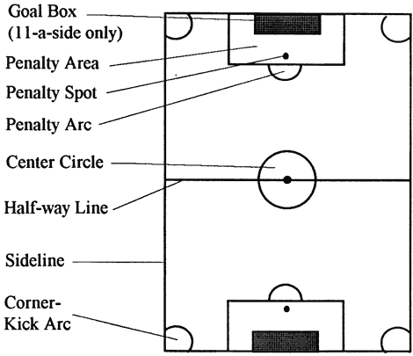

5-a-side Key Pitch Dimensions
Minimum Field Size | 40 meters by 30 meters (44 yards by 33 yards)
Maximum Field Size | 50 meters by 35 meters (55 yards by 38 yards)
Penalty Area | 7 meters deep by 12 meters wide (8 yards by 13 yards)
Penalty Spot | 6.4 meters (7 yards) from the goal line
Goal Size | 1.8 meters high by 3.7 meters wide (6 feet by 12 feet)

7-a-side Key Pitch Dimensions
Minimum Field Size | 50 meters by 35 meters (55 yards by 38 yards)
Maximum Field Size | 70 meters by 50 meters (77 yards by 55 yards)
Penalty Area | 7 meters deep by 12 meters wide (8 yards by 13 yards)
Penalty Spot | 6.4 meters (7 yards) from the goal line
Goal Size | 1.8 meters high by 3.7 meters wide (6 feet by 12 feet)

11-a-side Key Pitch Dimensions
Minimum Field Size | 91.4 meters by 50.3 meters (100 yards by 55 yards)
Maximum Field Size | 109.7 meters by 68.6 meters (120 yards by 75 yards)
Penalty Area | 16.5 meters deep by 40.2 meters wide (18 yards by 44 yards)
Penalty Spot | 11 meters (12 yards) from the goal line
Goal Size | 2.4 meters high by 7.3 meters wide (8 feet by 24 feet.)

Essential Components of Planning a Football Training Session
Special Olympics athletes respond well to a simple, well-structured training routine with which they can become familiar. An organized plan, prepared before you get to the field, will help establish such a routine and help make best use of your limited time. A recommended training plan is outlined below.

Warming Up/ Stretching
- Every player warms up with a ball; i.e., low-intensity dribbling drills.
- Stretch each muscle group.
- Have players lead the stretching while coaches assist individual players when necessary.
- Finish the warm-up with a fun dribbling/tag game.

Sample Warm-Up Routine

Easy Aerobic Run

Flexibility Stretches
Triceps Stretch
Side Stretch
Groin Stretch
Supine Hamstring Stretch
Hamstring Stretch
Seated Saddle Stretch
Hurdler’s Stretch/Reverse
Quad Stretch
Abdominal Stretch
Toe Pointers

Mobility Stretches
Forward-&-Back Leg Swings
Side Swings
Lunges

Rhythm Drills
Easy Skipping
High Knees
High Skipping
Jogging Butt Kicks
Skipping Kicks

Skills Instruction
- Quickly review and practice previously taught skills.
- Introduce the theme of the skills activity.
- Demonstrate skills simply and dramatically.
- Divide into groups of six or less for practice.
- Physically assist and prompt lower ability players when necessary.
- Introduce and practice new skills early in the practice session.

Competition Experience
- Use mini-games (one versus one / three versus three) to teach basic rules and game understanding.
- Use scrimmages to teach basic positions and restarts.
- Always allow at least 10 minutes of free play where the coach says nothing. Let them play.

Cool-Down
- Slow run/walk/stretch.
- As the players cool down, comment on the session and the next game.
- Finish with a team cheer.

Sample Cool-Down Routine

Activity | Purpose | Time (minimum)
Slow aerobic run | Lowers body temperature  Gradually reduces heart rate | 5 minutes
Light stretching | Removes waste from muscles | 5 minutes

See “Appendix A” for various training exercises and stretches

Sample Practice Plan Form

Date: |  | Location: |  | Time:
Goals:

Warm-Up - Make the body ready for practice.
Leader | Activity | Equipment

Team Talk - Let the athletes know your expectations for practice.
Goals for Today
Previous Skill Lesson
New Skill Lesson

Skill Development - Games and exercises to reinforce learning. Make it fun.
Leader | Activity | Equipment

Break - Supply water and take the skill into the scrimmage.
Reinforce Skill from Today:

Scrimmage - Emphasize last week’s skill and new skill.
Previous Skill
New Skill

Team Talk - Emphasize new skill and techniques from scrimmage.
Scrimmage
Lesson 1
Scrimmage
Lesson 2
Review Last Week’s Skill
Review
Homework

Developed by The Coaching Corner TM - www.thecoachingcorner.com

Sample Training Plan

Preseason
Week #1  Workouts | Warm-up  Skill Assessment  Fitness  Control-Receiving
Week #2  Workouts | Warm-up  Fitness  Dribbling  Rules Review

Competition Season
Week #3  Workouts | Warm-up  Review Control and Dribbling  Passing  Rules/Restarts
Week #4  Workouts | Warm-up  Review Passing  Shooting  Team Play/Positions
Week #5  Workouts | Warm-up  Team Play/Strategy  Passing  Review Shooting  Tournament Talk
Week #6  Workouts | Warm-up  Team Play/Wings  Review Passing  Goalkeeping  Tournament Skill Assessment
Week #7  Workouts | Warm-up  Review Team Play  Defending/Tackling  Team Play/Defending  Tournament Etiquette
Week #8  Workouts | Warm-up  Heading  Shooting  Tournament Preparation

Sample Fitness Program
Focus on overall general fitness for Special Olympics athletes. The program below has three major components: warm-up, exercises and cool-down. The number of repetitions (reps) and sets will determine the goal of your program: muscle endurance or muscle strength. Review the following muscle specific strength exercises and plyometric drills to develop your own fitness program.

Activity | Duration/ Sets & Reps
Warm-Up
Easy aerobic walk/jog/run | 3-5 minutes
Stretching | 15-20 minutes
- Upper Body | 3-5 exercises
- Low Back-Glutes | of each
- Lower Body | muscle group
Exercises
Agility & Conditioning
- Acceleration Strides | 3 x 30meters
- Leg Swings (F/S) | 1 x 10 each leg
- Calf Raises | 1 x 10 each leg
Arms & Shoulders
- Push-ups: Wide | 5 reps
- Triceps Dip | 5 reps
- Push-ups: Regular | 5 reps
Back & Abdomen
- Sit-Ups: Side Lifts | 10 reps
- Leg Raises | 10 reps
- Trunk Twists | 10 reps
Foot & Legs
- Lunges – Walking | 3 x 30meters
- Squats | 10 reps
- Kangaroo Hops | 2 x 5
Cool-Down
Easy aerobic walk/jog/run | 3-5 minutes
Light Stretching | 10-15 minutes

Training Principles Summary

Law of Overload
- Body adapts to training loads—explains how training works
- Adequate training loads improve overall fitness and increase performance
- Factors impacting training load: frequency, duration and intensity

Law of Reversibility
- Training loads that increase progressively create higher fitness levels
- No increase in fitness will occur if loading is too far apart or stays the same
- Over-training or incomplete adaptation occurs when training loads are too great or too close

Law of Specificity
- Specific training load produces specific response and adaptations
- General training prepares athletes for specific training
- Greater the volume of general training, greater the capacity for specific training

Principle of Individualism
- Athletes bring their unique talent, capabilities and capacities to training
- Heredity determines many physiological factors that impact training
- Chronological, biological and training ages must be considered when designing a training and competition plan

Principle of Variety
- Training is a long-term process, and loading and recovery can become boring
- Make it fun for the athlete
- Be creative

Principle of Active Involvement
- Athlete has to want to actively and willingly participate in his/her training program
- Athlete has to be committed
- All aspects of an athlete’s life contributes to his/her athletic success

Principles of Strength Training and Conditioning—At-A-Glance
Strength and conditioning training is designed to assist athletes in their overall development. There are two types of strength training programs: general and specific. The exercises used in each program reflect the athlete’s need for strength development. A general strength and conditioning training program gives athletes extra strength in the particular muscles that are needed to perform well in their sport-specific events. In addition, strength and conditioning training can help to prevent injury to athletes by building healthier, flexible and stronger muscles and bones.

Flexibility
- Stretch slowly and with control
- Do not bounce or feel pain
- Breathe slowly and rhythmically; do not hold your breath
- Easy stretch: slight tension to no tension—hold for 5-12 seconds
- Developmental stretch: stretch further feeling slight tension again—hold for 15-30 seconds

Muscle Balance
- Train both the front and the back muscles when strength training
- Example: if training the biceps, also train the triceps
- Important in preventing injury

Selection of Exercises
- Emphasize total body condition

Order of Exercises
- Very important in getting the most out of each exercise
- Exercises and lifts that work many muscle groups and require more mental concentration—perform early in the workout
- Exercises and lifts that work small muscle groups and require little concentration—perform last in the workout

Frequency of Training
- Always include one day of rest between strength training workouts

Number of Sets
- One set of each exercise is recommended during the first and second week of training. Increase the number of sets as your training program progresses.

Rest between Sets
- Depends upon the desired results of the workout
- Muscular endurance: short rest period—full recovery not required
- Strength and power: longer rest period—full recovery required

Active Rest
- An active period, recreational level, after the completion of a season of sport
- May or may not include strength training
- Gives athletes a break and their bodies time to regenerate and rest

Sample Circuit Training Routines
When prescribing exercises you need to focus on the exercises that will help the specific needs of your athlete in a particular position. The table below is a basic guideline to help get you started. These exercises can be incorporated into a training circuit to provide a variety of exercises for all your athletes that will be fun to do. Change the exercises a little, if you notice that an athlete has mastered the exercise and is getting bored.

Example

All athletes |  | Agility & Conditioning  Abdominal & Back
Forwards, Midfielders  (power-oriented athletes) | can benefit from | Agility & Conditioning  Plyometrics
Defense |  | Plyometrics
Goalies |  | Visual Reaction Drills

Using conditioning circuits takes the pressure off athletes by focusing on the time at each station, not the number of repetitions. The goal is to get the athletes to do as many reps as they can, as correctly as they can, in the specified time.

Exercise | Duration
Push-ups | 30 seconds
Crunches | 30 seconds
Leg raises | 1 minute
Lunges | 30 seconds
Triceps dip | 30 seconds
Running | 1 ½ minutes

General Conditioning Circuit – Sample

Number of circuits: | 1-5
Time at each station: | 30 seconds to  1½ minutes
Recovery between exercises: | 15-45 seconds
Recovery between circuits: | 2-5 minutes

Tips for Conducting Safe Training Sessions
Though the risks can be few, coaches have a responsibility to ensure that athletes know, understand and appreciate the risks of football. The safety and well-being of athletes are the coaches’ primary concerns. Football is not a dangerous sport, but accidents do occur when coaches forget to take safety precautions. It is the head coach’s responsibility to minimize the occurrence of injuries by providing safe conditions.
- Establish clear rules for behavior at your first practice and enforce them.
- Keep your hands to yourself.
- Listen to the coach.
- When you hear the whistle, “Stop, look and listen.”
- Ask the coach before you leave the field of play.
- When the weather is poor, have a plan to immediately remove athletes from inclement weather.
- Make sure athletes bring water to every practice, especially in hotter climates.
- Check your first-aid kit; restock supplies as necessary.
- Train all athletes and coaches on emergency procedures.
- Choose a safe field area. Do not practice in areas with rocks or holes that could cause injury. Simply telling players to avoid obstacles is not enough.
- Walk the field and boundaries and remove unsafe objects. Be particularly vigilant when you are playing in cluttered indoor gyms. Remove anything that a player might run in to.
- Check the balls for loose panels that could cause eye injury.
- Check the goals for poorly secured posts and cross-bars. Instruct players never to swing on goals. Pay particular attention to portable goals that could tip over in a high wind or if players swing on the cross-bar. Make sure these goals are securely staked into the ground.
- Review your first-aid and emergency procedures. Have someone who is trained in first aid and cardiopulmonary resuscitation on or very near to the field during practice and games.
- Establish clear rules for behavior at your first practice.
- Warm up and stretch properly at the beginning of each practice to prevent muscle injuries.
- Train to improve the general fitness level of your players. Physically fit players are less likely to get injured. Make your practices active.
- Make sure that players are physically matched in games where players go against each other, head-to-head, (e.g., one-on-one drills).
- Require all your players to wear shin pads at practices and games. The use of athletic cups and fitted mouth guards is recommended, particularly for players with slower reactions.
- Do not put a player with a very slow reaction time in the goalkeeper’s position. Make sure that a goalkeeper is able to understand how to play the position safely.

Selecting Team Members
The key to successful development of a traditional Special Olympics or Unified Sports team is the proper selection of team members. We have provided some primary considerations below.

Ability Grouping
Unified Sports football teams work best when all team members have similar sports skills. Partners with abilities that are far superior to other teammates will either control competition or accommodate others by not competing to their potential. In both situations, the goals of interaction and teamwork are diminished and a true competitive experience is not achieved.

Age Grouping
All team members should be closely matched in age.
- Within 3-5 years of age for athletes 21 years of age and under.
- Within 10-15 years for athletes 22 years of age and over.
For example, in football, an 8-year-old should not be competing against or with a 30-year-old athlete.

Special Olympics Football Skills Assessment Card

Athlete’s Name |  | Date
Coach’s Name |  | Date

Instructions
- Use tool at the beginning of the training/competition season to establish a basis of the athlete’s starting skill level.
- Have the athlete perform the skill several times.
- If the athlete performs the skill correctly three out of five times, check the box next to the skill to indicate that the skill has been accomplished.
- Program assessment sessions into your football program.
- Athletes may accomplish skills in any order. Athletes have accomplished this list when all possible items have been achieved.

Control-Receiving
Controls ball using inside of foot
Controls ball using chest
Controls ball using thigh
Cushions ball with chest or thigh
Distributes body weight, so that they are able to move backward, forward or sideways
Judges ball flight speed appropriately
Chooses the right technique and body surface to control ball

Dribbling
Dribbles forward, using the top of foot
Uses inside of foot to quickly change direction
Uses outside of foot to shield ball from opponents
Uses sole of foot to change ball direction
Dribbles up field with ball while walking
Dribbles up field with ball while running

Passing
Squares up ball, player and target in a straight line
Makes eye contact with intended receiver
Follows through in direction of intended receiver kicking foot
Places kicking foot flat against back of ball
Contacts ball with the toes pulled up, foot parallel to ground and ankle locked

Shooting
Approaches ball from side
Places non-kicking foot by side of ball
Controls ball before shooting

Tackling
Leans upper body into front-block tackle
Maintains good balance with outstretched leg in side-block tackle
Tracks and closes down on opponents dribbling the ball
Knows when to use appropriate tackle technique
Moves quickly to close distance to opponent with ball
Focuses attention on ball, not opponent’s body

Heading
Attempts to head the ball
Looks at ball as it comes toward the head
Rocks onto back foot before ball arrives
Attacks through ball for power
Directs ball in correct, general direction
Directs ball with accuracy
Heads ball while standing
Heads ball while jumping

Goalkeeping
Maintains concentration when ball is away from the goal
Gets behind the line of the ball
Scoops up low balls with legs straight and together
Goes down on one knee and scoops up low balls
Secures high ball with both hands working together as one unit
Dives on side of body
Distributes the ball, using appropriate technique

Football Attire
Players must wear appropriate football attire to train and compete successfully. Inappropriate uniforms and equipment can impact a player’s ability to play the game and, in some cases, may be a safety hazard. Teams dressed in good-looking and properly-fitted uniforms are more likely to be motivated to train and play as a team.
Appropriate football attire is required for all competitors. As coach, discuss the types of sport clothes that are acceptable and not acceptable for training and competition. Discuss the importance of wearing properly fitted clothing, along with the advantages and disadvantages of wearing certain types of clothing during training and competitions. For example, long-pant jeans to blue-jean shorts are not proper football attire for any event. Explain that they cannot perform their best while wearing jeans that restrict their movement. Take athletes to high school or collegiate matches and point out the attire being worn. You can even set the example, by wearing appropriate attire to training and competitions and not rewarding athletes that come improperly dressed to train and/or compete.

Shirts
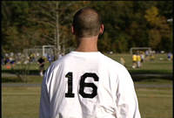

Shirts are best when they are loose fitting and made of light material. Short-sleeved shirts are recommended for warm weather. The player’s number is required on the back of the shirt in all official competitions.

Shorts
Shorts that are made of light, water-resistant nylon/polyester and have plenty of leg room are best. Male players, particularly those with slower motor skills, are encouraged to wear a protective athletic cup.

Socks

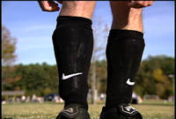

Long, knee-length socks to cover shin pads are recommended. A pair of under-socks, usually made of cotton or cotton blend, is recommended to help prevent blisters.

Shin Pads
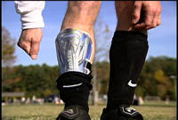

Shin pads are required for both competition and practices. Light-weight pads with elastic ties and placed between under-sock and top sock are recommended.

Shoes
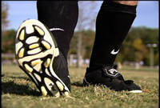

Cleats need to be sung-fitting. When purchasing shoes, try on the cleats with one pair of thin socks to make sure the fit is good. Shoes will quickly stretch to a comfortable fit. Molded rubber soles are recommended, rather than screw-in studs. Non-studded shoes are worn for indoor practice

Sweatshirts
Sweatshirts are recommended for cold-weather practice and day-long tournaments. Players are not allowed to wear sweat tops in official tournaments.

Nutrition

Guidelines for a Balanced Diet
- Eats lots of different kinds of food – vegetables, fruits, fish, meats, dairy produce and grains
- Eat fresh food rather than ready prepared, canned or frozen foods
- Eat a high proportion of complex carbohydrate-rich foods
- Grill, steam or bake foods. Avoid boiling or frying
- Avoid fatty meals and sweet and salty snacks
- Check fiber intake by eating whole grain breads, cereals, pastas
- Eat brown rice instead of white rice
- Flavor food with herbs and spices rather than salt
- Drink small amounts of water and fruit juices often

Pre-Competition Meal/Nutrients
The body’s energy levels need to be high before training and competition. The high-performance diet above will supply this everyday requirement. Athletes are individuals and require different foods, and their body responds differently to certain foods. Generally speaking, the guidelines below will help your athletes consume the proper nutrients before competition.
- Eat a small, easily digestible meal, usually less than 500 calories
- Eat about 2½-4 hours before competing
- Limit proteins and fats since they digest slowly
- Avoid foods which form gas in digestive system
- Drink small amounts of water often, before, during and after competing

During Competition Nutrients
- Besides hydration, nutrients are not needed for events that last less than one hour.
- For events that have more than one hour of continuous activity, carbohydrate drinks or fruit will supply the needed energy for continued effort.
- During tournaments lasting more than two hours, let your athletes nibble on small pieces of banana, peanut butter sandwiches, noodles or plain pasta (complex carbohydrates) when they have at least a half-hour break before their next game. This will help them keep their energy levels up. Do not fast your athletes for the duration of a 6-8 hour event.

Post-Competition Nutrients
- To replenish energy, foods with readily available carbohydrates (fruit, carbohydrate drink, granola bars) should be eaten in small amounts immediately following exercise.
- Throughout the remainder of the day, meals should contain 65 percent complex carbohydrates to replenish energy.

Football Rules, Protocol & Etiquette

Teaching the Rules of Football
The best time to teach the rules of football is during practice. Please refer to the Official Special Olympics Sports Rules for the complete listing of football rules. The International Federation of Football Association’s (FIFA) Fair Play Philosophy is advocated throughout the football world. The following guidelines are taken from FIFA’s Laws of the Game and Universal Guide for Referees. As coach, it is your responsibility to know and understand the rules of the game. It is equally important to teach your players the rules and to make them play within the spirit of the game. Following are selected laws of the 17 laws that govern the game of football. Maintain current copies of the Special Olympics Sports Rules and your national and international federation football rulebooks. Know the differences and carry them to every game.
Special Olympics rules for all formats, including 11-a-side, 5-a-side and 7-a-side competition are found on the Special Olympics Web site, www.specialolympics.org.

Law V - Referees
The referee is responsible for the entire game, including keeping a record of the game and acting as the timekeeper. The referee makes decisions on penalties, cautions and ejects players for misconduct. The referee may also end the game due to inclement weather, spectator interference, etc. The referee determines injury timeouts and other time stoppages. All decisions by the referee are final.

Law VI - Linesmen
Two linesmen are primarily responsible for indicating to the referee when the ball is out of play and which team is entitled to a throw-in, goal kick or corner kick.

Law VIII - The Start of Play
At the beginning of each half and after a goal is scored, a kickoff starts play. The ball is placed on the center spot inside the center circle. The ball must be kicked forward and roll the distance of its circumference before it is officially in play.
All players must remain on their half of the field, and the opposition must be outside of the center circle until the ball is in play. The player kicking the ball may not play the ball again until is it touched by another player. A goal may not be scored directly from a kickoff. A player other than the kicker must touch the ball before a goal can be scored.
A coin toss at the beginning of the game determines which team decides between taking the kickoff or defending a chosen side first. The team that does not take the kickoff at the beginning of the game takes the second half kickoff. A team that is scored upon is awarded a kickoff to restart the game.

Law IX - Ball In and Out of Play
The ball is out of play when it has wholly crossed the end line, goal line or touchline, and the referee has stopped play. The ball is in play at all other times even if it hits the goalposts, crossbar or referee, as long as it is still on the field of play.

Law X - Method of Scoring
A goal is scored when the whole ball crosses the goal line between the goal posts and under the crossbar. A goal cannot be thrown, carried or propelled by the hand or arm of a player on the opposing team.

Law XI - Offside
A player is offside when he or she is in the opponent’s half of the field and nearer to the opponent’s goal line than the ball, unless at least two opponents, including the goalkeeper, are nearer to the goal line than the attacking player or if the opponent receives the ball directly from a throw-in, corner kick or goal kick. Although a player may be in an offside position, a penalty is called only if the referee believes that the player is interfering with play or gaining advantage. There is no offside in either 5-a-side or 7-a-side competition.

Law XIII - Free Kick
Direct and indirect kicks are the two types of free kicks awarded during a game. A goal can be scored directly from a direct kick. For indirect kicks, the ball must be touched by a player other than the kicker before a goal can be scored. All defending players must stay at least 10 yards from the ball on all free kicks. The ball is in play once it has traveled the distance of its circumference. The kicker may not play the ball a second time until another player has touched it.

Law XIV - Penalty Kick
If any of the nine major fouls are committed by the defending team in its own penalty area, a penalty kick is awarded to the opposing team. The ball is placed on the penalty spot 12 yards from the goal. When the kick is taken, the goalkeeper must stand on the goal line between the goalposts. The goalkeeper may not move his or her feet until the ball has been struck. The only payers allowed inside the penalty area at the time of the kick are the goalkeeper and the player taking the kick. All other players must remain outside the penalty area, at least 10 yards from the ball, until the ball is in play.

Law XV - Throw-In
When a player plays the entire ball over one of the two touchlines, a throw-in is awarded to the opposing team at the place where the whole of the ball crosses the line. The player throwing the ball must face the field and deliver the ball using two hands placed behind and over the head. At the moment of release, both of the thrower’s feet must be on the ground and on or behind the touchline. In 5-a-side competition, a kick-in is used when the ball goes out of bounds on the side of the field. In 7-a-side competition, the ball may be either thrown in or kicked in.

Law XXI - Goal Kick
A goal kick is awarded to the defending team when the whole of the ball crosses the end line and was last touched by an opposing player. The defending team must place the ball inside the goal area. The ball must be kicked beyond the penalty area before it can be touched by another player. If the ball is touched by a player before it travels outside of the penalty area, the goal kick is retaken. Players from the opposing team must remain outside of the penalty area while the kick is being taken. The kicker may not touch the ball a second time until it has been touched by another player. A goal may not be scored directly from a goal kick.

Law XVII - Corner Kick
A corner kick is awarded to the attacking team when any member of the defending team plays the ball over the end line. A kick is taken from the quarter circle, with a radius of one yard, which is marked in each of the four corners of the field. The ball must be placed within the quarter circle at the defending side’s end line nearest to where the ball went out of play. The kicker may not touch the ball a second time until it has been touched by another player. A goal may be scored directly from a corner kick. All defenders must remain 10 yards from the ball until it has traveled the distance of its circumference.

The Nine Major Fouls
There are nine major offenses, or fouls, which result in either a direct free kick or a penalty kick, depending on the location of the offense.
- Kicking or attempting to kick an opponent.
- Tripping an opponent; i.e., throwing or attempting to throw an opponent with the legs or by undercutting an opponent with the body.
- Jumping at an opponent in a way that endangers the player.
- Charging an opponent in a violent or dangerous manner.
- Charging an opponent from behind unless the latter is obstructing.
- Striking, attempting to strike or spitting at an opponent.
- Holding an opponent.
- Pushing an opponent.
- Directing or stopping the ball by using the hands or arms. This rule does not apply to the goalkeeper within the penalty area.

Duration of the Game

5- or 7-a-side:
- The duration of the game shall be two equal periods of fifteen minutes with a halftime interval of five minutes. The referee should be responsible for keeping the playing time.
- If overtime is used to break a tie, two five-minute, “golden goal” overtime periods are used (first goal scored wins). If the game is still tied, penalty kicks will be used to break the tie. (See 11-a-side tie-break protocol.)

11-a-side:
- A minimum of two halves of 20 minutes each.

Special Olympics Unified Sports Rules
There are few differences between the rules for Unified Sports competition and the rules as stipulated in the official Special Olympics Sports Rules. The additions are highlighted below.
- For 5-a-side, 7-a-side,and 11-a-side football, similar age and ability levels are required of both athletes and partners.
- A lineup during the competition consists of three athletes and two partners for 5-a-side, four athletes and three partners for 7-a-side, and six athletes and five partners for 11-a-side football.
- Teams are divisioned for competition based primarily on ability. In football, division assignment is based on the best players on the roster, not the average ability of all players.
- Team sports must have an adult, non-playing coach. Player-coaches are not allowed in team sports.

The election of athletes and partners of similar age and ability is essential for Unified Sports football training and competition. Though rules modifications have been implemented to minimize differences between athletes and partners, inappropriate competition experiences and a higher risk of injury result from teams where athletes and partners are poorly matched.

Protest Procedures
Protest procedures are governed by the rules of competition. The role of the competition management team is to enforce the rules. As coach, your duty to your athletes and team is to protest any action or events while your athlete is competing that you think violate Official Football Rules. It is extremely important that you do not make protests because you and your athlete did not get your desired outcome of an event. Making protests are serious matters that impact a competition’s schedule. Check with the competition management team prior to competition to learn the protest procedures for that competition.

Football Glossary

Term | Definition
Advantage | A special rule that allows play to continue after a foul if it would be disadvantageous to the team that was fouled.
Center Mark | The circle in the middle of the field. It should be 10 yards in diameter.
Clearance | When a player kicks the ball out front of his/her own goal area.
Control | What a player tries to achieve when the ball comes to him/her.
Corner Kick | When the defending team kicks the ball over its own end line, the opposing team restarts the game.
Direct Free Kick | A free kick resulting from a foul that can be shot into the goal without having to be touched by another player.
Dribbling | A player who is running with the ball.
End Line | The line on the playing field where the goal is situated, on the short side of the field.
Field or Pitch | Football playing field.
Free Kick | How a game is restarted when a player is fouled.
Give-and-Go | A play in which a player who is faced by an opponent passes the ball to a teammate, runs around the opponent and receives the return pass.
Goal Area | The rectangular area, 20 yards wide by 6 yards deep, in front of each goal from which all goal kicks are taken; inside this area, it is illegal for opposing players to charge a goalkeeper not holding the ball.
Goal Kick | A free kick awarded the goalie if the offense was the last to contact the ball before passing over the goal line.
Goal line | The line on the playing field over which the ball must pass to score a goal.
Goals | What teams score.
Halves | Game is divided into two, timed halves.
Indirect Free Kick | A free kick resulting from a foul that cannot be shot directly into the goal. If the ball enters the goal without touching another player, the goal is void.
Injury Time | Additional time added to the end of each half to compensate for the stoppage of play due to injuries, wasted time or the scoring of a goal.
Kickoff | How a game is started.
Offside | An infraction of the rules in which an offensive player does not have at least two defensemen (including the goalie) between him/her and the goal line when the ball is played forward by a member of the offensive team.
Penalty Area | The area marked out in front of the goal within which the goalkeeper can use his/her hands. The area begins and ends 18 yards to each side of the goal (from the inside of the goal post) and extends 18 yards into the field.
Penalty Kick | A direct free kick awarded for a foul occurring in the penalty area. The ball is placed 12 yards away from the front of the goal. Only the goalie and fouled player may be in the penalty area during the kick, but any player may play the ball once touched by the goalie.
Penalty Mark | A ‘dot’ on the field that is 12 yards in front of the goal, equidistant to each goal post, or in other words, centered.
Screening | Also called “shielding.” A technique where a controlling player keeps his/her body between the ball and a marking opponent.
Shin Pads | Pads that protect the shins of a player.
Sideline | The line on the field where there are no goals situated, on the long sides of the field. Also called the Touchlines.
Sweeper | A defender that roams the defensive zone between the fullbacks and the goalie.
Tackle | To take the ball away from a dribbler using the feet.
Through Pass | A passed ball that splits a pair of defenders.
Throw-In | A technique to return the ball to play when it leaves the field over the touchlines. The player must have both hands on the ball and throw over his head while keeping both feet on the ground.
Touchline | The line on the field where there are no goals situated, on the long sides of the field. Also called the Sidelines.
Trap or Trapping | To receive the ball in a controlled manner with any part of the body (except hands or arms). Usually trapped with the foot, thigh or chest.
Volley | Kicking the ball in or out of midair.
Wall | A group of defenders standing shoulder-to-shoulder in attempt to defend a free kick near the goal.

Appendix A: Stretches

Upper Body
Note: In cold weather, it is advised that, when possible, these stretches should be done in a standing position or indoors; not sitting on frozen or wet ground.

Triceps Stretch – Back | Triceps Stretch – Front
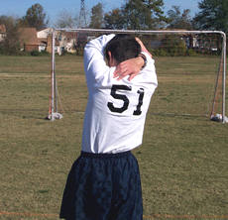 | 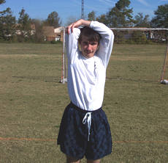
Raise both arms over head  Bend right arm, bring hand to back  Grasp elbow of bent arm and pull gently toward the middle of the back  Repeat with other arm | We want to eventually get the athlete to get his elbow up behind his head, so that his hands can ultimately touch his numbers

Shoulder Triceps Stretch
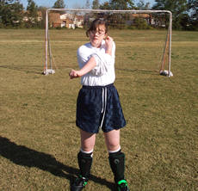
Take elbow into hand
Pull to opposite shoulder
Arm may be straight or bent

Low Back & Glutes

Crossed Ankle Stretch
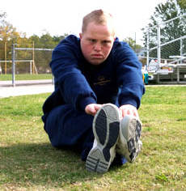
Sit, legs outstretched, crossed at ankles
Reach extended arms in front of body

Groin Stretch
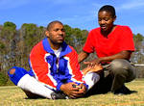 | 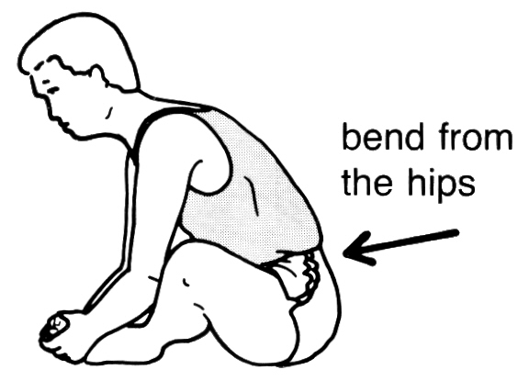 | 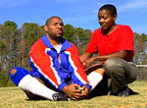
Here, the back and shoulders are rounded. The athlete is not bending from his hips and not getting the maximum benefit of the stretch | Sit, bottoms of feet touching  Hold feet/ankles  Bend forward from hips | Here, the athlete is pulling up in his lower back, bringing his chest to his feet and not pulling his toes towards his body

Low Back & Glutes

Hip Rolls
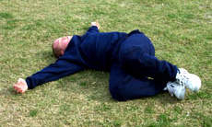 | 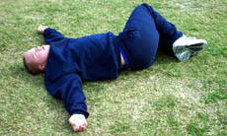
Lie on back, arms outstretched  Bring knees to chest  Slowly drop knees to left (exhale)  Bring knees back to chest (inhale)  Slowly drop knees to right (exhale) | Work on keeping the knees together to get the full stretch through the buttocks

Lower Body

Calf Stretch | Calf Stretch with Bent Knee
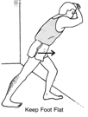 | 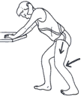
Stand facing wall/fence,  Bend forward leg slightly  Bend ankle of back leg | Bend both knees to ease strain

Lower Body

Hamstring Stretch | Seated Straddle Stretch
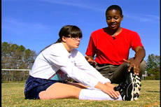 | 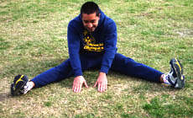
Legs straight out and together  Legs are not locked  Bend at hips, reach toward ankles  As flexibility increases, reach for feet  Push out through the heels, forcing toes to the sky | Legs straddled, bend at hips  Reach out toward the middle  Keep the back straight

Hurdler Stretch - Incorrect | Hurdler Stretch - Correct
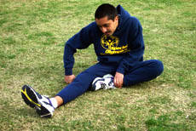 | 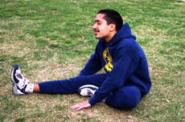
Correct alignment of lead leg is important in hurdle stretch regardless if you are a hurdler or not. The foot must be aligned in the forward direction of running.

Bend knee, touch bottom of foot to opposite thigh
Straight leg, toes are toward sky
Push out through the heel, forcing toes to the sky
Bend at hips in nice easy stretch, reaching toward the feet or ankles
Bring chest to knee

Stretching - Quick Reference Guidelines

Start Relaxed
Do not begin until relaxed and muscles are warm
Be Systematic
Start at the top of body and work your way down
Progress from General to Specific
Start general, then move into event-specific exercises
Easy Stretching before Developmental
Make slow, progressive stretches
Do not bounce or jerk to stretch farther
Use Variety
Make it fun. Work same muscle, yet with different exercises
Breathe Naturally
Do not hold breath, stay calm and relaxed
Allow for Individual Differences
Athletes start and progress at different levels
Stretch Regularly
Always include in warm-up and cool-down
Stretch while at home too

Warm-Up and Strength Drills

Butt Kicks
Butt kicks are a universal drill throughout sport. They are a great drill used in football training to help athletes develop those fast twitch muscles needed for the constant starting, stopping, pivoting and turning required in football.
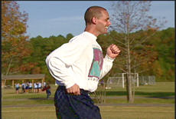

While doing butt kicks, the back is straight with a slight forward body lean. The body lean is natural as the player would assume while running.
Remember, arms are legs higher up. Encourage your athletes to keep pumping and driving them throughout the drill.

Push-Ups
Push-Ups – Up Position | Push-Ups – Down Position | Push-Ups with a Clap
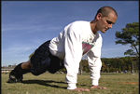 | 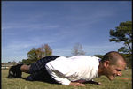 | 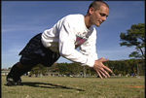
Make sure your athletes fully extend their arms in the start position, with a straight back. They can help keep a straight back by squeezing their abdominal muscles. | When athletes are in the down position, their elbows should be parallel with their shoulders. | For variety and increased intensity, add a clap to the push-up exercise. This can help athletes test themselves and each other while working hard and still have fun.

Jump and Reach
Reps: 10-12 jumps in a row

Teaching Steps
- Take “hips tall” position, feet slightly apart
- Bend knees and hold arms down toward ground
- Swing arms forward and up; reach as high up as possible while powerfully jumping straight up
- Flex knees and ankles to soften landing
- Return to start position

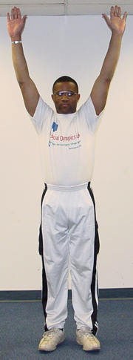  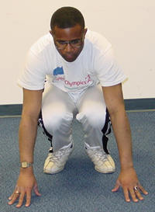 | 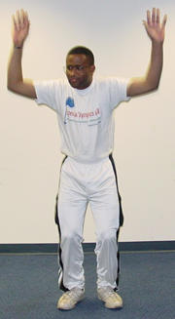  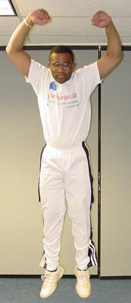

Points of Emphasis | Push strongly off ground with feet
When to Use | Conditioning or fitness circuits

Kangaroo Hops
Reps: 10-12 jumps in a row

Teaching Steps
- Take “hips tall” position, feet slightly apart
- Move weight to balls of feet
- Drive knees up to chest (hopping up)
- Arms drive out and up with knees
- Land on flat feet

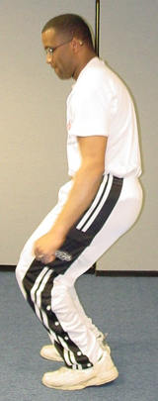 | 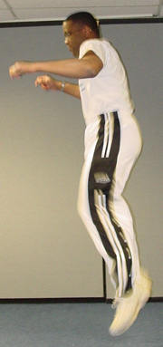
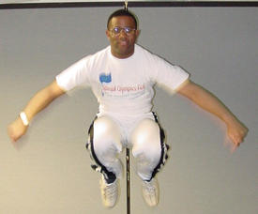 | 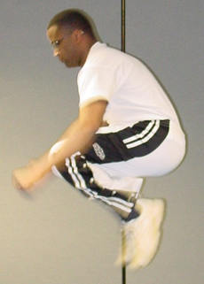

Points of Emphasis | Keep head up and arms out
When to Use | Conditioning or fitness circuits

Squats: Slow
Reps: 10-12 squats

Teaching Steps
- Stand with feet shoulder-width apart and pointing forward
- Hold arms in running form
- Squat slowly until knees are at 90 degrees
- Return to start position

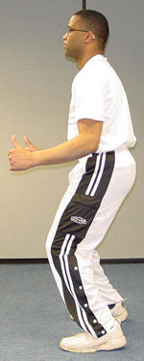 | 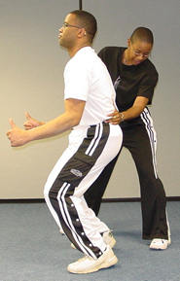

Points of Emphasis | - Keep head up and back straight  - Can also add weight for increased resistance; i.e., medicine ball
When to Use | Throughout season; conditioning or fitness circuits

Lunges: Single Leg
Reps: 10-12 squats

Teaching Steps
- Stand with feet shoulder-width apart and pointing forward
- Step out and squat with right leg until knee is 90 degrees
- Push up powerfully on ball of foot
- Return to start position
- Alternate legs

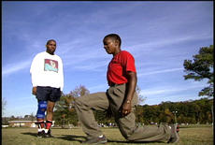 | 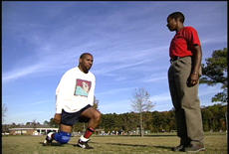

Points of Emphasis | - Keep head up and back straight  - Can also add weight for increased resistance; i.e., medicine ball
When to Use | Throughout season; conditioning or fitness circuits

Sit-Ups
Sit-Ups – Hands Behind Neck (up position) | Sit-Ups – Crossed on Shoulders
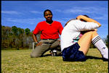 | 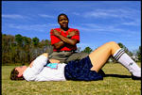
Here the athlete squeezed those abdominals coming up. Next time, we want to work on keeping the elbows straight out to the sides and parallel to the ground. | To reduce strain on the neck, athletes can place their hands on their opposite shoulders. As long as they are squeezing those abdominals, they are achieving the same intended result – stronger stomach muscles.

Sit-Ups: Regular
- Lie on floor with knees bent
- Hands can be on chest, shoulders or on side with fingers touching ears
- Elbows are out to the side
- Keep back straight; slowly lift shoulders, reaching sitting position
- Slowly return to start position

Sit-Ups: Crunches
- Perform steps 1-3 above
- Keep back straight; slowly lift shoulders about 45 degrees
- Slowly return to start position.

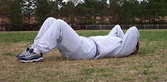 | 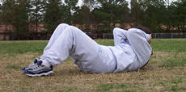

Sit-Ups: Side Lifts
- Lie on left side, resting on elbow, arm is at 90 degrees, knees are 45 degrees
- Lift hips off ground until body is in a straight line
- Slowly return to start position.
- Switch sides and perform lifts

Sit-Ups: Jack-knife With Medicine Ball
Reps: 2x5 (two sets of five reps)
- Lie on floor with arms and legs outstretched
- Hold medicine ball between hands
- Slowly lift ball and legs off ground at 45 degrees
- Slowly return to start position.
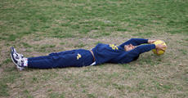 | 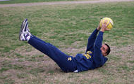

Trunk Lifts (Supermans)
Reps: 2x10
- Lie face down on the floor with toes pointed back
- Hands and legs are straight out
- Slowly raise upper body off the ground as high as possible
- Slowly return to start position

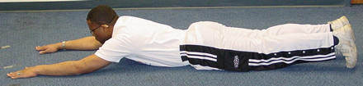

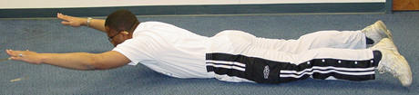

One-Arm Lifts
You can also add variety to this exercise alternating arm lifts.
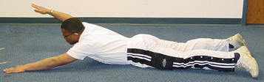

Points of Emphasis | - Can also be performed by lifting only legs or alternating arms and legs  - Do not use arms for leverage  - Keep hips, thighs, knees and feet on the ground
When to Use | Early season and throughout season as maintenance if desired

Appendix B: Skill Development Tips

Control Receiving

Teaching Control-Receiving
In football, the first touch is the most important. The easiest way to receive a ball is with the inside of the foot. The player stands in a relaxed position with his/her eyes focused on the ball and adjusts his/her position to remain in the flight of the ball. The non-kicking foot is slightly in front of the other foot. The kicking foot meets the ball and is then immediately withdrawn on the moment of impact. This will generally push the ball away from the player's body.
- Use the inside of the foot to bring a ground ball under control. All the body weight should be on the supporting leg with the receiving foot raised slightly off the ground.

Key Words
- Open up the foot
- Raise the foot

Relax and cushion the ball rather than offer resistance against the ball. The aim is to absorb any pace by meeting the ball with a cushioned touch. The ball is given as large an area to land. The chest, head, thigh or foot is withdrawn as contact is made.

Key Words
- Soft foot
- Cushion

Teaching Cushioning the Ball
- Player must stand lightly as the ball approaches.
- Position player in the ball’s line of travel.
- Assess player’s options, then decide which part of the body he/she wants to control the ball with.
- Look directly at the ball.
- Position player’s non-kicking foot ahead of the ball.
- Use arms for balance.
- Bring the striking foot back at the moment of impact.

Key Words
- Relax
- Cushion
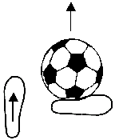 | 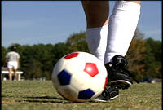

Receiving a Pass, Using Inside of Foot
- Receive the ball even with the toes of the plant foot or a little in front.
- Stiffen or relax the receiving foot so the ball stops about one step away, enabling the athlete to quickly take one step and strike it. It is this step that gives power to the pass.
- Be sure the receiving foot is four to five inches off the ground. If the receiving foot is too low, the ball will pop up and contact the ball on the back part of foot — under the anklebone, not near the toes. Pull the toes up so the foot is parallel with the ground, not pointing downward. If a player cannot remember to raise his/her foot, have the player practice by raising his/her foot higher than the ball and then bring the foot down in front of the ball to stop it. This will help them to remember.
- If you want the ball to go to the left or right, instead of straight in front, the athlete must angle his/her foot and contact the ball more in front or behind, depending on whether he/she wants the ball to go left or right.

Skill Progression
For more drills, please see Football CD
Attempts to control ball
Brings rolling ball under control, using inside of foot
Controls ball with chest
Controls ball with thigh
Cushions ball with chest or thigh
Distributes body weight so that he/she is able to move backward, forward or sideways
Judges ball flight speed appropriately
Chooses the right technique and body surface to control ball

Faults & Fixes Chart

Error | Correction | Drill/Test Reference
Ball bounces away after receiving it. | Let the ball come and just as it is received, pull foot back slightly. | - Roll or toss ball to player—slowly at first.  - Increase ball speed until player is comfortable.
Ball goes under foot. | Watch ball all the way to foot. | Let the ball hit foot.

Dribbling

Teaching Dribbling
When dribbling, the most important aspects are balance and coordination. To be able to go around a player, the body must be flexible enough to change direction by shifting weight quickly, while still maintaining balance and the ability to think quickly. When asking a player to jog round the field to warm up, it is better to do this with a ball at his/her feet to help increase confidence in ball control when running. A lot of skill in dribbling develops from players’ confidence, therefore it is important to praise and motivate at training. Dribbling essentials are close control, changing direction or pace and disguise. Players are not robots; always encourage them to express themselves.
- To help develop touch and control of the ball, the player dribbles forward using the top of the foot along the outside of the laces.
- Point the toe down toward the ground.
- Keep the ball close, within one yard from the body.

Key Words
- Keep it close—light touches
- Toe down
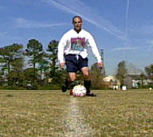

Encourage players to use the inside of the foot to quickly change direction and beat an opponent. Use short even strides, while keeping the ball close to the feet.
You want athletes to progress from using a line marker to practice going in a straight line to moving up to a quicker pace without cones or having to follow a line marker.

Key Words
- Inside of the foot
- Change direction
- Chop across the ball
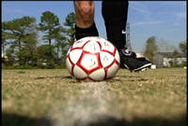

Encourage the player to use the outside of the foot to shield the ball from opponents and evade their tackles.

For more drills, please see Football CD

Skill Progression
Dribbles forward, using the top of foot, along outside of laces
Uses inside of foot to quickly change direction and bend opponent
Uses outside of foot to shield ball from opponents and evade tackles
Uses sole of foot to change ball direction
Dribbles up field with ball while walking
Dribbles up field with ball while running

Dribbling Faults & Fixes

Error | Correction | Drill/Test Reference
Cannot control ball when running. | - Player walks and dribbles.  - Slowly increase to light jog, then to a run. | Player dribbles around half of the field while running.
Loses ball when moving to right and/or left. | - Player slowly dribbles around cones.  - Increase speed as player develops better touch on the ball. | Keep time as player dribbles around cones. Award one point for the best time or best change in time.
Ball always runs away from player. | Slow down. Have the pace related to ability. | Cone dribbling.

Goalkeeping

Selecting a Goalkeeper

Confidence
Goalkeepers must be bold characters who are willing to throw themselves into a penalty area scrum.

Communication
As the last line of defense, the goalkeeper can play a vital role in organizing the players in front of them. Goalkeepers must always be willing to shout clearly when leaving their line to receive a cross.

Handling
A tall goalkeeper who cannot catch will be less effective than a shorter goalkeeper who has safe hands.

Distribution
In the modern game, goalkeepers must be confident ball kickers. A player who can kick the ball a long distance will be a major asset to the team.

Goalkeeper’s Position When Other Team Is Attacking
- Players head must remain still throughout.
- Eyes must stay fixed on the ball.
- Player must stand lightly on the balls of their feet.
- Feet are shoulder-width apart.
- Hands are at waist height with palms opened.

Coaches’ Tips for Goalkeeping—At-A-Glance

Tips for Practice

- A lower ability goalkeeper should be taught to stay close to the goal at all times and not wander out. Remind the goalkeeper to glance over his/her shoulder when the ball is away from the goal and to maintain position in the center of the goal. As a guideline, a goalkeeper should not go out to either side farther than the goal post.
- Teach all of the players not to blame a goalkeeper when the other team scores. Have a defender get the ball out of the net as quickly as possible to restart the game.
- Teach other players to be supportive. If you have a higher ability player who wants to learn to be a goalkeeper, it would be helpful to find a goalkeeper coach.
- The goalkeeper needs to be able to communicate to his/her field players. This is very important when the goalkeeper is going for the ball at the same time as the defender. The goalkeeper is responsible for calling the other players off of the ball.
- Always kick to a player on the wing, and not up the middle.
- Be aware of positions of opposing players.
- When throwing the ball, always ensure that the throw is hard enough.

Tips for Competition

- Have the goalkeeper stay focused on the play in front of him/her when the ball is not at his/her end of the field of play.
- Have the goalkeeper keep his/her eyes on the ball, not the players.
- Have a backup goalkeeper in case of injury or too many goals being scored.
- Ensure that the goalkeeper is always aware of his/her position on the line.

Skill Progression
For more drills, please see Football CD
Maintains concentration when ball is away from the goal.
Gets behind the line of the ball.
Scoops up low balls with legs straight and together.
Goes down on one knee and scoops up low balls.
Secures high ball with both hands working together as one unit.
Lowers body center of gravity before diving.
Dive on side of body, not flat on stomach.
Get both hands to the ball and bring it securely to the body.
Distribute the ball using appropriate technique.

Goalkeeping Faults & Fixes

Error | Correction | Drill/Test Reference
Player distributes the ball from too far back in the goal box. | Instruct player to move up to just inside the box before distributing the ball. | Have player count off three to five steps forward before distributing the ball.
Player stands on goal line. | Encourage player to stand on goal line and then take one big step forward. | If player is even with the posts, he/she needs to move out.
Throw ball out too quickly. | Make sure teammate is aware that you are passing the ball to them. | Communicate effectively with teammates when distributing ball.
Throwing ball out when not in right position. | If the pass fails, always make sure that your goal is covered. | Make sure when passing that the goalkeeper is in the middle of the goal area.

Heading

Teaching Heading
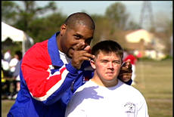

Look at the ball as it comes toward the head and keep the eyes open as contact is made.

Key Words
- Eyes open
- Watch the ball
To get more power, rock onto the back foot before the ball arrives to get some leverage when heading.

Key Words
- Rock back
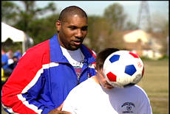
Make contact with the forehead, not with the top of the head, and attack through the ball for power.

Key Words
- Forehead
- Power through

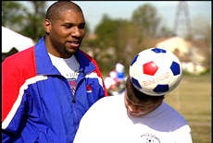

Incorrect heading of the ball.

Heading should be a pleasure, not a pain. Heading needs to be learned as well as all other techniques, as many goals will result from headers, and all outfield players will be required to head the ball many times during a game.
Headers not only finish movements with a strike at goal, they also start movements by intercepting a pass and heading to a player on the same team or heading to a teammate to shoot at goal.
It is also important for all players to be able to head the ball out of defense.

Skill Progression
For more drills, please see Football CD
Shows no fear in heading. Attempts to head the ball.
Looks at ball as it comes toward the head.
Keeps eyes open as contact is made with the ball.
Rocks onto back foot before ball arrives.
Has ball make contact with forehead.
Attacks through ball for power.
Gets power behind ball, using the upper body and neck.
Directs ball in correct, general direction.
Directs ball with accuracy.
Heads ball while standing.
Heads ball while jumping.

Heading Faults & Fixes

Error | Correction | Drill/Test Reference
Ball hits player’s head and goes in any direction. | Eyes must focus on ball. | Coach serves ball, ensuring that correct contact is made.
No direction in header. | Place feet in correct position. | Coach demonstrates correct timing.
Player refuses to head ball. | Build up confidence. | - Use a lighter ball  - Motivate  - Show correct technique

Passing

Teaching Passing
- Make eye contact with the intended receiver. This is the starting point for successful passing.
- Go through the technique with an imaginary ball first to correct the action.
- Ask player to bend their knee when passing.
- Place the player’s foot on the ball, so they know what part of foot to contact the ball with.

Coaching Tips
- Always begin teaching passing with the side of the foot.
- Have the receiver stand close, then as the passing gets better, move further away.
- The inside of the foot can be used for short push passes. The ball is struck firmly, with the foot following through in the direction of the intended receiver.

Teaching the Inside-of-Foot "Push" Pass
- ”Square up” so player, ball and target are in a straight line.
- Place “plant foot” about four inches from the side of the ball, pointing toward the target. The direction the plant foot points is important, because that is the direction the hips will face.
- Head is over the ball, eyes looking down, both knees slightly bent.

- Teach proper motion by first having the player place his/her striking foot flat against the back of the ball, about five inches above the ground, then push the ball toward the target, following through toward the target. This is a push and follow through, not a jab. Think of a tennis serve. However, jabbing a one-touch pass is okay.
- Be sure ball contact is with toes pulled up (i.e., foot parallel to the ground) and the ankle locked.
- Make contact with the arch, below the ankle bone, and follow through toward the target so the ball has top spin.
- Have player do the same, except start one step back from the ball — player, ball and target are in a straight line. This step provides power to the pass. If the pass goes into the air, it means it was struck too low.

For more drills, please see Football CD

Skill Progression
Squares up, so that ball, player and target are in a straight line.
Makes eye contact with intended receiver.
Places kicking foot flat against back of ball.
Pushes ball with kicking foot and follows through in direction of intended receiver.
Bends knees when kicking.
Knows which part of foot to contact the ball with.
Makes ball contact with the toes pulled up, foot parallel to ground and ankle locked.

Passing Faults & Fixes

Error | Correction | Drill/Test Reference
Frustrated player not receiving any passes. | Players put themselves in a good position to receive a pass and call for the ball. | Encourage players to move around on the field when they do not have the ball.
Ball goes in the air. | Show player the correct contact of ball. | Make contact with ball higher.
Player stumbles after kick. | Show player the correct contact of ball. | Make contact with ball lower.
Ball goes to the side of teammate. | Striking foot not square to balancing foot. | Correct stance of player.

Shooting

Teaching Shooting
- When shooting, approach the ball slightly from the side, not straight on. This allows the foot to make a more natural and effective strike on the ball.
- Place the non-kicking foot at the side of the ball.
- Swing the kicking foot backward with a bent knee.
- Keep your eye on the ball and head still.
- Swing the kicking foot forward with knee pointing down.
- Kicking foot follows the ball as the knee straightens.

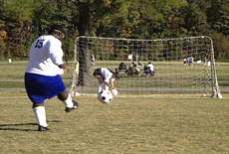 | 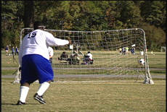
Following through with the kicking leg guides the ball into the corner of the net, the direction the foot and leg are pointed.

Coaching Tips
- Most goals are scored from the side of the goals, because the middle is usually well defended; therefore, it is more beneficial to teach players to shoot at an angle.
- It is important to teach shooting in the correct size goals.
- It is harder for a goalkeeper to save a low shot. When a ball is in the air, the goalkeeper can pick up the flight of the ball.
- Low shots can also be deflected or change direction by hitting bumps on the field.
- Always aim for the far post when shooting at an angle. This increases the chance of a secondary opportunity.
- When shooting, accuracy is more important than power.
- To shoot low, it is effective to hit the ball with the laces of the shoe.

Key Words
- From the side
- Sweep around
For good accuracy and power, keep the head down, and, with a firmly locked ankle, strike the ball with the instep.

Key Words
- Head down
- Toe down
- Watch the foot strike

Skill Progression
For more drills, please see Football CD
Approaches ball from side, not straight on.
Places non-kicking foot by side of ball.
Swings kicking foot backward with bent knee.
Keeps eye on ball and head still.
Swings kicking foot forward, knee pointing down.
Straightens knee when kicking foot follows ball.
Shoots with top of foot (instep) to generate power.
Controls ball before shooting.

Shooting Faults & Fixes

Error | Correction | Drill/Test Reference
Ball has a back spin when shot, or goes high or wide. | Encourage player to strike the middle of the ball. | Listen for the “boom” when ball is struck properly.
Player cannot get power or accuracy when shooting. | - Make sure player plants non-kicking foot next to the ball.  - Make sure knee on kicking leg is over the ball. Kick through the ball. | - Have player stand with non-kicking foot next to the ball.  - “Phantom” kick the ball with kicking foot.

Tackling

Major Types of Tackles
- Front Block Tackle
- Side Block Tackle
- Ground Block Tackle
- Sliding Tackle

Coaches Tips for Tackling—At-a-Glance

Tips for Practice
- Beginner players often rush in too fast and get wrong-footed by a simple move by the opponent. As these players run to an opponent, cue them to “slow down” and “concentrate on the ball.”
- Higher ability players can learn to slide tackle. These tackles are always made from the side of the dribbler with all the contact being on the ball. Slide tackles are very useful if a player has been beaten and is pursuing an opponent. This technique, however, can be dangerous if not done correctly. Use an experienced player to teach this to a higher ability player.
- Organize players in pairs with a ball. Have them kick the ball at the same time. This can result in a “boom” from the ball, getting them used to 50/50 balls and preparing them for tackling.
- Encourage players to run through tackles. This is done by keeping the legs moving when in close contact or in a 50/50 ball situation.
- Encourage players to jockey until the time is right to tackle.

Tips for Competition
- Do not play your defenders too far back. Have them play close to the opposing players with no more than a five-yard cushion.
- Only tackle when you think you will win the ball.
- Only commit to the tackle when you are in the right position.

Skill Progression
For more drills, please see Football CD
Executes a front block tackle; upper body leans into tackle, applying maximum force, aiming to block ball, rather than kick it.
Knows when to use appropriate tackle technique.
Executes a side block tackle; player maintains good balance with outstretched leg.
Successfully focuses, tracks and closes down on opponents dribbling the ball.
Player has good coordination to make good strong contact on the ball using inside of foot.
Does not easily fall for fakes.
Moves quickly to close distance to opponent with ball.
Focuses attention on ball, not opponent’s body.
Puts weight behind tackle.

Tackling Faults & Fixes

Error | Correction | Drill/Test Reference
Defender gets beat because of giving opposing player too much space. | Encourage defender to stay close to opposing players and to run with them. | Have defenders concentrate on the player they are defending and not other parts of the field.
Defender chases player and cannot catch opponent. | Always stay between your goal and player. | Teach positional sense.
Opposition player runs past player because of missed tackle. | Time tackle so that you are sure of winning ball. | - Teach players to properly time tackles.  - Do not commit too early.

