

Football (Soccer) Coaching Guide

The Benefits of Football
Football is generally considered to be the world’s most popular team sport. Played in just about every country, the sport’s success is due to the fact that it can be played by boys, girls, men and women of just about any physical build and ability. Football requires little in the way of specialized equipment and is organized using simple, intuitive rules.

Football is a particularly appropriate sport for individuals with mental retardation. Football:
- Involves all of the participants constantly;
- Is easy to teach and immediately rewarding to play;
- Allows relatively rapid initial improvement in skills and basic game understanding;
- Is a great conditioning activity.

Above all, football is fun.

The wonderful thing about football is that you do not need to be an expert to begin coaching. You just need enthusiasm and a commitment to learn the basics. With some guidance, anyone with time and interest can become a successful Special Olympics football coach and help athletes with mental retardation join the worldwide football family.

A Preview of Football Events Offered
- Football competition is based upon athletes’ ability levels. Following is a summary of those competition offerings.
- For athletes with lower ability, who do not have the readiness for direct, face-to-face offense and defense, competition is offered in individual skills competition.
- For athletes with average to moderate ability, competition is offered in modified team competition. The game is played in a smaller area and with a few modified rules. This game is simpler to understand and provides the transition from individual skills to traditional team play.
- For athletes with higher ability, competition is offered in traditional 11-a-side team play and Special Olympics Unified Sports® football.
- For the actual football events offered, see the Official Special Olympics Sports Rules for Football.

Acknowledgements
Special Olympics wishes to thank the professionals, volunteers, coaches and athletes who helped in the production of the Football Coaching Guide. They have helped fulfill the mission of Special Olympics: to provide year-round sports training and athletic competition in a variety of Olympic-type sports for people eight years of age and older with intellectual disabilities, giving them continuing opportunities to develop physical fitness, demonstrate courage, experience joy and participate in a sharing of gifts, skills and friendship with their families, other Special Olympics athletes and the community.
Special Olympics welcomes your ideas and comments for future revisions of this guide. We apologize if, for any reason, an acknowledgement has been inadvertently omitted.

Contributing Authors
Venisha Bowler, Special Olympics, Inc.
Floyd Croxton, Special Olympics, Inc., Athlete
Wanda S. Durden, Special Olympics, Inc.
Mark Hanken, Special Olympics Oregon
Dave Lenox, Special Olympics, Inc.
Eddie Meechan, Special Olympics Australia
Paul Rosin, Special Olympics Colorado
Jon-Paul St. Germain, Special Olympics, Inc.

Special Thanks To the Following for All of Your Help and Support
Special Olympics Virginia
Starring Athletes from Special Olympics Virginia
David Sutton
Darryl McCain
Kara Conaty
Samantha Errico
Vincent Woodhouse
Charles Silfies
Melissa Rowe
Emily Wilt
Devin Cameron
Richie Gregory
Katie Blind
Corey Sullivan (Unified Sports Partner)
Coaches from Special Olympics Virginia
Courtney Buffington
Jim Boyd
Phillip Redman
Nicole DeCandia
Special Olympics Asia Pacific
Special Olympics Europe/Eurasia
Special Olympics North America

Football Coaching Guide

Planning a Football Training and Competition Season

Table of Contents

Goals and Objectives
Setting Goals
Assessing Goals Checklist
Planning a Football Training and Competition Season
Sample Training Plan
Confirmation of Practice Schedule
Essential Components of Planning a Football Training Session
Considerations for Practice
Preparing for Practice
Sample Coaching Grid
Principles of Effective Training Sessions
Sample Practice Plan Form
Tips for Conducting Successful Training Sessions
Tips for Conducting Safe Training Sessions
Football Practice Competitions
Selecting Team Members
Ability and Age Grouping
Creating Meaningful Involvement in Unified Sports
Athlete Skills Assessment
Football Athlete Skills Assessment Card
Daily Performance Record
Football Attire
Football Equipment

To go directly to a section, hold down the control key and click on the heading

Goals
Realistic, yet challenging goals for each athlete are important to the motivation of the athlete both at training and during competition. Goals establish and drive the action of both training and competition plans. Sport confidence in athletes helps to make participation fun and is critical to the athlete’s motivation. Please see the Principles of Coaching section for additional information and exercises on goal setting.

Benefits
- Increases athlete’s level of physical fitness
- Teaches self-discipline
- Teaches the athlete sports skills that are essential to a variety of other activities
- Provides the athlete with a means for self-expression and social interaction

Goal Setting
Setting goals is a joint effort between the athlete and coach. Following are the main features of goal setting..
- Structured into short-term, intermediate and long-term
- Stepping stones to success
- Must be accepted by the athlete
- Vary in difficulty – easily attainable to challenging
- Must be measurable

Long-Term Goal
The athlete will acquire basic football skills, appropriate social behavior and functional knowledge of the rules necessary to participate successfully in football competitions.

Assessing Goals Checklist

- Write a goal statement.
- Does the goal sufficiently meet the athlete’s needs?
- Is the goal positively stated? If not, rewrite it.
- Is the goal under the athlete’s control and does it focus on his/her goals and no one else’s?
- Is the goal a goal and not a result?
- Is the goal important enough to the athlete that he/she will want to work toward achieving it? Have the time and energy to do it?
- How will this goal make the athlete’s life different?
- What barriers might the athlete encounter in working toward this goal?
- What does the athlete need to learn how to do?
- What risks does the athlete need to take?

Planning a Football Training and Competition Season
There will be many different skills to teach players during the course of a season. A season-long training plan will help coaches present skills in a systematic and effective way. The sessions in the plan below are organized in a twice-a-week format.
Make time at each practice to work individually with your goalkeepers for 10-15 minutes. If you do not have an assistant coach, you may have to do this before or after the practice session.

Sample Training Plan

Preseason
Week #1 | Assessment  Fitness  Assessment  Fitness
Week #2 | Dribbling  Fitness  Dribbling  Rules

Competition Season
Week #3 | Shooting  Rules/Restarts  Shooting  Rules/Restarts
Week #4 | Control  Team Play/Positions  Control  Team Play/Positions
Week #5 | Passing  Team Play/Support  Passing  Team Play/Support
Week #6 | Passing  Team Play/Wings  Passing  Team Play/Support
Week #7 | Tackling  Team Play/Defending  Tackling  Team Play/Defending
Week #8 | Heading  Tournament Prep  Shooting  Tournament Prep

Confirmation of Practice Schedule
Once your venue has been determined and assessed, you are now ready to confirm your training and competition schedules. It is important to publish training and competition schedules to submit to the interested groups below. This can help generate community awareness for your Special Olympics football program.
- Facility Representatives
- Local Special Olympics Program
- Volunteer Coaches
- Athletes
- Families
- Media
- Management Team Members
- Officials

The training and competition schedule is not exclusive to the areas listed below.
- Dates
- Start and end times
- Registration and/or meeting areas
- Contact phone number at the facility
- Coaches phone numbers

Essential Components of Planning a Football Training Session
Special Olympics athletes respond well to a simple, well-structured training routine with which they can become familiar. An organized plan, prepared before you get to the field, will help establish such a routine and help make best use of your limited time. A recommended training plan is outlined below.

Warming Up/Stretching
- Every player warms up with a ball; i.e., low-intensity dribbling drills.
- Stretch each muscle group.
- Have players lead the stretching while coaches assist individual players when necessary.
- Finish the warm-up with a fun dribbling/tag game.

Skills Instruction
- Quickly review and practice previously taught skills.
- Introduce the theme of the skills activity.
- Demonstrate skills simply and dramatically.
- Divide into groups of six or less for practice.
- Physically assist and prompt lower ability players when necessary.
- Introduce and practice new skills early in the practice session.

Competition Experience
- Players learn a lot by simply playing the game. The game is a great teacher.
- Use minigames (one vs. one / three vs. three) to teach basic rules and game understanding.
- Use scrimmages to teach basic positions and restarts.
- Always allow at least 10 minutes of free play where the coach says nothing. Let them play.

Cool Down
- Slow run/walk/stretch.
- As the players cool down, comment on the session and the next game.
- Finish with a team cheer.

Considerations for Practice

- When designing practices, exercises and drills, consider the strengths and weaknesses of each player and your team as a whole. Choose activities that allow your players to improve their weaknesses and exploit their strengths in competition.
- Teach so that your players learn to help coach each other. Instruct them to watch for correct and incorrect techniques, movements and decisions when in pairs or groups. The feedback your players give each other will prove invaluable in developing team unity and help players develop a greater understanding of the game.
- Make practices fun. Design practices that hold players’ attention. Use exercises and drills that your players enjoy. Use these exercises to lighten the load of hard work and to establish positive team attitude. When practicing drills, do enough to improve technique, yet not so much as to bore your athletes.
- Keep your talking to a minimum. Short, concise instructions are better than long explanations.
- Be willing to create or adapt drills to meet unique needs of your team. Skilled players master drills fairly quickly, so add some new twists to challenge these players.
- As you introduce new skills and techniques, you also need to review fundamental ones. Drills are a good vehicle for addressing your players’ technical flaws.
- Introduce new skills early in the practice session, when players are fresh and attentive. Practice new skills for several days before incorporating them into more complex drills and game scenarios.
- And above all, be well organized.

Preparing for Practice

Your Practice Plan
Practice is where you teach, make mistakes, gain fitness, practice game strategy and tactics and prepare for the next contest. A successful practice plan creates an environment that helps you accomplish your goals. With your goals in mind, design your practices specifically to fulfill those goals. Be sure to determine the time needed for each phase of practice. However, be willing to make time adjustments, depending on specific circumstances.
You need to develop a season plan just as you develop your individual practice sessions. Take time to review weekly, tournament and league-play goals and objectives for your team. Write out these goals before the start of the season. Each practice session is one block of a performance block. The better each block fits with the others, the stronger and higher the blocks will grow.

Equipment Setup
Before each day’s practice begins, determine the sequence of drills and where you will set up equipment. When possible, set up your practice field and equipment before the start of practice. Setting up and moving equipment can waste valuable practice time. Set up equipment early and assign different groups to bring out balls, cones, nets, goals and other equipment. You can also designate exercise captains to help organize players for drills, creating leaders within the team.

Coaching Grids
Grids are a great way to organize players and make maximal use of your practice field. They let you organize the field into distinct areas the size of which can be adapted to fit the skill level and number of the players involved. You can create grids by using cones, flags or other markers.
The game of football is about time and space. The best players can control the ball in little time and within a small space. Less skilled players need more time and greater space in which to perform. Coaching grids let you adjust the field of play according to the technical abilities of your athletes.
You can use the attached coaching grid to develop your own plays and game strategy.

Sample Coaching Grid
Forwards
Forwards
Halfbacks
(Midfielders)
Halfbacks
(Midfielders)
Fullbacks
(Defenders)
Fullbacks
(Defenders)
Goalie

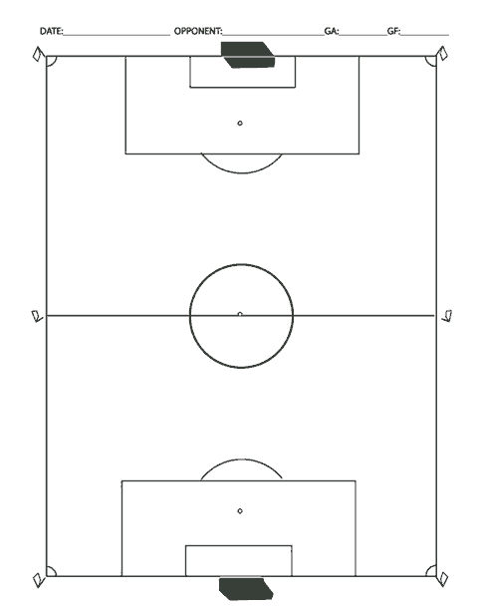

Principles of Effective Training Sessions

Keep all active | Athlete needs to be an active listener.
Create clear, concise goals | Learning improves when athletes know what is expected of them.
Give clear, concise instructions | Demonstrate – increase accuracy of instruction.
Record progress | You and your athletes chart progress together.
Give positive feedback | Emphasize and reward things the athlete is doing well.
Provide variety | Vary exercises – prevent boredom.
Encourage enjoyment | Training and competition is fun; help keep it this way for you and your athletes.
Create progressions | Learning is increased when information progresses from:  - Known to unknown – discovering new things successfully  - Simple to complex – seeing that “I” can do it  - General to specific – this is why “I” am working so hard
Plan maximum use of resources | Use what you have, and improvise for equipment that you do not have – think creatively.
Allow for individual differences | Different athletes, different learning rates, different capacities.

Sample Practice Plan Form

Date: |  | Location: |  | Time:
Goals:

Warm Up - Make the body ready for practice.
Leader | Activity | Equipment

Team Talk - Let the athletes know your expectations for practice.
Goals for Today
Previous Skill Lesson
New Skill Lesson

Skill Development - Games and exercises to reinforce learning. Make it fun.
Leader | Activity | Equipment

Break - Supply water and take the skill into the scrimmage.
Reinforce Skill from Today:

Scrimmage - Emphasize last week’s skill and new skill.
Previous Skill
New Skill

Team Talk - Emphasize new skill and techniques from scrimmage.
Scrimmage
Lesson 1
Scrimmage
Lesson 2
Review Last Week’s Skill
Review
Homework

Developed by The Coaching Corner TM - www.thecoachingcorner.com

Tips for Conducting Successful Training Sessions

- Assign assistant coaches their roles and responsibilities in accordance to your training plan.
- When possible, have all equipment and stations prepared before the athletes arrive.
- Introduce and acknowledge coaches and athletes.
- Review intended program with everyone. Keep athletes informed of changes in schedule or activities.
- Alter the plan according to weather, and the facility, to accommodate the needs of the athletes.
- Change activities before the athletes become bored and lose interest.
- Keep drills and activities brief so athletes do not get bored. Keep everyone busy with an exercise, even if it is rest.
- Devote the end of the practice to a fun, group activity that can incorporate challenge and fun, always giving them something to look forward to at the end of practice.
- If an activity is going well, it is often useful to stop the activity while interest is high.
- Summarize the session and announce arrangements for next session.
- Keep the “fun” in fundamentals.

Tips for Conducting Safe Training Sessions
Though the risks can be few, coaches have a responsibility to ensure that athletes know, understand and appreciate the risks of football. The safety and well-being of athletes are the coaches’ primary concerns. Football is not a dangerous sport, but accidents do occur when coaches forget to take safety precautions. It is the head coach’s responsibility to minimize the occurrence of injuries by providing safe conditions.

- Establish clear rules for behavior at your first practice and enforce them.
- Keep your hands to yourself.
- Listen to the coach.
- When you hear the whistle, “stop, look, and listen.”
- Ask the coach before you leave the field of play.
- When the weather is poor, have a plan to immediately remove athletes from inclement weather.
- Make sure athletes bring water to every practice, especially in hotter climates.
- Check your first-aid kit; restock supplies as necessary.
- Train all athletes and coaches on emergency procedures.
- Choose a safe field area. Do not practice in areas with rocks or holes that could cause injury. Simply telling players to avoid obstacles is not enough.
- Walk the field and boundary and remove unsafe objects. Be particularly vigilant when you are playing in cluttered indoor gyms. Remove anything that a player might run in to.
- Check the balls for loose panels that could cause eye injury.
- Check the goals for poorly secured posts and cross-bars. Instruct players never to swing on goals. Pay particular attention to portable goals that could tip over in a high wind or if players swing on the cross-bar. Make sure these goals are securely staked into the ground.
- Review your first-aid and emergency procedures. Have someone who is trained in first aid and cardiopulmonary resuscitation on or very near to the field during practice and games.
- Establish clear rules for behavior at your first practice.
- Warm up and stretch properly at the beginning of each practice to prevent muscle injuries.
- Train to improve the general fitness level of your players. Physically fit players are less likely to get injured. Make your practices active.
- Make sure that players are physically matched in games where players go against each other, head-to-head, (e.g., one-on-one drills).
- Require all your players to wear shin pads at practices and games. The use of athletic cups and fitted mouth guards is recommended, particularly for players with slower reactions.
- Do not put a player with a very slow reaction time in goal. Make sure that a goalkeeper is able to understand how to play the position safely.

Football Practice Competitions
The more we compete, the better we get. Part of the strategic plan for Special Olympics football is to drive more sport development at the local levels. Competition motivates athletes, coaches and the entire sport management team. Expand or add to your schedule as many competition opportunities as possible. We have provided a few suggestions below.
- Host football games with adjacent local Programs.
- Ask the local high school team if your athletes can compete with them in practice football games.
- Join the local community football league, club and/or associations.
- Create your own football league or club in your community.
- Host weekly football games for the area.
- Incorporate competition components, scrimmages at the end of every training session.

Simulate Game Situations
Football requires accurate and quick decision making. The ability to recognize situations, understand the pitch and make appropriate decisions is very important. Recognition skills are best learned in game settings. Create practice situations that emphasize skill and tactics likely to be encountered during a game. Practicing in a game-like setting will help your players learn to recognize when certain skills or tactics are appropriate. For example, playing four vs. four on a small field with regular goals is a great way to emphasize player movement and shooting, rather than simply shooting at the goal without opposition or movement.
Please refer to the Teaching Football Skills section to incorporate different types of teammate scrimmages into practice sessions. Scrimmages at practice allow players to develop a feel for the game, field positioning and basic technique in game-like situations.

Keep Away
Objective: One team attempts to keep possession of ball for as long as possible.

Steps
- Mark a designated area of the pitch.
- Create teams of unequal numbers with the larger teams having initial control of the balls.
- One team will have one or more balls.
- Player with ball moves only in marked area.
- Player with ball may have unlimited contacts with ball for no longer than three seconds.

Ball to the Goalie
Objective: Each team attempts to get possession of ball and pass it to its own goalie located at the opposite end of the court, standing behind specified line.

Steps
- Create two teams of equal numbers; one team has the ball.
- Goalie stands inside a marked space (e.g., circle) and may not step outside to catch the ball.
- Team with the ball must pass to at least two or more teammates before attempting to pass the ball to their goalie.
- Defenders must keep a four-foot distance from the goalie’s designated area.
- Start game with two to three players per team with one ball and gradually add players.
- Add balls and goalies, maintaining a 1-1 ratio between number of goalies and number of balls.

Selecting Team Members
The key to the successful development of a traditional Special Olympics or Unified Sports team is the proper selection of team members. We have provided some primary considerations below.

Ability Grouping
Unified Sports football teams work best when all team members have similar sports skills. Partners with abilities that are far superior to other teammates will either control competition or accommodate others by not competing to their potential. In both situations, the goals of interaction and teamwork are diminished and a true competitive experience is not achieved.

Age Grouping
All team members should be closely matched in age.
- Within 3-5 years of age for athletes 21 years of age and under.
- Within 10-15 years for athletes 22 years of age and over.
For example, in football, an 8-year-old should not be competing against or with a 30-year-old athlete.

Creating Meaningful Involvement in Unified Sports
Unified Sports embraces the philosophy and principles of Special Olympics. When selecting your Unified Sports team you want to achieve meaningful involvement at the beginning, during and end of your sport season. Unified Sports teams are organized to provide meaningful involvement for all athletes and partners. Every teammate should play a role and have the opportunity to contribute to the team. Meaningful involvement also refers to the quality of interaction and competition within a Unified Sports team. Achieving meaningful involvement by all teammates on the team ensures a positive and rewarding experience for everyone.

Indicators of Meaningful Involvement
- Teammates compete without causing undue risk of injury to themselves or others.
- Teammates compete according to the rules of competition.
- Teammates have the ability and opportunity to contribute to the performance of the team.
- Teammates understand how to blend their skills with those of other athletes, resulting in improved performance by athletes with lesser ability.

Meaningful Involvement Is Not Achieved When Team Members
- Have superior sports skills in comparison to their fellow team members.
- Act as on-field coaches rather than teammates.
- Control most aspects of the competition during critical periods of the game.
- Do not train or practice regularly and only show up on the day of competition.
- Lower their level of ability dramatically, so that they do not hurt others or control the entire game.

Football Athlete Skills Assessment
The sport skills assessment chart is a systematic method that is useful in determining the skill ability of an athlete. The Football Skills Assessment Card is designed to assist coaches in determining athletes’ ability levels before they begin participation. Coaches will find this assessment a useful tool for several reasons.
- Help coach to determine with the athlete which events they will compete in.
- Establish the baseline training areas of athlete.
- Assist coaches to group athletes of similar ability on training teams.
- Measure the athlete’s progression.
- Help determine athlete’s daily training schedule.

Before administering the assessment, coaches need to perform the following analysis when observing the athlete.
- Become familiar with each of the tasks listed under the major skills.
- Have an accurate visual picture of each task.
- Have observed a skilled performer executing the skill.
When administering the assessment, coaches will have a better opportunity in getting the best analysis from their athletes. Always begin by explaining the skill you would like to observe. When possible, demonstrate the skill.

Special Olympics Football Skills Assessment Card

Athlete’s Name |  | Date
Coach’s Name |  | Date

Instructions
- Use tool at the beginning of the training/competition season to establish a basis of the athlete’s starting skill level.
- Have the athlete perform the skill several times.
- If the athlete performs the skill correctly three out of five times, check the box next to the skill to indicate that the skill has been accomplished.
- Program assessment sessions into your program.
- Athletes may accomplish skills in any order. Athletes have accomplished this list when all possible items have been achieved.

Control-Receiving
Controls ball using inside of foot
Controls ball using chest
Controls ball using thigh
Cushions ball with chest or thigh
Distributes body weight, so that they are able to move backward, forward or sideways
Judges ball flight speed appropriately
Chooses the right technique and body surface to control ball

Dribbling
Dribbles forward, using the top of foot
Uses inside of foot to quickly change direction
Uses outside of foot to shield ball from opponents
Uses sole of foot to change ball direction
Dribbles up field with ball while walking
Dribbles up field with ball while running

Passing
Squares up ball, player and target in a straight line
Makes eye contact with intended receiver
Follows through in direction of intended receiver kicking foot
Places kicking foot flat against back of ball
Contacts ball with the toes pulled up, foot parallel to ground and ankle locked

Shooting
Approaches ball from side
Places nonkicking foot by side of ball
Controls ball before shooting

Tackling
Leans upper body into front-block tackle
Maintains good balance with outstretched leg in side-block tackle
Tracks and closes down on opponents dribbling the ball
Knows when to use appropriate tackle technique
Moves quickly to close distance to opponent with ball
Focuses attention on ball, not opponent’s body

Heading
Attempts to head the ball
Looks at ball as it comes toward the head
Rocks onto back foot before ball arrives
Attacks through ball for power
Directs ball in correct, general direction
Directs ball with accuracy
Heads ball while standing
Heads ball while jumping

Goalkeeping
Maintains concentration when ball is away from the goal
Gets behind the line of the ball
Scoops low balls up with legs straight and together
Goes down on one knee and scoops up low balls
Secures high ball with both hands working together as one unit
Dives on side of body
Distributes the ball using appropriate technique

Daily Performance Record
The Daily Performance Record is designed to keep an accurate record of the athlete’s daily performance as they learn a sports skill. There are several reasons why the coach can benefit from using the Daily Performance Record.
- The record becomes a permanent document of the athlete’s progress.
- The record helps the coach establish measurable consistency in the athlete’s training program.
- The record allows the coach to be flexible during the actual teaching and coaching session because he can break down the skills into specific, smaller tasks that meet the individual needs of each athlete.
- The record helps the coach choose proper skill-teaching methods, correct conditions and criteria for evaluating the athlete’s performance of the skills.

Using the Daily Performance Record
At the top of the record, the coach enters his/her name and the athlete’s name and event. If more than one coach works with an athlete, they should enter the dates that they work with the athlete next to their names.
Before the training session begins, the coach decides what skills will be covered. The coach makes this decision based on the athlete’s age, interests and their mental and physical abilities. The skill needs to be a statement or a description of the specific exercise that the athlete must perform. The coach enters the skill on the top line of the left-hand column. Each subsequent skill is entered after the athlete masters the previous skill. Of course, more than one sheet may be used to record all of the skills involved. Also, if the athlete cannot perform a prescribed skill, the coach may break down the skill into smaller tasks that will allow for the athlete’s success at the new skill.

Conditions and Criteria for Mastering
After the coach enters the skill, they must then decide on the conditions and criteria by which the athlete must master the skill. Conditions are special circumstances that define the manner in which the athlete must perform a skill. For example, “given a demonstration, and with assistance.” The coach needs to always operate under the assumption that the ultimate conditions in which the athlete masters a skill are, “upon command and without assistance” and, therefore, does not have to enter these conditions in the record next to the skill entry. Ideally, the coach needs to arrange the skills and conditions such that the athlete gradually learns to perform the skill while upon command and without assistance.
Criteria are the standards that determine how well the skill must be performed. The coach needs to determine a standard that realistically suits the athlete’s mental and physical abilities. For example, “pass to a target 60 percent of the time.” Given the varied nature of skills, the criteria might involve many different types of standards, such as amount of time, number of repetitions, accuracy, distance or speed.

Dates of Sessions and Levels of Instruction Used
The coach may work on one task for a couple of days and may use several methods of instruction during that time to progress to the point where the athlete performs the task upon command and without assistance. To establish a consistent curriculum for the athlete, the coach must record the dates he/she works on particular tasks and must enter the methods of instruction that were used on those dates.

Event: | Insert Event Name | Athlete’s Name | Insert Name
Skill: | Insert Skill | Coach’s Name | Insert Name

Skill Analysis | Conditions & Criteria | Dates & Instruction Methods | Date Mastered

Football Attire
Players must wear appropriate football attire to train and compete successfully. Inappropriate uniforms and equipment can impact a player’s ability to play the game and, in some cases, may be a safety hazard. Teams dressed in good-looking and properly-fitted uniforms are more likely to be motivated to train and play as a team.

DRESS LIKE A WINNER ... PLAY LIKE A WINNER!
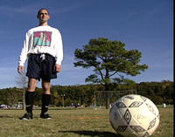

Appropriate football attire is required for all competitors. As coach, discuss the types of sport clothes that are acceptable and not acceptable for training and competition. Discuss the importance of wearing properly fitted clothing, along with the advantages and disadvantages of wearing certain types of clothing during training and competitions. For example, long-pant jeans to blue-jean shorts are not proper football attire for any event. Explain that they cannot perform their best while wearing jeans that restrict their movement. Take athletes to high school or collegiate matches and point out the attire being worn. You can even set the example by wearing appropriate attire to training and competitions and not rewarding athletes that come improperly dressed to train and/or compete.

Shirts
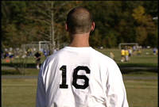

Shirts are best when they are loose fitting and made of light material. Short-sleeved shirts are recommended for warm weather. The player’s number is required on the back of the shirt in all official competitions.

Shorts
Shorts that are made of light, water-resistant nylon/polyester and have plenty of leg room are best. Male players, particularly those with slower motor skills, are encouraged to wear a protective athletic cup.

Socks
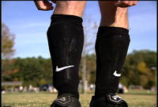

Long, knee-length socks to cover shin pads are recommended. A pair of under socks, usually made of cotton or cotton blend, is recommended to help prevent blisters.

Shin Pads
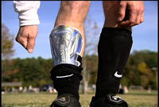

Shin pads are required for both competition and practices. Light-weight pads with elastic ties and placed between under-sock and top sock are recommended.

Shoes
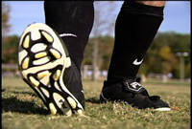

Cleats need to be sung-fitting. When purchasing shoes, try on the cleats with one pair of thin socks to make sure the fit is good. Shoes will quickly stretch to a comfortable fit. Molded rubber soles are recommended rather than screw-in studs. Non-studded shoes are worn for indoor practice

Sweatshirts
Sweatshirts are recommended for cold-weather practice and day-long tournaments. Players are not allowed to wear sweat tops in official tournaments.

No jeans. No shoes or high tops. No jewelry or watches!

Football Equipment
It is important for athletes to be able to recognize and understand how equipment works and impacts their performance for the specific events. Have your athletes name each piece of equipment as you show it, and give the use for each. To reinforce this, have athletes select the equipment used for their events as well.
A well-run training session begins with having the right coaching equipment. Below is a list of the most important training items.
A ball for every player must be available. Players can only improve their technical skills if they frequently touch a soccer ball. Junior players (under 12 years) play with a size-4 ball; all other players play with a larger size-5. Softer, synthetic leather balls should be used, particularly for beginner players. A brightly colored ball may help keep the attention of lower ability players and help players with visual impairments.
A set of scrimmage vests is essential when playing any kind of team activity. The brightly colored vests help players distinguish teammates from opponents, especially important for beginner Special Olympics athletes. Vests should be the slip-over type rather than the tie type that can be difficult to put on.
Plastic marker cones (12) are needed to mark playing areas and goals. It is almost impossible to run a training session without some kind of marker cones. Cones come in various sizes, but 9-inch plastic cones are recommended. Larger marker cones make ideal goals when proper goals are not available.
A whistle is useful for organizing players and for refereeing scrimmages. Coaches should use verbal commands whenever possible; however, some players respond better to the sound of the whistle.
A clipboard with that day’s training session plan will help you stay organized and keep you on track. Once a training session has started, it is easy to forget where you are going next unless you have a copy of the session plan.
A basic first-aid kit will allow you to treat minor cuts and abrasions on the field. Please refer to the Athlete, Fitness and Nutrition section for more information on first-aid kits and athlete injury.

General Football Equipment List At-A-Glance

Balls
Scrimmage Vests
Cones
Whistle
Clipboard
First-Aid Kit

Football Coaching Guide

Teaching Football Skills

Table of Contents

The Warm-Up
Sample Warm-Up Routine
The Cool-Down
Stretching
Upper Body
Low Back & Glutes
Lower Body
Stretching - Quick Reference Guidelines
Using Plyometrics in Football Training
Rhythm Drills
Butt Kicks
Aerobic Fitness for Football Players
Steady Pace Runs
Anaerobic Fitness for Football Players
Fartlek Runs
Shuttle Runs
Strength Training for Football Players
Sample Strength-Training Routine
Control-Receiving
Skill Progression
Teaching Control-Receiving
Teaching Cushioning
Faults & Fixes Chart
Ball Control
Control-Receiving Drills
Coaches Tips for Control-Receiving – At-A-Glance
Dribbling
Skill Progression
Teaching Dribbling
Faults & Fixes Chart
Dribbling Drills
Coaches Tips for Dribbling – At-A-Glance
Passing
Skill Progression
Teaching Passing
Basic Tips on Organizing Passing Practices
Faults & Fixes Chart
Passing Drills
Coaches Tips for Passing – At-A-Glance
Shooting
Skill Progression
Teaching Shooting
Faults & Fixes Chart
Shooting Drills
Coaches Tips for Shooting – At-A-Glance
Tackling
Skill Progression
Teaching Tackling
Front Block Tackle
Side Block Tackle
Ground Block Tackle
Sliding Tackle
Faults & Fixes Chart
Tackling Drills
Coaches Tips for Tackling – At-A-Glance
Heading
Skill Progression
Teaching Heading
Faults & Fixes Chart
Heading Drills
Accurate Contact with the Ball
Attacking the Ball
Coaches Tips for Heading – At-A-Glance
Goalkeeping
Skill Progression
Selecting a Goalkeeper
Teaching Handling Balls Coming Straight at the Goalkeeper
Teaching Diving for a Ground Ball
Teaching Distributing the Ball
Faults & Fixes Chart
Goalkeeping Drills
Coaches Tips for Goalkeeping – At-A-Glance
Understanding the Game
Football Concepts & Strategies
Simple Game Principles
Teaching Basic Restarts
Team Play
Teaching Team Formations & Selecting Positions for Each Player
Coaches Tips for Team Play – At-A-Glance
The Football Pitch
Modifications & Adaptations
Mental Preparation & Training
Home Training Guide
Weekly Home Training

To go directly to a section, hold down your control key and click on the heading

Warming Up
A warm-up period is the first part of every training session or preparation for competition. The warm-up starts slowly and systematically and gradually involves all muscles and body parts that prepare the athlete for training and competition. In addition to preparing the athlete mentally, warming up also has several physiological benefits.
Football is an active and physically demanding game. The importance of a warm-up prior to exercise cannot be overemphasized. A warm-up raises the body temperature and prepares the muscles, nervous system, tendons, ligaments and the cardiovascular system for upcoming stretches and exercises. The chances of injury are greatly reduced by increasing muscle elasticity. A player must always be ready and capable to produce 100 percent of effort from the kickoff. There are three types of warm-up.
Passive warm-up involves increasing the temperature by external means, such as massages, heating pads, steam baths or hot showers. Athletes with physical limitations may benefit form passive warm-up.
General warm-up increases overall body temperature through movement of major muscle groups that may or may not be associated with the upcoming activity; for example, jogging.
Specific warm-up concentrates on the positions of the body to be used in the upcoming activity and mimics that activity; for example, swinging the leg as if shooting.
- Raises body temperature
- Increases metabolic rate
- Increases heart and respiratory rate
- Prepares the muscles and nervous system for exercise
The warm-up is tailored for the activity to follow. Warm-ups consist of active motion leading up to more vigorous motion to elevate heart, respiratory and metabolic rates. The total warm-up period takes at least 25 minutes and immediately precedes the training or competition. It is also useful to warm up as a team. This strengthens the player’s sense of belonging within the team structure. A warm-up period will include the following basic sequence and components.

Activity | Purpose | Time (minimum)
Slow aerobic run | Heat muscles | 5 minutes
Stretching | Increase range of movement | 10 minutes
Football Drills | Coordination preparation for training/competition | 10 minutes

Running
Running is the first exercise of an athlete’s routine. Athletes begin warming the muscles by running slowly for
three to five minutes. This circulates the blood through all the muscles, thus providing them greater flexibility for stretching. The run starts out slowly, and then gradually increases in speed to its completion; however, the athletes never reach even 50 percent of their maximum effort by the end of the run. Remember, the sole objective of this phase of the warm-up is to circulate the blood and warm the muscles in preparation for more strenuous activity.

Stretching
Stretching is one of the most critical parts of the warm-up and an athlete’s performance. A more flexible muscle is a stronger and healthier muscle. A stronger and healthier muscle responds better to exercise and activities and helps prevent athlete injury. Please refer to Stretching information within this section for more in depth information.
Although it is important to warm up all muscles, the most important muscles in football are groin, hamstring, thigh, calf and achilles. Players are encouraged to take their time and ease into stretches. Sharp, sudden movements can cause damage and injury to athletes. It is also important to maintain steady breathing while stretching—breath in through the nose and exhale through the mouth.

Football Drills
Drills are progressions of learning that start at a low ability level, advance to an intermediate level and, finally, reach a high ability level. Encourage each athlete to advance to their highest possible level.
Kinesthetic movements are reinforced through repetitions of a small segment of the skill to be performed. Many times, the actions are exaggerated in order to strengthen the muscles that perform the skill. Each coaching session should take the athlete through the entire progression so that they are exposed to the total of all of the skills that make up an event.

Sample Warm-Up Routine

Easy Aerobic Run

Flexibility Stretches
Triceps Stretch
Side Stretch
Groin Stretch
Supine Hamstring Stretch
Hamstring Stretch
Seated Saddle Stretch
Hurdler’s Stretch/Reverse
Quad Stretch
Abdominal Stretch
Toe Pointers

Mobility Stretches
Forward-&-Back Leg Swings
Side Swings
Lunges

Rhythm Drills
Easy Skipping
High Knees
High Skipping
Jogging Butt Kicks
Skipping Kicks

The Cool-Down
The cool-down is as important as the warm-up; however, it is often ignored. Abruptly stopping an activity may cause pooling of the blood and slow the removal of waste products in the athlete’s body. It may also cause cramps, soreness and other problems for Special Olympics athletes. The cool-down gradually reduces the body temperature and heart rate and speeds the recovery process before the next training session or competitive experience. The cool-down is also a good time for the coach and athlete to talk about the session or competition.
A thorough cool-down also disperses most of the lactic acid that accumulates in the muscles during a hard workout. Not cooling down properly after intense exercise leads to stiff and painfully sore muscles the next day.

Activity | Purpose | Time (minimum)
Slow aerobic run | Lowers body temperature  Gradually reduces heart rate | 5 minutes
Light stretching | Removes waste from muscles | 5 minutes

The warming up and cooling down process is of paramount importance to the well-being of the player’s safety, and role of the coach is to make sure that the player has adequately followed his instructions.

Stretching
Flexibility is a major element to an athlete’s optimal performance in both training and competing. Flexibility is achieved through stretching, a critical component in warming up. Stretching follows an easy aerobic jog at the start of a training session or competition.
Begin with an easy stretch to the point of tension, and hold this position for 15-30 seconds until the pull lessens. When the tension eases, slowly move further into the stretch (developmental) until tension is again felt. Hold this new position for an additional 15 seconds. Each stretch should be repeated 4-5 times on each side of the body.
It is also important to continue to breathe while stretching. As you lean into the stretch, exhale. Once the stretching point is reached, keep inhaling and exhaling while holding the stretch. Stretching should be a part of everyone’s daily life. Regular, consistent, daily stretching has been demonstrated to have the following effects.

- Increases the length of the muscle-tendon unit
- Increases joint range of motion
- Reduces muscle tension
- Develops body awareness
- Promotes increased circulation
- Makes you feel good

Some athletes, like those with Down syndrome, may have low muscle tone that makes them appear more flexible. Be careful to not allow these athletes to stretch beyond a normal, safe range. Several stretches are dangerous to perform for all athletes and should never be part of a safe stretching program. These unsafe stretches include the following

- Neck Backward Bending
- Trunk Backward Bending
- Spinal Roll

Stretching is effective only if the stretch is performed accurately. Athletes need to focus on correct body positioning and alignment. Take the calf stretch, for example. Many athletes do not keep the feet forward in the direction that they are running.

Incorrect | Correct
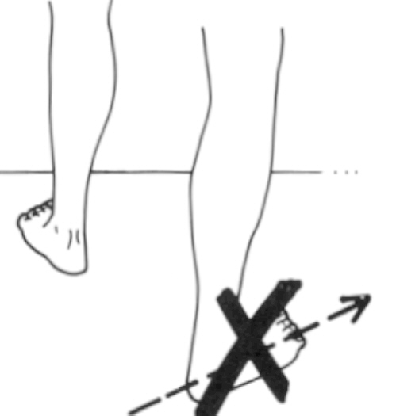
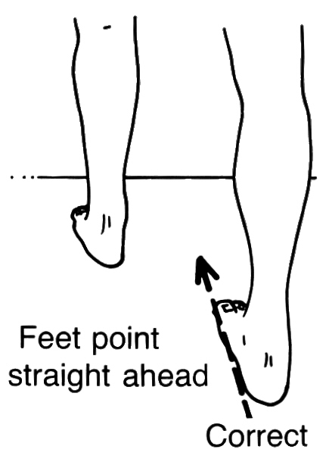

Another common fault in stretching that athletes make is bending the back in an attempt to get a better stretch from the hips. An example is a simple sitting forward leg stretch.

Incorrect | Correct
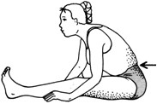
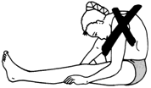

As you can imagine there are a host of stretches and variations to them to achieve your goals. However, we will focus on some basic stretches, highlighting major muscle groups. Along the way, we will also point out some common faults, illustrate corrections and identify stretches that are more event specific. In addition, we will also have some reminders to keep breathing while stretching. We will start at the top of the body and work down to the legs and feet.

Coaching Tips
- Try to have a low player/coach ratio.
- It is important that coaches and assistants make sure that stretches are being done effectively and are not harmful to the athlete. To do this may require direct, individual physical assistance, particularly with lower- ability players.
- Some stretches require a good sense of balance. If balance is a problem, use stretches that can be done while in a sitting or prone position.
- Coaches should attend to athletes doing the exercises improperly, as well as provide personal attention and reinforcement to those doing them effectively.
- Use stretching as a “teachable moment” with your athletes. Explain the importance of each stretching exercise and which muscle group is being stretched. Later, ask the athletes why each stretching exercise is important.

Upper Body

Chest Opener | Chest Opener with Assistance
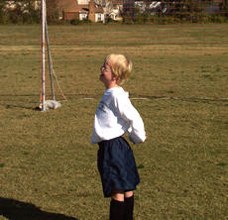 | 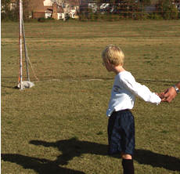
Clasp hands behind back  Palms facing in  Push hands towards sky | Sometimes a little lift to the hands is all that is needed to help athletes get the greatest benefit from this stretch

Side Stretch | Side Arm Stretch
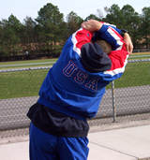 | 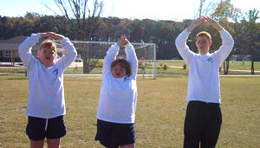
Raise arms over head  Clasp forearms  Bend to one side | Raise arms over head  Clasp hands, palms up  Push hands toward sky | If the athlete is unable to clasp their hands, they can still get a good stretch by pushing their hands to the sky, like the athlete in the middle

Upper Body

Triceps Stretch – Back | Triceps Stretch – Front
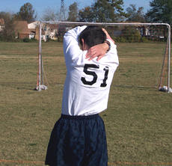 | 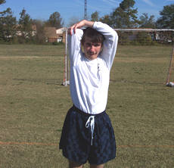
Raise both arms over head  Bend right arm, bring hand to back  Grasp elbow of bent arm and pull gently toward the middle of the back  Repeat with other arm | We want to eventually get the athlete to get his elbow up behind his head, so that his hands can ultimately touch his numbers

Shoulder Triceps Stretch
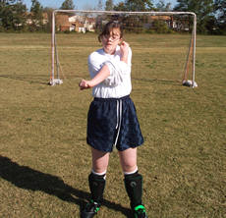
Take elbow into hand
Pull to opposite shoulder
Arm may be straight or bent

Low Back & Glutes

Deep Hip Stretch | Crossed Ankle Stretch
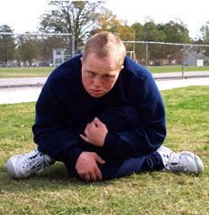 | 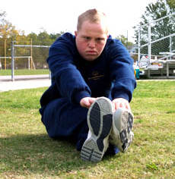
Kneel, cross left knee over right  Sit between heels  Hold knees, lean forward | Sit, legs outstretched, crossed at ankles  Reach extended arms in front of body

Groin Stretch
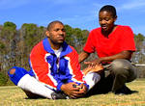 | 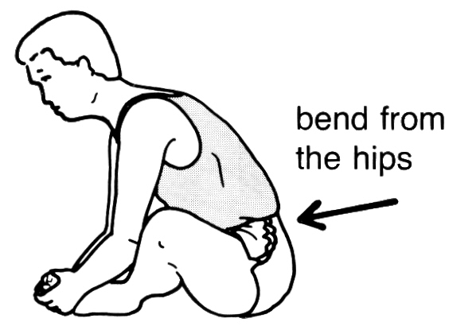 | 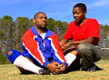
Here, the back and shoulders are rounded. The athlete is not bending from his hips and not getting the maximum benefit of the stretch | Sit, bottoms of feet touching  Hold feet/ankles  Bend forward from hips | Here, the athlete is pulling up in his lower back, bringing his chest to his feet and not pulling his toes towards his body

Low Back & Glutes

Hip Rolls
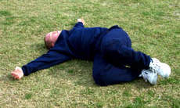 | 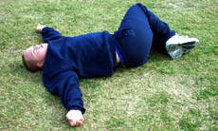
Lie on back, arms outstretched  Bring knees to chest  Slowly drop knees to left (exhale)  Bring knees back to chest (inhale)  Slowly drop knees to right (exhale) | Work on keeping the knees together to get the full stretch through the buttocks

Lower Body

Calf Stretch | Calf Stretch w/Bent Knee
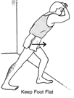 | 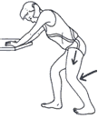
Stand facing wall/fence,  Bend forward leg slightly  Bend ankle of back leg | Bend both knees to ease strain

Lower Body

Hamstring Stretch | Seated Straddle Stretch
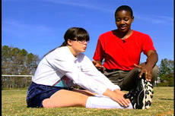 | 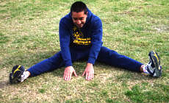
Legs straight out and together  Legs are not locked  Bend at hips, reach toward ankles  As flexibility increases, reach for feet  Push out through the heels, forcing toes to the sky | Legs straddled, bend at hips  Reach out toward the middle  Keep the back straight

Hurdle Stretch
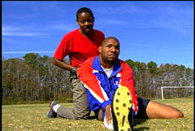 | 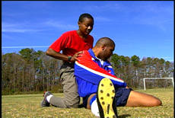  Sometimes a little assistance is needed to help the athlete maintain the “L” position until they can hold it for themselves.
Correct alignment of lead leg is important in the hurdle stretch, regardless if you are a hurdler or not. The foot must be aligned in the forward direction.

Extend right leg out in front of body, toe is toward the sky
Bend left leg, bringing knee out, away from the body, left foot is behind buttocks
Form an “L” shape with the legs
Push out through the heels, forcing toes to the sky
Bend at hips in nice easy stretch, reaching toward the feet or ankles
Bring chest to knee

To stretch the left leg quad
Turn the body and hands back toward the left side
Lean back slightly, feeling a little tension, not strain

Lower Body

Reverse Hurdle Stretch - Incorrect | Reverse Hurdle Stretch - Correct
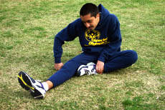 | 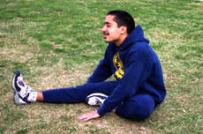
Correct alignment of lead leg is important in hurdle stretch regardless if you are a hurdler or not. The foot must be aligned in the forward direction of running.

Bend knee, touch bottom of foot to opposite thigh
Straight leg, toes are toward sky
Push out through the heel, forcing toes to the sky
Bend at hips in nice easy stretch, reaching toward the feet or ankles
Bring chest to knee

Reverse Hurdle Stretch
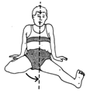 | 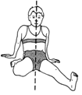
If pain in knees during hurdle stretch, bring knee closer towards the mid- line of the body

Lower Body

Quad Stretch
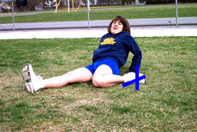 | 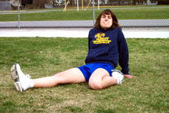
If pain in knees during stretch and foot is pointing out to the side, point foot back to relieve stress

Double Quad Stretch
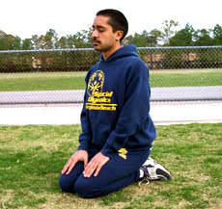 | 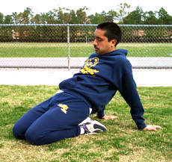 | 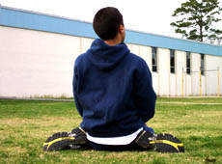  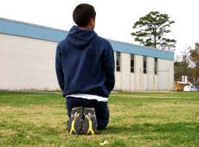  Correct
Sit on heels of feet
Place hands about 12 inches behind, hips
Lean back, feeling tension in top of thigh (quadriceps), not knee

Stretching - Quick Reference Guidelines

Start Relaxed
Do not begin until relaxed and muscles are warm
Be Systematic
Start at the top of body and work your way down
Progress from General to Specific
Start general, then move into event-specific exercises
Easy Stretching before Developmental
Make slow, progressive stretches
Do not bounce or jerk to stretch farther
Use Variety
Make it fun. Work same muscle, yet with different exercises
Breathe Naturally
Do not hold breath, stay calm and relaxed
Allow for Individual Differences
Athletes start and progress at different levels
Stretch Regularly
Always include in warm-up and cool-down
Stretch while at home too

Using Plyometrics in Football Training
You do not need to schedule specific workouts emphasizing plyometric training. For football players, plyometric drills can be incorporated after the warm-up and preceding the main body of training. These drills should emphasize a full and smooth range of motion more than eccentric overload and use the pre-stretch of the muscle to facilitate rapid movement, mechanical efficiency and coordination.
As with other types of training, plyometric exercises are performed in intervals over the course of the season. Volume and intensity will vary over the course of the season. In general, the volume of plyometric exercises for football players will be low to moderate. The intensity also will be low to moderate.
Begin each season with a gentle introduction to plyometric training using simple rhythm drills. As your athletes become accustomed to the exercises and their fitness grows, gradually increate volume and intensity.
Once athletes have learned basic rhythm skills, slowly introduce power exercises. Football players will employ a small volume of power drills combined with rhythm exercises.
As the competition phase of the season begins, plyometric work stresses rhythm and speed development. Once the peak competition phase starts, reduce plyometric training to one light session per week, though your athlete can continue to include plyometric drills in the warm-up. Stop any strenuous plyometric training 7-10 days before playoffs begin.

Rhythm Drills
Rhythm drills are a good method to help players develop strength through plyometrics. These drills usually follow stretching and flexibility exercises, and are done in conjunction with strength exercises, such as sit-ups and lunges. In addition, rhythm drills help players enhance both overall fitness and specific muscle development.

Types of Rhythm Drills used in Football Training
- Skipping – Easy
- Skipping – High
- Skipping Kicks
- Butt Kicks
- High Knees

Butt Kicks
Butt kicks are a universal drill throughout sport. They are a great drill used in football training to help athletes develop those fast twitch muscles needed for the constant starting, stopping, pivoting and turning required in football.
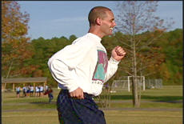
While doing butt kicks, the back is straight with a slight forward body lean. The body lean is natural as the player would assume while running.
Remember, arms are legs higher up. Encourage your athletes to keep pumping and driving them throughout the drill.

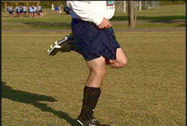

Emphasize quickness in bringing the heels to the buttocks, not in moving up the football field. You can even have your athletes practice the drill while stationary and add movement once they have mastered it to the best of their ability.

Aerobic Fitness for Football Players
Football requires running for extended periods of time; therefore, your players must be able to produce energy aerobically. Aerobic fitness is important for three primary reasons. Although football players, need to be aerobically fit, they do not need to be distance runners. Be balanced in your approach to fitness. Set standards, yet do not place fitness ahead of the ultimate goal of developing good football players and a good football team. A fit, skilled team is much more powerful than a fit, unskilled team. Following are benefits of aerobic fitness.
- Creates good cardiovascular capacity and strengthens muscles and tendons.
- Allows players to run at a steady pace without incurring oxygen debt, getting really tired and unable to recover.
- Allows your players to recover quickly from short sprints, making them more effective in the game.

Aerobic fitness is best developed during preseason training. However, if your schedule cannot be extended to include fitness in the preseason, you can integrate fitness exercises and activities into your weekly training sessions. This can be achieved through steady pace runs, ball skill drills or fitness circuits. For more information on general fitness, please refer to the Athlete, Nutrition and Fitness section in the general coaching section.

Sample Aerobic Fitness Activities

Steady Pace Runs
These runs are slow, continuous long-distance running. These runs can last for 20-30 minutes. You can add variety to these runs by having your players run with the ball through cones, around benches or defenders.

Anaerobic Fitness for Football Players
Football demands both aerobic and anaerobic capacity. During games, football players must be able to sprint hard, recover quickly and then sprint hard again. Anaerobic training starts once your athletes have developed basic aerobic fitness, because recovery capacity is developed by increasing aerobic fitness. In football, the demand for anaerobic speed is relatively short. The important point here is the ability of the player to recover quickly from multiple speed bursts.

Sample Anaerobic Fitness Activities

Fartlek Runs
Fartleks, also known as speed play, is another effective tool for football training because it can closely resemble the type of running during the course of a game – varied pace. Fartleks are easy to integrate in a workout. Players can jog one side of the field, sprint the other side. You can increase intensity and variety by jogging two sides and running one side or running two sides and jogging one side, etc. You can mix the jog-sprint sides according to the fitness and ability level of your players.

Shuttle Runs
Shuttle runs are a staple in football training. Essentially, shuttle runs are repetition or interval runs that involve numerous changes of direction. You can change the following sample shuttle run to meet the needs of your players. Just remember to keep the basics in mind when developing the run―athlete ability and fitness level.
- Runs 5 yards and back
- Runs 10 yards and back
- Runs 15 yards and back
- Runs 20 yards and back
- Runs 25 yards and back
- Repeat 3-4 times

Strength Training in Football
Strength training is important for football players. The basic elements of speed, mobility and endurance are all functions of muscular strength. According to the President’s Council on Physical Fitness and Sports, improvements in absolute muscular endurance, motor ability and athletic abilities are directly associated with an individual’s muscular strength.
Strength training for football usually has two purposes.
- Improving overall strength
- Developing muscle balance and preventing athlete injury.

Football running requires significant anaerobic energy which is directly related to muscle strength. Therefore, a muscle with greater strength can respond better to race challenges without incurring extreme fatigue and requiring a longer recovery period. Basically, strength training improves an athlete’s ability to run fast and produce anaerobic energy. Football players need to be able to run fast, sometimes very fast.
The following basic strength training routine can be accomplished outside of the weight room and easily incorporated into an athlete’s home training program. For more information on circuit and fitness training, please review the Athlete Nutrition, Safety and Fitness section in the general coaching section.

Sample Strength Training Routine
- Light Running to warm up
- Push-ups
- Lunges
- Sit-ups – Crunches
- Medicine-Ball Throws (please refer to Athlete Nutrition, Safety and Fitness section for medicine-ball throw exercises)
- Overhead Toss
- Forward Toss
- Side Toss
- Straight Arm Forward Toss to Partner

Push Ups
Push-Ups – Up Position | Push-Ups – Down Position | Push-Ups with a Clap
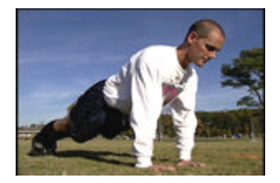 | 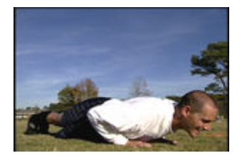 | 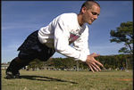
Make sure your athletes fully extend their arms in the start position, with a straight back. They can help keep a straight back by squeezing their abdominal muscles. | When athletes are in the down position, they want their elbows to be parallel with their shoulders. | For variety and increased intensity, add a clap to the push-up exercise. This can help athletes test themselves and each other while working hard and still have fun.

Lunges

90-degree angle, and thigh is parallel to ground | Explode off the ground, pushing up strong from the ground
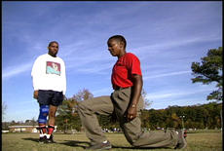
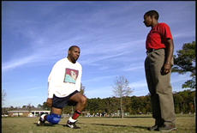

Sit-Ups

Sit-Ups – Hands Behind Neck (up position) | Sit-Ups – Crossed on Shoulders

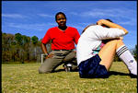
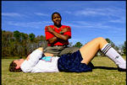
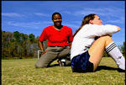

Here the athlete squeezed those abdominals coming up. Next time, we want to work on keeping the elbows straight out to the sides and parallel to the ground. |  | To reduce strain on the neck, athletes can place their hands on their opposite shoulders. As long as they are squeezing those abdominals, they are achieving the same intended result – stronger stomach muscles.

Skill Progression – Control-Receiving

Your Athlete Can: | Never | Sometimes | Often
Attempt to control ball
Bring rolling ball under control, using inside of foot
Control ball with chest
Control ball with thigh
Cushion ball with chest or thigh
Distribute body weight so that they are able to move backward, forward or sideways
Judge ball flight speed appropriately
Choose the right technique and body surface to control ball

Totals

Control-Receiving
The aim of the game is simple: score goals. To score goals, your players need to develop both good shooting technique and a positive attitude toward taking shots whenever they have a good opportunity. Players enable themselves and develop good shooting technique and positive attitude by developing good control-receiving skills.

Athlete Readiness
The beginner player usually reacts to a ball by kicking it rather than trying to control it. If the player does attempt to control the ball, it tends to bounce off the foot or the leg and is usually recovered by another player.
The intermediate player has the ability to get behind the flight of most balls that come within playing distance. The player successfully brings a rolling ball under control using the inside of the foot and makes a good attempt at controlling air balls using the chest. While control is good, the player will often lose composure and the ball when pressured by opponents.

Teaching Control-Receiving
In football, the first touch is the most important. The easiest way to receive a ball is with the inside of the foot. The player stands in a relaxed position with their eyes focused on the ball and adjusts their position to remain in the flight of the ball. The nonkicking foot is slightly in front of the other foot. The kicking foot meets the ball and is then immediately withdrawn on the moment of impact. This will generally push the ball away from the player’s body.
- Use the inside of the foot to bring a ground ball under control. All the body weight should be on the supporting leg with the receiving foot raised slightly off the ground.

Key Words
- Open Up the Foot
- Raise the Foot

Relax and cushion the ball rather than offer resistance against the ball. The aim is to absorb any pace by meeting the ball with a cushioned touch. The ball is given as large an area to land. The chest, head, thigh or foot is withdrawn as contact is made.

Key Words
- Soft Foot
- Cushion

Teaching Cushioning the Ball
- Player must stand lightly as the ball approaches.
- Position him/herself in the ball’s line of travel.
- Assess their options, then decide which part of the body they want to control the ball with.
- Look directly at the ball.
- Position their nonkicking foot ahead of the ball.
- Use arms for balance.
- Bring the striking foot back at the moment of impact.

Key Words
- Relax
- Cushion

Receiving a Pass Using Inside of Foot

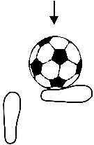
- Receive the ball even with the toes of the plant foot or a little in front.
- Stiffen or relax the receiving foot so the ball stops about one step away, enabling the athlete to quickly take one step and strike it. It is this step that gives power to the pass.
- Be sure the receiving foot is 4-5 inches off the ground. If the receiving foot is too low, the ball will pop up and contact the ball on the back part of foot―under the anklebone, not near the toes. Pull the toes up so the foot is parallel with the ground, not pointing downward. If a player cannot remember to raise their foot, have them practice by raising their foot higher than the ball and then bring the foot down in front of the ball to stop it. This will help them to remember.
- If you want the ball to go to the left or right, instead of straight in front, the athlete must angle their foot and contact the ball more in front or behind, depending on whether they want the ball to go left or right.

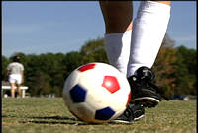

Additional Techniques for Control Receiving

Receiving with the Outside of the Foot
Players may also control and receive the ball with the outside of the foot. As with the inside of the foot, the player is aligned with the flight of the ball. The trapping foot is brought in front or across the plant leg so that the outside of the foot faces the ball. The toe is pointed slightly at the ground, the ankle locked.
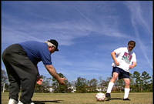

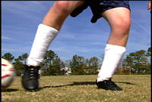

Receiving with the Thigh
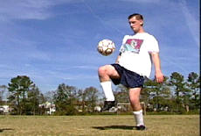

Player is balanced and stays in line with the flight of the ball. The player raises his thigh to a 90-degree angle with the ball. As the ball makes contact with the thigh, the knee drops toward the ground to create the cushioning effect.

Receiving with the Chest
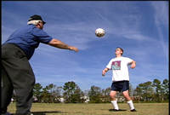
In receiving the ball with the chest, the player is also inline with the flight of the ball. Using the arms for balance, the player bends backward to get his chest underneath the ball. As the ball contacts the chest, the knees bend slightly to absorb the momentum of the ball, cushioning the ball down to his feet.
Here the athlete’s chest is too far forward and does not create a desired cushion for the ball. Work on getting the player to not stick his chest out but, instead, to arch his back. The athlete needs to bend backward more from the waist.

Faults & Fixes Chart

Error | Correction | Drill/Test Reference
Ball bounces away after receiving it. | Let the ball come and just as it is received, pull foot back slightly. | - Roll or toss ball to player slowly at first.  - Increase ball speed until player is comfortable.
Ball goes under foot. | Watch ball all the way to foot. | Let the ball hit foot.

Ball Control
There are three important points for good ball control.
- The first touch protects the ball from challenging players and does not give them a chance to regain possession.
- Play the ball into available space to allow for the next touch.
- Allow the game movement to start or continue by gaining or keeping momentum.

A poor first touch will risk taking the momentum out of play and increase the possibility of losing possession. Some players make the mistake of killing the ball dead and not concentrating on getting it out of their feet. The first touch is meant to ensure that a time wasting second touch is not needed to get the ball out and ready for the next action. The general technique for controlling the ball requires several simple skills which can be acquired through correct training practices.
The first key element in ball control is to place the controlling surface into the ball's line of flight. The body weight is well distributed, so it is possible to move forward, backward or sideways. Keep the head steady and watch the ball carefully to judge its flight and speed. It is difficult to keep one’s eyes permanently on the ball. Better players are able to take a quick glance to know what is happening around them before contact is made.
The second step is making an early judgment in choosing the right technique and body surface to control.
- Wedge control involves a more rigid surface where the player attempts to force the ball downwards or into space so they can move onto it.
- A cushioned control involves taking the sting out of the ball. This involves pulling the surface back, just when the ball makes contact. The body becomes elastic so that the ball simply drops at the players feet. This particular technique is very useful when closely marked; for example, a forward receiving the ball on the chest with his back to goal.

Control also requires good mental abilities, such as confidence and total concentration. A composed player is one who is calm, relaxed and unhurried in his movements. Confidence plays a big part in this as athletes who know what they can do and are confident in their ability are more likely to show great technique and succeed. Those who do not have confidence will be indecisive and their technique hurried.
When training, players can exaggerate the movements to get the feel of the right technique. Younger players can learn from the coach, who can demonstrate the technique, break it down and practice the individual elements and, eventually, practice the whole technique. Once the basic techniques have been mastered, the coach moves on to more advanced techniques and skills. These techniques and skills concentrate on improving control in pressure situations (for example, defenders coming from the side, front, back), control while moving at pace, control which involves an immediate layoff and controlling the ball for a teammate. The ball is received constantly from all angles, speeds, heights and surfaces.
Some common problems when controlling the ball are described below, along with a training method than can be used to improve technique.

Problem No. 1 - Ball path has been misread and the player has missed the pass.

Corrective Procedure
Repeated practice using passes from different distances with varying intensity. The coach must encourage player to keep their eyes on the ball at all times and get their body in line.

Problem No. 2 - Player is indecisive when choosing controlling body surface.

Corrective Procedure
Player shouts the type of body surface they will use. The server provides the pass and vice versa until the player gets the right feeling for the choice of technique.

Problem No. 3 - The player does not get the ball out of their feet and needs a second touch.

Corrective Procedure
Encourage the player to relax and exaggerate the movement. Repeated practice using passes from different distances with varying intensity.

Problem No. 4 - The ball bounces off the player and control is lost.

Corrective Procedure
Encourage the player to exaggerate the movement, especially the relaxation phase, first without the ball and then using gentle service, eventually building up service difficulty. Try using smaller or lighter balls.
As mentioned earlier, excellent ball control is an essential part of successful football. Like all other techniques, practice makes perfect, and it is hoped that the above not only encourages coaching and learning but also provides information on how to analyze and improve ball control technique.

Control - Receiving Drills

Lower Ability - Control and Shoot

Purpose of the Drill
- Quick control
- Teach players to think game-like situations.
- Increase individual skill and confidence.

Steps
- One coach per four players.
- Set up a 4-yard-by- 2-yard goal.
- Place a starting cone 12 yards out and a shooting cone 6-8 yards out.
- Coach rolls the ball out slowly to player who must control it then dribble and shoot within three seconds. Score one point per successful control/shot.
- Same player repeats three times then goes to back of line.
- With more mobile players, roll the ball slightly to one side, and make the player move to get behind the ball, control it and shoot.

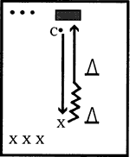

Points of Emphasis: | - First-touch control  Think quickly and react
When to Use: | Teaching positional play and also teaching players to react quickly in game-like situations.

Intermediate Ability - Control and Shoot (with chasers)

Purpose of the Drill
- Develop quick thinking in players.
- Develop good player reaction under pressure.

Steps
- Divide players into three teams: shooting team, defending team and goalkeeping team.
- Set up a 4-yard–by-2-yard goal, shooting cone at 15 yards and a defender’s cone at 20 yards.
- Coach stands to the side of the goal and rolls out a ball to the shooter.
- Shooter controls the ball, then dribbles and shoots.
- As the shooter receives the ball, the defender is released and tries to chase and tackle the shooter.
- Shooter can shoot at any time. Goalkeepers must remain within 1 yard of the goal line.
- Players return to their group after the shot.
- Rotate groups after five minutes.

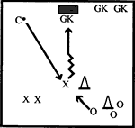

Points of Emphasis: | Allow players to express themselves.
When to Use: | Good when preparing players for games and increases the chances of them thinking correctly when under pressure.

Coaches Tips for Control – Receiving – At-A-Glance

Tips for Practice
- Help lower ability players move into position and get behind the flight of the ball. Use gentle physical prompting when necessary.
- Many players are too excited and caught up in the game to relax when the ball arrives.
- Coaching a player to slow down, relax and concentrate is as important as coaching the correct receiving technique.
- Have players receive the ball with different parts of their body - thigh, knee and chest.
- Players can work with a partner and toss the ball to each other. Let the ball hit the different parts of their body and drop to their feet.
- Emphasize the importance of the first touch.

Tips for Competition

- Give positive reinforcement to players that control the ball.
- Play a make-shift game, allowing players only two touches.
- Begin by giving players room to control the ball and then increase pressure from opponents.

Skill Progression – Dribbling

Your Athlete Can: | Never | Sometimes | Often
Dribble forward, using the top of foot, along outside of laces
Use inside of foot to quickly change direction and bend opponent
Use outside of foot to shield ball from opponents and evade tackles
Use sole of foot to change ball direction
Dribble up field with ball while walking
Dribble up field with ball while running

Totals

Dribbling
Dribbling is the skill of running with the ball at your feet. The player is speeding forward through open space, maneuvering out of tight situations and feinting to beat opponents. It is perhaps the most expressive and exciting part of the game.

Athlete Readiness
The beginner player typically kicks the ball some yards away and runs after it, rather than keeping it close and under control. Dribbling under control tends to be difficult because the player dribbles with the toe. These players can change direction slowly but will often lose the ball when pressured by an opponent.
The intermediate player can move the ball forward with the toe pointed down, keeping the ball close and under control. The player can change direction, using the inside or outside of the foot to beat opponents, but may have difficulty executing fakes to beat opponents.

Teaching Dribbling
When dribbling, the most important aspects are balance and coordination. To be able to go around a player, the body must be flexible enough to change direction by shifting weight quickly, while still maintaining balance and the ability to think quickly. When asking a player to jog round the field to warm up, it is better to do this with a ball at his/her feet to help increase confidence in ball control when running. A lot of skill in dribbling develops from players’ confidence, therefore it is important to praise and motivate at training. Dribbling essentials are close control, changing direction or pace, and disguise. Players are not robots; always encourage them to express themselves.
- To help develop touch and control of the ball, the player dribbles forward using the top of the foot along the outside of the laces.
- Point the toe down toward the ground.
- Keep the ball close, within one yard from the body.

Key Words
- Keep It Close - Light Touches
- Toe Down
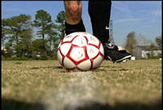
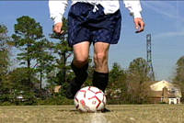
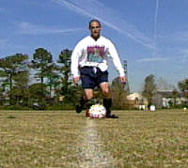

Encourage players to use the inside of the foot to quickly change direction and beat an opponent. Use short, even strides, while keeping the ball close to the feet.

You want athletes to progress from using a line marker to practice going in a straight line to moving up to a quicker pace without cones or having to follow a line marker.

Key Words
- Inside of the Foot
- Change Direction
- Chop Across The Ball

Encourage the player to use the outside of the foot to shield the ball from opponents and evade their tackles.

Key Words
- Keep It On The Outside
- Spin Away
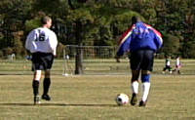

Teach players to use the sole of the foot to change direction with the ball, then move the ball to the outside of the foot. By keeping the ball on the outside, the player is in a better position to pass the ball to their teammate when dribbling up the field.

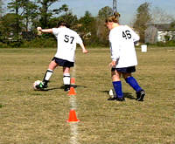

Key Words
- Balance
- Reverse

Faults & Fixes Chart

Error | Correction | Drill/Test Reference
Cannot control ball when running. | - Player walks and dribbles.  - Slowly increase to light jog, then to a run. | Player dribbles around half of the field while running.
Loses ball when moving to right and/or left. | - Player slowly dribbles around cones.  - Increase speed as player develops better touch on the ball. | Keep time as player dribbles around cones. Award one point for the best time or best change in time.
Ball always runs away from player. | Slow down. Have the pace related to ability. | Cone dribbling.

Dribbling Drills

Lower Ability – Dribble in the Square

Purpose of the Drill
- Player awareness.
- Confidence in holding ball in tight situations.

Steps
- Designate a 15-yard-by-15-yard square.
- Every player has a football.
- Players dribble around inside of the square, avoiding collisions with other players.
- Encourage the use of both feet.
- Encourage changing direction while looking up.
- Introduce different dribbling techniques.
- Coach can play as a chaser. Players must try to avoid being kicked out of the square.
- Play for 30 seconds.
- Award one point for keeping the ball safe.
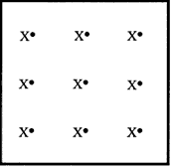

Points of Emphasis: | Be aware of surroundings
When to Use: | As a fun exercise while still teaching techniques.

Cone Drills

Purpose of the Drill
- Encourage players to keep close control without the pressure of an opponent.

Steps
- Set up seven cones in a straight line.
- Place a gate, using cones at either side.
- Demonstrate first without ball, then with ball.
- Have players weave through cones slowly without the ball, then with the ball.
- Correct players who lose control or weave too wide.
- Encourage players to use both feet.

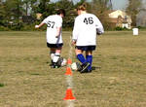
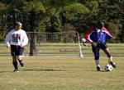

Sometimes, it is better for the athlete to begin walking through the cones and then progress to teammate passing drills.

Points of Emphasis: | Close control  Awareness of body positioning when weaving
When to Use: | Build players confidence where the emphasis is on praise and confidence.

Intermediate Ability – Immediate Attack (Three vs. Three with Dribbling Condition)

Purpose of the Drill
- Player under pressure in confined space.
- Player must learn to think quickly.

Steps
- Play on a minifield of 20 yards by 15 yards with 4-yard-wide goals.
- Form two teams of three players. One is a goalkeeper.
- Play a regular game, except that when a player gets possession of the ball, the player must immediately dribble against an opponent and try to get past the player.
- A player cannot pass the ball until this is done.
- Award one point for successfully dribbling past an opponent and three points for each goal scored.

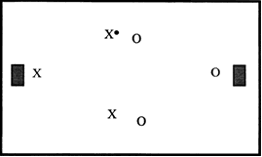

Points of Emphasis: | Learn the ability to think and react quickly under pressure.
When to Use: | Players who are beginning to express themselves on the field.

Coaches Tips for Dribbling – At-A-Glance

Tips for Practice
- For lower energy players who will not dribble very much, it is important for the coach or an assistant to work individually with them, and use gentle physical prompting (e.g., hand on the middle of the back) to create some forward motion.
- For higher energy players who dribble out of control and kick the ball 10 yards or more ahead, start by walking with the player and concentrate on dribbling under control before speeding up.
- For players that have mastered dribbling, have them dribble with their head up, viewing the field of play.
- Have players dribble, using imaginary players.
- Start by instructing the player on how you want them to go around the opponent, then allow them to express themselves.
- Encourage the use of individual tricks, as in dummies and stopovers, turns and dragging the ball back. This will keep the player interested and also increase their confidence.

Tips for Competition

- Encourage players to dribble and try to make a move to beat an opponent. The only way to improve your moves is to use them.
- Play game-like situations and give the player the option to dribble or pass.
- Encourage players to dribble to create space.
- Players need to be aware of teammates’ positions before dribbling.

Skill Progression – Passing

Your Athlete Can: | Never | Sometimes | Often
Square up, so that ball, player and target are in a straight line.
Make eye contact with intended receiver.
Place kicking foot flat against back of ball.
Push ball with kicking foot and follow through in direction of intended receiver.
Bend knee when kicking
Know which part of foot to contact the ball with.
Make ball contact with the toes pulled up, foot parallel to ground and ankle locked.

Totals

Passing
Football is a team game. Playing as a team requires each player to be able to pass the ball well. Through passing, a team can quickly counterattack from defense, maintain possession in midfield, and set up opportunities to score. The key to good passing, once the technique is perfected, is repetition.

Athlete Readiness
The beginner player tends to play with their head down, looking at the ball, and so is rarely able to look for a teammate before passing. The player usually uses the toe or awkwardly tries to pass with the inside of the foot. A player at this level can kick successfully in the correct general direction, but rarely to a teammate.
The intermediate player is able to locate and make eye contact with the intended receiver before passing. The player uses the inside of the foot for short passes and the instep for longer passes. A player at this level still finds some passes difficult to master; i.e., outside of the foot, chipped, and one-touch passes. In addition, the player is deliberate and predictable when passing in a game and will not disguise or fake passes.

Teaching Passing
- Make eye contact with the intended receiver. This is the starting point for successful passing.
- Go through the technique with an imaginary ball first to correct the action.
- Ask player to bend their knee when passing.
- Place the player’s foot on the ball, so they know what part of foot to contact the ball with.

Coaching Tips
- Always begin teaching passing with the side of the foot first.
- Have the receiver stand close, then as the passing gets better, move further away.
- The inside of the foot can be used for short push passes. The ball is struck firmly, with the foot following through in the direction of the intended receiver.

Teaching the Inside-of-Foot "Push" Pass

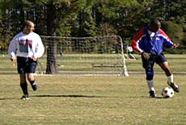
- “Square up” so player, ball and target are in a straight line.
- Place “plant foot” about 4 inches from the side of the ball, pointing toward the target. The direction the plant foot points is important, because that is the direction the hips will face. Try it. Or, have the player face the target and back of the ball, whichever the player prefers. Plant foot can be toward the middle.
- Head is over the ball, eyes looking down, both knees slightly bent.

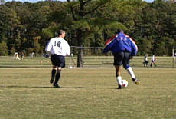
- Teach proper motion by first having the player place their striking foot flat against the back of the ball, about 5 inches above the ground, and pushing the ball toward the target, following through toward the target. This is a push and follow through, not a jab. Think of a tennis serve. However, jabbing a one-touch pass is okay.
- Be sure ball contact is with toes pulled up (i.e., foot parallel to the ground) and the ankle locked.
- Make contact with the arch, below the ankle bone, and follow through toward the target so the ball has top spin.
- Have player do the same, except start one step back from the ball—player, ball and target are in a straight line. This step provides power to the pass. If the pass goes into the air, it means it was struck too low.

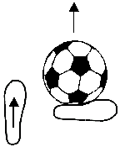

Key Words
- Head Up
- Look At Your Teammate
- Push The Ball Firmly
- Follow Though With Your Foot
- Toe Down
- Firm Strike

Coaching Tips
- When passing, encourage lower ability players to pass with the side of the foot.
- When practicing, try and encourage the use of both feet.
- The nonkicking foot is always alongside the ball.
- Players must check where they are aiming before striking the ball.
- Remind players to always keep their eye on the ball when striking.
- The instep can be used to send longer passes.

Basic Tips on Organizing Passing Practices

Organization
The players pass the ball on either side of each other. Players are allowed two touches - one touch to control the ball and one to pass the ball. The conditions can then change to any of the following:
- Control with one foot - pass with the same foot.
- Control with one foot - pass with the other foot.
- Control with the outside of one foot - pass with the inside of the same foot.
- Control with the inside of one foot - pass with the outside of the same foot.

Do
- Get in line with the ball.
- Select the surface to control the ball.
- Keep head still.
- Withdraw and relax the controlling surface to cushion the ball off the side to create a new angle to pass the ball.

Do When Passing
- Place the nonkicking foot as near the ball as possible.
- Kick through the middle of the ball with a firm foot.
- Keep head still.
- Follow through in the direction you want the ball to go.
- Do four vs. two contests as described below.

Organization –Four vs. Two Contest
- Four red-striped players against two striped defenders in an area 20 meters by 20 meters.
- Attackers attempt to score a goal by passing the ball, below head height and between the defenders.
- Defenders score if they gain possession of the ball or force the attackers to pass the ball out of the area.
- Change places after three minutes.

Do
- Look to control the ball and pass the ball forward between the two defenders.
- Pass the ball early and accurately between the defenders, as often as possible.
- Be able to disguise your control and pass. Pretend to control the ball in one direction, but control the ball in a different direction.
- Fake to pass to left, but pass right and vice versa.

Faults & Fixes Chart

Error | Correction | Drill/Test Reference
Frustrated player not receiving any passes. | Players put themselves in a good position to receive a pass and call for the ball. | Encourage players to move around on the field when they do not have the ball.
Ball goes in the air. | Show player the correct contact of ball. | Make contact with ball higher.
Player stumbles after kick. | Show player the correct contact of ball. | Make contact with ball lower.
Ball goes to the side of teammate. | Striking foot not square to balancing foot. | Correct stance of player.

Passing Drills

Passing Numbers

Purpose of the Drill
- Correct passing technique.

Steps
- Players are in pairs and 3 meters apart.
- Player passes ball to partner.
- Players can then be timed to see how many complete passes they make in one minute
- Repeat.

Passing in Triangle

Purpose of the Drill
- Increase passing skills from different sides using both feet.

Steps
- Players stands in triangle 3 meters apart.
- Players pass ball to each other in a clockwise direction.
- Players pass ball to each other in counterclockwise direction.
- This exercise can also be done in a square using four players.

Lower Ability - Football Bowling

Purpose of the Drill
- Increase accuracy when passing.
- Aids player passing under pressure.

Steps
- Designate a 10-meter-by-10-meter area.
- Place five to 10 cones up the middle.
- Form teams of three or four players.
- Players pass and try to knock down cones.
- Coach retrieves and returns balls from middle.
- Keep time to see how long it takes to knock down all the cones, or play one group against another.

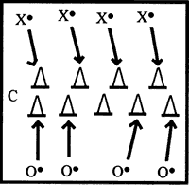

Points of Emphasis: | Knocking over the cones – stress accuracy of the pass, not speed.
When to Use: | Training sessions related to passing skills.

Intermediate Ability – Player in the Middle Passing

Purpose of the Drill
- Adapts players to game situations.
- Helps players to think quickly in possession.

Steps
- Designate a 15-meter-by-15-meter square.
- Position one player in the middle (initially the coach). Three players stand on the outside of the square with the ball.
- See how many passes the three players can make before being intercepted.
- Rotate middle player every two minutes.
- Show players how to move to the open corner to get open for a pass.
- See which group can get the most passes.

Points of Emphasis: | Keep the ball moving at all times, therefore, middle player always has to be alert.
When to Use: | End of training sessions when players are warmed up to increase their awareness in game-like situations.

Coaches Tips for Passing – At-A-Glance

Tips for Practice
- Lower ability players usually under-hit passes. At this level, encourage players to concentrate on kicking with some power in the general direction of a teammate, before being too concerned with precise accuracy.
- The major problem with most players is that they do not look for teammates before passing. Always look at your teammate, not the ball, when passing.
- A coach can help players in practice games by freezing the play, allowing the player with the ball to look for a teammate and make a pass, then continuing the play.
- Remind players that to get a good pass, you have to make a good pass.
- Seventy percent of passing or receiving is made with the inside of the foot; therefore, it is important to work on this technique.
- Practice at home, using a wall or fence to perfect technique.
- Both passing and control are dynamic skills best developed in small game situations; however, listed below are some simple exercises to improve controlling and passing the ball.

Tips for Competition

- Instruct players that when they do not have possession of the ball, they need to move into an open area to be able to receive a pass.
- When on offense, pass the ball from the outside of the field to the inside of the field.
- When you are open for a pass, talk to your teammates and call for the ball.
- Always pass the ball in front of your teammate.
- When you pass the ball, always be ready to receive a pass.

Skill Progression – Shooting

Your Athlete Can: | Never | Sometimes | Often
Approach ball from side, not straight on.
Place nonkicking foot by side of ball.
Swing kicking foot backward with bent knee.
Keep eye on ball and head still.
Swing kicking foot forward, knee pointing down.
Straighten knee when kicking foot follows ball.
Shoot with top of foot (instep) to generate power.
Controls ball before shooting.

Totals

Shooting
The aim of the game is simple: score goals. To score goals, your players need to develop both good shooting technique and a positive attitude toward taking shots whenever they have a good opportunity. If you do not shoot, you will not score.

Athlete Readiness
The beginner player is able to kick in the general direction of the goal, but without any consistency or power. They usually kick the ball with the toe or, awkwardly, with the inside of the foot. The player may slow down or stop before attempting to shoot and finds it very difficult to shoot a ball that is rolling across the body.
The intermediate player has a positive attitude toward taking shots and is able to shoot with a reasonable degree of accuracy. This player is able to shoot with the top of the foot (instep) to generate power. The player will occasionally connect successfully with a rolling ball but has learned to increase success by controlling the ball before shooting. The player is still likely to lose composure and effectiveness under pressure and has not mastered the advanced skill of volleying the ball out of the air.

Teaching Shooting
- When shooting, approach the ball slightly from the side, not straight on. This allows the foot to make a more natural and effective strike on the ball.
- Place the nonkicking foot at the side of the ball.
- Swing the kicking foot backward with a bent knee.
- Keep your eye on the ball and head still.
- Swing the kicking foot forward with knee pointing down.
- Kicking foot follows the ball as the knee straightens.

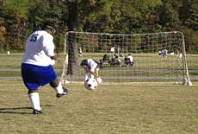
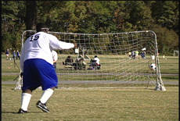

Following through with the kicking leg guides the ball in the corner of the net, the direction where the foot and leg is pointed.

Coaching Tips
- Most goals are scored from the side of the goals, because the middle is usually well defended; therefore, it is more beneficial to teach players to shoot at an angle.
- It is important to teach shooting in the correct size goals.
- It is harder for a goalkeeper to save a low shot. When a ball is in the air, the goalkeeper can pick up the flight of the ball.
- Low shots can also be deflected or change direction by hitting bumps on the field.
- Always aim for the far post when shooting at an angle. This increases the chance of a secondary opportunity.
- When shooting, accuracy is more important than power.
- To shoot low, it is effective to hit the ball with the laces of the shoe.

Key Words
- From The Side
- Sweep Around

For good accuracy and power, keep the head down and strike the ball with the instep and with the ankle firmly locked.

Key Words
- Head Down
- Toe Down
- Watch The Foot Strike

Make a strong impact on the ball, and follow through with the foot. When shooting, it is recommended to use proper size goals where available. To practice shooting, it is better to aim for the corners; therefore, cones can be placed on the goal line and players encouraged to aim between the cone and the post.

Key Words
- Strike

Faults & Fixes Chart

Error | Correction | Drill/Test Reference
Ball has a back spin when shot or goes high or wide. | Encourage player to strike the middle of the ball. | Listen for the “boom” when ball is struck properly.
Player cannot get power or accuracy when shooting. | - Make sure player plants nonkicking foot next to the ball.  - Make sure knee on kicking leg is over the ball. Kick through the ball. | Have player stand with nonkicking foot next to the ball.  “Phantom” kick the ball with kicking foot.

Shooting Drills

Lower Ability Shooting

Purpose of the Drill
- Shoot the ball as far as possible, using the correct technique.

Steps
- Set up cones at 1-, 2-, 3- and 4-meter intervals. Cone distance can vary, depending on athlete ability level.
- Line up and shoot the ball as far as possible.
- Record distance.

Lower Ability Shooting Accuracy

Purpose of the Drill
- Accurately shoot through two cones, using correct shooting techniques.

Steps
- Set up two cones 2 meters apart at a distance of 5 meters.
- Player shoots through cones (goals).
- Five shots per player.
- Record goals accurately scored, using correct technique.

Lower Ability – Shoot Out!

Purpose of the Drill
- Allows players to shoot in game-like situations.
- Allows players to position themselves before shooting.

Steps
- Use a regular goal or maker cones.
- Place a starting cone 15-20 meters from the goal.
- Three players on the shooting team; three players on the goalkeeping team.
- Shooter has three seconds to dribble and shoot.
- Coach counts down, 3-2-1-shoot.
- Goalkeepers rotate after each shot.
- Five shots each, then change teams.
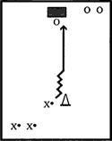

Points of Emphasis: | Players position themselves correctly, before using correct shooting technique.
When to Use: | Practicing shooting for goal.

Intermediate Ability – One vs. One to Goal

Purpose of the Drill
- Players gain confidence in going past a defender before shooting.
- Encourage game-like situations that players can relate to during a game.

Steps
- Designate a 20-meter-by-20-meter square with goals at opposite ends.
- Form two teams of three players.
- Number equally matched players, 1-2-3.
- Play No. 1 from each team on the field with No. 2 in goal and No. 3 behind the goal as a chaser.
- Play one vs. one for one minute.
- Coach rolls in spare balls when needed.
- One point for each shot on target and three points per goal.
- Rotate players.
- Keep the team score.
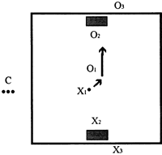

Points of Emphasis: | When the player gets past the defender, they must position themselves correctly before shooting.
When to Use: | At any training session to perfect forward play or defense.

Coaches Tips for Shooting – At-A-Glance

Tips for Practice
- As a general rule, teach players to control the ball before trying to shoot. Shooting a rolling ball is a difficult skill, and only the most advanced Special Olympics players will accomplish it successfully.
- Encourage players to shoot toward the corners of the goal, not to the middle of the goal.

Tips for Competition

- Do not be afraid to shoot, even if you are not close to the goal. Good things can happen when you send the ball toward the goal.

Skill Progression – Tackling

Your Athlete Can: | Never | Sometimes | Often
Execute a front block tackle; upper body leans into tackle, applying maximum force, aiming to block ball, rather than kick it.
Know when to use appropriate tackle technique.
Execute a side block tackle; player maintains good balance with outstretched leg.
Successfully focus, track and close down on opponents dribbling the ball.
Player has good coordination to make good strong contact on the ball using inside of foot.
Not easily fall for fakes.
Move quickly to close distance to opponent with ball.
Focus attention on ball, not opponent’s body.
Put weight behind tackle.

Totals

Tackling
Tackling refers to the skill of using your feet to take the ball away from an opponent. A truly successful team must be built on sound defensive abilities. As such, the ability to track, close down and tackle an opponent is a key to success for any team.
Whatever the position or role of a player on the pitch, the ability to tackle and win possession of the ball is vital. Defending is one of the least glamorous jobs on the pitch. However, any football purist will appreciate a perfectly timed tackle as much as any other game technique.
As with all other football techniques, mental aspects play an important role in successful tackling. A player must be 100 percent committed and determined to win the ball, while always keeping a cool head. A player should never deliberately try to hurt an opponent. Halfhearted challenges will not only lead to failure to win possession but also increase the risk of injury. Similarly, high levels of concentration and composure are needed as well as strength for good tackling. Good technique can help compensate for players who are weaker in other areas. A player must be able to anticipate the attacker’s actions and recognize the right moment to tackle. A player must also know which tackling technique to choose, depending on the position and movement of the attacker. This will be developed through practice and game situations.

Athlete Readiness
The beginner player will usually chase the ball or an approaching opponent and make some kind of effort to kick the ball away. The player is either tentative and may fear making tackles or is somewhat out of control and makes contact with just about everything, except the ball.
The intermediate player can successfully focus, track and close down on opponents dribbling the ball. The player has the coordination to make good, strong contact on the ball, using the inside of the foot. However, this player will often fall for fakes from the attacking player.

Teaching Tackling
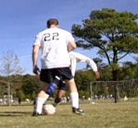
When an opponent has the ball, instruct the player to move quickly to close the distance to that player. As you near the player, slow down and concentrate. Focus attention on the ball, not on the opponent’s body.

Key Words
- Go To The Ball
- Do Not Let Them Dribble

- When you see an opportunity to get the ball, make a firm strike with the inside of the foot. Get your weight behind the tackle. Do not reach in.

Key Words
- See Your Foot Strike The Ball

Be alert after you make contact. The ball will often run loose. Be ready to pursue it and gain possession. Counterattack quickly.

Key Words
- Make Contact - Then Make It Yours!

Major Types of Tackles
- Front Block Tackle
- Side Block Tackle
- Ground Block Tackle
- Sliding Tackle

To win ball possession, all players, including forwards, need to be able to correctly execute these different tackling techniques. Players who do not tackle correctly will give away free kicks, increase their chances of getting hurt and generally improve their opponents attacking chances.

Front Block Tackle
When a defender meets an attacker head-on and with his body square to the ball, a player makes forceful contact with the inside of his boot, often at the same time as his opponent. The defender needs a sound base where his weight is transferred over and through the ball. The supporting foot must be next to the ball. The upper body must lean into the tackle, and the whole body works through the action. Steady and even pressure is applied, using the tensed-up leg muscles.

Coaching Tips
- Keep eye on ball.
- Upper body weight forward.
- Coordinate body movement.
- Apply maximum force, aiming to block the ball, rather than kick it.

Side Block Tackle
Use this tackle when an attacker has partially gone past a defender or when the defender tries to close down an attempted angled pass. This technique requires good balance, due to the block being made with an outstretched leg. The outstretched leg needs to be tensed to make strong contact with the ball. A stable base is required to quickly carry out the action. Finally, the overall timing is very important.

Coaching Tips
- Keep eye on ball.
- Teach athletes to not sell themselves as the attacker. Feint to shoot or pass.
- Try to touch shoulder to shoulder before tackling, as this can help reduce the risk of tackling too far away and letting the ball pass by the players leg.

Ground Block Tackle
If the attacker is in space and the block or side tackle cannot be used, the ground tackle is a useful technique. The defender “throws” him/herself into the ball to stop the attacker from going past. However, the defender stays on their feet as long as possible. The player accelerates into the action by dropping their hips, allowing the body to go quickly to the ground. Their contact leg is slightly flexed and as tense as possible and body weight is as far forward as possible to provide an overall firm contact. The heel of the contact leg can be anchored or pressed on the pitch to increase rigidity.

Coaching Tips
- Keep eye on ball.
- Be patient.
- Use this tackle only as a last resort once the action is executed, and the defender is momentarily out of the game.
- Aim to execute the tackle and get back on your feet as quickly as possible.

Sliding Tackle
This is probably the most exciting tackle. The defender uses this particular technique as a last resort to prevent the attacker from getting past him. To execute this action, the defender slides on the ground into the ball and plays it, using his outside leg. This action is particularly useful if the ball is next to the touchline where it can be played out into touch. The slide tackle can also be used as a means of winning the ball and turning defense into attack. The defender slides in a low sideways position and brings the tackling leg backward and swings it at the ball. The player attempts to trap the ball to gain possession, however, if the situation is dangerous, they player may want to try and play the ball directly into touch.

Coaching Tips – Similar to Ground Block Tackle
- To develop and improve tackling technique, the coach will have to design simple practices which involve repeated one-on-one situations where a defender is encouraged to utilize a wide range of tackling techniques as mentioned above.
- The coach must also be prepared to personally demonstrate tackling technique where necessary.

Faults & Fixes Chart

Error | Correction | Drill/Test Reference
Defender gets beat because of giving opposing player too much space. | Encourage defender to stay close to opposing players and to run with them. | Have defenders concentrate on the player they are defending and not other parts of the field.
Defender chases player and cannot catch opponent. | Always stay between your goal and player. | Teach positional sense.
Opposition player runs past player because of missed tackle. | Time tackle so that you are sure of winning ball. | - Teach players to properly time tackles.  - Do not commit too early.

Tackling Drills

Lower Ability – Tackle the Coach

Purpose of the Drill
- Encourage players to commit themselves to the tackle.

Steps
- Designate a 15-yard-by-15-yard square.
- Each coach has a soccer ball.
- Players try to pursue and tackle coaches. Coaches can call out the name of specific players, who then try to tackle.
- One point can be given for simply making any kind of foot contact with the coach’s ball, or, for a higher ability group, the ball must be cleared out of the square to score a point.
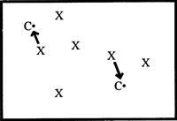

Coaching Tips
- Do not tackle unless you are sure you will win the ball.
- This can be used as a fun exercise.
- Creates interest because players always like to beat the coach.

Intermediate Ability – One vs. One vs. One

Purpose of the Drill
- Assists timing of tackles.
- Increases friendly competition between players.

Steps
- Designate a 10-yard-by-15-yard square.
- Form groups of three; each group with one ball. One group plays, while other groups rest.
- Two players stand at one end with the ball. The third player stands at the other end.
- Player No. 1 dribbles and tries to get past No. 2 and over the end line. Player No. 2 must try to tackle and either regain possession of the ball or force it out of the square. If No. 2 successfully wins the ball, he/she dribbles against player No. 3. If No. 2 is beaten to the end line by dribbler No. 1, No. 1 turns around and dribbles against player No. 3.
- Award one point per successful tackle.
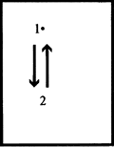

Coaching Tips
- Players must be encouraged to use correct technique.
- Playing game-like exercises encourage contact.

Coaches Tips for Tackling – At-A-Glance

Tips for Practice

- Beginner players often rush in too fast and get wrong-footed by a simple move by the opponent. As these players run to an opponent, cue them to “slow down” and “concentrate on the ball.”
- Higher ability players can learn to slide tackle. These tackles are always made from the side of the dribbler with all the contact being on the ball. Slide tackles are very useful if a player has been beaten and is pursuing an opponent. This technique, however, can be dangerous if not done correctly. Use an experienced player to teach this to a higher ability player.
- Organize players in pairs with a ball. Have them kick the ball at the same time. This can result in a “boom” from the ball, getting them used to 50/50 balls and preparing them for tackling.
- Encourage players to run through tackles. This is done by keeping the legs moving when in close contact or in a 50/50 ball situation.
- Encourage players to jockey until the time is right to tackle.

Tips for Competition

- Do not play your defenders too far back. Have them play close to the opposing players with no more than a 5-yard cushion.
- Only tackle when you think you will win the ball
- Only commit to the tackle when you are in the right position.

Skill Progression – Heading

Your Athlete Can: | Never | Sometimes | Often
Show no fear in heading. Attempts to head the ball.
Look at ball as it comes toward the head.
Keep eyes open as contact is made with the ball.
Rock onto back foot before ball arrives.
Have ball make contact with forehead.
Attack through ball for power.
Get power behind ball, using the upper body and neck.
Direct ball in correct, general direction.
Direct ball with accuracy.
Can head ball while standing.
Can head ball while jumping.

Totals

Heading
Please Note: Medical studies have found that extensive heading can cause brain damage. Some parents oppose practicing heading.
As players get older, they use their head more often to pass, receive, shoot or redirect the ball. There are two types of headers.
- Directional Header. The player wants to control the ball (i.e., pass, shoot or receive), which is struck with the forehead, just below or at the hairline, where the player can see the ball. Teach this by having them hold the ball on the forehead, and ask them if they can see it.
- Clearing Header. The objective is just to send the ball as far as possible and is struck with the forehead at the hairline or with the top of the head. The defender often leaps to get more power.

Do not try to teach headers until U-10. Do not stress them until U-11. If you play a lot of small sided, by U-10 or U-11 they will be learning on their own. Do not use a heavy or hard ball to teach headers. Use a soft or underinflated ball. A header that is aimed at the ground near the goal line, so it will bounce, is particularly difficult for the goalie to save.
In the game of football, the ball often takes to the air. As such, heading becomes an important skill to master. Defenders must be able to defend the skies in front of their goal. Attackers need to be able to head the ball on goal from crosses from the wing.
As your players begin to master heading techniques, progress to more difficult drills that incorporate game-like situations and pressure from the opponent. Players will be more likely to head the ball during the game if they can do it in practice.

Athlete Readiness
The beginner player is sometimes fearful of the ball and will avoid contact. Players that do try to head the ball, do so without looking at the ball, heading the ball with the top of the head rather than with the forehead. The result is inconsistent power and little accuracy.
The intermediate player shows no fear of attacking the ball with the head and is able to use good technique: keeps the eyes on the ball, plays the ball with the forehead. The player is able to get some power behind the ball by using the upper body and neck. The player will direct the ball in the correct, general direction but without fine accuracy. Most intermediate players will still find it difficult to jump and head a ball successfully.

Teaching Heading

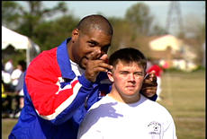
Look at the ball as it comes towards the head and keep the eyes open as contact is made.

Key Words
- Eyes Open
- Watch The Ball

To get more power, rock onto the back foot before the ball arrives to get some leverage when heading.

Key Words
- Rock Back

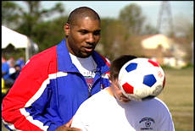
Make contact with the forehead, not with the top of the head as shown in the insert below, and attack through the ball for power.

Key Words
- Forehead
- Power Through

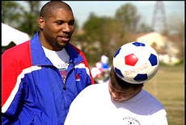

Incorrect heading of the ball

Heading should be a pleasure, not a pain. Heading needs to be learned as well as all other techniques, as many goals will result from headers, and all outfield players will be required to head the ball many times during a game.
Headers not only finish movements with a strike at goal, they also start movements by intercepting a pass and heading to a player on the same team or heading to a teammate to shoot at goal.
It is also important for all players to be able to head the ball out of defense.

Faults & Fixes Chart

Error | Correction | Drill/Test Reference
Ball hits player’s head and goes in any direction. | Eyes must focus on ball. | Coach serves ball, ensuring that correct contact is made
No direction in header. | Place feet in correct position | Coach demonstrates correct timing.
Player refuses to head ball. | Build up confidence. | - Use a lighter ball  - Motivate  - Show correct technique

Heading Drills
Heading is an essential part of successful football play. Approximately 20 percent of goals come from headed shots. A player must be able to pass, shoot, clear and even control the ball using their head, from a standing, jumping or diving position. For example, a central defender must be able to make good head clearances while having the capacity to move forward and score with a header from a corner kick. Younger players are encouraged to start heading the ball early, using a correctly sized ball that is light and smooth to avoid the risk of head injury. Some younger players may be afraid to head the ball for fear of hurting themselves. The coach must dispel this fear, using carefully chosen introductory practices and lots of encouragement.
Indeed, courage is a major factor in heading. “Putting your head in where it hurts” is an often coined phrase. A good example is the diving header, which, while spectacular, can sometimes put the player at risk of injury, is one of the most satisfying goal scoring actions. Likewise, attacking the ball is an important technique. Out of fear, younger players may shut their eyes and let the ball strike their head, when the aim is to assertively attack the ball. There are two important aspects of good heading technique.

Accurate Contact with the Ball
Contact with the ball should always be made with the forehead. From time to time, a player may use the top of their head to flick the ball from a long flight pass or throw-in. The eyes need to always be open until impact and fixed on the ball, and the body positioned in line. To direct the ball downwards, the forehead must make contact with the top half of the ball. The side of the forehead can be used to glance headers and the middle for more direct power headers. In a stationary position, the power comes from the legs, back and neck. The player rocks backward and pushes their body forward to meet the ball.

Attacking the Ball
As mentioned earlier, this is an extremely important technique. Putting power into a header requires successful coordination of different forces. To gain power, a player can run and jump off one leg to meet the ball. This requires both good timing of the run as well as anticipation of where the ball will be placed. After take off, the upper body arches backward. This momentum produces a snapping action when the body is propelled forward. At the same time, the neck is extended then snapped forward in synchronization with the body to strike the ball with maximum power. The ball must be struck at the top of the jump. If the player jumps too early, the player will touch the ball on the way down and lose all power. The ability to run and jump is useful in winning the ball in a crowd of players and needs to be practiced to ensure perfect synchronization of the action.
It is important to mention the technique for flicking the ball, which is often neglected by coaching books. This technique involves jumping for the ball to play or continue it in more or less the same direction as it was played. Many teams will play a long flight pass from the back to the center forward who will try to win the aerial challenge and flick the ball on to a teammate running behind them. This requires good timing and the ability to jump high. The player jumps in the same way as mentioned earlier, but drops slightly forward before making a backward flicking movement with the head to strike the ball, usually with the top of the head, to keep it moving forward.
To build up heading technique, the coach may want to start with simple practices, such as encouraging players to juggle the ball with their heads and gently throwing the ball in the air so the player can head it back to the thrower or to players positioned around the receiver. The receiver can be static to begin with, and then try to attack the ball. This will allow the player to gain confidence before moving on to more complex techniques. Once the basic technique has been acquired, different flight balls can be played to test and improve their ability (e.g. crosses to be headed into the goal or high balls to be cleared).

Lower Ability – Head to Coach

Purpose of the Drill
- Encourage players to be alert at all times.
- Helps coach perfect technique.

Steps
- Designate a 15-yard-by-15-yard square.
- Assign one coach per three players. Each coach has a soccer hall.
- Players jog around the coaches.
- Coach calls a player’s name then gently tosses a ball to be headed back.
- One point for a successful header.
- To keep players thinking, introduce surprise commands like “freeze,” “sit” and “all to the center,” to which players must react quickly or lose a point.

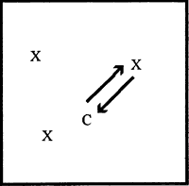

Points of Emphasis: | Correct contact with head.
When to Use: | Use as part of individual skills.

Intermediate Head on Goal

Purpose of the Drill
- Encourage players to think quickly under pressure.
- Increase confidence and timing under pressure.

Steps
- Divide players into two teams of three players each: attacking team and goalkeeping team.
- Set up a 4-yard-by-2-yard goal and a marker cone at 12 yards in front of the goal.
- Coach stands to the side of the goal and throws a ball underhand to an oncoming attacker.
- Attacker attempts to head the ball and score.
- Goalkeepers must remain within 1 yard of the goal line. Goalkeepers rotate after each shot.
- Repeat. Each player will get three attempts; then switch teams.

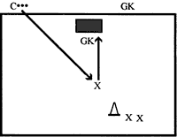

Coaching Tips
- Players must have correct technique.
- Let this be a fun exercise.
- Use at the end of a session to allow the players to wind down.

Coaches Tips for Heading – At-A-Glance

Tips for Practice

- With lower ability players, the greatest obstacle to successful heading is fear of the ball. In order to overcome this, work one-on-one, with the player heading a stationary ball out of the coach’s hand. Then gently toss the ball from very close range.
- Deflate the ball a little to make it soft, or use a sponge/foam ball at first. Gradually increase the distance from coach to player, as the player’s confidence builds.
- Higher ability players can begin to jump to head a ball, rather than waiting for the ball to come to them.
- The hardest technique here is timing. Use a verbal cue to help the player time the jump just before the ball arrives.
- Have a player toss the ball in the air and see how many times they can bounce it off their head in a row.
- Instruct player to pull arms and torso back when getting in position to head a ball; then push arms and torso forward when making contact with the ball.
- Have player stand in the correct pose then serve the ball.
- Throw ball in the air so that players can practice timing.
- Explain to players that power in heading comes from the trunk, legs and arms. A player will often try to throw the head at the ball by snapping the neck rather than keeping the neck firm and using the body to generate power. Whether the player is on the ground or in the air, the trunk arches backward prior to contacting the ball.
- When heading with the feet on the ground, the player keeps a wide base and staggered stance. This will help develop control and power.
- When jumping to head the ball, timing is the most important factor. Teach your players to jump early so as to strike the ball at the peak of the jump. They want to try to meet the ball at the height of the jump. Whenever possible, encourage players to use a single leg takeoff because it allows them to get the most height. Teach players to drive the nonjumping leg up toward the ball when jumping.

Tips for Competition

- If players are not comfortable with using their head, have them use their chest and bring the ball to their feet.
- For players who are not confident in heading, teach them how to deflect the ball to another player.

Skill Progression – Goalkeeping

Your Athlete Can: | Never | Sometimes | Often
Maintain concentration when ball is away from the goal.
Get behind the line of the ball.
Scoop low balls up with legs straight and together.
Go down on one knee and scoop up low balls.
Secure high ball with both hands working together as one unit.
Lower body center of gravity before diving.
Dive on side of body, not flat on stomach.
Get both hands to the ball and bring it securely to the body.
Distribute the ball using appropriate technique.

Totals

Goalkeeping
Goalkeeping is the skill of protecting your goal from the shots of opponents. It is perhaps the most important position on the field; however, it is often the position most neglected by coaches. A sound, confident goalkeeper does more than just stop shots. The goalkeeper is the source of confidence for the entire team. Goalkeeping is not a position for everyone and takes good concentration and confidence. Make sure that your goalkeeper wants to play in goal and has the strength of character to be successful. Goalkeeping entails some additional safety hazards. It is important that coaches select players who can learn to play this position safely.
Except in small-sided play, each team must have a designated goalkeeper. The goalkeeper is the only player on the field who can legally use their hands, and then only inside the penalty box. Once the goalkeeper picks up the ball they have six seconds to punt it or release it. The goalkeeper is allowed to pick up the ball, run with it and then punt it, throw it or drop it and dribble or kick it. However, they cannot touch it with their hands outside the penalty box. Once the goalkeeper drops the ball, they cannot touch it again with their hands until an opponent has touched it.
The goalkeeper has special protections inside the penalty box. The ball may not be kicked if the goalkeeper is touching it with their hand or arm. The referee will call a foul if the goalkeeper is endangered. The goalkeeper must wear a shirt or jersey that is recognizably different from all other players. Goalkeepers often wear special jerseys with padded elbows. In hot weather, do not put a goalkeeper jersey on a player. They can get overheated and become sick. Instead, have them wear a different colored shirt (one shirt only) or a mesh training vest over their shirt.
If the goalkeeper has a strong leg, let them take goal kicks. Encourage the player to play aggressively: push up on the attack and come out to the edge of the penalty box or beyond to play like a second sweeper. If the goalkeeper picks up the ball and no opponents are close, encourage him to drop the ball, dribble it out and kick it. Once the goalkeeper drops the ball or is out of the penalty box, the goalkeeper can play like a field player. However, the goalkeeper cannot touch the ball with his hands. Encourage the goalkeeper to play aggressively and take chances; everyone will have much more fun if you do, and more athletes will want to play goal.
Goalkeepers tend to get blamed for goals when, most of the time, it is not their fault. If the other defenders are doing a great job, there will not be any shots on goal. Tell your goalkeeper before the game that the other team is expected to score goals, and that it is not the goalkeeper’s fault if they score. Do not let anyone else, players or parents, blame the goalkeeper. In fact, after the game, have the rest of the team thank the goalkeeper, even if they did make mistakes. Encourage everyone who wants to try playing goalkeeper. You will be surprised who is good, and you really cannot predict until they actually play the position. At the very least, it will give all the players respect for how tough the position is, and they will be less likely to blame the goalkeeper when goals are scored. However, do not make an athlete play goalkeeper if they do not want to play that position.

Athlete Readiness
A goalkeeper needs different skills from other players. The goalkeeper needs speed off the mark, the courage to dive on the ball and the ability to throw and catch accurately.
The beginner goalkeeper is effective only if the ball is played directly at them. This player often reacts to ground balls by kicking them away rather than using their hands. The player has limited ability to time an effective dive for shots going into the corners of the goal. Throwing the ball out to teammates may be inaccurate.
The intermediate goalkeeper has a good awareness of the goal and of basic goalkeeping techniques and responsibilities. The player shows good lateral motion to get in a good position to take a shot, and will usually attempt to get their hands to the ball. The player attempts to dive for ground shots, although these dives may be slow. This level of goalkeeper will generally not be able to drive for shots in the air or attack crosses in the air. The intermediate goalkeeper is typically able to distribute the ball accurately to teammates.

Selecting a Goalkeeper
When selecting a goalkeeper, consideration must be given to a player’s confidence, communication, handling, ability and their ability to distribute the ball.

Confidence
Goalkeepers must be bold characters who are willing to throw themselves into a penalty area scrum.

Communication
As the last line of defense, the goalkeeper can play a vital role in organizing the players in front of them. Goalkeepers must always be willing to shout clearly when leaving their line to receive a cross.

Handling
A tall goalkeeper who cannot catch will be less effective than a shorter goalkeeper who has safe hands.

Distribution
In the modern game, goalkeepers must be confident ball kickers. A player who can kick the ball a long distance will be a major asset to the team.

Goalkeeper’s Position When Other Team Is Attacking
- Players head must remain still throughout.
- Eyes must stay fixed on the ball.
- Player must stand lightly on the balls of their feet.
- Feet are shoulder-width apart.
- Hands are at waist height with palms opened.

Teaching Handling Balls Coming Straight at the Goalkeeper
- Goalkeeping consists of occasional flurries of action and a lot of standing and waiting. Maintaining concentration when the ball is away from the goal is critical.

Key Words
- On Your Toes
- Watch the Play

- As the ball approaches, the goalkeeper is in the ready position with their hands up, about waist height.

Key Words
- Ready Position
- Hands Up

Receiving High Balls
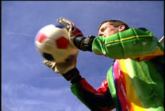
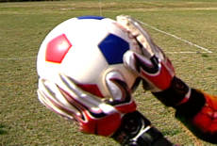

When receiving high balls, the goalie’s hands form a “W” with the thumbs almost touching. This hand position allows them to get their hands behind the ball and have a greater chance at safely stopping the ball and preventing a score.

Receiving Low Balls

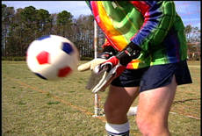
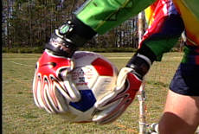
When receiving low balls, the goalie’s hands form an “M” with the little fingers almost touching. As in receiving high balls, this hand position allows the goalkeeper to get their hands behind the ball more consistently and effectively.

- If the ball is rolling along the ground, the goalkeeper must get behind the line of the ball and either scoop the ball up with the legs straight and together or go down on one knee and scoop the ball up.

Key Words
- Get Behind The Ball
- Feet-Together Scoop
- One-Knee-Down Scoop

- For a ball coming in the air, a goalkeeper secures the ball with both hands. The two hands need to work together as one unit.

Key Words
- Two Hands
- Catch It - Hug It

Teaching Diving for a Ground Ball
It is important to learn how to dive safely, without jarring the body. By lowering the center of gravity before diving, the impact on the ground will be less and the speed to the ball increased.

Key Words
- Stay Low
- Crouch Bend the Knees
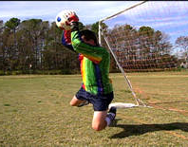

Teach the athlete to dive on the side of the body, not flat on the stomach. Diving on the side increases the barrier in front of the ball and is safer.

Key Words
- Side
- Not Stomach

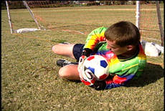

Encourage the player to get both hands to the ball, then immediately bring it into the body and secure it.

Key Words
- Two Hands To The Ball
- Then Hug It

Teaching Distributing the Ball
- When throwing the ball out (required in 5-a-side), goalkeepers need to look wide to the wings (near the sidelines), not up the middle. Other players should get wide quickly and be open to receive the throw.

Key Words
- Look Wide

- The throw can be underhand (like bowling), overhand (one-handed, like baseball), or a two-handed throw-in style. Goalkeepers need to try to distribute the ball quickly before the opponents have a chance to regroup.

Key Words
- Quick Throw

- In 11-a-side, a goalkeeper can punt the ball after gaining possession. This is usually the most effective way for a Special Olympics goalkeeper to distribute the ball.

Key Words
- Big Kick
- Up Field

Faults & Fixes Chart

Error | Correction | Drill/Test Reference
Player distributes the ball from too far back in the goal box. | Instruct player to move up to just inside the box before distributing the ball. | Have player count off three to five steps forward before distributing the ball.
Player stands on goal line. | Encourage player to stand on goal line and then take one big step forward. | If player is even with the posts, they need to move out.
Throw ball out too quickly. | Make sure teammate is aware that you are passing the ball to them. | Communicate effectively with teammates when distributing ball.
Throwing ball out when not in right position. | If the pass fails, always make sure that your goal is covered. | Make sure when passing that the goalkeeper is in the middle of the goal area.

Goalkeeping Drills

Lower Ability - Fundamentals

Purpose of the Drill
- Teach players correct techniques.
- Build confidence.

Steps
- Set up a triangle using large cones or flags, 4 yards per side.
- Position a goalkeeper on each side of the triangle. Coach stands in the middle with several balls.
- Go around the group working on basic goalkeeping fundamentals.
- Goalkeepers throw ball back to the coach.
- Do the same, but throw the ball randomly to keep goalkeepers thinking and mentally alert.

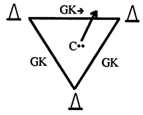

Coaching Tips
- Ensure correct techniques are used.
- Use with lower level players or at the beginning of training so that players master the correct basics.

Intermediate Ability - Goalie in the Middle

Purpose of the Drill
- Increase player’s ability to think quickly.
- Increase player’s agility when making saves.

Steps
- Mark out a central goal, 4 yards by 2 yards by 2 yards (or full-size goal for 11-a-side players), with flags or cones.
- Goalkeeper stands in the middle.
- Goalkeeper receives different kinds of shots (easy at first, then build up to hard shots).
- Goalkeeper takes a ball from one side, then quickly turns around and takes a shot from the other side.
- Count number of saves made before a goal is scored.

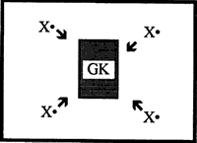

Coaching Tips
- Keep goalkeeper interested.
- Vary shots.
- Use one-on-one coaching while the rest of the team is learning specific skills.

Coaches Tips for Goalkeeping – At-A-Glance

Tips for Practice

- A lower ability goalkeeper should be taught to stay close to the goal at all times and not wander out. Remind the goalkeeper to glance over their shoulder when the ball is away from the goal and to maintain position in the center of the goal. As a guideline, a goalkeeper should not go out to either side further than the goal post.
- Teach all of the players not to blame a goalkeeper when the other team scores. Have a defender get the ball out of the net as quickly as possible to restart the game.
- Teach other players to be supportive. If you have a higher ability player who wants to learn to be a goalkeeper, it would be helpful to find a goalkeeper coach.
- The goalkeeper needs to be able to communicate to their field players. This is very important when the goalkeeper is going for the ball at the same time as the defender. The goalkeeper is responsible for calling the other players off of the ball.
- Always kick to a player on the wing, and not up the middle.
- Be aware of positions of opposing players.
- When throwing the ball, always ensure that the throw is hard enough.

Tips for Competition

- Keep focused on the play in front of you when the ball is not at your end of the field of play.
- Keep your eyes on the ball, not the players.
- Have a backup goalkeeper in case of injury or too many goals being scored.
- Always be aware of your position on your line.

Understanding the Game of Football
As a coach, it is our job to provide a positive learning environment in which athletes can develop their football skills. It is also our role to ensure all athletes, regardless of ability, receive a fair opportunity to play and progress their skills. It is important, too, that the athlete develop a love for the game of football, have fun and enjoy themselves.
It is also important that we develop their social skills. Players must be taught to respect their coaches, officials, their organization and each other. In addition, athletes:
- Must be encouraged to always try their best;
- Must respect the referees and the laws of the game; and,
- Most importantly, they must respect the opposition, and be gracious winners as well as gracious losers.

Players will react to a good, organized coach who keeps them interested and active. It is always better to prepare training sessions on paper.
- Organize quickly
- Be positive and purposeful
- Show enthusiasm
- Look and act the part
- Have the correct equipment
- Always stay calm under pressure, do not yell
- Always praise, especially for effort
- Understand that player development is more important than winning

Players will learn through repetition, fun and enjoyment, small-sided games, praise and positive reinforcement, good coaching and demonstration.

Players will not learn:
- If you tell them how to perform a skill instead of showing them
- If you do not give them enough ball contact
- If you emphasize winning

Players will not perform:
- If you give abusive and destructive criticism
- When there is hysterical sideline shouting from the coach and parents

Do not assume that lower ability players will know what the basic purpose or goal of the game is. Such players may have difficulty with simple concepts, such as distinguishing between teammates and opponents, and knowing in which direction to kick. However, with persistence, these things can be taught to any player.
Ball familiarity is also important. Some players respond to having a ball thrown at them, however, most do not. It is always better to give the player the ball and see what he does with it, then adapt training to suit. Always explain clearly, if the player does not understand, take a different approach.
Even 5-a-side football can seem complicated to a beginner player. Teach players about the basic purpose and organization of the game through minifootball games. Progress from the simplest one vs. one contests, up to full 5-a-side games, as players become more familiar with the basic principles and rules of play. A coach can create minifootball games to teach basic game principles. Minifootball games should become a part of every practice.
The best way to teach football is to play the game. This gives players an understanding of the concepts. From here, you can break up play into specific drills. To enhance players’ skills when running to warm up, use a ball at their feet. Always encourage players, and pick out what they are doing right, more than what they are doing wrong. Try and adapt training to be fun and interesting. Most importantly, include progression in the drills so that their ability is challenged.

Football Concepts and Strategies

Teammates

Activity: Two vs. Two
- Designate a 20-yard-by-10-yard field with 4-yard-by-2-yard goals at each end.
- Form four teams of two. Two teams stand behind each goal.
- Coach stands at the halfway line with several soccer balls.
- Teams come out to play two vs. two.
- If the ball goes out of play, leave it and receive another from the coach.
- If the defending player gains possession of the ball, the player must pass the ball to a teammate before trying to score.
- For lower ability players, allow each team to dribble and pass from one goal to the other without any opposition.
- Introduce opponents later.

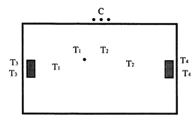

Key Questions to Ask Your Players
- Who is your teammate?
- Who do you pass to?
- Do you tackle your teammate? (No)

Attack/Defend

Activity: One vs. One
- Designate a 15-yard-by-10-yard area with 4-yard-by-2-yard goals at each end.
- Form two teams of three, wearing different colored scrimmage vests, and number the players 1-2-3 (no goalkeepers).
- Coach stands at the halfway line with several soccer balls.
- When a player’s number is called, the player comes out and plays for 30-45 seconds against opponent with the same number.
- Other players wait behind the goal, help collect balls and return them to the coach.
- If the ball goes out, the coach will immediately roll in another ball.

Key Questions to Ask Your Players
- Which goal are you scoring in?
- Which goal are you defending?
- What color shirt is your team wearing?
- What color shirt is the other team wearing?
- What do you do when you have the ball? (Attack)
- What do you do when the opponent has the ball? (Defend)

Activity: Three vs. Three
- Designate a 25-yard-by-15-yard field with 4-yard-by-2-yard goals.
- Form two teams of three without goalkeepers. You can also play this as four vs. four with a goalkeeper.
- Designate positions: right wing/left wing/center.
- Play a regular three vs. three game. Use kick-ins for a ball over the sidelines.
- Coach how to play in each part of the field.
- Focus on the wing players.
- Occasionally call freeze. Players must stop and check their positions. Award points for good positional play.
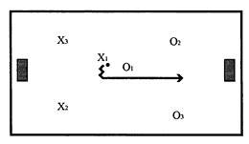

Key Questions to Ask Your Players
- What position are you playing?
- Where are the wings?
- We don’t crowd, we ________? (Spread Out)
- Great football players play as a ________? (Team)

Simple Game Principles
There are a few fundamental principles of good team football play that can be taught to all levels of players. These basic principles can be taught in practice drills and also by introducing a condition during practice games. A condition is an artificial rule that encourages a certain kind of play. For example, “For the next five minutes, to encourage passing, you are not allowed to dribble when you receive the ball.” Five key principles and some ideas for game conditions are outlined below.

Principle No. 1: Support the Player with the Ball
Football is a team game. When a teammate has the ball, it is essential that they practice with at least one teammate and preferably more. As a coach, it is important to have several playing options for athletes, besides dribbling alone. Beginner players tend to stand and watch what the player with the ball will do. The player with the ball needs their teammates to either move into an open space within passing distance or call for the ball.

Practice Game Condition
When a coach calls “freeze,” all players must stop where they are. The coach then asks the players what they could do to help the player with the ball. The player then runs to an open space to receive a pass. During match play, praise players who are supporting the player with the ball.

Key Words
- Move To Get Open
- Call For The Ball

Principle No. 2: Play Safe From The Back: Pass Out Of Your Own Half, Do Not Dribble
When a player has the ball, they have three options: pass, dribble or shoot. The question is what to do and when? A simple principle in your defending half of the field is to play “safely and simply.” Usually, it is safer to pass the ball quickly up field rather than dribble. If a player is tackled while dribbling near their own goal, the result will often be a goal for the opponents.

Practice Game Condition
A coach can encourage safe play by instituting a “two-touch” or “no dribble” condition on play in a team’s defending half. During match play, praise players who make quick passes out of defense.

Key Words
- Play Simple
- Pass From The Back

Principle No. 3: Take Risks in Attack: Use Dribbling Moves in the Opponent’s Penalty Area
The opposite of principle 2 applies when you have moved the ball up field near the opponent’s penalty area. This is the time to encourage more risky play and encourage attackers to try to dribble directly at goal and beat opponents with fakes and moves. Of course, well-placed passes can also work with crosses from the wings to attackers in the penalty area.

Practice Game Condition
Players must “dribble and shoot” when they are in or near the opponents’ penalty area.

Key Words
- Use Your Moves
- Go To Goal

Principle 4: Use Your Wings
There is plenty of space on the field. However, teams will often fail to make good use of this space. One of the typical mistakes is playing the ball too much up the middle of the field where the greatest concentration of defenders are waiting to tackle or intercept. It is often effective to play the ball wide to the wings, and attack down the side of the field before moving toward the goal.

Practice Game Condition
The ball must go out to the wing during an attack, for a goal to be scored.

Key Words
- Play Wide

Principle 5: Shoot Whenever You Have a Good Opportunity
Although football is a passing game, once a player has any reasonable chance to score, they need to shoot, even if there is another player in a better position. A pass to a teammate may result in an interception or loss of ball control.

Practice Game Condition
To encourage shooting, award one point for any shot on goal that requires a save from the goalkeeper and three points for a goal.

Key Words
- If You Have A Chance, Shoot

Teaching Basic Restarts
In football, the ball goes out of play, a free kick is awarded or a goal is scored. In each situation, play has to be restarted appropriately. When this happens, will your players know what to do?
Too often, we see Special Olympics players who have not been taught how to react in these situations. Oftentimes, the coach has to yell directions, or the referee feels compelled to provide instruction. Special Olympics players of all levels can learn basic restarts and, in doing so, become more accomplished players and a more effective team. One of the most impressive things to a spectator is a Special Olympics team that knows how to restart play with minimal prompting. Coaches need to provide a few minutes are every practice scrimmage to teach restarts.

Some Guidelines to Increase Your Success

- Keep all explanations simple. Do not provide multiple options for restarts until one basic play has been completely mastered.
- Use simple, concrete key words that are easy to remember and can be used as prompts when necessary during competition play.
- In competition play, when restart is needed, only use players who can restart play correctly. If a player has not mastered this skill, work on this in practice.

The Kickoff
At the beginning of the game, or after a goal is scored, the game is restarted with a kickoff. After a goal, the kickoff is taken by the team that conceded the goal.
The ball is placed on the center spot. Two players from the attacking team stand next to the ball. The defending team must move back at least to the edge of the center circle until the ball is played. One player passes the ball to the other and the game commences. The ball must be passed forward and must travel at least one revolution.

Basic Tactics
The player to whom the ball is passed can dribble forward, pass to a wing or pass back to a teammate. Lower ability teams are encouraged to dribble forward. Higher ability teams can pass the ball back to a defender and then build up from there after drawing the other team forward.

Key Words
- Two Players
- Forward Pass

The Goal Kick (11-A-Side) or Goalkeeper Clearance (5-A-Side)
When the attacking team plays the ball over the opponent’s end line, a goal kick (or goalkeeper clearance) is awarded to the defending team.
In 11-a-side, the game is restarted by the goalkeeper, who places the ball inside the goal box on the side of the field where the ball went out and kicks the ball up field. The ball must clear the penalty area. If it does not, the kick is retaken.
In 5-a-side, the ball is thrown back into play no further than the halfway line. If the ball is thrown further than the halfway line without touching any player, a free kick is awarded to the opposing team anywhere on the halfway line.

Basic Tactics
The goal kick (clearance) should be taken quickly, before the opposing team regroups. It is usually better to clear the ball to the wings rather than up the middle. Defenders and midfielders should be encouraged to quickly run wide to receive the ball.

Key Words
- Play It Quickly
- Look Wide

The Corner Kick
When the defending team kicks the ball over its own end line, a corner kick is awarded to the attacking team. The play is restarted by a player on the attacking team kicking the ball from inside the corner arc on the side of the field where the ball went out. Defenders must be at least 10 yards from the ball (5 yards in 5-a-side).

Basic Tactics
The player taking the kick can either kick the ball, usually in the air, toward the area in front of the goal or play a short pass to a teammate, who can then dribble towards the goal and shoot (a short corner). A short corner is particularly effective in 11-a-side where a team does not have a player who can kick the ball into the goal area.

Key Words
- Kick To The Middle
- Attackers In Front Of Goal

The Free Kick
When a foul is committed, a free kick is awarded. Serious fouls (i.e., tripping, pushing and hand ball) result in a direct free kick, where the player taking the kick can score directly from the free kick. Lesser fouls (i.e., obstruction, dangerous play) result in an indirect free kick where the ball must be played by more than one player before a goal is scored. Defenders must be at least 10 yards from the ball (5 yards in 5-a-side).

Basic Tactics
If the ball is close to the opponents’ penalty area, the best tactic is usually to try a direct shot. From further away from the goal, the player simply passes the ball up field to a teammate. From an indirect free kick close to the opponents’ penalty area, one teammate can pass the ball lightly to another teammate who then shoots.

Defending a Free Kick
If the attacking team is close enough to get a good shot on goal, the defending team should make a defensive wall to try and block the shot. In 11-a-side, the wall is usually made up of three to four players, standing 10 yards away from the ball. In 5-a-side, the wall is usually made up of one to two players, standing 5 yards away from the ball.

Key Words
- Shoot – for direct kick
- Pass First - for indirect kick
- Make A Wall - defending

Throw-In (11-A-Side) or Kick-In (5-A-Side)
When a player plays the ball over the sideline, a throw-in/kick-in is awarded to the other team. A throw-in is taken with two hands, from behind the sideline, with both feet on the ground and the ball thrown in one motion from behind the head. An improper throw-in―usually caused by lifting the feet―results in the throw-in being turned over to the other team.

Basic Tactics
Same as in a free kick, take the throw-in quickly. Throw up field whenever possible. The thrower immediately supports the player who receives the throw and is available for a return pass. A kick-in is simply a pass taken from the sideline. Defenders must retire at least 5 yards.

Key Words
- Quick Throw/Kick
- Up Field

Team Play

Athlete Readiness
Players who can kick a stationary ball at least 5 yards; pursue a moving ball, perhaps with some verbal prompting; react safely to a ball coming at them in the air; and distinguish, most of the time, a teammate from an opponent, can successfully play at least 5-a-side football.
Players who possess good basic skills and an understanding of the basic rules of the game and are also good athletes, with some speed and endurance, may be appropriate for the more demanding 11-a-side football. Higher ability players may also be appropriate for 11- a-side Unified Sports football.

Teaching Team Formations & Selecting Positions for Each Player

5-A-Side Football
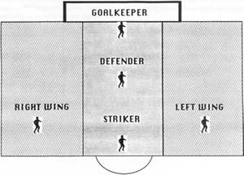

Goalkeeper
This is a critical position and requires an athlete with good vision and awareness, some patience and an ability to concentrate. This must be a confident player who is able to bounce back after letting in a goal.
- Protects the goal.
- Uses two hands as much as possible.
- Stays close to the goal.
- Throws the ball out quickly to the wings, on gaining possession.

Defender
The athlete at this position can be a less mobile player with a strong kick.
- Stops the opponents from shooting.
- Chases and tackles.
- Passes the ball up to attackers.
- Follows the play up the halfway line.

Wings
This position requires athletes with good stamina and endurance.
- Helps attack and defend.
- Gets open by going wide.
- Stays on their side of the field most of the game, particularly when their goalkeeper has the ball.

Striker
This position requires an athlete with a strong kick. However, they do not have to have great endurance.
- Goes for goal!
- Scores!
- Stays on the opponent’s side of the field most of the game.

11-A-Side Football

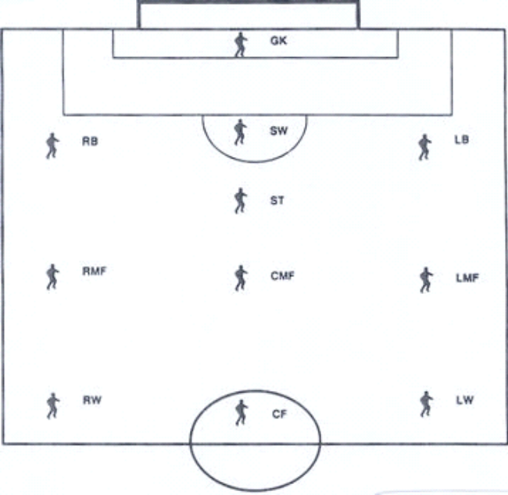

Goalkeeper
- Protects the goal.
- Uses two hands.
- Stays close to the goal.
- Quickly throws or punts ball to wings.

Sweeper
- Last line of defense.
- Backs up other defenders.
- Plays the ball quickly up field.

Stopper
- Key central defender.
- Marks the opposing center forward.
- Moves up to the halfway line when teammates possess the ball.

Defenders (Right Back/Left Back)
- Marks opposing forwards.
- Stops the opponents from shooting.
- Chases and tackles.
- Passes the ball up to attackers.
- Follows the play up to the halfway line.

Midfielders
- Links between defense and attack.
- Helps attack and defend. Players must have plenty of stamina to play this position.
- Gets open to receive passes from the defenders.
- Looks to make passes to their forwards, then runs up to support them.
- Midfielders can score goals too.

Wings
- Stays wide.
- Gets open for passes.
- Takes the ball down the wing and crosses it. Passes the ball into the penalty area for teammates to receive and score, or takes it to the goal and shoots.
- Chases back to about the halfway line.

Center Forward/Striker
- Goes for goal
- Scores!
- Stays up in opponent’s half of field.

Coaches Tips for Team Play – At-A-Glance

Tips for Practice

- In practice games, use cones to mark positions on the field. Call out the positions and have players run as quickly as possible to that position.
- When setting up for scrimmages, always ask players to name the position in which they are starting.
- Put players in their positions without opponents. Have them play without opponents, staying in their positions. In a scrimmage, spend time with each player, prompting them about where to play.

The Pitch
The layout of a field is shown below. The dimensions can be varied, depending on the number of players and their ability levels. Coaches need to spend adequate time at each practice identifying the boundaries and markings of the field, particularly with beginner players.

Goal Box
Goalkeeper must place the ball within this box for a goal kick (11-a-side only).

Penalty Area
Only the goalkeeper is allowed to use their hands within this box. Any major foul inside this area results in a one-on-one penalty kick taken from the penalty spot. When a penalty is in progress, all other players must stand outside the penalty area, including the penalty arc.

Center Circle
A kickoff is taken from the center of this circle. All defenders must stand beyond the circle.

Halfway Line
Both teams must be behind their side of this on a kickoff.

Sideline
The ball is out of play if it crosses this line, unlike American football and basketball. The line itself is in play.

Corner-Kick Arc
The ball must be placed within this arc for a corner kick.

The Pitch
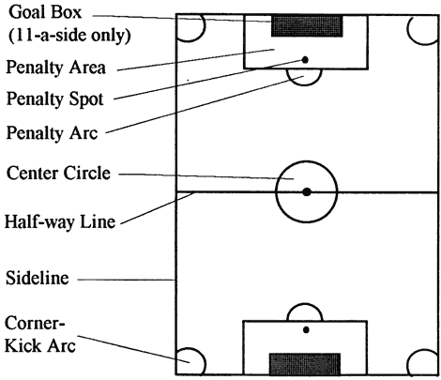

5-A-Side Key Dimensions

Minimum Field Size | 40 meters by 30 meters (44 yards by 33 yards)
Maximum Field Size | 50 meters by 35 meters (55 yards by 38 yards)
Penalty Area | 7 meters deep by 12 meters wide (8 yards by 13 yards)
Penalty Spot | 6.4 meters (7 yards) from the goal line
Goal Size | 1.8 meters high by 3.7 meters wide (6 feet by 12 feet)

11-A-Side key Dimensions

Minimum Field Size | 91.4 meters by 50.3 meters (100 yards by 55 yards)
Maximum Field Size | 109.7 meters by 68.6 meters (120 yards by 75 yards)
Penalty Area | 16.5 meters deep by 40.2 meters wide (18 yards by 44 yards)
Penalty Spot | 11meters (12 yards) from the goal line
Goal Size | 2.4 meters high by 7.3 meters wide (8 feet by 24 feet.)

Modifications and Adaptations
In competition, it is important that the rules not be changed to suit athletes’ special needs. However, coaches can modify the training exercises, the athlete’s special needs, their communication and sport equipment to assist athletes in achieving success.

Modifying Exercises
Modify the skills involved in an exercise so that all athletes can participate.

Modifying Your Communication Method
Different athletes require different communications methods. For example, some athletes learn and respond better to demonstrated exercises, whereas others require greater verbal communication. Some athletes may need a combination – to see, hear and even read a description of the exercise or skill.

Mental Preparation and Training
Mental training is important for athletes, whether striving to do their personal best or competing against others. Mental imagery, what Bruce D. Hale of Penn State calls “No Sweat Practice,” is very effective. The mind cannot tell the difference between what is real and what is imagined. Practice is practice, regardless of whether it is mental or physical.
Ask the athlete to sit in a relaxed position in a quiet place with few distractions. Tell the athlete to close their eyes and picture performing a particular skill. Each is seeing him/herself on a large movie screen on a football pitch. Walk them through the skill step by step. Use as much detail as possible, using words to elicit all the senses - sight, hearing, touch and smell—soft foot, cushion, deep it close, toe down, light touches. Ask the athlete to repeat the image. Picture rehearsing the skill successfully, even to the point of seeing the ball going in the goal.
Some athletes need help to start the process. Others will learn to practice this way on their own. The link between performing the skills in the mind and performing the skills on the football pitch may be hard to explain. However, the athletes who repeatedly imagine themselves correctly completing a skill and believing it to be true are more likely to make it happen. Whatever goes into one’s mind and one’s heart comes out in their actions.

Home Training Program

- If athletes only train once a week with their coaches and do no training on their own, progress will be very limited. A minimum of three training sessions are needed to facilitate a training effect. The Home Training Program for Football is designed to help facilitate basic sport skills and fitness activities between athletes and families or friends. The program can also be used as a basis for a Special Olympics Partners Club program. The Home Training Program can be used in homes, schools, group homes and parks and recreation program.
- An Athlete Handbook/Home Training Guide can be downloaded from the Special Olympics Web site to assist coaches in integrating home training into their season and help athletes and families with ideas on how to practice between practices!
- Nothing improves the athlete’s sport ability like playing! Parents/guardians can challenge the athlete to family competitions for additional practice or just for social outings.
- To be effective, coaches should run a home training orientation for family members and/or training partners. This should be an active session where partners get practical experience with the different activities.
- As a motivational tool, a coach may want to award a Certificate of Achievement to athletes and training partners who complete a set number of home training sessions during the season.

Weekly Home Training

Warm Up Exercises | Instructions
Jogging/Running | Jog around for 5-10 minutes
Triceps Stretch | Raise your arms over your head. Bend your right arm and bring your hand to the middle of your back. Grasp elbow of bent arm and pull gently toward the middle of the back. You want to work toward getting the elbow of the bent arm up and behind your head. Hold for 10 seconds and repeat with other arm. Repeat five times on each arm. Remember to reach down the middle of your back. ☺
Hamstring  Stretch | Extend your legs, straight out, keeping your knees together. Do not lock your legs. Bend at your hips, reaching your hands toward ankles, your chest to your knees. As your flexibility increases, reach for feet. Push out through your heels, forcing your toes up to the sky. Hold for 15 seconds. Repeat five times. Remember to not stretch so that it hurts. ☺
Calf/Achilles Stretch | Stand facing a wall or fence with one leg in front of the other. Bend your forward leg slightly. Bend at the ankle of your back leg. Remember, you do not want to feel pain, only slight tension of the muscle stretching. ☺
Push-Ups  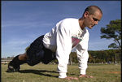 | Kneel down and place your hands on the ground in front of body, shoulder width apart. With a straight back, move your feet back behind you until you are on your toes. Your weight is on both your hands and feet. Slowly bend your arms until they are parallel to the ground. You chest will drop 4-5 inches from the ground. Push up to the starting position. Repeat five times. Try and work up to 10 or more. Remember, to fully extend your arms in the start position, with a straight back. You can help keep a straight back by squeezing your stomach muscles. ☺
Sit-Ups | Lie on your back with your knees bent. Your hands can be on your chest, shoulders or on the side with your fingers touching your ears. Your elbows are out to the side. Keep back straight as you slowly lift your shoulders, coming all the way up to a sitting position. Squeeze your stomach muscles as you slowly return to the start position. Repeat 10 times. Try and work up to two to three sets of 10. Rest for 30 seconds between sets. Remember, the wider apart the hands the more the athlete works on the chest muscles. ☺
Butt Kicks | Start jogging in place. Begin to quickly bring your heel up toward your buttock; as fast as you can alternate your legs. While doing butt kicks, the back is straight with a slight forward body lean. The body lean is as natural as the athlete assumes while running. Do butt kicks for 15 seconds. Rest for 30 seconds between sets. Repeat three times. Remember, arms are simply legs higher up, so keep pumping and driving them throughout the drill. ☺
Ball Dancing | Alternating legs, tap the top of the ball lightly with the sole of the right foot, then with the sole of the left foot. Alternate for 15 seconds. Rest for 30 seconds. Repeat.

Daily Exercise for the Week (Exercise a minimum of 10 minutes)
Day 1 – Juggling/Trapping | Day 2 – Shooting | Day 3 – Control-Receiving | Day 4 - Dribbling
 |  | 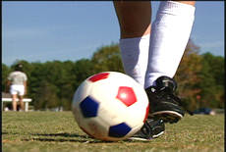 | 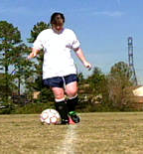

Game Play – Minifootball
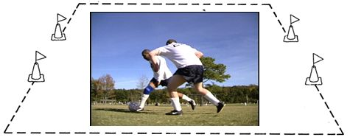

Football Coaching Guide

Football Rules, Protocol & Etiquette

Table of Contents

Teaching Football Rules
Unified Sports Rules
Protest Procedures
Sportsmanship
Football Glossary

To go directly to a section, hold down your control key and click on the heading

Teaching the Rules of Football
The best time to teach the rules of football is during practice. Please refer to the Official Special Olympics Sports Rules Book for the complete listing of football rules. The International Federation of Football Association’s (FIFA) Fair Play Philosophy is advocated throughout the football world. The following guidelines are taken from FIFA’s Laws of the Game and Universal Guide for Referees. As coach, it is your responsibility to know and understand the rules of the game. It is equally important to teach your players the rules and to make them play within the spirit of the game. Below are selected laws of the 17 laws that govern the game of football. Maintain current copies of the Special Olympics Sports Rules and your national and international federation football rulebooks. Know the differences and carry them to every game.

Law V - Referees
The referee is responsible for the entire game, including keeping a record of the game and acting as the timekeeper. The referee makes decisions on penalties, cautions and ejects players for misconduct. The referee may also end the game due to inclement weather, spectator interference, etc. Referee determines injury time outs and other time stoppages. All decisions by the referee are final.

Law VI - Linesmen
Two linesmen are primarily responsible for indicating to the referee when the ball is out of play and which team is entitled to a throw-in, goal kick or corner kick.

Law VIII - The Start of Play
At the beginning of each half and after a goal is scored, a kickoff starts play. The ball is placed on the center spot inside the center circle. The ball must be kicked forward and roll the distance of its circumference before it is officially in play.
All players must remain on their half of the field, and the opposition must be outside of the center circle until the ball is in play. The player kicking the ball may not play the ball again until is it touched by another player. A goal may not be scored directly from a kickoff. A player other than the kicker must touch the ball before a goal can be scored.
A coin toss at the beginning of the game determines which team decides between taking the kickoff or defending a chosen side first. The team that does not take the kickoff at the beginning of the game takes the second half kickoff. A team that is scored upon is awarded a kickoff to restart the game.

Law IX - Ball In and Out of Play
The ball is out of play when it has wholly crossed the end line, goal line or touchline and the referee has stopped play. The ball is in play at all other times even if it hits the goalposts, crossbar or referee, as long as it is still on the field of play.

Law X - Method of Scoring
A goal is scored when the whole ball crosses the goal line between the goal posts and under the crossbar. A goal cannot be thrown, carried or propelled by the hand or arm of a player on the opposing team.

Law XI - Offside
A player is offside when he or she is in the opponent’s half of the field and nearer to the opponent’s goal line than the ball, unless at least two opponents, including the goalkeeper, are nearer to the goal line than the attacking player or if the opponent receives the ball directly from a throw-in, corner kick or goal kick. Although a player may be in an offside position, a penalty is called only if the referee believes that the player is interfering with play or gaining advantage.

Law XIII - Free Kick
Direct and indirect kicks are the two types of free kicks awarded during a game. A goal can be scored directly from a direct kick. For indirect kicks, the ball must be touched by a player other than the kicker before a goal can be scored. All defending players must stay at least 10 yards from the ball on all free kicks. The ball is in play once it has traveled the distance of its circumference. The kicker may not play the ball a second time until another player has touched it

Law XIV - Penalty Kick
If any of the nine major fouls are committed by the defending team in its own penalty area, a penalty kick is awarded to the opposing team. The ball is placed on the penalty spot 12 yards from the goal. When the kick is taken, the goalkeeper must stand on the goal line between the goalposts. The goalkeeper may not move his or her feet until the ball has been struck. The only payers allowed inside the penalty area at the time of the kick are the goalkeeper and the player taking the kick. All other players must remain outside the penalty area, at least 10 yards from the ball, until the ball is in play.

Law XV - Throw-In
When a player plays the entire ball over one of the two touchlines, a throw-in is awarded to the opposing team at the place where the whole of the ball crosses the line. The player throwing the ball must face the field and deliver the ball using two hands placed behind and over the head. At the moment of release, both of the thrower’s feet must be on the ground and on or behind the touchline.

Law XXI - Goal Kick
A goal kick is awarded to the defending team when the whole of the ball crosses the end line and was last touched by an opposing player. The defending team must place the ball inside the goal area. The ball must be kicked beyond the penalty area before it can be touched by another player. If the ball is touched by a player before it travels outside of the penalty area, the goal kick is retaken. Players from the opposing team must remain outside of the penalty area while the kick is being taken. The kicker may not touch the ball a second time until it has been touched by another player. A goal may not be scored directly from a goal kick.

Law XVII - Corner Kick
A corner kick is awarded to the attacking team when any member of the defending team plays the ball over the end line. A kick is taken from the quarter circle, with a radius of 1 yard, which is marked in each of the four corners of the field. The ball must be placed within the quarter circle at the defending side’s end line nearest to where the ball went out of play. The kicker may not touch the ball a second time until it has been touched by another player. A goal may be scored directly from a corner kick. All defenders must remain 10 yards from the ball until it has traveled the distance of its circumference.

The Nine Major Fouls
There are nine major offenses, or fouls, which result in either a direct free kick or a penalty kick, depending on the location of the offense.
- Kicking or attempting to kick an opponent.
- Tripping an opponent; i.e., throwing or attempting to throw an opponent with the legs or by undercutting an opponent with the body.
- Jumping at an opponent in a way that endangers the player.
- Charging an opponent in a violent or dangerous manner.
- Charging an opponent from behind unless the latter is obstructing.
- Striking, attempting to strike or spitting at an opponent.
- Holding an opponent.
- Pushing an opponent.
- Directing or stopping the ball by using the hands or arms. This rule does not apply to the goalkeeper within the penalty area.

Unified Sports Rules
There are few differences between the rules for Unified Sports competition and the rules as stipulated in the official Special Olympics Sports Rules and modifications outlined in the rules book. The additions are highlighted below.

- For both 5-a-side and 11-a-side football, similar age and ability levels are required of both athletes and partners.
- A lineup during the competition consists of three athletes and two partners for 5-a-side, and six athletes and five partners for 11-a-side football.
- Teams are divisioned for competition based primarily on ability. In football, division assignment is based on the best players on the roster, not the average ability of all players.
- Team sports must have an adult, nonplaying coach. Player-coaches are not allowed in team sports.

The election of athletes and partners of similar age and ability is essential, for Unified Sports football training and competition. Though rules modifications have been implemented to minimize differences between athletes and partners, inappropriate competition experiences and a higher risk of injury result from teams where athletes and partners are poorly matched.

Protest Procedures
Protest procedures are governed by the rules of competition. The role of the competition management team is to enforce the rules. As coach, your duty to your athletes and team is to protest any action or events while your athlete is competing that you think violate Official Football Rules. It is extremely important that you do not make protests because you and your athlete did not get your desired outcome of an event. Making protests are serious matters that impact a competition’s schedule. Check with the competition management team prior to competition to learn the protest procedures for that competition.

Sportsmanship
Good sportsmanship is both the coach and athletes commitment to fair play, ethical behavior and integrity. In perception and practice, sportsmanship is defined as those qualities which are characterized by generosity and genuine concern for others. Below, we highlight a few key points and ideas on how to teach and coach sportsmanship to your athletes. Lead by example.

Competitive Effort
- Put forth maximum effort during each event.
- Practice skills with the same intensity as you would perform them in competition.
- Always finish a race or event - never quit.

Fair Play at All Times
- Always comply with the rules.
- Demonstrate sportsmanship and fair play at all times.
- Respect the decision of the officials at all times.

Expectations of Coaches
- Always set a good example for participants and fans to follow.
- Instruct participants in proper sportsmanship responsibilities, and demand that they make sportsmanship and ethics the top priorities.
- Respect judgment of contest officials, abide by rules of the event and display no behavior that could incite fans.
- Treat opposing coaches, directors, participants and fans with respect.
- Shake hands with officials and the opposing coach in public.
- Develop and enforce penalties for participants who do not abide by sportsmanship standards.

Expectations of Athletes & Partners in Unified Sports
- Treat teammates with respect.
- Encourage teammates when they make a mistake.
- Treat opponents with respect: shake hands prior to and after contests.
- Respect judgment of contest officials, abide by rules of the contest and display no behavior that could incite fans.
- Cooperate with officials, coaches or directors and fellow participants to conduct a fair contest.
- Do not retaliate (verbally or physically) if the other team demonstrates poor behavior.
- Accept seriously the responsibility and privilege of representing Special Olympics.
- Define winning as doing your personal best.
- Live up to the high standard of sportsmanship established by your coach.

Coaching Tips
- Discuss football etiquette, such as congratulating opponent after all events―win or lose; control temper and behaviour at all times.
- Give sportsmanship awards or recognition after each game or practice.
- Always commend the athletes when they demonstrate sportsmanship.

Remember …
- Sportsmanship is an attitude that is shown by the way you and your athletes act on and off the field of play.
- Be positive about competing.
- Respect your opponents and yourself.
- Always stay under control, even if you are feeling mad or angry.

Football Glossary

Term | Definition
Advantage | A special rule that allows play to continue after a foul if it would be disadvantageous to the team that was fouled.
Center Mark | The circle in the middle of the field. It should be 10 yards in diameter.
Clearance | When a player kicks the ball out front of their own goal area.
Control | What a player tries to achieve when the ball comes to them.
Corner Kick | When the defending team kicks the ball over their own end line, the opposing team restarts the game.
Direct Free Kick | A free kick resulting from a foul that can be shot into the goal without having to be touched by another player.
Dribbling | A player who is running with the ball.
Field or Pitch | Football playing field.
Free Kick | How a game is restarted when a player is fouled.
Give-and-Go | A play in which a player who is faced by an opponent passes the ball to a teammate, runs around the opponent and receives the return pass.
Goal Area | The rectangular area, 20 yards wide by 6 yards deep, in front of each goal from which all goal kicks are taken; inside this area, it is illegal for opposing players to charge a goalkeeper not holding the ball.
Goal Kick | A free kick awarded the goalie if the offense was the last to contact the ball before passing over the goal line.
Goal line | The line on the playing field over which the ball must pass to score a goal.
Goals | What teams score.
Halves | Game is divided into two, timed halves.
Indirect Free Kick | A free kick resulting from a foul that cannot be shot directly into the goal. If the ball enters the goal without touching another player, the goal is void.
Injury Time | Additional time added to the end of each half to compensate for the stoppage of play due to injuries, wasted time or the scoring of a goal.
Kickoff | How a game is started.
Offside | An infraction of the rules in which an offensive player does not have at least two defensemen (including the goalie) between them and the goal line when the ball is played forward by a member of the offensive team.
Penalty Area | The area marked out in front of the goal within which the goalkeeper can use his/her hands.
Penalty Area | The area marked out in front of the goal within which the goalkeeper can use their hands. The area begins and ends 18 yards to each side of the goal (from the inside of the goal post) and extends 18 yards into the field.
Penalty Kick | A direct free kick awarded for a foul occurring in the penalty area. The ball is placed 12 yards away from the front of the goal. Only the goalie and fouled player may be in the penalty area during the kick, but any player may play the ball once touched by the goalie.
Penalty Mark | A ‘dot’ on the field that is 12 yards in front of the goal, equidistant to each goal post, or in other words, centered.
Screening | Also called Shielding. A technique where a controlling player keeps their body between the ball and a marking opponent.
Shin Pads | Pads that protect the shins of a player.
Sweeper | A defender that roams the defensive zone between the fullbacks and the goalie.
Tackle | To take the ball away from a dribbler using the feet.
Through Pass | A passed ball that splits a pair of defenders.
Throw-In | A technique to return the ball to play when it leaves the field over the touchlines. The player must have both hands on the ball and throw over his head while keeping both feet on the ground.
Trap or Trapping | To receive the ball in a controlled manner with any part of the body (except hands or arms). Usually trapped with the foot, thigh or chest.
Volley | Kicking the ball in or out of mid air.
Wall | A group of defenders standing shoulder-to-shoulder in attempt to defend a free kick near the goal.

