Cycling Coaching Guide

Teaching Cycling Skills

Table of Contents
Warm-Up 5
Aerobic Warm-Up 5
Stretching 6
Event Specific Drills 6
Stretching 7
Upper Body 9
Low Back & Glutes 11
Lower Body 13
Stretching - Quick Reference Guidelines 16
Cool-Down 17
Tips for riding a three-wheel cycle 18
Learning to ride a two-wheel cycle (Bicycle) 18
Basic Cycling Skills 18
Learning to Ride a Bicycle 19
Skill Progression – Learning to Ride a Bicycle 19
Faults & Fixes Chart – Learning to Ride a Bicycle 20
Learning to Ride a Bicycle Drills 21
Coasting Drill 21
Pedaling Drill 21
Pedals with one leg isolated Drill 21
Mounting and Starting 22
Skill Progression – Mounting and Starting 22
Faults & Fixes Chart – Mounting and Starting 22
Mounting and Starting Drills 23
Mounting and Starting Drill 23
Braking (Hand Brakes) 24
Skill Progression – Braking (Hand Brakes) 24
Skill Progression – Braking (Coaster Brakes) 24
Faults & Fixes Chart – Braking (Hand Brakes) 25
Braking (Hand Brakes) Drills 26
Hand Brake Stopping Drill 26
Stopping and Dismounting 27
Skill Progression – Stopping and Dismounting 27
Faults & Fixes Chart – Stopping and Dismounting 27
Stopping and Dismounting Drills 28
Coaster Brake Stopping Drill 28
Hand Brake Stopping Drill 28
Dismounting Drills 28
Riding a straight and controlled line 29
Skill Progression – Riding a straight and controlled line 29
Faults & Fixes Chart – Riding a straight and controlled line 29
Riding a straight and controlled line Drills 30
Riding a Straight Line Drill 30
Looking Forward Drill 30
Riding side by side with another rider while riding straight Drill 30
Changing Direction 31
Skill Progression –Steering 31
Skill Progression –Cornering 32
Faults & Fixes Chart –Changing Direction 33
Changing Direction Drills 34
Steering Drill 34
Figure Eight Drill 34
Slalom Drill 35
Cornering Drill 35
Scanning 36
Skill Progression – Scanning 37
Faults & Fixes Chart – Scanning 37
Scanning Drills 37
Scanning Drill 37
Changing position of hands on bars 38
Skill Progression – Shifting Hand Positions on the bars 38
Faults and Fixes chart- changing hand positions 39
Hand Position Drills 40
Tapping Drill 40
One hand Drill 40
Fingertip Drill 40
Drinking from a Water Bottle or Hydration System (Camel Bak) 41
Skill Progression – Drinking from a Water Bottle or Camel Bak 42
Faults & Fixes Chart – Drinking from a Water Bottle or Camel Bak 42
Drinking from a Water Bottle or Camel Bak 43
Shifting Gears 44
Skill Progression – Shifting Gears 45
Faults & Fixes Chart – Shifting Gears 46
Shifting Gears Drills 47
Shifting Gears Drill 47
Controlling Pedal Cadence 48
Skill Progression – Controlling Pedal Cadence 49
Faults & Fixes Chart – Controlling Pedal Cadence 49
Controlling Pedal Cadence Drills 50
Climbing Hills 51
Skill Progression – Climbing Hills 52
Faults & Fixes Chart – Climbing Hills 52
Climbing Hills Drill 53
Hill Climbing Drill 53
Riding at Steady Speeds 54
Skill Progression – Riding at Steady Speeds 54
Faults & Fixes Chart – Riding at Steady Speeds 54
Riding at Steady Speeds Drills 55
Drafting 56
Pace Lines and Drafting 57
Skill Progression – Pace Lines and Drafting 58
Faults & Fixes Chart – Pace Lines and Drafting 59
Pace Line and Drafting Drills 60
Single Open Paceline 60
Rotating Closed Paceline 60
Riding in a Group 61
Skill Progression – Riding in a Group 62
Faults & Fixes Chart – Riding in a Group 62
Riding in a Group Drills 63
Dry Land Drill 63
Single Pace Line Road Drill 63
Advanced Cycling Skills 64
Riding over Pavement Changes/ Hopping Up One Short Step (Curb) 64
Skill Progression – Riding/ Hopping Up One Short Step (Curb) 64
Faults & Fixes Chart – Riding/ Hopping Up One Short Step (Curb) 64
Riding/ Hopping Up One Short Step (Curb) Drills 65
Competition Skills 66
Race Starts 66
Starting with One Foot on Ground 66
Skill Progression – Starting a Race with One Foot on Ground 66
Faults & Fixes Chart – Starting a Race with One Foot on Ground 66
Starting a Race with One Foot on Ground Drills 67
Starting a Time Trial from Holder with both Feet on Pedals 68
Skill Progression – Starting from Holder with both Feet on Pedals 69
Faults & Fixes Chart – Starting from Holder with both Feet on Pedals 70
Starting from Holder with both Feet on Pedals Drills 71
Road Width, Time Trial Turn-a-rounds 72
Skill Progression – Road Width, Time Trial Turn-a-rounds 72
Faults & Fixes Chart – Road Width, Time Trial Turn-a-rounds 72
Road Width, Time Trial Turn-a-rounds Drills 73
Sprinting 74
Skill Progression – Sprinting 74
Faults & Fixes Chart – Sprinting 75
Sprinting Drills 76
Maintaining High Sustainable Speed 77
Skill Progression – Maintaining High Sustainable Speed 77
Faults & Fixes Chart – Maintaining High Sustainable Speed 78
Maintaining High Sustainable Speed Drills 79
Everyday Skills 80
Bicycle as Transportation 80
Sample Workouts 81
Cross Training in Cycling 90

Warm-Up
A warm-up period is the first part of every training session or preparation for competition. The warm-up starts slowly and gradually involves all muscles and body parts. In addition to preparing the athlete mentally, warming up also has several physiological benefits.
The importance of a warm-up prior to exercise cannot be overstressed. Warming up raises the body temperature and prepares the muscles, nervous system, tendons, ligaments and cardiovascular system for upcoming stretches and exercises. The chances of injury are greatly reduced by increasing muscle elasticity.

Warming Up:
- Raises body temperature
- Increases metabolic rate
- Increases heart and respiratory rate
- Prepares the muscles and nervous system for exercise

The warm-up is tailored for the activity to follow. The intensity and duration of the warm-up should also depend on the activity you are warming up for. The shorter the event, the more intense the warm-up. The longer the event, such as a road race, the less intense the warm-up needs to be.
Warm-ups consist of active motion leading up to more vigorous motion to elevate heart, respiratory and metabolic rates. The total warm-up period takes at least 25 minutes and immediately precedes the training or competition. The effects of a warm-up can last up to 20 minutes. If there is a delay in starting the activity beyond 20 minutes, the warm-up may lose its benefit. A warm-up period will include the following basic sequence and components.

Activity | Purpose | Time (minimum)
Slow aerobic walk/ fast walk/ run/ easy spin | Heat muscles | 5 minutes
Stretching | Increase range of movement | 10 minutes
Event specific drills | Coordination preparation for training/competition | 10 minutes

Aerobic Warm-Up
The aerobic warm-up includes activities such as brisk walking, light jogging, walking while doing arm circles, jumping jacks, cycling on a stationary trainer or easy cycling.

Walking
Walking is the first exercise of an athlete’s routine. Athletes begin warming the muscles by walking at a gradually increasing pace for 5 minutes. This circulates the blood through all the muscles, thus providing them greater flexibility for stretching. The sole objective of the warm-up is to circulate the blood and warm the muscles in preparation for more strenuous activity.

Cycling
Cycling is the next exercise in an athlete’s routine. Athletes begin warming the muscles by cycling without getting out of breath for 5-10 minutes. This circulates the blood through all the muscles, thus providing them greater flexibility for stretching. The bike ride starts out slowly, and then gradually increases in speed; however, the athlete never reaches even 50 percent of maximum effort by the end of the ride. Remember, the sole objective of this phase of the warm-up is circulating the blood and warming the bike-specific muscles in preparation for more strenuous activity. Using a stationary trainer is an efficient way to warm up.
If the athlete is preparing for a short-distance time trial or a sprint, then he/she should do several anaerobic “jumps” on the bike prior to the event. The athlete should be out of breath and perspiring after the final stages of warm-up. If not properly prepared for the event, the athlete may find that he/she is not able to adapt to the physical requirements of the exertion of the event. Pre-stressing the body can be critical to performance. The issue for you as a coach is knowing what is too much preparation and what is too little.
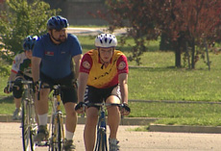

Stretching
Stretching is one of the most critical parts of the warm-up and an athlete’s performance. A more flexible muscle is a stronger and healthier muscle. A stronger and healthier muscle responds better to exercise and activities and helps prevent injury. Please refer to the Stretching section, below, for more in-depth information.

Event Specific Drills
Drills are segments of the sport activity that, when separate and focused upon, allow the athlete to perfect technique. Incorporating drills in the warm-up 1) allows the athlete to work on specific muscle groups recruited for the activity at a lower intensity level and 2) allows the athlete to be fresh when completing the tasks by removing obstacles such as fatigue (physical and mental), which will create a greater environment for improvement.
Progressions of learning start at a low ability level, advance to an intermediate level, and finally, reach a high ability level. Encourage each athlete to advance to the highest possible level. Drills can be combined with warm-up and lead into specific skill development.
Skills are taught and reinforced through repetition of a small segment of the skill to be performed. Many times, the actions are exaggerated in order to strengthen the muscles that perform the skill. Each coaching session should take the athlete through the entire progression so that he/she is exposed to all of the skills that make up an event.

Stretching
Flexibility is critical to an athlete’s optimal performance in both training and competition. Flexibility is achieved through stretching. Stretching follows an easy warm-up at the start of a training session or competition. The athletes should never stretch “cold”… their muscles and joints should always be warmed up prior to stretching.
Begin with an easy stretch to the point of tension, and hold this position for 15-30 seconds until the pull lessens. When the tension eases, slowly move further into the stretch until tension is again felt. Hold this new position for an additional 15 seconds. Each stretch should be repeated four or five times on each side of the body.
It is important to continue to breathe while stretching. As you lean into the stretch, exhale. Once the stretching point is reached, keep inhaling and exhaling while holding the stretch. Stretching should be a part of everyone’s daily life. Regular, daily stretching has been demonstrated to have the following effects:
- Increase the length of the muscle-tendon unit
- Increase joint range of motion
- Reduce muscle tension
- Develop body awareness
- Promote increased circulation
- Make you feel good

Cycling involves the unconscious coordination of complimentary muscle pairs. In order for the muscles to be efficient, one group of muscles must relax while the opposing group of muscles contracts and does work. If the muscles are tight or short, they will not relax and will conflict or “fight” the working muscles. The primary groups in cycling are the quadriceps and the hamstrings of the legs.
Important focus areas for stretching for cycling are:
- Quadriceps
- Hamstrings
- Calves
- Achilles
- Low back
- Neck and arms
Some athletes, such as those with Down Syndrome, may have low muscle tone that makes them appear more flexible. Be careful to not allow these athletes to stretch beyond a normal, safe range. Several stretches are dangerous to perform for all athletes, and should never be part of a safe stretching program. Unsafe stretches include the following:
- Neck Backward Bending
- Trunk Backward Bending
- Spinal Roll
Stretching is effective only if the stretch is performed accurately. Athletes need to focus on correct body positioning and alignment. Take the calf stretch, for example. Many athletes do not keep the feet forward, in the direction that they are running.
Incorrect | Correct
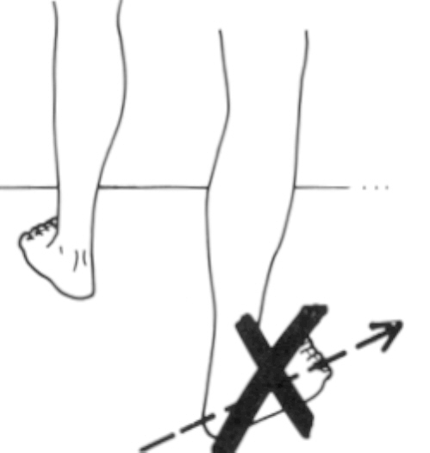
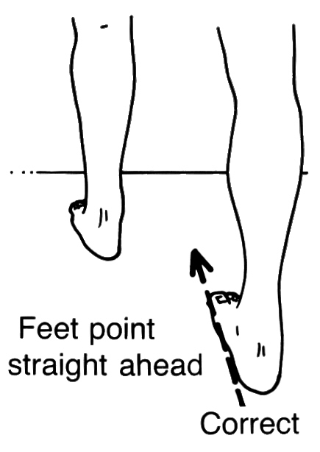

Another common fault in stretching is bending the back in an attempt to get a better stretch from the hips. An example is a simple sitting forward leg stretch.
Incorrect | Correct

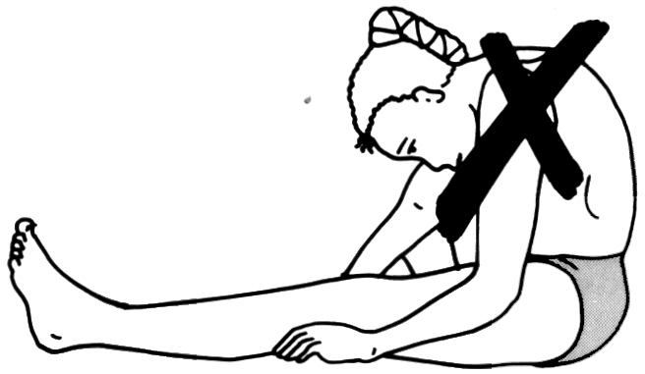
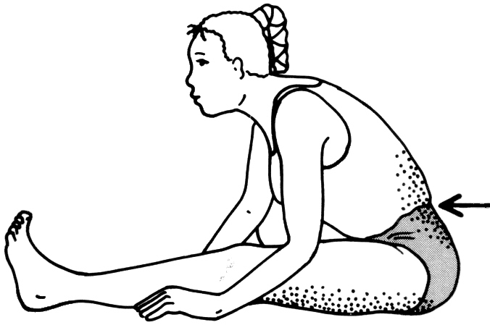

In this guide, we will focus on some basic stretches for major muscle groups. We will start at the top of the body and work our way to the legs and feet.

Upper Body

Chest Opener | Side Stretch
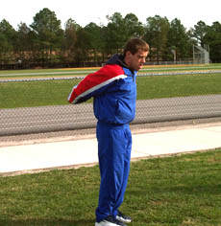 | 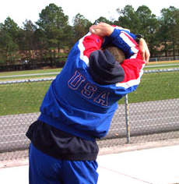
Clasp hands behind back  Palms facing in  Push hands toward sky | Raise arms over head  Clasp forearms  Bend to one side

Side Arm Stretch
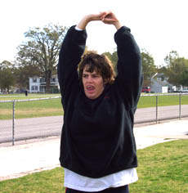
Raise arms over head  Clasp hands, palms up  Push hands toward sky | If the athlete is unable to clasp the hands, he/she can still get a good stretch by pushing the hands to the sky, like the athlete above

Triceps Stretch | Shoulder Triceps Stretch
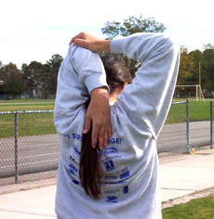 | 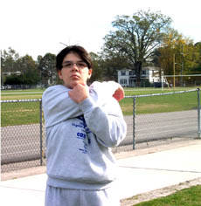
Raise both arms over head  Bend right arm, bring hand to back  Grasp elbow of bent arm and pull gently toward the middle of the back  Repeat with other arm | Take elbow into hand  Pull to opposite shoulder  Arm may be straight or bent

Chest Stretch
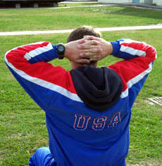 | 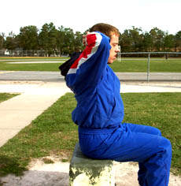
Clasp hands behind neck  Push elbows back  Keep the back straight and tall | This is a simple stretch that the athletes may not feel a lot when stretching. However, it opens up the chest and inner shoulder areas, preparing the chest and arms for the workout.

Low Back & Glutes

Crossed Ankle Stretch
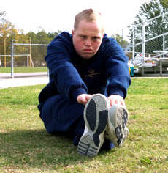
Sit, legs outstretched and crossed at ankles
Reach extended arms in front of body

Groin Stretch
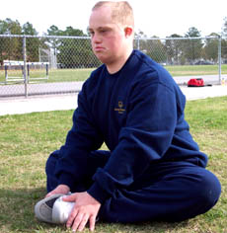 | 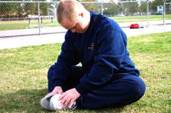 | 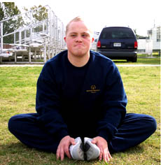
Sit, bottoms of feet touching  Hold feet/ankles  Bend forward from hips  Ensure that the athlete is pulling up in his lower back | Here, the back and shoulders are rounded. The athlete is not bending from his hips and is not getting the maximum benefit of the stretch | Here, the athlete is correctly bringing his chest to his feet and not pulling his toes toward his body

Hip Rolls
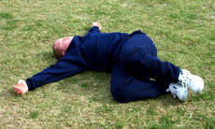 | 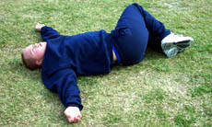
Lie on back, arms outstretched  Bring knees to chest  Slowly drop knees to left (exhale)  Bring knees back to chest (inhale)  Slowly drop knees to right (exhale) | Work on keeping the knees together to get the full stretch through the buttocks

Supine Hamstring Stretch | Spine Curl
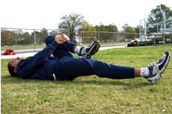 | 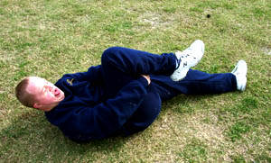
Lie on back, legs outstretched  Alternating legs, bring legs to chest  Bring both legs to chest at the same time | Lie on back  Bring left knee to chest  Lift head and shoulders to knee  Alternate legs

Downward Facing Dog  –Toes | Downward Facing Dog –  Flat Footed | Downward Facing Dog –  Alternating Legs
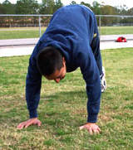 | 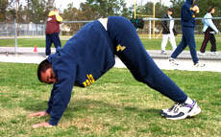 | 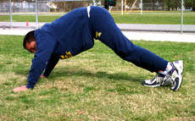
Kneel, hands directly under shoulders, knees under hips  Lift heels until standing on toes  Slowly lower heels to ground  Continue alternating up and down slowly | Drop heels to ground  Excellent stretch for the lower back | Alternate raising to toes with one leg up, while keeping the other foot flat on ground  Excellent stretch to prevent and help shin splints

Lower Body

Calf Stretch | Calf Stretch w/Bent Knee
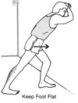 | 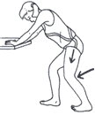
Stand facing wall/fence  Bend forward leg slightly  Bend ankle of back leg | Bend both knees to ease strain

Hamstring Stretch | Seated Straddle Stretch
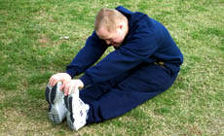 | 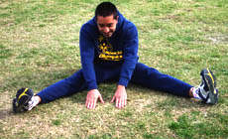
Legs straight out and together  Legs are not locked  Bend at hips, reach toward ankles  As flexibility increases, reach for feet  Push out through the heels, forcing toes to the sky | Legs straddled, bend at hips  Reach out toward the middle  Keep the back straight

Hurdle Stretch - Incorrect | Hurdle Stretch - Correct
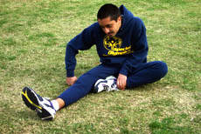 | 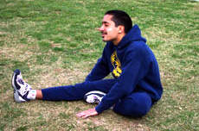
Correct alignment of the lead leg is important in a hurdle stretch. The foot must be aligned in the forward direction of running.

Sit with legs outstretched, bend knee, touch bottom of foot to opposite thigh
Toes of the straight leg are flexed toward sky
Push out through the heel, forcing toes to the sky
Bend at hips in nice easy stretch, reaching toward the feet or ankles
Bring chest to knee

Step Ups | Standing Hamstring Stretch
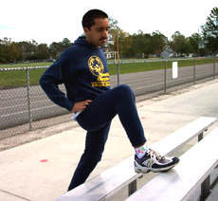 | 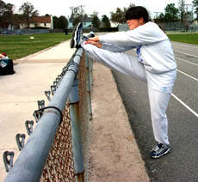
Step onto support, with bent leg  Push hips in, toward support | Rest heel of foot  Push chest/shoulders in and up

Forward Bend
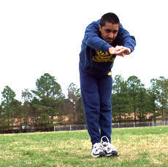 | 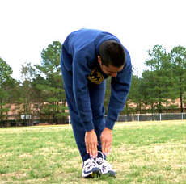
Stand, arms outstretched overhead
Slowly bend at waist
Bring hands to ankle or shin level without strain
Point fingers toward feet

Stretching - Quick Reference Guidelines

Start Relaxed
Do not begin until athletes are relaxed and muscles are warm
Be Systematic
Start at the top of body and work your way down
Progress from General to Specific
Start general, then move into event specific exercises
Easy Stretching before Developmental
Make slow, progressive stretches
Do not bounce or jerk to stretch farther
Use Variety
Make it fun, use different exercises to work the same muscles
Breathe Naturally
Do not hold your breath, stay calm and relaxed
Allow for Individual Differences
Athletes start and progress at different levels
Stretch Regularly
Always include time for warm-up and cool-down
Stretch at home

Cool-Down
The cool-down is as important as the warm-up; however, it is often ignored. Stopping an activity abruptly may cause pooling of the blood and slow the removal of waste products in the athlete's body. It may also cause cramps, soreness and other problems for Special Olympics athletes. The cool-down gradually reduces the body temperature and heart rate and speeds the recovery process before the next training session or competitive experience. The cool-down is also a good time for the coach and athlete to talk about the session or competition. Note that cool-down is also a good time to do stretching. Muscles are warm and receptive to stretching movements.
During cool-down, athletes should be reminded to start fluid and energy replacement. Remind them to take sips, not gulps of fluid. Recovery is a very important part of training that is often overlooked and ignored.

Activity | Purpose | Time (minimum)
Slow easy ride | Lowers body temperature  Gradually lowers heart rate | 10 minutes
Light stretching | Removes waste from muscles | 5 minutes

Tips for Riding a Three-wheel Cycle
Special Olympics encourages coaches to teach their athletes to ride a two-wheel bicycle, if possible. Spend a little time at each practice section working with the athlete riding the tricycle to try and transition that athlete to a bicycle; when this is no longer fun, go back to the tricycle. Common concerns about tricycle use:
- Three-wheel cycles are heavier than a standard bicycle and require more power to get up to speed.
- At higher speeds, changing direction can be unstable and dangerous.
- Three-wheel cycles are not allowed in non-Special Olympics cycling events.
- Maintenance can be harder due to parts availability.
- Transportation can be more difficult.

Learning to Ride a Two-wheel Cycle (Bicycle)
There are many methods for teaching someone to ride a two-wheeler. One successful way is to find a bicycle of the right size that your athlete can comfortably sit on the seat while touching the ground with both feet. This may mean using a bike that is normally too small for the rider, but for learning, it can add confidence and security. It is now best to remove the pedals, crank and chain, which allows the rider easy and clear access to the ground with the feet. (It is preferable to have your athlete in long pants and a long-sleeve shirt during this learning phase.) Find a very slight decline and have the rider scooter back and forth using the feet for propulsion. When the athlete is able to go down the slight downhill with feet off the ground, it is time to re-install the pedals so the athlete can learn to use themto move the bicycle forward. If you are frequently teaching someone to learn how to ride a two-wheeler, it may be best to have a small bicycle set up for this purpose. Be prepared to demonstrate; set up a bike for you to use for this drill.
Training wheels are probably the most common method for learning to ride a bicycle. One advantage of this method is that the training wheels make the bicycle more stable, which makes the rider more confident. For example, a stopped bicycle without training wheels will not stand up. As the rider gains balance, the training wheels may be raised up in small increments. Just remember that cornering at speed with training wheels may require more caution.

Basic Cycling Skills
Different cyclists will best learn different skills by different methods of teaching. It is your challenge as a coach to learn the most efficient way to teach your riders. Some will need much more verbal explanation, while others will learn simply by example. Breaking down the skills into steps will simplify the teaching process as well as provide positive reinforcement to the athlete who has performed some steps but may not yet be ready to acquire the entire skill.

Skill Progression – Learning to Ride a Bicycle

Your Athlete Can | Never | Sometimes | Often
Sit comfortably on the bicycle with feet on the ground, with no holder
Move the bicycle forward by pushing using the feet
Coast for a short distance while controlling the bicycle
Understand the pedaling motion
Coast for a short distance while controlling the bicycle with feet on pedals
Pedal for a short distance with assistance while controlling the bicycle
Pedal for a short distance with no assistance while controlling the bicycle
Ride the bike while displaying balance and control

Totals

Faults & Fixes Chart – Learning to Ride a Bicycle

Error | Correction | Drill Reference
Athlete moves forward too slowly to maintain balance. | Start the athlete on a slight decline. Encourage the athlete to push off harder to gain more forward momentum. | Coasting Drill
Athlete stops pedaling during progression forward. | Practice pedaling on a stationary bicycle before transitioning to outdoors. Use of a fixed gear/track bicycle on a trainer works well to correct this error. Verbally encourage continuous pedaling. | Pedaling Drill
Athlete is hesitant to put both feet on the pedals. | Coach physically spots the athlete while the athlete is moving forward. Coach runs alongside the athlete, verbally encouraging the athlete to place both feet on the pedals. Use a stationary bike or an exercise bike at a local gym to practice pedaling. | Pedaling Drill
Athlete has trouble securing pedal and foot. | Insure that athlete has enough speed that he/she does not “stall” before foot is secure.  Use stand or stationary bike to practice proper transition of foot from ground to pedal. | Pedaling Drill

Learning to Ride a Bicycle Drills

Coasting Drill
Position the bike on a gentle sloping road. Athlete should be able to sit comfortably on the bicycle with feet on the ground, with no holder. NOT using the pedals, the athlete should push off the ground and coast with feet up – not touching the ground.

Pedaling Drill
Athlete sits on bike and puts right foot on the right pedal, balancing on the left leg and pushing with the left foot to move the bike forward while at the same time pushing the right foot down on the pedal. Place left leg on left pedal as the bike starts to move forward while keeping the head up and looking forward.
NOTE: If there is a stationary trainer available; mount athlete’s bike on the trainer and practice pedaling.

Pedaling with One Leg Isolated Drill
Have the athlete remove one foot from the pedal and use the other to complete an entire circle of pedal stroke. Make sure the free foot stays clear of the rear wheel. One-leg drills should start with 20 revolutions and progress up to 40. Alternate legs and notice if one leg is stronger or more coordinated than the other.

Mounting and Starting
Mounting a bike is a prerequisite to riding a bicycle.
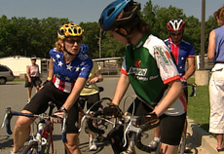

Skill Progression – Mounting and Starting
Your Athlete Can | Never | Sometimes | Often
Stand on the left side of the bicycle, place both hands on the handlebars and lift right leg over the seat to straddle the bicycle
Position the right foot on the pedal while leaving the left foot on the ground for balance
Rotate the right pedal around backward to a three o’clock position (on a bike with coaster brakes, position the pedal prior to mounting the bike)
Push forward with the left foot that is on the ground and simultaneously push down with right pedal
Lift himself/herself onto the saddle as the bicycle moves forward
Secure the left foot to the pedal while maintaining balance
Pedal forward in a straight line while looking in the direction of travel

Totals

Faults & Fixes Chart – Mounting and Starting

Error | Correction | Drill Reference
Pedals are in wrong start position, making start difficult. | Practice rotating pedals to place in correct position prior to straddling the bike. | Mounting and Starting Drill
Athlete is unable to lift himself/herself up onto the seat. | Try lowering the seat until this skill is acquired.
Athlete has trouble keeping bike moving forward in a straight line. | Encourage athlete to keep eyes forward, looking in the direction they want to go. Coach athlete to increase speed slightly to maintain balance and control.

Mounting and Starting Drill
Athlete straddles the bike and puts right foot on the right pedal, balancing on the left leg and pushing with the left foot to move the bike forward while at the same time pushing the right foot down on the pedal. Athlete lifts himself/herself up onto the saddle as the bike moves forward. He/she places left leg on left pedal as the bike starts to move forward, while keeping the head up and looking forward. Athlete should be able to pedal forward and in a straight line.

Braking (Hand Brakes)
Emphasize to your riders the importance of braking properly. Knowing when to begin braking in different situations is an important aspect of braking. Your athletes should understand that the front and rear brakes stop the bike in different ways. It is best to slow or stop the bicycle using both brakes. If only the rear brake is used, the bike will eventually stop. If only the front brake is applied with the same amount of pressure as used on the rear brake, the cyclist could go over the handlebars. Correct braking involves knowing the balance between the front and rear brakes as well as weighting the back wheel to avoid “skidding” or flipping over the handlebars. Braking skills involve not overreacting, braking gently and “feathering” the brakes by continuing to pedal while braking.

Skill Progression – Braking (Hand Brakes)
Your Athlete Can | Never | Sometimes | Often
Identify both the front and rear brake levers
Gradually stop the bicycle using only the rear brake
Understand that using too much pressure on the front brake could cause instability
Gradually stop the bicycle using both brakes simultaneously
Stop the bike with the rear brake without skidding
Stop the bike with both brakes at a predetermined point from a higher speed

Totals

Skill Progression – Braking (Coaster Brakes)
Your Athlete Can | Never | Sometimes | Often
Identify coaster brake/foot brake operation
Understand that they cannot pedal backward on a coaster brake bicycle
Understand that a coaster brake is engaged by placing reverse pressure on pedals
Gradually stop the bicycle using foot brake
Stop the bicycle in as short a distance as possible without skidding
Stop the bike at a predetermined point from a higher speed

Totals

Faults & Fixes Chart – Braking (Hand Brakes)

Error | Correction | Drill Reference
When athlete comes to a stop, the rear wheel lifts off the ground due to over-reliance on front brake. | The athlete must learn to use both the front and rear brake. Athlete must practice keeping his/her weight back when coming to a stop. | Hand Brake Stopping Drill
Rear wheel skids when attempting to stop the bicycle due to over-reliance on rear brake. | Review brake levers – which brake lever works on which wheel. Practice using rear brake lever along with front brake lever until athlete can stop without causing rear wheel to skid.  Review weight distribution over the rear wheel while braking. | Hand Brake Stopping Drill
The athlete slams down too hard on coaster brakes, causing bike to skid. | Work on applying slightly less pressure to the coaster brake to come to a stop.

Braking (Hand Brakes) Drill

Hand Brake Stopping Drill
Mount the bike; pedal forward toward a cone; discontinue pedaling while applying equal pressure, squeezing the brake levers until the bike comes to a stop.
NOTE: Athlete needs to be able to identify front and rear brake and practice squeezing the levers; athlete practices squeezing each brake: right lever to activate the rear brake and left lever to activate the front brake.
NOTE: If there is a stationary trainer available, mount athlete’s bike on the trainer and practice braking.

Stopping and Dismounting
The athlete must be able to stop the bike using the mechanical brake system and be able to dismount safely and correctly.
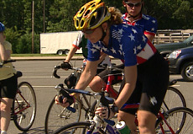

Skill Progression – Stopping and Dismounting

Your Athlete Can | Never | Sometimes | Often
Identify and demonstrate use of brakes in a stopped position
Use brakes while riding to control speed
Slow down to a controlled stop
Place both feet on the ground and straddle the bicycle when it comes to a complete stop
Lean the bicycle slightly to the left while swinging the right leg over the seat
Stand on the left side of the bicycle with hands on the handlebars

Totals

Faults & Fixes Chart – Stopping and Dismounting

Error | Correction | Drill Reference
Athlete dismounts before coming to a complete stop. | Athlete must use brakes to come to a complete stop before dismounting. | Dismounting Drill
Athlete attempts to stop the bicycle by dragging the feet on the ground. | Review correct use of brakes. | Coaster Brake Stopping Drill  Hand Brake Stopping Drill
Athlete fails to disengage from the pedals before stopping (when using clipless pedals or toe clips and straps). | Practice clipping in and clipping out of pedals. Use a stationary bicycle for practicing this skill. | Dismounting Drill

Stopping and Dismounting Drills

Coaster Brake Stopping Drill
Mount the bike and pedal forward toward a cone. Discontinue pedaling forward and keep the pedals in the middle position (3 and 9 o’clock) with the left pedal forward and the right pedal back. Gently push the right pedal backward and down; continue to apply pressure to the brakes while the bike slows down.
Just before the bike stops, lift the left foot from the pedal slightly in preparation to get off the saddle. Lean the bike to the left and put left foot on the ground when fully stopped.

Hand Brake Stopping Drill
Mount the bike and pedal forward toward a cone. Discontinue pedaling while applying equal pressure, squeezing the brake levers until the bike comes to a stop.
Just before the bike stops, lift the left foot from the pedal slightly in preparation to get off the saddle. Lean the bike to the left and put left foot on the ground when fully stopped.

Dismounting Drill
Follow the stopping drill procedure. After coming to a complete stop, lean the bike slightly to the left take the left foot off the pedal and put left foot on the ground. Then athlete moves forward off the saddle, leans upper body forward slightly, raises the right leg back and lifts body off the saddle while both hands hold the handlebars.
For clips and pedal systems, it takes extra time to remove or loosen the foot from the pedal. Allow extra time to remove the left foot from the pedal in advance of stopping.

Riding a Straight and Controlled Line
Riding in a straight line is a primary skill that all cyclists need; a cyclist must have the ability to ride steady no matter what the conditions may be. This skill is needed before a cyclist can ride in a group.

Skill Progression – Riding a Straight and Controlled Line

Your Athlete Can | Never | Sometimes | Often
Ride with enough speed to ensure steady balance
Ride in a controlled manner while keeping head up to identify hazards
Ride parallel to a line on the road or edge of the pavement
Ride in a straight line at a low speed while maintaining balance

Totals

Faults & Fixes Chart – Riding a Straight and Controlled Line

Error | Correction | Drill Reference
Athlete has difficulty keeping the bike moving forward in a straight line. | Encourage athlete to relax, look forward up the road at least 10 meters in the direction they want to go, and maintain speed. | Riding a Straight Line Drill
Athletes who have drop handlebars grip the bars incorrectly, causing the bike to be unsteady. | Try different hand positions on the bars until athlete is comfortable. | Riding a Straight Line Drill

Riding a Straight and Controlled Line Drills

Riding a Straight Line Drill
Set up two rows of five to six cones parallel to each other, with enough room to ride comfortably between. As the athlete becomes comfortable with this drill, increase the distance and decrease the width between the cones.

Looking Forward Drill
Using the drill above, athlete identifies a color card held up by the coach.

Riding Side-by-side with Another Rider While Riding Straight Drill
Use the Riding a Straight Line Drill, add another row of cones.

Changing Direction
Changing direction can involve turning or steering. Turning is a technique where the athlete turns the handlebars to change the direction of travel; this technique should only be used at lower speeds. Turning is a more basic skill that allows your athlete to change direction at low speeds. Steering is an intermediate skill where the athlete uses weight transference of the hips in the saddle (or leaning), rather than the handlebars, to change direction at higher speeds.
Steering on a tricycle can be a challenging task. As with a bicycle, the method is to stop pedaling, transfer weight to the inside pedal and get as much weight to the inside of the cycle as possible. The tendency is for the inside back wheel to lift off the ground and cause the tricycle to tip over. Getting the rider used to this light feeling on the inside wheel is good as long as he/she knows that tightening the corner or increasing the speed will cause a crash.
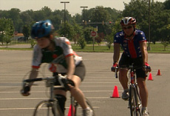

Skill Progression – Turning

Your Athlete Can | Never | Sometimes | Often
At a low speed, use the handlebars to turn around the left side of an obstacle
At a low speed, use the handlebars to turn around the right side of an obstacle
At a low speed, use the handlebars to maneuver around a series of obstacles.

Totals

Skill Progression – Steering

Your Athlete Can | Never | Sometimes | Often
At a moderate speed, initiate a change in direction to the right by using the hips to lean the bicycle to the right
At a moderate speed, initiate a change in direction to the left by using the hips to lean the bicycle to the left
Identify the correct line through a corner
At a moderate speed, approach a corner and, without steering, lean the bicycle while looking in the direction he/she wants to go
Understand that the inside pedal (right pedal if right turn, left pedal if left turn) must be up to avoid contact with pavement
Make a sharp corner at a high speed by keeping the inside pedal (right pedal if right turn, left pedal if left turn) up and keeping the outside pedal down and weighted

Totals

Faults & Fixes Chart – Changing Direction

Error | Correction | Drill Reference
Athlete hits obstacles. | Remind the athlete to look forward in the direction he/she wants to go versus focusing on the obstacle. At lower speeds, use handlebars to steer around the obstacle. | Steering Drill
At moderate speed, athlete attempts to go around an obstacle by steering versus leaning. | Review advantages of leaning the body slightly toward the direction you want the bike to go versus trying to steer the bike. | Steering Drill  Slalom Drill
Athlete goes around corner with inside pedal down – or athlete pedals through the corner causing the inside pedal to scrape along the ground. | Encourage athlete to keep pedal closest to curb above (outside pedal is down). | Cornering Drill  Slalom Drill
Front wheel slides out when cornering due to road conditions. | Athlete needs to choose the correct, clean line when cornering, and slide forward in the saddle in the turns to weight the front wheel. | Cornering Drill

Changing Direction Drills

Steering Drill
Make a circle of cones or use chalk to make a circle. Stand next to the bike on the left side, holding the bike by the handlebars with both hands. Push the bike counterclockwise around the circle; repeat drill going clockwise while standing to the right of the bicycle.
After a few laps in each direction, athlete mounts the bike away from the circle and pedals forward slowly and approaches the circle, steering onto the circle and riding multiple laps in both directions.
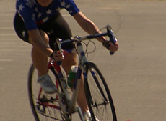

Figure 8 Drill
Using cones or chalk, make a figure eight and have athletes ride the figure eight course.
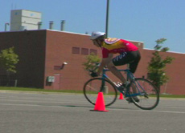
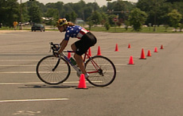

Slalom Drill
Place ten cones in a straight line approximately 7 meters apart. Before starting the course, athlete should be on the bike in a controlled manner well before the first cone.
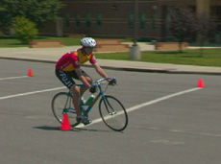
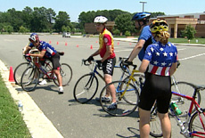

Cornering Drill
Go back to the circle of cones. This time the athlete holds the bike by the top of the seat and leans the bike slightly to the inside to make the bike follow the circle. Have the athlete do this exercise in both directions, changing hands.
Find a corner or use cones to make a turn. The athlete mounts the bike and, at a moderate but controlled speed, approaches the corner with the inside pedal up and the head up and looking through the turn. The inside knee is pointed toward the turn, and the athlete is coasting but not pedaling. Repeat this drill by having the athlete approach the corner in the opposite direction.
NOTE: It may be helpful to have the athlete think about touching the inside knee to the elbow just before approaching the turn.
Intermediate Cycling Skills
The next set of skills will prepare the rider to do more than just ride the bicycle. We will now take into account other riders around us as well as riding more efficiently.

Scanning
It is very hard to ride in a straight line forward while looking backward; however, it is not only helpful but also sometimes necessary to know what is going on behind you. Scanning is the ability to look from side to side and behind while maintaining a straight line. It is important to include looking over the left shoulder for cars coming from behind, looking back to change lanes and looking right to see if anybody is trying to pass on the inside. All these moves need to be done while holding a straight line. Cyclists tend to pull the bars in the direction they turn to look. For example, when looking to the back and left, the rider pulls the left hand on the bars causing the bike to veer left. To avoid this, have the upper body relaxed and hands loose on the bars. When looking to locate other riders they may have passed, riders should be able to look under the arm and look for the front wheel of the rider behind and/or to the side of them and ultimately look down and back under their arm to see past the rear wheel.
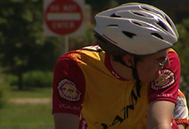
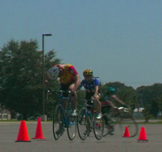

Skill Progression – Scanning

Your Athlete Can | Never | Sometimes | Often
Look backward without turning the handlebars
Look backward while cycling in a straight line
Identify traffic approaching from behind
Monitor competitors following or overtaking from behind
If athlete has a cycling computer, glance at computer and report current speed

Totals

Faults & Fixes Chart – Scanning

Error | Correction | Drill Reference
Athlete’s bicycle swerves when athlete attempts to look behind for approaching traffic. | Encourage athlete to keep a relaxed grip on the handlebars to keep the bars from turning when athlete turns his/her head. And do not twist shoulders. | Scanning Drill
Athlete abruptly slows down when scanning for traffic. | Athlete must continue pedaling to maintain speed while scanning. | Scanning Drill

Scanning Drill
Set up two rows of parallel cones (five or six cones), with rows approximately 5 meters long and cones 1 meter apart. Ask the athlete to approach the cones at a moderate speed and ride his/her bicycle between the cones a couple of times to practice riding in a straight line. Once the athlete is secure in riding a straight line, ask the athlete to ride between the cones at a moderate speed. At the halfway point, ask the athlete to look to the left (scan) briefly, while maintaining a straight line, and identify the color of a card held up by a coach. To practice scanning behind, ask the athlete to look back over the left shoulder to identify the card and then look forward to check that the bike has maintained a straight path. The athlete must call out the color of the card. Alternate riding the course scanning to both the left and the right. Hint: Begin by flashing the cards as the athlete approaches to get him/her used to looking for the card. Then, wait until the athlete passes you to flash the card so the athlete is required to scan to the left at approximately 90 degrees. Finally, wait to flash the card until the athlete passes so the athlete must scan over his/her shoulder in order to see the card. Practice first on a stationary bike. Emphasize the need to continue riding in a straight line, keep both hands on the handlebars, and turn the head – and not the shoulders – to scan.

Changing Position of Hands on Bars
In order to ride efficiently as well as comfortably, the rider needs to be able to change the position of the hands on the handlebars while riding. The grasp on the bars should remain light (no white knuckles!) and relaxed. If the bike has drop handlebars, the position of most control is on the drops, with one or two fingers poised on the brakes. For relaxing and easy riding, the rider may find that positioning the hands on the tops of the brake levers (or the “hoods”) is the most comfortable. Also the hoods are the preferred hand position for climbing hills, as it allows the chest to be more open and the diaphragm less compressed for easier breathing.
Placing one hand near the center of the tops of the bars (near the stem) will help the rider maintain good centered steering while riding one-handed for shifting, signaling and drinking from a water bottle or hydration system. The rider will need to change hand positions on the bars to accommodate braking or shifting or just to relieve pressure on the hands after a long ride.
The athlete should develop the ability to change hand positions frequently and comfortably without losing control of the bike. Adopting a “steering” style of directing the bike, with the hips rather than the handlebars, would be very helpful regarding adapting to this technique. In order to do all of this, the athlete will need to commit more weight to the saddle than to the handlebars.

Skill Progression – Shifting Hand Positions on the Bars

Your Athlete Can | Never | Sometimes | Often
Move hand position from the farthest part of the bars to the most center part of the bars without swerving
Move hands from the drops to the tops to the hoods without swerving or losing control
Move one hand to the center near the stem and touch the water bottle with the free hand
Move one hand to the center near the stem and signal a turn or wave at coach without losing control of bike
Control bike by just placing fingertips on tops of bars (not palms)
Control bike with only the fingertips of one hand on the bars and the other hand waving at coach

Totals

Faults and Fixes Chart – Changing Hand Positions

Error | Correction | Drill Reference
Athlete swerves and path of bike is choppy. | Encourage athlete to keep a relaxed grip on the handlebars and shift weight from the front of the bike to the saddle.
Athlete is afraid to remove hand from handlebars. | Gradually introduce “tapping” to the athlete.  It is most important that he/she have the body weight shifted to the saddle and not have the handlebars bearing the majority of the weight. | Tapping Drill

Hand Position Drills

Tapping Drill
Have the athlete move the hands to the top of the handlebars, toward the center near the stem, and the body weight to the saddle. He/she should be sitting up on the bike. Instruct the athlete to remove the dominant hand from the bars and then replace it quickly. Do this in increasingly longer intervals. Start off as if to tap the bars, and then increase the interval that the hand is away from the bars, therefore increasing the confidence and security of the athlete.
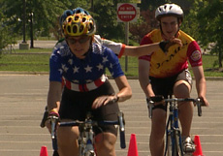

One Hand Drill
As the athlete becomes more secure, you can introduce more drills, such as touching the water bottle, waving and touching the helmet. Then move to the non-dominant hand with signaling. Throughout these drills, the hand on the handlebars should be in the center near the stem.
NOTE: To advance the drill, practice taking the water bottle out of the cage without looking, and then replacing it in the cage (which is far more difficult than removing it).
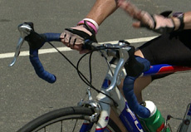

Fingertip Drill
An even more advanced version of this drill is to have the athlete place ONLY the fingertips on the bars. Start on the tops (but to further the difficulty, this can be done on the drops). Then reduce the number of fingers in contact with the bars as skill and confidence increase.

Drinking from a Water Bottle or Hydration System (CamelBak®)
It is a necessity to keep hydrated while exercising, and therefore drinking while cycling is an important skill. The two recommended methods of drinking on the bike are from a water bottle and from a hydration system. The water bottle is quite obvious, with the bottle carried in a bottle cage on the bicycle frame. A hydration system is a backpack-type reservoir with a tube reaching to the rider’s mouth.
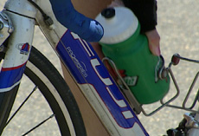
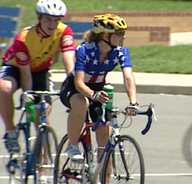
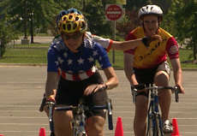

Skill Progression – Drinking from a Water Bottle or CamelBak
Your Athlete Can | Never | Sometimes | Often
Safely maintain control of the bicycle with one hand on the handlebars
Take eyes off road and keep bike going in a straight line
Successfully drink from AND replace water bottle

Totals

Faults & Fixes Chart – Drinking from a Water Bottle or CamelBak

Error | Correction
Bicycle changes direction as athlete looks for water bottle. | Have athlete feel for bottle without taking eyes off road.
Athlete cannot maintain control of bicycle while going through process of drinking from bottle. | Have athlete use hydration system with drinking tube positioned near mouth at all times.
Bike changes direction as the athlete replaces bottle. | Have athlete feel for bottle without taking eyes off road.

Drinking from a Water Bottle or CamelBak Drill
First, with the rider standing over the bike (stopped), have the athlete remove and drink from bottle without looking at it. Second, start drill by having athlete ride with one hand on the bars and the free hand giving you a wave. It is necessary that the athlete be able to control the bike for 30 seconds with only one hand. Placing the hand near the stem is the most stable one-hand control position on the bike. Next, have the athlete remove and drink from bottle while riding a straight line. It is important to keep eyes on the road and not have to look down for the bottle.
With the CamelBak hydration system, it is necessary to remove the hand from the bars for only a brief moment to insert drinking tube into mouth. Have athlete touch index finger of one hand to nose while riding; when comfortable with this skill, he/she can insert drinking tube into mouth while riding.

Shifting Gears
Shifting is the process of adjusting the gearing that allows the athlete to ride and negotiate a variety of terrain. For example, if riding up a hill using a high gear (e.g., the chain is on the large chain ring in the front and the small sprocket in the rear), we will encounter tremendous resistance, which may prevent us from making it to the top. The solution is to shift to a lower gear (e.g., shift the chain to a smaller chain ring in the front and/or a larger sprocket in the rear) before climbing a hill.
Work with the athlete to find the cadence that is most comfortable. Then ask the athlete to remember what the cadence feels like (perhaps referring to a cycling computer) and instruct him/her in shifting to maintain that cadence as the terrain changes. If pedaling too fast, then have the athlete shift into a gear that increases the resistance; if it is too hard or too slow, then shift to a gear that is a little easier. When approaching a hill, the athlete needs to remember to anticipate the change and to shift before it is needed, and to continue pedaling throughout the shifting process. Do not coast when shifting.
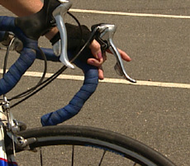
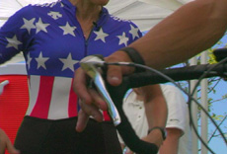
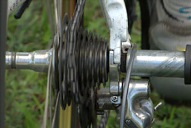

Skill Progression – Shifting Gears
Your Athlete Can | Never | Sometimes | Often
Identify the operation of the shifting system
Control the rear derailleur with the right shifter
Understand how many gears the right (rear) shifter controls
Use the right (rear) shifter to change from lowest (easiest) to highest (hardest) gear and from highest (hardest) to lowest (easiest)
Control the front derailleur with the left shifter
Understand how many gears the left (front) shifter controls
Use the left (front) shifter to change from lowest (easiest) to highest (hardest) gear and from highest (hardest) to lowest (easiest)
Understand that using a lower gear will make you pedal faster, and the higher gear will make you pedal slower
Demonstrate the ability to select the proper gear for the terrain or situation
Shift gears without taking eyes off of the road ahead

Totals

Faults & Fixes Chart – Shifting Gears

Error | Correction | Drill Reference
Athlete stops pedaling when changing gears. | Athlete must keep pedaling while changing gears. Instruct in “soft pedaling” or moving the pedals without any great force. | Shifting Gears Drill
Athlete doesn’t change gears despite changing terrain. | Review proper selection of gears while riding alongside the athlete. | Hill climbing/descending drills
Athlete looks at gear levers while changing gears. | Encourage athlete to keep looking in the direction he/she wants to go versus looking down when changing gears. | Shifting Gears Drill
Athlete is pedaling too slowly and struggling while going uphill. | Encourage athlete to anticipate changing terrain and switch gears in anticipation. | Shifting Gears Drill
Athlete has bike in too easy of a gear, causing uncontrolled spinning. | Ride alongside athlete to help him/her understand changing terrain and switching gears in anticipation of change.
Athlete’s gears don’t seem to be working properly due to shifting errors (derailleur is making excessive noise, chain comes off). | Review proper gear selection and shifting techniques to determine if gears aren’t working due to mechanical reasons or due to human error. Review how to “feather” the derailleur for extreme gear combinations where they may be “cross chained.”

Shifting Gears Drill
Using a stationary bike, ask the athlete to practice changing gears. Encourage the athlete to look forward, not down at the gears, in order to maintain a straight line when riding on the road. Ask the athlete to identify which gears are easier or harder to pedal by feel, not by sight. Ask the athlete to maintain a steady cadence while switching gears to emphasize how the gears affect how hard or easy it is to pedal.
On the road, find a course that offers a combination of flats and hills. While riding next to the athlete, prompt the athlete to select the appropriate gears for the terrain. Encourage the athlete to maintain a comfortable cadence throughout the ride (usually 70-80 rpm) by changing gears as the pitch of the road changes.
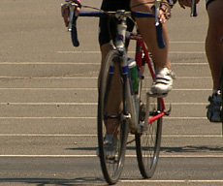
Controlling Pedal Cadence
Since pedaling is the primary method of getting a bike to move, it is very important that we understand cadence. Cadence is the number of pedal revolutions per minute (rpm’s) that we turn the crank over. By shifting gears we are able to maintain the perfect cadence. The ideal cadence will vary slightly from cyclist to cyclist due to individual style, but the average ideal rpm is around 90. That is, 90 pedal revolutions per minute.
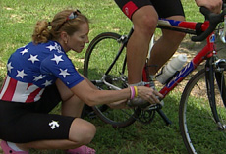
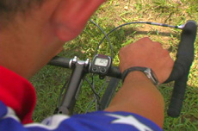
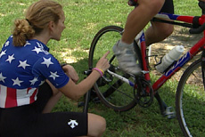
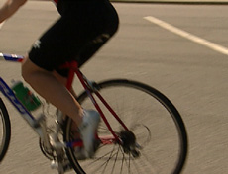

Skill Progression – Controlling Pedal Cadence
Your Athlete Can | Never | Sometimes | Often
Determine roughly what pedal cadence they are maintaining
Cycle on a flat road with pedal cadence in a recommended zone of 80-100 rpm’s
Shift appropriately to maintain proper cadence while climbing (recommended zone of 60-80 rpm’s while climbing)

Totals

Faults & Fixes Chart – Controlling Pedal Cadence

Error | Correction | Drill Reference
Athlete pedals less than 80 rpm’s on flat road with little wind. | Have athlete pedal as fast as possible (up to 160 rpm’s) in low gear to get feel of spinning. | Controlling Pedal Cadence Drill
Athlete rides in too low of gear, forcing rider to spin wildly. | Instruct athlete to use large chain ring in front to limit low gear possibilities. | Controlling Pedal Cadence Drill
Athlete has no idea of pedal cadence (pedal speed). | Count for six seconds the number of revolutions the rider makes, multiply by 10 and tell rider the number. Should be 80–100. | Controlling Pedal Cadence Drill

Controlling Pedal Cadence Drill
Work on low end of pedal cadence by having athlete pedal as fast as possible in the largest gear on the bike. This would be the large chainring in front and the smallest cog in the rear. This drill should last for a duration of 40 complete pedal revolutions and be done on a flat road.
Work on the high end of pedal cadence by having the athlete pedal at maximum pedal frequency. On a downhill road, have the athlete select a very low (easy) gear so there will be no resistance on the cranks, and see how many revolutions are possible in a period of six seconds. Cadence between 160 and 200 is target.

Climbing Hills
Gear selection is a very important part of climbing; therefore, understanding the skill of shifting gears is necessary. It is also important that the rider develops his or her own personal method or position for climbing. The two obvious styles are sitting and standing. The most efficient location for hands while climbing is on the hoods for control; this opens the chest and decompresses the diaphragm for breathing while climbing. Dropping the heels at the bottom of the pedal stroke yields more power to the climb. The body weight should be back over the saddle (whether the rider is in or out of the saddle), and the rider should be able to access the gearshift mechanism during the climb.
Gear shifting can make or break a climb. It is recommended that the athlete either adjust the power exerted or adjust the frequency of the pedal stroke to climb. This can be done by shifting the gears or applying more force on the pedals. If the athlete is not physically strong, he/she may opt for a lighter gear option. In this case the speed will decrease, but the actual energy output will decrease, and the time on the hill will increase. If the athlete is physically strong, he/she may be able to shift less often and accommodate by increasing the pressure in the pedals to increase the cadence. This is the fastest way to climb, but is also the most energy burning.
The athlete needs to complete the hill by making sure not to stop pedaling at the top to rest. Once the athlete begins to crest the hill, the cadence should increase and the rider should shift to a higher gear to complete the crest. It is also recommended not to coast down the other side, as this could cause lactic acid generated during the climb to “pool.” The athlete should keep the legs moving, even if there is no resistance; this acts as a muscle “pump” to remove the lactic acid.
Climbing out of the saddle almost acts like an extra gear for some riders. But unless they are well trained, most will become fatigued after being out of the saddle after 30-45 seconds. If they do opt to be out of the saddle, they need to keep their hips back near the saddle and not forward. The driving wheel is the rear wheel, and it needs all the traction it can get. If the riders return to the saddle during a climb, they need to ease back into the saddle and not “plop” in the saddle, as this will cause the bike to lurch backward down the hill and perhaps into the front wheel of another rider following closely.
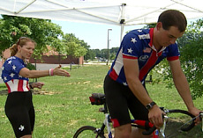
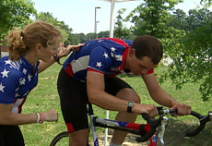

Skill Progression – Climbing Hills
Your Athlete Can | Never | Sometimes | Often
Assess that they are approaching a hill
Anticipate added resistance caused by the climb and make the necessary gear adjustments
Remain seated during the climb while maintaining pedal speed (cadence)
Climb by standing out of the saddle and putting the force of their weight into the pedaling
Alternate between the two styles (sitting and standing) and know which technique is best to use in different situations
Appropriately shift gears while climbing

Totals

Faults & Fixes Chart – Climbing Hills

Error | Correction | Drill Reference
Athlete doesn’t change gears despite hill. | Remind athlete to use the gears available to maintain pedal speed and reduce resistance. | Climbing Hills Drill
Athlete has trouble transitioning from a seated position to a standing position. | Athlete must be able to select appropriate gears while climbing before standing up out of saddle. | Climbing Hills Drill
Athlete weaves bike on hill. | Have athlete look up the hill, not straight in front. Also check gear and cadence.
Athlete rocks bike back and forth when out of the saddle. | Remind athlete that while this may look fancy, it is not efficient and is wasted energy. Have athlete practice pulling the bike with the handlebars into the downward stroke of the pedals. | Climbing Hills Drill

Climbing Hills Drill
Best done on a hill that has a moderate pitch and takes approximately 30 seconds to climb at a moderate pace. A coach riding next to the athlete while climbing is recommended. After warming up sufficiently, the athlete should approach the hill and work on climbing the hill while maintaining the appropriate cadence through proper gear selection as the hill pitches up. The athlete should practice climbing in seated position as well as while standing out of the saddle. A combination of seated and standing can be used on longer climbs. Ride next to the athlete during the drill to encourage proper gear choice and cadence and to encourage the athlete to stay relaxed. If the athlete is uncomfortable riding while standing, practice on a stationary bike. The rider should be able to correctly “gear up” as the hill crests. The coach may also mark key shifting areas of the hill with flags, cones or chalk to remind the athletes to shift.

Riding at Steady Speeds
Steady riding is most important for conservation of energy as well as allowing athletes to ride in a group. To maintain a steady rhythm / cadence, you may instruct the athlete to count pedal strokes or use a computer. Always discourage coasting and hard braking. Instruct the athlete in soft pedaling and feathering the brakes to modify speed.

Skill Progression – Riding at Steady Speeds
Your Athlete Can | Never | Sometimes | Often
Maintain steady speed through proper gear choices over varying terrain
Adjust speed to match other riders
Ride single file with other cyclists while maintaining steady speed

Totals

Faults & Fixes Chart – Riding at Steady Speeds

Error | Correction | Drill Reference
Athlete is unable to maintain steady speed because he/she doesn’t anticipate changing terrain and doesn’t make proper gear choice. | Review proper selection of gears. Ride next to athlete to verbally coach on selecting proper gears. | Riding at Steady Speeds Drill
Athlete is uncomfortable riding next to or near other athletes. | Ride near the athlete and gradually move closer. | Riding at Steady Speeds Drill

Riding at Steady Speeds Drill
After a sufficient warm-up, find a route that is relatively flat. Riding with the athlete, either behind or to the side, encourage bringing the bike up to a speed that the athlete believes he/she can manage for a few minutes. Using a cycling computer to monitor the athlete’s speed, coach the athlete to speed up or slow down to stay at a steady pace. Encourage the athlete to change gears to maintain cadence. Adjust the athlete’s speed down if he/she can’t manage a steady pace for at least 3 minutes. Try this interval three or four times with plenty of recovery between each effort. Gradually, with training, increase the amount of time the athlete trains at a steady speed.

Drafting
Drafting is the most energy efficient way to travel down the road. Riding in another rider’s slipstream will reduce the air friction and conserve approximately 30% of the rider’s energy. To achieve this, the rider must learn to ride in close proximity to another rider. Also, the direct benefit of the draft is dependent upon the speed the riders are traveling as well as the wind direction. The faster the athletes are riding, the more benefit there is in drafting. The harder the wind is blowing, the more benefit in drafting.
The logic behind drafting is that the rider in front is “breaking the wind” for the rider behind them, creating an “air pocket” for that rider to ride in that has 30% less air resistance. It is a huge advantage to ride in another rider’s slipstream or draft. But to be able to do this requires some skill and confidence.
First of all, the rider will need to become comfortable riding behind another rider’s wheel without hitting or overlapping the wheel. The rider also needs to become very aware of his/her own size in relation to that of the other riders. Usually, beginning riders feel very uncomfortable around other riders and have a huge “zone of comfort,” which limits allowing others into their “space.” The coach will need to help these athletes relax and become more confident in their skills and the skills of other riders. This will take time mostly, but you can create a few games on the bike that may help them start to relax.
Things to focus on when teaching how to draft:
- Don’t stare at the wheel in front. Look beyond the rider, up the road in front of them, to anticipate changes and obstacles.
- Do not overlap wheels. Stay 2 inches to half of a bike wheel’s diameter behind the other wheel for optimal drafting.
- Feather the brakes when you need to slow down. Ride with your right hand resting on the brake.
- Teach how to feel which direction the wind is blowing and how to accommodate whether you need to be to the right or the left of the wheel in front of you.
- All riding changes must be made gradually. Accelerate gradually, brake gradually and turn gradually. Do nothing suddenly.
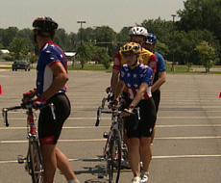

Pace Lines and Drafting
A pace line is a term for something as simple as one rider following another on a bicycle ride. It may also cover a much larger group riding two by two in a tight cohesive pack. Generally, riders take turns leading the pace line (rotating) so all riders share the workload. The purpose of a pace line is not only to keep order in the group but also to offer shelter or a draft to the riders behind you. Drafting is a technique the athletes will use to save up to 30% of their energy by closely following the rider in front of them.
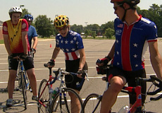
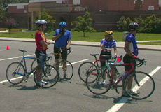
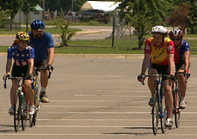
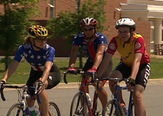

Skill Progression – Pace Lines and Drafting
Your Athlete Can | Never | Sometimes | Often
Ride as close as possible to the athlete in front of them safely
Ride comfortably in the draft of the rider ahead
Take a turn leading the pace line
Pull off of the pace line by moving out of the line (off of the front)
Maintain appropriate speed to drop to the back of the group

Totals

Faults & Fixes Chart – Pace Lines and Drafting

Error | Correction | Drill Reference
Athlete is not following close enough to be in draft of lead rider. | On grassy field, have athletes ride in a large circle following the leader as close as possible.
Athlete leaves gaps in left line (½ to 1 full bike length). | Work on comfort zone. | Work 1:1 and following drills
Athlete bumps rider in front and falls over. | Still on grass, have rider practice lightly bumping the rear wheel of the rider in front. | Rider behind must touch the lead rider’s rear wheel with front wheel, but keep body weight away from it to maintain balance.
Athletes keep missing advancing line transition from the back. | Have them pay attention to the advancing line. They also may be riding too slow in the resting line and the difference is too much to recover. | Scanning drills  Cadence drills
Lead rider rides too close to road edge for following rider to comfortably draft. | Ride two-by-two with lead rider (with coach on inside) and guide rider into proper position.
Pace line “accordions.” | Riders are surging and braking. | Cadence drills  Feathering the brakes
Athlete is braking frequently and overlapping gears. | Teach riders not to stare at rear wheels, but to anticipate change and feather the brakes. | Feathering the brakes  Scanning drill

Pace Line and Drafting Drills

Single Open Pace Line Drill
Have a group of four to six athletes ride in a straight line at as high a speed as can be maintained by the slowest rider in the group and take turns of one minute riding on the front. After the athlete has done their turn on the front they should move off to one side and let the group pass. The athlete should then follow the last rider in line. Keep the speed steady and the group must stay together.
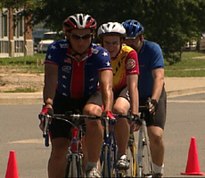

Rotating Closed Pace Line Drill
Have the group ride in two lines, side by side, with one line going slightly faster than the other. When the leading rider in the fast line is completely ahead of the leading rider in the slow line, the leading rider of the fast line should move to the [front of the] slow line and begin dropping back until he/she is the last rider in the slow line. At that point he/she moves to the back of the faster line and continues to rotate within the group.
The line on the left is the advancing line. The line on the right is the resting line. When the rider at the front of the left (advancing) line passes the rider at the front of the right (resting) line, the passing rider should look under the right arm to verify that he/she has cleared the front wheel of the rider who has been passed. The passing rider should then pedal (not coast) all the way over to the right and start to “soft pedal” or decrease the pressure on the pedals while pedaling. A few strokes of soft pedaling should help this rider to adjust his/her speed to that of the resting line.
At the back of the resting line, the riders should be looking for the last rider in the right line to pass them. At that time they should prepare to accelerate gradually between the lines to slide over to the advancing line and match their speed without leaving a gap.

Riding in a Group
Group riding is what makes cycling a unique sport. Group riding has many benefits over riding alone, such as camaraderie, shelter, pacing, direction and in some cases safety. In order to be effective as a group, you must be able to stay together as a group. Therefore, all changes must be made gradually, and communication is important. All accelerations, turns and stops must be made gradually. The riders at the front of the group must maintain a consistent pace and not surge or slow down quickly. The riders at the front must communicate their observations to the rest of the group, such as a hole in the road, a dog running toward them or a car either passing or turning in front of them. Riders in the back may be expected to communicate to the group that a car is passing them from behind. Everyone in the group should avoid braking if possible; however, if they need to do so, they should gradually adjust their speed. A sudden stop or change in line of direction may cause a chain reaction and ultimately a crash. If a gap does occur, the rider should close the gap gradually, not jump to close it, as the rider behind will be forced to do even more work to recover the distance.
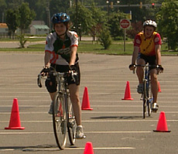
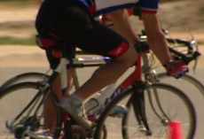

Skill Progression – Riding in a Group
Your Athletes Can | Never | Sometimes | Often
Ride in a single file line, closely following each other on a grassy field
While still on grass, ride two by two as closely as possible
While still on grass, practice riding in a matched group of three, side by side, as closely as possible alternating positions
Perform the same skills on the pavement

Totals

Faults & Fixes Chart – Riding in a Group

Error | Correction | Drill Reference
Athlete cannot maintain steady speed. | Riding two-by-two, ride alongsidethe athlete and have him/her match your speed.
When trying to ride two-by-two, athletes have too much space between them. | On a grassy field, have athletes ride two-by-two while touching elbows. When athletes are riding next to one other, their elbows should remain relaxed and loose. | It is important not to touch each other’s handlebars.

Riding in a Group Drills

Dry Land Drill
While standing (off the bike), ask the athletes to line up in a single line. Explain the concept of drafting to the athletes by explaining how the lead rider uses the most effort to travel forward since he/she is “breaking the wind,” and point out to each athlete that they are getting a “draft” from the rider in front of them. Ask the first athlete in the line to step to the left, and have the 2nd athlete in line step forward to become the lead rider. The drill helps athletes understand what a “single pace line” is. Now ask the athletes to stand to the right of their bikes with their hands on the handlebars. Line the athletes up in a single line and repeat the single pace line process, explaining that the closer the athletes’ bikes are to each other, the more draft each athlete will get.

Single Pace Line Road Drill
After a sufficient warm-up, coach the athletes into a single line while riding. Encourage the lead rider to ride at a steady pace to enable all the athletes to join in the single pace line. Ask each athlete to take a 30-second turn (pull) at the front of the line. Ride alongside the pace line in order to time each athlete’s turn at the front. After the 30-second pull, the lead rider will drift slightly to the right of the pace line to enable the 2nd rider to take on the role as the leader. While to the right of the pace line, the athlete must ride slightly slower than the group in order for the next athlete to take on the leader role. Coach the next athlete to maintain the steady pace and not accelerate while taking a turn as the new group leader. Change the “pull” time so the athletes can practice maintaining a steady pace for longer or shorter periods.
NOTE: When learning, it is best for riders to pull off to the right, as there is little room for error. If beginners pull off to the left, they usually will be riding very near the center line in traffic. This is a dangerous place to be.

Advanced Cycling Skills

Riding over Pavement Changes/ Hopping Up One Short Step (Curb)
The primary objective here is to teach riders to shift weight to the front or rear wheel while moving. This skill is necessary to safely ride through large potholes (that are unavoidable), onto different levels of pavement and up onto a sidewalk if necessary.
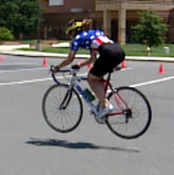

Skill Progression – Riding/ Hopping Up One Short Step (Curb)
Your Athlete Can | Never | Sometimes | Often
While coasting, stand on pedals and slightly lift front wheel off ground
While coasting, stand on pedals and, with pedals, slightly lift rear wheel off ground

Totals

Faults & Fixes Chart – Riding/ Hopping Up One Short Step (Curb)

Error | Correction
Leading edge of front wheel hits obstacle and stops. | Athlete must time the lift to coincide with pavement height change.
Front wheel smoothly gets up to new level, but rear wheel slams edge. | Athlete must put most of his/her weight on front wheel after it is placed at new level.

Riding/ Hopping Up One Short Step (Curb) Drill
This skill involves shifting the weight completely from one wheel to the other. The first step is to “pop a wheelie” by lifting the front wheel off the ground. For a beginner this means just off the surface of the ground. The second step is to then to un-weight the rear wheel by pushing down on the handlebars and picking up slightly on the pedals with the body weight off the saddle.
With a one-inch diameter stick on the road, have the ride try to pass over it without the wheels touching it. Increase the size of the obstacle until the rider is able to smoothly step up a 6-8-inch curb.

Competition Skills

Race Starts

Starting with One Foot on Ground
This skill is used every time we ride a bicycle. It is important to be able to perform this skill quickly and efficiently at the start of a road race, in traffic when the light turns green, or when being chased by a big dog.

Skill Progression – Starting a Race with One Foot on Ground
Your Athlete Can | Never | Sometimes | Often
Select the appropriate gear (on a multi-gear bicycle) to ensure quick acceleration off the line
Straddle the bicycle in the start lane with the leading edge of the front wheel positioned over the start line
Position the right foot on the pedal while leaving the left foot on the ground for balance
Rotate the right pedal around backward to a one- or two-o’clock position
Follow the commands of the starter
Push forward with the left foot that is on the ground and simultaneously push down with right pedal
Lift him/herself onto the saddle as the bicycle moves forward
Secure the left foot to the pedal while maintaining balance
Pedal forward in a straight line while looking in the direction he/she wants to go

Totals

Faults & Fixes Chart – Starting a Race with One Foot on Ground

Error | Correction | Drill Reference
Athlete must look down to position feet on pedals, causing swerving at start. | Athlete must be able to find second pedal based on the position of pedal that is already engaged. | Starting a Race with One Foot on Ground Drill
Athlete using clipless pedals cannot engage pedal without losing balance. | Athlete should first get up to speed with foot on top of pedal, then engage pedal when balance is steady. | Starting a Race with One Foot on Ground Drill

Starting a Race with One Foot on Ground Drill
Have a group of three to eight athletes line up in one row across the road, with one foot on the ground and the other foot in contact with the pedal at the 1- or 2-o’clock position (just past top center). On the command of “go,” have the riders push off with grounded foot, make contact on the pedal with the pushing foot and ride a controlled straight line for 100 meters. Gearing for this drill and for race starts should be on the low side (42 x 18 teeth), or large chainring to middle cog on the average bike.

Starting a Time Trial from Holder with Both Feet on Pedals
Starting a time trial with the assistance of a holder will enable the athlete to move quickly off of the start line, because both feet are on the pedals prior to the start.
The start of a tricycle time-trial is another area where specific training is helpful. The best way to compensate for this is with efficient use of the gears on a multi-speed cycle, or having a relatively low gear on a single-speed cycle. The most efficient short time trial would involve two to three shifts along the course. There are many methods to help the rider know when to shift; the simplest may be just to have the rider count the number of times his/her right foot has come to the top of the pedal stroke. After a certain number of strokes are reached, it is time to shift up one gear. Another method may be the use of light poles or road signs along the course; at every pole or two it is time to shift. Of course this is all dependent on the riders’ cadence, and ultimately your athletes will start to feel when they are pedaling the most efficient speed.
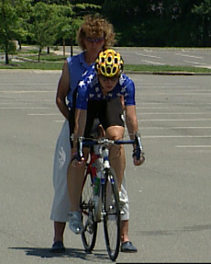

Skill Progression – Starting from Holder with Both Feet on Pedals
Your Athlete Can | Never | Sometimes | Often
Select the appropriate gear (on a multi-gear bicycle) to ensure quick acceleration off the line
Straddle the bicycle in the start lane with the leading edge of the front wheel positioned over the start line
Understand and be comfortable with the “holder” holding the seat
(The holder will stand behind the athlete and straddle the rear wheel of the athlete’s bicycle)
Demonstrate communication to the holder regarding a comfortable position, and balance in the starting position.
Lift him/herself up onto the saddle, with the bicycle being held
Position the left foot on the pedal
Place the right foot on the pedal and rotate the pedal around backward to a one- or two-o’clock position
Follow the commands of the starter
Apply force with the lead foot (right foot) on the “Go” command
Pedal forward in a straight line while looking up and forward in the direction he/she wants to go

Totals

Faults & Fixes Chart – Starting from Holder with Both Feet on Pedals

Error | Correction | Drill Reference
Rider struggles away when released by holder. | Rider should start in a lower (easier) gear. | Drill 1
Rider tries to leave early and therefore is not ready to start on “go” command. | Rider must wait until released and told to “go.” | Drill 1
Rider “stalls” and nearly falls. | Rider was not ready when “go” command was given and holder released the athlete. Rider needs to work on timing and listen to commands. | Drill 1
Rider swerves radically from side to side off the start. | Rider is pulling too hard on the handlebars one at a time. Should pull up equally on both bars at the same time, as if pulling on a boot. | Drill 2

Starting from Holder with Both Feet on Pedals Drills
Drill 1
Before the rider comes to the start practice area, have the rider look at the gears and, with assistance, shift the bike to the proper starting gear; this is usually one or two cogs down from the biggest cog in the rear and the big ring in the front. Rider practices with the coach holding the rider from behind and having another coach give a 5second count down. Rider has both hands on the bars in the drops (if they have drops); right pedal is positioned 2 inches higher than the left pedal. Rider is looking up and straight ahead, with both feet clipped in (or on pedals if no clips). On the count of Two, the rider stands up in the saddle, with hips directly above saddle, not forward; at Go, rider pulls up equally on the bars and at the same time pushesg down with the right foot and lifts up with the left foot. Rider continues out of the saddle until speed increases to a pace that requires shifting gears; then the rider gradually eases onto the saddle. When pedaling in the saddle, rider may practice shifting to a harder gear.

Drill 2
After the rider is comfortable with starting, work on having the rider stay within two lines of ten cones to practice riding straight after the start.

Road Width, Time Trial Turnarounds
Many individual time trials are held on out-and-back courses and therefore require a 180-degree turn at the halfway point to reverse the rider’s direction. The speed that is safe to perform this turn is based on the width of the road as well as the rider’s skill level.
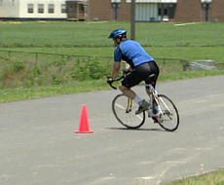

Skill Progression – Road Width, Time Trial Turnarounds
Your Athlete Can | Never | Sometimes | Often
Coast into the turn area, catch breath and make a controlled 180-degree turn
Maintain speed until last possible moment, brake hard and make turn
Do the above and also select proper gear for acceleration out of turn

Totals

Faults & Fixes Chart – Road Width, Time Trial Turnarounds

Error | Correction | Drill Reference
Athlete ends up overshooting pavement on far side of turn. | Athlete should use more brake and make turn at slower speed. | Figure 8 Drill
Athlete skids rear tire on approach to turn. | Athlete should stop pedaling sooner and start braking with both brakes evenly. Observe weight distribution; athlete may have too much weight forward and not enough over the driving wheel. | Drill 1
Athlete loses lots of time in turn. | Athlete must gain confidence in leaning bicycle to inside when making tight turns as well as confidence in jumping / accelerating after turnaround.

Road Width, Time Trial Turnarounds Drills

Drill 1
Find a straight stretch of road at least 500 meters long. Set up a cone at each end with a marshal at each cone. Have the athlete ride toward the cone, slow to almost a stop and turn around the cone. (Athlete should ride slowly toward the cone for the first practice of this drill.) Rider should practice shifting to an easier gear for the turn. After the turn, he/she should stand up out of the saddle as if sprinting and then sit and shift back to the gear that was being used before the turn.

Drill 2
Repeat at race speed – distance may need to be increased between cones to make this work.

Sprinting
Because the order of finish in mass start bicycle races is determined by place and not by time, it is important to be able to accelerate rapidly when approaching the finish line. Any rider coming to the finish of a race in a group or pack will have a sprint to the finish.
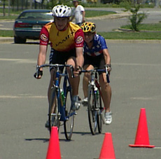 |  | 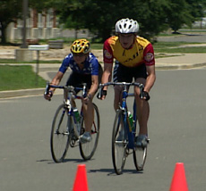
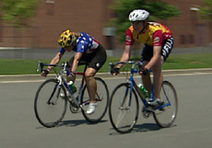 |  | 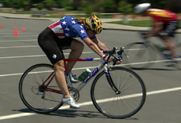

Skill Progression – Sprinting
Your Athlete Can | Never | Sometimes | Often
While seated, increase the cadence of pedaling to a maximum level while holding a straight line
Shift to a higher gear (harder), stand up on the pedals and accelerate the bike
Time the acceleration to reach the finish at maximum velocity

Totals

Faults & Fixes Chart – Sprinting

Error | Correction | Drill Reference
Athlete spins pedals wildly without a high rate of speed. | Athlete must learn to use a higher gear. | Sprinting Drill
Athlete tires and slows after attempting a sprint. | Athlete must try to maintain normal breathing while sprinting and not hold breath. Needs to time the sprint. The human body can only sprint for 10 seconds. This rider may have sprinted too soon. | Sprinting Drill
Athlete cannot ride a straight line while sprinting out of saddle. | Athlete must keep weight back and eyes forward even while sprinting. | Sprinting Drill

Sprinting Drill
Rider needs to practice getting out of the saddle with hands on the bars in the lowest position if using drop bars. In this drill, a cone should mark 200 meters before the drill finish line – marked by chalk and marshals. Rider should first practice riding at slow speed to the cone and then practice what is called a “jump.” The rider pulls up with the bars and seat comes off the saddle while pushing down and pulling up on the pedals. This is the same skill needed for the time trial start, which should be mastered first.

Rider “jumps” at the cone and proceeds to stay out of the saddle for as long as possible until reaching the finish line. Rider must control the bike at the finish.
Repeat drill at higher entering speeds.

Maintaining High Sustainable Speed
Time trialing or riding a long distance in the least amount of time requires being able to pace oneself and maintain a consistent and high rate of speed.
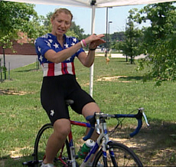
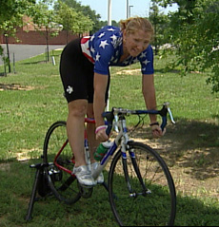

Skill Progression – Maintaining High Sustainable Speed
Your Athlete Can | Never | Sometimes | Often
Focus on effort and pedal speed for an extended length of tempo riding
Ride with a steady and fast speed in a comfortable position on the bicycle
Ride with a steady output in hilly terrain using the gears to control cadence

Totals

Faults & Fixes Chart – Maintaining High Sustainable Speed

Error | Correction
Athlete is looking around and not concentrating on maintaining high speed. | Have athlete follow coach or other rider at steady speed and maintain that pace.
Speed fluctuates greatly while riding. | Set rider up with speedometer on bike and work with him/her on maintaining a certain mph.

Maintaining High Sustainable Speed Drills

Drill 1
Find a straight, safe road that is at least I mile long – longer if possible.
Mark off a start area and a finish area, and have riders practice riding fast with no coasting. Take the riders’ times. Repeat as needed. If cycling computers are available, have each rider ride to a specific speed and report back the numbers seen on the computer.

Drill 2
Increase distance and practice using different gears to teach riders about the differences in gear choices.

Everyday Skills

Bicycle as Transportation
Riders need to learn the rules of the road. Time needs to be spent on teaching the riders about using their hearing to judge the size of vehicles approaching them, using hand signals, looking back before turning and looking before crossing intersections.
Spend time talking about what roads in their area are safe to ride alone, with another rider, or NEVER.
Before riders can use their bikes for transportation, they need to demonstrate knowledge of safe riding skills and habits: turning lights on, using a blinker, making hand signals, using a horn or making noises at a car that may be coming into an intersection fast. It is important that riders know how to ride on the side of the road in a straight line and to recognize road hazards such as railroad tracks, grates in the road, glass, etc. Riders need to know how to change a flat tire and be able to tell someone their name, address and phone number.
Another critical skill is how to deal with rude or angry drivers. Riders are always at the disadvantage on the road. Cars are bigger than we are, and no matter how angry or rude a driver may be, we always need to maintain composure and a non-combative attitude. Never yell or gesture rudely in return. Just smile and wave and take mental notes regarding the make and color of the car and, if you can…the license plate.

Sample Workouts
Special Olympics athletes can be a very diverse group of people with varied backgrounds and experiences. So it is impossible to create a training program that will fit every need in this category. We are going to attempt to meet as many needs as we can in this guide. The industry standard for bikes in road competition is road bikes with derailleurs. This training program is intended to be applied to athletes riding multi-speed (ten-speed or greater) bikes. That would be road bikes with derailleurs.
There are eight levels of training, the first being the most critical: the skills. If athletes do not know how to ride, then all the training theory in the world will not help them be better cyclists if they do not know how to ride, and ride safely. Therefore the skill element of training needs to be addressed initially.
After it is established that the athlete can ride and follow the skills safely, the remaining seven components of training should be integrated into the program. Most of these initial skill drills can be performed in a parking lot.

Training session #1

Introduction to cycling:
- Different types of bikes and the names of the components of the bike
- Helmets – what is acceptable and how to get a correct fit
- Clothing – bike shorts and why you wear them with no underwear; gloves, tights, jerseys and cycling shoes
- How to tell if your tires need air and how to pump them up
- Water bottles and hydration systems
- Proper bike fit

Skills:
- Mounting and dismounting the bike
- Starting and stopping
- Using toe clips and clipless shoe systems
- Pedaling
- Braking

Training session #2
- Review skills learned in previous session
- Moving hands on handlebars while riding
- Shifting gears
- Steering vs. turning
- Cornering
- Slalom drill
The athletes should be assigned “homework” to ride and practice these drills at least 20 minutes per day till the next training session the following week.

Training session #3
Review previous week’s drills, and correct and praise technique. You may need to divide the group by skill level and keep one group focused on perfecting the skills while the other group advances to the next level.

Next level of skills:
- Time Trial Start (with a holder).
- Feathering the brake – pedaling while braking.
- Drafting – what drafting is and why it is advantageous; how to tell the direction of the wind while you are riding. What the “sweet spot” feels like. Looking through the rider in front of you and not staring at the wheel. How close to get to the wheel. What overlapping is and why you don’t want to do it. (Most crashes are caused by overlapping wheels.)
- Reaching for your water bottle, getting it out and replacing it in the holder.
- Looking behind you while you are riding. Have riders paired with a partner, and have them take turns riding in front. The rider in back holds up a number of fingers and the lead rider tells them how many fingers they are holding up.

Training session #4
Again, review drills from the previous sessions and evaluate skill levels and readiness for advancement.

Next level of skills:
- How to appropriately touch another rider.
- How to ride side-by-side safely.
- Review drafting.
- Introduce single pace line techniques.
- What to do if you ride off the road. (KEEP PEDALING! Let the group go by, and then turn the front wheel so that it is nearly perpendicular to the road and return to the back of the group.)

Homework this week: Continue to practice the drills, and start riding a minimum of 30 minutes per day until the next week’s training session.

Training session #5
Review skills learned to date and evaluate individual readiness for advancement; place in groups accordingly.

Next level of skills:
- Sprinting – how to use the draft of another rider to accelerate.
- How to “Throw the bike” at the finish line.
- Double pace line.

Training session #6
Review previous drills and evaluate readiness for advancement.

Next level of skills:
- Double rotating pace line.
- How to maintain pace at the front without accelerating.
- How to move over into the resting line without hitting the front wheel of the rider in the relief / resting line.
- How to protect your front wheel.
- How to accelerate from the resting line to the working line of the pace line.
Homework this week: Practice drills and try to ride at least 45 minutes 4 days of the week till the next training session.

Training session #7
- Review skills from previous two weeks.
- Introduce the 500-meter individual time trial; get a time and record it for the riders.

Training session #8
Review skills again and introduce the topic of weight training. The athletes should start to introduce 20 minutes of weight training 2x/week to their training schedule. Remember to include warm-ups and stretching in the workout sessions.

Training session #9

Intervals:
What intervals are and how they can be done either on the road or on a bike trainer. If you have a trainer available, it may be very helpful in demonstrating what intervals are and how they can be done using this tool. If you have access to a paved running track or a fixed distance loop or neighborhood block or park loop, you could have the group do the intervals together. You can mark the “On” interval area with chalk or tape or have it divided up by telephone poles. Then explain that in the resting section of the drill, the riders should continue pedaling easy, not simply coast. Include a good warm-up, stretching and cool-down in the workout.

Training session #10

Hill climbing:
Find a medium sized (30 seconds to climb) hill with low traffic and ample room at the top and bottom for people to stand on the side of the road. Introduce athletes to the different styles of hill climbing, both in and out of the saddle. Reinforce pedaling (heels down) and pulling up on the backstroke of the pedal (if athletes have toe clips or clipless pedal systems). Instruct in the use of gears and which direction to shift and when, while on the hill. Introduce the concept of “cadence” and how it can be maintained with gearing adjustments.
Homework assignment: Continue to practice skills and ride 45 minutes 4x this week. Weight training should still be 20 minutes 2x/week.

Training session #11
- Do a 20–30-minute warm-up.
- Stretch after warm-up.
- Practice standing starts for 5-10 minutes.
- Explain preparation for time trial: athletes should come to the starting line after they have completed a proper warm-up, with a couple of fast accelerations. They should have their starting gear selected and tested (they have “jumped” on it a few times) before they come to the line. Explain that they should never shift gears while standing in line, as this will cause the gears to “slip” when they do their start.
- Have them do 2 x 500-meter time trials (record their times) with a 10-minute rest in between.
- Cool down with a 30-45 minute group ride (divided, if possible, into groups by skill level and speed).

Training session #12

Steady state riding:
Have the athletes practice steady state riding. Using a cycling computer, have them keep the numbers (either mph or cadence) steady at a number pre-assigned by you. After a 15-minute warm-up on the bike, have them maintain this speed – the steady state – for 2 minutes. Then increase the speed or the cadence (for example, increase from 15 mph to 17 mph) for 3 minutes. Have them rest for 5 minutes (riding easy, but continuing to pedal), then repeat the endurance intervals two more times.
Cool down with a recovery ride for 10 minutes. Stretch.
Homework: Have the athletes go on group rides on the weekend, increasing miles and time spent on the bike.

Training session #13
- Warm up and review last week’s prep for time trials.
- Stretch.
- Review rules regarding drafting. (Stay as close as possible without overlapping wheels.)
- Have each rider grouped (paired) with a coach or experienced rider.
- Do a 500-meter time trial, but instead of the rider doing this individually, have each athlete draft an experienced rider. The experienced rider should be faster than the rider that they are paired with, but must not ride so fast that the athlete develops a “gap” and loses the benefit of the draft. Have the experienced rider “lead” the Special Olympics athlete during the time trial. The athlete should practice drafting all through the time trial. The goal is to give the athlete 1) the experience of going faster than he/she normally would when riding alone, and 2) experience and practice with drafting.
- Repeat this drill 3 times with a rest interval (minimum 5 minutes). Record the times and mark them in the training book as “drafted time trials.”
For riders who are doing longer time trials, introduce them to the longer distances. Ride the distance as a group. Explain if and when they may need to shift if the terrain changes after the initial start. Reinforce steady state riding, focusing on speed or cadence.

Training session #14
- Group warm-up of 15-20 minutes in an easy gear.
- Use a course that can be controlled and defined in segments (by a natural segment or marker such as a telephone pole, a street block or a lap on a paved track) and is flat.
- The coach will need a stopwatch and a whistle.
- Have the riders all shifted into their small chain ring and a medium gear on their rear freewheel (around a 16-cog gear).
- Instruct the riders that when they hear you blow the whistle once, that means to pedal as fast as they can until they hear you blow the whistle in a long blast. That will mean to rest till the next whistle blow.
- The interval should be 15 seconds “On” and 45 seconds “Off.” Repeat for ten intervals.
- Athletes should rest for 5 minutes and then shift gears at the end of the rest period to one gear harder (42x15).
- Repeat the intervals with the higher gear.
- Shift to two gears easier (42x17) and rest (while still riding) for 5 minutes.
- Have the riders shift to their big chain ring (52x17); the “On” interval will be 20 seconds long, and the “Off” portion of the interval will be 1 minute off.
- It is best if you can have non-Special Olympics riders mixed in with the athletes to help motivate them and assist them with the timing.
- 15-minute cool-down and stretch.

Training session #15
- Review skills for shifting and hill climbing.
- Find a moderate hill with a flat entrance at the bottom (a 30–45 second climb).
- Place one flag at the entrance to the climb, where the rider should shift down into an easier gear. Place another just before the crest of the hill, one at the crest and the last one about 10 feet beyond the crest. Place a “coach” or supporter at each flag (there should be four), and have all the riders start from a rolling start at the bottom of the hill.
- Have the riders start one at a time with a time gap between each rider. Instruct them to ride once in the saddle and then the second time out of the saddle. At the first flag, they should shift into an easier gear (increasing their cadence just as it is getting harder to pedal). At the flag just before the crest, they should shift to ONE gear harder and then again to a harder gear at each of the following flags. This will give them more power at a difficult time on the climb.
- After climbing, they should keep pedaling and recover from the climb, and then turn around and do it again. Depending on the difficulty of the hill, they should do this at least four times each.
- Afterward, go for a distance ride. The groups should be divided by ability and speed.

Training session #16
- Introduce “step” warm-ups. This is best done at first in a controlled environment. A short loop would be best. Riders with bike computers are best suited for this warm-up.
- Have a coach riding with the riders, or have a loop where they will be passing by the coach at regular intervals.
- Ride at a medium pace for the first 10 minutes, practicing rotating pace lines.
- After the 10 minutes, select a rider at the front (with a computer) to pick up the pace 3-5 miles per hour. Try to keep the riders together in a group as close as possible. After 1-2 minutes at this pace, have the next rider come to the front and have them pick up the pace another 2-5 miles per hour. Repeat this till the group of riders cannot stay together. Rest for 5 minutes and regroup and repeat.
- The purpose of this drill is to teach the riders how to warm up for a race event. This will help the heart and respiratory system adapt to the physical stressors of competition. This should be fairly short as to not exhaust the riders yet still work the heart and lungs.
- Set up and prepare to practice time trials. You may want to review the starting procedures. Remind the riders about the countdown and the holder. Also reinforce that they should be shifted into their starting gear BEFORE they come to the starting line.
- Practice starts for 10-15 minutes.
- Assemble the riders and have them go through the time trial completely.
- Base the distances of the time trial on the ability of your athletes. You may need to set up different time trial courses to accommodate the different distances.
- After the first set of time trials, have the riders ride easy to recover. The rest interval should be 10-15 minutes.
- Repeat the time trial.
- Group cool-down.

Training session #17
If you have a group of riders who will be participating in road racing, they will need to start training in pack situations. You will need to separate them from those riders who are participating only in time trials.
The road race athletes will need to focus on riding skills with other riders in a pack situation. This is where you will need to call on your local bike club to see if they can act as “pack filler” for your athletes. To do race simulations you need a group of riders. “Pack filler” consists of riders who are not designated to win the race, but simulate the riders your athletes may have to contend with in competition. You will need to explain to these participants that your riderss are Special Olympics athletes who need their help to simulate a race. Since the normal field limit in Special Olympics is eight, you may only need four or five volunteers to help fill this need.
Start off practicing corners as a group. Have one skilled rider lead through the line of the corner, and have your athletes follow. Then as they get more comfortable with the line through the corner, have them go through the corner two by two (side by side and right behind two other riders).
After this is accomplished, introduce them to sprinting out of the corners with the group. This generally is composed of braking as they approach the corner, coasting through the corner while standing out of the saddle and accelerating out of the corner. Have them play Follow the Leader as a game to get this skill across.
Reinforce the safety measures of drafting, feathering the brakes and not overlapping wheels throughout these drills. Also reinforce how to avoid clipping pedals.
After the athletes and participants have become comfortable with these drills, stage a race. Make sure your volunteers do not drop the riders. If they bolt right from the start, the benefit of their participation is lost. Make sure they ride with your athletes tothe finish.

Time trial training: (for those not participating in road racing)
- Set up your time trial course so that it is 1.5 times greater than what the athletes will actually be competing in. This is physical training, not necessarily skill training. Explain that they may need to put a little less energy in the start to save energy for the longer distance. Start rules of thumb: The shorter the distance of the time trial, the more explosive the start, and the longer the distance, the more gradual (less energy used) it needs to be.
- Have them do one time trial on their own; then the next time trial can be paced by another rider.
- After a 15-minute rest, have them do their competition distance.
Homework for all riders: Individually work on accelerating out of corners and doing intervals. Riders should be going on 1-hour (or longer) rides at least 3x/week.

Training session #18

Road racing:
Athletes need to go on a ride twice the distance of their road race. Partnered with riders from the local bike club would be very helpful. The pace of the ride should be moderate to moderately hard. Riders should be pedaling the entire time. Avoid excessive coasting. If the ride is longer (50 kilometers), have them bring snacks and water with them. Remind them to drink while riding.

Time trial training:
Warm-up and stretching.
For riders who are competing in the 500-meter and the 1-kilometer time trials, have them train at 2 times their competition distance. Have them do this distance twice, with a 15-minute rest between. For those in the longer distances, have them go 1.5 times their competition distance.
Homework for all riders: Go on road rides with other riders for 90 minutes 3x/week.

Training session #19
Group warm-up and stretch.

Road Racing:
Set up a criterium course (1/4 to 1/2 mile loop with a clearly defined start/finish line, safe from traffic. You may consider setting this up with cones in a parking lot). Invite racers from the local bike club to act as pack filler for the athletes.
Review how to sprint and throw the bike at the finish line. (Introduced in week #3, session #5). Explain how a point race works. A point race is a race in which every lap has a sprint at the start/finish line. The sprints will be for points. The person at the end of the race with the most accumulated points wins the race. (Points are awarded as follows: 3 points for 1st place in the sprint, 2 points for 2nd place and 1 point for 3^{rd.}) Instruct the athletes and volunteer racers that this is a training race, and that the purpose of this race is to give them a practice setting where they can practice winning and sprinting. Depending on the skill level of your athletes, you will want to do either a 5k or 10k race. Having a lap counter and a bell will help give the athletes an idea how many more laps they have to go until the finish of the race.
After the race is over, have the group do a 30-40 minute cool-down ride. Review with the athletes what you saw them do well, and how they might improve.

Time Trialists:
Set up a start line and, 250 meters away, a finish line. Division your riders so that they will be of similar speed and ability on the bike. Have 2-4 riders in each division. Line them up on the start line with holders (volunteers who know how to hold a rider for a time trial start). Inform the riders that this will be a time trial start race: They will get a countdown from ten and, on “Go” (or whistle) they will all do a time trial start with the finish at the line just 250 meters away. Repeat this ten times per division. After the 5th time trial start, stop and review what you have seen the riders do. Praise good technique and instruct how they might improve.
After the final time trial sprint, have the group do a group cool-down ride for 30-40 minutes.

Training session #20
30-minute group warm-up followed by stretching.

Road Racing:
- Set up a course that will meet the distance that the athletes will be competing in. Use local bike racing volunteers to simulate race situations (simulate other riders during competition). Put as many corners into the course as you can. Focus on cornering at speed and how to save energy and do it safely without clipping pedals.
- Estimate how many laps will make up 10 kilometers. Have the group start together at a gradual easy pace. Again, use volunteer riders mixed in with the Special Olympics riders. In the first few laps, have the experienced riders set the line through the corners and have the Special Olympics athletes follow behind them, taking the same line. Each lap, have them increase their speed and gradually build intensity. The riders should be taking the corners with more speed, and adapting to it, with each lap. By the last two or three laps, they should be at race speed. At one lap to go, ring the bell and have them sprint for the finish.
- Have them cool down for 10-15 minutes riding. Meet as a group and talk about what they experienced and what you saw. Give praise and tell them how they can improve.
- This should take another 10-15 minutes.
- Then conduct another 10kilometer race, but this time it is not a build… it is a race.
- Cool-down ride. Have them eat and drink, followed by stretching. Explain that recovery is a very important component of training.

Time Trialists:
- Group warm-up of 20-30 minutes followed by stretching.
- Set up a 500-meter time trial start and finish, straight line. Repeat the previous workout with this increased distance.
- For those athletes competing in the 5k and 10k time trials, talk to them about pacing, i.e., how their starts will need to be much more gradual and use less energy than the starts of those competing in the 500m and 1k time trials. Talk to them about pacing during their time trials, that they need to ride steady and not use up too much energy in the beginning.
- Separate the athletes who are doing the 5k and 10k time trials, and have them work on more gradual starts. After you have witnessed them satisfactorily execute a gradual start, have them ride their time trial distance with mentors. Have a mentor ride behind each athlete, giving encouragement and advice regarding pace. Reference the speed the athletes are going as they look at their bike computers.
- Cool-down and stretch.

Homework: Taper off on the weight training and go on long easy rides this week – at least two long rides.

Training Sessions #21 and #22
The last two weeks should be dedicated to acclimatizing the athletes to the race environment and what to expect, both physically and psychologically.
Set up a competition venue as close as possible to what you would expect for the competitions your athletes will be participating in.
Have the athletes do a warm-up appropriate for the distance they will be riding. The longer the event, the less intense the warm-up needs to be, and the shorter the distance, the more intense the warm-up. Talk to the athletes about eating prior to the competition: what to eat and the timing.
Have them ride the distances that they will be competing in. Time every event and compare to previous times recorded at that distance. Treat every event as if you were the official, informing the riders and enforcing the rules. Make sure you give each athlete feedback.
At this point, it would be advantageous to have the athletes view a race or time trial held in the area. This would be an excellent “field trip” for the group. It would be even better if you could find a local event that would permit the athletes to participate. A time trial would be best from a safety perspective. The best training for racing is racing.

Cross Training in Cycling
Cross training is a modern day term which refers to the substitution of skills other than the skills directly involved in the performance of an event. Cross training came about as a result of injury rehabilitation and is now also used in injury prevention. When runners sustain injuries in the legs or feet that keeps them from cycling, other activities can be substituted so that the athlete can keep up his/her aerobic and muscular strength.
There is a limited value and cross over to the specific exercise. A reason to "cross train" is to avoid injury and maintain muscular balance during a period of intense sport specific training. One of the keys to success in sport is staying healthy and training over the long haul. Cross training allows athletes to do event specific training workouts with greater enthusiasm and intensity, or less risk of injury.
- Skating (in-line, roller and ice). Use the same muscle groups as cycling
- Weight training
- X-C Skiing
- Mountain biking
- Exercise bikes
- Ice Speed Skating

