

Basketball Coaching Guide

Acknowledgements
Special Olympics wishes to thank the professionals, volunteers, coaches and athletes who helped in the production of the Basketball Coaching Guide. They have helped fulfill the mission of Special Olympics: to provide year-round sports training and athletic competition in a variety of Olympic-type sports for people 8 years of age and older with intellectual disabilities, giving them continuing opportunities to develop physical fitness, demonstrate courage, experience joy and participate in a sharing of gifts, skills and friendship with their families, other Special Olympics athletes and the community.
Special Olympics welcomes your ideas and comments for future revisions of this guide. We apologize if, for any reason, an acknowledgement has been inadvertently omitted.

Contributing Authors
Dave Lenox, Special Olympics, Inc.
Ryan Murphy, Special Olympics, Inc.

Special Thanks To the Following for All of Your Help and Support
William Brown, Basketball Sport Resource Team Member
Leon Burwell, Basketball Sport Resource Team Member
Floyd Croxton, Special Olympics, Inc., Athlete
Wanda Durden, (formerly) Special Olympics, Inc.
Vickie Forsyth, Basketball Sport Resource Team Member
Harold Holland, Basketball Sport Resource Team Member
John Moreau, Basketball Sport Resource Team Member
Michael Mundy, Basketball Sport Resource Team Member
Paul Whichard, Special Olympics, Inc.
Sailaja Akunuri
Special Olympics Maryland
Special Olympics North America
Video Clips Starring Athletes from Special Olympics Maryland – Montgomery County
Terrel Limerick, Special Olympics, Inc., Athlete
Bobby – Special Olympics Maryland – Montgomery County Athlete
Bobby – Special Olympics Maryland – Montgomery County Athlete
Joe – Special Olympics Maryland – Montgomery County Athlete
Max – Special Olympics Maryland – Montgomery County Athlete
Rachel – Special Olympics Maryland – Montgomery County Athlete
Ricardo – Special Olympics Maryland – Montgomery County Athlete
Jacky Loube, Special Olympics, Inc. – Basketball Technical Delegate

Basketball Coaching Guide

Planning a Basketball Training & Competition Season

Table of Contents
Goals 5
Benefits 5
Goal Setting and Motivation 5
Goal Setting 7
Assessing Goals Checklist 8
Eight- Week Training Program 9
Sample Practice Schedules 12
Basketball Week-1 Practices 12
Basketball Week-2 Practices 13
Basketball Week-3 Practices 14
Basketball Week-4 Practices 15
Basketball Week-5 Practices 16
Basketball Week-6 Practices 17
Basketball Week-7 Practices 18
Basketball Week-8 Practices 19
Preseason Planning 20
In-Season Planning 22
Confirmation of Practice Schedule 23
Essential Components of Planning a Basketball Training Session 24
Sample Practice Plan Form 25
Principles of Effective Training Sessions 26
Tips for Conducting Successful Training Sessions 27
Tips for Conducting Safe Training Sessions 28
Basketball Practice Competitions 29
Sample Training Session 30
Selecting Team Members 32
Ability Grouping 32
Age Grouping 32
Creating Meaningful Involvement in Unified Sports® 32
Basketball Skills Assessment 33
Special Olympics Basketball Skills Assessment Card 34
Daily Performance Record 38
Basketball Attire 39
Shirts 39
Shorts 39
Socks 39
Shoes 39
Knee Pads 39
Warm-Up Suits 39
Head Bands 39
Basketball Equipment 41

Goals
Realistic yet challenging goals for each athlete are important to the motivation of the athlete both at training and during competition. Goals establish and drive the action of both training and competition plans. Sport confidence in athletes helps to make participation fun and is critical to the athlete’s motivation. Please see the Principles of Coaching Section for additional information and exercises on goal setting.

Benefits
- Increases athlete’s level of physical fitness
- Teaches self-discipline
- Teaches the athlete sports skills that are essential to a variety of other activities
- Provides the athlete with a means for self-expression and social interaction

Goal Setting and Motivation
Developing Self-Confidence through Goal Setting
Accomplishing goals at practice through repetition in settings similar to the competition environment will instill confidence. Setting goals is a joint effort between athletes and coaches. The main features of goal setting are:
- Goals need to be structured as short-term, intermediate and long-term.
- Goals need to be viewed as stepping stones to success.
- Goals must be accepted by the athlete.
- Goals need to vary in difficulty — from easily attainable to challenging.
- Goals must be measurable.
- Goals need to be used to establish the athlete's training and competition plan.
Athletes with or without an intellectual disability may be more motivated by accomplishing short-term goals than long-term goals; however, do not be afraid to challenge athletes. Include athletes in setting their personal goals. For example, ask the athlete, "How many correct passes do you want to make today? Let's see how many correct passes you made at the last practice. What is your personal best? What do you think you can do?" Awareness of why the athlete is participating is also important when setting goals. There are participation factors that may influence motivation and goal setting:
- Age appropriateness
- Ability level
- Readiness level
- Athlete performance
- Family influence
- Peer influence
- Athlete preference

Performance Goals versus Outcome Goals
Effective goals focus on performance, not outcome. Performance is what the athlete controls. Outcomes are frequently controlled by others. An athlete may have an outstanding performance and not win a contest because other athletes have performed even better. Conversely, an athlete may perform poorly and still win if all other athletes perform at a lower level. If an athlete's goal is to run the course in a certain time, the athlete has greater control in achieving this goal than winning. However, the athlete has even greater control of achieving a goal if the goal is to finish the course using the correct form. This performance goal ultimately gives the athlete more control over his/her performance

Motivation through Goal Setting
Goal setting has proved to be one of the most simple and effective motivational devices developed for sport within the past three decades. While the concept is not new, today the techniques for effective goal setting have been refined and clarified. Motivation is all about having needs and striving to have those needs met. How can you enhance an athlete's motivation?
- Provide more time and attention to an athlete when he/she is having difficulty learning a skill.
- Reward small gains of achievement in skill level.
- Develop other measures of achievement outside of winning.
- Show your athletes that they are important to you.
- Show your athletes that you are proud of them and excited about what they are doing.
- Fill your athletes with self-worth.
Goals give direction. They tell us what needs to be accomplished. They increase effort, persistence and the quality of performance. Establishing goals also requires that the athlete and coach determine techniques for how to achieve those goals.
Measurable and Specific
Effective goals are very specific and measurable. Goals stated in the form of "I want to be the best that I can be!" or "I want to improve my performance!" are vague and difficult to measure. It is positive sounding but difficult, if not impossible, to assess whether they have been reached. Measurable goals must establish a baseline of performance recorded during the past one or two weeks for them to be realistic.
Difficult, but Realistic
Effective goals are perceived as challenging, not threatening. A challenging goal is one perceived as difficult but attainable within a reasonable amount of time and with a reasonable amount of effort or ability. A threatening goal is one perceived as being beyond one's current capacity. Realistic implies that judgment is involved. Goals based upon a baseline of performance recorded during the past one or two weeks are likely to be realistic.
Long- versus Short-Term Goals
Both long- and short-term goals provide direction, but short-term goals appear to have the greatest motivational effects. Short-term goals are more readily attainable and are stepping stones to more distant long-term goals. Unrealistic short-term goals are easier to recognize than unrealistic long-term goals. Unrealistic goals can then be modified before valuable practice time has been lost.
Positive versus Negative Goal Setting
Positive goals direct what to do rather than what not to do. Negative goals direct our attention to the errors we wish to avoid or eliminate. Positive goals also require coaches and athletes to decide how they will reach those specific goals. Once the goal is decided, the athlete and coach must determine specific strategies and techniques that allow the goal to be successfully attained.
Set Priorities
Effective goals are limited in number and meaningful to the athlete. Setting a limited number of goals requires that athletes and coaches decide what is important and fundamental for continued development. Establishing a few carefully selected goals also allows athletes and coaches to keep accurate records without becoming overwhelmed with record keeping.
Mutual Goal Setting
Goal setting becomes an effective motivational device when athletes are committed to achieving those goals. When goals are imposed or established without significant input from the athletes, motivation is unlikely to be enhanced.
Set Specific Time Lines
Target dates provide urgency to an athlete's efforts. Specific target dates tend to eliminate wishful thinking and clarify which goals are realistic and which are not. Timelines are especially valuable in high-risk sports where fear often promotes procrastination in learning new skills.
Formal versus Informal Goal Setting
Some coaches and athletes think that goals must be set in formal meetings outside of practice and require long periods of thoughtful evaluation before they are decided upon. Goals are literally progressions that coaches have been using for years but are now expressed in measurable, performance terms rather than as vague, generalized outcomes.
Team versus Individual Goals
While team goals appear to have great importance for team sports, the reality is that most team goals can be broken down into individual roles or responsibilities. Each player must achieve these individual roles or responsibilities for the team to function effectively.
Goal Setting Domains
When asked to set goals, athletes typically focus on the learning of new skills or performances in competitions. A major role of the coach is to broaden the athlete's perception of those areas, and goal setting can be an effective tool. Goals can be set to enhance fitness, improve attendance, increase intensity, promote sportsmanship, develop team spirit, find more free time or establish consistency.

Goal Setting
Setting goals is a joint effort between the athlete and coach. Following are the main features of goal setting:

Structured into short-term and long-term
- Stepping stones to success
- Must be accepted by the athlete
- Vary in difficulty – from easily attainable to challenging
- Must be measurable

Short Term Objective
- Learning basketball in a fun environment.

Long Term Goal
The athlete will acquire basic basketball skills, appropriate social behavior and functional knowledge of the rules necessary to participate successfully in basketball competitions.

Assessing Goals Checklist

- Write a goal statement.
- Does the goal sufficiently meet the athlete’s needs?
- Is the goal stated positively? If not, rewrite it.
- Is the goal under the athlete’s control, and does it focus on that athlete’s actions and no one else’s?
- Is the goal important enough to the athlete that he/she will want to work toward achieving it? Does he/she have the time and energy to do it?
- How will achieving this goal make the athlete’s life different?
- What barriers might the athlete encounter in working toward this goal?
- What more does the athlete need to know?
- What does the athlete need to learn how to do?
- What risks does the athlete need to take?

Eight- Week Training Program
The following eight-week training plans have been used successfully with athletes of varying abilities with all training sessions. These are offered as samples and not as required training programs. In a best-case scenario, you will have many more than eight weeks to train, and many more opportunities for competition, than are listed here.

Week One – Practice 1
- Warm up with footwork activities and a ball, then stretch.
- Conduct Basketball Skills Assessment Tests (BSAT’s) – Dribble, Rebound, Perimeter Shooting.
- Cool down and team talk.

Week One – Practice 2
- Warm up with footwork activities and a ball, then stretch.
- Conduct Basketball Home Training Program – emphasis on dribbling theme.
- Play Dribble Tag; also introduce the concept of offense and defense.
- Cool down and team talk.

Week Two – Practice 1
- Warm up with footwork activities and a ball, then stretch.
- Divide into four equal groups and conduct four skill stations (10 minutes each) – dribbling, passing/catching, shooting and going after the ball.
- Conduct a controlled scrimmage.
- Cool down and team talk.

Week Two – Practice 2
- Warm up with footwork activities and a ball, then stretch.
- Divide into four equal groups and conduct four skill stations (10 minutes each) – dribbling, passing/catching (introduce throw-in), shooting and going after the ball.
- Teach a simple offense on the half court; scrimmage.
- Cool down and team talk.

Week Three – Practice 1
- Warm up with footwork activities and a ball, then stretch.
- Divide into four equal groups and conduct four skill stations (10 minutes each) – dribbling, passing/catching, shooting with Rebound Ball and one-on-one defense.
- Review a simple offense on the half court; teach a simple defense; scrimmage.
- Cool down and team talk.

Week Three – Practice 2
- Warm up with footwork activities and a ball, then stretch.
- Teach simple pre-game warm-up routine.
- Divide into four equal groups and conduct four skill stations (5-7 minutes each) – dribbling, passing/catching, shooting with Rebound Ball, and one-on-one and then two-on-one defender.
- Review a simple offense and defense on the half court and scrimmage (introduce 3-second lane).
- Cool down and team talk.

Week Four – Practice 1
- Warm up with footwork activities and a ball, then stretch.
- Use pre-game warm-up.
- Divide into four equal groups and conduct four skill stations (5-6 minutes each) – dribbling, passing/catching, shooting with Rebound Ball and two-on-one defender.
- Review a simple offense and defense on the half court and scrimmage (introduce changing baskets at halftime).
- Cool down and team talk.

Week Four – Practice 2
- Warm up with footwork activities and a ball, then stretch.
- Use pre-game warm-up.
- Divide into four equal groups and conduct four skill stations (5 minutes each ) – dribbling, passing/catching, shooting with Rebound Ball, and two-on-one and then two-on-two defense.
- Review a simple offense and defense on the half court, and scrimmage (teach jump ball and practice changing baskets at halftime).
- Cool down and team talk.

Week Five – Practice 1
- Use pre-game warm-up and then stretch.
- Divide into four equal groups and conduct four skill stations (4-5 minutes each) – dribbling, passing/catching, free throw with rebounding and two-on-two.
- Review the offense and defense on the half court; play a shortened game (set up a situation with ball out of bounds under the basket).
- Cool down and team talk.

Week Five – Practice 2 (Play a game against a local team.)

Week Six – Practice 1
- Use footwork activities, run through the pre-game warm-up, and then stretch.
- Divide into four equal groups and conduct four skill stations (4 minutes each) – dribbling, passing/catching, free throw with rebound ball, and two-on-two and then three-on-two.
- Review the offense and defense on the half court; play a shortened game (emphasize playing positions and changing ends at halftime; review situation with ball out of bounds under basket; set up situation with ball out of bounds at the sideline).
- Cool down and team talk.

Week Six – Practice 2
- Use footwork activities, run through pre-game warm-up, and then stretch.
- Divide into four equal groups and conduct four skill stations (4 minutes each) – dribbling, passing/catching, free throw with rebound ball, and three-on-two and then three-on-three.
- Review the offense and defense on the half court; play a shortened game (emphasize playing positions and changing ends at halftime; review situation with ball out of bounds under basket and at sideline).
- Cool down and team talk.

Week Seven – Practice 1
- Use footwork activities, run through pre-game warm-up, and then stretch.
- Divide into four equal groups and conduct four skill stations (3-4 minutes each) – dribbling, passing/catching, free throw with rebound ball, and three-on-two and then three-on-three.
- Review the offense and defense on the half court; play shortened game (emphasize playing positions and changing ends at halftime; review situation with ball out of bounds under basket and at sideline).
- Cool down and team talk.

Week Seven – Practice 2 (Play a game against a local team.)

Week Eight – Practice 1
- Use footwork activities, pre-game warm-up, and then stretch.
- Divide into four equal groups and conduct four skill stations (3-4 minutes each) – dribbling, passing/catching, free throw with rebound ball, and three-on-two and then three-on-three.
- Prepare for Area Tournament; set up any situations and scrimmage.
- Cool down and team talk.

Week Eight – Practice 2 (Compete in the Area Tournament.)
- Travel; arrive; register team and Individual Skills athletes; review schedule.
- Eat snack or meal an hour and a half before competing (or after competing when necessary).
- Warm up and stretch 20 minutes before competing.
- Compete.
- Receive awards.
- Cool down.
- Return home.

After the Eight-Week Season
- Continue training athletes going beyond Local or Area competition.
- Invite athletes, parents, group home staff, facility host, sponsors, etc.
- Have an end-of-the-season party to celebrate and recognize athletes’ achievements and assistant coaches’ help.
- Thank the facility host.
- Thank assistant coaches.
- Thank other volunteers.
- Send a follow-up news story and photos to media.
- Evaluate the season.
- Develop the season plan for next year.

Sample Practice Schedules

Basketball Week-1 Practices

Suggest Two Practices Minimum (repeating and reinforcing concepts for both)
20 minutes Warm up en masse in waves of four, starting at one end of court: Jogging (forward, backward; defensive sliding)
Dribbling, passing and moving to ball (in pairs and moving sideline to sideline). First person dribbles to opposite sideline, turns toward ball-hand side, pulls ball in new direction, stops halfway, bounce passes to partner who moves to catch ball before continuing dribble and repeating what partner did.
Stretching: Calves, hamstrings, quads, groin and arms

25 minutes Skill Work (one or two coaches per basketball; stations 5 minutes each; jogging to next station; athletes are ability-grouped to match strength and size for safety)
C•

O
O
O
O

- Rebounding: Go to the Ball (from rolling ball straight and then to each side, bouncing ball straight and then to each side, tossing ball straight and then to each side). Set up station with coach and line of athletes; athletes go to the ball, catch ball, bounce pass back to coach and go to end of line.

- Shooting: Pick up ball in proper shooting position (shooting hand on top; guide hand at side); then shoot short shots. Set up station with coach in front of basket and to side of line of athletes along lane line; athletes use backboard for shot. If time permits, player takes ball out of coach’s hand in proper shooting position.
O
O
O
O
C•

- Two-on-the-coach (Two offenders work on passing, moving, rebounding and scoring against one coach-defender). This is the beginning of offense. Three-on-three: Work on formation of defense in triangle (step to ball; belly to ball). Focus is on defense, reacting and moving to stop ball; start by passing the ball with defense stepping to ball and belly facing ball.
O•
O

35 minutes Team Concept for Five-on-five Teams
- Offense and two or three defense with no opponent – work on “Go” offense.
- Then scrimmage (play); coaches may need to “shadow” and assist low-ability athletes to positions on court.

Individual Skills Work with ISC Athletes: 10m Dribble; Target Pass; Spot Shot
- Conduct ISC and score; record efforts.
- Then play low-organized fun games using skills, i.e., Beat the Clock: see how many shots from positions 1 and 2 can be made in 30 seconds.

Conditioning Activities: Jump-the-Lines; Sit-ups; Push-ups
10 minutes Bring team together for cool-down stretching and reward efforts: winner’s circle with each athlete receiving accolades; coach notes one positive per athlete.

Basketball Week-2 Practices

Suggest Two Practices Minimum (repeating and reinforcing concepts for both)
20 minutes Warm-up: Jogging (forward then backward; side to side [defensive sliding])
Dribbling, passing and moving to ball (in pairs and moving sideline to sideline)
Stretching: Calves, hamstrings, quads, groin and arms.

25 minutes Skill Work (one or two coaches per basketball; stations 5 minutes each; jogging to next station; athletes are ability-grouped to match strength and size for safety)
C•

O
O
O
O
1-C•

O
O
O
O
- Rebounding: Go to the Ball (from rolling ball, bouncing, tossing; add shooting with athletes still in line, but coach shooting from side). Set up station with coach and line of athletes; athletes go to the ball, catch ball, bounce pass back to coach and go to end of line.
2-C•

- Shooting: Pick up ball in proper shooting position (shooting hand on top; guide hand at side); progress to receive pass, shoot and follow for rebound; then short shots. Set up station with coach under basket and in line of athletes along lane line.
O
O
O
O
C•

- Two-on-the-coach: Two offenders work on passing, moving, rebounding and scoring against one coach-defender who offers increasing levels of pressure.
O O*
X
- Three-on-three: Continue work on defense (step to ball; belly to ball / add Close the Door on drive). Focus is on defense, reacting and moving to stop ball; start by passing the ball with defense stepping to ball and belly facing ball, then dribble to gap with defense “closing the door” with closest defenders coming together and not allowing offender to go through the gap.
X
X
X
O•
O
O

35 minutes Team Concept for Five-on-five Teams
- Offense and two-on-three defense with no opponent – continue work on “Go” offense. Run to set-up positions from half court; proceed into offense.
- Then scrimmage in 5- to 7-minute blocks of time.
- Add jump ball practice to start game, add sideline play at offensive end: team goes to “set up” position with best passer or point guard taking ball out of bounds.

Individual Skills Work with ISC Athletes: 10m Dribble; Target Pass; Spot Shot
- Conduct ISC and score; record efforts.
- Then play low-organized fun games using skills (two-player Keep Away from Coach).

Conditioning Activities: Jump-the-Lines; Sit-ups; Push-ups
10 minutes Bring team together for cool-down stretching and reward efforts: winner’s circle with each athlete receiving accolades; coach notes one positive per athlete.

Basketball Week-3 Practices

Suggest Two Practices Minimum (repeating and reinforcing concepts for both)
20 minutes Warm-up: Jogging (forward then backward; side to side [defensive sliding])
Dribbling, passing, and moving to ball (in pairs and moving sideline to sideline)
Add playing Dribble Tag for 5 minutes: Divide athletes by ability, putting groups with each coach; depending on level of athlete, put two athletes in jumpball circle; each has a ball; each must start dribbling ball and prevent opponent from stealing ball while dribbling his/her own ball.
Stretching: Calves, hamstrings, quads, groin and arms

25 minutes Skill Work (one or two coaches per basketball; stations 5 minutes each; jogging to next station; athletes are ability-grouped to match strength and size for safety)
C•

O
O
O
O
1-C•

O
O
O
O
- Rebounding: Go to the Ball from rolling ball, bouncing, tossing, and shooting. Coach shoots from corner as last week; add pressure with coach trying to steal ball and providing physical contact with athlete.
2-C•

- Shooting: Pick up ball in proper shooting position (shooting hand on top; guide hand at side); progress to receive pass, shoot and follow for rebound; then short shots: Set up station with coach under basket and in line of athletes along lane line.
O
O
O
O
C•
C

- Two-on-the-coach: Two offenders work on passing, moving, rebounding and scoring against one coach-defender who offers increasing levels of pressure; add that athletes must make at least two passes before shooting.
O O*

- Three-on-three: Continue work on defense (step to ball; belly to ball / add Close the Door on drive). Focus is on defense, reacting and moving to stop ball; start by passing the ball with defense stepping to ball and belly facing ball, then dribble to gap with defense “closing the door” with closest defenders coming together and not allowing offender to go through the gap; add – when defense gets ball, pass back to coach with teams switching from offense to defense.
X
X
X
O•
O
O
35 minutes Team Concept for Five-on-five Teams
- Review “Go” offense and two-three defense with no opponent; run to set-up positions from half court and then from defense; proceed into offense.
- Scrimmage in 5- to 7-minute blocks of time.
- Continue jump ball and sideline out-of-bounds play on other side of basket; add lining up and shooting free throw.

Individual Skills Work with ISC Athletes: 10m Dribble; Target Pass; Spot Shot;
- Conduct ISC and score; record efforts.
- Then play low-organized fun games using skills (two-on-two coach-athlete teams).

10 minutes Bring team together for cool-down stretching and reward efforts; go over plans for competition this week (uniforms; travel logistics; parent and coach responsibilities)

Basketball Week-4 Practices

Suggest Two Practices Minimum (repeating and reinforcing concepts for both)
20 minutes Warm-up: Jogging (forward then backward; side to side [defensive sliding])
Dribbling, passing and moving to ball (in pairs and moving sideline to sideline)
Playing Dribble Tag for 6 minutes: Divide athletes into four groups – two groups lower ability, two groups higher ability; lower teams play in one half court; higher teams play in other half court; play in 3-minute time blocks; winning teams have more players left on the court at end of time.
Stretching: Calves, hamstrings, quads, groin and arms

25 minutes Skill Work (one or two coaches per basketball; stations 5 minutes each; jogging to next station; athletes are ability-grouped to match strength and size for safety)
C•

O
O
O
O
- Rebounding: Go to the Ball from rolling ball, bouncing, tossing and shooting. Coach shoots from corner as last week; add more pressure with coach and/or athlete behind trying to steal ball and providing physical contact with athlete.
1-C•

O
O
O
O
2-C•

- Shooting: Receive ball in proper shooting position (shooting hand on top; guide hand at side); progress to receive pass, shoot and follow for rebound; then short shots: Set up station with coach now at foul line, with pass coming at different angle.
O
O
O
O
C•
C

- Three-on-the-coach: Three offenders work on passing, moving, rebounding and scoring against one coach-defender who offers increasing levels of pressure; add that athletes must make at least two passes before shooting.
O O*
X
- Three-on-three: Continue focus on defense (step to ball; belly to ball; close the door on drive). Focus is on defense, reacting and moving to stop ball; stepping to ball and belly facing ball, then “closing the door” when offender drives gap; continue when defense gets ball, pass back to coach with teams switching from offense to defense.
X
X
X
O•
O
O

35 minutes Team Concept for Five-on-five Teams
- Continue review of “Go” offense and two-three defense with no opponent; run to positions from half court and then from defense; proceed into offense.
- Scrimmage in 5- to 7-minute blocks of time.
- Continue jump ball, sideline out-of-bounds play and shooting free throw; add end-line out-of-bounds play to score under own basket.

Individual Skills Work with ISC Athletes: 10m Dribble; Target Pass; Spot Shot
- Conduct ISC and score; record efforts.
- Then play low-organized fun games using skills (two-on-two coach-athlete teams).

10 minutes Bring team together for cool-down stretching and reward efforts; go over plans for competition this week (uniforms; travel logistics; parent and coach responsibilities).

Basketball Week-5 Practices

Suggest Two Practices Minimum (repeating and reinforcing concepts for both)
20 minutes Warm-up: Jogging (forward then backward; side to side [defensive sliding])
Dribbling, passing and moving to ball (in pairs and moving sideline to sideline)
Playing Dribble Tag for 6 minutes: Divide athletes into four groups -- two groups lower ability, two groups higher ability; lower teams play in one half court; higher teams play in other half court; play in 3-minute time blocks; winning teams have more players left on the court at end of time.
Stretching: Calves, hamstrings, quads, groin and arms

25 minutes Skill Work (one or two coaches per basketball; stations 5 minutes each; jogging to next station; athletes are ability-grouped to match strength and size for safety)
C•

O
O
O
O
- Rebounding: Go to the Ball from rolling ball, bouncing, tossing and shooting; then play Rebound Ball: Two players at a time with coach shooting and players trying to grab ball first.
O O
C•
C•
- Shooting: Receive ball in proper shooting position; shoot without and then with pressure. Set up station with coach under basket who passes to athlete and comes out to offer hand-up or in-face pressure.
O
O
O
O
C

- Three-on-the-coach plus One: Three offenders work on passing, moving, rebounding and scoring against one coach-defender and athlete teammate, who offer increasing levels of pressure.
O O*
X
- Three-on-three: Continue focus on defense (step to ball; belly to ball; close the door on drive). Focus is on defense, reacting and moving to stop ball; start by passing the ball with defense stepping to ball and belly facing ball, then dribble to gap with defense “closing the door” with closest defenders coming together and not allowing offender to go through the gap; continue when defense gets ball, pass back to coach with teams switching from offense to defense.
X
X
X
O•
O
O

35 minutes Team Concept for Five-on-five Teams
- Continue review of “Go” offense and two-three defense with no opponent. Run to positions from half court and then from defense; proceed into offense.
- Scrimmage in 5- to 7-minute blocks of time.
- Continue jump ball, sideline out-of-bounds play and shooting free throw; add end-line out-of-bounds play to score under own basket.

Individual Skills Work with ISC Athletes: 10m Dribble; Target Pass; Spot Shot
- Conduct ISC and score; record efforts.
- Then play low-organized fun games using skills (two-on-two athlete teams).

10 minutes Bring team together for cool-down stretching and reward efforts; go over plans for competition this week (uniforms; travel logistics; parent and coach responsibilities).

Basketball Week-6 Practices

Suggest 2 Practices Minimum (repeating and reinforcing concepts for both)
25 minutes Warm-up: Formalize pre-game warm-up (jogging, then partner dribbling and passing)
Stretching: Calves, hamstrings, quads, groin and arms
Lay-up and shooting (two lines: one shooting, the other rebounding)
Add Fast Break drill: Coach throws long; athlete runs, grabs ball first (does not dribble a bouncing ball), then dribbles in for lay-up, gets rebound and passes to coach; repeat coming back down court with new coach throwing ball.
20 minutes Skill Work (one or two coaches per basketball; stations 5 minutes each; jogging to next station; athletes are ability-grouped to match strength and size for safety)
C•

O
O
O
O
O O
C•
- Rebounding: Rebound ball. Two players at a time, with coach shooting and players trying to grab ball first.

- Shooting: Rapid Fire Shooting in group of three with two balls. Set up station with rebounder, passer and shooter, with coach near athlete to provide assistance.
R•

S
P•
C•

- Three-on-three: Offense-defense. Defense steps to ball, belly to ball and “closes the door;” offense works with teammates, moves to get open, rebounds and is aware of 3-second lane violation; when defense gets ball, pass back to coach with teams switching from offense to defense.
X
X
X
O•
O
O
C

35 minutes Team Concept for Five-on-five Teams
- Continue review of “Go” offense and two-three defense with no opponent. Run to positions from half court and then from defense; proceed into offense.
- Scrimmage in 5- to 7-minute blocks of time.
- Continue jump ball, sideline out-of-bounds play from both sides of court, shooting free throw, and end-line out-of-bounds play at both sides of court to score under own basket.

Individual Skills Work with ISC Athletes: 10m Dribble; Target Pass; Spot Shot
- Conduct ISC and score; record efforts.
- Then play low-organized fun games using skills (three-on-three teams of one coach and two athletes).

10 minutes Bring team together for cool-down stretching and reward efforts; go over plans for competition this week (uniforms; travel logistics; parent and coach responsibilities).

Basketball Week-7 Practices

Suggest Two Practices Minimum (repeating and reinforcing concepts for both)
25 minutes Warm-up: Review pre-game warm-up (jogging, then partner dribbling and passing)
Stretching: Calves, hamstrings, quads, groin and arms
Lay-up and shooting (two lines: one shooting, the other rebounding)
Continue Fast Break drill: Coach throws long; athlete runs, grabs ball first (does not dribble a bouncing ball), then dribbles in for lay-up, gets rebound and passes to coach; repeat coming back down court with new coach throwing ball.
20 minutes Skill Work (one or two coaches per basketball; stations 5 minutes each; jogging to next station; athletes are ability-grouped to match strength and size for safety)
C•

O
O
O
O
- Rebounding: Rebound Ball. Two players at a time, with coach shooting and players trying to grab ball first.

- Shooting: Rapid Fire Shooting from opposite side in groups of three with two balls. Set up station with rebounder, passer and shooter and coach near athletes to provide assistance; rotate clockwise every 30 seconds.
•R
S
P•
C

- 3-on-3: Offense-defense. Defense steps to ball, belly to ball and “closes the door;” offense works with teammates, moves to get open, rebounds and is aware of 3-second lane violation; when defense gets ball, pass back to coach with teams switching from offense to defense.
X
X
X
O•
O
O
C

35 minutes Team Concept for Five-on-five Teams
- Continue review of “Go” offense and two-three defense with no opponent. Run to positions from half court and then from defense; proceed into offense.
- Scrimmage in 5- to 7-minute blocks of time.
- Continue jump ball, sideline out-of-bounds play from both sides of court, shooting free throw and end-line out-of-bounds play at both sides of court to score under own basket.

Individual Skills Work with ISC Athletes
- 10m Dribble; Target Pass; Spot Shot
- Conduct ISC and score; record efforts.
- Then play low-organized fun games using skills (three-on-three teams of one coach and two athletes).

10 minutes Bring team together for cool-down stretching and reward efforts; go over plans for competition this week (uniforms; travel logistics; parent and coach responsibilities).

Basketball Week-8 Practices

Suggest Two Practices Minimum (repeating and reinforcing concepts for both)

25 minutes Warm-up: Review pre-game warm-up (jogging, then partner dribbling and passing)
Stretching: Calves, hamstrings, quads, groin and arms
Lay-up and shooting (two lines: one shooting, the other rebounding)
Continue Fast Break drill: Coach throws long; athlete runs, grabs ball first (does not dribble a bouncing ball), then dribbles in for lay-up, gets rebound and passes to coach; repeat coming back down court with new coach throwing ball.

20 minutes Skill Work (one or two coaches per basketball; stations 5 minutes each; jogging to next station; athletes are ability-grouped to match strength and size for safety)
C•

O
O
O
O
OOO
C•
- Rebounding: Rebound Ball. Three players at a time, with coach shooting and players trying to grab ball first.

- Shooting: Rapid Fire Shooting from both sides in groups of four with two balls and two shooters. Set up station with rebounder, passer and shooters; rotate clockwise every 30 seconds.
•R
S S
P•
C

- Three-on-three: Offense-defense. Defense steps to ball, belly to ball and “closes the door;” offense works with teammates, moves to get open, rebounds and is aware of 3-second lane violation; when defense gets ball, pass back to coach with teams switching from offense to defense.
X
X
X
O•
O
O
C

35 minutes Team Concept for Five-on-five Teams
- Scrimmage in 5- to 7-minute blocks of time.
- Continue jump ball, sideline out-of-bounds play from both sides of court, shooting free throw and end-line out-of-bounds play at both sides of court to score under own basket.

Individual Skills Work with ISC Athletes
- 10m Dribble; Target Pass; Spot Shot
- Conduct ISC and score; record efforts.
- Then play low-organized fun games using skills (three-on-three athlete teams).

10 minutes Bring team together for cool-down stretching and reward efforts; go over plans for culminating competition this week (uniforms; travel logistics; parent and coach responsibilities).

Preseason Planning
- Improve your knowledge of basketball and of coaching athletes with intellectual disabilities by attending a Special Olympics training school.
- Locate a facility that will accommodate your athletes’ needs (school, YMCA, church, playground, etc.).
- Secure the proper equipment.
- Recruit and orient volunteer assistant coaches.
- Recruit assistance providing athletes’ transportation to and from practice.
- Schedule two or more practices per week for at least eight weeks before a major tournament or National/State Games.
- Schedule scrimmages and games against local teams before National/State Games.
- Ensure that all athletes have been medically approved before the first practice.
- Obtain medical and parental releases.
- Establish goals and develop a plan for the season.
- What must your athletes be able to do by their first game?
- When do you introduce those skills?
- How will you build upon them?

Game Concepts Implementation Schedule
The following chart is a sample three-year seasonal plan for introducing game concepts. It has been used successfully in introducing game concepts to low ability athletes. The (X) indicates what is introduced or reemphasized in a particular year.
Concepts | 1st Year | 2nd Year | 3rd Year
3-Second Lane | X | X | X
Changing Baskets at Halftime | X | X | X
Simple Offense | X | X | X
- Adding One Option |  | X | X
- Adding Two Options |  |  | X
Simple Defense (attack and defend) | X | X | X
- Help (close the door) | X | X | X
- Box and chaser |  | X | X
- Player-to-player |  |  | X
Fast Break |  |  | X
Out-of-Bounds Play
- Basic Throw-In | X | X | X
- Sideline |  | X | X
- Baseline |  | X | X
- Full Court |  |  | X
Free Throw
- Basic Positioning | X | X | X
- Go for Steal |  |  | X
Jump Ball
- Basic Technique (two players) | X | X | X
- Go for Steal |  |  | X
Blocking Out |  |  | X

In-Season Planning
- Use skills assessments to identify each athlete’s skill level and to record each athlete’s progress throughout the season.
- Assess the team’s abilities:
- How many athletes can play one-on-one?
- How many athletes can work with teammates (two-on-two)?
- How many athletes can run the floor and control the ball (fast break)?
- How many athletes can offer pressure defense: half court, full court?
- Design an eight-week training program, such as the one suggested for a beginning program that follows.
- Plan and modify each session according to what needs to be accomplished.
- Design or use drills based on your needs:
- Directly relate drills to your offensive and defensive systems.
- Keep everyone busy.
- Be simple and specific.
- Reinforce proper technique.
- Keep drills short and intense (no shorter than 30 seconds, no longer than 10 minutes).
- Add progressions and demands to familiar drills as skills increase.
- Contribute to more than one aspect of the game when possible.
- Emphasize conditioning as skill is learned.
- Involve offense and defense (one area may be emphasized, but not at expense of other).
- Develop skills by progressively increasing difficulty.
- Perform the skill.
- Perform the skill a certain number of times.
- Count the number of times the skill is done in a prescribed time.
- Require the skill to be done a minimum number of times in a prescribed amount of time.
- Add an opponent and play, but emphasize the skill and enforce the rules.
- Play and reach a prescribed goal (time or frequency).
- Add more players (encourage competition and cooperation).
- Add conditions that must be met within the play.
- Introduce game concepts according to readiness level and development; modify the implementation schedule as needed.

Confirmation of Practice Schedule
Once your venue has been determined and assessed, you are ready to confirm your training and competition schedules. It is important to publish training and competition schedules to submit to the interested groups below. This can help generate community awareness for your Special Olympics basketball program.
- Facility representatives
- Local Special Olympics program
- Volunteer coaches
- Athletes
- Families
- Media
- Management team members
- Officials

The Training and Competition schedule is not exclusive to the areas listed below:
- Dates
- Start and end times
- Registration and/or meeting areas
- Contact phone number at the facility
- Coaches’ phone numbers

Essential Components of Planning a Basketball Training Session
Each training session needs to contain the same essential elements. The amount of time spent on each element will depend on the goal of the training session, the time of season, and the amount of time available for a particular session. The following elements need to be included in an athlete’s daily training program. Please refer to the noted sections in each area for more in-depth information and guidance on these topics.

Warm-Up | 25-30 minutes
Skill Development Workout | 15-20 minutes
Conditioning or Fitness Workout | 15-20 minutes
Cool-Down | 15-20 minutes

The final step in planning a training session is designing what the athlete is actually going to do. Remember when creating a training session to allow for a gradual buildup of physical activity.
- Easy to difficult
- Slow to fast
- Known to unknown
- General to specific
- Start to finish

Sample Practice Plan Form

Date: |  | Location: |  | Time:
Goals:

Warm-Up - Make the body ready for practice.
Leader | Activity | Equipment

Team Talk - Let the athletes know your expectations for practice.
Goals for Today
Previous Skill Lesson
New Skill Lesson

Skill Development - Games and exercises to reinforce learning. Make it fun.
Leader | Activity | Equipment

Break - Supply water and take the skill into the scrimmage.
Reinforce Skill from Today:

Scrimmage - Emphasize last week’s skill and new skill.
Previous Skill
New Skill

Team Talk - Emphasize new skill and techniques from scrimmage.
Scrimmage
Lesson 1
Scrimmage
Lesson 2
Review Last Week’s Skill
Review
Homework

Developed by The Coaching Corner TM - www.thecoachingcorner.com

Principles of Effective Training Sessions

Keep all athletes active | Athlete needs to be an active listener
Create clear, concise goals | Learning improves when athletes know what is expected of them
Give clear, concise instructions | Demonstrate – increase accuracy of instruction
Record progress | You and your athletes chart progress together
Give positive feedback | Emphasize and reward things the athlete is doing well
Provide variety | Vary exercises – prevent boredom
Encourage enjoyment | Training and competition is fun – help keep it this way for you and your athletes
Create progressions | Learning is increased when information progresses from:  - Known to unknown – discovering new things successfully  - Simple to complex – seeing that “I” can do it  - General to specific – this is why I am working so hard
Plan maximum use of resources | Use what you have and improvise for equipment that you do not have – think creatively
Allow for individual differences | Different athletes, different learning rates, different capacities

Tips for Conducting Successful Training Sessions

- Assign assistant coaches their roles and responsibilities in accordance to your training plan.
- When possible, have all equipment and stations prepared before the athletes arrive.
- Introduce and acknowledge coaches and athletes.
- Review intended program with everyone. Keep athletes informed of changes in schedule or activities.
- Alter the plan according to weather, the facility, or in order to accommodate the needs of the athletes.
- Change activities before the athletes become bored and lose interest.
- Keep drills and activities brief so athletes do not get bored. Keep everyone busy with an exercise, even if it is rest.
- Devote the end of the practice to a group activity that can incorporate challenge and fun, always giving the athletes something to look forward to at the end of practice.
- If an activity is going well, it is often useful to stop the activity while interest is high.
- Summarize the session and announce arrangements for next session.

Tips for Conducting Safe Training Sessions
Though the risks can be few, coaches have a responsibility to ensure that athletes know, understand and appreciate the risks of basketball. The safety and well-being of athletes are the coaches’ primary concerns. Basketball is not a dangerous sport, but accidents do occur when coaches forget to take safety precautions. It is the head coach’s responsibility to minimize the occurrence of injuries by providing safe conditions.

- Establish clear rules for behavior at the first practice, and enforce them.
- Keep your hands to yourself.
- Listen to the coach.
- When you hear the whistle, Stop, Look, and Listen.
- Ask the coach before you leave the court.
- Make sure athletes bring water to every practice.
- Check your first aid kit; restock supplies as necessary.
- Identify the nearest phone accessible during practice.
- Ensure that the locker rooms and/or rest rooms are available and clean during practice.
- Train all athletes and coaches on emergency procedures.
- Do not allow athletes to play while wearing watches, bracelets or jewelry, including earrings.
- Provide proper stretching exercises after warming up at the beginning of each practice.
- Provide activities that also improve general fitness levels. Fit athletes are less likely to get injured.
- Make the area safe. Repair warped boards or holes on the floors, remove protruding objects from walls, etc., that could cause injury. Simply telling athletes to avoid obstacles is not enough.
- Walk the court to see that safe conditions exist. The floor should be clean, lighting should be adequate and padding provided where needed. There should be no unnecessary equipment or obstacles and no loose objects.
- Identify a safe area where basketballs can be stored during practice. Safe areas must be at least two meters to the side or beyond the court. Unused basketballs can be placed in ball bags and stored in this location.
- Check the basketballs for proper inflation and loose panels.
- Check the baskets and nets.
- Encourage athletes to wear knee pads, knee braces, athletic supporters, eyeglass straps and mouth guards when needed. Some athletes need the extra protection.
- Encourage athletes to wear comfortable, loose-fitting clothing, one or two pairs of white cotton or cotton-blend socks, and properly fitted and tied court shoes.
- Evenly match athletes physically in games where they play against each other and in activities such as one-on-one, scrimmages, Mini-Basketball, etc.
- Provide one-to-one instruction, especially to athletes with lower ability.
- Always have at least two coaches at each practice and game to provide:
  - One-to-one coaching of athletes with the lowest ability
  - One-to-two coaching of athletes with lower ability
  - One-to-three coaching of athletes with moderate ability
  - One-to-four coaching of athletes with higher ability

Basketball Practice Competitions
The more we compete, the better we get. Competition motivates athletes, coaches and the entire sport management team. Expand or add to your schedule as many competition opportunities as possible. We have provided a few suggestions below:
- Host basketball games with adjacent local programs.
- Ask the local high school whether your athletes can compete with teams as practice basketball games.
- Join the local community basketball league, club and/or association.
- Create your own basketball league or club in your community.
- Host weekly basketball games for the area.
- Incorporate competition components and scrimmages at the end of every training session.

Sample Training Session
Special Olympics athletes generally respond to a simple, well-structured training routine. A structured routine can be a positive experience for Special Olympics athletes because it provides familiarity, stability and consistency. In addition, an organized plan, prepared before the coach arrives on site, will enable the coach to make the best use of limited time. It will also assist the head coach in organizing and communicating responsibilities with the assistant coaches. Every practice session should contain the following elements:
- Warm-up
- Stretches
- Previously taught skills
- New skills
- Competition experience
- Fitness training
- Cool-down
- Feedback on performance
The amount of time spent on each element will vary because of several factors:
- Time of the season - more skills practice is provided earlier in the season. In comparison, more competition experience is provided later in the season.
- Skill level - more practice of previously taught skills is needed for lower ability athletes.
- Number of coaches - the more coaches present and the more quality 1-to-1 instruction offered, the more improvement seen.
- Total amount of training time available - more time is spent on new skills in a 2-hour session than in a 90-minute session.
A recommended 90-minute training plan with coaching tips is outlined in the next column.
- Warm-Up and Stretching (20-25 minutes)
- Provide a safe court.
- Provide a basketball to every athlete, if possible.
- Start with a team cheer.
- Use a basketball as much as possible.
- Provide footwork activities.
- Stretch each muscle group.
- After the routine is learned, have athletes lead the stretching while coaches provide individual assistance, when needed.
- Basic Skills (15-20 minutes)
- Review previously learned skills.
- Introduce the new skill theme for this training session.
- Demonstrate simply and dramatically.
- Physically prompt and assist athletes with lower ability, when needed.
- Competition Experience (20-30 minutes)
- After being introduced to skills, athletes learn by playing the game. The game is the greatest teacher, for it is an opportunity to apply those skills.
- Mini games (Mini Basketball) teach basic rules and an understanding of the game.
- Scrimmages teach basic positions and the game itself.
- Utilize “freeze play” to periodically stop the game and reinforce proper skills.
- Teamwork and effort should be recognized and reinforced.
- Always allow at least 10 minutes of free play where the coach says nothing, but does enforce the game rules.
- Cool-Down And Team Talk (5 Minutes)
- Slowly jog, walk and stretch.
- Comment on the training session as the athletes cool down.
- Provide positive reinforcement on what they did well; recognize everyone’s contribution.
- Finish with a team cheer.

Selecting Team Members
The key to the successful development of a traditional Special Olympics or Special Olympics Unified Sports® team is the proper selection of team members. We have provided some primary considerations below for you.

Ability Grouping
Unified Sports and traditional Special Olympics basketball teams work best when all team members have similar sports skills. In Unified Sports, partners with abilities that are far superior to other teammates will either control competition or accommodate others by not competing to their potential. In both situations, the goals of interaction and teamwork are diminished and a true competitive experience is not achieved.

Age Grouping
All team members should be closely matched in age:
- Within 3-5 years of age for athletes 21 years of age and under.
- Within 10-15 years for athletes 22 years of age and over.
For example, in basketball, an 8-year-old should not be competing against or with a 30-year-old athlete.

Creating Meaningful Involvement in Unified Sports®
Unified Sports® embraces the philosophy and principles of Special Olympics. When selecting your Unified Sports team, you want to achieve meaningful involvement at the beginning, during and at the end of your sport season. Unified Sports teams are organized to provide meaningful involvement for all athletes and partners. Every teammate should play a role and have the opportunity to contribute to the team. Meaningful involvement also refers to the quality of interaction and competition within a Unified Sports team. Achieving meaningful involvement by all teammates on the team ensures a positive and rewarding experience for everyone.

Indicators of Meaningful Involvement
- Teammates compete without causing undue risk of injury to themselves or others.
- Teammates compete according to the rules of competition.
- Teammates have the ability and opportunity to contribute to the performance of the team.
- Teammates understand how to blend their skills with those of other athletes, resulting in improved performance by athletes with lesser ability.

Meaningful Involvement Is Not Achieved When Team Members
- Have superior sports skills in comparison to their fellow team members.
- Act as on-court coaches, rather than teammates.
- Control most aspects of the competition during critical periods of the game.
- Do not train or practice regularly, and only show up on the day of competition.
- Lower their level of ability dramatically, so that they do not hurt others or control the entire game.

Basketball Skills Assessment
The sport skills assessment chart is a systematic method useful in determining the skill ability of an athlete. The Basketball Skills Assessment Card is designed to assist coaches in determining athletes’ ability level in basketball before they begin participation. Coaches will find this assessment a useful tool for several reasons:
- Help coach to determine, with the athletes, the events in which they will compete
- Establish the baseline training areas of athlete
- Assist coaches in grouping athletes of similar ability into training teams
- Measure the athlete’s progression
- Help determine athlete’s daily training schedule

Before administering the assessment for an athlete the coach needs to perform the following analysis when observing the athlete.
- Become familiar with each of the tasks listed under the major skills
- Have an accurate visual picture of each task
- Have observed a skilled performer executing the skill
When administering the assessment, coaches will have a better opportunity in getting the best analysis from their athletes. Always begin by explaining the skill you would like to observe. When possible, demonstrate the skill.

Special Olympics Basketball Skills Assessment Card

Athlete’s Name |  | Date
Coach’s Name |  | Date

Instructions
- Use tool at the beginning of the training/competition season to establish a basis of the athlete’s starting skill level.
- Have the athlete perform the skill several times.
- If the athlete performs the skill correctly three out of five times, check the box next to the skill to indicate that the skill has been accomplished.
- Program Assessment Sessions into your program.
- Athletes may accomplish skills in any order. Athletes have accomplished this list when all possible items have been achieved.

Dribbling
Attempts to dribble a basketball in any manner.
Dribbles the ball in any manner at least three bounces in a row.
Dribbles the ball with one hand more than three bounces in a row while standing in one place.
Dribbles the ball with the opposite hand more than three bounces in a row while standing in one place.
Dribbles the ball with one hand, then the other hand, three bounces in a row each, without stopping and while standing still.
Dribbles the ball with one hand while walking forward ten steps.
Dribbles the ball with one hand while running forward twenty steps.
Dribbles the ball with either hand while moving in any direction (forward, backward or sideways).

Passing
Attempts to pass a basketball.
Passes the ball in any manner and in any direction.
Passes the ball in any manner to an intended target.
Makes a two-hand chest pass in any direction.
Makes a two-hand chest pass to an intended target.
Makes a bounce pass to an intended target.
Makes a two-hand overhead pass to an intended target.
Makes a lob pass to an intended target.
Makes a baseball pass to an intended target.
Participates in team passing drills.

Catching
Attempts to catch a basketball in any manner.
Catches the ball in any manner.
Catches a bounce pass in arms and chest.
Catches a bounce pass with hands only.
Catches a chest pass in arms and chest.
Catches a chest pass with hands only.
Attempts to catch a pass in any manner while moving.
Catches a pass in any manner while moving.
Catches a pass with hands only, while moving.

Shooting
Attempts to shoot a basketball toward the basket.
Hits the backboard with a one-hand set shot.
Makes a basket with a one-hand set shot.
Hits the backboard on a lay-up.
Makes a basket on a lay-up.
Hits the backboard with a jump shot.
Makes a basket with a jump shot.

Rebounding
Attempts to catch in any manner a basketball that is tossed into the air.
Catches a ball that is tossed into the air.
Attempts to catch in any manner a ball that rebounds off the backboard.
Tracks the ball as it is shot at the basket.
Turns to face the basket and takes ready position for rebounding.
Catches in any manner the ball after it rebounds off the backboard and bounces once on the floor.
Catches the ball with hands only, after it rebounds off the backboard and bounces once on the floor.
Catches the ball in the air with hands only after it rebounds off the backboard.
Participates in team rebounding drills.

Team Play
Attempts to participate in team play skills.
Participates in any manner in an offensive team play drill.
Participates in any manner in a defensive team play drill.
Demonstrates knowledge of fundamentals of offensive team play.
Demonstrates knowledge of fundamentals of defensive team play.

Participation
Attempts to participate in a basketball training program.
Participates in any manner in a basketball training program.
Participates upon own initiative in a basketball training program.
Practices basketball skills a minimum of three days a week.
Takes part in team activities.
Demonstrates knowledge of the basic rules of basketball.

Assessment & Matching Athletes with Events
It is important to encourage and to give athletes an opportunity to choose appropriate sports and events. However, the health and safety of all athletes is paramount. Sports and events must provide safe, meaningful and challenging opportunities for all athletes. For example, if sufficient numbers of athletes exist, wheelchair basketball is a highly appropriate sport for those non-ambulatory athletes. But when limited numbers of athletes prevent full 5 v 5 participation, coaches should provide assistance in referring athletes to community programs.
Wheelchair basketball, half-court 3 v 3 basketball, Individual Skills Contest, Speed Dribble and/or Team Skills Basketball are ideal for wheelchair athletes.
Wheelchair basketball, Individual Skills Contest, Speed Dribble and/or Team Skills Basketball are ideal for physically impaired athletes.
Half-court 3 v 3 basketball, Individual Skills Contest, Speed Dribble and/or Team Skills Basketball are ideal for visually impaired athletes.
It is important for the coach to consider the competition opportunity for which each athlete should train.

Speed Dribble | - Appropriate for athletes who are non-ambulatory and are very low-skilled.
Individual Skills Contest | - Appropriate for athletes who have very slow reactions, are unable to dribble the ball more than 10 meters, do not move to catch even a slow moving ball, and do not participate in an active manner.
Team Skills Basketball | - Appropriate for athletes who are non-ambulatory and low-skilled, and can pass and catch.
3 v 3 Basketball | - Appropriate for athletes who can dribble a ball at least 10 meters, pass and catch, shoot a lay-up, pursue a moving ball and recognize the difference between teammates and opponents.  - Also appropriate where facilities are limited and half court is more available, or where half court is more normalized in the community.
Full-Court 5 v 5 Basketball | - Appropriate for athletes who possess good basic skills, a good understanding of the rules and basic tactics of the game and endurance.
Unified Sports Basketball | - Appropriate for higher-skilled athletes.

Daily Performance Record
The Daily Performance Record is designed for the coach to keep an accurate record of the athletes’ daily performances as they learn a sports skill. There are several reasons why the coach can benefit from using the Daily Performance Record.
- The record becomes a permanent documentation of the athlete's progress.
- The record helps the coach establish measurable consistency in the athlete's training program.
- The record allows the coach to be flexible during the actual teaching and coaching session because he/she can break down the skills into specific, smaller tasks that meet the individual needs of each athlete.
- The record helps the coach choose proper skills teaching methods, conditions and criteria for evaluating the athlete's performance of the skills.

Using the Daily Performance Record
At the top of the record, the coach enters his/her name, the athlete's name, and the basketball skill the athlete is working on. If more than one coach works with the athlete, they should enter the dates that they work with the athlete next to their names.
Before the training session begins, the coach decides what skills will be covered. The coach makes this decision based on the athlete's age, interests and mental and physical abilities. The skill needs to be a statement or a description of the specific exercise that the athlete must perform. The coach enters the skill on the top line of the left-hand column. Each subsequent skill is entered after the athlete masters the previous skill. Of course, more than one sheet may be used to record all of the skills involved. Also, if the athlete cannot perform a prescribed skill, the coach may break down the skill into smaller tasks that will allow for the athlete's success at the new skill.

Conditions and Criteria for Mastering
After the coach enters the skill, he/she must then decide on the conditions and criteria by which the athlete must master the skill. Conditions are special circumstances that define the manner in which the athlete must perform a skill; for example, "given a demonstration, and with assistance." The coach should always operate under the assumption that the ultimate conditions in which the athlete masters a skill are, "upon command and without assistance," and therefore, does not have to enter these conditions in the record next to the skill entry. Ideally, the coach needs to arrange the skills and conditions such that the athlete gradually learns to perform the skill upon command and without assistance.
Criteria are the standards that determine how well the skill must be performed. The coach needs to determine a standard that realistically suits the athlete's mental and physical abilities; for example, "make three consecutive free throws, 60 percent of the time." Given the varied nature of skills, the criteria might involve many different types of standards, such as amount of time, number of repetitions, accuracy, distance or speed.

Dates of Sessions and Levels of Instruction Used
The coach may work on one task for a couple of days, and may use several methods of instruction during that time to progress to the point where the athlete performs the task upon command and without assistance. To establish a consistent curriculum for the athlete, the coach must record the dates he/she works on particular tasks, and must enter the methods of instruction that were used on those dates.

Basketball Attire
To train and compete successfully in any sport requires an athlete to be outfitted in appropriate sport attire. Inappropriate clothing and equipment can impact an athlete’s ability to move, as well as to play the game. Slick-soled, poor-fitting or unlaced shoes, un-strapped eyeglasses and jewelry are dangerous not only to the athlete wearing them, but also to others. An athlete dressed in a good looking, properly-fitted uniform and basketball shoes will feel good about himself or herself, be a part of a team and tend to play better.
Appropriate basketball attire is required for all competitors. As coach, discuss the types of sport clothes acceptable and not acceptable for training and competition. Discuss the importance of wearing properly fitted clothing, along with the advantages and disadvantages of certain types of clothing worn during training and competitions. For example, long-pant jeans to blue jean shorts are not proper basketball attire for any event. Explain that athletes cannot perform their best while wearing jeans that restrict their movement. Take athletes to high school or college basketball training sessions or competitions and point out the attire being worn. You can even set the example, by wearing appropriate attire to training and competitions and not rewarding athletes who do not come properly dressed to train and/or compete.

Shirts
Shirts for practice should be T-shirt type or sleeveless. Shirts should consist of lightweight material, be comfortable and allow freedom of movement in the shoulders. For competitions, the athlete should wear a clean uniform shirt (also with or without sleeves) that has a number on the front and the back. Check the rules regarding the size of the numbers. The shirt should fit properly and be long enough to tuck into the shorts.

Shorts
Shorts should be of a lightweight material, have an elastic waistband and allow freedom of movement in the hips and thighs.

Socks
Socks can come in all lengths and materials. One to two pairs of white, properly-fitted cotton or cotton-blend socks are recommended to prevent blisters.

Shoes
Shoes are the most important article of clothing for the athlete. They must have a good tread for traction. In addition, they must fit snugly around an athlete’s ankle yet provide room in the toe to prevent blisters. High-top court shoes are recommended because they provide the athlete with the best foot and ankle support. A firm arch and heel support and a cushioned insole are things to look for in a quality court shoe. Black-soled shoes should be avoided as they leave marks on some courts.

Knee Pads
Knee pads, elbow pads and eyeglass straps provide added protection and help prevent injuries. Knee braces may also be worn if they are properly covered.

Warm-Up Suits
Warm-up suits are needed for warming up before, and for staying warm after, a basketball practice or game. Warm-ups should not be worn during a practice or game because of their added weight and because they may cause heavy sweating. A medium weight cotton sweatshirt and pants are excellent and inexpensive warm-ups.

Head Bands
Head bands, rubber bands or ribbons are necessary for safety reason when the athlete needs to keep hair away from the face. According to the rules, metal clips or bobby pins are not acceptable.

Coaching Tips
- Display and discuss the types of clothing that can be worn to play basketball. Discuss the importance of wearing properly-fitted clothing.
- Point to the advantages and disadvantages of various types of clothing.
- Take the athletes to a basketball game and point out the clothes worn by the athletes.
- Involve the athletes in designing a team uniform.

Basketball Equipment
It is important for athletes to be able to recognize and understand how equipment works and impacts their performance. Have your athletes name each piece of equipment as you show it and give the use for each.
Proper equipment and use are essential for safety as well as for instruction. In addition, coaches should check equipment periodically and perform preventative maintenance to ensure safety.
Rubber covered basketballs are commonly used for practices, games and everyday play. They are particularly suited for outdoor use. Leather basketballs are recommended for indoor competition. Basketballs need to be inspected on a regular basis for proper inflation and possible defects. Basketballs are available in the official weight and size (76cm) or junior size (71cm).
Every athlete needs a basketball. Athletes can only improve if they frequently practice with a basketball. In addition, junior division athletes and women should use a smaller basketball. The smaller basketball allows these athletes to dribble, pass, catch and shoot with greater success. It also encourages proper form.
Carry a small air pump and one or two valve needles to the training site. One may be needed and may not be available.
Scrimmage vests or over-sized shirts are essential to help athletes distinguish teammates from opponents. Beginner Special Olympics athletes may find this distinction very difficult unless the two teams are clearly differentiated through the use of brightly colored scrimmage vests. If possible, these vests should be large enough to slip over the body, rather than tie, so that they are easier to put on and take off. The material is lightweight; mesh is also appropriate.
Plastic marker cones or pylons are useful for marking off skills assessment areas and Individual Skills Contest events. Nine-inch plastic cones are inexpensive, durable and easier to use than larger marker cones.
Chalk is used to mark areas on outside surfaces or to diagram plays on the floor or blackboard. Masking tape can be used to mark specific areas on the floor as for the Individual Skills Contest and the Skills Assessment Tests. X’s marked on the floor can cue defensive positions during team play.
A whistle does not take the place of verbal commands. However, it is essential for athletes to respond to whistles as they are used by officials during games. Athletes can be taught that the whistle means Stop, Look, and Listen. In addition, it assists in teaching athletes the habit of hustle.
A clipboard with a training session plan serves several purposes. Once a training session has started, it is easy to forget what should be done next. A clipboard with the training plan will greatly help the coach organize practice, share information with assistant coaches, stay on task and monitor progress.

Coaching Tips
- Coaches need to teach the athletes to take proper care of the basketballs. For example, basketballs should be cleaned and dried after outdoor use.
- Avoid kicking or sitting on basketballs, and keep them stored in a dry and secure place.

Basketball Coaching Guide

Teaching Basketball Skills

Table of Contents
Warm-up 46
Jogging 46
Stretching 46
Event Specific Drills 46
Basketball Warm-up Activities 46
Stretching 49
Upper Body 51
Low Back & Glutes 53
Lower Body 54
Stretching - Quick Reference Guidelines 56
Using Plyometrics in Basketball Training 57
Rhythm Drills 57
Types of Rhythm Drills used in Basketball Training 57
Aerobic Fitness for Basketball Players 59
Sample Aerobic Fitness Activities 59
Anaerobic Fitness for Basketball Players 60
Sample Anaerobic Fitness Activities 60
Strength Training in Basketball 61
Sample Strength Training Routine 61
Basketball Individual Skills Competition 63
Ten Meter Dribble 63
Spot Shot 64
Target Pass 65
Dribbling 66
Skill Progression – Dribbling 66
Faults & Fixes Chart – Dribbling 67
Coaches’ Tips for Basketball – At-A-Glance 68
Dribbling Drills 69
Stationary Dribbling 69
Stationary Dribbling in Multiple Positions 69
Dribbling while Moving Forward 70
Alternate Hands 5-4-3-2-1-Dribble 70
Dribble and Slide 70
Mini-Basketball: Dribbling Tag 71
Hot Griddle Dribble 71
Protect the Ball While Dribbling 72
Passing 73
Skill Progression – Passing 73
Faults & Fixes Chart – Passing 73
Coaches’ Tips for Basketball – At-A-Glance 74
Passing & Catching Drills 75
Target Pass (Individual Skill Competition – but can also be used as a drill) 75
Loose Ball Recovery 76
Passing under Pressure (Keep away) 76
Mini-Basketball: Two-on-One (in the backcourt) 77
Catching 81
Shooting 83
Faults & Fixes Chart – Shooting 83
Coaches’ Tips for Basketball – At-A-Glance 84
Shooting Drills 85
Shoot to Self - Shoot to Wall - Shoot to Partner 85
Teaching a One-Handed Set Shot 86
Teaching a Lay-Up Using the Backboard 86
Teaching Shooting a Jump Shot 87
Shoot to Lower Basket, then at Regular Basket 87
Rapid Fire Shooting 88
Two-Ball Lay-up or Power Up 88
Mini-Basketball: Shooting under Pressure 89
On Your Back Shooting 89
Eyes Wide Shut Shooting Drill 89
One Dribble Lay-ups 90
Shoot and Move 90
Defending 91
Faults & Fixes Chart – Defending 91
Coaches’ Tips for Basketball – At-A-Glance 91
Defending Drills 93
Rebounding 94
Faults & Fixes Chart – Rebounding 94
Coaches’ Tips for Basketball – At-A-Glance 95
Rebounding Drills 96
Jumping 96
Repetitive Jumping 96
Jumping and Grabbing a Ball 97
Rebounding a Tossed Ball 97
Two-Line Block Out 98
Mini-Basketball: Rebound Ball 98
Footwork 99
Agility Footwork Activities 99
Additional Basketball Drills 101
Pivoting Away from Defender 101
Getting Out of Double Team 101
Circle Passing 101
Four Corner Passing Drill 102
Dribble, Shoot, Rebound, Pass Game 102
Full Court Double Post Lay-up Drill 102
Go to the Ball 103
Understanding the Game 104
History 104
Common techniques and practice 105
Positions 105
Role of the Official 106
The Basketball Court 107
Modifications & Adaptations 108
Modifying Skills 108
Accommodating an Athlete’s Special Needs 108
Modifying Your Communication Method 108
Home Training Program 109
Cross Training in Basketball 110
Basketball Specific Concepts & Strategies 111
Training Sessions 111
During Competition 112
Team Play 114
Attack (Offense) vs. Defend (Defense) 115
Changing Baskets after Halftime 116
Three Seconds in the Lane 117
Fast Break 118
Free Throw 119
Jump Ball 120
The Give-and-Go 121
Recognizing and Working with Teammates 122
Teaching the Three-Player Offense 123
Team Defense 125
Teaching Progression for Team Defense 126
Team Offense 129
Teaching Progression for Team Offense 130
Throw-In 132
Teaching the Throw-In 132
Teaching Out-Of-Bounds Play At the Sideline 132
Teaching Out-Of-Bounds Play At Baseline 133
Cool-Down 134

Warm-up
A warm-up period is the first part of every training session or preparation for competition. The warm-up starts slowly and systematically and gradually involves all muscles and body parts that prepare the athlete for training and competition. In addition to preparing the athlete mentally, warming up also has several physiological benefits:
- Raises body temperature
- Increases metabolic rate
- Increases heart and respiratory rate
- Prepares the muscles and nervous system for exercise

The warm-up is tailored for the activity to follow. Warm-ups consist of active motion leading up to more vigorous motion to elevate heart, respiratory and metabolic rates. The total warm-up period takes approximately 1/3 of the training session and immediately precedes the training or competition. A warm-up period will include the following basic sequence and components:

Activity | Purpose | Time
Slow aerobic jog | Heat muscles | 3-5 minutes
Stretching | Increase range of movement | 5-10 minutes
Event specific drills | Coordination preparation for training/competition | 5-10 minutes

Jogging
Jogging is the first exercise of an athlete’s routine. Athletes begin warming the muscles by jogging slowly for 3-5 minutes. This circulates the blood through all the muscles, thus providing them greater flexibility for stretching. A jog should start out slowly, and then gradually increase in speed to its completion; however, the athlete should never reach even 50% of maximum effort by the end of the jog. Remember, the sole objective of this phase of the warm-up is circulating the blood.

Stretching
Stretching is one of the most critical parts of the warm-up and an athlete’s performance. A more flexible muscle is a stronger and healthier muscle. A stronger and healthier muscle responds better to exercise and activities and helps prevent injury. Please refer to Stretching within this section for more in-depth information.

Event Specific Drills
Drills are progressions of learning that start at a low ability level, advance to an intermediate level and, finally, reach a high ability level. Encourage each athlete to advance to his/her highest possible level.
Kinesthetic movements are reinforced through repetitions of a small segment of the skill to be performed. Many times, the actions are exaggerated in order to strengthen the muscles that perform the skill. Each coaching session should take the athlete through the entire progression so that he/she is exposed to the total of all of the skills that make up an event.

Basketball Warm-up Activities

Arm Circles
- Hold arms out to sides at shoulder height.
- Make 15 small circles rotating arms forward.
- Stop, then repeat arm circles by rotating arms backward 15 times.

Footwork
- Jog for 2 minutes.
- Perform fundamental footwork skills such as Agility Footwork Activities (Page 49) down the court and back.
- Combine running forward and backward, sliding, hopping, skipping, jumping, cutting, pivoting and stopping for 2-3 minutes.

Dribbling
Bend over, keep Head Up and Protect the ball with opposite-to-dribbling arm.
- Dribble the ball with one hand 10 times.
- Change to the other hand and dribble the ball 10 times.
- Alternate hands (right-left-right-left) and dribble the ball 10 times.
- Dribble the ball around and alternating each leg (in a figure “8”) 10 times.

Key Words
- Head Up, Protect
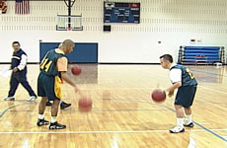

Partner Passing
Partners stand 2 meters apart with one ball between them.
- Pass the ball back and forth, working on good form (Step And Push).
- Make 10 bounce passes.
- Make 10 passes in the air.

Key Words
- Step, Push
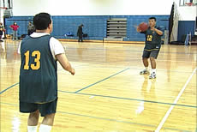

Shooting
Each athlete has a ball.
- Place ball in proper hand position.
- Bend and shoot ball overhead – Follow Through directly overhead.
- Shoot 10 times to oneself and/or to partner or wall.
- Move to basket and shoot 10 short bank shots (inside the lane at the block).

Key Words
- Follow Through
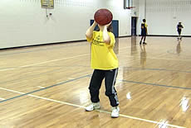

Stretching
Flexibility is a major element to an athlete’s optimal performance in both training and competing. Flexibility is achieved through stretching, a critical component in warming up. Stretching follows an easy aerobic jog at the start of a training session or competition.
- Begin with an easy stretch to the point of tension, and hold this position for 15-30 seconds until the pull lessens. When the tension eases, slowly move further into the stretch, stretching until tension is again felt. Hold this new position for an additional 15 seconds. Each stretch should be repeated four to five times on each side of the body.
- It is important to continue to breathe while stretching. As you lean into the stretch, exhale. Once the stretching point is reached, keep inhaling and exhaling while holding the stretch. Stretching should be a part of everyone’s daily life. Regular, daily stretching has been demonstrated to have the following effects:
- Increase the length of the muscle-tendon unit
- Increase joint range of motion
- Reduce muscle tension
- Develop body awareness
- Promote increased circulation
- Make you feel good

- Some athletes, such as those with Down Syndrome, may have low muscle tone that makes them appear more flexible. Be careful to not allow these athletes to stretch beyond a normal, safe range. Several stretches are dangerous to perform for all athletes, and should never be part of a safe stretching program. Unsafe stretches include the following:
- Neck Backward Bending Instead, try “Look to the right; then look to the left.”
- Trunk Backward Bending

- Stretching is effective only if the stretch is performed accurately. Athletes need to focus on correct body positioning and alignment. Take the calf stretch, for example. Many athletes do not keep the feet forward, in the direction that they are stretching.

Incorrect | Correct
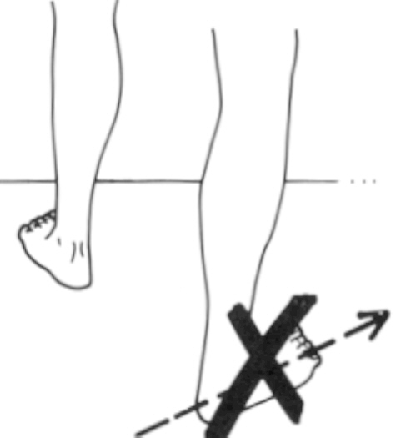
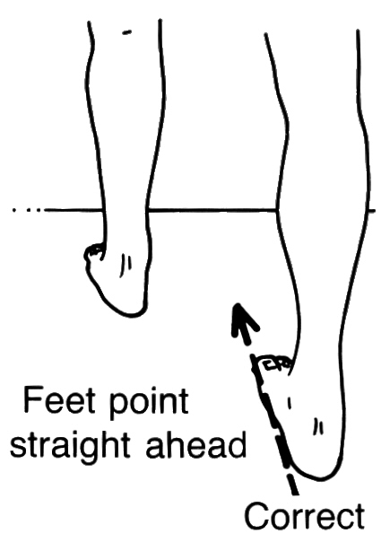

- Another common mistake that athletes make when stretching is bending the back in an attempt to get a better stretch from the hips. An example is a simple sitting forward leg stretch.

Incorrect | Correct

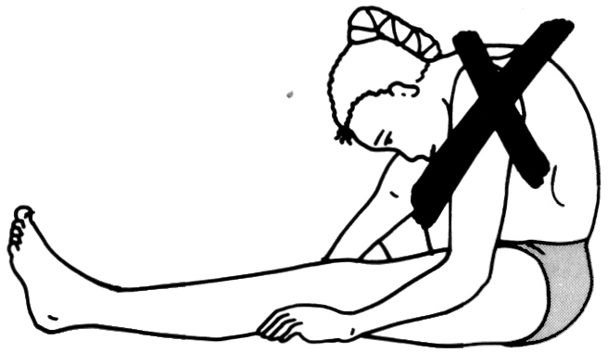

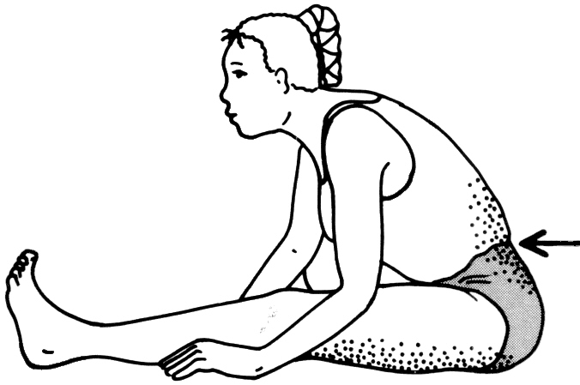

- As you can imagine, there are a host of stretches and variations of them to achieve your goals. However, we will focus on some basic stretches highlighting major muscle groups. In addition, we will also have some reminders to keep breathing while stretching. We will start at the top of the body and work our way to the legs and feet.

Upper Body
Chest Opener | Triceps Stretch | Side Arm Stretch
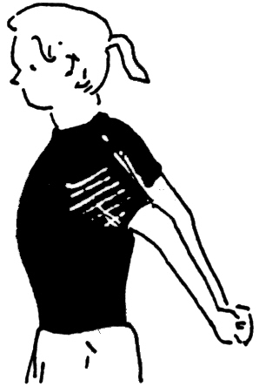 | 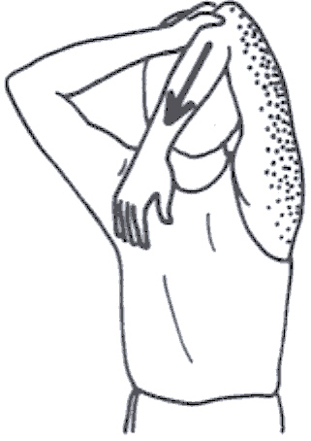 | 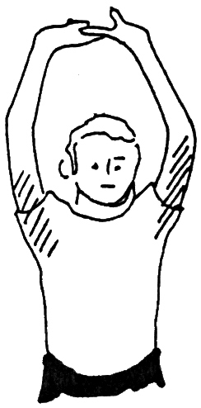
Clasp hands behind back  Palms facing in  Push hands toward sky | Raise arms over head  Bring hand to back  Pull slightly on bent elbow | Raise arms over head  Clasp hands, palms facing up  Push hands toward sky

Side Stretch | Shoulder Triceps Stretch | Shoulder Triceps w/ Neck Twist
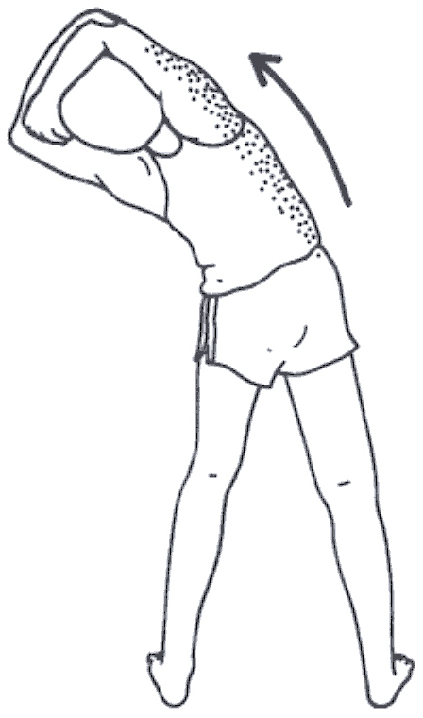 | 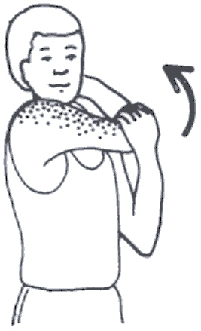 | 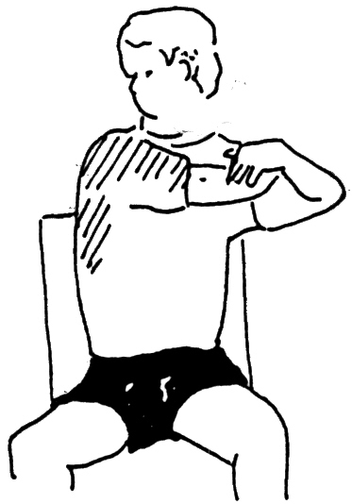
Raise arms over head  Clasp forearms  Bend to one side | Take elbow into hand  Pull to opposite shoulder | Take elbow into hand  Pull to opposite shoulder  Turn head away from elbow

Neck-Shoulder Stretch | Trunk Twist | Forearm Stretch
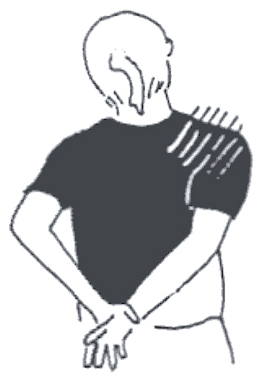 | 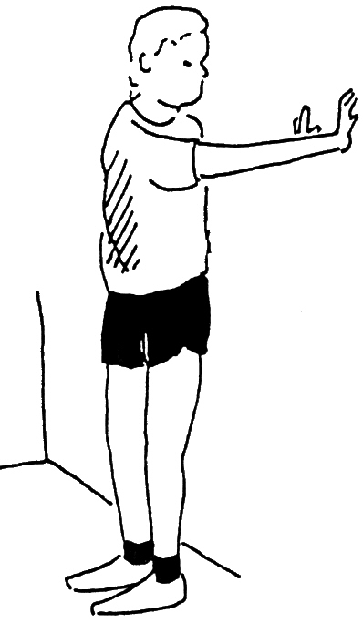 | 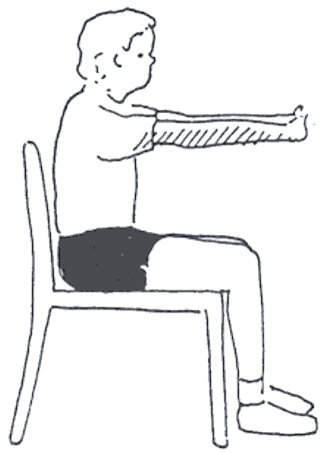
Hands behind back  Clasp wrist, pull arm down  Bend neck to opposite side | Stand with back to wall  Turn, reach palms to wall | Clasp hands in front of you  Palms out  Push out, away from body

Chest Stretch
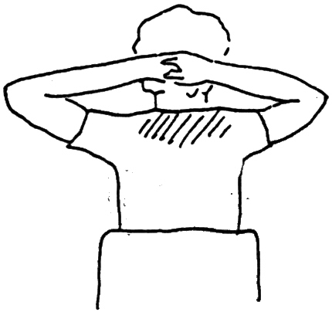 | 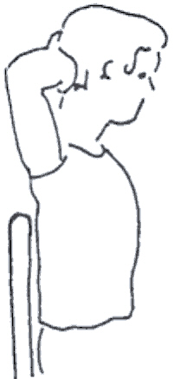
Clasp hands behind neck  Push elbows back | Side view

Low Back & Glutes
Low Back Tilts | Full Body Stretch
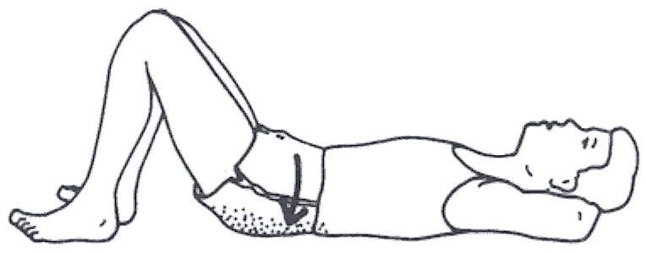 | 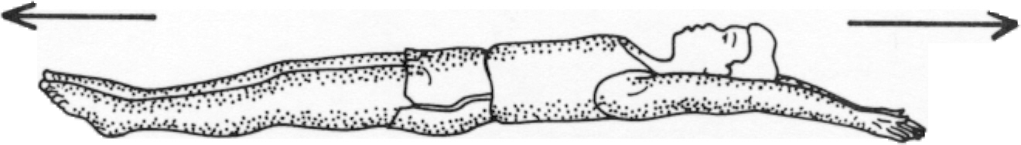
Lie on back, knees bent  Flatten small of back to ground | Lie on back, legs straight out  Reach out with both legs and arms

Groin Stretch
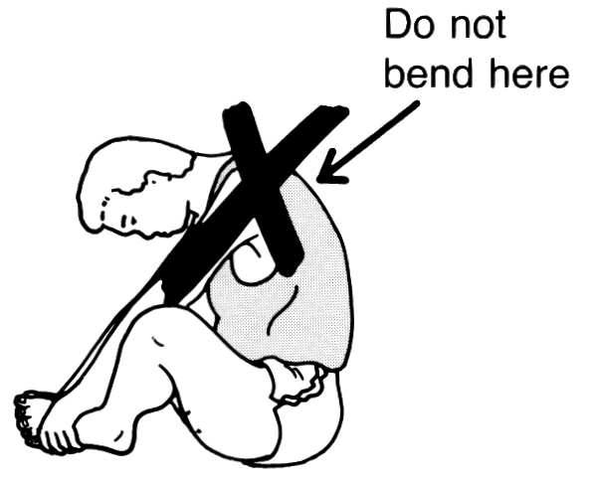 | 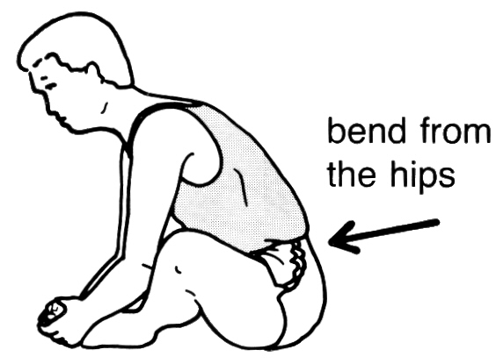 | 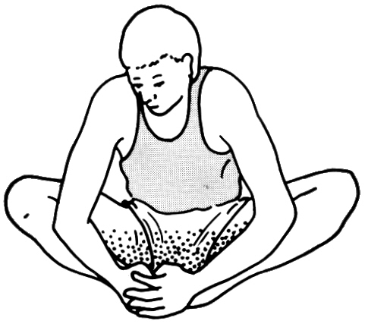
Sit, bottoms of feet touching
Hold feet/ankles
Bend forward from hips

Supine Hamstring Stretch
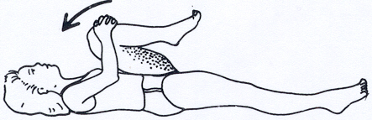
Lie on back, legs outstretched
Alternating legs, bring legs to chest
Bring both legs towards chest

Lower Body
Calf Stretch | Calf Stretch w/Bent Knee | Side Hamstring Twist
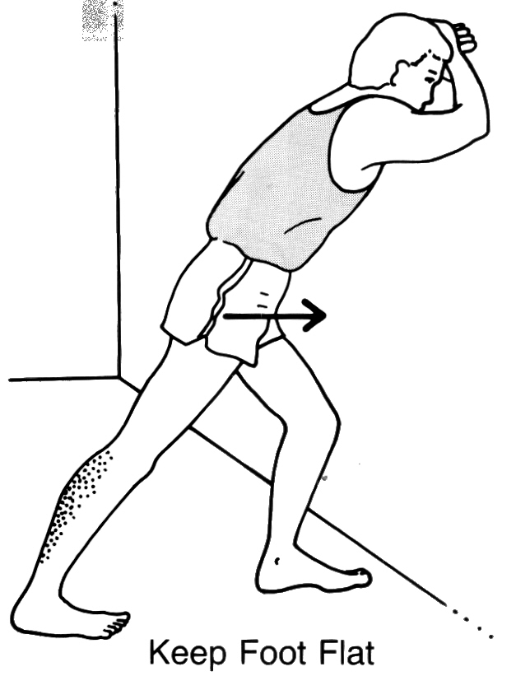 | 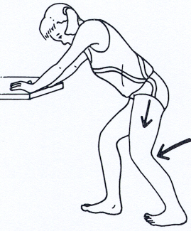 | 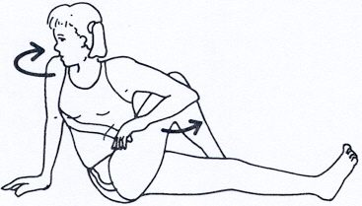
Stand facing wall/fence  Bend forward leg slightly  Bend ankle of back leg | Bend both knees to ease strain | Sitting, bring one leg over knee of other  Push bent leg with opposite elbow  Turn head in opposite direction

Hamstring Stretch |  | Seated Straddle Stretch
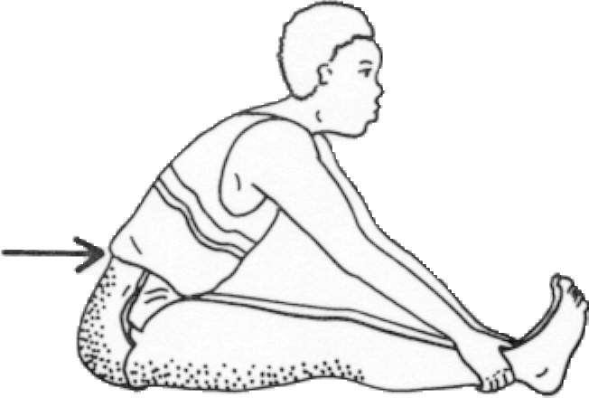 | 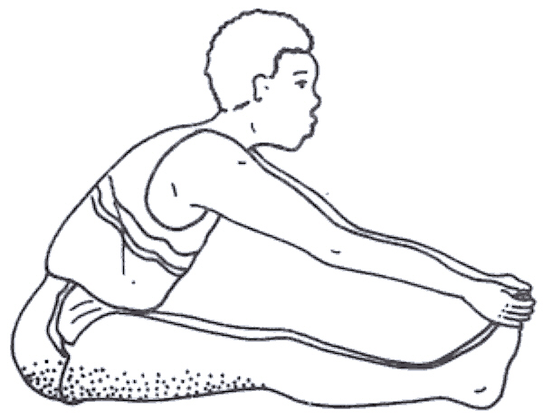  Exhale | 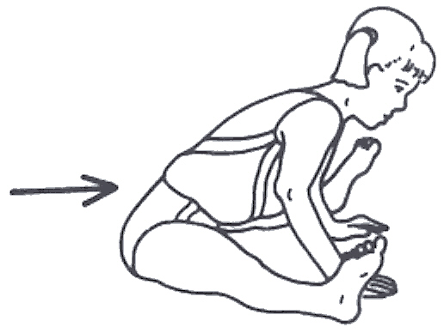
Legs straight out and together  Leg are not locked  Bend at hips, reach toward ankle | As flexibility increases, reach toward feet  Push out toward heels, forcing toes to the sky | Legs straddled, bend at hips  Reach out toward the middle  Keep the back straight

Hurdle Stretch
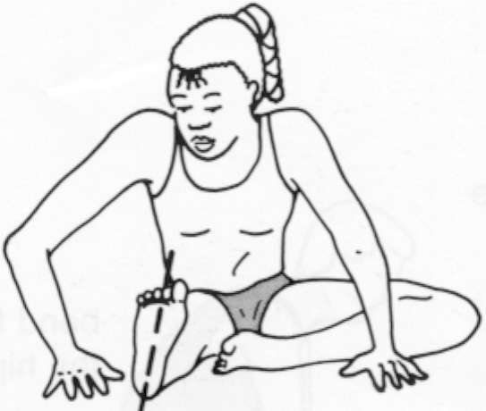 | Bend at hips
Correct alignment of lead leg is important in hurdle stretch whether you are a hurdler or not. The foot must be aligned in the forward direction of running.
Sit with legs outstretched, bend knee with bottom of foot touching opposite thigh
Toes of the straight leg are toward sky
Bend at hips in nice easy stretch

Step Ups | Standing Hamstring Stretch | Ankle Rotations
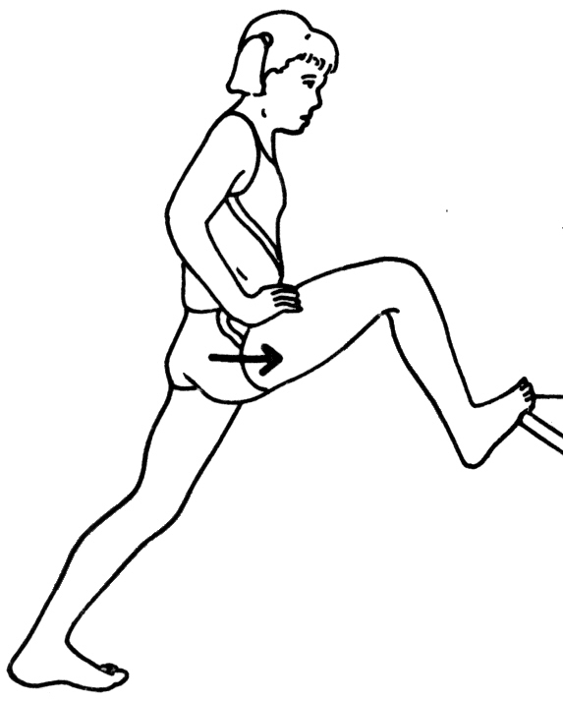 | 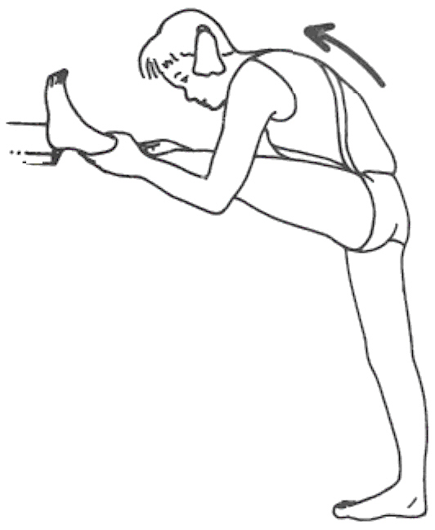 | 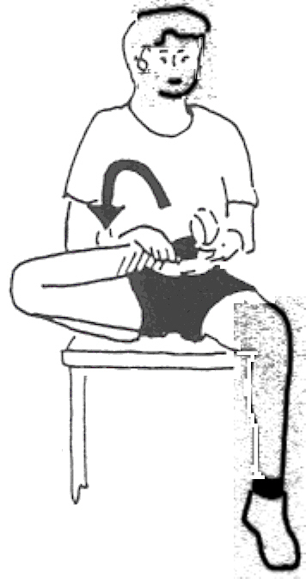
Step onto support, with bent leg  Push hips in toward support | Rest heel of foot on support  Push chest-shoulders in and up | Sitting, hold foot and ankle  Rotate ankle in both direction

Stretching - Quick Reference Guidelines
Start Relaxed
- Do not begin until athletes are relaxed and muscles are warm
Be Systematic
- Start at the top of body and work your way down
Progress from General to Specific
- Start general, then move into event specific exercises
Easy Stretching before Developmental
- Make slow, progressive stretches
- Do not bounce or jerk to stretch farther
Use Variety
- Make it fun, work same muscle using different exercises
Breathe Naturally
- Do not hold breath, stay calm and relaxed
Allow for Individual Differences
- Athletes start and progress at different levels
Stretch Regularly
- Always include in warm-up and cool-down
- Stretch while at home also

Using Plyometrics in Basketball Training
 | Plyometrics
Part of Speech: | noun
Definition: | a type of exercise using explosive movements to develop muscular power, esp. bounding, hopping, and jumping

Source: Webster's New Millennium™ Dictionary of English, Preview Edition (v 0.9.6)
Copyright © 2003-2005 Lexico Publishing Group, LLC

Basketball players might benefit from plyometric exercise to improve agility, speed, vertical leap and/or general body awareness and control.
- You do not need to schedule specific workouts emphasizing plyometric training. For basketball players, plyometric drills can be incorporated after the warm-up and preceding the main body of training. These drills should emphasize a full and smooth range of motion. Use the pre-stretch of the muscle to facilitate rapid movement, mechanical efficiency and coordination.
- As with other types of training, plyometric exercises are performed in intervals over the course of the season. Volume and intensity will vary over the course of the season. In general, the volume of plyometric exercises for basketball players will be low to moderate. The intensity also will be low to moderate.
- Begin each season with a gentle introduction to plyometric training using simple rhythm drills. As your athletes become accustomed to the exercises and their fitness grows, gradually increate volume and intensity.
- Once athletes have learned basic rhythm skills, slowly introduce power exercises. Basketball players will employ a small volume of power drills combined with rhythm exercises.
- As the competition phase of the season begins, plyometric work stresses rhythm and speed development. Once the peak competition phase starts, reduce plyometric training to one light session per week, though your athlete can continue to include plyometric drills in the warm-up. Stop any strenuous plyometric training 7-10 days before playoffs begin.

Rhythm Drills
Rhythm drills are a good method to help players develop strength through plyometrics. These drills usually follow stretching and flexibility exercises, and are done in conjunction with strength exercises, such as sit-ups and lunges. In addition, rhythm drills help players enhance both overall fitness and specific muscle development.

Types of Rhythm Drills used in Basketball Training
- Skipping – Easy
- Skipping – High
- Skipping Kicks
- Butt Kicks
- High Knees

Butt Kicks
Butt kicks are a universal drill throughout sport. They are a great drill used in basketball training to help athletes develop those fast-twitch muscles needed for the constant starting, stopping, pivoting and turning required in basketball.
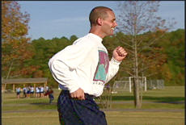
While doing butt kicks, the back is straight with a slight forward body lean. The body lean is natural as the player would assume while running.
Remember, arms are legs higher up. Encourage your athletes to keep pumping and driving them throughout the drill.

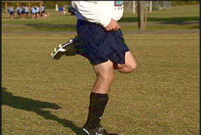

Emphasize quickness in bringing the heels to the buttocks, not in moving up the basketball court. You can even have your athletes practice the drill while stationary and add movement once they have mastered it to the best of their ability.

Aerobic Fitness for Basketball Players
Basketball requires running for extended periods of time; therefore, your players must be able to produce energy aerobically. However, although basketball players need to be aerobically fit, they do not need to be distance runners. Be balanced in your approach to fitness. Set standards, yet do not place fitness ahead of the ultimate goal of developing good basketball players and a good basketball team. A fit, skilled team is much more powerful than a fit, unskilled team. Aerobic fitness has three primary benefits::
- Creates good cardiovascular capacity and strengthens muscles and tendons
- Allows players to run at a steady pace without incurring oxygen debt, getting really tired and being unable to recover
- Allows your players to recover quickly from short sprints, making them more effective in the game

Aerobic fitness is best developed during preseason training. However, if your schedule cannot be extended to include fitness in the preseason, you can integrate fitness exercises and activities into your weekly training sessions. This can be achieved through steady pace runs, ball skill drills or fitness circuits. For more information on general fitness, please refer to the Athlete Nutrition, Fitness and Safety section in the general coaching section.

Sample Aerobic Fitness Activities

Steady Pace Runs
These runs are slow, continuous long-distance running. They can last for 20-30 minutes. You can add variety to these runs by having your players run with the ball through cones and around benches or defenders. Also, encourage athletes to run on their own at home with friends or family. Many families will welcome the invitation to involve siblings or friends in regular jogs.

Anaerobic Fitness for Basketball Players
Basketball demands both aerobic and anaerobic capacity. During games, basketball players must be able to sprint hard, recover quickly and then sprint hard again. Anaerobic training starts once your athletes have developed basic aerobic fitness, because recovery capacity is developed by increasing aerobic fitness. In basketball, the demand for anaerobic speed is relatively short. The important point here is the ability of the player to recover quickly from multiple speed bursts.

Sample Anaerobic Fitness Activities

Fartlek Runs
Fartleks, also known as speed play, are another effective tool for basketball training because theycan closely resemble the type of running during the course of a game – varied pace. Fartleks are easy to integrate in a workout. Players can jog around the perimeter of the court, jogging on one side of the court and sprinting on the other side. You can change intensity and variety by jogging two sides and running one side or running two sides and jogging one side, etc. You can mix the jog-sprint sides according to the fitness and ability level of your players.
Another variation is to have the team jog in single file around the outside of the court. At the whistle, the athlete at the back of the line sprints to the front. You can either monitor pace by blowing the whistle at faster intervals, or simply let the team monitor pace by letting the back runner know when his or her predecessor has reached the front of the line.

Shuttle Runs
Shuttle runs are a staple in basketball training. Essentially, shuttle runs are repetition or interval runs that involve numerous changes of direction. You can change the following sample shuttle run to meet the needs of your players. Just remember to keep the basics in mind when developing the run: athlete ability and fitness level.
- Run to foul line and back
- Run half court and back
- Run to opposite foul line and back
- Run to opposite base line and back
- Repeat 3-4 times

Strength Training in Basketball
Strength training is important for basketball players. The basic elements of speed, mobility and endurance are all functions of muscular strength. According to the President’s Council on Physical Fitness and Sports, improvements in absolute muscular endurance, motor ability and athletic abilities are directly associated with an individual’s muscular strength.
Strength training for basketball usually has two purposes:
- Improving overall strength
- Developing muscle balance and preventing athlete injury

Basketball requires significant anaerobic energy, which is directly related to muscle strength. Therefore, a muscle with greater strength can respond better to challenges without incurring extreme fatigue and requiring a longer recovery period. Basically, strength training improves an athlete’s ability to run fast and produce anaerobic energy. Basketball players need to be able to run fast, sometimes very fast.
The following basic strength training routine can be accomplished outside of the weight room and easily incorporated into an athlete’s home training program. For more information on circuit and fitness training, please review the Athlete Nutrition, Safety and Fitness section in the general coaching section.

Sample Strength Training Routine
- Light running to warm up
- Push-ups
- Lunges
- Sit-ups – crunches
- Medicine-ball throws (please refer to Athlete Nutrition, Safety and Fitness section for medicine-ball throw exercises)
- Overhead Toss
- Forward Toss
- Side Toss
- Straight Arm Forward Toss to Partner

Push-Ups
Push-Ups – Up Position  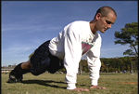 | Push-Ups – Down Position  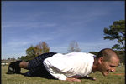 | Push-Ups with a Clap  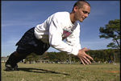

- Make sure your athletes fully extend their arms in the start position, with a straight back. They can help keep a straight back by squeezing their abdominal muscles. | - When athletes are in the down position, they want their elbows to be parallel with their shoulders. | - For variety and increased intensity, add a clap to the push-up exercise. This can help athletes test themselves and each other while working hard, yet still have fun.

Lunges

90-degree angle, thigh parallel to ground | Explode off the ground, pushing up strong from the ground
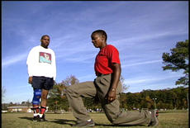
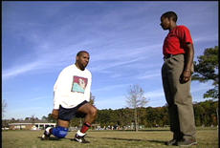

Sit-Ups

Sit-Ups – Hands Behind Neck (up position) | Sit-Ups – Crossed on Shoulders
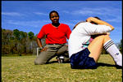
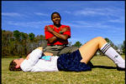
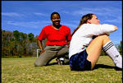

- Here the athlete squeezed the abdominals coming up, pulling with the elbows. Next time, we want to work on keeping the elbows straight out to the sides and parallel to the ground. |  | - To reduce strain on the neck, athletes can place their hands on their opposite shoulders. As long as they are squeezing the abdominals, they are achieving the same intended result – stronger stomach muscles.

Basketball Individual Skills Competition
The Ten Meter Dribble, Target Pass and Spot Shot events make up the Individual Skills Contest (ISC). The individual skills competition is designed for low-ability athletes who have not yet mastered the skills needed to participate meaningfully in team basketball. The ISC is not meant to be an additional medal opportunity for athletes already involved in team play. Each event challenges the athlete to perform skills without the pressure of a defender.

Athlete Readiness
- Athlete can dribble the ball.
- Athlete can pass the ball to a target.
- Athlete can catch the ball.
- Athlete can shoot the ball at a basket of regulation height.

Ten Meter Dribble
In the Ten Meter Dribble, the athlete dribbles the ball one-handed for 10 meters (32 feet, 10 inches). The athlete must also catch the ball after he or she crosses the finish line.

Teaching the Ten Meter Dribble
- Review the dribbling skill using proper from while dribbling in place (ball at the side of the body).
- Direct the athlete to walk forward as he/she continues dribbling the ball. The coach walks alongside, verbally encouraging and physically and verbally prompting when necessary.
- Play “Follow the Leader: The athlete follows the coach as they dribble the ball ten meters. Encourage the athlete to keep the ball low and close and to keep head up.
- Set up the Ten Meter Dribble event. Walk the lane with the athlete from start to finish.
- Direct the athlete to dribble the ball within the lane boundaries from start to finish, with the coach walking alongside. Reinforce staying within the boundaries and catching the ball once past the finish line.
- The coach now stands just beyond the finish line, encouraging the athlete at the start line to dribble toward the coach.
- Conduct the Ten Meter Dribble. The coach stands at the side and times the athlete from start to finish. Reinforce staying within the boundaries and catching the ball when past the finish line.
- Gradually remove the prompts.

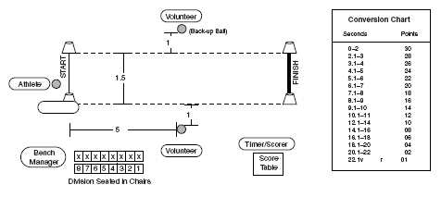

Spot Shot
In the Spot Shot, the athlete attempts two shots from six pre-determined spots. Three spots are to the left of the basket; three additional spots are to the right of the basket (basically the places around the “lane” occupied by players while a free throw is being shot). The athlete receives points for hitting the net, backboard and rim as well as making the basket.

Teaching the Spot Shot
- Place the hands in proper shooting position: two-handed set shot or one-handed shot.
- Review the shot with proper form as the athlete shoots to himself/herself and then to the coach. The coach physically prompts hand and body position. Take five shots.
- Take a position at spot #1, which is one of the two shortest shots in front and to the side the basket. The athlete bends the knees and extends using the legs to initiate the shot. Focus on the top corner of backboard’s square as the target. Reinforce powering from the legs and reaching for the corner or the target on the backboard.
- As the athlete develops strength and the ability to shoot the ball, gradually move from spot. Acknowledge a successful attempt if the net, rim or backboard are hit. Make scoring a basket exciting. Provide lots of high fives.
- Conduct the Spot Shot.
- Gradually remove the prompts.

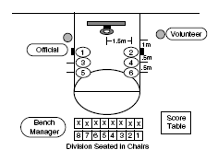

Key Words
- Bend and Extend
- Power From the Legs
- Reach For the Basket

Target Pass
In the Target Pass, the athlete passes the ball to a target that is 2.4 meters (7 feet) away. The athlete receives points according to the accuracy of his or her pass and a catch or trap.

Teaching the Target Pass
- Pick up the ball with proper hand placement (dominant hand on top, other hand on side). Coach can physically prompt as necessary.
- Push the ball (as in a dribble) forward toward the wall. The athlete is actually performing a bounce pass to the wall. The coach will initially catch the ball as it returns from the wall.
- Add a step to give more force to the pass as the athlete continues to bounce pass to the wall. Keep hand up and eyes on the ball. The passing hand’s palm will provide a target for a catch.
- Set up the Target Pass, adding the target to the wall. Step and push pass the ball to the target (inside the square), not the floor. Step and Reach For Square. The coach is still catching the ball as it comes off the wall.
- To work on the catch, face the athlete away from the wall. Physically prompt the catching position – the passing hand’s palm faces the coach with fingers up forming a target; other hand is to the side with fingers pointing to the side, and only the thumb is up. Catch a bounce pass – Feel for Ball and Gather It or Relax And Give.
- Go back to the wall; the athlete passes one ball at a time to the wall, aiming at the target. Encourage the athlete to catch the return or trap the ball against the body or the floor.
- Gradually remove the prompts.

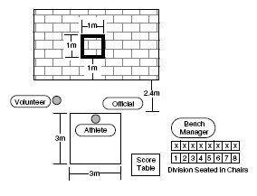

Key Words
- Step And Reach For The Square
- Relax And Give
- Keep Your Eyes On The Ball
- Look The Ball Into Your Hands

Coaching Tips
- Spend time on each event during each practice. The athlete may be at a different level of progression in each event.
- As the athlete develops skills, gradually remove the prompts but continue reinforcement and acknowledgment.
- Conduct mock competitions throughout the season, and record scores to monitor progress.
- Put these scores on a big chart in the gym so that the athletes can see their progress.

Dribbling
Dribbling is one of the most fundamental skills that must be learned. Not only is it important to learn how to dribble well, but it is also important to know when, and when not, to dribble. To become a good dribbler and ball handler, you must practice dribbling as often as you can, using both hands.

Skill Progression – Dribbling
Your Athlete Can | Never | Sometimes | Often
Attempt to dribble a basketball in any manner
Dribble the ball in any manner at least three bounces in a row
Dribble a ball with one hand more than three bounces in a row while standing in place
Dribble the ball with the opposite hand more than three bounces in a row while standing in place
Dribble the ball with one hand, then the other hand, three bounces in a row each, without stopping, while standing still
Dribble the ball with one hand while walking forward ten steps
Dribble the ball with one hand while running forward 20 steps
Dribble the ball with either hand while moving in any direction (forward, backward or sideways)
Dribble the ball with either hand while moving in any direction while protecting the ball from a defender

Totals

Teaching the Dribble

Key Words
- Feel for the Ball
- Head Up
- Protect

Faults & Fixes Chart – Dribbling

Error | Correction | Drill/Test Reference
Athlete pushes the ball too far out to make contact on the bounce to continue the dribble. | Start with dribbling in place, controlling the bounce and meeting it with your hand. | Stationary Dribbling
Athlete slaps at the ball at the top of the dribble. | Remember to have your hand low and feel for the ball as it comes back up off the floor. | Stationary Dribbling with partial coach assist. Coach can simulate the ball bounce to help the athlete feel meeting the ball and then pushing rather than slapping it back down.
Athlete watches the ball when dribbling. | Keep your head up and look occasionally for the rim. | Give the athletes a spot on the wall in front of them to focus on.
Athlete doesn’t “protect” the ball. | Practice keeping your body between the ball and the defender. | Protect the Ball While Dribbling
Athlete takes too many dribbles. | Push the ball out from the waist more and run after it. | Dribble While Moving or  Dribble and Slide
Athlete loses balance on the forward foot, causing the pivot foot to drag (travel). | Hop before you stop and land with feet shoulder width apart, with your head up. | Practice the Bunny Hop!
Athlete dribbles too high or wide to control the ball when changing direction. | Practice dribbling at knee height: stationary and then moving and changing direction. | Dribble and Slide

Coaches’ Tips for Basketball – At-A-Glance

Tips for Practice

- Assist the athletes by letting them put their hands on top of yours to feel the rhythm of dribbling. Start by using guided discovery. Allow the athlete to feel the roundness of the ball, the dimples and the weight. Ask the athletes what the ball feels like.
- Ask them to drop the ball and catch it. Direct them to place the ball on the floor, the dribbling hand on top, and the other hand to the side and almost under the ball. In this way, when the ball is picked up, it is in proper position for them to begin and continue dribbling.
- When dribbling the ball, the lower the bounce, the easier the control. Dribble the ball three times and pick it up.
- Reinforce proper position of hands, head and body.
- Practice each hand separately. Conduct a mini competition to see if the athletes can keep the ball dribbling for 15, 30, 45 and 60 seconds.

Dribbling Drills
For athletes with lower ability who have little experience dribbling, who dribble a ball with a flat hand or in the palm, or who dribble with two hands on the ball, use the following drills:
Key Words
- Feel for the Ball
- Head Up
- Protect

Stationary Dribbling
Perform while standing in place or simply moving with the ball.
Reps: Three sets of ten dribbles with each hand

Purpose of the Drill
- Develop ability and confidence in dribbling
- Teach athletes that once they catch a ball they have been dribbling, they must pass it

Steps
- Start dribbling with one hand only and count out loud to ten with the right hand and then to ten with the left hand.
- If the athlete has to catch the ball with both hands to control it, he or she must then pass it to the coach or another player (this prevents a “double dribble” call)
- The coach or other player then passes the ball back to the athlete to begin again.
- This may also be done in a circle with several athletes. Each time an athlete either completes 10 dribbles with each hand OR has to catch the ball with two hands, that athlete passes to another player in the circle.

Stationary Dribbling in Multiple Positions
Perform while standing, then kneeling, and finally sitting.
Reps: Three sets of ten dribbles in each position with each hand

Purpose of the Drill
- Develop ability and confidence in dribbling
- Develop ability to switch hands while dribbling

Steps
- Start dribbling and count out loud to ten with the right hand and then to ten with the left hand.
- Then keep dribbling as you kneel on the floor (ten with the right and ten with the left hand).
- Then move from kneeling to sitting on the floor and count to ten again with each hand.

Dribbling while Moving Forward
Reps: Two round trips; each round trip is from baseline to the far baseline and back

Purpose of the Drill
- Develop skill of controlling and protecting the ball while moving
- As confidence grows, the athlete can add speed to the dribble as well as the skill of stopping

Steps
- Stand in place and dribble the ball three times.
- Push the ball slightly forward and walk forward.
- Keep head and eyes looking forward, not down.
- Gradually add speed and more forward push to the ball.

Alternate Hands 5-4-3-2-1-Dribble
Reps: Three sets of 5-4-3-2-1 as described below.

Purpose of the Drill
- Practice switching dribbling hands
- Developing body and ball awareness as the ball shifts from side to side

Steps
- Stand in place and dribble the ball five times.
- Bounce the ball in front of the body and over to the other hand.
- Dribble the ball five times with the other hand.
- Bounce the ball back over to the first hand and perform four dribbles with each hand, without stopping.
- Repeat the pattern, each time doing one fewer dribble on each side.
- Once this is mastered, you can have athletes reverse the process and increase the number of dribbles on each side back up to five.

Dribble and Slide
Reps: Two to three rounds of 30-60 seconds per practice

Purpose of the Drill
- Practice dribbling and moving the ball intentionally
- Practice keeping focus on other players instead of the ball while dribbling

Steps
- Each player has a basketball and lines up with space between players, but so all can see the coach.
- Players start dribbling in place.
- The coach now uses arm movements (think airline stewards showing where the exits are on a plane) to direct the group to move left, right, to the back and to the front.
- For fun, try a diagonal or a snaking pattern back – have fun with the hand signals!
- Make sure athletes are using correct footwork and are keeping knees bent and heads up.

Mini-Basketball: Dribbling Tag
Reps: Two to three rounds per practice

Purpose of the Drill
- Practice dribbling and protecting the ball
- Practice trying to legally steal the ball from an opponent

Steps
- The group is divided into no fewer than two teams of two athletes each.
- Each player has a ball and wears a scrimmage vest for team identification.
- The area of the court depends upon the size and ability level of the group. The lower the ability level, the fewer the athletes. If there are two athletes, a jump ball circle can be used. If there are four to six athletes, the area inside the three-point arc and baseline can be used.
- The coach signals the athletes to begin dribbling. Each athlete must keep the ball bouncing and protected while trying to tip an opponent’s basketball away or outside the arc and the baseline.
- If anyone stops his/her dribble, or the basketball goes outside the boundaries, those athletes are out of the game.
- If a foul occurs, the ball handler stays and continues playing while the opponent is out of the game.
- Play Dribble Tag for 1-2 minutes.
- The team with the most athletes left dribbling inside the arc at the end of the time period wins.
- A best-of-three game series can be played to heighten competition.

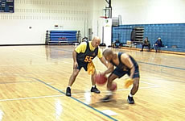

Hot Griddle Dribble
Reps: Two trips up and down the length of the court, stopping at the free-throw lines (extended), half court line and base lines.

Purpose of the Drill
- Practice changing from speed dribble to stationary dribble
- Practice keeping balance and setting up fake move or pass from a dribble

Steps
- Start at the base line and fast-dribble up to the first free-throw line.
- At that line, stop running and keep the dribble alive.
- While stationary at the stopping point, start moving your feet quickly up and down, in place (as if on a hot griddle).
- Hold that movement for 10 seconds and move on to the mid court line and repeat.
- Repeat again at the other free-throw line and then again at the far baseline.
- Turn around and repeat on the way back.

Protect the Ball While Dribbling
Reps: Two to three rounds with a coach

Purpose
- Practice dribbling and protecting the ball
- Practice moving while keeping the ball from an opponent

Steps
- Have athletes work one-on-one with a coach or assistant.
- Athlete starts dribbling in place.
- Coach takes the unprotected ball to show what we do NOT want to happen.
- Coach instructs athlete to keep his/her body between the ball and the defender, with an arm bent to further shield the ball.
- Now the coach moves around while the athlete continues to dribble, making sure the athlete moves the body to keep it between the ball and the coach.
- Finally, the athlete is instructed to move forward and back or side to side while keeping the ball protected.

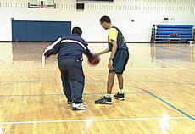 |  | 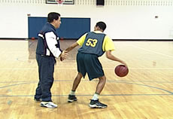

Passing

Skill Progression – Passing
Your Athlete Can | Never | Sometimes | Often
Attempt to pass a basketball
Pass the ball in any manner and in any direction
Pass the ball in any manner to an intended target
Make a two-handed chest pass in any direction
Make a two-handed chest pass to an intended target
Make a bounce pass to an intended target
Make a two-handed overhead pass to an intended target
Make a lob pass to an intended target
Make a baseball pass to an intended target
Participate in team passing drills

Totals

Faults & Fixes Chart – Passing

Error | Correction | Drill/Test Reference
Chest pass is too soft. | Start with elbows close to your body and push your wrist and fingers through the ball. | Target Pass
Bounce pass is too high and too slow. | Start with the ball at your waist and aim for a bounce spot closer to your teammate. | Modify the Target Pass to be a Bounce Pass. Target can be on the floor for bounce or the wall for a target.
Overhead pass is too soft. | Make sure the ball is over your head and not behind it when you start. | Passing Under Pressure
Passes are off target. | First two fingers of each hand should be pointing to the target/person at the end of the pass. | Target Pass

Coaches’ Tips for Basketball – At-A-Glance

Tips for Practice

- Assist an athlete with lower ability by standing behind him or her. Put your hands over the athlete’s hands and guide the athlete through the chest pass motion.
- Mark a target on a wall and ask the athlete to chest pass the ball to the target. Gradually increase the distance between the athlete and the wall as the athlete’s skill increases. Progress to starting at the same spot and asking the athlete to chest pass the ball to targets placed in several different locations, at varying heights and distances.
- Demonstrate passes that bounce before, on and well beyond the halfway spot.
- Allow the athletes to experiment with both short and long bounce passes to teammates standing at various distances.
- Encourage games of “tips” or just “catch,” to give athletes practice handling the ball.
- Encourage families to play passing games at home between practices.

Passing & Catching Drills
For athletes who have lower ability, impairments or a fear of the ball, start by using the following drills.

Key Words
- Look – Pass Through the Open Door
- Step and Push
- Give a Target
- Move to Get Behind the Ball
- Relax and Give
- Protect

Target Pass (Individual Skill Competition – but can also be used as a drill)
In the Target Pass, the athlete passes the ball to a target that is 2.4 meters (7 feet) away. The athlete receives points according to the accuracy of his or her pass and a catch or trap.

Teaching the Target Pass
- Pick up the ball with proper hand placement (dominant hand on top, other hand on side). Coach can physically prompt as necessary.
- Push the ball (as in a dribble) forward toward the wall. The athlete is actually performing a bounce pass to the wall. The coach will initially catch the ball as it returns from the wall.
- Add a step to give more force to the pass as the athlete continues to bounce pass to the wall. Keep hand up and eyes on the ball. The passing hand’s palm will provide a target for a catch.
- Set up the Target Pass, adding the target to the wall. Step and push pass the ball to the target (inside the square), not the floor. Step and Reach For Square. The coach is still catching the ball as it comes off the wall.
- To work on the catch, turn the athlete to face away from the wall. Physically prompt the catching position – the passing hand’s palm faces the coach with fingers up forming a target; other hand is to the side with fingers pointing to the side, and only the thumb is up. Catch a bounce pass – Feel for Ball and Gather It or Relax And Give.
- Go back to the wall; the athlete passes one ball at a time to the wall, aiming at the target. Encourage the athlete to catch the return or trap the ball against the body or the floor.
- Gradually remove the prompts.

Key Words
- Step And Reach For The Square
- Relax And Give

Loose Ball Recovery
Reps: Each athlete gets three times at the front of the line.

Purpose of the Drill
- Develop visual tracking skill
- Teaches “move to the ball”

Steps
- Coach divides athletes into as many equal-ability groups as there are coaches or assistants.
- Athletes in each group line up one behind the other.
- The coach instructs first athlete to Give A Target and be ready to move.
- The coach rolls or bounces the ball to the left or right of the athlete.
- The athlete moves to get behind the ball, catches it, passes it back to the coach, and returns to his/her position.
- Drill is repeated so that each athlete gets three to five attempts before going to the end of the line.
- The emphasis is on movement and tracking.
- Each athlete has an individual goal of recovering more than he/she did each previous time.

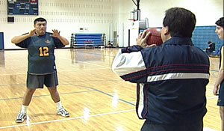

Key Words
- Move to Get Behind the Ball
- Go Get the Ball
- Give a Target

Passing under Pressure (Keep away)
Athletes with average to moderate ability – who can move to get behind the ball and can catch pass the ball – who are now ready for this drill.
Reps: Three rounds of 1- to 2-minute games

Purpose
- Develop quick passes to avoid steals
- Teaches players to move to get open for a pass

Steps
- The coach divides the group into pairs.
- Partners stand the width of the lane apart, facing each other.
- Passing and receiving are practiced using all passes: chest and one-handed bounce passes plus one-handed and overhead passes.
- A defender is added to each group.
- The ball starts with one teammate versus the defender.
- The athlete with the ball looks for the OPEN DOOR and passes to his/her teammate.
- If the pass is not deflected or stolen, the defender turns and moves to defend against the athlete who has the ball.
- When the defender makes a steal or deflects the ball, he/she becomes a teammate passer.
- The person whose pass was deflected or stolen becomes the next offensive teammate.
- Drill continues for 1-2 minutes.

Key Words
- Look for the Open Door
- Give a Target
- Move to Get Behind the Ball

Mini-Basketball: Two-on-One (in the backcourt)
The focus is on passing and catching as well as moving to get open. It is not on shooting. As the skill level increases, the defender can try to score after a steal. The offense attempts to recover and defend. The drill now becomes a transition drill as well as a skill drill.
Reps: One round of two to three possessions for each team

Purpose
- Develop teamwork and movement against a defender
- Teaches moving the ball up the court

Steps
- The coach pairs the athletes into equal teams. (Each team of two has one better athlete and one weaker athlete.)
- Two offense athletes and two defenders are at the end line.
- The coach stands near them and gives the ball to the offense (team A).
- The goal is for the offense to get the ball to the division line without it being stolen or turned over.
- One of the other two athletes (team B) becomes a defender – he/she takes a position between the players on offense on the court.
- As players advance the ball, the coach follows the play, verbally and physically prompting when necessary.
- As soon as the defense steals the ball, the coach calls the athlete’s name, and the athlete throws the ball to the coach.
- Count the number of successful passes.
- Each team will have two to three possessions.
- Team with highest number of successful passes wins.
- The rotation is defense/rest off court/offense/defense/etc.

Mini-Basketball: Two-on-Two (in the backcourt)
The above drill can be made more challenging when it is two-on-two in the backcourt. The offense is challenged to move more effectively to get open as well as to advance the ball. As the skill level increases, the defenders can try to score after a steal. The offense attempts to recover and defend. The drill now becomes a transition drill as well as a skill drill.

Steps
- Two defenders take positions between offenders at the division line.
- The drill is conducted as above.

Partner Pass
Reps: Three trials of 30 seconds each

Purpose
- Developing accurate and fast passes
- Teaches teamwork

Steps
- Divide athletes into teams of two – keeping athletes of similar skill together.
- One athlete has a ball and is positioned a set distance from a partner.
- The first athlete chest passes the ball to partner.
- The second athlete steps up to catch the pass and immediately passes it back to the partner.
- The first athlete steps up to catch the pass and bounce passes it back to the partner.
- This repeats as long as the athletes can keep the passes going while alternating pass types (bounce, chest, overhead, one-arm).

Partner Pass and Dash
Reps: Three trials of 30 seconds each

Purpose
- Developing accurate and fast passes
- Teaches athletes to move out after a pass and to move in to catch a pass
- Develops proper footwork for sliding into and away from plays
- Teaches teamwork

Steps
- Divide athletes into teams of two – keeping athletes of similar skill together.
- One athlete has a ball and is positioned a set distance from a wall (9-12 feet is recommended).
- The second athlete is positioned immediately behind the first.
- The first athlete chest passes the ball to the wall and immediately slides to the right.
- The second athlete steps up to catch the pass and immediately passes it back to the wall and slides to the left.
- The first athlete slides back to the center to catch the pass, passes it back to the wall and then slides to the left.
- This repeats as long as the athletes can keep the passes going while alternating sliding to the right and then left after each pass.

Teaching Two-Handed Bounce Pass
- Hold a basketball with both hands, at chest height and under the chin.
- Position the hands at the side of the ball, fingers pointing to target and thumbs behind the ball.
- Step forward with one foot toward the intended target.
- Extend elbows and push the ball forcefully toward a spot on the floor halfway to the target.
- Release the ball by snapping hands forward so the palms face out and the thumbs point toward the floor.
- Follow through toward the spot; track the ball to the target.

Key Words
- Step and Push
- Follow Through

Coaching Tips
- For athletes with lower ability, mark a spot on the floor that is halfway between two athletes facing each other. Have the passer aim at the spot so it will bounce up to the height of the other athlete’s chest.

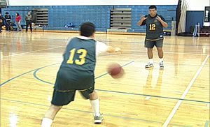

Teaching Two-Handed Overhead Pass
- Hold a basketball with both hands above the head.
- Step forward toward the target.
- Move the forearms forward and pass the ball toward the target.
- Release the ball by snapping the hands and arms forward.
- Follow through with the palms turned out and the thumbs pointed down.

Key Words
- Step and Push
- Follow Through

Coaching Tips
- Explain that this pass is used to pass over an opponent who is pressuring the athlete. Let the athlete practice the overhead pass over an opponent who is standing with arms and hands up in front of the passer.

Teaching One-Handed Pass
- Hold the basketball in dribbling position, with one hand on top of the ball and the other on the side.
- Pick up the ball and place it to the side of the body.
- Rest the elbow of the passing hand near the hip; the passing hand is behind the ball.
- Step forward toward the target.
- Release the ball by snapping the passing hand toward the target.

Key Words
- Step and Push
- Hand Behind
- Open Door
- Follow Through

Coaching Tips
- Explain that this pass is used to pass around an opponent who is pressuring the athlete. The ball is protected with the body, slightly turned away from the defender, and with the opposite arm, elbow out. The athlete looks for the Open Door and then passes through it.
- The pass can be an aerial pass or a bounce pass.

Catching
While catching is obviously part of the passing skill (it isn’t a good pass if it isn’t caught!), here are some tips to break down the catching skill for instruction.
Your Athlete Can | Never | Sometimes | Often
Attempt to catch a basketball in any manner
Catch the ball in any manner
Catch a bounce pass in arms and chest
Catch a bounce pass with hands only
Catch a chest pass in arms and chest
Catch a chest pass with hands only
Attempt to catch a pass in any manner while moving
Catch a pass in any manner while moving
Catch a pass with hands only, while moving

Totals

Teaching Catching

Key Words
- Get Behind the Ball
- Give a Target
- Catching the Egg
- Relax and Give with the Ball

Coaching Tips
For athletes with lower ability, impairments or fear of the ball, the following progression is recommended:
- Begin by bounce passing the ball to the athlete from a short distance. A softer ball can also be used.
- Work on getting the athlete to move his or her feet so that the athlete gets behind the oncoming ball. The ball can be trapped with arms and chest. Progress to catching the ball with the hands only. Then catch an aerial pass.
- Some athletes, because of other impairments, may never be able to catch an aerial pass. If they have tunnel vision or are extremely small, the best throw to them is either a bounce pass or a rolling-the-ball pass.
- Regardless of the height of the pass, the receiver’s hands are at the level of the pass with palms facing forward.

Key Words
- See the Ball
- Slide

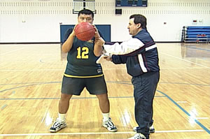

Shooting
Shooting is the most important skill in basketball. To win, you have to score points. All the other skills are tools a team uses to get the ball and its players into position to score. If your athletes can develop confident, accurate shooting skills, they will be hard to stop on the court!
Your Athlete Can | Never | Sometimes | Often
Attempt to shoot a basketball in any manner
Hit the backboard with a one-hand set shot
Make a basket with a one-hand set shot
Hit the backboard on a lay-up attempt
Make a basket on a lay-up attempt
Hit the backboard with a jump shot
Make a basket with a jump shot

Totals

Faults & Fixes Chart – Shooting

Error | Correction | Drill/Test Reference
Mechanics are correct but athlete still misses. | Watch athlete’s eyes to make sure he or she is keeping eyes on the target while shooting. | Rapid Fire Shooting with a focus on “spotting” the basket before shooting
Athlete lowers the ball while flexing the knees, lengthening the shooting stroke and making it easier to block the shot. | Remind athlete to keep the ball high and move only the legs during the down and up part of the shot. | Shoot to Self
When athlete jumps at the end of the shot, he or she drifts off balance and misses. | Have athlete work on jumping and landing on the same spot of the floor. | Jump Shot Drill
Shot is short of the basket. | Make sure athlete is using the legs to start the shot and isfollowing through. | Start with a lower basket and move up.
Athlete is slow to shoot after receiving a pass. | Have athlete practice being in a shooting position (knees bent) when receiving a pass, and immediately turning to shoot. | Rapid Fire Shooting

Coaches’ Tips for Basketball – At-A-Glance

Tips for Practice

- It is important that the athlete feels power for the shot coming from the legs. The movement sequence begins with the knees and is followed by the elbow, wrist and fingers. Physical prompting may be needed to assist the athlete in preparing for the shot as well as shooting it. Proper hand placement on the ball is critical.
- Younger athletes can practice by shooting to a partner, at a target on the wall or at a lower basket. Demonstrate putting an arc on the shot by lifting the shooting hand’s elbow so the ball has a better chance of going into the basket. Explain that it is best to use the backboard. The backboard softens the shot and allows a greater margin for error.
- Demonstrate lay-up; then have the athletes practice the motion without a ball while facing, but positioned away from, the basket. Practice jumping off one foot and landing on two feet. Instruct the athletes step by step through pretend shooting and landing.
- Repeat sequence with a ball before actually shooting a lay-up at a basket. The lay-up can also be done from a two-foot jump.
- Practice the motion of the shot without jumping and without the ball. Next, practice the motion of the shot with jumping but without the basketball. Finally, add and complete the jump shot.
- Use an adjustable basket with backboard to help athletes build confidence in their shooting ability. Remind the athlete to lift his/her elbow to put arc on the shot so that it has a better chance of going into the basket.
- Set up an imaginary wall (hanging a blanket or using an opponent with hands up) above which the athlete must jump in order to see the basket and shoot the ball. Practice the jump shot close to the basket and banking it off the backboard, gradually increasing the distance and using only the rim as a focus.

Shooting Drills
Use the following drills for athletes who are young, small or beginning basketball players.

Key Words
- Bend and Extend
- Follow Through (Gooseneck)

Shoot to Self - Shoot to Wall - Shoot to Partner
Reps: Three sets of ten shots each to self and wall
Purpose of the drill: To master the technique of using the whole body from bottom to top in each shot: Start with a balanced stance, then bent knees, then smooth motion up through back, shoulders and shooting arm; finally, let the ball roll off finger pads and follow through with the shooting hand.

Steps
- Focus on good form, not on the basket.
- Place ball in proper shooting position in hands and up to face.
- Bend legs and then extend them while shooting above head.
- Knees, elbow, wrist and hand extend in sequence.
- Follow Through.
- Shoot ten to self; then shoot ten to wall or partner.
- Emphasize good form.

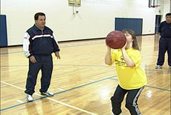 |  | 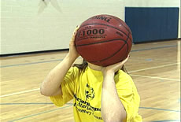
 |  | 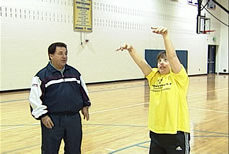

Teaching a One-Handed Set Shot
- Hold the ball in good dribbling position.
- Bring the ball up to the shooting position. The shooting hand is behind and slightly under the ball; the non-shooting hand is to the side of the ball; thumbs are up and apart from one another.
- Face the basket and look over the ball, focusing on the target.
- Keep the shooting-side leg slightly forward.
- Bend knees; lift elbow and extend shooting arm toward basket.
- Release the ball by snapping the shooting hand down, rolling the ball off the fingertips to impart lift and backspin to the ball.
- During this Follow Through, hand and arm form a Gooseneck.

Key Words
- High
- See the Basket over the Ball
- Follow Through (Gooseneck)

Teaching a Lay-Up Using the Backboard
- Face the front of the backboard and stand two steps away and to the right of the rim for a right-handed shooter.
- Pick the ball up to chest height in proper shooting position.
- Sight the target over the ball. Focus on the top right corner of the square on backboard for a right-hander.
- Step forward onto right foot, then left foot.
- Raise the shooting-side knee as the ball is lifted to the forehead.
- Extend body toward basket off left foot.
- Gently lay the ball up against the backboard on the top right corner of the square.
- Land on both feet under the backboard.

Key Words
  - Softly Lay the Ball Up On the Backboard
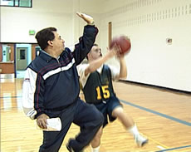 |  | 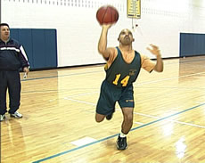

Coaching Tips
- For lower ability athletes, a step leading to a two-foot takeoff gives more power and body control. Mark the top corners of the square on the backboard with red tape. Left-handed athletes approach the basket on the left side. They start by stepping on the left foot, then the right foot as they raise the left knee and ball, preparing to shoot. Once the motion and shot can be performed, practice approaching the lay-up from a walking dribble, from a running dribble and from receiving a pass.

Teaching Shooting a Jump Shot
- Hold the basketball in proper hand position (shooting hand is behind and slightly under the ball, non-shooting hand is on the side of the ball supporting it).
- Face and focus on the basket.
- Bend knees slightly.
- Raise the ball above forehead (shooting-hand side of head) as the legs extend, and jump straight up off feet.
- Release the non-shooting hand from the ball as the ball is shot toward the basket (elbow, wrist and hand extend in rhythmical sequence).
- Land on the floor and track the ball to the basket.

Key Words
- Bend and Extend
- Reach For Basket
- Up - Shoot

Shoot to Lower Basket, then at Regular Basket
Athletes with average to moderate ability – can move to get behind the ball and can catch/pass the ball – are now ready for this drill. As skills improve, the coach increases the demand:
- The coach places the basketball on the floor for the athlete, who picks it up, brings his/her shooting-side leg under the ball, places the ball in front of the face, and shoots.
- The coach bounce passes the ball to the athlete, who takes one step to catch it, brings his/her shooting-side leg under the ball, places the ball in front of the face, and shoots.
- The coach chest passes the ball to the athlete, who takes one step to catch it, brings his/her shooting-side leg under the ball, places the ball in front of the face, and shoots.
- The coach varies passes to the athlete, who takes one step to catch the ball, brings his/her shooting-side leg under the ball, places the ball in front of the face, and shoots.

Reps: Three shots per athlete in line; go through the line three times

Purpose
- Improve shooting technique through repetition
- Improve quickness in shooting

Steps
- Line up two to four athletes behind one another at the side of the basket.
- Hand the ball to first shooter, making sure that the athlete receives it in proper hand placement.
- The athlete brings the ball up to the face and shoots it.
- Each athlete takes two to three shots, then rotates to the end of the line.
- While in the line, each athlete holds a pretend ball and mimics the shooter.

Rapid Fire Shooting
For athletes who can shoot, use the following drills that add more movement. Make sure the shooter turns to face the basket before shooting. On the turn, the ball is brought up to the face into proper shooting position. This drill can be done at any spot. For example, if the athlete shoots from in front of the basket, the passer is at the side. The rebounder is always underneath. In addition, the rebounder does not always have to be a coach; for a team drill, have athletes rotate to all positions; shooter to rebounder to passer to shooter, etc.

Steps
- One athlete (the shooter) is within his/her shooting range to the side and 1-2 meters from and facing the basket.
- Another athlete (the passer) is at the middle of the free-throw line or at the top of the key.
- Coach, or another athlete, is under the basket with back to basket (the rebounder).
- The rebounder and the passer each have a basketball.
- Passer bounce passes ball to the shooter.
- As soon as the passer passes his/her basketball, the rebounder calls the passer’s name and passes to the passer.
- The shooter shoots, and the rebounder rebounds the shot.
- Rebounder always rebounds; only the passer passes to the shooter; the shooter continues shooting for 30-45 seconds.
- After the time period, the athletes rotate to the next position in the triangle.
- Count how many shots are made, and record individually.

Key Words
- See the Basket
- Down and Up
- Follow Through (Gooseneck)
- Step and Push
- Pass to the Target
- Bounce Pass

Two-Ball Lay-up or Power Up
A higher ability athlete can be the re-bounder. This rebounding position demands focus on the ball, movement to the ball, recognizing the vacant block and replacing one ball while changing focus to one being shot.
Reps: Each athlete has two or three (depending on ability and interest) attempts of 30 seconds each

Purpose
- Quick positioning and setting of shooting stance
- Practice shooting from the post

Steps
- Two basketballs are placed on the floor, one on each block.
- Coach or higher ability athlete rebounds under the basket and with back to basket.
- Shooter stands inside the lane, bends down, picks up one ball, brings it up to shooting position and then shoots the ball.
- After shooting the ball, the shooter runs across the lane, picks up the other ball, turns to face the basket, brings the ball up to shooting position and then shoots this ball.
- Rebounder chases and rebounds each basketball shot and replaces it on the vacant block.
- Continue drill with the shooter moving and shooting from side to side for 30-60 seconds.
- Count the number of shots made, and chart for individual improvement comparisons.

Mini-Basketball: Shooting under Pressure
This is a team-against-the-defender drill. The amount of pressure is geared to the ability of each athlete. A coach or volunteer can do this better than another athlete. Plus, the coach does not want to set up a drill that goes against what he/she is teaching. For example, a teammate would never pass and then defend another teammate. In addition, the coach can change to different shooting positions on the floor.

Reps: Three rotations of 60 for each three- to four- person team

Purpose
- Develop confidence in shooting over a defender
- Improve quickness in shooting

Steps
- Two to three equal ability athletes are at each basket.
- One athlete is the shooter, who takes a position within shooting range to side and front of the basket.
- Other athletes line up behind the shooter.
- Coach is passive defender.
- The coach starts the drill by bounce passing the ball to the shooter.
- Shooter steps to receive it, brings shooting side leg under the ball, then brings the ball up to shooting position and shoots the ball over “hands up” type pressure from the coach.
- Shooter follows for the offensive rebound and shot, then goes to the end of the athletes’ line.
- Coach repeats the drill with each of the other athletes, one at a time.
- Count how many baskets each team makes in 60 seconds. Repeat drill, trying to improve on team scores.

On Your Back Shooting
Reps: Two 30-second trials – or time how long it takes to get 5 in a row

Purpose
- Perfect technique of having shooting hand behind the ball and proper elbow/shoulder alignment
- Work on release over fingertips and follow through
- Practice catching the ball as it returns and getting lined up to shoot again

Steps
- Athlete lies on back with the ball above the shooting shoulder.
- Athlete holds the ball with shooting hand behind the ball and index finger at the midpoint of the ball.
- Make sure the elbow is lined up between the ball and the shoulder – not sticking out to the side.
- Athlete shoots the ball straight up in the air with full elbow extension and follow through.
- The ball should go up and come back directly into athlete’s hands so he/she can catch it and repeat the shot.

Eyes Wide Shut Shooting Drill
Reps: Two sets of 20 free throws with athletes working in teams of two

Purpose
- To teach kinesthetic (physical) memory of how to shoot the ball without visual distractions
- Develop the ability to ignore visual distractions while shooting

Steps
- Have one athlete be a shooter and a second athlete as the rebounder.
- The shooting athlete positions himself/herself at the free-throw line and visualizes a successful free throw – then closes his/her eyes.
- The shooter shoots a basket with eyes closed, attempting to keep proper form and follow through.
- The rebounder rebounds the ball and tells the shooter what happened, i.e., “You shot too hard or too soft,” “It went to the left,” etc.
- This is repeated for 20 shots, with the rebounder keeping track of the number of successful attempts.
- At the end of 20 shots, the athletes switch places and repeat the drill.

One Dribble Lay-ups
Reps: Two 30-second drills per athlete or until athlete achieves five consecutive lay-ups

Purpose
- Develop a shot close to the basket
- Practice footwork close to the basket

Steps
- Athlete starts in a balanced stance at the middle hash mark on the side of the lane that is athlete’s strong side.
- Strong leg (pivot foot) should be back and weaker leg front.
- Dribble with the strong hand and take a small step with the weak-side foot.
- Pick the ball up at about knee height as the strong leg comes forward.
- Move straight up and through the shot in a strong-hand lay-up, putting the ball high above the box on the backboard.
- Land in balance and catch the ball either as it comes through the net or as a rebound.
- Then repeat the drill using the weak side.

Shoot and Move
Reps: Two sets of shooting 20 seconds from each of three positions

Purpose
- Develop the ability to catch and shoot in one motion with a quick release

Steps
- Three players are assigned to each group (or two players and a coach), with a whistle and stopwatch.
- Establish marks on the floor at 9 feet, 15 feet and behind the 3-point line (cones work well for this).
- Have one athlete (or coach) with a stopwatch and whistle, one athlete as a rebounder and one athlete as the shooter.
- The drill starts when the timer blows the whistle.
- The rebounder starts by passing (chest pass) to the shooter, who is already in shooting position at the 9-foot mark.
- The rebounder keeps passing balls to the shooter at the 9-foot mark until the timer blows the whistle (at 20 seconds).
- The shooter moves back to the 15-foot mark and continues shooting until the next whistle (20 seconds again).
- Finally, the shooter moves behind the 3-point line and continues shooting until the final whistle (20 seconds).
- Rebounder keeps track of successful baskets.
- Athletes switch places and repeat the drill.

Defending

Your Athlete Can | Never | Sometimes | Often
Assume proper body stance: legs bent, head and hands up and weight on balls of feet
Maintain proper body position while moving sideways, forward and backward
Maintain proper body position while moving in relation to the ball
Maintain proper body position while moving in relation to opponent and the ball

Totals

Faults & Fixes Chart – Defending

Error | Correction | Drill/Test Reference
Athlete gets too close to a player who receives a pass, allowing them to drive past. | Form an imaginary triangle between athlete, the ball and the player athlete is defending, making sure athlete can see both the ball and the player.
When defending during a shot, athlete fouls the shooter. | Remind athlete to keep arms straight up overhead and not reaching over.
The offensive ball handler moves around the athlete. | Make sure athlete ismoving the feet and sliding to match their movement – side to side and up and back. | Ike Like Mike

Coaches’ Tips for Basketball – At-A-Glance

Tips for Practice

- Ball focus and movement are essential, since the goal of defense is to stop or to limit the offense from scoring. Specific tasks help a defender know what to perform and how to perform it.
- Work on both man-to-man and zone defenses so athletes know different strategies for different situations.
- Teaching footwork and hand placement while on defense will help athletes focus on specific skills.

Teaching Defending
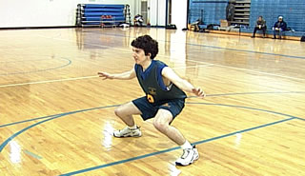

Key Words
- See the Ball
- Head and Hands Up
- Slide

Defending Drills

Defensive Positioning and Movement

“Ike Like Mike”
- Athletes spread out in the gym, at least arm’s length from one another. All athletes will move in the same way and in the same direction as the leader. Coach can also point direction of the movement and say key words as athletes follow the leader.
- Now the leader defends a player who has a basketball. All athletes will move in the same way and in the same direction as the leader.
- The goal for each athlete is to do cued footwork skills, not getting caught off balance, three times in a row.
- Three times equals one point; the first athlete to accumulate five points becomes the next leader.

Key Words
- See the Ball
- Slide

Rebounding
Your Athlete Can | Never | Sometimes | Often
Attempt to catch in any manner a basketball that is tossed into the air
Catch a ball that is tossed into the air
Attempt to catch in any manner a ball that rebounds off the backboard
Track the ball as it is shot at the basket
Turn to face the basket and take ready position for rebounding
Catch the ball in any manner after it rebounds off the backboard and bounces once on the floor
Catch the ball with hands only after it rebounds off the backboard and bounces once on the floor
Catch the ball in the air with hands only after it rebounds off the backboard
Move to “box out” an opponent before jumping for a rebound
Participate in team rebounding drills

Totals

Faults & Fixes Chart – Rebounding

Error | Correction | Drill/Test Reference
Opponents keep cutting athlete off from the rebound. | Advise athlete to locateopponent before focusing on the ball so he/she can get between opponent and the basket. | Two-Line Block Out
Athlete loses balance as people move around him/her near the basket. | Make sure athlete keeps feet apart enough to keep balance and move off the balls of the feet. | Repetitive Jumping
Athlete has trouble holding on to a rebound. | Make sure athlete is grabbing with both hands as firmly as possible. | Jump up to Grab a Ball

Coaches’ Tips for Basketball – At-A-Glance

Tips for Practice

- Rebounding is the most challenging of the basic skills, because it involves positioning, tracking the ball, timing, moving (jumping), catching and balance.
- Break down rebounding into its component parts from the skill progression and build one upon the other. In that way, the athlete can work toward effectively rebounding the ball during a game.
- Going for the ball is the concept put into concrete terms. Reinforce in all drills and game play.
- Being able to reach higher than the opponents is very helpful in rebounding, so work on vertical leap and reaching up to grab a loose ball.
- Rebounding is one skill that is used on both offense and defense, so it is worth extra time in practice to build this skill.
- The keys to rebounding include: quickness and strength, to jump; endurance, so jumping doesn’t wear you out; peripheral vision, to see what and who is around you; and balance, to maintain control during and after the rebound.

Teaching Rebounding

Key Words
- See the Ball
- Go Get the Ball

Rebounding Drills
For lower ability athletes, focus is on the proper body positioning and going to the ball without the pressure of an opponent. The following drills are appropriate for non-jumpers and beginning jumpers.

Jumping
If athlete still does not jump off floor, physically and visually prompt the movement by putting the athlete in the proper position and moving him/her through the jumping movement. If athlete still does not jump off floor, coaches can stand next to the athlete to model jumping, leading with their arms up in the air. On “Ready,” make sure the athlete is balanced with head over feet. On “Bend,” make sure the athlete maintains balance while bending at the knees. On “Jump,” model pushing up through the knees to arms extended up as if to grab a rebound. If progress is slow, be sure to look for small victories in each phase of the jump progression.

Reps: Two sets of ten jumps each

Purpose of the Drill
- Develop basic jumping skill

Steps
- Coach demonstrates; athletes watch, and then perform.
- Take a position with legs bent, elbows at sides and hands up.
- Bend legs and extend, sending body off floor into the air with arms overhead.
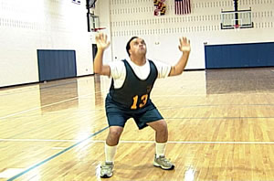

Key Words
- Bend and Jump

Repetitive Jumping
Reps: Three sets of ten jumps

Purpose
- Practice maintaining balance between jumps
- Build endurance for repeated rebound attempts

Steps
- Take proper body position.
- Bend and jump.
- Land under control and on balance, cat-like.
- Repeat nine more jumps in succession.

Key Words
- Bend and Jump
- Land Cat-Like

Jumping and Grabbing a Ball
Reps: Three out of five attempts

Purpose
- Develop reach and grab skills
- Practice control and protecting the ball while coming down with a rebound

Steps
- Hold a ball up and out of the athlete’s reach. If you aren’t tall enough to hold the ball out of reach, a slight toss works.
- Instruct the athlete to “Rebound the Ball.”
- Athlete jumps, grabs the ball and places it under his/her chin with elbows out.

Key Words
- See the Ball
- Rebound

Rebounding a Tossed Ball
For the average ability athlete who can track and go to the ball, the following drill is appropriate. As with other drills, practice follows demonstration.

Reps: Depending on the formation you choose, each athlete in each position at least twice

Purpose
- Progression of skills necessary for rebounding, from jumping through boxing out an opponent.
- Game simulation helps put skills into a competition context

Steps
- Instruct the athlete to “Rebound the Ball.”
- Toss a ball in the air.
- The athlete takes a step, goes to the ball and pulls it to his/her chest with elbows out.
- Rebound at least three of five attempts.
- Two to three athletes now stand in a single-file line in front of and facing the basket.
- Coach stands under the basket with his/her back to the basket.
- Coach tosses the ball backward and upward to bounce off the backboard.
- Each athlete initially gets three attempts to rebound before rotating to the end of the line.
- Same as the previous drill, add a pivot to the outside and a pass out to a waiting teammate.
- After the pass out, rotate athletes – re-bounder to outlet to outlet to end of line.
- Add a coach-defender who pressures the rebound and the outlet pass.
- The athlete is forced into position (block out) with coach-defender behind.
- Athlete must pass or dribble out and pass to outlet while being defended, like in a game.

Two-Line Block Out
Reps: Each athlete in each position at least three times

Purpose
- Simulate game experience of rebounding in a crowd
- Reinforce boxing out opponents as part of the rebound move

Steps
- The coach or shooter has the ball in the middle of free-throw line.
- Two athletes take positions on either side of the lane at the second mark; an additional two athletes are at the same mark, but farther off the lane.
- The athletes at the two spots closest to the basket are defenders and take proper defensive position. The athletes farther off the lane are offensive players.
- The shooter shoots; defenders call SHOT, turn, step to block or box out the offense, which includes the shooter. Defenders pivot backward, putting their buttocks next to the opponents’ thighs, elbows out, hands up. All then go for the rebound based on where the ball comes off the rim or backboard.
- Rotate athletes among positions.
- As athletes’ skills increase, add more speed to the drill, quickly going from offense to defense.

Mini-Basketball: Rebound Ball
This is an excellent game for encouraging assertive play. It also uses all the skills in a game-like situation, but without a full team. Athletes can learn to effectively move to the ball under pressure with this drill.

Reps: Practice each day for 3-5 minutes

Purpose
- Exposure to competing for a rebound
- Develop quick reaction time

Steps
- The coach divides the athletes into groups of three to four athletes per basket, keeping athletes of similar ability together.
- Two to three athletes (rebounders) stand in front of the basket.
- A shooter stands within shooting range in front of the free-throw line.
- After the ball is shot, each re-bounder goes for the ball.
- On the rebound, the athlete who gets the ball yells Ball and passes it to the coach, who calls Outlet.
- The game continues until one of the rebounders gets two to three rebounds. That person becomes the next shooter.
- The former shooter becomes a rebounder.
- The game continues for 2-3 minutes.

Footwork
Footwork is an essential part of both offense and defensive movement on the court. The ability to move and change directions or stop quickly is critical to success on the basketball court. While specific footwork is outlined in several drills, this section gives some basic drills that will also be helpful.
Your Athlete Can | Never | Sometimes | Often
Run forward, then run backward
Slide right, then slide left (step one foot to side, then step with other foot replacing first foot)
Hop on one foot, then hop on the other
Skip (step then hop on that foot, step with other foot then hop on that foot)
Cut (run diagonally for three steps, plant and push off the outside foot to change directions, turn hips to face desired direction and run three steps in that direction)
Stop (perform a two-step stop and later a jump-stop on the whistle)
Pivot (put weight on the ball of one stationary foot; other foot steps as the body circles around the pivot point)

Totals

Teaching Footwork

Key Words
- Head Up
- Elbows Bent With Hands Up (Ready)
- Run On Balls of Feet
- Get Low To Stop
- Pivot
- Slide

Agility Footwork Activities
Before doing the activity, demonstrate the skill. All athletes then do the skill in their places. When performing the two-step stop or the jump-stop, the athletes are to stop in no more than two steps, or a step to a jump-stop upon hearing the whistle. A game can be played, such as “Red Light, Green Light.”
- Line team up at the baseline in equal rows of four athletes across.
- Coach starts the first row.
- Athletes perform one of the above two footwork activities down the court, stopping at the free throw line, half court, far free-throw line and far baseline.
- As soon as the athletes pass the closest free-throw line, the coach starts the next row.
- Coaches perform the footwork activities alongside the athletes, verbally and physically prompting as necessary.
- Once at the far baseline, the coaches help line up the rows to return with the same footwork activity.
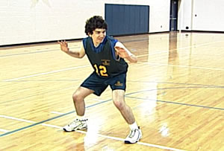

Coaching Tips
- Especially suitable for warm-up
- Once ball handling skills are learned, do a series of footwork drills while dribbling

Additional Basketball Drills

Pivoting Away from Defender
- Divide into equal-ability groups of two.
- Coach hands ball to offender; begins counting seconds out loud.
- Defender takes a position close to offender, pressures and tries to tap ball away.
- Offender pivots and moves the ball up and down the court.
The goal is for the offender to keep the ball away from the defenders for 5 seconds. The drill can be made more challenging by adding a teammate with the offender.
- Teammate will move back and forth while passer pivots and moves the ball.
- After 3 seconds and on “Pass” cue from coach, the athlete passes to teammate. Offender learns to stay calm, keep head up, pivot, move ball and pass to teammate.

Getting Out of Double Team
A double team will occur during a basketball game. This drill teaches the double team as well as provides practice getting out of it. Offender learns to stay calm, to keep head up, to pivot and to move ball. Defense learns to apply pressure and go after the ball without fouling.
- Divide into equal-ability groups of three.
- Two defenders take positions in front of offender; they will pressure and try to grab ball or tap ball away. Close The Door: step to the offender and stand next to the other defender.
- Coach hands offender the ball begins counting seconds out loud.
- Offender pivots away from defenders and moves ball up and down the court. Go To The Open Door: move to an open space away from the defenders. The goal is to control ball for 5 seconds without losing it.

Key Words
- Close The Door
- Find The Open Door
- Pivot
- Keep The Ball Moving

Circle Passing
One team can play against the other, but at opposite ends of the floor. A lower ability team may pass the ball in and out of the circle in a particular direction. Coach counts the number of passes in 60 seconds. This activity is fun and can go faster as skill increases. It adds movement to passing that is more game-like.
- Coach divides group into teams of four, five or six.
- Each team takes a position around one of the circles.
- One person from each team goes to the middle of that team’s circle.
- A person on the outside of the circle starts with the ball. The ball is passed to the person in the middle. The passer follows the pass, moving into the middle.
- The person in the middle passes to a teammate on the outside of the circle, follows his/her pass and takes that person’s place.
- The circle passing and moving continues for a prescribed number of passes (25) or a prescribed amount of time (60 seconds).
- If the ball goes out of control or out of play, it always begins with a person on the outside of the circle.

Key Words
- Face Your Teammate Before You Pass
- “Hands Up” – Give A Target
- Follow Your Pass

Four Corner Passing Drill
This is a good team activity where all work together. One ball is used first. As the athletes learn the skill, the coach can add more difficulty. For example: Add a return pass. Pass, follow, return pass and continue to follow, pass back and go to the end of the line. The ball and athletes must change direction when the coach cues Reverse. Add a second ball to activity. It must start in the opposite corner from the other ball. Add the cue Reverse to the activity with two basketballs.
- In the drill’s simplest form, the team lines up using the four corners of the half court. There will be at least two athletes in each corner.
- One of the athletes starts with a ball. The ball is passed counterclockwise around the square. Specify either bounce pass or chest pass.
- The team member will pass the ball, follow the pass and go to the end of that particular corner’s line.
- The person who just received the pass will pivot to his/her right, pass to that corner’s first person, follow the pass and take a position at the end of the line. The ball continues around the square, as do the athletes.

Key Words
- See The Ball
- Hands Up
- Give A Target
- Go To Meet The Pass / Follow Your Pass
- Turn And Face Your Teammate Before Passing

Dribble, Shoot, Rebound, Pass Game
- This is a transition game for lower ability athletes.
- The coach divides group into two teams of equal ability (Team A and Team B).
- Each team lines up along opposite sidelines and wears scrimmage vests of similar color.
- Each team has one basketball, different in color from the other team’s. An athlete can use only his/her team’s basketball.
- Coaches are at each end to officiate.
- The coaches begin with each respective team’s basketball and at opposite ends of the court.
- At the same time, coaches hand balls to the first athlete on each team.
- That athlete dribbles the full length of the court, takes one shot at the basket (preferably a lay-up), gets his/her own rebound, passes it to the next teammate closest to him/her at that end of the court and goes to the end of that line near mid court.
- This athlete now dribbles full length of the court, takes one shot at the basket (preferably a lay-up), gets his/her own rebound, passes it to the next teammate closest to him/her at that end of the court and goes to the end of that line near mid court.
- The game consists of four 6- to 8-minute running time quarters.
- Scores are announced at the end of each quarter by the scorer.
- A running total of made baskets is kept for each team.
- At the half, the teams change sidelines; the score is announced, and play resumes.
- When the game finishes, teams huddle together; the final score is announced. Teams line up to shake hands with their opponents. Team cheer is given.

Assistant coaches can note best dribblers, passers, rebounders and shooters. Encourage and enforce proper skills. In addition, this is a game in which parents, siblings and volunteers can all join. One condition for the non-Special Olympics athletes or basketball-experienced people is that they can only shoot from outside the lane.

Full Court Double Post Lay-up Drill
This is a continuous drill that lasts 2-3 minutes. It emphasizes passing and receiving on the move, taking a controlled lay-up or jump-stop lay-up and conditioning. Change posts every 60 seconds. Count the baskets made at each end. Do this drill periodically. It is the team against a goal, setting a personal best team mark.
- Four “posts” take positions at the corners where the free-throw lines meet the lane lines.
- Half the team lines up under one basket; the other half lines up under the opposite basket.
- Moving counterclockwise will emphasize right-handed lay-ups.
- The first person under each basket begins by passing (out letting) the ball to the post ahead.
- After the pass, each continues up that sideline and receives a return pass from the post.
- The athlete dribbles to the half court, passes to the next post and continues up sideline.
- Once the athlete reaches the free-throw line extended, he/she cuts toward the basket.
- The post bounce-passes the ball just in front so that the athlete can shoot a lay-up without dribbling.
- The first person under the basket rebounds the ball and passes to the post on the other side, continuing the activity up court.

Key Words
- Grab The Ball
- Move Under Control
- Hands Up
- Give A Target
- Lay Up The Ball Softly

Go to the Ball
The drill continues for 2-3 minutes. A second ball can begin after the teammate in position #3 has the first ball. Coaches should be stationed at each of the positions to prompt the athletes. Count the baskets made at each end. Do this drill periodically. It is the team against a goal, setting a personal best team mark
- The team is lined up in single-file order under one of the baskets.
- Positions 2-3-4-5 are located on the hash marks opposite one another.
- One person takes each of those positions on the court.
- #1 passes to #2, who has moved toward the ball. #1 follows to take #2’s initial position.
- #2 receives the ball and pivots, facing up court and #3.
- When #2 locks up court, #3 cuts toward the ball.
- #2 passes to #3 and follows to take #3’s initial position.
- #3 receives the ball and pivots, facing up court and #4.
- When #3 locks up court, #4 cuts toward the ball.
- #3 passes to #4 and follows to take #4’s initial position.
- #4 receives the ball and pivots, facing up court and #5.
- When #4 locks up court, #5 breaks toward the basket.
- #4 passes long to #5 and takes #5’s initial position.
- #5 grabs the ball and then dribbles it in for a lay-up.
- #5 gets his/her own rebound and dribbles the ball back outside the court to the line under the far basket.

Key Words
- See The Ball
- Hands Up
- Give A Target
- Go To Meet The Pass
- Grab The Ball
- Turn And Face

Understanding the Game
Do not assume that lower ability players will know even the basic aim of the game. Such players may have difficulty with simple concepts such as distinguishing between teammates and opponents.
Basketball is a game where players try to throw a round inflated ball through a raised basketlike goal. It is played on a court by two teams of five or three players. Points are made by shooting the ball through a high metal hoop and net at the opponent's end of the court. The large round ball used in this game is also called a basketball.

History

Early basketball
Basketball is unusual in that it was invented by one man, rather than evolving from a different sport. In 1891, Dr. James Naismith, a Canadian minister on the faculty of a college for YMCA professionals in Springfield, Massachusetts, sought a vigorous indoor game to keep young men occupied during the long New England winters. Legend has it that, after rejecting other ideas as either too rough or poorly suited to walled-in gymnasiums, he wrote the basic rules and nailed a peach basket onto the gym wall. The first official game was played in the YMCA gymnasium on January 20, 1892. "Basket ball," the name suggested by one of his students, was popular from the beginning and, with its early adherents being dispatched to YMCAs throughout the United States, the game was soon played all over the country.
Interestingly, while the YMCA was responsible for initially developing and spreading the game, within a decade it discouraged the new sport as rough play, and rowdy crowds began to detract from the YMCA's primary mission. Other amateur sports clubs, colleges and professional clubs quickly filled the void. In the years before World War I, the Amateur Athletic Union and the Intercollegiate Athletic Association (forerunner of the NCAA) vied for control over the rules of the game.
Basketball was originally played with a soccer ball. The first balls made specifically for basketball were brown, and it was only in the late 1950s that Tony Hinkle, searching for a ball that would be more visible to players and spectators alike, introduced the orange ball that is now in common use.

Rules and regulations
The object of the game is to outscore one's opponents by throwing the ball through the opponents' basket from above while preventing the opponents from doing so on their own. An attempt to score in this way is called a shot. Two points are scored for a successful shot, three points for a successful long-range shot (6.25 meters from the basket) and one point for each successful free throw.

Playing the game
The ball may be advanced toward the basket by being shot, passed, thrown, tapped, rolled or dribbled. Passing is the act of throwing the ball from player to player. Dribbling is the act of running while continuously bouncing the ball. The ball cannot be kicked or struck with the fist, and must stay within the playing court.
Running with the ball without bouncing it, called traveling, is illegal. Double dribbling, the act of dribbling with two hands or starting a second dribble after having caught the ball after a first one, is also illegal. A player's hand cannot pass the vertical while dribbling, so that his hand is partially below the ball; this is known as carrying the ball. In higher levels of basketball, time limits are imposed on advancing the ball past halfway, remaining in the restricted area (also known as the "paint") and attempting a shot. Rules are generally stricter in the NBA. Contrary to popular belief, there is no limit to the number of steps a player can take between bounces while dribbling.
To interfere with the ball while it is on its downward flight for a basket, or while it is bouncing on the basket, is called goal tending, and is a violation. Goal tending is one of the most complicated calls of basketball, and is significantly different in international basketball.

Fouls
An attempt to unfairly disadvantage an opponent through personal contact is illegal and is called a foul. These are most commonly committed by defensive players; however, they can be committed by offensive players as well. Players who are fouled either receive the ball to pass inbounds again, or receive one or more free throws if they are fouled in the act of shooting, depending on whether the shot was successful. One point is awarded for making a free throw, which is attempted from a line 4.5 meters (15 feet) from the basket.
If a team surpasses a preset limit of team fouls in a given period (four in international and NBA games), the opposing team is awarded free throws on all subsequent fouls for that period. Offensive fouls and double fouls are not counted as team fouls in the NBA, but they are counted in international games.
A player or coach who shows poor sportsmanship, for instance, by arguing with a referee or by fighting with another player, can be charged with a technical foul. A player or coach with two technical fouls is disqualified from the game and is required to leave the court. Blatant fouls with excessive contact or that are not an attempt to play the ball are called unsportsmanlike fouls (or flagrant fouls in the NBA) and incur a harsher penalty; in some rare cases a disqualifying foul will require the player to leave the stadium.
If a player commits five fouls (including technical fouls) in one game (six in some professional leagues, including the NBA), he is not allowed to participate for the rest of the game, and is described as having "fouled out." If no substitutes are available, the team must forfeit the game. Some leagues, including the NBA, allow disqualified players to re-enter the game at the cost of a technical foul on the team.

Players
A team consists of five players and up to seven substitutes, although in series where there are three games or fewer, only five substitutes are allowed. Any number of player substitutions is allowed during the game, although substitutes can only enter a game during a stoppage of play.
Male players generally wear shorts and a sleeveless top, and high-top sneakers that provide extra ankle support. Female players have worn shirts and skirts in the past, but most female players now wear uniforms identical to those worn by men.

Common techniques and practice

Positions
During the first five decades of basketball's evolution, a player occupied one of three positions, as follows: two guards, two forwards, and one center. Since the 1980s, more specific positions have evolved, as follows:
- Point guard
- Shooting guard
- Small forward
- Power forward
- Center
On some occasions, teams will choose to use a three guard offense, replacing one of the forwards or the center with a third guard.
Source: Wikipedia, the free encyclopedia © 2001-2005 Wikipedia contributors (Disclaimer)
This article is licensed under the GNU Free Documentation License.

Role of the Official

Officials
A referee and one or two umpires, called game officials, control the game. On the scorers’ table, there are table officials, who are responsible for the administration of the game. The table officials include the scorer, who keeps track of the score, time outs and fouls by each player; the timer, who controls the scoreboard; and the shot clock operator.
Referees and umpires generally wear a black and white stripped shirt and black trousers. These officials are responsible for the overall management of the game, to ensure the teams compete in a fair, honest and consistent environment.

The Basketball Court
The gymnasium or playing area (court) should be well defined to encourage organized activity. This permits the coach more time to spend on activities and less time on disciplinary measures. The area surrounding the court should not offer any physical hazards that might injure an athlete or damage the facility or equipment.
A basketball court consists of a level, hardtop surface, usually wood, and two baskets with backboards. Basketball can be played in a gym, at a playground or on a driveway. In addition, the dimensions of the court can be modified to suit the number and abilities of the athletes.
A basket consists of a nylon net hanging from a metal rim that is attached to a backboard. The backboard is usually rectangular and made of Plexiglas and has a square painted on it above the area where the rim is attached. The regulation height of the rim from the playing surface is 3.05 meters (10 feet). However, for instructional purposes, coaches may use an adjustable standard (backboard pole) that can be lowered and set according to an athlete’s ability.

Coaching Tips
- Discuss the boundaries of a basketball court. When taking athletes to a gym or outdoor court for practice, show athletes the marking on the court and show them how to measure the boundaries, if they are not already marked. Assist athletes with marking the boundaries.
- Walk around the court area and discuss what should be removed or repaired. Explain the importance of making the playing area safe and ready for play so that when they play at home or at school, the athletes will know how to be safe.

Modifications & Adaptations
In competition, it is important that the rules not be changed to suit athletes’ special needs. However, coaches can modify the training exercises to accommodate an athlete’s special physical, cognitive or communication needs. This may assist the athlete in mastering the basketball skills.
For more extensive information related to various disabilities and suggested modifications in coaching technique, see the Coaching Special Olympics Athletes section of this guide; specifically the Information and Problem Solving section. http://www.specialolympics.org/Special+Olympics+Public+Website/English/Coach/Coaching_Guides/Coaching+Special+Olympics+Athletes/Information+and+Problem+Solving.htm

Modifying Skills
Modify the skills involved in an exercise so that all athletes can participate. For example, if an activity calls for jumping, pair athletes of similar jumping ability. This will challenge them without making them feel inadequate next to a much more skilled athlete.

Accommodating an Athlete’s Special Needs
Use the sound of a bell for visually impaired athletes and a different colored ball for deaf athletes. Be sure that deaf athletes have a sign language interpreter or that you have an effective system for communication worked out with that athlete. Remember that each athlete is an individual and may learn or react differently from the other athletes. Check on each athlete in each activity to assess level of mastery and readiness before moving on.

Modifying Your Communication Method
Different athletes require different communication systems. For example, some athletes learn and respond better to demonstrated exercises, whereas others require greater verbal communication. Some athletes may need a combination – to see, hear and even read a description of the exercise or skill.

Home Training Program
- If athletes only train once a week with their coaches and do no training on their own, progress will be very limited. A minimum of three training sessions is needed to facilitate a training effect. The Home Training Program for Basketball is designed to help facilitate basic sport skills and fitness activities between athletes and families or friends. The program can also be used as a basis for a Partners Club program. The Home Training Program can be used in homes, schools, group homes and parks and recreation programs.
- An Athlete Handbook/Home Training Guide can be downloaded from the Special Olympics website www.specialolympics.org to assist coaches in integrating Home Training into their season, as well as helping athletes and families with ideas on how to practice between practices!
- The Basketball Home Training Program consists of simple warm-up and stretching exercises, basic skills practice, agility and conditioning activities and mini-game play. When the program is followed two or three times a week, the results can be dramatic. The program also promotes important nutrition guidelines and active lifestyle hints while encouraging social interactions between athletes, friends and families, and it can be fun for everyone.
- Nothing improves the athlete’s sport ability like playing! Parents/Guardians can challenge the athlete to family shooting or timed dribbling competitions for additional practice or just social outings.
- To be effective, coaches should run a home training orientation for family members and/or training partners. This should be an active session where parents get hands-on experience with the different activities.
- As a motivational tool, a coach may want to award a certificate of achievement to athletes and training partners who complete a set number of home training sessions during the season. The record keeping and scoring system are included in the Home Training Guide.

Cross Training in Basketball
Cross training is a modern-day term that refers to the substitution of skills other than the skills directly involved in the performance of an event. Cross training came about as a result of injury rehabilitation and is now also used in injury prevention. When basketball players sustain injuries that keep them from playing in a game, other activities can be substituted so that the athletes can keep up their aerobic and muscular strength.
- A reason to "cross train" is to avoid injury and maintain muscular balance during a period of intense sport specific training. One of the keys to success in sport is staying healthy and training over the long haul. Cross training allows athletes to do event specific training workouts with greater enthusiasm and intensity, or less risk of injury.
- Within Special Olympics, there are many sports that use some of the same skills and muscle groups as basketball. There are several individual sports that are excellent cross training sports. Cycling uses the legs, especially the quadriceps muscles. Cycling helps athletes develop areas prone to injury and essential for defense. Roller skating and speed skating also develop muscle strength, balance, power and endurance. Tennis enhances agility and lateral movement.
- Soccer and team handball are very similar team games in comparison with basketball. Team handball, especially, requires similar basic skills of moving, dribbling, passing, catching and defense. However, there is limited dribbling, and the ball is thrown into a goal on the floor instead of a basket in the air.
- The purpose of cross training is for the athlete to take part in activities that place similar demands on the body as basketball. These sports are different, challenging and fun. However, training is specific. The advantage of cross training activities is enhancing general fitness, not improving specific basketball skills.

Basketball Specific Concepts & Strategies

Training Sessions
There are five simple ways to create a training environment that brings out the best in each Special Olympics athlete.

Be organized
- Make sure that all training and playing schedules are understood.
- Pre-plan the training session; bring a written outline to practice.
- Review it briefly with the assistant coaches and players before starting.
- Be fully equipped to run the session (cones, balls, scrimmage vests, watch, etc.).
- Move quickly from one activity to the next.
- If possible, have athletes bring their own basketballs and water bottles.
Develop, with your athletes, a simple agreement for behavior and an agreement to abide by the Special Olympics Athlete Code of Conduct (see the section on Special Olympics Basics). Do this at your first Parent’s Meeting and your first practice.
- Athletes should understand the value of team rules. For example,
- Arrive on time.
- Come properly dressed.
- Listen to coaching instructions.
- Give 100% at all times.
- Support and encourage teammates.

Provide activities that are short and active.
- Some athletes may have difficulty standing around and watching or concentrating for a long period of time.
- They may become distracted and disruptive.
- Prepare athletes for game situations as well as skills improvement.
- Have enough help (coaches, parents or helpers) to keep the practice on schedule.
- Have brief water breaks after each activity.

Provide levels of coaching assistance appropriate for each athlete.
- Some athletes can understand brief verbal direction and demonstration.
- Others will need physical prompting or physical assistance to perform a skill.
- Use the Key Words rather than long explanations to explain and reinforce the technical components of skills and concepts.

Ask questions, rather than always dictate.
- Challenge athletes to think. Ask them questions that require thought and interaction.
- Listen to what they say.

During Competition

Before the Game
Arrive approximately one hour before the game. Allow enough time to register the athletes. In addition, give the athletes time to change into their uniforms, use the rest room and become familiar with the facility.
Have athletes run through a pre-game warm-up routine before the competition. If possible, team leaders can conduct it. A typical warm-up routine might include:
- 2-3 minutes of jogging and 5-10 minutes of stretching before taking the court
- 3-5 minutes of Two-line Lay-up and Rebound Drill
- Divide the team to form two lines – one line will lay-up to the right facing the basket; the other will rebound to the left facing the basket.
- The first person in the lay-up line dribbles in, shoots a lay-up and continues to the end of the rebound line.
- The first person in the rebound line runs to the basket, jumps up (if able) and gets the rebound from the lay-up made or missed.
- The rebounder dribbles the ball clear of the basket, passes it to the next person in the lay-up line and runs to the end of the lay-up line.
- Lay-up and rebound drill continues for 5 minutes.

- 3 minutes each of Individual Skills Practice, which includes ball handing: passing, catching and dribbling and shooting with rebounding. The group can be divided so that there are not too many athletes at the one basket.
  - Divide the team into two groups.
  - One group practices shooting and rebounding in pairs at the basket; after five shots, the shooters become rebounders and the rebounders shooters.
  - The other group practices ball handling (ball circling body parts and/or Dribble Five Spots) and passing under pressure in three’s and at half court.
  - After 5 minutes, the groups switch roles and positions.

- 5-minute review of actual offensive and defensive positions with the starters on the court.

- 2-3 minutes of team talk covering position assignments, key responsibilities, offensive basket and defensive basket.

Coaching Tips
- The lower the skill level of the team, the more prompting required. Coaches may need to assist athletes with the pre-game warm-up routine. However, the routine can be learned if it is practiced during training sessions, not just performed at competitions. In addition, higher ability athletes can lead each group. Always be positive and encouraging, but do not over-psych the athletes. Finish with a team cheer.

During the Game
- Encourage and support the athletes. Be positive and specific.
- Do not coach an athlete who has the ball; it will be too distracting. Allow the athletes to make their own decisions and their own mistakes.
- Develop team leaders who can prompt and help lower ability athletes.
- Commit to providing playing time for each athlete (assuming safety and behavior considerations are met).
- Watch the game actively and assess what the opponents and your athletes are doing and not doing; make adjustments through substitutions and time-outs.
- When giving players information, be specific and always correct the first mistake.
- Keep substitutions simple.
  - Plan strategies before the game as to the best playing combinations. Prepare athletes by playing those combinations during practice.
  - Do not move lower ability athletes from one position to another within a single game. Allow them the stability of playing one position.
  - Substitute purposefully:
  - Rest tired or injured athletes.
  - Improve the defense; send in a more aggressive player.
  - Adjust to what the opponent is doing to limit their effectiveness.
  - Protect a player who has three or more fouls.
  - Send in a specialist – the best defender, re-bounder, free-throw shooter, etc.
  - Remove an athlete who has become too distracted.
  - Always play to your strengths.
  - Play a lower ability athlete with stronger athletes at the end of the 2nd and 3rd quarters.

- Call time-outs wisely:
  - Stop an opponent who has made four to six points without your team scoring.
  - Make needed team adjustments on offense or on defense. For example:
  - If one of the opposing team members is a good shooter, play the best defensive player on him/her.
  - If the opponent has one strong player and the rest are of lower ability, double-team (place two defenders) on that player. The rest of the team can protect the basket in a triangle zone, which is the back three players in the 2-1-2 zone.
  - If the team has continued to run up and down the court without a good shot or rebounding opportunity, call a time-out; ask the team to pass the ball to the point guard as soon as possible. The point guard will dribble the ball up court slowly and cue the team to Set Up.
  - If the opponent presses, spread out the offense and keep the basketball in the hands of the best players. Design the offense with this as a part of it.
  - Go onto the court, re-position the players and walk through the adjustment if necessary, even during time-outs.
  - Be calm and refocus the team.
  - The athletes will be more likely to perform what was previously practiced.
  - Pressure is distracting. There will be a regression of skills during a game, especially if the team is young or inexperienced. The team will become more confident and skilled over time because of the training and competition opportunities provided.

- Use the halftime effectively.
- Break for water.
- Focus on the good plays and efforts.
- Identify one thing that needs to be done during the second half.
- Go onto the court, if necessary, to re-position the offense and defense.
- Set up the first offense and defensive play.
- Perform a team cheer; then go onto the court.

After the Game
- Line up immediately to shake hands with the opponent. Coach the athletes to appreciate sportsmanship and the other team as fellow basketball players, win or lose.
- Call the team together. Focus on their efforts, not only on the outcome. Acknowledge each athlete’s contribution. Help athletes deal with winning and losing.
- Announce the next practice or event.
- Never correct any mistakes after the game; wait until practice.
- At home, spend a few minutes reviewing the team’s performance. Prepare some useful comments and activities for the next practice.

Team Play
Basketball is a game played with two teams of five players each (we’ll deal with three-on-three basketball a little later). The game does not have to be complicated. A team is either attacking the opponent’s basket with the goal of scoring, or it is trying to regain possession of the ball while defending its basket and keeping the other team from scoring.
- However, the biggest challenge for the coach is teaching athletes game concepts and strategies, simply and effectively, so that the athletes can meaningfully play the game. Concepts or strategies can be isolated and transferred to the game. The game itself becomes the best teacher. Approximately half of the training time should be spent on basic skills and half on game play.
- One way that athletes can learn and practice basic game concepts or strategies is Mini-Basketball. Concepts and strategies are isolated in this mini game involving few people and simple offense and defense. The coach begins with one-on-one and progresses to five-on-five team play.

Attack (Offense) vs. Defend (Defense)

Athlete Readiness
- Athlete can dribble, shoot and move to the basketball.
- Athlete can move forward, backward and sideways while keeping hands up.
- Athletes should move in a step and slide motion (illustrate to players).
- Athlete can grab the basketball.

Teaching Attack vs. Defend
- Place one athlete with the ball on offense; direct that athlete to attempt to score.
- Place one athlete on defense, facing offender an arm’s length away and with back to basket.
- Direct defender to stay between offender and basket. Wherever offender moves, defender moves to prevent offender from dribbling to basket.
- When offender picks up ball, defender places nearest hand over ball, preventing or discouraging shot.
5. Athlete should play defense while trying not to foul the offensive player.

Mini-Basketball: One-on-One
- One offensive player and one defender are at the foul line.
- Goals for defender are to stay between offensive player and the basket and to obtain the ball before offender scores.
- Offensive player can dribble as well as shoot.
- After the ball is shot, defender actively goes for rebound.
- If offensive player gets rebound, that player stays on offense.
- As soon as score is made or defender gets ball, play is over.
- Rotation is defense to offense to end-of-the line to defense, etc.

Key Words
- Attack - Offense
- Defend - Defense

Coaching Tips
- When you begin, physically prompt athletes by placing them in the correct positions. Stand behind defender. For athletes with lower ability, the coach may have to physically assist the athlete in moving to stop the offender. With repetition, less and less prompting will be required.
- While playing, each athlete must recognize when he or she is on offense and when on defense. Some athletes get the ball under a basket and shoot, regardless of whether they are at their offensive or defensive baskets. As soon as athletes shoot at the wrong basket, stop play and correct.
- Make the most out of each moment. Ask your athletes:
- What do you do when you have the ball?(Attack the Basket)
- What do you do when the opponent has the ball? (Defend)

Changing Baskets after Halftime

Athlete Readiness
- Athlete can identify a teammate by the color of scrimmage vest he or she is wearing.
- Athlete can identify the basket at which he/she shoots and the basket at which he/she defends.

Teaching the Concept
- The team stands behind the coach at the team’s bench area; each athlete should be able to see the court and baskets.
- The coach points to and identifies the basket farthest from the team as the shooting basket - Offense.
- The coach asks the team at which basket they are shooting; the team responds by pointing and saying” Offense.”
- If necessary, the coach then physically assists the athletes into their team offense positions on the court.
- At the beginning of the second half, the team and the coach return to the bench.
- The coach points to the basket closest to the bench, which is now the new shooting basket.
- The coach asks the team at which basket they are now shooting; the team responds.
- The coach asks the team at which basket they are now defending; the team responds.
- If necessary, the coach then physically assists the athletes into team offense positions.

Key Words
- Offense
- Defense

Coaching Tips
- A tool that is quite helpful is a clipboard with a picture or diagram of a basketball court. When the coach identifies the shooting basket, he/she points to the basket on the clipboard and then the basket on the court.
- After halftime when the coach is identifying the baskets, the coach points out the baskets as they were during the first half. Then the coach physically moves the clipboard so that basket is now at the other end.
- The coach then asks the athletes at which basket the team is now shooting. The coach then instructs or physically assists the athletes to run to their Set-Up spots, their positions on offense.
- Ask your athletes:
- At which basket must we shoot?
- At which end do we play defense?

Three Seconds in the Lane

Athlete Readiness
- Athlete can move forward, backward and sideways.
- Athlete can recognize areas on the court.

Teaching the Concept
- Identify the lane areas of the court one is defensive, one offensive.
- Use the terms Hot and Cold. Identify offensive end with Hot: on offense, one must move through it or else burn up.
- Identify the defensive end with Cold: on defense, it helps to defend the opponent.
- Constantly reinforce Hot and Cold with proper positioning.
- Set up athletes’ positions on offense where all athletes are outside the lane.
- During half-court or full-court play, stand on the court. As players movie into their Set-Up positions on offense, move them out of the lane.

Key Words
- Hot
- Cold

Coaching Tips
- Concrete examples give a concept a form that the athlete can identify in his/her physical world.
- The three-second lane is as difficult to understand as changing baskets at halftime. It is permissible to be in the lane during half of the game, but then these lanes change just as the baskets change.
- Equate the three-second lane with offense, the shooting basket. This is not a first-year concept to learn for a lower ability or a beginning basketball team. This probably can be addressed during the second or third year, after a team has a firm understanding of offense.
- Ask your athletes:
- In which lane can we stand? Where is it Cold?
- In which lane must we move in and out? Where is it Hot?

Fast Break
The fast break is a play in which the defensive team gains possession of the ball and moves the ball quickly down the court. The goal is to score before the other team has a chance to set up a strong defense.
- All five players take part in the fast break and have various responsibilities. The ball is usually passed to the point guard, who dribbles it down the middle. Two teammates “Fill The Lanes” (explain) that are on either side of the point guard. These teammates run just inside the sidelines to give the dribbler enough dribbling space. In addition, running near the sidelines prevents defenders from stopping the play. The two remaining teammates initially trail the play and then move to get good rebounding positions under the basket.

Athlete Readiness
- Athlete can turn and forward. [is something missing?]
- Athlete can pass, catch, dribble and rebound the ball.
- Athlete recognizes and works with teammates.
- Athlete recognizes offensive and defensive ends of the court.

Teaching the Fast Break
- Review going for the ball.
- Review the rebound progression.
- Perform a Break-Away drill.
- After the point guard receives the ball he/she turns to face offensive basket, looks for the opening, drives down court and lays the ball up. The rebounder/passer trails the dribbler, rebounds a missed shot and attempts to make a follow-up shot.
- Perform a Two-Player Break.
- Plus Trailer Drill: A teammate is added to the above drill; he/she becomes one of the “WINGS” (explain) filling the nearest fast break lane.

Key Words
- Rebound
- Turn And Look
- Outlet
- Fill The Lanes
- Trail

Coaching Tips
- A lower ability team can fast break even though it may look more like a Break-Away or a Two-Player Break. Any player who rebounds the ball then outlets it to the best dribbler. That player may be moving to an open space or running down court.
- Teach the team to look for and pass to the designated dribbler.
- A coach wants the ball dribbled by the player who has the best ball control. This minimizes turnovers.
- The best rebounder and fastest player is taught to run down court after the ball is thrown, in order to offensively rebound.
- Defenders can be added to the above drill one at a time and after the athletes have learned the particular fast break skill. Since the emphasis is on offense, give the advantage to the offense. There should be one more athlete on offense than defense.
- A higher ability team can progress to perform a traditional three-lane fast break.
- In order for it to be effective, all athletes need to know their responsibilities. Identify specific tasks and practice them.

Free Throw

Athlete Readiness
- Athlete recognizes official areas and court lines (free-throw lane and lines).
- Athlete can shoot.

Teaching the Free Throw
- Set up a free-throw situation and explain why it has occurred (athlete has been fouled, especially while shooting).
- Two defenders take positions underneath lane at the blocks.
- Opponents alternate positions up the lane spaces (maximum four defensive players and two offensive players).
- The free-throw shooter has both feet behind the free-throw line.
- The players around the lane cannot move into the lane until the ball has left the shooter’s hands.
- The free-throw shooter cannot enter the lane until the ball hits the rim.
- Practice the situation during controlled scrimmages.

Key Words
- Feet Behind The Line
- Hold Your Position
- Go Get Ball After It Leaves Shooter’s Hand
- Come In After Shooting

Coaching Tips
- Do not spend much time on this concept with a beginning basketball team. It could be set up during the scrimmage portion of practice. Take proper positions and administer the free throw with play continuing.
- The free throw can be practiced in groups of three or four athletes when in stations or at the end of practice. During a game, athletes are fouled when they are tired. Practice free throws at the end of practice to simulate this.
- Ask your athletes:
- As a free-throw shooter, where are your feet? (Behind The Line)
- Where on offense can we line up? (Next To Defense, Alternate Position Along The Lane)
- Where on defense can we line up? (At First Spaces Under Basket, Alternate Position Along The Lane)

Jump Ball

Athlete Readiness
- Athlete can jump.
- Athlete can time the jump to tap the ball while in the air.
- Athlete can try to tap the ball to a teammate.

Teaching the Jump Ball
- Demonstrate and review the jump.
- Hold the ball above the athlete’s head and ask the athlete to tap it to a teammate.
- Toss the ball above athlete’s head and ask the athlete to tap it to a teammate.
- Take the position at a jump ball circle and repeat skill.
- Have the team line up around the center circle and next to an opponent.
- Repeat the skill.
- Remember, one player from each team stands at the top of the key protecting their basket.

Key Words
- Jump and Tap
- Tap To a Teammate

Coaching Tips
- There are jump balls at the beginning of the game and the start of overtime. After the beginning jump, possession of the ball alternates between teams on each jump ball (held ball) situation thereafter.
- Teach your two best jumpers (who have the best sense of timing) to be your jump-ball experts. Presently, jump balls do occur during held ball situations during the game and at the start of each half during international competition.
- Time needs to be spent with all athletes on the jump ball; however, this concept is not a high priority.
- Ask your athletes:
- Where does the jumper line up? (In the Circle)
- To whom does the jumper tap the ball? (Teammate)
- Where are the non-jumpers? (Outside and Around The Circle)

The Give-and-Go
The give-and-go is one of the most important team skills. An athlete learns to recognize and work with a teammate where the ultimate goal is scoring. An athlete passes the ball to a teammate who has moved to get open. The passer cuts to the basket for a return pass. This skill assists athletes in making the transition from skills to game play. The skill does not exist in isolation; it is incorporated into offense and team play.

Athlete Readiness
- Athlete can identify a teammate by the color of scrimmage vest he/she is wearing.
- Athlete can pass and catch, pivot, dribble, shoot and move to the ball.
- Athlete can move forward, backward and sideways.

Teaching the Concept
- Review the bounce pass.
- Teach the V-cut. The athlete takes one step to the basket, plants that outside foot, turns his/her hips toward the teammate with the ball and moves one or two steps toward the ball. The athlete receives the ball and attempts to score.
- Practice receiving the pass and turning (pivoting) to face the basket. As the athlete pivots to face the basket, the athlete raises the ball to a position in front and to the shooting side of the body. The athlete is now in an effective position to pass, dribble or shoot. This position is called “triple threat.”
- Perform the give-and-go without defense.
- Perform the give-and-go against a passive defender on the receiver.
- Perform the give-and-go against passive defenders one on the receiver and the other on the passer-cutter.
- Perform the give-and-go against more active defense.

Key Words
- Go Get the Ball
- Bounce Pass to Teammate
- V-Cut

Mini-Basketball: Two-on-One (in the front court)
- Teams are comprised of two athletes; team members wear same-colored scrimmage vests.
- Attacking team plays with two on the court.
- Defending team plays with one on the court and one off the court.
- Offense must make at least one pass before shooting.
- Defender protects basket but tries to steal ball.
- If ball goes out of bounds, it counts as a possession and a turnover.
- If offense shoots and gets rebound, play continues.
- If defender gets the ball, play is over and ball is passed to coach.
- Each team stays on offense or defense for three possessions.
- On each possession, a new defender plays defense.
- Each team plays offense and defense two to three times.
- Offense scores two points for a score and one point for offensive rebound; defense scores one point each for a steal or a rebound.

Recognizing and Working with Teammates

Athlete Readiness
- Athlete can identify a teammate by the color of scrimmage vest he or she is wearing.
- Athlete can pass and catch, dribble, shoot, defend and move to the ball.
- Athlete can move forward, backward and sideways.

Teaching the Concept
- Create teams of three.
- Place scrimmage vests of the same color on each team, different from the other teams’ colors.
- Require a minimum of one pass before a shot can be taken.

Key Words
- Go Get the Ball
- Bounce Pass to Teammate
- V-Cut

Mini-Basketball: Three-on-Three (w/o conversion)
- Create equal ability teams of three athletes at each basket.
- Attacking team, team A, faces the basket.
- Defending team, team B, plays between the basket and offenders (use offensive players).
- Coach stands at the division line, giving ball to offense.
- Offense must make at least one pass before shooting.
- Defenders protect basket but try to steal ball.
- Ball going out of bounds counts as a possession and a turnover.
- If offense shoots and gets rebound, play continues.
- If defense gets the ball, play is over and ball is passed to coach.
- Each team stays on offense or defense for three possessions.
- Each team plays offense and defense two to three times.
- Award two points for offensive score and one point for rebound; one point each for a defensive steal or rebound.

Coaching Tips
- When you first begin, physically prompt athletes by placing them in the correct positions. Stand behind the defenders. For athletes with lower ability, the coach may physically assist the athletes in staying between offenders and the basket.
- With repetition, less and less prompting is required.
- Ask your athletes:
- Where do you stand on defense? (Between Opponent And Basket)
- What are you trying to do on offense? (Score)
- Who is your Teammate? (Wearing Same-Colored Shirt)

Mini-Basketball: Three-on-Three (w/ modified conversion)
Play three-on-three as above with the following exceptions.
- When the defense gets the ball or when the offense scores, the ball is thrown to the coach.
- The teams change offensive and defensive positions.
- The coach passes to middle offender, and play continues.
- Each team stays on offense or defense for three possessions.
- Each team plays offense and defense two to three times.
- Award two points for offensive score and one point for rebound; one point each a defensive steal or rebound.

Coaching Tips
- The goal is to assist athletes’ changing from offense to defense and changing their positions on the half court. With the ball being passed to the coach after a score or a defensive steal or rebound, athletes have more time to make the adjustment. The coach can also verbally and physically prompt, if necessary.

Mini-Basketball: Three-on-Three (with conversion)
Play three-on-three with the following exceptions.
- When the defense gets the ball or when the offense scores, the ball is dribbled back to a position beyond the foul line extended.
- The teams change offensive and defensive positions.
- Play continues as before.
- One pass must be made before an offender can shoot.
- Play continues for 2-3 minutes
- Award two points for offensive score and one point for rebound; one point each for a defensive steal or rebound.

Coaching Tips
- This progression allows a more game-like situation. All athletes are challenged to react to the ball and to take possession of it. Each must get into position quickly. When on offense, the team faces the basket.
- When on defense, the team has its back to the basket and is positioned between opponents and the basket. The defense must dribble or pass the ball to a teammate beyond the foul line extended before it attacks the basket.
- With lower ability athletes, the coach verbally prompts the offense to “Take the Ball Back” and to “V-Cut” to get open. With repetition and reinforcement, less prompting is necessary.
- Ask your athletes:
- Who do you pass to? (Teammate)
- Where do you dribble or pass the ball after you go on defense? (Behind The Foul Line)
- What must you do to get open? (V-Cut)
- Teach a simple three-player offense. The structure will help athletes with lower ability know what to do and where to move. Each athlete should have only one or two tasks to perform. It is helpful if they learn a position on one side of the court. This helps to provide a point of reference that each can find.

Teaching the Three-Player Offense
- Position athletes on the court according to their abilities.
- Your most skilled athlete is #1, the point guard.
- Place the other two athletes one behind the other at the block (free-throw lane space) to the left of the basket and with their backs to the basket.
- On GO, each breaks to a spot.
- #2 athlete comes up the lane between defenders.
- #3 athlete runs just outside the block on the opposite side of the basket.
- Neither stands behind an opponent (defensive player); each moves to an open space.
- #1 passes to #2 and breaks to the basket.
- #2 pivots, faces the basket with the ball protected and passes back to #1, who shoots.
- #1, #2 and #3 go for the rebound.
- Or #2 can pivot, face the basket and dribble for a lay-up.
- Initially, #1 can pass to #3 as well. The play continues.

A simple player-to-player defense is encouraged. This helps athletes learn to defend a player with the ball and another without. This is an excellent transition to the five-player game. A triangle zone (explain) defense with the top defender on the ball can also be played. This lets athletes defend an area and the opponent with the ball in their area. It places them in the best rebounding position. Or two athletes can be assigned other opponents with one athlete back protecting the middle. This is the best of individual defense (pressure on the ball) and zone defense (protection of the basket).

Team Defense

Athlete Readiness
- Athlete can pass and catch, dribble, defend and move to the ball.
- Athlete can recognize and work with teammates.
- Athlete does not defend nor take the ball away from teammates.
- Athlete recognizes which basket to defend.
- Athlete understands the basic rules of the game.

Certainly, the aim of the game is to score more points than your opponent. Conversely, it is also to limit the number of points your opponent scores. Team defense is the concept that focuses on that aspect.
- When teaching team defense, it is much easier to begin by teaching a zone defense. Each team member learns how to defend an opponent, but within the safety of a smaller space.
- The 2-1-2 zone defense is one of the more easily taught zones. The coach is able to use court markings to place athletes close to the basket to prevent high percentage shots. Each athlete has one task to perform. It is important for the coach to recognize the abilities and capabilities of all team members for their strategic placement in the zone, making the team defense most effective.
- Concerning the placement of athletes, it is suggested that the most skilled all-around athlete (#1) be placed in the middle of the zone. This person is a stabilizing force, helping teammates and protecting the most vulnerable area (the middle). The smaller and quicker athletes take the top spots (#2 and #3). Taller athletes are at the bottom spots (#4 and #5) and closer to the basket. However, it is suggested that at least one of the positions be played by a smaller athlete who is assertive and who jumps or moves to the ball strongly.

Teaching Progression for Team Defense
Teach defensive positioning on the athlete with the ball.
- An athlete, coach or volunteer demonstrates proper stance, arm position and body position (arm’s length away from athlete with the ball, between opponent and basket, and with back to basket).
- While the team is spread around the court, each volunteer works with three to four athletes, verbally prompting proper body position.
- Then the group is divided so that there are four athletes and one coach/volunteer at each basket to individually practice positioning and movement one-on-one at the five zone positions. One offensive athlete has a ball and tries to drive past or shoot over one defensive athlete.

Key Words
- Belly to the Ball (explain)
- Step to the Ball

Teach zone areas for which each athlete is responsible
- Optional: Tape X’s on the floor, and gradually remove them over the course of the season. Make sure this is approved by the facility manager before putting tape on the floor.
- Use existing lines or marks on the court for cues, i.e., the junction of the foul line and lane line for the top spots on each side of the lane (#2, #3); the middle of the lane for the middle defender (#1); the low post blocks on the lane for the two bottom spots on each side of the lane (#4, #5).
- At the top spots, each athlete places his/her outside foot on the spots. At the bottom spots, each athlete places his/her inside foot on the spots. #1 is responsible for the lane.
- Place athletes in their areas; have them individually recognize their positions and court markings. Each area is two sliding steps out in radius from the athlete’s originating position.
- Cue Belly to the Ball and Step to the Ball (explain) and reinforce them throughout the progression.
- Direct athletes to move within their areas while the team on offense passes the ball around the perimeter. Each athlete adjusts to defending the opponent who has and does not have the ball in his or her area. Emphasize that:
- It takes all five athletes moving together to stop the ball and,
- When one defender moves, all must move, otherwise openings occur for scoring. (#3 moves to fill ball side block area.)

Teach offense-to-defense conversion
- Athletes line up in positions at their own offensive end of the court. Athlete shoots ball and coach retrieves. Coach cues “Defense” and “Go to Your X.” Assistants physically prompt athletes to run to the other end and set up their defensive positions on their respective X’s.
- Athletes sprint to opposite end and set up defense on their spots.
- Athletes move on defense as ball is passed by offense.
- Keep reinforcing “Belly to the Ball” and “Step to the Ball.”
- Gradually remove the X’s on the court.

Practice offense-to-defense-to-offense conversion
- Repeat above drill, beginning with ball shot at offensive end and athletes sprinting to defensive end to set up 2-1-2 zone.
- On a defensive steal and rebound, team breaks down court to offensive spots.
- Get offensive center out of lane; use strong physical prompt plus verbal cues (Hot, Get Out of the Fire). The coach must do this from day one, or athletes will have problems discriminating between defensive and offensive ends as well as getting out of the lane.

Coaching Tips
- Athletes with lower ability can play team sports. The key is making the concepts, athletes’ roles and responsibilities as simple and as concrete as possible. Through the development of skills and the repetition of their use in the game, the concepts become understandable.
- When teaching player-to-player or man-to-man defense, a player is responsible for defending a player, not an area. The above progression is extended as follows.

Teach off-the-ball defense (helping)
- Review proper defensive stance and movement.
- Teach a point-the-gun (open up) position on defending an opponent without the ball.
- One hand points to player defending; other hand points to player with the ball.
- Defender must always know where the ball is.
- Each defender must be able to see it without turning his/her head.

Key Words
- Step to the Ball
- Belly to the Ball
- Ball
- Help
- Deny

Mini-Basketball: Help and Recover positioning with passing
- Tape a dotted line down the middle of the court, lengthwise. This line is basket to basket.
- Movement and positioning should be demonstrated by the coaches, then practiced by the athletes.
- Two players play stationary offense at each side, with one coach being the point guard.
- Defenders take defensive positions on the offenders.
- Point guard is on one side of the basket-to-basket line.
- Athletes are positioned, taught that they play arm’s length away from the offender on the ball side and on the basket-to-basket line on the help side (non-ball side).
- Ball is passed slowly from the point guard to one offender.
- Cue “Step to the Ball” and “Belly to the Ball.”
- Defender on the ball plays between the offender and basket.
- Defender off the ball has one foot on the basket-to-basket line, other foot on the help side of the court, and back to the basket.
- As the ball moves, the two defenders move and call their positions.
- When on the player with the ball, an athlete yells Ball.
- When one pass away from the ball, the athlete yells Deny.
- When two passes away from the ball, the athlete yells Help.
- They pivot and slide to position while facing the ball.

The defense’s goal is a deflection, steal or rebound. Play in 1-minute intervals against a set offense. Keep score; the defense gets one point each for a deflection, steal or rebound. Each team has two to three times on defense. The team with the most points wins.

Mini-Basketball: Help and Recover positioning with passing and limited dribbling
- One element is added. When the offender receives the ball, he or she can drive.
- The ball side defender must try to stay with the driver and stop the dribbler (Stop The Ball) before he/she gets to the basket.
- The help side defender should be in position to help stop the dribbler (Stop The Ball) from shooting a lay-up.
- On the pass back to the point guard, all defenders recover to positions (Step To The Ball) and play Belly To The Ball.
- When the point drives, the defenders take a step to pinch (explain) the middle.
- When the point guard passes, the defenders recover to ball side defense or help side defense according to where the ball is.
- Play continues, and athletes yell their positions in relation to the ball as they move (Ball, Deny and Help).

The defense’s goal is a deflection, steal or rebound. Play in 1-minute intervals against a set offense. Keep score; the defense gets one point each for a deflection, steal or rebound. Each team has two to three times on defense. The winning team totals the most points.

Mini-Basketball: Shell positioning with passing
- Four offensive players line up in a box outside the lane. There is no one in the lane.
- The offense passes the ball around the perimeter.
- The defenders Step To The Ball, play Belly To The Ball, position properly if ball side or help side (on basket-to-basket line) and yell their position (Ball, Deny, and Help).

The defense’s goal is a deflection, steal or rebound. Play in 1-minute intervals. Keep score; the defense gets one point each for a deflection, steal or rebound. Each team has two to three times on defense. The winning team totals the most points.

Mini-Basketball: Shell positioning with passing and limited dribbling
- As above; however, now an offender can dribble after receiving the ball.
- The defenders Step To The Ball, play Belly To The Ball, position properly if ball side or help side (on basket-to-basket line) and yell their positions (Ball, Deny, and Help).

The defense’s goal is a deflection, steal or rebound. Play in 1-minute intervals. Keep score. The defense gets one point each for a deflection, steal or rebound. Each team has two to three times on defense. The winning team totals the most points.

Coaching Tips
- A combination defense can be quite effective, especially for a lower ability team. One or two players defend player-to-player defense, and the rest defend in a zone. This provides the coach with the best of two systems: pressure on the ball that is distracting, and stability on the court that protects the basket.
- In addition, there are some athletes who can focus on a player but not on an area. They contribute to the team by defending the player with the ball as a chaser while the rest of the team plays a zone behind them.

Team Offense
Team offense is based on the fundamental skills of dribbling, passing and catching, shooting and offensive rebounding. A coach can present each of these skills and assist in the athlete’s individual development. However, skills are just skills until an athlete uses them appropriately and successfully in game play with other teammates. Offense means scoring points making baskets. The ultimate goal of any of the offensive fundamental skills is to assist the athlete and the team in scoring. Certainly the aim of the game of basketball is to score more points than your opponent.

Athlete Readiness
- Athlete can pass and catch, dribble, shoot and go for the ball.
- Athlete can recognize and work with teammates.
- Athlete does not take the ball away from teammates.
- Athlete recognizes at which basket to score.
- Athlete understands the basic rules of the game.

Teaching Progression for Team Offense
Offensive skills: dribbling, passing, catching, shooting and rebounding.
- Present each skill.
- Practice it.
- Challenge higher skill: do the skill; do the skill more times (make five baskets); do the skill at higher speed; do a minimum of the skill in a limited time (make five baskets in 30 seconds).
Practice individually against defense: Attack to score.
Use the Mini-Basketball game of 1-on-1 to isolate basic offense against defense.

Practice team skills first without defense and then against defense
- Give-and-go is one of the most important team skills of recognizing and working with your teammate where the ultimate goal is scoring. An athlete passes the ball to a teammate (who has moved to get open) and cuts to the basket for a return pass.

Identify your athletes’ abilities
On a lower ability level team, athletes may never acquire all five of the offensive skills. It is important to identify what they can do and what they can do well, in order to build the best offense.

Place athletes in positions that best fit their abilities
- Utilize the strength of each athlete. For example, if an athlete can pass but not catch, he or she could be the point guard.
- Work around your best athlete. As in the mainstream, each team has an athlete or two who is higher in ability and game understanding than others. By utilizing their strengths, the coach gives his/her team the best chance for success.
- Assist each athlete in improving those skills. Provide time during practice for repetition and reinforcement of those individual skills.
- Help each athlete play a role, know and understand that role, and feel important to the team by playing it.
- Provide opportunities for all athletes to participate meaningfully. Give each athlete time on the court during practice and during competition. An opponent can help to elevate everyone’s skill. Athletes rise to the occasion. As opponents and situations become increasingly challenging, athletes’ abilities improve to meet those challenges. Athletes’ abilities improve with each practice and with each game.

Create a simple offense
The structure will give the team the best chance to play to its strengths and succeed. Simple structure will help, not complicate, athletes’ learning the game and playing together. It provides them stability and some certainty of what to do and where to move. The following is a simple offense called “Go Jerry.” It has been successfully played by lower ability athletes/teams.
- Team is the offense on the half court without defense. Each of the athletes is identified by a number. Their placement on the court is based on following abilities:
- #1: best all-around athlete who is right-handed
- #2: guard/average dribbler
- #3: good driver/rebounder
- #4: inside shooter/rebounder
- #5: good passer
- All athletes have Set-Up spots. #4 and #5 take positions one behind the other on the block on the left side of the court. #3 is in the same corner about 3m away.
- When athlete #1 reaches mid court, this is the visual cue for everyone to break (Cut) to their new positions. The verbal cue “Go Jerry” (who is the #4 athlete) is also given at this time.
- #2, #3, #4 and #5 move to their new positions, while #1 dribbles toward the top and right side of the key creating a passing angle.
- The cutting provides movement into open areas. It also gives the point guard a better passing angle. The offense then has an advantage over the defense.
- #1 passes to #5.
- #5 has four options:
- turn and shoot,
- pass to #1, who has cut to basket for return pass or rebound,
- pass to #4 or #3 for inside shots, or
- pass to #2.
- There will always be at least three rebounders (#3, #4, and #1), who are the most active in getting the ball.
- Once the offense is learned, it is important for the coach to assist athletes in performing it under more game-like conditions. One way to do this is to move athletes to the division or mid court line. The coach cues “Offense” and “Set Up” as the ball is picked up by the point guard. The athletes run to their spots and then run the offense on the “Go Jerry” cue.
- Athletes begin at their defensive end. The rebounder passes or hands off the ball to #1, who dribbles the ball up the court. The coach cues “Set Up” with the athletes running to their spots and then running the offense on the “Go Jerry” cue.
- Progress from offense to defense to offense. This now is the most game-like situation. The team is prompted in recognizing the transition from offense (when they get the ball) to defense (when their opponent has the ball) to offense (when they get the ball again).

Coaching Tips
- The following physical cues are suggested to assist the athletes’ learning the offense. Tape X’s on the floor for the athlete Set-Up cued spots. Tape different colored X’s on the floor for their end-of-cut cued positions. As the offense is learned, gradually remove the physical cues; use already existing lines on the floor.
- Verbalize the cues; reinforce good cuts. Your athletes will be able to repeat the offense.
- Reinforce not only cutting to the proper spots, but also throwing bounce passes and finishing the play. It is important for the receivers and the rebounders to Go Get the Ball whenever a pass is thrown or a shot is taken. As the ball leaves the shooter’s hand, everyone yells” Rebound,” turns to the basket and then goes for the ball. The coach must reinforce “Go Get the Ball.”
- Success is built on a team’s ability to score. Moving to the ball reinforces assertive play and gives a team more opportunities to score.

Provide a controlled scrimmage where offense goes against defense and the play is full court. Reinforce appropriate play, good teamwork and good results (effort and outcome).

Coaching Tips
- A coach can help athletes further develop self-esteem and team spirit by getting their input.
- Have them talk about what they are learning.
- Watch basketball games together.
- Discuss rules.
- Discuss what went right and what went wrong in your last game or practice, plus what they can do to improve. The interaction makes them feel valued and gives the coach important feedback.
- Offense, scoring and development can occur because the coach provides the necessary opportunities.
- Concepts are made concrete while athletes’ abilities are utilized. Even though offense is measured by the number of points scored, coaches can recognize and praise the contributions of all athletes.
- Reinforcing each athlete’s specific strengths enhances everyone’s experience. The most positive environment can be created for all and will yield the greatest gains.

Throw-In

Athlete Readiness
- Athlete can pass and catch.
- Athlete can identify a teammate by the color of scrimmage vest he/she is wearing.
- Athlete can stay behind the line until passing the ball.

Teaching the Throw-In
- Divide the group into pairs.
- One partner is out of bounds, the other is in bounds as a receiver. There are no defenders.
- Coach gives the ball to the passer, who throws a bounce pass to his/her teammate.
- Receiver V-cuts to get open and meets the pass.
- Passer steps inbounds to receive a pass back.
- Change responsibilities so that each athlete has a chance to inbound the ball and receive a pass.
- Add a defender in front of the passer. This defender pressures the pass and then defends the athlete stepping onto the court.
- Then add another defender on the receiver. The receiver has to work harder to get open.
- The goal for offense is making three of five passes. The goal of defense is making three of five steals or deflections.
- Consistently reinforce proper out-of-bounds placement and a proper throw-in by the passer during scrimmages.
11. Teach when the athlete can move (after a made basket) and when the athlete can’t move (violation).

Key Words
- Feet Behind The Line
- Hold Your Position
- Come In After Passing

Coaching Tips
- The coach should identify the two or three best passers on the team, and designate these players to inbound the ball during games.
- Ask your athletes:
- Where are your feet? (Behind the Line)
- To whom will you pass? (Teammate)
- When can you run onto the court? (After Passing)

Teaching Out-Of-Bounds Play At the Sideline
- Initially, use your offensive Set-Up positions. Athletes already know where they are to move (cut) on “Go.”
- Use one of the designated passers to yell “Go” and inbound the ball.
- Add a simple “box” set-up position.
- Each athlete has one cut and task to perform.
- Your best all-around athlete (#1) takes the ball out-of-bounds.
- The best re-bounders (#4 and #5) are at the top of the free-throw lane; the best passers (#2 and #3) are on the blocks. Ideally, the best rebounder (#4) and inside shooter are opposite the ball.
- On “Go”,” #4 and #5 cut toward the basket, and #2 and #3 cut away from the basket.
- #1 passes the ball to #3 and then cuts to the nearest corner.
- #3 turns and bounce passes the ball to #1 for a shot.
- #3, #4, and #5 Go Get the Ball for an offensive rebound and score.

Teaching Out-Of-Bounds Play At Baseline
- Initially, use your offensive Set-Up positions. Athletes already know where they are to move (cut) on “Go.”
- Use one of the designated passers to yell “Go” and inbound the ball.
- Add a simple “box” set-up position as before.
- Athletes will have one cut and one task to perform.
- Your best all-around athlete (#1) takes the ball out of bounds.
- The best rebounders (#4 and #5) are at the top of the free-throw lane; the best passers (#2 and #3) are on the blocks. Ideally, your best rebounder (#4) and inside shooter is opposite the ball.
- On “Go,” #4 and #5 cut toward the baseline, and #2 and #3 cut toward the top of the key and turn to face the ball.
- #1 passes to #4 and then cuts to the nearest corner.
- #4 powers up a shot.
- #3, #4 and #5 Go Get the Ball for an offensive rebound and score.

Cool-Down
The cool-down is as important as the warm-up; however, it is often ignored. Abruptly stopping an activity may cause pooling of the blood and slow the removal of waste products in the athlete's body. It may also cause cramps, soreness and other problems for Special Olympics athletes. The cool-down gradually reduces the body temperature and heart rate and speeds the recovery process before the next training session or competitive experience. The cool-down is also a good time for the coach and athlete to talk about the session or competition.

Activity | Purpose | Time (minimum)
Slow aerobic jog | Lowers body temperature  Gradually reduces heart rate | 5 minutes
Light stretching | Removes waste from muscles | 5 minutes

Basketball Coaching Guide

Basketball Rules, Protocol & Etiquette

Table of Contents

Teaching the Rules of Basketball 137
The Court 137
The Ball 137
Number of Players 137
Uniform of the Players 137
Referees 137
Official Score Table Personnel 138
Duration of the Game 138
The Start of the Game 138
The Game 138
The Ball In and Out Play 138
Fouls 138
Violations 138
Other Situations 138
Unified Sports® Rules 139
Protest Procedures 139
Basketball Protocol & Etiquette 139
During Practice 139
At Competition 139
Sportsmanship 140
Competitive Effort 140
Fair Play at All Times 140
Expectations of Coaches 140
Expectations of Athletes & Partners in Unified Sports® 140
Coaching Tips 140
Remember 140
Basketball Glossary 141

Teaching the Rules of Basketball
Below is a simplified list of rules for 5 v 5 basketball. Every coach should obtain a copy of the Official Rules of the Game, available from the Federation Internationale de Basketball (FIBA). The coach should also study the rule modifications in the Special Olympics Sports Rules, which can be found at www.specialolympics.org and described later in a separate section. Official Basketball Rules will give details of the rules; however, to get started, the coach and athletes need to know the basics.

The Court
- 5 v 5: Maximum is 28 meters (94 feet) long by 15 meters (50 feet) wide; minimum is 25.6 meters (84 feet) long by 15 meters (50 feet) wide.
- 3 v 3: (Half-court) Maximum is 14m (47 feet) long by 15 m (50 feet) wide; minimum is 12.8 meters (42 feet) long by 15 meters (50 feet) wide.
- For both: The court should be properly marked with sidelines, free-throw lanes, center circle and three-point field goal arc.
- The three-point field goal arc is a semi-circle that has a radius of 6.25m (19 feet 9 inches) from a point in the middle of the free-throw lane and directly below the center of the basket.
- There are two field goal baskets on backboards, one at each end of the court and each at 3.05 m (10 feet) above the floor.

The Ball
- For females: the smaller ball is used; it is 74 centimeters (28.5 inches) in circumference and 567 grams (18-20 ounces) in weight. It may be used as an alternative ball for junior division competition.
- For males ages 15 and older, the regulation ball is 78cm (29.5-30 inches) in circumference and 650g (20-22 ounces) in weight.

Number of Players
- To begin the game for 5 v 5, it is five; for 3 v 3, it is three.
- The minimum number to continue playing before forfeiture is two and one, respectively... unless the referee believes that the short-handed team has a possibility to win the game.
- Maximum number players on a team, eligible to participate in a game, is ten (in full-court 5 v 5 play) and five (in half-court 3 v 3 play).

Uniform of the Players
- Same color shirts and shorts must be worn by all players.
- According to Federation Rules, shirts must be numbered with plain Arabic numerals, front and back. The number shall be at least 6 inches high on the back and at least 4 inches high on the front and not less than ¾ inch in width.
- The following numbers are legal: 0, 3, 4, 5, 00, 10, 12, 13, 14, 15, 20, 21, 22, 23, 24, 25, 30, 31, 32, 33, 34, 35, 40, 41, 42, 43, 44, 45, 50, 51, 52, 53, 54 and 55. A team member list shall not have both numbers 0 and 00.
- In international competition, FIBA Rules dictate that shirts must be numbered with plain numbers, front and back.
- In international competition, the numbers on the back are at least 20cm high; those on the front at least 10cm high; and all made with material not less than 2cm wide. Players shall use numbers from 4 to 15. No watches or jewelry are to be worn.

Referees
- The officials on the court include a referee and an umpire (or when teams mutually agree, a referee and two umpires). The referee is the authority on the court.
- Decisions of the officials are final.

Official Score Table Personnel
- A scorer, a timer, and a 30-second clock operator assist the referees.

Duration of the Game
- The Official 5 v 5 game in Federation Rules includes four quarters of 8 minutes each.
- The Official 5 v 5 game in FIBA Rules includes two halves of 20 minutes each. Intermission is 10 minutes long.
- The Official 3 v 3 games are 20 minutes in length or until a team scores 20 points, whichever occurs first.
- All competition may be modified by local tournament organizers.

The Start of the Game
In 5 v 5, the referee will toss the ball between any two opponents at the center circle to start the game and each extra period necessary. Teams shoot at the basket opposite their benches during the first half. On a neutral court, the referee shall toss a coin to determine baskets. In 3 v 3, the game is started with a toss of a coin for team possession. There is no jump ball.

The Game
Basketball is played by two teams of five (in 5 v 5) and three (in 3 v 3) each. The goal for each team is to shoot the ball into its opponent’s basket and to prevent the other team from securing the ball or scoring. The ball may be passed, thrown, tapped, batted, rolled or dribbled in any direction, subject to restrictions in the Rules.

The Ball In and Out Play
The ball is out of play when it touches any baseline, sideline or anything outside the lines. It is put in play by the team opposite that which caused it to go out of bounds.
Scoring
Two points are awarded when a player makes a field goal that is shot inside the three-point arc. Three points are awarded when a player makes a field goal outside the three-point arc. One point is awarded for each made free throw.

Fouls
A personal foul is one that involves contact with an opponent. A player shall not block, hold, push, charge, trip, impede the progress of an opponent by extending his/her arm, shoulder or knee or by bending his/her body into other than normal position, nor use rough tactics. The player who has been offended against gets two free throws, if that player was in the act of shooting and missed. On the 7th foul in a half, the player fouled is allowed a 1-and-1 situation. On the 10th foul and thereafter in a half, the player fouled is allowed two shots. Prior to the 7th foul in a half, the team that has been offended against gets the ball out-of-bounds nearest the spot of the infraction. In 3 v 3, the player who has been offended against gets the ball at a designated spot above the free-throw line.

Violations
Ball handling infractions (double dribbling, traveling, carrying the ball, etc.), causing the ball to go out of play, stepping on the line, entering the free throw lane before the ball has left the shooter’s hand, etc., are penalized by awarding the ball out-of-bounds at the nearest point generally on the sideline from where the infraction occurred. A throw-in is taken from here by the team that has been offended against. In 3 v 3 play, the ball is taken at the designated spot above the free-throw line.

Other Situations
For a held ball (two opponents holding onto the ball simultaneously), the ball will be given to the teams on alternate possessions. During international competition, jump ball is administered. A technical foul is called for delay of game or unsportsmanlike conduct. The team that has been offended against gets two free throws and the ball out-of-bounds. In 5 v 5, each team gets five time-outs during regulation play.

Special Olympics Unified Sports® Rules
There are few differences in the rules for Special Olympics Unified Sports® competition as stipulated in the official Special Olympics Sports Rules and modifications outlined in the rules book. The additions are highlighted below:
- A roster consists of a proportionate number of athletes and partners. Although the exact distribution of roster spots is not specified, a basketball roster containing eight athletes and two partners does not meet the goals of Special Olympics Unified Sports.
- A lineup during the competition consists of half athletes and half partners. Teams that have an odd number of players (e.g., -on- basketball) have one more athlete than partner in the game at all times.
- Teams are divisioned for competition based primarily on ability. In team sports, division assignment is based on the best players on the roster, not the average ability of all players.
- Team sports must have an adult, non-playing coach. Player-coaches are not allowed in team sports.

Protest Procedures
Protest procedures are governed by the rules of competition. The role of the competition management team is to enforce the rules. As coach, your duty to your athletes and team is to protest any action or events while your athlete is competing that you think violated Official Basketball Rules. It is extremely important that you do not make protests because you and your athlete did not get your desired outcome of an event. Making a protest is a serious matter that impacts a competition’s schedule.
Check with the competition team prior to competition to learn the protest procedures for that competition.

Basketball Protocol & Etiquette

During Practice
When shooting baskets in a group where there are more players than balls, those without balls wait under the basket to rebound missed shots and move on to take the ball and attempt their own shot. If, however, the shooter makes the shot, he/she is entitled to keep the ball, and it is the duty of the person waiting to send the ball back to the successful shooter.

At Competition
When a player is injured on the floor, all players stop movement and kneel on one knee until the injured athlete is moved off the court or resumes play.

Sportsmanship
Good sportsmanship happens when both the coach and athletes commit to fair play, ethical behavior and integrity. In perception and practice, sportsmanship is defined as those qualities which are characterized by generosity and genuine concern for others. Below are highlighted a few focus points and ideas on how to teach and coach sportsmanship to your athletes. Lead by example.

Competitive Effort
- Put forth maximum effort during each event.
- Practice the skills with the same intensity as you would perform them in competition.
- Always finish a race or event - Never quit.

Fair Play at All Times
- Always comply with the rules.
- Demonstrate sportsmanship and fair play at all times.
- Respect the decision of the officials at all times.

Expectations of Coaches
- Always set a good example for participants and fans to follow.
- Instruct participants in proper sportsmanship responsibilities and demand that they make sportsmanship and ethics the top priorities.
- Respect judgment of contest officials, abide by rules of the event and display no behavior that could incite fans.
- Treat opposing coaches, directors, participants and fans with respect.
- Shake hands with officials and the opposing coach in public.
- Develop and enforce penalties for participants who do not abide by sportsmanship standards.

Expectations of Athletes & Partners in Unified Sports
- Treat teammates with respect.
- Encourage teammates when they make a mistake.
- Treat opponents with respect: Shake hands prior to and after contests.
- Respect judgment of contest officials, abide by rules of the contest and display no behavior that could incite fans.
- Cooperate with officials, coaches or directors and fellow participants to conduct a fair contest.
- Do not retaliate (verbally or physically) if the other team demonstrates poor behavior.
- Accept seriously the responsibility and privilege of representing Special Olympics.
- Define winning as doing your personal best.
- Live up to the high standard of sportsmanship established by your coach.

Coaching Tips
- Discuss basketball etiquette, such as congratulating opponent after all events, win or lose; and controlling temper and behavior at all times.
- Teach waiting for one's turn in field events.
- Teach staying in lane during running events.
- Give sportsmanship awards or recognition after each meet or practice.
- Always commend the athletes when they demonstrate sportsmanship.

Remember
Sportsmanship is an attitude that is shown in how you and your athletes act on and off the field of play.
- Be positive about competing.
- Respect your opponents and yourself.
- Always stay under control even if you are feeling mad or angry.

Basketball Glossary

Term | Definition
Assist | A pass to a teammate who scores directly or who does not dribble more than twice before scoring.
Backcourt | The end of the court opposite a team’s offensive goal.
Baseline | The end boundary line on a court.
Bench | Reserves.
Blocking | Personal contact that impedes the progress of an opponent who does not have the ball.
Blocking Out | A technique (also called “boxing out”) used by a rebounding player who steps in front of and with his/her back to an opponent and keeps that opponent behind him/her.
Blocks | The first lane spaces underneath the basket.
Boards | The backboards.
Bounce Pass | A pass that strikes the floor just more than halfway to the receiver.
Center | A player who plays in the center area close to the basket.
Chest Pass | A pass that is thrown in the air from about chest level.
Control | A player is in control when he is holding or dribbling a live ball. Team control exists when a live ball is being passed between members of a team.
Defender | A member of the team who does not have possession of the ball.
Defense | The team that does not have possession of the ball.
Double dribble | A violation in which a player dribbles the ball, stops, then begins to dribble again.
Dribble | Bounce the ball.
Fast Break | A play in which a team gains possession and then pushes the ball downcourt quickly, hoping to get a good shot off before the other team has a chance to get back and set up on defense.
Field goal | A basket, worth either two or three points, depending on whether it was taken from inside or outside the three-point line.
Foul | A rules infraction for which the penalty is one or more free throws.
Free Throw | Opportunity given to player to score one point by an unimpeded shot from behind the free throw line. Also called a Foul Shot.
Goaltending | A violation, in which a player interferes with a shot while the ball is on its downward arc, pins it against the backboard or touches it while it is in an imaginary cylinder above the basket; may be committed by either an offensive or defensive player.
Holding | Personal contact with an opponent which interferes with his freedom of movement.
Hoop | Basket or rim.
Jump Ball | A method of putting the ball in play by tossing it up between two opponents in one of three circles.
Jump Shot | A shot taken after a player jumps in the air.
Key | The free throw lane and circle.
Lane | The painted area between the end line and the free-throw line near each basket, outside which players line up for free throws. Also known as the key.
Offense | The team that has possession of the ball.
Outlet Pass | A quick, pass (often after a rebound) to a teammate that starts a fast break.
Perimeter Players | The offensive players (guards and one forward) who play outside the lane and face the basket.
Post Players | The offensive players (center and one forward) who play near the lane and have their backs to the basket.
Press | A term that is an abbreviation for pressure, as in defensive pressure.
Rebound | A missed shot that bounces off the rim or backboard; also to gain possession of the ball after such a missed shot.
Screen | An offensive play in which a player of offense acts as a stationary barrier to prevent a player on defense from defending a player. Also called a pick.
Steal | To take the ball away from the opposing team, either off the dribble or by picking off a pass.
Technical Foul | A penalty for improper behavior, such as using foul language or arguing with the referee.
Throw-in | Method of putting the ball in play from out of bounds.
Trap | A situation in which two defenders guard the player on offense who has the ball.
Travel | To run or walk illegally while holding the ball.
Turnover | Any loss of possession without a shot being taken.

