

Aquatics Coaching Guide

Teaching Aquatics Skills

Learn to Swim Program

Table of Contents

Skill Progression
Water Familiarization and Adjustment to the Pool Environment
Mental Adjustment – Water Confidence
Disengagement
Vertical Rotation
Lateral Rotation
Combined Rotation
Up Thrust
Balance is Stillness
Turbulent Gliding
Simple Progression
Basic Back Stroke
Coaches Tips for Water Familiarization - At-A-Glance
Learn to Swim Program
Pool/Water Acclimation
Water Entry
Water Exit
Push and Glide
Games and Activities to Teach Basic Skills
Training Session Plan Form
Sample Training Session Plan Form
Training Session Plan Form
12-Week Beginners Program - Sample
Aquatics Athletics Skills Learn to Swim Assessment

Skill Progression - Learn to Swim

Your Athlete Can, | Never | Sometimes | Often
Sits on pool edge
Sits on pool edge and kicks
Enters water with assistance
Enters waters independently
Blows into water
Continuous breathing and exhalation pattern
Stands in water with assistance
Stands in water independently
Puts face in the water
Walks across pool in shallow water (waist deep) with assistance
Walks across pool independently
Jumps in shallow water independently
Exits water with assistance
Exits waters independently
Supported, feet off bottom, moves forwards and backwards
Submerges in chest deep water with assistance
Submerges in chest deep water independently
Opens eyes under water with or without goggles
Can touch pool bottom in chest deep water
Sits on pool bottom in chest deep water
Floats on stomach with assistance (prone float)
Floats on stomach independently (prone float)
Recover from front float with assistance
Recover from front float independently
Performs prone float and recovers to standing position
Performs prone float with a flutter kick
Recovers from front float to back float with assistance
Recovers from front float to back float independently
Moves from back float to front and return with assistance
Moves from back float to front and return independently
Pushes and glides on front/back with assistance
Pushes and glides on front/back independently
Sculls using small or full arm movements
Kicks while holding onto pool side/gutter
Moves forward using kickboard and flutter kick on back with assistance
Moves forward using back flutter kick independently
Mushroom floats
From back float, can mushroom float and recover
Totals

Water Familiarization and Adjustment to the Pool Environment
Just as motor skills development is the first vital step for the beginner athlete for land sports, water familiarization and adjustment is the first critical stage for aquatics athletes. This Learn to Swim Program will prepare the athlete for progression through all stages of swimming training and competition. Missed or omitted components will hinder the swimmer at some stage through their swimming and will need to be taught.

Goals
These skills are subtly taught through activities, actions and games. The following describes the stages.

Security | Mental Adjustment to Water - Water Confidence
Control of Body | Resistance to and the Control of Rotation – Water Orientation
Swimming | The Final Stage

Mental Adjustment – Water Confidence
Mental adjustment is a continuous factor throughout the program and is of prime importance in the early stages of taking an athlete into the water. After a full familiarization with the pool environment, including toilets, change rooms, and start preparation for entry to the pool. Talk with your athletes about what to expect regarding water temperature, depth, how buoyancy affects the body, resistance (weight of water) and head control - blow water away when it comes near face.

Breathing in the Water
Getting to athlete to have trust in the water and their safety is key to their success. Teach your athletes to breath in their hands regularly to help develop water confidence. In addition, having athletes blow bubbles while in the water is a good technique to develop water confidence.
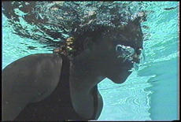

The swimmer seen “swimming” with a crawl stroke with the face well clear of the water, which is concerned by splashes and water near the face has failed to be properly adjusted to the water environment. Familiarization of the swimmer with this new environment and water medium is best achieved through play for both young and adult swimmers. Such play is directed towards developing in the swimmer an understanding of the properties of water.

Disengagement
This is a gradual progress from the early stages, when the athlete’s reliance on someone else is complete, to the time when they are to perform all tasks independently. When skills have been learned thoroughly and the athlete is progressing on to new skills, he/she may have to re-engage and gradually disengage again as they become more proficient – part of mental adjustment.

Vertical Rotation
Vertical rotation is one of the two planes of rotation in the water. Vertical is rotation forward around one’s center of buoyancy. This skill is required to recover from movement and inhibition of this rotation to prevent falling forward in the water.

Lateral Rotation
Lateral rotation is the other plane of rotation and can be performed either in the vertical or horizontal positions – that is standing or lying. These skills are required to return to a safe breathing position and require many separate skills to achieve.

Combined Rotation
Combined rotation is a combination of the two rotations and is the ability to rotate in two directions, ensuring that a swimmer can recover to a safe breathing position under any circumstances. This ability is required for safe pool entry for many athletes with disabilities affecting their spine or legs.
The swimmer can create or control movements occurring in both the vertical and horizontal planes. The athlete can fall forward into the water, rotate on to their back, and if desired, recover to the upright (standing) position.

Up Thrust
Up thrust or buoyancy is a property of water and allows the athlete to work against the bottom of the pool, instead of trying to stay up against the up thrust of the water. This gives added mental adjustment.

Balance is Stillness
This is the ability to stand, sit, kneel or lie in water and balance, not allowing the body to be disturbed by the movement of water.

Turbulent Gliding
Turbulent gliding is a means of progression through water where the coach uses turbulence to tow the swimmer in the back float position along, much as a mother duck. The swimmer must control his/her body in balance.

Simple Progression
Simple progression is the development from turbulent gliding when the swimmer uses his/her hands to make small scuttling movement at their sides. This ability to balance while creating movement is confined to the hands and kept close to the body around the center of buoyancy to start. Gradually, the movement can be widened and the legs involved.

Basic Back Stroke
The basic stroke can now be developed from the simple progression. In the back position, the arms are lifted high out of the water or the body will sink. The arms are taken low and fast over the water at about 10 o’clock and 2 o’clock positions. The arms are then brought to the sides and the swimmer glides before taking another stroke. A kicking action can be used.

Coaches Tips for Water Familiarization – At-A-Glance

Tips for Practice

- If a new swimmer is anxious, sit quietly beside pool and distract them, talking or looking about other things.
- Make the pool environment look interesting – add floating and sinking objects.
- Use a small blocked off area rather than a large open pool space.
- Activities initially include walking in water, feeling the water, walking or crawling down swim ramp, moving in shallow water and progress through all of the initial stages until buoyancy and submersion have been conquered.
- Practice walking in water, blowing “eggs” or ping-pong balls across surface of water – progress to races against other swimmers.
- Train in thigh to waist deep water, with a peer group of competitors.

Tips for Competition

- Assisted walk can be a successful activity for the swimmer who has just reached this stage.
- Teach to hold wall at start and start on signal.
- Train in completing distance and reaching for the finish point.
- Reward all swimmers as soon as they touch finish to develop sense of accomplishment being linked to the completion of the event.

Learn to Swim Program
The following skills are utilized to take the athlete through the stages to swimming readiness. Once these goals are achieved, the swimmer is now safe in the water and has developed all the basic skills from which to develop their swimming – skills, competition, recreation and fun.

Goals
- To achieve mental adjustment to water.
- To develop a physically balanced person in water.
- To demonstrate the abilities of the athlete.
- To properly prepare the person for swimming skills.
- To make the athlete safe in water.

Coaching Tips
- Spend as much time as necessary at each. Keep working through other steps at the athletes pace. That is, if an athlete is unable to blow (inhibits breathing ability) continue with activities to teach this, but also introduce other skills – perhaps once submersion is achieved breathing will come!
- Scatter a large quantity of swimming equipment (i.e. plastic bottles, spongers, pool toys, etc) in pool to make it more inviting.
- You may have to section off a small area in a large pool, to keep it from seeming overwhelming.

Pool/Water Acclimation

Sit on edge of pool without resistance

Teaching Points
- Walk around and familiarize oneself with pool area.
- Stand near pool.
- Sit near pool with coach.
- Sit on edge of pool.
- Progress to sitting on edge of pool without resistance four out of five times.

Coaching Tips
- Spend as much time at this stage as necessary. Almost none to several sessions may be required. Time spent at this stage will develop athlete confidence and, this confidence will hopefully stay with them the rest of their swimming career.

Sit on edge of pool and kick with feet in water

Teaching Points
- Sit on pool edge.
- Wash hands, arms, feet, face, shoulders, and neck.
- Move one foot up and down, then the other foot.
- Continue to alternate feet.

Coaching Tips
- Splash! Athlete splashes or kicks water while sitting on the side of the pool. The object of this game is to overcome the fear of the water by trying to get the coach wet. In doing so, the athlete gets himself/herself wet.

Skill: Walk across pool holding onto side with one hand four out of five times

Teaching Points
- Enter pool into chest deep water.
- Stand next to and face pool wall.
- Place both hands on wall.
- Side step width of the pool.
- Release one hand and side step the width of the pool with support of one hand.
- Stand with back to pool wall.
- Hold onto pool wall with one hand (outside hand) and walk from corner to corner in the shallow end.

Walk across the pool unassisted

Teaching Points
- Enter pool.
- Stand with back to pool wall.
- Walk from corner in shallow end.
- Walk across pool in shoulder-deep water.

Coaching Tips
- Scatter a large quantity of swimming equipment (i.e. plastic bottles, sponges, etc.) in pool requiring the athlete to move the toys out of their way in order to move about the pool with or without assistance.

Face in the Water

Teaching Points
- The athlete holds onto side of pool with straight arms.
- Lowering head between arms, the athlete takes a breath and puts face under the water.
- Perform step one, making sure the athlete’s eyes are open.
- Perform steps one and two and have the athlete exhale through the nose underwater (bubbling).

Coaching Tips
- If the athlete will not place his/her face directly into the water, have the athlete start with his/her head on its side in the water and slowly turn their head until the face enters the water.
- Athletes that are unsure of the water will tend to keep their eyes closed until they gain confidence.
- When working on step two, place your hands or an object under the water in front of the athlete’s face: then have him/her describe the object or tell you the number of fingers.
- When performing step three, make sure the athlete exhales through the nose. This will help when learning breathing for the six strokes.

Water Entry

Water Entry from Sitting Position - Assisted (Shoulder Method)

Teaching Points

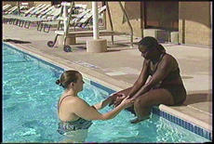
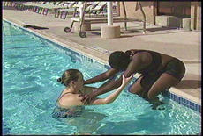
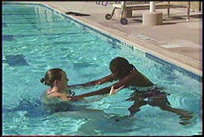

- Sit on edge of pool with feet in water. Coach stands in front of athlete in the water.
- Athlete places hands on coach’s shoulders, keeping eye contact with coach.

- Athlete leans forward. Coach places hands on athlete’s waist and slowly walks backward.

- Athlete slides into the water to a standing position.

Coaching Tips
- Have swimmers wear swim goggles to become aware of the new sensation.
- Reinforce that you have hold of the swimmer, and that he/she is safe.
- As the athlete becomes more relaxed and comfortable, offer less assistance as he/she is lowered into the water.
- Take care that the athlete does not jump forward and crash into you. Move back carefully and guide the swimmer to your side.

Water Entry from a Sitting Position - Assisted (Hand-To-Hand Method)

Teaching Points
- Sit on edge of pool facing the coach in the water.
- Place athlete’s hands palms down on the coach’s hands (palms up).
- Athlete leans forward and slides into the water, putting weight on hands for balance.
- Athlete assumes a standing position

Coaching Tips
- Make sure the athlete keeps eye contact with the coach.
- Give verbal reassurance to the athlete.
- Make sure the athlete feet are on the bottom before letting athlete’s hands go.

Water Entry - Twist Method

Teaching Points
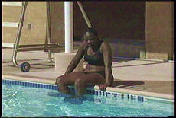
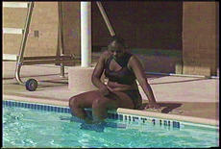

- Sit on the edge of the pool with legs in the water.

- Place palms down on the deck and rotate body 108 degrees.

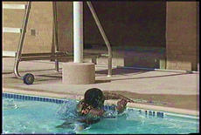

- Athlete will end up facing the pool wall, arms and chest supporting the body.

Coaching Tips
- Model the action of sitting on pool deck, placing feet in water, palms down on deck.
- Stand in front of athlete in the water, or behind on deck. Assist athlete as needed.
- Place two tape marks, shoulder distance apart on the deck edge. Sit the athlete down to the side of tape markings (opposite athlete’s dominant side). Once seated, have athlete reach with dominant hand across body and onto far tape mark. Head and shoulders will turn with arm placement.
- When body is firmly placed on the deck edge and upper body rotated, athlete will turn (roll) his/her hips, legs, and feet so that the entire body position depends on strength.
- Stand behind the athlete and gently assist him/her into the water. If possible, a second coach can assist in the water. Use of a kickboard by the athlete is recommended when a second coach is not available. The purpose of the kickboard is to balance and/or support the individual and to prevent the body from totally immersing in the water.

Water Entry – Using a Ladder

Teaching Points
- Athlete faces toward pool wall.
- Grip top of the ladder with thumbs on the inside and fingers on the outside of ladder railing.
- Place feet on first step of ladder.
- Continue down ladder one step at a time until both feet are on the bottom.

Coaching Tips
- Place tape on ladder to indicate proper place for each hand: red for one hand, green for the other.
- Stand in front of the athlete, giving verbal cues to ensure proper hand position. The second coach ensures proper foot position while standing behind the athlete in the water, giving support to him/her as needed.

Water Entry - the Waist Hold Method (Use for maximum assistance)

Teaching Points
- Athlete places his/her hands around coach’s neck.
- Coach supports athlete by holding athlete’s waist.
- Athlete maintains eye contact with coach.

Water Entry - Hand-to-Hand Method (Use for maximum assistance)

Teaching Points
- Athlete places his/her hands (palms down) on the coach’s hands (palms up).
- Both coach and athlete keep arms straight.

Water Entry - Front Pull

Teaching Points
- Athlete places hands (palms down) on top of coach’s hands (palms up).
- Both athlete and coach keep arms straight.
- Using this method, the coach is free to walk backward pulling the athlete around pool.

Water Entry - Back Float Shoulder Support (Use for maximum assistance)

Teaching Points
- Support the athlete while he/she leans back into the back floating position.
- Coach pulls the athlete in close, resting the athlete’s head on their shoulder.
- Coach supports the athlete by holding the athlete’s waist.

Water Entry - Back Float Back Support

Teaching Points
- Support the athlete while he/she leans into back floating position.
- Support the athlete just below the shoulder blades.
- Head can be supported on the coach’s arms if necessary.

Water Entry - Side Method

Teaching Points
- Athlete leans back into the back floating position while the coach supports.
- Athlete is held by the hips or in the middle of the back.
- This method allows good eye contact between coach and athlete.

Water Exit

Water Exit from Pool Edge - Independent
This water exit can also be accomplished with coach assistance. As the athlete pushes, using good leg strength, the coach boosts athlete up onto the edge of the pool deck. The coach continues to hold swimmer’s hips and helps the athlete up on pool edge.

Teaching Points
- Face the edge of the pool and put hands on pool deck (palms down).
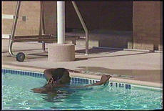

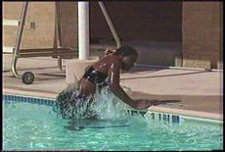

- Pushing with their feet off the pool bottom, using good leg strength, the athlete lifts themselves up while rotating their buttocks onto the pool edge.

- From this position, the athlete rolls over to end up in a sitting position on edge of pool.
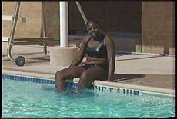

Coaching Tips
- Holding the athlete by the hips, help by lifting and guiding the athlete onto the pool edge.
- Make sure the athlete gives a good strong leg push.

Water Exit Ladder Method

Teaching Points
- Face ladder.
- Grip sides of the ladder with thumbs on inside and fingers on the outside of ladder rail.
- Place foot on bottom step.
- Continue up ladder one step at a time until top step is reached.
- Step onto pool deck.

Coaching Tips
- Stand in water behind athlete, giving verbal cues to ensure proper hand and foot placement.
- Second coach on the pool deck ensures safe exit from ladder to pool deck.

Push and Glide

Perform the Prone Float

Teaching Points
- Standing in waist deep water and bending forward at the waist, place arms straight in front of body no wider than shoulder width.
- Lower head until face is well into the water.
- Leaning forward, give a very slight push on toes until the feet leave the bottom and float to the surface.

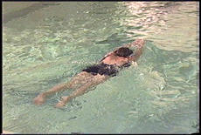
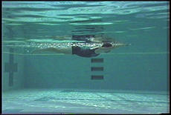

Coaching Tips
- Make sure the athlete gives a push with toes to bring legs to the surface.
- If the head is up, the legs and feet will not float.
- In the beginning, some athletes may need support from the coach.
- Have the athlete hold onto the edge of the pool, arms straight. Holding him/her at the waist, lift legs up from the bottom until the athlete is level the water. Gradually reduce assistance.

Prone Float Recovery

Teaching Points Push & Glide with Recovery – Independent

- Keeping the arms straight, push them down toward the bottom of the pool.

- Draw knees up and under the body while lifting the head.

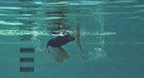
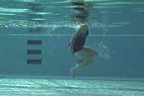

- Straighten legs and stand on the bottom of the pool.

Teaching Points Push & Glide with Recovery – Using One Kickboard
The steps in achieving the push and glide with recovery using one kickboard is the same as with any type of assistance or without assistance.

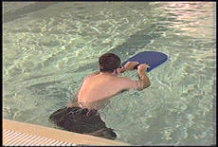

- Push from the side of the pool using one kickboard.
- Maintain a streamline position.
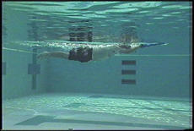

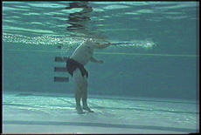

- From the streamline position, keep the arms straight, pushing the hands down toward the bottom of the pool.
- Draw knees up and under the body while lifting the head.
- Straighten legs and stand on the bottom of the pool.

Teaching Points Push & Glide with Recovery – Using Two Kickboards
Using two kickboard, the athlete uses the same technique with one kickboard.
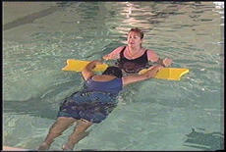

- Keeping the arms straight, push them down toward the bottom of the pool.

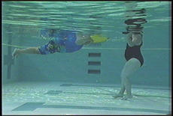

- Draw knees up and under the body while lifting the head.
- Straighten legs and stand on the bottom of the pool.

Teaching Points Push & Glide with Recovery – Assisted
For athletes that are not yet able to accomplish the push and glide independently, can use the same technique as the kickboard methods. However, the coach will provide upper body support to the athlete, as they reach their feet towards the pool bottom.
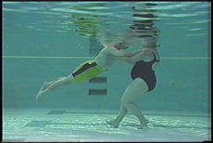

Coaching Tips
- The arms must be straight with the palms of the hands facing the pool bottom.
- As soon as the arm push is started, the head starts to lift.
- Athletes should not try to stand too soon. Wait until the body has moved completely to the vertical position.

Games and Activities to Teach Basic Skills

Teaching Point/Skill | Name | Description
Water Entry  Mental Adjustment  Water Confidence | Entry Songs | Sing song or rhyme as athlete enters water from sitting on the side of the pool, with assistance.
Water Confidence | Splash | Athlete sits on side of pool and splashes or kicks water to try to wet the coach. In doing so, the athlete gets wet also.
Water Confidence | Sit Near Pool | - Walk around pool and get familiar with the pool area.  - Stand near pool.  - Sit near pool with coach.
Water Confidence | Sit on Pool Edge | - Sit on edge of pool.  - Wash hands, feet, face, shoulders and neck.  - Move one foot up and down in water.  - Move other foot up and down as well.
Water Entry - Independent | Train | - Athletes hold hips or shoulders of athlete in front, forming a line/chain or train.  - Walk down ramp or walk around in shallow water pretending to be a train.  - Go under two assistant’s arms which form a tunnel.  - As athletes develop greater water confidence, they may not need to hold onto their teammate’s hips or shoulders as they walk down the ramp.

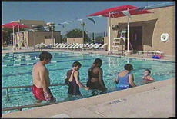

Teaching Point/Skill | Name | Description
Breathing | Egg Blow | Athlete blows a plastic egg or ping pong ball along the surface of the water. Athlete can try to flip egg over. (Blow onto Water)

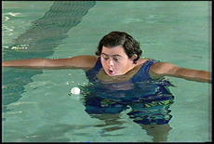

Teaching Point/Skill | Name | Description
Breathing | Magic Mirror | Pretend a dive ring is a magic mirror – ring on water and athlete blows in mirror to make a wish. (Blow onto Water)
Breathing | Cupped Hands | Athlete blows water away from cupper hands full of water. (Blow onto Water)

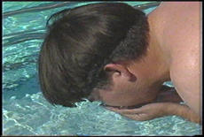

Teaching Point/Skill | Name | Description
Breathing | Shower Time | Use a plastic container with holes in the bottom. Fill container with water and hold over athlete’s head to create a shower. Call this time of the lesson “shower time”. (Blow onto Water)

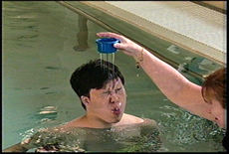

Teaching Point/Skill | Name | Description
Walking | Assisted Walking | - Enter pool into chest deep water.  - Standing, facing pool wall, place both hands on wall.  - Side step the width of the pool.  - Release one hand and side step the width of the pool with support of one hand.  - Stand with back to pool wall.  - Hold onto pool wall with one hand (outside hand) and walk from corner to corner in the shallow end.
Walking | Independent Walking | - Enter pool.  - Stand with back to pool wall.  - Walk from corner in the shallow end.  - Walk across the pool in shoulder deep water.
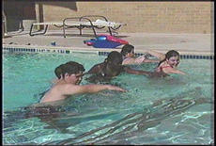

Teaching Point/Skill | Name | Description
Walking | Walking Races | - Line athletes up against wall in shallow water.  - On a “start” signal, they walk across the pool to the other the other side.  - The first to arrive is the winner.  - The game may be varied by floating hula hoops midway, with each athlete required to go through them, or by varying the manner in which athletes are told to move (walk, hop, skip, jump, etc.).  - It may also varied by giving each athlete a plastic spoon and a table tennis ball and letting the athlete push the ball with the spoon as he or she walks.
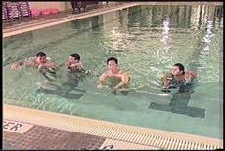
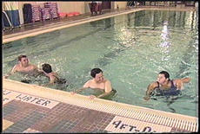

Teaching Point/Skill | Name | Description
Walking  Control of Rotation | Red Light | - An “It” (athlete) is chosen and goes to side of pool nearest the coach, opposite to the rest of the group.  - Group stands side by side on the other side of the pool.  - It turns back on group and watches the coach who is standing on the edge in front of him.  - As soon as “it’s” back is turned, the athletes begin to advance towards It in any manner and at any speed they choose.  - Coach turns on the red torch, It shouts “red light” as he turns to look at the others.  - Any athlete still observed moving by It must return to the starting point.  - Play continues until one athlete reaches It without having been detected moving. That athlete becomes the new It.
Walking | Snakes | - Athlete in line/chain formed by athlete putting arms on hips or shoulders of athlete in front.  - Walk around in water with leader or head trying to catch last athlete in line or tail.  - When tail is caught, tail becomes the head. Coaches with swimmers in the line if required.
Walking | Stepping Stones | Walk through the water as if stepping along large stepping stones. Lift feet off the pool bottom.
Teaching Point/Skill | Name | Description
Walking | How Few Steps? | Travel a given distance in as few steps as possible.
Walking - Control of Rotation | Follow the Leader | - In waist deep water, the athletes line up behind the “leader” who takes them through a number of movements that the coach asks them. E.g. Walking, running, forward and backward, zig-zagging, hopping, pick up a ring, through a hoop, etc. Change leaders to give all a go. Swimmers and coaches in line if required for swimmers assistance.
Walking - Control of Vertical Rotation | Hoops | In waist deep water, athletes join hands in a circle. Between every fourth athletes and hanging from grasped hands, is a hoop.  On “Go”, the athlete attempts to move the hoops around the circle without letting go of their hands.  This will require wriggling and ducking actions. When the coach calls “stop”, any athlete in contact with a hoop gets a point against them. Repeat. Winners are those with the fewest points at the end of play.
Jumping | Kangaroo Jumps | Pretend you are a kangaroo and do bouncing movements in the water. Swimmer faces the coach who will travel backward. Support as appropriate.

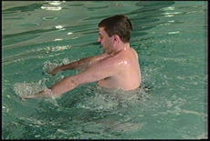 | 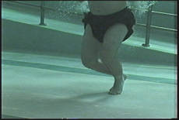

Teaching Point/Skill | Name | Description
Head Control | Unders and Overs | Swimmers in a line formation standing in the water.  Swimmers pass a ball over heads and under legs as the ball moves from the front of the line to the end.  When the swimmer at the end of the line receives the ball, he moves to the front of the line.

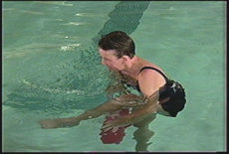 | 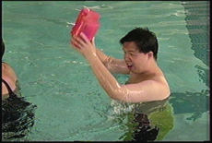
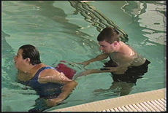 | 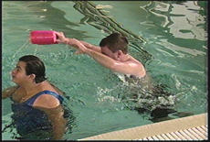

Teaching Point/Skill | Name | Description
Head Control | Water Bicycles | Form a line abreast, coaches behind swimmers. Coaches’ arms are inside swimmers arms - flat handlebars. Move as a group or scattered group. Steering and racing bike activities.
Breathing – Blows Bubbles | Magic Mirror | Blow bubbles in a dive ring to make a wish. (Blow Into Water)

Teaching Point/Skill | Name | Description
Forward Recovery (Vertical Rotation) | Sun, Wind and Rain | Circle formation, alternate instructor and swimmer. Support as appropriate.  On the call “The sun is shining” all swimmers lie back to sun bathe.  On the call “The wind is blowing” all swimmers rotate body to blow to the center of the circle.  Repeat.  To end game, all sun bathers are told “April showers” and feet create splash in the center.
Forward Recovery (Vertical Rotation) | Catch Toes | Circle facing inwards with swimmers in front of coaches.  Swimmer starts in chair position, and then puts head back to float, all feet pointing to the center.  On “catch toes”, a forward rotation to chairs, attempting to catch the foot of another swimmer.  Remind swimmers to blow.
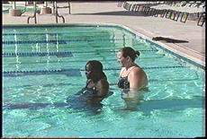
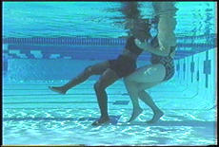
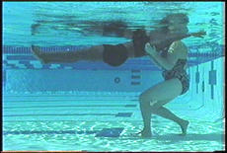

Teaching Point/Skill | Name | Description
Forward Recovery Vertical Rotation | Rag Dolls | - Line abreast formation, alternate coach and swimmer, plus one extra coach as side support at one end if joined in line.  - Coach walks backwards, swimmer in a relaxed back float.  - Coach changes direction to walking forward, and swimmer, using head movement only, makes a vertical rotation to prone floating position. Breathing control in prone floating position.
Forward Recovery (Vertical Rotation) | Merry Go Round/Water Wheel | - Swimmers and coaches in circle.  - Swimmers back float with support of coaches.  - Move circle around.  - Swimmers move from back float to front float position and return to back float.

Teaching Point/Skill | Name | Description
Submerges into Water | Hoop on Top of Water - Go Under | Use a large hoop and place it on top of the water. Swimmer has to start from outside the hoop and submerge and move to surface within the hoop.

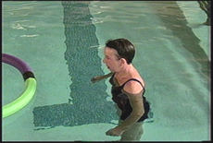 | 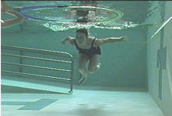 | 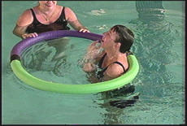

Teaching Point/Skill | Name | Description
Submerges into Water | London Bridge | Two swimmers make a bridge, arch with arms. Other swimmers go under the bridge and submerge. Raise or lower bridge to challenge swimmers.
Submerges into Water | Here, There, Where | - Coach says “Here”, “There” or “Where”  - When coach says “Here”, swimmers move as quickly as possible to where coach is.  - When coach says “There”, swimmers move to where coach is pointing.  - When coach says “Where”, swimmers submerge, (hide under water).

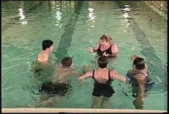 | 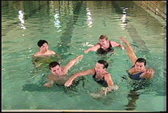 | 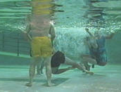

Teaching Point/Skill | Name | Description
Submerges into Water | Sunken Treasure | Instructor places objects (flutter discs, dive rings etc.) on bottom of the pool. Swimmers go underwater to collect treasure.
Submerges into Water | Underwater Catch | One swimmer must tag one of the other swimmers. If a swimmer goes underwater he cannot be tagged.
Teaching Point/Skill | Name | Description
Submerges into Water | Hear Your Number | Circle formation, alternate instructor and swimmer, with hand support. Coaches count slowly 1,2,3,4 etc. On ‘1’, swimmers submerge, breathing out slowly. Their number is that which they hear on surfacing. The highest number is the winner.
Eyes Open Underwater | Flutter Discs | Collect a particular numbered disc off the bottom of the pool. Instructor nominates a number which swimmer must pick up. Read the number on a while underwater. Instructor holds the disc and displays the disc number to the swimmer once submerged.
Eyes Open Underwater | Count Fingers Underwater | Swimmer submerges and instructor holds a number of fingers up underwater which the swimmer must look at while submerged. Swimmer surfaces and tells the instructor how many fingers were held up.
Eyes Open Underwater | Coins in a Fountain | A number of colored discs are thrown into the water. On the signal “go” swimmers submerge and with one breath only allowed, try to pick up as many as possible.
Breathing - Controlled | Talk Underwater to Partner | Two swimmers or swimmer and coach hold hands facing each other.  Both submerge together and talk to each other by blowing bubbles underwater – swimmers see if they can hear what each other said.  (Exhale While Submerged)
Breathing - Controlled | Partner See-Saw | - Two swimmers or swimmer and coach hold hands facing each other.  - One goes under and then surfaces  - The other goes under and then surfaces.  - Repeat a number of times like a see-saw going up and down.  - When go under must blow bubbles.  - (Exhale While Submerged)

Teaching Point/Skill | Name | Description
Rolling Recovery | Hello/Look At Me | - Swimmer is in back float position.  - Coach’s head is beside swimmers left ear, and support is at swimmers center of balance.  - Coach, quarter rotates swimmer to the right, then says “look at me” or “hello”.  - Swimmer turns head strongly to coach. Further rolling is restricted and swimmer will regain balance.  - Repeat on other side with coaches head by swimmers right ear and quarter rotate to the left.  - (Resist & Control Lateral Rotation – Rolling)

Basic Rolling Recovery Technique - As a Group
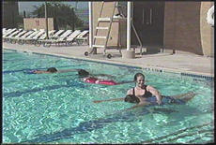
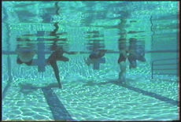
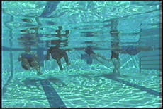

Teaching Point/Skill | Name | Description
Rolling Recovery | Ring Pass | - Athletes are in a circle formation, swimmers on their back with feet to center and instructor behind head.  - The upper back of swimmer is supported by coach’s hands.  - One or a number of rings (dive rings) are passed from swimmer to swimmer.  - All swimmers pass and receive ring with the same hand (i.e. all use left hand or all use right hand).  - (Resist & Control Lateral Rotation)

Teaching Point/Skill | Name | Description
Rolling Recovery | 360 Degree Lateral Roll | Lateral rotation from back float position for 360 degrees to return to the back float position.  (Resist & Control Lateral Rotation – Rolling)
Rolling Recovery | Fishes in the Net | - Circle formation with alternate swimmer and instructor, using long-arm support.  - Swimmers take turns at being ‘fish’ in the circular net.  - Escape from the net is under the arms of the circle, re-entry is over the arms with a combined rotation.  - Can also be played with the circle moving.  - (Resist & Control Lateral Rotation – Rolling)
Turbulent Gliding | Come to Me | - Swimmer on back floating.  - Coach is behind swimmers head and walking backwards creating turbulence with hands to move the swimmer along in a glide on the back.
Sit on the Bottom | Partner Sitting | Two swimmers hold each others’ hands and sit on the bottom of the pool together. Can also be swimmer and a coach.
Breathing - Controlled | Hum Underwater | Blowing out through the nose.
Mushroom Float | Mushroom Float | Float in a mushroom shape with hands holding ankles and the arched back facing the water surface.
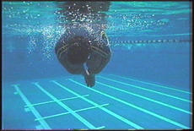

Teaching Point/Skill | Name | Description
Mushroom Float | Stars and Mushrooms | - If in shallow water, start in chair position; if in deep water, start by treading water.  - Group leader calls shape e.g. “Star”, and counts down “5,4,3,2,1” giving swimmers time to balance motionless in the shape called.  - Return to start position.  - Repeat with other position.

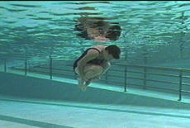 | 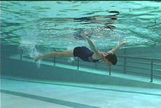

Teaching Point/Skill | Name | Description
Push and Glide | Rocket ships | Swimmers perform a push and glide and instructor calls this a rocket ship. Can use a large hoop which swimmers must glide through. How far can you glide?

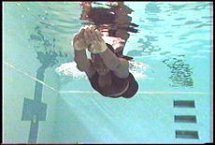

Teaching Point/Skill | Name | Description
Sculling | Row Boats | Swimmers perform a double arm backstroke like the oars of a row boat.
Sculling | How Few Strokes? | - Swimmers move over a given distance doing a propulsive action on their back (e.g. back sculling, double arm backstroke).  - Count arm actions/strokes and try to keep number to a minimum by emphasizing the glide in the stroke.
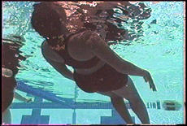
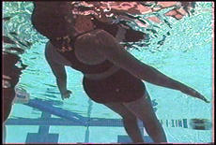

Teaching Point/Skill | Name | Description
Kicking | Torpedoes | Push, glide and kick in the front or back float position. This action is called torpedoes.
Kicking | Motor Boats | Tell swimmers they are to pretend to be motor boats by kicking their legs while holding one or two kickboards.
All | Simon Says | Play the game “Simon says” with activities designed to give confidence in the water and teach basic swimming skills. Coach selects task to meet required teaching points.
Water Familiarization | Splish-Splash | Swimmers organized in two teams. In waist deep water each team forms a circle. A plastic jug or bucket is placed in the center on a kickboard. On the signal ‘go’, all athletes begin splashing water into their teams jug or bucket. No athlete may touch their jug or bucket. The team to first fill the jug or bucket is the winner.
Water Familiarization & Confidence | Interception in Three | - Organized in threes, with the outside swimmers facing each other. Another swimmer stands between them.  - The two outside swimmers try to make as many passes as possible to each other without the center swimmer intercepting the ball.
Water Familiarization & Confidence | Spaceships and Space Station | - Coach (space capsule) envelops swimmer (astronaut) within circled arms and locked hands.  - Swimmer presses coach’s ear to unlock door of capsule.  - Then, using hands only (no leg movement), swimmer moves out of doorway, circles capsule, enters door again and presses other ear to lock it.  - A variation is for the whole group to link into a large space station, and two astronauts have to open the door and circuit the station, either traveling in the same or opposite directions.

Sample Training Session Plan Form

Group: Learn to Swim Group
Date: 2/2/2004 | Session Number: 3 of Week of 12
Number of Athletes: 20 | Number of Coaches: 4
Number of In Water Assistants/Coaches: 4 | Number of In Water Assistants/Coaches: 2 + 3 parents
Session Goals: Final Assessments & Goal Setting for Season + Group Goals

Group | 1 | 2 | 3 | 4
Ability | Beginner | Water Confident | Float and Glide | Adult Group – mixed ability
Number | 3 | 5 | 8 | 6
Ages | 8 years | 8-12 years | 12-18 years | 20 years+
Class Time | 40-60 minutes | 40-60 minutes | 60 minutes | 60 minutes
Staff | 1 coach - 1 assistant | 1 coach - 1 assistant | 1 coach - 1 assistant | 1 coach - 1 assistant
Other support | 1 session manager | 1 parent out of water supervisor | 1 parent out of water supervisor | 1 lane supervisor out of water
Lesson Goals | - Reinforce last session  - Build team confidence  - Humming | Work on  - Mobility  - Breathing  - Social skills | Develop skills needed to move to next level.  - Stretching  - Breathing | - Identify individual needs  - Breathing work to each athlete’s individual plan.
Equipment | - Kickboards – 2 each  - Dive Rings  - Hoop  - Flutter Disks  - Goggles | - Kickboards – 2 each  - Hoop | - Kickboards – 2 each  - Stretch Chart with pictures | - Kickboards – 2 each  - Dive Rings  - Goggles  - Flutter Disks  - Hoop  - Stretch Chart
Space Needs | Shallow pool space – secure area | Shallow and chest deep area. | Chest deep water – lane edge, some deep water work 1:1. | Chest deep water – lane edge – space to kick out from, back to wall along same water depth

Sample Training Session Plan Form, page 2

Group | 1 | 2 | 3 | 4
Warm Ups  (10–15 minutes) | - Jog on the spot  - Shake about  - Sits on pool edge  - Assisted entry  - “Hello” game in circle | - Run on the spot  - Shake all about  - Sits on pool edge  - Slide entry  - Kangaroo hops across own area | - Jog on the spot  - Shake about  - Simple stretches as per prepared chart  - Sits on pool edge  - Slide entry  - Run around designated area, return backwards | - Group gather, move bodies around – arm circles, jogs, shake legs  - Land stretches  - Enter pool  - Water aerobics to music: walk, slide, jog, jump, across lane space; stand and jog in spot using arm movements & high knees.
Assess & Review  (10–15 minutes) | - Drive Car Game – bubble into dive ring  - Bubble into dive ring on surface of water | - Make Walrus Noises into pool  - Say Hello underwater to buddy | - Push and glide with kickboard – blow bubbles into pool – stand to breathe  - Add relays | - Breathing work to suit - as across other 3 groups  - Speak to partner underwater – tell them what they said
Teaching Point of the Day  (10–15 minutes) | Begin Hum  “This is the Way We..” game – add hum | Practice Hum  Add hum and float – like hovering bees, use kickboards if necessary. | Practice mushroom float – hum  Try to tumble, use coaches, hoop and lane rope to assist | Hum activities at athlete’s own level, see groups 1,2,3.
Secondary Teaching Point  (10–15 minutes) | All Groups  - Check all Assessment Evaluations are current – try unmarked skills that you feel may be attainable.  - Out of water assistant marks accomplished tasks –Remainder of group also tries skill.
Cool Down  (10–15 minutes) | All Groups  - In place of usual games have swimmers help plan goals for the season.  - Write them down, or draw a sketch (e.g. bubbles) for the athlete to keep.

Training Session Plan Form

Group: Learn to Swim Group
Date: | Session Number:
Number of Athletes: | Number of Coaches:
Number of In Water Assistants/Coaches: | Number of In Water Assistants/Coaches:
Session Goals:

Group | 1 | 2 | 3 | 4
Ability
Number
Ages
Class Time
Staff
Other support
Lesson Goals
Equipment
Space Needs

Training Session Plan Form, page 2

Group | 1 | 2 | 3 | 4
Warm Ups
(10–15 minutes)
Assess & Review
(10–15 minutes)
Teaching Point of the Day
(10–15 minutes)
Secondary Teaching Point
(10–15 minutes)
Cool Down
(10–15 minutes)

12-Week Beginners Program - Sample

Week 1 | Get to know pool, staff, athletes, family and care givers  Water familiarization, entries, exits, pool rules, etiquette
Week 2 | Reinforce week 1  Begin Skills Assessments  Introduce breathing
Week 3 | Finalize Skills Assessments - Goal Setting for each individual for the season  Hum, mobility, control of rotation, floats and tumbles
Week 4 | Review previous session’s skills  Begin to identify and develop individual programs  Introduce arm actions, continue with breathing and floats
Week 5 | Review previous sessions  Work on weak points – reinforcements through games and activities  Introduce team and group activities – relays
Week 6 | Work on identified issues from previous week – work on weak spots  Review individual goals – adjust as required
Week 7 | Conduct Skills Assessments  Work on skills identified  Review and progress on previous session’s work.
Week 8 | Introduce new skills – back float, push and glide, kick as ready  Continue team work and relays
Week 9 | Introduce Competition Events as identified for each group  Practice in a non competitive games environment
Week 10 | Introduce race aspect of Events  Practice good sportsmanship – use relays and cheer on buddies
Week 11 | Conduct Final Skills Assessment for season  Practice full skills progression – end with events fun games
Week 12 | Fun Competition Gala with awards  Certificates of Achievement for the season

Aquatics Athlete Skills Learn to Swim Assessment

Athlete Name |  |  |  | Start Date
Coach Name

Instructions
- Use tool at the beginning of the training/competition season to establish a basis of the athlete’s starting skill level.
- Have the athlete perform the skill several times.
- If the athlete performs the skill correctly 3 out of 5 times, check the box next to the skill to indicate that the skill has been accomplished.
- Program assessment sessions into your program.
- Swimmers may accomplish skills in any order. Athletes have accomplished this list when all possible items have been achieved.

Water Adjustment
Sits on pool edge
Sits on pool edge and kicks

Water Entry - Assisted
Sits on pool edge
Walks down ramp
Enters pool using stairs
Climbs down ladder
Slides into pool from edge

Water Entry - Independent
Walks down ramp
Enters pool using stairs
Climbs down ladder
Slides into pool from edge
Jumps into shallow end

Breathing – Blows Air Out
Blows air out
Blows object across water
Exhales while submerged

Breathing – Blows Bubbles
Blows into water
Blows water away
Makes noises in the water
Hums under water through nose

Breathing – Controlled
Continuous breathing and exhalation pattern
Exhales through nose and mouth in a relaxed and rhythmical manner

Static Positions
Stands in water – assisted
Stands in water - independent
Stands in water against turbulence - assisted
Stands in water against turbulence - independent
Lies on back in still position - assisted
Lies on back in still position against turbulence - assisted
Stands or sit in chair position – assisted
Stand in chair position - independent
Stands or sit in chair position against turbulence - assisted
Stand in chair position against turbulence - independent

Develops Water Confidence
Puts face in the water
Confident enough not to grip coach

Walking in Water - Head Control
Walks across pool in shallow water (waist deep) - assisted
Walks across pool holding onto the side with one hand
Walks across pool - independent
Walks across pool independent - shallow water
Walks across pool assisted - chest deep
Walks across pool independent - chest deep
Slides sideways/change directions - assisted
Slides sideways/change directions - independent
Walks forwards and backwards - assisted
Walks forwards and backwards – independent

Jumping
Jumps in shallow water - assisted
Jumps in shallow water - independent

Water Exit - Assisted
Walks up ramp
Climbs up ladder
Maintains a safe position at side of pool
Climbs out over side of pool

Water Exit - Independent
Walks up ramp
Climbs up ladder
Maintains a safe position at side of pool
Climbs out over side of pool- independent

Forward Recovery
Supported, feet off bottom, moves forwards and backwards
Using two kickboard, moves forwards and backwards

Submerges in Water
Submerges in shallow water - assisted
Submerges in shallow water - independent
Submerges in chest deep water - assisted
Submerges in chest deep water - independent

Eyes Open Underwater
Able to open eyes underwater - with goggles
Able to open eyes underwater - without goggles

Sit on the Bottom
Can touch pool bottom in shallow water
Can touch pool bottom in chest deep water
Sits on pool bottom of pool in shallow water
Sits on pool bottom in chest deep water

Prone Float
Attempts to float on stomach
Floats on stomach with assistance (buoyancy belt)
Performs prone float for five seconds - independent
Recover from front float - assisted
Recover from front float using two kickboards - assisted
Recover from front float using two kickboards - independent
Recover from front float - independent
Performs prone float and recovers to standing position
Performs prone float with a flutter kick

Back Float
Attempts to float on back
Floats on back with assistance (buoyancy belt)
Performs a back float for five seconds - independent
Recover from back float - assisted
Recover from back float using two kickboards - assisted
Recover from back float using two kickboards - independent
Recover from back float to stand - independent
Performs a back float and recovers to a standing position
Performs a back float with a flutter kick

Rolling Recovery
Recovers from front float to back float - assisted
Recovers from front float to back float using floatation device - assisted
Recovers from front float to back float using floatation device - independent
Recovers from front float to back float - independent
Moves from back float to front and return - assisted
Moves from back float to front and return - independent

Turbulent Gliding
Floats on back while being propelled along

Push and Glide – Streamlined Position
Pushes and glides on front - assisted
Pushes and glides on front - using floatation device, two kickboards, noodle
Pushes and glides on front - using one kickboard
Pushes and glides on front - independent
Pushes and glides on back - assisted
Pushes and glides on back - using two kickboards
Pushes and glides on back - using one kickboard
Pushes and glides on back - independent

Sculling
Sculls using small arm movements
Sculls using full arm movements

Kicking
Kicks while holding onto pool side/gutter
Kicks legs with coach’s assistance
Moves forward using kickboard and back flutter kick - assisted
Kicks on front - assisted
Kicks to kick on front - assisted
Kicks on front in glide position - assisted
Kicks on front in glide position - independent
Moves forward using flutter kick- independent
Moves forwards using back flutter kick- independent

Mushroom Float
Supported, roll forwards, blow and roll back
Mushroom floats
From back float, can mushroom float and recover

Water Safety
Identifies swimming boundaries
Understands and identifies pool safety rules
Floats in neck deep water
Demonstrates a vertical float in deep water for two minutes
Demonstrates sculling arm action five strokes in neck deep water



You have learned the Basic Skills needed to be a
Great Swimmer

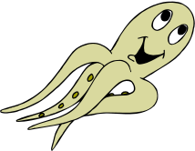
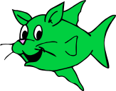
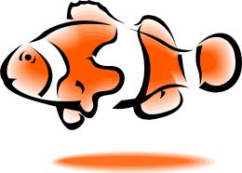

You Are Now Ready to Advance to the Stroke Development Level

Coach |  |  | Date

