SUGGESTED COMPETITION LEVELS
The levels below are suggested as a guide for use in competition, to assist the athletes in their transition from ISC to traditional matchplay.
The choice of level offered in a competition will depend on the ability levels of athletes entering.
Consideration must also be given to whether the athlete’s training has included these balls and court sizes.
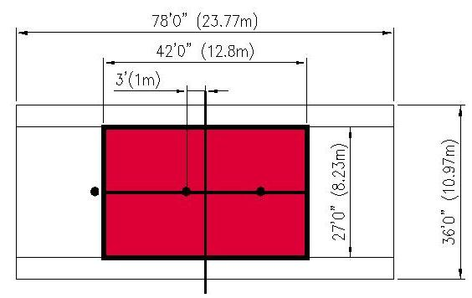  F  AV  AG | LEVEL 1 (ISC)  Court Dimensions: 42’ x 27’  Ball: ITF approved Red Foam Ball  Level 1 is suggested for athletes rated between 1.0 & 1.9.  It is intended to be an introduction to short court matchplay in Level 2.  ISC scoring for level 1 will consist of 5 points for each volley and groundstroke landing within the service boxes and 10 points for each correct serve.  Full court ISC may still be conducted, if more suitable to the ability level of the athletes.
Court Positioning F: Feeder for groundstrokes & volleys AG: Athlete for groundstrokes & serves AV: Athlete for volleys

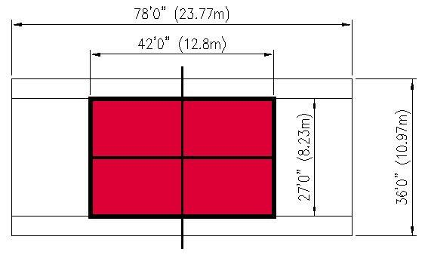 | LEVEL 2 – Short Court Matchplay  Court Dimensions: 42’ x 27’  Ball: ITF approved Red Foam Ball  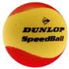  Level 2 is suggested for athletes rated between 2.0 & 2.9.
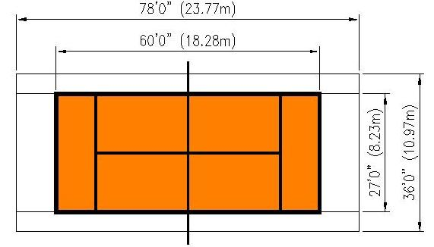 | LEVEL 3 – Intermediate Court Matchplay  Court Dimensions: 60’ x 27’  Ball: ITF approved Orange Ball  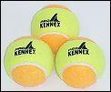  Level 3 is suggested for athletes rated between 3.0 & 3.9.
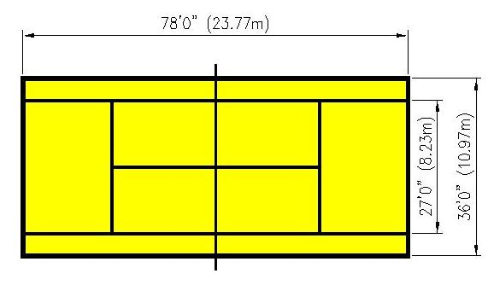 | LEVELS 4 & 5 – Traditional Court Matchplay  Court Dimensions: 78’ x 27’ for singles  78’ x 36’ for doubles  Ball: ITF approved green ball (level 4)  ITF approved Yellow Ball (level 5)  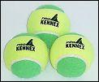  Level 4 is suggested for athletes rated between 4.0 & 4.9  Level 5 is suggested for athletes rated between 5.0 & 8.0.

*Tennis balls shown are examples only and are typical of ITF approved tennis balls

