Youth Rally “How To” Kit
Version 1.0

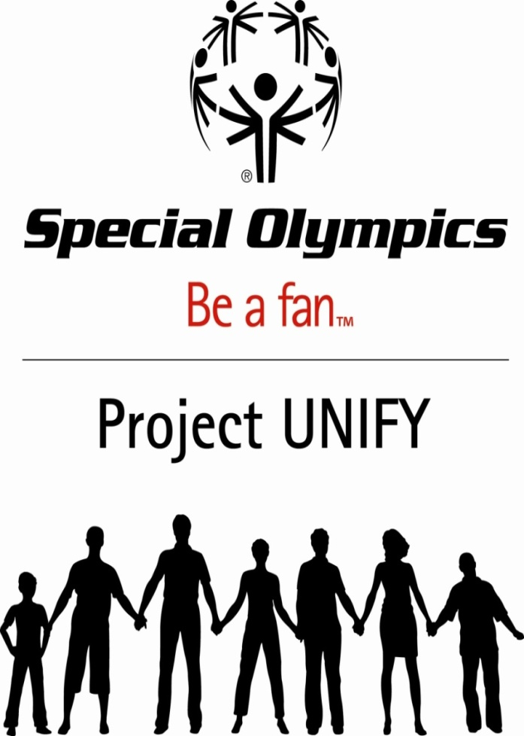

Special Olympics Project UNIFY
National Youth Activation Program1133 19th Street NW
Washington, DC USA 20036-3604

INTRODUCTION

Special Olympics Youth Rallies are the ultimate example of the Project UNIFY strategic framework of Educate, Motivate and Activate. At the rallies young people are educated about Special Olympics programs, the abilities and gifts of persons with intellectual disabilities and the hurtful and exclusionary effect of the casual use of demeaning language. Students are motivated to become engaged in a cause for social justice by inspirational first-hand testimonials, music performances, video and multi-media presentations that promote inclusion, acceptance and an opportunity to change the world. And before the rally is over a variety of hands-on and immediate ideas and options are presented to the audience for how each one of us can take action, be engaged, get involved in Special Olympics sports activities and advocate together with and on behalf of persons with intellectual disabilities in our communities.

MAKE IT HAPPEN IN YOUR SCHOOL

SPREAD THE WORD TO END THE WORD is a Special Olympics Project Unify campaign to raise awareness about the hurtful effects of using the word “retarded” to refer to people with intellectual disabilities. Last spring students from “Special Olympics(SO) College” decided that March 31, 2009 would be an official culminating day for various events to take place all over the country to spread the message about how harmful the “R” word is and to promote inclusiveness and acceptance of people with different abilities, or as Special Olympics Chairman of the Board Tim Shriver says, “diff-abilities.” But SPREAD THE WORD TO END THE WORD can be more than just a day - with your help it could be a movement.

In conjunction with the SPREAD THE WORD TO END THE WORD campaign, you can produce an event geared toward high school students, a very important group in this effort to change people’s attitudes towards those who have different intellectual abilities and to treat them with more “respect” – the new “R” word.

Youth Rallies are a successful way to get our message across to high school-ers like yourself, and to engage young people in the Special Olympics movement. By following the guidelines in this kit, you can produce your own youth rally at your high school!

On March 31, 2009, 11th grader Noah Gray produced the largest high school rally of its kind at Palmetto High School in Miami, Florida. This “How-to” kit is based on the rally that he produced. You can find sample documents from his rally at the end of this packet.

Before following the steps to create a youth rally, think of what you want to accomplish as a result of it. What are your goals for having the rally at your school? Below is a list of seven possible goals of the rally. These are just some goals – you may want to add your own.

Goals for hosting a youth rally at your school:

- To raise awareness about the hurtful consequences of the “R” word.
- To create positive social change in your school
- To promote unification between students with and without intellectual disabilities.
- To engage young people in the movement of Project UNIFY and Special Olympics.
- To have a good time while educating your peers.
- To encourage the students at your school to take the pledge to stop using the “R” word.
- To educate, motivate, and activate your students at your school

Where to Start:
- Pitch the idea to your school’s Principal, Assistant Principal, and/or Activities Director for approval to host a rally. As you follow the next 4 steps, you will work very closely with him/her/them on the logistical details of your rally.
- Find a mentor/supporter for your rally from your local or state Special Olympics Program.
- Apply for a youth sub-award grant through your state’s Project Unify program. Go to xxxxx to find out if you are eligible to receive funds to put on your youth rally.
- Work with your school to determine how many students will be in attendance and where and when the event will take place. (School gym? Auditorium? Field?) Although March 31 is the “official” Spread The Word To End The Word Day, your rally can take place any time of year.
- Find out who in your school is already involved with Special Olympics, and get them on board. (Unified Sports™ teams, Partners Clubs, volunteers, etc.) They will be very helpful in planning and organizing the rally.

Producing the Rally:
- Decide how long your rally will be. (A typical rally will be 1 class period) Make sure you leave enough time for students to enter, get seated etc.

- Think about if there are celebrities (actors, performers, athletes) or local celebrities (local music acts or entertainers, mayors and other government officials, university athletes and coaches) in your geographical area who have endorsed or are involved in Special Olympics. Talent can be a key ingredient in the success of your rally. Their “star power” will help contribute to the legitimacy and excitement of your rally. In Noah’s rally, actor Eddie Barbanell star of the movie, “The Ringer” was the headliner. Eddie served as the celebrity guest who entertained and moved the audience.

- Decide how you will engage your audience and get them interested in paying attention to the messages. Make sure to include a good mix of live speakers, videos, and music to keep the rally moving at a good pace. Multimedia adds to the excitement and is what young people expect.

- The “live” portion of your rally could consist of the following. (Please note that they are in no particular order, and it is YOUR rally.)

  - Celebrity guest- Could be a local or national celebrity. He or she will show your peers that celebrities endorse Special Olympics because it is a great cause and they should too!
  - Musical act- Could be anywhere from a high school band, to a local country singer, or rap artist. He or she/they could preferably sing about unification or Special Olympics. This could be used at the beginning of the show to immediately gain your peers’ attention and respect.
  - Special Olympics Athlete- The athlete is an essential part of your rally. The athlete could speak about how they feel when they hear the “R” word.
  - Volunteer- He or she could speak about why they got involved with Special Olympics and what volunteering with SO has done for them
  - You/Host- Can speak about why you were motivated to produce a youth rally. How you got involved with SO and what inspired you. You should be speaking to your peers about why unification is important and why they should have respect for people with disabilities.
  - Volunteer coordinator from your local Special Olympics- Towards the end of the rally, once you have hopefully educated and motivated your peers, you must activate them. You will most likely have hundreds of high school students at your event that will be moved to want to get involved with SO. This is why a volunteer coordinator from your local Special Olympics program could speak at the end and provide the students with the information they need in order to get involved with Special Olympics.

- Multimedia - The multimedia portion of your rally will be very important. You can create your own videos, or you can choose from many videos on Special Olympics’ Fan Community. You can see which videos Noah used as a part of his rally in his RALLY RUNDOWN at the end of this document. You can contact Noah Gray at ngray@specialolympics.org to obtain videos used in his rally. For assistance with downloading videos from the Fan Community, you can contact Ryan Eades at reades@specialolympics.org.

- Pledges- At the end of the rally, it would be nice for you to get your peers to take the pledge. You can do this in many ways. You can tell them to go to www.R-Word.org to pledge online. You can have giant posters around the venue where your rally is taking place and encourage your peers to sign them, or you can be creative and come up with your own way to get them to pledge.

- Media Coverage- By producing your own rally at your high school, you will be doing a great thing that the media will likely want to cover. Coverage of your event will help get more people involved in the movement and help SPREAD THE WORD TO END THE WORD. In order to properly inform the media of the event, you will need to create a Press Release as well as a Media Alert. You should send the Press Release to local media outlets about a week before the event, and the Media Alert to the same media outlets the day before the rally. It is also nice to make a follow up phone call on the day of or before the event to make sure that they received the Media Alert and see if they plan on having a crew or reporter attend the event. We have included a sample Media Alert, and Press Release from Noah’s rally which you may follow and customize for your rally.

- Materials- You may choose to hand out pledge cards, wrist bands, T-shirts etc. For materials and more resources to produce your own rally you can visit http://www.specialolympics.org/stw_resources.aspx where you can download items that you may need.

QUESTIONS AND ASISTANCE
To watch Noah Gray’s rally you can visit Noah Gray's Fan Community page, where it is uploaded in four parts. To request a DVD of the event or ask for his assistance, you may send him an email at ngray@specialolympics.org

SAMPLE PRESS RELEASE

FOR IMMEDIATE RELEASE

March 28, 2009 [A FEW DAYS BEFORE THE EVENT]

Contact:
[RALLY ORGANIZER’S NAME
TITLE
PHONE NUMBER – CELL PHONE IS BEST
E-MAIL ADDRESS]

Special Olympics HOSTS “Spread the Word to End the Word - 3.31.09” EVENT IN MIAMI to Raise Awareness about the “R-word”

Major Local Rally Organized by Miami-Palmetto Senior High Student

Miami, FL – Special Olympics is hosting a new youth-lead effort - Spread the Word to End the Word - 3.31.09, encouraging people nationwide to pledge to stop using the word “retard” in a derogatory way. The day will be devoted to educating and raising awareness about individuals with intellectual disabilities and the offensive use of the “R-word.”

On Tuesday, March 31, beginning at 12:35 PM, Miami-Palmetto High School will host a Youth Rally, involving over 700 students. Produced by 11th grade student Noah Gray, along with Special Olympics International and Special Olympics Florida, the event will reach thousands of students nationwide via a live stream at www.schooltube.com, and to be viewed later at www.r-word.org.

The event, which will run approximately 50 minutes, will feature the star of the hit movie “The Ringer,” who will speak about his personal experiences being called a “retard” and ask the students to stop and think before they label people who are different. Rap artist RUSH will pump up the crowd as he performs his original songs about dispelling the stereotypes about people with intellectual disabilities. The program also includes video messages and public service announcements created by young people, including student filmmaker Noah Gray. Athletes and volunteers from Special Olympics Florida will tell their stories and invite students to take the “R-word” pledge.

Spread the Word to End the Word - 3.31.09 was created by youth with and without intellectual disabilities who participated in the Special Olympics Global Youth Activation Summit in February held in conjunction with the 2009 Special Olympics World Winter Games. Motivated by their opportunity, they decided to lead this effort nationwide. Actor John C. McGinley was inspired by the motivation, creativity and passion the youth demonstrated in helping raise awareness about this issue and their dedication to stop the casual use of the “R-Word.”

“Most people don’t think of this word as the language of hate, but that’s exactly what it feels like to millions of people with intellectual disabilities, their families and friends,” said McGinley. “I choose to believe that most of us are fundamentally good and that we’re just not aware that the word is offensive and that it hurts.”

Students and schools across the country will unite to challenge everyone to think before they speak. Spread the Word to End the Word - 3.31.09 will follow a week of campaigning, mainly through viral media, posters and word-of-mouth encouraging everyone to pledge to stop the use of the word at r-word.org. Youth have set a goal to garner 100,000 online pledges through this campaign.

About Special Olympics
Special Olympics is an international organization that changes lives by encouraging and empowering people with intellectual disabilities, promoting acceptance for all, and fostering communities of understanding and respect worldwide. Founded in 1968 by Eunice Kennedy Shriver, the Special Olympics movement has grown from a few hundred athletes to nearly 3 million athletes in over 180 countries in all regions of the world, providing year-round sports training, athletic competition and other related programs.

Special Olympics now takes place everyday, changing the lives of people with intellectual disabilities in places like China and from regions like the Middle East to the community playgrounds and ball fields in every small neighborhood’s backyard. Special Olympics provides people with intellectual disabilities continuing opportunities to realize their potential, develop physical fitness, demonstrate courage and experience joy and friendship. Visit Special Olympics at www.specialolympics.org.

About the National Youth Activation Project
The National Youth Activation Project or “Project UNIFY” will establish a national capacity and commitment to support individuals with intellectual disabilities through an integrated program of education in the classroom and community, hands-on experiences, and purposeful leadership development among America’s youth.

About SO Get Into It
Special Olympics Get Into It is a structured classroom curriculum for primary, middle school and high school classrooms. The curriculum includes a series of classroom units that address intellectual disabilities and acceptance of individuals who have intellectual disabilities, the values of acceptance, role models among the intellectual disabilities community, etc. This curriculum has been used in thousands of schools and many countries.

###

MEDIA: The national project director for “Spread the Word to End the Word,” Andrea Cahn, will be in attendance and available for interview, as well as all Miami-Palmetto High School Youth Rally ceremony speakers.

On-site contact for Special Olympics Florida: Nancy Sawyer, Senior Vice President, Special Olympics Florida, 407-402-8603.
SAMPLE MEDIA ALERT
[E-MAIL TO LOCAL REPORTERS, BOTH PRINT AND TV, THE DAY BEFORE AND DAY OF THE EVENT, DATED, AND CUSTOMIZED TO YOUR RALLY]

MEDIA ALERT * MEDIA ALERT * MEDIA ALERT
Miami-Palmetto Senior High School Student Noah Gray and Special Olympics Announce Youth Rally to ‘Spread the Word to End the Word 3.31.09’ to Raise Awareness about the ‘R-word’
WHAT:

“Spread the Word to End the Word” Youth Rally, produced by 16-year old high school junior Noah Gray.

The “Spread the Word to End the Word” Youth Rally at Miami-Palmetto Senior High is a part of the national collaborative effort to Spread the Word to End the Word. 3.31.09 will be a National Awareness Day to raise the consciousness of society about the dehumanizing and hurtful effects of the word “retard(ed).”

The day will be devoted to educating and raising awareness about individuals with intellectual disabilities

Young people across the country will rally their schools and communities to pledge their support and stop the offensive use of the “R-word” in casual conversation at www.r-word.org.

WHO:

Actor Eddie Barbanell, star of the hit movie “The Ringer,” (and resident of Broward County), along with rap artist RUSH, as well as South Florida Special Olympics athletes and volunteers will unite with thousands of youth across the nation to Spread the Word to End the Word. The event will also feature original video messages and public service announcements produced by young people, including student filmmaker Noah Gray.

The national effort is spearheaded by college students, Soeren Palumbo (Notre Dame 2011) and Tim Shriver (Yale 2011) and led by young people and Special Olympics athletes across the country.

Celebrity activist, John C. McGinley of the hit show “Scrubs,” pledged his support and is actively promoting the national campaign.

WHEN:

Tuesday March 31, 2009 -- 50 minute live event begins promptly at 12:35 PM and will stream live on www.schooltube.com

Available for interviews:

Actor Eddie Barbanell
Producer Noah Gray
Andrea Cahn, Director of Special Olympics Project Unify
Nancy Sawyer, Special Olympics Florida

WHERE:
Miami-Palmetto Senior High School - Auditorium
7460 SW 118 Street, Pinecrest FL 33156
Media Contact:
Noah Gray
PHONE NUMBER
EMAIL ADDRESS

SAMPLE RUN OF SHOW
Name | Time | Type | Start Time | End  Time
How does the R word make you feel PSA | 00:51 | VIDEO
Unify Music video/ RUSH (rap artist)performs | 3:00 | VIDEO/LIVE
Noah (student host)welcome & speech | 4:00 | LIVE
Soeren (motivational about hurtful use of R word) speech | 3:37 | VIDEO
Noah introduce movie clip from “The Ringer” | 00:30 | LIVE
Ringer package | 1:30 | VIDEO
Eddie Barbanell (guest celebrity) speech | 7:30 | LIVE
R word is Respect PSA | 00:30 | VIDEO
University of Miami 3 word video | 2:45 | VIDEO
Nick(student volunteer) speaks briefly, introduces Andy, SO athlete from Miami | 1:00 | LIVE
Andy speech | 2:00 | LIVE
Adam PSA | 00:30 | VIDEO
I can see you PSA | 00:30 | VIDEO
Noah introduce student volunteer | 00:30 | LIVE
Woo Lim (Student volunteer) speech | 2:00 | LIVE
Introduce Nancy(SO representative) | 00:30 | LIVE
Nancy gives info on how to get involved | 2:00 | LIVE
Noah wrap up/ Invites everyone to pledge | 2:00 | LIVE
All cast come on stage - Finale | 3:03 | VIDEO/LIVE
TOTAL TIME | 40 min. and 48 sec.

