
The Special Olympics Project UNIFY blog is an open forum where youth leaders, educators and staff share their knowledge, experience and information about Project UNIFY as they advocate for inclusion, acceptance and respect in schools across the United States.

Whether you’re a regular blog contributor or a guest blog author, here are a few helpful things to think about when putting together a blog for Project UNIFY.

CONTENT: BE USEFUL AND UNIQUE
Questions to ask yourself:
- Who is your audience and what do they want to hear?
- What information, experience or expertise can you bring to the audience that will enhance their knowledge of the topic?

People invest their time reading posts that educate, enlighten, entertain, organize complex information, provide a unique personal experience or share pointers to great resources. The more useful your content is to your readers, the more they will engage with the blog.

For more information about creating good content, check out this article.

FORMATTING: BE READABLE, CONCISE AND CREATIVE
Make the post readable
Nothing’s worse than seeing a huge block of text in a blog post. It’s intimidating and turns people off from reading more. Try some of these formatting tips to help break up text and keep your post fun and informative:
- Use lists or bullets to separate out important information
- Use block quotes or bold/italicize to highlight information that is extremely important or relevant to your audience
- Include hyperlinks – don’t just tell someone about certain websites or information, link them directly where they need to go
- Write shorter paragraphs to keep text concise and simplified
- Use headers and sub-headers within the text to organize content and break into unique topics
- Add pictures or videos between paragraphs to break up text (and make your post more exciting)
Write in plain, concise, common-sense style
Just be you!
Provide a realistic perspective and bring your personality into your blogging so your readers get to know more about you. Feel free to be more colloquial with your readers and write like you would speak – no need to keep a formal, verbose or business-like presence in your blog post.

Be Creative
Don’t limit yourself to text. If you are more comfortable in front of the camera, try creating a video blog to share your experience and then uploading it to your blog post. Or use a photo slideshow to tell your story. The possibilities for creative storytelling are endless!

HEADLINES: WRITE A GREAT ONE
Your headline is the first thing people read and it will determine whether they keep reading. Nowadays, many people access blogs through a feed reader and the headline is the only thing they see, so make it catchy, informative and relevant to your content. Some tips:
- Try writing your headline last, that way you’ll know the most important themes/ideas of the post
- Keep it short, simple and easy to understand
- Grab attention with shock and awe (but make sure you provide the information/content in your post that you claim in your headline)
- Use important key words that will help your post be searchable
- Find more helpful headline tips in ‘Using Titles Effectively’ blog post

Final Words of Wisdom
- Wondering the ideal post length? Shoot for somewhere between 250 and 500 words. However, as one wise blogger said, “Write enough to comprehensively cover your topic and then stop. Long posts for the sake of them are not a wise move – but so are short ones that don’t cover the topic well.” (Pro Blogger)
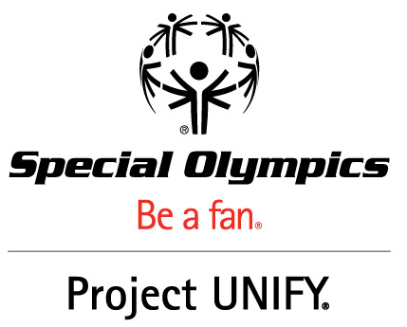
- Make sure to respond or acknowledge comments you receive on your post. If you’re a regular contributor on the blog, you’ll receive an email when someone comments on your post. Take the time to say thank you or respond to any outstanding questions – it will keep readers coming back for more.
- Once you’ve finished your post, share it with the world! Be proud of what you wrote and share it with your friends, family and colleagues through social media, email and more!

