

GLOBAL YOUTH SUMMIT HANDBOOK

CONTENTS

SECTION 1 – General Information page 2

SECTION 2: GYS Participant Responsibilities page 8

SECTION 3: Credentialing page 12

Section 4: Arrival page 15

Section 5: Opening Ceremony page 28

Section 6: Delegation Services page 20

Section 7: Delegation Accommodation page 20

Section 8: Sport and Competition page 23

Section 9: Non-Sports Programs page 26

Section 10: Closing Ceremony page 29

Section 11: Departure page 31

Section 12: Information Technology page 32

Section 13: Medical Services page 34

Section 14: Security and Safety page 37

Section 15: Family Services page 40

Section 16: Media Services page 41

SECTION 1: General Information

1. Introduction

This manual contains information needed to help each Global Youth Summit (GYS) delegation prepare for participation in the 2005 Global Youth Summit as part of the Special Olympics World Winter Games in Nagano, Japan from 25 February through 6 March.

2005 Special Olympics World Winter Games, Nagano (SONA) and Special Olympics (SOI) have attempted to make this handbook as comprehensive, complete and easy to understand as possible. Please understand, however, that we are still working on final operating plans so there may be slight modifications to the information it contains between publication and the Games.

SOI urges all GYS participants to familiarize themselves with the handbook and to ensure that the information it contains is shared with other family members and Special Olympics Program staff.

Please forward any specific questions to:

Ron Vederman, Ed.D.,
Director of Athlete Recruitment, School/Youth Outreach, Volunteer Services
Special Olympics
1133 19th Street, N.W.
Washington, DC 20036

Tel: +202-824-0275 (Cell phone number for Japan will be provided upon arrival to Nagano or sooner if possible)
Fax: +202-628-3926
E-mail: Rvederman@specialolympics.org
URL: www.specialolympics.org

1.1 Overview of the 2005 Special Olympics World Winter Games

Event Name
Official Name:

2005 Special Olympics World Winter Games

Games Period
Saturday, 26 February to Saturday, 5 March 2005 (8 days)

Opening Ceremony: Saturday, 26 February
Competition: Saturday, 26 February to Friday, 4 March
Closing Ceremony: Saturday, 5 March

Both opening and closing ceremonies will be held at the Nagano Olympic Memorial Arena (M-Wave) in Nagano City.

Theme of the Games

“Let’s Celebrate Together!”

Basic Concepts Underlying Games Operations
- The 2005 Special Olympics World Winter Games, with its “Let’s Celebrate Together” theme, is an historic opportunity to raise national consciousness about the capabilities of people with intellectual disabilities by actively encouraging the involvement of local people and maximizing opportunities for interaction with athletes from around the world.
(2) Games planning will make the most of our Nagano Olympic and Paralympic Games legacy to ensure athlete-centered Games offering warm hospitality.
- We will apply the operational expertise so highly evaluated at the Olympic and Paralympic Games to provide fair and impartial competition that enhances the dignity and prestige of athletes in a manner befitting a quadrennial World Games.
- We will promote exchange and mutual understanding by actively supporting non-sports programs unique to the Special Olympics such as the Host Towns Program, Healthy Athletes Program and the Global Youth Summit.

Venue Areas
Nagano City, Yamanouchi Town, Hakuba Village, Mure Village and Nozawa Onsen Village

Participants
Category | Estimated Numbers
1. Special Olympics Programs | Representing 80 countries and regions
2. Total Delegation Members | 3,150 (2,500 athletes; 650 coaches)
3. Family Members | 3,000
4. Guests | 1,000
5. Competition Officials | 1,000
6. Volunteers | 9,000 (Daily Peak of 4,500)
7. Press and Media | 1,000

Sports and Venues
Competition | Venue
Alpine Skiing | Yamanouchi Town: Ichinose Family Ski Ground in Shiga Kogen
Cross Country Skiing | Hakuba Village: Hakuba Cross Country Skiing Venue (Snow Harp)
Snowboarding | Mure Village: Iizuna Resort Ski Ground in Iizuna Kogen
Snowshoeing | Nozawa Onsen Village: Olympic Sports Park
Speed Skating | Nagano City: Nagano Olympic Memorial Arena (M-Wave)
Figure Skating | Nagano City: Wakasato Multipurpose Sports Arena (Big Hat)
Floor Hockey | Nagano City: Mashima Sports Arena (White Ring)
Total: 79 Events in 7 sports
Non-Sports Programs
Program |  | Schedule
1. Torch Run
 | Five Million Person Torch Run | Runs nationwide throughout Japan from September 2004 through February 2005
 | Special Olympics Torch Run  (Law Enforcement Torch Run) | The torch is lit in Athens in mid-February 2005 and arrives in Tokyo on the 18th. After being run though Nagano Prefecture from the 19th to the 25th it arrives in Nagano City on the 26th.
2. Host Town Program |  | 22-25 February 2005
3. Healthy Athlete Program |  | 26 February to 4 March 2005
4. Global Youth Summit |  | 26 February to 5 March 2005

1.2 Location of Competition Venues and SO Towns

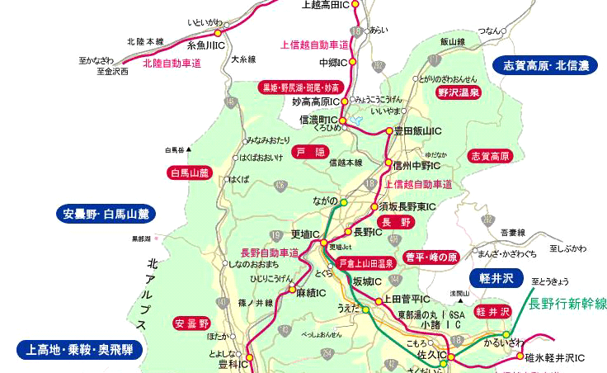
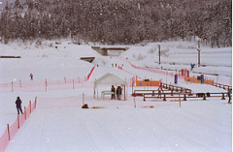
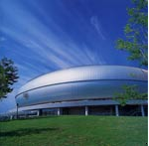
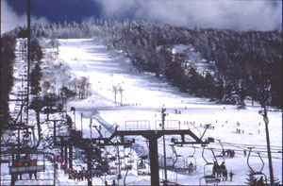
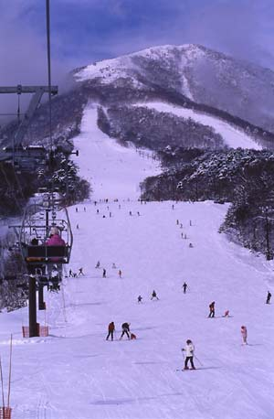
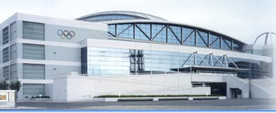
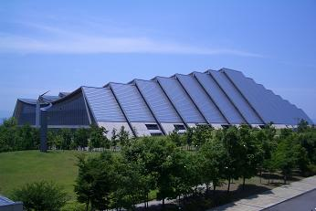
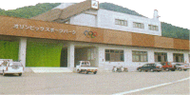
Shiga Ichinose Family Ski Ground
Yamanouchi Town
(Alpine Skiing)

Hakuba Snow Harp
Hakuba Village
(Cross Country Skiing)
Big Hat, Nagano City
(Figure Skating)
White Ring, Nagano City
(Floor Hockey)
Iizuna Resort Ski Ground
Mure Village
（Snowboarding）
M-Wave, Nagano City
(Speed Skating)
(Opening & Closing Ceremonies)
Olympic Sports Park
Nozawa Onsen Village
(Snowshoeing)
SO Town Nozawa
Nozawa Onsen Village
SO Town Shiga
Yamanouchi Town
SO Town Hakuba
Hakuba Village
SO Town Nagano
Nagano City

1.3 2005 Games Logo and Philosophy

Philosophy

The 2005 Special Olympics World Winter Games are of global significance as the first Special Olympics World Games in Asia and because they mark the first time the “three Olympics” – the Olympic Games, the Paralympic Games and the Special Olympics Games – will have been held in the same city.

The Games aim to create, with the enthusiastic support of the local community, a platform for athletes with intellectual disabilities to achieve their potential and their individual goals, sharing courage, joy and excitement with all Games participants.

The Games also seek to promote the Special Olympics Movement and, through peaceful competition in sport, show to the world a “barrier-free” attitude that transcends nationality and disability and creates local communities open and friendly to all.
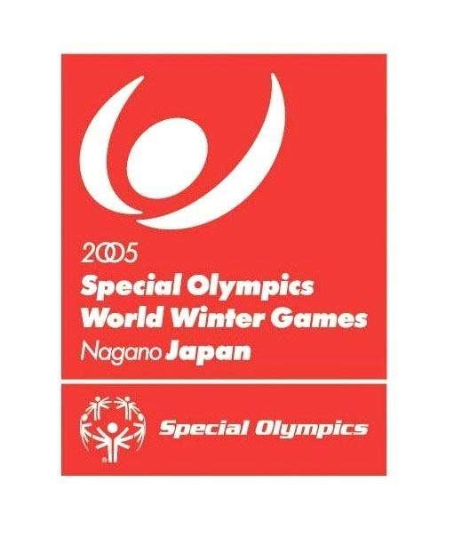

  - Language
Although Japanese is spoken in Japan, English is the official language of the 2005 Special Olympics World Winter Games and Global Youth Summit. Bilingual staff members and volunteers proficient in English and other languages will be available at all competition and other Games venues and accommodation facilities. GYS will be primarily responsible for providing their own translation to ensure smooth communication between the delegation and one another. This is why SOI requested that at least one member of the GYS team have proficiency in English.

  - Electricity
Standard Power
Electrical outlets at accommodation and other Games facilities supply power at 100V and 60Hz. If your electric device is rated either “100V 60Hz” or “100V 50Hz/60Hz,” it is safe to use. Available outlets come in either the two-prong or three-prong form factors below.

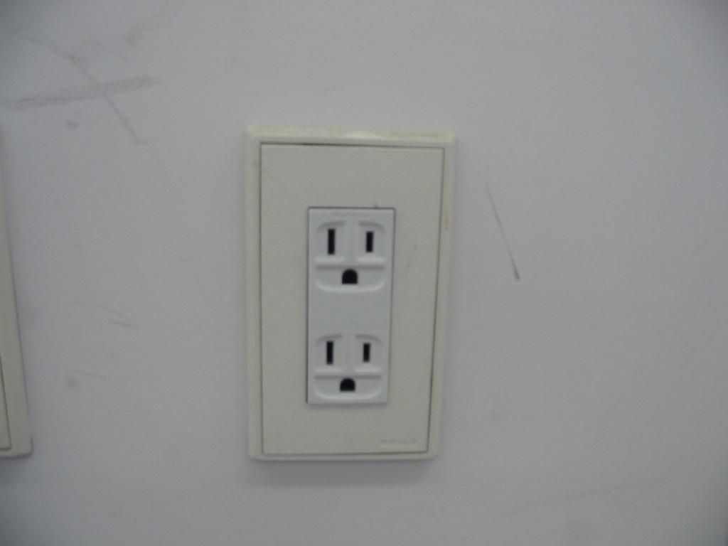
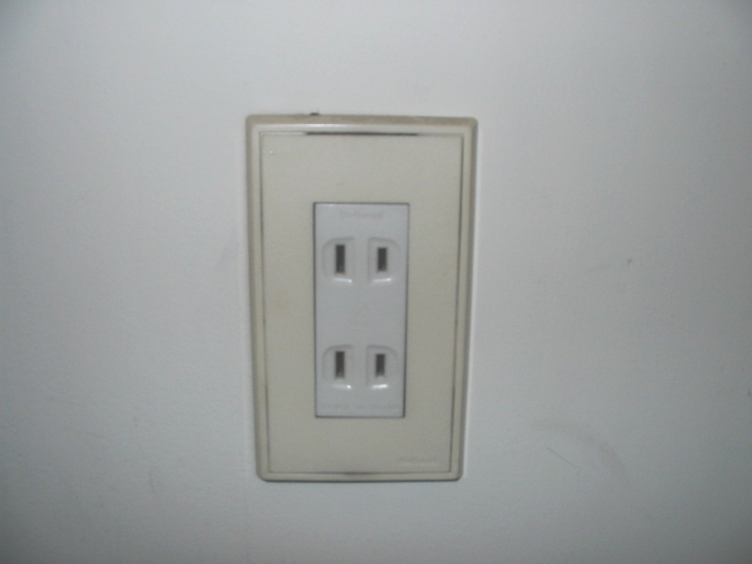

Note: Since accommodation and other Games facilities will not supply adapters or transformers, please bring your own as needed. Using electrical devices with incompatible voltage or frequency requirements risks not only damage and a degradation of performance but can also cause fires.

  - Public Phones and Mobile Telephones
Public phones come in two types: those that can accept either coins (10 yen and 100 yen) or pre-paid telephone cards and those that can accept only telephone cards. Calling charges vary by the distance of the call but local calls within the city cost 10 yen per minute. If you put in 20 yen and your call ends within a minute, the extra 10 yen will be returned. No change, however, is provided for 100-yen coins. Note that SONA-installed public telephones for international calls accept only cash or pre-paid telephone cards. Public phones can switch between Japanese and English display at the touch of a button. When making international calls, dial the international calling code supplied by your service provider followed by the country code and phone number of the person you’re calling.

You will be provided with a phone card upon arrive to the Garden Hotel in Nagano as part of your GYS “goodie bag”. This will be enough to briefly phone home a few times. Additional Pre-paid 1,000-yen telephone cards can be purchased at convenience stores, train station kiosks and special vending machines.

The Japanese mobile phone system differs from that used in other countries. Before bringing your own mobile phones to Japan, please confirm whether or not they will work here. Except for satellite phones or other special models, overseas mobile phones generally will not work in Japan.

Please see Section 13: Information Technology for more information on telephones and mobile phones.

  - Currency and Changing Money
Japanese currency includes both coins (1, 5, 10, 50, 100 and 500 yen) and notes (1,000, 2,000, 5,000 and 10,000 yen). Bank branches and currency exchange services are available at both Terminal 1 and Terminal 2 of Narita International Airport. However, it may be difficult to change money at the airport depending on time of arrival and the need to proceed to the GYS chartered bus taking you to Nagano. Bank checks are not used in Japan although traveler’s checks (denominated in Japanese yen, US dollars, Canadian dollars, British pounds, euros or Swiss Francs) can be cashed at some banks.

Most larger stores and restaurants accept VISA, Master Card and American Express cards. However, many smaller shops do not accept credit cards. We strongly recommend that delegations change money into Japanese yen while still in their home country just to get by for a day or so since you’ll arrive when banks may be closed. If this is impossible, please bring US dollars, which can be exchanged for Japanese yen at select bank branches in Nagano City.

Special Olympics will provide each GYS participant with an ATM pre-paid bank card with enough funds to purchase selected meals. You will receive this as part of your “goodie bag” when you get to the hotel in Nagano. You will have a “pin” that will be unique to each card. This ATM card will used to withdraw yen every few days to purchase your meals when they are not part of any scheduled group activity.

ATMs are quite common in Japan but most will not accept credit cards or cash cards from overseas. Many such cards can, however, be used at post office ATMs throughout Japan. Lists of acceptable cards are posted at the ATMs but include cash cards from the Cirrus, Plus, Maestro and Visa Electron networks and credit cards from Visa, MasterCard, American Express and Diners Club.

Weather
Nagano Prefecture’s weather patterns reflect its location in Japan’s interior, far from the coast, and it is known for the wide range between daily high and low temperatures. At high elevations, weather patterns are typical of mountainous areas with generally lower temperature, air pressure and humidity than in the plains. Sunlight is more intense at higher altitude so it is important to take precautions against sunburn. Wind is also stronger than in the plains so be sure to bring adequate cold-weather gear. Refer to the table below for average snow accumulation and temperature in February for each competition area.

Municipality (Venue) | Elevation (m) | Average Snow  Accumulation (cm) | Average Temperature (C)
Nagano City | 362 | 5 | 0.3
Mure Village  (Iizuna Resort Ski Ground | 900 | 170 | -2.5
Yamanouchi Town  (Ichinose Family Ski Ground) | 1,650 | 250 | -5.6
Hakuba Village  (Snow Harp) | 700 | 59 | -2.3
Nozawa Onsen Village  (Olympic Sports Park) | 620 | 146 | -1.3

Further detailed weather information is available in the following websites:
Ministry of Foreign Affairs: http://www.mofa.go.jp/index.html
JNTO: http://www.jnto.go.jp/

  - Acronyms and Abbreviations
CIQ: Customs, Immigration and Quarantine
DNF: Did Not Finish
DNS: Did Not Start
DQ: Disqualified
GOC: Games Organizing Committee
GYS: Global Youth Summit
MCC: Main Credential Center
MMC: Main Media Center
SID: Sports Information Desk
SMC: Sub Media Center
SOI: Special Olympics, Inc.
SONA: Special Olympics World Winter Games, Nagano
SOOPA: Special Olympics Officials Program for Athletes

  - Key Dates and Deadlines
Date | Comment
24-25 February 2005 | - GYS teams arrive
25 February 2005 | - GYS Welcome dinner at the Garden Hotel
26 February 2005 | - Opening Ceremony
5 March 2005 | - Closing Ceremony
6-7 March 2005 | - Delegation Departure

SECTION 2: GYS Participant Responsibilities

  - CHAPERONE CODE OF CONDUCT

Chaperones will comply with the following conduct guidelines:

- Treat Special Olympics Athletes, Summit partners, staff, officials, and volunteers with respect and communicate in a courteous manner.

- Provide at all times for the general welfare, health, and safety of the Special Olympics Athlete and Summit Partner in my charge during the Global Youth Summit.

- Dress and act at all times in a manner which is appropriate to my assigned responsibilities and a credit to myself, the athletes and Special Olympics.

- Report any emergencies to 2005 Special Olympics World Games authorities after first taking immediate action to ensure the health and safety of the participants.

- Refrain from consuming alcoholic beverages and non-prescribed controlled substances during the entire course of assigned duties. Refrain from smoking or using chewing tobacco at Summit and competition sites.

- Refrain from engaging in any type of sexual activity, physical abuse or other inappropriate behavior with either Special Olympics Athletes, Summit Partners, staff, officials or other volunteers.

- Be thoroughly familiar with information in the 2005 Global Youth Summit Handbook.

- Ensure that athletes and partners are at the designated meetings, sessions, scheduled events, meals, and other activities on time.

- Respect the property of the hotel, eating facilities, competition venues, and activity sites. Follow any rules established by these facilities for the safety and welfare of the 2005 Global Youth Summit participants.

- Familiarize yourself with the available medical history of athletes and partners for whom you are responsible.

- Be sure that athletes, partners, and yourself are wearing proper credentials and clothing to comply with the elements.

- Supervise travel to and from Nagano and manage clothing and luggage for athletes and partners.

2.2 SPECIAL OLYMPICS ATHLETE and SUMMIT PARTNER CODE OF CONDUCT

Athletes and Partners will comply with the following conduct guidelines:

- Dress and act, at all times, in a responsible manner that will be a credit to Special Olympics and your Program. Profanity, taunting and other forms of poor sportsmanship and uncooperative behavior are subject to disciplinary measures that may include an early return to your state or country of origin.

- Respect all residential sites, meeting sites, dining facilities, competition venues, and other activity areas.

- Treat other Global Youth Summit participants, 2005 World Games athletes, coaches, officials and volunteers with respect and communicate in a courteous manner.

- Do not drink or use alcoholic beverages, tobacco, and/or non-prescription drugs.

- Agree not to engage in any inappropriate contact or relationship with Special Olympics Athletes, Summit Partners, Summit Chaperones, staff, officials, or volunteers.

- Ensure that you are at the designated meetings, sessions, scheduled events, meals, and other activities on time.

- Be certain to wear proper credentials and appropriate clothing suitable for the weather.

- Follow the directions of your chaperone while traveling to and from Nagano and all the time you are attending the 2005 Global Youth Summit.

2.3 Before the Summit
Chaperones must:
- Comply with all deadlines issued by National Programs and Special Olympics Inc. (SOI).
- Submit all required documents from SOI.
- Communicate accurate travel itineraries to athletes, partners and their families.
- Communicate all required information to National Program and SOI.
- Ensure all travel documents are in order including visas and travel insurance.

2.4 During the Summit
Chaperones have the following responsibilities during the 2005 Global Youth Summit:
- Ensure you and GYS members have all travel documents, prescribed medications and luggage before leaving for the airport.
- Arrive at the departure airport in sufficient time to check in, check bags and proceed through security screening and customs.
- Coordinate check-in for your GYS participants at all official accommodations either at Narita Airport, Narita Airport Hotel (if arriving on 24 February or departing on 7 March) or the Garden Hotel in Nagano.
- Ensure your GYS group takes the GYS chartered bus to and from Narita Airport on 25 February and 6 March.
- Coordinate GYS housing arrangements and room assignments with Ron Vederman or designated volunteers upon arrival at the Garden Hotel in Nagano and oversee room key control.
- Ensure all GYS members are responsible for their personal belongings at all times and assist in maintaining the cleanliness, safety and security of their accommodation and possessions.
- Ensure that no visitors, including family members, are living or present in the private areas of the GYS accommodation.
- Ensure that all GYS members understand they will be fully financially responsible for any incidental expenses and for any damage they cause, and that they may be subject to further action by SOI.
- Ensure all GYS members receive their official GYS Credential and wear it at all times and understand that it may be revoked if used by unauthorized persons.
- Attend all GYS scheduled meetings. Inform Ron Vederman in advance of any problem that may prevent attendance from taking place.
- Maintain possession of hard copies of all medical forms for GYS members.
- Immediately take necessary steps to address any medical or emergency situation involving the GYS participants.
- Inform Ron Vederman or designee, of any emergency situation that jeopardizes the health and/or safety of the GYS participants.

Note:
- GYS member safety is a primary concern of SOI. Assuring the safety of all participants is a team effort that requires the full cooperation of members. All participants must cooperate with the operations systems implemented by SONA and SOI and conduct themselves in a manner that minimizes risk of injury.
- Any member of a GYS team who violates the policies and procedures of the 2005 Games and Youth Summit may be subject to immediate dismissal.

SECTION 3: Credentialing

3.1 Issuing of Summit Credentials
- Credentials
- Credentials serve to identify Games personnel (people involved in the Games either as participants or organizers) and their access privileges according to pre-defined categories based on their role. Credentials are issued by SONA and distributed to all Games personnel.
- Information to be printed on credentials is prepared in accordance with category-specific registration forms submitted to SOI or SONA.

(2) Credential Issuance Procedures
- Credentials are issued to Games personnel in advance of the Games based on the information included in category-specific registration forms.

(3) Credentials and Japanese Immigration
- Games personnel from overseas should wear their credentials around their necks upon arrival at Narita International Airport so that Customs, Immigration and Quarantine officials can identify Games personnel for expedited processing.

3.2 Venues Subject to Access Control
- Venues access will be controlled through pictograms at venues listed in the Venue Access column of the Access Entitlements table in Section 3.5.
- Within such venues, access to Competition & Athlete Areas, Administration & Operation Areas, Media Areas, Guest Areas, Family Areas and Accredited Person Circulation Areas will be controlled based on the zone codes listed in the Zone Access column of the Access Entitlements table in Section 3.5.

3.3 Loss and Replacement
(1) Credentials
- If your credentials are lost or stolen, immediately notify Ron Vederman or designee.

3.4 Credential and Access Privileges
(1) Sample Credential
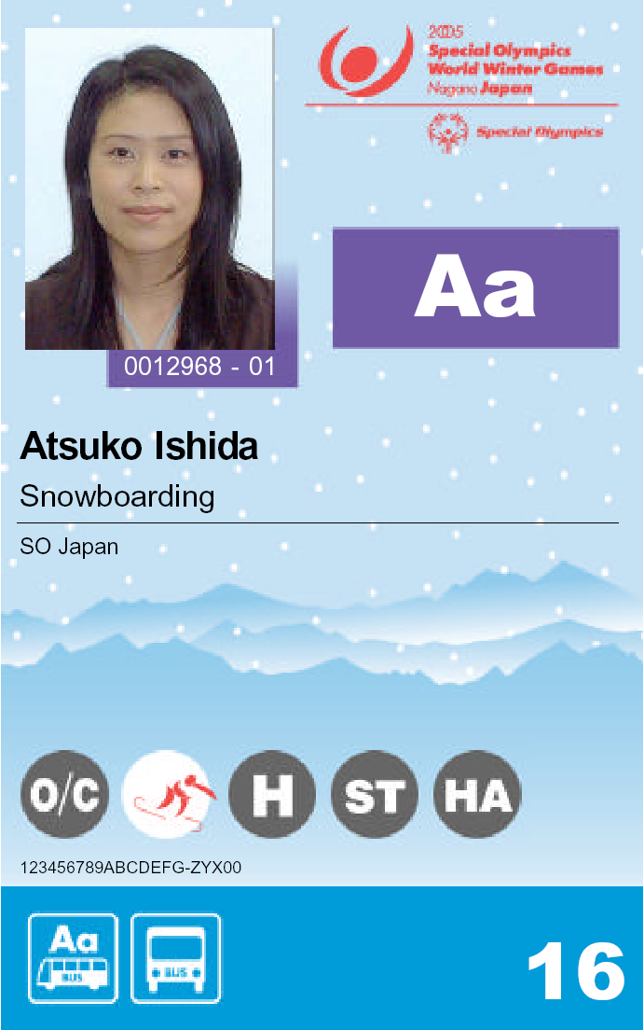

Official Logo of the Games

SOI Logo

Photo
m

Credential Number

Venue Access

Transportation Entitlements

Zone Access

(2) Access Entitlements
- Access entitlements come in three types: Venue Access, Zone Access and Transportation Entitlements
Venue Access: Indicates access privileges to Games venues
Zone Access: Indicates access privileges to zones within Games venues
Transportation Entitlements: Indicates Games-time transportation privileges.

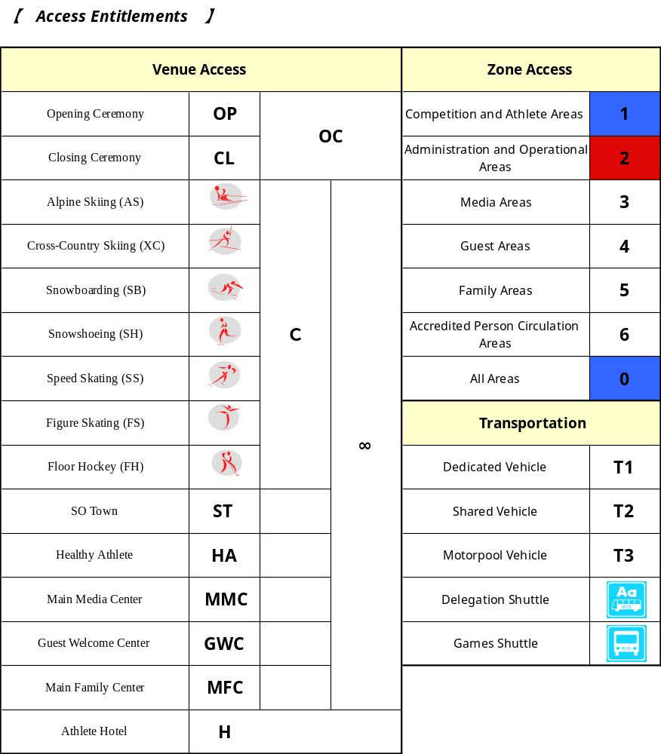
Section 4: Arrival

  - Designated Airport
To ensure smooth processing of delegations on arrival to and departure from Japan, we have named Narita International Airport the designated airport for the 2005 World Winter Games. Games staff will be stationed there to provide transportation services from 22 February through 6 March 2005. Transportation services will not be provided at other airports so please use Narita International Airport. Domestic travel costs beyond the transportation service period must, in principle, be borne by the delegation.

  - Visas and Immigration
Foreign citizens wishing to enter Japan must first obtain a passport issued by their home governments. In general, Japanese law requires that this passport must also be stamped with a visa obtained prior to arrival in Japan from their local Japanese embassy or consular office. Possession of a valid visa is one of the necessary requirements for receiving permission to land during the immigration inspection conducted at the airport of arrival. In general, those without a required visa may not land. Please confirm the expiration date of your passport and visa. Inquiries about passport validity should be directed to your local Japanese diplomatic mission.

  - Vaccination
Foreign travelers are not required to receive vaccinations but given the possibility of influenza outbreaks, delegations are encouraged to have their members receive influenza vaccinations if possible. Since influenza tends to strike with particular severity those with underlying conditions (such as respiratory or circulatory ailments or diabetes), such persons are strongly encouraged to receive a vaccination under the care of their physician.

  - Customs Information and Immigration Procedures
The diagram on the following page outlines immigration procedures upon arrival in Japan. To ensure that procedures go smoothly, be sure to wear the Games credentials received from SONA in advance around your neck. Should there be any difficulties, please tell the officer that you are in Japan for the 2005 Special Olympics World Winter Games. SONA staff will work to resolve the situation.

- Quarantine: The first procedure upon arrival in Japan is quarantine. Please complete, in advance, the quarantine questionnaire (either received in advance from SONA or aboard the airplane) and present it at the quarantine counter. Make a note of your pre-arrival state of health in the symptoms column on the questionnaire. Those suffering from headache, fever, diarrhea or other health problems should report to a quarantine officer or visit the health consultation room.

- Immigration Inspection: Please be sure to complete, in advance, the “International Embarkation Disembarkation (ED) Card” sent by SONA. To ensure passport control goes smoothly, slip your ED Card and visa inside your passport and wait in line. When it is your turn, present your passport, visa and ED Card to the immigration inspector at the examination booth. To show that you are participating in the Games, be sure to wear your credentials around your neck during immigration.

- Baggage Claim: Confirm your flight number and pick up your luggage from the conveyor belt designated for your flight. Luggage carts are available for easier movement within the airport. If you discover any damage to your luggage, notify your air carrier immediately.

- Plant Quarantine: Please do not bring in any plants or plant products (including pineapples, oranges and other fruits, cut flowers, vegetables and rice). Importation of many plants is prohibited or requires inspection at the plant quarantine counter.

- Animal Quarantine: Do not bring in any animals or animal products (including raw meat, dried meat, ham and sausages). Importation of many animals and animal products is prohibited or requires inspection at the animal quarantine counter.

- Customs Inspection: Items for personal use included in your baggage, whether carried with you or sent separately, are exempt from taxation as described in Section 4.11 Supplementary Materials. (If you have both accompanied and unaccompanied baggage, the contents of both are counted together.) Alcoholic beverages and tobacco products are not duty-free for minors. For children younger than six, only articles clearly intended for their personal use, such as toys, are exempt from duty. If you exceed the scope of duty exemption, please complete and submit the Accompanied and Unaccompanied Baggage Declaration form, available at the customs inspection area and aboard the airplane. Customs inspection for accompanied baggage is conducted at inspection lanes marked in green and red: use the green lines if you have nothing to declare and the red if you do or are unsure whether you do or not. If the items you carry exceed duty-free allowances you will be charged established tariffs. (For unaccompanied baggage, two (2) copies of the declaration are required.)
Access into Japan
Arrival
Quarantine Inspection
Immigration Inspection
Animal/Plant Quarantine
Baggage claim

Customs
■Immigration Procedures

  - Delegation Arrival Flow
After you have completed entry procedures, Nobue Tanaka or Eiko Kaneko from Special Olympics Nippon and volunteers for the GYS, will welcome you at the arrival lobby. Depending upon your arrival day and time, you would be either escorted to the Narita View Hotel shuttle if arriving on Thursday 24 February or taken to a designated waiting area for the charter bus to Nagano if arriving on Friday 25 February. If arriving on Thursday, you will spend the night in the Narita View Hotel (although this may change so you will be notified if there is any change).

Each delegation member should keep with them an overnight bag containing valuables, personal items and clothes for one night. Since the airport is likely to be very crowded, please refrain from shopping once you’ve come out into the arrival lobby.

  - Luggage Tags
In general, delegation members are limited to two pieces of accompanied baggage per person, excluding carry-on luggage taken on board the airplane. Please attach some type of airline name luggage tags to all of your baggage in advance to enable rapid identification. Please clearly print the name country of the bearer on each tag in capital block letters. It is also advisable to place a name tag on the inside of your luggage. Indicate the destination hotel (Mitsui Garden Hotel address in Nagano).

4.7 Supplementary Information

4.7.1 Plant and Animal Quarantine
When entering Japan, please do not bring any plants (including fruit such as pineapples or oranges, cut flowers, vegetables and rice), pets or other animals, or animal products such as raw meat, dried meat, ham or sausage. Note that importation of seeing-eye dogs or medical assistance dogs requires advance application and quarantine procedures that should be initiated immediately.

For plant quarantine issues please refer to the Plant Protection Station website: http://www.pps.go.jp/english/index.html. For animal quarantine issues please refer to the Animal Quarantine Service’s website: http://www.maff-aqs.go.jp/english/index.htm.

4.7.2 Customs
Items for personal use, whether carried on one’s person or sent separately, are exempted from duties in the amounts listed below. For items beyond these amounts, complete the customs declaration forms available on the airplane or at the customs desk and submit to the customs officer. Duties will be levied in accordance with the type and amount of the item (two copies of the form are required for unaccompanied baggage).

Per Person Duty-free Allowance (for Non-residents)
Item | Amount or Price | Note
Alcoholic Beverages | DO NOT BRING | DO NOT BRING
Tobacco Products | 400 cigarettes or 100 cigars or 500g of other kinds of tobacco | CHAPERONE ONLY
Perfume | 2 ounces
Other Products | 200,000 yen  (overseas market value) | Items of the same type whose total value does not exceed 10,000 yen need not be included in this calculation.

- You must declare cash, checks (including traveler’s checks), promissory notes or securities exceeding 1,000,000 yen or its equivalent.

Items whose importation into Japan is prohibited or restricted include:
- Opium, other narcotics and related paraphernalia; Stimulants (including Vicks inhalers and Sudafed); and Psychotropic substances (excluding those designated by ordinances of the Ministry of Health, Labour and Welfare)
- Quantity restrictions apply to the import of medicine and cosmetics even if for importer’s personal use:
Medicine/Medicated Cosmetics: No more than a two-month supply (up to 24
pieces per item for external medicine)
Cosmetics: No more than 24 pieces per item
Medical Devices: One set (household use only)
* For the items above, refer also to Section 14.2 Importation of Medical Supplies into Japan.

For further customs information, please see http://www.customs.go.jp/index_e.htm or http://www.tokyo-customs.go.jp/en/index.htm.

Section 5: Opening Ceremony

5.1 Opening Ceremony Overview
Date and Venue
Time: Saturday, 26 February 2005, 17:00－19:00
Venue: M-Wave

Theme
We Found our Wings of Courage.
We Stand Here Now, Courageous

Content
Professional artists, musicians, lighting designers and other performers produce the ceremonies for the 2005 Special Olympics World Games by portraying, on the spacious canvas of M-Wave, the message contained in the drawings of a young boy named JUNICHI. The flow of the ceremonies is as follows:
- Parade of Athletes
- Opening Performance
- Speeches
- Official Oath
- Entrance of the Special Olympics Flag
- Theme Entertainment
- Entrance and Lighting of the Special Olympics Torch
- Opening Declaration
- Finale

5.2 Transportation to Opening Ceremony
GYS buses will leave from bus stops near accommodation facilities in order to arrive at M-Wave no less than an hour prior to the start of the ceremony.

Please ensure all GYS are wearing their credentials when they get on and off the bus. Your credential is your ticket in.

5.3 Clothing
Although the event is held indoors, because the venue is a skating rink it can get quite chilly so everyone should be encouraged to wear warm clothing.

  - Transportation From Opening Ceremony
GYS should remain seated after the ceremony until a ceremonies escort instructs them to move toward their buses. They will return to their accommodations using the same buses on which they arrived, staged in the same locations as on arrival. Note that although toilet facilities will be installed outside the venue they may become crowded as athletes move to the buses after the ceremony. GYS should be encouraged to use the restrooms even during the ceremonies to prevent congestion afterwards.
Section 6: Delegation Services

6.1.1 Shuttle Bus Transportation
SONA will operate the following categories of shuttle bus between Games venues to provide safe, smooth and efficient transportation for all credentialed Games personnel:

Category |  | Description | Period
Games Shuttle |  | For all credentialed Games personnel | 22 February to  5 March
 | Direct Venue Shuttle | Links the main bus center in Nagano City with competition venues in Yamanouchi, Hakuba, Mure and Nozawa Onsen | 22 February to  5 March
 | Venue Area Loop Shuttle | Links accommodation facilities, competition venues and other facilities within Nagano City, Yamanouchi, Hakuba and Nozawa Onsen | 22 February to  5 March
Special Events Shuttle |  | For Games personnel traveling between accommodations and Opening and Closing Ceremony, receptions or other special events. | According to special event schedules
Shuttle buses will be leased from an outside bus operator, who will manage and operate them in accordance with timetables to be developed by the SONA.

Section 7: Delegation Accommodation

7.1 Alcohol and Tobacco Policy
Drinking and smoking is prohibited at accommodation facilities. No alcoholic beverages will be provided. Designated smoking areas (outside, for example) will be available.

7.2 Room Types
Rooms at the Mitsui Garden Hotel are Western-style. There is a small closet but no clothes dresser/bureau so mostly you use your suitcase to store clothing. There is a small desk, chair, TV and phone in the room. We will print out a complete list of room assignments once check-in and registration is completed.
- All members of the GYS will be housed together.
- Males and females will be allocated separate rooms.

7.3 Responsibility for Damage to Facilities or Theft
GYS participants assume full responsibility for any damage to facilities or fixtures as well as theft or loss of keys or other items by their delegation members during their stay. In cases of damage, theft or loss, the delegation must cover the cost of repair or replacement.

7.4 Check-in/Check-out
7.4.1 Check-in
We will all be arriving at the same time by bus from Narita Airport on 25 February. It is about a 5 ½ hour ride to the hotel. We will attempt to make your check-in as smooth and quick as possible. Here are a few things that will be done at check-in.
- Receive your room key
- Receive your GYS “goodie bag”
- Receive your cash card and secure “pin” number
- Confirmation of emergency escape routes
- Receive your meal cards

7.4.2 Check-out
We will all be checking out at the same time, then depart or Narita Airport at 8:00 am on Sunday 6 March. Check-out takes place at hotel front desks. Your must return all room keys and provide payment for any fee-based services that have been used (telephone, laundry, room service, etc.)

7.5 Automatic Lock Function
At some hotels, the doors lock automatically when closed. At such facilities, be sure to take your key with you when you leave your room or you could be locked out.

7.6 Meals (Breakfast and Dinner)
Nutritionally balanced, buffet-style breakfasts and dinners will be served at delegation accommodation facilities. All breakfasts and most dinners will be at the Mitsui Garden Hotel.

7.7.1 Menu
Based on mostly Asian and Western cuisine, menus take into consideration the culinary customs of areas of the world represented by participating delegations.

7.7.2 Mealtime
Mealtimes are scheduled as follows. It may be necessary to permit athletes who are scheduled to compete the early time schedule to dine first. We will provide any updates upon arrival to Nagano.
Breakfast 06:00 – 08:00
Dinner 18:00 – 20:00

7.8 Room Fixtures
All guest rooms are equipped with beds, chairs, desks, TVs and trash cans as well as amenities like bath and face towels. Please bring your own toothbrushes and toothpaste.

7.9 Guest Room Telephones
Telephones in guest rooms are for internal use only. Outside calls may be made using public telephones in the lobby and other areas. International calls cannot be made from some hotels, but international pay phones are available at competition venues and other locations.

7.10 AC Power Source
Power provided is 100V at 60Hz. Electrical appliances requiring different voltages cannot be used so please confirm your power requirements and bring transformers if necessary because accommodation facilities will not be able to provide them.

7.11 Drinking Water
Tap water is purified and sterilized and is safe to drink.

7.12 Bathing and Hot Water Supplies
Hot water is available in the bathroom and at the washstand. Please take care to adjust the temperature to avoid scalding.

7.13 Toilets
Never flush articles other than toilet paper down the toilet (scraps of paper, food, sanitary napkins, etc.) because they may become clogged.

7.14 Valuables
Each individual is responsible for his or her own valuables. Some accommodation facilities offer a safe in each guest room or a safe deposit box at the front desk. SOI or SONA is not responsible for any lost valuables.

7.15 Equipment Trouble
Please report any trouble with heating, plumbing, electricity or the like to the front desk.

7.16 Emergency Escape Routes
In the event of an emergency such as fire, please evacuate according to the escape route posted in the guest room. Please double-check the route during check-in and ensure that every delegation member understands it.

7.17 Japanese Emergency Exit Signs
The hotels and Japanese-style inns where delegations will stay have emergency exits for use in the event of fire, earthquake or other emergency. Signs pointing the way to emergency exits are installed in the lobby, hallways and other common areas. Should there be a need to evacuate during your stay, follow the emergency exit signs. An escape route diagram is posted on the inside of every guest room door. Be sure to confirm the route and at least two emergency exits when you check in.

Japanese Emergency Exit Signs

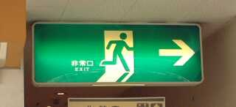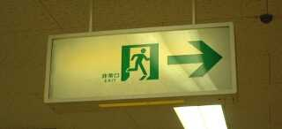

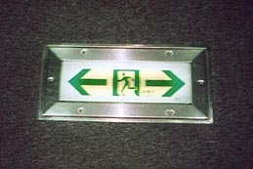

7.18 Fire Alarms and Fire Extinguishers
Fire alarms and fire extinguishers are located in the hallways on each floors. Activating a fire alarm by mistake will mobilize the fire services and cause great inconvenience so be sure not to touch them unless there is a fire. Your delegation will be responsible for cleaning charges if nay of its members use a fire extinguisher unnecessarily.

7.19 Housekeeping
Housekeeping is available in our hotel. Generally you can expect the following services:

Service Contents | Frequency
Cleaning of bathrooms and toilets | Daily
Garbage collection | Daily
Replenishment of toiletries | Every second day
Change of towels and bath mats | Every second day
Vacuuming of rooms | Every third day
Changing sheets & pillow covers | Every second or third day

Replacement sheets, pillow covers and towels are also available at the front desk or the Delegation Service Desk.

7.20 Laundry Services
Cleaning of t-shirts, socks, underwear and the like is available through the hotel for a fee.

Section 8: Sport and Competition

8.1 Competition Facilities
Alpine Skiing
Ichinose Family Ski Ground in Shiga Kogen
Games facilities open on 26 February 2005 and close on 4 March 2005.

An internationally renowned ski Mecca, Shiga Kogen has hosted numerous World Cup events as well as the 1998 Olympic Winter Games. Located in northern Nagano Prefecture at 36°44’ north latitude and 138°31’30” east longitude, the Ichinose Family Ski Ground is on the western slope of Mt. Higashitate, a 2,030m peak approximately 250km from Tokyo.

Average snowfall at the end of February exceeds two meters and there is plenty of high-quality powder for skiing from early December through early May. The main slope of the Ichinose Family Ski Ground is suitable for all levels of skiers. The lower part, with an average gradient of 9 degrees, is ideal for beginners and the upper part ia one of the best steep slopes in Shiga Kogen. With two quad and two double lifts, beginners and advanced skiers alike can enjoy themselves on the slopes.

Separate competition courses will be established for novice, intermediate and advanced athletes. A course for lower-level athletes will be located on the novice slope. FIS-certified competition and safety equipment devices will be used on all competition courses. At each, first and second electronic timing systems will be used with manual stopwatch backup. An electronic scoreboard will be installed near the finish area.

Cross-Country Skiing

8.2 Snow Harp
Snow Harp, the cross-country skiing venue, covers 37.7 ha on the eastern side of the valley at the pastoral southern part of Hakuba Village in the foothills of the Northern Alps.

Freestyle 1km, 3km, 5km, 7.5km, 10km and 4x1km relay events will be held on 1km, 1.5km and 2.5km forest courses centered on start and finish areas in the main venue. Classical 10m, 25m, 50m and 100m events will be held on the straight courses in the main venue.

With athletes passing through the main venue several times, races are especially exciting for spectators.

Snowboarding
8.3 Iizuna Resort Ski Ground (URL: http://www.iizuna-resort.com/)
Opened in 1984, Iizuna Resort Ski Ground is a relatively new ski area located just 30 minutes by car from downtown Nagano City. Although compact, it boasts many fans, young and old, due to its quality snow and excellent course layout catering to both beginners and advanced skiers. With snowboarding permitted since the facility was opened, the ski area is popular among snowboarders. On clear days, Mt. Fuji can even be seen in the distance

Iizuna Resort Ski Ground has three courses, with a 600m (1,968 feet) vertical drop, a maximum length of 2,500m (8,202 feet), a maximum gradient of 32º and an average gradient of 20º.

Five lifts are available: one high-speed detached quad (1,720m), one high-speed detached double chair (950m), one fixed double chair (941m) and two fixed singles (805m and 195m). There is also a kids’ park for children and beginners with a moving sidewalk (70m). With a new halfpipe completed this season, the Iizuna Resort Ski Ground has become increasingly popular among snowboarders as well as skiers.

Snowshoeing

8.4 Olympic Sports Park
The venue site of Nozawa Onsen, is a mountain village in northern Nagano Prefecture long renowned for its hot springs and for nozawa-na pickled turnip leaves. The area surrounding the village experiences 70 or more days of heavy snowfall of a meter or more for 7every year. The Nozawa Onsen Ski Ground was established in 1924 with a ski lift added in 1950, the third in the country. This ski slope is the largest to be administered by a village.

The Olympic Sports Park, the venue for snowshoeing, is located in a 625m elevation valley on the south side of the Nozawa Onsen Ski Ground at the foot of 1,650m Mt. Kenashi. The park served as the venue for biathlon competition during the 1998 Olympic and Paralympic Games. Although the area gets heavy snowfall, wind is not strong near the venue as the park is sheltered by the mountains. Average temperature in February is -1.3ºC, with an average minimum of -5.2ºC and an average maximum of 2.4ºC. Average wind velocity is 1.1m/s and average snowcover is 146cm.

The 1600m and 5km events use the cross-country ski trails featuring ups and downs and sharp curves, but most sections of the trails are machine-groomed. Athletes in the 5km race will do two laps of the 2.5km-loop course, with distance markers placed at 1km, 2km, 3km and 4km. The 1,600m event will use a 1,600m loop course with a 1km marker.

One section of the 5km course cuts into the Karasawa slope of the Nozawa Onsen Ski Ground, which will be set off with netting to offer general skiers an opportunity to watch the competition, one of numerous locations for spectating at trail events.

Athletes taking part in the 800m event will do two laps on the 400m track. 200m and 400m events will also be held on the 400m oval, which is also machine-groomed to some extent. The flat track has eight lanes and can be seen from the venue’s Athlete Lounge. 25m, 50m and 100m courses are flat and straight, with eight lanes.

All races start and finish inside the track area.

Speed Skating
8.5 M-Wave (URL: http://www.nagano-mwave.co.jp/)
The Nagano Olympic Memorial Arena, nicknamed M-Wave because of its cascading M-shaped roof, is reminiscent of Nagano’s panoramic mountain peaks. The arena is one of the largest in the world with a suspended wooden roof. Measuring 230m long and 160m wide, M-Wave hosted speed skating events during the 1998 Olympic Winter Games. During the Winter Paralympic Games, it served as the venue for Opening and Closing Ceremonies and ice sledge racing competition.

The arena accommodates a standard 400m double-track and a standard 111.12m short-track rink measuring 30m x 60m.

Figure Skating
8.6 Big Hat (URL: http://www.nagano-cvb.or.jp)
Big Hat is located in Nagano City about 10 minutes by car from JR Nagano Station. The large, hat-shaped roof that inspired the venue’s name blends with the surrounding mountains and evokes opening flowers, symbolizing the progress of Nagano City.

Completed in March 1995 as the first of the Nagano City Olympic Winter Games venues, Big Hat rises four stories high and also has a basement level. It was used as the main venue for ice hockey during the 1998 Olympic Winter Games.

With a standard figure skating rink measuring 60m x 30m, Big Hat will serve as a competition venue for the 2005 Special Olympics World Winter Games.

Floor Hockey
8.7 White Ring
White Ring, the 2005 Special Olympics floor hockey venue, is a dazzling white building located in southeast Nagano City near the site of the historically significant 16th-century Battle of Kawanakajima. During the 1998 Olympic Winter Games, White Ring was used for figure skating and short-track speed skating events. Its sparkling white roof glittering like a dewdrop on the Zenkoji Plain, the building is affectionately nicknamed White Ring.

Consisting of a main arena the size of three basketball courts, a sub-arena and tennis courts, White Ring is a comprehensive sports facility easily accessible to citizens.

White Ring transforms into a floor hockey arena during the Games with four courts in the main arena and two in the sub-arena, each measuring 26m (87 feet) x 15m (50 feet) in conformance with official floor hockey standards. Each courts has a marked floor, sideboards and spectator seating.

8.8 Rules
All competition will abide by Special Olympics policies as outlined in the Official Special Olympics Winter Sports Rules Book (2003–2006) Revised Edition, the Unified Sports Handbook, the Special Olympics General Rules and the International Sport Federation rules (as of 1 April 2004).

8.9 Award Ceremonies
Following competition, awards will be presented to athletes in each division to honor their achievements. Official medals will be awarded to first, second and third-place finishers, and official ribbons will be awarded to fourth through eighth-place finishers. Athletes disqualified for reasons other than unsportsmanlike conduct or violations of divisioning requirements, and those who do not finish, will be presented with a participation ribbon. In the event of a tie, athletes or teams that achieved the same result will receive awards for the same place. Athletes or teams will receive the appropriate award in the order of their finish.

Section 9: Non-Sports Programs

9.1 Special Olympics Towns
Special Olympics Towns (SO Towns) offer athletes a place to relax after competition and to interact with athletes from other sports. Events and activities designed to encourage interaction with local residents and deepen mutual understanding are also being planned.

A variety of events are planned during the Games, including some outside the venues such as concerts by professional musicians. Most locations offer the items below, although some items will not be held at some SO Towns:
- Dance Floor
Athletes can sing and dance
- Cultural and Art Performance
Opportunities to experience music, theatre and traditional performing arts
- Recreation Area
Athletes can enjoy physical activities like ring toss and ball games
- Hands-on Traditional Japanese Cultural Experiences
Opportunities to try traditional games and culture like kimono, calligraphy, the tea ceremony, origami, beanbags, bamboo flying toys and Japanese tops.
- Hands-on Traditional Craft
Opportunities to try handicrafts such as painting, working with clay, decorative projects using nut shells and the like, woodworking, building snow caves and making snow statues.
- Stretching Corner
Stretching and other exercises
- Game Corner
Video games, instant photo sticker machines, etc.
- Special Art Gallery
An exhibition of work by artists with intellectual disabilities at SO Town Nagano
and opportunities for hands-on craft experience at their workshops.
- Exchange Events
Opening ceremonies, farewell exchange events, etc.

SO Town Locations, Operating Period and Hours (Subject to Change):
Name |  | Location | Opening Date & Hours
SO Town Nagano |  | JA Acty Hall  (next to Monzen Plaza)  10 min. walk from JR Nagano Station | Friday, 25 February to Friday, 4 March  • Athlete-only and open-to-the-public days will be established.  • Opening hours are generally 13:00 to 20:00, but vary by day and location.  • On the evening of 25 February, Opening Ceremonies will be held at each SO Town. Farewell exchange events are scheduled for the evening of 4 March.  • Special Art Gallery  Friday, 25 February to Sunday, 6 March.  JR Nagano Station Concourse:  • Thursday, 24 February to Saturday, 5 March
 | Amusement Plaza
 | Culture Plaza | Monzen Plaza  (next to JA Acty Hall)  10 min. walk from JR Nagano Station
 | Special Art Gallery | Nagano Tokyu Department Store  Cher-Cher 5F  (West exit of JR Nagano Station)
 | JR Nagano Station | JR Nagano Station Concourse
SO Town Shiga Kogen |  | Shiga Grand Hotel  (Delegation accommodation)
SO Town Hakuba |  | Hakuba Village Multipurpose Training Facility  (next to the Hakuba Village Office)
SO Town Nozawa Onsen |  | Nozawa Onsen Arena
1) Loop shuttle bus service to SO Towns is available every 60 minutes.
2) SO Town Nozawa Onsen provides an indoor swimming pool with water slides. Be sure to bring your own swimsuits with you. (Rental suits are available for a fee.)

9.2 Athlete Entertainment
Athlete Entertainment including dance, Japanese theater and concerts will be held at Amusement Plaza in SO Town Nagano and at the SO Towns in each outlying region (Shiga Kogen, Hakuba and Nozawa Onsen). Concerts by volunteer performers will also be held on the JR Nagano Station Concourse. Locally hosted welcome events are also planned for the East Exit of JR Nagano Station on 26 and 27 February. Specific dates, times and other details can be found on the SONA website and in the SO Town Guide distributed after your arrival in Japan.

9.3 Healthy Athlete Program
The mission of the Healthy Athlete Program is to contribute to athlete strength and sports performance by improving visual, aural, dental and other health conditions that tend to be overlooked due to their disabilities, and to enhance their interest in daily health care.

From 26 February to 4 March 2005, The Healthy Athlete Program offers athletes a pleasant and meaningful experience with health care professionals who greet them cheerfully before screening and advising them in a wide variety of health care specialties. The 2005 Healthy Athlete Program in 2005 will include: Opening Eyes, Special Smiles, Healthy Hearing, Health Promotion, FUN Fitness and Fit Feet.

Period: Saturday, 26 February through Friday, 4 March 2005
Location: Monzen Plaza B1
Hours: 13:00－20:00
(Due to Opening Ceremony, hours are 11:00 to 14:00 on 26 February)

Dedicated shuttle buses will be provided on the following days to assist athletes staying outside Nagano City to participate in the Healthy Athlete Program:
Saturday, 26 February: Nagano City
Sunday, 27 February: Hakuba Village
Tuesday, 1 March: Shiga Kogen
Wednesday, 2 March: Nozawa Onsen Village

9.4 Global Youth Summit
Students with intellectual disabilities who do not participate in competitions will join students without disabilities in holding themed discussions and executing educational programs designed to remove prejudices against those with disabilities.

9.4.1 Summary
Period | Saturday, 26 February through Saturday, 5 May, 2005
Location | Competition venues, Nagano City Fullnet Center, etc.
Format | 14 teams of 3 members each.
Contents | - Student teams from 14 countries and regions will produce newspapers covering competitions.  - The Global Youth Forum will deepen understanding of disabilities.

9.4.2 Request for Cooperation in Competition Venue Coverage
In addition to media areas for representatives of general media organizations, students may also hold interviews with athletes at competition venue Athlete Lounges. Care will be taken to ensure that such interviews are conducted after competitions and training, when athletes have had a chance to relax. Please cooperate wherever possible with interview requests and other newsgathering activities by the Global Youth Summit participants.

9.4.3 Global Youth Forum
Period | 13:00 to 15:30 on Sunday, 27 February
Location | 1F Auditorium, Nagano Prefectural Office
Panelists | 1. 14 teams participating in the Summit (14 teams of 3 = 42)  2. 14 teams of students from Nagano Prefecture (14 teams of 3 = 42)
14 Overseas Teams | Romania, Austria, El Salvador, Panama, Chinese Taipei, China, Namibia, South Africa, Morocco, Bahrain, Indonesia, Mexico, India, Nevada (USA)
Theme | Changing Attitudes – Changing the World
Audience | Capacity: 300  • Student and teachers who have worked to promote understanding of intellectual disabilities.  • Athletes, Family and other SO representatives.  • Members of the general public

9.5 School Enrichment Program
SONA considers the 2005 Special Olympics World Winter Games an excellent opportunity for students without disabilities to deepen their understanding of people with intellectual disabilities, acknowledge individual diversity in aptitude, skill and ability, and learn to respect such differences. To this end, SONA promotes spectating at competitions and participating in the Host Town Program and volunteer activities through the One School, One Participation Program.

Elementary, middle and high school students in Nagano Prefecture are looking forward to interacting with athletes from overseas in various settings and we hope all delegations will participate in the following to the best of their ability:
- Correspondence with Japanese schools wishing to exchange letters with athletes before the Games begin (December 2004－February 2005). SONA has posted the delegation contact information on its website.
- Exchange with students from schools in areas where delegations will stay during the Host Town Program (22－25 February 2005)
- Exchanges with students during the Games (26 February－5 March 2005), such as interactions between athletes and students at competition venues or when invited to their schools

Section 10: Closing Ceremony

10.1 Closing Ceremony Overview

Date and Venue
Time: Saturday, 5 March 2005, 14:00－16:00
Venue: M-Wave

Theme
Flying bravely on our wings of courage.
Let’s share our wings with everyone.

Content
As in the Opening Ceremony, we will celebrate and share the courage of the athletes who have competed over eight days, focusing on the message conveyed by JUNICHI’s drawings. We plan a festival of dance that brings athletes and spectators together. The flow of the ceremony is as follows:
- Parade of Athletes
- Celebration
- Speeches
- Lowering of the Special Olympics Flag
- Demonstration by the Next Games Host
- Separation of the Flame from the Special Olympics Torch
- Closing Declaration
- Finale

10.2 Transportation to Closing Ceremony
GYS buses will leave from bus stops near accommodation facilities in order to arrive at M-Wave no less than one hour prior to the start of the ceremony.

10.3 Clothing
Although the event is held indoors, because the venue is a skating rink it can get quite chilly so athletes should be encouraged to wear warm clothing. Note that delegation members will also be required to wear their credentials.

10.4 Transportation From Opening Ceremony
GYS should remain seated after the ceremony until a ceremonies escort instructs them to move toward their buses, which may be different that those on which they arrived, by delegation. Note that although toilet facilities will be installed outside the venue they may become crowded as athletes move to the buses after the ceremony. Athletes should be encouraged to use the restrooms even during the ceremonies to prevent congestion afterwards.

Section 11: Departure

11.1 Transportation Between Accommodation and Narita Airport
GYS will be transported by chartered bus to Narita Airport on Sunday 6 March at 8:00 am arriving approximately 12:30 – 13:00 pm. Those with flight arrangements departing in the afternoon or evening will remain at the airport.

GYS participants will departures on Monday 7 March will be housed in a local Narita Airport and then transported by free hotel shuttle back to the airport on Monday. You will be responsible for arranging transportation from the hotel to the airport allowing enough time to complete check-in and emigration.

11.2 Emigration Procedures
(1) Check-in: Please complete boarding procedures for your return flight at your airline check-in counter. Present your tickets and passports, check your baggage and receive your boarding passes. Please confirm your boarding time and departure gate.
Departure
Security Check
Customs
Boarding
Passport Control
■Embarkation procedures
Check-in

(2) Security Check: To prevent hijacking, all carry-on baggage and people will be inspected. Please follow instructions when your carry-on bags are x-rayed and you pass through the metal detector.

(3) Customs: Customs inspectors will want to confirm any items for which you applied to be exempt from re-export duty.

(4) Passport Control: Complete the “International Embarkation Disembarkation Card” (ED Card) attached to your passport and present both passport and boarding pass to the immigration inspector.

  - Reconfirmation of Return Flights
Each delegation is responsible for reconfirming its own departure flights.

Section 12: Information Technology

12.1 IT Network
- GYS will have access to the Full Net Center in Nagano for all of our writing needs and internet. Volunteers are available to assist as needed.
- It is optional for GYS to bring their own laptops. PC’s are available at the Full Net Center.
- The official Games website is already available: http://www.2005sowwg.com

12.2 Venue Telephones
- International pay phones will be installed at competition venues, SO Towns, some delegation hotels and other key locations.
- Public phones can accept coins or pre-paid telephone cards that can be purchased at many stores or at the Games Information Counter.
- Pre-paid telephone cards are available in denominations of 1,000 yen.
- English manuals will be provided for SONA-installed public telephones

12.3 Radio Equipment That May by Used Without a Permit
Usage of radio equipment in Japan requires a permit granted by the Ministry of Internal Affairs and Communications. However, no permit is required for:
- RF devices emitting very low-powered radio waves
Although frequencies and applications are unrestricted, the equipment should have a field intensity (radio wave strength) at 3m that is below that indicated in this diagram:

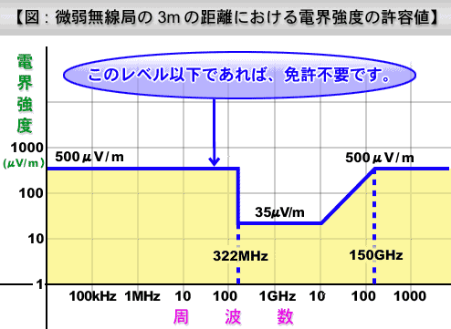
Permitted field intensity at distances of 3m from low-powered RF-emitting stations

No license required below this level
Field
Intensity

Frequency

- CB Radio
Radio equipment using specific types and frequencies of radio waves in the band from 26.9 to 27.2MHz, whose antenna power is no greater than 0.5W and that have received Technical Standards Conformity Certification
- Radio equipment used for specific electric power-saving purposes
Radio equipment that meets specific applications and objectives of low-power RF emitters and satisfies the conditions below:
- Antenna power of no more than 0.01W.
- Specific types and frequencies of radio waves.
- Has features such as automatic transmission and reception of call signs or ringing signals that prevent interference with operation of other radio stations.
- Has received Technical Standards Conformity Certification.

12.4 Radio Permits
Radio transmitters other than those described in Section 13.3 above require radio permits. There are not granted to those without Japanese citizenship so permits are unavailable for the 2005 Games.

12.5 Importation of Radio Equipment
Japan strictly regulates its airwaves and it is difficult to import radio equipment from overseas and obtain the permits to use it legally. Please refrain from bringing such equipment with you to Japan.

SONA will introduce vendors that rent radio devices but, as noted in Delegation Update 5, advance application is required. Rental fees vary depending on the model, but generally start at about 1,500 yen per day. Radio coverage is limited to within each of the Nagano, Shiga Kogen, Hakuba and Nozawa Onsen regions.

12.6 Use of Own Computers
12.6.1 Places and Internet Connections for Using Own Computers
- Booths providing Internet connections will be installed in SO Towns and at several delegation hotels, and you may connect your own computers there.
- We will provide Category 5 (Cat5) or better RJ45 (Ethernet LAN) cables.
- See Section 1.5 Electricity for information about Japan’s electrical standards. Please bring electronic devices only after confirming that they may be safely used.
- To establish a connection to the Internet, your computer’s TCP/IP settings must be set to DHCP so they can automatically obtain an IP address.

12.6.2 Internet Lines
- Booths for Internet connections will have either of the following two types of lines (booths for dialup modem connection will not be provided):
1. ADSL (Asymmetric Digital Subscriber Line)
Communication speed: 12－50 Mbps (theoretical maximum)
2. Fiber Optic Cable
Communication speed: 100 Mbps (theoretical maximum)

12.6.3 Utilization of Printers for Own Computers
No support for the use of printers with your own computers will be provided.
Section 13: Medical Services

The Medical Committee for the 2005 Special Olympics World Winter Games will provide medical services for all delegation members, competition officials, staff and volunteers at the Games. Please keep the following guidelines in mind while planning your stay:

13.1 Carrying Delegation Medical Information
GYS Chaperones must have the following forms in their possession at all times for each GYS member (especially those who refuse certain medical treatments for religious or other reasons and those with a history of serious medical problems):
- A copy of signed Athlete Registration/Medical form from their home country
- A copy of the signed Athlete Release Form provided by SOI for GYS
- A copy of the signed Partner Release Form provided by SOI for GYS
- A copy of the signed Chaperone Release Form provided by SOI for GYS
- Insurance information card that will be provided upon arrival to Nagano

  - Importation of Medical Supplies into Japan
Every delegation member must have a sufficient supply of any required prescription medication to last his or her entire stay. In addition to any necessary medication, each delegation member should have the following documents with him or her:
- A note explaining why such medication is required (copies of prescriptions, etc.)
- An accurate list in English of any medications being taken
- A schedule in English of these medications indicating dosage and times of administration (using Japan Standard Time)
In general, medication reported in advance either through the Importation of Medical Supplies Survey or the application forms for restricted medications provided by the Medical Committee may be brought in to Japan. When medication is to be brought into Japan, those taking the medication must carry their own through customs. Any necessary documents (copies of prescriptions etc.) should also be carried for restricted medications.

13.3 Glasses and Dentures
GYS members wearing contact lenses or eyeglasses may want to bring a second pair of lenses or glasses as a backup in case of loss or breakage.

Dentures should be inscribed with the owner’s name and backup dentures are recommended in case of loss or breakage.

13.4 Medical Support
All delegation members who become ill or injured may use medical services provided by SONA. For normal injuries and illnesses, every effort will be made to return GYS to activities as quickly as medically possible, as noted in Sections 14.6 Medical Services near Narita Airport through 14.8 Medical Rooms. Please do not have delegation members receive independent medical examination or treatments at other medical institutions.

In case of life-threatening injury or illness, please contact Medical Emergency Services first (Dial 119; see below) and then contact the nearest medical room as soon as possible.

13.5 Dial 119 (Medical Emergency Services)
The emergency number for disasters, emergencies, etc. in Japan is 119 and can be called from ordinary telephones. When in need of an ambulance or fire engine or in other emergency situation, lift the handset of any ordinary telephone and dial 1-1-9. Do this only in emergency situations. Please ensure that delegation members do not call 119 just to test the system. With some hotel telephones, you may have to dial 0 first to make an emergency call. Please check with the staff at your hotel on arrival to confirm. If you need to call 119 for medical help, please assess the situation before calling, especially in terms of whether the conditions are serious. Please also keep in mind that the SONA medical staff is available nearby to provide medical care.

13.6 Medical Services in Narita Airport Area

Inside Narita International Airport
Narita International Airport has partner hospitals in both terminals, where medical services will be provided upon arrival at the airport and during the stay at the DWC. In the event of an injury or illness requiring hospitalization, arrangements will be made for transporting patients to partner hospitals equipped with full facilities.
Transport

Narita Red Cross Hospital
Partner Hospitals at
Narita International Airport

If a GYS member becomes injured or ill at the airport, they should first receive medical care at an airport partner hospital. Then notify Ron Vederman

13.7 Medical Services at Games-time Accommodations

Accommodation Facilities in Nagano City
Accommodation facilities in Nagano City will be served by SO Medical Offices at two partner hospitals. Of the twelve delegation accommodation facilities, seven will have a first-aid station where nurses will be posted. If an ill or injured athlete or delegation member is unable to go to the first-aid station, a nurse will make a house call. Nurses will be able to reach hotels without first-aid stations in just a few minutes. The medical staff at first-aid stations can administer first-aid treatment; arrangements will be made if a patient must be transported to a SO Medical Office for further care.
First-Aid Station with Nurses
Hotels without First-Aid Stations
・SO Medical Office at Nagano Red Cross Hospital
・SO Medical Office at Nagano Matsushiro General Hospital
Nurses
Transport
Transport
Patient

If a GYS member becomes injured or ill at a hotel, please contact the nearest hotel first-aid station first. Then notify Ron Vederman.

13.8 Medical Rooms

Competition Venues
Medical Rooms with doctors and nurses will be established at all competition venues during and for one hour before and after (30 minutes at indoor venues) all official training and competition. Medical Room staff can treat light injuries and illnesses on site; arrangements will be made if a patient must be transported to a SO Medical Office for further care. (First-aid stations will also be established at M-Wave during Opening and Closing Ceremonies.)
Nagano Red Cross Hospital; Shinonoi General Hospital; Nagano Municipal Hospital; Hokushin General Hospital; Nagano Chuo Hospital; Iiyama Red Cross Hospital; Nagano Matsushiro General Hospital; Omachi General Hospital
Venue Medical Rooms (First-Aid Stations)
Transport

If a GYS member becomes injured or ill at a venue, please have the individual receive medical care at the venue Medical Room first. Then notify Ron Vederman.

SO Towns, etc.
Nurses at venues without First-Aid Stations or Medical Rooms)
Nagano Red Cross Hospital; Iiyama Red Cross Hospital; Omachi General Hospital

* Medical services for SO Town Shiga Kogen conform to those for accommodation facilities in Yamanouchi Town.

If a GYS member becomes injured or ill at a venue, please report to the person responsible for the venue first. Then notify Ron Vederman.

13.9 Medical Services for Volunteers, Staff and Spectators
The Medical Committee for the 2005 Special Olympics World Winter Games will provide emergency medical services to volunteers and spectators attending the Games. Should a volunteers, spectators or staff members be afflicted with a life-threatening illness or injury, emergency medical services staff will be called via Dial 119 to rush them to a hospital. First-aid treatment is available at the venues for non-urgent injuries or illnesses.

Section 14: Security and Safety

The mission of the Risk Management Department is to provide a safe and secure environment at all competition venues, accommodation facilities and other facilities during the 2005 Special Olympics World Winter Games, guaranteeing the safety of participating delegations, Games personnel and spectators and implementing appropriate security measures.

To this end, the Risk Management Department will formulate crisis management and security plans and prepare to respond to various situations through the Risk Management Center (RMC) at Games Headquarters.

Efforts will be closely coordinated with the police, fire stations, contracted security officers, volunteers and relevant institutions and organizations in order to smoothly execute the various security measures mentioned above.

14.1 Security Structure
During the Games, the 24-hour RMC will be established at Games Headquarters. Coordinators will be on location at competition venues, delegation accommodation facilities and SO Towns to work closely with the RMC in responding to various situations.

Contracted security officers and volunteers will also be assigned to competition venues and other locations to supplement police patrols.

Venues
Risk Management Center (RMC)
SO Towns

Accommodations

Police, firefighters and other relevant bodies

14.2 Carrying Credentials
Credentials will be issued to all Games participants, including delegation members, and should be worn at all times during the Games. GYS Chaperones are required to make their delegation members abide by the following guidelines:
- Credentials distributed to delegation members should be worn at all times.
- Be prepared to show credentials to officials at all controlled access points.
- Because venues are access-controlled, some areas will be off-limits. Please follow instructions.

14.3 Security at Competition Venues
14.3.1 Security Procedures
Competition venues security procedures will be handled by SONA staff, contracted security officers and volunteers as follows:
a) Security Check
Credentials and inspection of personal baggage at facility entrances
b) Internal and External Patrols
Contracted security officers, volunteers and others patrol inside and outside venues to prevent crime
c) Zone Control
Access to designated venue zones is controlled by access privileges on credentials

14.3.2 Security at Opening and Closing Ceremonies
Given the number of VIPs who will be attending Opening and Closing Ceremonies at M-Wave, additional security and law enforcement officers will be assigned.

14.4 Security at Games-time Accommodation
We will adopt not a centralized “Athletes’ Village” for accommodating delegations, but rather have them stay at hotels and other accommodation facilities in areas near the competition venues. In the facilities where guests will be numerous, consigned security officers will be on duty around the clock. In areas where the number of guests is smaller, more consigned security officers will be allocated in the larger accommodation facilities and cover all facilities in the areas.

Since delegations are dispersed among venue-area hotels rather than centralized in an athlete’s village, please make sure the people responsible for your teams do headcounts when they return to their hotels and other facilities.
- Accommodations in Nagano City
There will be twelve delegation accommodation facilities in Nagano City. Three that have a relatively small number of guests will be covered by three contracted security officers standing watch around the clock at the office of the Security Service Association located near JR Nagano Station.
- Accommodations in Shiga Kogen
There will be six delegation accommodation facilities in Shiga Kogen. Four that have a relatively small number of guests will be covered by three contracted security officers standing watch from 16:00 to 08:00 at the Shiga Grand Hotel.
- Accommodations in Hakuba Village
There will be three delegation accommodation facilities in Hakuba Village. Many guests will stay at each so contracted security officers will be assigned to all three.
- Accommodations in Nozawa Onsen
Nozawa Onsen Village has thirteen delegation accommodation facilities, all concentrated in one area and each with a small number of guests. Three contracted security officers will be stationed around the clock at the Tourist Association Office, a location central to all the facilities.

14.5 Security for Non-Sports Programs
- Special Olympics Town (SO Towns)
Contracted security officers will be assigned security duties. Numerous volunteers will also be allocated to supplement law enforcement officer patrols.

14.6 Missing Persons Response
Persons may go missing during the Games. To prevent this and ensure the safety of delegation members, please abide by the following:
(1) Persons responsible for your teams should confirm that everyone is accounted for upon arrival at competition venues, hotels or other locations.
(2) Wear credentials at all times while in transit.
- If someone does go missing, immediately notify one of the contracted security officers or volunteer at the venue hotel or other Games facility to ensure that information quickly reaches Games Headquarters, law enforcement, firefighting and any other relevant organizations.
- Notify Ron Vederman.

14.7 Dial 110 (Emergency Services)
In Japan, 110 can be dialed from any general access telephone to get help in emergency situations (crises, accidents and disasters). If you encounter an emergency situation, pick up the handset of any ordinary telephone and dial 1-1-0 to reach the police. This number should only be used during an emergency. Please ensure that no member of your delegation tries to place a call to 110 just to test the system.

With some hotel telephones, you may have to dial 0 first to make an emergency call. Please check with the staff at your hotel on arrival to confirm.

If you encounter a crisis, accident, etc., and are injured, please call 119 to dispatch an ambulance as well as 110.

14.8 Important Reminders
All GYS must heed the following matters and provide thorough instructions to delegation members to ensure everyone’s safety:
- SONA cannot be held responsible for delegation matters when the delegation has chosen to remove itself from Games support provided by Games headquarters, even if during the period of the Games. Chaperones must ensure that delegation members follow instructions from Games and SOI Headquarters to ensure their safety.
- Immediately report any missing credentials to staff at the competition venue, accommodation facility or other Games venue.
- Keep delegation members’ belongings in a secure place.
- Delegation members and other concerned parties must always be aware of planned destinations and return times.
Section 15: Family Services

15.1 Family
A family member is defined as follows:
- An athlete’s husband, wife, partner or child
- An athlete’s blood relative (mother, father, sister, brother, grandparent, aunt, uncle, niece, nephew, cousin, relative related by marriage or partner of a blood relative)
- An athlete’s legal guardian, foster parent, caretaker, or individual involved with the athlete in a parenting role

Family members of GYS planning to be in Japan are not registered as official Special Olympics family members. There will be some limited opportunities to join in activities with the GYS but these must be arranged and coordinated in advance with Ron Vederman.

GYS family members will be responsible for their own housing, meals, transportation, etc.

15.2 Family Lounges
As with the Family Center above, Family Lounges are places at each venue where athlete families can relax.
1. Location and Period of Operation
- Location: Each competition venue
- Period of Operation: Vary by competition schedule at each venue.

2. Functions of the Family Lounges:
• General information
• Provision of snacks
• International telephones
• Acceptance of the Athlete Visit Application Form

Section 16: Media Services

At the venues, GYS will have access to delegations through your credentials. Please respect media zones and wishes of delegations to be interviewed only if it will not interfere with their training or competition schedules. GYS, media personnel such as photographers and TV crews, and Mixed Zones, where reporters may interview athletes for a short time after competitions, will be established.

16.1 Games Newspaper
We will issue a daily newspaper for the ten-day period from Friday, 25 February to Sunday, 6 March. The GYS will contribute stories to this publication whenever feasible. The newspaper will be delivered to the hotels where delegations and other Games personnel are staying, competition venues and other Games facilities. The newspaper will be standard tabloid size and written in both Japanese and English, using an abundance of photographs to focus on competition results and schedules, interviews with guests and others Games personnel, the state of relevant programs and municipalities where competition venues are located, interaction between athletes and locals, etc. The contents of the newspaper will also be posted on the official Games website.

16.2 Games Website
The official website of the 2005 Special Olympics World Winter Games (URL: www.2005sowwg.com) will be used before and during the Games as SONA’s main information and communications portal. The website will be updated daily during the Games and contain athlete information, competition schedules, start lists, results, the Games newspaper, photographs, etc.

