SOCIAL MEDIA REPORT
“Special Olympics”
March 2012
REACH


Total Likes: 590,007 (+8,416)
Total Impressions: 8,597,499 (+2,300,480)
Unique Impressions: 2,912,383 (+1,082,307)
Post Likes: 27,454 (+11,234)
Post Shares: 7,015 (+4,467)
Post Comments: 1,108 (+354)

Followers: 20,389 (+991)
Mentions: DATA UNAVAILABLE
Mentions Reach: DATA UNAVAILABLE
Retweets Reach: 2,423,982 (-1.04%)
Tweet Reach: 1,934,933 (+1.1%)

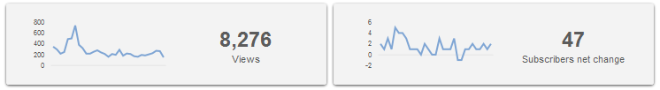

Views by Geography (+549 total)
US – 5,535
Canada – 429
UK – 400
Top 3 Viewed Videos
R-word PSA – 1,220
John C. McGinley and the R-word – 835
The New R-word is Respect – 595


Views: 6,660 (-5,929)
Posts: 8 (-1)
# of Authors: 4 (+/-0)
# of Followers: 179 (+4)
Most read post: “Fly Your Hope with Apolo Ohno: Reflections from my trip to China and Japan” (894 views, 32nd All-time)
Tip or Trick of the Month
The web is becoming more visual by the minute. From photo sharing via Instagram, Tumblr, Facebook and other sites, to photo driven platforms like Pinterest, it is more crucial than ever to take a look through our websites and blog to make sure our images are compelling, strong, and help tell our story. Instead of asking ourselves “Is this photo appropriate for this article on this page?” before we post on one of our web properties, we should be asking, “Will this photo inspire someone to share it outside of our web domains?”

ENGAGEMENT
57,221 / 2,912,383 x 100 = 1.96% (-0.79%)
Daily Page Engaged (Unique) / Daily Reach (Unique) x 100
Daily People Talking About
Total: 41,201 (+9,797)
Average per day: 1,329 (+247)
High: 7,627 on March 21
Most Popular Posts:
Liked (5,667) PHOTO: In honor of Word Down Syndrome Day– a wonderful photo shared by Olimpiadas Especiales Mexico! ¡Qué hermoso! (March 21 5:30pm EST)
http://www.facebook.com/photo.php?fbid=10150899307928782&set=a.146562253781.143839.10331123781&type=1
Shared (885) VIDEO: We are completely inspired by these young people who are ready to fight for the acceptance and respect of their siblings! Truly amazing! (March 6 3:40pm EST)
http://www.facebook.com/SpecialOlympics/posts/257634340985146
Comments: (117) VIDEO: We’ve been sharing some great videos all day on Twitter, so we had to share one of our favorites here. Special Olympics… it’s fantastic! (March 27 5:45pm EST)
http://www.facebook.com/SpecialOlympics/posts/267200873364493
RTs of @SpecialOlympics: 114 (-5)
RTs per Tweet: 1.36 (+/- 0)
RTs by @SpecialOlympics: 46 (-10)
Tweets: 84 (-3)
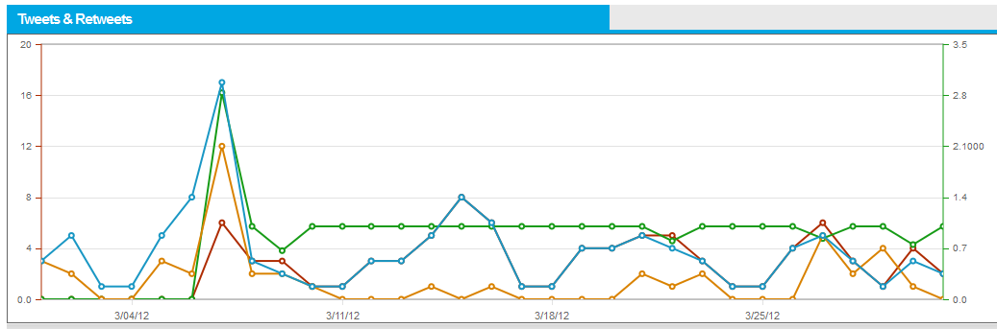
-12 0 -9 -8 -14 -5
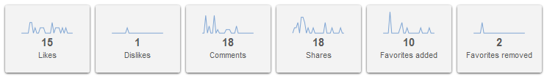
Comments: 8 (-28)
Likes: 0 (+/- 0)
Social Shares: 539 (-396)
Pingbacks: 0 (- 3)
Google Analytics (www.specialolympics.org)
Referral Traffic:
Facebook: 2,059 visitors (+1.18%)
Mobile Facebook: 753 visitors (+21.45%)
Ecommerce:
Facebook: $15.00 (+$10.00)
Key Accomplishments
- Leveraged “Spread the Word to End the Word” Day on March 7 and World Down Syndrome Day on March 21 to drive high levels of engagement via visual content sharing on Facebook.
- Leveraged our relationship with celebrity Apolo Ohno during an international trip supporting SO to raise levels of engagement via multiple tweets and guest blog post.
- Conducted two social media webinars for SONA Programs on Social Media 201
Lessons learned/what worked
- Continued to see huge engagement in photos and very strong sharing in videos.
- Late afternoon between 4-6pm EST seems to be the best time for us to post for maximum sharing and engagement.
- Need to create more regular educational and resources sessions for Program staff to maximize the Special Olympics digital footprint.
- I think scrubbing and organizing our visual assets in some places could pay nice dividends on engagement, specifically our You Tube organization of videos.

Industry Trends & News
- Everyone wants an accurate way to Measure Influence: Does KLOUT really do it?
- Who is using Pinterest? (INFOGRAPHIC)
- Tracking Referral Traffic (Pinterest)

