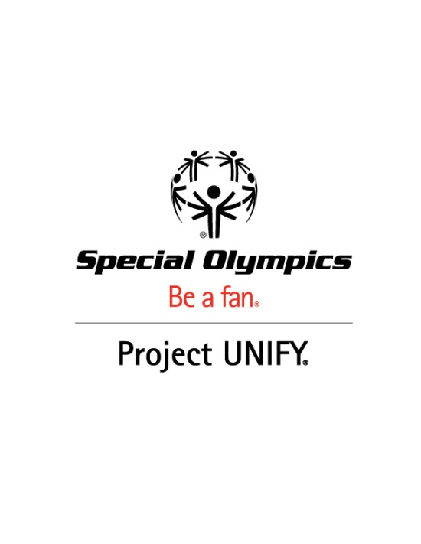

Special Olympics Project UNIFY
A Broader Vision of social Inclusion through Youth Activation and inclusive sports

The Problem (universal, not limited to ID population)
The challenges all young students face today are many, from achieving personal and academic success to feeling emotionally and physically healthy and safe. These challenges are compounded for some students due to the presence of an intellectual disability. Although progress has been made by many educational systems, including the US, in promoting the physical and instructional inclusion of students with intellectual disabilities (ID), there are still staggering social challenges for these students that compromise their social and emotional well-being. Students with ID experience negative attitudes from their peers, social isolation and rejection, and even victimization in the form of bullying. And, in many cultures, youth with ID are not included in educational programs at all or are educated separately and unnecessarily away from their peers without ID.

The Intervention (evidence based)
Special Olympics Project UNIFY® is built upon the premise that in order to have the greatest impact the change process needs to start with young people. Project UNIFY brings youth with and without intellectual disabilities together through education and sports and related initiatives that provide them with the knowledge, attitudes and skills necessary to create and sustain school communities that promote the acceptance, respect and human dignity for all students. Project UNIFY is made up of three main components:

- Inclusive Sports and Fitness - provides students with and without intellectual disabilities opportunities to participate in sports activities alongside one another and which we have found to be among the most conducive activity for breaking down stereotypes (e.g. Unified Sports®, unified physical education and intramurals, inclusive Young Athletes®).
- Youth Leadership & Advocacy – provides students with and without intellectual disabilities opportunities to take on leadership roles in promoting Project UNIFY activities in the school and in the community (e.g. Partners Clubs, Youth Activation Committees, Youth Summits).
- Whole School Engagement – provides opportunities for all students in the school to participate in Project UNIFY through school-wide activities (e.g. R-word campaign, Fans In the Stands, Youth/Pep Rallies, Pledge and Plunge).
It is the combination of these unique components that provides the most opportunity for creating positive school climates and to ensuring that all students, particularly those with ID, become part of the social fabric of the school.

Outcomes
- Students without disabilities hold more positive attitudes toward their peers with intellectual disabilities. (Measure: attitude and behavior change)
- School communities of acceptance where students with intellectual disabilities feel welcome and are routinely included in, and feel a part of, all school activities, opportunities and functions; (Measure: perceptions of school climate)
- Perception of Special Olympics as a school and community partner that offers programming that benefits all students. (Measure: perceptions of Special Olympics by general educators and school administrators)
- More students with and without ID playing sports together (Measures: increased Unified Sports Teams and programs, more 2-7 year-olds participating in Young Athletes, and more Young Athlete programs)

Impact
- Two thirds, or 66%, of school liaisons observed that Project UNIFY helps raise awareness about students with ID and increases opportunities for students with and without ID to work together;
- More than half of school liaisons observed that Project UNIFY increases opportunities for students with ID to get involved in school activities;
- Three quarters, or 74%, of participating students said Project UNIFY was a positive turning point in their lives and that they became more patient, learned to compromise, and in two thirds of instances said they learned they have things in common with their peers with ID;
- Nearly all school liaisons and students said they would like to participate next year and that Project UNIFY was successful at their schools.

Reach
Current:
- Project UNIFY is currently offered in 2,100 schools across 42 states.
- As many as 500,000 young people are experiencing Project UNIFY activities and projects, including 21,000 Special Olympics athletes and 11,000 youth leaders.
- Approximately 8,000 school-age Unified partners participated this past year.
Future Goals:
- Expand Project UNIFY in the U.S. by 2015 to include 5,000 schools.
- Expand opportunities for youth leadership in all U.S. Programs and increase Unified Sports participation among school aged youth.
- Increase the engagement of general educators and school and state administrators in Project UNIFY principles and practices.

