Contact:

DeVries Public Relations:

Stacey Stapleton/212-891-0487

sstapleton@devries-pr.com

Special Olympics:

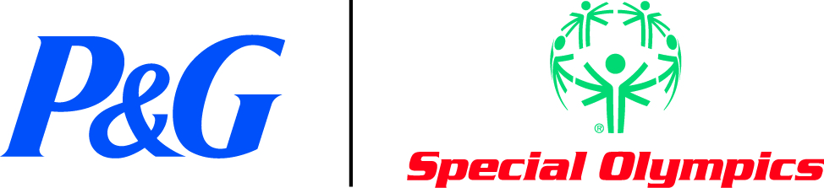
FOR IMMEDIATE RELEASE
PROCTER & GAMBLE brandSAVER SUPPORTS SPECIAL OLYMPICS
Ring in the new year by picking up $95 in valuable coupons for everyday
essentials while helping a worthy cause

LOCATION (DATE XXX) – Procter & Gamble expects to raise at least $500,000 in support of Special Olympics through a variety of marketing programs in the next two months.

First, for each consumer who redeems a coupon from P&G’s January brandSAVER, the company’s monthly coupon book, the company will make a donation to Special Olympics.

The money-saving coupon booklet will be distributed in newspapers to more than 55 million U.S. households on one day only – January 1, 2012 – and will offer $95 in savings on some of P&G’s most popular brands including Olay®, Crest®, Pantene®, Tide®, Pampers® and Duracell®. The goal of the brandSAVER is to increase awareness and donations for Special Olympics.

Also, P&G has also announced a consumer Facebook initiative to augment their donation. For every new “like,” P&G receives on its Thank You Mom Facebook page (facebook.com/thankyoumom) through February 28, 2012, the company will donate one dollar to Special Olympics, up to $100,000.

“Having a company like P&G foster a vision of people with intellectual disabilities living full and meaningful lives athletically and socially is wonderful. This kind of support goes a long way toward changing the conversation regarding people with ID,” says Kerry Hincka, mother of two Special Olympics athletes, and who has been featured in P&G advertising. “When we first became involved with Special Olympics 12 years ago, the acceptance and encouragement our daughters received was a very new feeling for us. We watched them blossom and felt ourselves relax for the first time in a long time. Here was a place we didn't have to wonder how they would be received or if they’d be given a chance.”

P&G has been a supporter of Special Olympics in the United States since 1979, making the partnership one of the longest continuous cause marketing relationships in the country. The January brandSAVER along with P&G’s recent support of the Special Olympics World Summer Games in Athens, Greece and other U.S.-based marketing program have raised more than $1 million for Special Olympics in the past year.

The goal of Special Olympics is to help persons with intellectual disabilities develop self-esteem through sports and P&G’s global partnership will reach even more athletes and their families worldwide. In the U.S., the partnership will continue to be realized as part of P&G’s “Proud Sponsor of Moms” campaign aimed at celebrating and thanking moms for everything they do for their families and communities.

For a list of newspapers that will contain the brandSAVER, please view the following link: http://www.pgeverydaysolutions.com/pgeds/brandsaver-coupons.jsp

About Procter & Gamble
P&G touches and improves the lives of about 4.4 billion people around the world with its portfolio of trusted, quality brands. The Company's leadership brands include Pampers®, Tide®, Ariel®, Always®, Whisper®, Pantene®, Mach3®, Bounty®, Dawn®, Fairy®, Gain®, Pringles®, Charmin®, Downy®, Lenor®, Iams®, Crest®, Oral-B®, Duracell®, Olay®, Head & Shoulders®, Wella®, Gillette®, Braun®, Fusion®, Ace®, Febreze®, and Ambi Pur®. With operations in about 80 countries, P&G brands are available in more than 180 countries worldwide. Please visit http://www.pg.com for the latest news and in-depth information about P&G and its brands.

About Special Olympics
Special Olympics is an international organization that changes lives by encouraging and empowering people with intellectual disabilities, promoting acceptance for all, and fostering communities of understanding and respect worldwide. Founded in 1968 by Eunice Kennedy Shriver, the Special Olympics movement has grown from a few hundred athletes to nearly 3.5 million athletes in over 170 countries in all regions of the world, providing year-round sports training, athletic competition health screenings, and other related programs. Special Olympics now takes place every day, changing the lives of people with intellectual disabilities in all regions of the world and in community playgrounds and ball fields in every small neighborhood’s backyard. Special Olympics provide people with intellectual disabilities continuing opportunities to realize their potential, develop physical fitness, and demonstrate courage and experience joy and friendship. Visit Special Olympics at www.specialolympics.org.

###

