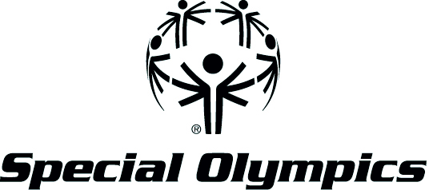

WHAT LEADERS NEED TO KNOW!

When you meet with your Member of Congress make sure you stress that these are Urgent and National Crises, that Special Olympics is a Solution and that Special Olympics has an enormous Impact on the Nation. And tell your personal stories about these topics.

NATIONAL CRISES | SPECIAL OLYMPICS SOLUTIONS | THE IMPACT through Special Olympics
Silent Epidemic of Discrimination in community schools and workplace  - ID is the most bullied and mistreated population. (2/3 more than typical students)  - Isolation in and outside of school and depression/suicide  - By 9th grade, virtually all students have heard “retard” used maliciously  - As a nation we cannot ignore this crisis as it leads to greater problems and greater expenses  - Sub-standard education  - Fewer people with ID working  - Fewer people with ID paying taxes & contributing to society  - Greater number of people with ID dependent on gov’t assistance programs | Project UNIFY  – School-based attitude change, education and activities led by youth; National Unified Schools network in 44 States and 1,500 schools  Unified Sports  - students with and without disabilities playing and socializing together  Unified Young Athletes  - 3 to 7 years old. Gives families and young people with ID hope and inspiration like all other families  R-word campaign  –national student campaign to stop the use of this awful and hurtful word  - 1,000 communities involved  - Youth-led and locally organized | - Enlightened youth leaders/attitude change  - Passage of laws that support people with ID – Rosa’s Law  - Research shows Project UNIFY participants are more engaged in communities and have better attitudes towards school.  - Inclusive school climates  - Early intervention – 8 months of motor activity from 8 weeks of involvement  - Increased acceptance and friendships  - Increased confidence and social skills critical for success in the workplace  - 52% of athletes are employed; only 10% of others with ID work.
NATIONAL CRISES | SPECIAL OLYMPICS SOLUTIONS | THE IMPACT through Special Olympics
ID – The most underserved population  Health & Health Care  - Unmet needs  - Lack of access and health care  - 65% are overweight or obese (suspect higher percentage for those not involved with SO)  - 35-50% have dental cavities or infections in their mouths  - 31% have hearing loss  - 50% need vision correction  - 22% have bone loss  - 61% have foot problems/infections  - Health professional are not trained to help people with ID  - This is shameful and discriminatory! | Healthy Athletes Screenings  ( all volunteers)  - 1 million + over 10 years  - 7 areas of health  - COMPLETELY FREE  Health Professional Training and Experience  - 15,000 + trained per year  - Professional curricula for students and practitioners  Community Based Partnerships  - Corporations  - Businesses  - Government – Federal and State  - Universities  - Professional Groups  Athlete Electronic Health Record  All volunteers! | - Every federal dollar in seed money provided to Special Olympics health programs provides $5 worth of health care.  - Early Diagnosis and referral  - Self Care capability  - Removal of pain and infection  - Prevention of disease, dysfunction and death  - Increase functioning in school, work, community activities and sport  - Health professionals more able and willing to treat people with ID in their private practices
Obesity & Physical Inactivity are Killing the Nation and  Costing Millions!!  - Shorter life spans  - Lower productivity  - Higher health care costs! | Special Olympics Sports & Unified Sports  – 620,000 US Athletes and 18,000 partners, 99,000 coaches  Healthy Athletes  – 1 million + free screenings, 104 countries and 50 U.S. states  Community health promotion projects  – Healthy Walking Programs  TRAIN – Aptitude, Athletics and Attitude - health and educational program to assess skills and provide nutritional information. | - Lower health care costs  - 52% of athletes are employed; only 10% of others with ID work.  - Action plan ready to launch with our massive network of volunteers and social network  - Better diet choices  - More physical activity  - Family wellness  - Healthy weight  - Self-efficacy  - Less disease and depression

