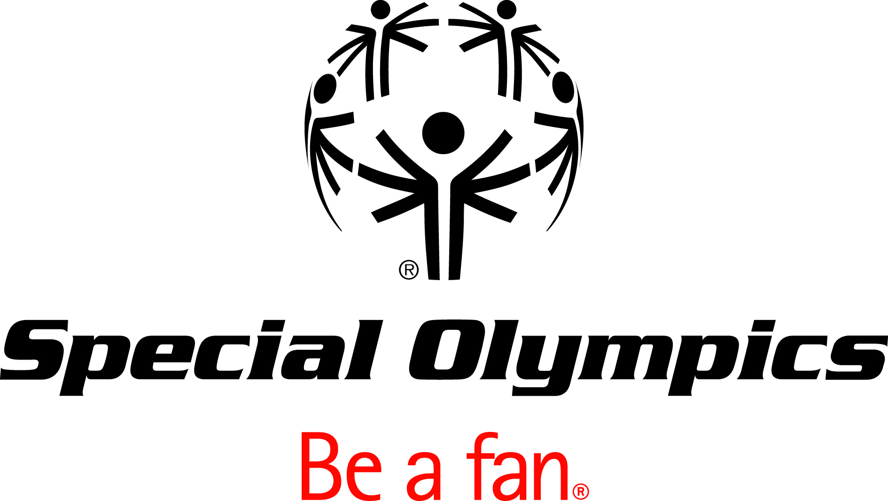

Special Olympics

2010 Global Congress
Summary Reports
Brief

Table of Contents

Movement Letter 3
Executive Summaries 4
Global Athlete Congress 4
Advance Sports & Competitions 5
Build Communities 6
Connect Fans & Funds 7
Define Movement Leadership 8
Establish Sustainable Communities 9
Games 10

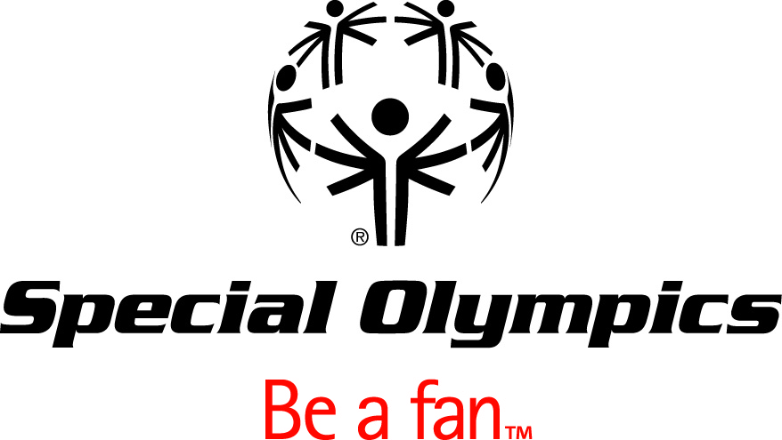

July 15, 2010

Global Congress Session Summaries and Strategic Planning Update

Dear Fellow Special Olympics Leaders:

We are so grateful for all those who were able to join us in Marrakech, Morocco for our 2010 Special Olympics Global Congress. It was undoubtedly a milestone event in the history of our Movement. We made new friends, exchanged ideas, and made significant progress against our Strategic Plan.

We are pleased to share the attached official Global Congress Summary Reports. These reports cover each of our six track sessions and Global Athlete Congress. For each session, we include a one-page Executive Summary as well as Detailed Notes. Wherever possible, we tried to capture what you said and how you said it.

We hope that all of you will take the time to review the Global Congress Summary as you work to integrate some of these strategies and tactics into your own Regions, Programs, and initiatives.

These Global Congress Summary Reports form the basis of our continued work to complete our 2011-15 Strategic Plan by the end of November. Our staff at SOI plus numerous Movement leaders will continue to hone the plan over the next several months. We have committed to release Version 3.0 on August 31st. In addition to continued work on each strategic pillar and strategies, we will be adding some cost analysis, implementation prioritization and sequencing work, and some important monitoring routines. We intend to gather your input and feedback during September and October. That input will be considered during the final submission to our SOI Board of Directors for its mid-November meeting.

We appreciate your time and commitment to making this a real success. Your guidance and support is crucial as we finalize our Plan and begin to implement it in 2011. We share your optimism that this Plan can be a true “game changer” for our entire Movement.

Very Sincerely,
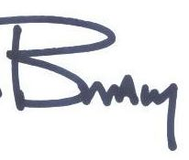
Timothy Shriver J. Brady Lum
Chairman & CEO President & COO
Special Olympics International Special Olympics International

GLOBAL ATHLETE CONGRESS- SESSION SUMMARY
Consent Agenda: First, athletes voted on a “Consent Agenda” that represented input that had come from athletes from all 7 regions. Three items were on that Consent Agenda and each of these was approved:
- The Special Olympics International Board of Directors must include the Chair of the Global Athlete Congress as a member of the Board and utilize the delegates of the GAC as an International Athlete Input Council.

- Every Special Olympics Program must have Governance Training that results in an Athlete Input Council and governance-trained athletes on Boards and committees.
- Every Special Olympics Program must ensure that their staff, directors, and board members know the mission of Special Olympics and of Athlete Leadership Programs.

Issues for Consideration: Next up was a vote to determine which of six issues raised by athletes around the world was the most important and thus should be addressed in depth, and the issue selected was:

What sort of training should be required to address the issues that we see as problems?

- Sandbagging is still an issue
- Officials aren’t calling the games using the real rules – too much pity
- Competitions and our athletic performance are not taken seriously – events are more about the fun or just getting done on time than the competition
- People STILL don’t understand the mission and divisioning rules

Most recommendations revolved around Officials and Officiating. There is a clear call from the athletes of the world for more rigorous rule enforcement and MUCH less pity on the field of play.

Election: In addition, the Global Athlete Congress elected a new Chairperson, Matthew Williams from British Columbia, Canada.

ADVANCE SPORTS & COMPETITIONS- SESSION SUMMARY
Delegate notes confirmed a Movement-wide enthusiasm for increasing and enhancing quality in our sports and competitions. While delegates were supportive of many of the proposed tactics, they expressed concern about the lack of resources (primarily people, funding, and infrastructure) necessary to achieve a range of stretch goals.
Quality Training: Delegates were most concerned about improving the quality of the athlete experience. They shared a widespread belief that growth should not come at the cost of quality, and they saw increasing minimum training opportunities for athletes as the key means for enhancing the athlete experience in this area. Of those delegates who expressed a view (through our dot exercise) on whether SO should grow the number of athletes registered worldwide by 8-10% per year, 35% were not in favour of continued growth, while 49% expressed ambivalence about the issue.
Quality Competitions: Delegates largely supported strategies aimed at improving the quality of competitions. The vast majority felt that it was important for each athlete to participate in multiple competitions per season. Importance of training and the need for an in-depth understanding of the sports rules by all athletes were emphasized in the course of the discussions, as well as the need to conduct competitions in accordance with the Sport Governing Body standards. In the words of an athlete delegate: “We want to be real athletes. No pity needed from officials!”
Coaching Excellence: Special Olympics must to do more to support coaches in reaching their full coaching potential. A near majority of delegates supported the creation of a Coaching Model that would define expectations for coach certifications, outline coach-to-athlete ratios, provide key certification metrics, and establish a coach recognition program. Delegates expressed some concern that some of the tactics would deter coaches from volunteering or be hard to implement across all Programs due to language barriers and Regional characteristics.
Athlete Development Model: This model received a strong, positive response from delegates who saw benefits from providing coaches with a tool for sports selection and performance tracking and stronger linkages with the broader sports delivery systems. While delegates were largely supportive of a health and fitness coalition, they also noted the difficulty in building the relationships necessary for making this initiative a success.
Unified Sports: There was a mixed reaction to the development and enhancement of Unified Sports. While delegates appreciated that Unified Sports offered significant opportunities for promoting inclusion and spreading our Movement, they had very different definitions of what Unified Sports would entail. Many felt that “Unified Sports” should really be a “unified experience” in which partnerships with organizations provide integrated opportunities for ID and non-ID athletes. Delegates questioned the resources involved in and necessity of promoting our own initiative. A small number questioned the entire concept saying that Unified Sports is not feasible across all countries.

BUILD COMMUNITIES- SESSION SUMMARY

Delegates acknowledge the importance of effectively involving a community of athletes, volunteers, youth, coaches, families, and other stakeholders in our Movement. They were quick to acknowledge obstacles to community involvement, but were just as quick to offer suggestions for strengthening relationships with existing Movement members and bringing new members on board.

Athlete Leadership Programs: The delegates had many suggestions for making ALPs more robust. They wanted the program to provide more consistent information about the full scope of ALPs offerings and make sure that Programs implement ALPs while maintaining a consistency in athlete leadership standards. On-going funding for the initiative is of utmost importance, and ALPs programming needs to build up and leverage emerging relationships with UNICEF and other international partners. Of the existing ALPs offerings, athletes as Board Members, athletes as coaches, and athlete training programs appear to have the greatest delegate support. Program guidelines must be more specific and easier to monitor.

Family: Common obstacles to family participation fall into four categories: time constraints (other obligations, travelling inconveniences, focus on Games participation), budget constraints (travelling costs, socio-economic status), lack of clear role (board members, coaches, and schools have more defined participation), and social stigmas that limit level of engagement. Delegates feel that there are opportunities to increase family involvement through offering families more training programs, meaningful volunteer activities, and leadership roles.

Youth Engagement: The Movement’s youth engagement efforts can be enhanced if Special Olympics clearly identifies youth education and orientation opportunities, offers flexible options for youth engagement, and defines the Movement’s target youth audience. The roles best suited for youth participation include volunteering, fundraising, acting as a coach or assistant coach (depending on the age of the youth), or serving as a Unified sports partner, Best Buddy, youth advisory member, fan, board member, advocate, messenger, referee, intern, volunteer recruiter/trainer, medal presenter, ambassador, or event coordinator at schools. The roles that the delegates thought should be off-limits to youth include any role that has a legal age limit, coaching (until 18), full time staff, athlete transport, financial management, and volunteer coordination.

Health Programs: Delegates believe that the primary obstacles to implementing effective, sustainable health programs fall into three categories: lack of financial resources, communication problems, and barriers to access. The most important health services for the Programs to deliver to SO athletes include dentistry, Medfest, optometry, and sex education. Other responses include hearing, podiatry, cardiovascular, and pulmonary health. Some delegates want to see health services at all levels and sports, not just at the national level.

CONNECT FANS & FUNDS- SESSION SUMMARY

Delegates agreed that enhancing Program quality and achieving growth objectives depends on our shared ability to effectively engage our fans and raise critical funds. There was recognition that Programs vary in their maturity and countries have different branding and fundraising needs. Plans should be tailored to individual Programs and made flexible to allow for Program growth, cultural changes, and development of new ideas. Throughout this planning process, delegates stressed that everyone should work together to raise awareness of our brand.

Brand and Building and Awareness: Delegates felt strongly about continuing to clarify our brand and building Special Olympics brand awareness. While some delegates noted that building a brand was a real challenge, most acknowledged that creating this brand was a critical means for achieving global support for the Movement. Cost effective media could be used to spread awareness of the Movement and its successes, recruit more fans and youth families, and organize more frequent activities to give our athletes greater exposure to the broader community.

Athletes as Fundraisers: Special Olympics athletes were clear in telling us that they want to help raise funds for the organization. The delegates identified many ways for athletes to participate in fundraising activities. These included utilizing athletes as Global Messengers, providing them with goods to sell (the Girl Scout cookie model), organizing grassroots fundraising events (ex., car washes), or including them in meetings with corporate sponsors. Athlete involvement should vary by country. Every Program should develop a plan for appropriately getting its athletes involved.
Integrated Global Campaign: Delegates believe that an integrated global campaign can help build unity within and beyond the current reaches of the Movement. Delegates pointed to unifying issues that all Programs have in common. These include competition from other nonprofit organizations, lack of training for fundraisers, and the need for more funds. Delegates also identified opportunities for an integrated campaign. Focusing global funding activities on a specified area (ex. family) could give us greater access to larger donations from corporations, foundations, and individual donors.

Of course, there are barriers to becoming a successfully integrated campaign. These include difficulties in raising money in many countries, cultural differences, competition for funds, lack of funds, donor fatigue, and lack of donor awareness about the Movement. An integrated campaign depends on having a clear campaign focus and raising Movement awareness.

DEFINE MOVEMENT LEADERSHIP- SESSION SUMMARY

Global Congress: Delegates overwhelmingly support the idea of a Global Congress every 4-5 years, because it provides delegates with the opportunity to share experience and learn from each other. Some delegates encouraged us to explore more frequent sessions of the Global Congress.

Leadership Training: The delegates agreed that there is a need to develop universal guidelines for effective leadership training. Training can be led by experienced mentors, volunteers, staff, and athletes. An evaluation and support system can help measure the performance of leaders and provide them with feedback. Some delegates proposed cost effective training options, such as on-line websites and resources.
Program Evaluation and Development: Delegates defined a successful Program as one that has high athlete, coach, and volunteer quality and retention. Most delegates said that quality, such as quality training facilities, competitions, and coaches, is the most important aspect of any Program. To help evaluate our Programs there should be set benchmarks, systems (such as money audits and GMS), and risk management strategies. Some delegates expressed concern that SOI is taking on too many roles and responsibilities. Other delegates commented that our current Strategic Plan seems like a United States document, not a global document.
Recognition Programs: Most delegates support Recognition Programs as a means for honoring athletes, coaches, volunteers, families, and national directors. There was significant support for volunteer service awards, because “recognition leads to retention”. Local recognition programs should include athlete nominations of coaches for awards and formal recognition for participant certification and training. Many delegates suggested a Sports Hall of Fame featuring committee selected athletes. Other delegates acknowledged the existence of current recognition programs and were less enthusiastic about these new ideas.
EKS Fellows Program: Delegates had a mixed response to the idea of tripling the size of the EKS Fellows Program. Some of the delegates supported the expansion by noting that there are currently very few participants in the program. Other delegates were less receptive to the idea. They did not fully understand the program and thought that it needed clarification or would rather focus on other programs (such as sister cities, host town program, exchange programs, Special Olympics Programs at the university level, or an international Law Enforcement Torch Run). Other delegates felt that growth could jeopardize the quality of the program and the caliber of program participants.

ESTABLISH SUSTAINABLE CAPABILITIES- SESSION SUMMARY

SO Values: Delegates were asked to assess proposed SO values. Overall, delegates voiced a desire for values that were easily understood, inspiring, and unifying. In many instances, they felt that the proposed value descriptions were too long and complicated, which made them hard to understand and translate into other languages. Delegates responded negatively to words that did not resonate across cultures. Delegates also suggested values that were currently missing from the Plan, including accountability, commitment, stewardship and trustworthiness, and health.

While the proposed values originally received a mixed reaction, delegates largely supported the values after spending some time discussing what the values meant and tweaking some of the value definitions. Most delegates came to agree that that there are core principles that they all care about. At the same time, Programs may sometimes need to adapt value wording so values can resonate with people across the Movement.

Shared Services: Delegates were supportive of the idea of shared services. They identified opportunities for shared services which include bulk purchases of sportswear, equipment, and medals, centralized travel purchases (airlines and hotels) and training, and a common courier. While delegates expressed an enthusiasm for lower costs, they also expressed concern about how the shared services initiatives would be implemented. Delegates wanted to know whether shared services would be optional or required. They also wanted to know how much flexibility Programs would have in adapting services to meet cultural or language needs. Finally, they worried that a new shared services program would lead to lower quality of service in some areas.

GAMES- SESSION SUMMARY
Delegates hope that Games will help Programs reach recruitment, marketing, and fundraising goals. They want to increase media attention, public awareness, and the number of athletes, competitions, and regional Games without jeopardizing Game quality.
Single Sport Strategy: This idea received mixed feedback. Some delegates thought that it would be successful on the global level but felt that national programs should have the flexibility to tailor their own sports offerings. Others thought that a single sport strategy could lessen the financial strain in countries with limited funds. On a global level, delegates thought popular sports would include football, track & field, basketball, and swimming. Many delegates stressed that a single sports strategy cannot detract from other sports.
World and Regional Games: Delegates believe that World and Regional Games become “community Games” when they achieve high amounts of media awareness (public announcements, advertising) and there is a close community interaction between the participants and the host town. Many delegates suggested the Host Town Program as a way to unite all the athletes, families, and volunteers in the community and to add an additional international aspect to the games. Most delegates defined Game success as having an increased awareness and acceptance of our Movement and a positive experience for all people involved. Delegates also want Games to increase the dedication and motivation of coaches and athletes.
In order to reach their goals, delegates want to implement new technology and networking initiatives (Facebook, Twitter), form alliances with corporations and the government, use the World Games to recruit more international advocates, leverage our brand more effectively, and expand sponsor involvement through inviting sponsors to games. Delegates want to see more media coverage before, during, and after the games, but most importantly, they want to see the Games treated as a sports event, not a human relations story.
Delegates felt that the Games can help their Programs by increasing public awareness through televising the games and producing posters, videos, and brochures. They hope that the Athens Games will include a strong community component that allows families and athletes to connect with the community in Athens.

