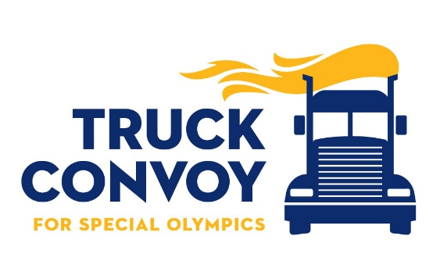
What: World’s Largest Truck Convoy®

Who: • Compassionate Wyoming Truck Drivers
• Law Enforcement
• Special Olympics Athletes
• Families, Friends, and Volunteers

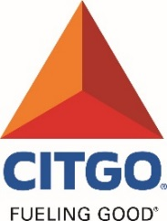
When: Saturday, September 16, 2017
9:30 a.m. Registration
10:30 a.m. Welcome and Inspiration
11:00 a.m. Truck Convoy Begins
12:00 p.m. Barbecue • Recognition • Pictures
1:30 p.m. Event finishes
This form is available on the
Special Olympics Wyoming web-site:
www.specialolympicswy.org
- Fundraising
  - Special Fundraising events
Where: New Cheyenne Location in 2017!
Will be posted on the Special Olympics Wyoming Website once we have confirmation

How: Working together Truckers and Law Enforcement meet up and stage a convoy through Cheyenne. Athletes are there to celebrate the support; lunch is provided, and it all goes to support Special Olympics Wyoming.

Why: •To support the over 1,600 children and adults with intellectual disabilities that currently compete in 16 Olympic-type sports; basketball, athletics, aquatics, tennis, power lifting, cycling, equestrian, golf, softball, soccer, alpine skiing, cross-country skiing, snowboarding, snowshoeing, bowling, and MATP (Motor Activities Training Program)
• State Competitions:
- Winter Games are held every February in Jackson
- Summer Games are held every May in Laramie
- Summer Sports Classic is held in August in Casper
- Fall Tournament is held in Casper every October

The mission of Special Olympics is to provide year-round sports training and athletic competition in a variety of Olympic-type sports for persons eight years of age and older with intellectual disabilities, giving them continuing opportunities to develop physical fitness, demonstrate courage, experience joy and participate in a sharing of gifts, skills and friendship with their families, other Special Olympics athletes, and the community.

  - 2017 Sponsors
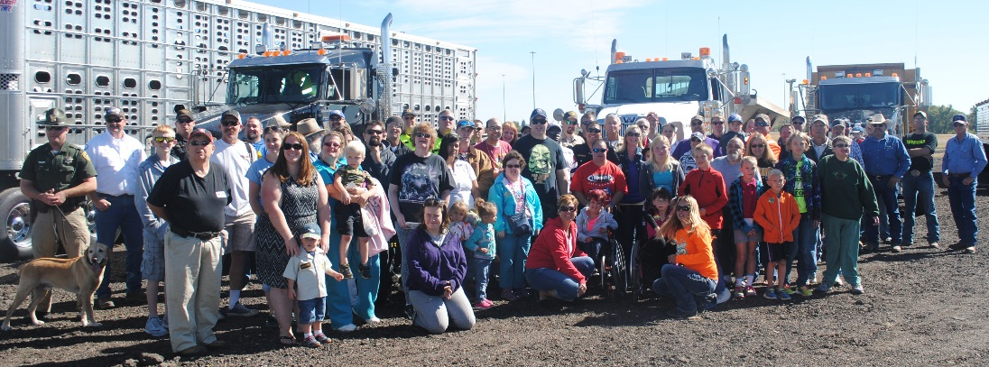
Wyoming Trucking Association
CITGO
Wyoming Association of Sheriffs & Chiefs of Police
Walmart
Sutherland Trucking
Simon Contractors
Arrow Moving & Storage
Knife River

For more information contact Priscilla Dowse at Special Olympics Wyoming
(307) 235-3062 or (800) 735-8345 or pdowse@specialolympicswy.org

  - 2017 WLTC Sponsorship Packages
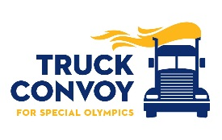
Participation in this event is available through any of the following categories:

SHAKE THE BUSHES SPONSOR
$2000 donation allows:
- Up to 20 entries in the convoy, one of which will be designated to be in the top 5 or tail 5. (First come, first served.)
- Company name or logo placed in the event program.
- Lunch for corporate representative and/or participating drivers and family members.
- Company name or emblem on the T-shirt (must be provided by August 15th).
- Two sponsor-provided banners displayed at the post-Convoy celebration.

HAMMER DOWN SPONSOR | GEORGIA OVERDRIVE SPONSOR
$1000 donation allows:  - Up to 10 entries in the convoy.  - Company name placed in the event program.  - Lunch for corporate representative and/or participating drivers and family members.  - Sponsor-provided banner displayed at the post-Convoy celebration. | $500 donation allows:  - Up to 5 entries in the convoy.  - Listed in the event program.  - Lunch for corporate representative and/or participating drivers and family members.

KING PIN SPONSOR | VIRTUAL PARTICIPANT
$100 allows:  - One entry in the convoy  - Lunch for corporate representative and/or participating drivers and family members. | $100 allows:  Participate without a truck entry! A $100 donation or more entitles the donor to a personal invitation to the event and post celebration, lunch, a goody bag, and recognition!

All amounts are tax-deductible in accordance with applicable laws.
Each participant will receive a goody bag that includes:
WLTC T-Shirt, Hat and Pin

~ For more information on the Wyoming Truck Convoy, contact Priscilla Dowse at (307)235-3062, (800)735-8345 or pdowse@specialolympicswy.org.

~For information on convoys in other locations, please call (800)700-8585 or e-mail convoy@specialolympics.org.
Or visit their website, www.worldslargesttruckconvoy.com
This form is available from the Special Olympics Wyoming web-site: www.specialolympicswy.org
• Go to the Fundraising Page and then click on Special Fundraising events to find the Convoy information

