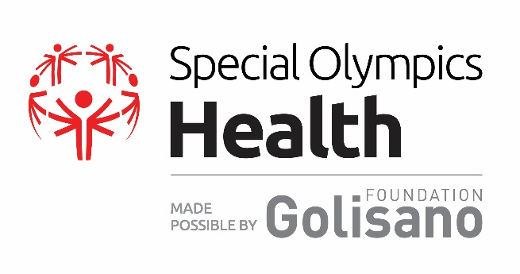
Golisano Health Leadership Award

Official Nomination Form for Regional Award
About the Award:
The Golisano Health Leadership Award is the highest honor for health partners and individuals that Special Olympics awards. The award was created to recognize local health champions and their extraordinary efforts toward fulfilling the goals, values, and mission of Special Olympics’ global health program, made possible by the Golisano Foundation.
Awards will recognize individual leaders and/or organizations that are making significant contributions to Special Olympics Health programs and the promotion of equal access to healthcare, wellness, and fitness for people with intellectual disabilities. Every two years, one awardee per region will be selected from the pool of Program level awardees and invited to the World Games to be presented with the Regional Golisano Health Leadership Award for their region. Programs that have received a 2016 3-year Healthy Community Grant or where one of the 14 Healthy Community pilot Programs may submit a nomination for the Regional award.
Nominees for the Regional award will be evaluated based on their leadership for and contributions to the following areas:
- Expanding the Special Olympics Healthy Athletes® program in the nominee’s home state/country
- Increasing local athletes’ ability to access quality follow-up health care and/or Increasing athletes’ access to and participation in year-round wellness/ fitness programs
- Increasing the financial sustainability of Special Olympics health work
- Advancement of the health rights of Special Olympic athletes and people with ID

To be considered for this award, nominations must include:
- A completed Nomination Form submitted to healthawards@specialolympics.org by 1 October 2016
- A bio and headshot for the individual nominee or a short write up on the organization nominated
- Confirmation that they have received a Golisano Health Leadership Award from the SO Program
- Please note that nominees cannot be paid staff of Special Olympics

Special Olympics Program Name:

Nominee Information:
Name: Date:

Phone: Email:
Is this nominee able to travel to World Games in Austria March 17th-20th, 2017*: Yes No
*Please note, if selected for recognition at World Games, all travel expenses for the honoree will be paid by Special Olympics, Inc.

Please describe how the nominee has contributed to the areas below.
Area 1 - Expanding Healthy Athletes
How many years has the nominee been involved with Healthy Athletes?
Is the nominee a Healthy Athletes Clinical Director?
Please describe the nominee’s contributions to the Healthy Athletes Program:
Area 2A - Increasing Athletes’ Ability to Access Quality Follow-Up Health Care
Please describe the nominee’s contributions in this area:
Please describe the impact this has had on Special Olympics’ athletes:
Area 2B - Increasing Athletes’ Access to and Participation in Year-Round Wellness/ Fitness Programs:
Please describe the nominee’s contributions in this area:
Please describe the impact this has had on Special Olympics’ athletes:
Area 3 - Increasing the Financial Sustainability of Special Olympics’ Health Program:
Please describe how the nominee has contributed to the financial sustainability of the health work in their home state/country:

Additional Information for the Nomination Committee’s Review:
Please provide any additional information you would like the Award Review Committee to know about this nominee and their advancement of health rights for Special Olympic athletes and other people with ID:
Nominated by:
Signature:
Date:
Nomination Approval Page

To be completed by the Program:

Approval by Program’s President/CEO Date

Approval by Local Athlete Leader Date

To be completed by Special Olympics, Inc.

Approval by Regional President/ Managing Director Date

Approval by Mary Davis, Special Olympics Inc. President and CEO Date

Approval by Ann Costello, Executive Director, Golisano Foundation Date

