Athlete Leadership Global Messenger –

*Public Speaking*

Trainer Notes

2016

**Sargent Shriver Global Messenger – Public Speaking**

**Beginner Trainer Guide**

**Background**

*As a trainer, it is recommended that you read through all pages indicated as Trainer Guide in the PowerPoint presentation prior to giving the training so that you can be prepared and make any necessary modification to the presentation or the Participant Guide.*

*Keep in mind that this is a working document and is meant to be tailored to fit the needs of your Program. The notes pages in the PowerPoint presentation have a summary script. This is just an information script for you to expand on as you are presenting. This gives you a very good idea of what you need to say for each slide.* ***For a more detailed script, you would use the Word for Word script in this Trainer Guide. The Word for Word script is good for new trainers who would like a little more guidance in their presentation.***

*Also included in both the* PowerPoint *and the Trainer Guide are optional activities (as noted) that may be incorporated into your training to enhance or emphasize a point or topic. Keep in mind that unless it states the word “optional” the topic is mandatory, important and must be covered. Optional exercises have been tested and found to make developing a speech easier as athletes have had mini exercises to build their speech.*

The Global Messenger Trainer Guide is one of the many components of Athlete Leadership Programs and covers information for a Global Messenger Beginner Training. The Athlete Participant Guide, Trainer Manual, Trainer Notes and the PowerPoint have been designed to be used in conjunction with each other. The overall course has been formatted to provide flexibility and creativity by the trainer, based on length of course time and participants’ experience. The Participant Guide for Athletes is an excellent tool and resource.

**Training Options**

The length of time for this training will vary, depending on the material to be covered. Some Programs may not be able in the early stages of Athlete Leadership to hold a separate Introduction to Athlete Leadership Course. For them, this could be a two day course which contains the core factual information about Special Olympics that all athlete leaders need to know before they start having conversations in public with different audiences. This training will take a day and a half if you’ve conducted the Intro Course. Some Programs (who do not have transportation issues) choose to hold the training over a period of several weeks for 2-3 hours at a time and practice exercises in between sessions. Others will add exercises and stretch to two days. The format is entirely up to the program to decide what length is best for them. **NOTE: The Program at some time will have to offer the Introduction to Athlete Leadership Course (which covers a lot more than facts of Special Olympics) to each active athlete leader. This course is a great one to offer at the local program level.**

**Training Format**

To simplify training format, the course is divided into to three sections:

**Part A** Welcome, Introductions and Objectives (General)

**Part B** Facts about Special Olympics and Athlete Leadership (Facts Section)

**Part C**  Global Messenger 1 – Beginner Training

If your Program has not offered the **Introduction to Athlete Leadership Course,** you will need to include Parts A, B and C. This will give you a great opportunity to have athletes help train this Facts Section and become trainers in waiting.

If your Program has offered **Introduction to Athlete Leadership Course,** you will train Part A and C.

**Part A Welcome and Introductions**

**Slide 1** Cover with the Presenters’ Names

Time: 0 minutes

**Slide 2** Welcome and Introduction

Welcome the new “class” of Global Messengers and tell them they have been chosen because of their outgoing personalities and their ability to talk with people.

Let the trainers introduce themselves, providing information about their experience that that provide credibility in the eyes of participants.

Time: 2 minutes

**Slide 3:** Introductions Information

Objective: To have participants get to know each other and have an opportunity to speak in front of an audience.

Material: Refer to page 3 in Participant Guide called Introduction Information

Time: 10 minutes

*(Continued on next page)*

Summary: The participants will get their first experience of speaking in front of an audience.

After the trainers have given their own introductions, it is time for the participants to introduce someone else in the room … Global Messengers to introduce Global Messengers and Speech Coaches to introduce other Speech Coaches.

Possible Script:

I know that many of you know each other, but it is only right that we all know a little bit about everyone. I just introduced myself, so now you know a little bit about me, and I would like to get to know each of you a little bit more.

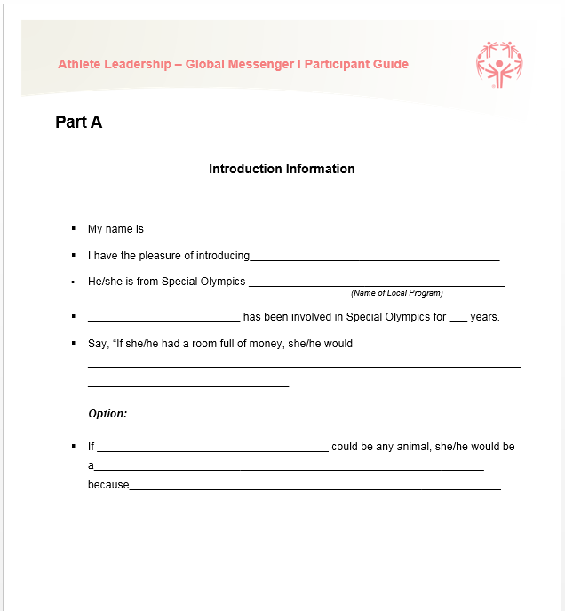

Turn to page 3 in your Participant Guide. I am going to give you only a couple of minutes to find someone that you do not already know in the room. Global Messengers, you will “interview” other Global Messengers. Speech Coaches, you will “interview” other Speech Coaches. When we are done with that, each of you will stand and tell me what you learned about that person. You have 2 minutes to “interview” someone. They have 2 minutes to interview you.

*(When done)*

Who will go first? *(No corrections here; just let them talk.) (When all are done, proceed.) There is only time to allow athletes to share introductions unless you choose to lengthen day.*

That was fantastic everyone. This exercise has shown us exactly what we will be doing when WE have to introduce someone who will be speaking at one of our Special Olympics events.

How did you feel about standing up in front of all of us and introducing someone? *Let them give responses pretty quickly.* Now we are all experienced speakers, we have all gotten up in front of an audience and spoke.

If you have time you may call attention to all the different ways people answered. How many people would give money to ____ (cause) or how many people wanted to be eagles, panthers, dogs as their animal. It shows how very difference we all are and that is a very good thing!

**Slide 4: Objectives of Training**

Objectives: To familiarize the participants with the objective of the training and the expectations of them as a Global Messenger.

Materials: PowerPoint

Flipchart and Markers

Time: 2 minutes

Summary: Participants will understand why they are at the training and the expectations you as the trainer have for them.

Possible Script:

Objectives of Training: So why are we here? You have come here and planned to spend all this time with us; why are you doing that, what are you going to learn today? *Wait for an answer.*

We are here today to not only learn to be a public speaker but also to learn about Athlete Leadership and about Special Olympics. In order to be a speaker for Special Olympics, we need to know as much about our Athlete Leadership as possible. We will learn how to CREATE a speech as well as learn about how to seek out speaking engagements or places for you to speak. You will learn how to write and give a speech to a specific audience and FINALLY you will give a speech that will be between 1 to 5 minutes long.

If we are to accomplish all these goals, we are going to need some ground rules. What are your ideas for rules we should have during the training? *You can write answers on flipchart.*

*Here you need to establish that people need to pay attention and be respectful as well as do the assigned work. This is a good place to put some expectations down and note that sometimes people want to just “unplug” and not participate; but that won’t be part of our accepted practices here! Everyone must participate.*

So do you think we can do all this in this short amount of time? If we are going to, we better get started! I am really excited about what is to come.

**End of Part A. Go to part C now if you have conducted an Introduction to Athlete Leadership Course already.**

**Part B Facts about Athlete Leadership and Special Olympics**

If you want more extensive script suggestions on these slides, review the PowerPoint for the Introduction to Athlete Leadership Course. The script referenced below is a shorter version.

**Slides 6-9: Athlete Leadership** (13 minutes total)

Objectives: To introduce the concept of Athlete Leadership and the opportunities provided for athletes to choose activities and to play roles beyond that of competitor.

Summary: Athletes should understand what Athlete Leadership is and what is offered in your Program…empowering athletes, giving athletes choices and leadership of program.

Materials: PowerPoint and Participant Guide (pages 5-7)

Flipchart and markers

**Slide 6 What is Athlete Leadership?**

What do YOU think Athlete Leadership stands for? *Allow Global Messengers to give answers.*

Time: 2 minutes

**Slide 7: Components of Athlete Leadership**

There are three things that describe Athlete Leadership: 1) Providing athletes with choices of how they want to be involved in their own program, 2) inviting athletes to serve in positions of influence in the organization (like serving on a board or as a coach or public speaker), and 3) providing training for existing leaders in how to welcome and work with you in these new roles.

Athlete Leadership was developed to allow athletes to choose how they want to participate in their Program.

It is developed to support athletes as they seek meaningful leadership roles within their Program other than only as a competitor.

*(Continued on next page)*

And finally, Athlete Leadership is designed to help provide training for the existing leadership within each program to find a way to have those meaningful roles available to these Athlete Leaders.

An Athlete Leader is defined as a person with an intellectual disability who participates in at least one Athlete Leadership program. They must be an athlete in good standing with a current Application for Participation (Medical Form) on file. They may or may not be training or competing as an athlete, currently.

Each Program may make their own criteria for Athlete Leadership participation as long as the athlete is in good standing.

Time: 3 minutes

**Slide 8 Roles of Athlete Leaders *(don’t show slide till after discussion)***

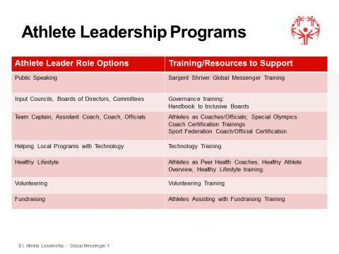Have any of you ever participated in any other role other than that of athlete in Special Olympics? *List* *the responses on a flip chart.* Do you have any ideas for jobs that you would like to do in Special Olympics? *List the responses on a flip chart.*

All of these jobs are part of the Athlete Leadership program. Here in (your Program) we provide trainings/opportunities for: *List them on slide or flipchart, then talk about the roles on the page 7.*

When you decide if you would like to do other roles besides athlete and Global Messenger, just let your coach know.

It is important to note that not all Athlete Leadership roles REQUIRE training. While trainings are available, they are seldom a requirement for serving in a leadership role.

Exception to that is the role of Coach or Sport Official.

*Cover these Roles well so Global Messengers understand what other roles are available within your Program*

Time: 4 minutes

*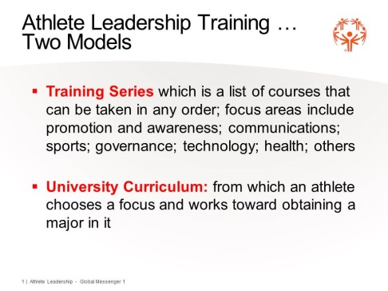***Slide 9**: Framework

*Pass out the one-pager which reflects the model of Athlete Leadership Training your Program is going to offer. Currently, there are two models – taking a series of courses based on interest with the ability to change areas of focus or focusing on one area and obtaining a major in it. Athlete Leadership University allows an athlete to choose a major and pursue courses in that major.*

*(Remove the model that you will not be using from the slide. However, if you may be working toward a University Curriculum, feel free to keep it in.)*

Special Olympics feels very strongly that every athlete and mentor/speech coach should be offered the best training possible to fulfill their new roles. Let’s review the courses in the Training Series (or University model) that is listed in the handout Athlete Leadership Training Series (or University Curriculum).

Part of the process in taking the Introduction to Athlete Leadership Course is to determine what you really like to do and what courses are right for you!

Time: 4 minutes

**Slides 10-22: The Mission of Special Olympics and Voting**

Objectives: To understand the Mission of Special Olympics.

Materials: PowerPoint and Participant Guide (Pages 8-14)

Time: 55 minutes

Summary: Introduce the Mission statement and highlight the fact that we can break it down to smaller concepts by looking at individual words and what they mean.

**Only do the Voting Activity if you have enough time built into your training day**

**(Slide 21). It is a very impactful activity, and you should try to include it if possible.**

Possible Script:

The Mission of Special Olympics is a POWERFUL statement that tells people Who we are AND What we do. Each part of the Mission statement makes up the whole mission. Each of you probably have a favorite part of the Mission and as you grow as a Special Olympics athlete and Global Messenger your favorite part of the Mission may change over time. *If you are working with Athlete presenters / trainers, have them (or you) read the Mission statement emphasizing the underlined words.*

**Slide 10: The Mission of Special Olympics**

To provide *year-round* *sports training* and *athletic competition* in a variety of *Olympic-type* sports for *children and adults* with *intellectual disabilities*, giving them continuing opportunities to d*evelop physical fitness*, *demonstrate courage*, *experience joy* and participate in the sharing of *gifts*, *skills* and *friendship* with their families, other Special Olympics athletes and the community.

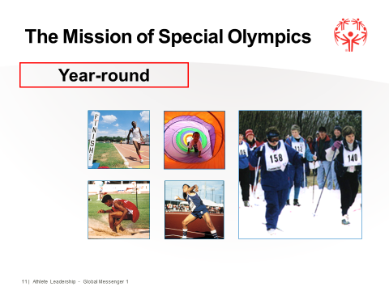

**Slide 11**

Different options for definitions of **YEAR ROUND** (i.e. different sport seasons to allow athletes to participate in several sports, or a year-round training plan for one sport.) The point here is that we do NOT want to see places offering Special Olympics for only a few weeks each year. Our athletes need to have options ALL year.

Ask athletes their favorite sport or how many train and compete ALL year.

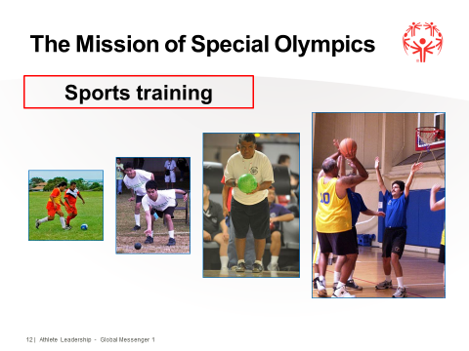**Slide 12**

**Recreation vs. Sports**

Can athletes truly compete without training in that sport? Can an athlete train 1 or 2 times and be “good” at their sport? Can they be in condition to do that sport? Where does an athlete “learn” the skills to do their sport?

You can ask them how often do you feel you should be training each week? You can ask them how often they train in the sport they are currently doing?

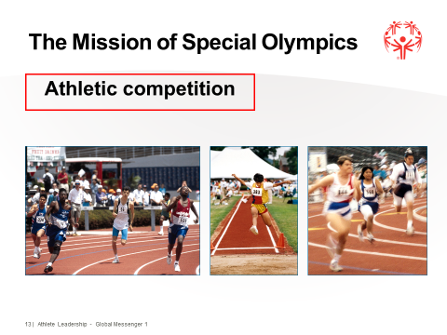**Slide 13**

Ask the athletes if they would like to just train, train, train? Why do we need **competition**? That’s why both Training AND Competition are in the Mission.

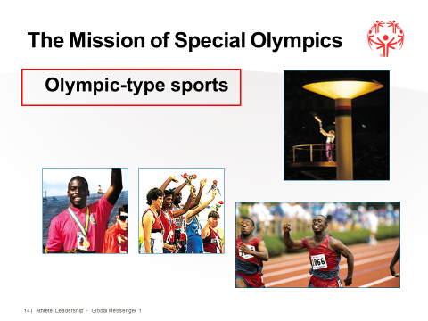**Slide 14**

Special Olympics trains and competes in **Olympic-type** sports. Special Olympics has an agreement with the International Olympic Committee that we are the only one of two organizations that have the rights to use “Olympics” (Junior Olympics and Special Olympics). In order to fulfill the agreement, they ask that we have certain rituals within our competitions that must be done such as: Rules of the Sport (play by them), Use of the Torch, Sportsmanship, Awarding of Medals, Rules, Opening and Closing Ceremonies, and the Parade of Athletes.

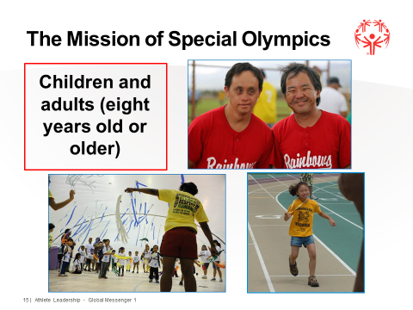**Slide 15**

Ask how many are 18 or older – how often are you called kids? A lot of people think that Special Olympics is just for kids. Athletes need to remind people that Special Olympics is a program for **youth AND adults**.

If you have time you can ask the group what is the youngest athlete in their Program (hopefully, you get 2 years old and YAP) and what their oldest athlete age is.

**Slide 16**

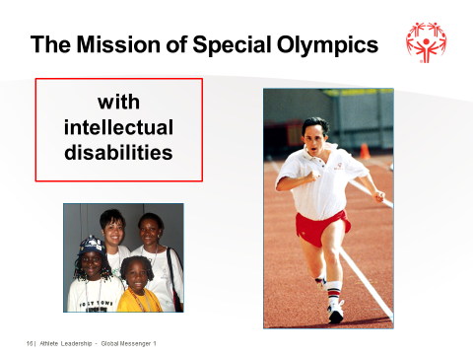

*You can insert slide with a description of Intellectual Disabilities here –* ***People with intellectual disability*** *– what does that mean? Let them give you some answers.*

Learn more slowly – does that mean that people with an Intellectual Disability don’t or can’t learn? Special Olympics started when Eunice Kennedy Shriver had the idea that people with ID could grow and learn through sports. The First Games were held in 1968 at Soldier Field, Chicago, Illinois**.**

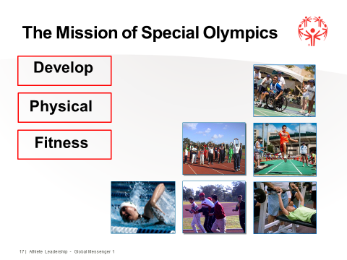**Slide 17**

Why is **Physical Fitness** important? Healthy Body makes for a Healthy Mind, Longer life, Stay Strong, etc.

What is it? The World Health Organization states that everyone in the world has a right to physical fitness. Do we believe that?

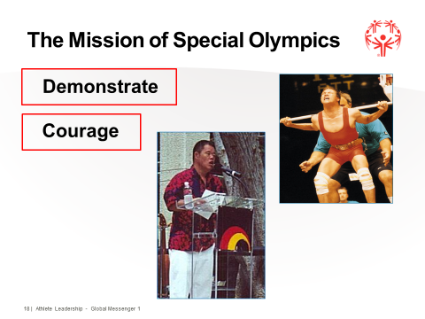**Slide 18**

Coaches/Parents/Global Messenger – tell me a time when an athlete demonstrated **courage**? Example – you’ve already shown courage today by getting up and introducing someone, which can be very scary for most people.

You can ask them if they know what the #1 fear of most people around the world is. That’s right, public speaking. And they are doing it!!!

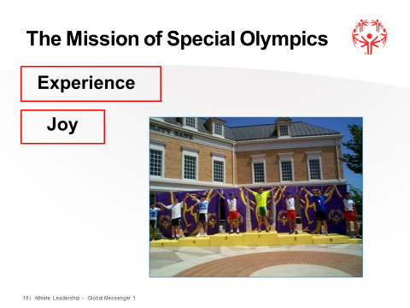

**Slide 19**

Tell me something about Special Olympics that is FUN and that brought you **JOY**!

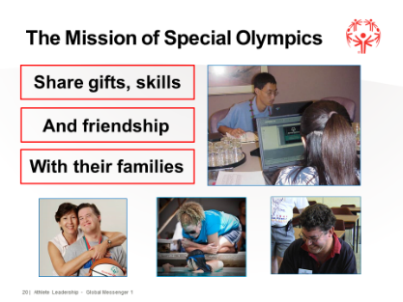**Slide 20**

How do you think Special Olympics can help people **share gifts, skills and friendship** with their family?

* My family can see that I CAN do things.
* My family can see that I am successful.
* I have sports skills; I can make friends; I can be happy, etc.
* I can make friends; my family can make friends. Special Olympics becomes part of your family.

**Slides 21: The Mission of Special Olympics - Voting**

OPTIONAL ACTIVITY:

Objectives: To “Vote” on the key elements of the Mission of Special Olympics.

Materials: PowerPoint and Participant Guide (page 14)

Flipchart, markers and 2 colors of Post-it Notes or Dots

Time: 20 minutes

Summary: The voting exercise gives everyone in the room a chance to say which aspect of the mission is the most important to them.

Possible Script:

The Mission means different things to different people. We are going to “vote” on what the most important part of the Mission statement is to the people in this room. I want to see what the most important thing to our Global Messengers is and what the most important thing is for our Speech Coaches. Each of you has been given 3 post-it notes. You will see that we have put paper up on the wall that have the key elements to the Mission Statement written on it. You will decide what 3 things mean the most to you; please don’t discuss this with anyone; it is completely up to you. You can ask your speech coach to help you read the elements if you need to, but you need to make the decision on your own.

When you have decided, go to that sheet of paper and place just 1 post-it note on it. Then go to the 2nd sheet and place another post it, then to the 3rd and place your last post-it. Speech Coaches you have a different color post-it note, but you are going to do the same thing. *Give them a minute to do that and then let them take a 5-minute break while you tally the numbers; update your slide with the results.*

Results are in! The Global Messengers have stated that the most important thing to them in our Mission Statement is ________________. 2nd most important is _______________. And the 3rd most important thing is ___________. Our Speech Coaches feel the most important thing in the Mission is ____________. The 2nd most important thing is _______________. 3rd most important thing is _____________________.

*USUALLY, the most important thing for Global Messengers and Speech Coaches are not the same thing.* Speech Coaches, you can see that what you feel is the most important thing in Special Olympics is not the same thing that our athletes feel is important. What do you think this means when you see that athlete’s think ____________ is the most important thing? *Give them a chance to answer and then respond to it such as: If friendship is the most important thing to our athletes, what do you think that should mean for our coaches during practice? Maybe they need to fit time in for our athletes to socialize before, during breaks, after their practice?*

*(Continued on next page)*

**The Mission of Special Olympics  
VOTING**

0

0

0

0

0

0

0

0

0

0

**Courage**

**Joy**

**Sharing gifts, skills & friendship**

**Competition**

**Physical fitness**

**Children/Adults**

**Olympic-type**

**Year-round**

**Intellectual Disabilities**

**Sports Training**

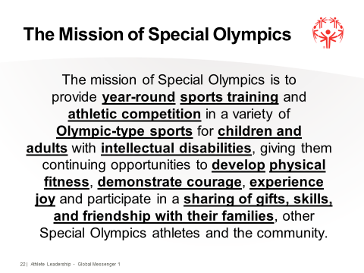**Slide 22: The Mission of Special Olympics**

Time: 1 minute

All of the parts come together to create the Mission statement.

*If you have Athlete Trainers working with you have them read the full Mission, emphasizing the underlined words. Otherwise, a trainer should read in order to show how to emphasize words.*

After trainer has read, explain why they emphasized the words the way they did. This is part of an activity later that reinforces a speaking enhancement that you will talk about later in the training.

**Slides 23-24: What Makes Special Olympics Unique?**

Objectives: To understand the unique aspects of Special Olympics.

Materials: PowerPoint and Participant Guide (page15)

Time: 11 minutes

Summary: There are some things that make Special Olympics “unique” or different than other sports organizations like Pop Warner or the Olympics.

Possible Script:

There are things that make Special Olympics UNIQUE or DIFFERENT than other sports organization. Unlike organizations like American Youth Soccer Association (AYSO), Basketball Leagues, etc. there is no charge to join our program. Eunice Kennedy Shriver wanted to make sure that ALL individuals with intellectual disabilities had the opportunity to join Special Olympics, not just the ones whose families could afford it. Now, does that mean that we do not need to raise money or that athlete’s and their families should not help to raise money? Of course not, everyone needs to help support the fundraising efforts in order for Special Olympics to continue. However, it does mean that athletes and their families should not have to “pay to play”. Does anyone know what that means? *See if you can get the correct answer.* Pay to Play means you are not allowed to join a team unless your give them money.

Awards for ALL: what do you think that means? *Let them give you the correct answer.* That is correct; everyone that competes in Special Olympics events receives an award based on place of finish in the events that they compete in. Unlike the Olympics where only the 1st, 2nd and 3rd place winners receive awards.

Advancement to higher levels for competition: In most organizations, you MUST compete in a local competition before you are able to advance to the next level. Winning a 1st place from the highest level in your Program makes you eligible to compete for the next level of competition. How are athletes supposed to be selected for that Advancement? *See if they can come up with Random draw.* Random draw!!! In order for an athlete to be eligible that athlete must have received a gold medal from the previous year in the sport in which they are applying. Names of all eligible athletes are then put into a hat and selected by a random draw.

We have events for athletes of all ability levels from athletes who use wheelchairs, on crutches, etc. that are walking 10 meters to athletes that are running marathons. Hopefully, we have something for everyone to do.

Divisioning is very unique for Special Olympics. Because every athlete should have an equal opportunity to excel in their heat, we must be very careful on how we division each heat. Special Olympics allows athletes to compete in the fairest way possible.  Within each sport, events are divisioned based on athletes' age, gender and ability.  Each division can have up to eight athletes but no less than three.  Sometimes exceptions are made according to each Program’s circumstances.  Can males/females be in the same division? YES, if they are the same ability, same skill level. Can there be a range in age? YES, as long as the athletes are the same ability. We don’t want an 8 year old running against a 40 year old if we can help it, but if they are the only 2 people in that event, can they run against each other?

OPTIONAL ACTIVITY # 1: Stork Stand. See Stork Stand Activity. 15 minutes

**Slide 25: Stork Stand**

Objectives: To introduce the concept of Divisioning for Special Olympics Competitions.

Materials: Pieces of scratch paper or post-its, pens, watches with second hands or stopwatches

Time: 15 minutes

Summary: Special Olympics divisioning is very misunderstood throughout Programs. Many people do not understand the process or why divisions are set up the way they are set up. The Stork Stand helps to break it down into a very easy hands-on activity.

See following page for full activity.

Stork Stand

First, go over what divisioning is and how it is decided (age, gender, ability with ability the most important). Ask how many weeks training (8) and how many should be in each division (minimum of 3, maximum of 8).

Then advise the group that they are going to be in a made-up event (because they haven’t had eight weeks of training) – the Stork Stand (you may use any activity that will give you different times/distances within the group). They should be in groups of two or three, and one person must have a watch with a second hard. Ask everyone to pretend to kick a ball. That is their stronger foot, and that will be in the air. To do the Stork Stand, they will cross their arms, close their eyes, and stand on the weaker foot (the other should be lifted behind them). When their partner says “Go”, they are to try to stand this way, eyes closed, without moving (no wobbling!), and the partner times how many seconds they could stand this way. They write their name and time on a piece of paper or post-it.

When all have completed this task, they take their paper – they decide where they think they fall in “line” (without talking or showing paper). Go to that spot on the floor. Have them show their paper (talk about how sometimes as coaches, we really do not know where our athletes fall within a competition), put them in the correct order, and have someone division them.

Then ask for volunteers to see if they have made good “divisions”. They may move the notes around to make better divisions. There should be someone who has stood for much longer or shorter than anyone else – discuss what you can do with this single person – combine in another group, have a single person division, etc. Explain that making good divisions can be very difficult, but that games management teams do the best they can.

Ask, “If this were a local event, and now we are being invited to a national event and can have three athletes attend, who should go?” If no one comes up with the rule of random draw, you should tell them (and this is one of the points that makes Special Olympics unique). You then take off the first place winners in each of the divisions, put them in a hat, and draw three names. Make sure you explain this is not a real event and that they are not being chosen to attend a real Games.

Discuss why Special Olympics does this – our Games are not just competition – they are a celebration of what people can achieve, etc. Each first place winner should have an equal opportunity to attend higher-level competition.

**OPTIONAL ACTIVITY #2**: Take pictures of athletes (at least 6) throwing the softball. Try to include athletes of varying level of abilities Global Messengers pick who they “think” would throw the farthest. Tell them not to turn pictures over. Let mentor hold pictures and lay them on the table. Use flip chart to record their guesses. This is a good teamwork project so you only have 3 or 4 groups to record. Have the length thrown written on the back and then have them “division” the athletes.

Record each group’s division on flip chart or white board Review why they did what they did with each group Picture Activity 15 minutes.

**Slides 26 - 27: Facts about Special Olympics**

Objectives: To understand the facts about the Special Olympics program.

Materials: PowerPoint and Participant Guide (page 16)

Time: 10 minutes

Summary: The following are the basic Special Olympics facts:

1. Special Olympics is for people with intellectual disabilities.
2. Special Olympics is FREE for all participants.
3. Athletes 8 years of age and older may participate in Special Olympics.
4. 2-7 year olds can participate in Young Athletes Program.
5. Special Olympics is worldwide with Programs in over 170 countries.
6. Special Olympics offers 32 official or demonstration sports.
7. Special Olympics is year-round.
8. Special Olympics is both sports training and competition.
9. Unified Sports is for o
10. Special Olympics offers both team and individual sports.

Possible Script:

There are certain things that you MUST know about our program in order for you to give a successful speech to any audience. We have already spoken about our Mission Statement. Tell me again what our Mission Statement does? *Let them answer.* That is right it tells your audience who we are and wWhat we do.

There are other “facts” about Special Olympics that are not listed in the Mission Statement. Can any of you think of some facts that you know about that your audience might want to hear? *Let them say some things, you can write on flipchart if you want.*

Here are some of the things that you might also want to include besides all the things you just said. *List the items they missed saying.*

**End of Part B Information about Athlete Leadership and Special Olympics**

**Part C Global Messenger Beginning Training**

**Slide 29: Let’s Review** Ask questions in a rapid fire, game like atmosphere.

Mission, Facts, What’s Unique – pick specific questions from each.

Time: 6 minutes Total

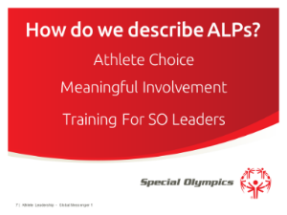**Slide 7: Review of the definition athlete leadership**

Objective: To understand the most important components of Athlete Leadership.

Script: Who can define what Athlete Leadership is – wait show slide or

Who would like to tell me what the most important aspects of the definition of Athlete Leadership are? Show Slide

Who would like to share what athlete leadership means to you

**Slide 10:** **Review of the Mission Statement**

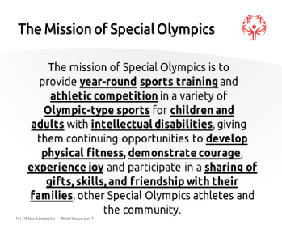Objective: To review the Mission.

Script: I would like each one of you to look at the mission statement in your Participant Guide (page 8) and pick out the part that you like best. Then I am going to ask each one of you to share your favorite part and tell us why you like that particular part of the mission

Activity: Show Mission Statement and ask each athlete to stand and tell what is their favorite part of the mission and why.

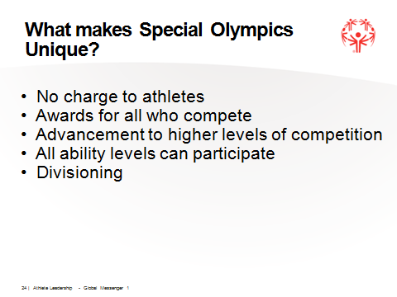**Slide 24: Review what makes Special Olympics Unique**

Objective: To understand the unique aspects of Special Olympics.

Script: What is one thing that makes Special Olympics different from other sports organizations.

**NOTE:** Advancement and divisioning if one answers.

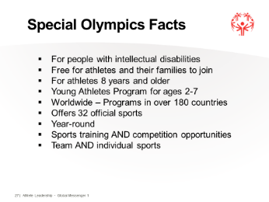**Slide 27: Special Olympics Facts**

Objective: To understand the basic components of Special Olympics

Script: Who would like to tell me what the important aspects of Special

Olympics are?

Who would like to share what Special Olympics means to them?

**Slide 30: Using Your Participant Guide**

Objective: To understand how the Participant Guide is organized by using the Table of Contents.

Materials: PowerPoint and Participant Guide

Time: 10 minutes

Summary:

*The participants will learn how their guides are organized and how to find specific sections and pieces of information. The goal is that they will continue to refer to these guides after the training is over and when working with their Speech Coaches to prepare speeches.*

Possible Script:

Each of you received your very own copy of the Participant Guide when you checked into the training. This book is going to be very useful while you are learning how to make speeches today, and even after this training when you are getting ready for your other speeches, you should use this guide. Already today we have used it several times. Today we will also do all of our activities in this guide.

This guide is very easy to use. I want you to turn to page 2 in your guide. Does anyone know what this page is called? *Wait for an answer*. That is right, **Table of Contents**, now does anyone know what the Table of Contents is used for? *Wait for the answer. If you don’t get the right answer, say the following.* Those are all great answers, but the Table of Contents helps you to find the information you want without having to look at every page.

This is how it works. Can someone tell me what page I need to go to if I want to look at the Mission Statement? *Wait for an answer, explain further if they are not looking at it right.* That is right; did everyone find where the Mission Statement is? Let’s turn to page 8 and see if that is right.

Now who can tell me where we can find some Target Audience Selling Points? *Wait for the correct answer.* That is right, let’s turn to page 27. On this page you will find ideas on what you should put in your speech when talking to that audience? Can someone tell me an idea for selling to a Potential Sponsor? *Wait for an answer*. Who can tell me one for a Volunteer? *Do a couple of these to have them look through the pages and to get a feel for the “selling points.”*

**Note**: Participants who do not read well will need assistance from their Speech Coaches, but it is important that they value the Guide as a resource.

**Slides 31-33: Roles of the Global Messenger and Ambassadors**

Objectives: To familiarize the participants with what is expected of them as a Global Messenger and Ambassador.

Materials: PowerPoint and Participant Guide (page 17)

Time: 5 minutes

Summary: Learning what is expected of Global Messengers and Ambassadors through their Job Descriptions

Possible Script:

What does being a Global Messenger mean?

When getting hired for a job, your employer will give you a job description. This job description lets you know what is expected of you.

Everyone turn to page 17 in your Participant Guide. Who would like to read the first bullet point? *Have a Global Messenger read each bullet point, you expand on any point you feel they might not fully understand.*

As a Global Messenger, you are also an Ambassador for Special Olympics. You won’t just be giving speeches to audiences, you may be in a small group and talking with sponsors or you might be at a practice talking to potential athletes. You will not always have a script to follow, so the more information you know, the better Ambassador for our Program you will be.

Roles and Responsibilities

Global Messenger:

The role of a Global Messenger is to promote, educate and inform others about the Mission, philosophy, benefits and direction of Special Olympics through public speaking and public appearances on behalf of Special Olympics. The Global Messenger should be a current participant in Special Olympics who has enthusiasm for Special Olympics and a willingness to share with others.

* Be attentive during the training.
* Understand Special Olympics Mission, Facts, Unique Aspects, Target Audiences, Philosophy, and Spread the Work.
* Learn different ways to provide information to audiences.
* Prepare and practice a 1 to 5-minute speech.
* Demonstrate the ability to give a public speech to different audiences with enthusiasm.
* Maintain contact with Speech Coach and Special Olympics staff.
* Represent Special Olympics professionally in manner and appearance.
* Be a spokesperson of Special Olympics, always.

Selection Criteria for Global Messenger

* Commitment to the Mission and philosophy of Special Olympics
* Ability to express self (verbally or non-verbally)
  + Non-verbal Global Messengers may communicate through PowerPoint presentations, etc.
* Ability to travel
* Time to prepare and make presentations

Ambassadors

An Ambassador for Special Olympics may or may not be a Global Messenger. Ambassadors can be any of our Athlete Leaders that represent our Program. Ambassadors need to know as much information about Special Olympics as they can. Let’s turn to page 17 in the Participant Guide. *Have a Global Messenger read a bullet point; you expand on any point you feel they might not fully understand.*

The role of an Ambassador is not necessarily the same as that of a Global Messenger. An Ambassador can be any of our Athlete Leaders that represent our movement. Ambassadors should be able to talk about Special Olympics wherever they go and to whomever they meet. Ambassadors need to know as much information about Special Olympics as they can, usually from the Introduction to Athlete Leadership.

Ambassadors Need To Know…

* Mission and facts about Special Olympics; the Athlete Oath
* Misconceptions about Special Olympics and how we are unique
* Key elements of philosophy
* Add your Program’s information (major fundraising events, competitions, YAP, MATP, sports offered, etc.)
* Commitment to their Global Messenger program; waiting to be trained as Global Messengers
* Likes to meet and greet people

**Slides 34-35: Elevator Speech and Template**

Objectives: To introduce the concept of speaking in a small group of people.

Materials: PowerPoint and Participant Guide

Time: 17 minutes

Summary: An Elevator Speech is a concise, punchy, planned description that overviews the value provided by a person or organization. It should be in the time that it takes to ride an elevator. About 30 seconds.

Possible Script:

We will not always be standing in front of an audience giving a formal presentation. There will be times that you will be asked to be a greeter at an event or just to walk around and talk with people. You might also be asked to go to a school and just talk to students about joining Special Olympics. *(Tell them about something they might specifically do for your Program.)* In order to do this, you must be able to talk about the Mission and the Facts about Special Olympics, and you must also be willing to give information about yourself. We call this an Elevator Speech.

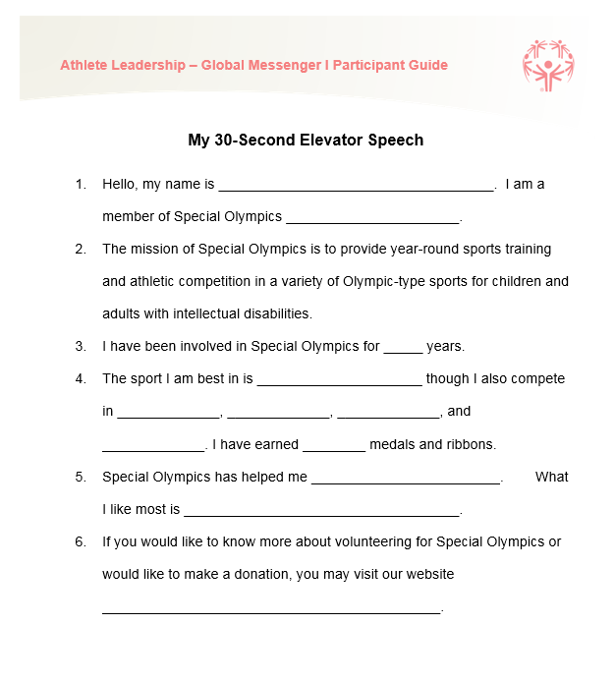

**Slide 35: Elevator Speech Template**

Turn to page 18 in your Participant Guide. Review the script with your Speech Coach. Each Global Messenger is going to stand and read this script filling in the blanks. Once again, we are not going to write the answers because it is something that you should be able to say from your heart. Who would like to go first?

**Slide 36: Role of the Speech Coach**

Objectives: To familiarize the Speech Coaches with what is expected of them during the training and after.

Materials: PowerPoint and Participant Guide (page 19)

Time: 5 minutes

Summary: Learning what is expected of the Speech Coach through their Job Descriptions.

Possible Script:

I hope that our Speech Coaches had an opportunity to look through their Job Descriptions before coming to this training. Your role here today and in the next couple of years is vital to the success of the Global Messengers that you are here with today.

It is essential that you understand that you are here to “support” your Global Messenger, not to write their speeches for them or to tell them what to put into their speeches. The best speeches that our Global Messengers give are ones that they write on their own. Today you will be involved in almost all the activities and some of you will have to work VERY hard to not give them too much help, but we also do not want our Global Messengers to get frustrated with the process, so you will have to judge how much help they need during the training and then how much help they will need when you begin to develop speeches outside of the training. As they get more comfortable, they will need you less and less.

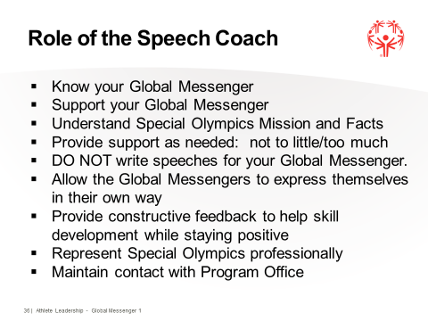Support outside of the training includes more than just helping them write the speech, they will need you to help find them places to GIVE their speeches, they will not be able to do this alone. We want them to be able to give (determine a number for your Program) speeches in the next year. You may have to help decide what they should wear to each speech, you may be their transportation to and from AND you will always be the coach standing in the back of the room giving them gestures on what needs to be improved WHILE they are speaking. You are also going to be the person to help them evaluate each speech they give so they can improve each time.

Do you think you are up to the challenge? I am guessing that you are.

**Slides 37-38: What is a Speech?**

Objectives: The participants will understand what a speech is.

Materials: PowerPoint and Participant Guide (page 20)

Time: 2 minutes

Summary: The Global Messengers need to know the definition of what a speech is.

Possible Script:

Since you will be giving many speeches over the next few years, it might be a good idea to know what a speech is. A speech is simply telling a group of people about something that interests you and your audience.

**Slide 39: Preparing a Speech**

Objectives: Understanding WHY Global Messengers will give a speech and WHAT KIND of speech they might give.

Materials: PowerPoint

Time: 5 minutes

Summary: Global Messengers need to understand that they are the “voice” of the Special Olympics Program. People don’t want to hear from us or from the CEOs; they want to hear from the people who are affected by this program the most, them.

OPTIONAL: Types of speeches: there are all kinds of speeches that Global Messengers give.

Possible Script:

You are the “voice” of Special Olympics. The people that you will be speaking to do not want to hear from me or even our CEO, they want to hear from you. You are the people that are most important in Special Olympics. They need to see and hear what you do. You are credible. You ARE Special Olympics!

There are 3 types of speeches:

First is: Informative: You will give information to your audience. It can be information about Special Olympics or information about an event. You will be told who your audience is that you are speaking to and what it is that we need to tell them. You will put that information into your speech.

Second is: Demonstrative: You will give information as well as “teach” your audience something. You may be speaking about a specific event or sport and you will give them information that teaches them about it.

Third is: Persuasive: You are going to try and persuade the audience to do something such as give us money or come out and coach.

For Special Olympics and in your speeches, you will always be giving information and trying to convince them to do something.

**Slide 40: What’s Wrong Here**

Objectives: To give the participants an example of how not to look and act when making a speech. ` This is a lead up to Speech Enhancements.

Materials: Someone to be a terrible presenter

Time: 6 minutes

Summary: Trainer tells the audience to pretend that they are people who might want to become Special Olympics sponsors. A speaker is going to tell them what Special Olympics means to him or her. What the participants do not know is that the trainer or helper is deliberately looking disheveled and acting inappropriately.

Script:

As you can imagine, representing Special Olympics is a big responsibility. Making a good first impression is so important! It is very important to look and act your best. Throughout this training, we are looking at examples of some of our trained speakers. We can learn a great deal from watching what others do well--and not so well.

For this next activity, I’d like you to pretend that you are a group who might give Special Olympics some money. After hearing the presentation, you will decide whether or not you’d like to donate to us.

*(Continued on next page)*

*In bursts the designated speaker, apparently late and frazzled. He or she looks disheveled and is dressed inappropriately for the type of speech to be given. The speaker starts fumbling for materials in a bag.*

*“Gosh, I’m so sorry that I am late. I wasn’t sure how long it would take me to get here. And then I didn’t know where to go inside the building.” …*

*Speaker has note cards and brochures somewhere in the bag or folder. He or she must appear disorganized and, because of being so late, nervously tries to get set up at the podium or table in front of the room.*

*Have the speaker give his speech. He can answer his cell phone during the speech, act like they do not know who they are speaking to, etc. Trainer ends the speech and lets everyone know that the fumbling speaker is just acting to help them realize the types of mistakes that a speaker can make.*

I noticed that some of you looked like you couldn’t believe that this speaker was asked to come to our training. He was really asked to show you what not to do when you speak in front of a group. Let’s discuss what you think he did correctly … and incorrectly.

*Trainer then elicits comments from the participants as to what the speaker did or did not do correctly. This discussion can also be directed by asking participants what they think would be a better way to prepare for a speech.*

(This activity is designed to focus on the speaker’s overall appearance and behavior.)

Problems Ways to Improve

Ex: Came in late Be sure you know how long it takes to get to the location.

Looked sloppy Dress neatly and appropriately.

Always tuck in your shirt, tie your shoes,

Comb your hair, wear nice clothes, brush your teeth, etc.

Seemed unorganized Practice, practice, practice

Have all your materials neatly organized

*(Continued on next page)*

Problems Ways to Improve

Did not know the audience Always know who you are talking to.

Know your selling points for that audience.

Answered the cell phone NEVER have your cell phone turned on.

You have come up with some very good ideas about the importance of looking and acting appropriately. Remember, you are representing Special Olympics, and we want you to be proud of how you look and confident when you give your speech! You can find very good information in your Participant Guide.

**Slide 41: Speech Enhancements (Cover Slide)**

Time: 1 minute

**Slides 42: Gold Medal Presentations**

Objectives: To understand how to enhance presentations through appearance, body language, vocal variety, emphasis.

Materials: PowerPoint and Participant Guide (page 21)

Time: 5 minutes

Summary: Global Messengers need to have an idea of how to make their speeches more exciting by using body language, volume control, pitch, eye contact, gestures, and emphasizing words.

Possible Script:

We have talked about what a speech is and what kind of speeches you can do. Now I would like to talk to you about how to make a speech exciting and how you can learn to hold an audience’s attention while you are speaking.

In order to have a Gold Medal Presentation you need to exhibit winning behaviors below:

* Smile! Be friendly and courteous.
* Use positive body language, that is how you hold yourself when speaking, what your facial expressions tell the audience, how long you hold eye contact, and use of gestures.
* Don’t speak too loudly or too softly.
* Know who you are talking to.
* Give personal space: don’t stand too close to someone when talking to them.
* Always arrive on time. NEVER be late to any place that you are representing Special Olympics.
* Remember to take the things that you need in order to do the speech that you have planned.

**Slide 43: Body Language**

**OPTIONAL:**

Objectives: To understand how to enhance presentations with the use of body language.

Materials: PowerPoint and Participant Guide (page 22)

Time: 5-10 minutes (depends on Optional Activities)

Summary: Global Messengers need to have an idea of how to make their speeches more exciting by using body language such as posture, facial expression, eye contact, gestures and movement.

Possible Script:

1. Body Language is an important part of speaking. It helps to enhance your message, provides speakers with a means of control and helps to release any nervous energy.
2. Posture is how you hold yourself. Be proud, stand and talk with your shoulders relaxed.
3. Eye Contact makes the audience feel like you are talking directly to them. A hint on how to remember to make eye contact during your speech is to highlight a spot in your notes where you would like to look up at the audience. If you highlight it in your notes, it helps you not to lose your place. You can underline it, put a smiley face at the end of a sentence, color highlight it, use your finger as you go, etc.
4. Movement/Gestures are movements done with your hands during your speech. You don’t want to use too many because your audience will begin to look at your hands and arms and not listen to what you are saying. Use gestures to emphasize a point in your speech. Only use a gesture when it means something such as Number 4, you hold 4 fingers up. *Show them.*

**OPTIONAL Gesture Exercise:** Practice gestures. Have them work with their coaches on pointing, shaking their fist with anger, slapping one hand into another to emphasize a point, etc.

Movement is kind of hard. Most of the time you will be standing behind a podium and mike so it is hard to move around. However sometimes it is OK to move around to talk to people. It makes your audience have to keep track of where you are at.

1. Facial Expressions: Your audience can figure out a lot about you by just seeing your facial expressions during your speech. They will know if you are talking about something that makes you happy or something that makes you sad. *You can add an Optional Activity here.*

**OPTIONAL Facial Exercise**: *Refer to Facial Expressions in Participant Guide, page 22.* We are going to do an exercise so you can practice how to make those expressions during your speech. *Have the Global Messengers make a happy face, angry face, upset face, sad face, shocked face, etc.*

Facial Expression Exercise



**Slide 44: Vocal Variety**

**OPTIONAL:**

Objectives: To understand how to enhance presentations by your volume control, pitch, rate of talking, quality of your tone and use of pauses.

Materials: PowerPoint and Participant Guide (page 23)

Time: 5 minutes

Summary: Global Messengers need to have an idea of how to make their speeches heard by their audience through vocal variety.

Possible Script:

How you use your voice when you are giving a speech is very important. If you speak too softly *(speak softly),* your audience will not be able to hear you or too loudly *(speak loudly),* and your audience will be covering their ears and not want to listen to you. You want to work on how you need to speak when you do not have a microphone to talk into and how loud you need to speak when you do have a mic’.

Pitch is how high your voice is (squeaky) or how low it is (deep). How fast do you speak? If you are naturally a fast speaker or if you speak faster when you are nervous, you have to know this and slow down so you can be understood.

Can you put emotions into your voice? That really is great for your speech. Then the audience feels what you are feeling as you speak.

Pauses are terrific; it is always great to put a few pauses or quiet time into your speech to draw their attention back to you. This is also a great time to look up at your audience and make eye contact.

**Slide 45: Volume Activity: What Special Olympics Means to Me**

**OPTIONAL Activity:**

Objective: Provide Global Messengers an opportunity to work on their volume control as well as independent speech making. Speech Coaches will develop signals to give their Global Messengers during the presentation to help improve the presentation.

Material: PowerPoint

Time: 30 minutes

Summary: Global Messenger will independently tell the group “What Special Olympics Means to Me” or “My Favorite Memory of Special Olympics” or “My most memorable experience at Special Olympics?”

Possible Script:

One of the most important qualities of a good speaker is to be understood by your audience. When you are listening to the radio or watching television, sometimes you have to adjust the volume. You will need to do that with your speeches as well. Sometimes, you will not have a microphone to use; sometimes there will be background noise that you will need to speak over. When speaking, you might have to adjust your own volume or loudness of your voice. Speech Coaches, this is one of your most important jobs, to help your athlete be heard by the audience. For this activity, you will be in the back of the room; athletes when you begin to talk you need to look at your Speech Coach to determine if you are speaking loud enough. Coaches, develop hand signals for your athletes. These hand signals will be for other things besides volume. Develop one for eye contact, smile, hand gestures, etc.

Your personal story is so important when giving a speech to an audience. They want to know about you and your success and yes, even the hardship that you have gone through to get to be the person that you are today. The best way of doing that is speaking from the heart. You don’t need to write this information down; you just need to tell your story.

Today, each of you will stand up and tell us one of your best experiences with Special Olympics. I only want this to be 30 seconds to a minute long so know what you want to talk about before you stand up.

Possible Script: (continued)

Remember, you must always introduce yourself to your audience, be loud enough so everyone can hear you, but not too loud that they have to cover their ears. Look at the people you are talking to and SMILE! Remember, the Speech enhancements we worked on earlier: eye contact, smile, and hand gestures.

I am going to give you about a minute to think up your best story. *When time is up.* OK, who is going to be my first speaker? Speech Coaches, please go to the back of the room. Global Messengers, don’t forget to introduce yourselves.

**Slide 46: Word Punch**

**OPTIONAL ACTIVITY:**

Objectives: To understand how to enhance sentences by emphasizing key words in a speech.

Materials: PowerPoint and Participant Guide (page 24)

Time: 10 minutes

Summary: Emphasizing key words in a sentence will help the Global Messengers to enhance their speeches. Emphasizing certain words makes a sentence sound and mean different things.

Possible Script:

Did you know that you can make a sentence sound differently by the way you say a certain word? It is really cool. Listen. *If you are working with Athlete Trainers have them demonstrate sentences on Slide 45 for the group. If not an athlete any trainer can demonstrate.*

We are going to do an activity where you are going to work on emphasizing different words and see if you think it made the sentence sound different or even made it mean something different. Turn to page 24 for the sentences that you will use.

*Have each Global Messenger work with their Speech Coach saying each sentence.*

Did you find that by emphasizing a different word it gave the sentence a different meaning? *Get answers.* For example, when I say this sentence, I was born in (place of birth), do you think that I was really proud to be from that town?

Word Punch

Practice each sentence below while you emphasize highlighted words.

1. I was born in (place of birth).
2. I was born in (place of birth).
3. I was born in (place of birth).
4. I was born in (place of birth).
5. I was born in (place of birth).

**Slide 47: Develop a “Catch Line”**

Objective: To develop a “Catch Line” that the Global Messenger can use in their presentation to catch the attention of the audience.

Material: PowerPoint and Participant Guide (page 24)

Time: 20 minutes

Summary: A “Catch Line” is used by a speaker to help “catch” the attention of their audience. This is a powerful tool that the Global Messengers can use in their speeches.

Possible Script:

Have you ever listened to someone talking, and you hear them say something, and you think, Wow, that is true or Wow, I didn’t know that? That is probably a “Catch Line.” It is something they say to help describe what they are talking about. It helps to pull your audience into what you are trying to say.

One of my favorite lines *(tell them your favorite line)* (Sample: when I am talking with youth within a school setting I say, “It is you, the youth of today, that will change the World.”) What do you think might be your “Catch Line” when you are talking to people about Special Olympics?

Here is one example of a catch line that one athlete uses: “Andy is my name; swimming is my game, and Special Olympics is my Life”.

Turn to your “Catch Line” Worksheet on page 25. I am only going to give you 5 minutes to come up with a “Catch Line”. Remember coaches, this has to be something the Global Messenger would say, not something you would say. *(Give them 5 minutes to finish the worksheet.)*

Alright who wants to be the first person to stand up and tell us their “Catch Line”? *(Have all stand and give it.)*

How do you think you could use your new “Catch Line”? *Looking for answer to put it in all our speeches.*

My “Catch Line”

What do I want to say in my speeches that will excite the audience and get their attention?

_________________________________________________________________

_________________________________________________________________

_________________________________________________________________

Examples are:

Special Olympics changes lives.

Special Olympics inspires all.

Special Olympics creates heroes.

Special Olympics celebrates differences.

Special Olympics is Training for life.

**Slide 48: Target Audiences**

Objective: To identify target audiences.

Material: PowerPoint and Participant Guide (page 26)

Time: 10 minutes

Summary: Global Messengers should select the Target Audience they will be writing their speech for this training for.

Possible Script:

It is the goal of our training for each of you to give a 3-5 minute presentation. In order to do this, you need to know who you are talking to, that is called your target audience. Each of you were asked to bring either 1 or 2 target audiences for whom you wanted to develop your speech. Right now, you are going to stand and tell me what audience you selected first and then second, and I will write them down. *(If you don’t care who the audience is, then they just tell you their first choice. If you want to make sure you have a variety of speeches, you as the trainer must pick the audience for each Global Messenger from their 2 choices.)*

These are the audiences that you will develop all your information and your speech for.

**Slides 49-51: Special Olympics Target Audience**

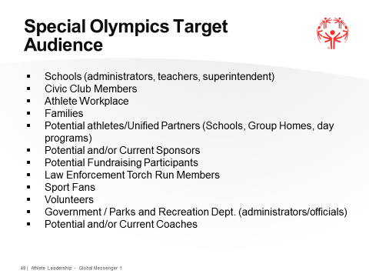Objective: To identifying selling points for specific Special Olympics audiences.

Material: PowerPoint and Participant Guide

Time: 20 minutes

Summary: Special Olympics will have very specific target audiences who each have their own unique set of “selling” points that our Global Messengers need to be able to talk about in their speeches.

Possible Script:

Can someone tell me who needs to know about Special Olympics? *Let athletes tell you all the types of people that should know about Special Olympics.*

Ok, that is a great list. Who can tell me WHY we might want to give a presentation to this group of people? *Let them answer.* So we can target a message to that specific group that means something special to them. WHY would teachers want their students to join? *Have them give a couple of answers.* WHY do you think police officers would join the Torch Run? *Have them give a couple of answers.* WHY should volunteers come out and volunteer for our events? *Have them give a couple of answers.*

Who can tell me what a salesperson does? Can you give me an example of a product that you have seen being sold on TV? *Ask several different people to answer in hopes that one person comes back with a car salesman.*

Who can tell me something that you remember about a car commercial? What were they trying to tell you about the car that was really good? *The goal is for them to say several different things that the commercials relay. If they do not respond, then continue with the following reasons*. Some commercials talk about how many people you can get in the car. Some commercials talk about getting good gas mileage. Others talk about smooth ride and luxury and good music.

If a family came to the car lot and the salesman saw a mom and dad, 3 children and a baby looking at cars, how do you think he would size them up and what kind of car do you think he would try to sell them? He would probably say it is very roomy, and it gets good mileage on the road. There is plenty of storage in the back and a luggage rack on top. Lots of cup holders, and for a little more, you can get a TV on the back of the seat to keep the children entertained! Wow! Do you think he may have sold them a car? Do you think those were some good selling points? *Goal is to get athletes to see how good selling points can make a difference!*

Did you know that you are really a salesperson for Special Olympics? You have to know something about WHY the group that you are talking to would want to do what you are going to ask them to do. These are called Selling Points.

***Slide #50***: Now let’s look at the Selling Points for athletes joining Special Olympics on page 37 of your guide. *Let them flip to page and then bring up Slide #50 on PowerPoint.* What are the two most important selling points on why athletes would want to join our Program? *Let them read each bullet point.*

***Slide #51*:** We have put together several Selling Points sheets for you to review before you prepare a speech (page 27-42 in Participant Guide). It is your job to pull out the most important one or two selling points for your speech. Let’s look at page 34 for Special Olympics Selling Points for Families and look at why a family would want their son or daughter to join Special Olympics. *Have them read each bullet point).*  You will have to decide which 2 or 3 items you want to put in your speech*.*

Can anyone see how these Selling Points are different? *Have them tell you what is different on these 2 slides.* You have to make sure you are saying the right thing to each audience. You have to “sell” them. You will be using this information this afternoon as you prepare to write your speech.

TARGET AUDIENCES

* Schools (administrators, teachers, superintendent)
* Civic Club Members
* Athlete Workplace
* Families
* Potential Athletes (group homes, day program)
* Unified Partners (schools)
* Potential and/or Current Sponsors
* Potential Fundraising Participants
* Law Enforcement Torch Run Members
* Sports Fans
* Volunteers
* Government / Parks and Recreation Department (administrators/officials)
* Potential and/or Current Coaches

Now I need you to go to page 43. The worksheet includes who the target audience is, what you are going to ask them to do, what you might need to bring to the presentation such as brochures, a video, business cards, sign-up sheets, etc., what you are going to wear, and what it is that you need to tell them in order to “sell” them on what it is that you want them to do. Note: there is a sample worksheet completed on page 44.

Once again, I am not going to give you a lot of time to do this, so move through it quickly. When you have completed the worksheet, you will stand and in full sentences tell me the information that you have gathered. This is what I want it to sound like.

*If you have an Athlete trainer with you, have them read the completed sample worksheet using full sentences. If not, you read it.*

*Give them 10 minutes to write.*

Who would like to go first?

Target Audiences Practice Worksheet Sample

My Target audience is Volunteers .

Answer Section:

My target group is the Lions Club . I want to get them to

Volunteer for the Holiday Classic in December .

I am going to bring to the presentation a picture board of the Games, fact sheets about Special Olympics, a volunteer video to show them, and volunteer registration forms.

I am going to wear nice pants, dress shirt, and dress shoes.

I am going to tell them

1. Volunteering helps to build their OWN self esteem .
2. There are many things they can do at the events .
3. It’s a chance for them to improve their professional skills .
4. They will make new friends .
5. They will make a difference in other people’s lives .

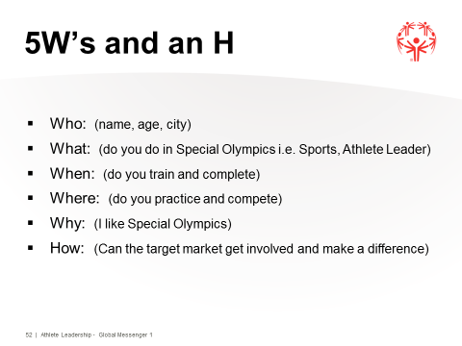**Slide 52: What goes into a Speech - 5W’s and an H**

Objective: To establish important personal information that can be later used when preparing a speech.

Materials: PowerPoint and Participant Guide (page 45)

Time: 35 minutes

Summary: This activity will involve each Global Messenger working with their Speech Coach to come up with information that can be used when preparing speeches.

Possible Script:

If you have ever read a newspaper article or watched a television reporter tell a news story, you have heard about the 5W’s and an H. In reporter terms, these basic facts, the WHO, WHAT, WHEN, WHERE, WHY AND HOW are included in every news story.

The **WHO** is about you. Your name, age if you want to give it, where you come from.

The **WHAT** is what do you do in Special Olympics or What is Special Olympics. Sports, Athlete Leadership, etc. Tell the Mission.

The **WHEN** is about Special Olympics. When are the Games, when do you practice, etc.

The **WHERE** is where do you practice, where are the Games, where do you give speeches, etc.

The **WHY** might be the most important part, WHY do you do Special Olympics; WHY do you like it?

The **HOW** is a little bit different. This is not about you; this is about your audience. HOW do you want them to get involved? HOW can they make a difference?

As Global Messengers, you are going to be acting as reporters about Special Olympics. Therefore, it’s important that you write down some facts about your personal involvement as an athlete.

Turn to Page 45 in your Participant Guide. As you work with your Speech Coach to complete this sheet, please think about your training, competition, and social activities associated with Special Olympics. Speech Coaches, sometimes it helps to have these written in full sentences on the worksheet. The Global Messengers can use this worksheet over and over for their speeches.

*Circulate around the room as participants and coaches complete the handouts. When you see that everyone is finished, invite them to come up, one by one, and present their information. Remind the Speech Coaches to go to the back of the room and give hand signals regarding volume.*

Now it is time to let us know who you REALLY are. Using full sentences, you will tell us what you have written out that you will use later in your speech. Who would like to go first?

Thanks everyone. You now have some of the basic information about yourselves written down. You’ll be able to use this information later when you prepare your speeches. After you practice, practice, and practice this part of your speech, you will be able to do it from memory and not read from your paper.

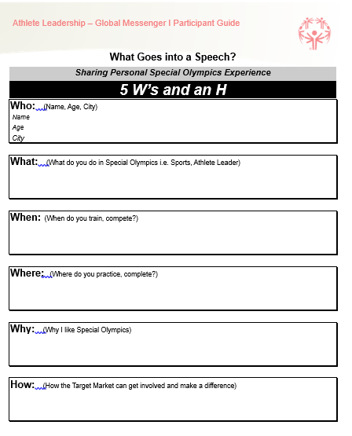



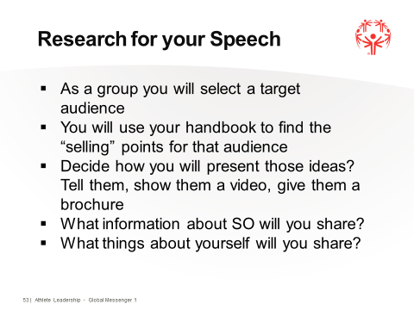**Slide 53: Research for your Speech**

Objective: To understand how the Global Messenger will formulate what they want to put into their speech for their target audience.

Material: PowerPoint and Participant Guide (page 46)

Time: 30 minutes

Summary: Because the goal of this program is to have the Global Messengers write an effective speech, it is important that they understand the speech development process.

Possible Script:

We have already learned HOW to find the things you need to put into your speech for the audience you are addressing. We now have to think about the actual writing of the speech. At first this may seem like a long and frustrating process, but I think you will find that each time it will get a little easier.

Turn to page 46 in your Participant Guide.

We have to begin the process of writing our speech with 1 important aspect.

RESEARCH - Thinking, planning and deciding what it is that you are going to write about:

a) You have to know Who is the target audience that you will be speaking to? You have that chosen already.

b) What are the selling points? What is it that will interest this audience, why should they do what you want them to do? Where do you find that information again? *Participant Guide.* That is right and you have already written down the selling points for your speech.

c) How will you present those ideas? Video or just talking?

d) What information about Special Olympics do you want to give?

e) What personal information do you want to share?

f) What is it that you want the audience to do?

g) How should you dress when you go?

h) Do I need to take anything with me to help with my speech?

We are going to do a RESEARCH exercise right now. You are going to work with your Speech Coach using the Target Audience that you have already selected and fill out the Research Worksheet on page 46 of your Participant Guide. Keep in mind these are the things that you will probably be using in your speech so work hard on it.

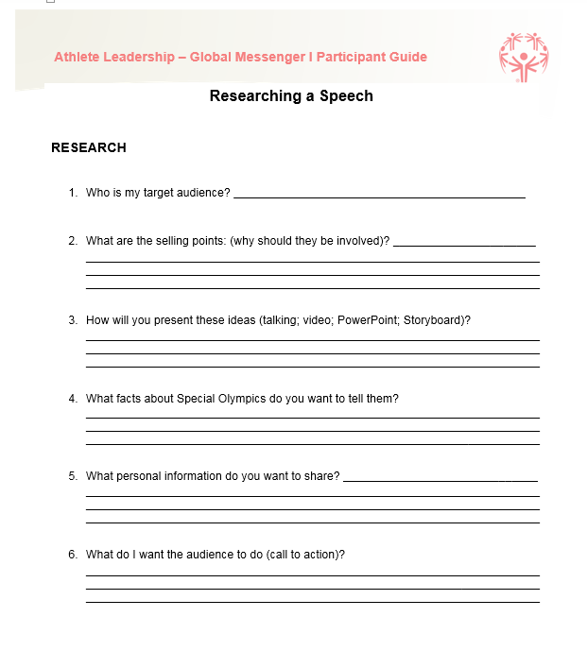*Allow 10-15 minutes for everyone to finish, if you have time.*

It looks like everyone has completed their worksheets. Does anyone want to volunteer to read their research information? Don’t forget that I want you to use full sentences in explaining this.

**Slides 54-57: Parts of a Speech**

Objective: To formulate an understanding of the speech content such as Opening, Body, and Closing.

Material: PowerPoint and Participant Guide (page 47-49)

Time: 15 minutes

Summary: Because the goal of this program is to have the Global Messengers write an effective speech, it is important that they understand speech content.

***Slide #54.***

Time: 0 minutes

Possible Script:

Why are we here today? *You are looking To become a Global Messenger or To learn to write speeches.* That is correct; we are here to Become a Global Messenger and to learn to write a speech. To fulfill this role, we need to understand HOW to write a speech. In the future, you will be going out into the community and promoting Special Olympics. Your speech will be your instrument for doing this.

***Slide #55.***Every speech that you give will have 3 parts to it. An OPENING, A BODY, and a CLOSING. You can see how the Opening begins your speech then flows into the Body of your speech which flows into how you are going to Close your speech. Your speech needs to be smooth and each sentence needs to make sense.

Turn to page 47 in your Participant Guide and follow along.

***Slide #56:***In your *OPENING*, you will thank the person who introduced you and thank the audience for having you come and speak with them. Tell them your name. Tell them what you are going to be talking about in your speech (Tell them what you are going to tell them). You want to make the beginning part of your speech pretty catchy so you get their attention early. Your “catch” line might work here.

**OPTIONAL Activity #2:** You can ask the Global Messengers and Speech Coaches to work together and come up with an introduction to their audience. Don’t have them write it down, just practice it with their speech coach several times. This is a VERY good way to get them to not have to use notes during this part of their speech for their 3-5 minute speech.

***Slide #57:***In the *BODY* of your speech you will tell them something about yourself (team, sports you do, why you like Special Olympics, etc.).

***Slide #58:***  Who AM I can be used for practice. Tell them the facts about Special Olympics and Always tell them about the Mission Statement. What do you want them to do? Do you want them to volunteer? Give money? Join as Athletes? Tell them WHY they should do what you are asking to do. Remember those are the selling points of your audience. This would be the time to show them a video if you have one. And if you feel your “catch” line fits in this section better, put it here.

**Slide 58: Who Am I?**

Objective: To begin to develop aspects of a speech with personal information.

Materials: PowerPoint and Participant Guide (page 48)

Time: 20 minutes

Summary: Each participant will tell a little information about themselves.

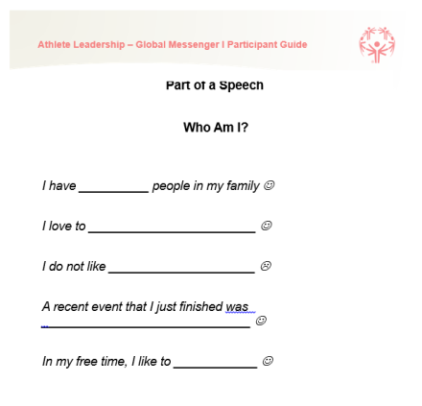Possible Script:

In the BODY of your speech remember, we said that you were going to tell your audience a little bit about yourself. I have listed some sentences that you will need to fill in the blanks to tell us a little bit about yourselves. You are NOT going to write this information down; you are going to just speak. Open your Participant Guides to page 48. I am going to give you a minute to talk with your Speech Coach about each one of these sentences. *When time is up.* Who would like to go first?

*Give the Global Messengers and their Speech Coaches a minute to discuss. Each participant should take a turn.*

You may not want to tell your audience all this information or even any of it, but you can if you want. All of this information is something that you will soon have memorized and it will flow as if you are in a conversation. This is what we want to happen in your speeches.

**Slide #59:** In your CLOSING you will tell them what you just told them. This is recapping your main points from the BODY of your speech. Remind them about what you want them to do. Tell them HOW they can do it. Ask them if they have any questions. If you brought them material such as brochures, sign-up sheets, etc., let them know where they can pick them up. Thank them for inviting you and learning how they can do what you just asked them to do. Let them know for more information, they can always go to the website and give them that site address. [resources.specialolympics](http://www.specialolympics).org and click on Athlete Leadership. And guess what, you could even put your “catch line” here in the CLOSING to leave them with excitement.

*(Continued on next page)*

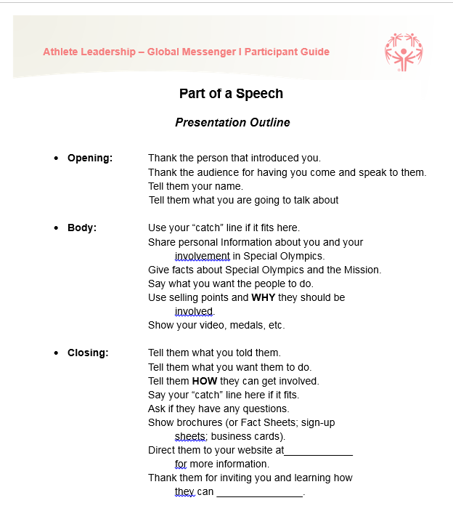

Check for clarity from the Global Messengers because this is the most important part of the Global Messenger Training.

We have just gone through some new and complicated concepts. As you have seen the speech writing process is not easy. It takes a lot of time and energy. If you understand the OPENING, BODY, and CLOSING you will ALWAYS put together a very informative and creative speech that your audience will enjoy listening to.

Turn to page 50 in your Participant Guide, “Tools for Talk”, to review all the options of tools.

**Slide 60: Guest VIP**

Time:

**Demonstration of 5 minute speech by current Global Messenger**

Give these instructions to the Global Messenger making the speech or your PR Chairman or PR Staff Person.

Speech will happen at the end of day 1 training, right before the new Global Messengers begin to develop their speeches for presentations the next day.

The Trainer will say:

_______________________ is going to demonstrate what your speech should sound like tomorrow. I am going to provide feedback on the speech so you have an idea of what that will be like tomorrow as well.

*After you speak:*

That was terrific ______________________. Here is your feedback on your speech?

Global Messenger:

You will need to develop a 5 minute speech on Who you are, What Special Olympics is and what it means to you and your family, why you continue with Special Olympics and most important your message will be to donors and what you want them to do. You will need to write out this speech completely in order to practice, practice, practice. Make sure you are close to 5 minutes in length, and then you can write out your NOTES for the speech anyway that you want to for your presentation such as bullet points. Please make sure you put your notes in a binder or in your iPad or other technology device.

Make sure you have the following:

OPENING: Thank whoever is introducing you, Thank the audience for letting you come, give your name, tell the audience why you are talking to them.

BODY: Information about yourself, information about Special Olympics (Mission for sure), what Special Olympics means to you and your family, why you continue to stay in Special Olympics and then tell them what you want them to do for Special Olympics (for this speech, donating to us and why they should).

CLOSING/Conclusion: Remind them of what you what them to do, tell them HOW they can do it, see if they have any questions, and thank them.

Review page 49-51 in Participant Guide.

**Slide 61: Writing Your First Speech**

Objective: To have Global Messengers begin the process of writing their 1-5 minute speech.

Material: PowerPoint and Participant Guide

Time: 45 minutes

Summary: The Global Messenger by this time should have already chosen the target audience for their speech. They have worked on parts of their Introduction and the selling points for their audience. They understand they must use an Opening, Body and Closing when writing their speech. They will take this time to begin to write the complete speech and practice presenting it.

Possible Script:

It is now time to put the ideas we have learned during this training to work! As you know, it is our goal to give a 3-5 minute presentation.

We will go around the room, and each of you will tell us again who WE will be during your speech. Please use full sentences when telling us your target audience. *Let the Global Messengers tell us their audiences.*

Great! Now that we all know what our target audiences are, it is time to prepare our speeches. Don’t forget that your speech will be 3-5 minutes. We want your speech to be closer to 5 minutes than to 3 minutes.

Tell me again what you have to put into your speech? *Let them tell you each thing for Opening (thank yous, tell them what your speech is going to be about); Body (facts, selling points, what you want from them); Closing (Tell them what you told them, questions, thank yous).*

Each of you MUST have an Opening, Body, and Closing in your speech. If some of you are comfortable enough, I would love to see parts of your speeches be done from memory, especially when you are talking about yourself. Review page 49, Part of a Speech.

Use your Participant’s Guide to find the things you need to put into your speech. I want to hear a great introduction and information about yourself, you MUST put in the Mission Statement and some facts about Special Olympics, use some selling points for your audience. Don’t forget that you should begin your Closing with In Conclusion or In Closing I would like …

Can someone tell me how you think you should be dressed for your speech? How about your hygiene? What should you bring with you? Let’s look at page 51 and review the “**Getting Ready for a Presentation Checklist**” you should use before each speech.

Speech Coaches where will you be standing when your athletes are speaking? What will you do if they are speaking too softly or too loudly?

Speech Coaches, here are a few tips for you to “help” your athletes even more. If you find that they are not looking up from their paper when speaking, put a smiley face at the end of a sentence/paragraph. This will remind them to look up. If you find that they lose their place on their paper when they DO look up, have them use their pointer finger to follow their words. That way when they look back down, they will know exactly where to go. Some athletes may still need a little more assistance when reading their speech, if that is the case; you may need to stand beside them in order to help them through instead of standing in the back of the room.

You will use a 3-ring binder or smart device for your speech. *You may have another system such as index cards.* Binders fit nicely on most podiums, and you will never have to worry about your pages getting mixed up.

You will be videoed giving your speeches. This video will be sent to you and your speech coach later for you to look at how you did. After your speech, you will be given verbal and written feedback of how you did. Please know that this is VERY important. Can anyone tell me why it is important to have our speeches evaluated? *Let them give some answers.* Evaluating our speech is the ONLY way that we will get better. We have to know what we need to work on in order to improve what we are doing. For our speeches, the room can give lots of good things that the speaker did, then I will give the rest of the feedback. This will have many good things, and it will have a couple of things that you will work on for your next speech. Any questions?

**OPTIONAL:**

_______________________*athlete trainer who understands the critique process* is going to demonstrate what your speech should sound like. I am going to give them feedback on their speech like I will for your speech so you have an idea of what that will be like.

*Athlete gives a 3-5 minutes speech. Do not let it be a 1 minute speech. You want your Global Messengers to try and develop a longer speech. This longer demonstration will help them do that.*

That was terrific ______________________. Here is your feedback? *Give lots of good things and 1 or 2 things to work on.*

You and your Speech Coach have the next ______ hours to work on organizing your speech and then you will need to get together tonight again it is easier to work with your Global Messengers here than in your hotel room or at home. They are tired, so they may not want to do anything; please stay here until (time). When you get home, remember to practice, practice, and practice your speech a few times after it is written. When you come back to give your speech, please have your FINAL copy ready. I will give you about a half hour to come in and practice it a few more times before you have to give it. Good luck, and we will see you at (time) sharp. I can’t wait to hear all of your speeches.

*Check to see if there are any final questions. If you have not already given them their binders and sheet protectors, do so now.*

Review page 50-51-52 in Participant Guide.

**Slide 62: Speech Time**

Objective: To provide the Global Messengers the opportunity to give their speeches to their selected audience.

Material: Feedback Form in Participant Guide

Video camera if videoing

Time: 90 minutes per Global Messenger

Summary: This feedback form should not be completed by other athletes. It is strictly for the trainers of the training. Each trainer should fill out the form and verbally critique the Global Messenger’s presentation.

Possible Script:

Don’t forget that you will be videotaped giving your speeches today. This video will be sent to you and your speech coach later for you to look at how you did *Or it will be put on YouTube.* After your speech you will be given feedback on how you did. Does anyone remember why it is important to have our speeches evaluated? *Let them answer.* Evaluating our speech is the ONLY way that we will get better. We have to know what we need to work on in order to improve what we are doing. For your feedback today, the room can give lots of good things that the speaker did, then I will give the rest of the feedback. This will have many good things, and it will have a couple of things that you will work on for your next speech. Any questions before we begin?

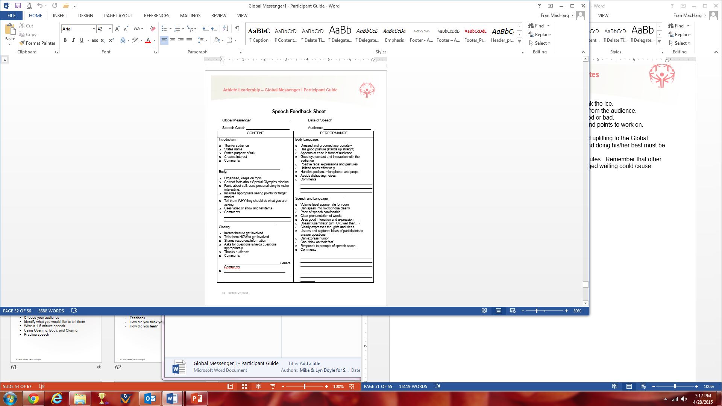

Review speech Feedback Sheet page 52 of Participant Guide to Review how speeches would be received and feedback given.

OK, who would like to be first? *You should have all the Global Messengers’ Participant Guides so you can use the Feedback Form in their own books.*

**Note:** The format for the feedback should be as follows:

1. Trainer makes a very positive point about the presentation to break the ice.
2. Ask for comments about something good about the presentation from the audience.
3. Ask the athlete who gave the speech to share any comments, good or bad.
4. Have the trainers offer strong positive points of the presentation and points to work on.
5. Give 1 or 2 items that they can work on for their next speech.
6. Throughout the entire process, the trainers need to be positive and uplifting to the Global Messenger. Encouragement for getting up in front of the group and doing his/her best must be constantly reinforced.
7. The total time for the process should be no more than 10 - 15 minutes. Remember that other Global Messengers are waiting to give their speeches, and prolonged waiting could cause anxiety.

**Slide 63: Next Steps Back Home**

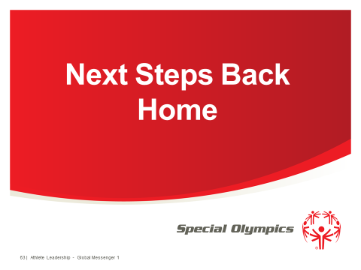

What do you think you need to do when you get back home? Wait for answers.

* 1. Meet with your Program; do a speech for them.
  2. Tell Management team that you can give speeches in the future.
  3. Identify the best way to contact each other.
  4. Find out if you get Business Cards or not.
  5. Make your plan for speeches.

Go to page 53 in Participant Guide and fill in what you are going to do.

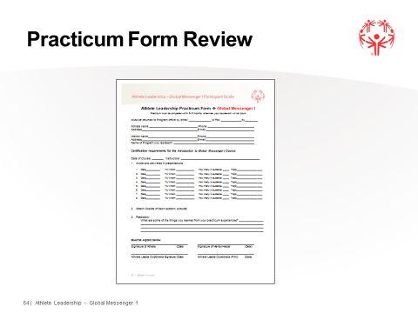**Slide 64: Practicum**

Turn to page 54 in your Participant Guide, and let’s review what you need to complete.

**Slide 65: Training Feedback**

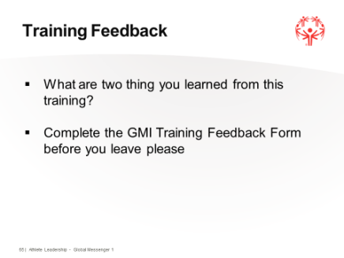

Objectives: To ensure that each participant gives an evaluation of the training.

Materials: Training Feedback Form

Time: 10 minutes

Summary: Feedback of the training and reminders on what Global Messengers and Speech Coaches are expected to do when they return home.

Possible Script:

We are at the end of the training! We have heard a lot of great speeches! We’ve learned a lot about each other and ourselves and how we can be good Ambassadors for Special Olympics and ourselves.

But now it is time to think about AFTER the training! First, we want to know what you learned the most and how you think we could improve this training when we offer it the next time. For that, I want the Speech Coaches to go with (name) and Global Messengers I want you to stay here. *Separate group out. Both get the following information.*

What are some things that people have learned since we got started? *Let them give ideas.*

What are some ideas you have for how to make this training better next time? *Let them give ideas.*

Great! Those are some excellent ideas that will help the people who come after you in the next class of Global Messengers. But now we need to get all that down on paper. Take a few minutes to work with your Speech Coach and answer the questions on the Feedback Form, i*f you have one.*

*Give a few minutes to complete. Groups come back together.*

Now to the most important thing: What are you going to do when you go home? What is next for this class of Global Messengers? Who has something that you want to do when you get home that you thought of during this training? *Let them give ideas.*

Let’s turn to page 55. I want to show you what you have in this Guide that you can use when you get home and writing your next speech. *Go through the at home pages in the Participant Guide. Make sure they meet what your Program wants.*

*Say goodbye to your group. Time for Graduation: Give out class certificates and other items that you have for your graduates and Speech Coaches.*

**Global Messenger Training Feedback**

Please complete this Evaluation Form and return to the instructors by the end of the class. We value your opinions and want to make continuous improvements.

**Name**: ________________________________ **Program**: ______________________

Please check (X) Athlete _____ Mentor ____

Name 2 things YOU learned that is going to help you when you speak to a group.

1.

2.

Describe the section of this course you liked best____________________________________

And explain why you liked it.

Identify which part of the course didn’t work for you.____________________________________ Suggest why it may not have worked.

Explain how you would improve this course when we offer it in the future?

What was your favorite experience/exercise in the Global Messenger course?

What are you going to do to start you Global Messenger experience when you go to back home?

**Sample Agenda A & C Calculated for 8 athletes – See Trainer Guide for more Detail**

**Date:**

|  |  |  |  |  |
| --- | --- | --- | --- | --- |
| **Start Time** | **End Time** | **Slide #** | **Description** | **Trainer** |
| **Part A** | | | | |
| 8:00 A.M. | 8:12 A.M. | 1-3 | Welcome, Introductions |  |
| 8:12 A.M. | 8:14 A.M. | 4 | Course Objectives |  |
| **Part C** | | | | |
| 8:14 A.M. | 8:20 A.M. | 29 | Definition of Athlete Leadership; Mission, Unique; Facts Slides 7, 22, 24, 27 |  |
| 8:20 A.M. | 8:25 A.M. | 30 | Participant Guide |  |
| 8:25 A.M. | 8:31 A.M. | 31-32 | Role of a Global Messenger |  |
| 8:31 A.M. | 8:34 A.M. | 33 | Ambassadors |  |
| 8:34 A.M. | 8:51 A.M. | 34-35 | Elevator Speech |  |
| 8:51 A.M. | 8:56 A.M. | 36 | Speech Coach Job Description |  |
| 8:56 A.M. | 8:58 A.M. | 37-38 | Speeches |  |
| 8:58 A.M. | 9:02 A.M. | 39 | Preparing a Speech |  |
| 9:02 A.M. | 9:08 A.M. | 40 | What’s wrong here? |  |
| 9:08 A.M. | 9:09 A.M. | 41 | Speech Enhancements |  |
| 9:09 A.M. | 9:14 A.M. | 42 | Gold Medal Presentation |  |
| 9:14 A.M. | 9:24 A.M. | 43 | Body Language |  |
| 9:24 A.M. | 9:29 A.M. | 44 | Vocal Variety |  |
| 9:29 A.M. | 9:49 A.M. | 45 | Volume Activity |  |
| 9:49 A.M. | 9:59 A.M. | 46 | Word Punch |  |
| 9:59 A.M. | 10:19 A.M. | 47 | “Catch Line” |  |
| 10:19 A.M. | 10:34 A.M. |  | Break (15 minutes) |  |
| 10:34 A.M. | 10:49 A.M. | 48-49 | Target Audience |  |
| 10:49 A.M. | 10:59 A.M. | 50-51 | Selling Points; Families, Potential Athletes |  |
| 10:59 A.M. | 11:29 A.M. | 52 | 5 W’s and an H |  |
| 11:29 A.M. | 11:59 A.M. | 53 | Researching for Speech |  |
| 11:59 A.M. | 11:59 A.M. | 54 | Parts of a Speech |  |
| 11:59 A.M. | 12:45 P.M. | 55-59 | Parts of a Speech , Tools, Checklist |  |
| 12:45 P.M. | 1:30 P.M. |  | Lunch (45 minutes) |  |

|  |  |  |  |  |
| --- | --- | --- | --- | --- |
| 1:30 P.M. | 1:37 P.M. | 60 | Guest VIP/ and critique |  |
| 1:37 P.M. | 4:00 P.M. | 61 | Write and Practice Speeches ( 15 min break)  breeak breakbraBreak) included |  |
| 4:00 PM | 5:00 PM |  | Extra time if you ran over in exercises previous to building and writing speech |  |
| 8:00 AM | 8:30AM | DAY 2 | **Day Two**- allow time before starting to let athletes practice with the lectern |  |
| 8:30 | 11:25 | 62 | Give Speeches and Feedback (allow 20 minutes per athlete for speech to be done twice) once with Q and A from Audience with feedback and the 2nd time without a Q and A but with positive feedback on improvements from first speech.(Time is geared for 8 athletes) Break is included |  |
| 11:25 AM | 11:47 AM | 63-65 | Practicum Form Review, Next Steps and Training Feedback Each person must complete Feedback Form before leaving |  |
| 11:47 A.M. | 12:12 P.M. | 66-67 | Closing Remarks, Closing Ceremonies and Pictures |  |
| 12:15 A.M. |  |  | Optional Lunch |  |