Social Media Ideas
We challenge all to support #PlayUnified on EKS Day!
EKS Day Social Media Activation
Join us in celebrating “EKS Day” on September 24, 2016. EKS Day celebrates the life, legacy & vision of Special Olympics founder Eunice Kennedy Shriver. Through sport, Mrs. Shriver sought to make sure that all people with intellectual disabilities were included & respected in their communities. Today, we ask that you take to social media to help her vision become a reality!

Please use the following language to promote this vision on or around September 24th with the goal of driving people to our website to join our Movement and share with their networks. To accompany the message, you can also use the attached “P.L.A.Y.” graphics on your platforms or if you have a picture of you & someone with intellectual disability please feel free to use that as well.

Twitter
• Join the #PlayUnified Movement so all athletes are included & respected! www.specialolympics.org/EKSDay
• I pledge to help everyone be included & respected. I challenge [@FRIENDNAME] to join me & #PlayUnified! www.specialolympics.org/EKSDay
• I challenge [@FRIENDNAME] to #PlayUnified & so all athletes can be included & respected. www.specialolympics.org/EKSDay
• I am proud to stand with the world of [tag] @SpecialOlympics as we challenge YOU to join the #PlayUnified Movement ➡ www.specialolympics.org/EKSDay [https://youtu.be/g7QKJOc4T0k]

Facebook
• In celebration of the vision & legacy of [tag] Special Olympics founder Eunice Kennedy Shriver I’m pledging to help people with intellectual disabilities be included & respected. I challenge [@FRIENDNAME] to join me & #PlayUnified! www.specialolympics.org/EKSDay [OPTIONAL TO INSERT PLAY GRAPHIC PIC]
• Join me in celebrating the vision & legacy of [tag] Special Olympics founder Eunice Kennedy Shriver by joining the #PlayUnified Movement and making sure people with intellectual disabilities are included & respected. www.specialolympics.org/EKSDay [OPTIONAL TO INSERT PLAY GRAPHIC PIC]
• I am proud to stand with [tag] @TimShirver, Terrel and the world of [tag] @SpecialOlympics as we celebrate the vision & legacy of Eunice Kennedy Shriver by making sure those with intellectual disabilities are included & respected. I challenge you to join us by joining the #PlayUnified Movement: www.specialolympics.org/EKSDay. [https://youtu.be/g7QKJOc4T0k]

Instagram
• Join me in celebrating the vision & legacy of [tag] Special Olympics founder Eunice Kennedy Shriver by joining the #PlayUnified Movement so people with intellectual disabilities are included & respected. www.specialolympics.org/EKSDay [INSERT PLAY GRAPHIC PIC]
• I am proud to stand with Tim Shriver, Terrel, and the world of [tag] @SpecialOlympics as we celebrate the vision & legacy of Eunice Kennedy Shriver by making sure those with intellectual disabilities are included & respected. I challenge YOU to join us by joining the #PlayUnified Movement: www.specialolympics.org/EKSDay. [https://youtu.be/g7QKJOc4T0k]

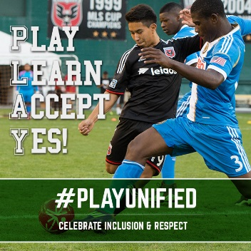
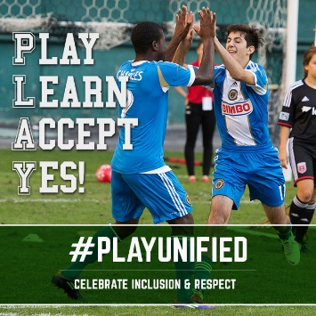
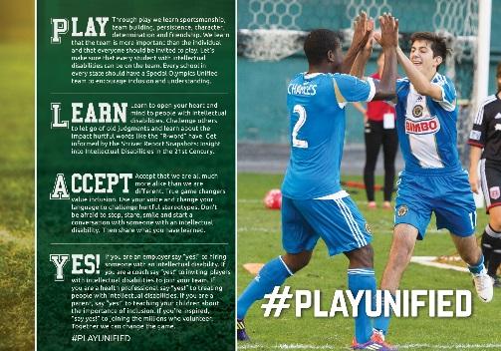
• In celebration of the vision & legacy of [tag] Special Olympics founder Eunice Kennedy Shriver I’m pledging to help people with intellectual disabilities be included & respected. I challenge [@FRIENDNAME] to join me & #PlayUnified [INSERT PLAY GRAPHIC PIC] www.specialolympics.org/EKSDay

