Social Media Ideas

#LETSCHANGETHEGAME Challenge
EKS Day Social Media Activation

Join us in celebrating “EKS Day” on September 26, 2015. EKS Day celebrates the life, legacy & vision of Special Olympics founder Eunice Kennedy Shriver. Through sport, Mrs. Shriver sought to make sure that all people with intellectual disabilities felt included & respected in their communities. We are asking that you take to social media to help her vision become a reality.

Please use the following language to promote this vision on or around September 26th with the goal of driving people to our website to sign-up and join our Movement and share with their networks. You can also use the attached “P.L.A.Y.” graphics on your platforms or if you have a picture of you & someone with intellectual disability please feel free to use that as well.

Twitter
• Take the #LetsChangeTheGame Challenge & make everyone feel they are included & respected. www.specialolympics.org/LetsChangeTheGame

• I pledge to make everyone feel they are included & respected. I challenge [@FRIENDNAME] to join me. #LetsChangeTheGame www.specialolympics.org/LetsChangeTheGame*

• I challenge [@FRIENDNAME] to take the #LetsChangeTheGame Challenge & make everyone feel they are included & respected. www.specialolympics.org/LetsChangeTheGame*

*Note: Number of characters available here will depend on friend’s handle

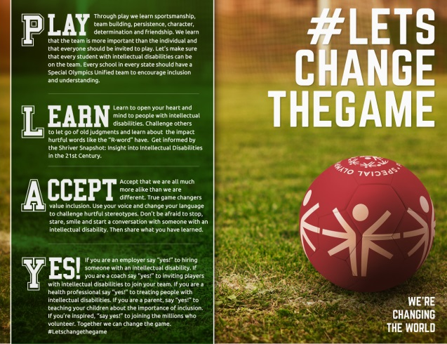

Twitter – Tweet Samples

Reach beyond your comfort zone and leave your differences behind to play for a common goal- Unity. Find out how you can honor Eunice Kennedy Shriver today (link).

@Oprah once told EKS "If you run for president, I'll campaign for you." Find out why by visiting http://bit.ly/1hcITRX. #EKSday

Eunice Kennedy Shriver started a movement and changed the world. Join us in celebrating her vision. Find out how you can honor her legacy. (link to list of events going on)

As Eunice Kennedy once said, “You are the stars and the world is watching you.” How will you change the world? Honor her legacy (link to list of events going on)

Eunice Kennedy Shriver was fearless, bold & revolutionary. Reach out to (local SO program) to find out how you can honor her legacy. #EKSday

Today we celebrate the life of a woman who saw opportunity where others saw barriers- Eunice Kennedy Shriver. Join us (link to list of events).

Eunice Kennedy Shriver gave her daughter Maria the gift that keeps on giving. Click here to find out more. http://www.specialolympics.org/video-TheGift.aspx

“My mother was a force of nature, I never saw anybody like her.” says Maria Shriver. Eunice Kennedy Shriver changed the world. Learn more http://www.specialolympics.org/video-TheGift.aspx

